|  |  |  |  |  |  |  |  |
| --- | --- | --- | --- | --- | --- | --- | --- |
| **طرح نگهداشت و افزایش تولید 27 مخزن** | | | | | | | |
| **CALCULATION NOTE FOR DC CHARGER SYSTEM**  **نگهداشت و افزایش تولید میدان نفتی بینک** | | | | | | | |
|  |  |  |  |  |  |  |
|  |  |  |  |  |  |  |
| D02 | May.2022 | IFA | H.Shakiba | M.Fakharian | M.Mehrshad |  |
| D01 | JAN.2022 | IFA | H.Shakiba | M.Fakharian | M.Mehrshad |  |
| D00 | DEC. 2021 | IFC | H.Shakiba | M.Fakharian | M.Mehrshad |  |
| **Rev.** | **Date** | **Purpose of Issue/Status** | **Prepared by:** | **Checked by:** | **Approved by:** | **CLIENT Approval** |
| Class: | | Client Doc. Number: **F0Z-709011** | | | | |
| Status: | IDC: Inter-Discipline Check  IFC: Issued For Comment  IFA: Issued For Approval  AFD: Approved For Design  AFC: Approved For Construction  AFP: Approved For Purchase  AFQ: Approved For Quotation  IFI: Issued For Information  AB-R: As-Built for CLIENT Review  AB-A: As-Built –Approved | | | | | |

**REVISION RECORD SHEET**

|  |  |  |  |  |  |  |  |  |  |  |  |  |
| --- | --- | --- | --- | --- | --- | --- | --- | --- | --- | --- | --- | --- |
| **PAGE** | **D00** | **D01** | **D02** | **D03** | **D04** |  | **PAGE** | **D00** | **D01** | **D02** | **D03** | **D04** |
| **1** | X | X | X |  |  | **51** |  |  |  |  |  |
| **2** | X | X | X |  |  | **52** |  |  |  |  |  |
| **3** | X | X |  |  |  | **53** |  |  |  |  |  |
| **4** | X |  |  |  |  | **54** |  |  |  |  |  |
| **5** | X | X |  |  |  | **55** |  |  |  |  |  |
| **6** | X | X | X |  |  | **56** |  |  |  |  |  |
| **7** | X | X | X |  |  | **57** |  |  |  |  |  |
| **8** | X | X | X |  |  | **58** |  |  |  |  |  |
| **9** | X | X | X |  |  | **59** |  |  |  |  |  |
| **10** | X | X | X |  |  | **60** |  |  |  |  |  |
| **11** | X | X | X |  |  | **61** |  |  |  |  |  |
| **12** |  |  |  |  |  | **62** |  |  |  |  |  |
| **13** |  |  |  |  |  | **63** |  |  |  |  |  |
| **14** |  |  |  |  |  | **64** |  |  |  |  |  |
| **15** |  |  |  |  |  | **65** |  |  |  |  |  |
| **16** |  |  |  |  |  | **66** |  |  |  |  |  |
| **17** |  |  |  |  |  | **67** |  |  |  |  |  |
| **18** |  |  |  |  |  | **68** |  |  |  |  |  |
| **19** |  |  |  |  |  | **69** |  |  |  |  |  |
| **20** |  |  |  |  |  | **70** |  |  |  |  |  |
| **21** |  |  |  |  |  | **71** |  |  |  |  |  |
| **22** |  |  |  |  |  | **72** |  |  |  |  |  |
| **23** |  |  |  |  |  | **73** |  |  |  |  |  |
| **24** |  |  |  |  |  | **74** |  |  |  |  |  |
| **25** |  |  |  |  |  | **75** |  |  |  |  |  |
| **26** |  |  |  |  |  | **76** |  |  |  |  |  |
| **27** |  |  |  |  |  | **77** |  |  |  |  |  |
| **28** |  |  |  |  |  | **78** |  |  |  |  |  |
| **29** |  |  |  |  |  | **79** |  |  |  |  |  |
| **30** |  |  |  |  |  | **80** |  |  |  |  |  |
| **31** |  |  |  |  |  | **81** |  |  |  |  |  |
| **32** |  |  |  |  |  | **82** |  |  |  |  |  |
| **33** |  |  |  |  |  | **83** |  |  |  |  |  |
| **34** |  |  |  |  |  | **84** |  |  |  |  |  |
| **35** |  |  |  |  |  | **85** |  |  |  |  |  |
| **36** |  |  |  |  |  | **86** |  |  |  |  |  |
| **37** |  |  |  |  |  | **87** |  |  |  |  |  |
| **38** |  |  |  |  |  | **88** |  |  |  |  |  |
| **39** |  |  |  |  |  | **89** |  |  |  |  |  |
| **40** |  |  |  |  |  | **90** |  |  |  |  |  |
| **41** |  |  |  |  |  | **91** |  |  |  |  |  |
| **42** |  |  |  |  |  | **92** |  |  |  |  |  |
| **43** |  |  |  |  |  | **93** |  |  |  |  |  |
| **44** |  |  |  |  |  | **94** |  |  |  |  |  |
| **45** |  |  |  |  |  | **95** |  |  |  |  |  |
| **46** |  |  |  |  |  | **96** |  |  |  |  |  |
| **47** |  |  |  |  |  | **97** |  |  |  |  |  |
| **48** |  |  |  |  |  | **98** |  |  |  |  |  |
| **49** |  |  |  |  |  | **99** |  |  |  |  |  |
| **50** |  |  |  |  |  | **100** |  |  |  |  |  |

**CONTENTS**

1.0 INTRODUCTION 4

2.0 GENERAL DEFINITION 4

3.0 Scope 5

4.0 REFERENCES AND STANDARDS 5

5.0 DC SIZING ASSUMPTIONS 5

6.0 DC-UPS Load PROFILE 6

7.0 DC LOAD CONSUMPTION 6

8.0 DC DUTY CYCLE 7

**8.1** **Battery duty cycle diagram (110 VDC)** 7

**8.2** **Battery Duty Cycle Diagram (24 VDC)** 8

9.0 NUMBER OF CELL CALCULATION 8

**9.1** **110 VDC Cell** 8

**9.2** **24 VDC Cell** 8

**9.3** **Battery Selection** 8

10.0 BATTERY CHARGER RATING 9

11.0 CONCLUSION* 10

12.0 REFERENCE DOCUMENTS 10

13.0 ATTACHMENTS 11

1. **INTRODUCTION**

Binak oilfield in Bushehr province is a part of the southern oilfields of Iran, is located 20 km northwest of Genaveh city.

With the aim of increasing production of oil from Binak oilfield, an EPC/EPD Project has been defined by NIOC/NISOC and awarded to Petro Iran Development Company (PEDCO). Also PEDCO (as General Contractor) has assigned the EPC-packages of the Project to "Hirgan Energy - Design and Inspection" JV.

As a part of the Project, a New Gas Compressor Station (adjacent to existing Binak GCS) shall be constructed to gather of 15 MMSCFD (approx.) associated gases and compress & transfer them to Siahmakan GIS.

1. **GENERAL DEFINITION**

The following terms shall be used in this document.

|  |  |
| --- | --- |
| CLIENT: | National Iranian South Oilfields Company (NISOC) |
| PROJECT: | Binak Oilfield Development – Surface Fcilities; New Gas Compressor Station |
| EPD/EPC CONTRACTOR (GC): | Petro Iran Development Company (PEDCO) |
| EPC CONTRACTOR: | Joint Venture of : Hirgan Energy – Design & Inspection (D&I) Companies |
| VENDOR: | The firm or person who will fabricate the equipment or material. |
| EXECUTOR: | Executor is the party which carries out all or part of construction and/or commissioning for the project. |
| THIRD PARTY INSPECTOR (TPI): | The firm appointed by EPD/EPC CONTRACTOR (GC) and approved by COMPANY (in writing) for the inspection of goods. |
| SHALL: | Is used where a provision is mandatory. |
| SHOULD: | Is used where a provision is advisory only. |
| WILL: | Is normally used in connection with the action by CLIENT rather than by an EPC/EPD CONTRACTOR, supplier or VENDOR. |
| MAY: | Is used where a provision is completely discretionary. |

1. **Scope**

This specification describes the practices that shall be employed and the Standards that will be   
required to be met for the DC charger and batteries.

1. **REFERENCES AND STANDARDS**

* IEC 60478 Stabilized Power Supplies, DC Output
* IEC 60623 Secondary Cells and Batteries Containing Alkaline or Other non-acid electrolytes Vented Nickel-Cadmium Prismatic Rechargeable Single Cells
* IEC 60947 LV Switchgear & Control Gear
* IEEE 1115 IEEE Recommended Practice for Sizing Nickel-Cadmium Batteries for Stationary Applications
* IPS-E-EL-100 Engineering Standard for Electrical System Design
* IPS-M-EL-174 Material and Equipment Standard for Battery & Battery Charger

1. **DC SIZING ASSUMPTIONS**

The bases of the DC charger calculation performed in this document are summarized as below:

| **Table 1: DC UPS Characteristics for Compressor Station** | | |
| --- | --- | --- |
| **Item** | **110 VDC** | **24 VDC (F&G)** |
| Input AC Voltage | 440/400/380 V=10% | 440/400/380 V=10% |
| Input AC Voltage frequency | 50Hz=5% | 50Hz=5% |
| DC system Nominal Voltage | 110 VDC | 24 VDC |
| DC system Voltage Limits | 104.89 VDC~151.8 VDC | 22.88 VDC ~ 29.28 VDC |
| Overall Aging Factor | 1.1 | 1.1 |
| Design Margin Factor | 1.1 | 1.1 |
| Battery Backup Time | 8 hours | 24 hours + 5 Min. |
| Battery Configuration | 2 x 50% | 2 x 50% |
| Charger Configuration | 2 x 100% | 2 x 100% |
| Battery Type | Ni-Cd (SBLE) | Ni-Cd (SBLE) |
| Nominal Cell Voltage | 1.2 V/Cell | 1.2 V/Cell |
| Float Charge Voltage | 1.42 V/Cell | 1.42 V/Cell |
| Fast Charge Voltage | 1.47 V/Cell | 1.46 V/Cell |
| End Cell Voltage | 1.14 V/Cell | 1.144 V/Cell |

1. **DC-UPS Load PROFILE**

The load list of 110 VDC is in excel attached file, but the 24VDC F&G which has been derived from instrument discipline is as follow (I&C Power Consumption Sammary-BK-GCS-PEDCO-120-IN-0007)s

D02

|  |  |  |  |  |
| --- | --- | --- | --- | --- |
| **Table 2: F&G Power Consumption** | | | | |
| **Item** | **Description** | **Unit Power Consumption (KW)** | **With 20% Spare Capacity** | **Back Up Time** |
| 1 | F&G System | 1.1 | 1.32 | 24 HR |
| 2 | 3.8 | 4.56 | 5 Min |

1. **DC LOAD CONSUMPTION**

DC load consists of the power absorbed by control and protection devices in switchgear cabinets. These devices include CB spring charging motors, CB closing coils, CB opening coils, contactors coils, auxiliary relays, protective relays, signal lamps, annunciations and transducers.

Depending on the type of a feeder, different equipment in the relevant cubicle shall be used. The DC power consumed in each cubicle equals to sum of the consumptions.

Where more than one equipment of the same type is used, a utilization factor is applied to consider the non-simultaneous operation. In, DC load of each substation is calculated in normal status and during plant shutdown. For each switchgear, there is a separate table comprising of all available types of feeders. Here also, a utilization factor is used for non-simultaneous operation of the similar feeders.

Total DC consumption of the switchgear is calculated at the bottom of the table.

Table 1 shows a summary of total DC consumption of each substation during normal and shutdown status.

| **Table 3: Total DC Consumption** | | | | | |
| --- | --- | --- | --- | --- | --- |
| **DC System Tag / Substation** | **Time** | **Consumption in Normal Condition** | | **Consumption in Worst Case Condition** | |
| **Power (W)** | **Current (A)** | **Power (W)** | **Current (A)** |
| **DC-UPS-01 (110 VDC)** | 8 HR | 2090 | 19 | 5090 | 46.27 |
| **DC-UPS-02 (24 VDC)** | 24 HR | 660 | 27.5 | - | - |
| 5 Min | 2280 | 95 |  |  |

**Note:** According to Item 5.3 of IPS-M-El-174(2), the DC power supply shall consist of two similar thyristor type chargers each rated for 100 percent of rated load, two battery banks each rated for 50 percent of the rated load and one DC distribution panel. Therefore to calculate the capacity of battery bank half of demand load shall be considered.

1. **DC DUTY CYCLE**

Duty cycle diagram shows the total load at any time during the cycle is an aid in the analysis of the duty cycle. This profile obtained based on two consecutives tripping of the switchgears. The details of the consumptions have been listed in separate Tables of Attachment #1 for 110 VDC.

In addition, for 24 VDC calculation, 5000 W for 24 hours has been assumed.

* 1. **Battery duty cycle diagram (110 VDC)**

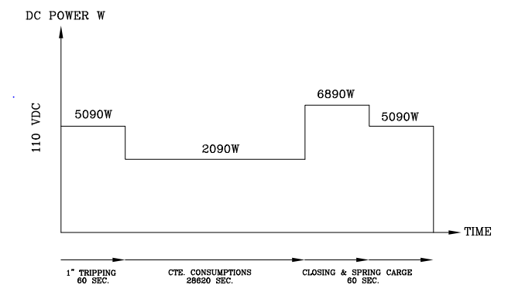

* 1. **Battery Duty Cycle Diagram (F&G)**

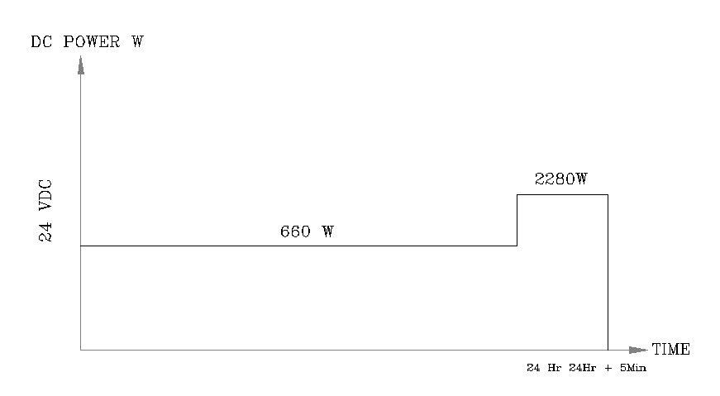

1. **NUMBER OF CELL CALCULATION**
   1. **110 VDC Cell**

With considering nominal DC link voltage equal to 110VDC, the No. of cells is obtaining as below:

No. of cells = Nominal DC Link Voltage /

= 110 / 1.2 ~ 92 cells Final discharge cell voltage

Note: The exact number depends on the type of battery and will be determined by the vendor.

* 1. **24 VDC Cell**

With considering nominal DC link voltage equal to 24VDC, the No. of cells is obtaining as below:

No. of cells = Nominal DC Link Voltage /

= 24 / 1.2 ~ 20 cells Final discharge cell voltage

Note: The exact number depends on the type of battery and will be determined by the vendor.

* 1. **Battery Selection**

Overall rating of batteries shall be so chosen to provide the load current for 8 hours for 2 x 50% load, according to project specification.

D02

To calculate battery capacity, the following equation can be used.

(1)

$$C=\frac{1}{L}\sum_{i=1}^{n}{I_{i}T_{i}}$$

Where:

C: Rated Capacity (Ah)

L: Maintenance Factor (1) (Design Margin 1.1 & Aging Factor 1.1)

n: Number of Loads

I: Load Current

T: Battery Discharge Time

In equation (1), T is the same 8 hours for 50% loads in the substations. Therefore, $$C=\frac{1}{L}(T)\sum_{i=1}^{n}{I_{i}}$$  
Where, *“I”* is the total current consumption. Using the values of the battery duty cycle diagram presented in clause 7 which obtained from attachment #1, battery capacity can be calculated. The battery calculation is performed by using SAFT BaSics Software. According to the results presented in Attachment #2 & #4, the selected battery set for 110 VDC system is 2 sets of (1×92×SBLE 325 AH). In addition according to Attachment #4, the selected battery set for 24 VDC system is 2 sets of (1×20×SBLE 1150 AH)

(2)

The stand proposal proposed in Attachment #3 & #5, also. It should be noted that this is only typical and the battery layout can be configured according to the space which is available using the adopted stand structure.

1. **BATTERY CHARGER RATING**

In the worst condition when batteries are completely discharged, the charger should provide power for DC loads and charge the batteries at the same time. The total size of battery chargers shall meet the following equation:

Battery charger current (A) = IC=LLc+2*(0.2*C5)

Where:

C5: battery Capacity (ampere-hours)

LLc: Continuous Dc Load (in amperes)

Battery Charger Rating for 110 VDC is as follow:

According to table 3, LLc is 2×19=38

IC=LLc+2*(0.2*C5)

IC = 38+2 x (0.2x325) = 168

PC = 168x104.89 / 0.9 ̴ 20 Kw

Battery Charger Rating for 24 VDC is as follow:

According to table 3, LLc is 2×27.5=55

IC = 55+2 x (0.2x1150) = 515

PC = 515x22.88 / 0.9 ̴ 13.09 Kw

1. **CONCLUSION\***

|  |  |  |  |  |  |  |
| --- | --- | --- | --- | --- | --- | --- |
| **Item** | **Charger** | | **Battery** | | **Inverter** | |
| Configuration | Size | Config | Cell No.x Cap. | Config | Size |
| DC-UPS-01(110VDC) | 2x100% (Redundant) | 168 A | 2x50% | 2 x (92 x SBLE 325) | - | - |
| DC-UPS-02 (24 VDC) | 2x100% (Redundant) | 515 A | 2x50% | 1 x (20 x SBLE 1150) | - | - |

*Note: Final calculations shall be provided and/or verified by selected vendor as per type and characteristics of equipment.

1. **REFERENCE DOCUMENTS**

|  |  |
| --- | --- |
| **Document No.** | **Title** |
| BK-GNRAL-PEDCO-000-EL-SP-0005 | Specification for DC Charger |
| BK-GCS-PEDCO-120-EL-SL-0001 | Electrical Overall Single Line Diagram |
| BK-GCS-PEDCO-120-EL-SL-0002 | LV Switchgear/MCC Single Line Diagram |
| BK-GCS-PEDCO-120-EL-SL-0003 | Existent MV Switchgear Expansion Single Line Diagram |
| BK-GCS-PEDCO-120-IN-LI-0007 | I&C Power Consumption Summary |

D02

1. **ATTACHMENTS**

**ATTACHMENT A- Native file of 110 VDC Calculation**

**ATTACHMENT B- Native file of 24 VDC Calculation**

**ATTACHMENT 1- 110 VDC Load Consumption List for Substation**

**ATTACHMENT 2- Battery & Stand Sizing Report for 110 VDC**

**ATTACHMENT 3- Battery Stand proposal for 110 VDC**

**ATTACHMENT 4- Battery &Stand Sizing Report for 24 VDC**

**ATTACHMENT 5- Battery Stand proposal for 24 VDC**