|  |  |  |  |  |  |  |  |
| --- | --- | --- | --- | --- | --- | --- | --- |
| **طرح نگهداشت و افزایش تولید 27 مخزن** | | | | | | | |
| **CALCULATION NOTE FOR CABLE SIZING**  **نگهداشت و افزایش تولید میدان نفتی بینک** | | | | | | | |
|  |  |  |  |  |  |  |
|  |  |  |  |  |  |  |
|  |  |  |  |  |  |  |
|  |  |  |  |  |  |  |
| D00 | May. 2022 | IFC | H.Shakiba | M.Fakharian | M.Mehrshad |  |
| **Rev.** | **Date** | **Purpose of Issue/Status** | **Prepared by:** | **Checked by:** | **Approved by:** | **CLIENT Approval** |
| **Class:** | | **CLIENT Doc. Number: F0Z-709009** | | | | |
| **Status:** | **IDC: Inter-Discipline Check**  **IFC: Issued For Comment**  **IFA: Issued For Approval**  **AFD: Approved For Design**  **AFC: Approved For Construction**  **AFP: Approved For Purchase**  **AFQ:** Approved For Quotation  **IFI: Issued For Information**  **AB-R: As-Built for CLIENT Review**  **AB-A: As-Built –Approved** | | | | | |

**REVISION RECORD SHEET**

|  |  |  |  |  |  |  |  |  |  |  |  |  |
| --- | --- | --- | --- | --- | --- | --- | --- | --- | --- | --- | --- | --- |
| **PAGE** | **D00** | **D01** | **D02** | **D03** | **D04** |  | **PAGE** | **D00** | **D01** | **D02** | **D03** | **D04** |
| **1** | X |  |  |  |  | **51** |  |  |  |  |  |
| **2** | X |  |  |  |  | **52** |  |  |  |  |  |
| **3** | X |  |  |  |  | **53** |  |  |  |  |  |
| **4** | X |  |  |  |  | **54** |  |  |  |  |  |
| **5** | X |  |  |  |  | **55** |  |  |  |  |  |
| **6** | X |  |  |  |  | **56** |  |  |  |  |  |
| **7** | X |  |  |  |  | **57** |  |  |  |  |  |
| **8** |  |  |  |  |  | **58** |  |  |  |  |  |
| **9** |  |  |  |  |  | **59** |  |  |  |  |  |
| **10** |  |  |  |  |  | **60** |  |  |  |  |  |
| **11** |  |  |  |  |  | **61** |  |  |  |  |  |
| **12** |  |  |  |  |  | **62** |  |  |  |  |  |
| **13** |  |  |  |  |  | **63** |  |  |  |  |  |
| **14** |  |  |  |  |  | **64** |  |  |  |  |  |
| **15** |  |  |  |  |  | **65** |  |  |  |  |  |
| **16** |  |  |  |  |  | **66** |  |  |  |  |  |
| **17** |  |  |  |  |  | **67** |  |  |  |  |  |
| **18** |  |  |  |  |  | **68** |  |  |  |  |  |
| **19** |  |  |  |  |  | **69** |  |  |  |  |  |
| **20** |  |  |  |  |  | **70** |  |  |  |  |  |
| **21** |  |  |  |  |  | **71** |  |  |  |  |  |
| **22** |  |  |  |  |  | **72** |  |  |  |  |  |
| **23** |  |  |  |  |  | **73** |  |  |  |  |  |
| **24** |  |  |  |  |  | **74** |  |  |  |  |  |
| **25** |  |  |  |  |  | **75** |  |  |  |  |  |
| **26** |  |  |  |  |  | **76** |  |  |  |  |  |
| **27** |  |  |  |  |  | **77** |  |  |  |  |  |
| **28** |  |  |  |  |  | **78** |  |  |  |  |  |
| **29** |  |  |  |  |  | **79** |  |  |  |  |  |
| **30** |  |  |  |  |  | **80** |  |  |  |  |  |
| **31** |  |  |  |  |  | **81** |  |  |  |  |  |
| **32** |  |  |  |  |  | **82** |  |  |  |  |  |
| **33** |  |  |  |  |  | **83** |  |  |  |  |  |
| **34** |  |  |  |  |  | **84** |  |  |  |  |  |
| **35** |  |  |  |  |  | **85** |  |  |  |  |  |
| **36** |  |  |  |  |  | **86** |  |  |  |  |  |
| **37** |  |  |  |  |  | **87** |  |  |  |  |  |
| **38** |  |  |  |  |  | **88** |  |  |  |  |  |
| **39** |  |  |  |  |  | **89** |  |  |  |  |  |
| **40** |  |  |  |  |  | **90** |  |  |  |  |  |
| **41** |  |  |  |  |  | **91** |  |  |  |  |  |
| **42** |  |  |  |  |  | **92** |  |  |  |  |  |
| **43** |  |  |  |  |  | **93** |  |  |  |  |  |
| **44** |  |  |  |  |  | **94** |  |  |  |  |  |
| **45** |  |  |  |  |  | **95** |  |  |  |  |  |
| **46** |  |  |  |  |  | **96** |  |  |  |  |  |
| **47** |  |  |  |  |  | **97** |  |  |  |  |  |
| **48** |  |  |  |  |  | **98** |  |  |  |  |  |
| **49** |  |  |  |  |  | **99** |  |  |  |  |  |
| **50** |  |  |  |  |  | **100** |  |  |  |  |  |

**CONTENTS**

1.0 INTRODUCTION 4

2.0 Scope 5

3.0 NORMATIVE REFERENCES 5

3.1 Local Codes & Standards 5

3.2 International Codes & Standard 5

3.3 The Project Documents 5

3.4 Environmental Data 6

3.5 Order of Precedence 6

4.0 MAXIMUM / MINIMUM CROSS SECTIONS 6

5.0 CABLE CONSTRUCTION 7

6.0 Cable installation 7

7.0 Cable sizing criteria 12

8.0 Cable sizing procedure 12

8.1 Current Carrying Capacity 12

8.2 Voltage Drop 13

8.3 Short Circuit Capacity 14

9.0 Short circuit calculation 15

9.1 Minimum Cable Size for MV Feeder 15

9.2 Minimum Cable Size for LV Feeder (0.4 KV) 16

10.0 De-Rating factor calculation 16

10.1 De-Rating Factor for MV Cables 16

10.2 De-Rating Factor for MV Cables in Air 19

10.3 De-Rating Factor for MV Cables in Ground 22

10.4 De-Rating Factor for LV Cables In Air 26

10.5 De-Rating Factor for Underground LV Cables 30

11.0 CABLE RESISTANCE 33

12.0 CAble sizing Example 34

12.1 Gas Compressor C-2101 34

12.2 LV Transformer “GCS-TR-001” Primary Side 35

12.3 LV Transformer “GCS-TR-001” Secondary Side 35

1. **INTRODUCTION**

Binak oilfield in Bushehr province is a part of the southern oilfields of Iran, is located 20 km northwest of Genaveh city.

With the aim of increasing production of oil from Binak oilfield, an EPC/EPD Project has been defined by NIOC/NISOC and awarded to Petro Iran Development Company (PEDCO). Also PEDCO (as General Contractor) has assigned the EPC-packages of the Project to "Hirgan Energy - Design and Inspection" JV.

As a part of the Project, a New Gas Compressor Station (adjacent to existing Binak GCS) shall be constructed to gather of 15 MMSCFD (approx.) associated gases and compress & transfer them to Siahmakan GIS.

**GENERAL DEFINITION**

The following terms shall be used in this document.

|  |  |
| --- | --- |
| CLIENT: | National Iranian South Oilfields CLIENT (NISOC) |
| PROJECT: | Binak Oilfield Development – Surface Fcilities; New Gas Compressor Station |
| EPD/EPC CONTRACTOR (GC): | Petro Iran Development Company (PEDCO) |
| EPC CONTRACTOR: | Joint Venture of : Hirgan Energy – Design & Inspection (D&I) Companies |
| VENDOR: | The firm or person who will fabricate the equipment or material. |
| EXECUTOR: | Executor is the party which carries out all or part of construction and/or commissioning for the project. |
| THIRD PARTY INSPECTOR (TPI): | The firm appointed by EPD/EPC CONTRACTOR (GC) and approved by CLIENT (in writing) for the inspection of goods. |
| SHALL: | Is used where a provision is mandatory. |
| SHOULD: | Is used where a provision is advisory only. |
| WILL: | Is normally used in connection with the action by CLIENT rather than by an EPC/EPD CONTRACTOR, supplier or VENDOR. |
| MAY: | Is used where a provision is completely discretionary. |

1. **Scope**

This document describes the electrical cables cross-section calculation and selection. In this document, a general methodology for cable sizing is presented.

1. **NORMATIVE REFERENCES**

## Local Codes & Standards

* IPS-E-EL-100 (1) Engineering Standard for Electrical System
* IPS-M-EL-271(2) Material and equipment standard for LV cables & wires
* IPS-M-EL-272 (2) Material & equipment standard for medium & high voltage power cable
* IPS-C-EL-115 Construction standard for electrical installation

## International Codes & Standard

* + - IEC 60364-5-52 Low voltage electrical installations, selection and erection of electrical equipment-wiring system
    - IEC 60364-5-54 Electrical installations of buildings, selection and erection of electrical equipment-earthing arrangements, protective conductors and protective bonding conductors
    - IEC 60364-4-43 Low-voltage electrical installations - Part 4-43: Protection for safety – Protection against overcurrent
    - IEC 60502-2 Power cables with extruded insulation and their accessories for rated voltages from 1 kV (Um = 1,2 kV) up to 30 kV (Um = 36 kV) Part 1: Cables for rated voltages of 1 kV (Um = 1,2 kV) and 3 kV (Um = 3,6 kV)
    - IEC 60502-2 Power cables with extruded insulation and their accessories for rated voltages from 1 kV (Um = 1,2 kV) up to 30 kV (Um = 36 kV)- Part 2: Cables for rated voltages from 6 kV (Um = 7,2 kV) up to 30 kV (Um = 36 kV)
    - IEC 60228 Conductors of insulated cables
    - IEC 60287 Electric cables - Calculation of the current rating
    - IEC 60332 Tests on electric and optical fibre cables under fire conditions

## The Project Documents

* BK-GCS-PEDCO-120-EL-LI-0001 Electrical Load List
* BK-GNRAL-PEDCO-000-EL-DC-0001 Electrical System Design Criteria
* BK-GNRAL-PEDCO-000-EL-SP-0014 Specification for Power & Control Cables

## Environmental Data

Refer to "Process Basis of Design; Doc. No. BK-GNRAL-PEDCO-000-PR-DB-0001"

## Order of Precedence

In case of conflict between requirements specified herein & the requirements of any other referenced document, the most approved stringent requirements of below listed items shall be considered based on the approval given by the owner’s representative:

* Purchase order
* Material Requisition
* MTO & Data Sheet
* This Specification
* Drawing & Other Specification
* Reference Project Specification
* Iranian Petroleum Standard (IPS)
* Reference international Code & Standards

When the term “Authorized”, Authorization”, “Approval”, or “Approved” are used in this specification, it shall mean authorization or Approval from OWNER.

In case of any conflict between the project documents, the most stringent one shall be considered.

1. **MAXIMUM / MINIMUM CROSS SECTIONS**

Minimum cable cross sectional areas shall be as follows:

* 2.5 mm2 for control cables
* 2.5 mm2 for lighting and power circuit

For MV/HV cables, the following cross sectional areas shall not be exceeded:

* 240 mm2 for three/four core cables
* 400 mm2 for single core cables

For LV cables, the maximum limits shall be as follows:

* 240 mm2 for three/four core cables
* 400 mm2 for single core cable

1. **CABLE CONSTRUCTION**

According to cables specification, the cables construction is as follows

* Conductor: Copper stranded conductors
* Insulation Material: XLPE
* Shield: Extruded semi-conducting shield + plain annealed copper screen per core for MV type
* Armour: Most of cables are steel wire armour for multicore cables and Aluminium wire armour for single cores.
* Cover: Lead sheath
* Inner sheath: PVC
* Outer sheath: PVC
* Maximum Conductor Temp.: 90°C

1. **Cable installation**

Generally power and control cables in area shall be installed in cable trench. Distance between MV and LV cables in rows and columns will be determined according to the cabling system installation standards based on IPS-C-EL-115.

Outdoor cables will be directly buried in ground. In this case installation method "D" of IEC is applicable (according to Table A.52.3 of IEC 60364-5-52).

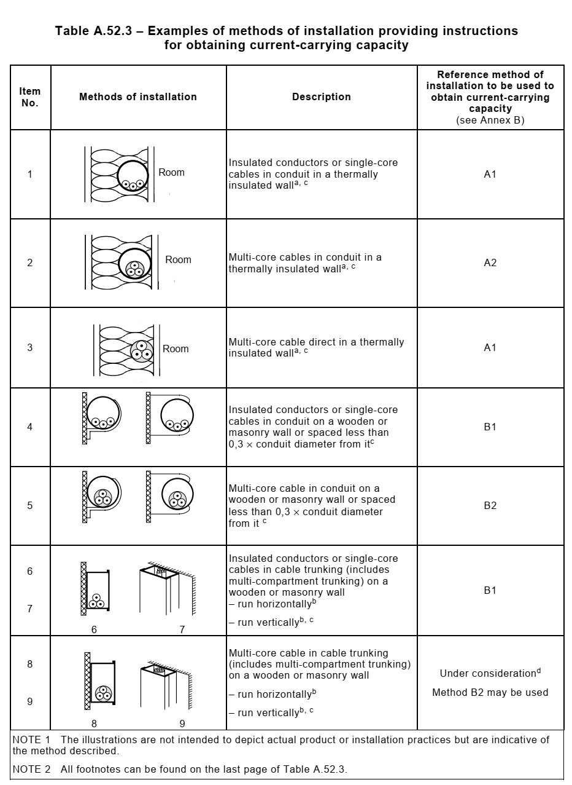

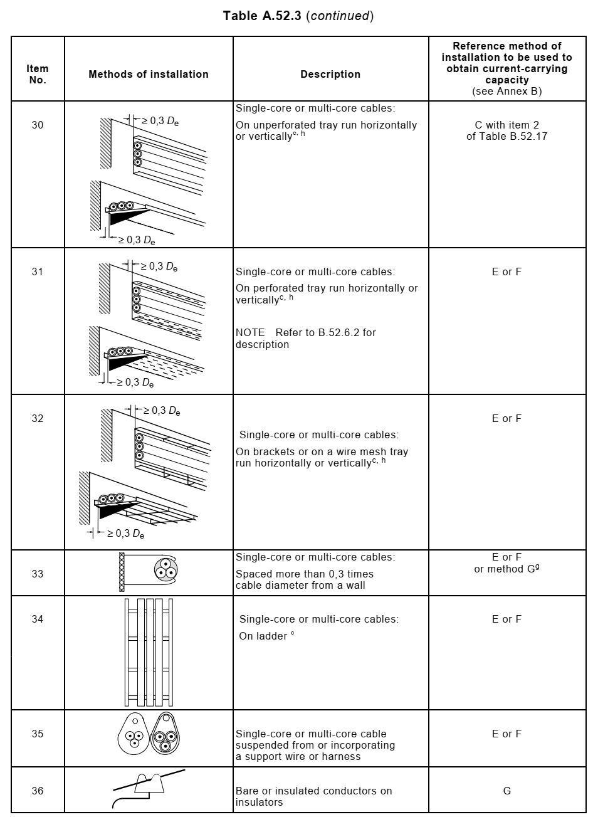

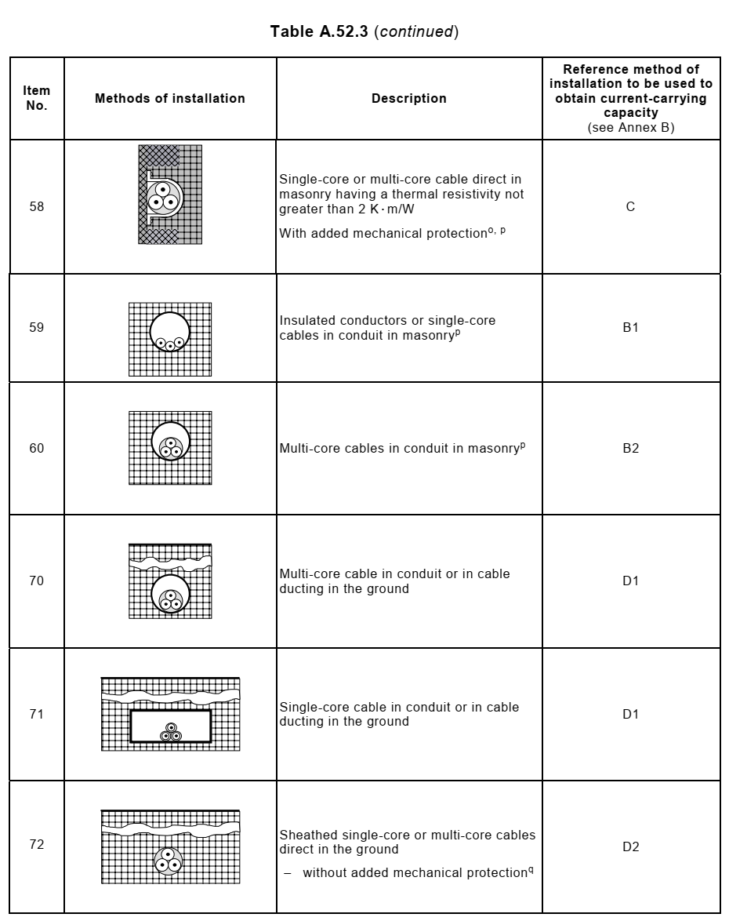

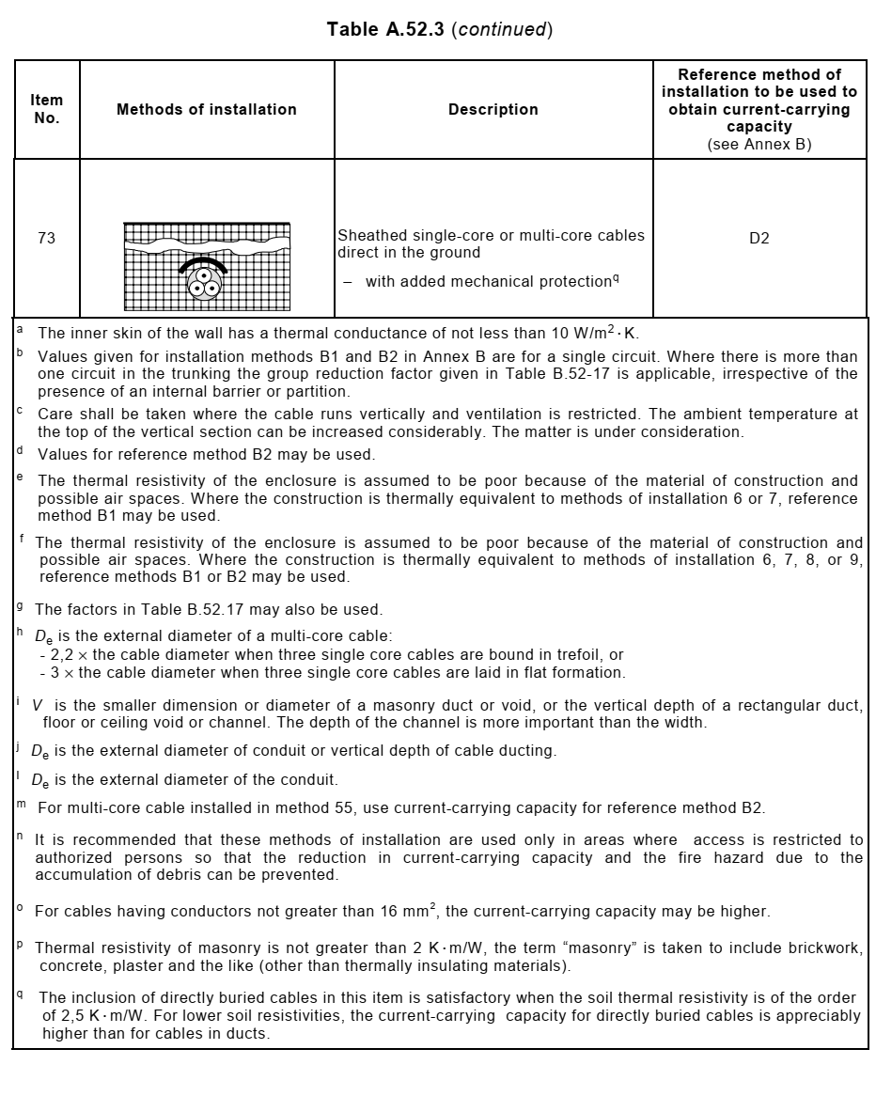

Items 72/73 of this Table corresponds to direct burial installation of cables and item 70 corresponds to installation of cables in sleeves in the duct banks. Underground installation of cables inside buildings shall be in cable ladders inside concrete trenches or false floors. In this case installation method E or F will be applicable.

1. **Cable sizing criteria**

The cables will be sized with the following design criteria:

* Current rating
* Voltage drop
* Short circuit capacity
* IPS standard

All HV/MV/LV distribution feeders, DC and UPS service cables will be individually sized. Cable current ratings and impedances are taken from typical standard data, as referred in section 12.

They are applicable for a specific ground thermal resistance of 2.5 K.m/W, for a soil temperature of 20°C and for laying at a depth of 0.6m to 1m. These ratings are based on Iranian manufactures, with the application of correction factors for different ground temperature and cables laying and grouping. The tables shall be superseded by actual ratings of the cables for this project after vendor data received.

Cable sizes will be rationalized in order to reduce the number of different cable types and sizes on the project.

1. **Cable sizing procedure**

In this section sizing procedure for each criterion mentioned will be studied. Examples are only for illustration of calculation method and current carrying capacities and impedance data that are given in tables can be used in the absence of manufacturers’ data.

## Current Carrying Capacity

* Underground Installation

Current carrying-capacity shall be greater than the full load current divided by de-rating factor “f”.

Where:

f = f1 x f2 x f3 x f4 (1)

In which

f: Overall de-rating factor

f1: De-rating factor for different ambient ground temperature other than 35°C

f2: De-rating factor for different soil thermal resistivity other than 2.5 K.m/W

f3: De-rating factor for different typical installation (Grouping factor)

f4: De-rating factor for depths of laying other than 1m for direct buried cables

Note: Reference tables for coefficients f1 to f4 are referred in section 11 based on related standards for LV and MV cables, separately.

* Aboveground Installation

Current carrying-capacity shall be greater than the full load current divided by de-rating factor “f”.

Where:

f = f1 x f2 (2)

In which

f : Overall de-rating factor

f1: De-rating factor for different ambient air temperature other than 35°C

f2: De-rating factor for different typical installation (Grouping factor)

Note: Reference tables for coefficients f1 and f2 are referred in section 11 based on related standards for LV and MV cables, separately.

## Voltage Drop

Voltage drop will be calculated by following equations

$∆u=\frac{\sqrt{3}×LI×(RCos∅+XSin∅)}{U_{N}}×100$ (3) (For 3 Phase System)

$∆u=\frac{2×LI×(RCos∅+XSin∅)}{U_{N}}×100$ (4) (For 1 Phase System)

$∆u=\frac{2×LIR}{U_{N}}×100$ (5) (For direct current System)

Where

$∆u$: Voltage Drop [%]

$I$: Rated Current [A]

$L$: Length of Cable [km]

$R$: Unit Length Resistance [Ω/km]

$X$: Unit Length Reactance [Ω/km]

$U_{N}$: Nominal Voltage [V]

$Cos$: Power Factor

For motor starting conditions voltage drop calculation, power factor will be considered as IPS-E-EL-100 recommendation where no exact manufacturer data’s present.

The electrical power system shall be designed to limit voltage drop (based on nominal voltage) in the feeder cables to the following values:

Feeders to transformers: 1%

Feeders to switchboards: 1%

Power source to panel board: 2%

MV Motor branch circuits: 3.25% at full load

LV Motor branch circuits: 5% at full load

Lighting circuits:

* 3% between lighting panel board and the most distant fixture
* 2% between 400V switchgear and lighting panel board

The maximum voltage drop in the motor feeder cable during motor starting shall be limited to 15% of the nominal voltage.

## Short Circuit Capacity

Based on IEC 60724, the following formula will be used to calculate the minimum required cross section of cores, to restrict temperature rise below 250°C for XLPE and 160°C for PVC.

$S_{min}=\frac{I_{sc}×\sqrt{T_{P}}}{K_{sc}}$ (6)

Where:

$S_{min}$: Minimum Required Cross Section of Cores

$I_{sc}$: Short Circuit Current

$T_{P}$: is the duration in seconds and shall consist of circuit breaker breaking time, Backup Protection relays operating time including lock-out relay, Tolerance of operating time of relay and circuit breaker

$K_{sc}$: Constant depending on initial temperature, final temperature and material of conductor insulation. This factor is obtained from following formula

$K_{sc}=K×\sqrt{\log_{e}{\frac{(T_{f}+β)}{(T_{i}+β)}}}$ (7)

Where:

$K$: Constant for the material of the conductor

$T_{f}$: Final Temperature (°C).

$T_{i}$: Initial Temperature (°C).

$β$: Reciprocal of the temperature coefficient of resistance (α) of the conductor

Per degree Celsius at 0°C)

$T_{f}$ is equal to 250°C for XLPE and 160°C for PVC as well as Ti is equal to 90°C for XLPE and 70°C for PVC. $K$& $β$ are obtained from table below:

|  |  |  |
| --- | --- | --- |
| Conductor Material Specification | | |
| **Material** | **k** | **β** |
| Copper | 226 | 234.5 |
| Aluminium | 148 | 228 |

Therefore $K_{sc}$ is 115 for PVC insulated copper wire and 143 for XLPE insulated copper wire.

When cable’s protected by fuse, the following formula can be used instead:

$S_{min}=\frac{\sqrt{I^{2}×t}}{K_{sc}}$ (8)

Where $I^{2}t$ is let through energy of fuse, and shall be considered from fuse manufacturer’s curves.

1. **Short circuit calculation**

## Minimum Cable Size for MV Feeder

|  |  |  |
| --- | --- | --- |
| **33, 11 & 3.3 KV Cable** | | |
| **Voltage Bus Connected** | **Momentary Fault Current RMS (KA) (“I”)** | **Clearing Time(S)** |
| 33 & 11 KV Feeder (Incoming) | 25 | 0.5 |
| 33 &11 KV Feeder (Outgoing) | 25 | 0.3 |

According to Standard IEEE 242 ITEM 7.2.7, the maximum capability of a circuit breaker to withstand the effects of short circuit flow for a stated period, typically 0.5 s or less without opening.

According to IPS-E-EL-100(1) ITEM 7.7.2.3, for medium voltage power cables controlled by circuit breaker, the minimum fault clearance time shall be considered 0.3 seconds.

Considering the above, minimum cable size is obtained from the following formula:

**For incoming feeder**: S = √t x I / k = √0.5 x 25 / 143 ~ 120 mm2

Therefore, the minimum cable size for 33, 11 kV incoming feeders shall be 120 mm2 which are next largest cable sizes in consideration of above calculation.

**For 33, 11 & 3.3 KV outgoing feeder**: S = √t x I / k = √0.3 x 25 / 143 ~ 95 mm2

Therefore, the minimum cable size for 11 kV outgoing feeders shall be 95 mm2 which are next largest cable sizes in consideration of above calculation.

Additionally, since fault current for outgoing feeders with HRC fuse contactor shall be cleared immediately, minimum cable size for these feeders shall be considered 50 mm2 for motors.

## Minimum Cable Size for LV Feeder (0.4 KV)

For 0.4kV incoming feeders (with ACB): S =√t x I/ k=√0.5 x 25 / 143 ~ 120 mm2

For 0.4kV outgoing feeders (with ACB): S =√t x I/k=√0.25 x 25 / 143 ~ 95 mm2

Therefore, the minimum cable size for LV ACB type incoming and outgoing feeders shall be respectively 120 mm2 and 95 mm2 which are next largest cable sizes in consideration of above calculation.

1. **De-Rating factor calculation**

## De-Rating Factor for MV Cables

For XLPE Insulation (in 48 °C air temperature and 35°C soil temperature with 2.5 K.w/m soil thermal resistivity), Current carrying capacity for MV cables are as follows based on IEC60502-2 Table B.2 and B6:

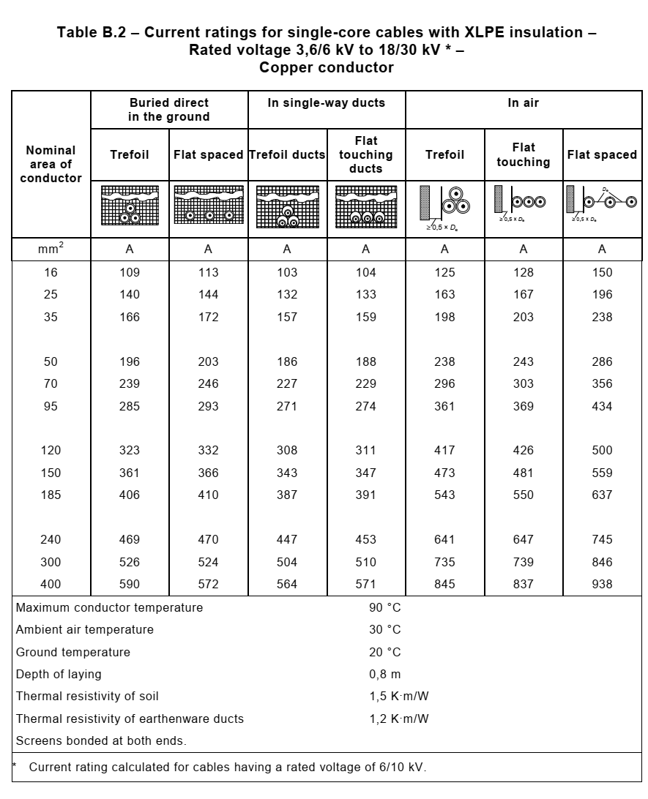

According to page 50 of Attachment 1.

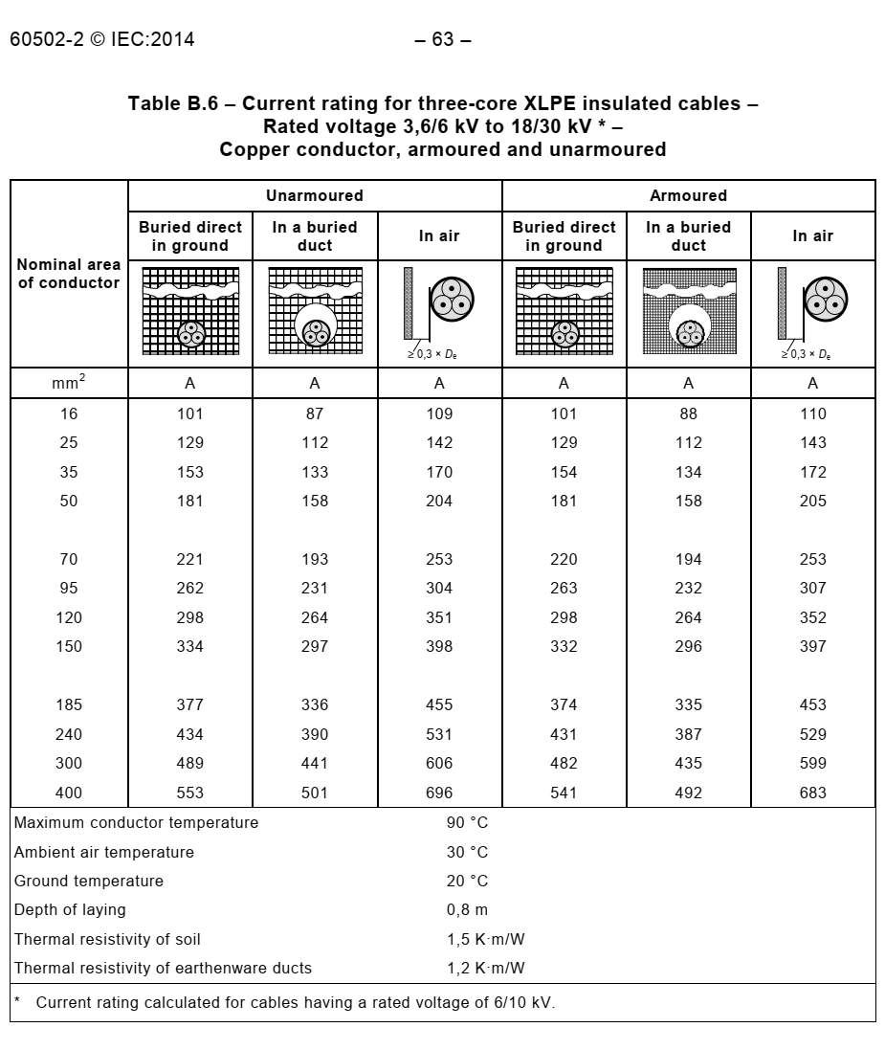

According to page 54 of Attachment 1.

## De-Rating Factor for MV Cables in Air

According to section 9.1, coefficient f1 & f2 will be Calculated According to IEC 60502-2 Table B.10 and B.22 & B.23 respectively for XLPE (in 48 °C air temperature and 20°C soil temperature with 2.5 K.w/m soil thermal resistivity),

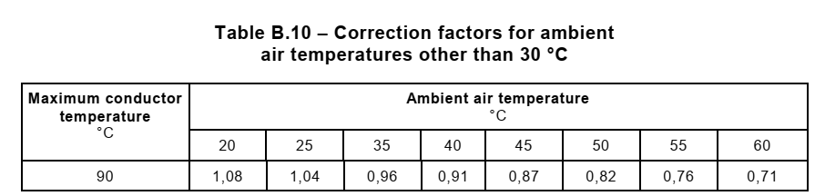

According to table 8 of page 56 of Attachment 1

According to Linear Interpolation ambient air correction factor will be:

$y-y_{1}=( \frac{y_{1}-y_{2}}{x_{1}-x_{2}})(x-x_{1})$

$y-0.82=( \frac{0.82-0.87}{50-45})(48-50)$ (9)

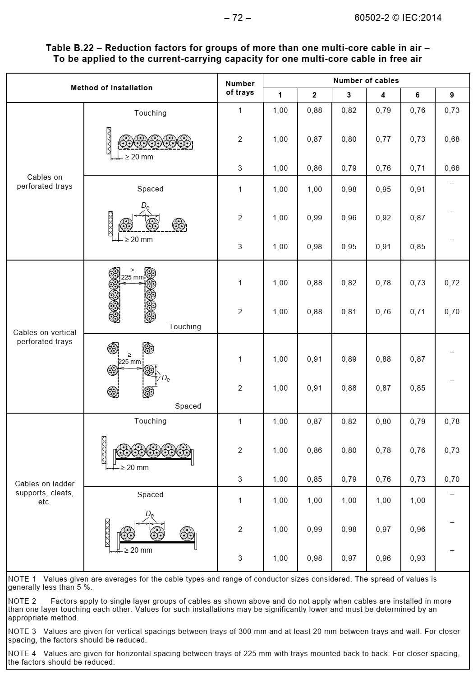

According to table 20 of page 62 of Attachment 1.

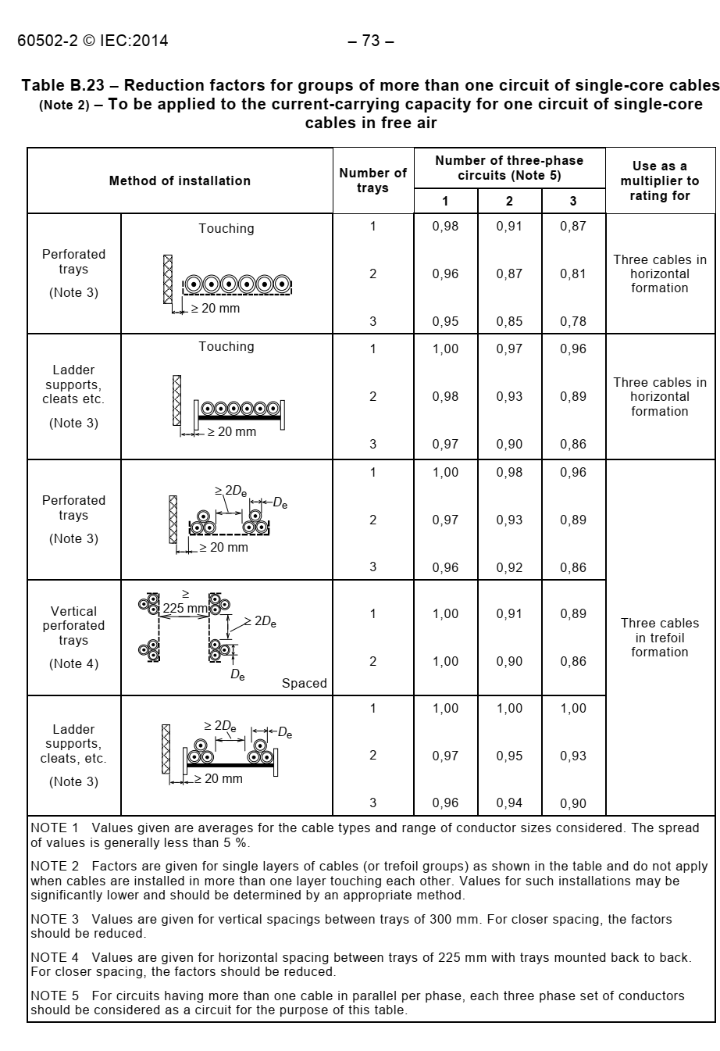

According to table 21 of page 63 of Attachment 1.

|  |  |  |  |  |
| --- | --- | --- | --- | --- |
| MV Above  Ground Cable | Multi Core | Air Temperature Table B.10 of IEC 60502-2 | f1 | 0.84 |
| Grouping cable Table B.22 of IEC 60502-2 | f2 | 0.73 |
| Result | f1×f2 | 0.61 |
| Single Core | Air Temperature Table B.10 of IEC 60502-2 | f1 | 0.84 |
| Grouping cable Table B.23 of IEC 60502-2 | f2 | 0.86 |
| Result | f1×f2 | 0.72 |

According to formula (9), f1 is 0.84. Grouping factor (f2) will be achieved based on touching cables on ladders & 3 number of cables.

## De-Rating Factor for MV Cables in Ground

According to section 8.1, coefficient f1, f2, f3 & f4 will be Calculate According to IEC 60502-2 Table B.11 and B.22 & 23 respectively:

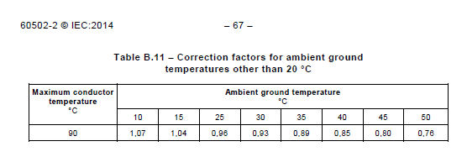

According to table 9 of page 56 of Attachment 1

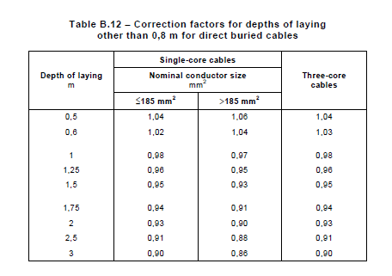

According to table 10 of page 56 of Attachment 1

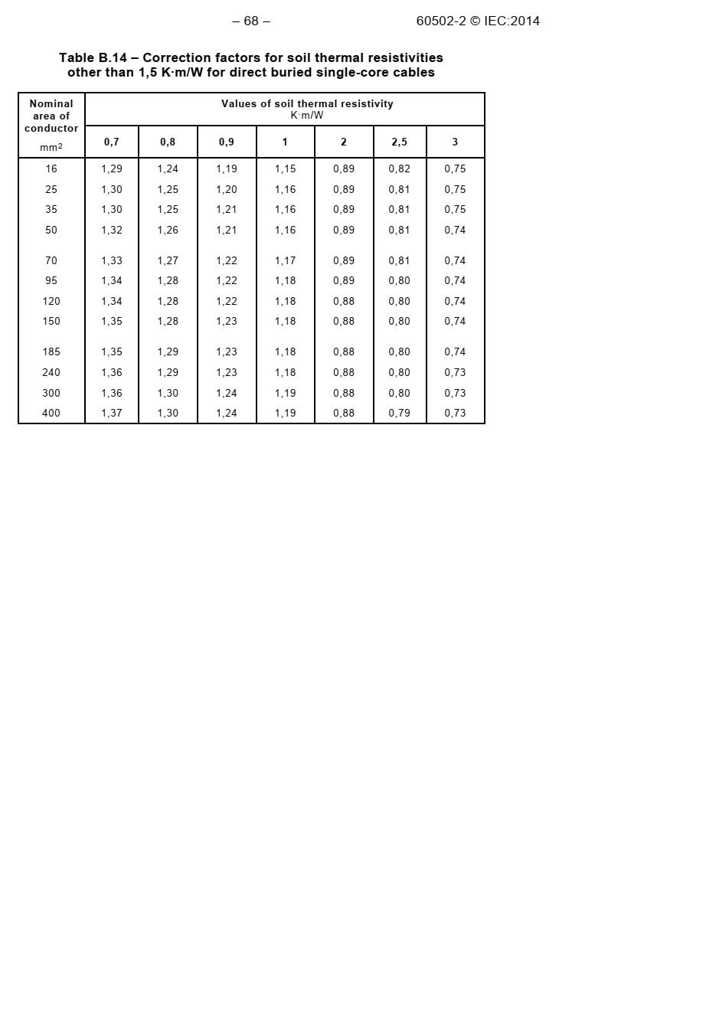

According to table 12 of page 57 of Attachment 1

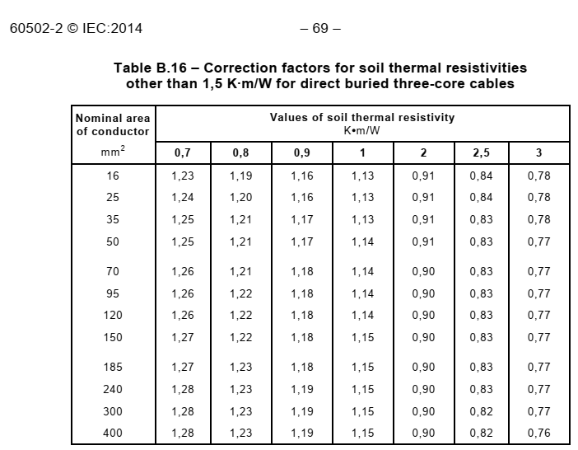

According to table 14 of page 58 of Attachment 1

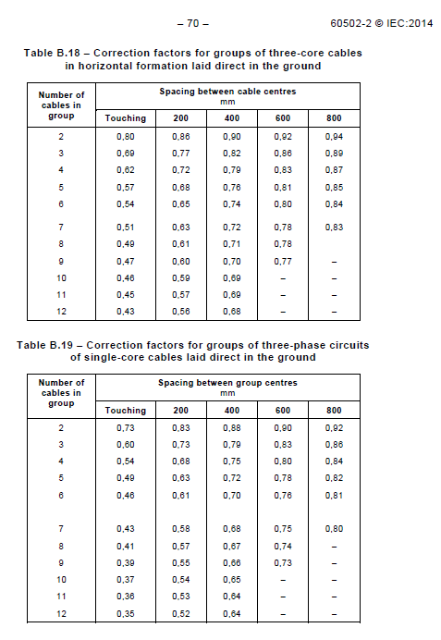

According to table 16 & 17 of page 60 of Attachment 1

| MV Under  Ground Cable | Items | De-rates | Three core | Single core |
| --- | --- | --- | --- | --- |
| Soil Temperature Table B.11 of IEC 60502-2 | f1 | 0.89 | 0.89 |
| Soil thermal resistivity Table B.16 (3 core)  Table B.14 (1 core) of IEC 60502-2 | f2 | 0.83 | 0.8 |
| Grouping of cables Table B.18 (3 core)  Table B.19 (1 core) of IEC 60502-2 | f3 | 0.77 | 0.73 |
| Depth of laying cables  Table B.12 of IEC 60502-2 | f4 | 0.98 | 0.98 |
| Result  Multiple of above values | f1×f2×f3×f4 | 0.56 | 0.5 |

Grouping factor (f3) is based on 3 number of cable with minimum distance 15 cm based on typical drawing as per IPS standard.

## De-Rating Factor for LV Cables In Air

According to section 8.1, coefficient f1 & f2 will be Calculate According to IEC 60364-5-52:

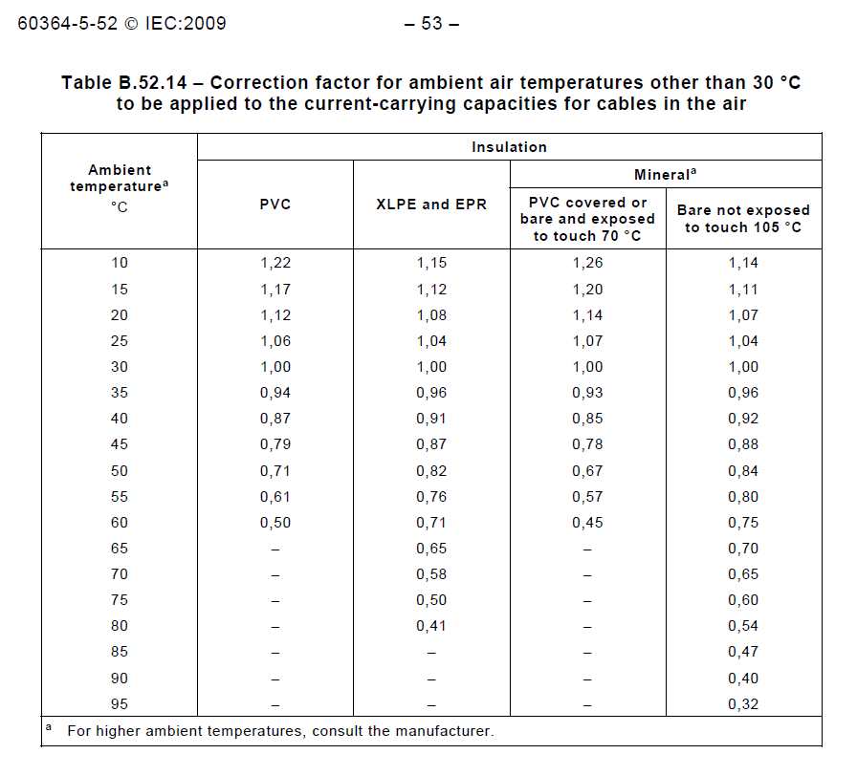

According to table 9 of page 110 of Attachment 2

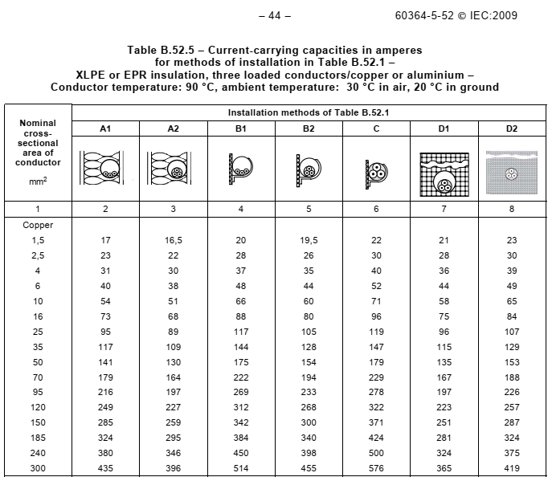

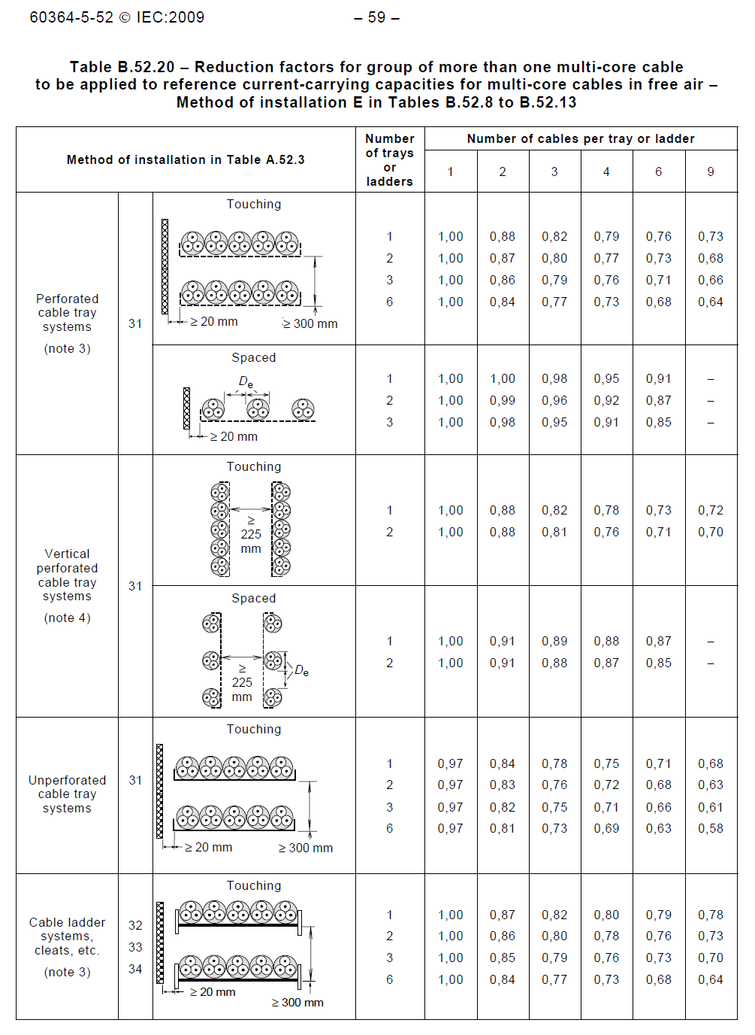

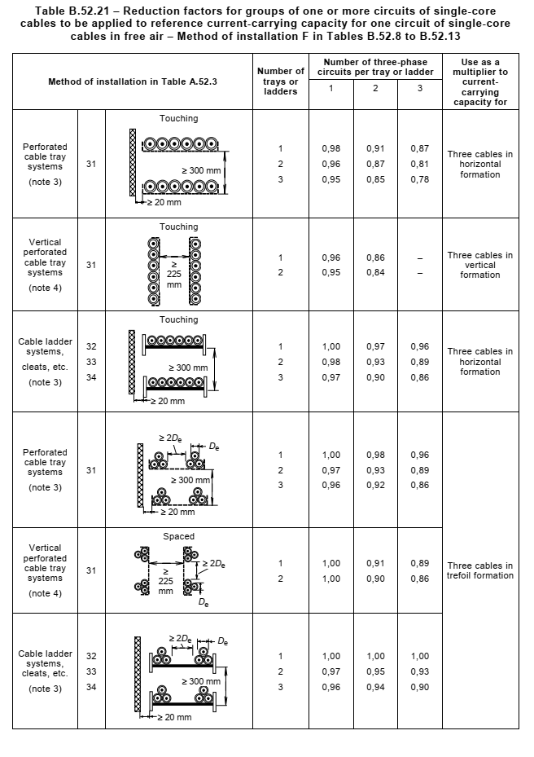

According to table 16 of page 116 of Attachment 2.

|  |  |  |  |  |  |
| --- | --- | --- | --- | --- | --- |
| LV Above  Ground Cable  (In Air) | Cable Type | Verified Tables | De-rate | XLPE | PVC |
| Multi Core | Air Temperature Table B.52-14 of IEC 60364 | f1 | 0.84 | 0.74 |
| Grouping cable Table B.52-20 of IEC 60364 | f2 | 0.73 | 0.73 |
| Result | f1×f2 | 0.61 | 0.54 |
| Single Core | Air Temperature Table B.52-14 of IEC 60364 | f1 | 0.84 | 0.74 |
| Grouping cable Table B.52-21 of IEC 60364 | f2 | 0.86 | 0.86 |
| Result | f1×f2 | 0.72 | 0.63 |

F1: According to table B.52-14 & based on linear interpolation, 0.84 & 0.74 derived for XLPE & PVC cable.

F2: According to table B.52-20, derating factor for 6 number of cables in 3 layer ladder is 0.73 for multi core while this factor is 0.86 for single core cable based on B.52-21 table.

## De-Rating Factor for Underground LV Cables

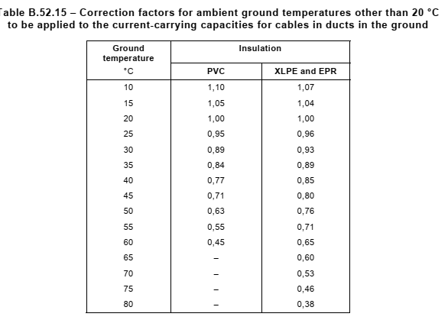

According to table 10 of page 111 of Attachment 2

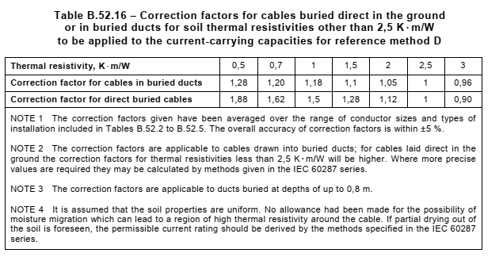

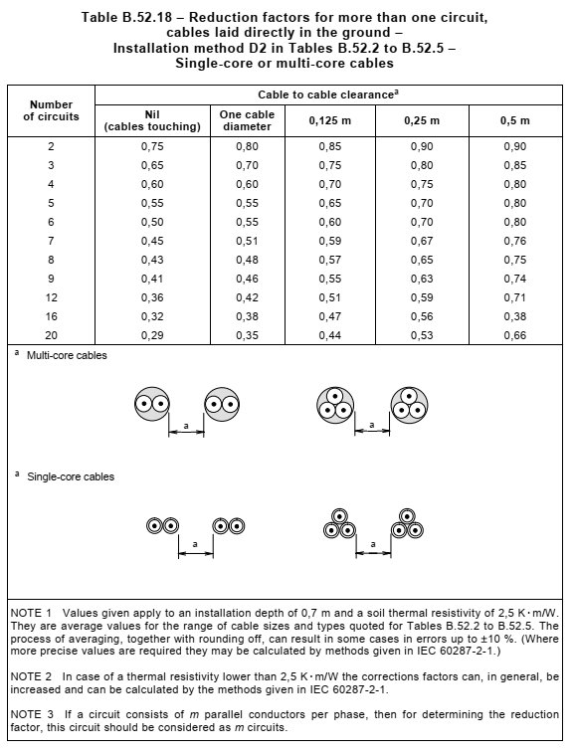

According to table 13 of page 113 of Attachment 2

| LV Under  Ground Cable | Verified Tables | De-rates | XLPE | PVC |
| --- | --- | --- | --- | --- |
| Soil Temperature Table B.52.15 of IEC 60364-5-52 | f1 | 0.89 | 0.89 |
| Soil thermal resistivity Table B.52.16 | f2 | 1 | 1 |
| Grouping of cables Table B.52.18 | f3 | 0.6 | 0.6 |
| Depth of laying cables  Table B.12 of IEC 60502-2 | f4 | 0.98 | 0.98 |
| Result  Multiple of above values | f1×f2×f3×f4 | 0.52 | 0.52 |

F1: According to table B.52-15 & soil temperature 35 0C, F1 will be 0.89.

F2: this factor is 1 based on table B.52.16

F3 is 0.6 based on table B.52-18 for 6 number of circuit with one .125m distance.

F4; depth of laying is 1 meter.

1. **CABLE RESISTANCE**

| Cable Resistance | | | | |
| --- | --- | --- | --- | --- |
|  | XLPE | | PVC | |
| X-Section | 1 Core | 3 Core | 1 Core | 3 Core |
| 1.5 | - | 15.43+j0.103 | - | - |
| 2.5 | - | 9.45+j0.095 | - | - |
| 4 | - | 5.88+j0.09 | - | - |
| 6 | - | 3.93+j0.087 | - | - |
| 10 | - | 2.33+j0.083 | - | - |
| 16 | 1.47+j.261 | 1.47+j0.081 | 1.38+j0.146 | 1.38+j0.087 |
| 25 | 0.927+j0.248 | 0.927+j0.081 | 0.87+j0.137 | 0.87+j0.086 |
| 35 | 0.668+j0.239 | 0.669+j0.079 | 0.627+j0.131 | 0.627+j0.083 |
| 50 | 0.494+j0.227 | 0.494+j0.075 | 0.463+j0.123 | 0.464+j0.08 |
| 70 | 0.342+j0.217 | 0.343+j0.075 | 0.321+j0.116 | 0.322+j0.078 |
| 95 | 0.247+j0.208 | 0.247+j0.072 | 0.232+j0.111 | 0.232+j0.077 |
| 120 | 0.196+j0.201 | 0.197+j0.072 | 0.184+j0.107 | 0.185+j0.075 |
| 150 | 0.159+j0.196 | 0.16+j0.072 | 0.15+j0.104 | 0.15+j0.075 |
| 185 | 0.1278+j0.19 | 0.129+j0.072 | 0.12+j0.102 | 0.1212+j0.075 |
| 240 | 0.098+j0.183 | 0.099+j0.071 | 0.092+j0.099 | 0.093+j0.074 |
| 300 | 0.0792+j0.178 | 0.081+j0.071 | 0.074+j0.097 | 0.076+j0.074 |
| 400 | 0.0632+j0.171 | - | 0.059+j0.095 | - |

1. **CAble sizing Example**

## Gas Compressor C-2101

1. **Current Capacity**

According to load list (BK-GCS-PEDCO-120-EL-LI-0001), the rated power of each C-2101 is 1250 kw:

Rated Power: 1250 kw

Voltage: 11 kv

Power Factor: 0.77

Efficiency: 0.95

$$I_{l}=\frac{1250}{\sqrt{3}×11×0.77}=89.7 A$$

Since this cable is buried, it is considered as an under-ground cable which the de-rating factor is specified above and being 0.72. Therefore the rating current will be:

According to ABHAR catalogue, in page 54 of attachment 1, the minimum size is 3Cx70 mm2 with 154A current-carrying capacity for compressor but based on section 8.3, the minimum cross section will be 3Cx95 mm2 .

1. **Voltage Drop at Normal Operation**

According to section 8.2, voltage drop for MV motor shall be lower than 3.25%. So the minimum cable size that satisfied this condition is derived from equation (3), maximum cable length 250m and Cosφ =0.77 (Sin φ =0.64):

$Δu=\frac{\sqrt{3}LI(RCosϕ+XSinϕ)}{U_{N}}×100=\frac{\sqrt{3}×0.25×89.7×(0.247×0.77+0.105×0.64)}{11×10^{3}}×100=0.09 \%<3.25 \%$

1. **Voltage Drop at Starting**

According to section 8.2, voltage drop for MV motor at starting shall be lower than 15%. So the minimum cable size that satisfied this condition is derived from equation (3), maximum cable length 250m and Cosφ =0.4 (Sin φ =0.91):

$Δu=\frac{\sqrt{3}LI(RCosϕ+XSinϕ)}{U_{N}}×100=\frac{\sqrt{3}×0.25×6×89.7×(0.247×0.4+0.105×0.91)}{11×10^{3}}×100=0.41 \%<15 \%$

So, the cable size, 3Cx95 mm2, can sufficiently be used for this feeder.

## LV Transformer “GCS-TR-001” Primary Side

1. **Current Capacity**

$S=1250 KVA$

$V=11 KV$

$PF=0.8$

$$I_{l}=\frac{S}{\sqrt{3}×V}=\frac{1250}{\sqrt{3}×11}=65.6 A$$

Since this cable is buried, it is considered as an under-ground cable which the de-rating factor is specified above and being 0.72. Therefore the rating current will be:

According to ABHAR catalogue, in page 54 of attachment 1, the minimum size is 3Cx50 mm2 with 130A current-carrying capacity for transformer but based on section 8.3, the minimum cross section will be 3Cx95 mm2.

1. **Voltage Drop**

According to section 8.2, voltage drop for LV transformer shall be lower than 1%. So the minimum cable size that satisfied this condition is derived from equation (3), maximum cable length 250m and Cosφ =0.8 (Sin φ =0.6):

$Δu=\frac{\sqrt{3}LI(RCosϕ+XSinϕ)}{U_{N}}×100=\frac{\sqrt{3}×0.1×65.6×(0.247×0.8+0.105×0.6)}{11×10^{3}}×100=0.03 \%<1 \%$

So, the cable size, 3Cx95 mm2, can sufficiently be used for this feeder.

## LV Transformer “GCS-TR-001” Secondary Side

1. **Current Capacity**

$S=1250 KVA$

$V=0.4 KV$

$PF=0.8$

$$I_{l}=\frac{S50}{\sqrt{3}×V}=\frac{1250}{\sqrt{3}×0.4}=1804 A$$

Since this cable is aboveground, the de-rating factor is specified 0.72. Therefore the rating current will be:

$$I_{r}=\frac{I_{l}}{f_{UG_{LV}}}=\frac{1804}{0.72}=2505 A$$

According to ABHAR catalogue, in page 108 of attachment 2, the minimum size is 4x1Cx400 mm2 with 2505A current-carrying capacity for transformer is sufficient.

1. **Voltage Drop**

According to section 8.2, voltage drop for LV transformer shall be lower than 1%. So the minimum cable size that satisfied this condition is derived from equation (3), maximum cable length 20m and Cosφ =0.8 (Sin φ =0.6):

$Δu=\frac{\sqrt{3}LI(RCosϕ+XSinϕ)}{U_{N}}×100=\frac{\sqrt{3}×0.02×1804×(0..0158×0.8+0.105×0.023)}{11×10^{3}}×100<1 \%$

According to above calculation, the cables for secondary side of LV transformer will be 14x1Cx400.