|  |  |  |  |  |  |  |  |
| --- | --- | --- | --- | --- | --- | --- | --- |
| **طرح نگهداشت و افزایش تولید 27 مخزن** | | | | | | | |
| **CALCULATION REPORT FOR GAS COMPRESSORS SHELTER**  **نگهداشت و افزایش تولید میدان نفتی بینک** | | | | | | | |
|  | |  |  |  |  |  |  |
|  | |  |  |  |  |  |  |
|  | |  |  |  |  |  |  |
|  | |  |  |  |  |  |  |
| D00 | | JUL. 2022 | IFC | R.Berlouie | M.Fakharian | M.Mehrshad |  |
| **Rev.** | | **Date** | **Purpose of Issue/Status** | **Prepared by:** | **Checked by:** | **Approved by:** | **CLIENT Approval** |
| **Class:2** | | | **CLIENT Doc. Number:F0Z-709119** | | | | |
| **Status:** | | **IDC: Inter-Discipline Check**  **IFC: Issued For Comment**  **IFA: Issued For Approval**  **AFD: Approved For Design**  **AFC: Approved For Construction**  **AFP: Approved For Purchase**  **AFQ:** Approved For Quotation  **IFI: Issued For Information**  **AB-R: As-Built for CLIENT Review**  **AB-A: As-Built –Approved** | | | | | |

**REVISION RECORD SHEET**

|  |  |  |  |  |  |  |  |  |  |  |  |  |
| --- | --- | --- | --- | --- | --- | --- | --- | --- | --- | --- | --- | --- |
| **PAGE** | **D00** | **D01** | **D02** | **D03** | **D04** |  | **PAGE** | **D00** | **D01** | **D02** | **D03** | **D04** |
| **1** | X |  |  |  |  | **66** |  |  |  |  |  |
| **2** | X |  |  |  |  | **67** |  |  |  |  |  |
| **3** | X |  |  |  |  | **68** |  |  |  |  |  |
| **4** | X |  |  |  |  | **69** |  |  |  |  |  |
| **5** | X |  |  |  |  | **70** |  |  |  |  |  |
| **6** | X |  |  |  |  | **71** |  |  |  |  |  |
| **7** | X |  |  |  |  | **72** |  |  |  |  |  |
| **8** | X |  |  |  |  | **73** |  |  |  |  |  |
| **9** | X |  |  |  |  | **74** |  |  |  |  |  |
| **10** | X |  |  |  |  | **75** |  |  |  |  |  |
| **11** | X |  |  |  |  | **76** |  |  |  |  |  |
| **12** | X |  |  |  |  | **77** |  |  |  |  |  |
| **13** | X |  |  |  |  | **78** |  |  |  |  |  |
| **14** | X |  |  |  |  | **79** |  |  |  |  |  |
| **15** | X |  |  |  |  | **80** |  |  |  |  |  |
| **16** | X |  |  |  |  | **81** |  |  |  |  |  |
| **17** | X |  |  |  |  | **82** |  |  |  |  |  |
| **18** | X |  |  |  |  | **83** |  |  |  |  |  |
| **19** | X |  |  |  |  | **84** |  |  |  |  |  |
| **20** | X |  |  |  |  | **85** |  |  |  |  |  |
| **21** | X |  |  |  |  | **86** |  |  |  |  |  |
| **22** | X |  |  |  |  | **87** |  |  |  |  |  |
| **23** | X |  |  |  |  | **88** |  |  |  |  |  |
| **24** | X |  |  |  |  | **89** |  |  |  |  |  |
| **25** | X |  |  |  |  | **90** |  |  |  |  |  |
| **26** | X |  |  |  |  | **91** |  |  |  |  |  |
| **27** | X |  |  |  |  | **92** |  |  |  |  |  |
| **28** | X |  |  |  |  | **93** |  |  |  |  |  |
| **29** | X |  |  |  |  | **94** |  |  |  |  |  |
| **30** | X |  |  |  |  | **95** |  |  |  |  |  |
| **31** | X |  |  |  |  | **96** |  |  |  |  |  |
| **32** | X |  |  |  |  | **97** |  |  |  |  |  |
| **33** | X |  |  |  |  | **98** |  |  |  |  |  |
| **34** | X |  |  |  |  | **99** |  |  |  |  |  |
| **35** | X |  |  |  |  | **100** |  |  |  |  |  |
| **36** | X |  |  |  |  | **101** |  |  |  |  |  |
| **37** |  |  |  |  |  | **102** |  |  |  |  |  |
| **38** |  |  |  |  |  | **103** |  |  |  |  |  |
| **39** |  |  |  |  |  | **104** |  |  |  |  |  |
| **40** |  |  |  |  |  | **105** |  |  |  |  |  |
| **41** |  |  |  |  |  | **106** |  |  |  |  |  |
| **42** |  |  |  |  |  | **107** |  |  |  |  |  |
| **43** |  |  |  |  |  | **108** |  |  |  |  |  |
| **44** |  |  |  |  |  | **109** |  |  |  |  |  |
| **45** |  |  |  |  |  | **110** |  |  |  |  |  |
| **46** |  |  |  |  |  | **111** |  |  |  |  |  |
| **47** |  |  |  |  |  | **112** |  |  |  |  |  |
| **48** |  |  |  |  |  | **113** |  |  |  |  |  |
| **49** |  |  |  |  |  | **114** |  |  |  |  |  |
| **50** |  |  |  |  |  | **115** |  |  |  |  |  |
| **51** |  |  |  |  |  | **116** |  |  |  |  |  |
| **52** |  |  |  |  |  | **117** |  |  |  |  |  |
| **53** |  |  |  |  |  | **118** |  |  |  |  |  |
| **54** |  |  |  |  |  | **119** |  |  |  |  |  |
| **55** |  |  |  |  |  | **120** |  |  |  |  |  |
| **56** |  |  |  |  |  | **121** |  |  |  |  |  |
| **57** |  |  |  |  |  | **122** |  |  |  |  |  |
| **58** |  |  |  |  |  | **123** |  |  |  |  |  |
| **59** |  |  |  |  |  | **124** |  |  |  |  |  |
| **60** |  |  |  |  |  | **125** |  |  |  |  |  |
| **61** |  |  |  |  |  | **126** |  |  |  |  |  |
| **62** |  |  |  |  |  | **127** |  |  |  |  |  |
| **63** |  |  |  |  |  | **128** |  |  |  |  |  |
| **64** |  |  |  |  |  | **129** |  |  |  |  |  |
| **65** |  |  |  |  |  | **130** |  |  |  |  |  |

**CONTENTS**

1.0 INTRODUCTION 4

2.0 Scope 4

3.0 NORMATIVE REFERENCES 5

3.1 Local Codes and Standards 5

3.2 International Codes and Standards 5

3.3 The Project Documents 5

3.4 ENVIRONMENTAL DATA 5

3.5 Order of Precedence 5

4.0 Material properties 6

5.0 STRUCTURE ‘s systems 6

6.0 INPUT DATA 6

**6.1** **DESIGN LOAD** 6

6.1.1. Dead load 6

6.1.2. LIVE loadS 7

6.1.3. SNOW LOADS 8

6.1.4. SEISMIC LOADS 11

6.1.5. wind LOADS 13

6.1.6. CRAINE LOADS 22

**6.2** **SAP loading table** 23

7.0 STRUCTURE ANALYSIS AND DESIGN 25

7.1 ANALYSIS 25

**7.2** **Control of Columns Required Axial Strength** 26

8.0 Structural Design Results 26

**8.1** **Graphical output** 26

**8.2** **DRIFT CONTROL** 27

9.0 Structural connections 28

**9.1** **Special Moment Frame** 28

- **Beam to column** 28

28

**9.2** **Description of Design Procedure & Parameters** 29

**9.3** **cONNECTION FORCE CALCULATION:** 31

**9.4** **BEAM SPECIFICATION:** 31

**9.5** **end plate thickness calculation:** 31

10.0 purlin design 32

**10.1** **SOIL PRESSURE** 32

11.0 foundation design 33

**11.1** **SOIL PRESSURE** 33

**11.2** **DESIGN** 34

**11.3** **FOUNDATION DESIGN CONTROL** 34

1. **INTRODUCTION**

Binak oilfield in Bushehr province is a part of the southern oilfields of Iran, is located 20 km northwest of Genaveh city.

With the aim of increasing production of oil from Binak oilfield, an EPC/EPD Project has been defined by NIOC/NISOC and awarded to Petro Iran Development Company (PEDCO). Also PEDCO (as General Contractor) has assigned the EPC-packages of the Project to "Hirgan Energy - Design and Inspection" JV.

**GENERAL DEFINITION**

The following terms shall be used in this document.

|  |  |
| --- | --- |
| CLIENT: | National Iranian South Oilfields Company (NISOC) |
| PROJECT: | Binak Oilfield Development – Surface Fcilities; New Gas Compressor Station |
| EPD/EPC CONTRACTOR (GC): | Petro Iran Development Company (PEDCO) |
| EPC CONTRACTOR: | Joint Venture of : Hirgan Energy – Design & Inspection (D&I) Companies |
| VENDOR: | The firm or person who will fabricate the equipment or material. |
| EXECUTOR: | Executor is the party which carries out all or part of construction and/or commissioning for the project. |
| THIRD PARTY INSPECTOR (TPI): | The firm appointed by EPD/EPC CONTRACTOR (GC) and approved by CLIENT (in writing) for the inspection of goods. |
| SHALL: | Is used where a provision is mandatory. |
| SHOULD: | Is used where a provision is advisory only. |
| WILL: | Is normally used in connection with the action by CLIENT rather than by an EPC/EPD CONTRACTOR, supplier or VENDOR. |
| MAY: | Is used where a provision is completely discretionary. |

1. **Scope**

This report covers the structure calculation report of the “GAS COMPRESSORS SHELTER ”. The structure modelled by “SAP” software & the foundation modelled by “SAFE” software.

1. **NORMATIVE REFERENCES**

## Local Codes and Standards

* INBC Part 6 “Iranian National Building Code
* INBC Part 7 “Iranian National Building Code
* INBC Part 9 “Iranian National Building Code
* INBC Part 10 “Iranian National Building Code
* Iranian Seismic Design Code for Petroleum Facilities(3rd edition)

## International Codes and Standards

* ASCE 7-10 “Minimum Design Loads and Associated Criteria for Buildings and Other Structures-American Society of Civil Engineers”.
* ACI 318. “Building Code Requirements for Reinforced Concrete”, American Concrete Institute.
* AISC 358 “Prequalified Connections for Special and Intermediate Steel Moment Frames for Seismic Applications.” American Institute of Steel Construction, Inc.
* AISC 360 - “Specification for Structural Steel Buildings”. American Institute of Steel Construction, Inc.

## The Project Documents

* BK-GNRAL-PEDCO-000-ST-SP-0001 SPECIFICATION FOR CONCRETE WORK
* BK-GNRAL-PEDCO-000-ST-SP-0003 SPECIFICATION FOR FABRICATION OF STEEL STRUCTURES
* BK-GNRAL-PEDCO-000-ST-SP-0004 SPECIFICATION FOR GROUTING
* BK-GNRAL-PEDCO-000-ST-SP-0005 SPECIFICATION FOR ERECTION OF STEEL STRUCTURES
* BK-GNRAL-PEDCO-000-ST-DW-0002 STANDARD DRAWING FOR ANCHOR BOLTS
* BK-GNRAL-PEDCO-000-ST-DW-0011 GENERAL NOTES-STEEL STRUCTURES
* BK-GNRAL-PEDCO-000-ST-DW-0014 STANDARD DRAWING FOR STRUCTURAL BUILT-UP SECTIONS

## ENVIRONMENTAL DATA

Refer to "Process Basis of Design; Doc. No. -----------------------".

## Order of Precedence

In case of any conflict between the contents of this document or any discrepancy between this document and other project documents or reference standards, this issue must be reported to the CLIENT. The final decision in this situation will be made by CLIENT.

1. **Material properties**

Material properties are delivered in the following table.

|  |  |
| --- | --- |
| Foundation Concrete | F'c = 25 Mpa(28- day cylindrical sample) |
| Long. reinforcement bar | Fy = 400 Mpa(AIII) |
| Trans. reinforcement bar | Fy = 400 Mpa(AIII) |
| Bolt Type | HV 8.8 |
| Electrode Type | E 70 |

1. **STRUCTURE ‘s systems**

The structure’s system is OMF in X direction and OCBF system in Y direction.

Seismic Parameters according to Iranian seismic design code listed at below table.

|  |  |  |  |
| --- | --- | --- | --- |
| dir | R | Omega | cd |
| x | 3.5 | 3 | 3 |
| y | 3.25 | 2 | 3.25 |

1. **INPUT DATA**
   1. **DESIGN LOAD**

### 6.1.1. Dead load

Dead loads include the self-weight of the structure and all the permanent equipment which are supported by the structures

$Corogated sheet :8 kg/m^{2}$ $Z Purlin : 8 kg/m^{2}$ $Insulation :10 kg/m^{2}$

$$\sum{sum= 26 kg/m^{2}}$$

Roof weight is assigned in software 26 kg/m2.

* At ended frame : $26×3=78 kg/m$ At middle frame : $26×6=156 kg/m$

**For wall:** Consider galvanize sheet with weight 8kg/m2 (8 kg/m2 assign to the model)

* At ended frame : $8×3=24 kg/m$ At middle frame : $6×8=48 kg/m$

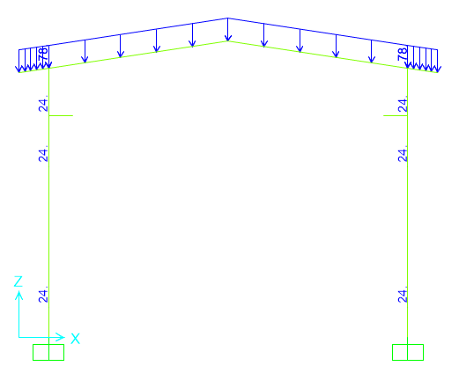 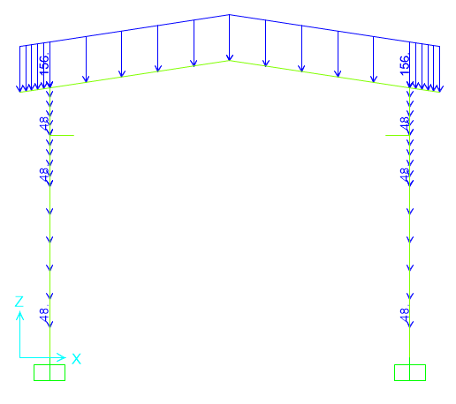

**Figure 1-**applied Dead load on ended axe(1&3&6&8&11&13) (kg/m) **Figure 2-**applied Dead load on middle axe (2&7&12) (kg/m)

### 6.1.2. LIVE loadS

The design live load on an area shall be defined as the weight of all movable loads, including personnel, tools, and parts of dismantled equipment, cranes, hoist, and temporarily stored materials.

According to Iranian National Building code No.6 Live load in light slop roof is 50kg/m2 and assumed 1.3KN concentrated load has been applied at critical frame.

* At ended frame : $3×50=150 kg/m$ At middle frame : $6×50=300 kg/m$

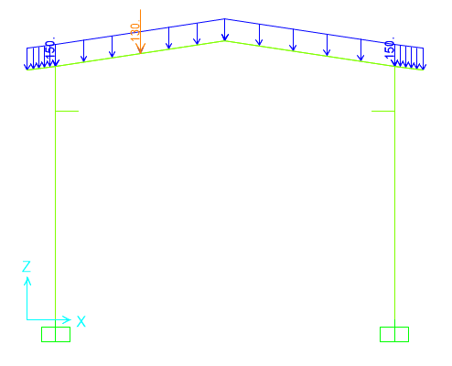 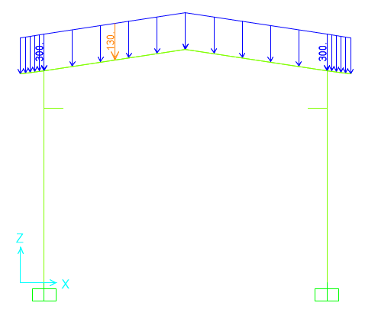

**Figure 3-**Applied live Load on frame (1&3&6&8&11&13)(kg/m) **Figure 4-**Applied live Load on frame (2&7&10)(kg/m)

### 6.1.3. SNOW LOADS

Snow load of this structure is calculated in accordance with Iranian National Building Code No.6 Latest edition.. Parameters which are used in calculation of snow force is presented in below:

Ps=25 kg/m2 Is=1 Cs= 0.91 (slope 15)=1- $\frac{α-α_{0}}{70-α_{0}}=1-\frac{15-10}{70-10}=0.91$

Ch=1 Cn=0.8 $P_{r}=P_{s}C_{n}C_{h}I_{S}C_{s}=16.00\frac{kg}{m2}$

* At ended frame : $3×16=48 kg/m$ At middle frame : $6×48=96 kg/m$

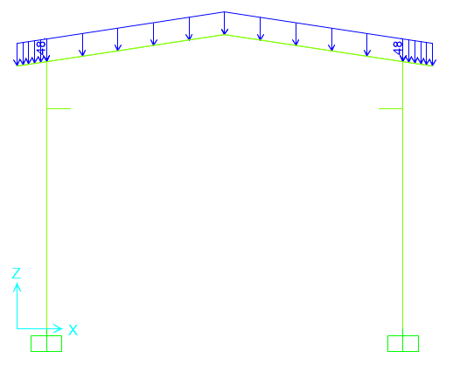 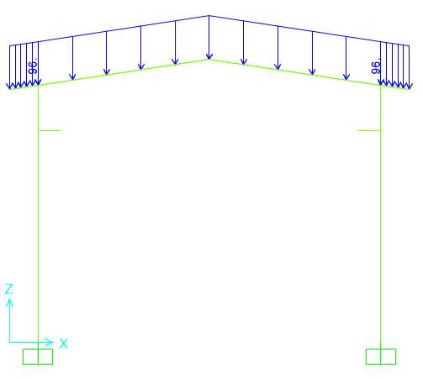

**Figure 5-**Applied Snow Load on frame (1&3&6&8&11&13)(kg/m) **Figure 6-**Applied Snow Load on frame (2&7&10)(kg/m)

**Unbalanced SNOW LOADS**

According to Iranian National Building Code No.6 (latest edition)) Unbalanced snow load have been considered for roof slope between 4%~60%..in this structure Calculation of this load represents as below:

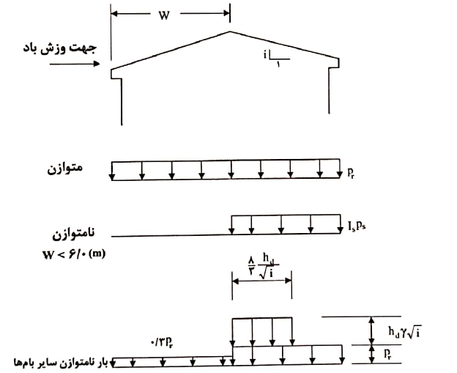



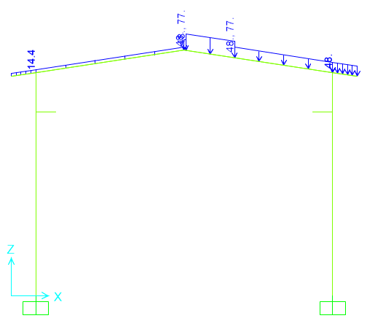 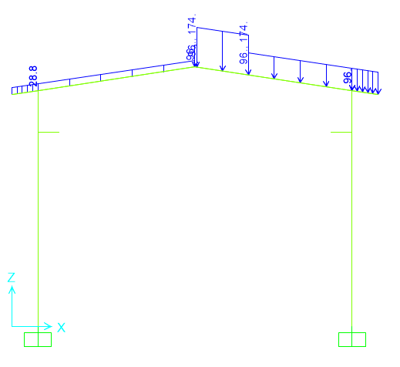

Load on frame (1&3&6&8&11&13) (kg/m) Load on frame (2&7&12) (kg/m)

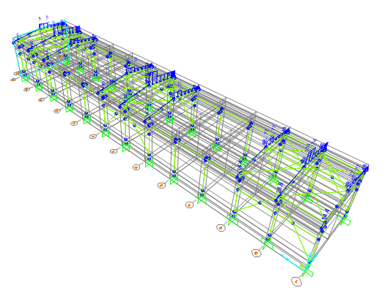

**Figure 7-**Applied Unbalanced Snow Load on frame-SP-

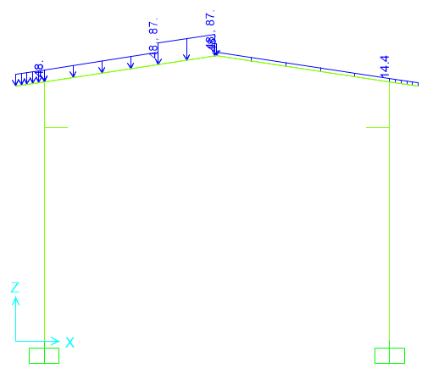 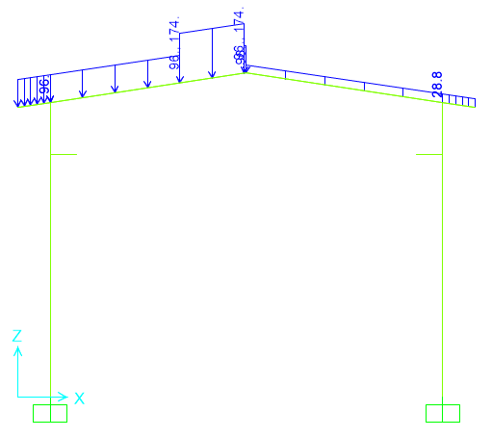

Load on frame (1&3&6&8&11&13) (kg/m) Load on frame (2&7&12) (kg/m)

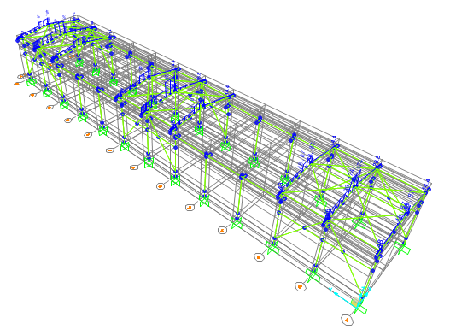

**Figure 8-**Applied Unbalanced Snow Load on frame-SN-

### 6.1.4. SEISMIC LOADS

All structures are in area with high risk zone of seismic and until finalizing of “Geotechnical Final Report” soil type consider is type III. Equivalent static method is used for calculation of seismic loads. Parameters which are used in calculation of earthquake force and seismic coefficient is presented in below

Seismic loads are calculated according to Iranian Seismic Design code for petroleum facilities (3rd Edition)

For OMF system (X direction)

Rux=3.5 Omega=3 Cd=3

For OCBF system (Y direction)

Ruy=3.25 Omega=2 Cd=3.25

Soil Type : Type III

According to Iranian Seismic Design code for petroleum facilities (3rd Edition)

* **For X direction**

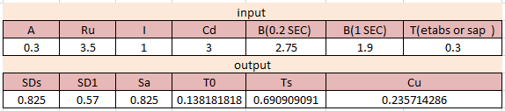

A=0.3

$Ru=3.5$ (According to table 4-4 code 038 3r Edition)

$Cd=3.0$ (According to table 4-4 code 038 3r Edition)

$$I=1$$

B(0.2s)=2.75( According to Soil type) B(1s)=1.9( According to Soil type)

$$T=0.3 according to sap software$$

T0<T<Ts $Sa=A.B\left(0.2s\right)=0.825$ $C_{u}x=\frac{S_{a}.I}{R_{u}}$ =0.235

* **For Y direction:**

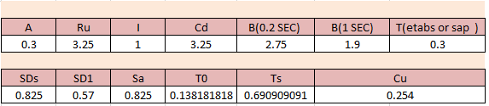

$A=0.3$ ( In this area)

$Ru=3.25$ (According to table 4-4 code 038 3r Edition)

$Cd=3.25$ (According to table 4-4 code 038 3r Edition)

$$I=1$$

B(0.2s)=2.75( According to Soil type) B(1s)=1.9( According to Soil type)

$T=0.3 according to sap model$

T0<T<Ts $Sa=A.B\left(0.2s\right)=0.825$ $C_{u}y=\frac{S_{a}.I}{R_{u}}$ =0.254

Ev : Vertical seismic load applied at model according to section 2-2-3-2 (code 038)

$${ E}_{v}=αS_{DS}=0.2*0.825=0.165$$

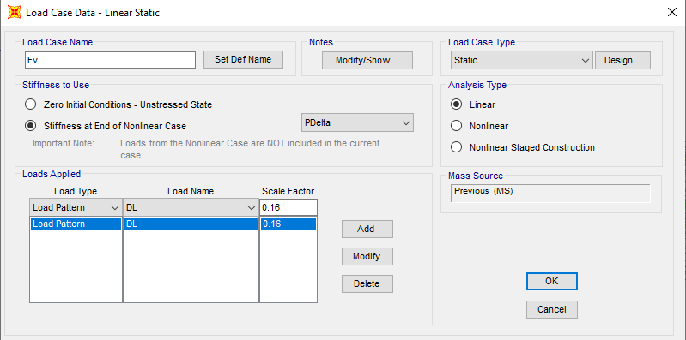

Ev applied at model as a portion of dead load as above.

### 6.1.5. wind LOADS

Wind loads are calculated according to ASCE07-last Edition and applied at model as below:

V=120K km/h(according to Iranian National Building Code No.6 last edition)

$${ V}_{ASCE}=1.53×\sqrt{1.6Iw} ×V_{INBC} V\left(\frac{m}{S}\right)$$

$$V_{ASCE}=1.53×\sqrt{1.6Iw} ×V_{INBC} =1.53×\sqrt{1.6}×120×\frac{10}{36} =64.5 mph$$

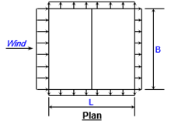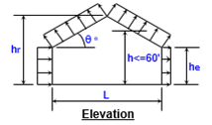

Building classification =I building and other structures that represent a low risk to human life in the event of failure (Risk Category)

Exposure Category=C(open terrain with scattered obstructions having heights generally<30ft . this category includes flat open country and grass lands.

Ridge height =9.9 m Eave height =9 m Building width=12 m Building length=72m

Roof type =Gable

Topo factor Kzt=1

Direct factor kd=1

Enclose =yes

Hurricane rfegion =no

Roof angle =8.50

Mean roof height =9.45 m

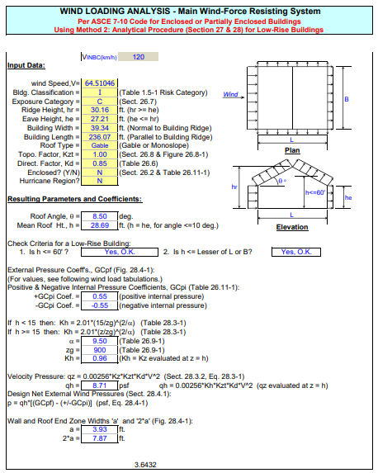

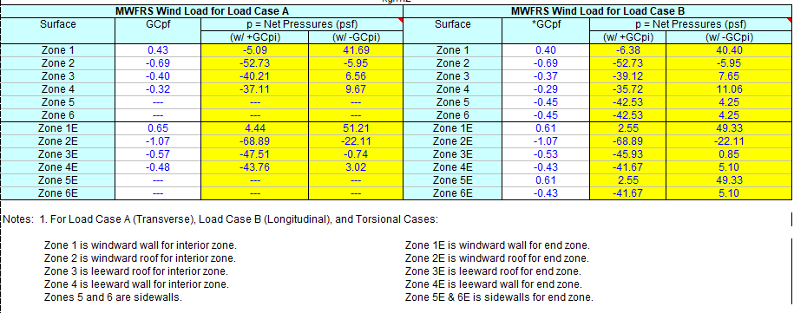

**Figure 9-Wind Load calculation( (kg/m2))**

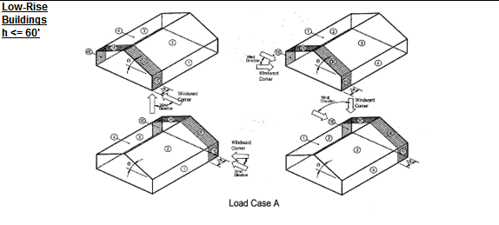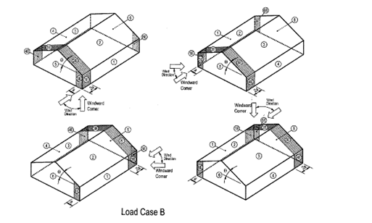

**Figure 10-Wind Load Direction**

Load Case A

(Wx) Due to G+Cpi : Wx1: Due to G-Cpi $1: Wx=-5.09×6=-30.54 \frac{kg}{m} 1: Wx=41.69×6=250.14 \frac{kg}{m}$

$2: Wx=-52.73×6=-316.38 \frac{kg}{m} 2: Wx=-5.95×6=-35.70 \frac{kg}{m}$

$$3: Wx=-40.21×6=-241.26 \frac{ kg}{m} 3: Wx=6.56×6=39.36 \frac{ kg}{m}$$

$$4: Wx=-37.11×6=-222.66 \frac{ kg}{m} 4: Wx=9.67×6=58.02 \frac{ kg}{m}$$

(WxE) Due to G+Cpi : Wx1E: Due to G-Cpi $1: Wx=4.44×3=13.32 \frac{kg}{m} 1: Wx=51.24×3=153.63 \frac{kg}{m}$

$2: Wx=-68.88×3=-206.64 \frac{kg}{m} 2: Wx=-22.11×3=-66.33 \frac{kg}{m}$

$$3: Wx=-47.51×3=-142.53 \frac{ kg}{m} 3: Wx=-0.74×3=-2.22 \frac{ kg}{m}$$

$$4: Wx=-43.76×3=-131.28 \frac{ kg}{m} 4: Wx=3.02×3=9.06 \frac{ kg}{m}$$

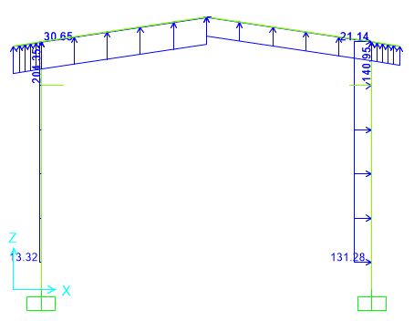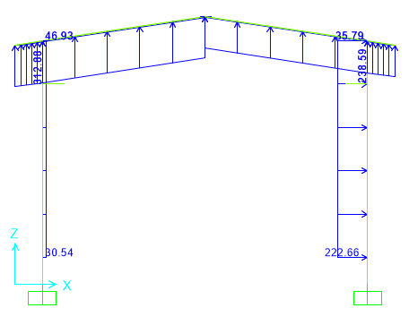

Load on frame (1&13) (kg/m) Load on frame (2&3&6&7&8&11&12) (kg/m)

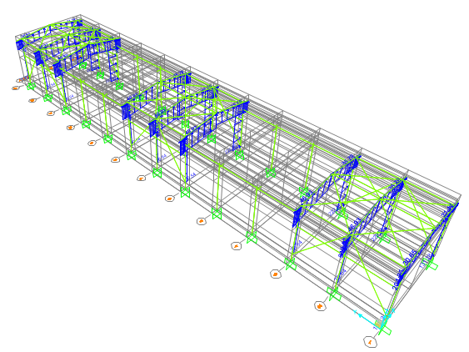

**Figure 11-**Applied Wind Load on frame-Wx-

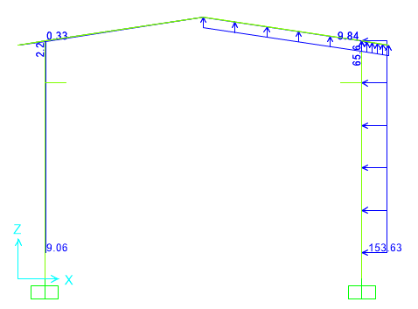 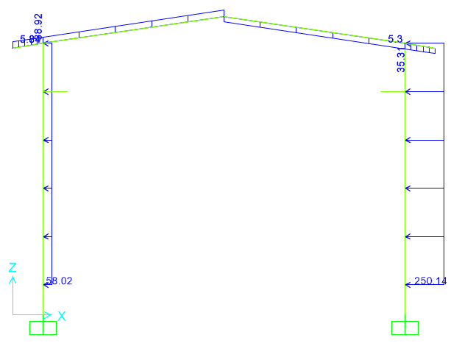

Load on frame (1&13) (kg/m) Load on frame (2&3&6&7&8&11&12) (kg/m)

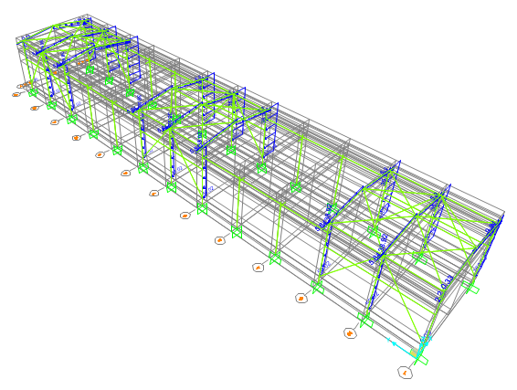

**Figure 12-**Applied Wind Load on frame-Wx1-

Load Case B

(Wy) Due to G+Cpi : Wy1: Due to G-Cpi $1: Wy=-6.38×6=-38.28 \frac{kg}{m} 1: Wy=40.40×6=242.40 \frac{kg}{m}$

$2: Wy=-52.73×6=-316.38 \frac{kg}{m} 2: Wy=-5.95×6=-35.70 \frac{kg}{m}$

$$3: Wy=-39.12×6=-234.72 \frac{ kg}{m} 3: Wy=7.65×6=45.90 \frac{ kg}{m}$$

$$4: Wy=-35.72×6=-214.32 \frac{ kg}{m} 4: Wy=11.06×6=66.36 \frac{ kg}{m}$$

$$5: Wy=-42.53×6=-255.18 \frac{ kg}{m} 5: Wy=4.25×6=25.50 \frac{ kg}{m}$$

$$6: Wy=-42.53×6=-255.18 \frac{ kg}{m} 6: Wy=4.25×6=25.50 \frac{ kg}{m}$$

(WyE) Due to G+Cpi : Wy1E: Due to G-Cpi $1: Wy=2.55×3=7.65 \frac{kg}{m} 1: Wy=49.33×3=147.99 \frac{kg}{m}$

$2: Wy=-68.88×3=-206.64 \frac{kg}{m} 2: Wy=-22.11×3=-66.33 \frac{kg}{m}$

$$3: Wy=-45.93×3=-137.79 \frac{ kg}{m} 3: Wy=0.85×3=2.55 \frac{ kg}{m}$$

$$4: Wy=-41.67×3=-125.01 \frac{ kg}{m} 4: Wy=5.10×3=15.30 \frac{ kg}{m}$$

$$5: Wy=2.55×3=7.65 \frac{ kg}{m} 5: Wy=49.33×3=147.99 \frac{ kg}{m}$$

$$6: Wy=-41.67×3=-125.01 \frac{ kg}{m} 6: Wy=5.10×6=15.30 \frac{ kg}{m}$$

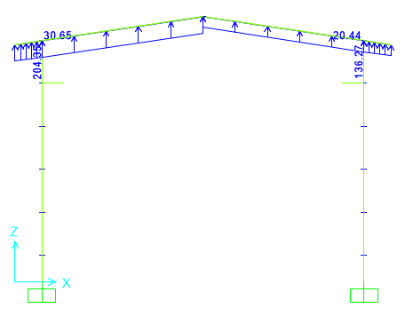 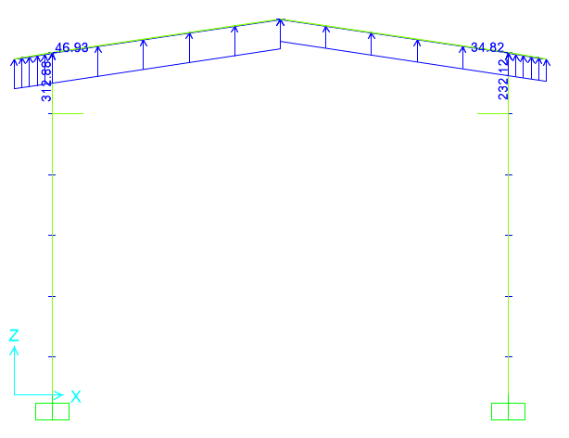 Load on frame (1&13) (kg/m) Load on frame (2&3&6&7&8&11&12) (kg/m)

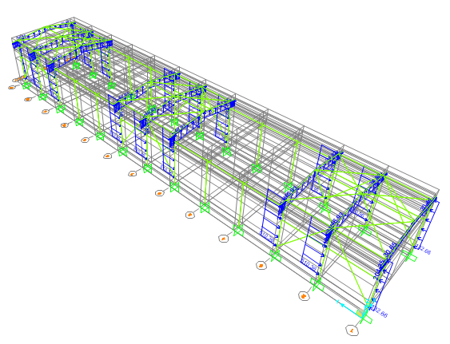

**Figure 13-**Applied Wind Load on frame-Wy-

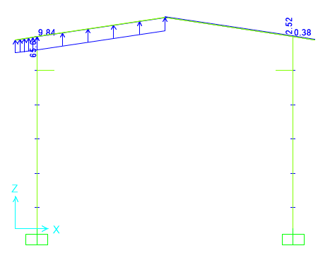 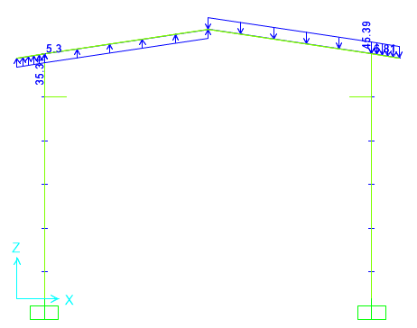

Load on frame (1&13) (kg/m) Load on frame (2&3&6&7&8&11&12) (kg/m)

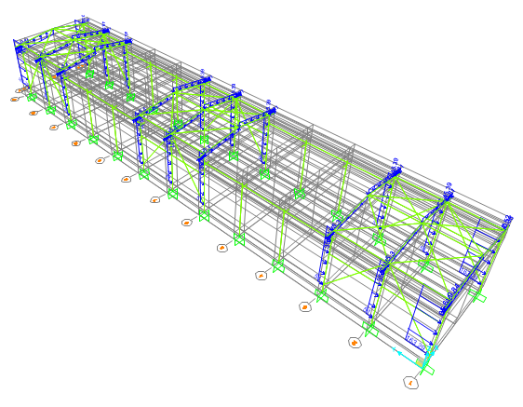

**Figure 14-**Applied Wind Load on frame-Wy1-

### 6.1.6. CRAINE LOADS

For the shelter structure of the main gas compressors, an electric overhead crane with a capacity of 10 tons is provided in annex 10 (description of works in the contractor’s commitment).

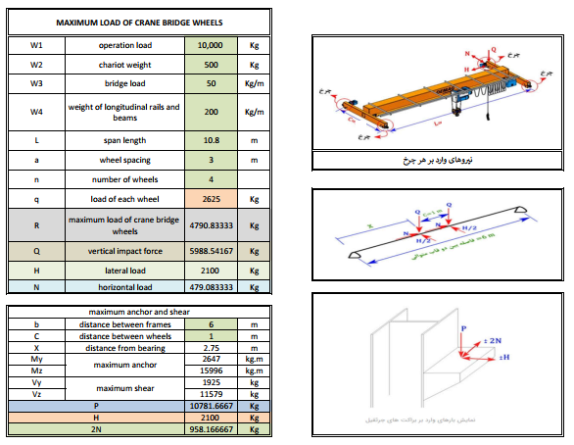

* 1. **SAP loading table**

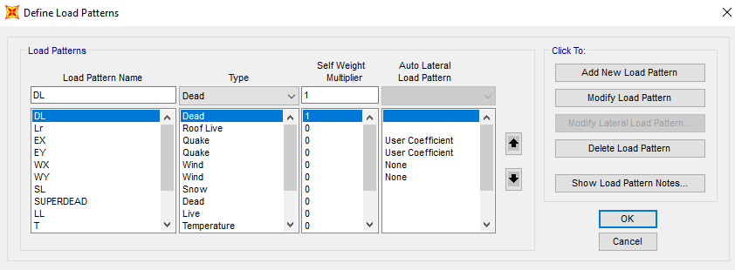

Load combinations

According to code ASCE7 structures, components, and foundations shall be designed, so that their design strength equals or exceeds that effect of factored loads in the following combination:

1.4(D)

(1.2D) +1.6(L)+0.5(Lr/S/R)

1.2D+1.6(Lr/S/R) + (L/0.5W)

1.2D+1.0(W) + L+.5(Lr/S)

1.2D+1.0E+L+0.2S

0.9D+1.0W

0.9D+1.0E

Load listed herein shall be considered to act in the following combinations; whichever produces the most unfavorable effect considering soil reactions.

D

D+L

D+(Lr/S/R)

D+0.75(L)+0.75(Lr/R/S)

D+(0.6W or 0.7E)

D+0.75L+0.75(0.6W)+0.75(Lr/S/R)

D+0.75L+0.75(0.7E)+0.75S

0.6D+0.6W

0.6D+0.7E

1. **STRUCTURE ANALYSIS AND DESIGN**

## ANALYSIS

Structural analysis is done by SAP2000 software. In model loads are applied, some graphical outputs from model are shown as follows.

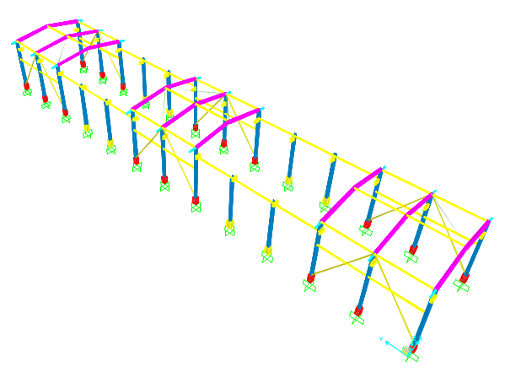

**Figure 15 -** 3D view of SAP model

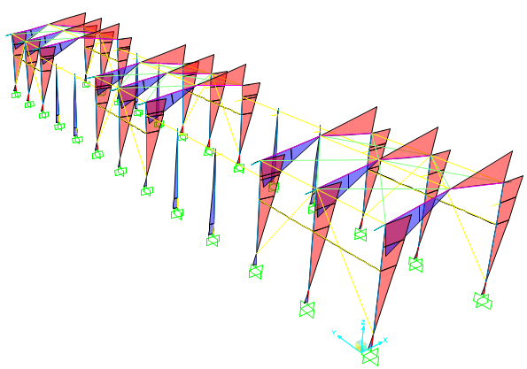

**Figure 16 -** Moment 3-3 under Ex load

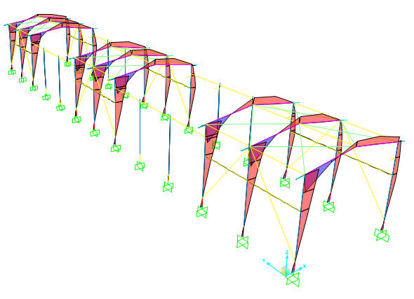

**Figure 17 -** Moment 3-3 under Wx load

* 1. **Control of Columns Required Axial Strength**

According to AISC 341-10 section D1.4a. columns axial strength shall be checked with load combination including amplified seismic load.

Omega X = 3

Omega Y = 2

Load combination for amplified seismic control:

1- D+0.75L+0.75S±2EY (compression)

2- 0.6D±2EY (tension)

According to design file (sap model) axial load in columns in above combination checked an all columns are acceptable .

1. **Structural Design Results**
   1. **Graphical output**

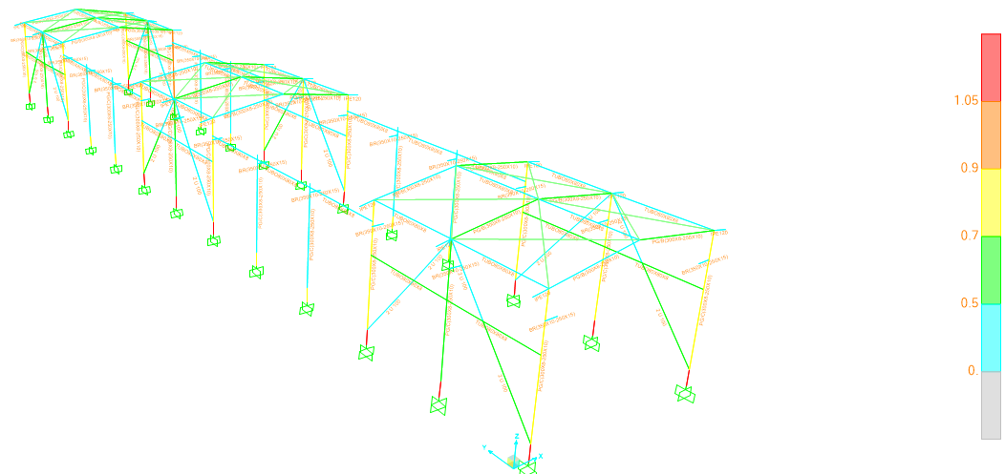

**Figure 18 –** Design Results

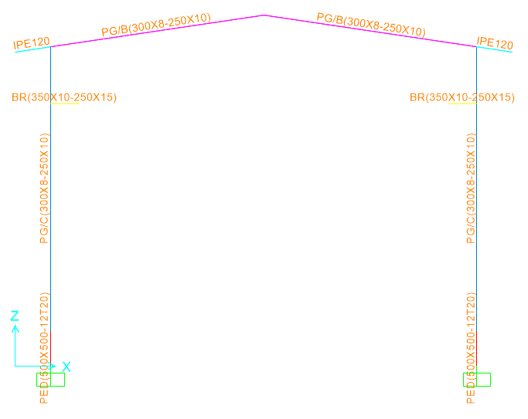 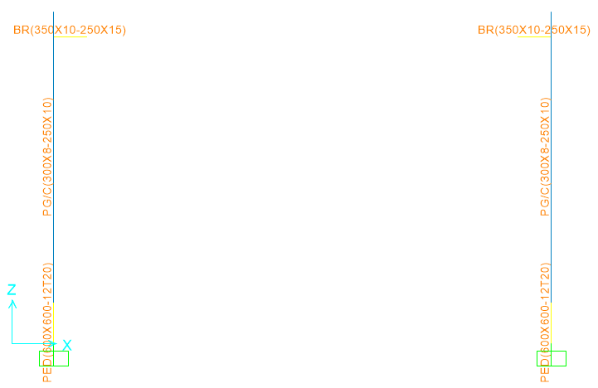

Section of frame (1&2&3&6&7&8&11&12&13) Section of frame (4&5&9&10)

**Figure 19** : Frames

* 1. **DRIFT CONTROL**

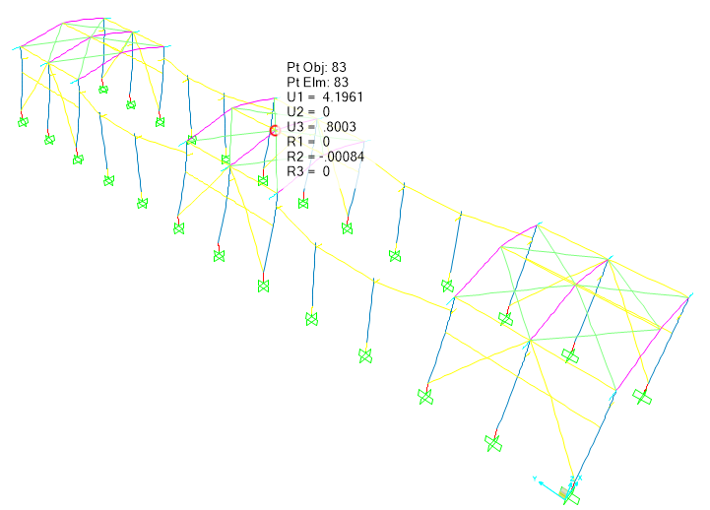

Maximum displacement according to above output from sap model under critical service load combination is about 4.19 cm which is less than allowable drift.

$$allowable drift is \frac{h}{180}=5.5cm$$

1. **Structural connections**
   1. **Special Moment Frame**

* **Beam to column**

According to AISC 358-10 chapter 6, connection types 4ES and 8ES shall be used. Prequalified Special moment frame connections have been determined according to AISC 341- 10, Part 1, Section 10; AISC 358-10, Chapter 6 & AISC Design Guides 4, 13. Introductory figures & tables are attached. (Design procedure is mainly based on AISC 358 – 10 section 6.10)

High pretension bolts, used are equivalent to HV8.8 with ultimate strength of Fu=8,000 kg/cm2. The units used in the above mentioned codes & based calculation are kg-cm.

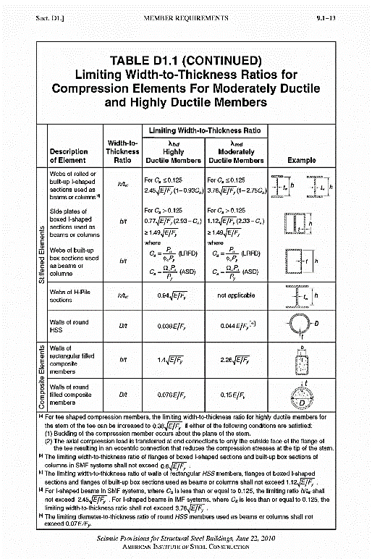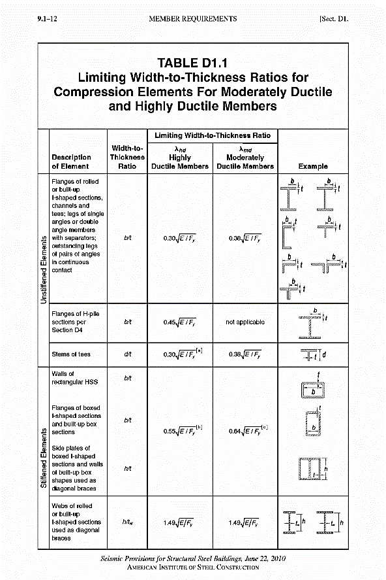

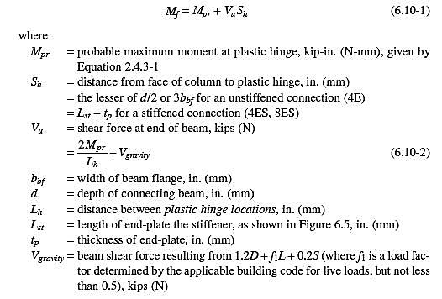

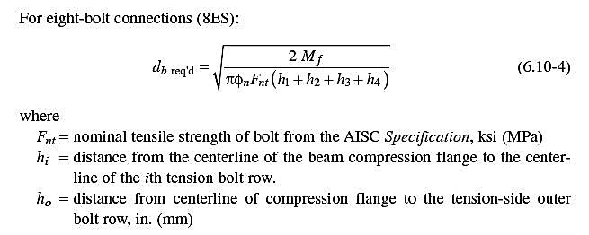

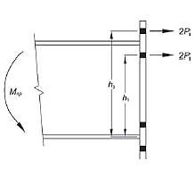

* 1. **Description of Design Procedure & Parameters**

Compact sections shall be selected according to AISC 360-10.

bf, tf, hw and tw are sizes of girder.

Ry is the ratio of expected to specified structural steel yield strength.

$M_{pr}=C_{pr}.R_{y}.F_{y}.Z$ probable maximum moment at plastic hinge (according to AISC358- 10).

$S_{h}=$ distance from the face of column to plastic hinge $= L_{st}+t_{p}$ (according to AISC358- 10).

$L_{st}=$ Length of the end-plate stiffener.

$t_{p}=$ end-plate thickness.

$L_{n}=$ distance between plastic hinges.

$M_{f}=M_{pr}+V_{p}.L_{n}$ moment at the face of te column (according to AISC358- 10).

$V_{p}= \frac{2M_{pr}}{L_{n}}+\frac{wL_{n}}{2}$ Shear force at the end of the beam (according to AISC358- 10).

$M_{ff}=$ since amplified moment is allowed to be used for Special frame connections. It is extracted from the load combination using $ΩM_{E}$ ($Ωx=3 , Ωy=2$).

$F_{u}=$ bolt ultimate strength (HV8.8).

$F_{nt}=$ nominal tensile strength of bolt.

$ϕ_{n}=$ non-ductile resistance factor ($=0.9$ according to AISC358-10).

$h_{i}=$ distance from the centerline of the beam compression flange to the centerline of ith tension bolt row.

$(d_{b})=$ required bolt dimension (according to AISC358-10)

$d_{b}=$ selected bolt diameter

phi Rn 4S = bolt shear rupture strength of the connection (according to AISC358-10)

$F_{b} 4S$ bolt stress according to flexural < phi Fnt.

phi Rn yield = local column web yielding strength at beam flanges (according to AISC358-10).

phi Rn buck. = unstiffened column web buckling strength at beam compression flange (according to AISC358-10).

phi Rn cripp. = unstiffened column web crippling strength at beam compression flange (according to AISC358-10).

$d_{c}=$ overall depth of column.

$t_{wc}=$ column web thickness including doubler plates with plug weld.

Astiff = calculated required continuity plates area.

$t_{p}=$ thickness of end-plate calculated according to plate theories formulas regarding plate boundary conditions. (it submits exactly the same amount using AISC 358 formulas).

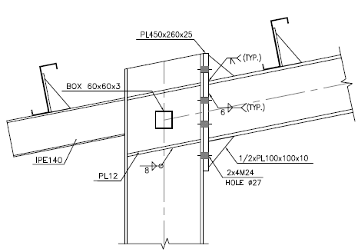

* 1. **cONNECTION FORCE CALCULATION:**
 $$S_{h}=\min\left(\frac{d}{2} , 3b_{bf}\right)=16 cm$$

 $$L_{h}=L-2Sh= 11.68 m$$

$$Wu=1.2D+L+0.2s=0.506 t/m$$

2. **BEAM SPECIFICATION:**
 $$b_{f}\left(cm\right)=25 ,t_{f}\left(cm\right)=1 , h_{w}\left(cm\right)= 30 , t_{w}\left(cm\right)=0.8$$

 $$Z=955 cm3$$

$$M_{p}=Z*Fy= 955*2400=2292000 Kg.cm$$

$$1.1≤C_{pr}=\frac{F_{y}+F_{u}}{2Fy}=1.27≤1.2 C_{pr}=1.2$$

$$M_{pr}=C_{pr}R_{y}M_{p}=1.2×1.15×2292000=3162960 kg.cm=31.62 t.m$$

$$R_{y}=1.15$$

$${V^{H}}_{gravity}=\frac{W_{u}L_{h}}{2}=2.96 ton$$

$$V_{pr}=\frac{2M_{pr}}{L_{h}}=5.41 ton$$

$$M_{u}=M_{pr}+\frac{W_{u}Sh^{2}}{2}=31.62 ton.m$$

3. **end plate thickness calculation:**

Mu=31.62 ton.m

$$∅_{d}=1.0$$

$$F_{yp}=2400 kg/cm2$$

$Y_{P}=\frac{b_{p}}{2}$ [$h_{1}\left(\frac{1}{P_{fi}}+\frac{1}{S}\right)+h0\left(\frac{1}{P_{fo}}\right)-\frac{1}{2}]+\frac{2}{g}[h1(P_{fi}+S)]$

$t_{p req}=\sqrt{\frac{1.11M_{u}}{φ_{d}F_{yp}Y_{p}}}=2.5 cm$

1. **purlin design**
   1. **SOIL PRESSURE**

**Property of Purlin(Z180x2.5)**

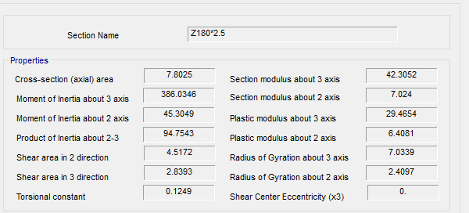

**Section Property Of Purlin**

According to above table :

$$A=7.80 cm2$$

$$J=0.12 cm4$$

$$Ix=386.06 cm4$$

$$Iy=45.304 cm4$$

$$rx=7.033 cm$$

$$ry=2.41 cm$$

$$ho=18 cm$$

$$SY=42.305 cm3$$

$$SX=7.024 cm3$$

FOR Z 180 :

$$D+L=26+50=76 kg/m^{2}$$

$$P_{y}=76.\cos{11}=74.6 kg/m^{2}$$

$$P_{x}=76.\sin{11}=14.5 kg/m^{2}$$

$$middle of span : M_{y}=\frac{w.L^{2}}{8}=\frac{76×1.0×6^{2}}{8}=342 kg.m$$

$$middle of span : M_{x}=\frac{w.L^{2}}{360}=\frac{14.5×1×6^{2}}{360}=1.45kg.m$$

$$f_{b}=\frac{M_{y}}{s_{y}}+2\frac{M_{x}}{s_{x}}=\frac{342×100}{42.305}+2\frac{1.45×100}{7.024}=808.42+20.65=829<1440 ok$$

$$moment on sagrod support : M_{y}=\frac{w.L^{2}}{9}=\frac{76×1.0×6^{2}}{9}=304 kg.m$$

$$moment on sagrod support : M_{x}=\frac{w.L^{2}}{90}=\frac{14.5×1.0×6^{2}}{90}=5.8 kg.m$$

$$f_{b}=\frac{M_{y}}{s_{y}}+2\frac{M_{x}}{s_{x}}=\frac{304×100}{42.305}+2\frac{5.8×100}{7.024}=498.99+114.46=884< 1440 ok$$

11.13.2.Un deformed shape CONTROL:

$$dead+live loads : ∆=\frac{5×q×L^{4}}{384×E×I}=\frac{5×0.76×1.0×{600}^{4}}{384×2.04×{10}^{6}×1350}=0.46cm < \frac{L}{240}=2.0cm$$

$$for live loads : ∆=\frac{5×q×L^{4}}{384×E×I}=\frac{5×0.5×1.0×{600}^{4}}{384×2.04×{10}^{6}×1350}=0.31cm < \frac{L}{360}=1.3 cm$$

1. **foundation design**
   1. **SOIL PRESSURE**

Until finalize of geotechnical report for this area we consider => qa= 2kg/cm2

Based on Bowels experimental formula for subgrade modulus => Ks = 1.345qall

Loading used for foundation design, have been received from SAP analysis.

* 1. **DESIGN**

Concrete Foundation are designed according to ACI 318-14. Required loads are derived from SAP data, and design process will be done according to ACI code based on ultimate strength procedure.

* 1. **FOUNDATION DESIGN CONTROL**

### **10.3.1** **Check of Stress for Foundation**

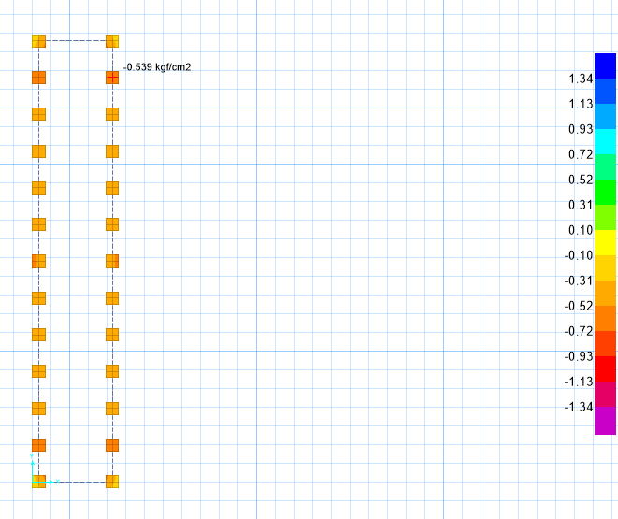

**Figure 20** : Check of Stress for Foundation (kg/cm2)

According to SAFE report, Max soil pressure under the foundation is:

$$q_{n}=0.539kg/{cm}^{2} < 2 kg/{cm}^{2} ok$$

**10.3.2**  **REINFORCING CONTROL**

Minimum rebar for foundation:



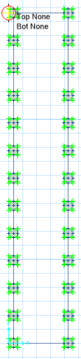

**Figure 21** : additional reinforement



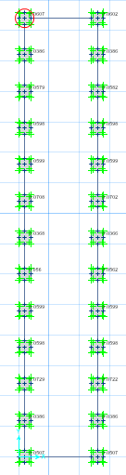

**Figure 22**: punch shear control