|  |  |  |  |  |  |  |  |
| --- | --- | --- | --- | --- | --- | --- | --- |
| **طرح نگهداشت و افزایش تولید 27 مخزن** | | | | | | | |
| **CALCULATION NOTE FOR LIGHTING SYSTEM OF WELL PADS AREA**  **نگهداشت و افزایش تولید میدان نفتی بینک** | | | | | | | |
|  |  |  |  |  |  |  |
|  |  |  |  |  |  |  |
|  |  |  |  |  |  |  |
| D01 | Jul. 2022 | IFA | H.Shakiba | M.Fakharian | M.Mehrshad |  |
| D00 | May. 2022 | IFC | H.Shakiba | M.Fakharian | M.Mehrshad |  |
| **Rev.** | **Date** | **Purpose of Issue/Status** | **Prepared by:** | **Checked by:** | **Approved by:** | **CLIENT Approval** |
| **Class:2** | | **CLIENT Doc. Number: F0Z-707380** | | | | |
| **Status:** | **IDC: Inter-Discipline Check**  **IFC: Issued For Comment**  **IFA: Issued For Approval**  **AFD: Approved For Design**  **AFC: Approved For Construction**  **AFP: Approved For Purchase**  **AFQ:** Approved For Quotation  **IFI: Issued For Information**  **AB-R: As-Built for** **CLIENT Review**  **AB-A: As-Built –Approved** | | | | | |

**REVISION RECORD SHEET**

|  |  |  |  |  |  |  |  |  |  |  |  |  |
| --- | --- | --- | --- | --- | --- | --- | --- | --- | --- | --- | --- | --- |
| **PAGE** | **D00** | **D01** | **D02** | **D03** | **D04** |  | **PAGE** | **D00** | **D01** | **D02** | **D03** | **D04** |
| **1** | X | X |  |  |  | **51** |  |  |  |  |  |
| **2** | X | X |  |  |  | **52** |  |  |  |  |  |
| **3** | X |  |  |  |  | **53** |  |  |  |  |  |
| **4** | X |  |  |  |  | **54** |  |  |  |  |  |
| **5** | X | X |  |  |  | **55** |  |  |  |  |  |
| **6** | X | X |  |  |  | **56** |  |  |  |  |  |
| **7** | X |  |  |  |  | **57** |  |  |  |  |  |
| **8** | X |  |  |  |  | **58** |  |  |  |  |  |
| **9** |  |  |  |  |  | **59** |  |  |  |  |  |
| **10** |  |  |  |  |  | **60** |  |  |  |  |  |
| **11** |  |  |  |  |  | **61** |  |  |  |  |  |
| **12** |  |  |  |  |  | **62** |  |  |  |  |  |
| **13** |  |  |  |  |  | **63** |  |  |  |  |  |
| **14** |  |  |  |  |  | **64** |  |  |  |  |  |
| **15** |  |  |  |  |  | **65** |  |  |  |  |  |
| **16** |  |  |  |  |  | **66** |  |  |  |  |  |
| **17** |  |  |  |  |  | **67** |  |  |  |  |  |
| **18** |  |  |  |  |  | **68** |  |  |  |  |  |
| **19** |  |  |  |  |  | **69** |  |  |  |  |  |
| **20** |  |  |  |  |  | **70** |  |  |  |  |  |
| **21** |  |  |  |  |  | **71** |  |  |  |  |  |
| **22** |  |  |  |  |  | **72** |  |  |  |  |  |
| **23** |  |  |  |  |  | **73** |  |  |  |  |  |
| **24** |  |  |  |  |  | **74** |  |  |  |  |  |
| **25** |  |  |  |  |  | **75** |  |  |  |  |  |
| **26** |  |  |  |  |  | **76** |  |  |  |  |  |
| **27** |  |  |  |  |  | **77** |  |  |  |  |  |
| **28** |  |  |  |  |  | **78** |  |  |  |  |  |
| **29** |  |  |  |  |  | **79** |  |  |  |  |  |
| **30** |  |  |  |  |  | **80** |  |  |  |  |  |
| **31** |  |  |  |  |  | **81** |  |  |  |  |  |
| **32** |  |  |  |  |  | **82** |  |  |  |  |  |
| **33** |  |  |  |  |  | **83** |  |  |  |  |  |
| **34** |  |  |  |  |  | **84** |  |  |  |  |  |
| **35** |  |  |  |  |  | **85** |  |  |  |  |  |
| **36** |  |  |  |  |  | **86** |  |  |  |  |  |
| **37** |  |  |  |  |  | **87** |  |  |  |  |  |
| **38** |  |  |  |  |  | **88** |  |  |  |  |  |
| **39** |  |  |  |  |  | **89** |  |  |  |  |  |
| **40** |  |  |  |  |  | **90** |  |  |  |  |  |
| **41** |  |  |  |  |  | **91** |  |  |  |  |  |
| **42** |  |  |  |  |  | **92** |  |  |  |  |  |
| **43** |  |  |  |  |  | **93** |  |  |  |  |  |
| **44** |  |  |  |  |  | **94** |  |  |  |  |  |
| **45** |  |  |  |  |  | **95** |  |  |  |  |  |
| **46** |  |  |  |  |  | **96** |  |  |  |  |  |
| **47** |  |  |  |  |  | **97** |  |  |  |  |  |
| **48** |  |  |  |  |  | **98** |  |  |  |  |  |
| **49** |  |  |  |  |  | **99** |  |  |  |  |  |
| **50** |  |  |  |  |  | **100** |  |  |  |  |  |

**CONTENTS**

1.0 INTRODUCTION 4

2.0 Scope 5

3.0 NORMATIVE REFERENCES 5

**3.1** **Codes and Standards** 5

**3.2** **The Project reference Documents** 5

4.0 LANGUAGE AND SYSTEM OF UNITS 5

5.0 Lighting system 5

6.0 Design software 8

7.0 LIGHTING CALCULATION – dETAIL REPORT 8

1. **INTRODUCTION**

Binak oilfield in Bushehr province is a part of the southern oilfields of Iran, is located 20 km northwest of Genaveh city.

With the aim of increasing production of oil from Binak oilfield, an EPC/EPD Project has been defined by NIOC/NISOC and awarded to Petro Iran Development Company (PEDCO). Also PEDCO (as General Contractor) has assigned the EPC-packages of the Project to "Hirgan Energy - Design and Inspection" JV.

**GENERAL DEFINITION**

The following terms shall be used in this document.

|  |  |
| --- | --- |
| CLIENT: | National Iranian South Oilfields Company (NISOC) |
| PROJECT: | Binak Oilfield Development – General Facilities |
| EPD/EPC CONTRACTOR(GC) | Petro Iran Development Company (PEDCO) |
| EPC CONTRACTOR: | Joint Venture of : Hirgan Energy – Design & Inspection(D&I) Companies |
| VENDOR: | The firm or person who will fabricate the equipment or material. |
| EXECUTOR: | Executor is the party which carries out all or part of construction and/or commissioning for the project. |
| THIRD PARTY INSPECTOR (TPI): | The firm appointed by EPD/EPC CONTRACTOR(GC) and approved by COMPANY (in writing) for the inspection of goods. |
| SHALL: | Is used where a provision is mandatory. |
| SHOULD: | Is used where a provision is advisory only. |
| WILL: | Is normally used in connection with the action by CLIENT rather than by an EPC/EPD CONTRACTOR, supplier or VENDOR. |
| MAY: | Is used where a provision is completely discretionary. |

1. **Scope**

This specification describes the practices that shall be employed and the Standards that will be required to be met for the Area Lightings Illumination

1. **NORMATIVE REFERENCES**
   1. **Codes and Standards**

* IPS-E-EL-100 Engineering Standard For Electrical System Design (Industrial And Non-Industrial)
  1. **The Project reference Documents**
* BK-GNRAL-PEDCO-000-PR-DB-0001 Process Basis Of Design
* BK-GNRAL-PEDCO-000-EL-DC-0001 Electrical System Design Criteria
* BK-GNRAL-PEDCO-000-EL-SP-0007 Specification For Lighting & Small Power System
* BK-W046S-PEDCO-110-PI-DW-000 Plot Plan Drawing - W046S

D01

* BK-W046S-PEDCO-110-SA-PY-0001 Hazardous Area Classification W046S

1. **LANGUAGE AND SYSTEM OF UNITS**

All documentation, drawings, data, etc. furnished by the manufacturer shall be in English. SI metric system of measurement shall be used except for pipe and pipe fitting sizes, flange ratings and nozzle dimensions in which inch will be used.

1. **Lighting system**

The lighting system will provide a uniform and adequate light distribution in all working areas, the minimum average illumination levels will be as per IPS-E-EL-100(1). Major areas indicated in the below table:

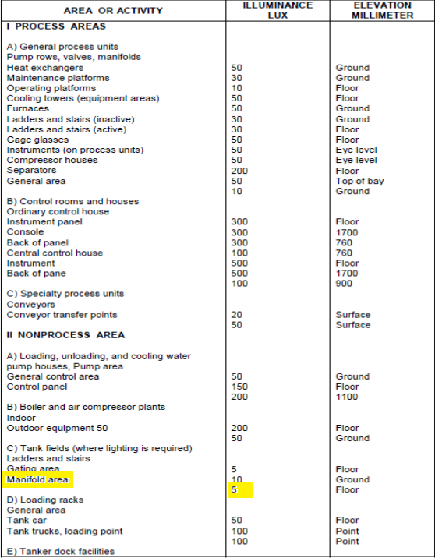

D01





D01

It is clear that according to IPS standard in non-process area, the required luminance shall be 5 Lux, while based on our calculation, it is 22 Lux in average.

1. **Design software**

Calculation is performed with version 4.13 of DIALUX Software.

1. **LIGHTING CALCULATION – dETAIL REPORT**

DIALUX report has been attached in “Attachment”