|  |  |  |  |  |  |  |  |
| --- | --- | --- | --- | --- | --- | --- | --- |
| **طرح نگهداشت و افزایش تولید 27 مخزن** | | | | | | | |
| **ISOLATION PHILOSOPHY**  **نگهداشت و افزایش تولید میدان نفتی بینک** | | | | | | | |
|  |  |  |  |  |  |  |
| D03 | AUG.2022 | AFD | M.Aryafar | M.Fakhariam | M.Mehrshad |  |
| D02 | APR.2022 | IFA | M.Aryafar | M.Fakhariam | M.Mehrshad |  |
| D01 | JAN.2022 | IFA | M.Aryafar | M.Fakhariam | M.Mehrshad |  |
| D00 | NOV.2021 | IFC | M.Aryafar | M.Fakharian | M.Mehrshad |  |
| **Rev.** | **Date** | **Purpose of Issue/Status** | **Prepared by:** | **Checked by:** | **Approved by:** | **CLIENT Approval** |
| **Class: 2 CLIENT Doc. Number: F0Z-708524** | | | | | | |
| **Status:** | **IDC: Inter-Discipline Check**  **IFC: Issued For Comment**  **IFA: Issued For Approval**  **AFD: Approved For Design**  **AFC: Approved For Construction**  **AFP: Approved For Purchase**  **AFQ: Approved For Quotation**  **IFI: Issued For Information**  **AB-R: As-Built for CLIENT Review**  **AB-A: As-Built –Approved** | | | | | |

**REVISION RECORD SHEET**

|  |  |  |  |  |  |  |  |  |  |  |  |  |
| --- | --- | --- | --- | --- | --- | --- | --- | --- | --- | --- | --- | --- |
| **PAGE** | **D00** | **D01** | **D02** | **D03** | **D04** |  | **PAGE** | **D00** | **D01** | **D02** | **D03** | **D04** |
| **1** | X | X | X | X |  | **66** |  |  |  |  |  |
| **2** | X | X | X | X |  | **67** |  |  |  |  |  |
| **3** | X |  |  |  |  | **68** |  |  |  |  |  |
| **4** | X |  |  |  |  | **69** |  |  |  |  |  |
| **5** | X |  |  |  |  | **70** |  |  |  |  |  |
| **6** | X |  |  |  |  | **71** |  |  |  |  |  |
| **7** | X |  |  |  |  | **72** |  |  |  |  |  |
| **8** | X |  |  |  |  | **73** |  |  |  |  |  |
| **9** | X | X |  |  |  | **74** |  |  |  |  |  |
| **10** | X |  |  |  |  | **75** |  |  |  |  |  |
| **11** | X |  |  |  |  | **76** |  |  |  |  |  |
| **12** | X |  |  |  |  | **77** |  |  |  |  |  |
| **13** | X |  |  |  |  | **78** |  |  |  |  |  |
| **14** | X |  |  |  |  | **79** |  |  |  |  |  |
| **15** | X |  |  |  |  | **80** |  |  |  |  |  |
| **16** | X |  |  |  |  | **81** |  |  |  |  |  |
| **17** | X | X |  |  |  | **82** |  |  |  |  |  |
| **18** | X |  |  |  |  | **83** |  |  |  |  |  |
| **19** | X |  |  |  |  | **84** |  |  |  |  |  |
| **20** |  |  |  |  |  | **85** |  |  |  |  |  |
| **21** |  |  |  |  |  | **86** |  |  |  |  |  |
| **22** |  |  |  |  |  | **87** |  |  |  |  |  |
| **23** |  |  |  |  |  | **88** |  |  |  |  |  |
| **24** |  |  |  |  |  | **89** |  |  |  |  |  |
| **25** |  |  |  |  |  | **90** |  |  |  |  |  |
| **26** |  |  |  |  |  | **91** |  |  |  |  |  |
| **27** |  |  |  |  |  | **92** |  |  |  |  |  |
| **28** |  |  |  |  |  | **93** |  |  |  |  |  |
| **29** |  |  |  |  |  | **94** |  |  |  |  |  |
| **30** |  |  |  |  |  | **95** |  |  |  |  |  |
| **31** |  |  |  |  |  | **96** |  |  |  |  |  |
| **32** |  |  |  |  |  | **97** |  |  |  |  |  |
| **33** |  |  |  |  |  | **98** |  |  |  |  |  |
| **34** |  |  |  |  |  | **99** |  |  |  |  |  |
| **35** |  |  |  |  |  | **100** |  |  |  |  |  |
| **36** |  |  |  |  |  | **101** |  |  |  |  |  |
| **37** |  |  |  |  |  | **102** |  |  |  |  |  |
| **38** |  |  |  |  |  | **103** |  |  |  |  |  |
| **39** |  |  |  |  |  | **104** |  |  |  |  |  |
| **40** |  |  |  |  |  | **105** |  |  |  |  |  |
| **41** |  |  |  |  |  | **106** |  |  |  |  |  |
| **42** |  |  |  |  |  | **107** |  |  |  |  |  |
| **43** |  |  |  |  |  | **108** |  |  |  |  |  |
| **44** |  |  |  |  |  | **109** |  |  |  |  |  |
| **45** |  |  |  |  |  | **110** |  |  |  |  |  |
| **46** |  |  |  |  |  | **111** |  |  |  |  |  |
| **47** |  |  |  |  |  | **112** |  |  |  |  |  |
| **48** |  |  |  |  |  | **113** |  |  |  |  |  |
| **49** |  |  |  |  |  | **114** |  |  |  |  |  |
| **50** |  |  |  |  |  | **115** |  |  |  |  |  |
| **51** |  |  |  |  |  | **116** |  |  |  |  |  |
| **52** |  |  |  |  |  | **117** |  |  |  |  |  |
| **53** |  |  |  |  |  | **118** |  |  |  |  |  |
| **54** |  |  |  |  |  | **119** |  |  |  |  |  |
| **55** |  |  |  |  |  | **120** |  |  |  |  |  |
| **56** |  |  |  |  |  | **121** |  |  |  |  |  |
| **57** |  |  |  |  |  | **122** |  |  |  |  |  |
| **58** |  |  |  |  |  | **123** |  |  |  |  |  |
| **59** |  |  |  |  |  | **124** |  |  |  |  |  |
| **60** |  |  |  |  |  | **125** |  |  |  |  |  |
| **61** |  |  |  |  |  | **126** |  |  |  |  |  |
| **62** |  |  |  |  |  | **127** |  |  |  |  |  |
| **63** |  |  |  |  |  | **128** |  |  |  |  |  |
| **64** |  |  |  |  |  | **129** |  |  |  |  |  |
| **65** |  |  |  |  |  | **130** |  |  |  |  |  |

**CONTENTS**

1.0 INTRODUCTION 4

2.0 Scope 5

3.0 NORMATIVE REFERENCES 5

3.1 Local Codes and Standards 5

3.2 International Codes and Standards 5

3.3 The Project Documents 5

3.4 ENVIRONMENTAL DATA 5

3.5 Abbreviations 6

4.0 PROCESS DEFINITIONS 6

4.1 High Vapor Pressure Service 6

4.2 High H2S Risk Areas 6

5.0 ISOLATION METHODS AND APPLICATION 6

5.1 Positive Isolation 7

5.2 General Isolation 7

5.3 General Recommendation 8

6.0 ISOLATION PHILOSOPHIES 9

6.1 Isolation for Shutdown Maintenance 9

6.2 Isolation at Unit Battery Limit 9

6.3 Isolation at Package Units 12

7.0 ISOLATION FOR ON-STREAM MAINTENANCE 12

7.1 Isolation for Relief Valves 12

7.2 Isolation of Utilities from Process Systems 15

7.3 Blow down Valve 16

8.0 PIPELINE AND TRANSFER LINE ISOLATION 17

8.1 General Considerations 17

8.2 TRANSPORTATION PipelineS 17

8.3 Launcher/Receiver Isolation 17

1. **INTRODUCTION**

Binak oilfield in Bushehr province is a part of the southern oilfields of Iran, is located 25 km northwest of Genaveh city.

With the aim of increasing production of oil from Binak oilfield, an EPC/EPD Project has been defined by NIOC/NISOC and awarded to Petro Iran Development Company (PEDCO). Also PEDCO (as General Contractor) has assigned the EPC-packages of the Project to "Hirgan Energy - Design and Inspection" JV.

As a part of the Project, New Gas/Condensate Pipelines (from Binak New GCS to Siahmakan GIS/Binak PU) shall be constructed.

**GENERAL DEFINITION**

The following terms shall be used in this document.

|  |  |
| --- | --- |
| CLIENT: | National Iranian South Oilfields CLIENT (NISOC) |
| PROJECT: | Binak Oilfield Development – Surface Facilities; Gas & Gas-Condensate Pipelines |
| EPD/EPC CONTRACTOR (GC): | Petro Iran Development Company (PEDCO) |
| EPC CONTRACTOR: | Joint Venture of : Hirgan Energy – Design & Inspection(D&I) Companies |
| VENDOR: | The firm or person who will fabricate the equipment or material. |
| EXECUTOR: | Executor is the party which carries out all or part of construction and/or commissioning for the project. |
| THIRD PARTY INSPECTOR (TPI): | The firm appointed by EPD/EPC CONTRACTOR (GC) and approved by CLIENT (in writing) for the inspection of goods. |
| SHALL: | Is used where a provision is mandatory. |
| SHOULD: | Is used where a provision is advisory only. |
| WILL: | Is normally used in connection with the action by CLIENT rather than by an EPC/EPD CONTRACTOR, supplier or VENDOR. |
| MAY: | Is used where a provision is completely discretionary. |

1. **Scope**

The purpose of this document is to provide safe and consistent method for the isolation of process equipment prior to and during maintenance / modification / repair. The philosophy is intended to cover common isolation applications and covers process and utility pipework. Isolation requirements for the following categories will be covered:

* Unit Battery Limits,
* Shutdown Maintenance,
* Personnel Protection,
* On-stream Maintenance,
* Start-Up/ Regeneration Lines,

1. **NORMATIVE REFERENCES**

## Local Codes and Standards

|  |  |
| --- | --- |
| * IPS -E‐PR‐230 | Engineering Standard for Piping & Instrumentation Diagram (P&IDS), First Revision, July 2009 |
| * IPS-D-PI-119 | Pressure Blind Details |

## International Codes and Standards

|  |  |
| --- | --- |
| * API STD 521 | Pressure‐relieving and Depressuring Systems, 6th Edition |
| * API STD 520, Part 1 | Sizing, Selection, and Installation of Pressure‐relieving Devices, Part I ‐ Sizing and Selection, 9th Edition |
| * API STD 607 | Fire Test for Soft-Seated Quarter-turn Valves", Fourth Edition, 1998 |

## The Project Documents

For each plant defined by NISOC within project scope of work, corresponding documents (P&IDs, Design Basis, Process design criteria, ESD Philosophy) shall be used as reference for using this document.

## ENVIRONMENTAL DATA

Refer to "Process Basis of Design; Doc. No. BK-00-HD-000-PR-DB-0001".

## Abbreviations

CSC Car Sealed Closed

CSO Car Sealed Open

DBB Double block and bleed

LC Locked Closed

LO Locked Open

RV Fails Closed Relief Valve

EDV/BDV Emergency Depressuring Valve

ESDV Emergency Shutdown Valve

1. **PROCESS DEFINITIONS**

## High Vapor Pressure Service

High vapor pressure service must be considered for all hydrocarbons with a RVP equal or above 12psia.

## High H2S Risk Areas

High H2S risk areas are defined as those where the process contain toxic gases with H2S partial pressure exceeding 1 Bara and liquids in equilibrium with such gases.

1. **ISOLATION METHODS AND APPLICATION**

All isolation methods can fail (even positive isolations – particularly during installation and plant reinstatement activities). The potential for human failure is a major factor affecting the overall reliability of an isolation method. The performance of an isolation depends not only on the integrity of the isolation hardware, but also on the adequacy of the arrangements to identify each isolation point, secure the isolation, prove/monitor the isolation and maintain overall control of the work.

The methods of isolation provided are divided into two categories:

1. Positive Isolation: where no leakage can be tolerated; for example entry into vessels.
2. For less critical duties than the clause (1); for example when isolation is required for a short period and to enable positive isolation to be affected i.e. blinding device to be inserted.

## Positive Isolation

**5.1.1 Definition**

The purpose of positive isolation is to cut the continuity of a circuit conveying a fluid both liquid and gas.

This is achieved with one of the following techniques:

* Taking off piping removable section and tapping open lines with blind flanges,
* Installation of blind spacers between flanges,

In case it is not practical to provide spectacle blind or spade, positive isolation shall be achieved by a removable spool piece (RS).

**5.1.2 Requirements**

Design of new plant should include facilities for positive isolation (including the valved isolation to install the positive isolation) in the following situations:

* For isolation of toxic services.
* To control segregation of parts of the plant which, in alternative operating modes, might otherwise be exposed to overpressure conditions. This applies where it is not reasonably practicable for the installed safety systems to protect all foreseeable operating configurations, for example the separation of a high-pressure plant from its drainage system.

## General Isolation

General isolation shall be provided by double block and bleed, double block without intermediate bleed, single block and bleed or isolation with single block valve.

This kind of isolation is used to safe achievement/ install of positive isolation or as primary isolation if it is considered safe enough or to maintain the pressure in confined space.

**5.2.1 Isolation with a Single Valve (SV)**

Isolation against non-sour hydrocarbon systems as well as low H2S risk systems can be accomplished with a single isolation valve.

Also single isolation valve shall be provided for isolation requirements in all Non-Hydrocarbon systems, i.e. Instrument Air, Utility Air, Utility Water, Potable Water, Inert Gas, etc.

**5.2.2 Double Block and Bleed (DBB)**

This system consists of two valves; the space between those valves is an interconnecting piping spool fitted with a bleed connection as a vent/ drain.

For sweet service the bleed valve shall be routed out to the atmosphere (at safe location) and monitoring.

It is recommended to use double valves without a bleed valve mounted on the pipe work between them.

Areas where double block and bleed valves shall be specified include:

* Systems isolating high temperature fluids at or above auto ignition,
* Toxic service (where H2S partial pressure is higher than 1 bara)
* Isolation between Metering System and Proving System,
* For High Pressure Services over Design Pressure of 38 barg, Or Where the Nature of Liquid Requires It.

Distance between the two valves shall be minimized to reduce the volume to be vented or drained. In case of ice or hydrate formation, the valves shall be separated by 600 mm to reduce the risk of simultaneous obstruction of both valves by ice or hydrate formation.

If an ESD valve is part of the two valves, a manually operated three-way valve with a lock closed facility shall be provided for each actuator to enable the valve to be closed locally and be locked closed for operations/ maintenance purposes.

NOTE: Based on Basic Engineering Endorsement Report document “Doc. No. BK- GNRAL-PEDCO-000-PM-RT-0001-D02”HD-000-PR-DB-0001“single isolation valve must be considered for isolation of all systems.

## General Recommendation

A group of items containing no block valves in the interconnecting pipework may be considered as one item of equipment.

ESD valve in combination with a manual block valve can be considered as double block valve configuration.

All isolation valves shall be ball type for sour liquid hydrocarbon and gas services and should be gate type for sweet liquid hydrocarbon and generally liquid services.

Control valves shall not be used for isolation purposes.

Operated valves, which fail open, shall not be used as single isolation valves.

1. **ISOLATION PHILOSOPHIES**

## Isolation for Shutdown Maintenance

Shutdown means that the Plant, Unit or System has been isolated and that it is at atmospheric pressure, drained, steamed out or purged and free of hydrocarbons or chemicals.

For the complete Unit shutdown, all the feeds, products and utility lines shall be isolated at the Unit battery limits. There must be provision made to do this.

For equipment isolation, more specific isolation needs to be made either during normal operation or on shutdown when this isolation is to remain in place after plant start-up.

The generic method identifies the system to be shut down and provides positive isolation. It is important that the isolation is positive and does not rely on valves alone, which may leak. A positive means of isolation with an insertion plate (standard), blank flange, removable spool, etc. is normally required.

## Isolation at Unit Battery Limit

Blinds (spectacle) shall be fitted on all Battery Limit (BL) lines. At the blinding station, the block valve or valves shall be closed and the BL bleeder valve left open.

Typical sketches for general hydrocarbon, high vapor pressure fluids in two-way isolation are given in Figures 6.1 ~ 6.3 below.

Utility isolation is shown in Figures 6.4.

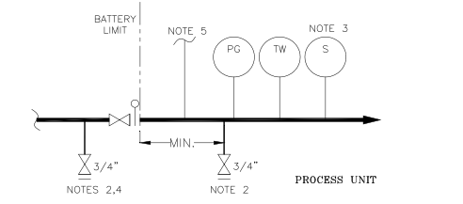

**Figure 6.1: General Low Pressure Hydrocarbon Upstream Isolation (Note 1)**

**Figure 6.2: General Low Pressure Hydrocarbon Downstream Isolation (Note 1)**

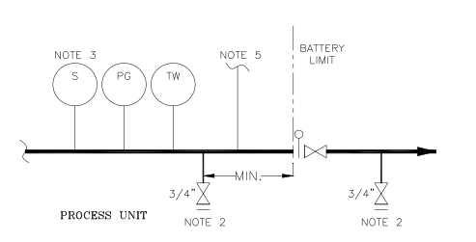

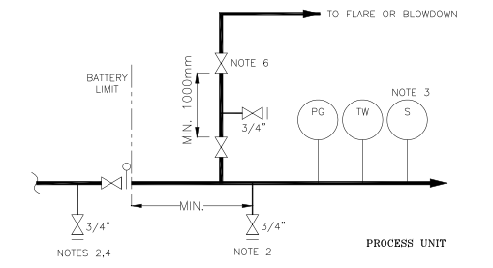

**Figure 6.3: High Vapor Pressure Service Upstream Isolation (Note 1)**

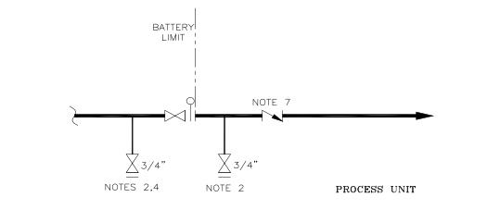

**Figure 6.4: General Utility (Note 1)**

**Notes**:

* 1. Double block and bleed valves may be required
  2. Drain valve size is dependent on process line size. Normally 3/4" as defined on the P&ID.
  3. Sample connection (if required).
  4. Upstream valve may be required in some services.
  5. To/from flushing oil, flare connections, etc., if required.
  6. The need for BL depressurizing depends on the overall unit depressurizing philosophy.
  7. NRV for Nitrogen service.

## Isolation at Package Units

All lines to and from VENDOR supplied package units shall have positive isolation.

This may be provided within the VENDOR Package or shown on the CONTRACTOR P&IDs. The means of isolation should be reviewed during the Detailed Engineering phase to avoid duplication of valves.

1. **ISOLATION FOR ON-STREAM MAINTENANCE**

## Isolation for Relief Valves

**7.1.1 Relief Valve for Services Other Than Thermal Relief**

1. Relieving to Flare or Process

A Full bore block valve with an LO facility and bleed shall be specified for both inlet and outlet lines. (Double block and bleeds shall be used for services in section 5.2.2).

1. Relieving to Atmosphere at Safe Location

A full-bore block valve with an LO facility and bleed shall be specified only on the inlet line Provide separate tail pipes for each valve.

**7.1.2 Relief Valve for Thermal Relief/Rupture Disk**

1. Relieving to Flare or Process

A full bore block valve with an LO facility and bleed shall be specified for both inlet and outlet lines.

1. Relieving to Atmosphere at Safe Location

A single block valve with an LO facility and bleed shall be specified only on the inlet line Provide separate tail pipes for each valve.

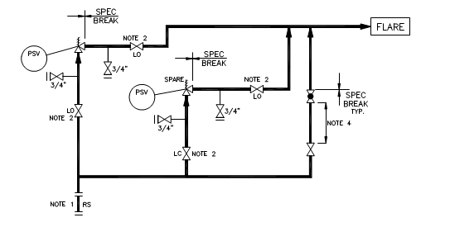

**Figure 7.1: Services other than Thermal Relief‐ Closed Relief System**

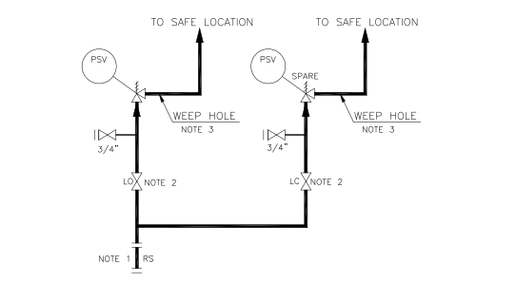

**Figure 7.2: Services other than Thermal Relief‐ Open Relief System**

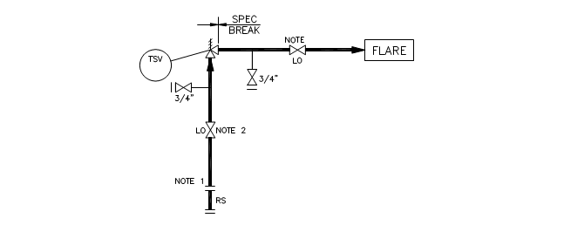

**Figure 7.3: Thermal Relief‐ Closed Relief System**

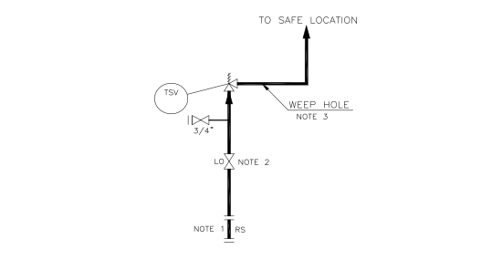

**Figure 7.4: Thermal Relief- Open Relief System**

**Notes:**

1. From vessel or from piping on vessel without intervening valves.
2. Double block valve (without intermediate bleed and pressure indicator) shall be used for applications mentioned in Section 5.2.2.
3. Give consideration to whether condensation could occur e.g. in steam service if valve leaks badly, very hot water will come from the drain.
4. For wet and LPG service, a minimum spacing of 600 mm shall be specified between isolating and globe valves in order to avoid freezing.

**7.1.3 Bypass Line**

A bypass line around the relief valve(s) with a single isolation valve shall be specified only where there is a requirement to vent the gas in the system to flare and no other connection to flare is provided nearby. For wet and LPG service, a minimum spacing of 600 mm shall be specified between isolating and globe valves in order to avoid freezing.

**7.1.4 Bleed Valves/ Weep Holes**

Bleed valve shall be provided on the Relief Valve arrangement. Any requirement to vent at a safe location shall be noted. Weep holes shall be provided for valves, relieving to atmosphere (to prevent rainwater accumulating), with shielding or diversion for personnel protection as necessary.

**7.1.5 Relief Valve Arrangement**

The arrangement for a spared relief valve isolating valves and connections shall be shown as in Figure 7-1.

## Isolation of Utilities from Process Systems

Temporary piping/ hoses for steam out and purging should normally be used. If permanent connections are required, Figure 7.5 shall be followed.

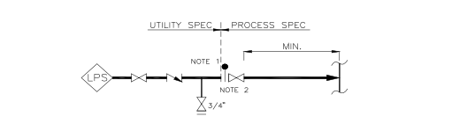

**Steam Out**

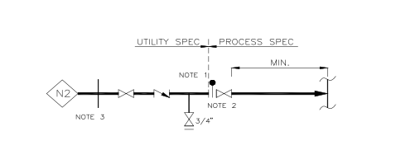

**Nitrogen Purge**

**Figure 7.5: Utility Isolation**

**Notes:**

1. The valve is to be included in the higher specification.
2. Double block valves may be provided. Valve closest to pipe or vessel to be locked closed.
3. A removable spool piece may be provided for maintenance isolation.

## Blow down Valve

Emergency Depressurizing Valve/ Blow down Valve (EDV/ BDV) should be equipped with a locked open isolation valve and restriction orifice in downstream. Minimum 600 mm distance should be respected between EDV/ BDV outlet and restriction orifice.

1. **PIPELINE AND TRANSFER LINE ISOLATION**

## General Considerations

There are two methods for pipeline isolation:

* Isolation and decommissioning of the entire pipeline.
* Isolation and decommissioning of a localized section of the pipeline.

The later can be executed using block valves located along the length of the pipeline, or by using various techniques such as line plugging, pipe stoppers, bags, high friction pigs or use of slugs of inert fluids. These techniques, by nature, contain an element of risk, and appropriate trials are recommended before execution in the field. The use of block valves is examined below.

## TRANSPORTATION PipelineS

* Double block and bleed system should be used in the situations where isolation of the main stream from the ancillary equipment is needed for safe operation and maintenance without depressurizing the pipeline.
* Valves to be used in the pipeline which will be pigged shall be full bore through-conduit gate valve or full bore ball valves.
* Block valves should be provided at each end of all pipelines, at all connections and branches of the pipeline and where necessary for safety and maintenance reasons to isolate long pipelines into sections as to limit the release of line content in case of leaks or line raptures.
* The number of flanges in the pipeline and piping systems should be kept to a minimum and should be installed only to facilitate maintenance and inspection and where construction conditions or process requirements dictate. Tie-in welds are preferred.

## Launcher/Receiver Isolation

Isolation of pig launchers/receivers is necessary for safe pigging operation. The principles of positive isolation as given in section 5 shall be applied around pig launchers and receivers.

Once the launcher/receiver has been depressurized and isolated, the launcher/receiver shall be suitably flushed and purged before opening the closure door. Mechanical interlocks should be provided to ensure safe operation and to prevent inadvertent opening of the door while the pressure remains in the system.

## line-break VALVE

Isolating block valves fitted with automatic line-break-operators should be installed in fenced areas on either side of the major river crossings. If valves are installed in valve pits, the top of the pits should be above maximum recorded high water level and if there is possibilities of water ingressing into the pits, facilities should be considered for emptying the water.

The automatic line-break-operators should be designed to close the valve in the event of pipeline failure and subsequent rapid rate of change of pressure in the pipeline but should not be affected by normal operational pressure fluctuations. The design should ensure that changes of the water course and/or collapse of the river side walls will not endanger the integrity of the valve support.