|  |  |  |  |  |  |  |  |
| --- | --- | --- | --- | --- | --- | --- | --- |
| **طرح نگهداشت و افزایش تولید 27 مخزن** | | | | | | | |
| **MATERIAL & EQUIPMENT CONTROL INDEX (MCI)**  **نگهداشت و افزایش تولید میدان نفتی بینک** | | | | | | | |
|  |  |  |  |  |  |  |
|  |  |  |  |  |  |  |
|  |  |  |  |  |  |  |
|  |  |  |  |  |  |  |
| G00 | Aug. 2022 | IFC | M.Torabi | M.Fakharian | M.Mehrshad |  |
| **Rev.** | **Date** | **Purpose of Issue/Status** | **Prepared by:** | **Checked by:** | **Approved by:** | **CLIENT Approval** |
| **Class: 2** | | **CLIENT Doc. Number:** **F0Z-707038** | | | | |
| **Status:** | **IDC: Inter-Discipline Check**  **IFC: Issued For Comment**  **IFA: Issued For Approval**  **AFD: Approved For Design**  **AFC: Approved For Construction**  **AFP: Approved For Purchase**  **AFQ: Approved For Quotation**  **IFI: Issued For Information**  **AB-R: As-Built for CLIENT Review**  **AB-A: As-Built –Approved** | | | | | |

**REVISION RECORD SHEET**

|  |  |  |  |  |  |  |  |  |  |  |  |  |
| --- | --- | --- | --- | --- | --- | --- | --- | --- | --- | --- | --- | --- |
| **PAGE** | **G00** | **G01** | **G02** | **G03** | **G04** |  | **PAGE** | **G00** | **G01** | **G02** | **G03** | **G04** |
| **1** | X |  |  |  |  | **66** |  |  |  |  |  |
| **2** | X |  |  |  |  | **67** |  |  |  |  |  |
| **3** | X |  |  |  |  | **68** |  |  |  |  |  |
| **4** | X |  |  |  |  | **69** |  |  |  |  |  |
| **5** | X |  |  |  |  | **70** |  |  |  |  |  |
| **6** | X |  |  |  |  | **71** |  |  |  |  |  |
| **7** | X |  |  |  |  | **72** |  |  |  |  |  |
| **8** | X |  |  |  |  | **73** |  |  |  |  |  |
| **9** |  |  |  |  |  | **74** |  |  |  |  |  |
| **10** |  |  |  |  |  | **75** |  |  |  |  |  |
| **11** |  |  |  |  |  | **76** |  |  |  |  |  |
| **12** |  |  |  |  |  | **77** |  |  |  |  |  |
| **13** |  |  |  |  |  | **78** |  |  |  |  |  |
| **14** |  |  |  |  |  | **79** |  |  |  |  |  |
| **15** |  |  |  |  |  | **80** |  |  |  |  |  |
| **16** |  |  |  |  |  | **81** |  |  |  |  |  |
| **17** |  |  |  |  |  | **82** |  |  |  |  |  |
| **18** |  |  |  |  |  | **83** |  |  |  |  |  |
| **19** |  |  |  |  |  | **84** |  |  |  |  |  |
| **20** |  |  |  |  |  | **85** |  |  |  |  |  |
| **21** |  |  |  |  |  | **86** |  |  |  |  |  |
| **22** |  |  |  |  |  | **87** |  |  |  |  |  |
| **23** |  |  |  |  |  | **88** |  |  |  |  |  |
| **24** |  |  |  |  |  | **89** |  |  |  |  |  |
| **25** |  |  |  |  |  | **90** |  |  |  |  |  |
| **26** |  |  |  |  |  | **91** |  |  |  |  |  |
| **27** |  |  |  |  |  | **92** |  |  |  |  |  |
| **28** |  |  |  |  |  | **93** |  |  |  |  |  |
| **29** |  |  |  |  |  | **94** |  |  |  |  |  |
| **30** |  |  |  |  |  | **95** |  |  |  |  |  |
| **31** |  |  |  |  |  | **96** |  |  |  |  |  |
| **32** |  |  |  |  |  | **97** |  |  |  |  |  |
| **33** |  |  |  |  |  | **98** |  |  |  |  |  |
| **34** |  |  |  |  |  | **99** |  |  |  |  |  |
| **35** |  |  |  |  |  | **100** |  |  |  |  |  |
| **36** |  |  |  |  |  | **101** |  |  |  |  |  |
| **37** |  |  |  |  |  | **102** |  |  |  |  |  |
| **38** |  |  |  |  |  | **103** |  |  |  |  |  |
| **39** |  |  |  |  |  | **104** |  |  |  |  |  |
| **40** |  |  |  |  |  | **105** |  |  |  |  |  |
| **41** |  |  |  |  |  | **106** |  |  |  |  |  |
| **42** |  |  |  |  |  | **107** |  |  |  |  |  |
| **43** |  |  |  |  |  | **108** |  |  |  |  |  |
| **44** |  |  |  |  |  | **109** |  |  |  |  |  |
| **45** |  |  |  |  |  | **110** |  |  |  |  |  |
| **46** |  |  |  |  |  | **111** |  |  |  |  |  |
| **47** |  |  |  |  |  | **112** |  |  |  |  |  |
| **48** |  |  |  |  |  | **113** |  |  |  |  |  |
| **49** |  |  |  |  |  | **114** |  |  |  |  |  |
| **50** |  |  |  |  |  | **115** |  |  |  |  |  |
| **51** |  |  |  |  |  | **116** |  |  |  |  |  |
| **52** |  |  |  |  |  | **117** |  |  |  |  |  |
| **53** |  |  |  |  |  | **118** |  |  |  |  |  |
| **54** |  |  |  |  |  | **119** |  |  |  |  |  |
| **55** |  |  |  |  |  | **120** |  |  |  |  |  |
| **56** |  |  |  |  |  | **121** |  |  |  |  |  |
| **57** |  |  |  |  |  | **122** |  |  |  |  |  |
| **58** |  |  |  |  |  | **123** |  |  |  |  |  |
| **59** |  |  |  |  |  | **124** |  |  |  |  |  |
| **60** |  |  |  |  |  | **125** |  |  |  |  |  |
| **61** |  |  |  |  |  | **126** |  |  |  |  |  |
| **62** |  |  |  |  |  | **127** |  |  |  |  |  |
| **63** |  |  |  |  |  | **128** |  |  |  |  |  |
| **64** |  |  |  |  |  | **129** |  |  |  |  |  |
| **65** |  |  |  |  |  | **130** |  |  |  |  |  |

**CONTENTS**

1.0 INTRODUCTION 4

2.0 SCOPE 5

3.0 rEFERENCE 5

4.0 Order of Precedence 5

5.0 EXHIBITS 5

## INTRODUCTION

Binak oilfield in Bushehr province is a part of the southern oilfields of Iran, is located 20 km northwest of Genaveh city.

With the aim of increasing production of oil from Binak oilfield, an EPC/EPD Project has been defined by NIOC/NISOC and awarded to Petro Iran Development Company (PEDCO). Also PEDCO (as General Contractor/GC) has assigned the EPC-packages of the Project to "Hirgan Energy - Design and Inspection" JV.

**GENERAL DEFINITION**

The following terms shall be used in this document.

|  |  |
| --- | --- |
| CLIENT: | National Iranian South Oilfields Company (NISOC) |
| PROJECT: | Binak Oilfield Development – General Facilities |
| EPD/EPC CONTRACTOR (GC) | Petro Iran Development Company (PEDCO) |
| EPC CONTRACTOR: | Joint Venture of : Hirgan Energy – Design & Inspection(D&I) Companies |
| VENDOR: | The firm or person who will fabricate the equipment or material. |
| EXECUTOR: | Executor is the party which carries out all or part of construction and/or commissioning for the project. |
| THIRD PARTY INSPECTOR (TPI): | The firm appointed by EPD/EPC CONTRACTOR (GC) and approved by CLIENT (in writing) for the inspection of goods. |
| SHALL: | Is used where a provision is mandatory. |
| SHOULD: | Is used where a provision is advisory only. |
| WILL: | Is normally used in connection with the action by CLIENT rather than by an EPC/EPD CONTRACTOR, supplier or VENDOR. |
| MAY: | Is used where a provision is completely discretionary. |

## SCOPE

This document presents some index (exhibits) for control of the project material and equipment.

## rEFERENCE

* ISO 9001
* Procurement & Services Contracting Procedure (BK-GNRAL-HD-000-PM-PR-0009)
* Material Control Procedure (BK-GNRAL-HD-000-PM-PR-0011)
* Quality Control Plan (BK-GNRAL-PEDCO-000-QC-PR-0002)
* Inspection Test Plans (ITPs)
* Vendor’s Quality System Procedures

## Order of Precedence

In case of any conflict between the contents of this document or any discrepancy between this document and other project documents or reference standards, this issue must be reported to the CLIENT. The final decision in this situation will be made by CLIENT.

## EXHIBITS

Exhibit – 1: Codded Marking Control Log

Exhibit – 2: Item Transfer Slip

Exhibit – 3: Application & Result For Inspection

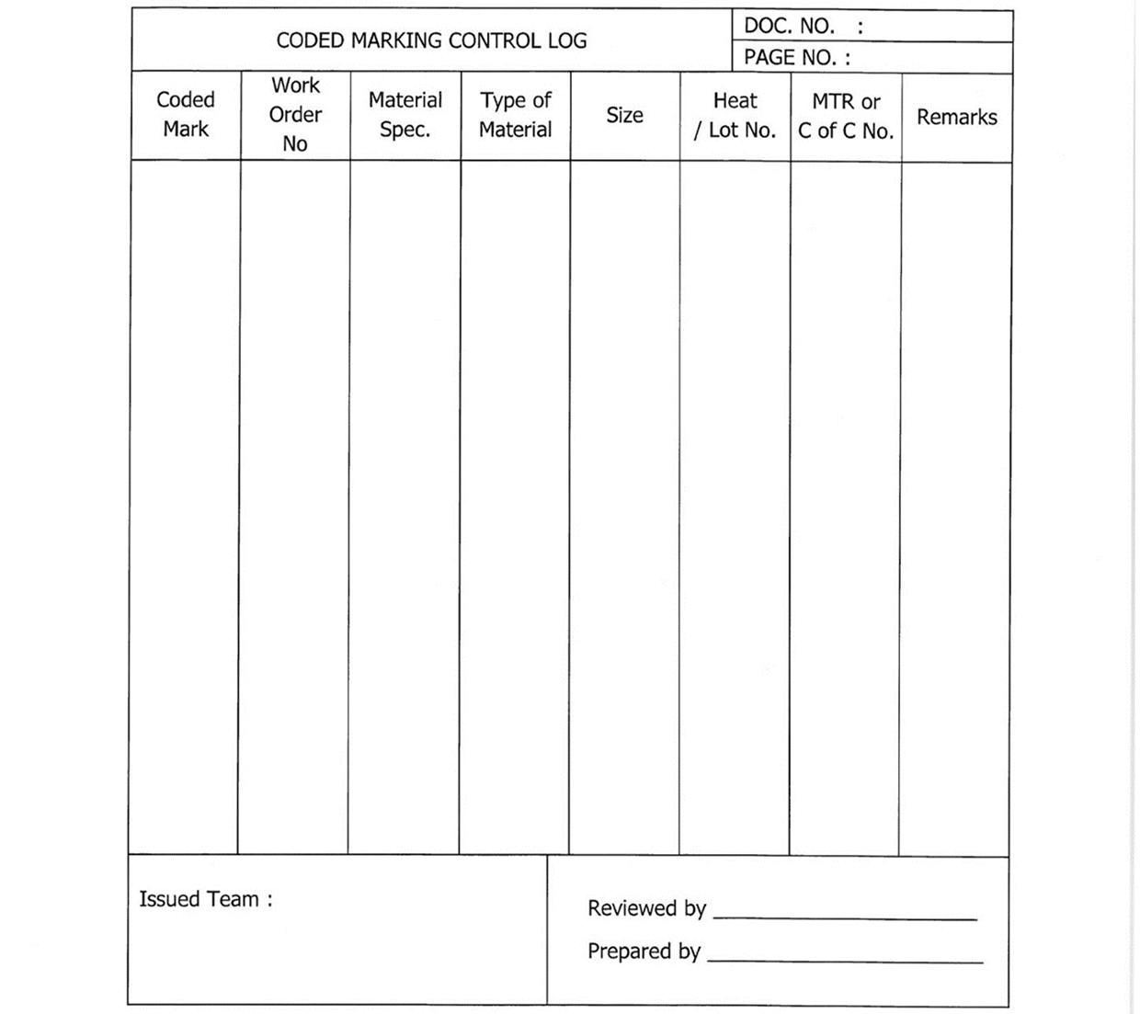**Exhibit-1: Codded Marking Control Log**

