|  |  |  |  |  |  |  |  |
| --- | --- | --- | --- | --- | --- | --- | --- |
| **طرح نگهداشت و افزایش تولید 27 مخزن** | | | | | | | |
| **CALCULATION NOTE FOR CHEMICAL INJECTION AND STORAGE SHELTER**  **نگهداشت و افزایش تولید میدان نفتی بینک** | | | | | | | |
|  | |  |  |  |  |  |  |
|  | |  |  |  |  |  |  |
|  | |  |  |  |  |  |  |
|  | |  |  |  |  |  |  |
| D00 | | AUG. 2022 | IFC | R.Berlouie | M.Fakharian | M.Mehrshad |  |
| **Rev.** | | **Date** | **Purpose of Issue/Status** | **Prepared by:** | **Checked by:** | **Approved by:** | **CLIENT Approval** |
| **Class:2** | | | **CLIENT Doc. Number:** **F0Z-709141** | | | | |
| **Status:** | | **IDC: Inter-Discipline Check**  **IFC: Issued For Comment**  **IFA: Issued For Approval**  **AFD: Approved For Design**  **AFC: Approved For Construction**  **AFP: Approved For Purchase**  **AFQ:** Approved For Quotation  **IFI: Issued For Information**  **AB-R: As-Built for CLIENT Review**  **AB-A: As-Built –Approved** | | | | | |

**REVISION RECORD SHEET**

|  |  |  |  |  |  |  |  |  |  |  |  |  |
| --- | --- | --- | --- | --- | --- | --- | --- | --- | --- | --- | --- | --- |
| **PAGE** | **D00** | **D01** | **D02** | **D03** | **D04** |  | **PAGE** | **D00** | **D01** | **D02** | **D03** | **D04** |
| **1** | X |  |  |  |  | **66** |  |  |  |  |  |
| **2** | X |  |  |  |  | **67** |  |  |  |  |  |
| **3** | X |  |  |  |  | **68** |  |  |  |  |  |
| **4** | X |  |  |  |  | **69** |  |  |  |  |  |
| **5** | X |  |  |  |  | **70** |  |  |  |  |  |
| **6** | X |  |  |  |  | **71** |  |  |  |  |  |
| **7** | X |  |  |  |  | **72** |  |  |  |  |  |
| **8** | X |  |  |  |  | **73** |  |  |  |  |  |
| **9** | X |  |  |  |  | **74** |  |  |  |  |  |
| **10** | X |  |  |  |  | **75** |  |  |  |  |  |
| **11** | X |  |  |  |  | **76** |  |  |  |  |  |
| **12** | X |  |  |  |  | **77** |  |  |  |  |  |
| **13** | X |  |  |  |  | **78** |  |  |  |  |  |
| **14** | X |  |  |  |  | **79** |  |  |  |  |  |
| **15** | X |  |  |  |  | **80** |  |  |  |  |  |
| **16** | X |  |  |  |  | **81** |  |  |  |  |  |
| **17** | X |  |  |  |  | **82** |  |  |  |  |  |
| **18** | X |  |  |  |  | **83** |  |  |  |  |  |
| **19** | X |  |  |  |  | **84** |  |  |  |  |  |
| **20** | X |  |  |  |  | **85** |  |  |  |  |  |
| **21** | X |  |  |  |  | **86** |  |  |  |  |  |
| **22** | X |  |  |  |  | **87** |  |  |  |  |  |
| **23** | X |  |  |  |  | **88** |  |  |  |  |  |
| **24** | X |  |  |  |  | **89** |  |  |  |  |  |
| **25** | X |  |  |  |  | **90** |  |  |  |  |  |
| **26** | X |  |  |  |  | **91** |  |  |  |  |  |
| **27** | X |  |  |  |  | **92** |  |  |  |  |  |
| **28** | X |  |  |  |  | **93** |  |  |  |  |  |
| **29** | X |  |  |  |  | **94** |  |  |  |  |  |
| **30** | X |  |  |  |  | **95** |  |  |  |  |  |
| **31** | X |  |  |  |  | **96** |  |  |  |  |  |
| **32** | X |  |  |  |  | **97** |  |  |  |  |  |
| **33** | X |  |  |  |  | **98** |  |  |  |  |  |
| **34** | X |  |  |  |  | **99** |  |  |  |  |  |
| **35** | X |  |  |  |  | **100** |  |  |  |  |  |
| **36** | X |  |  |  |  | **101** |  |  |  |  |  |
| **37** | X |  |  |  |  | **102** |  |  |  |  |  |
| **38** | X |  |  |  |  | **103** |  |  |  |  |  |
| **39** | X |  |  |  |  | **104** |  |  |  |  |  |
| **40** |  |  |  |  |  | **105** |  |  |  |  |  |
| **41** |  |  |  |  |  | **106** |  |  |  |  |  |
| **42** |  |  |  |  |  | **107** |  |  |  |  |  |
| **43** |  |  |  |  |  | **108** |  |  |  |  |  |
| **44** |  |  |  |  |  | **109** |  |  |  |  |  |
| **45** |  |  |  |  |  | **110** |  |  |  |  |  |
| **46** |  |  |  |  |  | **111** |  |  |  |  |  |
| **47** |  |  |  |  |  | **112** |  |  |  |  |  |
| **48** |  |  |  |  |  | **113** |  |  |  |  |  |
| **49** |  |  |  |  |  | **114** |  |  |  |  |  |
| **50** |  |  |  |  |  | **115** |  |  |  |  |  |
| **51** |  |  |  |  |  | **116** |  |  |  |  |  |
| **52** |  |  |  |  |  | **117** |  |  |  |  |  |
| **53** |  |  |  |  |  | **118** |  |  |  |  |  |
| **54** |  |  |  |  |  | **119** |  |  |  |  |  |
| **55** |  |  |  |  |  | **120** |  |  |  |  |  |
| **56** |  |  |  |  |  | **121** |  |  |  |  |  |
| **57** |  |  |  |  |  | **122** |  |  |  |  |  |
| **58** |  |  |  |  |  | **123** |  |  |  |  |  |
| **59** |  |  |  |  |  | **124** |  |  |  |  |  |
| **60** |  |  |  |  |  | **125** |  |  |  |  |  |
| **61** |  |  |  |  |  | **126** |  |  |  |  |  |
| **62** |  |  |  |  |  | **127** |  |  |  |  |  |
| **63** |  |  |  |  |  | **128** |  |  |  |  |  |
| **64** |  |  |  |  |  | **129** |  |  |  |  |  |
| **65** |  |  |  |  |  | **130** |  |  |  |  |  |

**CONTENTS**

1.0 INTRODUCTION 5

2.0 Scope 5

3.0 NORMATIVE REFERENCE 5

**3.1** **Local Codes and Standards** 5

**3.2** **International Codes and Standards** 5

**3.3** **The Project Documents** 5

4.0 Material properties 6

5.0 STRUCTURE ‘s systems 6

6.0 DESIGN LOAD 6

**6.1** **Dead load** 6

**6.2** Live Loads 7

**6.3** SNOW LOADS 8

**6.4** **-Unbalanced SNOW LOADS** 9

**6.5** **Seismic loads** 10

**6.6** **CRANE load** 12

**6.7** **WIND loads** 13

7.0 SAP loading table 18

8.0 Load combinations 18

9.0 STRUCTURE ANALYSIS AND DESIGN 18

**9.1** **ANALYSIS** 18

**9.2** **Flextural design of crane beam** 20

**9.3** **Deflection control :** 20

**9.4** **Drift control :** 21

10.0 Structural Design Results 22

**10.1** **Graphical output** 22

11.0 STRUCTURE CONNECTIONS 24

**11.1** **Special moment frame** 24

-Beam to column 24

**11.2** **Description of Design Procedure & Parameters** 25

**11.3** **Connection Force Calculation :** 27

**11.4** **Beam Specification:** 27

**11.5** **End plate thickness calculation :** 28

**11.6** **End Plate Specification :** 28

**11.7** **Determine Multiplier force of the flange :** 28

**11.8** **Shear yield control of the end plate :** 28

**11.9** **Shear rupture control of end plate** 29

**11.10** **Control of shear rupture resistance of screws:** 29

**11.11** **Continuty plate requirement** : 29

**11.12** **local column web yielding control** : 29

**11.13** **PURLIN DESIGN** 30

**11.14** **Base Plate** 32

12.0 FOUNDATION DESIGN 36

**12.1** **Soil pressure and settlement** 36

**12.2** **DESIGN** 37

**12.3** **FOUNDATION DESIGN CONTROL** 37

12.3.1Check of Stress for Foundation 37

12.3.2. Check of Displacement for Foundation 38

12.3.3 REINFORCING CONTROL 38

12.3.4Punching shear control 39

1. **INTRODUCTION**

Binak oilfield in Bushehr province is a part of the southern oilfields of Iran, is located 20 km northwest of Genaveh city.

With the aim of increasing production of oil from Binak oilfield, an EPC/EPD Project has been defined by NIOC/NISOC and awarded to Petro Iran Development Company (PEDCO). Also PEDCO (as General Contractor) has assigned the EPC-packages of the Project to "Hirgan Energy - Design and Inspection" JV.

1. **Scope**

This report covers the structure & foundation calculation report of the “Chemical injection and Storage Shelter ”. The structure modelled by “SAP” software & the foundation modelled by “SAFE” software.

1. **NORMATIVE REFERENCE**
   1. **Local Codes and Standards**

* INBC Part 6 “Iranian National Building Code
* INBC Part 7 “Iranian National Building Code
* INBC Part 9 “Iranian National Building Code
* INBC Part 10 “Iranian National Building Code
* Iranian Seismic Design Code for Petroleum Facilities(3rd edition)
  1. **International Codes and Standards**
* ASCE 7-10 “Minimum Design Loads and Associated Criteria for Buildings and Other Structures-American Society of Civil Engineers”.
* ACI 318. “Building Code Requirements for Reinforced Concrete”, American Concrete Institute.
* AISC 358 “Prequalified Connections for Special and Intermediate Steel Moment Frames for Seismic Applications.” American Institute of Steel Construction, Inc.
* AISC 360 - “Specification for Structural Steel Buildings”. American Institute of Steel Construction, Inc.
  1. **The Project Documents**

## BK-GNRAL-PEDCO-000-ST-SP-0001 SPECIFICATION FOR CONCRETE WORK

## BK-gcs-PEDCO-120-ST-DW-0058 Structural drawing for chemical injection & storage shelter

1. **Material properties**

Material properties are delivered in the following table.

table 1 -Material Properties

|  |  |
| --- | --- |
| Foundation Concrete | F'c = 25 Mpa(28- day cylindrical sample) |
| Long. reinforcement bar | Fy = 400 Mpa(AIII) |
| Trans. reinforcement bar | Fy = 400 Mpa(AIII) |
| Bolt Type | HV 8.8 |
| Electrode Type | E 70 |

1. **STRUCTURE ‘s systems**

The Structure’s System is OMF in X direction and OCBF system in Y direction.Seismic Parameters according to Iranian seismic design code listed at below table.

table 2 -Material Properties

|  |  |  |  |
| --- | --- | --- | --- |
|  | R | Omega | cd |
| x dir | 3.5 | 3 | 3 |
| y dir | 3.25 | 2 | 3.25 |

1. **DESIGN LOAD**
   1. **Dead load**

Dead loads include the self-weight of the structure and all the permanent equipment which are supported by the structures

$$Corogated sheet :8 kg/m^{2}$$

$$Z Purlin : 8 kg/m^{2}$$

$$Insulation :10 kg/m^{2}$$

$$\sum{sum= 26 kg/m^{2}}$$

Roof weight is assigned in software 26 kg/m2.

* At ended frame : $26×2.5=65 kg/m$
* At middle frame : $26×5=130 kg/m$

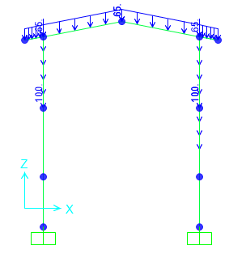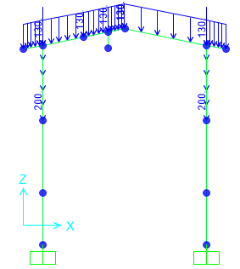

**Figure 1-**applied Dead load on ended axe(1&3) (kg/m)  **Figure 2-**applied Dead load on middle axe 2(kg/m)

* 1. Live Loads

The design live load on an area shall be defined as the weight of all movable loads, including personnel, tools, and parts of dismantled equipment, cranes, hoist, and temporarily stored materials.

According to Iranian National Building code No.6 Live load in light slop roof is 50kg/m2 and assumed 1.3KN concentrated load has been applied at critical frame.

* At ended frame : $50×2.5=125 kg/m$
* At middle frame : $50×5=250 kg/m$

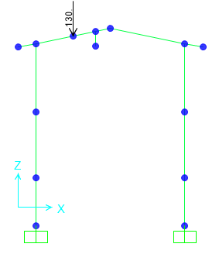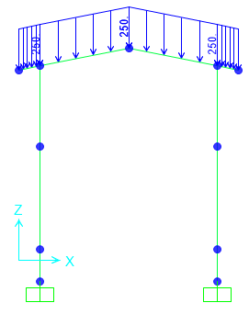

**Figure 3-Applied live Load on frame 2 (kg/m)**

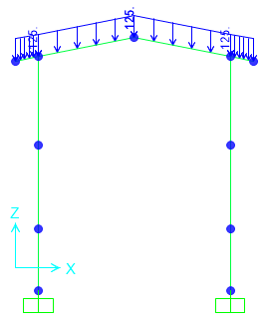

**Figure 4-Applied live Load on frame 1&3 (kg/m)**

* 1. SNOW LOADS

Snow load of this structure is calculated in accordance with Iranian National Building Code No.6 Latest edition.. Parameters which are used in calculation of snow force is presented in below:

$$P_{r}=P_{s}C_{n}C_{h}I_{S}C_{s}$$

Ps=25 kg/m2 , Is=1

Cs= 0.91 (slope 11.31o)=1-

Ch=1

Cn=0.8

$$P_{r}=P_{s}C_{n}C_{h}I_{S}C_{s}=18..06\frac{kg}{m2}$$

* At ended frame : $18.06×2.5=45.15 kg/m$
* At middle frame : $18.06×5=90.3 kg/m$

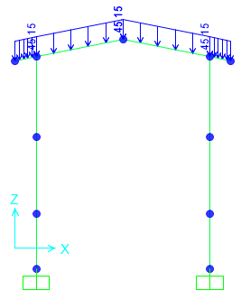 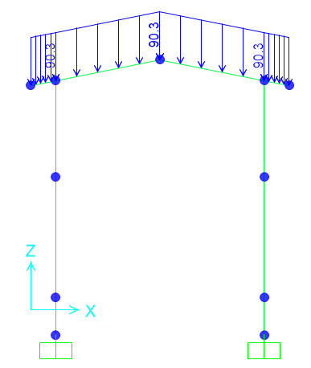

**Figure 5-**applied Snow load on ended axe(1&3) (kg/m)  **Figure 6-**applied Snow load on middle axe 2(kg/m)

* 1. **-Unbalanced SNOW LOADS**

According to Iranian National Building Code No.6 (latest edition)) Unbalanced snow load have been considered for roof slope between 4%~60%..in this structure Calculation of this load represents as below:

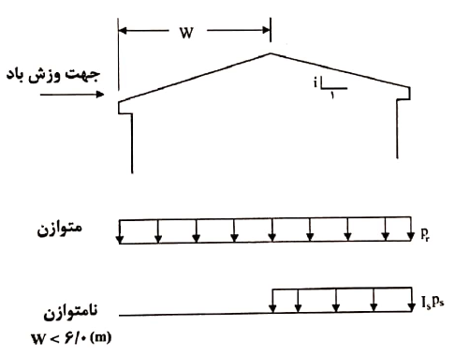

$${ for lu<6 m P}_{r}={I_{s}P}_{g}=25\frac{kg}{m2}$$

`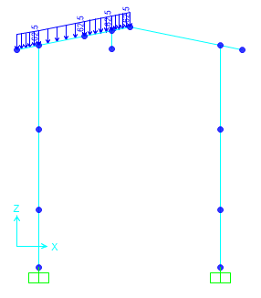 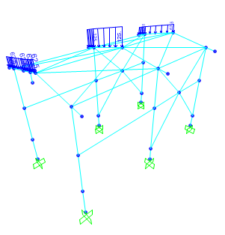

Wind load

**Figure 7-applied unbalancexd Snow Load(SN)**

* At ended frame : $25×2.5=62.5 kg/m$

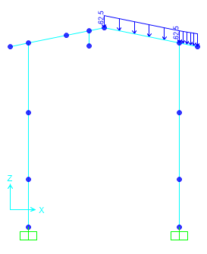 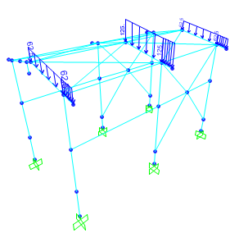

Wind load

**Figure 8-applied unbalancexd Snow Load(SP)**

* 1. **Seismic loads**

All structures are in area with high risk zone of seismic and until finalizing of “Geotechnical Final Report” soil type consider is type III. Equivalent static method is used for calculation of seismic loads. Parameters which are used in calculation of earthquake force and seismic coefficient is presented in below.

Seismic loads are calculated according to Iranian Seismic Design code for petroleum facilities (3rd Edition)

For OMF system (X direction)

Rux=3.5

Omega=3

Cd=3

For OCBF system (Y direction)

Ruy=3.25

Omega=2

Cd=3.25

Soil Type : Type III

According to Iranian Seismic Design code for petroleum facilities (3rd Edition)

* **For X direction**

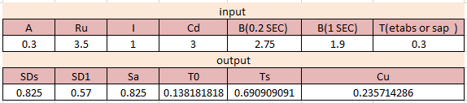

A=0.3

$Ru=3.5$ (According to table 4-4 code 038 3r Edition)

$Cd=3.0$ (According to table 4-4 code 038 3r Edition)

$$I=1$$

B(0.2s)=2.75( According to Soil type)

B(1s)=1.9( According to Soil type)

$$T=0.3 according to sap software$$

T0<T<Ts $Sa=A.B\left(0.2s\right)=0.825$

$C_{u}x=\frac{S_{a}.I}{R_{u}}$ =0.235

* **For Y direction:**

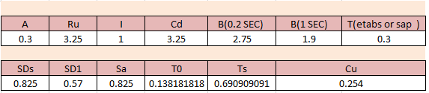

$A=0.3$ ( In this area)

$Ru=3.25$ (According to table 4-4 code 038 3r Edition)

$Cd=3.25$ (According to table 4-4 code 038 3r Edition)

$$I=1$$

B(0.2s)=2.75( According to Soil type)

B(1s)=1.9( According to Soil type)

$T=0.3 according to sap model$

T0<T<Ts $Sa=A.B\left(0.2s\right)=0.825$

$C_{u}y=\frac{S_{a}.I}{R_{u}}$ =0.254

-Ev : Vertical seismic load applied at model according to section 2-2-3-2 (code 038)

$${ E}_{v}=αS_{DS}=0.2*0.825=0.165$$

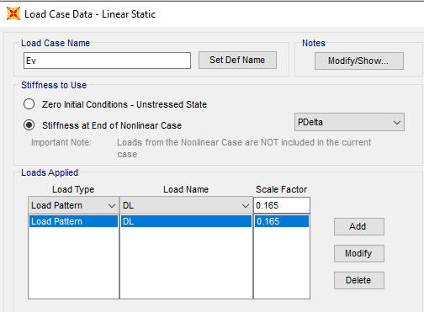

Ev applied at model as a portion of dead load as above.

* 1. **CRANE load**

Distribution of crane load is as below :

Capacity : 2000 kg

Monorail weight +Trolley weight : 2000 kg

Cis: crane vertical impact load

Cvs+Cis=KvCvs

Kvs =1.25 (according to INBC no.6)

Cvs=1.25x(2000+2000)= 5000 kg = 5 ton

Cls=0.1x5000 = 500 kg (in Y direction)

* 1. **WIND loads**

Wind loads are calculated according to ASCE07-10 and applied at model as below:

V=120 km/h(According to Iranian National Building Code No.6 last edition)

${ V}_{ASCE}=1.53×\sqrt{1.6Iw} ×V_{INBC} V\left(\frac{m}{S}\right)$

$${ V}_{ASCE}=1.53×\sqrt{1.6Iw} ×V_{INBC} =1.53×\sqrt{1.6}×120×\frac{10}{36} =64.5 mph$$

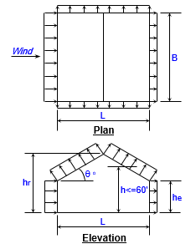

Building classification =I building and other structures that represent a low risk to human life in the event of failure (Risk Category)

Exposure Category=C(open terrain with scattered obstructions having heights generally<30ft . this category includes flat open country and grass lands.

Ridge height =5.7 m

Eave height =5.2 m

Building width=5 m

Building length=10m

Roof type =Gable

Topo factor Kzt=1

Direct factor kd=1

Enclose =yes

Hurricane rfegion =no

Roof angle =11.31

Mean roof height =5.45 m

$q_{h=}0..00256*Kz*Kzt*Kd*v^{2}=7.97$ psf

$${GC}_{pi } Coefficient \left(Positive Internal pressure\right)=0.18$$

$${GC}_{pi } Coefficient \left(Negative Internal pressure\right)=-0.18$$

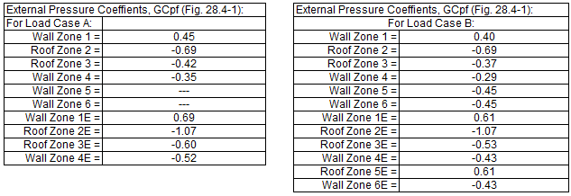

|  |  |  |  |  |  |  |  |
| --- | --- | --- | --- | --- | --- | --- | --- |
| Zone 1 is windward wall for interior zone. | | | | Zone 1E is windward wall for end zone. |  |  |  |
| Zone 2 is windward roof for interior zone. | | | | Zone 2E is windward roof for end zone. |  |  |  |
| Zone 3 is leeward roof for interior zone. | | | | Zone 3E is leeward roof for end zone. |  |  |  |
| Zone 4 is leeward wall for interior zone. | | | | Zone 4E is leeward wall for end zone. |  |  |  |
| Zones 5 and 6 are sidewalls. | | |  | Zone 5E & 6E is sidewalls for end zone. |  |  |  |
| Zone 1T is windward wall for torsional case |  |  |  | Zone 2T is windward roof for torsional case. |  |  |  |
| Zone 3T is leeward roof for torsional case |  |  |  | Zone 4T is leeward wall for torsional case. | | | |

According to ASCE 07-10 Design wind pressure for the building of all height shall be determined by the following equation : $P=qGCp-qi\left(GCpi\right)$

|  |  |  |  |  |  |  |  |
| --- | --- | --- | --- | --- | --- | --- | --- |
| **MWFRS Wind Load for Load Case A** | | |  | **MWFRS Wind Load for Load Case B** | | | |
| Surface | GCpf | p = Net Pressures (psf) |  | Surface | *GCpf | p = Net Pressures (psf) |  |
|  |  | (w/ +GCpi) | (w/ -GCpi) |  |  | (w/ +GCpi) | (w/ -GCpi) |
| Zone 1 | 0.45 | 2.19 | 5.06 | Zone 1 | 0.40 | 1.75 | 4.62 |
| Zone 2 | -0.69 | -6.94 | -4.07 | Zone 2 | -0.69 | -6.94 | -4.07 |
| Zone 3 | -0.42 | -4.75 | -1.88 | Zone 3 | -0.37 | -4.39 | -1.52 |
| Zone 4 | -0.35 | -4.22 | -1.35 | Zone 4 | -0.29 | -3.75 | -0.88 |
| Zone 5 | --- | --- | --- | Zone 5 | -0.45 | -5.02 | -2.15 |
| Zone 6 | --- | --- | --- | Zone 6 | -0.45 | -5.02 | -2.15 |
| Zone 1E | 0.69 | 4.07 | 6.94 | Zone 1E | 0.61 | 3.43 | 6.30 |
| Zone 2E | -1.07 | -9.97 | -7.10 | Zone 2E | -1.07 | -9.97 | -7.10 |
| Zone 3E | -0.60 | -6.20 | -3.33 | Zone 3E | -0.53 | -5.66 | -2.79 |
| Zone 4E | -0.52 | -5.57 | -2.70 | Zone 4E | -0.43 | -4.86 | -1.99 |
| Zone 5E | --- | --- | --- | Zone 5E | 0.61 | 3.43 | 6.30 |
| Zone 6E | --- | --- | --- | Zone 6E | -0.43 | -4.86 | -1.99 |

|  |  |  |  |  |  |  |  |
| --- | --- | --- | --- | --- | --- | --- | --- |
| **MWFRS Wind Load for Load Case A** | | | | **MWFRS Wind Load for Load Case B** | | | |
| Surface | GCpf | p = Net Pressures (kg/m2) |  | Surface | *GCpf | p = Net Pressures (kg/m2) |  |
|  |  | (w/ +GCpi) | (w/ -GCpi) |  |  | (w/ +GCpi) | (w/ -GCpi) |
| Zone 1 | 0.45 | 10.69 | 24.70 | Zone 1 | 0.40 | 8.56 | 22.57 |
| Zone 2 | -0.69 | -33.85 | -19.85 | Zone 2 | -0.69 | -33.85 | -19.85 |
| Zone 3 | -0.42 | -23.20 | -9.19 | Zone 3 | -0.37 | -21.40 | -7.39 |
| Zone 4 | -0.35 | -20.58 | -6.57 | Zone 4 | -0.29 | -18.29 | -4.28 |
| Zone 5 | --- | --- | --- | Zone 5 | -0.45 | -24.51 | -10.51 |
| Zone 6 | --- | --- | --- | Zone 6 | -0.45 | -24.51 | -10.51 |
| Zone 1E | 0.69 | 19.84 | 33.85 | Zone 1E | 0.61 | 16.73 | 30.74 |
| Zone 2E | -1.07 | -48.64 | -34.63 | Zone 2E | -1.07 | -48.64 | -34.63 |
| Zone 3E | -0.60 | -30.25 | -16.24 | Zone 3E | -0.53 | -27.63 | -13.62 |
| Zone 4E | -0.52 | -27.17 | -13.17 | Zone 4E | -0.43 | -23.74 | -9.73 |
| Zone 5E | --- | --- | --- | Zone 5E | 0.61 | 16.73 | 30.74 |
| Zone 6E | --- | --- | --- | Zone 6E | -0.43 | -23.74 | -9.73 |

**Figure 5-Wind Load calculation( (kg/m2))**

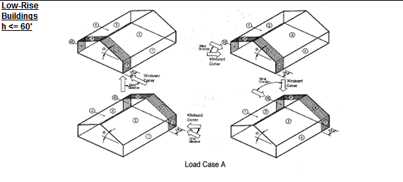 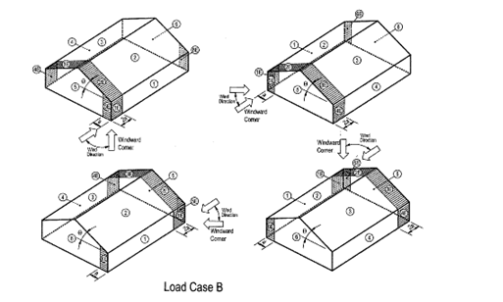

**Figure 9-Wind Load Direction**

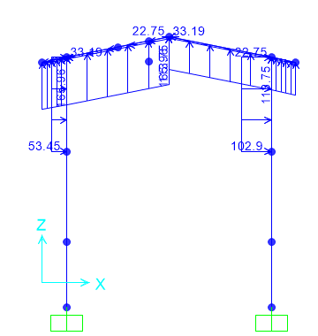**-Wind Load Apply at Frame 2**

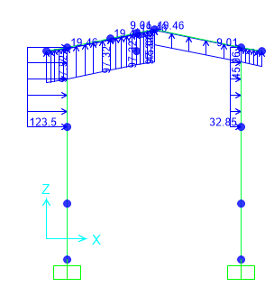

**Figure 10-Wind Load apply(wx &wx1)**

Load Case A

(Wx) Due to G+Cpi : Wx1: Due to G-Cpi $1: Wx=10.69×5=53.45 \frac{kg}{m} 1: Wx=24.70×5=123.50 \frac{kg}{m}$

$2: Wx=-33.85×5=-169.25 \frac{kg}{m} 2: Wx=-19.85×5=-99.25 \frac{kg}{m}$

$$3: Wx=-23.20×5=-116 \frac{ kg}{m} 3: Wx=-9.19×5=-45.95 \frac{ kg}{m}$$

$$4: Wx=-20.58×5=-102.9 \frac{ kg}{m} 4: Wx=-6.57×5=-32.85 \frac{ kg}{m}$$

**Wind Load Apply at Frame 2 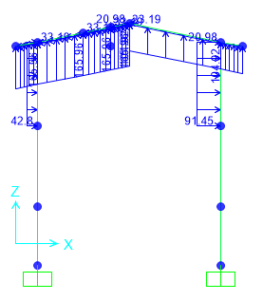:**

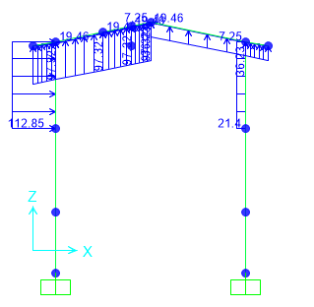  
**Figure 11-Wind Load apply(wy &wy1)**

Load Case A

(WY) Due to G+Cpi : WY1: Due to G-Cpi $1: Wy=8.56×5=42.80 \frac{kg}{m} 1: Wy1=22.75 ×5=112.85 \frac{kg}{m}$

$2: Wy=-33.85×5=-169.25 \frac{kg}{m} 2: Wy1=-19.85×5=-99.25 \frac{kg}{m}$

$$3: Wy=-21.40×5=-107 \frac{ kg}{m} 3: Wy1=-7.39×5=-36.95 \frac{ kg}{m}$$

$$4: Wy=-18.29×5=-91.45 \frac{ kg}{m} 4: Wy1=-4.28×5=-21.40 \frac{ kg}{m}$$

$$5: Wy=-24.51×0.25=-6\frac{ kg}{m} 5: Wy1=-10.51×0.25=-2.62\frac{ kg}{m}$$

$$6: Wy=-24.51×0.25=-6 \frac{ kg}{m} 6: Wy1=-10.51×0.25=2.62 \frac{ kg}{m}$$

1. **SAP loading table**

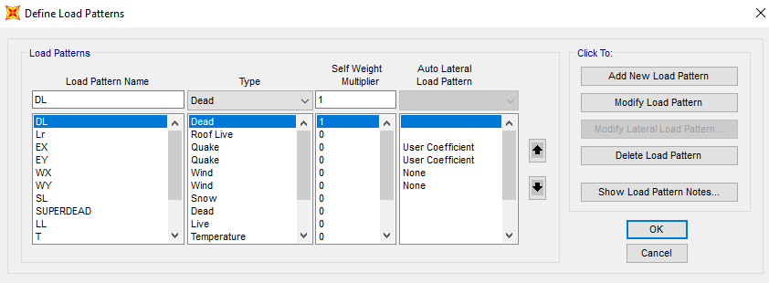

1. **Load combinations**

According to code ASCE7 structures, components, and foundations shall be designed, so that their design strength equals or exceeds that effect of factored loads in the following combination:

* *1.4(D)*
* *(1.2D) +1.6(L)+0.5(Lr/S/R)*
* *1.2D+1.6(Lr/S/R) + (L/0.5W)*
* *1.2D+1.0(W) + L+.5(Lr/S)*
* *1.2D+1.0E+L+0.2S*
* *0.9D+1.0W*
* *0.9D+1.0E*

Load listed herein shall be considered to act in the following combinations; whichever produces the most unfavorable effect considering soil reactions.

* *D*
* *D+L*
* *D+(Lr/S/R)*
* *D+0.75(L)+0.75(Lr/R/S)*
* *D+(0.6W or 0.7E)*
* *D+0.75L+0.75(0.6W)+0.75(Lr/S/R)*
* *D+0.75L+0.75(0.7E)+0.75S*
* *0.6D+0.6W*
* *0.6D+0.7E*

1. **STRUCTURE ANALYSIS AND DESIGN** 
   1. **ANALYSIS**

Structural analysis is done by SAP2000 software. In model loads are applied, some graphical outputs from model are shown as follows.

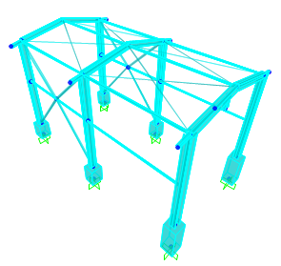

**Figure 12-3D view of SAP model**

:

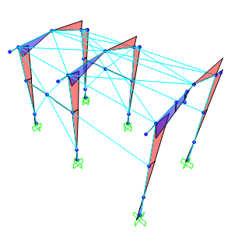

**Figure 13:** **Moment 3-3 under Ex load**

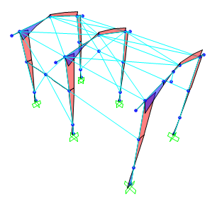

**Figure 14: Moment 3-3 Wx load**

* 1. **Flextural design of crane beam**

According to below output from sap software maximum crane beam moment under critical load combination is 605863 kg.cm :

$$∅Mn=0.9xZxFy=0.9x2400x561=1211760 kg.cm$$

$$M_{u}=605863 kg.cm$$

$$s=\frac{6.058}{12.11}=0.5 ok$$

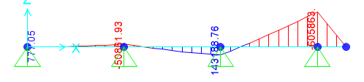

**Figure 15: Moment 3-3 under service load combination on crane beam**

* 1. **Deflection control :**

Maximum beam deflection under crane live load is :

$δ=\frac{PL^{3}}{48EI}=\frac{2000*500^3}{48*2.1*10^{6}*9723}=0.25$ cm< 0.625 ok

* 1. **Drift control :**

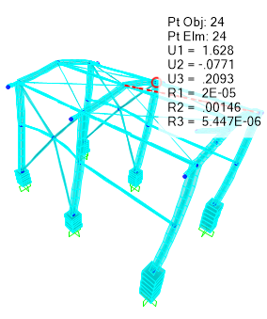

**Figure 16: Moment 3-3 under service load combination on crane beam**

Maximum displacement according to above output from sap model under critical service load combination is about 1.62 cm which is less than allowable drift.

$$allowable drift is \frac{h}{180}=2.5cm$$

1. **Structural Design Results**
   1. **Graphical output**

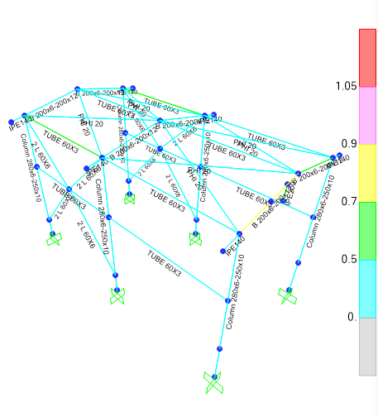

**Figure 17: Steel Design Output**

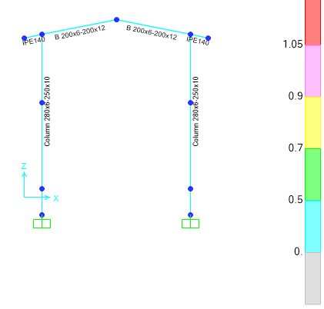

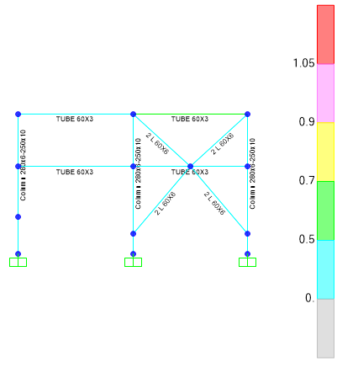

**Figure 18**: **Demand Capacity Ratio of Elements**

1. **STRUCTURE CONNECTIONS**
   1. **Special moment frame**

### -Beam to column

According to AISC 358-10 chapter 6, connection types 4ES and 8ES shall be used. Prequalified Special moment frame connections have been determined according to AISC 341- 10, Part 1, Section 10; AISC 358-10, Chapter 6 & AISC Design Guides 4, 13. Introductory figures & tables are attached. (Design procedure is mainly based on AISC 358 – 10 section 6.10)

High pretension bolts, used are equivalent to HV8.8 with ultimate strength of Fu=8,000 kg/cm2. The units used in the above mentioned codes & based calculation are kg-cm.

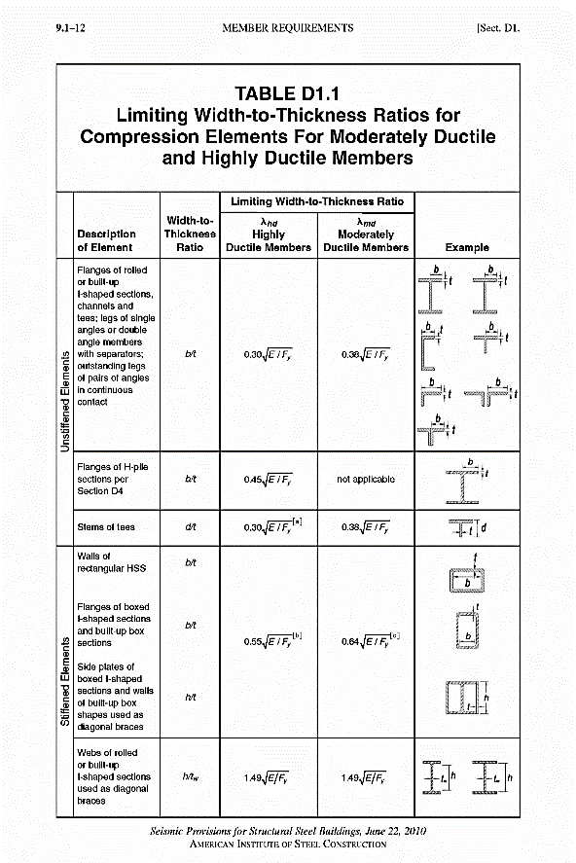

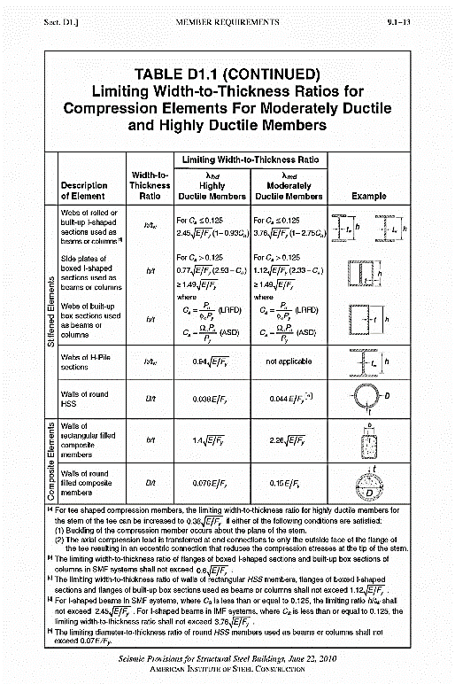

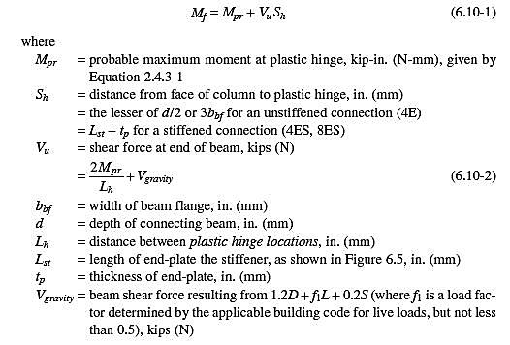

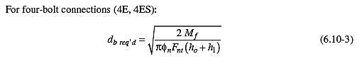

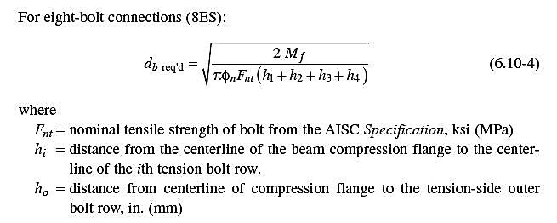

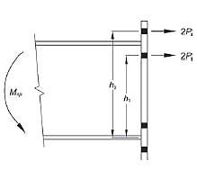

**Figure 19**: **4ES (four Extended Stiffened)**

* 1. **Description of Design Procedure & Parameters**

Compact sections shall be selected according to AISC 360-10.

bf, tf, hw and tw are sizes of girder.

Ry is the ratio of expected to specified structural steel yield strength.

$M_{pr}=C_{pr}.R_{y}.F_{y}.Z$ probable maximum moment at plastic hinge (according to AISC358- 10).

$S_{h}=$ distance from the face of column to plastic hinge $= L_{st}+t_{p}$ (according to AISC358- 10).

$L_{st}=$ Length of the end-plate stiffener.

$t_{p}=$ end-plate thickness.

$L_{n}=$ distance between plastic hinges.

$M_{f}=M_{pr}+V_{p}.L_{n}$ moment at the face of te column (according to AISC358- 10).

$V_{p}= \frac{2M_{pr}}{L_{n}}+\frac{wL_{n}}{2}$ Shear force at the end of the beam (according to AISC358- 10).

$M_{ff}=$ since amplified moment is allowed to be used for Special frame connections. It is extracted from the load combination using $ΩM_{E}$ ($Ωx=3 , Ωy=2$).

$F_{u}=$ bolt ultimate strength (HV8.8).

$F_{nt}=$ nominal tensile strength of bolt.

$ϕ_{n}=$ non-ductile resistance factor ($=0.9$ according to AISC358-10).

$h_{i}=$ distance from the centerline of the beam compression flange to the centerline of ith tension bolt row.

$(d_{b})=$ required bolt dimension (according to AISC358-10)

$d_{b}=$ selected bolt diameter

phi Rn 4S = bolt shear rupture strength of the connection (according to AISC358-10)

$F_{b} 4S$ bolt stress according to flexural < phi Fnt.

phi Rn yield = local column web yielding strength at beam flanges (according to AISC358-10).

phi Rn buck. = unstiffened column web buckling strength at beam compression flange (according to AISC358-10).

phi Rn cripp. = unstiffened column web crippling strength at beam compression flange (according to AISC358-10).

$d_{c}=$ overall depth of column.

$t_{wc}=$ column web thickness including doubler plates with plug weld.

Astiff = calculated required continuity plates area.

$t_{p}=$ thickness of end-plate calculated according to plate theories formulas regarding plate boundary conditions. (it submits exactly the same amount using AISC 358 formulas).

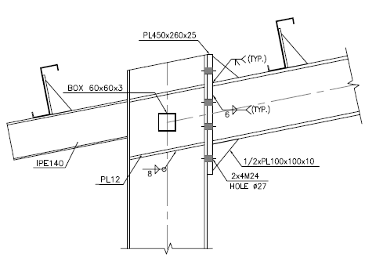

Figure 20: BEAM TO COLUMN CONNECTION

* 1. **Connection Force Calculation :**
 $$S_{h}=\min\left(\frac{d}{2} , 3b_{bf}\right)=11.2 cm$$

 $$L_{h}=L-2Sh=4.776m$$

$$Wu=1.2D+L+0.2s=0.424 t/m$$

2. **Beam Specification:**
 $$b_{f}\left(cm\right)=20 ,t_{f}=1.2cm , h_{w}\left(cm\right)=20 , t_{w}\left(cm\right)=0.6$$

 $$Z=579.33cm3$$

$$M_{p}=Z*Fy=1918734.33kg.cm$$

$$1.1≤C_{pr}=\frac{F_{y}+F_{u}}{2Fy}=1.27≤1.2 C_{pr}=1.2$$

$$M_{pr}=C_{pr}R_{y}M_{p}=1.2×1.2×1918734.33=2020065.361 kg.cm=20.20 t.m$$

$$R_{y}=1.2$$

$${V^{H}}_{gravity}=\frac{W_{u}L_{h}}{2}=9.09 ton$$

$$V_{pr}=\frac{2M_{pr}}{L_{h}}=9.04 ton$$

$$M_{u}=M_{pr}+\frac{W_{u}Sh^{2}}{2}=2.02×{10}^{6} kg.cm=20.2 ton.m$$

3. **End plate thickness calculation :**

Mu=20.2 ton.m

$$∅_{d}=1.0$$

$$F_{yp}=2400 kg/cm2$$

$s=\frac{1}{2}\sqrt{b_{p}g}=$ 14 cm

$Y_{P}=\frac{b_{p}}{2}$ [$h_{1}\left(\frac{1}{P_{fi}}+\frac{1}{S}\right)+h0\left(\frac{1}{P_{fo}}\right)-\frac{1}{2}]+\frac{2}{g}[h1(P_{fi}+S)]=141.71$

$t_{p req}=\sqrt{\frac{1.11M_{u}}{φ_{d}F_{yp}Y_{p}}}=2.5 cm$ We Used Plate 450 x 270 x 25

* 1. **End Plate Specification :**

|  |  |
| --- | --- |
| bp(cm) | 27 |
| tp(cm) | 2.5 |
| g(cm) | 14 |
| s | 9.72 |
| pfi | 6 |
| pfo | 6 |

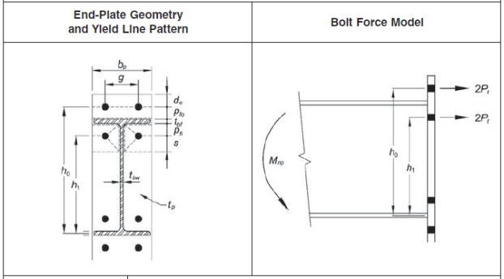

* 1. **Determine Multiplier force of the flange :**
 $$F_{fu}=\frac{M_{u}}{d_{b}-t_{bf}}=95298.65 kg$$

 2. **Shear yield control of the end plate :**
 $$R_{n}=0.6F_{yp}b_{p}t_{p}=97200 kg=97.20 ton$$

 $$\frac{F_{fu}}{2}≤∅_{d}R_{n } \frac{95298.65}{2}=47649.32≤1×97200 ok$$

3. **Shear rupture control of end plate**
 $$An=tp\left(bp-2dcal\right)=43.72cm2$$

 $$dcal=2.6cm$$

$$R_{n}=0.6F_{up}A_{n}=97051.9 kg=97.051ton$$

$$\frac{F_{fu}}{2}≤∅_{n}R_{n} 47649<0.9×97.05=87.345 ok$$

4. **Control of shear rupture resistance of screws:**
 $$V_{u}=9.094 ton$$

 $$∅_{n}=0.9$$

$$n_{b}=4$$

$$F_{u}=8000 kg/cm2$$

$$F_{nv}=0.55Fu=4400\frac{kg}{cm2}$$

$$d_{b}=2.4cm$$

$$A_{b}=\frac{(πd_{b})^2}{4}=4.52 cm2$$

$$R_{n}\left(kg\right)=n_{b}F_{nv}A_{b}=79580.16$$

$$V_{u}=9.094≤∅_{n}R_{n}=0.9*79.58=71.622 ton ok$$

5. **Continuty plate requirement** :

Column flange design force:

* 1. **local column web yielding control** :

$$∅d=1$$

$$Ct=1$$

$$K_{c}=1$$

$$F_{yc}=2400 kg/cm2$$

$$t_{cw}=0.6 cm$$

$$t_{bf}=1.2 cm$$

$$t_{p}=2.5cm$$

$$F_{fu}=95.298 ton$$

$$R_{n}=C_{t}\left(6Kc+tbf+2tp\right)=Fyc tcw=48.528 ton$$

$$F_{fu}<∅_{d}R_{n }$$

Continuty plate is needed. According to above calculation Ffu>

* 1. **PURLIN DESIGN**

## 11.13.1. Property of Purlin(Z180x2.5)

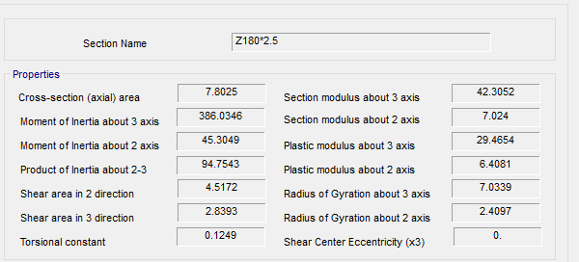

**Figure 21-Section Property Of Purlin**

According to above table :

$$A=7.80 cm2$$

$$J=0.12 cm4$$

$$Ix=386.06 cm4$$

$$Iy=45.304 cm4$$

$$rx=7.033 cm$$

$$ry=2.41 cm$$

$$ho=18 cm$$

$$SY=42.305 cm3$$

$$SX=7.024 cm3$$

FOR Z 180 :

$$D+L=26+50=76 kg/m^{2}$$

$$P_{y}=76.\cos{11}=74.6 kg/m^{2}$$

$$P_{x}=76.\sin{11}=14.5 kg/m^{2}$$

$$middle of span : M_{y}=\frac{w.L^{2}}{8}=\frac{76×1.0×5^{2}}{8}=237.5 kg.m$$

$$middle of span : M_{x}=\frac{w.L^{2}}{360}=\frac{14.5×1×5^{2}}{360}=1.00kg.m$$

$$f_{b}=\frac{M_{y}}{s_{y}}+2\frac{M_{x}}{s_{x}}=\frac{237.5×100}{42.305}+2\frac{1.00×100}{7.024}=561.39+28.47=589.86<1440 ok$$

$$moment on sagrod support : M_{y}=\frac{w.L^{2}}{9}=\frac{76×1.0×5^{2}}{9}=211.11 kg.m$$

$$moment on sagrod support : M_{x}=\frac{w.L^{2}}{90}=\frac{14.5×1.0×5^{2}}{90}=4.02 kg.m$$

$$f_{b}=\frac{M_{y}}{s_{y}}+2\frac{M_{x}}{s_{x}}=\frac{211.11×100}{42.305}+2\frac{4.02×100}{7.024}=498.99+114.46=613.45< 1440 ok$$

### 11.13.2.Un deformed shape CONTROL:

* 1. **Base Plate**

**Design force :**

$$V_{tr}=\frac{M_{p}}{H}=\frac{ZF_{y}}{H}=\frac{842.6×2400×{10}^{-5}}{4.5}=4.49 ton$$

$$V_{long}=R_{y}A_{g}F_{y}cosθ=1.25×4000×13.68×cos 50=43966 kg=43.966ton$$

**Shear check in transverse direction :**

According to INBC No.10 section 10-2-6-2-1

$$∅V_{n}=0.6F_{y}A_{w}C_{v } ∅_{v}$$

$\frac{h}{t_{w}}=\frac{28}{0.6}=46.67<2.24\sqrt{\frac{2.06×{10}^{6}}{2400}=65}$ then $C_{v}=1 ∅_{v}=1$

$${∅V}_{n}=0.6×2400×\left(28×0.6\right)×1×1=24.192 ton>4.49 ton$$

**Shear check in longitudinal direction :**

According to INBC No.10 section 10-2-6-7-2

$$K_{v}=1.2$$

$$\frac{h}{t_{w}}=\frac{\frac{b}{2}}{t_{f}}=\frac{12.5}{1}=12.5$$

$$A_{w}=2b_{f}t_{f}=2×25×1=50 cm2$$

$$\frac{h}{t_{w}}<1.1\sqrt{\frac{K_{v}E}{F_{y}}}=35.3 then C_{v}=1 ∅_{v}=0.9$$

$$∅V_{n}=0.9×0.6×2400×50×1=64800 kg=64.8 ton>43.9 ton$$

According to above acalculation The column section is ok for shear check .

**Bolt control in shear**

$$V_{max}=43.96 ton$$

$$F_{nv}=0.55F_{u}=3300 kg$$

$$∅=0.75$$

$$A_{nb}=\frac{V_{max}}{∅F_{nv}}=\frac{43960}{0.75×3300}=17.76 cm^{2} USE 4M27\left(Area=22.90 cm2\right)$$

$Mpc=F_{y}Z_{3-3}=2400×842.6×{10}^{-5}=20.22 ton$

$$\frac{\sum{Mpc}}{Hs}=\frac{20.22}{4.5}=4.49 Vc2$$

$$Mp=1.1RyFyZc=1.1×1.2×2400×842.6×{10}^{-5}=26.69 ton.m$$

$$M_{cx}=\min\left(256.69,5.52\right)=5.5 ton.m$$

$$f_{c}=250 kg/cm2$$

$$\frac{A2}{A1}=1 , ∅_{c}=0.65 f_{pmax}=∅_{c} 0.85 f'c\sqrt{\frac{A2}{A1}}=132kg/cm2$$

$$q_{max}=f_{pmax}×B=6630 kg/cm2$$

**For ordinary & critical load combination**

$$M_{u}=3.33 ton.m$$

$$P_{u}=6.87 ton$$

$$Y_{min}=\frac{P_{u}}{q_{max}}=\frac{6870}{6630}=1.03cm$$

$$ε_{max}=\frac{N}{2}-\frac{Ymin}{2}=24.48 cm$$

$$e=\frac{M_{u}}{P_{u}}=\frac{3.33}{6.87}=0.48m=48cm>ε_{max} tension applied.$$

$$d=6cm$$

$$f=\frac{N}{2}-d=\frac{50}{2}-6=19cm$$

$$Y=\left(f+\frac{N}{2}\right)±\sqrt{{\left(f+\frac{N}{2}\right)}^{2}-\frac{2Mu}{qmax}}=(19+25)±\sqrt{{\left(19+25\right)}^{2}-\frac{2×7.5×{10}^{5}}{6630}}$$

$$Yall=2.66 cm$$

$$\sum{T=qmaxY-Pu=6630×2.66=17.635 ton.m}$$

**Tension Strength control of anchor bolts :**

$$d_{b}=24mm$$

$$A_{nb}=4.52 cm2$$

$$T_{u}=\frac{17.635}{2}=8.8ton$$

$$f_{uT}=\frac{T_{u}}{A_{nb}}=\frac{8.8×1000}{4.52}=1946 kg/cm2$$

$$F_{nT}=0.75F_{u}=4500kg/cm2$$

$$∅=0.75$$

$$R_{nt}=F_{nt}A_{nb}=4500×4.52×{10}^{-3}=20.34 ton$$

$$∅R_{nt}=15.25 ton ≥Tu=8.8 ton ok$$

**Shear control of Anchor Bolts:**

* 1. **General requirements of embedment in concrete**:

**According to ACI318 appendix D:**

Concrete breakout strength of anchor in tension : the nominal concrete breakout strength Ncbg shall not exceed

$$N_{cbg}=\frac{A_{NC}}{A_{NCO}}ω_{ec}ω_{ed,N}ω_{c,N}ω_{cp,N}N_{b}$$

$$A_{CNO}=9hef^{2}$$

$$A_{NC}=(S1+3hef)(S2+3hef)$$

$$K_{c}=10$$

$$N_{b}=10γ_{a}\sqrt{f_{c}}h_{ef}^{1.5}=10×1×\sqrt{25}×{126.6}^{1.5}=71.2 KN$$

$$λ_{ef}=\max\left(\frac{Ca,max}{1.5},\frac{S1}{3},\frac{S2}{3}\right)=\left(\frac{\frac{60}{1.5,380}}{3}\right)=126.6mm$$

$$C_{a,max}=\max\left(Ca1,Ca2,Ca3,Ca4\right)=60 mm$$

$$A_{NCO}=9×{126.6}^{2}=144248.04 mm2$$

$$A_{NC}=\left(60+3×126.6\right)×\left(60+3×126.6\right)=193424.04mm2$$

$$ω_{ec,N}=1$$

$$C_{a,min}=60 mm$$

$$h_{ef}=126.6 mm$$

$$ω_{ed,N}=0.7+0.3×\frac{60}{1.5×126.6}=0.79$$

$$ω_{c,N}=1$$

$$ω_{cp,N}=1$$

$$N_{cbg}=\frac{A_{NC}}{A_{NCO}}ω_{ec}ω_{ed,N}ω_{c,N}ω_{cp,N}N_{b}=\frac{193424.04}{144248.04}×1×0.79×1.25×71.2=94.27 KN$$

$$∅=0.7$$

$$∅N_{cbg}=6.72ton>1.75 ok$$

Concrete strength to withstand against tension in braced frame column under combination with Ω factor is acceptable.

**Concrete breakout of anchor in shear :**

The nominal concrete breakout strength Vcbg in shear shall not exceed :

$$V_{cbg}=\frac{A_{VC}}{A_{VCO}}ω_{ec,V}ω_{ed,V}ω_{c,V}ω_{h,V}V_{b}$$

$$A_{Vco}=4.5{Ca1}^{2}$$

$$\frac{A_{V}}{A_{Vco}}=0.66<n=2$$

$$h_{a}=\min\left(t_{f},1.5{Ca}_{1,2}\right)=\left(1600,1.5×60\right)=90mm$$

$$A_{vc}=120×90=10800 mm2$$

$$A_{vco}=4.5{Ca1}^{2}=16200mm2$$

$$ω_{ed,V}=1$$

$$ω_{e,v}=1.4$$

$$ω_{h,v}=\sqrt{\frac{1.5{Ca}_{1}}{ha}}=1$$

$$V_{b}=\min\left(0.6{\left(\frac{l_{e}}{d_{a}}\right)}^{0.2}\sqrt{d_{a} }λ_{a}\sqrt{fc }{Ca1}^{1.5} , 3.7λ_{a}\sqrt{fc }{Ca1}^{1.5}\right)=\min\left( 10.353 KN,8.5KN\right)=8.5 KN$$

$$λ_{a}=1$$

$$V_{cbg}=\frac{A_{VC}}{A_{VCO}}ω_{ec,V}ω_{ed,V}ω_{c,V}ω_{h,V}V_{b}=\frac{10800}{16200}×1×1.4×1×8.5=7.93 ton>2 ton ok$$

### -REQUIRED THICKNESS

Maximum Axial Load according to SAP2000 model is about 4.3 ton Under critical load combination:

$t=l\sqrt{\frac{2P_{U}}{0.9F_{y}BN} }$ =11.7 $\sqrt{\frac{2x4300}{0.9x2400x50x50}}=0.46$ cm used th=2 cm

$m=\frac{N-0.95d}{2}$ = $\frac{500-0.95*280}{2}$ =117

$n=\frac{B-0.8bf}{2}$ = $\frac{500-0.8*250}{2}$ =150

$${λn}^{'}=λ\frac{\sqrt{dbf}}{4}=1*\frac{\sqrt{240*250}}{4}=61$$

L=max(m,n,λn)=117

1. **FOUNDATION DESIGN**
   1. **Soil pressure and settlement**

Until finalize of geotechnical report for this area we consider => qa= 2kg/cm2

Based on Bowels experimental formula for subgrade modulus => Ks = 1.345qall

Loading used for foundation design, have been received from SAP analysis.

* 1. **DESIGN**

Concrete Foundation are designed according to ACI 318-14. Required loads are derived from SAP data, and design process will be done according to ACI code based on ultimate strength procedure.

* 1. **FOUNDATION DESIGN CONTROL**

### 12.3.1Check of Stress for Foundation

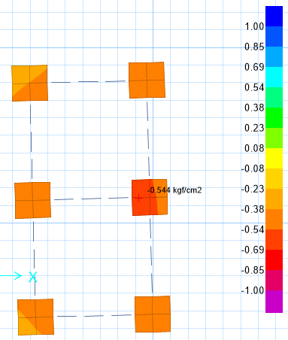

**Figure 22** **- Check of Stress for Foundation (kg/cm2)**

According to SAFE report, Max soil pressure under the foundation is:

$$q_{n}=0.544kg/{cm}^{2} < 2 kg/{cm}^{2} ok$$

### 12.3.2. Check of Displacement for Foundation

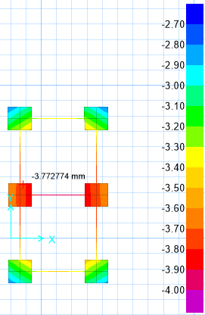

**Figure23- Check of Displacement for Foundation(mm)**

According to SAFE report, Max soil displacement under the foundation is:

$$d_{n}=3.75 mm < 25 cm ok$$

### 12.3.3 REINFORCING CONTROL

Minimum rebar for foundation:

$$A_{s min}=0.0018bh$$

$$A_{smin}=\frac{1}{2}0.0018 bh=\frac{1}{2}0.0018×100×50=4.5 cm^{2}/m$$

$$A_{s used}=∅16@200=10.05cm^{2}$$

### 12.3.4Punching shear control

### 

**Figure 24: additional reinforement Figure 25: punch shear control**