|  |  |  |  |  |  |  |  |
| --- | --- | --- | --- | --- | --- | --- | --- |
| **طرح نگهداشت و افزایش تولید 27 مخزن** | | | | | | | |
| **CALCULATION NOTE FOR DIESEL GENERATOR SIZING**    **نگهداشت و افزایش تولید میدان نفتی بینک** | | | | | | | |
|  |  |  |  |  |  |  |
|  |  |  |  |  |  |  |
|  |  |  |  |  |  |  |
| D01 | Aug. 2022 | IFA | H.Shakiba | M.Fakharian | M.Mehrshad |  |
| D00 | Nov. 2021 | IFC | H.Shakiba | M.Fakharian | M.Mehrshad |  |
| **Rev.** | **Date** | **Purpose of Issue/Status** | **Prepared by:** | **Checked by:** | **Approved by:** | **CLIENT Approval** |
| **Class: 2** | | **CLIENT Doc. Number: F0Z-709013** | | | | |
| **Status:** | **IDC: Inter-Discipline Check**  **IFC: Issued For Comment**  **IFA: Issued For Approval**  **AFD: Approved For Design**  **AFC: Approved For Construction**  **AFP: Approved For Purchase**  **AFQ:** Approved For Quotation  **IFI: Issued For Information**  **AB-R: As-Built for Company Review**  **AB-A: As-Built –Approved** | | | | | |

**REVISION RECORD SHEET**

|  |  |  |  |  |  |  |  |  |  |  |  |  |
| --- | --- | --- | --- | --- | --- | --- | --- | --- | --- | --- | --- | --- |
| **PAGE** | **D00** | **D01** | **D02** | **D03** | **D04** |  | **PAGE** | **D00** | **D01** | **D02** | **D03** | **D04** |
| **1** | X | X |  |  |  | **51** |  |  |  |  |  |
| **2** | X | X |  |  |  | **52** |  |  |  |  |  |
| **3** | X | X |  |  |  | **53** |  |  |  |  |  |
| **4** | X | X |  |  |  | **54** |  |  |  |  |  |
| **5** | X | X |  |  |  | **55** |  |  |  |  |  |
| **6** | X | X |  |  |  | **56** |  |  |  |  |  |
| **7** | X | X |  |  |  | **57** |  |  |  |  |  |
| **8** | X | X |  |  |  | **58** |  |  |  |  |  |
| **9** | X | X |  |  |  | **59** |  |  |  |  |  |
| **10** | X | X |  |  |  | **60** |  |  |  |  |  |
| **11** | X | X |  |  |  | **61** |  |  |  |  |  |
| **12** | X | X |  |  |  | **62** |  |  |  |  |  |
| **13** |  |  |  |  |  | **63** |  |  |  |  |  |
| **14** |  |  |  |  |  | **64** |  |  |  |  |  |
| **15** |  |  |  |  |  | **65** |  |  |  |  |  |
| **16** |  |  |  |  |  | **66** |  |  |  |  |  |
| **17** |  |  |  |  |  | **67** |  |  |  |  |  |
| **18** |  |  |  |  |  | **68** |  |  |  |  |  |
| **19** |  |  |  |  |  | **69** |  |  |  |  |  |
| **20** |  |  |  |  |  | **70** |  |  |  |  |  |
| **21** |  |  |  |  |  | **71** |  |  |  |  |  |
| **22** |  |  |  |  |  | **72** |  |  |  |  |  |
| **23** |  |  |  |  |  | **73** |  |  |  |  |  |
| **24** |  |  |  |  |  | **74** |  |  |  |  |  |
| **25** |  |  |  |  |  | **75** |  |  |  |  |  |
| **26** |  |  |  |  |  | **76** |  |  |  |  |  |
| **27** |  |  |  |  |  | **77** |  |  |  |  |  |
| **28** |  |  |  |  |  | **78** |  |  |  |  |  |
| **29** |  |  |  |  |  | **79** |  |  |  |  |  |
| **30** |  |  |  |  |  | **80** |  |  |  |  |  |
| **31** |  |  |  |  |  | **81** |  |  |  |  |  |
| **32** |  |  |  |  |  | **82** |  |  |  |  |  |
| **33** |  |  |  |  |  | **83** |  |  |  |  |  |
| **34** |  |  |  |  |  | **84** |  |  |  |  |  |
| **35** |  |  |  |  |  | **85** |  |  |  |  |  |
| **36** |  |  |  |  |  | **86** |  |  |  |  |  |
| **37** |  |  |  |  |  | **87** |  |  |  |  |  |
| **38** |  |  |  |  |  | **88** |  |  |  |  |  |
| **39** |  |  |  |  |  | **89** |  |  |  |  |  |
| **40** |  |  |  |  |  | **90** |  |  |  |  |  |
| **41** |  |  |  |  |  | **91** |  |  |  |  |  |
| **42** |  |  |  |  |  | **92** |  |  |  |  |  |
| **43** |  |  |  |  |  | **93** |  |  |  |  |  |
| **44** |  |  |  |  |  | **94** |  |  |  |  |  |
| **45** |  |  |  |  |  | **95** |  |  |  |  |  |
| **46** |  |  |  |  |  | **96** |  |  |  |  |  |
| **47** |  |  |  |  |  | **97** |  |  |  |  |  |
| **48** |  |  |  |  |  | **98** |  |  |  |  |  |
| **49** |  |  |  |  |  | **99** |  |  |  |  |  |
| **50** |  |  |  |  |  | **100** |  |  |  |  |  |

**CONTENTS**

1.0 INTRODUCTION 4

2.0 Scope 5

3.0 NORMATIVE REFERENCES 5

3.1 Local Codes & Standards 5

3.2 The Project Documents 5

3.3 Environmental Data 5

3.4 Order of Precedence 5

4.0 DIESEL SIZING 6

4.1 Continuous Operation 6

4.2 Diesel Sizing - Standby Operation (The Biggest Motor Starting) 6

4.3 Diesel Sizing – Conclusion 7

5.0 Generator SIZING 7

5.1 Generator Sizing – Continuous Operation 7

5.2 Generator Sizing – Motor Starting Study 8

5.3 Generator Sizing – Conclusion 8

APPENDIX 1 9

APPENDIX 2 9

1. **INTRODUCTION**

Binak oilfield in Bushehr province is a part of the southern oilfields of Iran, is located 20 km northwest of Genaveh city.

With the aim of increasing production of oil from Binak oilfield, an EPC/EPD Project has been defined by NIOC/NISOC and awarded to Petro Iran Development Company (PEDCO). Also PEDCO (as General Contractor) has assigned the EPC-packages of the Project to "Hirgan Energy - Design and Inspection" JV.

As a part of the Project, a New Gas Compressor Station (adjacent to existing Binak GCS) shall be constructed to gather of 15 MMSCFD (approx.) associated gases and compress & transfer them to Siahmakan GIS.

**GENERAL DEFINITION**

The following terms shall be used in this document.

|  |  |
| --- | --- |
| CLIENT: | National Iranian South Oilfields Company (NISOC) |
| PROJECT: | Binak Oilfield Development – Surface Fcilities; New Gas Compressor Station |
| EPD/EPC CONTRACTOR (GC): | Petro Iran Development Company (PEDCO) |
| EPC CONTRACTOR: | Joint Venture of : Hirgan Energy – Design & Inspection (D&I) Companies |
| VENDOR: | The firm or person who will fabricate the equipment or material. |
| EXECUTOR: | Executor is the party which carries out all or part of construction and/or commissioning for the project. |
| THIRD PARTY INSPECTOR (TPI): | The firm appointed by EPD/EPC CONTRACTOR (GC) and approved by COMPANY (in writing) for the inspection of goods. |
| SHALL: | Is used where a provision is mandatory. |
| SHOULD: | Is used where a provision is advisory only. |
| WILL: | Is normally used in connection with the action by COMPANY rather than by an EPC/EPD CONTRACTOR, supplier or VENDOR. |
| MAY: | Is used where a provision is completely discretionary. |

1. **Scope**

This document covers minimum necessary requirements for the design, selection, manufacture,   
inspection, testing and delivery of diesel generator. The diesel generator set under consideration, will provide emergency power to essential loads in the case of loss of power.

It shall be used in conjunction with data/requisition sheets for present document subject.

1. **NORMATIVE REFERENCES**

## Local Codes & Standards

* IPS-E-EL-100 Engineering Standard for Electrical System Design

## The Project Documents

D01

* BK-GCS-PEDCO-120-EL-LI-0001 Electrical Load List
* BK-GNRAL-PEDCO-000-EL-SP-0009 Specification for Diesel Generator
* BK-GCS-PEDCO-120-EL-DT-0003 Data Sheets for Diesel Generator
* BK-GCS-PEDCO-120-EL-SL-0002 LV Switchgear/MCC Single Line Diagram

## Environmental Data

Refer to "Process Basis of Design; Doc. No. BK-GNRAL-PEDCO-000-PR-DB-0001-D07"

## Order of Precedence

In case of conflict between requirements specified herein & the requirements of any other referenced document, the most approved stringent requirements of below listed items shall be considered based on the approval given by the owner’s representative:

* Purchase order
* Material Requisition
* MTO & Data Sheet
* This Specification
* Drawing & Other Specification
* Reference Project Specification
* Iranian Petroleum Standard (IPS)
* Reference international Code & Standards

When the term “Authorized”, Authorization”, “Approval”, or “Approved” are used in this specification, it shall mean authorization or Approval from OWNER.

In case of any conflict between the project documents, the most stringent one shall be considered.

1. **DIESEL SIZING**

## Continuous Operation

D01

According to Electrical Load List “BK-GCS-PEDCO-120-EL-LI-0001-D04”, total Peak Active Power is equal to 343 kW. (Refer to end page)

Considering 20% spare capacity diesel generator load will be equal to:

Pde = 343×1.2 = 412 kW (This will be used for diesel engine sizing)

According to Electrical Load List, total Apparent Peak Power is equal to 404 kVA. Considering 20% spare capacity, diesel generator load will be equal to:

Sde = 404×1.2 = 485 kVA (This will be used for generator sizing).

For calculation of mechanical shaft power, electrical demand shall be divided by diesel efficiency. Diesel efficiency according to attached typical efficiency curves (Appendix 1) is about 0.946 @ 80% of rated kVA, so Pdm = P / 0.946= 412/0.946= 435 kWm (net engine power)

10kW cooling fan power requirement (typical value) shall be added to this power:

Pd = 435+10 (fan) = 445 Kw (gross engine power)

Derating factor for site conditions shall be foreseen for diesel engine.

* For humidity no derating factor is recommended by manufacturers.
* For altitudes below 1000m no derating factor is required (da = 1)
* Typical derating factor for ambient temperature is 1.0% per each 5°C over 40°C

So, derating factor for 52°C ambient temperature is dt = (52-40)/5 x 1.0 = 2.4%

Derating factor for site conditions will be da × dt = 0.976

P =Pdm / (da × dt) = 435 /0.976 = 445 kWm (net engine power)

P = Pd / (da × dt) = 445/0.976 = 455 kWm (gross engine power)

Diesel engine prime power shall be 445 kWm (net) / 455 kWm (gross)

According to client letter 1401-2294-156941 dated on 1401-05-06, the coefficient of continuous diesel is 1.15, and therefore diesel sizing will be:

Diesel engine prime power shall be **445×1.15=511** kWm (net) / **455×1.15=523** kWm (gross)

## Diesel Sizing - Standby Operation (The Biggest Motor Starting)

D01

Starting of the biggest motor in the system shall be studied as follow:

In this project, the largest motor in the system is related to the HVAC compressor of control room with direct on line starting motor 85 KW.

|  |  |
| --- | --- |
| P=85 kW | η = 90% |
| $${PF}_{Nominal}= 0.85$$ | $${PF}_{Starting}= 0.4$$ |

$I_{Nominal}=\frac{85}{\sqrt{3}×0.4×0.85×0.9}=160$

$I_{st}=160×6=962$

Pstart = $√3$.V.Ist.Cos φst = $√3$ × 0.4 × 962 × 0.4 = 266 kW

Total required Emergency Active Power =343-85=258 kW

Pde = (266+258)×1.2=628 Kw

Pdm = 628 / 0.946=663 kWm.

Pd = 663 + 10 =673

P = Pdm / 0.976 = 663 / 0.976=679 kWm (Net) & 673 / 0.976=689 kWm (Gross)

Diesel engine prime power shall be:

679 × 1.15 = 781 kWm (net)

689 × 1.15 = 792 kWm (gross) at ISO conditions

*Noted: According to NEMA MG-1, Diesel shall be capable of withstanding a current equal to 1.5 times the rated current for not less than 30 seconds when the diesel is initially at normal operating temperature. So the size of Diesel can be selected 520KW (781KW/1.5).

## Diesel Sizing – Conclusion

Diesel engine continuous power shall be > 445 kWm (net)

Diesel engine prime power shall be > 511 kWm (net)

Diesel engine standby power shall be > 490 kWm (net)

1. **Generator SIZING**

D01

## Generator Sizing – Continuous Operation

According to clause 4.1, Sde = 485 kVA. So, generator shall have a power rating more than 485 kVA at site conditions. Since the site condition is 52°C, to consider effect of working in 40°C, a typical de-rating factor equals to 0.9 according to APPENDIX 2 is considered. So, the rated generator apparent power shall be about 485 / 0.9 = 539 kVA at 52°C. So, generator shall have power rating more than 539 kVA at 52°C. (Total Loads)

## Generator Sizing – Motor Starting Study

The biggest motor in the system is compressor of HVAC system of control room with Direct on Line starting:

|  |  |
| --- | --- |
| P=85 kW | $${PF}_{Starting}= 0.4$$ |
| $${PF}_{Nominal}= 0.85$$ | S=100 kVA |
| η = 90% | |

Since the largest motor is compressor 85 kw, therefore

$S_{Starting}=6×S_{Nominal}=600 KVA$

Total required Emergency Apparent Power =404-100=304 KVA

Sde = (600+304) =904 KVA

With considering derating factor 0.9, therefore:

S=904/0.9=1004 KVA

*Noted: According to NEMA MG-1, generator shall be capable of withstanding a current equal to 1.5 times the rated current for not less than 30 seconds when the diesel is initially at normal operating temperature. So the size of Generator can be selected 670KVA (1004KVA/1.5).

## Generator Sizing – Conclusion

According to above calculation, the generator sizing will be 670 KVA.

**Note: Diesel Generator sizing calculation shall be checked by vendor based on manufacture standards.**

# APPENDIX 1

**GENERATOR EFFICIENCY**

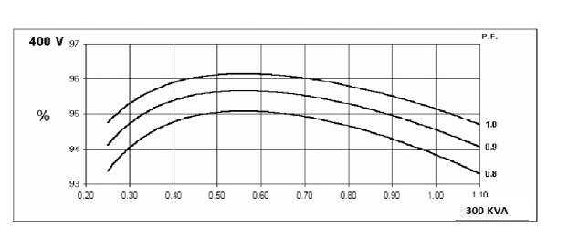

# APPENDIX 2

**AMBIENT TEMPERATURE DERATING FACTOR (GENERATOR)**

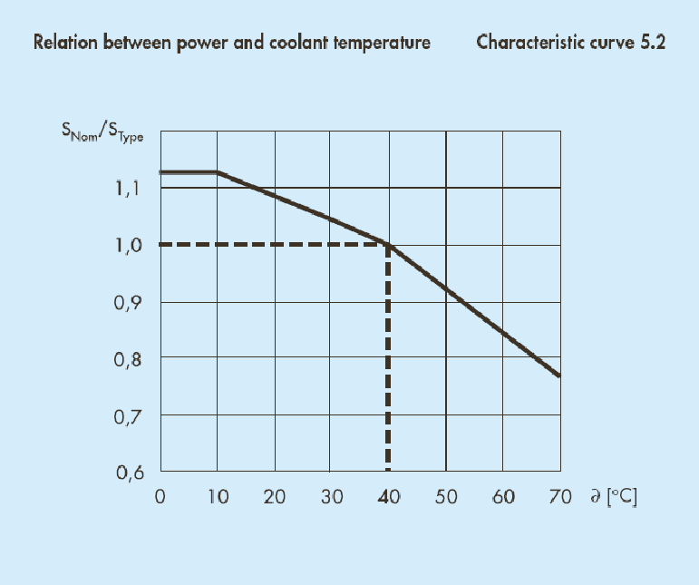

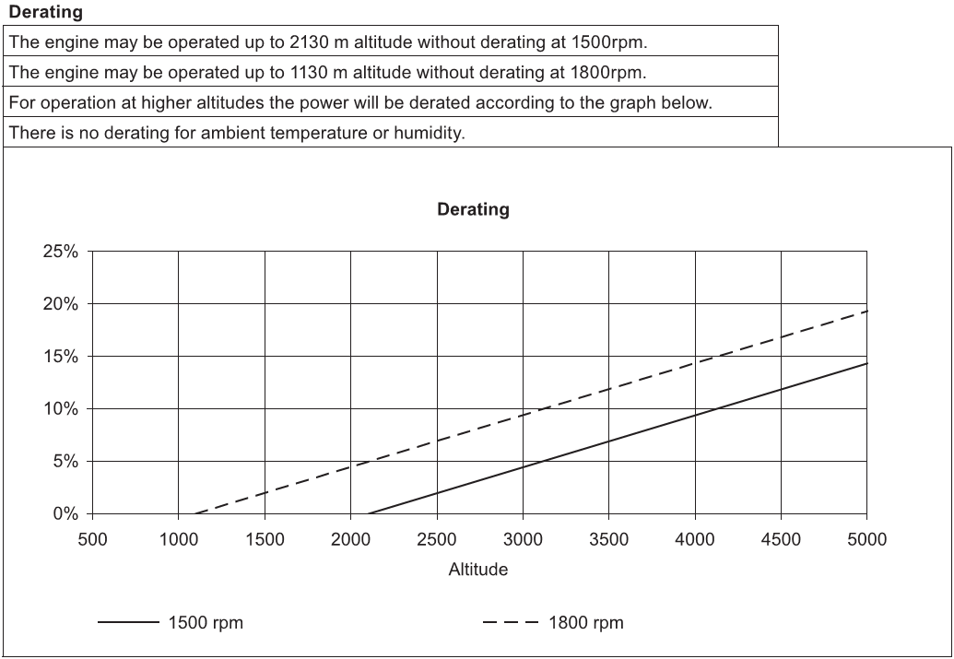

| **Item** | **Equipment Number** | **Load Description** | **Service Type** | **Load Duty** | **Rated**  **Voltage (V)** | **Rated Power (Kw)** | **Absorbed Peak**  **Active Power**  **(Kw)** | **Absorbed Peak**  **Reactive Power**  **(Kvar)** |
| --- | --- | --- | --- | --- | --- | --- | --- | --- |
| 1 | PK-C-2203A | Instrument & Plant Air Package A | E | C | 0.4 | 50 | 50.00 | 30.99 |
| 2 | PK-C-2203B | Instrument & Plant Air Package B | E | S | 0.4 | 50 | 5.00 | 3.10 |
| 3 | IG-2201 | LP Flare Ignition Package | E | I | 0.4 | 2 | 1.50 | 0.49 |
| 4 | P-2203A | Sump Pump A | E | I | 0.4 | 2.2 | 0.86 | 0.72 |
| 5 | P-2203B | Sump Pump B | E | I | 0.4 | 2.2 | 0.86 | 0.72 |
| 6 | P-2202A | Closed Drain Pump A | E | I | 0.4 | 1.1 | 2.59 | 1.94 |
| 7 | P-2202B | Closed Drain Pump B | E | I | 0.4 | 1.1 | 2.59 | 1.94 |
| 8 | P-2201A | LP Flare K.O. Drum Pump A | E | I | 0.4 | 1.1 | 0.54 | 0.40 |
| 9 | P-2201B | LP Flare K.O. Drum Pump B | E | I | 0.4 | 1.1 | 0.54 | 0.40 |
| 10 | GCS-400-EDP-01 | Process Area Emergency Distribution Panel | E | C | 0.4 | 10 | 10.00 | 6.20 |
| 11 | GCS-400-EDP-02 | Utility Area Emergency Distribution Panel | E | C | 0.4 | 5 | 5.00 | 3.10 |
| 12 | CTRL- HVAC | HVAC Panel for Control Room | E | C | 0.4 | 150 | 150.00 | 92.96 |
| 14 | GCS-110-CHG-002 | 110VDC Charger 2 | E | C | 0.4 | 20 | 22.22 | 13.77 |
| 15 | GCS-24-CHG-002 | 24VDC Charger 2 | E | C | 0.4 | 18.5 | 20.56 | 12.74 |
| 16 | GCS-110-UPS-002 | 110VAC UPS 2 | E | C | 0.4 | 36 | 40.00 | 24.79 |
| 17 | GCS-110-UPS-Bypass | 110VAC UPS By Pass | E | S | 0.4 | 20 | 2.22 | 1.38 |
| 18 | GCS-230-FDP 01 | Fire Diesel Panel 01 (Electrical Main Motor) | E | C | 0.23 | 1 | 1.00 | 0.62 |
| 19 | GCS-230-FDP 02 | Fire Diesel Panel 02 (Diesel Engine) | E | C | 0.23 | 1 | 1.00 | 0.62 |
| 20 | SPH-01 | Space Heater & Lighting for New LV Switchgear | E | C | 0.23 | 2 | 2.00 | 1.24 |
| 21 | SPH-02 | Space Heater & Lighting for MV Switchgear | E | C | 0.23 | 2 | 2.00 | 1.24 |
| 22 | GCS-400-EDP-CRM | Control Room Emergency Distribution Panel | E | C | 0.4 | 23 | 23.00 | 14.25 |

|  |  |  |  |  |  |
| --- | --- | --- | --- | --- | --- |
| **GCS-400-NSWG-001E** | | | | | |
| Continuous | | Intermittent | | Standby | |
| Avtive Power (Kw) | Reactive Power (Kvar) | Avtive Power (Kw) | Reactive Power (Kvar) | Avtive Power (Kw) | Reactive Power (Kvar) |
| 326.78 | 202.52 | 9.49 | 6.62 | 7.22 | 4.48 |
| Power Calculation | | Avtive Power (Kw) | Reactive Power (Kvar) | Apparent power (KVA) | Power Factor |
| Maximum Normal Running Load | | 336.26 | 209.14 | 395.99 | 0.85 |
| Peak Load | | 343.49 | 213.61 | 404.49 | 0.85 |
| **Peak Load With 20% Spare (KVA)** | | | | **485.389** | |