|  |  |  |  |  |  |  |  |
| --- | --- | --- | --- | --- | --- | --- | --- |
| **طرح نگهداشت و افزایش تولید 27 مخزن** | | | | | | | |
| **FLOW LINE HYDRAULIC CALCULATION REPORT**  **نگهداشت و افزایش تولید میدان نفتی بینک** | | | | | | | |
| D05 | OCT. 2022 | AFC | M.Aryafar | M.Fakharian | M.Mehrshad |  |
| D04 | AUG. 2022 | IFA | M.Aryafar | M.Fakharian | M.Mehrshad |  |
| D03 | APR. 2022 | IFA | M.Aryafar | M.Fakharian | M.Mehrshad |  |
| D02 | FEB. 2022 | IFA | M.Aryafar | M.Fakharian | M.Mehrshad |  |
| D01 | DEC. 2021 | IFA | M.Aryafar | M.Fakharian | M.Mehrshad |  |
| D00 | OCT. 2021 | IFC | M.Aryafar | M.Fakharian | M.Mehrshad |  |
| **Rev.** | **Date** | **Purpose of Issue/Status** | **Prepared by:** | **Checked by:** | **Approved by:** | **CLIENT Approval** |
| **Class:2** | | **CLIENT Doc. Number:F0Z-707606** | | | | |
| **Status:** | **IDC: Inter-Discipline Check**  **IFC: Issued For Comment**  **IFA: Issued For Approval**  **AFD: Approved For Design**  **AFC: Approved For Construction**  **AFP: Approved For Purchase**  **AFQ:** Approved For Quotation  **IFI: Issued For Information**  **AB-R: As-Built for CLIENT Review**  **AB-A: As-Built –Approved** | | | | | |

**REVISION RECORD SHEET**

|  |  |  |  |  |  |  |  |  |  |  |  |  |  |  |
| --- | --- | --- | --- | --- | --- | --- | --- | --- | --- | --- | --- | --- | --- | --- |
| **PAGE** | **D00** | **D01** | **D02** | **D03** | **D04** | **D05** |  | **PAGE** | **D00** | **D01** | **D02** | **D03** | **D04** | **D05** |
| **1** | X | X | X | X | X | X | **66** |  |  |  |  |  |  |
| **2** | X | X | X | X | X | X | **67** |  |  |  |  |  |  |
| **3** | X |  |  |  |  |  | **68** |  |  |  |  |  |  |
| **4** | X |  |  |  |  |  | **69** |  |  |  |  |  |  |
| **5** | X |  |  |  |  |  | **70** |  |  |  |  |  |  |
| **6** | X | X |  |  |  |  | **71** |  |  |  |  |  |  |
| **7** | X |  |  |  |  |  | **72** |  |  |  |  |  |  |
| **8** | X |  | X |  | X |  | **73** |  |  |  |  |  |  |
| **9** | X | X | X |  |  |  | **74** |  |  |  |  |  |  |
| **10** | X | X |  |  |  |  | **75** |  |  |  |  |  |  |
| **11** | X | X | X | X | X |  | **76** |  |  |  |  |  |  |
| **12** | X | X |  |  | X |  | **77** |  |  |  |  |  |  |
| **13** |  | X | X |  | X |  | **78** |  |  |  |  |  |  |
| **14** |  | X |  |  | X |  | **79** |  |  |  |  |  |  |
| **15** |  | X |  |  | X |  | **80** |  |  |  |  |  |  |
| **16** |  | X |  | X | X |  | **81** |  |  |  |  |  |  |
| **17** |  | X |  |  | X |  | **82** |  |  |  |  |  |  |
| **18** |  | X |  |  | X |  | **83** |  |  |  |  |  |  |
| **19** |  |  |  |  |  |  | **84** |  |  |  |  |  |  |
| **20** |  |  |  |  |  |  | **85** |  |  |  |  |  |  |
| **21** |  |  |  |  |  |  | **86** |  |  |  |  |  |  |
| **22** |  |  |  |  |  |  | **87** |  |  |  |  |  |  |
| **23** |  |  |  |  |  |  | **88** |  |  |  |  |  |  |
| **24** |  |  |  |  |  |  | **89** |  |  |  |  |  |  |
| **25** |  |  |  |  |  |  | **90** |  |  |  |  |  |  |
| **26** |  |  |  |  |  |  | **91** |  |  |  |  |  |  |
| **27** |  |  |  |  |  |  | **92** |  |  |  |  |  |  |
| **28** |  |  |  |  |  |  | **93** |  |  |  |  |  |  |
| **29** |  |  |  |  |  |  | **94** |  |  |  |  |  |  |
| **30** |  |  |  |  |  |  | **95** |  |  |  |  |  |  |
| **31** |  |  |  |  |  |  | **96** |  |  |  |  |  |  |
| **32** |  |  |  |  |  |  | **97** |  |  |  |  |  |  |
| **33** |  |  |  |  |  |  | **98** |  |  |  |  |  |  |
| **34** |  |  |  |  |  |  | **99** |  |  |  |  |  |  |
| **35** |  |  |  |  |  |  | **100** |  |  |  |  |  |  |
| **36** |  |  |  |  |  |  | **101** |  |  |  |  |  |  |
| **37** |  |  |  |  |  |  | **102** |  |  |  |  |  |  |
| **38** |  |  |  |  |  |  | **103** |  |  |  |  |  |  |
| **39** |  |  |  |  |  |  | **104** |  |  |  |  |  |  |
| **40** |  |  |  |  |  |  | **105** |  |  |  |  |  |  |
| **41** |  |  |  |  |  |  | **106** |  |  |  |  |  |  |
| **42** |  |  |  |  |  |  | **107** |  |  |  |  |  |  |
| **43** |  |  |  |  |  |  | **108** |  |  |  |  |  |  |
| **44** |  |  |  |  |  |  | **109** |  |  |  |  |  |  |
| **45** |  |  |  |  |  |  | **110** |  |  |  |  |  |  |
| **46** |  |  |  |  |  |  | **111** |  |  |  |  |  |  |
| **47** |  |  |  |  |  |  | **112** |  |  |  |  |  |  |
| **48** |  |  |  |  |  |  | **113** |  |  |  |  |  |  |
| **49** |  |  |  |  |  |  | **114** |  |  |  |  |  |  |
| **50** |  |  |  |  |  |  | **115** |  |  |  |  |  |  |
| **51** |  |  |  |  |  |  | **116** |  |  |  |  |  |  |
| **52** |  |  |  |  |  |  | **117** |  |  |  |  |  |  |
| **53** |  |  |  |  |  |  | **118** |  |  |  |  |  |  |
| **54** |  |  |  |  |  |  | **119** |  |  |  |  |  |  |
| **55** |  |  |  |  |  |  | **120** |  |  |  |  |  |  |
| **56** |  |  |  |  |  |  | **121** |  |  |  |  |  |  |
| **57** |  |  |  |  |  |  | **122** |  |  |  |  |  |  |
| **58** |  |  |  |  |  |  | **123** |  |  |  |  |  |  |
| **59** |  |  |  |  |  |  | **124** |  |  |  |  |  |  |
| **60** |  |  |  |  |  |  | **125** |  |  |  |  |  |  |
| **61** |  |  |  |  |  |  | **126** |  |  |  |  |  |  |
| **62** |  |  |  |  |  |  | **127** |  |  |  |  |  |  |
| **63** |  |  |  |  |  |  | **128** |  |  |  |  |  |  |
| **64** |  |  |  |  |  |  | **129** |  |  |  |  |  |  |
| **65** |  |  |  |  |  |  | **130** |  |  |  |  |  |  |

**CONTENTS**

1.0 INTRODUCTION 4

2.0 Scope 5

3.0 NORMATIVE REFERENCES 5

3.1 LOCAL Codes and Standards 5

3.2 International Codes and Standards 5

3.3 The Prject Documents 5

3.4 ENVIRONMENTAL DATA 6

4.0 PROCESS DESCRIPTION 6

5.0 SIMULATION METHODOLOGY 6

5.1 SIMULATION SOFTWARE 6

5.2 ASSUMPTIONS 6

5.3 PIPELINE SIZING CRITERIA FOR TWO PHASE 7

6.0 DESIGN BASIS 8

6.1 FLUID COMPOSITION 8

6.2 WATER CUT 8

6.3 FLUID PROPERTIES 9

6.4 TEMPERATURE OF WELLHEAD & DESTINATION PRESSURE 9

6.5 ENVIRONMENTAL DATA 9

6.6 FLOWLINES PROPERTIES 9

6.7 MATERIAL 10

7.0 SIMULATION RESULT 11

7.1 SIZING CALCULATION 11

7.2 HYDRAULIC CALCULATION 12

1. **INTRODUCTION**

Binak oilfield in Bushehr province is a part of the southern oilfields of Iran, is located 20 km northwest of Genaveh city.

With the aim of increasing production of oil from Binak oilfield, an EPC/EPD Project has been defined by NIOC/NISOC and awarded to Petro Iran Development Company (PEDCO). Also PEDCO (as General Contractor) has assigned the EPC-packages of the Project to "Hirgan Energy - Design and Inspection" JV.

As a part of the Project, construction of well location, access road, wellhead facilities for W046S shall be done. In addition, construction of new flowline from aforementioned well location to Binak B/C unit is in the Project scope of work.

**GENERAL DEFINITION**

The following terms shall be used in this document.

|  |  |
| --- | --- |
| CLIENT: | National Iranian South Oilfields Company (NISOC) |
| PROJECT: | Binak Oilfield Development – Construction of Well Location, Wellhead Facilities & Flowline for W046S |
| EPD/EPC CONTRACTOR (GC): | Petro Iran Development Company (PEDCO) |
| EPC CONTRACTOR: | Joint Venture of : Hirgan Energy – Design & Inspection(D&I) Companies |
| VENDOR: | The firm or person who will fabricate the equipment or material. |
| EXECUTOR: | Executor is the party which carries out all or part of construction and/or commissioning for the project. |
| THIRD PARTY INSPECTOR (TPI): | The firm appointed by EPD/EPC CONTRACTOR (GC) and approved by CLIENT (in writing) for the inspection of goods. |
| SHALL: | Is used where a provision is mandatory. |
| SHOULD: | Is used where a provision is advisory only. |
| WILL: | Is normally used in connection with the action by CLIENT rather than by an EPC/EPD CONTRACTOR, supplier or VENDOR. |
| MAY: | Is used where a provision is completely discretionary. |
|  |  |
|  |  |

1. **Scope**

This document includes flowlines hydraulic study of W046S well which is transferred the fluid from new well BINAK Cluster Unit.

1. **NORMATIVE REFERENCES**

## LOCAL Codes and Standards

|  |  |
| --- | --- |
| * IPS-E-PR-440 | Engineering Standard for Process Design of Piping Systems (Process Piping and Pipeline Sizing) |

## International Codes and Standards

|  |  |
| --- | --- |
| * API | American Petroleum Institute |
| * ASME | American Society of Mechanical Engineers |
| * ISA | Instrument Society of America |
| * ISO | International Standards Organization |
| * NACE | National Association of Corrosion Engineers |
| * API | American Petroleum Institute |

## The Prject Documents

|  |  |
| --- | --- |
| * BK-GNRAL-PEDCO-000-PR-DB-0001 | Process Basis of Design |
| * BK-GNRAL-PEDCO-000-PR-DC-0001 | Process Design Criteria |
| * BK-W046S-PEDCO-110-PR-PF-0001 | Process Flow Diagram |
| * BK-W046S-PEDCO-110-PR-PI-0001 | P&ID |

## ENVIRONMENTAL DATA

Refer to "Process Basis of Design; Doc. No. “BK-GNRAL-PEDCO-000-PR-DB-0001".

1. **PROCESS DESCRIPTION**

With the aim of increasing the oil production rate from BINAK field, the construction of flow lines and wellhead facilities has been on the agenda. Therefore, National Iranian South Oil Company has intends to establish the project of "Construction of flow lines and wellhead Facilities for BINAK Oil Field ".The most important activities and facilities needed for the project are as follows:

* Construction of 6 wells with 6 wellhead facilities series (class 5000 for wellhead facilities & class 3000 for flow lines)
* Construction of 6 flow lines with construction and installation of supports with all necessary facilities for pipelines and connecting lines to the manifold in BINAK Cluster unit.
* Design, Construction & Extension of existing manifold for Connecting new 8 flow lines (which 2 connections will be considered for future)

1. **SIMULATION METHODOLOGY**

## SIMULATION SOFTWARE

Following process software will be used in this project as per requirements:

* ASPEN HYSYS V.11
* OLGA 2017
* PVT SIM 2011

Aspen HYSYS, is normally used for process simulation as main modelling software, which shall utilize the Peng-Robinson equation of state.

Olga software is used for flowlines hydraulic calculation; this software allows calculation of flowline size, flow regimes, and pressure drop.

## ASSUMPTIONS

**Table 5-2: Assumption of calculation**

|  |  |  |  |  |
| --- | --- | --- | --- | --- |
| **FLOWLINE** | **Size** | **Material** | **Thickness (mm)** | **Roughness (mm)** |
| **FLOWLINE FOR W046S**  **WELLHEAD** | 6” | C.S. | 7.9 | 0.0457 |

## PIPELINE SIZING CRITERIA FOR TWO PHASE

Transporting gas and liquid in two phase flow should be sized primarily on the basis of flow velocity. Flow velocity should be kept at least below fluid erosional velocity (the erosion velocity must be <1). If solid (sand) production is anticipated fluid velocity should be reduced accordingly.

The velocity above which erosion may occur can be determined by the following empirical equation:

$$Ve=\frac{1.22*C}{ \sqrt{ρm}}$$

Where:

**Ve** = fluid erosional velocity, m/s

**C** = empirical constant, to be considered as 125 for non-continuous operation

And 100 for continuous operation

**ρm** = gas/liquid mixture density at flowing pressure and temperature, kg/m3

The mixture density is determined from the HYSYS simulation program.

1. **DESIGN BASIS**

## FLUID COMPOSITION

Dry basis composition of the incoming fluid is given in following tables:

**Table 6-1.1: W046S (Bangestan) Crude Oil Composition**

| **Reservoir Oil Component** | **Bangestan (%MOLE )** |
| --- | --- |
| H2S | 0.32 |
| Nitrogen | 0.06 |
| CO2 | 1.77 |
| Methane | 28.14 |
| Ethane | 9.74 |
| Propane | 7.78 |
| i-Butane | 1.47 |
| n-Butane | 4.16 |
| i-Pentane | 1.36 |
| n-Pentane | 1.36 |
| n-Hexane | 5.44 |
| n-Heptane | 6.24 |
| n-Octane | 3.81 |
| n-Nonane | 3.29 |
| n-Decane | 3.07 |
| n-C11 | 2.58 |
| C12+*BANGESTAN | 19.31 |
| C12+ of BANGESTAN: Sp.Gr @ 60/60 F = 0.9312 & Molecular weight = 454 | |
| Max GOR of BANGESTAN: 496 SCF/STB | |

## WATER CUT

Volume percentage of formation water in crude oil is considered as following table:

**Table 6-2.1: Water Cut**

|  |  |
| --- | --- |
| **Crude Oil** | **Volume Percent (%)** |
| **Bangestan** | 0~40 |

## FLUID PROPERTIES

The maximum and minimum amount of oil produced from the W046S (Bangestan) well is provided in the following table:

**Table 6-3.1: W046S (**Bangestan**) Wellhead Condition**

| **WELL NO.** | **Minimum flow rate for well (bbl/day)** | **Maximum flow rate for well (bbl/day)** |
| --- | --- | --- |
| **W046S** | 1000 | 1500 |

## TEMPERATURE OF WELLHEAD & DESTINATION PRESSURE

The outlet fluid temperature from the W046S (Bangestan) well and the pressure at the flowline destination is considered in accordance with the following table:

**Table 6-4.1: Temperature of Wellhead & Destination Pressure**

| **Case** | **Wellhead Flowing Temperature (°C)** | **Pressure (barg)** |
| --- | --- | --- |
| **W046S (**Bangestan**)** | 80 | 12.78 |

## ENVIRONMENTAL DATA

**Table 6-5.1: Average Ambient Temperature**

| **CASE** | **Temp(°C)** |
| --- | --- |
| **Winter** | 15 |
| **Summer** | 32 |

## FLOWLINES PROPERTIES

Information about thicknesses and inner/outer diameters of different sizes of flowline is given in the following table:

**Table 6-6.1: Thickness and Diameters of Flowline**

| **Type** | **Nominal Diameter(in)** | **Wall Thickness**  **(mm)** | **Outside Diameter**  **(mm)** | **Inner Diameter**  **(mm)** |
| --- | --- | --- | --- | --- |
| Bangestan | 6 | 7.9 | 168.3 | 152.5 |

## MATERIAL

The physical properties of the flowline material are as follows:

**Table 6-7.1: Physical properties**

| **Material** | **Heat Capacity (j/kg.°C)** | **Thermal Conductivity (w/m °C)** | **Density**  **(kg/m3)** |
| --- | --- | --- | --- |
| Steel | 450 | 45.3 | 7800 |

1. **SIMULATION RESULT**

## SIZING CALCULATION

**Table 7-1.1: Result of W046S (Bangestan) Flowline in summer (WATER CUT 40%)**

|  |  |  |  |  |  |  |  |  |  |  |  |  |
| --- | --- | --- | --- | --- | --- | --- | --- | --- | --- | --- | --- | --- |
| **Summer Case** | | | | | | | | | | | | |
| **Flow line Well No.** | **OD** | **Mass Flow Rate** | **In.** | | **Out.** | | **Temp.** | | **Press.** | | **Flow Regime** | **EVR** |
| **Velocity** | | **Velocity** | |
| **UG** | **UL** | **UG** | **UL** | **IN** | **OUT** | **IN** | **OUT** |
| **(in)** | **(kg/hr)** | **(m/s)** | | **(m/s)** | | **(°C)** | | **(barg)** | |
| **W046S** | 6 | 17421.9093 | 9.38 | 0.72 | 2.79 | 1.65 | 78.82 | 31.96 | 20.96 | 12.78 | Stratified/Slug | 0.35 |
| **W046S** | 6 | 11614.6062 | 9.84 | 0.34 | 0.50 | 1.02 | 78.27 | 31.29 | 21.18 | 12.78 | Stratified/Slug | 0.23 |

**Table 7-2.1: Result of W046S (Bangestan) Flowline in winter (WATER CUT 40%)**

|  |  |  |  |  |  |  |  |  |  |  |  |  |
| --- | --- | --- | --- | --- | --- | --- | --- | --- | --- | --- | --- | --- |
| **Winter Case** | | | | | | | | | | | | |
| **Flow line Well No.** | **OD** | **Mass Flow Rate** | **In.** | | **Out.** | | **Temp.** | | **Press.** | | **Flow Regime** | **EVR** |
| **Velocity** | | **Velocity** | |
| **UG** | **UL** | **UG** | **UL** | **IN** | **OUT** | **IN** | **OUT** |
| **(in)** | **(kg/hr)** | **(m/s)** | | **(m/s)** | | **(°C)** | | **(barg)** | |
| **W046S** | 6 | 17421.9093 | 9.36 | 0.90 | 1.13 | 0.57 | 78.25 | 15.20 | 21.84 | 12.78 | Stratified/Slug | 0.19 |
| **W046S** | 6 | 11614.6062 | 8.57 | 0.36 | 2.21 | 0.53 | 78.34 | 14.54 | 21.77 | 12.78 | Stratified/Slug | 0.15 |

## HYDRAULIC CALCULATION

The results of the hydraulic calculations for the 6 inches flowline is shown in the following curves:

* **GEOMETRY CURVES**

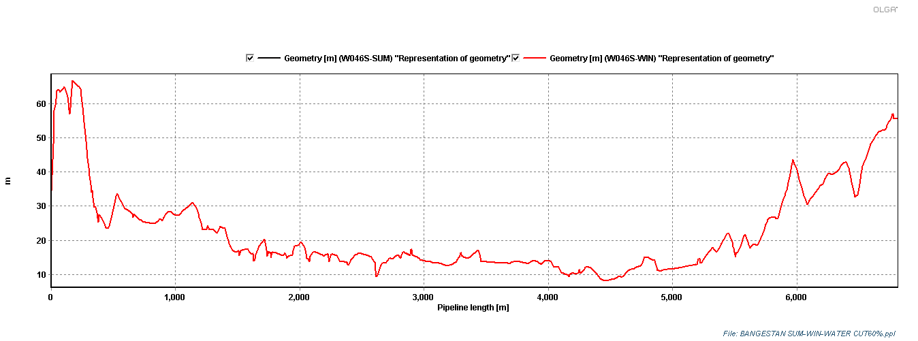

**Curve 7-2.1: geometry of 6” Bangestan Flowlines**

* **EVR CURVES**

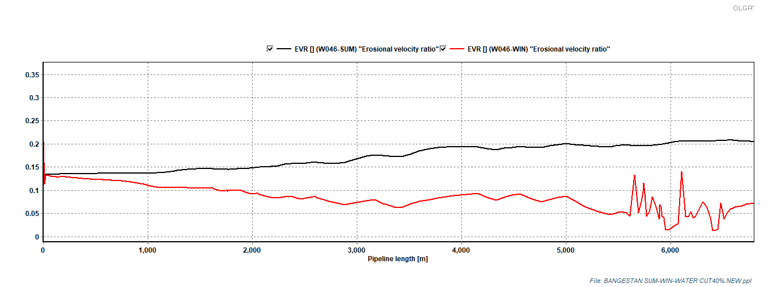

**Curve 7-2.2: EVR of 6” Bangestan Flowlines in Summer & Winter (MAX-FLOW)**

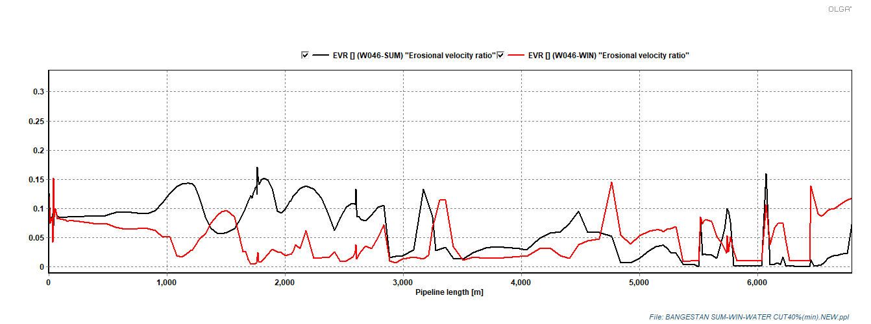

**Curve 7-2.2: EVR of 6” Bangestan Flowlines in Summer& Winter (MIN-FLOW)**

**Conclusions**

* The above diagram shows the variations of gas velocity inside flowlines. It is obvious that at the beginning of flow line after passing choke valve, manifold and main pipeline the gas velocity increases to about 0.35 m/s due to change in flow characteristics.
* **FLOW REGIME CURVES**

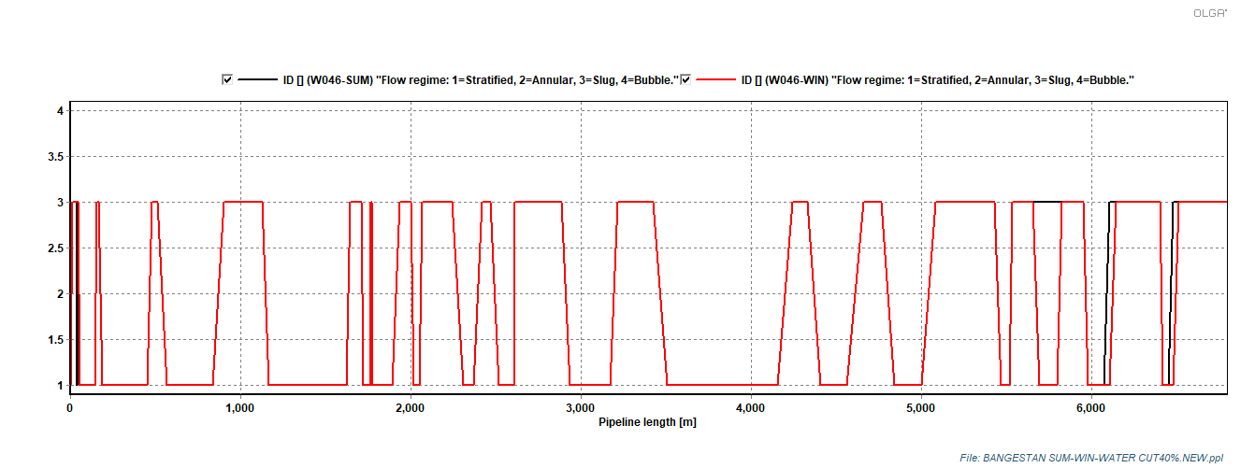

**Curve 7-2.3: Flow Regime of W046 Bangestan Flowline (MAX-FLOW)**

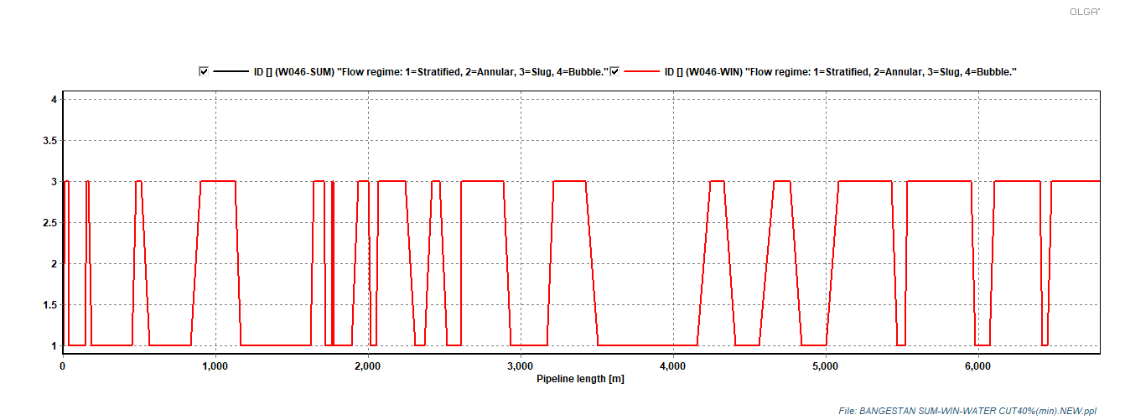

**Curve 7-2.4: Flow Regime of W046 Bangestan Flowline (MIN-FLOW)**

**Conclusions**

* The above diagrams show the variations of flow regime indicator flow line. In downstream of choke valve, the flow regime is generally slug flow but in receiving area outlet cluster to binak is generally slug flow.
* **PRESSURE and TEMPERATURE PROFILES**

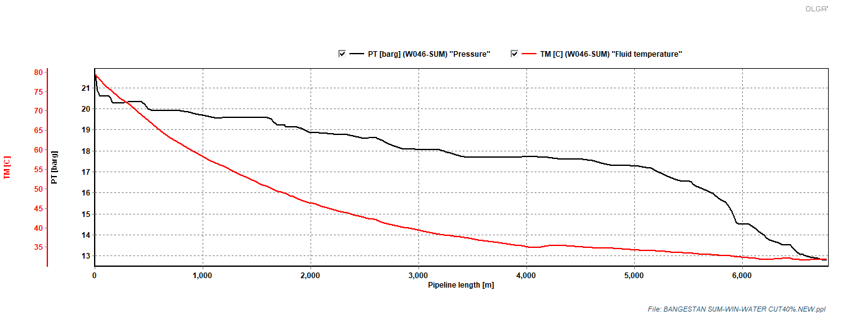

**Curve 7-2.5: Temp/Press. Profile of 6” Bangestan W046S Flow Line in summer (MAX-FLOW)**

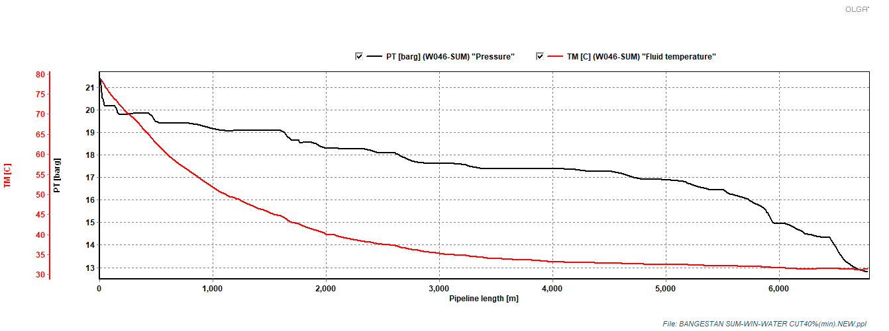

**Curve 7-2.6: Temp/Press. Profile of 6” Bangestan W046S Flow Line in summer (MIN-FLOW)**

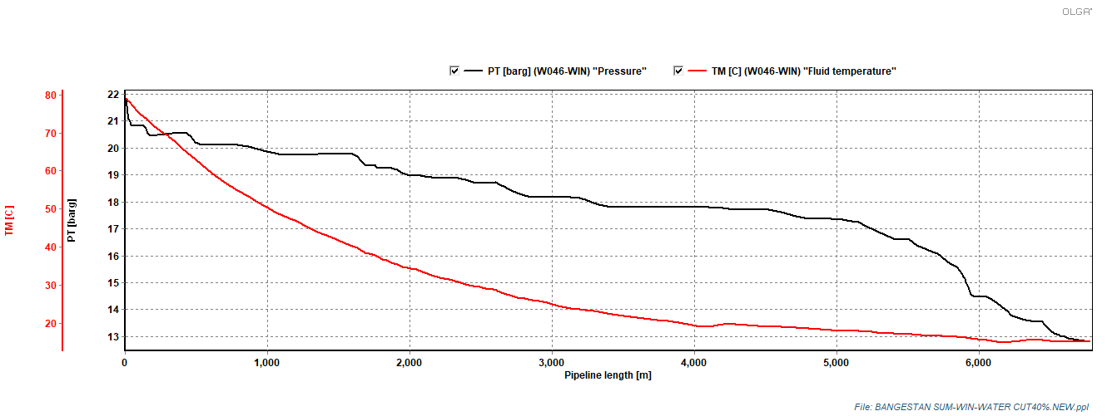

**Curve 7-2.7: Temp/Press. Profile of 6” Bangestan W046S Flow Line in winter (MAX-FLOW)**

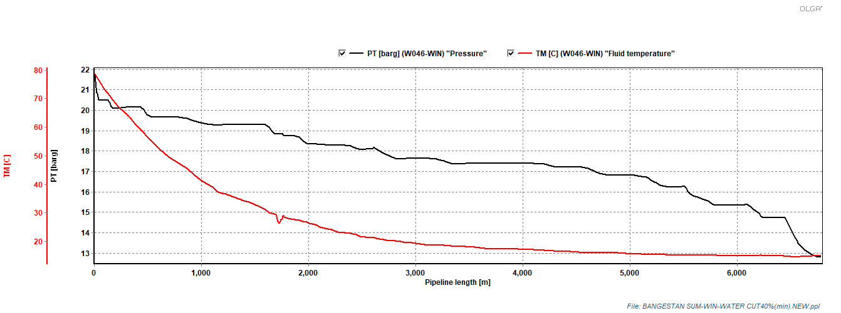

**Curve 7-2.8: Temp/Press. Profile of 6” Bangestan W046S Flow Line in winter (MIN-FLOW)**

**Conclusions**

* It is found out from above diagrams that the pressure of fluid in downstream of choke valves is maximum 21.84 BARG and will reach to 12.78 BARG at the BINAK Cluster B.L.
* It is obvious that temperature of fluid in downstream of choke valves is 78.82 °C, 31.96 °C then reaches to ambient temperature at BINAK Cluster B.L.

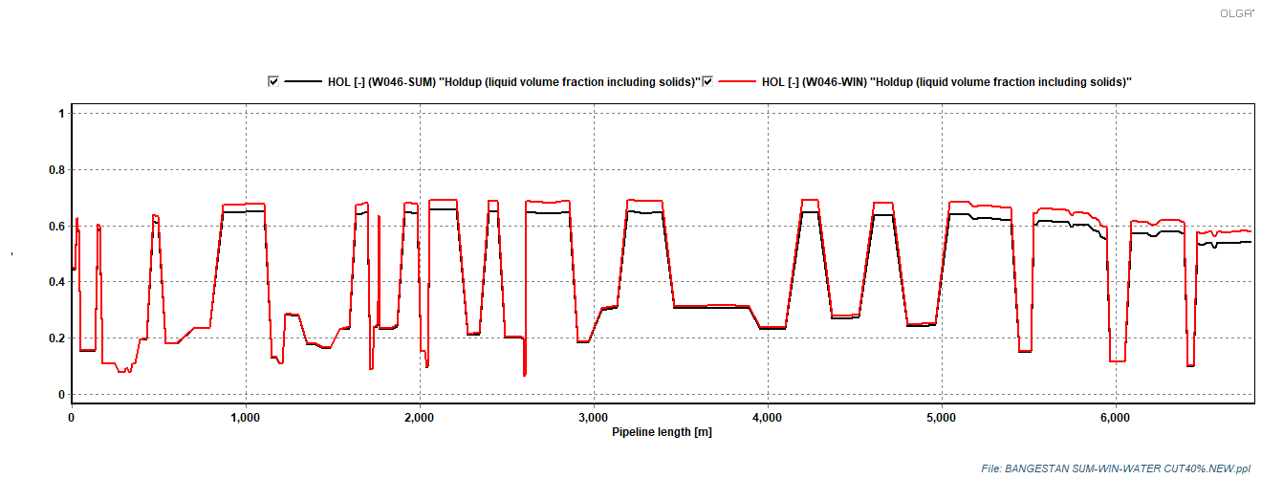

**Curve 7-2.9: HOL. Profile of 6” Bangestan W046S Flow Line inSummer /winter (Max-FLOW)**

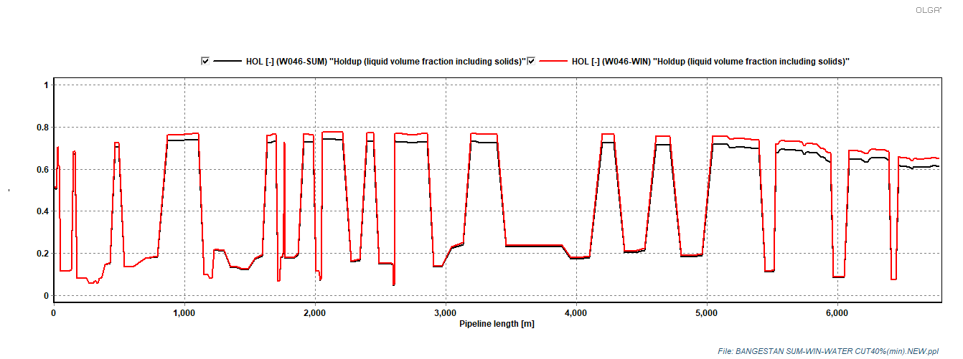

**Curve 7-2.10: HOL. Profile of 6” Bangestan W046S Flow Line inSummer /winter (MIN-FLOW)**

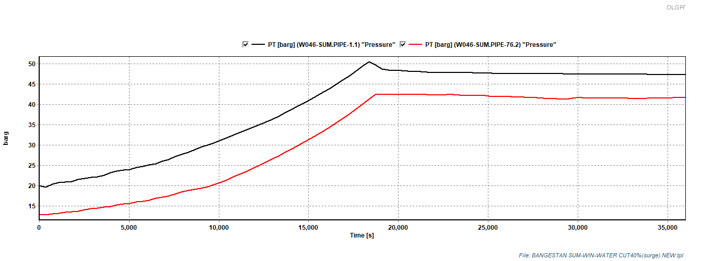

**Figure 7-2.11: Surge Pressure for BANGESTAN Flow lines disposal wells (summer case/ max-flow)**

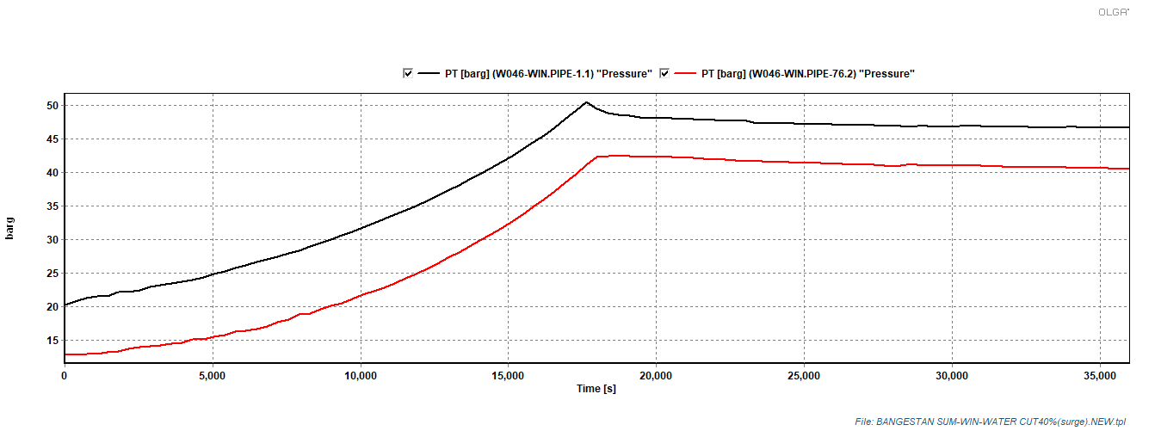

**Figure 7-2.12: Surge Pressure for BANGESTAN Flow lines disposal wells (winter case/max-flow)**

**Conclusions**

According to project P&ID the design pressure of BINAK flow line is (3000 psia) 205 barg, If PSHH on well head is set to(740 psia) 50 barg, this pressure rise does not expose the flow line and related equipment/devices to danger.