|  |  |  |  |  |  |  |
| --- | --- | --- | --- | --- | --- | --- |
| **طرح نگهداشت و افزایش تولید 27 مخزن** | | | | | | |
| **CALCULATION NOTE FOR EARTHING & LIGHTNING SYSTEM OF WELL PADS**  **نگهداشت و افزایش تولید میدان نفتی بینک** | | | | | | |
|  |  |  |  |  |  |  |
|  |  |  |  |  |  |  |
|  |  |  |  |  |  |  |
| D01 | Oct.2022 | IFA | H.Shakiba | M.Fakharian | M.Mehrshad |  |
| D00 | Apr.2022 | IFC | H.Shakiba | M.Fakharian | M.Mehrshad |  |
| **Rev.** | **Date** | **Purpose of Issue/Status** | **Prepared by:** | **Checked by:** | **Approved by:** | **CLIENT Approval** |
| **Class: 2** | | **CLIENT Doc. Number: F0Z-707383** | | | | |
| **Status:** | **IDC: Inter-Discipline Check**  **IFC: Issued For Comment**  **IFA: Issued For Approval**  **AFD: Approved For Design**  **AFC: Approved For Construction**  **AFP: Approved For Purchase**  **AFQ:** Approved For Quotation  **IFI: Issued For Information**  **AB-R: As-Built for CLIENT Review**  **AB-A: As-Built –Approved** | | | | | |

**REVISION RECORD SHEET**

|  |  |  |  |  |  |  |  |  |  |  |  |  |
| --- | --- | --- | --- | --- | --- | --- | --- | --- | --- | --- | --- | --- |
| **PAGE** | **D00** | **D01** | **D02** | **D03** | **D04** |  | **PAGE** | **D00** | **D01** | **D02** | **D03** | **D04** |
| **1** | X | X |  |  |  | **51** |  |  |  |  |  |
| **2** | X | X |  |  |  | **52** |  |  |  |  |  |
| **3** | X | X |  |  |  | **53** |  |  |  |  |  |
| **4** | X | X |  |  |  | **54** |  |  |  |  |  |
| **5** | X | X |  |  |  | **55** |  |  |  |  |  |
| **6** | X | X |  |  |  | **56** |  |  |  |  |  |
| **7** | X | X |  |  |  | **57** |  |  |  |  |  |
| **8** | X | X |  |  |  | **58** |  |  |  |  |  |
| **9** | X | X |  |  |  | **59** |  |  |  |  |  |
| **10** | X | X |  |  |  | **60** |  |  |  |  |  |
| **11** | X | X |  |  |  | **61** |  |  |  |  |  |
| **12** | X | X |  |  |  | **62** |  |  |  |  |  |
| **13** | X | X |  |  |  | **63** |  |  |  |  |  |
| **14** | X | X |  |  |  | **64** |  |  |  |  |  |
| **15** | X | X |  |  |  | **65** |  |  |  |  |  |
| **16** | X | X |  |  |  | **66** |  |  |  |  |  |
| **17** | X | X |  |  |  | **67** |  |  |  |  |  |
| **18** | X | X |  |  |  | **68** |  |  |  |  |  |
| **19** | X | X |  |  |  | **69** |  |  |  |  |  |
| **20** | X | X |  |  |  | **70** |  |  |  |  |  |
| **21** |  | X |  |  |  | **71** |  |  |  |  |  |
| **22** |  |  |  |  |  | **72** |  |  |  |  |  |
| **23** |  |  |  |  |  | **73** |  |  |  |  |  |
| **24** |  |  |  |  |  | **74** |  |  |  |  |  |
| **25** |  |  |  |  |  | **75** |  |  |  |  |  |
| **26** |  |  |  |  |  | **76** |  |  |  |  |  |
| **27** |  |  |  |  |  | **77** |  |  |  |  |  |
| **28** |  |  |  |  |  | **78** |  |  |  |  |  |
| **29** |  |  |  |  |  | **79** |  |  |  |  |  |
| **30** |  |  |  |  |  | **80** |  |  |  |  |  |
| **31** |  |  |  |  |  | **81** |  |  |  |  |  |
| **32** |  |  |  |  |  | **82** |  |  |  |  |  |
| **33** |  |  |  |  |  | **83** |  |  |  |  |  |
| **34** |  |  |  |  |  | **84** |  |  |  |  |  |
| **35** |  |  |  |  |  | **85** |  |  |  |  |  |
| **36** |  |  |  |  |  | **86** |  |  |  |  |  |
| **37** |  |  |  |  |  | **87** |  |  |  |  |  |
| **38** |  |  |  |  |  | **88** |  |  |  |  |  |
| **39** |  |  |  |  |  | **89** |  |  |  |  |  |
| **40** |  |  |  |  |  | **90** |  |  |  |  |  |
| **41** |  |  |  |  |  | **91** |  |  |  |  |  |
| **42** |  |  |  |  |  | **92** |  |  |  |  |  |
| **43** |  |  |  |  |  | **93** |  |  |  |  |  |
| **44** |  |  |  |  |  | **94** |  |  |  |  |  |
| **45** |  |  |  |  |  | **95** |  |  |  |  |  |
| **46** |  |  |  |  |  | **96** |  |  |  |  |  |
| **47** |  |  |  |  |  | **97** |  |  |  |  |  |
| **48** |  |  |  |  |  | **98** |  |  |  |  |  |
| **49** |  |  |  |  |  | **99** |  |  |  |  |  |
| **50** |  |  |  |  |  | **100** |  |  |  |  |  |

**CONTENTS**

1.0 INTRODUCTION 4

2.0 Scope 5

3.0 NORMATIVE REFERENCES 5

3.1 Local Codes & Standard 5

3.2 The Project Documents 5

3.3 Environmental Data 6

3.4 Order of Precedence 6

4.0 Definition 6

4.1 Earth Well 6

4.2 Earth Rod 6

4.3 Earth Conductor 6

4.4 Main Earth Conductor 7

4.5 Earthing System 7

4.6 Exposed Conductive Part 7

4.7 Extraneous Conductive Part 7

4.8 Equipotential Bonding 7

4.9 Neutral Conductor 7

4.10 Earthing Voltage 7

4.11 Earth Fault Current 7

4.12 Reference Earth 8

5.0 GENERAL CONCEPTION EARTHING 8

5.1 Main Earth Conductor 8

5.2 Earth Well 8

5.3 Earth Bar 8

5.4 Earth Conductor 8

5.5 Equipment to Be Earthed 9

6.0 SOIL RESISTIVITY 9

7.0 CONDUCTOR SIZING 11

7.1 Selection of an earthing conductor for Transformer neutral point 11

7.2 Selection of an Earthing Conductor for Main Earthing Loop at Site 12

7.3 Earthing System Calculation for Well Area 12

7.4 Clean Earth for Control Room in Manifold Area 14

7.5 Equipment Earthing Conductor Sizing 15

8.0 LIGHTNING PROTECTION SYSTEM 16

8.1 Calculation Method (Simplified Risk Assessment) 16

8.2 Lightning Protection System Calculation 21

1. **INTRODUCTION**

Binak oilfield in Bushehr province is a part of the southern oilfields of Iran, is located 20 km northwest of Genaveh city.

With the aim of increasing production of oil from Binak oilfield, an EPC/EPD Project has been defined by NIOC/NISOC and awarded to Petro Iran Development Company (PEDCO). Also PEDCO (as General Contractor) has assigned the EPC-packages of the Project to "Hirgan Energy - Design and Inspection" JV.

As a part of the Project, construction of well location, access roads, wellhead facilities for 6 new wells (with electric power supply for 2 of them) and required modifications on 4 workover wells (with electric power supply) shall be done. In addition, construction of 6 new flowlines from new wells to Binak B/C unit (with extension of relevant manifold) is in the Project scope of work.

**GENERAL DEFINITION**

The following terms shall be used in this document.

|  |  |
| --- | --- |
| CLIENT: | National Iranian South Oilfields Company (NISOC) |
| PROJECT: | Binak Oilfield Development – Construction of New Well Locations, Modifications on Workover Wells, Wellhead Facilities, Electrification Facilities, Flowlines and Extension of Binak B/C Manifold |
| EPD/EPC CONTRACTOR (GC): | Petro Iran Development Company (PEDCO) |
| EPC CONTRACTOR: | Joint Venture of : Hirgan Energy – Design & Inspection (D&I) Companies |
| VENDOR: | The firm or person who will fabricate the equipment or material. |
| EXECUTOR: | Executor is the party which carries out all or part of construction and/or commissioning for the project. |
| THIRD PARTY INSPECTOR (TPI): | The firm appointed by EPD/EPC CONTRACTOR (GC) and approved by CLIENT (in writing) for the inspection of goods. |
| SHALL: | Is used where a provision is mandatory. |
| SHOULD: | Is used where a provision is advisory only. |
| WILL: | Is normally used in connection with the action by CLIENT rather than by an EPC/EPD CONTRACTOR, supplier or VENDOR. |
| MAY: | Is used where a provision is completely discretionary. |

1. **Scope**

This document covers minimum necessary requirements for the design, selection, manufacture,   
inspection, testing and delivery of Earthing System.

It shall be used in conjunction with data/requisition sheets for present document subject.

1. **NORMATIVE REFERENCES**

D01

## Local Codes & Standard

* BS 7430:2011+A1:2015 Code of practice for protective earthing of electrical installations
* IEC 60364 Electrical installation of buildings
* IEC 60621 Electrical installation for outdoor sites under heavy conditions
* IEC 60724 Short circuit temperature limits of electric cables
* BS 6651 Protection of structures against lightning
* IPS E-EL-100(1) Engineering standard for electrical system design
* NFPA 780 Standard for installation of lightning protection system

## The Project Documents

* BK-W007S-PEDCO-110-GT-RT-0001 Geotechnical Investigation Report - W007S
* BK-BK14-PEDCO-110-GT-RT-0001 Geotechnical Investigation Report - BK14
* BK-BK12-PEDCO-110-GT-RT-0001 Geotechnical Investigation Report - BK12
* BK-BK15-PEDCO-110-GT-RT-0001 Geotechnical Investigation Report - BK15
* BK-W046S-PEDCO-110-GT-RT-0001 Geotechnical Investigation Report - W046S
* BK-BK05-PEDCO-110-GT-RT-0001 Geotechnical Investigation Report - BK05
* BK-SSGRL-PEDCO-110-EL-PY-0010 Earthing & Lightning Layout for Well Pads

## Environmental Data

* BK-GNRAL-PEDCO-000-PR-DB-0001 Process Basis of Design

## Order of Precedence

In case of conflict between requirements specified herein & the requirements of any other referenced document, the most approved stringent requirements of below listed items shall be considered based on the approval given by the owner’s representative:

* Purchase order
* Material Requisition
* MTO & Data Sheet
* This Specification
* Drawing & Other Specification
* Reference Project Specification
* Iranian Petroleum Standard (IPS)
* Reference international Code & Standards

When the term “Authorized”, Authorization”, “Approval”, or “Approved” are used in this specification, it shall mean authorization or Approval from OWNER.

In case of any conflict between the project documents, the most stringent one shall be considered.

1. **Definition**

## Earth Well

Earth well shall be consist of a 0.7*0.7 square meter copper plate with thickness 3mm which should be set vertically underground to depth where receive wet organics soil.

## Earth Rod

1.5 meter copper rod embedded in ground and electrically connects to it.

## Earth Conductor

A conductor that connects parts of the installation to main earth conductor and the main earth conductor to the earth well.

## Main Earth Conductor

A conductor which makes a ring loop in a room or electrical substations or process plants to which several earth conductors are connected.

## Earthing System

A locally confined assemblage of earth wells or metal components and earth conductors, electrically connected together.

## Exposed Conductive Part

A conductive part of equipment which can be touched and which is not a live part but may become live under faulty condition.

## Extraneous Conductive Part

A conductive part liable to introduce a potential, generally earth potential, and not forming part of the electrical installation.

## Equipotential Bonding

Electrical connection maintaining various exposed conductive parts and extraneous conductive parts at substantially the same potential.

## Neutral Conductor

A conductor connected to the neutral point of a system and capable of contributing to the transmission of electrical energy.

## Earthing Voltage

$E_{u}$ is the voltage which occurs between an earthing installation and a reference earth.

## Earth Fault Current

If is the current passing to earth or earthed parts when an earth fault exists at only one point at the site of the fault (earth fault location). This is:

1. The capacitive earth fault current IC with networks with isolated neutral.
2. The earth fault residual current IRest in networks with earth fault compensation.
3. The Earth fault current I”k1 in networks with low resistance neutral earthing. Also includes networks with isolated neutral point or earth fault compensators in which the neutral point is briefly earthed at the start of the fault.

## Reference Earth

Reference earth or neutral earth, is that part of the earth, particularly surface outside the area of influence of an earth electrode or an earthing system, in which there are no detectable voltages resulting from the earthing current between any two random points.

1. **GENERAL CONCEPTION EARTHING**

## Main Earth Conductor

Insulated stranded copper conductors to be embedded in the soil. This earth conductor will make the main earthing system layout to carry the main earth fault current to earth wells and provide the major safety for operators. This conductor will run among the whole site and will interconnect all earthing wells and sub-systems via a loop.

For achieving more reliability the connection of main earthing conductor to the earthing of a building will be via a ring the buildings. The ring should be installed in a cable gallery.

## Earth Well

Two earth wells will be installed and connected to main earthing conductor.

## Earth Bar

A 6-way copper earth bar can be installed wherever various earthing conductors should be connected to each other (e.g. Earth well to the main earthing conductor or neutral conductor).

## Earth Conductor

Above-ground earthing conductor shall be insulated stranded copper conductor. For switchgears, the earthing conductor shall be sized, based on the maximum short circuit current to earthing system i.e.In this project maximum short circuit current is 68 KA. So this fault current should be considered in calculation of earth conductors.

Short circuit analysis will be attacheted after finalizing in next revision.

## Equipment to Be Earthed

* All crane runways shall be earthed on both ends.
* All MV- and LV switchgear should be earthed.
* Steel structures (welded or screwed) should be interconnected to each other (e.g. staircases with railings) and common earth. The minimum size of earth bridges is 50mm2 stranded copper conductors.
* Conveyors will be earthed at their entering points to the buildings (inside of building).
* Any mobile electrical equipment (conveyor,…) shall be connected to the earth by earthing tong before operation.
* All LV equipment like MCC panels or distribution boards with metallic covers, doors or walls shall be connected to earth.
* The fixing bolts of the apparatus and structures may not be used for the fixing of earthing wire. If there are no earthing screws, the connection of earthing wire have to be done by means of a hexagonal screw of minimum size M10 welded or screwed to a metallic body of equipment.
* To avoid spark discharges due to either electrostatic charge inside the system or lightning stroke, steel structures and equipment’s piping are to be earthed.
* All motor frames and their local control box with metallic covers shall be earthed by earthing conductors separately.
* Vertical beams around structures with height up to 20m shall be earthed at maximum intervals of 20m. For higher structures, maximum interval is 10m.
* The steel structure of all cable trays and ladders installed in the plant should be earthed. The cable ladders shall form a continuous electrically conductive part. Where necessary, the cable ladders must be electrically bridged.
* All cable ladder runs should be earthed with interval connection 20 m.
* All the tanks shall be earthed and bonded earth.

1. **SOIL RESISTIVITY**

D01

Soil resistivity measurement has been done by BARAN Geotechnical Company for several points of the site as below:

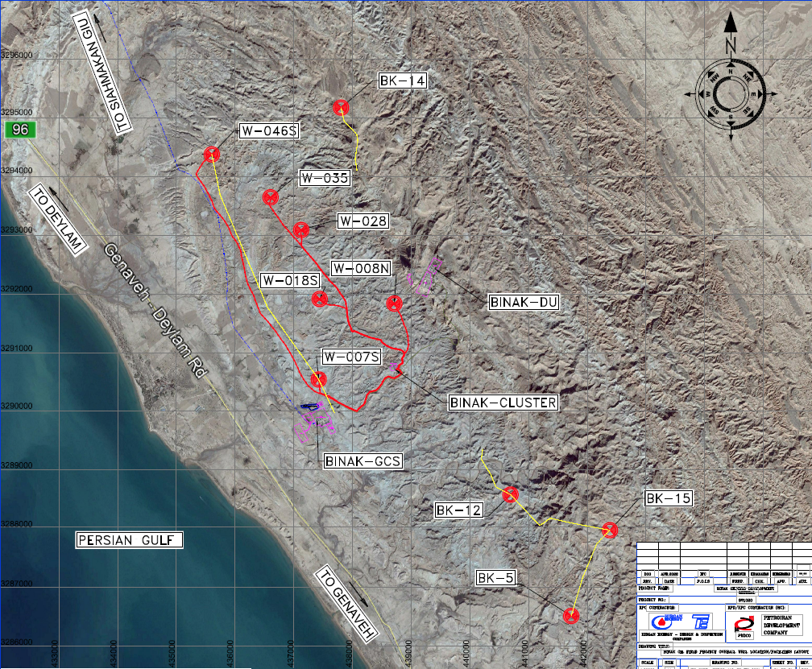

There are 6 wells with code number BK-05, BK-12, BK-14, BK-15, W-046S, and W-007S .For each well some points for measurement of earth resistance has been chosen. The average of earth resistance for each well has been shown in Table “1”.

D01

The below table has been extracted from ten Geotechnical Investigation Reports:

| Table “1”: Electrical Test Resistivity Result | | |
| --- | --- | --- |
| Well no. | Document No. | Average ρa (Ωm) in depth of 3 Meter |
| BK-05 | BK-BK05-PEDCO-110-GT-RT-0001 | 120.9 |
| BK-12 | BK-BK12-PEDCO-110-GT-RT-0001 | 89.74 |
| BK-14 | BK-BK14-PEDCO-110-GT-RT-0001 | 89.17 |
| BK-15 | BK-BK15-PEDCO-110-GT-RT-0001 | 69.23 |
| W-046S | BK-W046S-PEDCO-110-GT-RT-0001 | 88.06 |
| W-007 | BK-W007S-PEDCO-110-GT-RT-0001 | 57.37 |

According to Table “A” for all wells except BK-5, the average resistance in depth of 3 meter approximately is 90 ohm per meter. For well BK-05, the resistance is 120 ohm per meter.

1. **CONDUCTOR SIZING**

## Selection of an earthing conductor for Transformer neutral point

The minimum cross-section of earthing conductor for earthing neutral point of transformer and main earthing of around substation is calculated with below formula according to BS 7430:2015.

$S=I\frac{\sqrt{t}}{K}\left(mm^{2}\right)$

D01

Where:

* I: is the average fault current, in A r.m.s.;
* t: is the fault current duration, in s.;
* K: is the current density in amperes per square millimeter r.m.s;(Table 4:BS 7430)

For other initial and final temperatures the current density K for a 1 s duration may be obtained from the following equation:

$$K=K^{'}{\left[\ln\left(\frac{T_{2}+β}{T_{1}+β}\right)\right]}^{1/2}\left(A/mm^{2}\right)$$

Where:

* T2: Final temperature in °C
* T1: Initial temperature in °C (max. ambient temp.)
* K´ & ß: Coefficients as **Error! Not a valid bookmark self-reference.**7 of BS 7430

| **Table 2 – K′ Coefficient for different materials (according to BS 7430-Table 7)** | | |
| --- | --- | --- |
| **Metal** | **K′ A/mm² (rms)** | **β** |
| Copper | 226 | 234.5 |
| Aluminum | 148 | 228 |
| Steel | 78 | 202 |

* T2 = 160 ˚C for PVC insulation cables (Table 1: IEC 60724)
* T2 = 160 ˚C for PVC insulation cables (Table 1: IEC 60724)

So, the r.m.s current density (K) for PVC insulation cables will be:

$K=K^{'}{\left[\ln\left(\frac{T_{2}+β}{T_{1}+β}\right)\right]}^{1/2}=226[\ln\left(\frac{160+234.5}{30+234.5}\right)]^{\frac{1}{2}}≅142.3\left(A/mm^{2}\right)$

So the used values are as below:

Isc= 50 kA (According to ETAP study)

t = 0.5 s

D01

K= 142.3

$S_{min}=50kA×\frac{\sqrt{0.5}}{142.3}=248.4≈300 mm2$

300 mm2 PVC insulated copper conductor will be applied for neutral point of transformers earthing.

## Selection of an Earthing Conductor for Main Earthing Loop at Site

The minimum cross-section of earthing conductor for main earthing loop is calculated with below formula according to BS 7430:2015.

$S=I\frac{\sqrt{t}}{K}\left(mm^{2}\right)$

Where:

* I: is the average fault current, in A r.m.s.;
* t: is the fault current duration, in s.;
* K: is the current density in amperes per square millimeter r.m.s;(Table 4:BS 7430)
* So the used values are as below:
* Isc= 16 kA (According ETAP result)
* t= 0.5 s

D01

* K= 159

$S_{min}=16kA×\frac{\sqrt{0.5}}{159}=71≈70 mm2$

Therefore, 70 mm2 **bare copper conductor** will be applied for earthing system around site.

**Earthing system calculation**

## Earthing System Calculation for Well Area

Refer to section 9.5.5 of BS 7430, the approximate resistance to earth of a round conductor can be calculated from the following:

$Rt= \frac{ρ}{2πL}Ln\left(\frac{L^{2}}{khd}\right)$

Where:

* $ρ$: is the resistivity of the soil in in Ω.m
* L: is the length of the strip or conductor, in metres (m
* h: is the depth of the buried, in metres (m)
* d: is the width of the strip or the diameter of the round conductor, in metres (m);
* k: has the value 1.36 for strip or 1.83 for round conductor.
* Rt is the resistance of a single strip of length L, calculated from the preceding Rt equation, in ohms (Ω).

When two or more straight lengths, each of length L in metres (m) and a separation distance s metres (m) are laid parallel to each other and connected together at one end only the combined resistance may be calculated from the following equation:

$R_{n}=FR_{t}$

Where:

$R_{n}is the resistance of n conductors in parallel, in ohms (Ω)$

D01

F has the following value:

For two lengths, $F=0.5+0.078×{(\frac{S}{L})}^{-0.307}$

For three lengths, $F=0.33+0.071×{(\frac{S}{L})}^{-0.408}$

For four lengths, $F=0.25+0.067×{(\frac{S}{L})}^{-0.451}$

Based on explanation on table “A”, soil resistance of all wells is 90 Ω.m except 120 Ω.m

| **Calculation of Earth in Different Wells** | | |
| --- | --- | --- |
| **Item** | **Well BK-12, BK-14, BK-15, W-046S & W-007S** | **Well BK-05** |
| $$ρ$$ | 90 Ω.m | 90 Ω.m |
| $$L$$ | 130 m | 130 m |
| W | 40 | 40 |
| $$h$$ | 0.6 m | 0.6 m |
| d | $$\sqrt{\frac{70×4}{π}}=9.44 mm$$ | $$\sqrt{\frac{70×4}{π}}=9.44 mm$$ |
| K | 1.83 | 1.83 |
| $$Rt$$ | $$\frac{90}{2*3.14*130}Ln\left(\frac{{130}^{2}}{1.83*0.6*0.00944}\right)=1.58 Ω$$ | $$\frac{120}{2*3.14*130}Ln\left(\frac{{130}^{2}}{1.83*0.6*0.00944}\right)=2.1 Ω$$ |
| $$F_{2}$$ | $$0.5+0.078×{(\frac{40}{130})}^{-0.307}=0.612$$ | $$0.25+0.067×{(\frac{40}{130})}^{-0.451}=0.364$$ |
| $$Rt=FRn$$ | $$1.58×0.612=0.965$$ | $$2.1×0.364=0.765$$ |

## Clean Earth for Control Room in Manifold Area

D01

Around existing control room, clean earth is required for instrument system, the earthing resistance shall be below 0.5Ω. Regarding to achieve this resistance using rod electrode with 1 meter length and 19 mm2 diameter rod based on BS 7430 section 9.5.8.5 around control room is done as below:

The average of soil resistance in depth of 1 meter is almost 6.7 based on document No.” BK-GCS-PEDCO-120-EL-CN-0006-D01”, so it should be considered for calculating clean earth system as well.

$R_{rod}˭\frac{ρ}{2πL}×\left[Ln\left(\frac{8.L}{d}\right)˗1\right]$

Where:

L: is the length of electrode in (m)

d: is the diameter of the electrode in (m)

ρ: The resistivity of the soil (Ω.m)

$R_{rod}˭\frac{6·7}{2xπx1}×\left[Ln\left(\frac{8x1}{0·019}\right)˗1\right]˭5·37 Ω$

The combine resistance of 'N' rod electrodes in parallel can be obtained from the following equation (BS 7430-2011-table2):



$R_{n}˭R\left[\frac{1˖λa}{N}\right]$

In Which

$a˭\frac{ρ}{2πRs}$

Rn: is the resistance of 'n' rods in Hollow Square in 'Ω'

R: is the resistance of one rod in 'Ω'

s : is the spacing of rods, in meters (m);=10

λ: is a factor given in above table

N: is the number of rods used as electrodes (N=4*(n-1)) n=4 and N=12

$a˭\frac{6·7}{2xπx5·37x10}˭0·02$

Therefore:

$R_{n}˭5·37\left[\frac{1˖₍5·46x0·02₎}{12}\right]˭0·496Ω$ (Calculated value Rn is lower than criterion, 0.5Ω)

So all instrument facilities should be connected to clean earth system.

## Equipment Earthing Conductor Sizing

According to IPS-D-EL-417, all steel structures in site shall be earthed with Green-Yellow PVC insulated stranded copper wire. Earthing conductor which is applied to the exposed conductive part shall be selected from following table:

| **Number of Metallic Earthing Connection** | | | |
| --- | --- | --- | --- |
| **Equipment** | **Remark** | **No. of Grounding Points** | **Grounding Conductor Size (sq.mm.)** |
| Tank or Storage | ≤ 10 m in diameter | 2 | 35 |
| >10 m in diameter | One connection at maximum 30 m interval along the perimeter of the tank | 35 |
| Tower | <20 m in height | 1 | 35 |
| ≥20 m in height | 2 | 35 |
| Drum |  | 1 | 35 |
| Heat Exchanger |  | 1 | 16 |
| Steel Structure |  | 2 | 70 or 35 |
| Pipe Rack |  | Every 30 m (Min. 2) | 70 |
| Pipe |  | In Accordance with Layout | 16 |
| Ladder & Stairways |  | In Accordance with Layout | 35 |

| **Number of Electrical Earthing Connection** | | | |
| --- | --- | --- | --- |
| **Electrical Equipment** | **Remark** | **No. of Grounding Points** | **Grounding Conductor Size (sq.mm.)** |
| Transformer | Body | 1 | 70 (min.) |
| Medium Voltage & High Voltage Switchgear | Switchgear | 2 | 120 (min.) |
| Lightning Arrestor | 1 | 70 |
| Low Voltage Switchgear, MCC or Panels | - | In Accordance with Layout | 185 (min.) |
| Local Control Station | - | 1 | 16 |
| Local lighting/Small Power Distribution Boards | - | 1 | 35 |
| Motor | Up to 22kW | 1 | 16 |
| 23kW to 55kW | 1 | 35 |
| More than 56kW | 1 | 70 |
| Welding Outlet | - | 1 | 35 |
| Main Loop | - | In Accordance with Layout | 70 |
| Substation Loop | - | In Accordance with Layout | 300 |

1. **LIGHTNING PROTECTION SYSTEM**

D01

## Calculation Method (Simplified Risk Assessment)

Regarding to BS 6651 standard, at first we have to calculate the risk assessment of lightning which may be occur. If the risk is high according to NFPA780 standard, lightning protection system shall be considered.

## Average Lightning Flash Density

According to below map, approximately 15 thunderstorm days per year is expected for site location.

Average lightning flash density (Ng) will be estimated from following equation according to BS EN 62305-2-2012

$$N_{g}=0.1(T_{d})$$

Where:

$T_{d }:$ Thunderstorm days per year

So:

$$N_{g}=0.1×(15)=1.5$$

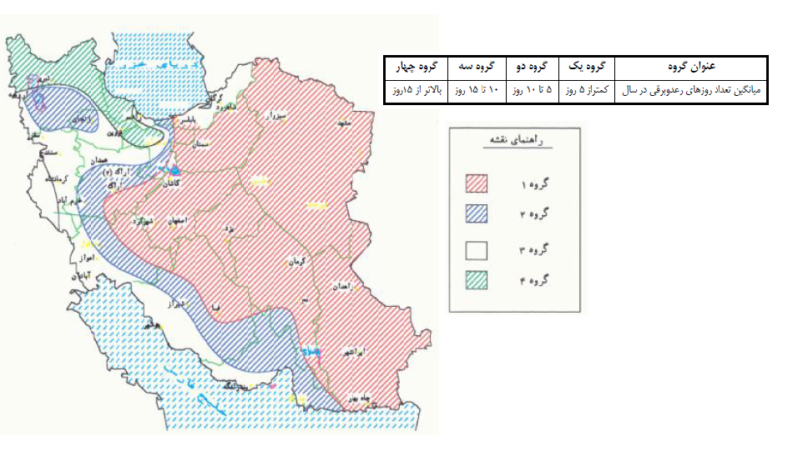

Figure A: Lightning isochrones map of Iran

## Annual Threat of Occurrence

The yearly annual threat of occurrence (lightning strike frequency) ($N_{d}$) to a structure is determined by the following equation:

$$N_{d}=N_{g}×A_{e}×C_{1}×{10}^{-6}$$

Where:

$N_{d}$ = yearly lightning strike frequency to the structure or object

$N_{g}$ = lightning ground flash density in flashes/km2/year

$A_{e}$ = the equivalent collection area of the structure (m2)

$C_{1}$ = environmental coefficient

## Equivalent Collection Area

It is an area adjusted for the structure that includes the effect of the height and location of the structure.

The equivalent collection area of a rectangular structure with length L, width W, and height H is as follows:

$$A_{e}=\left(L×W\right)+6×H×\left(L+W\right)+π×9×H^{2}$$

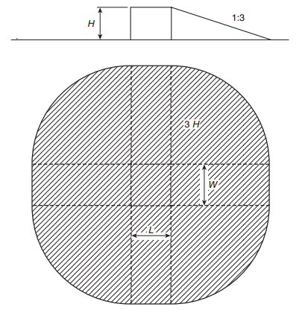

Where:

$A_{e}$ = equivalent collection area of the building in m2

L= length of the building in meter

W=Width of the building in meter

H=Height of the building in meter.

## Environmental Coefficient (C1)

The location factor accounts for the topography of the site of the structure and any objects located within the distance 3H from the structure that can affect the collection area.

Location factors are given in below Table:

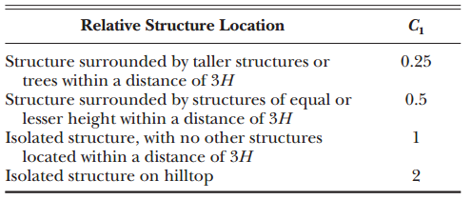

NFPA 780 - Table L.4.2- Location Factor, $C_{1}$

## Simplified Risk Assessment

Simplified risk assessment calculates the tolerable lightning frequency (Nc) and compares it to the annual threat of occurrence (Nd). The tolerable lightning frequency (Nc) is a measure of the risk of damage to the structure, including factors affecting risks to the structure, to the contents, and of environmental loss. It is calculated by dividing the acceptable frequency of property losses by various coefficients relating to the structure, the contents, and the consequence of damage.

The tolerable lightning frequency is expressed by the following formula:

$$N_{c}=\frac{{1.5×10}^{-3}}{C}$$

Where:

$C=C_{2}×C_{3}×C_{4}×C_{5}$

## Construction Coefficient (C2)

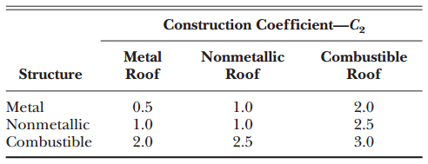

NFPA 780 - Table L.5.1.2 (a) - Determination of Construction Coefficient, $C_{2}$

## Structure Contents Coefficient (C3)

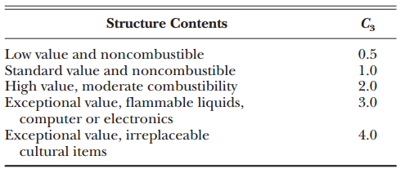

NFPA 780 - Table L.5.1.2 (b) - Determination of Structure Contents Coefficient, $C_{3}$

## Structure Occupancy Coefficient (C4)

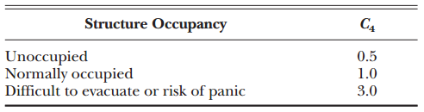

NFPA 780 - Table L.5.1.2(c) - Determination of Structure occupancy Coefficient, $C_{4}$

## Lightning Consequence Coefficient (C5)

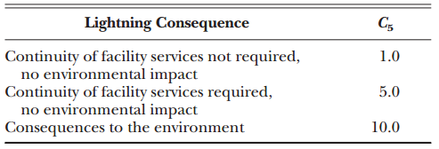

NFPA 780 - Table L.5.1.2 (d) - Determination of Lightning Consequence Coefficient, $C_{5}$

## Conclusion

if:

${ N}_{c }<N_{d }$ Lightning protection is required

D01

${ N}_{c }=>N_{d }$ Lightning protection is not required.

## Lightning Protection System Calculation

|  |  |  |  |  |  |  |  |  |  |  |  |  |  |  |
| --- | --- | --- | --- | --- | --- | --- | --- | --- | --- | --- | --- | --- | --- | --- |
| **No** | **Structure Name** | **Structure Dimension** | | | **Ae** | **C1** | **Nd (Ng=1.5)** | **C2** | **C3** | **C4** | **C5** | **C** | **Nc** | **LPS Requied** |
| **L(m)** | **W(m)** | **H(m)** |
| **RECEIVING AREA** | | | | | | | | | | | | | | |
| 1 | Switchgear Building | 10.3 | 8.9 | 6.65 | 2108 | 1 | $$3.1x{10}^{-3}$$ | 1 | 1 | 1 | 5 | 5 | $$0.3x{10}^{-3}$$ | Yes |
| 2 | Security Shelter | 8.4 | 5 | 4.95 | 1132 | 1 | $$1.6x{10}^{-3}$$ | 1 | 1 | 1 | 1 | 1 | $$1.5x{10}^{-3}$$ | Yes |

The installation of lightning system for required structures will be done according to BS 6651.