|  |  |  |  |  |  |  |  |
| --- | --- | --- | --- | --- | --- | --- | --- |
| **طرح نگهداشت و افزایش تولید 27 مخزن** | | | | | | | |
| **CALCULATION NOTE FOR FIRE WATER DEMAND**  **نگهداشت و افزایش تولید میدان نفتی بینک** | | | | | | | |
| D04 | NOV. 2022 | AFD | A.H.Saber | M.Fakharian | M.Mehrshad |  |
| D03 | AUG. 2022 | IFA | A.H.Saber | M.Fakharian | M.Mehrshad |  |
| D02 | MAY. 2022 | IFA | A.H.Saber | M.Fakharian | M.Mehrshad |  |
| D01 | JAN. 2022 | IFA | A.H.Saber | M.Fakharian | M.Mehrshad |  |
| D00 | DEC. 2021 | IFC | E.Sadeghi | M.Fakharian | M.Mehrshad |  |
| **Rev.** | **Date** | **Purpose of Issue/Status** | **Prepared by:** | **Checked by:** | **Approved by:** | **CLIENT Approval** |
| **Class: 2** | | **CLIENT Doc. Number: F0Z-708987** | | | | |
| **Status:** | **IDC: Inter-Discipline Check**  **IFC: Issued For Comment**  **IFA: Issued For Approval**  **AFD: Approved For Design**  **AFC: Approved For Construction**  **AFP: Approved For Purchase**  **AFQ: Approved For Quotation**  **IFI: Issued For Information**  **AB-R: As-Built for CLIENT Review**  **AB-A: As-Built –Approved** | | | | | |

**REVISION RECORD SHEET**

|  |  |  |  |  |  |  |  |  |  |  |  |  |
| --- | --- | --- | --- | --- | --- | --- | --- | --- | --- | --- | --- | --- |
| **PAGE** | **D00** | **D01** | **D02** | **D03** | **D04** |  | **PAGE** | **D00** | **D01** | **D02** | **D03** | **D04** |
| **1** | X | X | X | X | X | **66** |  |  |  |  |  |
| **2** | X | X | X | X | X | **67** |  |  |  |  |  |
| **3** | X |  |  |  |  | **68** |  |  |  |  |  |
| **4** | X |  |  |  |  | **69** |  |  |  |  |  |
| **5** | X | X |  |  |  | **70** |  |  |  |  |  |
| **6** | X | X |  | X |  | **71** |  |  |  |  |  |
| **7** | X | X |  |  |  | **72** |  |  |  |  |  |
| **8** | X |  |  | X |  | **73** |  |  |  |  |  |
| **9** | X |  | X | X |  | **74** |  |  |  |  |  |
| **10** | X | X | X | X |  | **75** |  |  |  |  |  |
| **11** | X | X | X | X |  | **76** |  |  |  |  |  |
| **12** | X | X | X | X |  | **77** |  |  |  |  |  |
| **13** | X |  | X | X |  | **78** |  |  |  |  |  |
| **14** |  |  | X |  |  | **79** |  |  |  |  |  |
| **15** |  |  |  |  |  | **80** |  |  |  |  |  |
| **16** |  |  |  |  |  | **81** |  |  |  |  |  |
| **17** |  |  |  |  |  | **82** |  |  |  |  |  |
| **18** |  |  |  |  |  | **83** |  |  |  |  |  |
| **19** |  |  |  |  |  | **84** |  |  |  |  |  |
| **20** |  |  |  |  |  | **85** |  |  |  |  |  |
| **21** |  |  |  |  |  | **86** |  |  |  |  |  |
| **22** |  |  |  |  |  | **87** |  |  |  |  |  |
| **23** |  |  |  |  |  | **88** |  |  |  |  |  |
| **24** |  |  |  |  |  | **89** |  |  |  |  |  |
| **25** |  |  |  |  |  | **90** |  |  |  |  |  |
| **26** |  |  |  |  |  | **91** |  |  |  |  |  |
| **27** |  |  |  |  |  | **92** |  |  |  |  |  |
| **28** |  |  |  |  |  | **93** |  |  |  |  |  |
| **29** |  |  |  |  |  | **94** |  |  |  |  |  |
| **30** |  |  |  |  |  | **95** |  |  |  |  |  |
| **31** |  |  |  |  |  | **96** |  |  |  |  |  |
| **32** |  |  |  |  |  | **97** |  |  |  |  |  |
| **33** |  |  |  |  |  | **98** |  |  |  |  |  |
| **34** |  |  |  |  |  | **99** |  |  |  |  |  |
| **35** |  |  |  |  |  | **100** |  |  |  |  |  |
| **36** |  |  |  |  |  | **101** |  |  |  |  |  |
| **37** |  |  |  |  |  | **102** |  |  |  |  |  |
| **38** |  |  |  |  |  | **103** |  |  |  |  |  |
| **39** |  |  |  |  |  | **104** |  |  |  |  |  |
| **40** |  |  |  |  |  | **105** |  |  |  |  |  |
| **41** |  |  |  |  |  | **106** |  |  |  |  |  |
| **42** |  |  |  |  |  | **107** |  |  |  |  |  |
| **43** |  |  |  |  |  | **108** |  |  |  |  |  |
| **44** |  |  |  |  |  | **109** |  |  |  |  |  |
| **45** |  |  |  |  |  | **110** |  |  |  |  |  |
| **46** |  |  |  |  |  | **111** |  |  |  |  |  |
| **47** |  |  |  |  |  | **112** |  |  |  |  |  |
| **48** |  |  |  |  |  | **113** |  |  |  |  |  |
| **49** |  |  |  |  |  | **114** |  |  |  |  |  |
| **50** |  |  |  |  |  | **115** |  |  |  |  |  |
| **51** |  |  |  |  |  | **116** |  |  |  |  |  |
| **52** |  |  |  |  |  | **117** |  |  |  |  |  |
| **53** |  |  |  |  |  | **118** |  |  |  |  |  |
| **54** |  |  |  |  |  | **119** |  |  |  |  |  |
| **55** |  |  |  |  |  | **120** |  |  |  |  |  |
| **56** |  |  |  |  |  | **121** |  |  |  |  |  |
| **57** |  |  |  |  |  | **122** |  |  |  |  |  |
| **58** |  |  |  |  |  | **123** |  |  |  |  |  |
| **59** |  |  |  |  |  | **124** |  |  |  |  |  |
| **60** |  |  |  |  |  | **125** |  |  |  |  |  |
| **61** |  |  |  |  |  | **126** |  |  |  |  |  |
| **62** |  |  |  |  |  | **127** |  |  |  |  |  |
| **63** |  |  |  |  |  | **128** |  |  |  |  |  |
| **64** |  |  |  |  |  | **129** |  |  |  |  |  |

**CONTENTS**

1.0 INTRODUCTION 4

2.0 Scope 5

3.0 NORMATIVE REFERENCES 5

3.1 Codes and Standards 5

3.2 The Project Documents 5

3.3 ENVIRONMENTAL DATA 5

3.4 abbreviation 5

4.0 Calculation basis 5

5.0 calculations 8

5.1 Deluge System Calculation 11

5.2 Nozzle Calculation 12

6.0 ConclusionS 12

7.0 attachments 13

1. **INTRODUCTION**

Binak oilfield in Bushehr province is a part of the southern oilfields of Iran, is located 20 km northwest of Genaveh city.

With the aim of increasing production of oil from Binak oilfield, an EPC/EPD Project has been defined by NIOC/NISOC and awarded to Petro Iran Development Company (PEDCO). Also PEDCO (as General Contractor) has assigned the EPC-packages of the Project to "Hirgan Energy - Design and Inspection" JV.

As a part of the Project, a New Gas Compressor Station (adjacent to existing Binak GCS) shall be constructed to gather of 15 MMSCFD (approx.) associated gases and compress & transfer them to Siahmakan GIS.

**GENERAL DEFINITION**

The following terms shall be used in this document.

|  |  |
| --- | --- |
| CLIENT: | National Iranian South Oilfields Company (NISOC) |
| PROJECT: | Binak Oilfield Development – Surface Fcilities; New Gas Compressor Station |
| EPD/EPC CONTRACTOR (GC): | Petro Iran Development Company (PEDCO) |
| EPC CONTRACTOR: | Joint Venture of : Hirgan Energy – Design & Inspection (D&I) Companies |
| VENDOR: | The firm or person who will fabricate the equipment or material. |
| EXECUTOR: | Executor is the party which carries out all or part of construction and/or commissioning for the project. |
| THIRD PARTY INSPECTOR (TPI): | The firm appointed by EPD/EPC CONTRACTOR (GC) and approved by CLIENT (in writing) for the inspection of goods. |
| SHALL: | Is used where a provision is mandatory. |
| SHOULD: | Is used where a provision is advisory only. |
| WILL: | Is normally used in connection with the action by CLIENT rather than by an EPC/EPD CONTRACTOR, supplier or VENDOR. |
| MAY: | Is used where a provision is completely discretionary. |

1. **Scope**

The design of the fire water system should be such so as to enable the fire to be extinguished whilst cooling adjacent equipment, in order to avoid escalation of the incident.

1. **NORMATIVE REFERENCES**

## Codes and Standards

|  |  |
| --- | --- |
| Fire Water Distribution and Storage Facilities | * IPS-E-SF-220 |
| Application of Fixed Water Spray Systems for Fire Protection in the Petroleum and Petrochemical Industries | * API-RP 2030 |
| Fixed firewater system | * TOTAL GS-EP-SAF-322 |
| Standard for water spray fixed systems for fire protection | * NFPA 15 |

## The Project Documents

* BK-GNRL-PEDCO-000-SA-SP-0003 Specification For Fire Water System

## ENVIRONMENTAL DATA

Refer to "Process Basis of Design; Doc. No. BK-GNRL-PECO-000-PR-DB-0001".

## abbreviation

|  |  |
| --- | --- |
| AFP | Active Fire Protection |
| ALARP | As Low As Reasonably Practicable |
| F&G | Fire & Gas |
| HAZID | Hazard Identification |
| HAZOP | Hazard and Operability Study |
| HSE | Health, Environment and Safety |
| ISBL | Inside Boundary Limit |
| OSBL | Outside Boundary Limit |
| PFP | Passive Fire Protection |
| SIL | Safety Integrity Level |
| CGD | Catalytic Gas Detectors |
| IRGD | Infrared Gas Detectors |

1. **Calculation basis**

The firefighting system shall be designed on the basis of only one major fire at a time.

No simultaneous occurrence of fire either at the single or the area more than single shall be considered.

The fire water demand has been determined based on the largest fire water out of the respective area requirement in the process area or building.

The maximum fire water demand is assumed as the sum of following:

* Fire water demand for the simultaneous operation of one water monitors and two hydrants,
* Water spray demand for the protection of pumps, drums and/or compressors areas to be protected.

In the process area, water spray system application rate as per IPS-E-SF-220 are as following:

* 10.2 Lpm/m2 for the un-insulated surface of process equipment such as( column, tower, vessel…)
* 20.4 Lpm/m2 for pumps that handle flammable liquids.

But there is no clear guideline in IPS-E-SF-220 for compressor application rate. It is recommended NFPA 15 & TOTAL GS-EP-SAF-322 to be used as reference standard for deluge spray rate on compressor area.

The system shall cover the compressor casing, associated piping and valving, gearbox, lube oil console and other auxiliary equipment and Application rate shall be considered 20.4 lit/min/m².

So based on that and as per project data sheet:

* For gas compressor (foundation area +1.5 m outskirt) application rate shall be 20.4 lit/min/m².

According to API-RP-2030:

Hydrant is able to deliver fire water flow minimum 1000 LPM and flow capacity of monitor is not less than 2000 LPM.

10% safety factor for hydraulic imbalance and size extension is considered.

Floor area including 1.5 m outskirt around the compressor foundation shall be covered by water spray. Protection to include the compressor casing, associated piping and valving the gear box and the lube oil console.

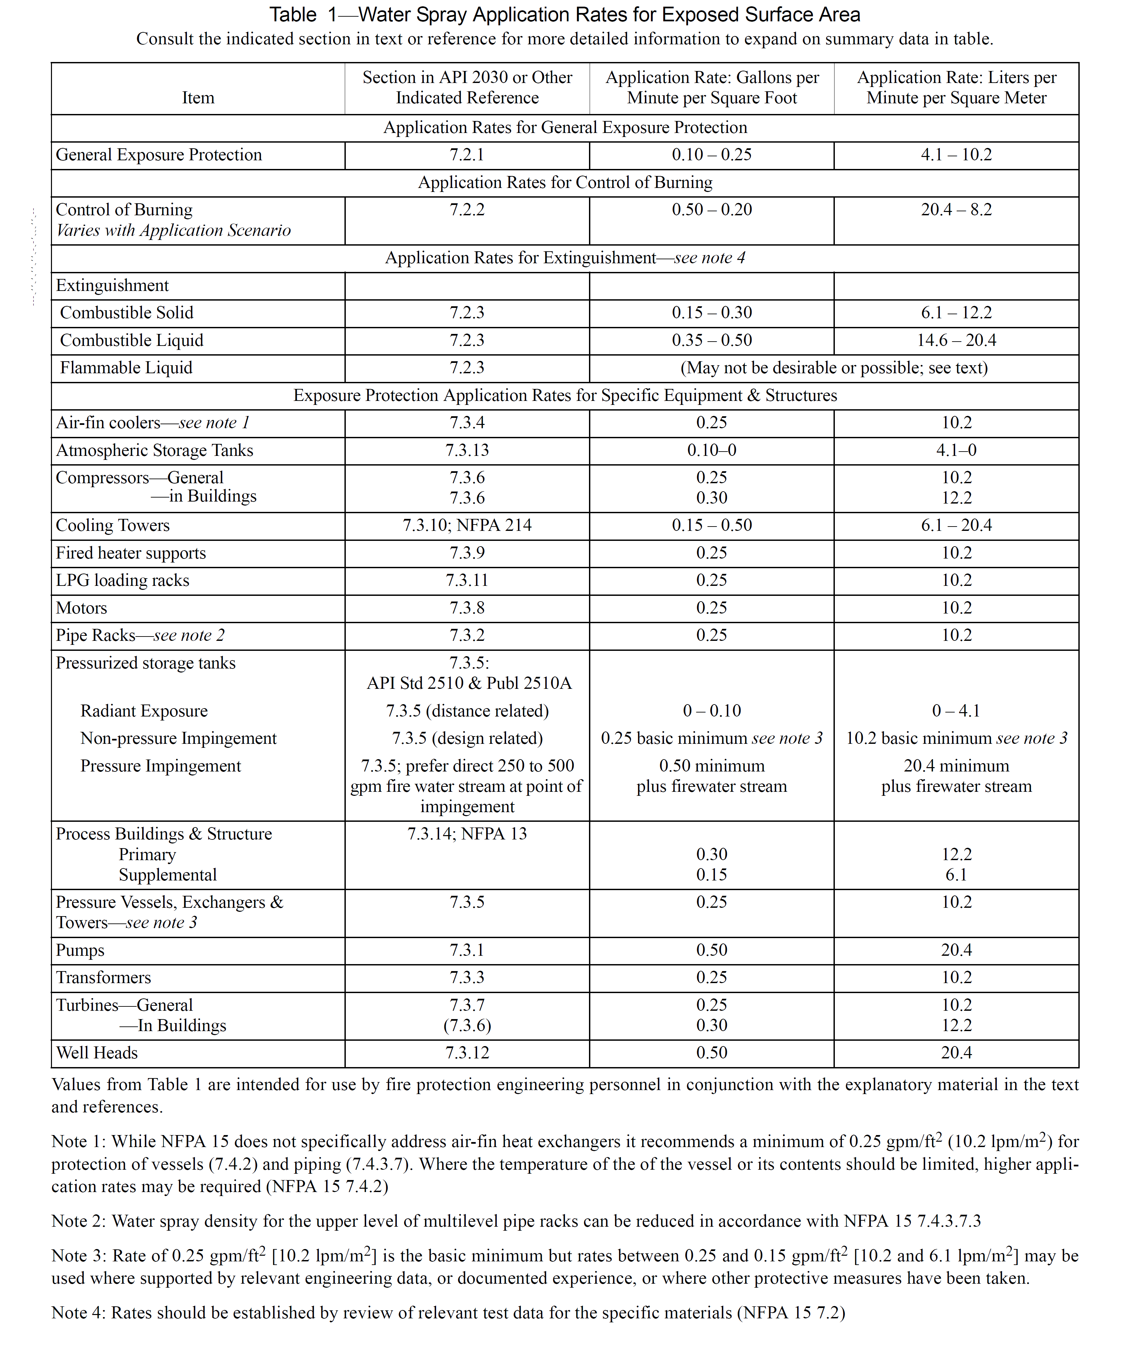

1. **calculations**

Hydrant/monitors are fed by firewater pumps for cooling and firefighting purpose during emergency cases. In addition deluge spray system will be used on compressor and suction drum areas to cool the surface of equipment to prevent any overpressure inside them.

All process area is considered as one fire zone which divided to four separate sub-deluge zones.

Each compressor set are located in sufficient distances from each other which prevent the escalation of fire into other compressor areas. So the mentioned distances divides each compressor set to separate sub-deluge zones.

Slug catcher Drum, Slug pumps, and Inlet Knock out Drum are considered as one sub-deluge zone.

Maximum fire water demand can be seen in below Tables:

**Table 1** Fire water Demand Calculation

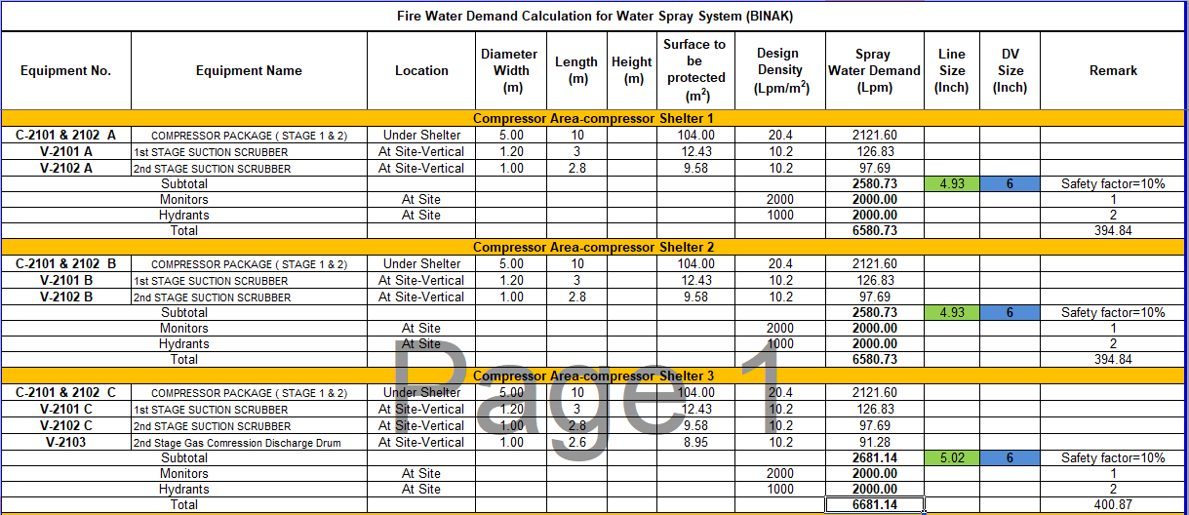

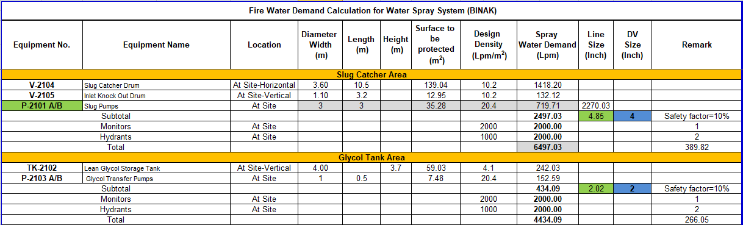

*Calculated demands are based on equipment preliminary sizes and will be finalized according to Vendor Data.

## Deluge System Calculation

The deviation between theoretical and hydraulic calculation for deluge system can be seen in table below:

**Table 2** Deluge system calculation

|  |  |  |  |
| --- | --- | --- | --- |
| DV-No. | Theoretical Flow Rate Calculated (LPM) | Hydraulic Flow Rate Calculated (LPM) | Total Deviation |
| DV-2301 | 2270 | 2407 | 6% |
| DV-2302 | 2347 | 2459 | 4.7 % |
| DV-2303 | 2347 | 2459 | 4.7 % |
| DV-2304 | 2437 | 2496 | 2.4% |

## Nozzle Calculation

The details of spray nozzles for each deluge valve and related covered equipment based on fire water demand calculation can be seen in table below:

**Table 3** Nozzle details

|  |  |  |  |  |  |
| --- | --- | --- | --- | --- | --- |
| DV-No. | Size (Inch) | Covered Equipment No. | No. of Nozzle | K Factor | Q (LPM) |
| DV-2301 | 4 | V-2104 | 24 | 35 | 60 |
| V-2105 | 6 | 18 | 30 |
| P-2101 A/B | 8 | 51 | 90 |
| DV-2302 | 6 | C-2101 & 2102 A | 18 | 64 | 118 |
| V-2101 A | 2 | 35 | 64 |
| V-2102 A | 2 | 30 | 48.9 |
| DV-2303 | 6 | C-2101 & 2102 B | 18 | 64 | 118 |
| V-2101 B | 2 | 35 | 64 |
| V-2102 B | 2 | 30 | 48.9 |
| DV-2304 | 6 | C-2101 & 2102 C | 18 | 64 | 118 |
| V-2101 C | 2 | 35 | 64 |
| V-2102 C | 2 | 26 | 48.9 |
| V-2103 | 2 | 26 | 48.9 |

1. **ConclusionS**

As the result of maximum fire water demand as listed before, the largest fire water demand rate is 6681.14 Lpm (401 m3/h) and created by Compressor Area (compressor Shelter 3 Area). Fire water will be supplied by two identical fire pumps; each pump shall be capable of supplying the 100% fire water demand (401 m3/h).fire water pumps shall be located in a safe area. The main fire water pump shall be driven by an electric pump with one backup pumps powered by diesel. Firewater pumps rates as per NFPA 20 will be 7570 LPM (454.2 m3/hr).

Firewater will be provided by two firewater storage tanks for duration of 4 hours for hydrant /Monitors and also deluge spray system. Working capacity of fire water tanks based on IPS-E-SF-220 is 60% total required fire water capacity .with consideration of above philosophy:

Max demand firewater system= 401 M3/hr

Required Firewater for 4 hours = 401 X 4 = 1603 m3

Tank Capacities = 60% Total capacity= 962 M3

Firewater tank standard capacities based on IPS-E-SF-220 will be 1135.50 m3.

1. **attachments**

Attachment1. Calculation Note Fire Water Demand

Attachment2. Firewater Tank Capacity