طرح نگهداشت و افزایش تولید 27 مخزن
SPECIFICATION FOR MANUAL VALVES

نگهداشت و افزایش تولید میدان نفتی بینک

D01 | JAN. 2023 | AFD | M.Noori | M.Fakharian | M.Mehrshad
D00 | AUG. 2021 | IFC | M.Asgharnejad | M.Fakharian | Sh.Ghalikar
Rev. | Date | Purpose of Issue/Status | Prepared by: | Checked by: | Approved by: | CLIENT Approval
Class:2 |  | CLIENT Doc. Number: 'F0Z-707139
Status: | IDC: Inter-Discipline Check  IFC: Issued For Comment  IFA: Issued For Approval  AFD: Approved For Design  AFC: Approved For Construction  AFP: Approved For Purchase  AFQ: Approved For Quotation  IFI: Issued For Information  AB-R: As-Built for COMPANY Review  AB-A: As-Built –Approved

REVISION RECORD SHEET
PAGE | D00 | D01 | D02 | D03 | D04 |  | PAGE | D00 | D01 | D02 | D03 | D04
1 | X | X |  |  |  |  | 66
2 | X | X |  |  |  |  | 67
3 | X |  |  |  |  |  | 68
4 | X |  |  |  |  |  | 69
5 | X |  |  |  |  |  | 70
6 | X |  |  |  |  |  | 71
7 | X |  |  |  |  |  | 72
8 | X |  |  |  |  |  | 73
9 | X |  |  |  |  |  | 74
10 | X |  |  |  |  |  | 75
11 | X | X |  |  |  |  | 76
12 | X |  |  |  |  |  | 77
13 | X |  |  |  |  |  | 78
14 | X | X |  |  |  |  | 79
15 | X | X |  |  |  |  | 80
16 | X |  |  |  |  |  | 81
17 | X |  |  |  |  |  | 82
18 | X |  |  |  |  |  | 83
19 | X |  |  |  |  |  | 84
20 | X |  |  |  |  |  | 85
21 | X |  |  |  |  |  | 86
22 | X | X |  |  |  |  | 87
23 | X |  |  |  |  |  | 88
24 | X |  |  |  |  |  | 89
25 | X |  |  |  |  |  | 90
26 | X | X |  |  |  |  | 91
27 | X |  |  |  |  |  | 92
28 | X |  |  |  |  |  | 93
29 | X | X |  |  |  |  | 94
30 | X |  |  |  |  |  | 95
31 | X |  |  |  |  |  | 96
32 | X | X |  |  |  |  | 97
33 |  |  |  |  |  |  | 98
34 |  |  |  |  |  |  | 99
35 |  |  |  |  |  |  | 100
36 |  |  |  |  |  |  | 101
37 |  |  |  |  |  |  | 102
38 |  |  |  |  |  |  | 103
39 |  |  |  |  |  |  | 104
40 |  |  |  |  |  |  | 105
41 |  |  |  |  |  |  | 106
42 |  |  |  |  |  |  | 107
43 |  |  |  |  |  |  | 108
44 |  |  |  |  |  |  | 109
45 |  |  |  |  |  |  | 110
46 |  |  |  |  |  |  | 111
47 |  |  |  |  |  |  | 112
48 |  |  |  |  |  |  | 113
49 |  |  |  |  |  |  | 114
50 |  |  |  |  |  |  | 115
51 |  |  |  |  |  |  | 116
52 |  |  |  |  |  |  | 117
53 |  |  |  |  |  |  | 118
54 |  |  |  |  |  |  | 119
55 |  |  |  |  |  |  | 120
56 |  |  |  |  |  |  | 121
57 |  |  |  |  |  |  | 122
58 |  |  |  |  |  |  | 123
59 |  |  |  |  |  |  | 124
60 |  |  |  |  |  |  | 125
61 |  |  |  |  |  |  | 126
62 |  |  |  |  |  |  | 127
63 |  |  |  |  |  |  | 128
64 |  |  |  |  |  |  | 129
CONTENTS
1.0 INTRODUCTION 4
2.0 SCOPE AND FIELD OF APPLICATION 5

- INTRODUCTION
Binak oilfield in Bushehr province is a part of the southern oilfields of Iran, is located 20 km northwest of Genaveh city.
With the aim of increasing production of oil from Binak oilfield, an EPC/EPD Project has been defined by NIOC/NISOC and awarded to Petro Iran Development Company (PEDCO). Also PEDCO (as General Contractor) has assigned the EPC-packages of the Project to "Hirgan Energy - Design and Inspection" JV.
GENERAL DEFINITION
The following terms shall be used in this document.
CLIENT: | National Iranian South Oilfields CLIENT (NISOC)
PROJECT: | Binak Oilfield Development – General Facilities
EPD/EPC CONTRACTOR: | Petro Iran Development Company (PEDCO)
EPC CONTRACTOR: | Joint Venture of : Hirgan Energy – Design & Inspection(D&I) Companies
VENDOR: | The firm or person who will fabricate the equipment or material.
EXECUTOR: | Executor is the party which carries out all or part of construction and/or commissioning for the project.
THIRD PARTY INSPECTOR (TPI): | The firm appointed by EPC CONTRACTOR and approved by GC & COMPANY (in writing) for the inspection of goods.
SHALL: | Is used where a provision is mandatory.
SHOULD: | Is used where a provision is advisory only.
WILL: | Is normally used in connection with the action by COMPANY rather than by an EPC/EPD CONTRACTOR, supplier or VENDOR.
MAY: | Is used where a provision is completely discretionary.

GUIDANCE FOR USE OF THIS DOCUMENT
The amendments/supplement to the related IPS Standard(s) given in this document are directly related to the equivalent sections or clauses in the IPS Standard(s). For clarity, the section and paragraph numbering of the IPS Standard(s) has been used as long as possible. Where clauses in IPS are referenced within this document, it shall mean those clauses are amended by this document. Clauses in” IPS” that are not amended by this document shall remain valid as written.
For ease of reference, the clause or section numbering of the related IPS Standard(s) has been used throughout this specification. For the purpose of this specification, the following definitions shall hold:
Sub. (Substitution): The IPS Std. Clause is deleted and replaced by a new clause.
Del. (Deletion): The IPS Std. Clause is deleted without any replacement.
Add. (Addition): A new clause with a new number is added.
Mod. (Modification): Part of the IPS Std. Clause is modified, and/or a new description and/or condition is added to that clause.
- SCOPE AND FIELD OF APPLICATION
This specification gives amendment and supplement IPS-M-PI-110(1), “Material and Equipment Standard for Valves engineering “for the design, manufacture, inspection and testing of valves intended in this project. This specification shall apply only to conventional valves such as ball, globe, check… made of carbon steel, stainless steel.

PART ONE
GENERAL REQUIREMENTS

Contents

1.0 GENERAL 8
2.0 DESIGN 9
3.0 MATERIAL 12
4.0 INSPECTION (MOD.) 12
5.0 TESTING (MOD.) 13
6.0 REPAIRS (MOD.) 15
7.0 FINISHING, PAINTING (AND/OR COATING) (MOD.) 15
8.0 IDENTIFICATION 16
9.0 PACKAGING (Mod.) 16
10.0 HANDLING AND SHIPPING (Mod.) 16
11.0 GUARANTEE 16
12.0 REJECT CAUSES 16
13.0 DOCUMENTATIONS AND LANGUAGE 16
14.0 DRAWING AND DATA 16

GENERAL
  - Scope
No amendments or supplements are to state.
  - Conflict Requirements (Sub.)
In case of any conflict between the project documents, the following order of precedence shall apply.
- Requisition / Purchase Order
- Data Sheets
- This Document
- Drawings & Other Project Documents
- Project Referred Documents Listed Above
- Iranian Petroleum Standards (IPS)
- Other Local Codes and Standards
- International Codes and Standards
  - References
    - IPS Standards(Add.)
- IPS-E-PI-221 (1) Engineering Standard for Piping Material Selection
- IPS-M-PI-110 (1) Material & Equipment standards for Valves
    - The Project Documents (Add.)
- BK-GENRAL-PEDCO-000-PI-SP-0011 Specification for Welding Piping System
- BK-GCS-PEDCO-120-PI-SP-0001 Piping Material Specification
- BK-GENRAL-PEDCO-000-PI-SP-0016 Specification for Piping Design & Plant Layout
- BK-GENRAL-PEDCO-000-PI-SP-0006 Specification for Painting
- BK-GENRAL-PEDCO-000-PI-SP-0010 Specification for Plant Piping Systems Pressure Testing
- BK-GENRAL-PEDCO-000-PL-DC-0001 Pipeline Design Criteria
- BK-GENRAL-PEDCO-000-PL-SP-0007 Specification for Pipeline Coating
- BK-GENRAL-PEDCO-000-PL-SP-0009 Specification for Welding of Transportation Pipelines
- BK-GENRAL-PEDCO-000-PL-SP-0008 Specification for Transportation Pipelines Pressure Testing
  - Environmental Data (Add.)
Refer to “Process Basis of Design; Doc. No. BK-GNRAL-PEDCO-000-PR-DB-0001 ".

DESIGN

2.1. Dimensions

The end of valves shall be as per project piping material specification.

2.1.2. (Mod.)

a) Steel flanges up to DN 600 (NPS 24) per ANSI/ASME 16.5. (Mod.)

b) Steel flanges over DN 600 (NPS 24) per MSS-SP-44. (Mod.)

c) (Del.)

d) (Del.)

2.1.3. (Mod.)

Socket weld ball valves shall be provided with 100 mm long plain end nipples (each side) made of either an integral forged nipple or of a socket welded one, of materials complying with the relevant Piping Material Classes requirements, unless otherwise specified on the Valve Data Sheets. Typical requirements are shown on the following sketch: (Add.)

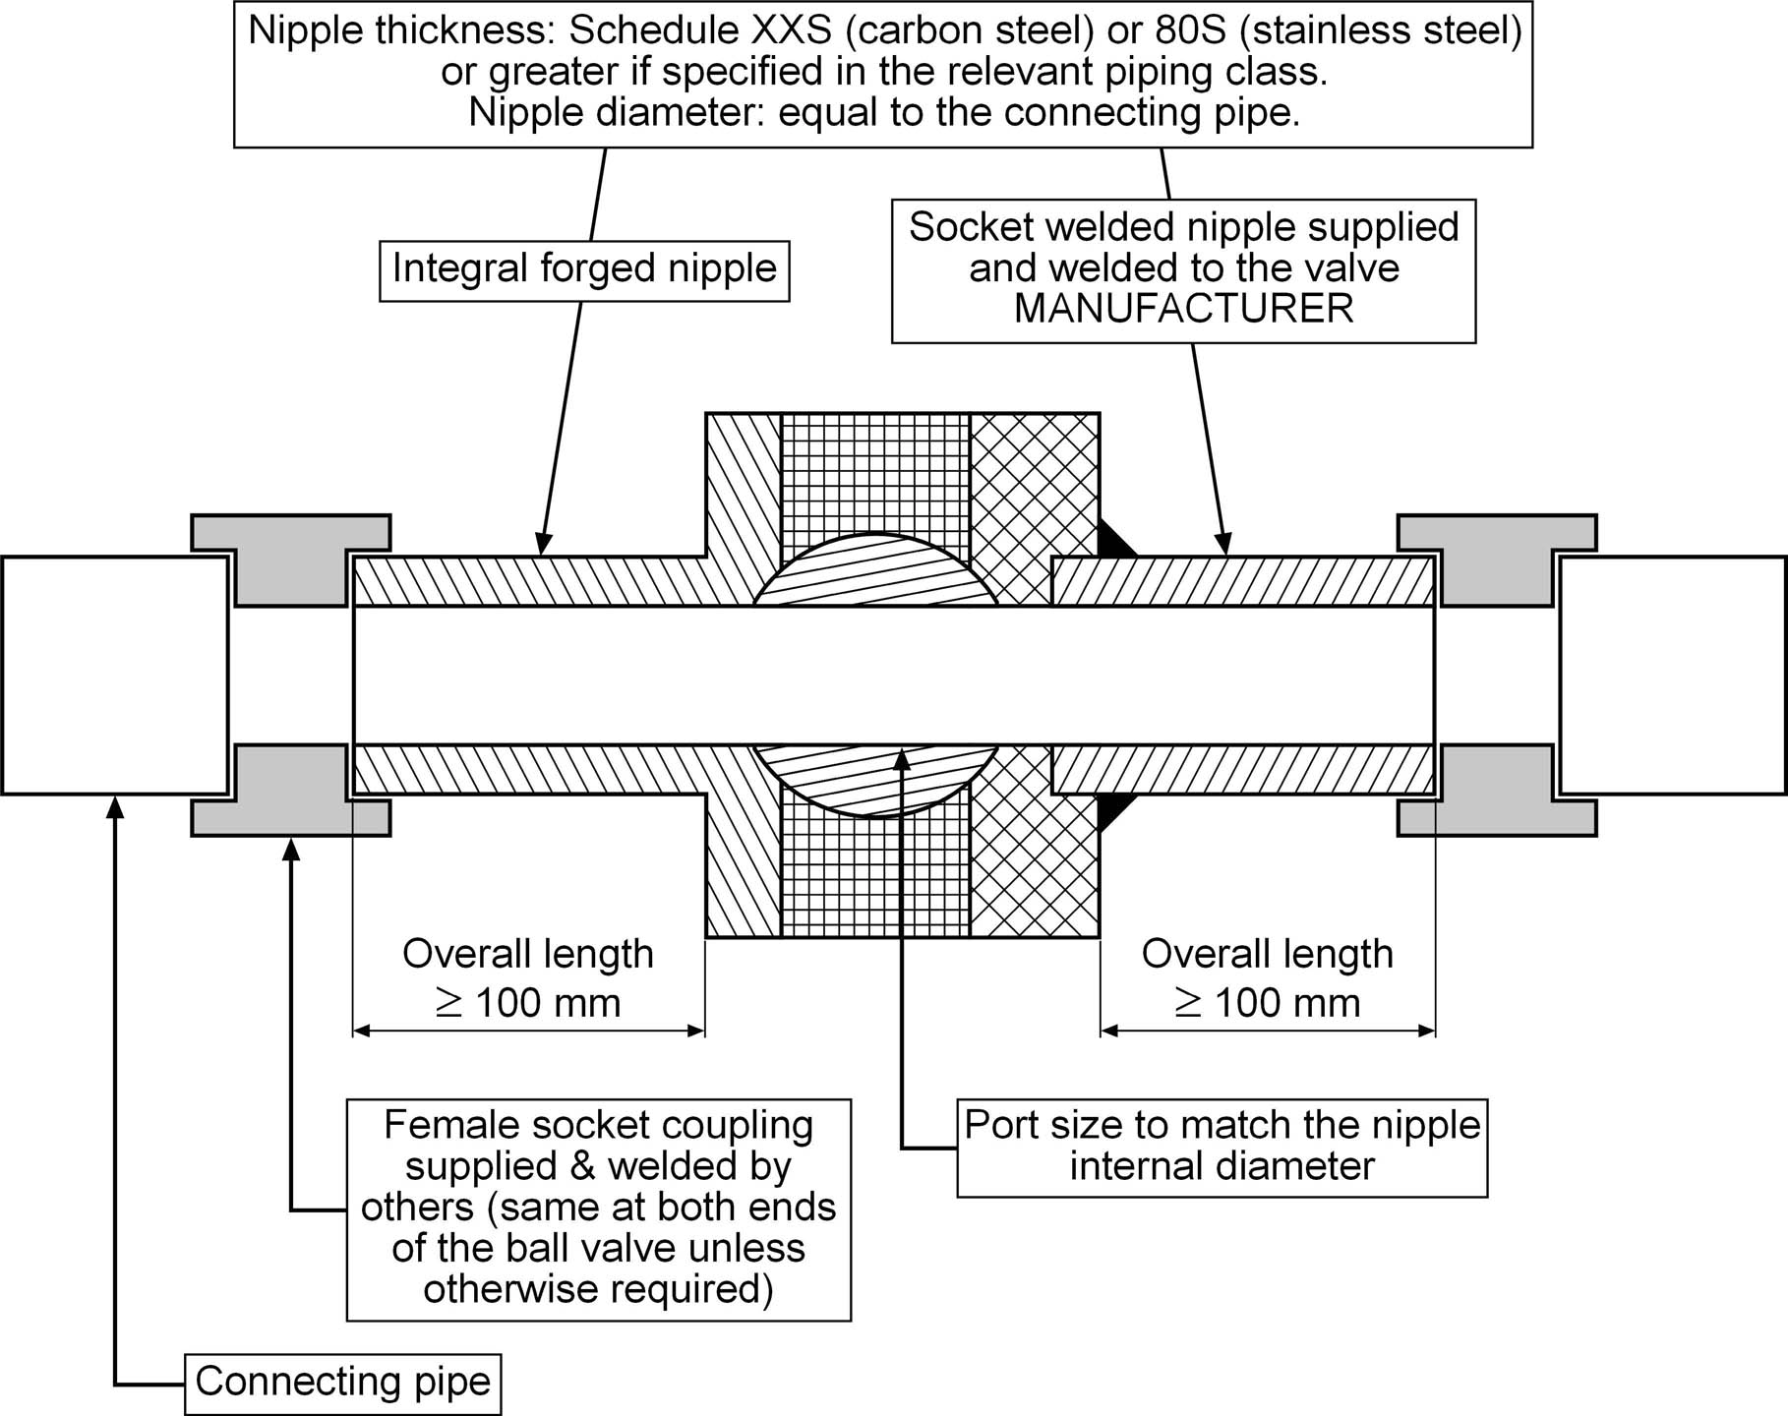

Figure 8.2.3 - Typical requirements for nipples on socket-welded end ball valves

2.1.4. (Mod.)

a) Steel valves per ANSI/ASME-B 1.20.1. (Mod.)

b) (Del.)

c) (Del.)

2.1.5. (Mod.)

a) Steel per ANSI/ASME B 16.34 or related standards of valves as applicable (Mod.)

b) (Del.)

c) (Del.)

d) (Del.)

e) (Del.)

2.1.6. (Del.)

Gear operator shall be provided for large valves requiring great torque for operation. Valves to requiring gear operator are in accordance with the piping material specification. (Add.)
D01
VALVE | CLASS & SIZE
GATE VALVE | 150# - 14” & LARGER  300# - 14” & LARGER  600# - 12” & LARGER  900# - 8” & LARGER  1500# & 2500# - 6” & LARGER
GLOBE VALVE | 150# - 8” & LARGER  300# - 8” & LARGER  600# - 6” & LARGER  900# - 4” & LARGER  1500# & 2500# - 4” & LARGER
BALL VALVE* | 150# - 8” & LARGER  300# - 6” & LARGER  600# - 4” & LARGER
PLUG VALVE | 150# - 6” & LARGER  300# - 6” & LARGER
BUTTERFLY VALVES | 150# - 6” & LARGER  300# - 6” & LARGER  600# - 4” & LARGER

* 3” and larger size of ball valves shall be trunnion mounted type.

MATERIAL

3.1. (Del.)

3.2. Material Composition of Welding End Valves (Mod.)
b) (Del.)
c) Austenitic stainless steel (Mod.)
The valve bodies and bonnets shall undergo a heat treatment ("Annealing") in accordance with the corresponding ASTM standards. When type 316 stainless flanged valves in material to ASTM A 351 Gr. CF8M are specified, forged materials to ASTM A 182 Gr. F316 are acceptable substitutes. For stainless steel lines stem & seat of valves shall be SS 316L. (Add.)
All the stainless steel valves in this project shall be socket weld for size up to 2” and flanged end for 2” and above as per project piping material specification.
3.5 Materials for pressure-containing and pressure-controlling parts and bolting shall meet the requirements of NACE MR 0175/ISO 15156 if sour service is specified. (Mod.)
Where pressure containing parts have been specified as forged, substitution of casting is not permitted without prior approval of the Company.

INSPECTION (MOD.)

4.1 Quality Control (Add.)
The inspection and tests necessary to confirm that the products meet the requirements
of the standards, specifications and of the Purchase Order shall be carried out in
the
Manufacturer’s plant by personnel of the plant. These specially qualified
personnel shall be independent of the production department of the plant.
Products that are to specifications shall be guaranteed by an adequate inspection
certificate, conformity certificate, material certificate, test certificate, etc.
If the Manufacturer does not have the necessary means of examination, these
tests shall be carried out by an agency and at a place approved by the Company or by the Engineering Company.

4.2 Visual Examination (Add.)
All valves must be 100 % visually inspected as per the API 598 and the MSS SP 55.

4.3 Special Examinations (Add.)
For all valves 6" and larger in pressure class 600 and higher, castings shall be
examined in accordance with ASME B 16.34 (Requirements for special class valves, examination of steel castings) and MSS SP 55.
For ferrous materials, Magnetic Particle examination shall be used in
preference to Dye Penetrant.
A full radiographic inspection shall be carried out on 100 % of the bevelled areas
of all weld-end valves of sizes 2" and above, and on all butt-welded joints, to
prove that these areas are free from any defects. Bevelled area of valve ends
made of forgings may be inspected by ultrasonic testing instead of radiography.
Additionally, any weld (including fillet welds) on valve bodies, regardless of size or pressure class, shall be 100 % examined by dye penetrant testing.
Radiographic defect acceptance levels on welds shall be in accordance with the
following:
- Welds in forged or other wrought materials: ASME B 31.3 Table 341.3.2A, for
normal fluid service (although the inspection level must be 100 %, and not
"spot or random"); however, acceptance criteria for inspection of welds in
valves specified for "severe cyclic services" shall be those for "severe cyclic
conditions" of the Table 341.3.2A.
- Welds in castings - ASTM E 446 up to 25 mm wall: level 1; above 25 mm wall:
level 2

TESTING (MOD.)

5.1 Pressure Tests

5.1.1 General
All valves (i.e., 100 % of the supply) shall undergo pressure tests in accordance with the requirements of the API 6D Specification, completed by the API 598. ("Spot Testing" is not acceptable.) Valves not covered by these standards shall be tested in accordance with MSS SP 61.
The Manufacturer shall submit for the Company's approval its detailed testing
procedure for each type of valves, including each pressure class and size. This
procedure must be in full accordance with the present specification requirements and the applicable codes.
Test certificates must be supplied for each valve of the supply, which must
accordingly be identified by an appropriate fabrication numbering system.

5.1.2 Test medium
D01
a) Water tests
Testing medium shall be clean, inhibited, fresh water. Stainless steel valves shall
be tested using inhibited fresh water having a maximum chloride content of 30
ppm. This also applies to valves fabricated with some parts made of stainless steel. The temperature of the test must be a minimum of +10°C. In case of non-impact tested body materials, the minimum temperature of the test medium shall be +16°C.
After testing with water, all valves shall be thoroughly dried to prevent possible corrosion from the water.
b) Gas tests
Gas tests shall be monitored using soap bubble method where zero leaks are
either expected or requested. Where leak rates other than zero are specified, the leakage rate shall be measured using a flow meter calibrated with the gas
used for testing.
5.1.3 Acceptance criteria
High-pressure hydrostatic seat test leakage rates shall comply with API 6D. The
following criteria apply to gas tests only (including air, nitrogen, etc.):
- External leakage (maximum allowable leak rate from each source):
5 SCF/annum (0.27 SCC/min.)

- Seat leakage: according to the table 5.1.3 hereafter.

Table 5.1.3 - Leakage rates acceptance criteria for closure tests with gas
(All values are in SCC/cm dia/min.)

Testing at ambient temperature
 |  | Low pressure tests  (all sizes) | High pressure tests  (all sizes)
Soft seals | Valve pressure class ≤ 600 | 0 leakage | 0.5
Metallic seals | Valve pressure class ≤ 600 | 0 leakage | 2
  - Toughness Tests
The toughness tests to be carried-out on the valves (if required) are normally
shown on the Purchase Order documents.
When these tests are required, they shall be carried out in conformity with the
requirements of ASTM A 370 and at the temperature required for the grade of
material.
  - Hardness Tests
If specified in the Purchase Order documents, hardness tests shall be carried out
on each valve body (e.g. for compliance with the NACE standards in case of H2S
service).

REPAIRS (MOD.)
- Repairs may be local or total when non-conforming conditions are found. Defects in excess of acceptance standard shall be removed by reducing weld overlay thickness and shall be repaired by re-welding. (Add.)

- All excavations shall be dye penetrant inspected prior to the start of repair welding in order to confirm the complete removal of defects. (Add.)

- Repair by re-welding shall be performed in accordance with a written procedure. The following information must be given in these procedures: (Add.)

- Method of removing defects
- Requirements related to the shape of the excavation
- Inspection of repair prior to re-welding
- Applicable welding procedure and qualification tests
- Inspection after welding.

FINISHING, PAINTING (AND/OR COATING) (MOD.)
After protection of all machined and threaded external surfaces and covering all valve(s) nozzles and openings, the equipment shall be blast cleaned to Swedish standard SIS-05-5900 grade, SA 2½. This shall be followed by the purchaser Specification for Painting with Doc. No. BK-GNRAL-PEDCO-000-PI-SP-0006. (Mod.)
D01

IDENTIFICATION
No amendments or supplements are to state.

PACKAGING (Mod.)
The valves must be packed in sea packing, waterproof. Packing must be suitable for all stages of transport (rail, road, air, etc.).(Add.)

HANDLING AND SHIPPING (Mod.)
No amendments or supplements are to state.

GUARANTEE
No amendments or supplements are to state.

REJECT CAUSES
No amendments or supplements are to state.

DOCUMENTATIONS AND LANGUAGE
No amendments or supplements are to state.

DRAWING AND DATA
No amendments or supplements are to state.

PART TWO
GATE VALVES

Contents
1 SCOPE 19
2 DESIGN AND MANUFACTURING (MOD.) 19
3 SUPPLEMENT TO REFERENCE STANDARDS 19

SCOPE
No amendments or supplements are to state.

DESIGN AND MANUFACTURING (MOD.)
2.1 All classes of carbon and Ferritic alloy steel DN 15 (NPS 1/2) and higher, stainless steel, flanged and butt welding ends double disc and wedge gate valve Per API-STD-600 or API-STD-6D as Applicable. (Mod.)
2.4 PN 130 (ANSI 800), Carbon, Ferritic alloy and stainless steel, threaded and
socket welding ends, wedge gate valves up to DN 50 (NPS 2) Per : API-STD. 602.(Mod.)
2.8 (Del.)
2.9 (Del.)
2.10 (Del.)
2.11 (Del.)
2.12 (Del.)
2.13 (Del.)
2.14 (Del.)

SUPPLEMENT TO REFERENCE STANDARDS

SECTION ONE SUPPLEMENT TO API-6D (2008)(MOD.)
7.28 UNDERGROUND VALVES (DEL.)

SECTION TWO SUPPLEMENT TO API-600 (2009)
No amendments or supplements are to state.

SECTION THREE SUPPLEMENT TO API-602 (2009) (MOD.)
No amendments or supplements are to state.

PART THREE
GLOBE VALVES

Contents

1.0 SCOPE 22
2.0 DESIGN AND MANUFACTURING (MOD.) 22
3.0 SUPPLEMENT TO REFERENCE STANDARD (BS 1873-1975) 22

- SCOPE
No amendments or supplements are to state.
- DESIGN AND MANUFACTURING (MOD.)
2.1 Carbon and alloy steel flanged ends and butt-welding ends Per BS 1873. (Mod)
2.2 Carbon and alloy steel socket welding, threaded, flanged and butt welding
ends up to DN50 per API 602 or ISO 15761. (Mod.)
D01
2.3 (DEL.)
2.4 (DEL.)
- SUPPLEMENT TO REFERENCE STANDARD (BS 1873-1975)
No amendments or supplements are to state.

PART FOUR
PLUG VALVES

Contents
1.0 SCOPE 25
2.0 DESIGN AND MANUFACTURING (MOD.) 25
3.0 SUPPLEMENT TO API 6D 25

- SCOPE
No amendments or supplements are to state.

- DESIGN AND MANUFACTURING (MOD.)
2.1 Steel valves, flanged and butt welding ends Per API-STD-599. (Mod.)
2.4 (DEL.)
2.5 (DEL.)

- SUPPLEMENT TO API-6D (2008)
No amendments or supplements are to state.

PART FIVE
BUTTERFLY VALVES
D01
No amendments or supplements are to state.

PART SIX
CHECK VALVES

Contents

1.0 SCOPE 29
2.0 DESIGN AND MANUFACTURING (MOD.) 29
3.0 SUPPLEMENT TO REFERENCE STANDARD (API 6D-2008) 29

- SCOPE
No amendments or supplements are to state.

- DESIGN AND MANUFACTURING (MOD.)
2.1 Steel swing type pipeline check valves flanged and butt welding ends or wafer type: per API-594. (Mod.)
2.3 Steel, screwed and socket welding ends, piston, ball, disk type up to DN 50 (NPS 2) ISO15761 or API 602 as Applicable. (Mod.)
D01
2.4 Steel, flanged and butt welding ends, swing type check valve up to DN 600 (NPS 24) BS-1868 and up to DN 50 (NPS 2) ISO15761 or API 602. (Mod.)
2.5 (Del.)
2.6 (Del.)
2.7 (Del.)
- SUPPLEMENT TO REFERENCE STANDARD (API 6D-2008)

No amendments or supplements are to state.

PART SEVEN
BALL VALVES

Contents
1.0 SCOPE 32
2.0 DESIGN AND MANUFACTURING (MOD.) 32
3.0 SUPPLEMENT TO REFERENCE STANDARD 32
SECTION ONE 32
SECTION TWO 32
SUPPLEMENT TO BS/EN ISO 17292 (1986, AMDT 1990) 32

- SCOPE
No amendments or supplements are to state.

- DESIGN AND MANUFACTURING (MOD.)
2.1 Steel ball valves flanged and butt welding ends.. (Mod.)
2.2 Steel ball valves, threaded ends and socket welding ends:. (Mod.)
2.3 (Del.)
- SUPPLEMENT TO REFERENCE STANDARD
No amendments or supplements are to state.

SECTION ONE
SUPPLEMENT TO API-6D (2008)
2.16 Buried Valves (DEL.)

SECTION TWO

SUPPLEMENT TO BS/EN ISO 17292 (1986, AMDT 1990)
1. SCOPE (MOD.)
Add the following paragraphs to existing clause:
This specification applies to flanged, butt welded and threaded end ball valves,
reduced and full bore, soft and metal seated, carbon steel valves in nominal size
and PN (ANSI) rating, generally in accordance with BS/EN ISO 17292. This
document is a supplement to the pertaining design standard and shall be
governing where conflict occurs. This standards shall be used for ball valves DN 50 (NPS 2) and ratings equal 800# and below (Mod.)
D01

