|  |  |  |  |  |  |  |  |
| --- | --- | --- | --- | --- | --- | --- | --- |
| **طرح نگهداشت و افزایش تولید 27 مخزن** | | | | | | | |
| **PDMS Model Review Report (30%)**  **نگهداشت و افزایش تولید میدان نفتی بینک** | | | | | | | |
|  |  |  |  |  |  |  |
|  |  |  |  |  |  |  |
|  |  |  |  |  |  |  |
| D01 | JAN. 2023 | IFA | M.Noori | M.Fakharian | M.Mehrshad |  |
| D00 | MAR. 2022 | IFC | A.Khosravi | M.Fakharian | M.Mehrshad |  |
| **Rev.** | **Date** | **Purpose of Issue/Status** | **Prepared by:** | **Checked by:** | **Approved by:** | **CLIENT Approval** |
| **Class:2** | | **CLIENT Doc. Number:** **F0Z-708907** | | | | |
| **Status:** | **IDC: Inter-Discipline Check**  **IFC: Issued For Comment**  **IFA: Issued For Approval**  **AFD: Approved For Design**  **AFC: Approved For Construction**  **AFP: Approved For Purchase**  **AFQ:** Approved For Quotation  **IFI: Issued For Information**  **AB-R: As-Built for CLIENT Review**  **AB-A: As-Built –Approved** | | | | | |

**REVISION RECORD SHEET**

|  |  |  |  |  |  |  |  |  |  |  |  |  |
| --- | --- | --- | --- | --- | --- | --- | --- | --- | --- | --- | --- | --- |
| **PAGE** | **D00** | **D01** | **D02** | **D03** | **D04** |  | **PAGE** | **D00** | **D01** | **D02** | **D03** | **D04** |
| **1** | X | X |  |  |  | **66** |  |  |  |  |  |
| **2** | X | X |  |  |  | **67** |  |  |  |  |  |
| **3** | X |  |  |  |  | **68** |  |  |  |  |  |
| **4** | X |  |  |  |  | **69** |  |  |  |  |  |
| **5** | X |  |  |  |  | **70** |  |  |  |  |  |
| **6** | X |  |  |  |  | **71** |  |  |  |  |  |
| **7** | X | X |  |  |  | **72** |  |  |  |  |  |
| **8** | X |  |  |  |  | **73** |  |  |  |  |  |
| **9** | X | X |  |  |  | **74** |  |  |  |  |  |
| **10** | X | X |  |  |  | **75** |  |  |  |  |  |
| **11** |  |  |  |  |  | **76** |  |  |  |  |  |
| **12** |  |  |  |  |  | **77** |  |  |  |  |  |
| **13** |  |  |  |  |  | **78** |  |  |  |  |  |
| **14** |  |  |  |  |  | **79** |  |  |  |  |  |
| **15** |  |  |  |  |  | **80** |  |  |  |  |  |
| **16** |  |  |  |  |  | **81** |  |  |  |  |  |
| **17** |  |  |  |  |  | **82** |  |  |  |  |  |
| **18** |  |  |  |  |  | **83** |  |  |  |  |  |
| **19** |  |  |  |  |  | **84** |  |  |  |  |  |
| **20** |  |  |  |  |  | **85** |  |  |  |  |  |
| **21** |  |  |  |  |  | **86** |  |  |  |  |  |
| **22** |  |  |  |  |  | **87** |  |  |  |  |  |
| **23** |  |  |  |  |  | **88** |  |  |  |  |  |
| **24** |  |  |  |  |  | **89** |  |  |  |  |  |
| **25** |  |  |  |  |  | **90** |  |  |  |  |  |
| **26** |  |  |  |  |  | **91** |  |  |  |  |  |
| **27** |  |  |  |  |  | **92** |  |  |  |  |  |
| **28** |  |  |  |  |  | **93** |  |  |  |  |  |
| **29** |  |  |  |  |  | **94** |  |  |  |  |  |
| **30** |  |  |  |  |  | **95** |  |  |  |  |  |
| **31** |  |  |  |  |  | **96** |  |  |  |  |  |
| **32** |  |  |  |  |  | **97** |  |  |  |  |  |
| **33** |  |  |  |  |  | **98** |  |  |  |  |  |
| **34** |  |  |  |  |  | **99** |  |  |  |  |  |
| **35** |  |  |  |  |  | **100** |  |  |  |  |  |
| **36** |  |  |  |  |  | **101** |  |  |  |  |  |
| **37** |  |  |  |  |  | **102** |  |  |  |  |  |
| **38** |  |  |  |  |  | **103** |  |  |  |  |  |
| **39** |  |  |  |  |  | **104** |  |  |  |  |  |
| **40** |  |  |  |  |  | **105** |  |  |  |  |  |
| **41** |  |  |  |  |  | **106** |  |  |  |  |  |
| **42** |  |  |  |  |  | **107** |  |  |  |  |  |
| **43** |  |  |  |  |  | **108** |  |  |  |  |  |
| **44** |  |  |  |  |  | **109** |  |  |  |  |  |
| **45** |  |  |  |  |  | **110** |  |  |  |  |  |
| **46** |  |  |  |  |  | **111** |  |  |  |  |  |
| **47** |  |  |  |  |  | **112** |  |  |  |  |  |
| **48** |  |  |  |  |  | **113** |  |  |  |  |  |
| **49** |  |  |  |  |  | **114** |  |  |  |  |  |
| **50** |  |  |  |  |  | **115** |  |  |  |  |  |
| **51** |  |  |  |  |  | **116** |  |  |  |  |  |
| **52** |  |  |  |  |  | **117** |  |  |  |  |  |
| **53** |  |  |  |  |  | **118** |  |  |  |  |  |
| **54** |  |  |  |  |  | **119** |  |  |  |  |  |
| **55** |  |  |  |  |  | **120** |  |  |  |  |  |
| **56** |  |  |  |  |  | **121** |  |  |  |  |  |
| **57** |  |  |  |  |  | **122** |  |  |  |  |  |
| **58** |  |  |  |  |  | **123** |  |  |  |  |  |
| **59** |  |  |  |  |  | **124** |  |  |  |  |  |
| **60** |  |  |  |  |  | **125** |  |  |  |  |  |
| **61** |  |  |  |  |  | **126** |  |  |  |  |  |
| **62** |  |  |  |  |  | **127** |  |  |  |  |  |
| **63** |  |  |  |  |  | **128** |  |  |  |  |  |
| **64** |  |  |  |  |  | **129** |  |  |  |  |  |
| **65** |  |  |  |  |  | **130** |  |  |  |  |  |

**CONTENTS**

1.0 INTRODUCTION 4

2.0 Scope 4

3.0 NORMATIVE REFERENCES 5

**3.1** The Project Documents 5

**3.2** Order of Precedence 5

4.0 KEY OBJECTIVES 5

5.0 STATISTICS 6

6.0 DESCRIPTION AND CONCLUSIONS 6

1. **INTRODUCTION**

Binak oilfield in Bushehr province is a part of the southern oilfields of Iran, is located 20 km northwest of Genaveh city.

With the aim of increasing production of oil from Binak oilfield, an EPC/EPD Project has been defined by NIOC/NISOC and awarded to Petro Iran Development Company (PEDCO). Also PEDCO (as General Contractor) has assigned the EPC-packages of the Project to "Hirgan Energy - Design and Inspection" JV.

As a part of the Project, a New Gas Compressor Station (adjacent to existing Binak GCS) shall be constructed to gather of 15 MMSCFD (approx.) associated gases and compress & transfer them to Siahmakan GIS.

**GENERAL DEFINITION**

The following terms shall be used in this document.

|  |  |
| --- | --- |
| CLIENT: | National Iranian South Oilfields Company (NISOC) |
| PROJECT: | Binak Oilfield Development – Surface Facilities; New Gas Compressor Station |
| EPD/EPC CONTRACTOR (GC): | Petro Iran Development Company (PEDCO) |
| EPC CONTRACTOR: | Joint Venture of : Hirgan Energy – Design & Inspection (D&I) Companies |
| VENDOR: | The firm or person who will fabricate the equipment or material. |
| EXECUTOR: | Executor is the party which carries out all or part of construction and/or commissioning for the project. |
| THIRD PARTY INSPECTOR (TPI): | The firm appointed by EPD/EPC CONTRACTOR (GC) and approved by CLIENT (in writing) for the inspection of goods. |
| SHALL: | Is used where a provision is mandatory. |
| SHOULD: | Is used where a provision is advisory only. |
| WILL: | Is normally used in connection with the action by CLIENT rather than by an EPC/EPD CONTRACTOR, supplier or VENDOR. |
| MAY: | Is used where a provision is completely discretionary. |

1. **Scope**

This document presents all raised issues and made decisions during 30% model review session of PROJECT which should be followed and performed during continuation of PROJECT.

1. **NORMATIVE REFERENCES**

## The Project Documents

* BK-GNRAL-PEDCO-000-PI-PR-0001 3D-Model (PDMS) Review Procedure

## Order of Precedence

In case of any conflict between the contents of this document or any discrepancy between this document and other project documents or reference standards, this issue must be reported to the CLIENT. The final decision in this situation will be made by CLIENT.

1. **KEY OBJECTIVES**

The purpose of 30% Model Review is to freeze a basic design and concept and to hand over to a detail design stage. Plot plan, equipment layout, major piping arrangement, process requirements, major equipment maintenance, operability, major access way and conformity of PDMS catalogue with Piping Material Specification are critical review points and the following objectives shall be addressed during the model review:

1. Confirm if there are any potential deviations from project specifications and then study the practical resolutions at the earliest possible timing.
2. Review critical areas having a possibility of schedule interruption to the downstream detailed design activities, especially
   * Steel Structures and platforms
   * Static Equipment

The model minimum content for the 30% model review shall be:

* + Major equipment located in compliance with plot plan which is available at that stage.
  + Major structures (steel/concrete) outlines in compliance with the plot plan.
  + Major above ground piping (line sizes equal and greater than 6" for CS and all sizes for SS) with insulation information.
  + Major concrete foundation outlines, slabs, paving and roads.
  + Package unit outlines, locations and orientation.
  + Major pipe racks/pipe support outlines located in compliance with available plot plan.
  + Main electrical/instrument underground cable route.
  + All underground piping systems.
  + Building outlines.
  + Dropout/bundle pulling and lay down areas, mobile crane aprons.

1. **STATISTICS**

The followings indicate the number of modeled major items which were reviewed during 30% model review:

* + Number of modeled equipment: 60
  + Number of modeled A/G and U/G Lines: 180
  + Number of hydrant and monitor: 16
  + Number of modeled shelter, structure and building: 14
  + Electrical main trench
  + Instrument main cable trench

1. **DESCRIPTION AND CONCLUSIONS**

The 30% model review for “Binak Oilfield Development – Surface Facilities; New Gas Compressor Station” was held with representatives of CLIENT, EPD/EPC CONTRACTOR (GC) and EPC CONTRACTOR, on 1400/12/01. The subjects of discussion for the meeting were organized and considered based on the following issues:

* General layout and arrangement,
* Operation access rooms,
* Maintenance requirements,
* Installing location for instruments, platforms, and access to instruments,
* Lineup of primary lines.

It was stated that following items should be checked and corrected during 60% modeling and would be reviewed in 60% model review meeting:

## Surveying data of existing inlet gas pipeline from BINAK cluster and branch of new line for new gas compressor station on it should be shown in 60% 3D model

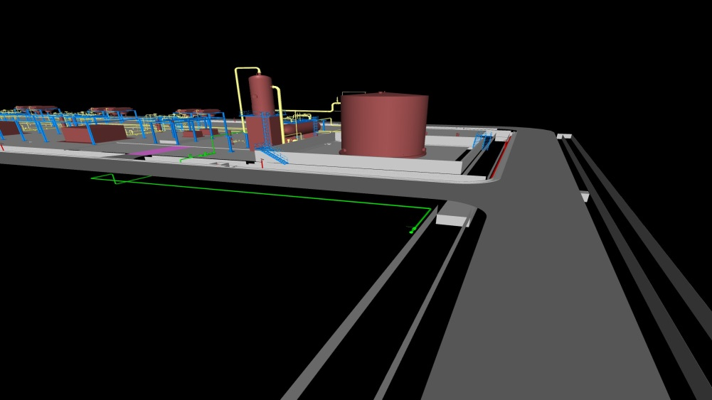

## It is decided that sunshade should be considered for condensate pumps

D01

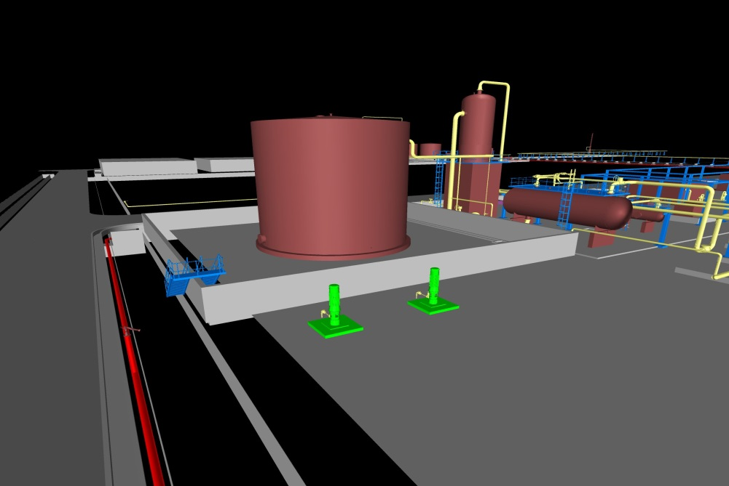

## Location and installation elevation of Degassing Vessel and also piping between Degassing Vessel and Condensate Tank should be reviewed and shown with more detail

## 

## Access road of chemical shelter should be moved toward east so that more access room to be provided for other equipment which are located between mentioned shelter and Condensate Tank

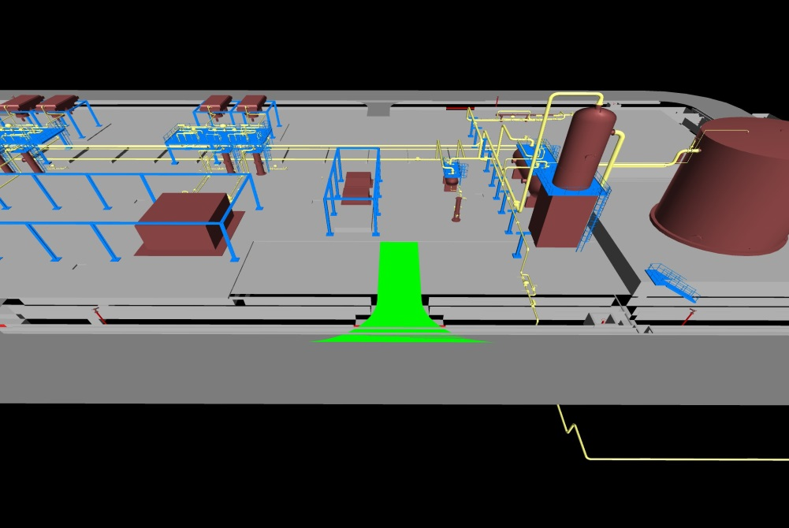

## Staircase should be considered for structures of control valves and PSVs of compressors instead of ladder. For train C a ladder should be considered in addition.

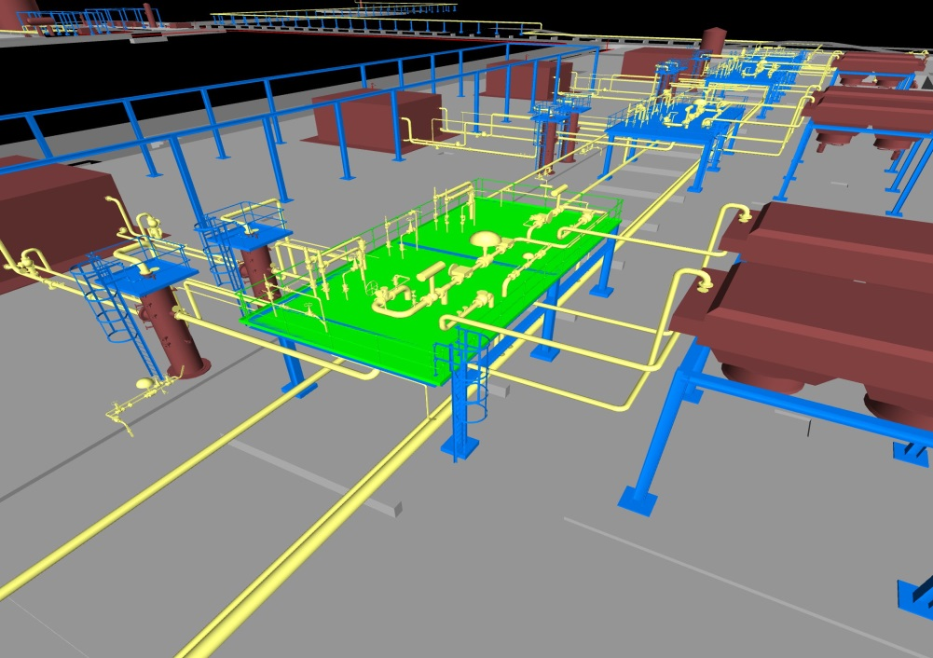

## Dimensions of Methanol Package should be revised in 60% 3D model based on vendor data

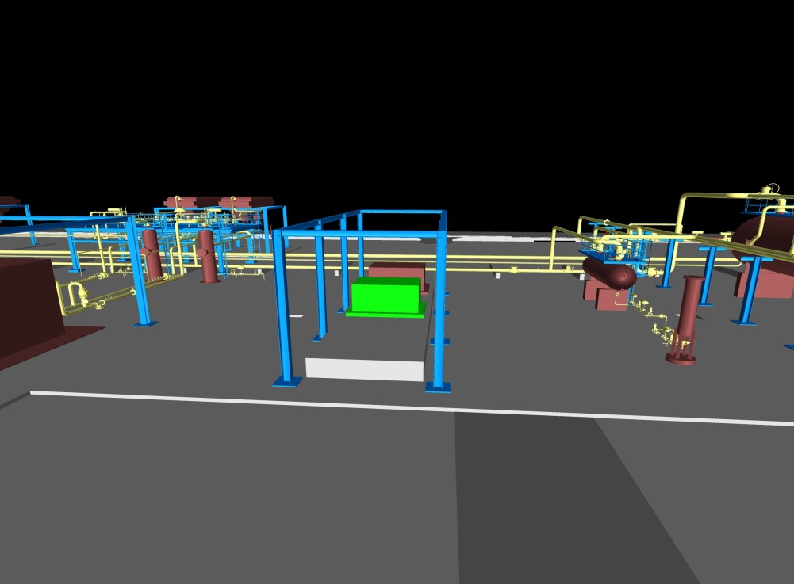

## It is decided that a staircase should be considered for pit of closed drain drum in addition to ladder

D01

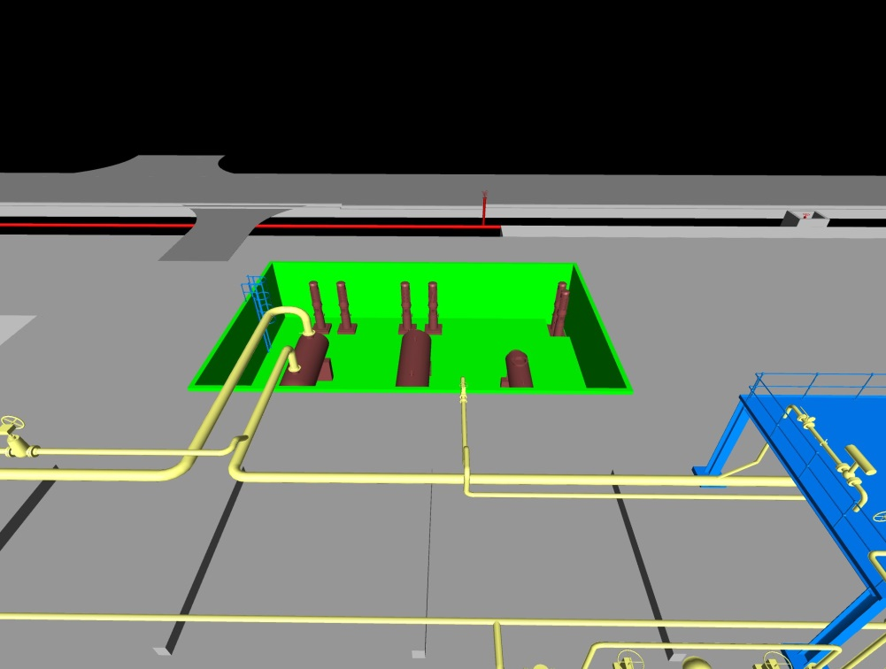

## It was stated that an open channel network to be considered to collect process open drainage and surface oily water simultaneously. Also, closed drain pipe network to be located inside of mentioned channel. This channel should be covered by grating.Separate open channel should be considered for clean surface water system.

D01

## Location of emergency diesel generator should be changed to reduce relevant cables. Adjacent to existing substation at the north side will be considered in this regard. Final decision will be taken by Client.

D01

## Piping route of control loop of pig Launcher / Receiver shall be changed from vertical to horizontal arrangement

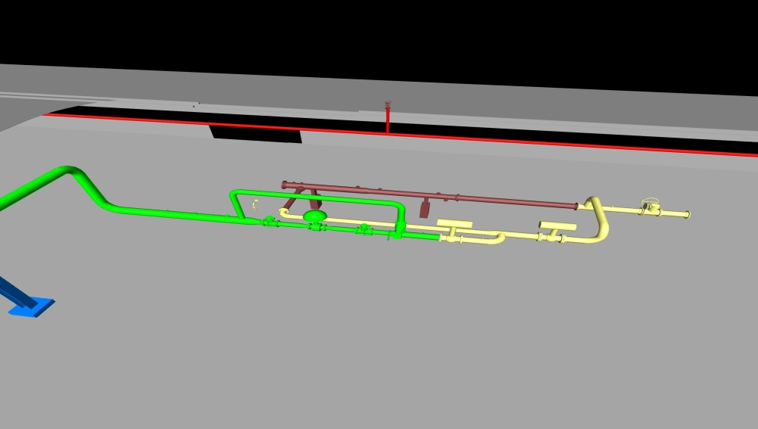

## Electrical and instrument cable routes shall be designed in complete detail for 60% 3D model

