|  |  |  |  |  |  |  |  |
| --- | --- | --- | --- | --- | --- | --- | --- |
| **طرح نگهداشت و افزایش تولید 27 مخزن** | | | | | | | |
| **CALCULATION NOTE FOR EARTHING & LIGHTNING SYSTEM**  **نگهداشت و افزایش تولید میدان نفتی بینک** | | | | | | | |
|  |  |  |  |  |  |  |
|  |  |  |  |  |  |  |
| D02 | Jan. 2023 | IFA | H.Shakiba | M.Fakharian | M.Mehrshad |  |
| D01 | Sep. 2022 | IFA | H.Shakiba | M.Fakharian | M.Mehrshad |  |
| D00 | Apr. 2022 | IFC | H.Shakiba | M.Fakharian | M.Mehrshad |  |
| **Rev.** | **Date** | **Purpose of Issue/Status** | **Prepared by:** | **Checked by:** | **Approved by:** | **CLIENT Approval** |
| **Class: 2** | | **CLIENT Doc. Number: F0Z-709012** | | | | |
| **Status:** | **IDC: Inter-Discipline Check**  **IFC: Issued For Comment**  **IFA: Issued For Approval**  **AFD: Approved For Design**  **AFC: Approved For Construction**  **AFP: Approved For Purchase**  **AFQ: Approved For Quotation**  **IFI: Issued For Information**  **AB-R: As-Built for CLIENT Review**  **AB-A: As-Built –Approved** | | | | | |

**REVISION RECORD SHEET**

|  |  |  |  |  |  |  |  |  |  |  |  |  |
| --- | --- | --- | --- | --- | --- | --- | --- | --- | --- | --- | --- | --- |
| **PAGE** | **D00** | **D01** | **D02** | **D03** | **D04** |  | **PAGE** | **D00** | **D01** | **D02** | **D03** | **D04** |
| **1** | X | X | X |  |  | **51** |  |  |  |  |  |
| **2** | X | X | X |  |  | **52** |  |  |  |  |  |
| **3** | X | X |  |  |  | **53** |  |  |  |  |  |
| **4** | X | X |  |  |  | **54** |  |  |  |  |  |
| **5** | X | X |  |  |  | **55** |  |  |  |  |  |
| **6** | X | X | X |  |  | **56** |  |  |  |  |  |
| **7** | X | X |  |  |  | **57** |  |  |  |  |  |
| **8** | X | X |  |  |  | **58** |  |  |  |  |  |
| **9** | X | X |  |  |  | **59** |  |  |  |  |  |
| **10** | X | X |  |  |  | **60** |  |  |  |  |  |
| **11** | X | X | X |  |  | **61** |  |  |  |  |  |
| **12** | X | X |  |  |  | **62** |  |  |  |  |  |
| **13** | X | X |  |  |  | **63** |  |  |  |  |  |
| **14** | X | X |  |  |  | **64** |  |  |  |  |  |
| **15** | X | X | X |  |  | **65** |  |  |  |  |  |
| **16** | X | X |  |  |  | **66** |  |  |  |  |  |
| **17** | X | X | X |  |  | **67** |  |  |  |  |  |
| **18** | X | X |  |  |  | **68** |  |  |  |  |  |
| **19** | X | X |  |  |  | **69** |  |  |  |  |  |
| **20** |  | X |  |  |  | **70** |  |  |  |  |  |
| **21** |  | X |  |  |  | **71** |  |  |  |  |  |
| **22** |  | X | X |  |  | **72** |  |  |  |  |  |
| **23** |  | X |  |  |  | **73** |  |  |  |  |  |
| **24** |  |  |  |  |  | **74** |  |  |  |  |  |
| **25** |  |  |  |  |  | **75** |  |  |  |  |  |
| **26** |  |  |  |  |  | **76** |  |  |  |  |  |
| **27** |  |  |  |  |  | **77** |  |  |  |  |  |
| **28** |  |  |  |  |  | **78** |  |  |  |  |  |
| **29** |  |  |  |  |  | **79** |  |  |  |  |  |
| **30** |  |  |  |  |  | **80** |  |  |  |  |  |
| **31** |  |  |  |  |  | **81** |  |  |  |  |  |
| **32** |  |  |  |  |  | **82** |  |  |  |  |  |
| **33** |  |  |  |  |  | **83** |  |  |  |  |  |
| **34** |  |  |  |  |  | **84** |  |  |  |  |  |
| **35** |  |  |  |  |  | **85** |  |  |  |  |  |
| **36** |  |  |  |  |  | **86** |  |  |  |  |  |
| **37** |  |  |  |  |  | **87** |  |  |  |  |  |
| **38** |  |  |  |  |  | **88** |  |  |  |  |  |
| **39** |  |  |  |  |  | **89** |  |  |  |  |  |
| **40** |  |  |  |  |  | **90** |  |  |  |  |  |
| **41** |  |  |  |  |  | **91** |  |  |  |  |  |
| **42** |  |  |  |  |  | **92** |  |  |  |  |  |
| **43** |  |  |  |  |  | **93** |  |  |  |  |  |
| **44** |  |  |  |  |  | **94** |  |  |  |  |  |
| **45** |  |  |  |  |  | **95** |  |  |  |  |  |
| **46** |  |  |  |  |  | **96** |  |  |  |  |  |
| **47** |  |  |  |  |  | **97** |  |  |  |  |  |
| **48** |  |  |  |  |  | **98** |  |  |  |  |  |
| **49** |  |  |  |  |  | **99** |  |  |  |  |  |
| **50** |  |  |  |  |  | **100** |  |  |  |  |  |

**CONTENTS**

1.0 INTRODUCTION 4

2.0 Scope 5

3.0 NORMATIVE REFERENCES 5

3.1 Codes & Standards 5

3.2 The Project Documents 5

3.3 Environmental Data 5

3.4 Order of Precedence 6

4.0 Definition 6

4.1 Earth Plate 6

4.2 Earth Rod 6

4.3 Protective Conductor 6

4.4 Main earth conductor 7

4.5 Earthing System 7

4.6 Exposed Conductive part 7

4.7 Extraneous conductive part 7

4.8 Equipotential bonding 7

4.9 Neutral conductor 7

4.10 Earthing voltage 7

4.11 Earth Fault Current 7

4.12 Reference Earth 8

5.0 GENERAL CONCEPTION EARTHING 8

5.1 Main Earth conductor 8

5.2 Earth Bar 8

5.3 Equipment to be earthed 8

6.0 SOIL RESISTIVITY 9

7.0 CONDUCTOR SIZING 10

7.1 Selection of an earthing conductor for Transformer neutral point 10

7.2 Selection of an Earthing Conductor Around Substation 11

7.3 Selection of an earthing conductor for main earthing loop at site: 12

8.0 Earthing system calculation 13

8.1 Earthing System Calculation for process plants 13

8.2 Clean Earth 14

8.3 Equipment Earthing Conductor Sizing 15

9.0 LIGHTNING PROTECTION SYSTEM 17

9.1 Calculation number of rods for lightning system 17

9.2 Calculation Method (Simplified Risk Assessment) 18

9.3 Lightning Protection Risk Calculation 23

1. **INTRODUCTION**

Binak oilfield in Bushehr province is a part of the southern oilfields of Iran, is located 20 km northwest of Genaveh city.

With the aim of increasing production of oil from Binak oilfield, an EPC/EPD Project has been defined by NIOC/NISOC and awarded to Petro Iran Development Company (PEDCO). Also PEDCO (as General Contractor) has assigned the EPC-packages of the Project to "Hirgan Energy - Design and Inspection" JV.

As a part of the Project, a New Gas Compressor Station (adjacent to existing Binak GCS) shall be constructed to gather of 15 MMSCFD (approx.) associated gases and compress & transfer them to Siahmakan GIS.

**GENERAL DEFINITION**

The following terms shall be used in this document.

|  |  |
| --- | --- |
| CLIENT: | National Iranian South Oilfields CLIENT (NISOC) |
| PROJECT: | Binak Oilfield Development – Surface Facilities; New Gas Compressor Station |
| EPD/EPC CONTRACTOR (GC): | Petro Iran Development Company (PEDCO) |
| EPC CONTRACTOR: | Joint Venture of : Hirgan Energy – Design & Inspection (D&I) Companies |
| VENDOR: | The firm or person who will fabricate the equipment or material. |
| EXECUTOR: | Executor is the party which carries out all or part of construction and/or commissioning for the project. |
| THIRD PARTY INSPECTOR (TPI): | The firm appointed by EPD/EPC CONTRACTOR (GC) and approved by CLIENT (in writing) for the inspection of goods. |
| SHALL: | Is used where a provision is mandatory. |
| SHOULD: | Is used where a provision is advisory only. |
| WILL: | Is normally used in connection with the action by CLIENT rather than by an EPC/EPD CONTRACTOR, supplier or VENDOR. |
| MAY: | Is used where a provision is completely discretionary. |

1. **Scope**

The main purpose of this document is calculate earthing and lightning system relating to “Binak gas compressor station plant”.

1. **NORMATIVE REFERENCES**

## Codes & Standards

* BS 7430:2011+A1:2015 Code of practice for protective earthing of electrical installations
* IEC 60364 Electrical installation of buildings
* IEC 60621 Electrical installation for outdoor sites under heavy conditions
* IEC 60724 Short circuit temperature limits of electric cables
* BS 6651 Protection of structures against lightning
* IPS E-EL-100(1) Engineering standard for electrical system design
* NFPA 780 Standard for installation of lightning protection system

## The Project Documents

* BK-GCS-PEDCO-120-GT-RT-0001 Geotechnical Investigation Report for Compressor

Station

* BK-GNRAL-PEDCO-000-EL-SP-0006 Specification For Earthing & Lightning System
* BK-GNRAL-PEDCO-000-EL-DC-0006 Electrical System Design Criteria
* BK-GNRAL-PEDCO-000-EL-DW-0002 Typical Installation Details & Notes For Earthing &

Lightning Protection System

## Environmental Data

* BK-GNRAL-PEDCO-000-PR-DB-0001 Process Basis of Design

## Order of Precedence

In case of conflict between requirements specified herein & the requirements of any other referenced document, the most approved stringent requirements of below listed items shall be considered based on the approval given by the owner’s representative:

* Purchase order
* Material Requisition
* MTO & Data Sheet
* This Specification
* Drawings
* Reference Project Specification
* Iranian Petroleum Standard (IPS)
* International Code & Standards

When the term “Authorized”, Authorization”, “Approval”, or “Approved” are used in this specification, it shall mean authorization or Approval from Client.

In case of any conflict between the project documents, the most stringent one shall be considered.

1. **Definition**

## Earth Plate

Earth plate shall be consist of a 0.7*0.7 square meter copper plate with thickness 3mm which should be set vertically underground to depth where receive wet organics soil.

## Earth Rod

D02

Copper rod embedded in ground and electrically connects to it. The length and diameter is obtained regarding to the location which used.

## Protective Conductor

A conductor that connects parts of the installation to main earth conductor and the main earth conductor to the earth well.

## Main earth conductor

A conductor which makes a ring loop in a room or electrical substations or process plants to which several earth conductors are connected.

## Earthing System

Arrangement of connections and devices necessary to earth equipment or a system separately or jointly.

## Exposed Conductive part

A conductive part of equipment which can be touched and which is not a live part but may become live under faulty condition.

## Extraneous conductive part

A conductive part liable to introduce a potential, generally earth potential, and not forming part of the electrical installation.

## Equipotential bonding

Electrical connection maintaining various exposed conductive parts and extraneous conductive parts at substantially the same potential.

## Neutral conductor

A conductor connected to the neutral point of a system and capable of contributing to the transmission of electrical energy.

## Earthing voltage

$E_{u}$ Is the voltage which occurs between an earthing installation and a reference earth.

## Earth Fault Current

If is the current passing to earth or earthed parts when an earth fault exists at only one point at the site of the fault (earth fault location). This is:

1. The capacitive earth fault current IC with networks with isolated neutral.
2. The earth fault residual current Irest in networks with earth fault compensation.
3. The Earth fault current I”k in networks with low resistance neutral earthing. Also includes networks with isolated neutral point or earth fault compensators in which the neutral point is briefly earthed at the start of the fault.

## Reference Earth

Reference earth or neutral earth, is that part of the earth, particularly surface outside the area of influence of an earth electrode or an earthing system, in which there are no detectable voltages resulting from the earthing current between any two random points.

1. **GENERAL CONCEPTION EARTHING**

## Main Earth conductor

Stranded copper conductors to be embedded in the soil. This earth conductor will make the main earthing system layout to carry the main earth fault current to earth wells and provide the major safety for operators. This conductor will run among the whole site and will interconnect all earthing wells and sub-systems via a loop.

For achieving more reliability the connection of main earthing conductor to the earthing of a building will be via a ring the buildings. The ring should be installed in a cable gallery.

## Earth Bar

A min. 6-way copper earth bar can be installed wherever various earthing conductors should be connected to each other (e.g. Earth well to the main earthing conductor or neutral conductor).

## Equipment to be earthed

* All crane runways shall be earthed on both ends.
* All MV- and LV switchgear should be earthed.
* Steel structures (welded or screwed) should be interconnected to each other (e.g. staircases with railings) and common earth. The minimum size of earth bridges is 50mm2 stranded copper conductors.
* Conveyors will be earthed at their entering points to the buildings (inside of building).
* Any mobile electrical equipment (conveyor…) shall be connected to the earth by earthing tong before operation.
* All LV equipment like MCC panels or distribution boards with metallic covers, doors or walls shall be connected to earth.
* The fixing bolts of the apparatus and structures may not be used for the fixing of earthing wire. If there are no earthing screws, the connection of earthing wire have to be done by means of a hexagonal screw of minimum size M10 welded or screwed to a metallic body of equipment.
* To avoid spark discharges due to either electrostatic charge inside the system or lightning stroke, steel structures and equipment’s piping are to be earthed.
* All motor frames and their local control box with metallic covers shall be earthed by earthing conductors separately.
* Vertical beams around structures with height up to 20m shall be earthed at maximum intervals of 20m. For higher structures, maximum interval is 10m.
* The steel structure of all cable trays and ladders installed in the plant should be earthed. The cable ladders shall form a continuous electrically conductive part. Where necessary, the cable ladders must be electrically bridged.
* All cable ladder runs should be earthed with interval connection 30 m.
* All the tanks shall be earthed and bonded earth.
* All Steel fences shall be earthed with interval connection 30 m.

1. **SOIL RESISTIVITY**

Soil resistivity measurement has been done by Baran Geotechnics Company for several points of the site as below:

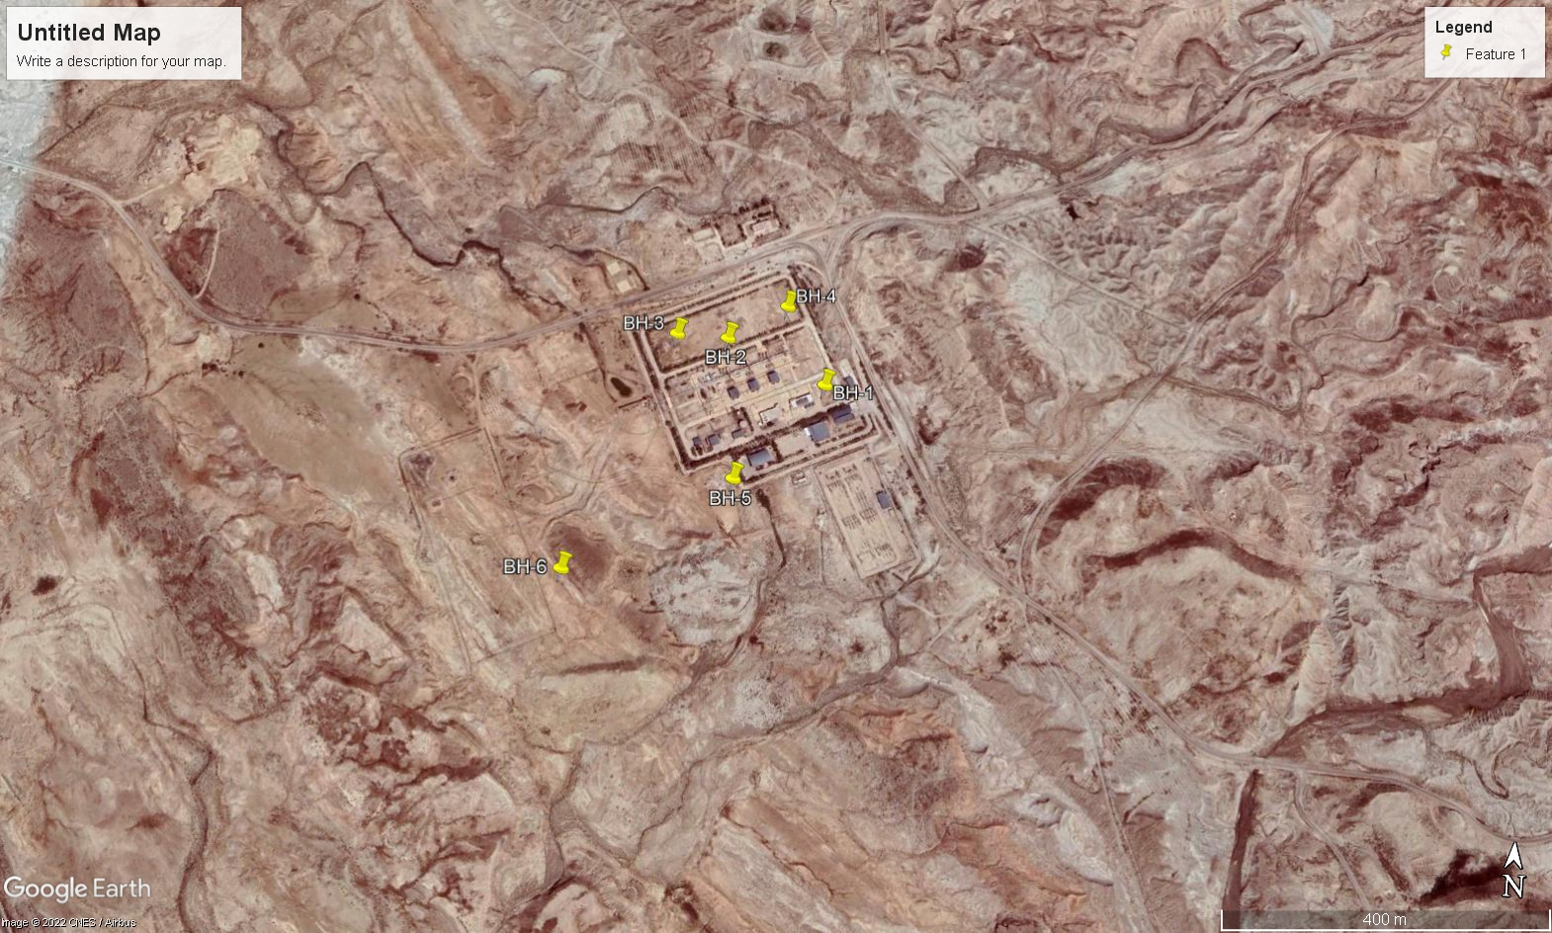

| tABLE A.ELECTRICAL TEST RESISTIVITY RESULT  (Doc no. BK-GCS-PEDCO-120-GT-RT-0001) | | |
| --- | --- | --- |
| Station No. | ρa (Ωm) | |
| a=1m | a=3m |
| BH-1 | 5.98 | 114.89 |
| BH-2 | 4.56 | 19.74 |
| BH-3 | 7.49 | 74.10 |
| BH-4 | 3.97 | 77.90 |
| BH-5 | 1.24 | 9.32 |
| BH-6 | 16.96 | 66.04 |
| Average | 6.7 | 60.33 |

According to Table “A” data the average resistance in 3 meters for these 6 boreholes is 60.33 ohm.m. So in this calculation the equal soil resistivity will be considered as 60 ohm.m

1. **CONDUCTOR SIZING**

## Selection of an earthing conductor for Transformer neutral point

The minimum cross-section of earthing conductor for earthing neutral point of transformer and main earthing of around substation is calculated with below formula according to BS 7430:2015.

$$S=I\frac{\sqrt{t}}{K}\left(mm^{2}\right)$$

Where:

* I: is the average fault current, in A r.m.s.;
* t: is the fault current duration, in s.;
* K: is the current density in amperes per square millimeter r.m.s;(Table 4:BS 7430)

For other initial and final temperatures the current density K for a 1 s duration may be obtained from the following equation:

$$K=K^{'}{\left[\ln\left(\frac{T_{2}+β}{T_{1}+β}\right)\right]}^{1/2}\left(A/mm^{2}\right)$$

Where:

* T2: Final temperature in °C
* T1: Initial temperature in °C (max. ambient temp.)
* K´ & ß: Coefficients as Table 7 of BS 7430

| **Table 2 – K′ Coefficient for different materials (according to BS 7430-Table 7)** | | |
| --- | --- | --- |
| **Metal** | **K′ A/mm² (rms)** | **β** |
| Copper | 226 | 234.5 |
| Aluminum | 148 | 228 |
| Steel | 78 | 202 |

* T2 = 160 ˚C for PVC insulation cables (Table 1: IEC 60724)

So, the r.m.s current density (K) for PVC insulation cables will be:

$K=K^{'}{\left[\ln\left(\frac{T_{2}+β}{T_{1}+β}\right)\right]}^{1/2}=226[\ln\left(\frac{160+234.5}{30+234.5}\right)]^{\frac{1}{2}}≅142.3\left(A/mm^{2}\right)$

So the used values are as below:

Isc= 50 kA (According to ETAP study)

t = 0.5 s

K= 142.3

$S_{min}=50kA×\frac{\sqrt{0.5}}{142.3}=248.45≈300 mm2$

300 mm2 PVC insulated copper conductor will be applied for neutral point of transformers earthing.

## Selection of an Earthing Conductor Around Substation

According to table 4 of BS 7430, the coefficient of bare conductor is 159.

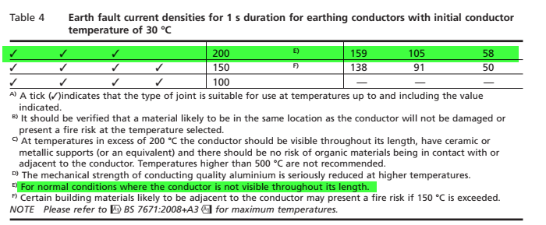

D02

Therefore main earthing around of substation with bare copper cable is

120 mm2 bare copper conductor will be applied for main ring around substation.

## Selection of an earthing conductor for main earthing loop at site:

The minimum cross-section of earthing conductor for main earthing loop is calculated with below formula according to BS 7430:2015.

$S=I\frac{\sqrt{t}}{K}\left(mm^{2}\right)$

Where:

* I: is the average fault current, in A r.m.s.;
* t: is the fault current duration, in s.;
* K: is the current density in amperes per square millimeter r.m.s;(Table 4:BS 7430)
* So the used values are as below:
* Isc= 16 kA (According ETAP result)
* t= 0.5 s
* K= 159

$S_{min}=16kA×\frac{\sqrt{0.5}}{159}=71≈70 mm2$

Therefore, 70 mm2 **bare copper conductor** will be applied for earthing system around site.

1. **Earthing system calculation**

## Earthing System Calculation for process plants

According to site plan there are two area which are:

**Process Area: 210x65 meter**

**Utility Area: 75x67 meter**

Refer to section 9.5.5 of BS 7430, the approximate resistance to earth of a round conductor can be calculated from the following:

$Rt= \frac{ρ}{2πL}Ln\left(\frac{L^{2}}{khd}\right)$

Where:

* $ρ$: is the resistivity of the soil in in Ω.m
* L: is the length of the strip or conductor, in metres (m
* h: is the depth of the buried, in metres (m)
* d: is the width of the strip or the diameter of the round conductor, in metres (m);
* k: has the value 1.36 for strip or 1.83 for round conductor.
* Rt is the resistance of a single strip of length L, calculated from the preceding Rt equation, in ohms (Ω).

When two or more straight lengths, each of length L in metres (m) and a separation distance s metres (m) are laid parallel to each other and connected together at one end only the combined resistance may be calculated from the following equation:

$R_{n}=FR_{t}$

Where:

$R_{n}is the resistance of n conductors in parallel, in ohms (Ω)$

F has the following value:

$F=0.5+0.078×{(\frac{S}{L})}^{-0.307}$

| **The Resistance for Process & Utility Area** | | |
| --- | --- | --- |
| **Item** | **Process Area** | **Utility Area** |
| $$ρ$$ | 60 Ω.m | 60 Ω.m |
| $$L$$ | 210 m | 75 m |
| W | 65 | 67 |
| $$h$$ | 0.6 m | 0.6 m |
| d | $$\sqrt{\frac{70×4}{π}}=9.44 mm$$ | $$\sqrt{\frac{70×4}{π}}=9.44 mm$$ |
| K | 1.83 | 1.83 |
| $$Rt$$ | $$\frac{60}{2*3.14*210}Ln\left(\frac{{210}^{2}}{1.83*0.6*0.00944}\right)=0.69 Ω$$ | $$\frac{60}{2*3.14*75}Ln\left(\frac{{75}^{2}}{1.83*0.6*0.00944}\right)=1.68 Ω$$ |
| $$F$$ | $$0.5+0.078×{(\frac{65}{210})}^{-0.307}=0.61$$ | $$0.5+0.078×{(\frac{67}{75})}^{-0.307}=0.58$$ |
| $$Rt=FRn$$ | $$0.69×0.61=0.42$$ | $$1.68×0.58=0.97$$ |

## Clean Earth

In this project, clean earth is also required for instrument system, the earthing resistance shall be below 0.5 Ω. regarding to achieve this resistance using rod electrode with 1 meter length and 19 mm2 diameter based on BS 7430 section 9.5.8.5 around control room is done as below:

The average of soil resistance in depth of one meter is almost 6.7, so it should be considered for calculating clean earth system as well.

$R_{rod}˭\frac{ρ}{2πL}×\left[Ln\left(\frac{8.L}{d}\right)˗1\right]$

Where:

L: is the length of electrode in (m)

d: is the diameter of the electrode in (m)

ρ: The resistivity of the soil (Ω.m)

$R_{rod}˭\frac{6·7}{2xπx1}×\left[Ln\left(\frac{8x1}{0·019}\right)˗1\right]˭5·37 Ω$

The combine resistance of 'N' rod electrodes in parallel can be obtained from the following equation (BS 7430-2011-table2):



$R_{n}˭R\left[\frac{1˖λa}{N}\right]$

In Which

$a˭\frac{ρ}{2πRs}=\frac{6.7}{2×π×5.37×10}=0.02$

Rn: is the resistance of 'n' rods in Hollow Square in 'Ω'

R: is the resistance of one rod in 'Ω'

s : is the spacing of rods, in meters (m);=10

λ: is a factor given in above table

N: is the number of rods used as electrodes

Therefore:

$R_{2}˭5·37×(\frac{1+2.71×0..02}{4×\left(2-1\right)})˭1.41 Ω$

$R_{3}˭5·37×\left(\frac{1+4.51×0..02}{4×\left(3-1\right)}\right)˭0.73 Ω$

$R_{4}˭5·37×\left(\frac{1+5.46×0..02}{4×\left(4-1\right)}\right)˭0.496 Ω$

According to above calculation the number of electrodes are 4 x (4-1) = 12

So all instrument facilities should be connected to clean earth system

## Equipment Earthing Conductor Sizing

According to IPS-D-EL-417, all steel structures in site shall be earthed with Green-Yellow PVC insulated stranded copper wire. Earthing conductor which is applied to the exposed conductive part shall be selected from following table:

| **Number of Metallic Earthing Connection** | | | |
| --- | --- | --- | --- |
| **Equipment** | **Remark** | **No. of Grounding Points** | **Grounding Conductor Size (sq.mm.)** |
| Tank or Storage | ≤ 10 m in diameter | 2 | 35 |
| >10 m in diameter | One connection at maximum 30 m interval along the perimeter of the tank | 35 |
| Tower | <20 m in height | 1 | 35 |
| ≥20 m in height | 2 | 35 |
| Drum |  | 1 | 35 |
| Heat Exchanger |  | 1 | 16 |
| Steel Structure |  | 2 | 70 or 35 |
| Pipe Rack |  | Every 30 m (Min. 2) | 70 |
| Pipe |  | In Accordance with Layout | 16 |
| Ladder & Stairways |  | In Accordance with Layout | 35 |

| **Number of Electrical Earthing Connection** | | | |
| --- | --- | --- | --- |
| **Electrical Equipment**  D02 | **Remark** | **No. of Grounding Points** | **Grounding Conductor Size (sq.mm.)** |
| Transformer | Body | 2 | 70 (min.) |
| Oil tank | 1 | 35 (min.) |
| Medium Voltage & High Voltage Switchgear | Switchgear | 2 | 120 (min.) |
| Lightning Arrestor | 1 | 70 |
| Low Voltage Switchgear, MCC or Panels | - | In Accordance with Layout | 185 (min.) |
| Local Control Station | - | 1 | 16 |
| Local lighting/Small Power Distribution Boards | - | 1 | 35 |
| Motor | Up to 22kW | 1 | 16 |
| 23kW to 55kW | 1 | 35 |
| More than 56kW | 1 | 70 |
| Welding Outlet | - | 1 | 35 |
| Main Loop | - | In Accordance with Layout | 70 |
| Substation Loop | - | In Accordance with Layout | 120 |

1. **LIGHTNING PROTECTION SYSTEM**

## Calculation number of rods for lightning system

Rod electrode are used for lightning system, the min. resistance should be 5 ohm. Regarding to achieve this resistance using rod electrode with 3 meter length and 19 mm2 diameter based on BS 7430 section 9.5.8.5 around buildings is done as below:

The average of soil resistance in depth of three meter is almost 60, so it should be considered for calculating clean earth system as well.

$R_{rod}˭\frac{ρ}{2πL}×\left[Ln\left(\frac{8.L}{d}\right)˗1\right]$

Where:

L: is the length of electrode in (m)

d: is the diameter of the electrode in (m)

ρ: The resistivity of the soil (Ω.m)

$R_{rod}˭\frac{60}{2xπx3.}×\left[Ln\left(\frac{8x3}{0·019}\right)˗1\right]˭19·5 Ω$

The combine resistance of 'N' rod electrodes in parallel can be obtained from the following equation (BS 7430-2015-table2):



$R_{n}˭R\left[\frac{1˖λa}{N}\right]$

In Which

$a˭\frac{ρ}{2πRs}$

Rn: is the resistance of 'n' rods in Hollow Square in 'Ω'

R: is the resistance of one rod in 'Ω'

s : is the spacing of rods, in meters (m);=7

λ: is a factor given in above table

N: is the number of rods used as electrodes (N=4*(n-1))

$a˭\frac{60}{2xπx19.5x7}˭0·07$

Therefore:

$R_{2}˭19·5\left[\frac{1˖^{(}2.71x0·07₎}{4(2-1)}\right]˭5.8 Ω$

$R_{3}˭19·5\left[\frac{1˖₍4·51x0·07₎}{4(3-1)}\right]˭3.2 Ω$

According to above calculation the number of electrodes are 4 x (3-1) = 8 for achieving to resistance below 5 $Ω$.

## Calculation Method (Simplified Risk Assessment)

Regarding to BS 661 standard, at first we have to calculate the risk assessment of lightning which may be occur. If the risk is high according to NFPA780 standard, lightning protection system shall be considered.

D02

## Average Lightning Flash Density

According to below map (Process Basis of Design sec. 7.12 average lightning flash density), approximately 15 thunderstorm days per year is expected for site location.

Average lightning flash density (Ng) will be estimated from following equation according to BS EN 62305-2-2012

$$N_{g}=0.1(T_{d})$$

Where:

$T_{d }:$ Thunderstorm days per year=15

So:

$$N_{g}=0.1×(15)=1.5$$

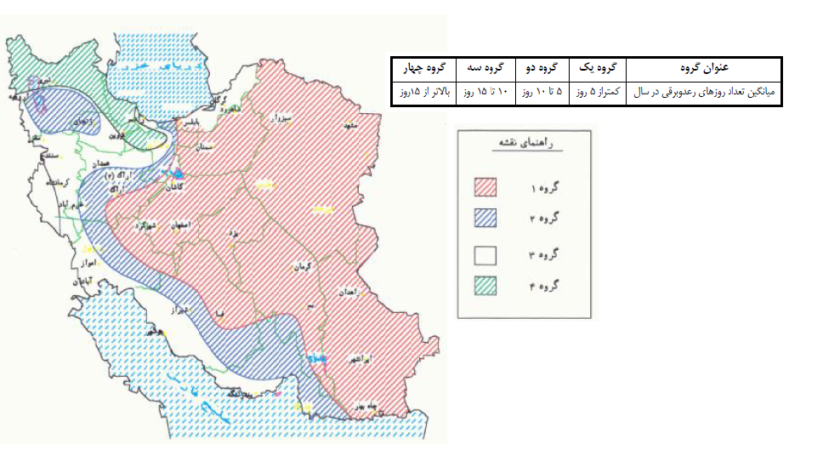

Figure A: Lightning isochrones map of Iran

## Annual Threat of Occurrence

The yearly annual threat of occurrence (lightning strike frequency) ($N_{d}$) to a structure is determined by the following equation:

$$N_{d}=N_{g}×A_{e}×C_{1}×{10}^{-6}$$

Where:

$N_{d}$ = yearly lightning strike frequency to the structure or object

$N_{g}$ = lightning ground flash density in flashes/km2/year

$A_{e}$ = the equivalent collection area of the structure (m2)

$C_{1}$ = environmental coefficient

## Equivalent Collection Area

It is an area adjusted for the structure that includes the effect of the height and location of the structure.

The equivalent collection area of a rectangular structure with length L, width W, and height H is as follows:

$$A_{e}=\left(L×W\right)+6×H×\left(L+W\right)+π×9×H^{2}$$

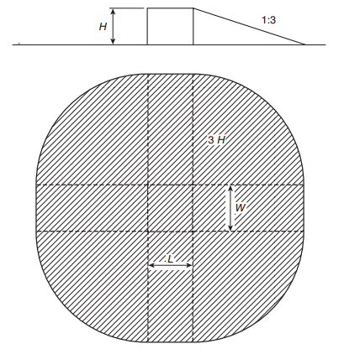

Where:

$A_{e}$ = equivalent collection area of the building in m2

L= length of the building in meter

W=Width of the building in meter

H=Height of the building in meter.

## Environmental Coefficient (C1)

The location factor accounts for the topography of the site of the structure and any objects located within the distance 3H from the structure that can affect the collection area.

Location factors are given in below Table:

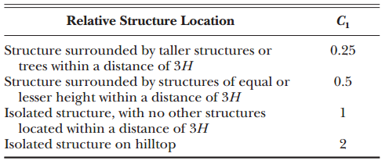

NFPA 780 - Table L.4.2- Location Factor, $C_{1}$

## Simplified Risk Assessment

Simplified risk assessment calculates the tolerable lightning frequency (Nc) and compares it to the annual threat of occurrence (Nd). The tolerable lightning frequency (Nc) is a measure of the risk of damage to the structure, including factors affecting risks to the structure, to the contents, and of environmental loss. It is calculated by dividing the acceptable frequency of property losses by various coefficients relating to the structure, the contents, and the consequence of damage.

The tolerable lightning frequency is expressed by the following formula:

$$N_{c}=\frac{{1.5×10}^{-3}}{C}$$

Where:

$$C=C_{2}×C_{3}×C_{4}×C_{5}$$

## Construction Coefficient (C2)

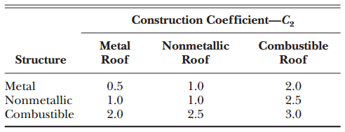

NFPA 780 - Table L.5.1.2 (a) - Determination of Construction Coefficient, $C_{2}$

## Structure Contents Coefficient (C3)

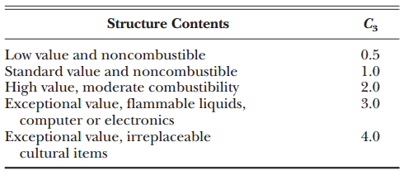

NFPA 780 - Table L.5.1.2 (b) - Determination of Structure Contents Coefficient, $C_{3}$

## Structure Occupancy Coefficient (C4)

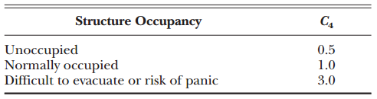

NFPA 780 - Table L.5.1.2(c) - Determination of Structure occupancy Coefficient, $C_{4}$

## Lightning Consequence Coefficient (C5)

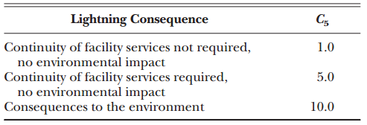

NFPA 780 - Table L.5.1.2 (d) - Determination of Lightning Consequence Coefficient, $C_{5}$

## Conclusion

If:

${ N}_{c }<N_{d }$ Lightning protection is required

${ N}_{c }=>N_{d }$ Lightning protection is not required.

D02

## Lightning Protection Risk Calculation

|  |  |  |  |  |  |  |  |  |  |  |  |  |  |  |
| --- | --- | --- | --- | --- | --- | --- | --- | --- | --- | --- | --- | --- | --- | --- |
| **No.** | **Structure Name** | **Structure Dimension** | | | **Ae** | **C1** | **Nd (Ng=1.5)** | **C2** | **C3** | **C4** | **C5** | **C** | **Nc** | **LPS Requied** |
| **L(m)** | **W(m)** | **H(m)** |
| **Receiving Area** | | | | | | | | | | | | | | |
| 1 | Control Building | 25 | 23 | 6.5 | 3641 | 1 | $$5.46x{10}^{-3}$$ | 1 | 3 | 1 | 5 | 15 | $$0.1x{10}^{-3}$$ | Yes |
| 2 | Gas Compressor Shelter | 72 | 12 | 6 | 4905 | 0.5 | $$3.6x{10}^{-3}$$ | 0.5 | 3 | 1 | 5 | 7.5 | $$02x{10}^{-3}$$ | Yes |
| 3 | Fire Fighting Shelter | 18 | 10 | 6 | 2205 | 0.25 | $$0.8x{10}^{-3}$$ | 0.5 | 2 | 0.5 | 5 | 2.5 | $$0.6{10}^{-3}$$ | Yes |
| 4 | Chemical Shelter | 10 | 5 | 6 | 1812 | 0.5 | $$1.2x{10}^{-3}$$ | 0.5 | 3 | 0.5 | 10 | 7.5 | $$0.2x{10}^{-3}$$ | Yes |
| 5 | Utility Shelter | 18 | 14 | 6 | 2421 | 0.25 | $$0.9x{10}^{-3}$$ | 0.5 | 2 | 0.5 | 5 | 2.5 | $$.6x{10}^{-3}$$ | Yes |

D01

The installation of lightning system for required structures will be done according BS 6651.