|  |  |  |  |  |  |  |
| --- | --- | --- | --- | --- | --- | --- |
| **طرح نگهداشت و افزایش تولید 27 مخزن** | | | | | | |
| **CALCULATION NOTE FOR COMPRESSOR AREA MAIN SLEEPERS**  **نگهداشت و افزایش تولید میدان نفتی بینک** | | | | | | |
|  |  |  |  |  |  |  |
|  |  |  |  |  |  |  |
|  |  |  |  |  |  |  |
|  |  |  |  |  |  |  |
| D00 | JAN.2023 | IFC | R.Berlouie | M.Fakharian | M.Mehrshad |  |
| **Rev.** | **Date** | **Purpose of Issue/Status** | **Prepared by:** | **Checked by:** | **Approved by:** | **CLIENT Approval** |
| **Class:2** | | **CLIENT Doc. Number:F0Z-709129** | | | | |
| **Status:** | **IDC: Inter-Discipline Check**  **IFC: Issued For Comment**  **IFA: Issued For Approval**  **AFD: Approved For Design**  **AFC: Approved For Construction**  **AFP: Approved For Purchase**  **AFQ:** Approved For Quotation  **IFI: Issued For Information**  **AB-R: As-Built for CLIENT Review**  **AB-A: As-Built –Approved** | | | | | |

**REVISION RECORD SHEET**

|  |  |  |  |  |  |  |  |  |  |  |  |  |
| --- | --- | --- | --- | --- | --- | --- | --- | --- | --- | --- | --- | --- |
| **PAGE** | **D00** | **D01** | **D02** | **D03** | **D04** |  | **PAGE** | **D00** | **D01** | **D02** | **D03** | **D04** |
| **1** | X |  |  |  |  | **66** |  |  |  |  |  |
| **2** | X |  |  |  |  | **67** |  |  |  |  |  |
| **3** | X |  |  |  |  | **68** |  |  |  |  |  |
| **4** | X |  |  |  |  | **69** |  |  |  |  |  |
| **5** | X |  |  |  |  | **70** |  |  |  |  |  |
| **6** | X |  |  |  |  | **71** |  |  |  |  |  |
| **7** | X |  |  |  |  | **72** |  |  |  |  |  |
| **8** | X |  |  |  |  | **73** |  |  |  |  |  |
| **9** | X |  |  |  |  | **74** |  |  |  |  |  |
| **10** | X |  |  |  |  | **75** |  |  |  |  |  |
| **11** | X |  |  |  |  | **76** |  |  |  |  |  |
| **12** | X |  |  |  |  | **77** |  |  |  |  |  |
| **13** | X |  |  |  |  | **78** |  |  |  |  |  |
| **14** | X |  |  |  |  | **79** |  |  |  |  |  |
| **15** |  |  |  |  |  | **80** |  |  |  |  |  |
| **16** |  |  |  |  |  | **81** |  |  |  |  |  |
| **17** |  |  |  |  |  | **82** |  |  |  |  |  |
| **18** |  |  |  |  |  | **83** |  |  |  |  |  |
| **19** |  |  |  |  |  | **84** |  |  |  |  |  |
| **20** |  |  |  |  |  | **85** |  |  |  |  |  |
| **21** |  |  |  |  |  | **86** |  |  |  |  |  |
| **22** |  |  |  |  |  | **87** |  |  |  |  |  |
| **23** |  |  |  |  |  | **88** |  |  |  |  |  |
| **24** |  |  |  |  |  | **89** |  |  |  |  |  |
| **25** |  |  |  |  |  | **90** |  |  |  |  |  |
| **26** |  |  |  |  |  | **91** |  |  |  |  |  |
| **27** |  |  |  |  |  | **92** |  |  |  |  |  |
| **28** |  |  |  |  |  | **93** |  |  |  |  |  |
| **29** |  |  |  |  |  | **94** |  |  |  |  |  |
| **30** |  |  |  |  |  | **95** |  |  |  |  |  |
| **31** |  |  |  |  |  | **96** |  |  |  |  |  |
| **32** |  |  |  |  |  | **97** |  |  |  |  |  |
| **33** |  |  |  |  |  | **98** |  |  |  |  |  |
| **34** |  |  |  |  |  | **99** |  |  |  |  |  |
| **35** |  |  |  |  |  | **100** |  |  |  |  |  |
| **36** |  |  |  |  |  | **101** |  |  |  |  |  |
| **37** |  |  |  |  |  | **102** |  |  |  |  |  |
| **38** |  |  |  |  |  | **103** |  |  |  |  |  |
| **39** |  |  |  |  |  | **104** |  |  |  |  |  |
| **40** |  |  |  |  |  | **105** |  |  |  |  |  |
| **41** |  |  |  |  |  | **106** |  |  |  |  |  |
| **42** |  |  |  |  |  | **107** |  |  |  |  |  |
| **43** |  |  |  |  |  | **108** |  |  |  |  |  |
| **44** |  |  |  |  |  | **109** |  |  |  |  |  |
| **45** |  |  |  |  |  | **110** |  |  |  |  |  |
| **46** |  |  |  |  |  | **111** |  |  |  |  |  |
| **47** |  |  |  |  |  | **112** |  |  |  |  |  |
| **48** |  |  |  |  |  | **113** |  |  |  |  |  |
| **49** |  |  |  |  |  | **114** |  |  |  |  |  |
| **50** |  |  |  |  |  | **115** |  |  |  |  |  |
| **51** |  |  |  |  |  | **116** |  |  |  |  |  |
| **52** |  |  |  |  |  | **117** |  |  |  |  |  |
| **53** |  |  |  |  |  | **118** |  |  |  |  |  |
| **54** |  |  |  |  |  | **119** |  |  |  |  |  |
| **55** |  |  |  |  |  | **120** |  |  |  |  |  |
| **56** |  |  |  |  |  | **121** |  |  |  |  |  |
| **57** |  |  |  |  |  | **122** |  |  |  |  |  |
| **58** |  |  |  |  |  | **123** |  |  |  |  |  |
| **59** |  |  |  |  |  | **124** |  |  |  |  |  |
| **60** |  |  |  |  |  | **125** |  |  |  |  |  |
| **61** |  |  |  |  |  | **126** |  |  |  |  |  |
| **62** |  |  |  |  |  | **127** |  |  |  |  |  |
| **63** |  |  |  |  |  | **128** |  |  |  |  |  |
| **64** |  |  |  |  |  | **129** |  |  |  |  |  |
| **65** |  |  |  |  |  | **130** |  |  |  |  |  |

**CONTENTS**

1.0 INTRODUCTION 4

2.0 Scope 5

3.0 NORMATIVE REFERENCES 5

4.0 MATERIALS 6

5.0 PIPING weight 6

6.0 SOIL PARAMETERS 7

7.0 LOADING 8

8.0 FOUNDATION ANALYsis 9

1. **INTRODUCTION**

Binak oilfield in Bushehr province is a part of the southern oilfields of Iran, is located 20 km northwest of Genaveh city.

With the aim of increasing production of oil from Binak oilfield, an EPC/EPD Project has been defined by NIOC/NISOC and awarded to Petro Iran Development Company (PEDCO). Also PEDCO (as General Contractor) has assigned the EPC-packages of the Project to "Hirgan Energy - Design and Inspection" JV.

As a part of the Project, a New Gas Compressor Station (adjacent to existing Binak GCS) shall be constructed to gather of 15 MMSCFD (approx.) associated gases and compress & transfer them to Siahmakan GIS.

**GENERAL DEFINITION**

The following terms shall be used in this document.

|  |  |
| --- | --- |
| CLIENT: | National Iranian South Oilfields Company (NISOC) |
| PROJECT: | Binak Oilfield Development – Surface Fcilities; New Gas Compressor Station |
| EPD/EPC CONTRACTOR (GC): | Petro Iran Development Company (PEDCO) |
| EPC CONTRACTOR: | Joint Venture of : Hirgan Energy – Design & Inspection (D&I) Companies |
| VENDOR: | The firm or person who will fabricate the equipment or material. |
| EXECUTOR: | Executor is the party which carries out all or part of construction and/or commissioning for the project. |
| THIRD PARTY INSPECTOR (TPI): | The firm appointed by EPD/EPC CONTRACTOR (GC) and approved by CLIENT (in writing) for the inspection of goods. |
| SHALL: | Is used where a provision is mandatory. |
| SHOULD: | Is used where a provision is advisory only. |
| WILL: | Is normally used in connection with the action by CLIENT rather than by an EPC/EPD CONTRACTOR, supplier or VENDOR. |
| MAY: | Is used where a provision is completely discretionary. |

1. **Scope**

This report covers the Sleeper Pipe Supports foundation Design . The structure modeled by “SAP” software.

1. **NORMATIVE REFERENCES**

## Local Codes and Standards

* INBC Part 9 Iranian National Building Code, Part 9 (4th Edition)
* Iranian Standard No.2800 Iranian Code of Practice for Seismic Resistant Design of Buildings (4th Edition)

## International Codes and Standards

* ACI 315 Manual of Standard Practice for Detailing Reinforced Concrete
* ACI 318 Building Code Requirements for Reinforced Concrete

## The Project Documents

* BK-GCS-PEDCO-120-GT-RT-0001 Geotechnical Investigation Report for Compressor Station
* BK-GNRAL-PEDCO-000-ST-DC-0001 Structural Design Criteria

## ENVIRONMENTAL DATA

Refer to "Process Basis of Design; Doc. No. BK-GNRAL-PEDCO-000-PR-DB-0001".

## Order of Precedence

In case of any conflict between the contents of this document or any discrepancy between this document and other project documents or reference standards, this issue must be reported to the CLIENT. The final decision in this situation will be made by CLIENT.

1. **MATERIALS**

Material properties are delivered in the following table.

**Material Properties**

|  |  |
| --- | --- |
| Foundation Concrete | F'c = 300 kg/cm2 (28- day cylindrical sample) |
| Long. reinforcement bar | Fy = 4000 kg/cm2 (AIII) |
| Trans. reinforcement bar | Fy = 4000 kg/cm2 (AIII) |

1. **PIPING weight**

All load are received from PIPING department.

|  |  |  |  |  |  |  |
| --- | --- | --- | --- | --- | --- | --- |
| Type | Fz **↓** (kg/m) | No. (SIMPLE) | No. (ANCHOR) | Fx (kg/m) | Fy (kg/m) | Length (m) |
| A | 800 | 29 | 2 | 320 | 640 | 5 |
| B | 700 | 2 | 0 | 280 | 560 | 1.7 |
| C | 600 | 10 | 1 | 240 | 480 | 4 |
| D | 1200 | 10 | 1 | 480 | 960 | 3 |
| E | 500 | 26 | 1 | 200 | 400 | 2 |

1. **SOIL PARAMETERS**

According to Soil Investigation Report, prepared by BKP:

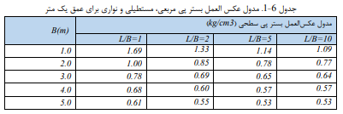

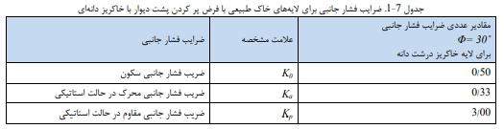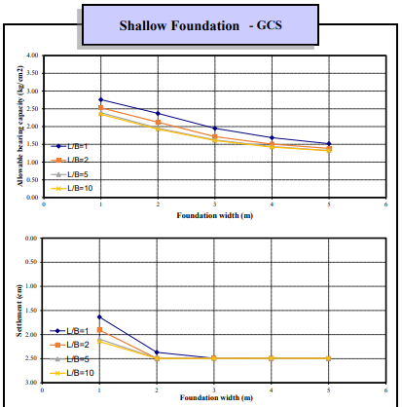

1. **LOADING**

## Dead Load

Dead load of pipes according to piping documents assign in model.

## Live Load

Live load (operation) of Equipment according to piping documents assign in model.

## Seismic Load

Seismic load (occasional) of Equipment according to piping documents assign in model.

## Wind Load

Wind load is not applicable for pipe support foundation.

## LOAD COMBINITION FOR DESIGN

According to AISC structures, components, and foundations shall be designed, so that their design strength equals or exceeds that effect of factored loads in the following combination:

* 1.4(D+F)
* 1.2(D+T+F) +1.6(L+H)+0.5(S)
* 1.2D+1.6(S) + (L)
* 1.2D+L+0.5( S)
* 1.2(D+F)+1.0E+L+1.6(H)+0.2S
* 0.9D+1.0E+1.2F+1.6H

Load listed herein shall be considered to act in the following combinations; whichever produces the most unfavorable effect considering soil reactions.

* D+L+T+H+F
* D+F
* D+H+F+S
* D+H+F+0.75(L+T)+0.75(S)
* D+H+F+(0.7E)
* D+H+F+0.75(0.7E)+0.75L+0.75(S)
* 0.6D+0.7E+H

1. **FOUNDATION ANALYsis**

## sleeper type A

## piping load data

|  |  |  |  |  |  |  |
| --- | --- | --- | --- | --- | --- | --- |
| Type | Fz **↓** (kg/m) | No. (SIMPLE) | No. (ANCHOR) | Fx (kg/m) | Fy (kg/m) | Length (m) |
| B | 800 | 29 | 2 | 160 | 320 | 5 |

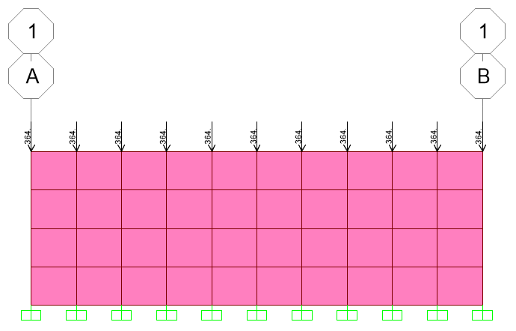

FIGURE 1-OPE Points Loads on sleeper (Kg)

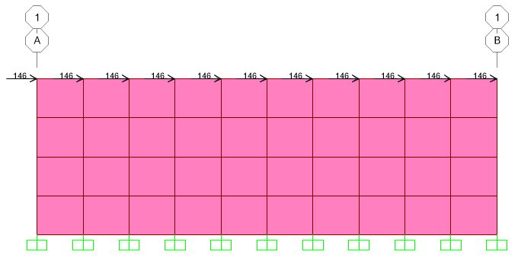

FIGURE 2-OCCX Points Loads on sleeper (Kg)

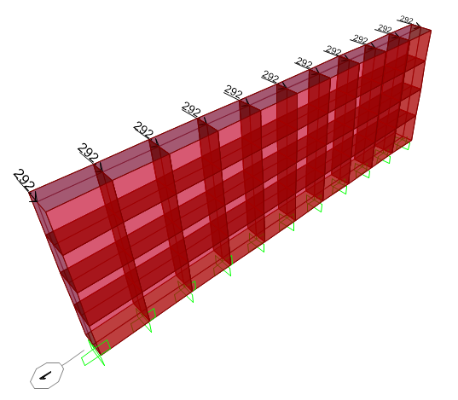

FIGURE 3-OCCY Points Loads on sleeper (Kg)

## wall design

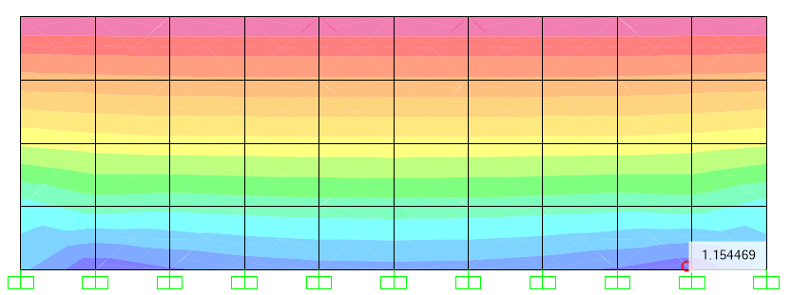

**

*15.68*

$$ρ=\frac{As}{b×d}=\frac{1005}{1000×401}=0.0025$$

$$ρ=\frac{1}{m}×\left[1-\sqrt{1-\frac{2×m×Rn}{fy}}\right]=1/15.68×\left[1-\sqrt{1-\frac{2×15.68×Rn}{4000}}\right]=0.0025$$

$$Rn=9.80$$

$$Rn=\frac{Mn}{b×d^{2}}=\frac{Mn}{100×{40.1}^{2}}=9.80→Mn=15.76 Ton.-m/m$$

$$Mn=\frac{Mu}{0.9}=15.76→Mu=14.18 Ton-m/m$$

## check of stress & settlement for foundation (500x150x40)

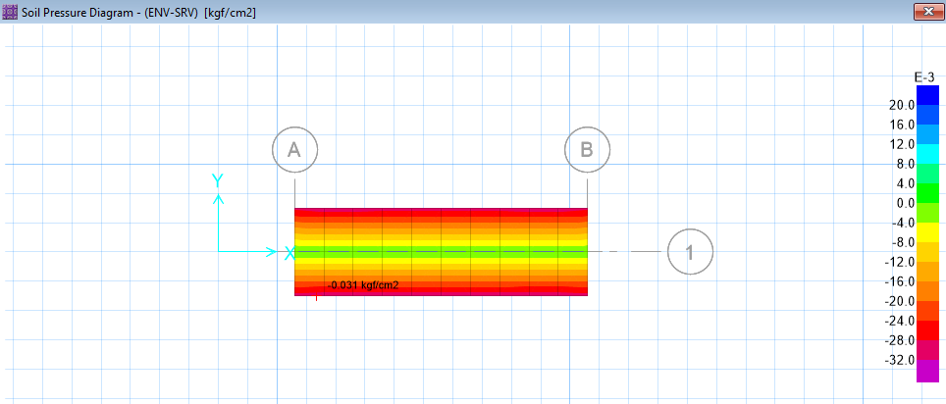

figure 4.stress diagram for foundation

*According to SAFE results, the maximum soil stress under the foundation in combination ENV-SRV is:*

$$max. stress under foundation: 0.31 < 1.20 kg/cm^{2} ok.$$

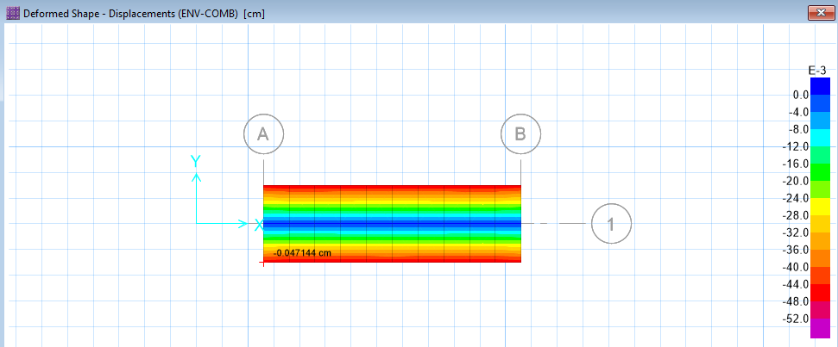

figure 5.displacement diagram for foundation

*According to SAFE results, the maximum soil displacement under the foundation in combination ENV-COMB is:*

$max. displacement under foundation :0.47 cm < 2 cm ok.$

## foundation REINFORCING CONTROL

$$for foundation : A_{smin}=\frac{1}{2}0.0018 bh=\frac{1}{2}0.0018×100×40=7.20 cm^{2}$$

$$A_{s used}=∅16 @ 200=10.05 cm^{2} OK$$

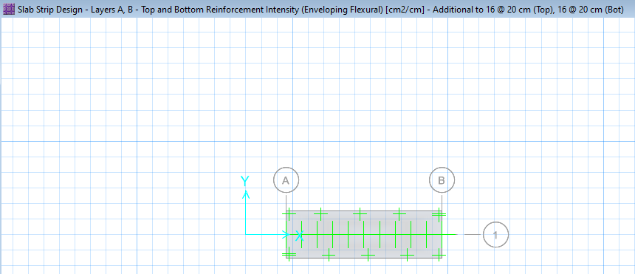

figure 6.slab design (additional reinforcement)

## OVERTURNING and sliding CONTROL CALCULATION

