|  |  |  |  |  |  |  |  |
| --- | --- | --- | --- | --- | --- | --- | --- |
| **طرح نگهداشت و افزایش تولید 27 مخزن** | | | | | | | |
| **CONSUMPTION LIST**  **نگهداشت و افزایش تولید میدان نفتی بینک** | | | | | | | |
|  | |  |  |  |  |  |  |
|  | |  |  |  |  |  |  |
| D02 | | APR.2023 | AFC | M.Aryafar | M.Fakharian | M.Mehrshad |  |
| D01 | | SEP.2022 | IFA | M.Aryafar | M.Fakharian | M.Mehrshad |  |
| D00 | | FEB.2022 | IFC | M.Aryafar | M.Fakharian | M.Mehrshad |  |
| **Rev.** | | **Date** | **Purpose of Issue/Status** | **Prepared by:** | **Checked by:** | **Approved by:** | **CLIENT Approval** |
| **Class:** 2 | | | **CLIENT Doc. Number:** F0Z-707350 | | | | |
| **Status:** | | **IDC: Inter-Discipline Check**  **IFC: Issued For Comment**  **IFA: Issued For Approval**  **AFD: Approved For Design**  **AFC: Approved For Construction**  **AFP: Approved For Purchase**  **AFQ:** Approved For Quotation  **IFI: Issued For Information**  **AB-R: As-Built for CLIENT Review**  **AB-A: As-Built –Approved** | | | | | |

**REVISION RECORD SHEET**

|  |  |  |  |  |  |  |  |  |  |  |  |  |
| --- | --- | --- | --- | --- | --- | --- | --- | --- | --- | --- | --- | --- |
| **PAGE** | **D00** | **D01** | **D02** | **D03** | **D04** |  | **PAGE** | **D00** | **D01** | **D02** | **D03** | **D04** |
| **1** | X | X | X |  |  | **66** |  |  |  |  |  |
| **2** | X | X | X |  |  | **67** |  |  |  |  |  |
| **3** | X |  |  |  |  | **68** |  |  |  |  |  |
| **4** | X |  |  |  |  | **69** |  |  |  |  |  |
| **5** | X | X |  |  |  | **70** |  |  |  |  |  |
| **6** | X | X |  |  |  | **71** |  |  |  |  |  |
| **7** |  | X |  |  |  | **72** |  |  |  |  |  |
| **8** |  | X |  |  |  | **73** |  |  |  |  |  |
| **9** |  | X |  |  |  | **74** |  |  |  |  |  |
| **10** |  |  |  |  |  | **75** |  |  |  |  |  |
| **11** |  |  |  |  |  | **76** |  |  |  |  |  |
| **12** |  |  |  |  |  | **77** |  |  |  |  |  |
| **13** |  |  |  |  |  | **78** |  |  |  |  |  |
| **14** |  |  |  |  |  | **79** |  |  |  |  |  |
| **15** |  |  |  |  |  | **80** |  |  |  |  |  |
| **16** |  |  |  |  |  | **81** |  |  |  |  |  |
| **17** |  |  |  |  |  | **82** |  |  |  |  |  |
| **18** |  |  |  |  |  | **83** |  |  |  |  |  |
| **19** |  |  |  |  |  | **84** |  |  |  |  |  |
| **20** |  |  |  |  |  | **85** |  |  |  |  |  |
| **21** |  |  |  |  |  | **86** |  |  |  |  |  |
| **22** |  |  |  |  |  | **87** |  |  |  |  |  |
| **23** |  |  |  |  |  | **88** |  |  |  |  |  |
| **24** |  |  |  |  |  | **89** |  |  |  |  |  |
| **25** |  |  |  |  |  | **90** |  |  |  |  |  |
| **26** |  |  |  |  |  | **91** |  |  |  |  |  |
| **27** |  |  |  |  |  | **92** |  |  |  |  |  |
| **28** |  |  |  |  |  | **93** |  |  |  |  |  |
| **29** |  |  |  |  |  | **94** |  |  |  |  |  |
| **30** |  |  |  |  |  | **95** |  |  |  |  |  |
| **31** |  |  |  |  |  | **96** |  |  |  |  |  |
| **32** |  |  |  |  |  | **97** |  |  |  |  |  |
| **33** |  |  |  |  |  | **98** |  |  |  |  |  |
| **34** |  |  |  |  |  | **99** |  |  |  |  |  |
| **35** |  |  |  |  |  | **100** |  |  |  |  |  |
| **36** |  |  |  |  |  | **101** |  |  |  |  |  |
| **37** |  |  |  |  |  | **102** |  |  |  |  |  |
| **38** |  |  |  |  |  | **103** |  |  |  |  |  |
| **39** |  |  |  |  |  | **104** |  |  |  |  |  |
| **40** |  |  |  |  |  | **105** |  |  |  |  |  |
| **41** |  |  |  |  |  | **106** |  |  |  |  |  |
| **42** |  |  |  |  |  | **107** |  |  |  |  |  |
| **43** |  |  |  |  |  | **108** |  |  |  |  |  |
| **44** |  |  |  |  |  | **109** |  |  |  |  |  |
| **45** |  |  |  |  |  | **110** |  |  |  |  |  |
| **46** |  |  |  |  |  | **111** |  |  |  |  |  |
| **47** |  |  |  |  |  | **112** |  |  |  |  |  |
| **48** |  |  |  |  |  | **113** |  |  |  |  |  |
| **49** |  |  |  |  |  | **114** |  |  |  |  |  |
| **50** |  |  |  |  |  | **115** |  |  |  |  |  |
| **51** |  |  |  |  |  | **116** |  |  |  |  |  |
| **52** |  |  |  |  |  | **117** |  |  |  |  |  |
| **53** |  |  |  |  |  | **118** |  |  |  |  |  |
| **54** |  |  |  |  |  | **119** |  |  |  |  |  |
| **55** |  |  |  |  |  | **120** |  |  |  |  |  |
| **56** |  |  |  |  |  | **121** |  |  |  |  |  |
| **57** |  |  |  |  |  | **122** |  |  |  |  |  |
| **58** |  |  |  |  |  | **123** |  |  |  |  |  |
| **59** |  |  |  |  |  | **124** |  |  |  |  |  |
| **60** |  |  |  |  |  | **125** |  |  |  |  |  |
| **61** |  |  |  |  |  | **126** |  |  |  |  |  |
| **62** |  |  |  |  |  | **127** |  |  |  |  |  |
| **63** |  |  |  |  |  | **128** |  |  |  |  |  |
| **64** |  |  |  |  |  | **129** |  |  |  |  |  |
| **65** |  |  |  |  |  | **130** |  |  |  |  |  |

**CONTENTS**

1.0 INTRODUCTION 4

2.0 Scope 5

3.0 NORMATIVE REFERENCES 5

3.1 The Project Documents 5

3.2 ENVIRONMENTAL DATA 5

3.3 Order of Precedence 5

4.0 Consumption LIST 6

4.1 Air Consumption Calculation 7

4.2 Fuel oil consumption 7

4.3 Potable water 8

5.0 appendixes 9

Appendix 1 9

1. **INTRODUCTION**

Binak oilfield in Bushehr province is a part of the southern oilfields of Iran, is located 20 km northwest of Genaveh city.

With the aim of increasing production of oil from Binak oilfield, an EPC/EPD Project has been defined by NIOC/NISOC and awarded to Petro Iran Development Company (PEDCO). Also PEDCO (as General Contractor) has assigned the EPC-packages of the Project to "Hirgan Energy - Design and Inspection" JV.

As a part of the Project, construction of well location, access roads, wellhead facilities for 6 new wells (with electric power supply for 2 of them) and required modifications on 4 workover wells (with electric power supply) shall be done. In addition, construction of 6 new flowlines from new wells to Binak B/C unit (with extension of relevant manifold) are in the Project scope of work.

**GENERAL DEFINITION**

The following terms shall be used in this document.

|  |  |
| --- | --- |
| CLIENT: | National Iranian South Oilfields Company (NISOC) |
| PROJECT: | Binak Oilfield Development – Construction of New Well Locations, Modifications on Workover Wells, Wellhead Facilities, Electrification Facilities, Flowlines and Extension of Binak B/C Manifold |
| EPD/EPC CONTRACTOR (GC): | Petro Iran Development Company (PEDCO) |
| EPC CONTRACTOR: | Joint Venture of : Hirgan Energy – Design & Inspection (D&I) Companies |
| VENDOR: | The firm or person who will fabricate the equipment or material. |
| EXECUTOR: | Executor is the party which carries out all or part of construction and/or commissioning for the project. |
| THIRD PARTY INSPECTOR (TPI): | The firm appointed by EPD/EPC CONTRACTOR (GC) and approved by CLIENT (in writing) for the inspection of goods. |
| SHALL: | Is used where a provision is mandatory. |
| SHOULD: | Is used where a provision is advisory only. |
| WILL: | Is normally used in connection with the action by CLIENT rather than by an EPC/EPD CONTRACTOR, supplier or VENDOR. |
| MAY: | Is used where a provision is completely discretionary. |

1. **Scope**

This document gives the list and calculation for consumption of water and diesel. It shall be used in conjunction with data/requisition sheets for Present document’s Subject.

1. **NORMATIVE REFERENCES**

## The Project Documents

|  |  |
| --- | --- |
| * BK-GNRAL-PEDCO-000-PR-DC-0001 | Process Design Criteria |
| * BK-GNRAL-PEDCO-000-PR-DB-0001 | Process Basis Of Design |

## ENVIRONMENTAL DATA

Refer to "Process Basis of Design; Doc. No. BK-GNRAL-PEDCO-000-PR-DB-0001".

## Order of Precedence

In case of any conflict between the contents of this document or any discrepancy between this document and other project documents or reference standards, this issue must be reported to the CLIENT. The final decision in this situation will be made by CLIENT.

1. **Consumption LIST**

**Table 4-1: Overall Consumption**

| **SERVICE** | **DESCRIPTION** | **WATER** | **FUEL OIL** | **INSTRUMENT AIR** |
| --- | --- | --- | --- | --- |
| **m3/h** | **m3/h** | **Nm3/hr** |
| PK-1901 | Diesel Generator Package (BK05) |  | 0.06  (NOTE 1,2) |  |
| TK-1902 | Potable Water Tank (BK05) | 0.0125  (NOTE 2) |  |  |
| PK-2001 | Diesel Generator Package (BK12) |  | 0.06  (NOTE 1,2) |  |
| TK-2002 | Potable Water Tank (BK12) | 0.0125  (NOTE 2) |  |  |
| PK-2101 | Diesel Generator Package (BK14) |  | 0.06  (NOTE 1,2) |  |
| TK-2102 | Potable Water Tank (BK14) | 0.0125  (NOTE 2) |  |  |
| PK-2201 | Diesel Generator Package (BK15) |  | 0.06  (NOTE 1,2) |  |
| TK-2202 | Potable Water Tank (BK15) | 0.0125  (NOTE 2) |  |  |
| PK-1201 | Diesel Generator Package (W007S) |  | 0.06  (NOTE 1,2) |  |
| TK-1202 | Potable Water Tank (W007S) | 0.0125  (NOTE 2) |  |  |
| PK-1301 | Diesel Generator Package (W046S) |  | 0.06  (NOTE 1,2) |  |
| TK-1302 | Potable Water Tank (W046S) | 0.0125  (NOTE 2) |  |  |
| Control Valves & On/Off Valves in Manifold | |  |  | 5.4 |

Note 1) Will be finalized by vendor.

Note 2) Water/Diesel consumption is intermittent.

## Air Consumption Calculation

Control valve: 0.68 Sm3/hr (Based on IPS-E-PR-330)

On/Off valve: 0.68 Sm3/hr (Based on IPS-E-PR-330)

6* control valves X 0.7 Sm3/hr = 4.2 Sm3/hr

6* On/Off valves X 0.7 Sm3/hr X 0.3 (Coefficient of coincidence) = 1.26 Sm3/hr

Total air requirement = 4.2 Sm3/hr + 1.26 Sm3/hr = 5.36 Sm3/hr ~ 5.4 Nm3/hr

## Fuel oil consumption

Fuel oil consumption for diesel generator (250 kW 100% loads) has been calculated as following:

* As per NFPA 20 ;” Fuel supply tank(s) shall have a capacity at least equal to 1 gal per hp (5.07 L per kW), plus 5 percent volume for expansion and 5 percent volume for sump.”

So: (250 X 5.07)/24 + 5% = 55.45 LPH

* As per below diesel consumption chart:

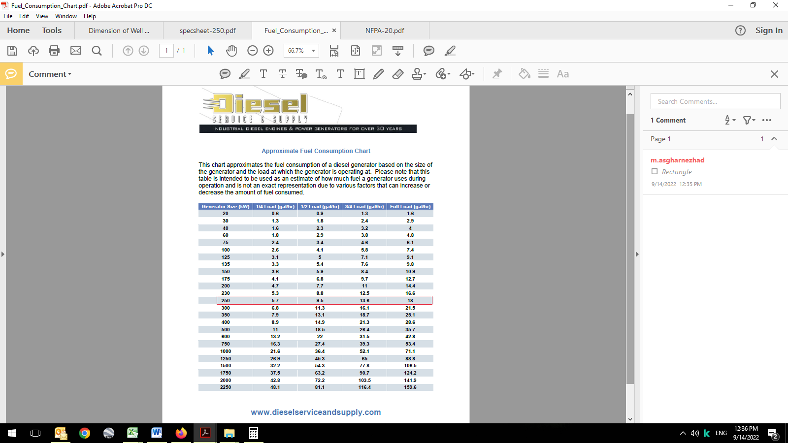

Approximate fuel consumption for 250 Kw @ 100 Loads will be 18 gal/hr or 68.13 LPH.

* Based on vendor data – see appendix 1:

It is 56.4 LPH

With considering of above assumption, diesel consumption rate will be around 60 LPH (0.06 m3/hr).

## Potable water

The potable water consumption is based on 100 lit./day per person, with considering 3 persons.

Potable water consumption: 3 X 0.1 = 0.3 m3/day

With considering of 7 days storage duration, total required capcity will be 7 X 0.3 = 2.1 m3.

1. **appendixes**

[**Appendix 1**](../Downloads/specsheet-250.pdf)



