طرح نگهداشت و افزایش تولید 27 مخزن
QRA Report

نگهداشت و افزایش تولید میدان نفتی بینک
D02 | APR.2023 | AFD | A.H.Saber | M.Fakharian | M.Mehrshad
D01 | NOV.2022 | IFA | A.H.Saber | M.Fakharian | M.Mehrshad
D00 | JUL. 2022 | IFC | A.H.Saber | M.Fakharian | M.Mehrshad
Rev. | Date | Purpose of Issue/Status | Prepared by: | Checked by: | Approved by: | CLIENT Approval
Class: 1 |  | CLIENT Doc. Number: 708629
Status: | IDC: Inter-Discipline Check  IFC: Issued For Comment  IFA: Issued For Approval  AFD: Approved For Design  AFC: Approved For Construction  AFP: Approved For Purchase  AFQ: Approved For Quotation  IFI: Issued For Information  AB-R: As-Built for CLIENT Review  AB-A: As-Built –Approved

REVISION RECORD SHEET
PAGE | D00 | D01 | D02 | D03 | D04 |  | PAGE | D00 | D01 | D02 | D03 | D04
1 | X | X | X |  |  |  | 66
2 | X | X | X |  |  |  | 67
3 | X |  |  |  |  |  | 68
4 | X |  |  |  |  |  | 69
5 | X |  |  |  |  |  | 70
6 | X |  |  |  |  |  | 71
7 | X |  |  |  |  |  | 72
8 | X |  |  |  |  |  | 73
9 | X |  |  |  |  |  | 74
10 | X |  |  |  |  |  | 75
11 | X |  |  |  |  |  | 76
12 | X |  |  |  |  |  | 77
13 | X |  |  |  |  |  | 78
14 | X |  |  |  |  |  | 79
15 | X |  |  |  |  |  | 80
16 | X | X |  |  |  |  | 81
17 | X |  |  |  |  |  | 82
18 | X |  |  |  |  |  | 83
19 | X |  |  |  |  |  | 84
20 | X |  |  |  |  |  | 85
21 |  |  |  |  |  |  | 86
22 |  |  |  |  |  |  | 87
23 |  |  |  |  |  |  | 88
24 |  |  |  |  |  |  | 89
25 |  |  |  |  |  |  | 90
26 |  |  |  |  |  |  | 91
27 |  |  |  |  |  |  | 92
28 |  |  |  |  |  |  | 93
29 |  |  |  |  |  |  | 94
30 |  |  |  |  |  |  | 95
31 |  |  |  |  |  |  | 96
32 |  |  |  |  |  |  | 97
33 |  |  |  |  |  |  | 98
34 |  |  |  |  |  |  | 99
35 |  |  |  |  |  |  | 100
36 |  |  |  |  |  |  | 101
37 |  |  |  |  |  |  | 102
38 |  |  |  |  |  |  | 103
39 |  |  |  |  |  |  | 104
40 |  |  |  |  |  |  | 105
41 |  |  |  |  |  |  | 106
42 |  |  |  |  |  |  | 107
43 |  |  |  |  |  |  | 108
44 |  |  |  |  |  |  | 109
45 |  |  |  |  |  |  | 110
46 |  |  |  |  |  |  | 111
47 |  |  |  |  |  |  | 112
48 |  |  |  |  |  |  | 113
49 |  |  |  |  |  |  | 114
50 |  |  |  |  |  |  | 115
51 |  |  |  |  |  |  | 116
52 |  |  |  |  |  |  | 117
53 |  |  |  |  |  |  | 118
54 |  |  |  |  |  |  | 119
55 |  |  |  |  |  |  | 120
56 |  |  |  |  |  |  | 121
57 |  |  |  |  |  |  | 122
58 |  |  |  |  |  |  | 123
59 |  |  |  |  |  |  | 124
60 |  |  |  |  |  |  | 125
61 |  |  |  |  |  |  | 126
62 |  |  |  |  |  |  | 127
63 |  |  |  |  |  |  | 128
64 |  |  |  |  |  |  | 129
65 |  |  |  |  |  |  | 130
CONTENTS
1.0 INTRODUCTION 4
2.0 Scope 4
3.0 NORMATIVE REFERENCES 5
3.1 International Codes and Standards 5
3.2 The Project Documents 5
3.3 Order of Precedence 5
4.0 GENERAL REQUIREMENTS 5
5.0 OBJECTIVES 5
6.0 BASIS OF CALCULATION 6
6.1 Software 6
6.2 Meteorological Data 6
7.0 METHODOLOGY OF QRA 8
7.1 Definitions 8
7.2 Key Components in a QRA 9
8.0 scenario 12
9.0 CONGESTED AREAS 13
10.0 FREQUENCY ANALYSIS 13
10.1 Event Tree Probabilities 13
10.2 Ignition Probabilities 14
10.3 Ignition Sources 14
11.0 CONSEQUENCE MODELING 15
12.0 RESULTS OF THE RISK ASSESSMENT 15
12.1 General 15
12.2 Risk Acceptance Criteria 16
12.3 Individual Risk Results 17
13.0 Risk mitigation 20

- INTRODUCTION
Binak oilfield in Bushehr province is a part of the southern oilfields of Iran, is located 20 km northwest of Genaveh city.
With the aim of increasing production of oil from Binak oilfield, an EPC/EPD Project has been defined by NIOC/NISOC and awarded to Petro Iran Development Company (PEDCO). Also PEDCO (as General Contractor) has assigned the EPC-packages of the Project to "Hirgan Energy - Design and Inspection" JV.
GENERAL DEFINITION
The following terms shall be used in this document.
CLIENT: | National Iranian South Oilfields Company (NISOC)
PROJECT: | Binak Oilfield Development – General Facilities
EPD/EPC CONTRACTOR (GC): | Petro Iran Development Company (PEDCO)
EPC CONTRACTOR: | Joint Venture of : Hirgan Energy – Design & Inspection(D&I) Companies
VENDOR: | The firm or person who will fabricate the equipment or material.
EXECUTOR: | Executor is the party which carries out all or part of construction and/or commissioning for the project.
THIRD PARTY INSPECTOR (TPI): | The firm appointed by EPD/EPC CONTRACTOR (GC) and approved by CLIENT (in writing) for the inspection of goods.
SHALL: | Is used where a provision is mandatory.
SHOULD: | Is used where a provision is advisory only.
WILL: | Is normally used in connection with the action by CLIENT rather than by an EPC/EPD CONTRACTOR, supplier or VENDOR.
MAY: | Is used where a provision is completely discretionary.
- Scope
The scope of this document is performing quantitative risk assessment study (QRA) on an 8” pipeline between BINAK new CGS and SIAHMAKAN UNIT.
- NORMATIVE REFERENCES

International Codes and Standards
- TNO | Green Book “Methods for determining of possible damage”, 1992  Purple book, “Guidelines for quantitative risk assessment”, 2005
- DNV | Process Equipment Failure Frequencies", Technical Note T14 (Revision No. 03), 2006
- IP | Research Report, “Ignition Probability Review, Model Development And Look-Up Correlations”, 2005
- EGIG | 11th Report of the European Gas Pipeline Incident Data Group

The Project Documents
- BK-PPL-PEDCO-320-PR-PF-0001_D02 Process Flow Diagram
- BK-PPL-PEDCO-320-PR-PI-0001_D02 Piping And Instrumentation Diagram

Order of Precedence
In case of any conflict between the contents of this document or any discrepancy between this document and other project documents or reference standards, this issue must be reported to the CLIENT. The final decision in this situation will be made by CLIENT.
- GENERAL REQUIREMENTS
A Quantitative Risk Assessment (QRA) study is carried out to assess the process/operational risk exposed to onsite personnel due to hazardous events that could occur as a result of Loss of Containment (LoC) of the handled material.
- OBJECTIVES
The main objectives of this QRA study were to:
- Identify all potential process hazards, verify and assess the frequency and consequence of the identified hazards and calculate the risk levels arising from the operation.
- Estimate the Individual and Societal Risks. The risk levels for identified hazard scenarios are quantified in terms of:
- Location Specific Individual Risk (LSIR) Contours;
- Individual Risk Per Annum (IRPA) for the exposed worker groups;
- Compare the results of the QRA with the applicable Project Risk Criteria.
- Provide recommendations if Project Risk Criteria is not met in order to mitigate the risk to As Low as Reasonably Practicable (ALARP).
- BASIS OF CALCULATION
The QRA methodology and model input data are presented in this document along with the calculation methodology, the installations, the operational conditions, the geographical and geometrical properties, the meteorological conditions, the location of ignition sources and the population. Relevant scenarios which lead to a release of inventory and subsequently to hazardous fire, explosion events or toxic releases are included in the QRA calculations. The frequencies of the considered scenarios are identified considering generic failure frequencies from EGIG 11th report data. The consequences of the identified hazardous scenarios are calculated and with their failure frequencies lead to the final individual and societal risk results.

Software
The calculation model was set up in the commercial software SAFETI 8.22 from DNV GL Software including extensive input data. In general, the default model parameters given in SAFETI 8.22 are used, representing a conservative approach regarding risk calculation. To allow a more detailed risk determination, some less conservative parameter changes may be considered, e.g. for main risk contributing installations and scenarios.

Meteorological Data
Meteorological data were required at two stages of the QRA study. First, various parts of the consequence modelling require specification of wind speed and atmospheric stability. Second, the impact (risk) calculations required wind-rose frequencies for each combination of wind speed and stability class used. The average of climate parameters is shown in Table 1.
Table 1. Modelling Weather Condition
Location | Wind Speed (m/s) | Pasquil Stability | Average Temp. (C) | Solar Radiation (kW/m²) | Humidity (%)
BINAK | 5 | D | 32.25 | 1 | 57
 | 2 | F | 20.61 | 0 | 65
Wind rose of the area is shown in Figure 1.
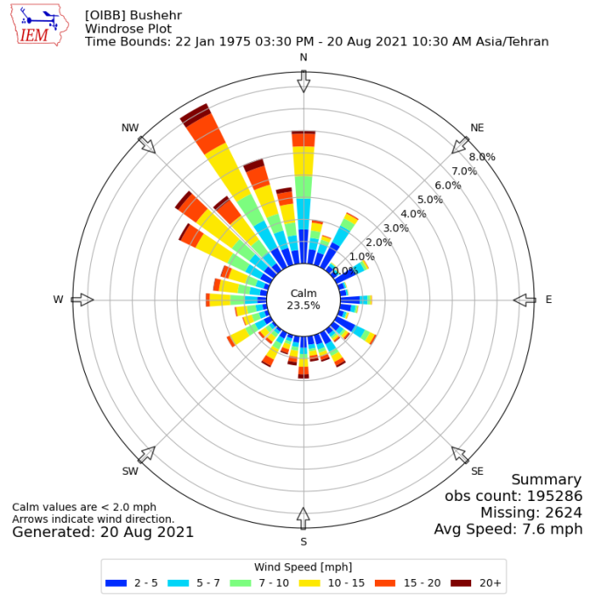
Figure 1. Wind Rose
Typically, different weather conditions representing all Pasqual atmospheric stability classes are used to predict different possible consequences and risks. Pasqual stability classes describe the amount of turbulence in the atmosphere.
Table 2. Pasqual stability parameters definition
Class | Stability Status | Class Description
A | Very Unstable | Sunny, light winds
B | Unstable | As with A, only less sunny or more windy
C | Moderately Unstable | Very windy/sunny or overcast/light wind
D | Neutral | Little sun and high wind or over cast/windy night
E | Moderately Stable | Less overcast and less windy than D
F | Stable | Night with moderate clouds and light/moderate wind
Each weather category should be characterized by a wind rose (at least 12 wind directions) and averaged values of wind speed, air temperature, solar radiation and humidity and some other parameters.
In addition to meteorological data, some information is required to introduce the type of ground in nearby areas or surface roughness. This parameter describes the type of surface over which the cloud is dispersing and can be identified using information shown in Table 3. For general onshore process plants, this parameter is considered in the range of 0.1 - 1.0 m. Average surface roughness has been considered 30 Millimeter corresponding to open flat terrain.

Table 3. Typical values for the surface roughness length
Surface  Classification | Type of Surface | Roughness  Length (m)
Highly urban | Centers of cities with tall buildings, very hilly or mountainous area | 3-10
Urban area | Centers of towns, villages, fairly wooded country | 1-3
Residential area | Industrial site without large obstacles | 1
Large refineries | Distillation columns and other tall equipment pieces | 1
Small refineries | Smaller equipment, over a smaller area | 0.5
Cultivated land | Open area with great overgrowth, scattered houses | 0.3
Flat land | Few trees, long grass, fairly level grass plains | 0.1
Open water | Large expanses of water, desert flats | 0.001
Sea | Calm open sea, snow covered flat, rolling land | 0.0001
- METHODOLOGY OF QRA

Definitions
The following was a series of definitions that were used throughout this report. The definitions were presented here to assist the reader who is not familiar with the terms used in this QRA report, and for those who are familiar, to confirm consultant understands of the terms and their application in the context of this report.
An onshore hazardous installation is intended to benefit its owners, operators and the country, by helping to produce products, providing employment and generating wealth. However, such installation also has the potential to cause harm, such as:
- Sickness, injury or death of workers;
- Damage to property and investments;
- Degradation of the physical and biological environment; and
- Interruption to production and disruption of business.
Physical situations that have the potential to cause such harm are known as hazards. Thus, for example, a fuel storage tank is a hazard because it has the potential to cause a fire; chemical process such as high-pressure natural gas generation is a hazardous activity because it has the potential to cause large confined vapour cloud explosions. The word `hazard' does not express a view on the magnitude of the consequences or how likely it is that the harm will actually occur. A `major hazard' is an installation (or a part of one, such as a high-pressure pipeline) with potential to cause significant damage or multiple fatalities. The term does not imply that such events are likely.
Accidents are the actual realization of a hazard. They are sudden unintended departures from normal conditions, in which some degree of harm is caused. They range from minor incidents such as a small gas leak, to major pipeline accidents such as New Mexico 2000, and Ghislenghien 2004. Sometimes, the more neutral term `event' is used in place of the more colloquial term `accident'. For flammable accidents, ignition has to take place for a hazard to be realized. For toxic releases, the release itself may pose a hazard, if sufficient vapors are generated.
Risk is the combination of the likelihood and the consequences of such accidents. More scientifically, it is defined as the probability of a specific adverse event occurring in a specific period or in specified circumstances. The likelihood may be expressed either as a frequency (i.e. the rate of events per unit time) or a probability (i.e. the chance of the event occurring in specified circumstances). The consequence is the degree of harm caused by the event.
Risk is sometimes defined as the product of likelihood and consequence. In fact, this is just one of several possible measures of risk and such a definition may be over-simplistic.
The distinction between `hazard' and `risk' is an important one, although in colloquial use, and also in popular dictionaries, risk and hazard are treated virtually as synonyms. Rimmington (1992) has suggested that `hazard' was first used in its modern sense in relation to a physical obstacle in the game of golf, whereas `risk' has been used in the insurance market for nearly 300 years to signify the chance of a specific hazard being realized, such as the loss of a ship at sea.
`Risk' is sometimes used as a very general term roughly equivalent to `danger' (e.g. a platform with high risks, a low-risk operation etc), and sometimes as a precise scientific term with many qualifications (e.g. the risk of impairment of escape routes due to hydrocarbon fires, or the individual risk of death per annum for a helicopter pilot).
Safety is the inverse of risk. The higher the risk for an occupation or installation, the lower is its safety. The popular understanding of safety sometimes appears to be `zero risk', but this is impossible in an intrinsically hazardous activity such as oil and gas production.

Key Components in a QRA
The first stage is system definition, where the potential hazards associated with an installation or the activity is to be analyzed. The scope of work for a QRA should be to define the boundaries for the study, identifying which activities are to be included and which are excluded, and which phases of the installation's life are to be assessed.
The hazard identification consists of a qualitative review of possible accidents that may occur, based on previous accident experience or judgment where necessary. There are several formal techniques for this, which are useful in their own right to give a qualitative appreciation of the range and magnitude of hazards and indicate appropriate mitigation measures. This qualitative evaluation is described in this guide as `hazard assessment'. In a QRA, hazard identification uses similar techniques, but has a more precise purpose - selecting a list of possible failure cases that are suitable for quantitative modeling.
Once the potential hazards have been identified, frequency analysis estimates how likely it is for the accidents to occur. The frequencies are usually obtained from analysis of previous accident experience, or by some form of theoretical modeling.
In parallel with the frequency analysis, consequence modeling evaluates the resulting effects if the accidents occur, and their impact on personnel, equipment and structures, the environment or business. Estimation of the consequences of each possible event often requires some form of computer modeling, but may be based on accident experience or judgments if appropriate.
When the frequencies and consequences of each modeled event have been estimated, they can be combined to produce risk results. Various forms of risk presentation may be used, such as:
- Individual risk - the risk experienced by an individual person in a given location;
- Group (or societal) risk - the risk experienced by the whole group of people exposed to the hazard;
- Potential loss of asset and business disruption; and
- Environmental impact etc.
Up to this point, the process has been purely technical, and is known as risk analysis. The next stage is to introduce criteria, which are yardsticks to indicate whether the risks are acceptable, or to make some other judgment about their significance. Risk assessment is the process of comparing the level of risk against a set of criteria as well as the identification of major risk contributors. The purpose of risk assessment is to develop mitigation measures for unacceptable generators of risk, as well as to reduce the overall level of risk to as low as reasonably practical (ALARP).
In order to make the risks acceptable, risk reduction measures may be necessary. The benefits from these measures can be evaluated by repeating the QRA with them in place, thus introducing an iterative loop into the process. The economic costs of the measures can be compared with their risk benefits using cost-benefit analysis.
QRA results may be used to provide some form of input to the design or on-going safety management of the installation, depending on the objectives of the study.
The traditional QRA methodology is visualized in Figure 2.
It should be pointed out that DNV Software for the Assessment of Flammable, Explosive, and Toxic Impact (hereinafter called as SAFETI) risk management software, version 8.22, was used in performing the consequence modeling, and risk quantification of this QRA study. DNV SAFETI software is the world leading software for consequence analysis, and risk assessment. It was originally released as a commercial package in 1987, and now has more than 28 years of industrial application experiences.

Data Collection

Hazard Identification (Failure Scenario)
Frequency Analysis
Consequence Modelling
Risk Summation and Results
Risk Criteria
Risk Assessment & Risk Ranking
Study Findings & Conclusions
Sensitivity Analysis
Kick-off Meeting

Report Production & Result Presentation

Figure 2. Typical QRA Methodology

- scenario
The present QRA covers a 44 km 8” gas pipeline (UG) coming from BINAK CGS to SIAHMAKAN UNIT. There are two LBV (Line Break Valve) located in 28.4 km and 28.6 km of the beginning of the pipeline.
The figure below demonstrates the pipeline.
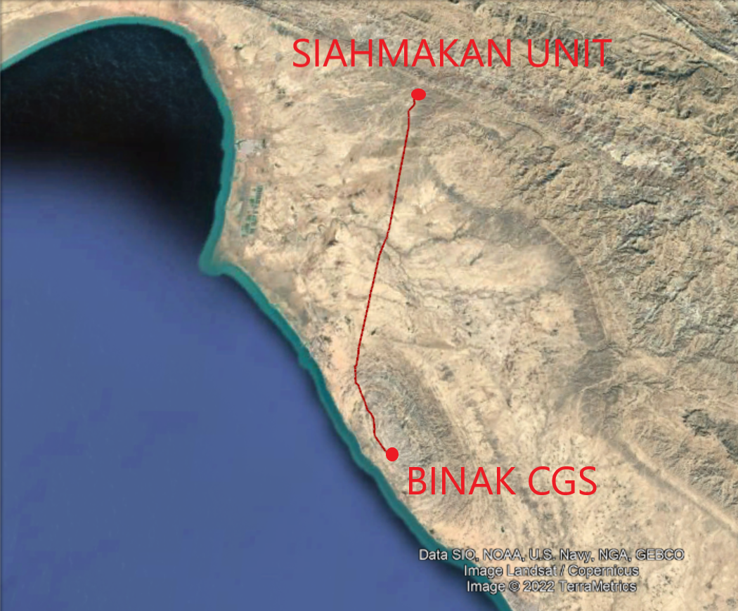
Figure 3. The Pipeline Route

The stream process condition is described below:
Table 4. Process Condition of the Scenario.
Stream N. | Phase | P(barg) | T(C) | Flow rate (kg/hr)
1 | V | 50.90 | 58.30 | 17170.81
The leaks are categorized into representative leak hole sizes (shown in Table 5) which are considered in the risk calculations according to their individual frequency of occurrence.

Table 5. Leak Size Categories
Leak Category | Representative Leak Hole Size(mm)
Small | 10 mm
Medium | Half of the size of connection
Full Bore Rupture | Equivalent to size of connection
- CONGESTED AREAS
There is no congested area in this study. Therefore, VCE is not included in the scenarios.
- FREQUENCY ANALYSIS

Event Tree Probabilities
For Estimating the frequency of final incident outcomes, further to base case failure frequencies, the probabilities of sequential events to occur are also required. This sequence is calculated in the form of internal Event Tree of DNV SAFETI software (SAFETI Technical Documentation, MPACT Theory). Figure 4 shows the typical event tree for a flammable release. As was mentioned, there are two types of ignitions including immediate and delayed ignitions. The probability of immediate ignition (Pi) is a function of released material reactivity and discharge flow rate. The delayed ignition probability (Pd) assumed to be equal to immediate.
By identifying base failure frequencies (F) and successive probabilities of immediate and delayed ignitions (Pim, Pd and Pc), the frequency of occurrence of each incident outcome is estimated to be further combined by its respective consequence to calculate the amount of risk.

Base Failure Case | Immediate Ignition? | Delayed Ignition | Congestion | Outcome | Outcome  Frequency
 | (Pi) |  |  | Jet Fire/  Pool Fire | F.Pi
 |  |  | Pc | VCE | F.(1-Pi).Pd.Pc
Leak |  | Pd
(F) |  |  | (1-Pc) | Flash Fire/  Pool Fire | F.(1-Pi).Pd.(1-Pc)
 | (1-Pi)
 |  | (1-Pd) |  | Toxic Dispersion/  No Effect | F(1-Pi)(1-Pd)
Figure 4. Event Tree for a Flammable Leak Scenario
According to EGIG 11th report, the frequency of failure in the pipeline in the interval of 30 years (1990-2019) is 0.183 per 1000 km.year. In Table 6, the frequency of each leak size used in this study is listed.
Table 6. Failure Frequency of Each leak size
Leak size | Failure Frequency per 1000 km.year
Small | 0.088
Medium | 0.022
Full bore | 0.013

Ignition Probabilities
Table 7 illustrates the probability of immediate ignition (Pim).
Table 7. Probability of Immediate Ignition
Leak Discharge Flow Rate (kg/s) | Probability of Immediate Ignition
 | Gas | Liquid
<1 | 0.01 | 0.01
1-50 | 0.07 | 0.03
>50 | 0.3 | 0.08
As the phase is gas and the flow rate is 4.76 kg/s (17170.81 kg/hr), the probability of immediate ignition is 0.07.

Ignition Sources
For the risk calculation of a release of flammable substance, the probabilities of immediate and delayed ignition have to be predicted.
Delayed ignition usually occurs at a given location, where an ignition source exists and where the concentration of the substance reaches the LEL (lower explosive limit). The relevant ignition sources are presented in Table 8.
It should be mentioned that 3 roads are identified in the vicinity of the pipeline which are as mentioned bellow, the ignition sources with the probability of 0.4 per minute.
Table 8. Ignition Probabilities for Different Ignition Sources
Source Type | Ignition Source | Probability of Ignition per min
Point source (on the site) | Adjacent process installation  Flare  Furnace (outside)  Furnace with steam curtain*  Furnace (inside)  Boiler (outside)  Boiler (inside) | 0.5  1  0.9  0.18  0.45  0.45  0.23
Line source (on the site) | High-voltage cable (per 100 m)  Motor vehicle  Train  Ship | 0.2  0.4  0.9  0.5
Population source | Manning level / population (per person) | 0.01
Process site area | Hazardous area classification  Zone 1  Zone 2  unclassified | 0.03  0.06  0.16
- CONSEQUENCE MODELING
In this section, potential failures of the pipeline were postulated, and consequence modelling of each failure is carried out to determine the potential effects of the releases, the results of which are discussed in terms of hazard distances.
- Release Scenarios
The most common consequences of an accidental release in a pipeline with a high pressure are jet fire and flash fire:
- Jet fire
Jet fire is a burning jet of gas whose shape is dominated by the momentum of the release. Typically, a jet fire affects a relatively narrow conical volume, however due to high momentum, the jet fire can emit very significant radiant heats. Therefore, depending on the release orientation, location, density and composition of the surrounding activities and population etc., personnel injury or fatality is possible if he or she has physical contact with the fire or is exposed to certain thermal radiation level generated by the jet fire.
- Flash fire
A flash fire occurs when a flammable cloud of gas burns without generating any significant overpressure or radiant heat. The cloud is typically ignited on its edge, remote from the leak source. The combustion zone moves through the cloud away from the ignition point, and slightly expands a small distance beyond the LFL due to thermal turbulent effect within the burning cloud. Normally the duration of the flash fire is relatively short.
- RESULTS OF THE RISK ASSESSMENT

General
This section presents the results of the frequency analysis and the risk calculations using SAFETI 8.22. Results regarding individual risk are shown including the location specific risks.

Risk Acceptance Criteria
01
    - Individual Risk
For the risk ranking procedure of the present QRA study, the individual risks are compared against requirements from UK HSE. The UK regulations are presented in Table 9.
Table 9. Individual Risk Criteria
Individual Risk Criteria | UK Regulation [fatality/year]
Maximum tolerable risk to workers | 10⁻³
Maximum tolerable risk to the public | 10⁻⁴
Broadly acceptable (negligible) risk to workers and public | 10⁻⁶
The regulations in Table 9 show that the maximum tolerable individual risk to workers and to the public is 10⁻³ year⁻¹ and 10⁻⁴ year⁻¹, respectively.
1 × 10⁻⁴ per year for on-site (Public)

1 × 10⁻⁴ per year for off-site (Public)

Upper Bound
Lower Bound
1 × 10⁻³ per year for on-site (Personnel)

1 × 10⁻⁴ per year for off-site (Public)

1 × 10⁻⁶ per year
UNACCEPTABLE
REGION
Risk cannot be justified safe in extraordinary circumstances
Tolerable only if risk reduction is impracticable or if its cost is grossly disproportionate to the improvement gained.
Tolerable if cost of reduction would exceed cost of improvement
ALARP REGION
(Risk reduction is undertaken only if a benefit is desired)
BROADLY ACCEPTABLE REGION
(No need for detailed assessment to demonstrate ALARP)
Necessary to ensure that risk remains at this level.
Negligible Risk

Figure 5. Individual risk Criteria

    - Societal Risk
For the present QRA study, the societal risk criteria according to UK HSE regulations are used and presented as societal risk acceptance criteria in Table 10.
Table 10. Societal Risk Criteria
N, Fatalities | F, Cumulative Frequency of N or more Fatalities per Year
 | Broadly Acceptable | Tolerable
1 | 10⁻⁴ | 10⁻²
10 | 10⁻⁵ | 10⁻³
100 | 10⁻⁶ | 10⁻⁴
1000 | 10⁻⁷ | 10⁻⁵

Individual Risk Results
The individual risk can be interpreted as the chance of fatality of one individual staying 24 h/day outdoor without protecting clothes at a certain location onsite or adjacent to the establishment. The calculation of the individual risk of a given establishment is always related to a specific location. The probabilities of fatality due to all identified hazardous events which have an impact on the appropriate location are summed up to a location specific probability of fatality. Performing the calculations for a whole area, results to risk contours. The information of population presence at the related location is not required to determine the individual risk. However, since population is also considered as a delayed ignition source, its presence has to be taken into account for the calculation of the individual risk.
The risk criteria for the individual risk according to HSE UK are presented in Table 9. The individual risk criteria (tolerability and acceptability limit) are shown for workers (onsite, adjacent industrial areas) and public population (adjacent residential / public areas).
The individual risk contours of the investigated pipeline are presented in Figure 6 and Figure 7. The risk contours are calculated for an average calendar year.
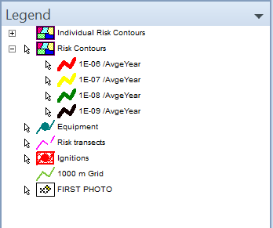 | 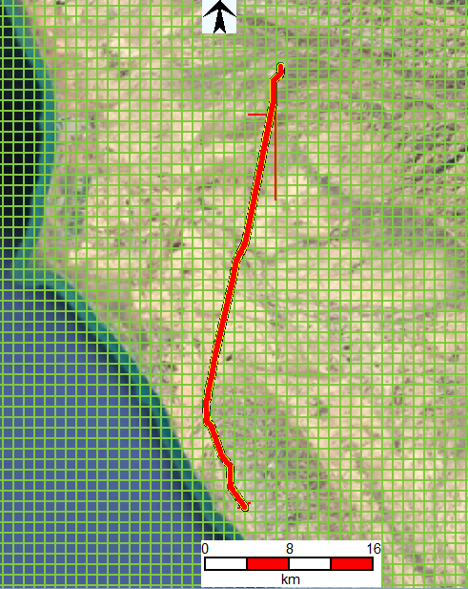
Figure 6. LSIR of the Pipeline (Total-UP)
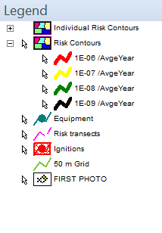 | 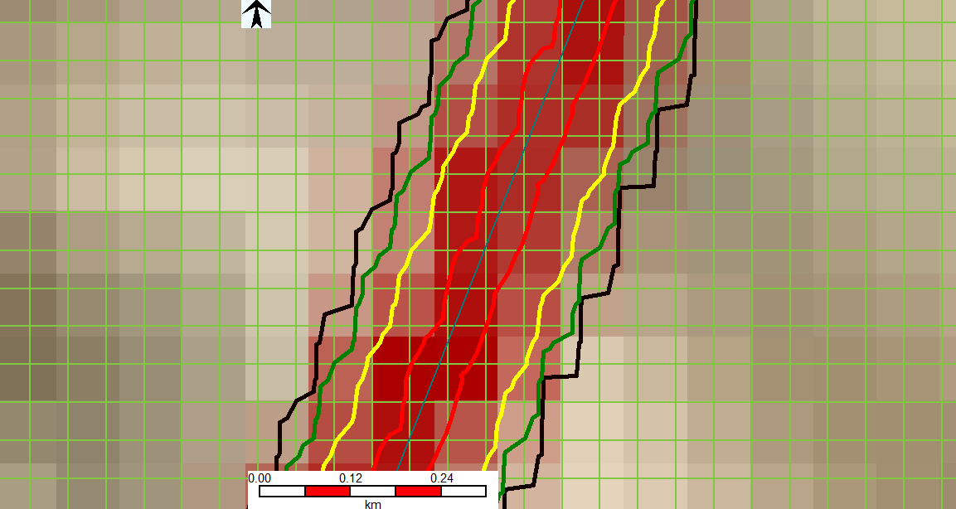
Figure 7. LSIR of the Pipeline (Detail-DOWN)

As per as shown in Figure 6 and Figure 7, the maximum risk level which imposed by the pipeline is more than 10E-6. It should be mentioned that this risk level is LSIR and could not be compared with Table 9, which shows the IRPA risk criteria.
To have better view of risk level, horizontal risk transect is considered. Horizontal transect line for the pipeline is shown in Figure 8.
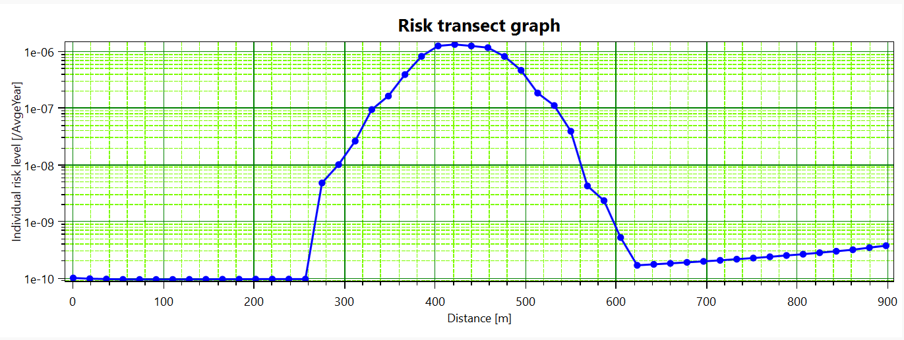
Figure 8. Risk Transect of the pipeline
Regarding Table 9, in order to be in ALARP zone for a typical worker, should spend time in high risk zone. Following equation should be considered to calculate IRPA of each typical worker.
$$IRPA=\sum_{i=places}{{LSIR}_{i}×{\left(Probability of presence\right)}_{i}}≤{10}^{-3}$$
$$\left(Probability of presence\right)=\frac{Hours spent at that location in one day}{24hrs}$$

    - Risk to Off-Site Population
There is no information available on the offsite population located in close proximity of the pipeline (if any). Therefore, at this stage the risk imposed to offsite population was not estimated. However, the societal risk imposed to the offsite population (if any) should be estimated and updated during the next phase of the project, once the information becomes available.

- Risk mitigation
Considering Figure 6, the risk of the pipeline along its location is not higher than 10E-6 which is not a main concern. However, these cases should be taken into account:
- The safe distances around the pipeline should be in compliance with the rules and legislations and also the standards.
- Regarding the legislations and standards, construction of any buildings or any residential areas should be deemed carefully since this study is done without any data available for the population near the pipeline. Moreover, it is evident that the situation and the density of population might change in the future.
- In this study, it is assumed that there is adequate maintenance regarding the pipeline. Therefore, consideration should be given to proper and continuous maintenance activities namely cathodic protection as a corrosion prevention measure.
- As one of the most important incidents happening in pipelines are stemmed from TPD (third party damage), like any other pipelines, the necessity of prevention actions such as providing markers along the pipelines is prominent.
- Having two LBVs in the pipeline, it is presumed that their frequency of failure is zero. Thus, the maintenance regarding these LBVs is essential because any failure in the valve can take its toll on the consequences and the associated risk.

