|  |  |  |  |  |  |  |  |  |
| --- | --- | --- | --- | --- | --- | --- | --- | --- |
| **طرح نگهداشت و افزایش تولید 27 مخزن** | | | | | | | | |
| **SPECIFICATION FOR BARRED TEE**  **نگهداشت و افزایش تولید میدان نفتی بینک** | | | | | | | | |
| D04 | | MAY. 2023 | AFD | A.M.Noori | M.Fakharian | A.M.Mohseni |  |
| D03 | | MAY. 2023 | AFD | A.M.Noori | M.Fakharian | A.M.Mohseni |  |
| D02 | | JAN. 2022 | IFA | A.Khosravi | M.Fakharian | M.Mehrshad |  |
| D01 | | JAN. 2022 | IFA | H.Shahrokhi | M.Fakharian | Sh.Ghalikar |  |
| D00 | | AUG. 2021 | IFC | M.Asgharnejad | M.Fakharian | Sh.Ghalikar |  |
| **Rev.** | | **Date** | **Purpose of Issue/Status** | **Prepared by:** | **Checked by:** | **Approved by:** | **CLIENT Approval** |
| **Class: 2** | | | **CLIENT Doc. Number:** **F0Z-707154** | | | | | |
| **Status:** | | **IDC: Inter-Discipline Check**  **IFC: Issued For Comment**  **IFA: Issued For Approval**  **AFD: Approved For Design**  **AFC: Approved For Construction**  **AFP: Approved For Purchase**  **AFQ:** Approved For Quotation  **IFI: Issued For Information**  **AB-R: As-Built for CLIENT Review**  **AB-A: As-Built –Approved** | | | | | |

**REVISION RECORD SHEET**

|  |  |  |  |  |  |  |  |  |  |  |  |  |
| --- | --- | --- | --- | --- | --- | --- | --- | --- | --- | --- | --- | --- |
| **PAGE** | **D00** | **D01** | **D02** | **D03** | **D04** |  | **PAGE** | **D00** | **D01** | **D02** | **D03** | **D04** |
| **1** | X | X | X | X |  | **66** |  |  |  |  |  |
| **2** | X |  |  | X |  | **67** |  |  |  |  |  |
| **3** | X |  |  |  |  | **68** |  |  |  |  |  |
| **4** | X | X |  |  |  | **69** |  |  |  |  |  |
| **5** | X | X |  |  |  | **70** |  |  |  |  |  |
| **6** | X | X |  |  |  | **71** |  |  |  |  |  |
| **7** | X | X | X |  |  | **72** |  |  |  |  |  |
| **8** | X |  | X |  |  | **73** |  |  |  |  |  |
| **9** | X | X |  |  |  | **74** |  |  |  |  |  |
| **10** | X |  |  |  |  | **75** |  |  |  |  |  |
| **11** | X |  |  |  |  | **76** |  |  |  |  |  |
| **12** | X |  |  |  |  | **77** |  |  |  |  |  |
| **13** | X | X |  |  |  | **78** |  |  |  |  |  |
| **14** | X | X |  |  |  | **79** |  |  |  |  |  |
| **15** | X |  | X |  |  | **80** |  |  |  |  |  |
| **16** | X |  |  |  |  | **81** |  |  |  |  |  |
| **17** | X |  | X |  |  | **82** |  |  |  |  |  |
| **18** |  |  |  |  |  | **83** |  |  |  |  |  |
| **19** |  |  |  |  |  | **84** |  |  |  |  |  |
| **20** |  |  |  |  |  | **85** |  |  |  |  |  |
| **21** |  |  |  |  |  | **86** |  |  |  |  |  |
| **22** |  |  |  |  |  | **87** |  |  |  |  |  |
| **23** |  |  |  |  |  | **88** |  |  |  |  |  |
| **24** |  |  |  |  |  | **89** |  |  |  |  |  |
| **25** |  |  |  |  |  | **90** |  |  |  |  |  |
| **26** |  |  |  |  |  | **91** |  |  |  |  |  |
| **27** |  |  |  |  |  | **92** |  |  |  |  |  |
| **28** |  |  |  |  |  | **93** |  |  |  |  |  |
| **29** |  |  |  |  |  | **94** |  |  |  |  |  |
| **30** |  |  |  |  |  | **95** |  |  |  |  |  |
| **31** |  |  |  |  |  | **96** |  |  |  |  |  |
| **32** |  |  |  |  |  | **97** |  |  |  |  |  |
| **33** |  |  |  |  |  | **98** |  |  |  |  |  |
| **34** |  |  |  |  |  | **99** |  |  |  |  |  |
| **35** |  |  |  |  |  | **100** |  |  |  |  |  |
| **36** |  |  |  |  |  | **101** |  |  |  |  |  |
| **37** |  |  |  |  |  | **102** |  |  |  |  |  |
| **38** |  |  |  |  |  | **103** |  |  |  |  |  |
| **39** |  |  |  |  |  | **104** |  |  |  |  |  |
| **40** |  |  |  |  |  | **105** |  |  |  |  |  |
| **41** |  |  |  |  |  | **106** |  |  |  |  |  |
| **42** |  |  |  |  |  | **107** |  |  |  |  |  |
| **43** |  |  |  |  |  | **108** |  |  |  |  |  |
| **44** |  |  |  |  |  | **109** |  |  |  |  |  |
| **45** |  |  |  |  |  | **110** |  |  |  |  |  |
| **46** |  |  |  |  |  | **111** |  |  |  |  |  |
| **47** |  |  |  |  |  | **112** |  |  |  |  |  |
| **48** |  |  |  |  |  | **113** |  |  |  |  |  |
| **49** |  |  |  |  |  | **114** |  |  |  |  |  |
| **50** |  |  |  |  |  | **115** |  |  |  |  |  |
| **51** |  |  |  |  |  | **116** |  |  |  |  |  |
| **52** |  |  |  |  |  | **117** |  |  |  |  |  |
| **53** |  |  |  |  |  | **118** |  |  |  |  |  |
| **54** |  |  |  |  |  | **119** |  |  |  |  |  |
| **55** |  |  |  |  |  | **120** |  |  |  |  |  |
| **56** |  |  |  |  |  | **121** |  |  |  |  |  |
| **57** |  |  |  |  |  | **122** |  |  |  |  |  |
| **58** |  |  |  |  |  | **123** |  |  |  |  |  |
| **59** |  |  |  |  |  | **124** |  |  |  |  |  |
| **60** |  |  |  |  |  | **125** |  |  |  |  |  |
| **61** |  |  |  |  |  | **126** |  |  |  |  |  |
| **62** |  |  |  |  |  | **127** |  |  |  |  |  |
| **63** |  |  |  |  |  | **128** |  |  |  |  |  |
| **64** |  |  |  |  |  | **129** |  |  |  |  |  |
| **65** |  |  |  |  |  | **130** |  |  |  |  |  |

**CONTENTS**

1.0 INTRODUCTION 4

2.0 Scope 4

3.0 NORMATIVE REFERENCES 5

4.0 MATERIAL AND DESIGN 7

5.0 FABRICATION REQUIREMENTS 9

6.0 INSPECTION AND TESTS 10

7.0 TEST CERTIFICATES 13

8.0 PAINTING AND COATING 14

9.0 PREPARATION FOR SHIPMENT, STORAGE AND HANDLING 14

1. **INTRODUCTION**

Binak oilfield in Bushehr province is a part of the southern oilfields of Iran, is located 20 km northwest of Genaveh city.

With the aim of increasing production of oil from Binak oilfield, an EPC/EPD Project has been defined by NIOC/NISOC and awarded to Petro Iran Development Company (PEDCO). Also PEDCO (as General Contractor) has assigned the EPC-packages of the Project to "Hirgan Energy - Design and Inspection" JV.

**GENERAL DEFINITION**

The following terms shall be used in this document.

|  |  |
| --- | --- |
| CLIENT: | National Iranian South Oilfields Company (NISOC) |
| PROJECT: | Binak Oilfield Development – General Facilities |
| EPD/EPC CONTRACTOR (GC): | Petro Iran Development Company (PEDCO) |
| EPC CONTRACTOR: | Joint Venture of : Hirgan Energy – Design & Inspection(D&I) Companies |
| VENDOR: | The firm or person who will fabricate the equipment or material. |
| EXECUTOR: | Executor is the party which carries out all or part of construction and/or commissioning for the project. |
| THIRD PARTY INSPECTOR (TPI): | The firm appointed by EPD/EPC CONTRACTOR (GC) and approved by CLIENT (in writing) for the inspection of goods. |
| SHALL: | Is used where a provision is mandatory. |
| SHOULD: | Is used where a provision is advisory only. |
| WILL: | Is normally used in connection with the action by CLIENT rather than by an EPC/EPD CONTRACTOR, VENDOR. |
| MAY: | Is used where a provision is completely discretionary. |

1. **Scope**

This document covers the requirements for fabrication of multi-purpose Barred Tees for this project which shall be observed by vendors. This Specification covers the minimum requirements for production and testing of Barred Tee from the suitable materials as specified hereunder in this specification.

Deviations from this specification shall be approved by client. Any omission in these requirements shall not relieve the vendor of his responsibility of requirements specified in the project documentation.

1. **NORMATIVE REFERENCES**
   1. **Local Codes and Standards**

* IPS-C-PI-140 Construction standard for transportation pipelines(onshore)
* IPS-E-PI-140 Engineering Standard for Onshore Transportation Pipelines
* IPS-M-PI-190 Material And Equipment Standard For Line Pipe
* IPS-E-PM-400 Engineering Standard For Vendor’s Data Requirements
* IPS-G-GN-210 General Standard For Packing & Packages
* IPS-D-PI-149 Scraper Guide Bars For Pipeline Tees
* IPS-E-TP-100 Engineering Standards For Paints
  1. **International Codes and Standards**
* ASME B 16.9 Factory made Wrought Butt welding Fitting
* ASME B31.4 Liquid Transportation System for Hydro Carbons and other liquids
* ASME B31.8 Gas Transmission and Distribution Piping Systems
* ASME Section VIII Boiler and Pressure Vessel Code - Rules for Construction of Pressure Vessels
* ASME Section IX Boiler and Pressure Vessel Code –Welding and Brazing Qualification
* API 5L Specification for line pipe
* API 1104 Welding of Pipelines and related facilities
* ASTM A283 Standard Specification for Low and Intermediate Tensile Strength Carbon Steel Plates
* ASTM A860 Wrought High Strength Low Alloy Steel Butt Welding Fittings
* ASTM A370 Standard Test Methods and Definitions for Mechanical Testing of Steel Products
* ASTM E23 Standard test methods for notched bar impact testing of Metallic Materials
* ASTM E92 Standard Test Method for Vickers Hardness of Metallic Materials.
* ASTM E709 Standard Guide for Magnetic Particle Examination
* ASNT-SNT-TC-1 American Society for Non-destructive Testing
* BS EN 10160 Ultrasonic testing of steel flat product of thickness equal or greater than 6mm
* EN 10204 Metallic Products – Type of inspection documents
* ISO 9000 Quality Management and Quality Assurance Standards
* ISO 9001 Model for Quality Assurance in Design, Development,

Production, Installation and Servicing

* ISO 1027 Non-destructive testing - Image quality of radiographs
* ISO 12094 Welded steel tubes for pressure purposes – ultrasonic testing for the detection of laminar imperfections in strips/plates used in the manufacture of tubes.
* ISO 148 Steel-Charpy Impact Test (V-notch)
* ISO 15590-2 Petroleum and Natural Gas Industries – Induction Bends, Fittings and Flanges for Pipeline Transportation Systems – Part 2: Fittings
* MSS-SP-75 Specification for High Test Wrought Butt Welding Fittings
* MSS-SP-25 Standard Marking System for Valves, Fittings, Flanges, and Unions
* NACE MR 0175/ISO 15156 Materials For Use In H2S Containing Environments (HIC) Test
* NACE TM0177 Laboratory testing of metals for resistance to sulfide stress cracking and stress corrosion cracking in H2S environments
* SHELL DEP 31,40,10,13 Technical Specification Design of Pipeline Pig Trap Systems
  1. **PROJECT DOCUMENTS**
* BK-PPL-PEDCO-320-PL-DT-0002 Data sheets For Barred Tee
* BK-GNRAL-PEDCO-000-PL-SP-0001 Pipeline Material Specification
* BK-GNRAL-PEDCO-000-PL-SP-0002 Specification For Line Pipes
  1. **ENVIRONMENTAL DATA**

Refer to "Process Basis of Design; Doc. No.BK-GNRAL-PEDCO-000-PR-DB-0001".

* 1. **CONFLICT REQUIREMENT**



## In case of any conflict between requirements specified herein & the requirements of any other referenced document, this subject shall be reflected to CLIENT and the final decision will be made by CLIENT.

1. **MATERIAL AND DESIGN**
   1. **Design and Fabrication**

The design code, design factor, rating, corrosion allowance, grade of material, nominal diameter and nominal wall thickness for the mating main pipe and branch pipe and any requirement for sour service will be as stated in the Data Sheet.

Tees with branches 50% or more of the main pipeline diameter shall have configuration of bars as indicated in Appendix A. The bars shall be made of Hot Rolled Mild Steel Plate and shall be welded using a qualified procedure.

The tees shall be designed and manufactured in accordance with IPS-D-PI-149, as specified in data sheet, also shall be manufactured to MSS-SP-75 or ASME/ANSI B16.9 as appropriate and the requirements of this Specification. Full encirclement Tees shall not be allowed.

The tees shall meet or exceed the strength requirements of the matching pipe as calculated by ASME B31.4 and B31.8.

Data supporting the design in the form of calculations and drawings shall be submitted for approval prior to commencement of manufacture. Design shall be in strict accordance with the appropriate Design Code. Documented data of successful proof tests according to the relevant standard shall be submitted in support of the design.

VENDOR shall check & confirm the number of Bars (as stated in Appendix A) required for tees.

All pipeline tees shall be suitable for passage, in either direction, of instrumented inspection tools.

* 1. **Material Requirements**

All materials shall be suitable for the required sour service as stated on the Data Sheet and tested as required by this Specification.

Materials for barred tees shall be compatible with the line pipe to which they are welded. Where applicable shall meet the requirements of NACE MR 0175/ISO 15156 and shall be suitable for a minimum design temperature as specified in Data Sheet.

As a minimum, the grade, mechanical properties, chemical composition and carbon equivalent for tee material and bars shall comply with requirements of Specification For Line Pipe BK-GNRAL-PEDCO-000-PL-SP-0002.The tees shall be manufactured from material, which exceeds the specified minimum yield strength of the mating pipe. Actual yield shall not exceed the 80,000 psi (550 MPa).

The material for barred tees shall consist of blooms, billets, slabs, forging quality bar, plate, seamless or fusion welded tubular products with filler metal added. The chemical composition and mechanical properties shall be compatible grade with pipeline material grades. The tees shall be heat treated by normalizing, quenching and tempering to achieve the same strength of line pipe.

Tees shall not be machined from bar stock.

Tees shall be supplied in the normalized, normalized and tempered or quenched and tempered condition.

Test rings will be required from the main run of pipe for weld procedure qualifications for the main pipeline as indicated on the Data Sheet. Rings shall be 400 mm minimum in length and subject to the same forging and heat treatment as the supplied tee.

* 1. **Material Traceability**

All material shall be traceable in all Technical and Inspection Documents and also these documents shall be related to each other.

Material Test Certificate shall be in accordance with above documents.

1. **FABRICATION REQUIREMENTS**
   1. **General**

The barred tees shall be piggable for all types of pigs and designed with the bars across the branch to prevent the pig from entering the branch. The bars are to be flush with the inside bore of the tee. All edges of the bars to be ground smooth to a radius of at least 3 mm and the completed welds attaching the bars within the tee shall be dressed/ ground to a smooth profile.

The barred tees, shall allow the free passage in either direction of intelligent inspection tools and pigs. The internal diameter shall be nominated in the data sheet. Maximum deviation of the bore from specified bore shall be +/- 1.0 mm.

Welding ends shall be machine bevelled to the requirements of MSS-SP-75.

VENDOR’s detailed fabrication drawings shall be submitted to the CLIENT for approval prior to commencement of fabrication.

* 1. **Welding**

All welds shall be made using a CLIENT approved Weld Procedure Specification (WPS) qualified by a Procedure Qualification Record (PQR) and API 1104. All materials are to be provided by VENDOR to complete the Procedure Qualification Record. The procedure qualification shall include impact tests and hardness tests in accordance with NACE MR 0175/ISO 15156. The CLIENT may witness the qualification and the Procedure Qualification Record.

All welds shall be completed by welders fully qualified in accordance with the provisions of the requirements of ASME Section IX and API 1104.

All WPS’s, associated PQR’s and welder qualifications shall be approved by the CLIENT before the commencement of welding.

All welds shall be inspected and tested as detailed in section 6 of this specification. Minor defects may be ground or blended out provided that the minimum wall thickness requirement (including corrosion allowance) is not affected.

Weld repair of wrought material is not acceptable.

* 1. **Heat Treatment**

Where applicable, post weld heat treatment shall be carried out on all welds, including fillet welds, to an approved procedure and Weld Procedure Specification.

Details of the heat treatment performed shall be included in the VENDOR’s Manufacturing Records Book (MRB).

1. **INSPECTION AND TESTS**
   1. **Inspection and Test Plan (ITP)**

The VENDOR shall submit for CLIENT’s approval an Inspection and Test Plan (ITP), which will form the plan for Inspection and Testing for the scope of supply.

* 1. **Manufacture, Qualification and Production Testing**

**Manufacture**

Tees shall be made by forging the branch from a suitable pipe and/or a pre-bent fabrication and shall have a maximum of one seam weld only. Circumferential welds are not permitted. Seamless tees are preferred. The chemical and physical properties of material shall meet the line pipe specification. The VENDOR shall produce a manufacturing procedure for approval by the CLIENT prior to manufacture of the tee. Double sided submerged arc welding is required for the longitudinal weld in the main run, single sided welding requires specific approval from the CLIENT.

**Qualification**

A tee shall be qualified when it passes all production testing as required by clause 6.3.3 and this section. The qualification is valid for the main and branch nominal pipe size combination, per grade, heat treatment and manufacturing route only. A tee with an equal branch, however will qualify for tees with the same main OD with smaller branch OD’s of the same grade or lower grades.

A test ring from the main run and prolongations of the forged branch of the tee shall be tested to qualify the manufacturing route per size, grade, and heat treatment and material source.

Welds and body shall be tested in accordance with clause 6.3.3 of this Specification. Testing shall be carried out per steel source per heat.

The full penetration welds for the bars shall be qualified to ASME Section IX or other welding code approved by the CLIENT.

All welding, including weld repairs shall be performed in accordance with Specification for Welding of Transportation Pipeline & NDT (BK-GNRAL-PEDCO-000-PL-SP-0004) and welders/operators qualified in accordance with ASME Section IX and API 1104. Welding procedures required for sour service applications shall also include the hardness tests.

**Production Testing**

Destructive testing of tees shall include the tests as given below. Specimens and testing shall be carried out in accordance with clause 6.2 of API 5L and shall meet the acceptance criteria of Specification for Welding of Pipe Line & NDT Procedure (BK-GNRAL-PEDCO-000-PL-SP-0009 & BK-GNRAL-PEDCO-001-QC-PR-0012).

Test frequency shall be once per heat, per heat treatment batch, per grade of material for each size of tee. The minimum test temperature shall be 0 °C.

The Charpy V-notch test shall consist of three specimens. Longitudinally welded tees shall include one set in the body and four sets to be taken from the weld (if present), one set to be taken from each of the weld centre line, fusion line, fusion line +2 mm, fusion line +5 mm. One set shall be taken from the extruded branch. All Charpy specimens shall be transverse.

Proof tests (bursting tests) as per MSS-SP-75 are required.

* 1. **Non Destructive Testing and Visual Inspection**

1. **General**

All personnel performing Non-Destructive Tests (NDT) shall be qualified in the technique applied, in accordance with ASNT-SNT-TC-1A Level II by an independent third party, or equivalent approved by the CLIENT. Original certificates shall be made available for inspection by CLIENT’s inspector at the VENDOR’s premises, if required. Personnel interpreting results of any non-destructive testing shall be qualified by an independent third party to ASNT-SNT-TC-1A, levels II or III.

All Non-Destructive testing (NDT) shall be performed in accordance with written procedures. These procedures shall have the prior approval of the CLIENT. NDT shall be carried out on tees after all mechanical testing and manufacturing stages and any heat treatment have been completed.

1. **Visual Inspection**

All tees shall be subjected to 100% Visual Inspection. The body of every fitting shall be examined internally and externally for surface defects. The surfaces of the tees shall be free from all dents, gouges, laps, score marks, arc strikes, laps, undercuts or other detrimental defects. Welds shall be inspected for 100% of the length, both outside and inside. The requirements of Workmanship and defects shall be as per the connected line pipe specification document No. BK-GNRAL-PEDCO-000-PL-SP-0002. Defects shall be removed by grinding or by weld repair, except that weld repair is not allowed on the body of the tee. Weld repairs shall be qualified and carried out in accordance with Specification for Welding and NDT of Pipe Line.

1. **Non-Destructive Testing**

Radiographic Testing

100% radiographic testing of all seam welds is required. Radiography of seam welds shall be in accordance with ASME VIII Div 1. For butt welds in tees, with a thickness greater than 20 mm (0.8 inches), radiographic inspection may be replaced by ultrasonic inspection, at the discretion of CLIENT.

The VENDOR shall record on a review form accompanying the radiograph, the interpretations of each radiograph and disposition of the fitting inspected.

The penetrameter used shall be of the wire type in accordance with ISO 1027. The selection of penetrameter wire diameters shall be based on a sensitivity of 2% of weld metal thickness. Penetrameter must be placed source side.

For the acceptance of radiographic films, the used technique shall be resulted in sensitivity more than 2% of the weld metal thickness and relative film density of2.0 to 3.5 in the weld metal.

Magnetic Particle Inspection (MPI)

Magnetic Particle Inspection (MPI) of 100% surface of the tees, all bevel ends and all welds shall be in accordance with the requirements of ASTM E709. The wet fluorescent particle method shall be used; the use of probes is unacceptable. Relevant linear indications greater than 3mm in bevel ends shall require re-bevelling. Any ground surface shall be re-inspected by MPI to verify that the indication has been removed. The bevelled surface shall be free from defects such as cracks, laps or laminations visible to the naked eye as revealed by Magnetic particle inspection.

Ultrasonic Tests (UT)

Ultrasonic tests (UT) shall be carried out on all bevel ends of all tees, in accordance with ASTM E709. No relevant linear defects are allowed greater than 3 mm. UT shall be as per Specification for NDT Procedure of Pipe Line (BK-GNRAL-PEDCO-001-QC-PR-0012).

All repairs shall include a minimum preheat of 100 °C, unless the qualification test shows that a higher temperature is necessary.

Each repair welding procedure shall be qualified on a pipe section under realistic conditions in accordance with API 5L Appendix C and Specification for Welding of Pipe Line (BK-GNRAL-PEDCO-000-PL-SP-0009).

1. **Dimensional Inspection**

Each tee shall conform to the dimensional requirements of ANSI/ASME B16.9 or MSS-SP-75 as appropriate and the additional requirements of this section.

The ends of each fitting shall be tested for out-of-roundness using an internal ring gauge with a diameter of 5 mm (0.2 inch) less than the nominal internal diameter.

The gauge shall pass freely into each end of the fitting for a distance of 100 mm when held perpendicular to the fitting axis. The tolerance for the internal diameter of the run pipe part of the tee shall be within -0 mm +1.5 mm (-0, +0.059 inches) of the nominal dimension of the connecting pipe at the ends.

End bevel preparation for the tees shall be in accordance with API 5L. If necessary, the ends shall be machined such that the maximum wall thickness at the ends of the tee is no greater than 1.5 times the nominal wall thickness of the mating pipe.

A taper of 1:4 is permitted to reduce the thickness of the tee body to meet the thickness of the weld bevel.

A gauging pig shall be passed through the main run of each tee. The pig shall consist of two Aluminum plates of at least 3 mm thick, joined by a rigid rod through their centers. The diameter of the plates shall be 95% (-0 mm +1 mm) of the nominal inside diameter of the main pipe. The pig shall pass without sticking or damage to the tee.

The gap produced when a flat plate perpendicular to the pipe axis is held against the machined bevel of main and branch pipe ends shall be within +3.0 mm.

**Note:**

All above Test Reports and some other Tests such as RN, IC and all related Test Reports, shall be prepared by vendor.

1. **TEST CERTIFICATES**

The VENODR shall submit the following certificates, in accordance with

EN 10204 3.2

a) Test certificates of chemical analysis, mechanical tests, NDT, heat treatment, dimensional inspection and hydrotest carried out on pipe used for fabrication of barred tees.

b) Test certificates of mechanical tests carried out on barred tees.

c) Test certificates of required non-destructive test inspection.

d) Records of heat treatment for barred tees.

e) Certified reports of dimensional tolerance for barred tees.

f) Certificates of all other tests as required in this Specification.

g) The certificates shall be valid only when signed by CLIENT’s Inspector. Only those barred tees which have been accepted by CLIENT’s Inspector shall be despatched from VENDOR’s works.

h) The product is certified by the VENDOR and a certificate of conformity is to be issued.

1. **PAINTING AND COATING**

Painting or coating, if required, shall be in accordance as specified in the Data Sheet For Barred Tees as below Document No.:BK-PPL-PEDCO-320-PL-DT-0002

1. **PREPARATION FOR SHIPMENT, STORAGE AND HANDLING**

The VENDOR shall perform storage, shipping and handling in view of the long voyage from manufacturing locations and climatic extremes at the job site according to CLIENT’s requirements in Material Requisition and Standard for Packing and Packages for equipment preservation and preparation for shipment, document number IPS-G-GN-210.

An appropriate design of end cap shall be fitted to each opening to protect the butt weld ends and prevent ingress of foreign material.

APPENDIX A – DESIGN OF BARRED TEES

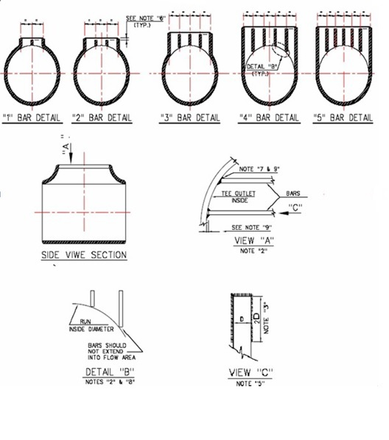

Design and Manufacture of Barred Tees shall be in accordance with IPS-D-PI-149

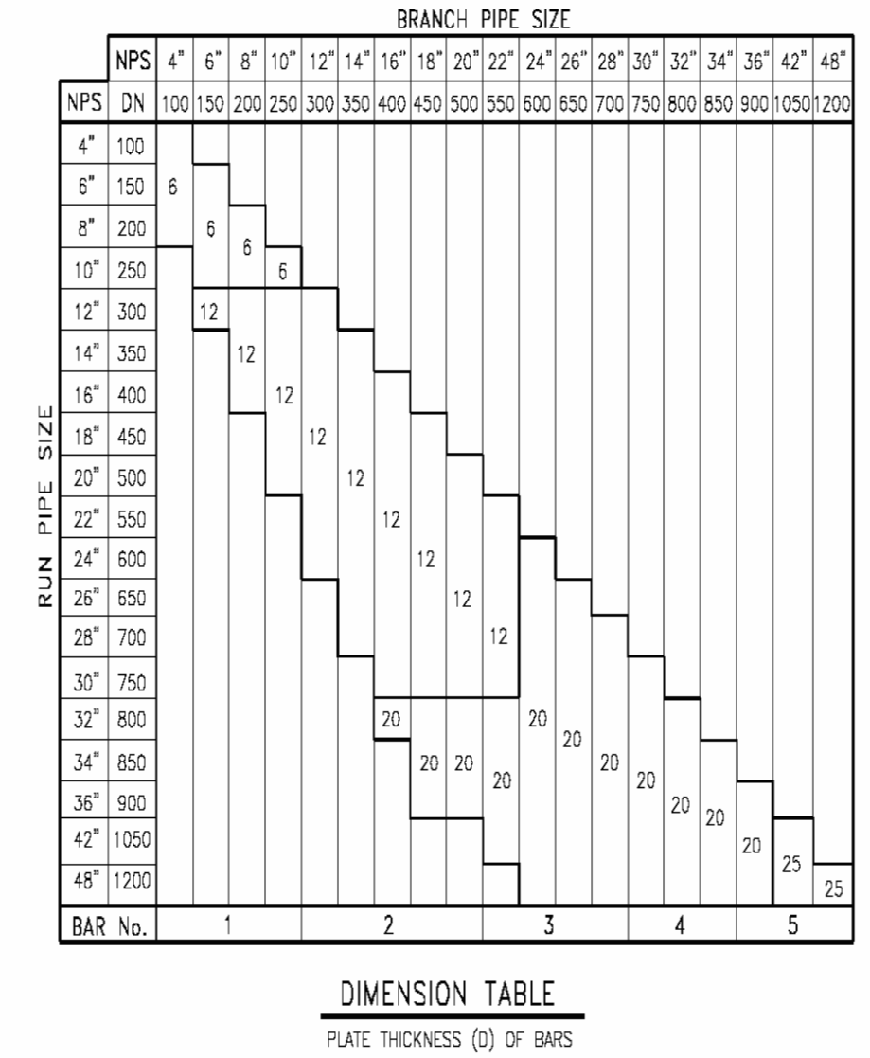

NOTES:

1) All thickness values and dimensions are in mm.

2) Alignment bars to be square end cut and corner ground to contour of crotch & flush mounted in line with the inside wall of run pipe.

3) Fillet welds of bars must not extend into crotch of tee.

4) Bar material is hot rolled mild steel plate unless otherwise specified.

5) Per standard practice welding is permitted on plate type bars in order to maintain the specified clearance of tee.

6) This dimension shall be same as bar plate thickness used in outlet. It may vary due to outlet height available.

7) Square end cut and ground to fit outlet contour along one corner of bar.

8) Square end cut and round all sharp corners to 3 mm Radius.

9) Clearance 1.5± 1.5 for all Plates.

10) For reinforcement & protection of scraper guide bar, equality spaced guide bar supports should be use as following:

|  |  |  |
| --- | --- | --- |
| Branch Diameter | No. of Guide Bar Support | DIA. (mm) |
| 22”~30” | 3 | 12 |
| 32”~48” | 4 | 20 |