|  |  |  |  |  |  |  |  |
| --- | --- | --- | --- | --- | --- | --- | --- |
| **طرح نگهداشت و افزایش تولید 27 مخزن** | | | | | | | |
| **RELAY COORDINATION & SETTING STUDY REPORT OF**  **WELL PADS**  **نگهداشت و افزایش تولید میدان نفتی بینک** | | | | | | | |
|  | |  |  |  |  |  |  |
|  | |  |  |  |  |  |  |
|  | |  |  |  |  |  |  |
|  | |  |  |  |  |  |  |
| D00 | | May. 2023 | IFI | H.Shakiba | M.Fakharian | A.M.Mohseni |  |
| **Rev.** | | **Date** | **Purpose of Issue/Status** | **Prepared by:** | **Checked by:** | **Approved by:** | **Client Approval** |
| **Class: 3** | | | **Client Doc. Number: F0Z-707422** | | | | |
| **Status:** | | **IDC: Inter-Discipline Check**  **IFC: Issued For Comment**  **IFA: Issued For Approval**  **AFD: Approved For Design**  **AFC: Approved For Construction**  **AFP: Approved For Purchase**  **AFQ: Approved For Quotation**  **IFI: Issued For Information**  **AB-R: As-Built for Client Review**  **AB-A: As-Built –Approved** | | | | | |

**REVISION RECORD SHEET**

|  |  |  |  |  |  |  |  |  |  |  |  |  |
| --- | --- | --- | --- | --- | --- | --- | --- | --- | --- | --- | --- | --- |
| **PAGE** | **D00** | **D01** | **D02** | **D03** | **D04** |  | **PAGE** | **D00** | **D01** | **D02** | **D03** | **D04** |
| **1** | X |  |  |  |  | **51** |  |  |  |  |  |
| **2** | X |  |  |  |  | **52** |  |  |  |  |  |
| **3** | X |  |  |  |  | **53** |  |  |  |  |  |
| **4** | X |  |  |  |  | **54** |  |  |  |  |  |
| **5** | X |  |  |  |  | **55** |  |  |  |  |  |
| **6** | X |  |  |  |  | **56** |  |  |  |  |  |
| **7** | X |  |  |  |  | **57** |  |  |  |  |  |
| **8** | X |  |  |  |  | **58** |  |  |  |  |  |
| **9** | X |  |  |  |  | **59** |  |  |  |  |  |
| **10** | X |  |  |  |  | **60** |  |  |  |  |  |
| **11** | X |  |  |  |  | **61** |  |  |  |  |  |
| **12** | X |  |  |  |  | **62** |  |  |  |  |  |
| **13** | X |  |  |  |  | **63** |  |  |  |  |  |
| **14** |  |  |  |  |  | **64** |  |  |  |  |  |
| **15** |  |  |  |  |  | **65** |  |  |  |  |  |
| **16** |  |  |  |  |  | **66** |  |  |  |  |  |
| **17** |  |  |  |  |  | **67** |  |  |  |  |  |
| **18** |  |  |  |  |  | **68** |  |  |  |  |  |
| **19** |  |  |  |  |  | **69** |  |  |  |  |  |
| **20** |  |  |  |  |  | **70** |  |  |  |  |  |
| **21** |  |  |  |  |  | **71** |  |  |  |  |  |
| **22** |  |  |  |  |  | **72** |  |  |  |  |  |
| **23** |  |  |  |  |  | **73** |  |  |  |  |  |
| **24** |  |  |  |  |  | **74** |  |  |  |  |  |
| **25** |  |  |  |  |  | **75** |  |  |  |  |  |
| **26** |  |  |  |  |  | **76** |  |  |  |  |  |
| **27** |  |  |  |  |  | **77** |  |  |  |  |  |
| **28** |  |  |  |  |  | **78** |  |  |  |  |  |
| **29** |  |  |  |  |  | **79** |  |  |  |  |  |
| **30** |  |  |  |  |  | **80** |  |  |  |  |  |
| **31** |  |  |  |  |  | **81** |  |  |  |  |  |
| **32** |  |  |  |  |  | **82** |  |  |  |  |  |
| **33** |  |  |  |  |  | **83** |  |  |  |  |  |
| **34** |  |  |  |  |  | **84** |  |  |  |  |  |
| **35** |  |  |  |  |  | **85** |  |  |  |  |  |
| **36** |  |  |  |  |  | **86** |  |  |  |  |  |
| **37** |  |  |  |  |  | **87** |  |  |  |  |  |
| **38** |  |  |  |  |  | **88** |  |  |  |  |  |
| **39** |  |  |  |  |  | **89** |  |  |  |  |  |
| **40** |  |  |  |  |  | **90** |  |  |  |  |  |
| **41** |  |  |  |  |  | **91** |  |  |  |  |  |
| **42** |  |  |  |  |  | **92** |  |  |  |  |  |
| **43** |  |  |  |  |  | **93** |  |  |  |  |  |
| **44** |  |  |  |  |  | **94** |  |  |  |  |  |
| **45** |  |  |  |  |  | **95** |  |  |  |  |  |
| **46** |  |  |  |  |  | **96** |  |  |  |  |  |
| **47** |  |  |  |  |  | **97** |  |  |  |  |  |
| **48** |  |  |  |  |  | **98** |  |  |  |  |  |
| **49** |  |  |  |  |  | **99** |  |  |  |  |  |
| **50** |  |  |  |  |  | **100** |  |  |  |  |  |

**CONTENTS**

1.0 INTRODUCTION 4

2.0 Scope 5

3.0 NORMATIVE REFERENCES 5

3.1 Local Codes & Standards 5

3.2 International Codes & Standards 5

3.3 The Project Documents 5

4.0 DOCUMENT PRIORITY 6

5.0 GENERAL NOTES 6

5.1 MOTOR FEEDERS PROTECTION 6

5.2 Transformer Protection 8

5.3 Coordination of O.C. relays with fuses and low-voltage trip devices 10

5.4 Typical setting for LV outgoing feeders 11

1. **INTRODUCTION**

Binak oilfield in Bushehr province is a part of the southern oilfields of Iran, is located 20 km northwest of Genaveh city.

With the aim of increasing production of oil from Binak oilfield, an EPC/EPD Project has been defined by NIOC/NISOC and awarded to Petro Iran Development Company (PEDCO). Also PEDCO (as General Contractor) has assigned the EPC-packages of the Project to "Hirgan Energy - Design and Inspection" JV.

As a part of the Project, construction of well location, access roads, wellhead facilities for 6 new wells (with electric power supply for 2 of them) and required modifications on 4 workover wells (with electric power supply) shall be done. In addition, construction of 6 new flowlines from new wells to Binak B/C unit (with extension of relevant manifold) are in the Project scope of work.

**GENERAL DEFINITION**

The following terms shall be used in this document.

|  |  |
| --- | --- |
| CLIENT: | National Iranian South Oilfields Company (NISOC) |
| PROJECT: | Binak Oilfield Development – Construction of New Well Locations, Modifications on Workover Wells, Wellhead Facilities, Electrification Facilities, Flowlines and Extension of Binak B/C Manifold |
| EPD/EPC CONTRACTOR(GC): | Petro Iran Development Company (PEDCO) |
| EPC CONTRACTOR: | Joint Venture of : Hirgan Energy – Design & Inspection(D&I) Companies |
| VENDOR: | The firm or person who will fabricate the equipment or material. |
| EXECUTOR: | Executor is the party which carries out all or part of construction and/or commissioning for the project. |
| THIRD PARTY INSPECTOR (TPI): | The firm appointed by EPC CONTRACTOR (GC) and approved by GC & COMPANY (in writing) for the inspection of goods. |
| SHALL: | Is used where a provision is mandatory. |
| SHOULD: | Is used where a provision is advisory only. |
| WILL: | Is normally used in connection with the action by COMPANY rather than by an EPC/EPD CONTRACTOR, supplier or VENDOR. |
| MAY: | Is used where a provision is completely discretionary. |

1. **Scope**

This document covers study method of relay coordination & setting for substation in well pads.

1. **NORMATIVE REFERENCES**

## Local Codes & Standards

* IPS-E-EL-100 Engineering Standard for Electrical System Design

## International Codes & Standards

* IEC60 909-1 to IEC60909-3 : Short Circuit Calculation
* IEC600 76 -1 to IEC600 76 -5 : Power Transformer
* IEC 60034-1 to IEC 60034-18: Rotating Electrical Machines
* IEEE Std 399-1997: IEEE Recommended Practice for Industrial & Commercial Power Systems Analysis
* IEEE-Std-242-2001: IEEE Recommended Practice for Protection and

Coordination of Industrial and Commercial Power Systems

* IEEE C37.2-1991: IEEE Standard Electrical Power System device

Function Numbers

* IEEE C37.96-2000: Guide For AC Motor Protection.

## The Project Documents

* BK-GNRAL-PEDCO-000-EL-DC-0001 Electrical System Design Criteria
* BK-GCS-PEDCO-120-EL-RT-0001 Electrical Network (load flow,

motor starting & short circuit) study report

* BK-GNRAL-PEDCO-000-PR-DB-0001Process Basis of Design

1. **DOCUMENT PRIORITY**

In the event of any conflict between this specification, data sheets, drawings, codes and standards, the priority shall be given in the following order

* Purchase Order
* Agreed Exceptions / Deviations List
* This Material Requisition
* Main Project Specification
* Project Specific Data Sheet
* Other Project Specifications and Drawings
* International Codes & Standards

In any case vendor shall refer the matter with purchaser and obtain clarification before

proceeding with any work.

1. **GENERAL NOTES**

## MOTOR FEEDERS PROTECTION

Motors are affected by:

Faults related to the driven loads,

* Power supply faults,
* Motor internal faults.

ANSI codes for motor protection are as follow:

**ANSI code Function**

50 Phase fault

50N/51N Earth fault

49 Thermal O.L

46 Negative sequence protection

48/51LR Lock rotor

66 Motor starting protection

47 Phase sequence

66 Restart Inhibit

As general rule transient conditions such as motor starting or inrush current should not affect coordination, protection and continuity of network.

**Definite time O.C or short circuit protection (50):** The energization of motors causes a starting current of initially 5 to 6 times the rated current (locked rotor current). A typical time-current curve for an induction motor is shown in Fig 1.At the first 100 ms, a fast decaying asymmetrical inrush current appears additionally. With conventional relays it was common practice to set the instantaneous over current stage of the short circuit protection 20 to 30 % above the locked rotor current and 80% below of minimum short circuit level with a short time delay of 50 to 100 ms to override the asymmetrical inrush period. (If fuse is used, Ansi code 50 should be off because contactor I^2t is limited.)

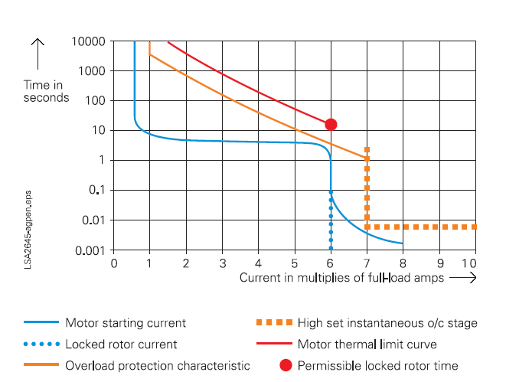

Fig-1: Typical motor current – time characteristics

**Earth fault protection (50N/51N):** Typical value for earth fault setting is (10% to 20%) of earth fault current. According to Motor vendors, for reduce of stator damages, earth fault currents in motor should limited to (20A to 30A). A short time delay of 50 to 100 ms to override the asymmetrical inrush period shall be considered.

**Thermal overload protection (49)** Cold and hot thermal withstand curves for starting & running conditions for every MV motor are required, to be obtained from motor manufacturer. Relay cold and hot curves must be below than corresponding motor curves to initiate motor tripping before exceeding motor thermal with stand time for any multiple of motor rated current.

**Excessive starting time and locked rotor starting time supervision (48)** The same function provides both types of protection (ANSI 48-51LR), an instantaneous current threshold is set below the value of the starting current (generally Ip=150%In) and activated after a delay that begins when the motor is energized; the delay is set longer than the normal starting time. Locked rotor protection is activated outside starting periods by current above a threshold, after a delay.

**Unbalance protection (46)** 3-phase power supply may be unbalanced because of the following reasons:

The power source (transformer or AC generator) does not supply symmetrical 3-phase voltage, all the other consumers together do not constitute a symmetrical load and this unbalances the power supply system, the motor is being powered by two phases after a fuse has blown on one phase, power supply unbalance creates negative sequence current which causes very high losses and quick rotor overheating.

Generally, pickup function 46 is set between (10%-20%)*In and delay time greater than starting time for first step and 40%In with 1 second delay time for second step or IDMT curve with (10%-30%)*In and tripping time more than starting time.

**Successive starts:** The successive starts protection function (ANSI 66) is based on the number of starts within a given interval of time or on the time between starts.

## Transformer Protection

The transformer is a particularly important in power system component. Transformer requires effective protection against all faults liable to damage them, whether of internal or external origin. The choice of a protection unit is often based on technical and cost considerations related to the power rating.

ANSI code for protecting power transformer is as follow:

**ANSI code Function**

50/51 Phase fault

50N/51N Earth fault

87T Differential

49RMS Over Load

**Over current (51)** has been selected 30% - 40% above transformer nominal current. Time multiplier (TMS) has been selected so that relay could be coordinated with downstream relay in max fault level.

$I_{p(51)}$ = 1.3× $I_{fla}$ (current inside power system)

$I_{r(51)}$ = $\frac{1.3× I_{fla}}{In}×In$ (current inside relay)

In= CT primary current

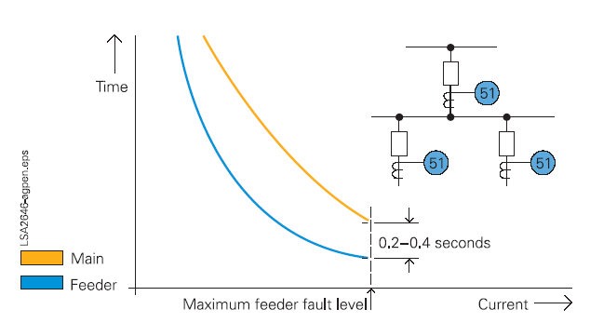

Fig-2: Coordination of inverse-time relays

**Instantaneous (50)** this is typically applied on the final supply load or on any protection relay with sufficient circuit impedance between itself and the next downstream protection relay. The setting at transformers, for example, must be chosen about at least 20 to 30 % of higher fault current. The relay must remain stable during energization of the transformer. Time grading between upstream & downstream should be 0.2 to 0.4 sec.

**Earth fault protection (ANSI 50N):** located on the upstream power system for frame faults that affect the transformer primary circuit.

Recommended setting: Threshold > 20% of maximum earth fault current and > 10% of CT rating with delay 0.1 second.

**Thermal overload protection (49):** This is used to protect against transformer overloads. It simulates the heat rise of the machine to be protected using the current measurement. Loading transformer from a cold or hot state will be effect on tripping time.

**Transformer differential protection (ANSI 87T):** which provides fast protection against phase-to-phase faults. It is sensitive and used for vital high power transformers.

To ensure fast clearing of 3phase short circuit, setting of “high set point differential” shall be more than inrush current of transformer.

To avoid tripping nuisance, the 2nd harmonic of the differential current is measured to detect transformer energizing (H2 restraint) recommended setting is 20%.

To ensure stability of the protection function in the event of an abnormal increase in the voltage or a drop in network frequency, we recommend that the fifth harmonic restraint set point is set to 35%.



Fig-3: Transformer differential (87T) relays

## Coordination of O.C. relays with fuses and low-voltage trip devices

The procedure is similar to the above-described grading of O.C. relays. A time interval between 0.1 and 0.2 seconds is usually sufficient for a safe time coordination. Very and extremely inverse characteristics are often more suitable than normal inverse characteristics in this case. Fig 5 shows typical examples. Simple distribution grid stations use a power fuse on the secondary side of the supply transformers. (Fig-4 b) In this case, the operating characteristic of the o/c relay at the in feed has to be coordinated with the fuse curve. Very inverse characteristics may be used with expulsion- type fuses (fuse cutouts) while extremely inverse versions adapt better to current limiting fuses. In any case, the final decision should be made by plotting the curves in the log-log coordination diagram.

Electronic trip devices of LV breakers have long delay, short-delay and instantaneous zones.

Numerical o/c relays with one inverse-time and two definite-time zones can closely be adapted to this (Fig-4 a).

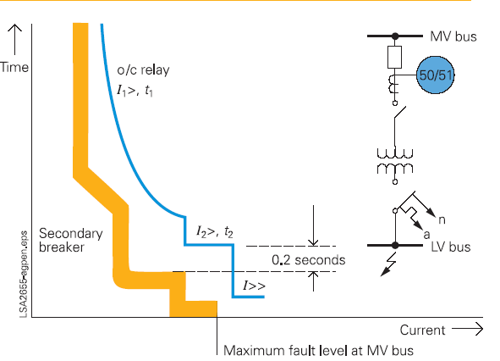

A B

Fig-4: Coordination of an O.C. relay with a LV fuse and low-voltage breaker trip device

Setting for LSI for LV CB is as bellow:

Long time: Pickup is set between 1.05 up to 1.25 full load amp. Class is dependent to coordination protection with downstream.

Short time: Pick up is dependent to max. short circuit downstream ,is usually is set at 80% min. short circuit on switchgear time grading between upstream and downstream is set at min 0.1 sec

Instantaneous: pickup can be off for coordination or be set at max pickup.

## Typical setting for LV outgoing feeders

In follow there is recommended setting for various type of LV outgoing feeders as per project feeder types with regard to project typical diagram for lv switchgear:

TYPE L1 (L < 50A)

Setting for Thermal unit(49) : (1.05 ~ 1.25)*In

Setting for Magnet unit(50) : (6 ~ 8)*In

TYPE L2 (L ≥ 50A)

Setting for Thermal unit(49) : (1.05 ~ 1.25)*In

Setting for Magnet unit(50) : (6 ~ 8)*In

Setting for Earth fault (50N): 0.1*In or 3A, smallest one.

TYPE M2 (4kw ≤ M <18.5KW)

Setting for Thermal unit(49) : (1.05 ~ 1.25)*In

Setting for Magnet unit(50) : FIX for MPCB

TYPE M3 (18.5KW ≤ M < 150KW)

Setting for Thermal unit(49) : (1.05 ~ 1.25)*In

Setting for Magnet unit(50) : (8 ~10)*In

Setting for Earth fault(50N) : 0.1A or 30A, smallest one or 3A for sensitive motors.

Capacitor bank.

Setting for Thermal unit(49) : (1.5 ~ 2)*In

Setting for Magnet unit(50) : (8 ~10)*In

**NOTE**: This document is preliminary and will be finalized after vendor’s documents finalization.