|  |  |  |  |  |  |  |  |
| --- | --- | --- | --- | --- | --- | --- | --- |
| **طرح نگهداشت و افزایش تولید 27 مخزن** | | | | | | | |
| **PDMS MODEL REVIEW REPORT (30%) - W007S**  **نگهداشت و افزایش تولید میدان نفتی بینک** | | | | | | | |
|  |  |  |  |  |  |  |
|  |  |  |  |  |  |  |
|  |  |  |  |  |  |  |
|  |  |  |  |  |  |  |
| D00 | JUL. 2023 | IFC | M.Noori | M.Fakharian | A.M.Mohseni |  |
| **Rev.** | **Date** | **Purpose of Issue/Status** | **Prepared by:** | **Checked by:** | **Approved by:** | **CLIENT Approval** |
| **Class:2** | | **CLIENT Doc. Number:** **F0Z-707958** | | | | |
| **Status:** | **IDC: Inter-Discipline Check**  **IFC: Issued For Comment**  **IFA: Issued For Approval**  **AFD: Approved For Design**  **AFC: Approved For Construction**  **AFP: Approved For Purchase**  **AFQ:** Approved For Quotation  **IFI: Issued For Information**  **AB-R: As-Built for CLIENT Review**  **AB-A: As-Built –Approved** | | | | | |

**REVISION RECORD SHEET**

|  |  |  |  |  |  |  |  |  |  |  |  |  |
| --- | --- | --- | --- | --- | --- | --- | --- | --- | --- | --- | --- | --- |
| **PAGE** | **D00** | **D01** | **D02** | **D03** | **D04** |  | **PAGE** | **D00** | **D01** | **D02** | **D03** | **D04** |
| **1** | X |  |  |  |  | **66** |  |  |  |  |  |
| **2** | X |  |  |  |  | **67** |  |  |  |  |  |
| **3** | X |  |  |  |  | **68** |  |  |  |  |  |
| **4** | X |  |  |  |  | **69** |  |  |  |  |  |
| **5** | X |  |  |  |  | **70** |  |  |  |  |  |
| **6** | X |  |  |  |  | **71** |  |  |  |  |  |
| **7** | X |  |  |  |  | **72** |  |  |  |  |  |
| **8** | X |  |  |  |  | **73** |  |  |  |  |  |
| **9** |  |  |  |  |  | **74** |  |  |  |  |  |
| **10** |  |  |  |  |  | **75** |  |  |  |  |  |
| **11** |  |  |  |  |  | **76** |  |  |  |  |  |
| **12** |  |  |  |  |  | **77** |  |  |  |  |  |
| **13** |  |  |  |  |  | **78** |  |  |  |  |  |
| **14** |  |  |  |  |  | **79** |  |  |  |  |  |
| **15** |  |  |  |  |  | **80** |  |  |  |  |  |
| **16** |  |  |  |  |  | **81** |  |  |  |  |  |
| **17** |  |  |  |  |  | **82** |  |  |  |  |  |
| **18** |  |  |  |  |  | **83** |  |  |  |  |  |
| **19** |  |  |  |  |  | **84** |  |  |  |  |  |
| **20** |  |  |  |  |  | **85** |  |  |  |  |  |
| **21** |  |  |  |  |  | **86** |  |  |  |  |  |
| **22** |  |  |  |  |  | **87** |  |  |  |  |  |
| **23** |  |  |  |  |  | **88** |  |  |  |  |  |
| **24** |  |  |  |  |  | **89** |  |  |  |  |  |
| **25** |  |  |  |  |  | **90** |  |  |  |  |  |
| **26** |  |  |  |  |  | **91** |  |  |  |  |  |
| **27** |  |  |  |  |  | **92** |  |  |  |  |  |
| **28** |  |  |  |  |  | **93** |  |  |  |  |  |
| **29** |  |  |  |  |  | **94** |  |  |  |  |  |
| **30** |  |  |  |  |  | **95** |  |  |  |  |  |
| **31** |  |  |  |  |  | **96** |  |  |  |  |  |
| **32** |  |  |  |  |  | **97** |  |  |  |  |  |
| **33** |  |  |  |  |  | **98** |  |  |  |  |  |
| **34** |  |  |  |  |  | **99** |  |  |  |  |  |
| **35** |  |  |  |  |  | **100** |  |  |  |  |  |
| **36** |  |  |  |  |  | **101** |  |  |  |  |  |
| **37** |  |  |  |  |  | **102** |  |  |  |  |  |
| **38** |  |  |  |  |  | **103** |  |  |  |  |  |
| **39** |  |  |  |  |  | **104** |  |  |  |  |  |
| **40** |  |  |  |  |  | **105** |  |  |  |  |  |
| **41** |  |  |  |  |  | **106** |  |  |  |  |  |
| **42** |  |  |  |  |  | **107** |  |  |  |  |  |
| **43** |  |  |  |  |  | **108** |  |  |  |  |  |
| **44** |  |  |  |  |  | **109** |  |  |  |  |  |
| **45** |  |  |  |  |  | **110** |  |  |  |  |  |
| **46** |  |  |  |  |  | **111** |  |  |  |  |  |
| **47** |  |  |  |  |  | **112** |  |  |  |  |  |
| **48** |  |  |  |  |  | **113** |  |  |  |  |  |
| **49** |  |  |  |  |  | **114** |  |  |  |  |  |
| **50** |  |  |  |  |  | **115** |  |  |  |  |  |
| **51** |  |  |  |  |  | **116** |  |  |  |  |  |
| **52** |  |  |  |  |  | **117** |  |  |  |  |  |
| **53** |  |  |  |  |  | **118** |  |  |  |  |  |
| **54** |  |  |  |  |  | **119** |  |  |  |  |  |
| **55** |  |  |  |  |  | **120** |  |  |  |  |  |
| **56** |  |  |  |  |  | **121** |  |  |  |  |  |
| **57** |  |  |  |  |  | **122** |  |  |  |  |  |
| **58** |  |  |  |  |  | **123** |  |  |  |  |  |
| **59** |  |  |  |  |  | **124** |  |  |  |  |  |
| **60** |  |  |  |  |  | **125** |  |  |  |  |  |
| **61** |  |  |  |  |  | **126** |  |  |  |  |  |
| **62** |  |  |  |  |  | **127** |  |  |  |  |  |
| **63** |  |  |  |  |  | **128** |  |  |  |  |  |
| **64** |  |  |  |  |  | **129** |  |  |  |  |  |
| **65** |  |  |  |  |  | **130** |  |  |  |  |  |

**CONTENTS**

1.0 INTRODUCTION 4

2.0 Scope 5

3.0 NORMATIVE REFERENCES 5

**3.1** The Project Documents 5

**3.2** Order of Precedence 5

4.0 KEY OBJECTIVES 5

5.0 STATISTICS 6

6.0 DESCRIPTION AND CONCLUSIONS 6

ATTACHMENT 1: MOM (1402/02/25) 8

ATTACHMENT 2: navis 3d model (30%) of w007S 8

1. **INTRODUCTION**

Binak oilfield in Bushehr province is a part of the southern oilfields of Iran, is located 20 km northwest of Genaveh city.

With the aim of increasing production of oil from Binak oilfield, an EPC/EPD Project has been defined by NIOC/NISOC and awarded to Petro Iran Development Company (PEDCO). Also PEDCO (as General Contractor) has assigned the EPC-packages of the Project to "Hirgan Energy - Design and Inspection" JV.

As a part of the Project, construction of well location, access road, wellhead facilities (with electric power supply) for W007S shall be done. In addition, construction of new flowline from aforementioned well location to Binak B/C unit (with extension of relevant manifold) are in the Project scope of work.

**GENERAL DEFINITION**

The following terms shall be used in this document.

|  |  |
| --- | --- |
| CLIENT: | National Iranian South Oilfields Company (NISOC) |
| PROJECT: | Binak Oilfield Development – Construction of Well Location, Wellhead Facilities, Electrification Facilities, Flowlines for W007S and Extension of Binak B/C Manifold |
| EPD/EPC CONTRACTOR (GC): | Petro Iran Development Company (PEDCO) |
| EPC CONTRACTOR: | Joint Venture of : Hirgan Energy – Design & Inspection (D&I) Companies |
| VENDOR: | The firm or person who will fabricate the equipment or material. |
| EXECUTOR: | Executor is the party which carries out all or part of construction and/or commissioning for the project. |
| THIRD PARTY INSPECTOR (TPI): | The firm appointed by EPD/EPC CONTRACTOR (GC) and approved by CLIENT (in writing) for the inspection of goods. |
| SHALL: | Is used where a provision is mandatory. |
| SHOULD: | Is used where a provision is advisory only. |
| WILL: | Is normally used in connection with the action by CLIENT rather than by an EPC/EPD CONTRACTOR, supplier or VENDOR. |
| MAY: | Is used where a provision is completely discretionary. |

1. **Scope**

This document presents all raised issues and made decisions during 30% model review session of PROJECT which should be followed and performed during continuation of PROJECT.

1. **NORMATIVE REFERENCES**

## The Project Documents

* BK-GNRAL-PEDCO-000-PI-PR-0001 3D-Model (PDMS) Review Procedure

## Order of Precedence

In case of any conflict between the contents of this document or any discrepancy between this document and other project documents or reference standards, this issue must be reported to the CLIENT. The final decision in this situation will be made by CLIENT.

1. **KEY OBJECTIVES**

The purpose of 30% Model Review is to freeze a basic design and concept and to hand over to a detail design stage. Plot plan, equipment layout, major piping arrangement, process requirements, major equipment maintenance, operability, major access way and conformity of PDMS catalogue with Piping Material Specification are critical review points and the following objectives shall be addressed during the model review:

1. Confirm if there are any potential deviations from project specifications and then study the practical resolutions at the earliest possible timing.
2. Review critical areas having a possibility of schedule interruption to the downstream detailed design activities, especially
   * Steel Structures and platforms
   * Static Equipment

The model minimum content for the 30% model review shall be:

* + Major equipment located in compliance with plot plan which is available at that stage.
  + Major structures (steel/concrete) outlines in compliance with the plot plan.
  + Major above ground piping (line sizes equal and greater than 6" for CS and all sizes for SS) with insulation information.
  + Major concrete foundation outlines, slabs, paving and roads.
  + Package unit outlines, locations and orientation.
  + Major pipe racks/pipe support outlines located in compliance with available plot plan.
  + Main electrical/instrument underground cable route.
  + All underground piping systems.
  + Building outlines.
  + Dropout/bundle pulling and lay down areas, mobile crane aprons.

1. **STATISTICS**

The followings indicate the number of modeled major items which were reviewed during 30% model review:

* + Number of modeled equipment: 3
  + Number of modeled A/G and U/G Lines: 8
  + Number of modeled shelter, structure and building
  + Electrical main trench
  + Instrument main cable trench

1. **DESCRIPTION AND CONCLUSIONS**

The 30% model review for “Binak Oilfield Development – Subsurface Facilities “was held with representatives of CLIENT, EPD/EPC CONTRACTOR (GC) and EPC CONTRACTOR, on 1400/12/11. The subjects of discussion for the meeting were organized and considered based on the following issues:

* General layout and arrangement,
* Operation access rooms,
* Maintenance requirements,
* Installing location for instruments, platforms, and access to instruments,
* Lineup of primary lines.

It was stated that following items should be checked and corrected during 60% modeling and would be reviewed in 60% model review meeting:

## The security room shall be located inside of fence in next revision arrangement of doors will be commented by client.

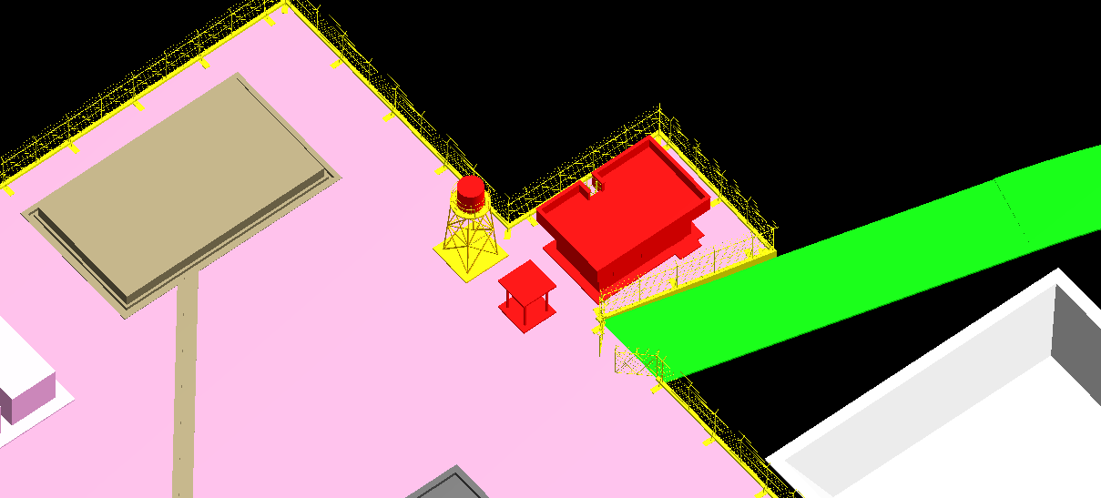

## Due to comment of engineering department expert of FARAVARESH about last experience of installation of IRP pumps; it was decided that the mentioned pump should rotate 180degrees and turn product and burn pit line toward the fence.

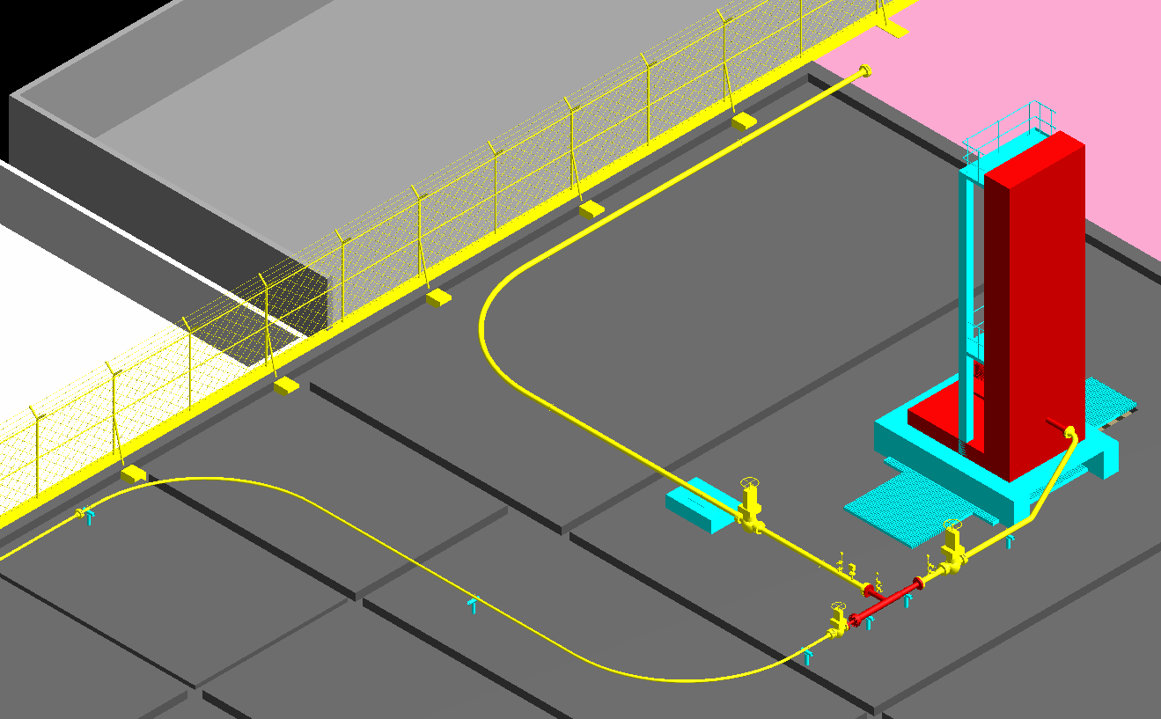

## According to the wellhead topography, the second exit door is approved by client safety expert.

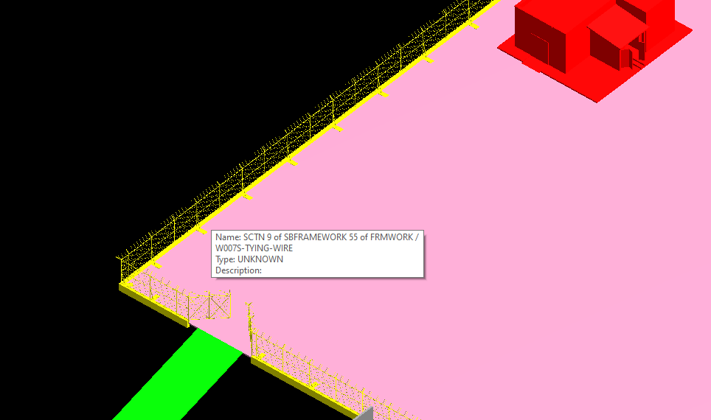

## Fence of gantry shall be added.

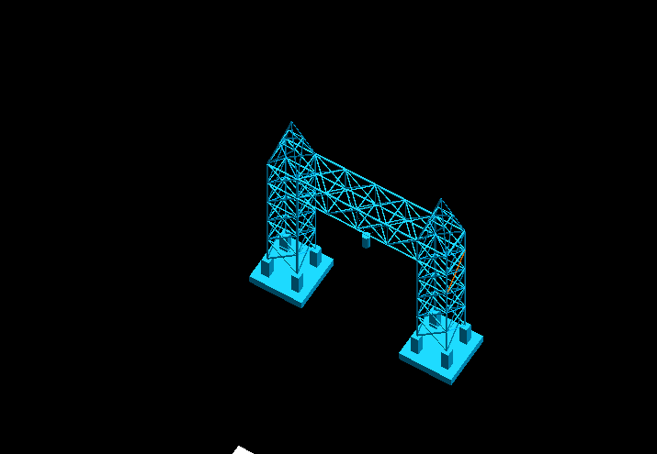

**ATTACHMENT 1: MOM (1402/02/25)**

**ATTACHMENT 2: navis 3d model (30%) of w007S**