|  |  |  |  |  |  |  |
| --- | --- | --- | --- | --- | --- | --- |
| **طرح نگهداشت و افزایش تولید 27 مخزن** | | | | | | |
| **Flare Radiation & Dispersion Study Report**  **نگهداشت و افزایش تولید میدان نفتی بینک** | | | | | | |
| D05 | JUL. 2023 | AFD | M.Aryafar | M.Fakharian | M.Mehrshad |  |
| D04 | APR. 2023 | AFD | M.Aryafar | M.Fakharian | M.Mehrshad |  |
| D03 | DEC. 2022 | IFA | M.Aryafar | M.Fakharian | M.Mehrshad |  |
| D02 | OCT. 2022 | IFA | M.Aryafar | M.Fakharian | M.Mehrshad |  |
| D01 | JUN. 2022 | IFA | M.Aryafar | M.Fakharian | M.Mehrshad |  |
| D00 | JAN. 2022 | IFC | M.Aryafar | M.Fakharian | M.Mehrshad |  |
| **Rev.** | **Date** | **Purpose of Issue/Status** | **Prepared by:** | **Checked by:** | **Approved by:** | **CLIENT Approval** |
| **Class:2** | | **CLIENT Doc. Number:** **F0Z-708816** | | | | |
| **Status:** | **IDC: Inter-Discipline Check**  **IFC: Issued For Comment**  **IFA: Issued For Approval**  **AFD: Approved For Design**  **AFC: Approved For Construction**  **AFP: Approved For Purchase**  **AFQ:** Approved For Quotation  **IFI: Issued For Information**  **AB-R: As-Built for CLIENT Review**  **AB-A: As-Built –Approved** | | | | | |

**REVISION RECORD SHEET**

|  |  |  |  |  |  |  |  |  |  |  |  |  |  |
| --- | --- | --- | --- | --- | --- | --- | --- | --- | --- | --- | --- | --- | --- |
| **PAGE** | **D00** | **D01** | **D02** | **D03** | **D04** | **D05** |  | **PAGE** | **D00** | **D01** | **D02** | **D03** | **D04** |
| **1** | X | X | X | X | X | X | **66** |  |  |  |  |  |
| **2** | X | X | X | X | X | X | **67** |  |  |  |  |  |
| **3** | X |  |  |  |  |  | **68** |  |  |  |  |  |
| **4** | X |  |  |  |  |  | **69** |  |  |  |  |  |
| **5** | X |  |  |  |  |  | **70** |  |  |  |  |  |
| **6** | X | X | X | X |  |  | **71** |  |  |  |  |  |
| **7** | X | X | X | X |  |  | **72** |  |  |  |  |  |
| **8** | X | X | X | X | X |  | **73** |  |  |  |  |  |
| **9** | X |  | X | X |  |  | **74** |  |  |  |  |  |
| **10** | X | X | X | X | X |  | **75** |  |  |  |  |  |
| **11** | X | X | X | X | X |  | **76** |  |  |  |  |  |
| **12** | X | X | X | X | X |  | **77** |  |  |  |  |  |
| **13** | X | X | X | X | X |  | **78** |  |  |  |  |  |
| **14** | X | X | X | X | X |  | **79** |  |  |  |  |  |
| **15** | X |  |  |  |  |  | **80** |  |  |  |  |  |
| **16** | X |  |  |  |  |  | **81** |  |  |  |  |  |
| **17** | X | X | X |  |  |  | **82** |  |  |  |  |  |
| **18** | X |  | X |  |  | X | **83** |  |  |  |  |  |
| **19** | X | X | X |  |  | X | **84** |  |  |  |  |  |
| **20** | X | X | X |  |  | X | **85** |  |  |  |  |  |
| **21** | X | X |  |  | X | X | **86** |  |  |  |  |  |
| **22** | X |  | X |  | X |  | **87** |  |  |  |  |  |
| **23** | X |  |  |  |  |  | **88** |  |  |  |  |  |
| **24** | X |  |  |  |  |  | **89** |  |  |  |  |  |
| **25** |  |  |  |  |  |  | **90** |  |  |  |  |  |
| **26** |  |  |  |  |  |  | **91** |  |  |  |  |  |
| **27** |  |  |  |  |  |  | **92** |  |  |  |  |  |
| **28** |  |  |  |  |  |  | **93** |  |  |  |  |  |
| **29** |  |  |  |  |  |  | **94** |  |  |  |  |  |
| **30** |  |  |  |  |  |  | **95** |  |  |  |  |  |
| **31** |  |  |  |  |  |  | **96** |  |  |  |  |  |
| **32** |  |  |  |  |  |  | **97** |  |  |  |  |  |
| **33** |  |  |  |  |  |  | **98** |  |  |  |  |  |
| **34** |  |  |  |  |  |  | **99** |  |  |  |  |  |
| **35** |  |  |  |  |  |  | **100** |  |  |  |  |  |
| **36** |  |  |  |  |  |  | **101** |  |  |  |  |  |
| **37** |  |  |  |  |  |  | **102** |  |  |  |  |  |
| **38** |  |  |  |  |  |  | **103** |  |  |  |  |  |
| **39** |  |  |  |  |  |  | **104** |  |  |  |  |  |
| **40** |  |  |  |  |  |  | **105** |  |  |  |  |  |
| **41** |  |  |  |  |  |  | **106** |  |  |  |  |  |
| **42** |  |  |  |  |  |  | **107** |  |  |  |  |  |
| **43** |  |  |  |  |  |  | **108** |  |  |  |  |  |
| **44** |  |  |  |  |  |  | **109** |  |  |  |  |  |
| **45** |  |  |  |  |  |  | **110** |  |  |  |  |  |
| **46** |  |  |  |  |  |  | **111** |  |  |  |  |  |
| **47** |  |  |  |  |  |  | **112** |  |  |  |  |  |
| **48** |  |  |  |  |  |  | **113** |  |  |  |  |  |
| **49** |  |  |  |  |  |  | **114** |  |  |  |  |  |
| **50** |  |  |  |  |  |  | **115** |  |  |  |  |  |
| **51** |  |  |  |  |  |  | **116** |  |  |  |  |  |
| **52** |  |  |  |  |  |  | **117** |  |  |  |  |  |
| **53** |  |  |  |  |  |  | **118** |  |  |  |  |  |
| **54** |  |  |  |  |  |  | **119** |  |  |  |  |  |
| **55** |  |  |  |  |  |  | **120** |  |  |  |  |  |
| **56** |  |  |  |  |  |  | **121** |  |  |  |  |  |
| **57** |  |  |  |  |  |  | **122** |  |  |  |  |  |
| **58** |  |  |  |  |  |  | **123** |  |  |  |  |  |
| **59** |  |  |  |  |  |  | **124** |  |  |  |  |  |
| **60** |  |  |  |  |  |  | **125** |  |  |  |  |  |
| **61** |  |  |  |  |  |  | **126** |  |  |  |  |  |
| **62** |  |  |  |  |  |  | **127** |  |  |  |  |  |
| **63** |  |  |  |  |  |  | **128** |  |  |  |  |  |
| **64** |  |  |  |  |  |  | **129** |  |  |  |  |  |
| **65** |  |  |  |  |  |  | **130** |  |  |  |  |  |

**CONTENTS**

1.0 INTRODUCTION 4

2.0 Scope 4

3.0 NORMATIVE REFERENCES 5

3.1 Local Codes and Standards 5

3.2 International Codes and Standards 5

3.3 The Project Documents 5

3.4 ENVIRONMENTAL DATA 5

4.0 radiation study 6

4.1 FLARE SYSTEM 6

4.2 radiation permissible design level 6

4.3 falre radiation scenarios 7

4.4 Assumptions 8

4.5 Environmental data 9

4.6 results 10

4.7 Flare radiation study base on wind velocity 10m/s 10

5.0 Process consequence modeling 15

5.1 basic of the calculation 15

5.1.1 applied documents and used software 15

5.1.2 process data 15

5.1.3 SENSITIVITY OF EFFECTIVE PROCESS PARAMETER ON OUTCOMES 16

5.1.3.1 Pressure 16

5.1.3.2 Temperature 16

5.1.3.3 Inventory 16

5.1.3.4 Release direction 16

6.0 flare radiation and dispersion 16

6.1 Flare description 16

6.2 Restricted Area (sterile zone) result for flare 17

6.3 Flare DISPERSION 20

7.0 CONCLUSION 22

1. **INTRODUCTION**

Binak oilfield in Bushehr province is a part of the southern oilfields of Iran, is located 25 km northwest of Genaveh city.

With the aim of increasing production of oil from Binak oilfield, an EPC/EPD Project has been defined by NIOC/NISOC and awarded to Petro Iran Development Company (PEDCO). Also PEDCO (as General Contractor) has assigned the EPC-packages of the Project to "Hirgan Energy - Design and Inspection" JV.

As a part of the Project, a New Gas Compressor Station (adjacent to existing Binak GCS) shall be constructed to gather of 15 MMSCFD (approx.) associated gases and compress & transfer them to Siahmakan GIS.

**GENERAL DEFINITION**

The following terms shall be used in this document.

|  |  |
| --- | --- |
| CLIENT: | National Iranian South Oilfields Company (NISOC) |
| PROJECT: | Binak Oilfield Development – Surface Fcilities; New Gas Compressor Station |
| EPD/EPC CONTRACTOR (GC): | Petro Iran Development Company (PEDCO) |
| EPC CONTRACTOR: | Joint Venture of : Hirgan Energy – Design & Inspection (D&I) Companies |
| VENDOR: | The firm or person who will fabricate the equipment or material. |
| EXECUTOR: | Executor is the party which carries out all or part of construction and/or commissioning for the project. |
| THIRD PARTY INSPECTOR (TPI): | The firm appointed by EPD/EPC CONTRACTOR (GC) and approved by CLIENT (in writing) for the inspection of goods. |
| SHALL: | Is used where a provision is mandatory. |
| SHOULD: | Is used where a provision is advisory only. |
| WILL: | Is normally used in connection with the action by CLIENT rather than by an EPC/EPD CONTRACTOR, supplier or VENDOR. |
| MAY: | Is used where a provision is completely discretionary. |

1. **Scope**

The purpose of this document is to define the safety limits for radiation and dispersion of relief gases to be burnt/dispersed in flare stacks of the “BIMAK NEW Gas Compressor Station”.

1. **NORMATIVE REFERENCES**

## Local Codes and Standards

|  |  |
| --- | --- |
| * IPS-E-PR-450 | Process Design Of Pressure Relieving Systems Inclusive Safety Relief Valves |
| * IPS-E-PR-460 | Process Design Of Flare And Blowdown Systems |
| * IPS-G-SF-860 | General Standard for Air Pollution Control |

## International Codes and Standards

|  |  |
| --- | --- |
| * API-RP-521 | "Guide for Pressure-Relieving and Depressurizing Systems" Fifth Edition, 2007. |
| * API-RP-520 | "Sizing, Selection and Installation of Pressure-Relieving Devices in Refineries, Part 1-Sizing and Selection", Eighth Edition, 2008. |

## The Project Documents

|  |  |
| --- | --- |
| * BK-GNRAL-PEDCO-000-PR-DB-0001 | Process Basis of Design |
| * BK-GNRAL-PEDCO-000-PR-DC-0001 | Process Design Criteria |
| * BK-GCS-PEDCO-120-PR-RT-0001 | Flare Network Study Report |
| * BK-GCS-PEDCO-120-PR-LI-0008 | Relief Load Summery |
| * BK-GCS-PEDCO-120-PR-PH-0003 | Flare,Blow Down And Relief Philosophy |

## ENVIRONMENTAL DATA

Refer to "Process Basis of Design; Doc. No. BK-GNRAL-PEDCO-000-PR-DB-0001".

1. **radiation study**

## FLARE SYSTEM

In case of any conflict between the contents of this document or any discrepancy between this document and other project documents or reference standards, this issue must be reported to the CLIENT. The final decision in this situation will be made by CLIENT. All relief devices capable of relieving hydrocarbons under any failure mode shall relieve to a closed flare system. Hydrocarbons shall not be relieved to the atmosphere directly from relief devices wherever possible. In certain cases where the routing of hydrocarbon vents to a closed relief system is not possible, discharges may be routed to atmosphere at safe location.

The function of the flare system unit is to collect and burn all gases that are vented from the unit due to both continuous and emergency operations. The system must be able to handle the volume of gas through the depressurizing operation during emergencies and shut down.

Vapor relief headers should be sized in accordance with API-RP-521 and IPS-E-PR-460. In order to reduce the relief header loads and prevents surges due to two-phase gas/liquid flow as much as possible, it is advised to direct the disposed liquids into a separate closed hydrocarbon drain system. This system should be designed based on IPS-E-PR-460.

One flare systems have been considered for BINAK NEW Gas Compressor Station:The flare system capable to relieved gas from pressure source between 0.5 barg to 54.1 barg.

The flare network is including of independent 12” flare stack, ignition system, knock-out drum have been considered for hydrocarbons in order to reduce the effects of backpressure into low pressure relief systems. The stack has minimum three pilots to guarantee flame light.

## radiation permissible design level

A safe level of heat radiation intensity for continuous flaring for a limited time exposure of up to 3 minutes shall be 4.73 kw/m2 (1500 BTU/hr-ft2). If it is necessary to work within this radiation circle, protective measures must be taken to ensure safety. 6.31 kw/m2 (2000 BTU/hr-ft2) of heat intensity in areas where emergency actions lasting up to 1 minute may be required by personnel without shielding but with appropriate clothing.

Personnel access to the radiation intensity circle of 9.46 kw/m2 (3000 BTU/hr-ft2) in the plant shall be prohibited. Protection shall be required for equipment in this area.

In the following table permissible design levels for radiation have been specified as per API 521:

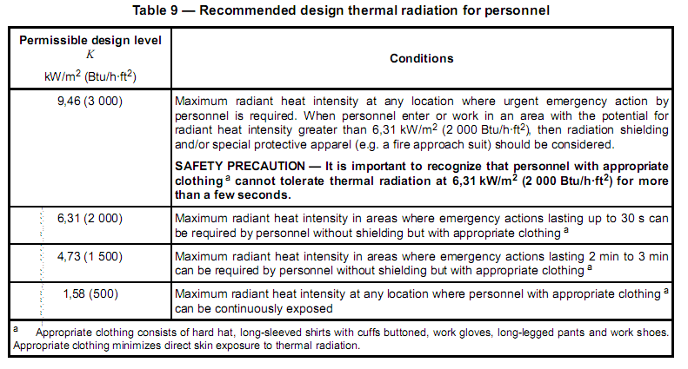

## falre radiation scenarios

For radiation from the flare, a scenario has been considered:

1. Fire case at compressor station by Fire Case area 1(PSV-2111/2112, PSV-2113/2114,PSV-2131A ,PSV-2121A,PSV-2271 are in fire)

The maximum load from this scenario is included in Table 1 applied in flare radiation study. Radiation study the arrangement and stack height calculated, reported based on worst scenario:

**Table 1: Flaring scenario**

|  |  |
| --- | --- |
| **Scenarios** | **Fire Case area 1**  **(PSV-2111/2112, PSV-2113/2114,PSV-2131A ,PSV-2121A,PSV-2271)** |
| Vapour Fraction | 1.00 |
| Temperature [C] | 272 |
| Molecular Weight | 48.1 |
| Pressure [Barg] | 0.4 |
| Molar Flow [MMSCFD] | 16.6 |
| Mass Flow [kg/h] | 39824 |
| Cp/Cv | 1.074 |
| Z Factor | 0.9954 |
| Viscosity [cP] | 0.011 |
| **Master Comp Mole Frac** |  |
| Mole Frac (H2O) | 0.525812 |
| Mole Frac (CO2) | 0.001000 |
| Mole Frac (H2S) | 0.015006 |
| Mole Frac (Methane) | 0.006002 |
| Mole Frac (Ethane) | 0.015006 |
| Mole Frac (Propane) | 0.039016 |
| Mole Frac (i-Butane) | 0.011004 |
| Mole Frac (n-Butane) | 0.033013 |
| Mole Frac (i-Pentane) | 0.042017 |
| Mole Frac (n-Pentane) | 0.027011 |
| Mole Frac (n-Hexane) | 0.136054 |
| Mole Frac (n-Heptane) | 0.074030 |
| Mole Frac (n-Octane) | 0.041016 |
| Mole Frac (n-Nonane) | 0.026010 |
| Mole Frac (n-Decane) | 0.006002 |
| Mole Frac (n-Undecane) | 0.002001 |
| Mole Frac (Nitrogen) | 0.00000 |

## Assumptions

1. Maximum 0.5 Mach for sizing of riser diameters is considered. (Sub Sonic type)
2. Maximum radiation level is 1.58 kw/m2 at fence of BINAK NEW Gas Compressor Station.
3. Maximum radiation level is 4.73 kw/m2 outside of sterile area of flare at maximum relieving rate mentioned in Table 1.
4. High efficiency Method has been considered for fraction of combustion heat radiated from a flame.For clean burning, smokeless flares from well-designed flare tips in good condition the High Efficiency method can be used. So based on this assumption, F factor will be calculated by software which in this project is ( F ~ 0.17)
5. The Flaresim API method is used to model the flame length in these simulations.



**Figure 1: Stack distance**

## Environmental data

**Table 2: Environmental Data**

|  |  |  |  |  |  |  |
| --- | --- | --- | --- | --- | --- | --- |
| **Atmosphere** | | | | | | |
| Pressure | 0.99 bar | Temperature | 50 C | Humidity | | 4% |
| Wind Speed | Flare thermal radiation = 10 m/s | Wind Direction | NW to SE |  |  |  |
| **Background** | |  |  |  |  |  |
| Background Noise | 60.0 dB | Solar Radiation | 1.010 kW/m2 |  |  |  |
| Inc. Background Noise | Active | Inc. Solar Radiation | Active |  |  |  |

## results

Each study on radiation from the flare resulted into the minimum required flare stack height.

**Table 3: Flare Stack Design Results**

|  |  |  |
| --- | --- | --- |
| Description | Stack height (m) | Riser diameter (in) |
| **FLARE (Smokeless operation)** | 22.5 | 12 |

Worst case condition for sizing based on table 1 is of the flare and the results for worst scenario (Fire case Area 1) are presented in the following:

## Flare radiation study base on wind velocity 10m/s

**Table 4: Flare tip calculation result**

|  |  |  |  |  |  |  |  |
| --- | --- | --- | --- | --- | --- | --- | --- |
| **TIP RESULTS** | | | | | | | |
| Flame Length | 41.47 m | | Heat Release | | 396698 KW |  |  |
| API Flame Length | 42.31 m | | F (factor) Heat Radiated | | 0.1721 |  |  |
| Exit Temperature | 272 C | | Actual Volume Flow | | 37919 m3/h |  |  |
| Wind Speed At Tip | 10 m/s | |  | |  |  |  |
| **ASSIST FLUID** | | | | | | | |
| Fluid | Air | | Mass Flow | | 9444 kg/h | Flow Ratio | 0.2371 |
| **VELOCITIES and PRESSURE DROP** | | | | | | | |
| Exit Velocity | 144.4 m/s | | Tip Outlet pres. | | 0.99 bar | Total Tip Outlet pres. | 1.100 bar |
| Exit Mach Number | 0.4265 | | Tip Inlet pres. | | 1.004 bar | Total Tip Inlet pres. | 1.112 bar |
| Contraction Coeff. | 1 | | Seal Inlet pres. | | 1.022 bar | Total Seal Inlet pres. | 1.128 bar |
|  |  | | Stack Inlet pres. | | 1.109bar | Total Stack Inlet pres. | 1.206 bar |
|  |  | | Tip Pressure Drop | | 0.01445 bar | Tip Total Pressure Drop | 0.01290 bar |
|  |  | | Seal Pressure Drop | | 0.01776 bar | Seal Total Pressure Drop | 0.01584bar |
|  | |  | Stack Pressure Drop | 0.08641bar | Stack Total Pressure Drop | | 0.07814 bar |

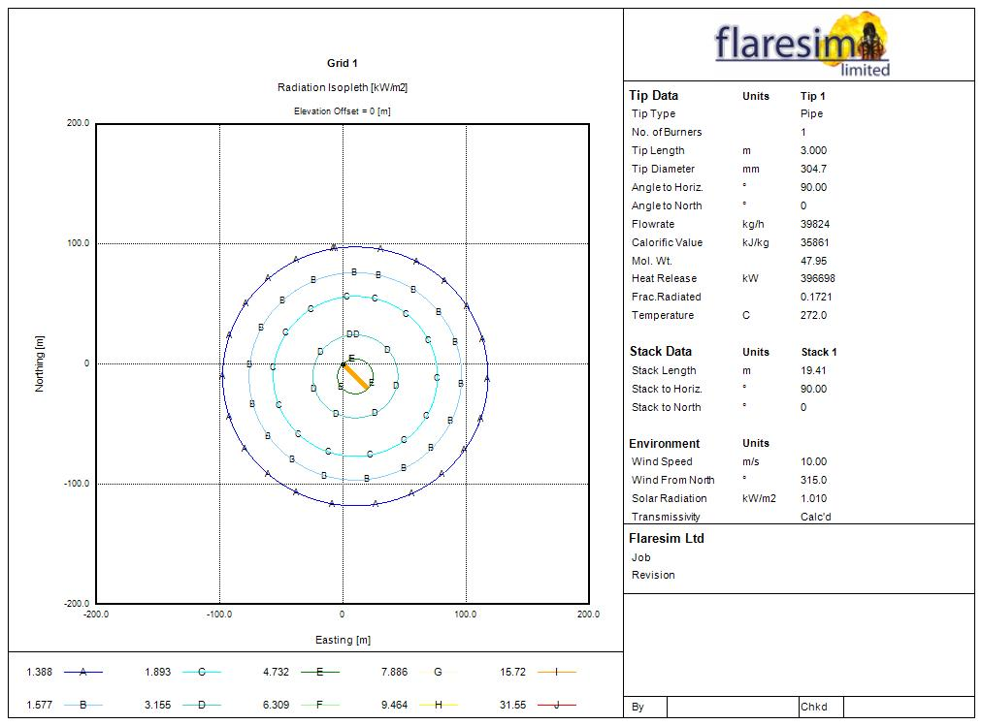

**Figure 2: Radiation Results**

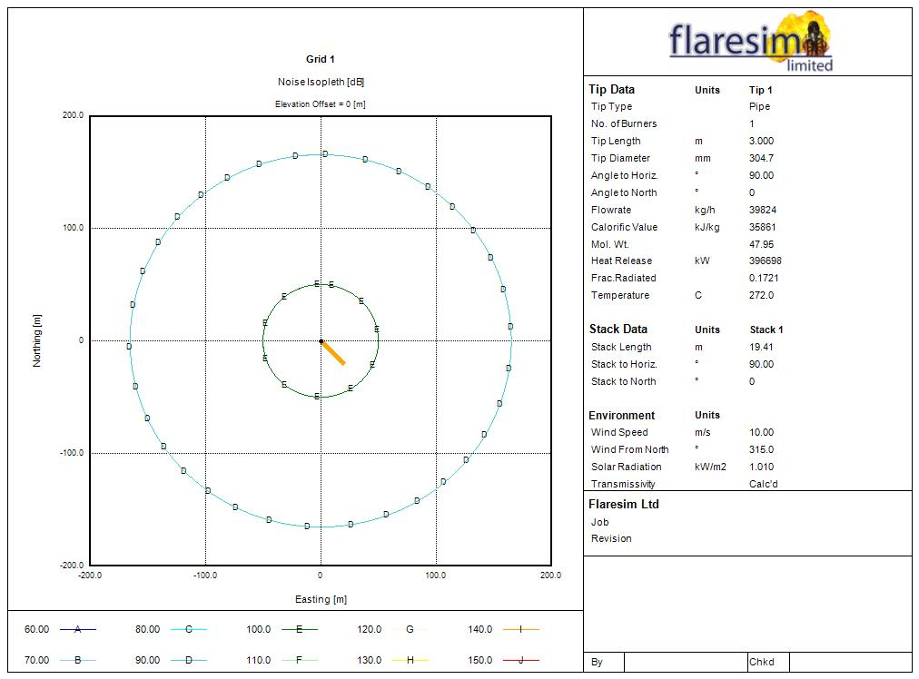

**Figure 3: Noise Results**

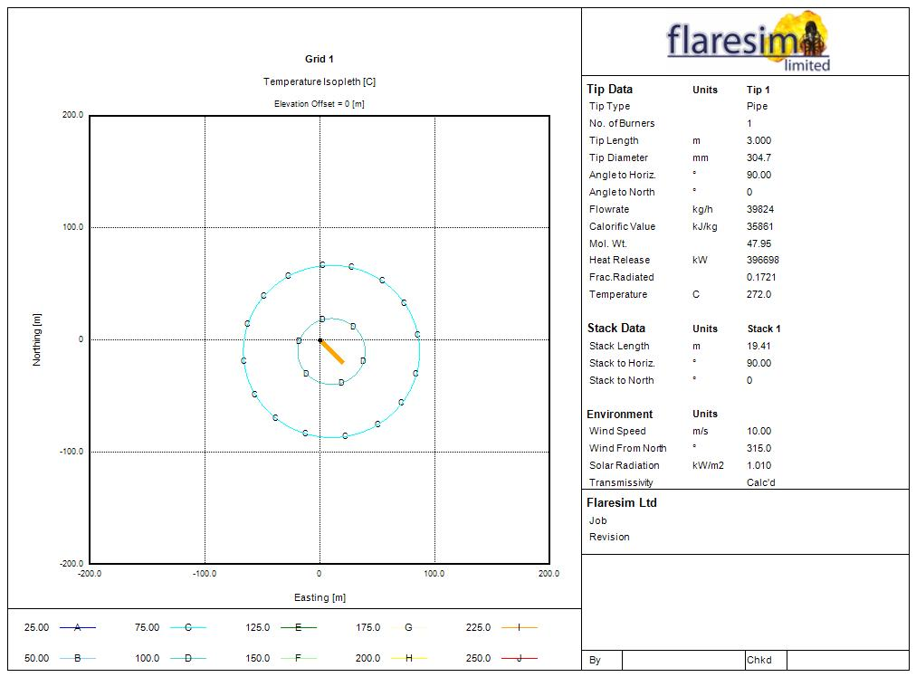

**Figure 4: Temperature Results**

**Table 5: Flare Results max Radiation/Noise/Temperature**

|  |  |  |  |  |  |  |  |  |
| --- | --- | --- | --- | --- | --- | --- | --- | --- |
| **Maximum Radiation (near stack)** | | | | | | | | |
| Sizing Limit | ----- | | Find Max. Rad. | TRUE |  | Initial Grid Points | - |  |
| Radiation | **4.729 kW/m2** |  | Northing | 0 m |  | Easting | 0.0 m |  |
| Noise | **107.9** |  |  |  |
| Temperature | **115.9** |  |  |  |
| **Maximum Radiation (stack fence area)** | | | | | | | | |
| Sizing Limit | ----- |  | Find Max. Rad. | TRUE |  | Initial Grid Points | - |  |
| Radiation | **2.782kW/m2** |  | Northing | 0 m |  | Easting | 50.0 m |  |
| Noise | **100** |  |  |  |
| Temperature | **90.03** |  |  |  |
| **Radiation near unit** | | | | | | | | |
| Sizing Limit | ----- |  | Find Max. Rad. | TRUE |  | Initial Grid Points | - |  |
| Radiation | **1.151 kW/m2** |  | Northing | 0 m |  | Easting | 190.0 m |  |
| Noise | **88.75** |  |  |  |
| Temperature | **67.01** |  |  |  |

1. **Process consequence modeling**

## basic of the calculation

## applied documents and used software

The calculations for the consequences analysis are made according to the Total Exploration Production document TOTAL-GS-SF-253 General Specification Safety of Impacted Area, Restricted Area and Fire Zones. The software used for the consequence analysis has been PHAST 8 (DNV).

## process data

The data used is the design data available at detail stage of the project, such as noted in PFD’s, Process Heat and Material Balances, P&ID and in some cases equipment data sheets. For each case, the most conservative process data are taken into consideration to perform the simulation.

Based on Total GS-EP-SAF-253; the table below gives the definition of the main typical scenarios outcomes applicable to Vents and Flare Operation.

**Table 6: typical scenarios and chance of occurrence**

|  |  |  |
| --- | --- | --- |
| **Scenario outcome** | **Definition** | **Specific conditions** |
| Flare normal operation | Maximum Continuous Flaring (MCF): flaring the largest allowable  steady flow of combustible gas in normal operating conditions  (Client).  Emergency Flaring (EF): flaring a peak flow of combustible gas in upset or emergency operating conditions (Client). | It will be studied. |
| Flare flame out: flammable and/or  toxic | Unignited flare gas release. | It will be studied. |
| Cold vents | Vent handling significant flow rates generally from pressurized equipment. The word “cold” meaning without flame (Client). | Cold vent is not in scope of this project, so this scenario will not be studied. |
| Degassing vents | Vent handling low flow rates, generally from atmospheric equipment. A degassing vent is a non-ignited vent to atmosphere. (Client). | There is no such a case in this project, so this scenario will not be studied. |

## SENSITIVITY OF EFFECTIVE PROCESS PARAMETER ON OUTCOMES

Sensitivity of each process parameters on outcomes has been illustrated in this section:

## Pressure

Pressure has MAJOR effect on Fire & Dispersion scenarios. Increase in pressure leads to more momentum of discharging material from hole and consequently bigger jet fire, and dispersion effect (toxic or flammable).

## Temperature

Temperature has MINOR effect on Fire & Dispersion scenarios. The prediction of behavior of discharging material by changing temperature is not easy, but generally cold material has bigger dispersion effect. This effect could be different depending on material composition, pressure and etc.

## Inventory

Inventory has NO effect in Fire Zone study and Minor effect on Restricted and Impacted area study.

As TOTAL-GS-SF-253 mentioned, for “Flammability” and “Thermal radiation” calculation, release flow rate shall be “Initial release rate for 10 minutes” and therefore the inventory has NO effect at all.

In Restricted and Impacted scenarios, where the “release flow rate of leak” is less than “flow rate of inlet line to vessel”, inventory has NO effect at all. In comparison, for scenarios that leak flow rates are less than “flow rate of inlet line to vessel”, inventory has Minor effect on “discharging material flow rate”, unless the inventory is very low.

## Release direction

In most gas releases, Horizontal impingement causes bigger dispersion effect in comparison to Horizontal. For volatile liquid cases, normally Horizontal release leads more dispersion effect than of Horizontal Impingement. Furthermore, Horizontal impingement scenario reduces the effect of Jet Fire significantly almost in all scenarios.

1. flare radiation and dispersion

## Flare description

The function of the Flare System Unit is to collect and burn all gases that are vented from the other units of the plant due to both continuous and emergency operations. It must also cater for the possibility of depressurization of equipment during emergencies.

In this report, In this report, two main scenarios have been studied which summarized in below table:

Table 7 - Flare studied scenarios

|  |  |
| --- | --- |
|  | Flare |
|  | **Fire Case area 1**  **(PSV-2111/2112, PSV-2113/2114,PSV-2131A ,PSV-2121A,PSV-2271)** |
| Diameter (in) | 12 |
| Default Height (m) | 22.5 |
| Temperature (C) | 272 |
| Flow rate (kg/hr) | 39824 |
| Mol. Wt. | 48.1 |
| Mole Frac (H2O) | 0.525812 |
| Mole Frac (CO2) | 0.001000 |
| Mole Frac (H2S) | 0.015006 |
| Mole Frac (Methane) | 0.006002 |
| Mole Frac (Ethane) | 0.015006 |
| Mole Frac (Propane) | 0.039016 |
| Mole Frac (i-Butane) | 0.011004 |
| Mole Frac (n-Butane) | 0.033013 |
| Mole Frac (i-Pentane) | 0.042017 |
| Mole Frac (n-Pentane) | 0.027011 |
| Mole Frac (n-Hexane) | 0.136054 |
| Mole Frac (n-Heptane) | 0.074030 |
| Mole Frac (n-Octane) | 0.041016 |
| Mole Frac (n-Nonane) | 0.026010 |
| Mole Frac (n-Decane) | 0.006002 |
| Mole Frac (n-Undecane) | 0.002001 |

## Restricted Area (sterile zone) result for flare

According to the results of flare radiation and dispersion modeling which have been reported as below tables, current available /sterile zones for flare are 50m and 55m respectively.

* **Restricted Area:**

### flammable GAS DISPERSION (FLAMe out GAS/SPRAY CLOUD):

* Release height 22.5 m
  + Sizing criteria: 100% LFL

### toxic GAS DISPERSION (FLAMe out GAS/SPRAY CLOUD):

* Release height 22.5 m

D05

* + Sizing criteria: 472 ppm (LC1%) H2S for emergency flaring

### toxic GAS DISPERSION (combustion product GAS/SPRAY CLOUD):

* Release height 22.5 m
  + Sizing criteria: 5 ppm (TLV STEL) SO2 for emergency flaring

### heat radiation effected zone

* Release height 22.5 m
* Sizing criteria: 4.7 Kw/m2
* **IMPACTED Area:**

### toxic GAS DISPERSION (FLAMe out GAS/SPRAY CLOUD):

* Release height 22.5 m
  + Sizing criteria: 100ppm (IDLH) H2S for emergency flaring

D05

### toxic GAS DISPERSION (combustion product GAS/SPRAY CLOUD):

* Release height 22.5 m
  + Sizing criteria: 96 ppm (IDLH) SO2 for emergency flaring

### heat radiation effected zone

* Release height 22.5 m
* Sizing criteria: 2 Kw/m2

Table 8 - Gas Dispersion Results Based on 22.5 meter Heights- Emergency Flaring

D05

**Fire Case area 1**

**(PSV-2111/2112, PSV-2113/2114, PSV-2131A, PSV-2121A, PSV-2271)**

|  |  |  |  |  |
| --- | --- | --- | --- | --- |
| **Scenario** | **Weather Condition** | **LFL gas cloud maximum distance and minimum height (m) from source and ground level** | **H2S TOXIC gas cloud maximum distance and minimum height (m) from source and ground level** | **SO2 TOXIC gas cloud maximum distance @ ground level** |
| Flare FST-2201; RESTRICTED AREA | Summer 2/F | 3.4/20 | 21.9/20 | Not Reached |
| Summer 5.2/D | 4.3/20 | 24.3/20 | Not Reached |
| Summer 7/D | 4.7/20 | 24.8/20 | Not Reached |
| Summer 11.2/D | 5.3/20 | 23.6/20 | Not Reached |
| Winter 2/F | 3.2/20 | 19.6/20 | Not Reached |
| Winter 5.2/D | 4.1/20 | 22.7/20 | Not Reached |
| Winter 7/D | 4.5/20 | 23.5/20 | Not Reached |
| Winter 11.2/D | 5.1/20 | 22.3/20 | Not Reached |
| Flare FST-201; IMPACTED AREA | Summer 2/F | N.A | 127/20 | Not Reached |
| Summer 5.2/D | N.A | 84.8/20 | Not Reached |
| Summer 7/D | N.A | 75.7/20 | Not Reached |
| Summer 11.2/D | N.A | 63.3/20 | Not Reached |
| Winter 2/F | N.A | 116/20 | Not Reached |
| Winter 5.2/D | N.A | 82.8/20 | Not Reached |
| Winter 7/D | N.A | 73.1/20 | Not Reached |
| Winter 11.2/D | N.A | 61/20 | Not Reached |

Table 9 – Heat Radiation Results Based on 22.5 meter Heights- Emergency Flaring

D05

**Fire Case area 1**

**(PSV-2111/2112, PSV-2113/2114, PSV-2131A, PSV-2121A, PSV-2271)**

|  |  |  |  |
| --- | --- | --- | --- |
| **Scenario** | **Weather Condition** | **4.7 Kw/m2 @ ground level** | **2 Kw/m2 @ ground level** |
| Flare FST-2201; RESTRICTED AREA | Summer 2/F | 15 | N.A |
| Summer 5.2/D | 24 | N.A |
| Summer 7/D | 27 | N.A |
| Summer 10/D | 30 | N.A |
| Winter 2/F | 15 | N.A |
| Winter 5.2/D | 24 | N.A |
| Winter 7/D | 27 | N.A |
| Winter 10/D | 30 | N.A |
| Flare FST-201; IMPACTED AREA | Summer 2/F | N.A | 68 |
| Summer 5.2/D | N.A | 73 |
| Summer 7/D | N.A | 75 |
| Summer 10/D | N.A | 77 |
| Winter 2/F | N.A | 68 |
| Winter 5.2/D | N.A | 73 |
| Winter 7/D | N.A | 75 |
| Winter 10/D | N.A | 77 |

As seen in the above tabled, Fuel gas normal flaring will not have radiation impacts on surrounding facilities due to low flow rate of burning gas.

D05

Maximum Calculate Restricted (Fenced) area for emergency flaring will be around 30 meter which is much more lower than fenced area with radius 55 meter around flare stack. So based on the results and with considering of 22.5 m stack height, no areas will be affected by fire radiation of 4.7 kw/m2.

Also impacted area for emergency flaring will be around 77 m .The impacted area is not under the control of Client but agreement shall be formalized with Local Authorities to minimize presence of public (e.g. to limit construction of buildings, in particular permanent settlements, or operation of transportation means open to public).

With considering of flare height of 22.5 m and based on the result of this study, there is no any chance of reaching the 100% LFL flaring gas and toxic material (H2S) in flare flameout condition and also (SO2) flared gas combustion product to the ground level. The selected height of flare system is adequate to dilute venting gas during emergency condition in downwind of wind direction.

D05

## Flare DISPERSION

The objective of this section is to determine the required exclusion zone around the relief area and determine the design requirement to ensure personnel safety during emergency hydrocarbon flare relief. The scope of this study includes:

* Modelling of dispersion of flammable gas from flare for emergency depressurisation (emergency flaring, i.e. flame-out);
* Modelling of dispersion of H2S from flare for emergency depressurisation (emergency flaring , i.e. flame-out);
* Modelling of dispersion of SO2 from flare for emergency depressurisation (emergency flaring , i.e. flared gas combustion product);

D05

|  |  |  |  |
| --- | --- | --- | --- |
| Flare Restricted area affected zone by flammable gas dispersion (m) | Not Reached | Flare Impacted area  affected zone by flammable gas dispersion (m) | Not Reached |
| Flare Restricted area affected zone by toxic gas (H2S) dispersion (m) | Not Reached | Flare Impacted area affected zone by toxic gas (H2S) dispersion (m) | Not Reached |
| Flare Restricted area affected zone by toxic gas (SO2) dispersion (m) | Not Reached | Flare Impacted area affected zone by toxic gas (SO2) dispersion (m) | Not Reached |

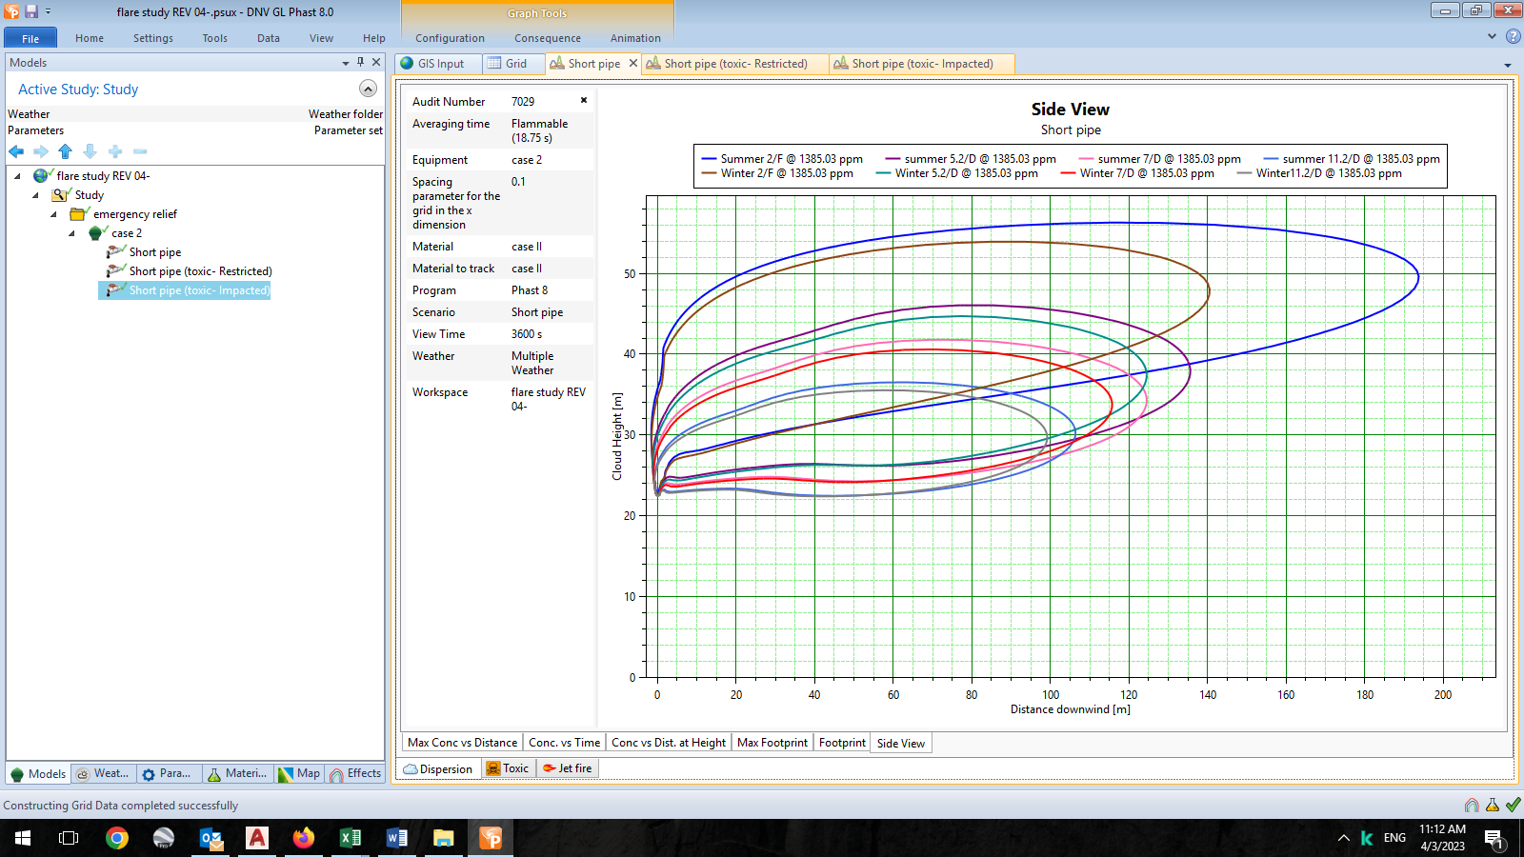

Figure 1 - Flare Affected Area-LFL Distribution for Flame Out Case I (RESTRICTED)

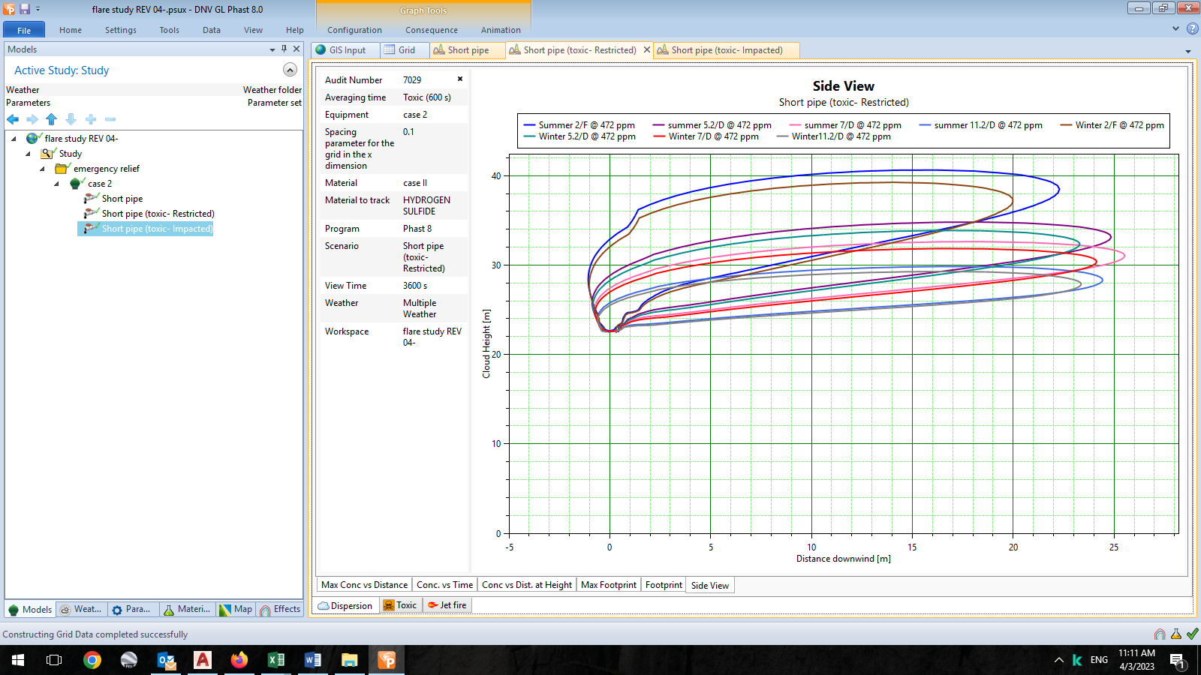

Figure 2 - Flare Affected Area-Toxic Gas Distribution for Flame Out Case I (RESTRICTED)

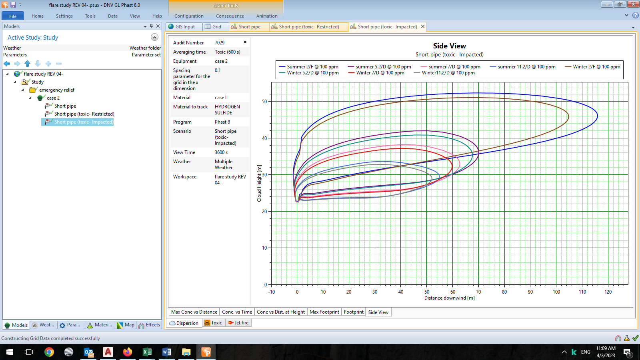

Figure 5 - Flare affected area- Distribution for Flame Out Case I (IMPACTED)

1. CONCLUSION

Based on the results and with considering of 22.5 m stack height, no areas will be affected by fire radiation of 4.7 kw/m2.

With considering of flare height of 22.5 m and based on the result of this study, there is no any chance of reaching the 100% LFL flaring gas to the ground level. The selected height of flare system (22.5 m) is adequate to dilute venting gas during emergency condition in downwind of wind direction.

Modelled flare tip in current design has 200 m distance from the plant while the calculated impacted area is not effected considered distance. So the location of flare is so good and no need to relocate it.