|  |  |  |  |  |  |  |
| --- | --- | --- | --- | --- | --- | --- |
| **طرح نگهداشت و افزایش تولید 27 مخزن** | | | | | | |
| **Calculation Note for Utility Area Sleepers**  **نگهداشت و افزایش تولید میدان نفتی بینک** | | | | | | |
|  |  |  |  |  |  |  |
|  |  |  |  |  |  |  |
|  |  |  |  |  |  |  |
|  |  |  |  |  |  |  |
| D00 | JUL. 2023 | IFC | R.Berlouie | M.Fakharian | A.M.Mohseni |  |
| **Rev.** | **Date** | **Purpose of Issue/Status** | **Prepared by:** | **Checked by:** | **Approved by:** | **CLIENT Approval** |
| **Class:2** | | **CLIENT Doc. Number:F0Z-709139** | | | | |
| **Status:** | **IDC: Inter-Discipline Check**  **IFC: Issued For Comment**  **IFA: Issued For Approval**  **AFD: Approved For Design**  **AFC: Approved For Construction**  **AFP: Approved For Purchase**  **AFQ:** Approved For Quotation  **IFI: Issued For Information**  **AB-R: As-Built for CLIENT Review**  **AB-A: As-Built –Approved** | | | | | |

**REVISION RECORD SHEET**

|  |  |  |  |  |  |  |  |  |  |  |  |  |
| --- | --- | --- | --- | --- | --- | --- | --- | --- | --- | --- | --- | --- |
| **PAGE** | **D00** | **D01** | **D02** | **D03** | **D04** |  | **PAGE** | **D00** | **D01** | **D02** | **D03** | **D04** |
| **1** | X |  |  |  |  | **66** |  |  |  |  |  |
| **2** | X |  |  |  |  | **67** |  |  |  |  |  |
| **3** | X |  |  |  |  | **68** |  |  |  |  |  |
| **4** | X |  |  |  |  | **69** |  |  |  |  |  |
| **5** | X |  |  |  |  | **70** |  |  |  |  |  |
| **6** | X |  |  |  |  | **71** |  |  |  |  |  |
| **7** | X |  |  |  |  | **72** |  |  |  |  |  |
| **8** | X |  |  |  |  | **73** |  |  |  |  |  |
| **9** | X |  |  |  |  | **74** |  |  |  |  |  |
| **10** | X |  |  |  |  | **75** |  |  |  |  |  |
| **11** | X |  |  |  |  | **76** |  |  |  |  |  |
| **12** | X |  |  |  |  | **77** |  |  |  |  |  |
| **13** | X |  |  |  |  | **78** |  |  |  |  |  |
| **14** | X |  |  |  |  | **79** |  |  |  |  |  |
| **15** | X |  |  |  |  | **80** |  |  |  |  |  |
| **16** | X |  |  |  |  | **81** |  |  |  |  |  |
| **17** | X |  |  |  |  | **82** |  |  |  |  |  |
| **18** | X |  |  |  |  | **83** |  |  |  |  |  |
| **19** | X |  |  |  |  | **84** |  |  |  |  |  |
| **20** | X |  |  |  |  | **85** |  |  |  |  |  |
| **21** | X |  |  |  |  | **86** |  |  |  |  |  |
| **22** | X |  |  |  |  | **87** |  |  |  |  |  |
| **23** | X |  |  |  |  | **88** |  |  |  |  |  |
| **24** | X |  |  |  |  | **89** |  |  |  |  |  |
| **25** | X |  |  |  |  | **90** |  |  |  |  |  |
| **26** | X |  |  |  |  | **91** |  |  |  |  |  |
| **27** | X |  |  |  |  | **92** |  |  |  |  |  |
| **28** | X |  |  |  |  | **93** |  |  |  |  |  |
| **29** | X |  |  |  |  | **94** |  |  |  |  |  |
| **30** | X |  |  |  |  | **95** |  |  |  |  |  |
| **31** | X |  |  |  |  | **96** |  |  |  |  |  |
| **32** | X |  |  |  |  | **97** |  |  |  |  |  |
| **33** | X |  |  |  |  | **98** |  |  |  |  |  |
| **34** | X |  |  |  |  | **99** |  |  |  |  |  |
| **35** | X |  |  |  |  | **100** |  |  |  |  |  |
| **36** | X |  |  |  |  | **101** |  |  |  |  |  |
| **37** | X |  |  |  |  | **102** |  |  |  |  |  |
| **38** |  |  |  |  |  | **103** |  |  |  |  |  |
| **39** |  |  |  |  |  | **104** |  |  |  |  |  |
| **40** |  |  |  |  |  | **105** |  |  |  |  |  |
| **41** |  |  |  |  |  | **106** |  |  |  |  |  |
| **42** |  |  |  |  |  | **107** |  |  |  |  |  |
| **43** |  |  |  |  |  | **108** |  |  |  |  |  |
| **44** |  |  |  |  |  | **109** |  |  |  |  |  |
| **45** |  |  |  |  |  | **110** |  |  |  |  |  |
| **46** |  |  |  |  |  | **111** |  |  |  |  |  |
| **47** |  |  |  |  |  | **112** |  |  |  |  |  |
| **48** |  |  |  |  |  | **113** |  |  |  |  |  |
| **49** |  |  |  |  |  | **114** |  |  |  |  |  |
| **50** |  |  |  |  |  | **115** |  |  |  |  |  |
| **51** |  |  |  |  |  | **116** |  |  |  |  |  |
| **52** |  |  |  |  |  | **117** |  |  |  |  |  |
| **53** |  |  |  |  |  | **118** |  |  |  |  |  |
| **54** |  |  |  |  |  | **119** |  |  |  |  |  |
| **55** |  |  |  |  |  | **120** |  |  |  |  |  |
| **56** |  |  |  |  |  | **121** |  |  |  |  |  |
| **57** |  |  |  |  |  | **122** |  |  |  |  |  |
| **58** |  |  |  |  |  | **123** |  |  |  |  |  |
| **59** |  |  |  |  |  | **124** |  |  |  |  |  |
| **60** |  |  |  |  |  | **125** |  |  |  |  |  |
| **61** |  |  |  |  |  | **126** |  |  |  |  |  |
| **62** |  |  |  |  |  | **127** |  |  |  |  |  |
| **63** |  |  |  |  |  | **128** |  |  |  |  |  |
| **64** |  |  |  |  |  | **129** |  |  |  |  |  |
| **65** |  |  |  |  |  | **130** |  |  |  |  |  |

**CONTENTS**

1.0 INTRODUCTION 4

2.0 Scope 5

3.0 NORMATIVE REFERENCES 5

3.1. Local Codes and Standards 5

3.2. International Codes and Standards 5

3.3. The Project Documents 5

3.4. ENVIRONMENTAL DATA 5

3.5. Order of Precedence 5

4.0 MATERIALS 6

5.0 DESIGN INFORMATION 7

5.1 LOCATION OF SLEEPERS 7

6.0 PIPING weigh 8

7.0 SOIL PARAMETERS 9

8.0 LOADING 10

8.1. Dead Load 10

8.2. Live Load 10

8.3. Seismic Load 10

8.4. Wind Load 10

9.0 LOAD COMBINITION FOR DESIGN 10

10.0 FOUNDATION ANALYsis 14

1. **INTRODUCTION**

Binak oilfield in Bushehr province is a part of the southern oilfields of Iran, is located 20 km northwest of Genaveh city.

With the aim of increasing production of oil from Binak oilfield, an EPC/EPD Project has been defined by NIOC/NISOC and awarded to Petro Iran Development Company (PEDCO). Also PEDCO (as General Contractor) has assigned the EPC-packages of the Project to "Hirgan Energy - Design and Inspection" JV.

As a part of the Project, a New Gas Compressor Station (adjacent to existing Binak GCS) shall be constructed to gather of 15 MMSCFD (approx.) associated gases and compress & transfer them to Siahmakan GIS.

**GENERAL DEFINITION**

The following terms shall be used in this document.

|  |  |
| --- | --- |
| CLIENT: | National Iranian South Oilfields Company (NISOC) |
| PROJECT: | Binak Oilfield Development – Surface Fcilities; New Gas Compressor Station |
| EPD/EPC CONTRACTOR (GC): | Petro Iran Development Company (PEDCO) |
| EPC CONTRACTOR: | Joint Venture of : Hirgan Energy – Design & Inspection (D&I) Companies |
| VENDOR: | The firm or person who will fabricate the equipment or material. |
| EXECUTOR: | Executor is the party which carries out all or part of construction and/or commissioning for the project. |
| THIRD PARTY INSPECTOR (TPI): | The firm appointed by EPD/EPC CONTRACTOR (GC) and approved by CLIENT (in writing) for the inspection of goods. |
| SHALL: | Is used where a provision is mandatory. |
| SHOULD: | Is used where a provision is advisory only. |
| WILL: | Is normally used in connection with the action by CLIENT rather than by an EPC/EPD CONTRACTOR, supplier or VENDOR. |
| MAY: | Is used where a provision is completely discretionary. |

1. **Scope**

This report covers the Sleeper Pipe Supports foundation Design . The structure modeled by “SAP” software.

1. **NORMATIVE REFERENCES**

## Local Codes and Standards

* INBC Part 9 Iranian National Building Code, Part 9 (4th Edition)
* Iranian Standard No.2800 Iranian Code of Practice for Seismic Resistant Design of Buildings (4th Edition)

## International Codes and Standards

* ACI 315 Manual of Standard Practice for Detailing Reinforced Concrete
* ACI 318-14 Building Code Requirements for Reinforced Concrete
* ASCE7-10 Minimum Design Loads and Associated Criteria for Buildings and Other Structures-American Society of Civil Engineers
* ISDC-038 Iranian Seismic Design Code for Petroleum Facilities(3rd edition)

## The Project Documents

* BK-GCS-PEDCO-120-GT-RT-0001 Geotechnical Investigation Report for Compressor Station
* BK-GNRAL-PEDCO-000-ST-DC-0001 Structural Design Criteria

## ENVIRONMENTAL DATA

Refer to "Process Basis of Design; Doc. No. BK-GNRAL-PEDCO-000-PR-DB-0001".

## Order of Precedence

In case of any conflict between the contents of this document or any discrepancy between this document and other project documents or reference standards, this issue must be reported to the CLIENT. The final decision in this situation will be made by CLIENT.

1. **MATERIALS**

Material properties are delivered in the following table.

**Table1-Material Properties**

|  |  |
| --- | --- |
| Foundation Concrete | F'c = 300 kg/cm2 (28- day cylindrical sample) |
| Long. Reinforcement bar | Fy = 4000 kg/cm2 (AIII) |
| Trans. Reinforcement bar | Fy = 4000 kg/cm2 (AIII) |

1. **DESIGN INFORMATION**

**5.1 LOCATION OF SLEEPERS**

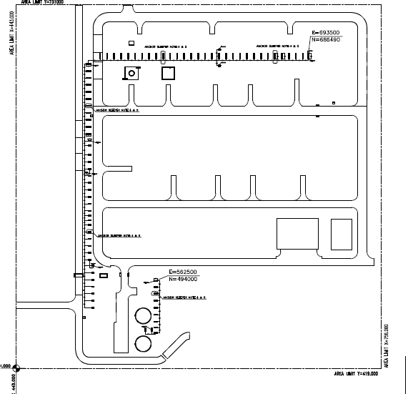

1. Location of Utility sleepers According to Piping SLD

Sleepers foundation plan (Type A & B ) and section with embedded plate shows as follow:

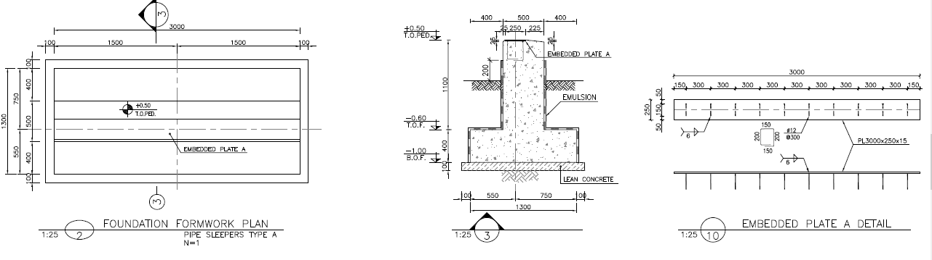

1. Sleeper Type A

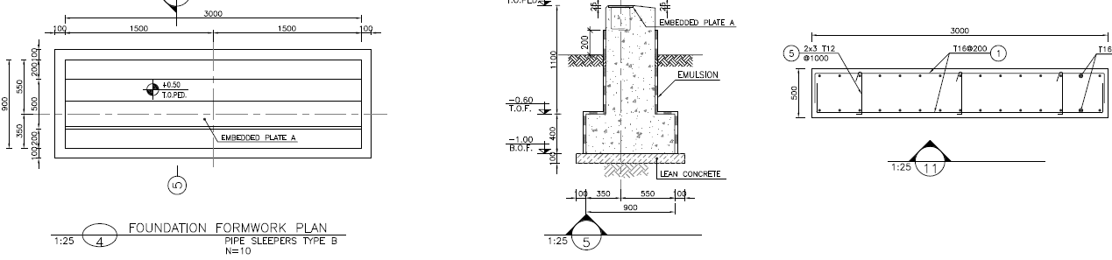

1. Sleeper Type B
2. **PIPING weigh**

Data Received from Piping is as single lines and loading table for each point as bellow:

According to piping data In utility area for all sleepers gravity force is about 12 KN/m.

*Note:

Sleeper type B: Lateral & axial Friction loads for uniform loads=0.3*vertical load

Sleeper type B: Lateral & axial seismic load for uniform loads = 0.4* vertical load

Sleeper type A: Lateral seismic& friction loads for anchor sleepers =0.4*Vertical Load

Sleeper type A: Axial seismic & friction loads for anchor sleepers = 0.8* vertical load

1. **SOIL PARAMETERS**

According to Soil Investigation Report, prepared by BKP:

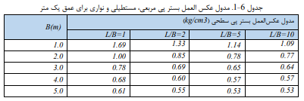

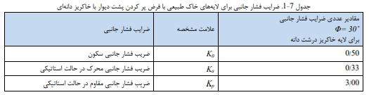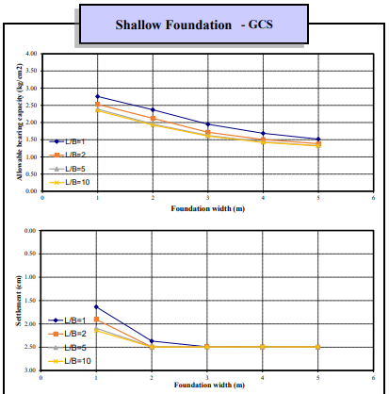

1. Geotechnical Parameters
2. **LOADING**

## Dead Load

Dead load of pipes according to piping documents assign in model.

## Live Load

Live load (operation) of Equipment according to piping documents assign in model.

## Seismic Load

Seismic load (occasional) of Equipment according to piping documents assign in model.

## Wind Load

Wind load is not applicable for pipe support foundation.

1. **LOAD COMBINITION FOR DESIGN**

According to ASCE07-10 structures, components, and foundations shall be designed, so that their design strength equals or exceeds that effect of factored loads in the following combination

$E_{v}=αS_{Ds}*D$

$$Ev=0.2*0.75*Sus=0.15*D$$

**

Vertical seismic load applied at combinations with load combination with coefficient of 0.15*dead load.In combinations with earthquake load .

|  |  |  |  |  |  |
| --- | --- | --- | --- | --- | --- |
| **Load Pattern** | | | | | |
| **Case** | **LoadType** | **LoadName** | | **LoadSF** | |
|  |  |  | |  | |
| SUS | Load pattern | SUS | | 1 | |
| OPE | Load pattern | OPE | | 1 | |
| OCCX | Load pattern | OCCX | | 1 | |
| OCCY | Load pattern | OCCY | | 1 | |
| HYD | Load pattern | HYD | | 1 | |
| FRx | Load pattern | FRx | | 1 | |
| Ev | Load pattern | Ev | | 1 | |
| FRy | Load pattern | FRy | | 1 | |
| H | Load pattern | H | | 1 | |
|  |  |  | |  | |
|  |  |  | |  | |
| **Load Combination** | | | | | | | | |
| **ComboName** | | | **ComboType** | | **AutoDesign** | | **CaseName** | **ScaleFactor** |
|  | | |  | |  | |  |  |
| 1.35D+L+EX+FR+1.6H | | | Linear Add | | No | | SUS | 1.35 |
| 1.35D+L+EX+FR+1.6H | | |  | |  | | OCCX | 1 |
| 1.35D+L+EX+FR+1.6H | | |  | |  | | OPE | 1 |
| 1.35D+L+EX+FR+1.6H | | |  | |  | | FRx | 1 |
| 1.35D+L+EX+FR+1.6H | | |  | |  | | FRy | 1 |
| 1.35D+L+EX+FR+1.6H | | |  | |  | | H | 1.6 |
| 1.35D+L-EX+FR+1.6H | | | Linear Add | | No | | SUS | 1.35 |
| 1.35D+L-EX+FR+1.6H | | |  | |  | | OCCX | -1 |
| 1.35D+L-EX+FR+1.6H | | |  | |  | | OPE | 1 |
| 1.35D+L-EX+FR+1.6H | | |  | |  | | FRx | 1 |
| 1.35D+L-EX+FR+1.6H | | |  | |  | | FRy | 1 |
| 1.35D+L-EX+FR+1.6H | | |  | |  | | H | 1.6 |
| 1.35D+L+EY+FR+1.6H | | | Linear Add | | No | | SUS | 1.35 |
| 1.35D+L+EY+FR+1.6H | | |  | |  | | OCCY | 1 |
| 1.35D+L+EY+FR+1.6H | | |  | |  | | FRx | 1 |
| 1.35D+L+EY+FR+1.6H | | |  | |  | | OPE | 1 |
| 1.35D+L+EY+FR+1.6H | | |  | |  | | FRy | 1 |
| 1.35D+L+EY+FR+1.6H | | |  | |  | | H | 1.6 |
| 1.35D+L-EY+FR+1.6H | | | Linear Add | | No | | SUS | 1.2 |
| 1.35D+L-EY+FR+1.6H | | |  | |  | | OCCY | -1 |
| 1.35D+L-EY+FR+1.6H | | |  | |  | | FRx | 1 |
| 1.35D+L-EY+FR+1.6H | | |  | |  | | OPE | 1 |
| 1.35D+L-EY+FR+1.6H | | |  | |  | | FRy | 1 |
| 1.35D+L-EY+FR+1.6H | | |  | |  | | H | 1.6 |
| 0.9D+Ex+1.6H | | | Linear Add | | No | | SUS | 0.9 |
| 0.9D+Ex+1.6H | | |  | |  | | OCCX | 1 |
| 0.9D+Ex+1.6H | | |  | |  | | H | 1.6 |
| 0.9D-Ex+1.6H | | | Linear Add | | No | | SUS | 0.9 |
| 0.9D-Ex+1.6H | | |  | |  | | OCCX | -1 |
| 0.9D-Ex+1.6H | | |  | |  | | H | 1.6 |
| 0.9D-Ey+1.6H | | | Linear Add | | No | | SUS | 0.9 |
| 0.9D-Ey+1.6H | | |  | |  | | OCCY | -1 |
| 0.9D-Ey+1.6H | | |  | |  | | H | 1.6 |
| 0.9D+Ey+1.6H | | | Linear Add | | No | | SUS | 0.9 |
| 0.9D+Ey+1.6H | | |  | |  | | OCCY | 1 |
| 0.9D+Ey+1.6H | | |  | |  | | H | 1.6 |
| 1.2D+1.6L+1.6FR+1.6H | | | Linear Add | | No | | SUS | 1.2 |
| 1.2D+1.6L+1.6FR+1.6H | | |  | |  | | OPE | 1.6 |
| 1.2D+1.6L+1.6FR+1.6H | | |  | |  | | FRx | 1.6 |
| 1.2D+1.6L+1.6FR+1.6H | | |  | |  | | FRy | 1.2 |
| 1.2D+1.6L+1.6FR+1.6H | | |  | |  | | H | 1.6 |
| D+L+FR | | | Linear Add | | No | | SUS | 1 |
| D+L+FR | | |  | |  | | FRx | 1 |
| D+L+FR | | |  | |  | | OPE | 1 |
| HYD+FR | | | Linear Add | | No | | HYD | 1 |
| HYD+FR | | |  | |  | | FRx | 1 |
| 1.4D | | | Linear Add | | No | | SUS | 1.4 |
| 0.75D-Ex | | | Linear Add | | No | | SUS | 0.75 |
| 0.75D-Ex | | |  | |  | | OCCX | -1 |
| 0.75D-Ey | | | Linear Add | | No | | SUS | 0.75 |
| 0.75D-Ey | | |  | |  | | OCCY | -1 |
| 0.75D+Ey | | | Linear Add | | No | | SUS | 0.75 |
| 0.75D+Ey | | |  | |  | | OCCY | 1 |
| 0.75D+Ex | | | Linear Add | | No | | SUS | 0.75 |
| 0.75D+Ex | | |  | |  | | OCCX | 1 |
| Envelope Strength | | | Envelope | | No | | 1.4D | 1 |
| Envelope Strength | | |  | |  | | 1.35D+L+EY+FR+1.6H | 1 |
| Envelope Strength | | |  | |  | | 1.35D+L+EX+FR+1.6H | 1 |
| Envelope Strength | | |  | |  | | 1.35D+L-EY+FR+1.6H | 1 |
| Envelope Strength | | |  | |  | | 1.35D+L-EX+FR+1.6H | 1 |
| Envelope Strength | | |  | |  | | 1.2D+1.6L+1.6FR+1.6H | 1 |
| Envelope Strength | | |  | |  | | 0.9D+Ey+1.6H | 1 |
| Envelope Strength | | |  | |  | | 0.9D+Ex+1.6H | 1 |
| Envelope Strength | | |  | |  | | 0.9D-Ey+1.6H | 1 |
| Envelope Strength | | |  | |  | | 0.9D-Ex+1.6H | 1 |
| Envelope Strength | | |  | |  | | 0.75D-Ex | 1 |
| Envelope Strength | | |  | |  | | 0.75D-Ey | 1 |
| Envelope Strength | | |  | |  | | 0.75D+Ey | 1 |
| Envelope Strength | | |  | |  | | 0.75D+Ex | 1 |
| D+L+H | | | Linear Add | | No | | SUS | 1 |
| D+L+H | | |  | |  | | OPE | 1 |
| D+L+H | | |  | |  | | H | 1 |
| D+0.7OCCX+H | | | Linear Add | | No | | SUS | 1 |
| D+0.7OCCX+H | | |  | |  | | OCCX | 0.7 |
| D+0.7OCCX+H | | |  | |  | | H | 1 |
| D-0.7OCCX+H | | | Linear Add | | No | | SUS | 1 |
| D-0.7OCCX+H | | |  | |  | | OCCX | -0.7 |
| D-0.7OCCX+H | | |  | |  | | H | 1 |
| D+0.7OCCY+H | | | Linear Add | | No | | SUS | 1 |
| D+0.7OCCY+H | | |  | |  | | OCCY | 0.7 |
| D+0.7OCCY+H | | |  | |  | | H | 1 |
| D-0.7OCCY+H | | | Linear Add | | No | | SUS | 1 |
| D-0.7OCCY+H | | |  | |  | | OCCY | -0.7 |
| D-0.7OCCY+H | | |  | |  | | H | 1 |
| D+0.75L+0.75OCCX+H | | | Linear Add | | No | | SUS | 1 |
| D+0.75L+0.75OCCX+H | | |  | |  | | OPE | 0.75 |
| D+0.75L+0.75OCCX+H | | |  | |  | | OCCX | 0.75 |
| D+0.75L+0.75OCCX+H | | |  | |  | | H | 1 |
| D-0.75L-0.75OCCX+H | | | Linear Add | | No | | SUS | 1 |
| D-0.75L-0.75OCCX+H | | |  | |  | | OPE | 0.75 |
| D-0.75L-0.75OCCX+H | | |  | |  | | OCCX | -0.75 |
| D-0.75L-0.75OCCX+H | | |  | |  | | H | 1 |
| D+0.75L+0.75OCCY+H | | | Linear Add | | No | | SUS | 1 |
| D+0.75L+0.75OCCY+H | | |  | |  | | OPE | 0.75 |
| D+0.75L+0.75OCCY+H | | |  | |  | | OCCY | 0.75 |
| D+0.75L+0.75OCCY+H | | |  | |  | | H | 1 |
| D-0.75L-0.75OCCY+H | | | Linear Add | | No | | SUS | 1 |
| D-0.75L-0.75OCCY+H | | |  | |  | | OPE | 0.75 |
| D-0.75L-0.75OCCY+H | | |  | |  | | OCCY | -0.75 |
| D-0.75L-0.75OCCY+H | | |  | |  | | H | 1 |
| D+H | | | Linear Add | | No | | H | 1 |
| D+H | | |  | |  | | SUS | 1 |
| Envelope allowable | | | Envelope | | No | | D+L+H | 1 |
| Envelope allowable | | |  | |  | | HYD+FR | 1 |
| Envelope allowable | | |  | |  | | D+L+FR | 1 |
| Envelope allowable | | |  | |  | | D+H | 1 |
| Envelope allowable | | |  | |  | | D+0.7OCCY+H | 1 |
| Envelope allowable | | |  | |  | | D+0.7OCCX+H | 1 |
| Envelope allowable | | |  | |  | | D+0.75L+0.75OCCY+H | 1 |
| Envelope allowable | | |  | |  | | D+0.75L+0.75OCCX+H | 1 |
| Envelope allowable | | |  | |  | | D-0.75L-0.75OCCX+H | 1 |
| Envelope allowable | | |  | |  | | D-0.75L-0.75OCCY+H | 1 |
| Envelope allowable | | |  | |  | | 0.75D+Ey | 1 |
| Envelope allowable | | |  | |  | | 0.75D+Ex | 1 |
| Envelope allowable | | |  | |  | | 0.75D-Ex | 1 |
| Envelope allowable | | |  | |  | | 0.75D-Ey | 1 |

1. **FOUNDATION ANALYsis**

## 10.1.sleeper type A

## piping load data

|  |  |  |  |  |  |
| --- | --- | --- | --- | --- | --- |
| L(m) | Fy(kg/m) | Fx(kg/m) | No. | Fz(kg/m) | Type |
| 3 | 960 | 480 | 1 | 1200 | A |

|  |  |  |  |  |  |
| --- | --- | --- | --- | --- | --- |
| L(m) | Fy(kg/m) | Fx(kg/m) | No. | Fz(kg/m) | Type |
| 3 | 480 | 360 | 10 | 1200 | B |

10.1.1.Operating weight of Pipng

This type of loading is operating weight of pipes that are considered by Piping and illustrated in tables and is equal to OPR for each point.

$$Fz=1200kg/m×3m=3600 kg$$

$$Fz=3600kg÷7(point)=515 kg$$

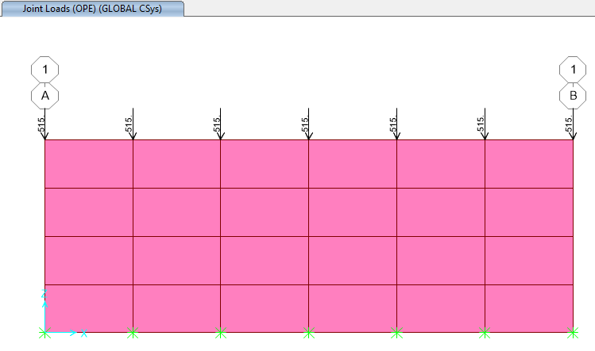

1. OPE Points Loads on sleeper TYPE A &B(515Kg)

10.1.2.PURE SEISMIC WEIGHT OF PIPING (OCCX & OCCY)

This type of loading is pure seismic load of piping that are considered by Piping and illustrated in tables and is equal to PURE SEISMIC for each point in sleeper model. According to piping data for anchor sleepers axial seismic loads is 0.8*vertical load that applied on sleeper as follow :

$$Occx=1200 kg/m×3m×0.8=2880 kg$$

$$Occx(each point)=2880 kg÷7\left(point\right)=412 kg$$

According to piping data for anchor sleepers (type A) lateral seismic load is 0.4*vertical load that applied on sleeper as follow :

$$Occy=Fry=1200 kg/m×3m×0.4=1440 kg$$

$$Occy=Fry(each point)=1440 kg÷7\left(NO. of point\right)=205 kg$$

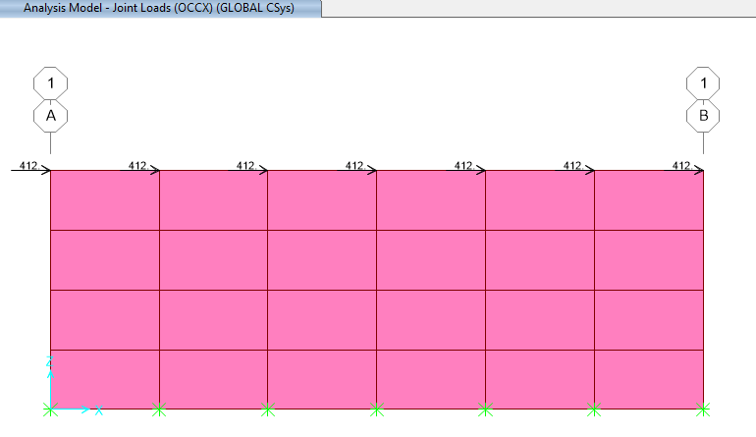

1. OCCX Points Lads on sleeper type A(412 Kg)

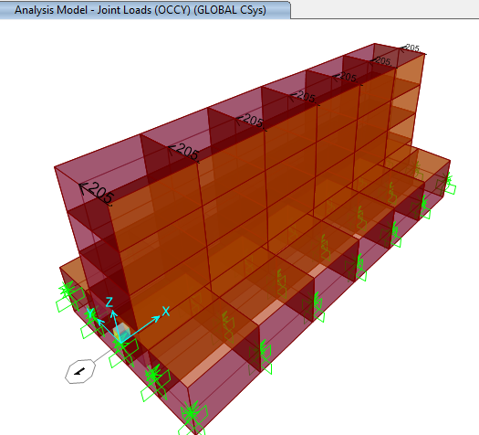

1. OCCY Points Loads on sleeper type A( 205 Kg)

According to piping data for other sleepers (type B) lateral & axial seismic load is 0.4*vertical load that applied on sleeper as follow :

$$Occx\&Occy=Fry=1200 kg/m×3m×0.4=1440 kg$$

$$Occx\&Occy(each point)=1440 kg÷7\left(No. of point\right)=205 kg$$

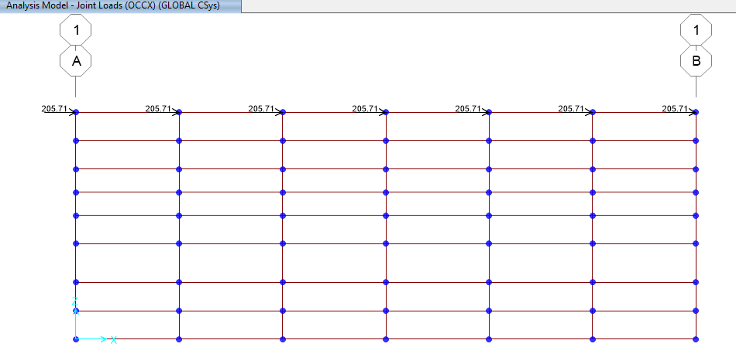

1. OCCX Points Lads on sleeper type B(205 Kg)

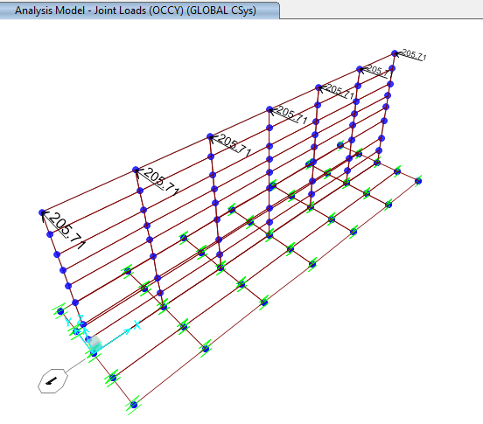

1. OCCY Points Lads on sleeper type B(205 Kg)

10.1.3.Friction Load (FRX & FRY)

Thermal displacement due to Operating condition and the friction between pipes and the sleepers, causes lateral forces are given in the model . According to piping data for anchor sleepers type A axial friction load is 0.8*vertical load that applied on sleeper as follow :

$$FRx=1200 kg/m×3m×0.8=2880 kg$$

$$FRx(each point)=2880 kg÷7\left(point\right)=412 kg$$

According to piping data for anchor sleepers type A lateral friction load 0.4*vertical load that applied on sleeper as follow :

$$FRy=1200 kg/m×3m×0.4=1440 kg$$

$FRy(each point)=1440 kg÷7\left(point\right)=205 kg$

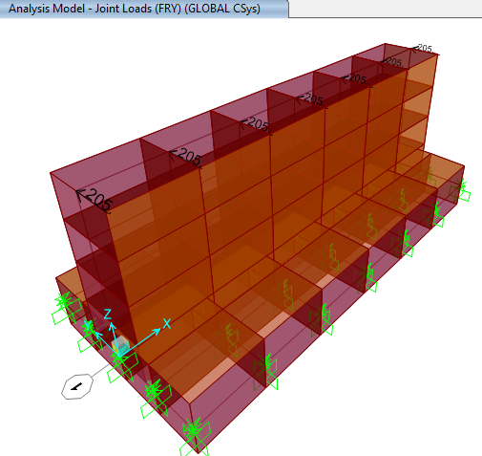

1. FRY Points Loads on sleeper Type A (205 Kg)

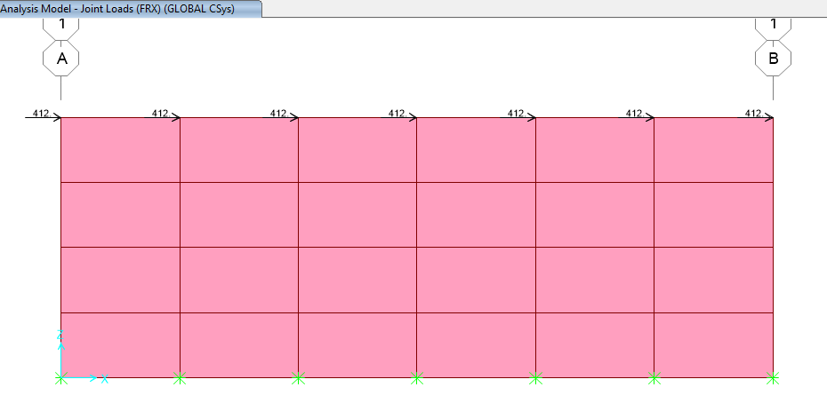

1. FRX Points Loads on sleeper Type A(412 Kg)

According to piping data for other sleepers type B axial and lateral friction load is 0.3*vertical load that applied on sleeper as follow :

$$FRx \& FRy=1200 kg/m×3m×0.3=1080 kg$$

$$FRx \& FRy(each point)=2880 kg÷7\left(point\right)=154.29 kg$$

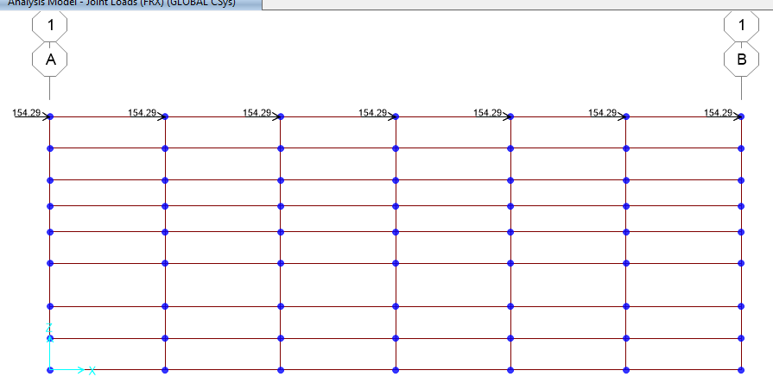

1. FRX Points Loads on sleeper Type B(154.29 Kg)

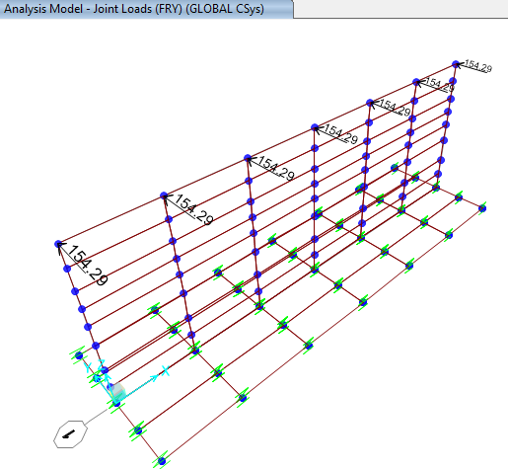

1. FRY Points Loads on sleeper Type B (154.29 Kg)

10.1.4.Vertical seismic load

The vertical seismic load effect, 𝐸𝑣, shall be determined in accordance with the following Equation ASCE7-16 Eq. (12.14-6):

𝐸𝑣 = 0.2 $S_{DS}$ 𝐷 (ASCE7/ Eq. 12.14-6)

$S_{DS}$ = Design, 5% damped, spectral response acceleration parameter (g) at short periods (0.2 sec).

D = effect of dead load

Loads case name: EQZ=0.2*AB*W=0.15*W (where W=DL+OPR1+OPR FUTURE)

A=0.3g, B=2.5

According to Iranian Seismic design code for petroleum facilities(3rd edition) section 4-8-2 $S_{DS}=AB\left(0.2s\right)=0.3×2.5=0.75$

$$E_{v}=0.15 Sds=0.15*515kg=77.25 kg$$

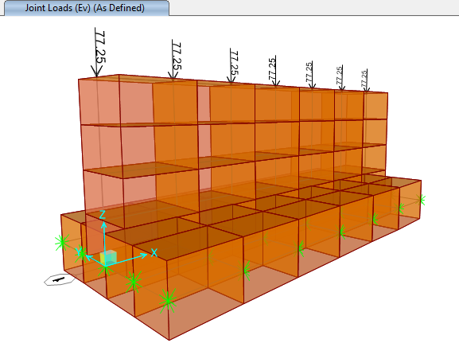

1. Ev Points Loads on sleeper type A =0.15*SUS(Kg)

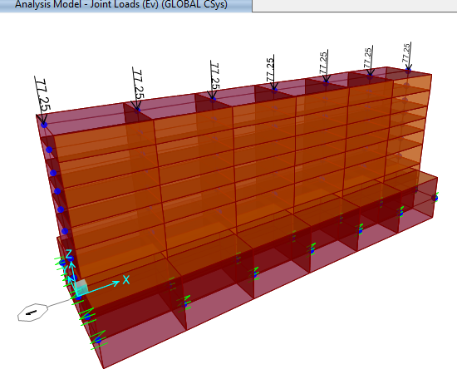

1. Ev Points Loads on sleeper type B =0.15*SUS(Kg)

10. $1.5.$ Soil load on foundation

Soil load weight has been applied on foundation as below

$$γ_{soil}=1850kg/m3$$

$h_{soil}=0.6m$ $P=γh=1850*0.6=1110\frac{kg}{m2}$

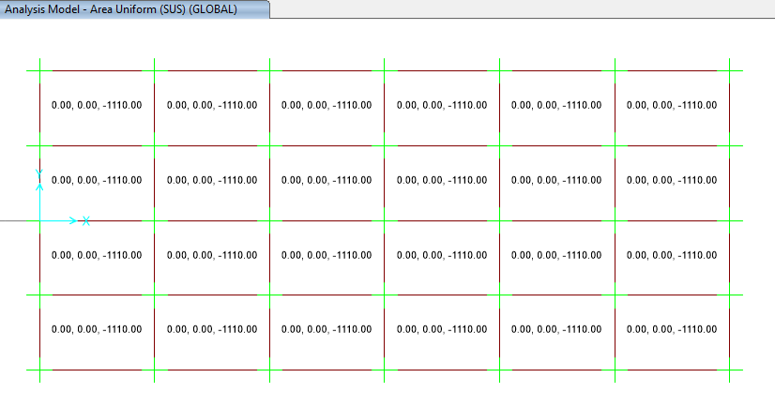

1. applied soil load on foundation type A(1110Kg)

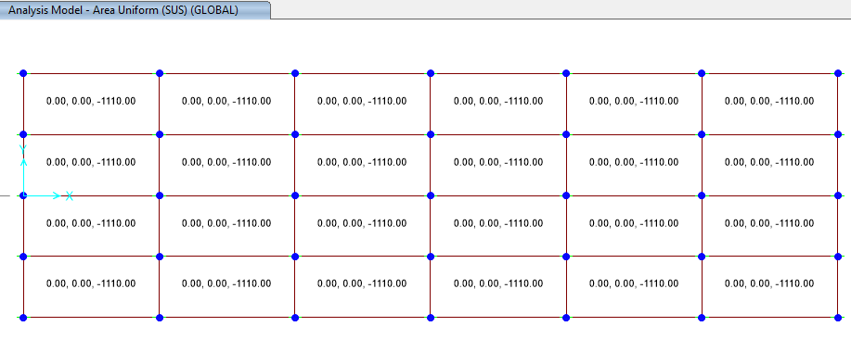

1. applied soil load on foundation type B(1110Kg)

10.1.6.Soil Pressure on wall of sleeper

According to drawings approximately 0.6m is under ground that horizontal pressure applied on model as below :

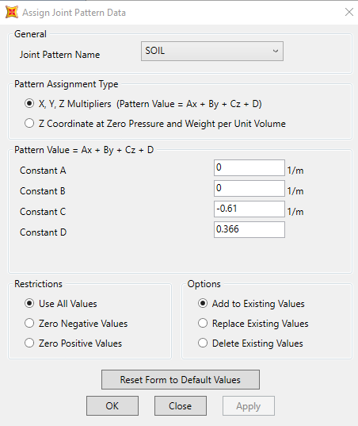

1. Define joint Pattern

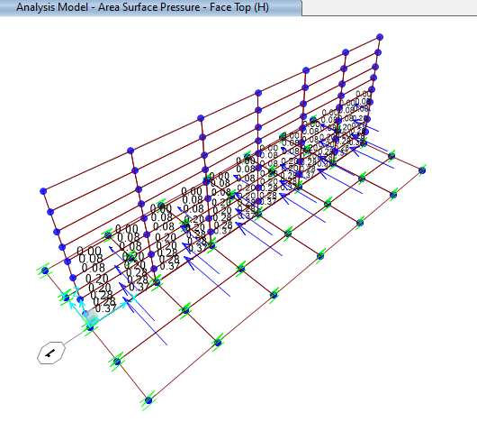

1. Applied soil pressure load on sleeper Type A

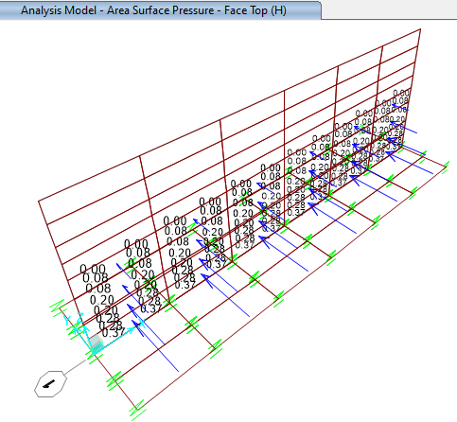

1. applied soil pressure load on sleeper Type B

## 10.2. wall design

* SAP2000 has been used in order to modeling, analyses and design of this wall &foundation.

$$wall thickness=500 mm$$

$$according to sap model M_{max}=0.56 ton.m$$

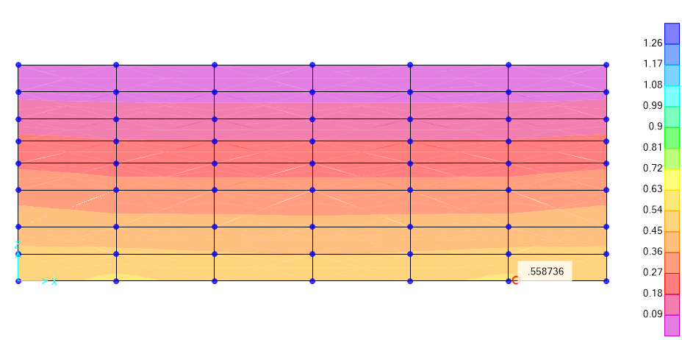

1. -Graphical output of Mmax Sleeper Type A(ton-m)

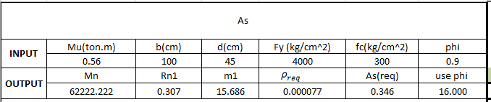

According to above output max Moment is about 56000 kg-cm

$${Mu}_{1}=56000 kg.cm$$

$$b=100 cm$$

$$f_{c}=300$$

$$f_{y}=4000$$

$$d=45cm$$

$$∅=0.9$$

$$M_{n}=\frac{M_{u}}{∅}=62222.22 kg.cm$$

$$R_{n1}=\frac{M_{n1}}{b.d^{2}}=0.307$$

$$m_{1}=\frac{f_{y}}{0.85f_{c}}=15.686$$

$$ρ_{req}=\frac{1}{m_{1}}\left(1-\sqrt{1-\frac{{2m}_{1}R_{n1}}{f_{y}}}\right)=0.000077$$

$A_{s(req)}=ρ_{req}.b.d$ =0.346 cm2 << : uses Ø16@200 As=10.05cm2 ok

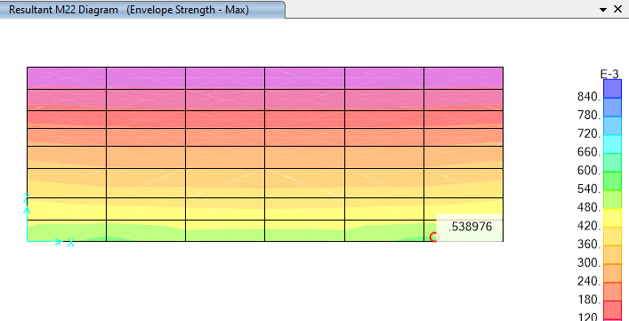

1. -Graphical output of Mmax Sleeper Type B(ton-m)

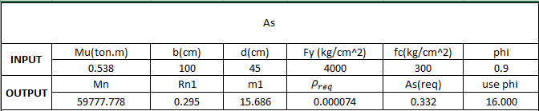

According to above output max Moment is about 56000 kg-cm

$${Mu}_{1}=53800 kg.cm$$

$$b=100 cm$$

$$f_{c}=300$$

$$f_{y}=4000$$

$$d=45cm$$

$$∅=0.9$$

$$M_{n}=\frac{M_{u}}{∅}=59777.778 kg.cm$$

$$R_{n1}=\frac{M_{n1}}{b.d^{2}}=0.295$$

$$m_{1}=\frac{f_{y}}{0.85f_{c}}=15.686$$

$$ρ_{req}=\frac{1}{m_{1}}\left(1-\sqrt{1-\frac{{2m}_{1}R_{n1}}{f_{y}}}\right)=0.000074$$

$A_{s(req)}=ρ_{req}.b.d$ =0.332 cm2 << : uses Ø16@200 As=10.05cm2 ok

## 10.3.check of stress & settlement for foundation (type A:300x130x40

## type b:300x90x40)

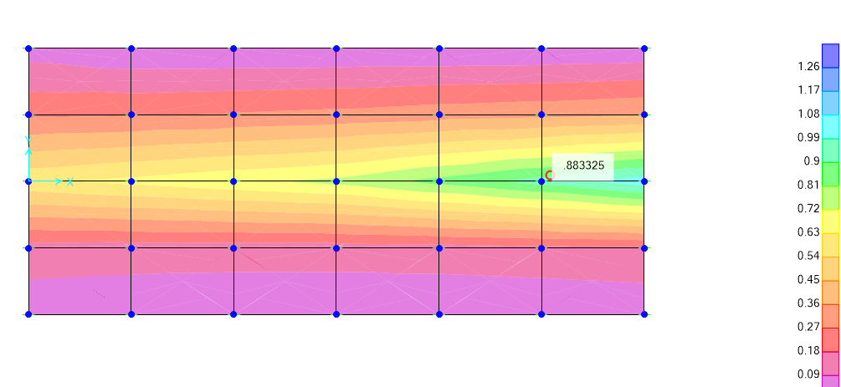

1. stress diagram for foundation (Sleeper Type A)

According to Sap results, the maximum soil stress under the foundation in combination ENV-Allowable is:

$$max. stress under foundation: 0.9×0.7=0.63 kg/cm2< 1.20 kg/cm^{2} ok.$$

Foundation joints displacement under load combinations is as below:

|  |  |  |  |  |
| --- | --- | --- | --- | --- |
| **TABLE: Joint Displacements** | | | | |
| **Joint** | **OutputCase** | **CaseType** | **StepType** | **U3** |
| Text | Text | Text | Text | cm |
| 35 | Envelope allowable | Combination | Max | 0.19268 |
| 35 | Envelope allowable | Combination | Min | -0.627161 |
| 36 | Envelope allowable | Combination | Max | -0.104303 |
| 36 | Envelope allowable | Combination | Min | -0.704222 |
| 39 | Envelope allowable | Combination | Max | 0.128448 |
| 39 | Envelope allowable | Combination | Min | -0.578981 |
| 47 | Envelope allowable | Combination | Max | 0.064221 |
| 47 | Envelope allowable | Combination | Min | -0.530808 |
| 52 | Envelope allowable | Combination | Max | -1.866E-12 |
| 52 | Envelope allowable | Combination | Min | -0.511529 |
| 57 | Envelope allowable | Combination | Max | -0.064221 |
| 57 | Envelope allowable | Combination | Min | -0.575752 |
| 62 | Envelope allowable | Combination | Max | -0.128448 |
| 62 | Envelope allowable | Combination | Min | -0.639982 |
| 70 | Envelope allowable | Combination | Max | 0.192641 |
| 70 | Envelope allowable | Combination | Min | -0.638263 |
| 71 | Envelope allowable | Combination | Max | -0.089401 |
| 71 | Envelope allowable | Combination | Min | -0.704127 |
| 72 | Envelope allowable | Combination | Max | -0.089401 |
| 72 | Envelope allowable | Combination | Min | -0.704127 |
| 73 | Envelope allowable | Combination | Max | 0.192641 |
| 73 | Envelope allowable | Combination | Min | -0.63828 |
| 74 | Envelope allowable | Combination | Max | 0.128422 |
| 74 | Envelope allowable | Combination | Min | -0.638255 |
| 75 | Envelope allowable | Combination | Max | 0.128436 |
| 75 | Envelope allowable | Combination | Min | -0.578945 |
| 76 | Envelope allowable | Combination | Max | 0.192661 |
| 76 | Envelope allowable | Combination | Min | -0.627121 |
| 77 | Envelope allowable | Combination | Max | 0.128436 |
| 77 | Envelope allowable | Combination | Min | -0.578953 |
| 78 | Envelope allowable | Combination | Max | 0.192661 |
| 78 | Envelope allowable | Combination | Min | -0.627129 |
| 79 | Envelope allowable | Combination | Max | 0.128422 |
| 79 | Envelope allowable | Combination | Min | -0.638272 |
| 80 | Envelope allowable | Combination | Max | 0.064208 |
| 80 | Envelope allowable | Combination | Min | -0.638251 |
| 81 | Envelope allowable | Combination | Max | 0.064216 |
| 81 | Envelope allowable | Combination | Min | -0.560451 |
| 82 | Envelope allowable | Combination | Max | 0.064216 |
| 82 | Envelope allowable | Combination | Min | -0.56046 |
| 83 | Envelope allowable | Combination | Max | 0.064208 |
| 83 | Envelope allowable | Combination | Min | -0.638268 |
| 84 | Envelope allowable | Combination | Max | -1.317E-11 |
| 84 | Envelope allowable | Combination | Min | -0.63825 |
| 85 | Envelope allowable | Combination | Max | -7.521E-12 |
| 85 | Envelope allowable | Combination | Min | -0.56045 |
| 86 | Envelope allowable | Combination | Max | 3.79E-12 |
| 86 | Envelope allowable | Combination | Min | -0.560459 |
| 87 | Envelope allowable | Combination | Max | 9.449E-12 |
| 87 | Envelope allowable | Combination | Min | -0.638267 |
| 88 | Envelope allowable | Combination | Max | -0.064208 |
| 88 | Envelope allowable | Combination | Min | -0.638251 |
| 89 | Envelope allowable | Combination | Max | -0.064216 |
| 89 | Envelope allowable | Combination | Min | -0.57572 |
| 90 | Envelope allowable | Combination | Max | -0.064216 |
| 90 | Envelope allowable | Combination | Min | -0.57572 |
| 91 | Envelope allowable | Combination | Max | -0.064208 |
| 91 | Envelope allowable | Combination | Min | -0.638268 |
| 92 | Envelope allowable | Combination | Max | -0.0894 |
| 92 | Envelope allowable | Combination | Min | -0.639899 |
| 93 | Envelope allowable | Combination | Max | -0.128436 |
| 93 | Envelope allowable | Combination | Min | -0.639945 |
| 94 | Envelope allowable | Combination | Max | -0.128436 |
| 94 | Envelope allowable | Combination | Min | -0.639945 |
| 95 | Envelope allowable | Combination | Max | -0.0894 |
| 95 | Envelope allowable | Combination | Min | -0.639899 |
| 96 | Envelope allowable | Combination | Max | -0.104313 |
| 96 | Envelope allowable | Combination | Min | -0.704178 |
| 97 | Envelope allowable | Combination | Max | -0.104313 |
| 97 | Envelope allowable | Combination | Min | -0.704178 |
|  |  |  | Max | -0.704222 |

According to above sap 2000 results, the maximum soil displacement under the foundation in combination ENV-COMB is:

4. 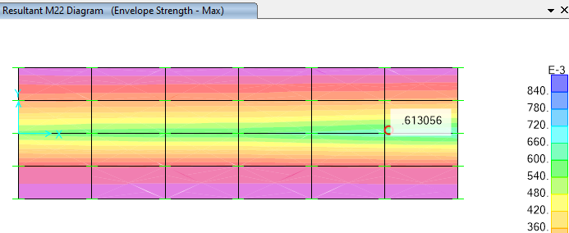

1. stress diagram for foundation (Sleeper Type B)

According to Sap results, the maximum soil stress under the foundation in combination ENV-Allowable is:

$$max. stress under foundation: 1.1×0.9=0.99 kg/cm2< 1.20 kg/cm^{2} ok.$$

Foundation joints displacement under load combinations is as below:

|  |  |  |  |  |
| --- | --- | --- | --- | --- |
| **TABLE: Joint Displacements(Sleeper Type B)** | | | | |
| **Joint** | **OutputCase** | **CaseType** | **StepType** | **U3** |
| Text | Text | Text | Text | cm |
| 35 | Envelope allowable | Combination | Max | 0.104216 |
| 35 | Envelope allowable | Combination | Min | -0.684127 |
| 36 | Envelope allowable | Combination | Max | -0.104216 |
| 36 | Envelope allowable | Combination | Min | -0.725856 |
| 37 | Envelope allowable | Combination | Max | -0.104222 |
| 37 | Envelope allowable | Combination | Min | -0.725889 |
| 38 | Envelope allowable | Combination | Max | 0.104222 |
| 38 | Envelope allowable | Combination | Min | -0.684155 |
| 39 | Envelope allowable | Combination | Max | 0.069475 |
| 39 | Envelope allowable | Combination | Min | -0.649381 |
| 40 | Envelope allowable | Combination | Max | 0.069476 |
| 40 | Envelope allowable | Combination | Min | -0.649388 |
| 41 | Envelope allowable | Combination | Max | 0.104218 |
| 41 | Envelope allowable | Combination | Min | -0.684134 |
| 42 | Envelope allowable | Combination | Max | 0.069477 |
| 42 | Envelope allowable | Combination | Min | -0.649394 |
| 43 | Envelope allowable | Combination | Max | 0.10422 |
| 43 | Envelope allowable | Combination | Min | -0.684143 |
| 44 | Envelope allowable | Combination | Max | 0.069477 |
| 44 | Envelope allowable | Combination | Min | -0.649397 |
| 45 | Envelope allowable | Combination | Max | 0.104221 |
| 45 | Envelope allowable | Combination | Min | -0.684148 |
| 46 | Envelope allowable | Combination | Max | 0.069477 |
| 46 | Envelope allowable | Combination | Min | -0.649399 |
| 47 | Envelope allowable | Combination | Max | 0.034737 |
| 47 | Envelope allowable | Combination | Min | -0.62163 |
| 48 | Envelope allowable | Combination | Max | 0.034737 |
| 48 | Envelope allowable | Combination | Min | -0.621636 |
| 49 | Envelope allowable | Combination | Max | 0.034737 |
| 49 | Envelope allowable | Combination | Min | -0.621642 |
| 50 | Envelope allowable | Combination | Max | 0.034737 |
| 50 | Envelope allowable | Combination | Min | -0.621645 |
| 51 | Envelope allowable | Combination | Max | 0.034738 |
| 51 | Envelope allowable | Combination | Min | -0.621649 |
| 52 | Envelope allowable | Combination | Max | -1.378E-12 |
| 52 | Envelope allowable | Combination | Min | -0.621628 |
| 53 | Envelope allowable | Combination | Max | -1.378E-12 |
| 53 | Envelope allowable | Combination | Min | -0.621634 |
| 54 | Envelope allowable | Combination | Max | -1.378E-12 |
| 54 | Envelope allowable | Combination | Min | -0.62164 |
| 55 | Envelope allowable | Combination | Max | -1.378E-12 |
| 55 | Envelope allowable | Combination | Min | -0.621644 |
| 56 | Envelope allowable | Combination | Max | -1.378E-12 |
| 56 | Envelope allowable | Combination | Min | -0.621647 |
| 57 | Envelope allowable | Combination | Max | -0.034737 |
| 57 | Envelope allowable | Combination | Min | -0.656366 |
| 58 | Envelope allowable | Combination | Max | -0.034737 |
| 58 | Envelope allowable | Combination | Min | -0.656373 |
| 59 | Envelope allowable | Combination | Max | -0.034737 |
| 59 | Envelope allowable | Combination | Min | -0.656379 |
| 60 | Envelope allowable | Combination | Max | -0.034737 |
| 60 | Envelope allowable | Combination | Min | -0.656383 |
| 61 | Envelope allowable | Combination | Max | -0.034738 |
| 61 | Envelope allowable | Combination | Min | -0.656387 |
| 62 | Envelope allowable | Combination | Max | -0.069475 |
| 62 | Envelope allowable | Combination | Min | -0.691109 |
| 63 | Envelope allowable | Combination | Max | -0.069476 |
| 63 | Envelope allowable | Combination | Min | -0.691116 |
| 64 | Envelope allowable | Combination | Max | -0.069477 |
| 64 | Envelope allowable | Combination | Min | -0.691124 |
| 65 | Envelope allowable | Combination | Max | -0.069477 |
| 65 | Envelope allowable | Combination | Min | -0.691127 |
| 66 | Envelope allowable | Combination | Max | -0.069477 |
| 66 | Envelope allowable | Combination | Min | -0.69113 |
| 67 | Envelope allowable | Combination | Max | -0.104218 |
| 67 | Envelope allowable | Combination | Min | -0.725865 |
| 68 | Envelope allowable | Combination | Max | -0.10422 |
| 68 | Envelope allowable | Combination | Min | -0.725874 |
| 69 | Envelope allowable | Combination | Max | -0.104221 |
| 69 | Envelope allowable | Combination | Min | -0.725881 |
| 70 | Envelope allowable | Combination | Max | 0.104208 |
| 70 | Envelope allowable | Combination | Min | -0.905793 |
| 71 | Envelope allowable | Combination | Max | 0.093521 |
| 71 | Envelope allowable | Combination | Min | -0.905793 |
| 72 | Envelope allowable | Combination | Max | 0.093521 |
| 72 | Envelope allowable | Combination | Min | -0.905829 |
| 73 | Envelope allowable | Combination | Max | 0.104208 |
| 73 | Envelope allowable | Combination | Min | -0.905829 |
| 74 | Envelope allowable | Combination | Max | 0.093522 |
| 74 | Envelope allowable | Combination | Min | -0.905787 |
| 75 | Envelope allowable | Combination | Max | 0.069473 |
| 75 | Envelope allowable | Combination | Min | -0.742847 |
| 76 | Envelope allowable | Combination | Max | 0.104212 |
| 76 | Envelope allowable | Combination | Min | -0.742853 |
| 77 | Envelope allowable | Combination | Max | 0.069473 |
| 77 | Envelope allowable | Combination | Min | -0.742866 |
| 78 | Envelope allowable | Combination | Max | 0.104212 |
| 78 | Envelope allowable | Combination | Min | -0.742872 |
| 79 | Envelope allowable | Combination | Max | 0.093522 |
| 79 | Envelope allowable | Combination | Min | -0.905823 |
| 80 | Envelope allowable | Combination | Max | 0.093522 |
| 80 | Envelope allowable | Combination | Min | -0.905783 |
| 81 | Envelope allowable | Combination | Max | 0.034735 |
| 81 | Envelope allowable | Combination | Min | -0.742844 |
| 82 | Envelope allowable | Combination | Max | 0.034735 |
| 82 | Envelope allowable | Combination | Min | -0.742862 |
| 83 | Envelope allowable | Combination | Max | 0.093522 |
| 83 | Envelope allowable | Combination | Min | -0.905819 |
| 84 | Envelope allowable | Combination | Max | 0.093521 |
| 84 | Envelope allowable | Combination | Min | -0.905782 |
| 85 | Envelope allowable | Combination | Max | -1.117E-11 |
| 85 | Envelope allowable | Combination | Min | -0.742843 |
| 86 | Envelope allowable | Combination | Max | 8.419E-12 |
| 86 | Envelope allowable | Combination | Min | -0.742861 |
| 87 | Envelope allowable | Combination | Max | 0.093521 |
| 87 | Envelope allowable | Combination | Min | -0.905818 |
| 88 | Envelope allowable | Combination | Max | 0.093522 |
| 88 | Envelope allowable | Combination | Min | -0.905783 |
| 89 | Envelope allowable | Combination | Max | -0.034735 |
| 89 | Envelope allowable | Combination | Min | -0.742844 |
| 90 | Envelope allowable | Combination | Max | -0.034735 |
| 90 | Envelope allowable | Combination | Min | -0.742862 |
| 91 | Envelope allowable | Combination | Max | 0.093522 |
| 91 | Envelope allowable | Combination | Min | -0.905819 |
| 92 | Envelope allowable | Combination | Max | 0.093522 |
| 92 | Envelope allowable | Combination | Min | -0.905787 |
| 93 | Envelope allowable | Combination | Max | -0.069473 |
| 93 | Envelope allowable | Combination | Min | -0.742847 |
| 94 | Envelope allowable | Combination | Max | -0.069473 |
| 94 | Envelope allowable | Combination | Min | -0.742866 |
| 95 | Envelope allowable | Combination | Max | 0.093522 |
| 95 | Envelope allowable | Combination | Min | -0.905823 |
| 96 | Envelope allowable | Combination | Max | -0.104212 |
| 96 | Envelope allowable | Combination | Min | -0.742853 |
| 97 | Envelope allowable | Combination | Max | -0.104212 |
| 97 | Envelope allowable | Combination | Min | -0.742872 |
| 98 | Envelope allowable | Combination | Max | 0.069476 |
| 98 | Envelope allowable | Combination | Min | -0.649392 |
| 99 | Envelope allowable | Combination | Max | 0.104219 |
| 99 | Envelope allowable | Combination | Min | -0.684139 |
| 100 | Envelope allowable | Combination | Max | 0.034737 |
| 100 | Envelope allowable | Combination | Min | -0.62164 |
| 101 | Envelope allowable | Combination | Max | -1.378E-12 |
| 101 | Envelope allowable | Combination | Min | -0.621638 |
| 102 | Envelope allowable | Combination | Max | -0.034737 |
| 102 | Envelope allowable | Combination | Min | -0.656377 |
| 103 | Envelope allowable | Combination | Max | -0.069476 |
| 103 | Envelope allowable | Combination | Min | -0.691121 |
| 104 | Envelope allowable | Combination | Max | -0.104219 |
| 104 | Envelope allowable | Combination | Min | -0.72587 |
| 105 | Envelope allowable | Combination | Max | 0.069475 |
| 105 | Envelope allowable | Combination | Min | -0.649385 |
| 106 | Envelope allowable | Combination | Max | 0.104217 |
| 106 | Envelope allowable | Combination | Min | -0.684131 |
| 107 | Envelope allowable | Combination | Max | 0.069477 |
| 107 | Envelope allowable | Combination | Min | -0.649398 |
| 108 | Envelope allowable | Combination | Max | 0.104222 |
| 108 | Envelope allowable | Combination | Min | -0.684152 |
| 109 | Envelope allowable | Combination | Max | 0.034737 |
| 109 | Envelope allowable | Combination | Min | -0.621633 |
| 110 | Envelope allowable | Combination | Max | 0.034737 |
| 110 | Envelope allowable | Combination | Min | -0.621647 |
| 111 | Envelope allowable | Combination | Max | -1.378E-12 |
| 111 | Envelope allowable | Combination | Min | -0.621631 |
| 112 | Envelope allowable | Combination | Max | -1.378E-12 |
| 112 | Envelope allowable | Combination | Min | -0.621646 |
| 113 | Envelope allowable | Combination | Max | -0.034737 |
| 113 | Envelope allowable | Combination | Min | -0.65637 |
| 114 | Envelope allowable | Combination | Max | -0.034737 |
| 114 | Envelope allowable | Combination | Min | -0.656385 |
| 115 | Envelope allowable | Combination | Max | -0.069475 |
| 115 | Envelope allowable | Combination | Min | -0.691113 |
| 116 | Envelope allowable | Combination | Max | -0.069477 |
| 116 | Envelope allowable | Combination | Min | -0.691128 |
| 117 | Envelope allowable | Combination | Max | -0.104217 |
| 117 | Envelope allowable | Combination | Min | -0.72586 |
| 118 | Envelope allowable | Combination | Max | -0.104222 |
| 118 | Envelope allowable | Combination | Min | -0.725885 |
| 119 | Envelope allowable | Combination | Max | 0.069477 |
| 119 | Envelope allowable | Combination | Min | -0.649396 |
| 120 | Envelope allowable | Combination | Max | 0.104221 |
| 120 | Envelope allowable | Combination | Min | -0.684146 |
| 121 | Envelope allowable | Combination | Max | 0.034737 |
| 121 | Envelope allowable | Combination | Min | -0.621644 |
| 122 | Envelope allowable | Combination | Max | -1.378E-12 |
| 122 | Envelope allowable | Combination | Min | -0.621642 |
| 123 | Envelope allowable | Combination | Max | -0.034737 |
| 123 | Envelope allowable | Combination | Min | -0.656381 |
| 124 | Envelope allowable | Combination | Max | -0.069477 |
| 124 | Envelope allowable | Combination | Min | -0.691125 |
| 125 | Envelope allowable | Combination | Max | -0.104221 |
| 125 | Envelope allowable | Combination | Min | -0.725877 |
|  |  |  | Min | -0.905829 |

According to above sap 2000 results, the maximum soil displacement under the foundation in combination ENV-COMB is:

$max. displacement under foundation :0.905 cm < 2 cm ok$

## 

## 10.4. foundation REINFORCING CONTROL

$$for foundation : A_{smin}=\frac{1}{2}0.0018 bh=\frac{1}{2}0.0018×100×40=7.20 cm^{2}$$

$$A_{s used}=∅16 @ 200=10.05 cm^{2} OK$$

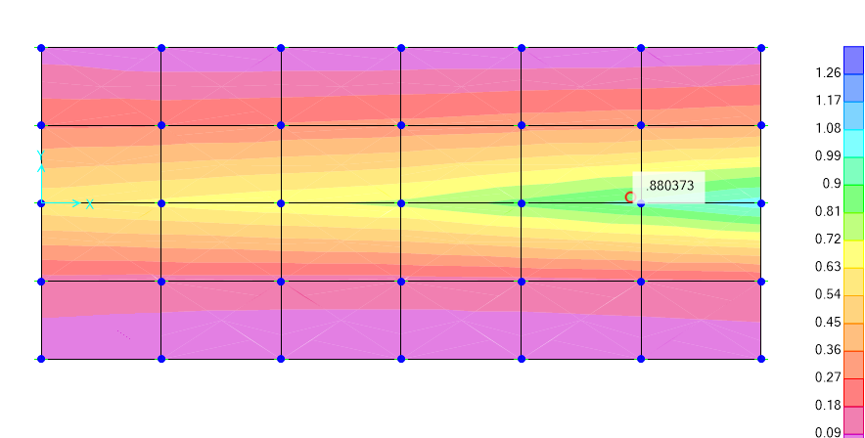

1. stress diagram for Sleeper Type A Foundation

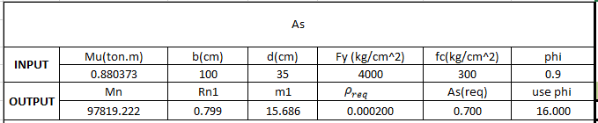

$${Mu}_{1}=880373 kg.cm$$

$$b=100 cm$$

$$f_{c}=300$$

$$f_{y}=4000$$

$$d=35cm$$

$$∅=0.9$$

$$M_{n}=\frac{M_{u}}{∅}=97819.222 kg.cm$$

$$R_{n1}=\frac{M_{n1}}{b.d^{2}}=0.799$$

$$m_{1}=\frac{f_{y}}{0.85f_{c}}=15.686$$

$$ρ_{req}=\frac{1}{m_{1}}\left(1-\sqrt{1-\frac{{2m}_{1}R_{n1}}{f_{y}}}\right)=0.000200$$

$A_{s(req)}=ρ_{req}.b.d$ =0.7cm2 << : uses Ø16@200 As=10.05cm2 ok

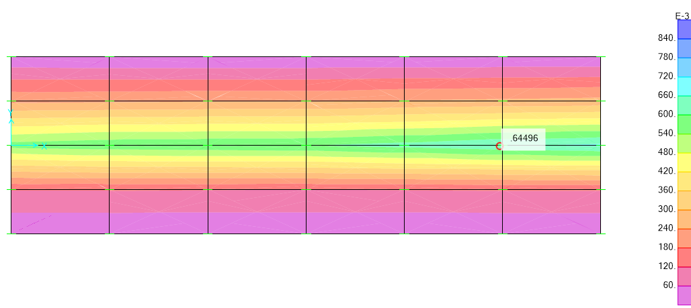

1. stress diagram for Sleeper Type B Foundation

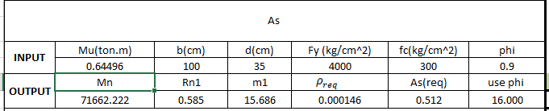

$${Mu}_{1}=644960 kg.cm$$

$$b=100 cm$$

$$f_{c}=300$$

$$f_{y}=4000$$

$$d=35cm$$

$$∅=0.9$$

$$M_{n}=\frac{M_{u}}{∅}=71662.22 kg.cm$$

$$R_{n1}=\frac{M_{n1}}{b.d^{2}}=0.585$$

$$m_{1}=\frac{f_{y}}{0.85f_{c}}=15.686$$

$$ρ_{req}=\frac{1}{m_{1}}\left(1-\sqrt{1-\frac{{2m}_{1}R_{n1}}{f_{y}}}\right)=0.000146$$

$A_{s(req)}=ρ_{req}.b.d$ =0.512cm2 << : uses Ø16@200 As=10.05cm2 ok

## 10.5.OVERTURNING and sliding CONTROL CALCULATION

10.5.1.Anchor Sleeper TYPE A:

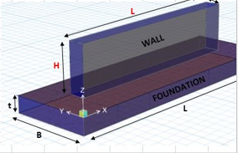

## 10.5.1.1.Sliding control calculation:

L=3 m , B=1.3m , t=0.4m ,H=1.1m(0.6m soil height &0.5m above ground)

For pipe10 inch weight per meter is about 25kg/ m .

$γ_{SOIL}=1850 kg/m^{3}$

$$γ_{concrete}=2500 kg/m^{3}$$

$$W_{F}=3×1.3×0.4×2.5=3.9 ton$$

$$W_{wall}=3×0.5×1.1×2.5=4.125 ton$$

$$W_{soil}=1.85×\left(0.6×0.8×3\right)=2.66 ton$$

$$W_{pipe}=25×5.75×0.001=0.14375 ton$$

$$Mr=\left(3.9+4.125+2.66+0.14375\right)×0.65=7.038 ton.m$$

$$Mo=205×7×1.5=2.1525 ton .m$$

$$SF= \frac{M_{r}}{Mo}=\frac{7.038}{2.1525}=3.26> 1.5 OK$$

## 10.5.1.2.Sliding control calculation:

$$μ=\tan\left(0.67∅\right)=0.4$$

$$V_{eqy}=1.435 ton$$

$$K_{p}=3$$

$$γ=1.85 \frac{gr}{cm^{3}}$$

$$R_{sliding}=μ×W_{R}+0.5KpγH^{2}L=0.4×\left(3.9+4.125+2.66+0.14375\right)+0.5×3×1.85×{0.6}^{2}×3= 7.328 ton$$

$$SF=\frac{R_{sliding}}{V_{eqy}}=\frac{7.328}{1.435}=5.1 ≥ 1.00 OK$$

10.5.2.Anchor Sleeper TYPE B:



## 10.5.2.1.Sliding control calculation:

L=3 m , B=0.9 , t=0.4m ,H=1.1m(0.6m soil height &0.5m above ground)

For pipe10 inch weight per meter is about 25kg/ m .

$γ_{SOIL}=1850 kg/m^{3}$

$$γ_{concrete}=2500 kg/m^{3}$$

$$W_{F}=3×0.9×0.4×2.5=2.7 ton$$

$$W_{wall}=3×0.5×1.1×2.5=4.125 ton$$

$$W_{soil}=1.85×\left(0.6×0.4×3\right)=1.332 ton$$

$$W_{pipe}=25×6×0.001=0.15 ton$$

$$Mr=\left(2.7+4.125+1.332+0.15\right)×0.45=3.7 ton.m$$

$$Mo=1440×1.5=2.16 ton .m$$

$$SF= \frac{M_{r}}{Mo}=\frac{3.7}{2.16}=1.71> 1.5 OK$$

## 10.5.2.2.Sliding control calculation:

$$μ=\tan\left(0.67∅\right)=0.4$$

$$V_{eqy}=1.44 ton$$

$$K_{p}=3$$

$$γ=1.85 \frac{gr}{cm^{3}}$$

$$R_{sliding}=μ×W_{R}+0.5KpγH^{2}L=0.4×\left(2.7+4.125+1.332+0.15\right)+0.5×3×1.85×{0.6}^{2}×3= 6.32 ton$$

$$SF=\frac{R_{sliding}}{V_{eqy}}=\frac{6.32}{1.44}=4.38 ≥ 1.00 OK$$