|  |  |  |  |  |  |  |  |
| --- | --- | --- | --- | --- | --- | --- | --- |
| **طرح نگهداشت و افزایش تولید 27 مخزن** | | | | | | | |
| **Calculation Note for Tank Foundation (TK-2301 A/B)**  **نگهداشت و افزایش تولید میدان نفتی بینک** | | | | | | | |
|  | |  |  |  |  |  |  |
|  | |  |  |  |  |  |  |
|  | |  |  |  |  |  |  |
|  | |  |  |  |  |  |  |
| D00 | | SEP. 2023 | IFC | R.Berlouie | M.Fakharian | A.M.Mohseni |  |
| **Rev.** | | **Date** | **Purpose of Issue/Status** | **Prepared by:** | **Checked by:** | **Approved by:** | **CLIENT Approval** |
| **Class:2** | | | **COMPANY Doc. Number:** **F0Z-709122** | | | | |
| **Status:** | | **IDC: Inter-Discipline Check**  **IFC: Issued For Comment**  **IFA: Issued For Approval**  **AFD: Approved For Design**  **AFC: Approved For Construction**  **AFP: Approved For Purchase**  **AFQ:** Approved For Quotation  **IFI: Issued For Information**  **AB-R: As-Built for CLIENT Review**  **AB-A: As-Built –Approved** | | | | | |

**REVISION RECORD SHEET**

|  |  |  |  |  |  |  |  |  |  |  |  |  |
| --- | --- | --- | --- | --- | --- | --- | --- | --- | --- | --- | --- | --- |
| **PAGE** | **D00** | **D01** | **D02** | **D03** | **D04** |  | **PAGE** | **D00** | **D01** | **D02** | **D03** | **D04** |
| **1** | X |  |  |  |  | **66** |  |  |  |  |  |
| **2** | X |  |  |  |  | **67** |  |  |  |  |  |
| **3** | X |  |  |  |  | **68** |  |  |  |  |  |
| **4** | X |  |  |  |  | **69** |  |  |  |  |  |
| **5** | X |  |  |  |  | **70** |  |  |  |  |  |
| **6** | X |  |  |  |  | **71** |  |  |  |  |  |
| **7** | X |  |  |  |  | **72** |  |  |  |  |  |
| **8** | X |  |  |  |  | **73** |  |  |  |  |  |
| **9** | X |  |  |  |  | **74** |  |  |  |  |  |
| **10** | X |  |  |  |  | **75** |  |  |  |  |  |
| **11** | X |  |  |  |  | **76** |  |  |  |  |  |
| **12** | X |  |  |  |  | **77** |  |  |  |  |  |
| **13** | X |  |  |  |  | **78** |  |  |  |  |  |
| **14** | X |  |  |  |  | **79** |  |  |  |  |  |
| **15** | X |  |  |  |  | **80** |  |  |  |  |  |
| **16** | X |  |  |  |  | **81** |  |  |  |  |  |
| **17** | X |  |  |  |  | **82** |  |  |  |  |  |
| **18** | X |  |  |  |  | **83** |  |  |  |  |  |
| **19** | X |  |  |  |  | **84** |  |  |  |  |  |
| **20** | X |  |  |  |  | **85** |  |  |  |  |  |
| **21** | X |  |  |  |  | **86** |  |  |  |  |  |
| **22** | X |  |  |  |  | **87** |  |  |  |  |  |
| **23** | X |  |  |  |  | **88** |  |  |  |  |  |
| **24** | X |  |  |  |  | **89** |  |  |  |  |  |
| **25** |  |  |  |  |  | **90** |  |  |  |  |  |
| **26** |  |  |  |  |  | **91** |  |  |  |  |  |
| **27** |  |  |  |  |  | **92** |  |  |  |  |  |
| **28** |  |  |  |  |  | **93** |  |  |  |  |  |
| **29** |  |  |  |  |  | **94** |  |  |  |  |  |
| **30** |  |  |  |  |  | **95** |  |  |  |  |  |
| **31** |  |  |  |  |  | **96** |  |  |  |  |  |
| **32** |  |  |  |  |  | **97** |  |  |  |  |  |
| **33** |  |  |  |  |  | **98** |  |  |  |  |  |
| **34** |  |  |  |  |  | **99** |  |  |  |  |  |
| **35** |  |  |  |  |  | **100** |  |  |  |  |  |
| **36** |  |  |  |  |  | **101** |  |  |  |  |  |
| **37** |  |  |  |  |  | **102** |  |  |  |  |  |
| **38** |  |  |  |  |  | **103** |  |  |  |  |  |
| **39** |  |  |  |  |  | **104** |  |  |  |  |  |
| **40** |  |  |  |  |  | **105** |  |  |  |  |  |
| **41** |  |  |  |  |  | **106** |  |  |  |  |  |
| **42** |  |  |  |  |  | **107** |  |  |  |  |  |
| **43** |  |  |  |  |  | **108** |  |  |  |  |  |
| **44** |  |  |  |  |  | **109** |  |  |  |  |  |
| **45** |  |  |  |  |  | **110** |  |  |  |  |  |
| **46** |  |  |  |  |  | **111** |  |  |  |  |  |
| **47** |  |  |  |  |  | **112** |  |  |  |  |  |
| **48** |  |  |  |  |  | **113** |  |  |  |  |  |
| **49** |  |  |  |  |  | **114** |  |  |  |  |  |
| **50** |  |  |  |  |  | **115** |  |  |  |  |  |
| **51** |  |  |  |  |  | **116** |  |  |  |  |  |
| **52** |  |  |  |  |  | **117** |  |  |  |  |  |
| **53** |  |  |  |  |  | **118** |  |  |  |  |  |
| **54** |  |  |  |  |  | **119** |  |  |  |  |  |
| **55** |  |  |  |  |  | **120** |  |  |  |  |  |
| **56** |  |  |  |  |  | **121** |  |  |  |  |  |
| **57** |  |  |  |  |  | **122** |  |  |  |  |  |
| **58** |  |  |  |  |  | **123** |  |  |  |  |  |
| **59** |  |  |  |  |  | **124** |  |  |  |  |  |
| **60** |  |  |  |  |  | **125** |  |  |  |  |  |
| **61** |  |  |  |  |  | **126** |  |  |  |  |  |
| **62** |  |  |  |  |  | **127** |  |  |  |  |  |
| **63** |  |  |  |  |  | **128** |  |  |  |  |  |
| **64** |  |  |  |  |  | **129** |  |  |  |  |  |
| **65** |  |  |  |  |  | **130** |  |  |  |  |  |

**CONTENTS**

1.0 INTRODUCTION 4

2.0 Scope 4

3.0 NORMATIVE REFERENCE 4

**3.1** **Local Codes and Standards** 4

**3.2** **International Codes and Standards** 4

**3.3** **The Project Documents** 5

4.0 Material properties 5

5.0 Computer software 5

6.0 Geometry 6

7.0 DESIGN LOAD 8

**7.1** **Ds (Total Dead Load of Structure and Foundation & Soil overburden)** 8

**7.2** **De (Total dead load of tank)** 9

**7.3** **F (Normal Fluid Load)** 9

**7.4** **HT (Test Fluid Load)** 10

**7.5** **E (Earthquake Load)** 11

**7.6** **W (Wind Load)** 12

8.0 Design Load Combinations 13

9.0 Tank ANALYSIS AND DESIGN 16

**9.1** **Tank geometry** 16

**9.2** **Tank Design Results** 16

9.2.1. Soil Pressure Control 16

9.2.2. Foundation reinforcement 20

1. **INTRODUCTION**

Binak oilfield in Bushehr province is a part of the southern oilfields of Iran, is located 20 km northwest of Genaveh city.

With the aim of increasing production of oil from Binak oilfield, an EPC/EPD Project has been defined by NIOC/NISOC and awarded to Petro Iran Development Company (PEDCO). Also PEDCO (as General Contractor) has assigned the EPC-packages of the Project to "Hirgan Energy - Design and Inspection" JV.

1. **Scope**

This report covers design of Fire Water Storage Tanks (TK-2301A/B). The calculation of foundation is performed using “SAP” software.

1. **NORMATIVE REFERENCE**
   1. **Local Codes and Standards**

* INBC Part 6 “Iranian National Building Code
* INBC Part 7 “Iranian National Building Code
* INBC Part 9 “Iranian National Building Code
* INBC Part 10 “Iranian National Building Code
* Iranian Seismic Design Code for Petroleum Facilities(3rd edition)
  1. **International Codes and Standards**
* ASCE 7-10 “Minimum Design Loads and Associated Criteria for Buildings and Other Structures-American Society of Civil Engineers”.
* ACI 318. “Building Code Requirements for Reinforced Concrete”, American Concrete Institute.
* AISC 358 “Prequalified Connections for Special and Intermediate Steel Moment Frames for Seismic Applications.” American Institute of Steel Construction, Inc.
* AISC 360 - “Specification for Structural Steel Buildings”. American Institute of Steel Construction, Inc.
  1. **The Project Documents**
* BK-GNRAL-PEDCO-000-ST-SP-0001 SPECIFICATION FOR CONCRETE WORK
* BK-GNRAL-PEDCO-000-ST-DC-0001 Structural Design Criteria
* BK-GNRAL-PEDCO-000-CV-SP-0004 Specification For Earth Work
* BK-GCS-PEDCO-120-GT-RT-0001 Geotechnical Investigation Report for Compressor Station

1. **Material properties**

Material properties are delivered in the following table.

|  |  |
| --- | --- |
| Material properties | |
| Structure and Foundation concrete | F’c=300kg/cm²(28 days cylindrical sample) |
| Long. Reinforcement | Fy=4000 kg/cm² (AIII) |
| Trans. Reinforcement | Fy=4000 kg/cm² (AIII) |

1. **Computer software**

Computer’s Software, which is used in structure and foundation analysis and design, are defined in the following table.

|  |  |
| --- | --- |
| Computer software | |
| analysis and design of structure and foundation | SAP 20.1.0 |

1. **Geometry**
2. **foundation and pedestal plan for TK-2301-A**



1. **foundation and pedestal plan for TK-2301-B**
2. **DESIGN LOAD**
   1. **Ds (Total Dead Load of Structure and Foundation & Soil overburden)**

Soil overburden:

Inside of Ring wall = 1.85 × 1.5 = 2.78 t/m²

Outside of Ring wall = 1.85 × 0.9 = 1.67 t/m²

Top of Pedestal = +0.60

Top of Foundation= -0.90

Soil Pressure on Ring wall:

Ds = 0.5 × 1.85 × (1.5) = 1.40 ton/m²

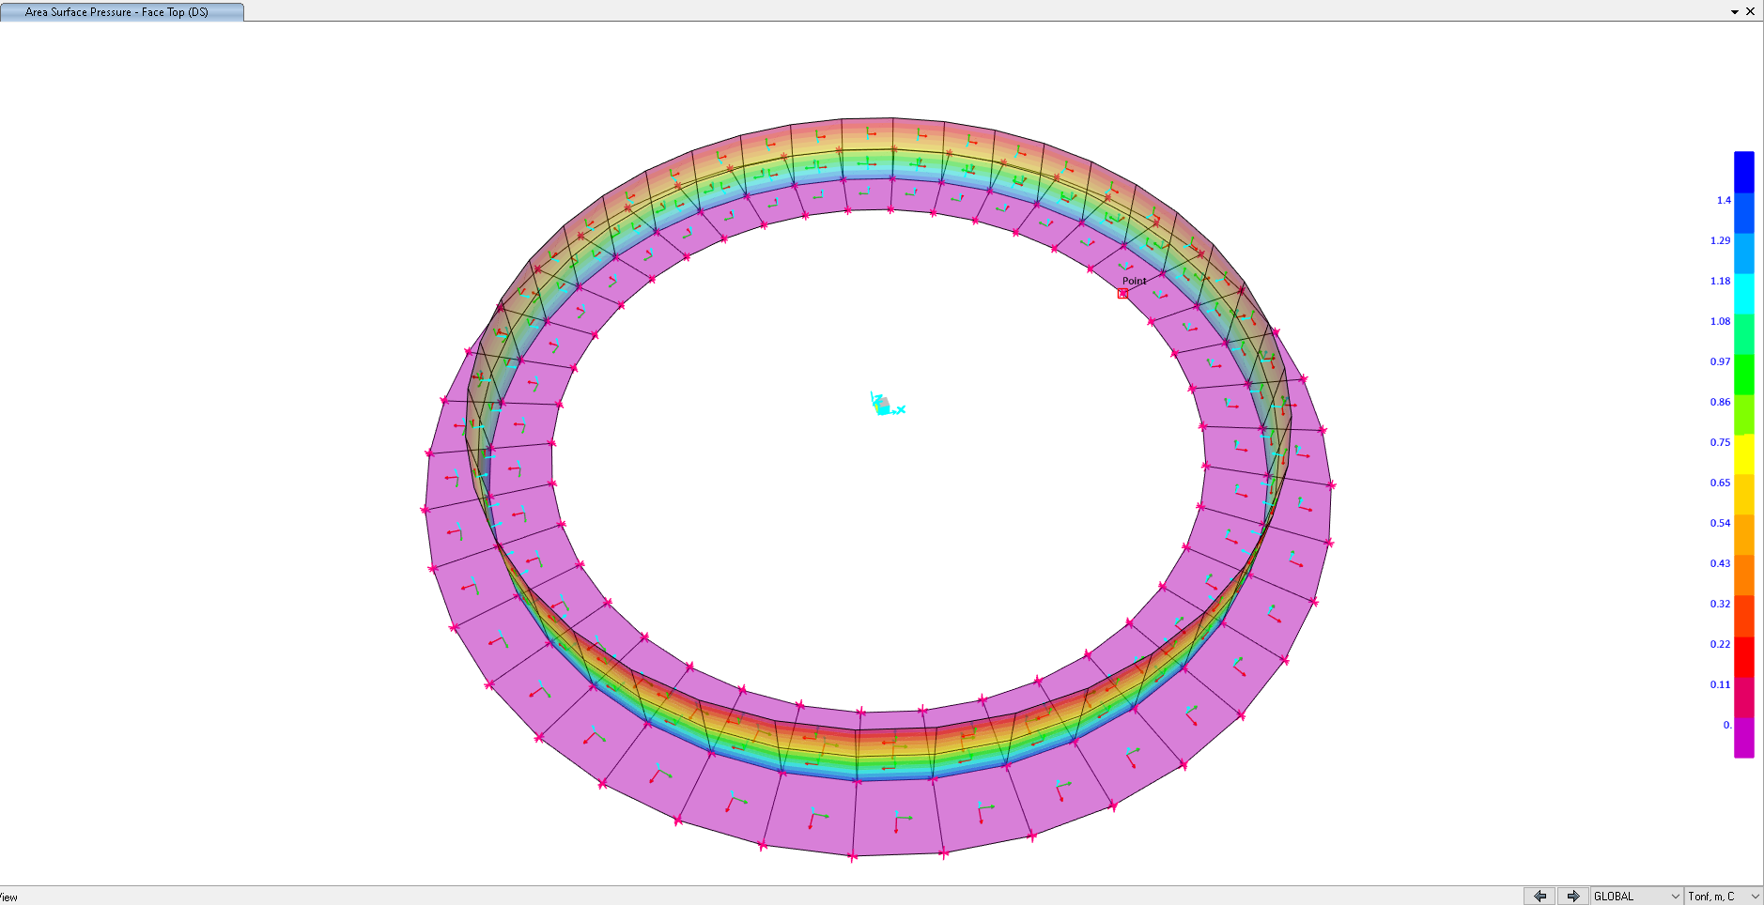

1. **area surface pressure for ring wall (face top)**
   1. **De (Total dead load of tank)**

Weight of empty tank: 45.283 ton

Weight of bottom plate: 9.353 ton

Weight of roof plate: 11.98 ton

Weight of shell with roof: 45.283 + 11.98 = 57.265 ton

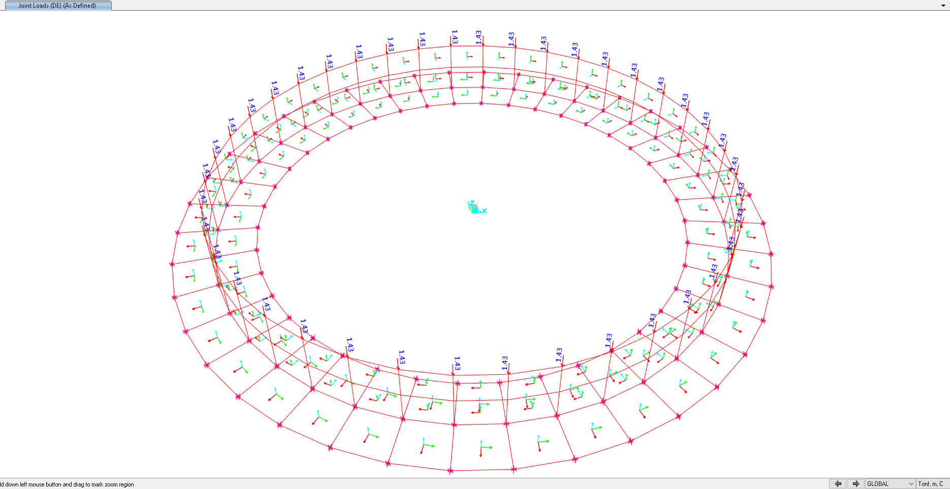De = 57.265/40(joint) = 1.43 ton

1. **joint load on ring wall** 
   1. **F (Normal Fluid Load)**

Normal Fluid Load on ring foundation:

F = Ope load / area of ring foundation → area of ring foundation: (𝜋 × 13²)/4 = 132.67 m → 1085.3 / 132.67 = 8.18 ton/m²

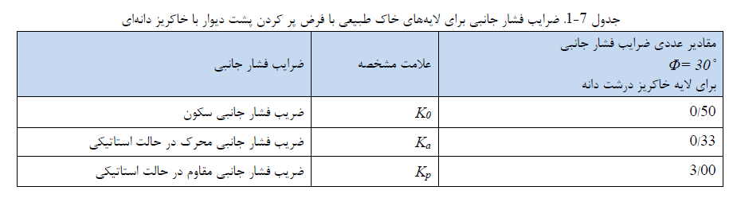Soil Pressure Due to Normal Fluid Load on Ring wall:

F = 8.18 × (Kₒ = 0.5) = 4.09 t/m²

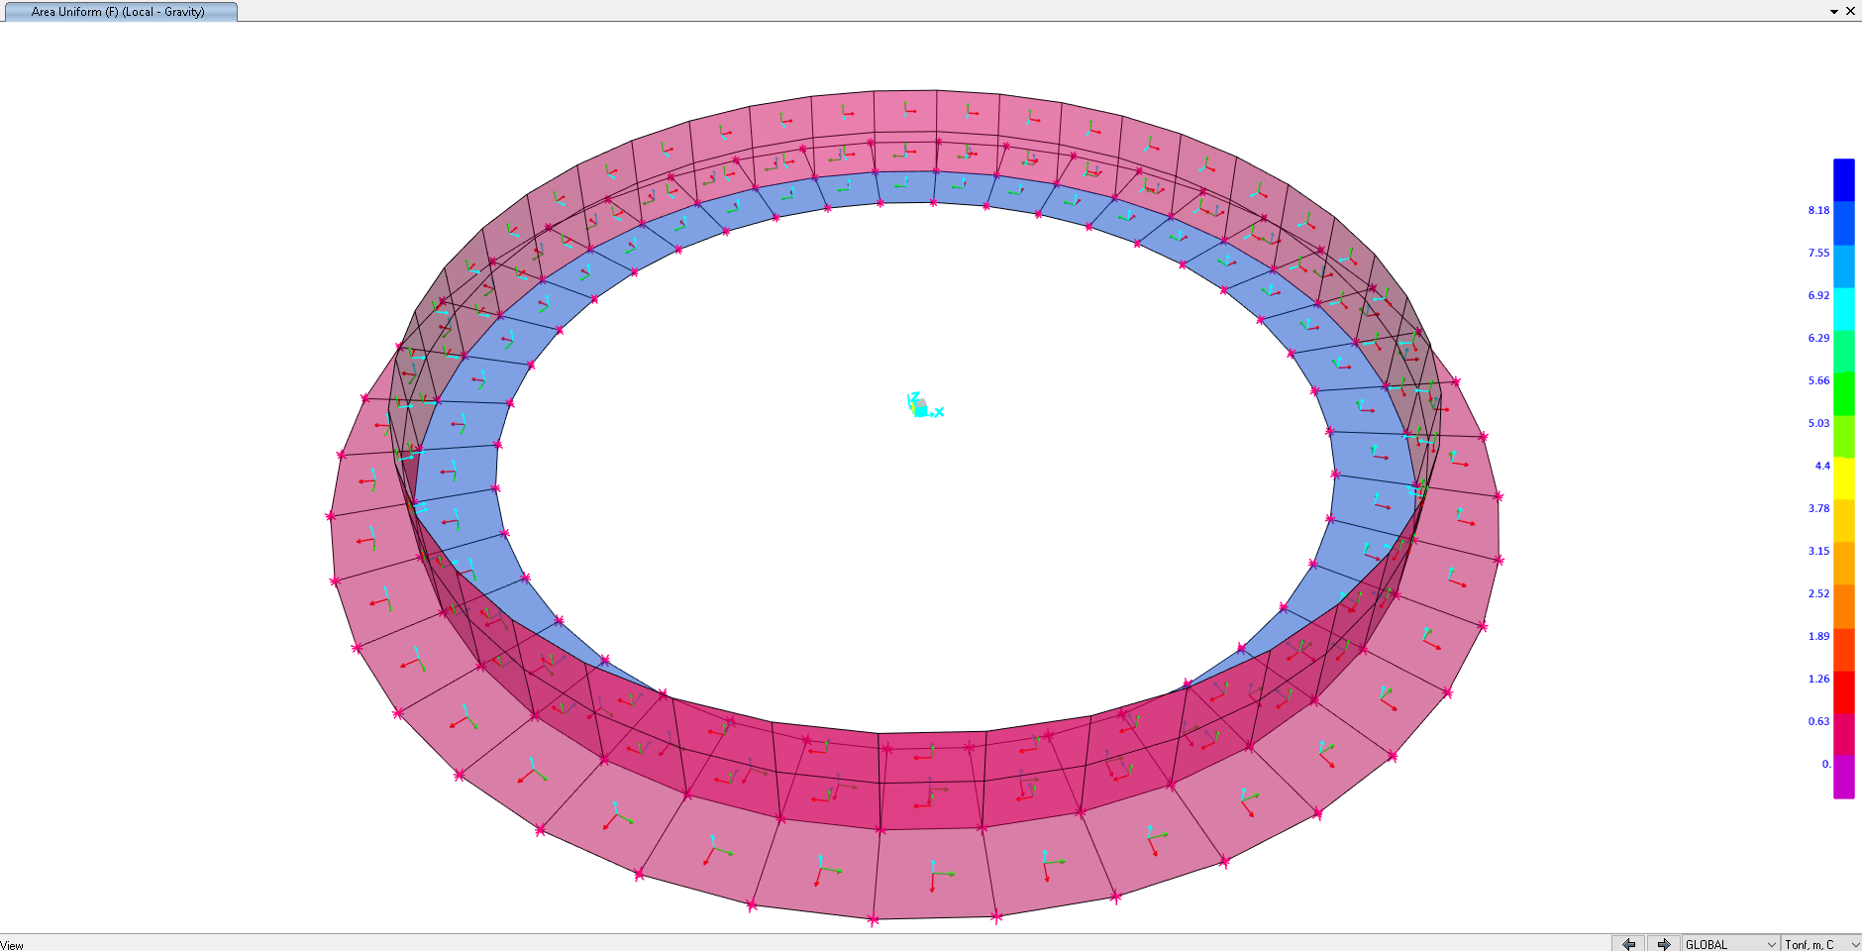

1. **area uniform F load on the inside ring foundation and ring wall** 
   1. **HT (Test Fluid Load)**

Test Load on ring foundation:

HT = Hydrotest load / area of ring foundation → area of ring foundation: (𝜋 × 13²)/4 = 132.67 m → 1305.3 / 132.67 = 9.84 ton/m²

Soil Pressure Due to Test Fluid Load on Ring wall:

HT = 9.84 × (Kₒ = 0.5) = 4.92 t/m²

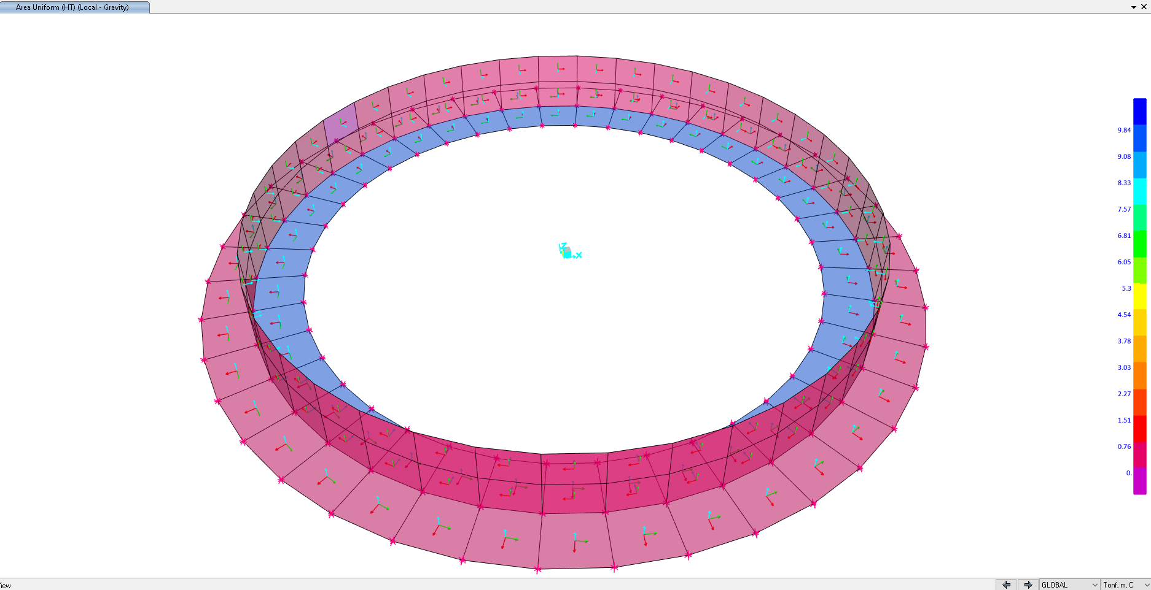

1. **area uniform HT load on the inside ring foundation and ring wall** 
   1. **E (Earthquake Load)**

Shear load = 1151613.8 N (based on Mechanical Data Sheet for fire water storage Tanks (TK-2301 A/B).

This shear is based on the datasheet, but we used API650 with ASD behavior coefficient so its value is multiplied by 1.4 → 1151613.8  1.4 = 1612259.3 N

Shear load based on earthquake on ring wall= 1612259.3 N / 40(joints) = 40306.5 N

Moment = 3679379.2 N.m (based on Mechanical Data Sheet for fire water storage Tanks (TK-2301 A/B).

This moment is based on the datasheet, but we used API650 with ASD behavior coefficient so its value is multiplied by 1.4 → 3679379.2  1.4 = 5151130.2 N.m

Based on this moment, we calculate the tensile and compressive force for each anchor bolt and place it in the position of each theme

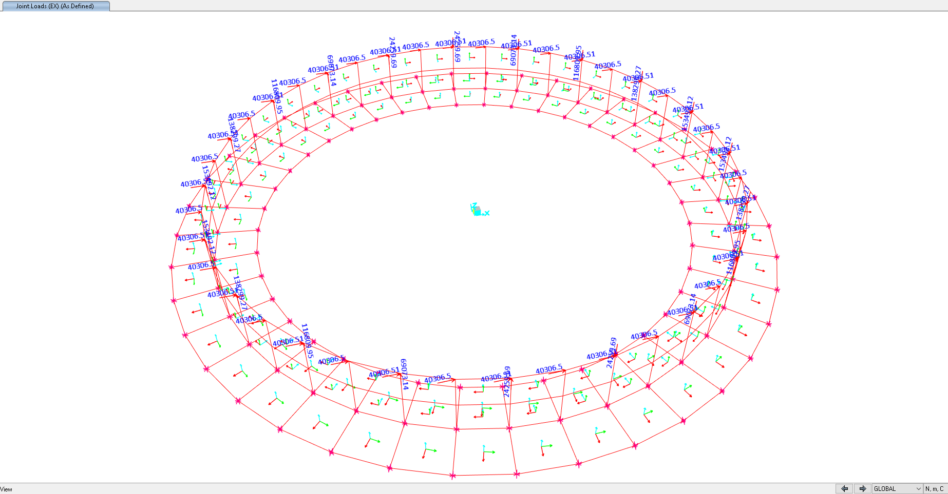

1. **joint load (EX) on ring wall and anchor bolt’s locations based on shear and moment of earthquake** 
   1. **W (Wind Load)**

Shear load = 110468.3 N (based on Mechanical Data Sheet for fire water storage Tanks (TK-2301 A/B).

Shear load based on wind on ring wall= 110468.3 N / 40(joints) = 2761.7N

Moment = 716860.7 N.m (based on Mechanical Data Sheet for fire water storage Tanks (TK-2301 A/B).

Based on this moment, we calculate the tensile and compressive force for each anchor bolt and place it in the position of each theme

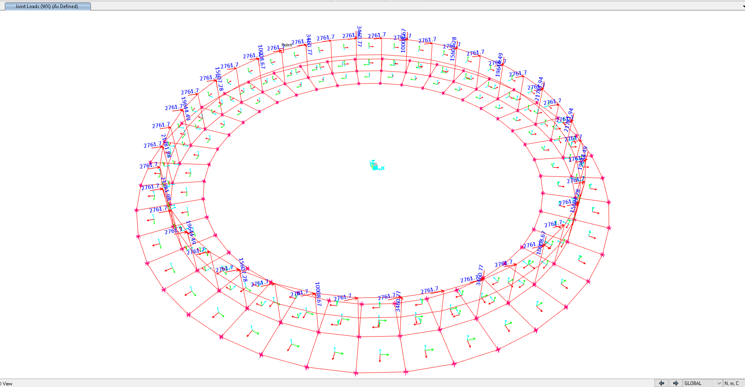

1. **joint load (WX) on ring wall and anchor bolt’s locations based on shear and moment of wind**
2. **Design Load Combinations**

|  |  |  |  |
| --- | --- | --- | --- |
| **Load Assignments** | | | |
| **Case** | **LoadType** | **LoadName** | **LoadSF** |
| Text | Text | Text | Unitless |
| A.A.O.1-NL | Load pattern | DE | 1 |
| Load pattern | DL | 1 |
| Load pattern | DS | 1 |
| Load pattern | F | 1 |
| A.A.O.2-NL | Load pattern | DE | 1 |
| Load pattern | DL | 1 |
| Load pattern | DS | 1 |
| Load pattern | F | 1 |
| Load pattern | WX | 1 |
| A.B.T.1-NL | Load pattern | DL | 1 |
| Load pattern | DE | 1 |
| Load pattern | DS | 1 |
| Load pattern | HT | 1 |
| Load pattern | WX | 0.25 |
| A.B.T.2-NL | Load pattern | DL | 0.6 |
| Load pattern | DE | 0.6 |
| Load pattern | DS | 0.6 |
| Load pattern | HT | 0.6 |
| Load pattern | WX | 0.25 |
| A.C.E.1-NL | Load pattern | DL | 1 |
| Load pattern | DE | 1 |
| Load pattern | DS | 1 |
| Load pattern | WX | 1 |
| A.C.E.2-NL | Load pattern | DL | 0.6 |
| Load pattern | DE | 0.6 |
| Load pattern | DS | 0.6 |
| Load pattern | WX | 1 |
| A.D.E.1-NL | Load pattern | DL | 1 |
| Load pattern | DS | 1 |
| Load pattern | DE | 1 |
| Load pattern | F | 1 |
| Load pattern | EX | 0.7 |
| A.D.E.2-NL | Load pattern | DL | 0.6 |
| Load pattern | DS | 0.6 |
| Load pattern | DE | 0.6 |
| Load pattern | F | 0.6 |
| Load pattern | EX | 0.7 |
| S.A.O.1-NL | Load pattern | DL | 1.4 |
| Load pattern | DS | 1.4 |
| Load pattern | DE | 1.4 |
| Load pattern | F | 1.4 |
| S.A.O.2-NL | Load pattern | DL | 1.2 |
| Load pattern | DS | 1.2 |
| Load pattern | DE | 1.2 |
| Load pattern | F | 1.2 |
| Load pattern | WX | 1 |
| S.A.O.3-NL | Load pattern | DL | 0.9 |
| Load pattern | DS | 0.9 |
| Load pattern | DE | 0.9 |
| Load pattern | F | 0.9 |
| Load pattern | WX | 1 |
| S.B.T.1-NL | Load pattern | DL | 1.2 |
| Load pattern | DE | 1.2 |
| Load pattern | DS | 1.2 |
| Load pattern | HT | 1.2 |
| Load pattern | WX | 0.25 |
| S.B.T.2-NL | Load pattern | DL | 0.9 |
| Load pattern | DE | 0.9 |
| Load pattern | DS | 0.9 |
| Load pattern | HT | 0.9 |
| Load pattern | WX | 0.25 |
| S.C.E.1-NL | Load pattern | DE | 1.2 |
| Load pattern | DL | 1.2 |
| Load pattern | DS | 1.2 |
| Load pattern | WX | 1 |
| S.C.E.2-NL | Load pattern | DE | 0.9 |
| Load pattern | DL | 0.9 |
| Load pattern | DS | 0.9 |
| Load pattern | WX | 1 |
| S.D.E.1-NL | Load pattern | DE | 1.2 |
| Load pattern | DL | 1.2 |
| Load pattern | DS | 1.2 |
| Load pattern | F | 1.2 |
| Load pattern | EX | 1 |
| S.D.E.2-NL | Load pattern | DE | 0.9 |
| Load pattern | DL | 0.9 |
| Load pattern | DS | 0.9 |
| Load pattern | F | 0.9 |
| Load pattern | EX | 1 |

1. **Tank ANALYSIS AND DESIGN** 
   1. **Tank geometry**

As noted before, the structure has modeled and analyzed by SAP2000. This figure shows a 3D view of the model in software.

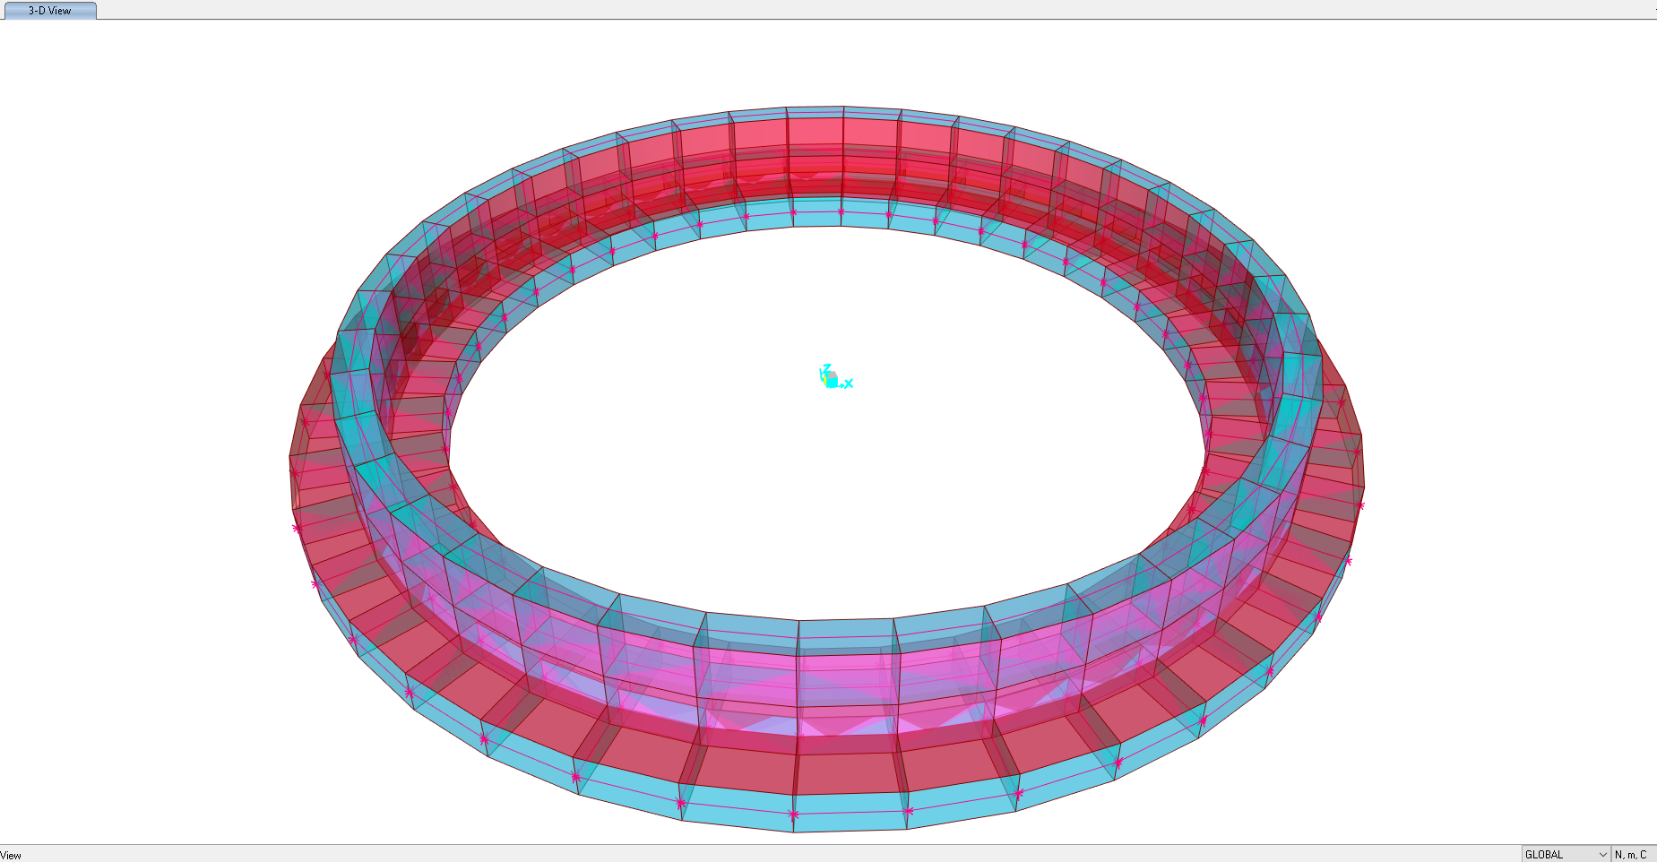

1. **3D model** 
   1. **Tank Design Results**







10. 2. 1. Soil Pressure Control

Soil pressures in different service load combinations should be checked by allowable value. The following figure is extracted from “SAP” model.

According to Geotechnical report Ks = 0.73 Kg/cm³ ,allowable settlement = 2.5 cm and Max soil pressure for this foundation is 1.80 Kg/cm², in this foundation maximum existing settlement is 1.686 cm and maximum existing stress is about 1.26 Kg/cm² .

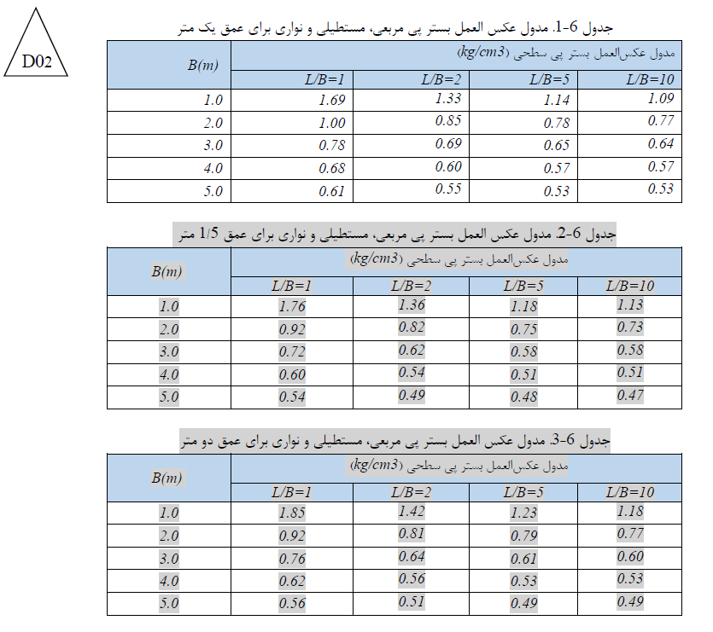

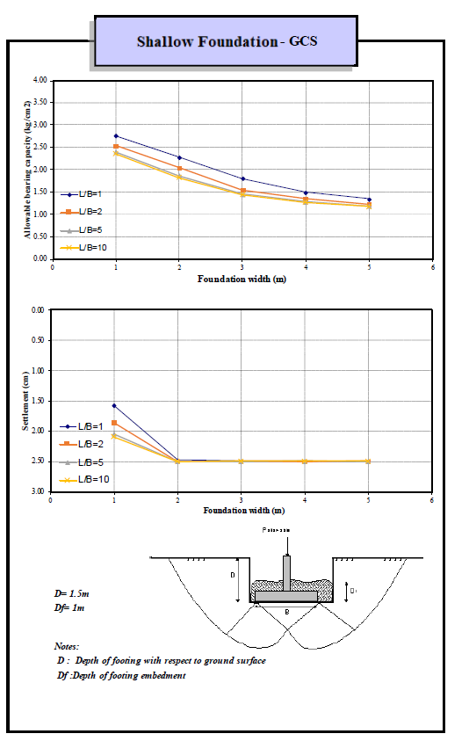

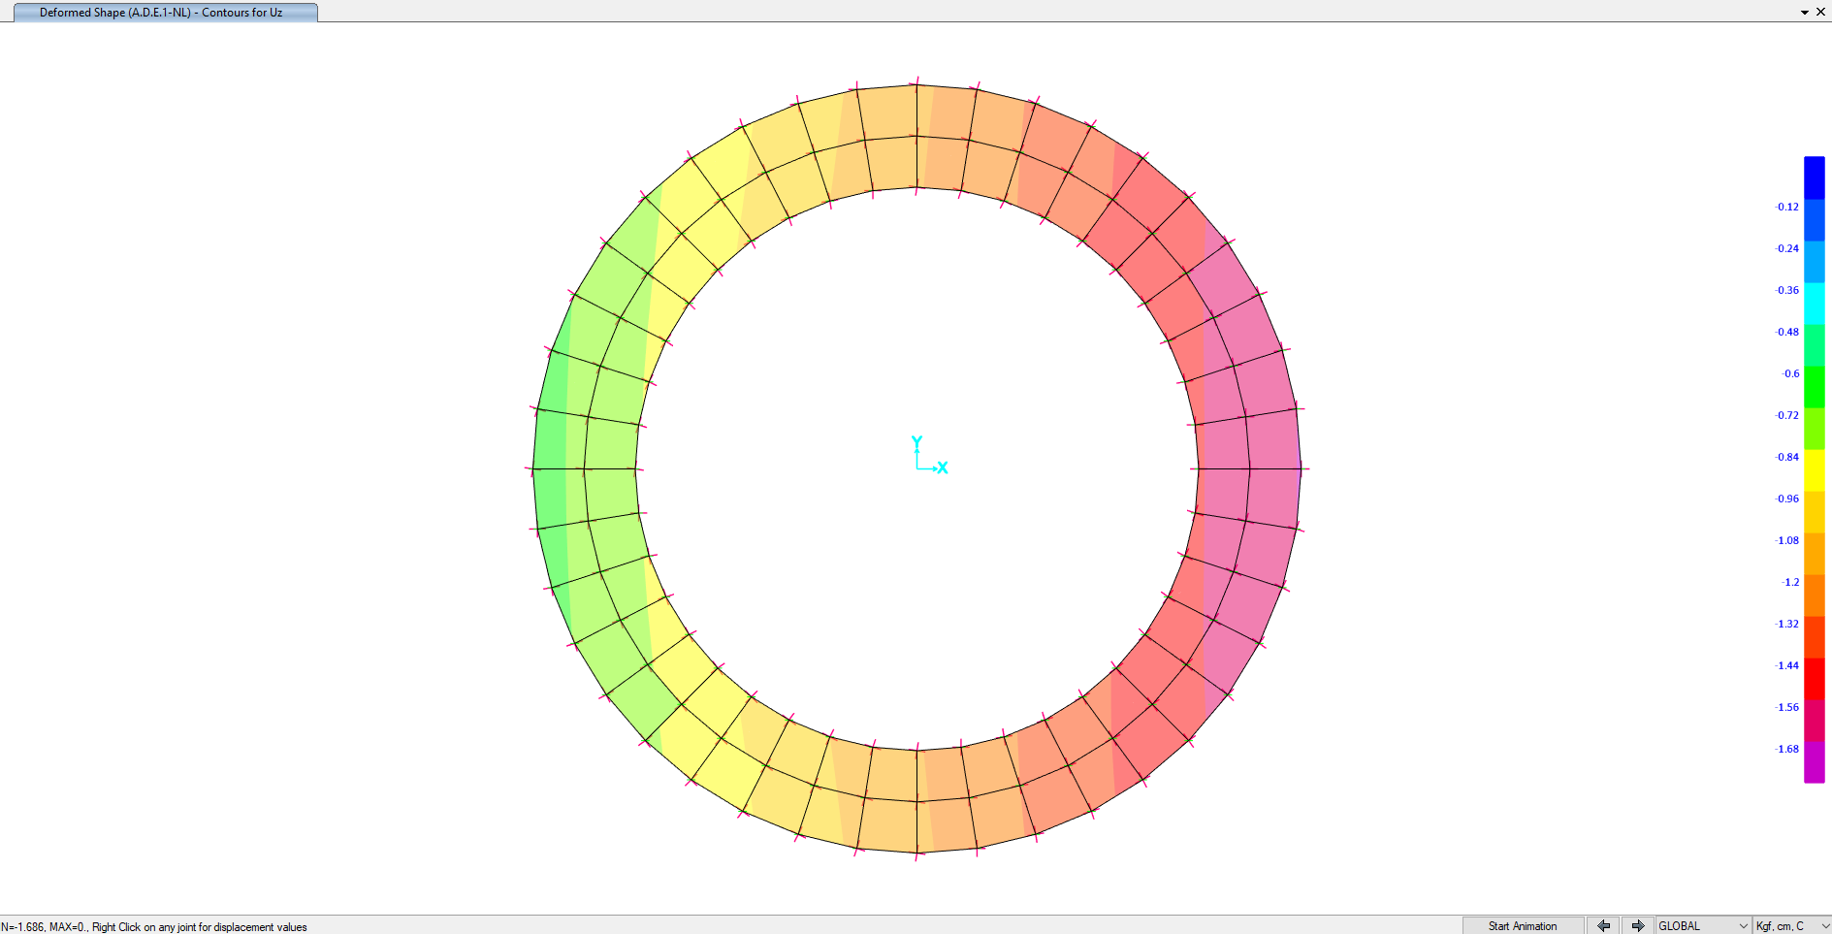

1. 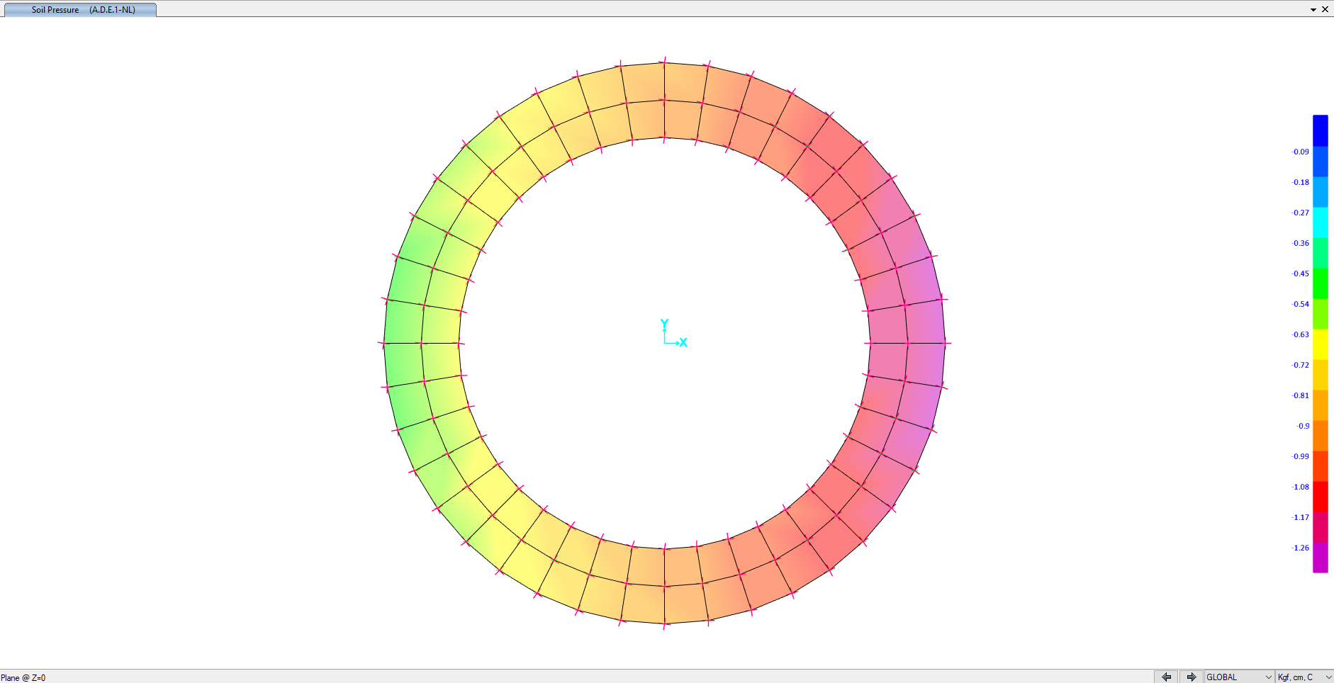**displacement shape (cm)**
2. **Soil pressure (kg/cm²)**
   * 1. Foundation reinforcement

According to ACI-318-08:

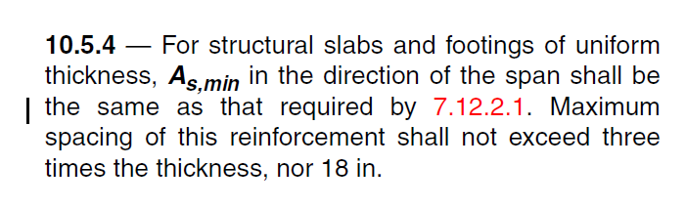

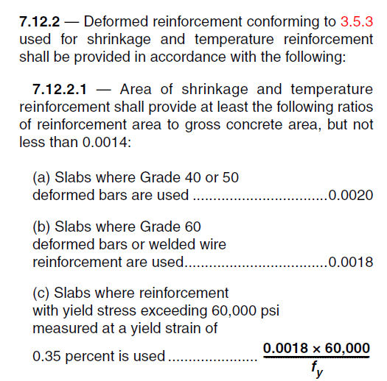

$A_{S,min}=0.0018×60×100=10.8{cm}^{2} for top and bottom$ → If use Φ 12@200 → A = 5.65cm² → 5.65 cm² ≤ 10.8/2 = 5.4 cm² → ok



1. **Foundation reinforcement plan**

$$fc=300 kg/cm²$$

$$fy=4000 kg/cm²$$

$$φ=0.9$$

$$As used=T12@200=5.6cm²$$

$$cover=75mm$$

$$h=600 mm$$

$$a=\frac{A_{s}f_{y}}{0.85b{fc}^{'}}=\frac{5.6*4000}{0.85*100*300}=0.9cm$$

$$M_{n}=0.9×5.6×4000×50.1=10.1 ton.m$$

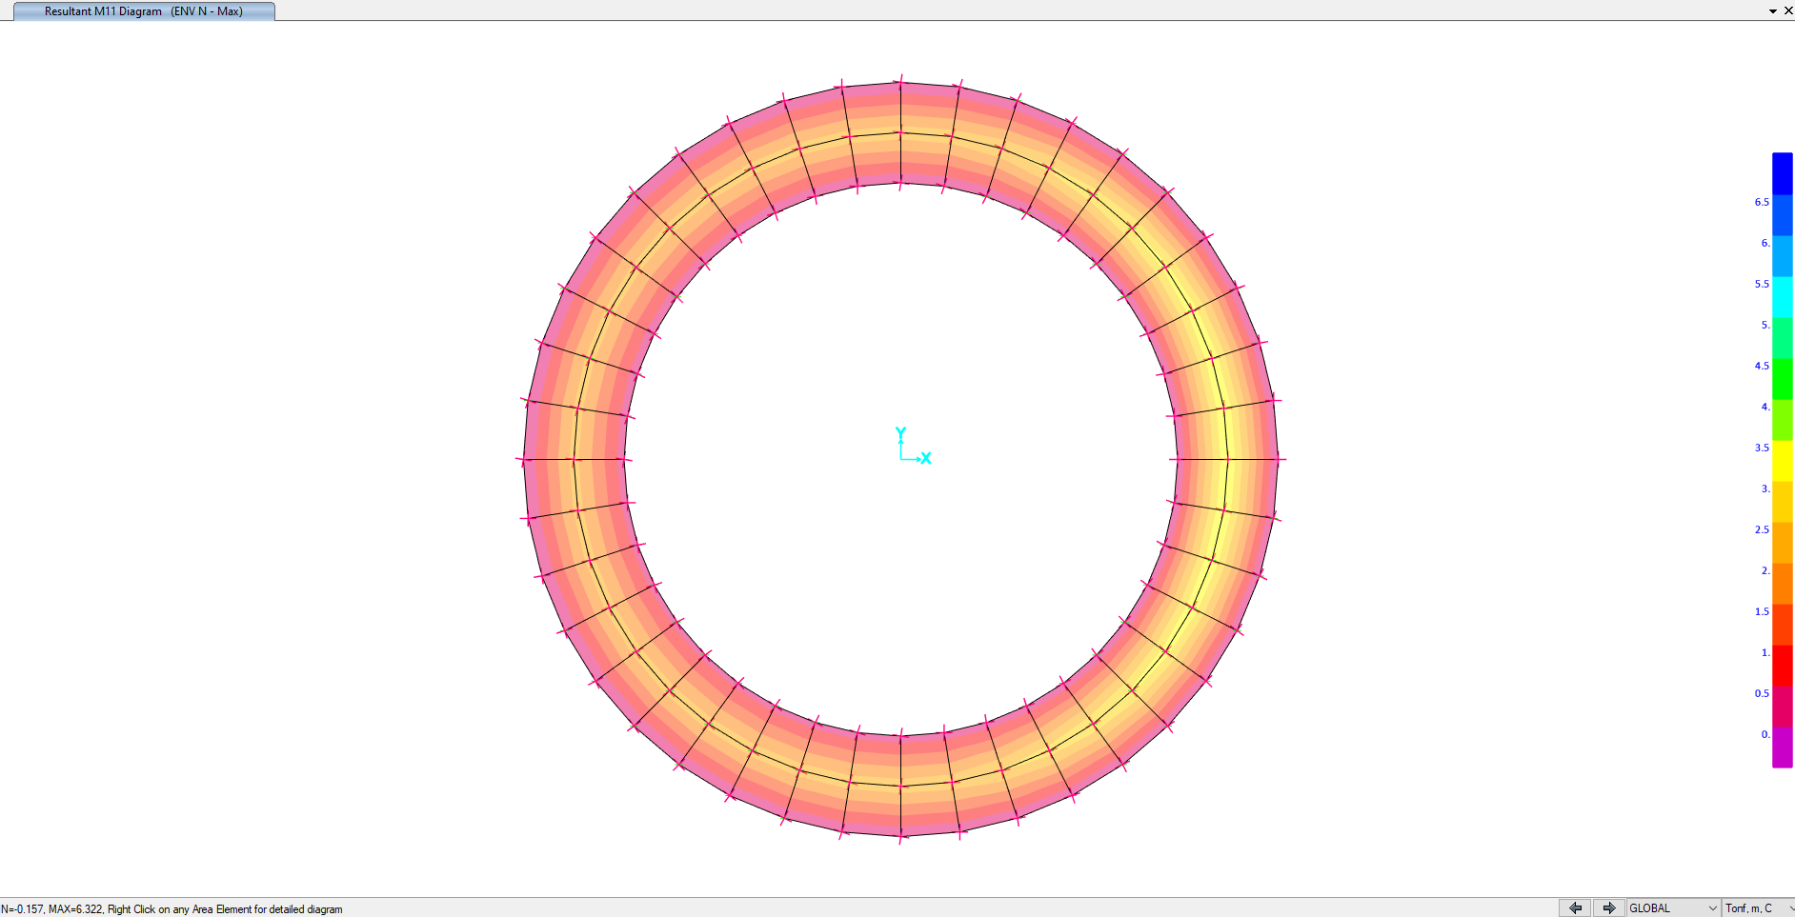

1. **M11 Max**

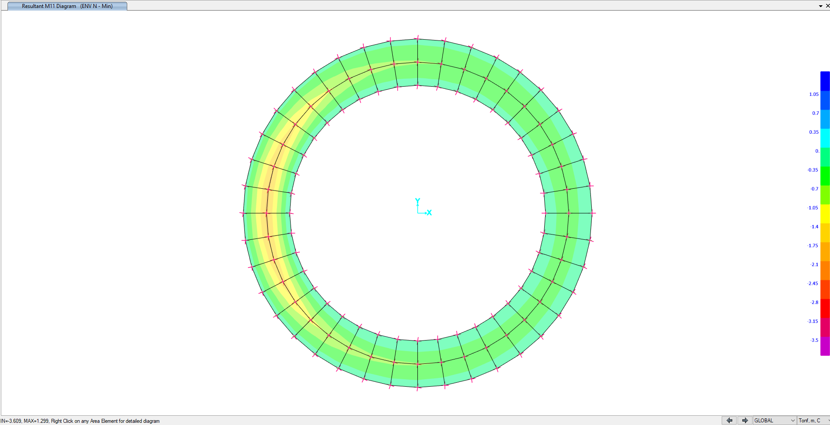

1. 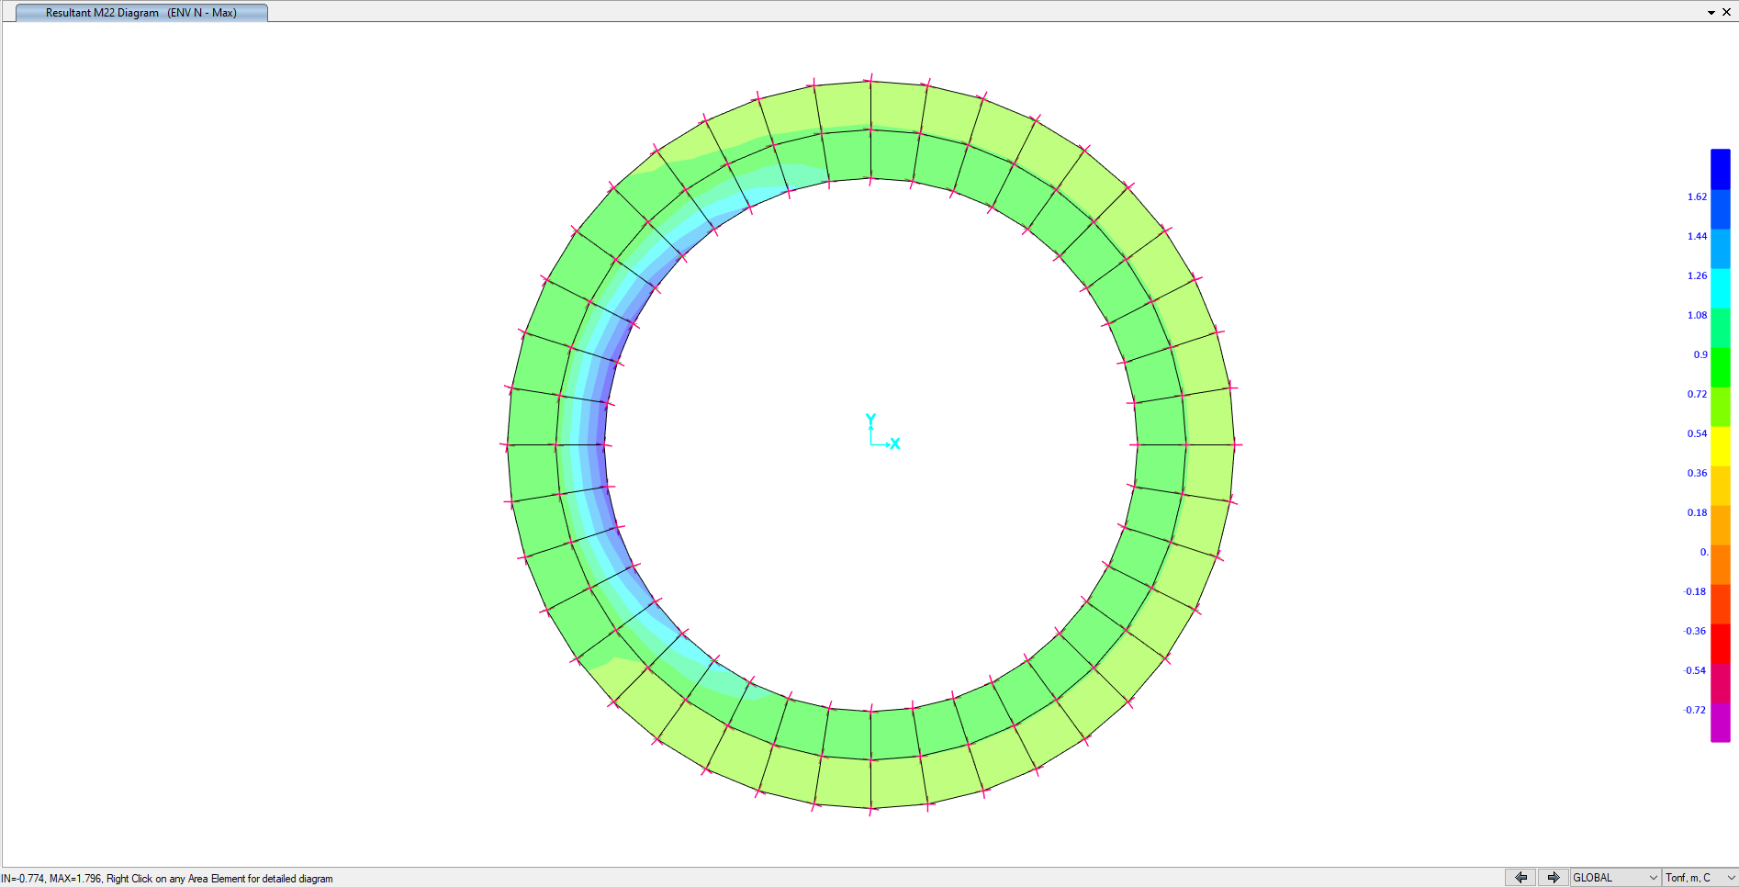**M11 Min**
2. **M22 Max**

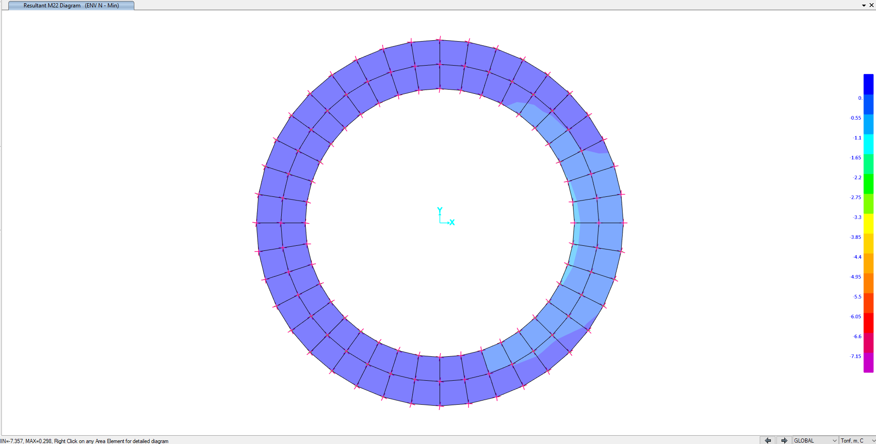

1. **M22 Min**