|  |  |  |  |  |  |  |  |
| --- | --- | --- | --- | --- | --- | --- | --- |
| **طرح نگهداشت و افزایش تولید 27 مخزن** | | | | | | | |
| **CONSEQUENCE MODELING REPORT**  **نگهداشت و افزایش تولید میدان نفتی بینک** | | | | | | | |
|  |  |  |  |  |  |  |
|  |  |  |  |  |  |  |
|  |  |  |  |  |  |  |
| D01 | SEP. 2023 | AFC | A.H.Saber | M.Fakharian | A.M.Mohseni |  |
| D00 | NOV. 2021 | IFC | E.Sadeghi | M.Fakharian | M.Mehrshad |  |
| **Rev.** | **Date** | **Purpose of Issue/Status** | **Prepared by:** | **Checked by:** | **Approved by:** | **CLIENT Approval** |
| **Class: 1** | | **CLIENT Doc. Number: F0Z-709004** | | | | |
| **Status:** | **IDC: Inter-Discipline Check**  **IFC: Issued For Comment**  **IFA: Issued For Approval**  **AFD: Approved For Design**  **AFC: Approved For Construction**  **AFP: Approved For Purchase**  **AFQ:** Approved For Quotation  **IFI: Issued For Information**  **AB-R: As-Built for CLIENT Review**  **AB-A: As-Built –Approved** | | | | | |

**REVISION RECORD SHEET**

|  |  |  |  |  |  |  |  |  |  |  |  |  |
| --- | --- | --- | --- | --- | --- | --- | --- | --- | --- | --- | --- | --- |
| **PAGE** | **D00** | **D01** | **D02** | **D03** | **D04** |  | **PAGE** | **D00** | **D01** | **D02** | **D03** | **D04** |
| **1** | X | X |  |  |  | **66** |  |  |  |  |  |
| **2** | X | X |  |  |  | **67** |  |  |  |  |  |
| **3** | X |  |  |  |  | **68** |  |  |  |  |  |
| **4** | X |  |  |  |  | **69** |  |  |  |  |  |
| **5** | X |  |  |  |  | **70** |  |  |  |  |  |
| **6** | X |  |  |  |  | **71** |  |  |  |  |  |
| **7** | X |  |  |  |  | **72** |  |  |  |  |  |
| **8** | X |  |  |  |  | **73** |  |  |  |  |  |
| **9** | X |  |  |  |  | **74** |  |  |  |  |  |
| **10** | X |  |  |  |  | **75** |  |  |  |  |  |
| **11** | X |  |  |  |  | **76** |  |  |  |  |  |
| **12** | X |  |  |  |  | **77** |  |  |  |  |  |
| **13** | X |  |  |  |  | **78** |  |  |  |  |  |
| **14** | X |  |  |  |  | **79** |  |  |  |  |  |
| **15** | X |  |  |  |  | **80** |  |  |  |  |  |
| **16** | X |  |  |  |  | **81** |  |  |  |  |  |
| **17** | X |  |  |  |  | **82** |  |  |  |  |  |
| **18** | X |  |  |  |  | **83** |  |  |  |  |  |
| **19** | X |  |  |  |  | **84** |  |  |  |  |  |
| **20** | X |  |  |  |  | **85** |  |  |  |  |  |
| **21** | X |  |  |  |  | **86** |  |  |  |  |  |
| **22** | X |  |  |  |  | **87** |  |  |  |  |  |
| **23** | X |  |  |  |  | **88** |  |  |  |  |  |
| **24** | X |  |  |  |  | **89** |  |  |  |  |  |
| **25** | X |  |  |  |  | **90** |  |  |  |  |  |
| **26** | X |  |  |  |  | **91** |  |  |  |  |  |
| **27** | X |  |  |  |  | **92** |  |  |  |  |  |
| **28** | X |  |  |  |  | **93** |  |  |  |  |  |
| **29** | X |  |  |  |  | **94** |  |  |  |  |  |
| **30** | X |  |  |  |  | **95** |  |  |  |  |  |
| **31** | X |  |  |  |  | **96** |  |  |  |  |  |
| **32** | X |  |  |  |  | **97** |  |  |  |  |  |
| **33** | X |  |  |  |  | **98** |  |  |  |  |  |
| **34** | X |  |  |  |  | **99** |  |  |  |  |  |
| **35** | X |  |  |  |  | **100** |  |  |  |  |  |
| **36** | X |  |  |  |  | **101** |  |  |  |  |  |
| **37** | X |  |  |  |  | **102** |  |  |  |  |  |
| **38** | X |  |  |  |  | **103** |  |  |  |  |  |
| **39** | X |  |  |  |  | **104** |  |  |  |  |  |
| **40** | X |  |  |  |  | **105** |  |  |  |  |  |
| **41** | X |  |  |  |  | **106** |  |  |  |  |  |
| **42** | X |  |  |  |  | **107** |  |  |  |  |  |
| **43** | X |  |  |  |  | **108** |  |  |  |  |  |
| **44** | X |  |  |  |  | **109** |  |  |  |  |  |
| **45** | X |  |  |  |  | **110** |  |  |  |  |  |
| **46** | X |  |  |  |  | **111** |  |  |  |  |  |
| **47** | X |  |  |  |  | **112** |  |  |  |  |  |
| **48** | X |  |  |  |  | **113** |  |  |  |  |  |
| **49** | X |  |  |  |  | **114** |  |  |  |  |  |
| **50** | X |  |  |  |  | **115** |  |  |  |  |  |
| **51** | X |  |  |  |  | **116** |  |  |  |  |  |
| **52** | X |  |  |  |  | **117** |  |  |  |  |  |
| **53** | X |  |  |  |  | **118** |  |  |  |  |  |
| **54** | X |  |  |  |  | **119** |  |  |  |  |  |
| **55** | X |  |  |  |  | **120** |  |  |  |  |  |
| **56** | X |  |  |  |  | **121** |  |  |  |  |  |
| **57** | X |  |  |  |  | **122** |  |  |  |  |  |
| **58** | X |  |  |  |  | **123** |  |  |  |  |  |
| **59** |  |  |  |  |  | **124** |  |  |  |  |  |
| **60** |  |  |  |  |  | **125** |  |  |  |  |  |
| **61** |  |  |  |  |  | **126** |  |  |  |  |  |
| **62** |  |  |  |  |  | **127** |  |  |  |  |  |
| **63** |  |  |  |  |  | **128** |  |  |  |  |  |
| **64** |  |  |  |  |  | **129** |  |  |  |  |  |
| **65** |  |  |  |  |  | **130** |  |  |  |  |  |

**CONTENTS**

1.0 INTRODUCTION 5

2.0 Scope 6

3.0 NORMATIVE REFERENCES 6

3.1 International Codes and Standards 6

3.2 The Project Documents 6

3.3 ENVIRONMENTAL DATA 6

3.4 ABBREVIATIONS 6

3.5 PURPOSE 7

3.6 DEFINITION 8

3.6.1 MAJOR FAILURE 8

3.6.2 FIRE ZONE 8

3.6.3 RESTRICTED AREA 9

3.6.4 IMPACTED AREA 9

3.6.5 VCE (Vapor cloud explosion) 10

3.6.6 blast 10

3.6.7 jet fire 10

4.0 Process consequence modeling 10

4.1 basic of the calculation 10

4.1.1 applied documents and used software 10

4.1.2 process data 10

4.1.3 weather condition 15

4.1.4 SCENARIO SELECTION 16

4.1.5 Source 18

4.1.5.1 Source process condition 19

4.1.5.2 Inventory 19

4.1.5.3 Leak Size 19

4.1.5.4 Leak elevation 19

4.1.5.5 SENSITIVITY OF EFFECTIVE PROCESS PARAMETER ON OUTCOMES 20

4.1.5.6 Pressure 20

4.1.5.7 Temperature 20

4.1.5.8 Inventory 20

4.1.5.9 Release direction 20

4.2 FIRE ZONE, RESTRICTED AND IMPACTED AREA 20

4.2.1 Fire Zone 22

4.2.1.1 FIRE ZONE CRIDIBLE SCENARIOS AND CONSEQUENCES 23

4.2.1.2 FIRE ZONES DESCRIPTION 23

4.2.1.3 FIRE ZONE STUDY RESULTS 29

4.2.1.4 ESDV FIRE ZONE RESULTS 33

4.2.2 RESTRICTED & IMPACTED AREA 38

4.2.2.1 Restricted & Impacted Area Credible Scenarios And Consequences Restricted Area Criteria 39

4.2.2.2 Impacted Area Criteria 39

4.2.2.3 Restricted AND IMPACTED Area Results FOR FLAMMABILITY AND THERMAL RADIATION 40

4.2.2.4 Congested Areas Specifications and Overpressure Results for Restricted and Impacted 43

4.2.2.1 Restricted AND IMPACTED Area Results FOR TOXICITY 43

5.0 blast study on building 45

5.1 Purpose 45

5.2 Methodology 45

5.3 Congested Zone Selection Approach 46

5.4 BLAST STUDY RESULT 50

6.0 Conclusion 50

6.1 FIRE ZONE 50

6.2 Restricted Area 53

6.3 Impacted Area 55

7.0 APPENDIX a – FIRE ZONE, IMPACTED AND RESTRICTED AREA LAYOUTS 57

8.0 Appendix b – simulation (phast) files 58

1. **INTRODUCTION**

Binak oilfield in Bushehr province is a part of the southern oilfields of Iran, is located 20 km northwest of Genaveh city.

With the aim of increasing production of oil from Binak oilfield, an EPC/EPD Project has been defined by NIOC/NISOC and awarded to Petro Iran Development Company (PEDCO). Also, PEDCO (as General Contractor) has assigned the EPC-packages of the Project to "Hirgan Energy - Design and Inspection" JV.

As a part of the Project, a New Gas Compressor Station (adjacent to existing Binak GCS) shall be constructed to gather of 15 MMSCFD (approx.) associated gases and compress & transfer them to Siahmakan GIS.

**GENERAL DEFINITION**

The following terms shall be used in this document.

|  |  |
| --- | --- |
| CLIENT: | National Iranian South Oilfields Company (NISOC) |
| PROJECT: | Binak Oilfield Development – Surface Fcilities; New Gas Compressor Station |
| EPD/EPC CONTRACTOR (GC): | Petro Iran Development Company (PEDCO) |
| EPC CONTRACTOR: | Joint Venture of: Hirgan Energy – Design & Inspection (D&I) Companies |
| VENDOR: | The firm or person who will fabricate the equipment or material. |
| EXECUTOR: | Executor is the party which carries out all or part of construction and/or commissioning for the project. |
| THIRD PARTY INSPECTOR (TPI): | The firm appointed by EPD/EPC CONTRACTOR (GC) and approved by CLIENT (in writing) for the inspection of goods. |
| SHALL: | Is used where a provision is mandatory. |
| SHOULD: | Is used where a provision is advisory only. |
| WILL: | Is normally used in connection with the action by CLIENT rather than by an EPC/EPD CONTRACTOR, supplier or VENDOR. |
| MAY: | Is used where a provision is completely discretionary. |

1. **Scope**

The analysis considered all the units identified as part of the New Gas Compressor Station (adjacent to existing Binak GCS). In current report consequence of major hazards, such as Fire, explosion and toxic gas dispersion, associated with a process area has been reported and analyzed. Fire Zone, Restricted Area, Impacted Area have been evaluated in different sections of this study.

1. **NORMATIVE REFERENCES**

## International Codes and Standards

* API RP 752 (2009) Management of Hazard Associated with Location of Process Plant Permanent Buildings
* TOTAL GS-EP- SAF-253 (2012)  Impacted area, restricted area and fire zones
* TOTAL GS-EP-SAF-041 (2011) Technological Risk Assessment
* TOTAL GS-EP-SAF-221 (2011) Safety rules for buildings

## The Project Documents

* BK-GNRAL-PEDCO-000-PR-DB-0001 Process Basis of Design
* BK-GCS-PEDCO-120-PR-DP-0001 Process & Utility Description
* BK-GCS-PEDCO-120-PR-PH-0002 Control Philosophy
* BK-GCS-PEDCO-120-PR-PF-0001 Process Flow Diagram (PFD)
* BK-GCS-PEDCO-120-PI-PY-0001 Unit Plot Plan Drawing

## ENVIRONMENTAL DATA

Refer to "Process Basis of Design; Doc. No. BK-GNRAL-PEDCO-000-PR-DB-0001".

## ABBREVIATIONS

* API American Petroleum Institute
* ESD Emergency Shutdown
* ESDV Emergency Shutdown Valve
* H2S Hydrogen Sulphide
* HSE Health, Safety & Environment
* HVAC Heating, Ventilation and Air Conditioning
* LFL Lower Flammable Limit
* MW Molecular Weight
* PFD Process Flow Diagram
* P&ID Piping and Instrumentation Diagram
* IDLH Immediately Dangerous to Life and Health
* TLV Threshold Limit Value
* VCE Vapor Cloud Explosion
* PPM Part Per Million

## PURPOSE

The purpose of this document is “identifying contours of Fire Zone, Impacted and Restricted area”. This approach is aimed at fulfilling a two-fold objective:

* Based upon unit lay-out, nature of equipment and risks (nature and level) associated to equipment, provide means or take dispositions that shall ensure:
  + - Prevention of ignition: Separate, as far as practicable, ignition sources from fuel sources.
    - Mitigation: Minimize the consequences of fires, explosions and other hazard; prevent escalation of fire to other areas; minimize hydrocarbon inventory in areas where fire initiated (isolation and depressurization); focus active fire-fighting to one single zone and improve the emergency response; contain the risk within the boundaries of the installation and avoid exposure of public to hazards.
    - Escape, Evacuation and Rescue: Protect personnel from fire and explosion in the escape routes to a safe area.
* Provide tools that will ensure the safety of public that may be present, either permanently or just passing by, in the vicinity of production facilities.

This study will cover the following zones:

* Process facilities including:
  + Compressors
  + Suction drums
  + KO drums
  + Air coolers
  + Fuel gas KO drum
  + Dehydration Package
* Buildings
* Flare system

The following zones will not be studied:

* Non-flammable systems
  + Fire Water station (fire water tank and distribution system)
  + Raw Water System
  + Nitrogen System
  + Utility Air System
  + Instrument Air System
* Other systems
  + Diesel System (as flash point is higher than ambient temperature)
  + Non-hazardous Open Drain System (as does not normally contain hydrocarbon)
  + Closed drain System (as flow rate and pressure are usually low)
  + Pig launcher (it is not in continuous service and safety checks will be done before operation)

## DEFINITION

## MAJOR FAILURE

A conceivable incident that can possibly occur on the facility, selected out of a list of reference incidents based on experience and considering that mitigation measures have been implemented and protection systems have operated as required.

## FIRE ZONE

Fire Zones are the areas within the installation where equipment is grouped by nature and/or homogeneous level of risk attached to them.

The partition of an installation into fire zones results in a significant reduction of the level of risk. This implies that consequences of a fire, flammable gas leak or an explosion corresponding to the credible event likely to occur in the concerned fire zone, shall not impact other fire zones to an extent where their integrity could be put at risk.

## RESTRICTED AREA

The Restricted Area is the area within the boundaries of the installation and hence under the control of Client. The restricted area is affected:

• Permanently by normal operation of the facility

• Exceptionally by the consequences of an emergency situation caused by a major failure.

Within the restricted area, Client shall have control of all possible sources of ignition, including vehicles. A security fence shall include at least the restricted area.

## IMPACTED AREA

The Impacted Area is the area that extends beyond the boundaries of the installation but which is nevertheless affected either permanently by normal operation of the facility (e.g., noise or radiation) or exceptionally by the consequences of an emergency situation caused by a major failure. The impacted area is not under the control of Client but agreement shall be formalized with Local Authorities to minimize presence of public (e.g., to limit construction of buildings, in particular permanent settlements, or operation of transportation means open to public).

Typical layout of Fire Zone, Restricted and Impacted area is shown in ‎0.



**Figure 1- Typical layout - Fire zoning, restricted and impacted areas boundaries**

## VCE (Vapor cloud explosion)

One of the physical phenomena that may occur after the accidental release of dangerous goods is a vapor cloud explosion. A vapor cloud can be created by either the release of a gas from containment or by the evaporation of a liquid that was released from containment.

The explosion resulting from an ignition of a premixed cloud of flammable vapor, gas or spray with air, in which flames accelerate to sufficiently high velocities to produce significant overpressure. This type of explosion can occur in a confined enclosed unit or in a congested open unit.

## blast

A characteristic feature of explosions is blast. Vapor cloud explosions are characterized by rapid combustion in which high-temperature combustion products expand and affect the surroundings. In this fashion, the heat of combustion of a fuel-air mixture (chemical energy) is partially converted into expansion (mechanical energy). Mechanical energy is transmitted into the surrounding atmosphere in the form of a blast-wave.

## jet fire

Jet fires are burning jets of gas or atomized liquid whose shape is dominated by the momentum of the release. A jet fire is an intense fire that gives rise to high levels of thermal radiation at a considerable distance. If compressed or liquefied gases are released from storage tanks or pipelines, the materials discharging through the hole will form a gas jet that entrains and mixes with the ambient air. If the material encounters an ignition source while it is in the flammable range, a jet fire may occur.

1. **Process consequence modeling**

## basic of the calculation

## applied documents and used software

The calculations for the consequences analysis are made according to the Total Exploration Production document TOTAL-GS-SF-253 General Specification Safety of Impacted Area, Restricted Area and Fire Zones. The software used for the consequence analysis has been PHAST 8 (DNV).

## process data

The data used is the design data available at detail stage of the project, such as noted in PFD’s, Process Heat and Material Balances, P&ID and in some cases equipment data sheets. For each case, the most conservative process data are taken into consideration to perform the simulation.

There is only one process fire zone including three compressor trains with all related accessories.

For composition of streams to be referred to appendixes.







Figure 2; PFD of BINAK GCS

## weather condition

The meteorological conditions envisaged for the simulations are the following:

**Ambient temperature:**

* Min. average ambient temperature (°C): 18.75 °C
* Max. Average ambient temperature (°C): 33.03 °C

**Relative humidity:**

|  |  |
| --- | --- |
| * Maximum Range: | 60.52% |
| * Average Relative Humidity | 54.7% |
| * Minimum Relative Humidity: | 34.94% |

**Solar radiation:**

Solar radiation (maximum): 1010 W /m2

**Wind condition:**

|  |  |
| --- | --- |
| * Max. wind velocity: | 28.33 m/s |
| * Normal Wind Velocity | 5.96 m/s |
| * Prevailing wind direction: | NW to SE |
| * Prevailing wind Velocity: | > 7 m/s |

For all scenarios, the simulations are made with 4 wind speeds: 2 m/s, 5 m/s, 15 m/s and 28 m/s considering a neutral atmosphere by Pasquil class respectively F and D.

Finally, four different classes are selected as illustrated in table 1:

**Table 1 :Overview of weather condition**

|  |  |  |  |  |
| --- | --- | --- | --- | --- |
| **Weather Condition** | **F2** | **D5** | **D15** | **D28** |
| Pasquil Class | F | D | D | D |
| Wind Speed (m/s) | 2 | 5 | 10 | 20 |
| Average Temperature °C | 18.75 | 33 | 33 | 33 |
| Solar Radiation. kW/m² | 0 | 1 | 1 | 1 |

## SCENARIO SELECTION

The term “scenario” is used as an accident initiator, which is usually represented by a variety of leakage/ full bore ruptures with different sizes in pressurized equipment, piping and fittings (due to process upset, incorrect materials of construction, design error, over pressure, corrosion, equipment malfunction, operational error, and abnormal operation).

Each scenario is characterized by the following specifications:

* Source (single equipment or a group of equipment which feed the leak)
* Source process condition (normal process condition just behind the leak including, material composition, phase, pressure and temperature)
* Inventory (the amount of potential material which is discharge through leak)
* Leak size (representative hole diameter)
* Leak elevation

Based on Total GS-EP-SAF-253; the table below gives the definition of the main typical scenario outcomes applicable to oil and gas production and processing installations. Some of these scenarios will not be studied due to not availability of required specific conditions. For more detail to be referred to the below table:

Table 2 : typical scenarios and chance of occurrence

| **Scenario outcome** | **Definition** | **Specific conditions** |
| --- | --- | --- |
| Un-ignited gas/spray cloud (flammable gas cloud or flammable atmosphere) | Mixture of flammable gas or vapor in air which will burn when ignited (ISO). | It could be happened on all hydrocarbon vessel/compressors. |
| Un-ignited gas/spray cloud (toxic gas cloud) | Mixture of toxic gas or vapor in air (Client). | Due to not existence of toxic gas in process streams, there will not be chance of toxic gas dispersion on the site. |
| Vapor Cloud Explosion in unit (VCE) | The explosion resulting from an ignition of a premixed cloud of  flammable vapor, gas or spray with air, in which flames accelerate  to sufficiently high velocities to produce significant overpressure  (Yellow Book, TNO, 1997).  This type of explosion can occur in a confined enclosed unit or in a congested open unit (Client). | It could be happened in compressor shelter area. |
| Pool fire | Combustion of flammable or combustible liquid spilled and retained on a surface (ISO).  Combustion of material evaporating from a layer of liquid at the base of the fire (UKOOA). | As there is no any dike wall, retention basin, this scenario will not be studied. |
| Jet fire | The combustion of material emerging from an orifice with a significant momentum (UKOOA). Ignited release of pressurized flammable fluids (ISO). | It could be happened. |
| Boiling Liquid Expanding Vapor Explosion (BLEVE) & boil over | BLEVE: sudden rupture due to fire impingement of a vessel and/or system containing liquefied flammable gas under pressure; the pressure burst and the flashing of the liquid to vapor creates a blast wave and potential missile damage, and immediate ignition of the expanding fuel-air mixture leads to intense combustion creating a fireball (UKOOA).  Boil over: expulsion of crude oil (or certain other liquids) from a burning tank. The light fractions of the crude oil burn off producing a heat wave in the residue, which on reaching a water stratum may result in the expulsion of a portion of the contents of the tank in the form of froth (OSHA). | As there is no any liquefied flammable gas under pressure this scenario will not be studied.  [NFPA](https://en.wikipedia.org/wiki/National_Fire_Protection_Association) defines boil-over as: An event in the burning of certain oils in an open-top tank when, after a long period of quiescent burning, there is a sudden increase in fire intensity associated with expulsion of burning oil from the tank. As there is no any open-top tank, this scenario will not be studied. |
| Blowout | When well pressure exceeds the ability of the wellhead valves to control it. Oil and gas “blow wild” at the surface (UKOOA). | Wellhead study is not in scope of this project. So this scenario will not be studied. |
| Fixed roof tank explosion | Confined explosion of a fuel-oxidant mixture inside a closed system such as vessel, module, etc. (UKOOA). | There is no any hydrocarbon storage tank, so this scenario will not be studied. |
| Flare normal operation | Maximum Continuous Flaring (MCF): flaring the largest allowable  steady flow of combustible gas in normal operating conditions  (Client).  Emergency Flaring (EF): flaring a peak flow of combustible gas in upset or emergency operating conditions (Client). | It will be studied. |
| Flare flame out: flammable and/or  toxic | Unignited flare gas release. | It will be studied. |
| Cold vents | Vent handling significant flow rates generally from pressurized equipment. The word “cold” meaning without flame (Client). | Cold vent is not in scope of this project, so this scenario will not be studied. |
| Degassing vents | Vent handling low flow rates, generally from atmospheric equipment. A degassing vent is a non-ignited vent to atmosphere. (Client). | There is no such a case in this project, so this scenario will not be studied. |
| LPG pool vaporization | Vaporization of liquid LPG spilled and retained on a surface | LPG will not be used in this project, so this scenario will not be studied. |

## Source

It is obvious that process condition such as composition, phase and temperature are changed through the process. In order to consider this change in consequence modeling and analysis, the process facilities should be divided to different isolated process segments (separated by SDVs, ESDVs). Thus, each segment has its own gas and liquid inventory during a release. After this classification, any part of these segments that may cause different scenario outcomes because of different process conditions will be considered as an independent scenario. Figure 3 shows an example of Isolated process segment.

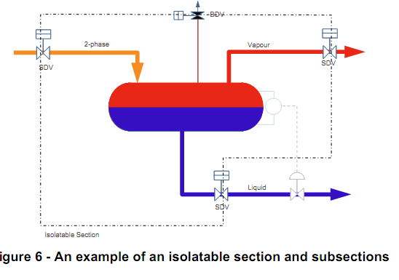

Figure 3 -An example of an isolatable process segment

## Source process condition

New Binak gas compression station includes 3 train compressors with all related accessories and Dehydration package which handle hydrocarbon gases.

## Inventory

Inventory is defined as the amount of potential material, which is discharged through leak; this parameter depends on both capacity and isolation time.

## Leak Size

In accordance with TOTAL-GS-SF-253, different leak size criteria are defined for various purposes.

## Leak elevation

Leak elevation determines the height that the material is released from the leakage source. Based on TOTAS-GS-253 section 7.2, the leak elevation is considered 1.0 m for all scenarios.

## SENSITIVITY OF EFFECTIVE PROCESS PARAMETER ON OUTCOMES

Sensitivity of each process parameters on outcomes has been illustrated in this section:

## Pressure

Pressure has MAJOR effect on Fire & Dispersion scenarios. Increase in pressure leads to more momentum of discharging material from hole and consequently bigger jet fire, and dispersion effect (toxic or flammable).

## Temperature

Temperature has MINOR effect on Fire & Dispersion scenarios. The prediction of behavior of discharging material by changing temperature is not easy, but generally cold material has bigger dispersion effect. This effect could be different depending on material composition, pressure and etc.

## Inventory

Inventory has NO effect in Fire Zone study and Minor effect on Restricted and Impacted area study.

As TOTAL-GS-SF-253 mentioned, for “Flammability” and “Thermal radiation” calculation, release flow rate shall be “Initial release rate for 10 minutes” and therefore the inventory has NO effect at all.

In Restricted and Impacted scenarios, where the “release flow rate of leak” is less than “flow rate of inlet line to vessel”, inventory has NO effect at all. In comparison, for scenarios that leak flow rates are less than “flow rate of inlet line to vessel”, inventory has Minor effect on “discharging material flow rate”, unless the inventory is very low.

## Release direction

In most gas releases, Horizontal impingement causes bigger dispersion effect in comparison to Horizontal. For volatile liquid cases, normally Horizontal release leads more dispersion effect than of Horizontal Impingement. Furthermore, Horizontal impingement scenario reduces the effect of Jet Fire significantly almost in all scenarios.

## FIRE ZONE, RESTRICTED AND IMPACTED AREA

The table below gives the different scenarios outcomes used to define distances between fire zones and to establish the contour limits of restricted and impacted areas. This table is extracted from Total-GS-EP-SAF-253 and probable scenarios which could be happened in this project. Scenarios are described in section 4.1.4 and occurrence probability of each scenario is detailed in this section table 3.

**Table 3**: **Fire zone, restricted /impacted area criteria**

|  |  |  |  |  |
| --- | --- | --- | --- | --- |
| **FIRE ZONE** | | | | |
| **Effect** | **Scenario** | **Specific conditions** | **Criteria** | |
| **Flammability** | Un-ignited flammable gas/spray cloud dispersion from gas/ two phase or liquid release | * 20 mm leak diameter * Initial release rate for 10 minutes * Release height 1 m * Horizontal jet and horizontal impacted jet | LFL | |
| Flare flame out | * Emergency flow rate * Release direction according to the tip direction |
| **Thermal radiation** | Jet fire from gas, two-phase or liquid release | * 20 mm (1) leak diameter * Initial release rate for 10 minutes * Release height 1 m * Horizontal jet | 9.5 kW/m2 ** | |
| **Overpressure** | Vapour cloud explosion (VCE) in unit | Unit volume half full of flammable gas at stoichiometric concentration | 200 mbar | |
| **RESTRICTED AREA** | | | | |
| **Flammability** | Un-ignited flammable  gas/spray cloud dispersion from gas/ two- | * Leak diameter vs. pipe diameter:   0.20 pipe diameter limited to a minimum  leak size of 20 mm and a maximum  leak size of 150 mm   * Average release rate or release rate vs. Time * Release height 1 m * Horizontal jet and horizontal-impacted jet | | LFL |
| **Thermal radiation or Thermal dose** | Jet fire from gas, two phase or liquid release | * Leak diameter vs. pipe diameter:   0.20 pipe diameter limited to a minimum  leak size of 20 mm and a maximum  leak size of 150 mm   * Average release rate or release rate vs. time * Release height 1 m * Horizontal jet | | 4.73 kW/m2 ** |
| Flare - emergency  operation (ignited) | * Emergency flow rate * Release direction according to the tip direction | | 4.7 kW/m2 ** |
| Flare - continuous  operation (ignited) | * Maximum continuous flow rate * Release direction according to the tip direction | | 3.2 kW/m2 ** |
| **Overpressure** | Vapour cloud explosion (VCE) in unit | Unit volume half full of flammable gas at stoichiometric concentration | | 140 mbar |
| **Toxicity** | Un-ignited toxic gas/spray  cloud dispersion from gas/  two-phase or liquid release | • Leak diameter vs. pipe diameter:  0.20 pipe diameter limited to a minimum leak size of 20 mm and a maximum leak size of 150 mm  • Average release rate or release rate vs. time  • Release height 1 m  • Horizontal jet and horizontal-impacted  jet | | Toxic gas LC1% |
| **IMPACTED AREA** | | | | |
| **Thermal radiation or Thermal dose** | Jet fire from gas, two phase or liquid release | * Leak diameter vs. pipe diameter:   0.20 pipe diameter limited to a minimum leak size of 20 mm and a maximum leak size of 150 mm   * Average release rate * Release height 1 m * Horizontal jet | | 3.2 kW/m2 ** |
| Flare - emergency  operation (ignited) | * Emergency flow rate * Release direction according to the tip direction | | 2.0 kW/m2 ** |
| Flare - continuous  operation (ignited) | * Maximum continuous flow rate * Release direction according to the tip direction | | 1.6 kW/m2 ** |
| **Overpressure** | Vapour cloud explosion (VCE) in unit | Unit volume full of flammable gas at stoichiometric concentration | | 50 mbar |
| Toxicity | Un-ignited toxic gas/spray  cloud dispersion from gas/  two-phase or liquid release | • Leak diameter vs. pipe diameter:  0.20 pipe diameter limited to a  minimum leak size of 20 mm and a maximum leak size of 150 mm  • Average release rate or release rate vs. time  • Release height 1 m  • Horizontal jet and | | Toxic gas IDLH |

**. Including solar radiation

## Fire Zone

In order to limit the consequences of the hazardous scenarios, Client installations shall be partitioned into Fire Zones. Separate fire zones are created in order to segregate hazards and limit the probability of escalation. Simultaneous independent hazardous scenarios in two separate fire zones shall not be considered (single jeopardy concept).

Fire zones should be as small as possible to increase safety; however, the number of fire zones should be reduced in order to minimize the installation complexity. The partition into fire zones shall result from the optimum combination of these conflicting requirements, compounded with asset protection constraints.

To protect a fire zone by avoiding that the hazardous inventory of the external system connected to the mentioned fire zone feeds an accident within the fire zone between two fire zones ESDV shall be installed.

The ESDV shall be designed, located or protected so that a credible event within the fire zone it protects cannot create a failure of the ESDV itself or of its outboard connected piping.

Credible events within a fire zone shall not expose their associated ESDVs to levels greater than:

* A radiation of 15.9 kW/m2 (5000 BTU/hr/ft2), solar radiation included
* An overpressure of 300 mbar.

Therefore, ESDV shall not be exposed to a radiation level of more than 15.9 kW/m2 (5000 BTU/hr/Sqft), solar radiation included, and/or an over-pressure of more than 0.3 bar in case of explosion in the fire zone it protects. If, due to any reason, an ESDV is located within radiation or explosion zone, proper fire and explosion proofing shall be considered.

### FIRE ZONE CRIDIBLE SCENARIOS AND CONSEQUENCES

Below scenarios, main input data (based on retained credible events) and criteria are applicable to establish the fire zone safety distances based on TOTAL GS 253.

Except TK-2101, pool fire will not be occurred due to not availability of dike or bund walls. Other pool fire scenarios in this plant will be just from lubricating oil or diesel which the affected zones will be covered by other scenarios due to low volume of them.

Only Process units with Pipe racks that are surrounded by equipment (Vessels, compressors, pumps …) have been considered as congested Zone.

### FIRE ZONES DESCRIPTION

Each Fire Zone composed of one or more units. In a process unit, “Isolated Process Segments” and “congested areas” are prone to threat other facilities by leading to fire, explosion or toxic Gas Dispersion.

Based on location of ESDVs and SDVs, each fire zone (or Unit), has been divided to number of isolated process segments. Each segment has its own gas and liquid inventory during a release. After this classification, any part of these segments that may cause different scenario outcomes, based on different process conditions, will be considered as an independent source of release.

Fire zones of this site will be as following:

* Process area *
* Buildings outside the boundary
* Flare

* Due to this fact that equipment is located close together and plant is not a big plant, whole process facilities is considered as one fire zone (study assumption), but is divided to number of isolated process segments (IPS) as following:

Table 4 - List of isolated process segments (IPS)

| IPS No. | Concern Equipment | Process data | | | | | | Maximum Line Pipe bore | IPS isolating XVs/ESDVs | Density  Kg/m3 | Inventory |
| --- | --- | --- | --- | --- | --- | --- | --- | --- | --- | --- | --- |
| vessel dimension ID X TT (m) | Stream Number | Pressure | Temperature | Phase | Flow rate | (in) | (kg) |
| (barg) | (C) |  | (kg/h) Note 1 |
| IPS-01  Note 3 | V-2104 | 3.60 X 10.50 | 2 | 5.5 | 48 | Vapor | 11661.57 | 8 | ESDV-2102, ESDV-2112 & ESDV-2111 | 5.87 | 1097.03 |
| IPS-02 | V-2106 | 2.5 X 6.3 | (Slug) | 0.5 | 47.97 | Liquid | 7898 | 10 | ESDV-2112 & ESDV-1215 | 857 | Not specified |
| TK-2101 | 13.0 X 13.) |
| P-2101A/B | - | 28.5 | 47.97 |
| IPS-03 | V-2105 | 1.1 X 3.2 | 3 | 5.3 | 47.89 | Vapor | 17921.01 | 10 | ESDV-2111, ESDV-2113 & ESDV-2114 | 5.92 | 31.47 |
| IPS-04  Note 2 & 3 | V-2101A | 0.9 X 2.55 | 11 | 54.10 | 145.81 | Vapor | 8925.5 | 8 | XV-2121A & XV-2132A | 59.21 | 622.41 |
| C-2101A | -- |
| AE-2101A | -- |
| V-2102A | 0.9 X 2.55 |
| C-2102A | -- |
| AE-2102A | -- |
| IPS-05  Not 2 & 3 | V-2101B | 0.9 X 2.55 | 11 | 54.10 | 145.81 | Vapor | 8925.5 | 8 | XV-2121B & XV-2132B | 59.21 | 622.41 |
| C-2101B | -- |
| AE-2101B | -- |
| V-2102B | 0.9 X 2.55 |
| C-2102B | -- |
| AE-2102B | -- |
| IPS-06  Note 2 & 3 | V-2101C | 0.9 X 2.55 | 11 | 54.10 | 145.81 | Vapor | 8925.5 | 8 | XV-2121C & XV-2132C | 59.21 | 622.41 |
| C-2101C | -- |
| AE-2101AC | -- |
| V-2102C | 0.9 X 2.55 |
| C-2102C | -- |
| AE-2102C | -- |
| IPS-07 | V-2103 | 0.9 X 2.55 | 13 | 54.1 | 60.1 | Vapor | 17678.37 | 6 | XV-2132A/B/C & ESDV-2141 | 59.21 | 169.1 |
| IPS-08 | PK-2101 | Not specified | 14 | 53.1 | 63.5 | Vapor | 17597.9 | 6 | ESDV-2141& B.L. valve | 56.89 | Not specified |
| IPS-09 | V-2202 | 2.5 X 7.5 | H/C | -- | -- | Liquid | -- | 6 | Isolated by sump | -- | -- |
| IPS-10  Note 2 & 6 | PK-V-2208 | 1.1 X 3.2 | Methanol | 8 | 33 | Liquid | -- | 2 | Boundary isolating valve, XV-2131A/B/C, XV-2132A/B/C, XV-2142 | 778.6 | 6341.7 |
| IPS-11  Note 6 | V-2205 | 0.4 X 2.4 | 4 | 5.1 | 47.8 | Vapor | -- | 2 | ESDV-2251, XV-2252 & Boundary isolating valves | 5.73 | 3.18 |
| IPS-12 | TK-2102 | 4.0 X 5.0 | LEAN GLYCOL | 0.5 | 47.97 | Liquid | -- | 3 | By dike wall | -- | -- |

Note 1: ESDV closing time is assumed 1 s/in.

Note 2: Process condition such as Pressure & Temperature of gas streams are the maximum condition in the specified IPS.

Note 3: For gas compressor and air coolers 1 m3 inventory is considered. Due to not probability of calculating the volume of gas inside these pipes, 20% extra volume is considered for inventory calculation.

Note 4: Pig Launcher is not considered as credible scenarios for Fire Zone study due to limited time of service during plant operation.

Note 5: Vessel dimensions are approximately and conservatively considered same as V-2105.

Note 6: Due to not probability of calculating the volume of vapor inside these pipes, 50% extra volume is considered for inventory calculation.

### FIRE ZONE STUDY RESULTS

| **Scenario** | **Weather Condition** | **Cloud Dispersion distance downwind(m) (LFL); 20 mm hole size** | **Jet Fire / Pool Fire Radius (m) (9.5 kW/m2)** | **Congested Volume (m3)** | **Vapor Cloud Explosion (200 mbar)** |
| --- | --- | --- | --- | --- | --- |
| **SC1-L-HI**  IPS-01  V-2104  Leak  Horizontal Impingment | 2/F | 2 | 2 | - | - |
| 5/D | 3 | 2 | - | - |
| 15/D | 4.5 | - | - | - |
| 28/D | 6 | - | - | - |
| **SC1-L-H**  IPS-01  V-2104  Leak  Horizontal | 2/F | 4 | 7 | - | - |
| 5/D | 3.5 | 7 | - | - |
| 15/D | 2.5 | - | - | - |
| 28/D | 2 | - | - | - |
| **SC2A-L-HI**  IPS-02A  P-2101A/B  Leak  Horizontal Impingment | 2/F | 11 | 7.5 | - | - |
| 5/D | 14.5 | 11 | - | - |
| 15/D | 5.5 | 11 | - | - |
| 28/D | 4 | 11 | - | - |
| **SC2A-L-H**  IPS-02A  P-2101A/B  Leak  Horizontal  **SC2A-VCE**  Congested volume= 2316/2 m3  R0= 8.2 m | 2/F | 12.5 | 22.5 | - | - |
| 5/D | 10.5 | 20.5 | - | - |
| 15/D | 5.5 | 20 | One fourth of CZ-5 &  CZ-6 | 31.3 |
| 28/D | 4.5 | 20 | - | - |
| **SC2B-P**  IPS-02B  TK-2101  Pool fire in dike  Dike area= 28 X 28 m2  R0= 15.8 m | 2/F | - | 7 | - | - |
| 5/D | - | 14.5 | - | - |
| 15/D | - | 18.5 | - | - |
| 28/D | - | 19.5 | - | - |
| **SC3-L-HI**  IPS-03  V-2105  Leak  Horizontal Impingment | 2/F | 6 | 2 | - | - |
| 5/D | 4.5 | 2.5 | - | - |
| 15/D | 3 | - | - | - |
| 28/D | 2 | - | - | - |
| **SC3-L-I**  IPS-03  V-2105  Leak  Horizontal | 2/F | 4 | 7 | - | - |
| 5/D | 3.5 | 7 | - | - |
| 15/D | 3 | - | - | - |
| 28/D | 2 | - | - | - |
| **SC4-L-HI**  IPS-04  V-2101A, C-2101A, AE-2101A, V-2102A, C-2102A, AE-2102A,  Leak  Horizontal Impingment  **SC4-VCE**  Congested volume= 7704/2 m3  R0=12.3 m | 2/F | 20 | 8 | CZ-1, CZ-4, one fourth of CZ-5 & CZ-6 | 42 |
| 5/D | 16 | 8.5 | - | - |
| 15/D | 8 | 7.5 | - | - |
| 28/D | 5 | 7.5 | - | - |
| **SC4-L-H**  IPS-04  V-2101A, C-2101A, AE-2101A, V-2102A, C-2102A, AE-2102A,  Leak  Horizontal | 2/F | 10 | 21 | - | - |
| 5/D | 9 | 21.5 | - | - |
| 15/D | 6.5 | 20 | - | - |
| 28/D | 5 | 20 | - | - |
| **SC5-L-HI**  IPS-05  V-2101B, C-2101B, AE-2101B, V-2102B, C-2102B, AE-2102B,  Leak  Horizontal Impingment  **SC5-VCE**  Congested volume= 7404/2 m3  R0=12.1 m | 2/F | 20 | 8 | CZ-1, CZ-4 & one fourth of CZ-5 | 41.5 |
| 5/D | 16 | 8.5 | - | - |
| 15/D | 8 | 7.5 | - | - |
| 28/D | 5 | 7.5 | - | - |
| **SC5-L-H**  IPS-05  V-2101B, C-2101B, AE-2101B, V-2102B, C-2102B, AE-2102B Leak  Horizontal | 2/F | 10 | 21 | - | - |
| 5/D | 9 | 21.5 | - | - |
| 15/D | 6.5 | 20 | - | - |
| 28/D | 5 | 20 | - | - |
| **SC6-L-HI**  IPS-06  V-2101C, C-2101C, AE-2101C, V-2102C, C-2102C, AE-2102C,  Leak  Horizontal Impingment  **SC6-VCE**  Congested volume= 7404/2 m3  R0=12.1 m | 2/F | 20 | 8 | CZ-2, CZ-4 & one fourth of CZ-5 | 41.5 |
| 5/D | 16 | 8.5 | - | - |
| 15/D | 8 | 7.5 | - | - |
| 28/D | 5 | 7.5 | - | - |
| **SC6-L-H**  IPS-06  V-2101C, C-2101C, AE-2101C, V-2102C, C-2102C, AE-2102C,  Leak  Horizontal | 2/F | 10 | 21 | - | - |
| 5/D | 9 | 21.5 | - | - |
| 15/D | 6.5 | 20 | - | - |
| 28/D | 5 | 20 | - | - |
| **SC7-L-HI**  IPS-07  V-2103  Leak  Horizontal Impingment  **SC7-VCE**  Congested volume= 8076/2  R0= 12.4 | 2/F | 31 | 9.5 | CZ-1, one third of CZ-5 & CZ-2 | 43 |
| 5/D | 23 | 10 | - | - |
| 15/D | 10 | 10 | - | - |
| 28/D | 6 | 10 | - | - |
| **SC7-L-H**  IPS-07  V-2103  Leak  Horizontal | 2/F | 12 | 24 | - | - |
| 5/D | 11 | 24.5 | - | - |
| 15/D | 7.5 | 24.5 | - | - |
| 28/D | 6 | 25 | - |  |
| **SC8-L-HI**  IPS-08  Pk-2101  Leak  Horizontal Impingment  **SC8-VCE**  Congested volume= 5280/2 m3  R0= 10.8 | 2/F | 30 | 9.5 | Half of CZ-1 & one third of CZ-5 | 37.2 |
| 5/D | 22 | 10 | - | - |
| 15/D | 10 | 10 | - | - |
| 28/D | 6 | 10 | - | - |
| **SC8-L-H**  IPS-08  PK-2101  Leak  Horizontal | 2/F | 12 | 23.5 | - | - |
| 5/D | 10.5 | 24 | - | - |
| 15/D | 7.5 | 24 | - | - |
| 28/D | 5.5 | 24.5 | - | - |
| **SC9-P**  IPS-09  V-2202  Pool fir in sump  Sump area= 13.6 X 5.6 m2  R0= 4.9 m | 2/F | - | 9 | - | - |
| 5/D | - | 11.5 | - | - |
| 15/D | - | 12.5 | - | - |
| 28/D | - | 12.5 | - | - |
| **SC10-L-HI**  IPS-10  Pk-2208  Leak  Horizontal Impingment  **SC10-VCE**  Congested volume= 5280/2 m3  R0=10.8 | 2/F | 7.5 | 13.5 |  | - |
| 5/D | - | 15.5 | Half of CZ-1 & one third of CZ-5 | 37.5 |
| 15/D | - | 24 |  | - |
| 28/D | 10 | 24 |  | - |
| **SC10-L-H**  IPS-10  PK-2208  Leak  Horizontal | 2/F | 8 | 13.5 |  | - |
| 5/D | - | 15.5 |  | - |
| 15/D | - | 24 | - | - |
| 28/D | 10 | 24 | - | - |
| **SC11-L-HI**  IPS-11  V-2205  Leak  Horizontal Impingment | 2/F | 6 | 2 | - | - |
| 5/D | 4.5 | 2 | - | - |
| 15/D | 3 | - | - | - |
| 28/D | 2 | - | - | - |
| **SC11-L-H**  IPS-11  V-2205  Leak  Horizontal | 2/F | 3.5 | 7 | - | - |
| 5/D | 3.5 | 7 | - | - |
| 15/D | 2.5 | - | - | - |
| 28/D | 2 | - | - | - |
| **SC12-P**  IPS-12  TK-2102  Pool fir in dike  Dike area= 10 X 10 m2  R0= 5.6 m | 2/F | - | - | 12.5 | - |
| 5/D | - | - | 16.5 | - |
| 15/D | - | - | 18.5 | - |
| 28/D | - | - | 18.5 | - |

### ESDV FIRE ZONE RESULTS

| **Scenario** | **Weather Condition** | **Cloud Dispersion distance downwind(m) (LFL); 20 mm hole size** | **Jet Fire / Pool Fire Radius (m) (15.9 kW/m2)** | **Congested Volume (m3)** | **Vapor Cloud Explosion (300 mbar)** |
| --- | --- | --- | --- | --- | --- |
| **SC1-L-HI**  IPS-01  V-2104  Leak  Horizontal Impingment | 2/F | 2 | - | - | - |
| 5/D | 3 | - | - | - |
| 15/D | 4.5 | - | - | - |
| 28/D | 6 | - | - | - |
| **SC1-L-H**  IPS-01  V-2104  Leak  Horizontal | 2/F | 4 | - | - | - |
| 5/D | 3.5 | - | - | - |
| 15/D | 2.5 | - | - | - |
| 28/D | 2 | - | - | - |
| **SC2A-L-HI**  IPS-02A  P-2101A/B  Leak  Horizontal Impingment | 2/F | 11 | 6.5 | - | - |
| 5/D | 14.5 | 9.5 | - | - |
| 15/D | 5.5 | 9 | - | - |
| 28/D | 4 | 9 | - | - |
| **SC2A-L-H**  IPS-02A  P-2101A/B  Leak  Horizontal  **SC2A-VCE**  Congested volume= 2316/2 m3  R0= 8.2 m | 2/F | 10.5 | 20 | - | - |
| 5/D | 12.5 | 17.5 | - | - |
| 15/D | 5.5 | 17 | One fourth of CZ-5 &  CZ-6 | 22 |
| 28/D | 4.5 | 17 | - | - |
| **SC2B-P**  IPS-02B  TK-2101  Pool fire in dike  Dike area= 28 X 28 m2  R0= 15.8 m | 2/F | - | - | - | - |
| 5/D | - | 4.2 | - | - |
| 15/D | - | 11.2 | - | - |
| 28/D | - | 16.7 | - | - |
| **SC3-L-HI**  IPS-03  V-2105  Leak  Horizontal Impingment | 2/F | 6 | - | - | - |
| 5/D | 4.5 | - | - | - |
| 15/D | 3 | - | - | - |
| 28/D | 2 | - | - | - |
| **SC3-L-I**  IPS-03  V-2105  Leak  Horizontal | 2/F | 4 | - | - | - |
| 5/D | 3.5 | - | - | - |
| 15/D | 3 | - | - | - |
| 28/D | 2 | - | - | - |
| **SC4-L-HI**  IPS-04  V-2101A, C-2101A, AE-2101A, V-2102A, C-2102A, AE-2102A,  Leak  Horizontal Impingment  **SC4-VCE**  Congested volume= 7704/2 m3  R0=12.3 m | 2/F | 20 | 7 | CZ-1, CZ-4, one fourth of CZ-5 & CZ-6 | 21.5 |
| 5/D | 16 | 7 | - | - |
| 15/D | 8 | 7 | - | - |
| 28/D | 5 | 5.5 | - | - |
| **SC4-L-H**  IPS-04  V-2101A, C-2101A, AE-2101A, V-2102A, C-2102A, AE-2102A,  Leak  Horizontal | 2/F | 10 | 19.5 | - | - |
| 5/D | 9 | 19.5 | - | - |
| 15/D | 6.5 | 19 | - | - |
| 28/D | 5 | 19 | - | - |
| **SC5-L-HI**  IPS-05  V-2101B, C-2101B, AE-2101B, V-2102B, C-2102B, AE-2102B,  Leak  Horizontal Impingment  **SC5-VCE**  Congested volume= 7404/2 m3  R0=12.1 m | 2/F | 20 | 7 | CZ-1, CZ-4 & one fourth of CZ-5 | 22 |
| 5/D | 16 | 7 | - | - |
| 15/D | 8 | 7 | - | - |
| 28/D | 5 | 5.5 | - | - |
| **SC5-L-H**  IPS-05  V-2101B, C-2101B, AE-2101B, V-2102B, C-2102B, AE-2102B Leak  Horizontal | 2/F | 10 | 19.5 | - | - |
| 5/D | 9 | 19.5 | - | - |
| 15/D | 6.5 | 19 | - | - |
| 28/D | 5 | 19 | - | - |
| **SC6-L-HI**  IPS-06  V-2101C, C-2101C, AE-2101C, V-2102C, C-2102C, AE-2102C,  Leak  Horizontal Impingment  **SC6-VCE**  Congested volume= 7404/2 m3  R0=12.1 m | 2/F | 20 | 7 | CZ-1, CZ-4 & one fourth of CZ-5 | 22 |
| 5/D | 16 | 7 | - | - |
| 15/D | 8 | 7 | - | - |
| 28/D | 5 | 5.5 | - | - |
| **SC6-L-H**  IPS-06  V-2101C, C-2101C, AE-2101C, V-2102C, C-2102C, AE-2102C,  Leak  Horizontal | 2/F | 10 | 19.5 | - | - |
| 5/D | 9 | 19.5 | - | - |
| 15/D | 6.5 | 19 | - | - |
| 28/D | 5 | 19 | - | - |
| **SC7-L-HI**  IPS-07  V-2103  Leak  Horizontal Impingment  **SC7-VCE**  Congested volume= 8076/2  R0= 12.4 | 2/F | 31 | 8 | CZ-1, one third of CZ-5 & CZ-2 | 22.5 |
| 5/D | 23 | 8.5 | - | - |
| 15/D | 10 | 9 | - | - |
| 28/D | 6 | 9.5 | - | - |
| **SC7-L-H**  IPS-07  V-2103  Leak  Horizontal | 2/F | 12 | 22 | - | - |
| 5/D | 11 | 22.5 | - | - |
| 15/D | 7.5 | 23 | - | - |
| 28/D | 6 | 24 | - |  |
| **SC8-L-HI**  IPS-08  Pk-2101  Leak  Horizontal Impingment  **SC8-VCE**  Congested volume= 5280/2 m3  R0= 10.8 | 2/F | 30 | 8 | Half of CZ-1 & one third of CZ-5 | 19.7 |
| 5/D | 22 | 8.5 | - | - |
| 15/D | 10 | 9 | - | - |
| 28/D | 6 | 9 | - | - |
| **SC8-L-H**  IPS-08  PK-2101  Leak  Horizontal | 2/F | 12 | 21.5 | - | - |
| 5/D | 10.5 | 22 | - | - |
| 15/D | 7.5 | 23 | - | - |
| 28/D | 5.5 | 24 | - | - |
| **SC9-P**  IPS-09  V-2202  Pool fir in sump  Sump area= 13.6 X 5.6 m2  R0= 4.9 m | 2/F | - | 6.6 | - | - |
| 5/D | - | 9.6 | - | - |
| 15/D | - | 11.1 | - | - |
| 28/D | - | 11.1 | - | - |
| **SC10-L-HI**  IPS-10  Pk-2208  Leak  Horizontal Impingment  **SC10-VCE**  Congested volume= 5280/2 m3  R0=10.8 | 2/F | 6 | 8 |  | - |
| 5/D | 6 | 14 | Half of CZ-1 & one third of CZ-5 | 19.7 |
| 15/D | 3.5 | 21 |  | - |
| 28/D | 2 | 21 |  | - |
| **SC10-L-H**  IPS-10  PK-2208  Leak  Horizontal  Note 1 | 2/F | 18 | 57 |  | - |
| 5/D | 18 | 44.5 |  | - |
| 15/D | 13.5 | 42 | - | - |
| 28/D | 11 | 41 | - | - |
| **SC11-L-HI**  IPS-11  V-2205  Leak  Horizontal Impingment | 2/F | 6 | - | - | - |
| 5/D | 4.5 | - | - | - |
| 15/D | 3 | - | - | - |
| 28/D | 2 | - | - | - |
| **SC11-L-H**  IPS-11  V-2205  Leak  Horizontal | 2/F | 3.5 | - | - | - |
| 5/D | 3.5 | - | - | - |
| 15/D | 2.5 | - | - | - |
| 28/D | 2 | - | - | - |
| **SC12-P**  IPS-12  TK-2102  Pool fir in dike  Dike area= 10 X 10 m2  R0= 5.6 m | 2/F | - | 9 | - | - |
| 5/D | - | 13 | - | - |
| 15/D | - | 16 | - | - |
| 28/D | - | 16.5 | - | - |

Note 1: Due to existing roadway and process equipment, jet fir for horizontal is not credible. Therefore, for ESD fire zone layout horizontal impingement is considered.

## RESTRICTED & IMPACTED AREA

The Restricted Area is the area within the boundaries of the installation and hence under the control of Client. The restricted area is affected:

* + Permanently by normal operation of the facility
  + Exceptionally by the consequences of an emergency situation caused by a major failure.

Within the restricted area, Client shall have control of all possible sources of ignition, including vehicles.

The Impacted Area is the area that extends beyond the boundaries of the installation but which is nevertheless affected either permanently by normal operation of the facility (e.g., noise or radiation) or exceptionally by the consequences of an emergency situation caused by a major failure.

### Restricted & Impacted Area Credible Scenarios And Consequences Restricted Area Criteria

The restricted area is the area within the boundaries of the installation and hence under the control of the Client

BLEVE and boil over will not be occurred due to not availability of open top tanks or liquefied gas.

There is any fixed roof tank inside plant, so overpressure made by this system will not be studied.

Flare will be studied as separate fire zone.

Also, there is not any LPG tank inside this plant.

### Impacted Area Criteria

The Impacted Area is the area that extends beyond the boundaries of the installation but which is nevertheless affected either permanently by normal operation of the facility (e.g. noise or radiation) or exceptionally by the consequences of an emergency situation caused by a major failure.

BLEVE and boil over will not be occurred due to not availability of open top tanks or liquefied gas.

There is fixed roof tank inside plant and overpressure made by this system will not be studied.

Also, there is not any LPG tank inside this plant.

### Restricted AND IMPACTED Area Results FOR FLAMMABILITY AND THERMAL RADIATION

| **Scenario** | **Leak Size**  **(mm)** | **Weather Condition** | **Cloud Dispersion distance downwind (m) (LFL)** | | **Jet / Pool Fire Radius (m) (4.7 kW/m2)** | **Jet / Pool Fire Radius (m) (3.2 kW/m2)** | **RA**  **Max.**  **Distance** | **IA**  **Max.**  **Distance** | |
| --- | --- | --- | --- | --- | --- | --- | --- | --- | --- |
| **Horizontal Jet** | **Horizontal Impingmen jet** |
| **SC1-L-HI/H**  IPS-01  V-2104  Leak | 41 | 2/F | 7.5 | 15 | 8 | 9 | 15 | 9 | |
| 5/D | 7 | 10 | 7.5 | 8.5 |  | 8.5 | |
| 15/D | 5 | 5.5 | 7 | 8 |  |  |
| 28/D | 4 | 4 | 7 | 7.5 |  |  |
| **SC2A-L-HI/H**  IPS-02A  P-2101A/B  Leak | 5.5 | 2/F | 12 | 11 | 26.5 | 29.5 | 26.6 |  |
| 5/D | 10.5 | 14.5 | 26.5 | 31 |  |  |
| 15/D | 5.5 | 5.5 | 25.5 | 30.5 |  |  |
| 28/D | 4.5 | 4 | 25.5 | 30.5 |  | 30.5 |
| **SC2B-P**  IPS-02B  TK-2101  Pool fire in dike  Dike area= 28 X 28 m2  R0= 15.8 m | 51 | 2/F | - | - | 34.5 | 41 |  |  |
| 5/D | - | - | 43.5 | 52 |  | 52 |
| 15/D | - | - | 45 | 52 |  |  |
| 28/D | - | - | 45 | 51 | 45 |  |
| **SC3-L-HI/H**  IPS-03  V-2105  Leak | 51 | 2/F | 10 | 21 | 23 | 24.5 |  |  |
| 5/D | 9 | 16 | 24 | 26.5 | 24 | 26.5 |
| 15/D | 6 | 7 | 23 | 24.5 |  |  |
| 28/D | 5 | 5 | 22 | 23 |  |  |
| **SC4-L-HI/H**  IPS-04  V-2101A, C-2101A, AE-2101A, V-2102A, C-2102A, AE-2102A,  Leak | 41 | 2/F | 27 | 44 | 51 | 55.5 |  |  |
| 5/D | 24.5 | 54 | 53 | 60 | 54 | 60 |
| 15/D | 19.5 | 32 | 51 | 55.5 |  |  |
| 28/D | 14.5 | 19 | 47 | 49.5 |  |  |
| **SC5-L-HI/H**  IPS-05  V-2101B, C-2101B, AE-2101B, V-2102B, C-2102B, AE-2102B,  Leak | 41 | 2/F | 27 | 44 | 51 | 55.5 |  |  |
| 5/D | 24.5 | 54 | 53 | 60 | 54 | 60 |
| 15/D | 19.5 | 32 | 51 | 55.5 |  |  |
| 28/D | 14.5 | 19 | 47 | 49.5 |  |  |
| **SC6-L-HI/H**  IPS-06  V-2101C, C-2101C, AE-2101C, V-2102C, C-2102C, AE-2102C,  Leak | 41 | 2/F | 27 | 44 | 51 | 55.5 |  |  |
| 5/D | 24.5 | 54 | 53 | 60 | 54 | 60 |
| 15/D | 19.5 | 32 | 51 | 55.5 |  |  |
| 28/D | 14.5 | 19 | 47 | 49.5 |  |  |
| **SC7-L-HI/H**  IPS-07  V-2103  Leak | 30.5 | 2/F | 22.5 | 46 | 42.5 | 46 |  |  |
| 5/D | 20 | 48 | 44.5 | 50 | 48 | 50 |
| 15/D | 14.5 | 23 | 42.5 | 46 |  |  |
| 28/D | 10.5 | 13 | 39.5 | 41 |  |  |
| **SC8-L-HI/H**  IPS-08  Pk-2101  Leak | 30.5 | 2/F | 33.5 | 21 | 41.5 | 45.5 |  |  |
| 5/D | 42 | 19.5 | 44 | 49 | 44 | 49 |
| 15/D | 22 | 14 | 42 | 45.5 |  |  |
| 28/D | 12.5 | 10 | 39 | 4.5 |  |  |
| **SC9-P**  IPS-09  V-2202  Pool fire in sump  Sump area= 13.6 X 5.6 m2  R0= 4.9 m | 30.5 | 2/F | - | - | 19.5 | 9 |  |  |
| 5/D | - | - | 23 | 12.5 |  |  |
| 15/D | - | - | 23 | 13 | 23 | 13 |
| 28/D | - | - | 22 | 13 |  |  |
| **SC10-L-HI/H**  IPS-10  Pk-2208  Leak | 20 | 2/F | 9 | 12 | 57 | 62 |  |  |
| 5/D | 21 | 11.5 | 60 | 68.5 | 60 | 68.5 |
| 15/D | 17.5 | 17 | 57 | 68.5 |  |  |
| 28/D | 10 | 10 | 60 | 64.5 |  |  |
| **SC11-L-HI/H**  IPS-11  V-2205  Leak | 20 | 2/F | 4 | 8 | 8 | 8.5 |  |  |
| 5/D | 3.5 | 4.5 | 8 | 9 | 8 | 9 |
| 15/D | 2.5 | 3 | 6.5 | 7.5 |  |  |
| 28/D | 2 | 2 | 7 | 7.5 |  |  |
| **SC12-P**  IPS-12  TK-2102  Pool fire in dike  Dike area= 10 X 10 m2  R0= 5.6 m |  | 2/F | - | - | 15.5 | 19 |  |  |
| 5/D | - | - | 19 | 24.5 | 19 | 24.5 |
| 15/D | - | - | 19 | 23 |  |  |
| 28/D | - | - | 18.5 | 22 |  |  |

### Congested Areas Specifications and Overpressure Results for Restricted and Impacted

| **Congested Area** | **Volume** | **R0** | **Congested Level** | **Strength Factor** | **Distance to 140 mbar (RA)** | **Distance to 50 mbar (IA)** |
| --- | --- | --- | --- | --- | --- | --- |
| CZ-1 | 5184 | - | Low | 5.6 | - | - |
| CZ-2 | 204 | - | Low | 5.6 | - | - |
| CZ-3 | 204 | - | Low | 5.6 | - | - |
| CZ-4 | 204 | - | Low | 5.6 | - | - |
| CZ-5 | 8064 | - | Low | 5.6 | - | - |
| CZ-6 | 300 | - | Low | 5.6 | - | - |
| Total congesed volume | 11472 | 17.6 | Low | 5.6 | 100.5 | 283 |

Note 1: Due to the long pipe rack, two thirds of the pipe rack will be filled by flammable gas clous. Therefore, two thirds of the CZ-5 has been considered in total conjected volume.

Note 2: 2152 kg Flammable mass in cloud is calculated based on IPS-04 initial inventory (662 kg) plus discharge rate 2.55 kg/s multipy by 600 s esdv closure duration

### Restricted AND IMPACTED Area Results FOR TOXICITY

| **Scenario** | **Leak Size**  **(mm)** | **Weather Condition** | **Toxic Gas Cloud Dispersion distance downwind (m) (LC1%)** | | **Toxic Gas Cloud Dispersion distance downwind (m) (IDLH)** | | **RA**  **Max.**  **Distance** | **IA**  **Max.**  **Distance** | |
| --- | --- | --- | --- | --- | --- | --- | --- | --- | --- |
| **Horizontal Jet** | **Horizontal Impingmen jet** | **Horizontal Jet** | **Horizontal Impingmen jet** |
| **SC1-L-HI/H**  IPS-01  V-2104  Leak | 41 | 2/F | 85 | 109.5 | 286.5 | 248 | 109.5 | 286.5 | |
| 5/D | 53.5 | 54.5 | 137 | 96 |  |  | |
| 15/D | 22.5 | 19 | 52.5 | 38.5 |  |  |
| 28/D | 13 | 10 | 29.5 | 25 |  |  |
| **SC3-L-HI/H**  IPS-03  V-2105  Leak | 51 | 2/F | 45 | 47.5 | 82.5 | 67 |  |  |
| 5/D | 55 | 56 | 96.5 | 77 | 56 | 96.5 |
| 15/D | 25.5 | 22.5 | 62 | 44 |  |  |
| 28/D | 15 | 12 | 35 | 28 |  |  |
| **SC4-L-HI/H**  IPS-04  V-2101A, C-2101A, AE-2101A, V-2102A, C-2102A, AE-2102A,  Leak | 41 | 2/F | 158 | 102.5 | 250 | 238 | 158 |  |
| 5/D | 120 | 143.5 | 322 | 188 |  | 322 |
| 15/D | 90 | 71 | 166 | 126.5 |  |  |
| 28/D | 56.5 | 41 | 102 | 81 |  |  |
| **SC5-L-HI/H**  IPS-05  V-2101B, C-2101B, AE-2101B, V-2102B, C-2102B, AE-2102B,  Leak | 41 | 2/F | 158 | 102.5 | 250 | 238 | 158 |  |
| 5/D | 120 | 143.5 | 322 | 188 |  | 322 |
| 15/D | 90 | 71 | 166 | 126.5 |  |  |
| 28/D | 56.5 | 41 | 102 | 81 |  |  |
| **SC6-L-HI/H**  IPS-06  V-2101C, C-2101C, AE-2101C, V-2102C, C-2102C, AE-2102C,  Leak | 41 | 2/F | 158 | 102.5 | 250 | 238 | 158 |  |
| 5/D | 120 | 143.5 | 322 | 188 |  | 322 |
| 15/D | 90 | 71 | 166 | 126.5 |  |  |
| 28/D | 56.5 | 41 | 102 | 81 |  |  |
| **SC7-L-HI/H**  IPS-07  V-2103  Leak | 30.5 | 2/F | 90 | 83 | 148.5 | 111.5 |  |  |
| 5/D | 113.5 | 98 | 169 | 129.5 | 98 | 169 |
| 15/D | 71 | 54.5 | 130.5 | 97.5 |  |  |
| 28/D | 41.5 | 29.5 | 76.5 | 62 |  |  |
| **SC8-L-HI/H**  IPS-08  Pk-2101  Leak | 30.5 | 2/F | 59.5 | 54 | 85.5 | 70 |  |  |
| 5/D | 73 | 60 | 94 | 71.5 | 73 |  |
| 15/D | 68 | 53.5 | 112.5 | 86.5 |  | 112.5 |
| 28/D | 41 | 29 | 74.5 | 61 |  |  |
| **SC11-L-HI/H**  IPS-11  V-2205  Leak | 20 | 2/F | 13 | 17.5 | 35.5 | 30.5 | 17.5 |  |
| 5/D | 9 | 12.5 | 41 | 32.5 |  | 41 |
| 15/D | 5.5 | 5 | 16.5 | 11.5 |  |  |
| 28/D | 4 | 4 | 9 | 8 |  |  |

1. **blast study on building**

## Purpose

The aim of this study is evaluating blast load and blast pulse duration due to vapor cloud explosion (VCE) on each independent building within the Binak plant.

## Methodology

VCEs are typically the dominant explosion scenarios for refineries and petrochemical plants.

Although processes may handle materials with the potential to generate a flammable vapor cloud, only some areas of the site may have conditions suitable for a VCE to occur. The main conditions that can determine whether a VCE will occur are the degree of congestion and degree of confinement.

The explosion evaluation is included calculation of blast loads on buildings. There are several methods available for calculating VCE blast loads, with different levels of complexity and data requirements. The TNT equivalency method shall not be used to assess VCE blast loads for building siting evaluation (API RP 752, 2009). For this study, following API 752 (2009), TOTAL GS 253 and EXXON MOBIL XV-H (2001), TNO Multi-Energy method has been selected for VCE study. This air/gas mixture volume V is assumed to be a hemisphere (radius R0) which is tangent to the unit edge as shown on the Figure 4.

TNO's Multi-energy model gives the radius to the overpressure criteria X (mbar) counted from the explosion center: Rx mbar.

The distance of effect from the edge of the module, dx mbar, is given by the formula:

dx mbar = Rx mbar - R0

Where Rx mbar is the gross result of the Multi-energy model.



Figure 4 - TNO Vapor Cloud Explosion hemisphere

## Congested Zone Selection Approach

Based on API RP 752, blast curves can be applied in several approaches, two of which are listed below.

Filled Congested Zone: It is assumed that there are releases that could completely fill the congested Zone with a flammable cloud. In this approach, the source of the release is not needed as it is assumed that there is a scenario that could completely fill the congested Zone.

Dispersion Calculated Congested Zone: A leak scenario is utilized in conjunction with dispersion analysis (using process specific information) to determine the flammable cloud size. The smaller of the actual congested volume(s) or the volume of the flammable cloud within the congested volume(s) is used for the VCE calculation

Filled congested Zone approach has been applied for this report as more conservative approach and with confirming the fact that there is a scenario that could completely fill the congested Zone within each Fire Zone.

* **Assumptions for Congested Zone calculation:**
* Only Process units with Pipe racks that are surrounded by equipment (Vessels, compressors, pumps …) have been considered as congested Zone.
* Average height of process Equipment has been considered 4m.
* Average height of Pipe racks has been considered 6m. For Pipe rack with more than 6m height, it is assumed that cloud height maximum height is 6m.
* **TNO multi-Energy Strength Factor**

Based on TOTAL GS 253:

Maximum explosion overpressure within module: 500 mbar for congested units.

Maximum explosion overpressure within module: 350 mbar for low congestion units.

Based on experience petrochemical plants with multi stage structures are congested and oil and gas refineries without multi stage structure are low congested.

* **List of building**

List of Vulnerable buildings to blast load due to vapor cloud explosion and occupancy of each one is listed in table 5.

Table 5 - Technical buildings

|  |  |
| --- | --- |
| Item | Building Name |
| 1 | Building number 2 |
| 2 | Building number 3 |
| 3 | Building number 4 |
| 4 | Building number 5 |
| 5 | Building number 6 |

* These building are removed and just one medical center (Clinic) is remained which is shown the modelling impacts on that area.

Figure 5 shows the location of buildings in project Plot Plan.

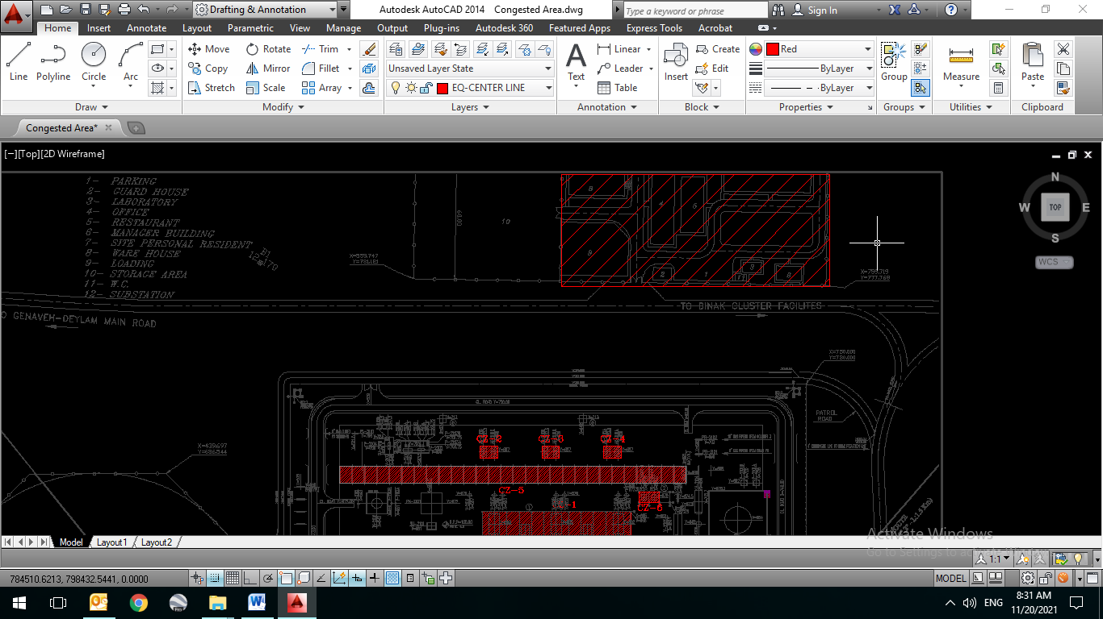

**Figure 5- Building location**

* **List of congested area**

Process area consisting Pipe rack and adjacent equipment within Fire Zone is congested.

Average height of compressor shelter and pipe racks heights have been considered 6m. For Pipe racks with more than 6m height, it is assumed that cloud height maximum height is 6m.

Below air cooler, congested height is considered 4m.

This plant is divided to 8 independent congested Zones which have been listed in table 6 and is shown in Figure 6.

Table 6- List of congested area

|  |  |  |  |  |
| --- | --- | --- | --- | --- |
| **No.** | **Description** | **Pipe rack**  **congested volume m3** | **Shelter/equipment congested volume m3** | **Total Congested Zone**  **m3** |
| Congested Zone 1 | Compressor shelter  C-210A/B/C | -- | 72 X 12 X 6 | 5184 |
| Congested Zone 2 | AE-210C | -- | 8.5 X 6 X 4 | 204 |
| Congested Zone 3 | AE-210B | -- | 8.5 X 6 X 4 | 204 |
| Congested Zone 4 | AE-210A | -- | 8.5 X 6 X 4 | 204 |
| Congested Zone 5 | Pipe Rack | 168 X 8 X 6 | -- | 8064 |
| Congested Zone 6 | Shelter for PK-2007 & 2008 | -- | 10 X 5 X 6 | 300 |

Total congested are is 14160 M3

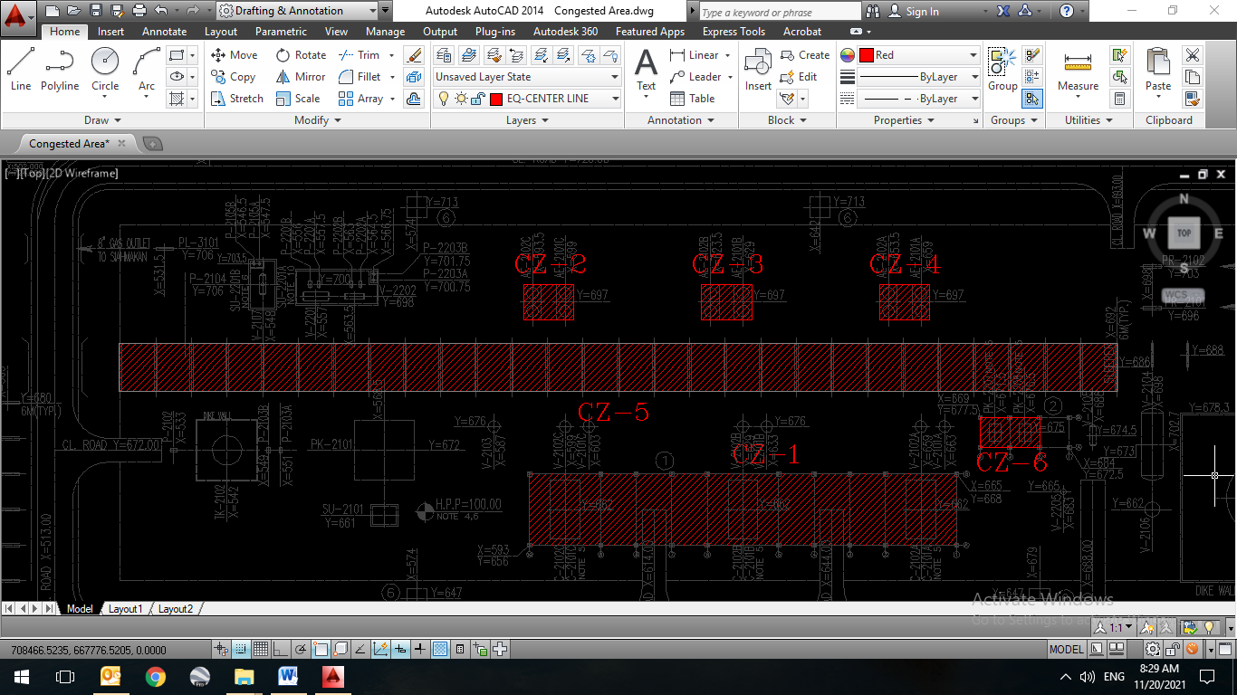

Figure 6 - Congested areas within plant

## BLAST STUDY RESULT

Blast study results are presented in Table 7. For the sake of building blast protection, CIVIL department shall refer to following table and extract maximum values of peak Overpressure, pulse duration and Impulse for each building.

Note that these are not static values. The civil department shall calculate the equivalent static value for the building blast protection dimensioning, considering the interaction between the blast wave and the structure (wave reflection, resonance, etc.).

Table 7- Detail result of Vapor Cloud Explosion load on each vulnerable building

|  |  |  |  |  |  |  |  |
| --- | --- | --- | --- | --- | --- | --- | --- |
| **Distance** | **Description** | **Building No. 2** | **Building No. 3** | **Building No. 4** | **Building No. 5** | **Building No. 6** | **Building No. 11** |
| Congested Zone 4 | Distance from edge (m) | 84.5 | 108 | 100.5 | 111 | 117 | 102 |
| Peak Overpressure (bar) | 0.127 | 0.095 | 0.104 | 0.092 | 0.087 | 0.102 |
| Pulse Duration (ms) | 75 | 76 | 76 | 76 | 76 | 76 |
| Impulse (pa.s) | **952.5** | **722** | **790.4** | **699.2** | **661.2** | **775.2** |

* Above input data is based on VCE from congested volume 8076 / 2 m3, calculated by worst case scenario SC7-L-HI and SC7-VCE in Fire Zone study. For detail refer to section 4.2.1.3.

1. **Conclusion**

## FIRE ZONE

As mentioned in previous section, new Gas Compressor Station is considered as one fire zone.

Calculation results indicate that max distance for fire zone is 43 m which is related to VCE scenario SC7-VCE. So, fire zone extent for new Gas Compressor Station shall be considered 43 m minimum safety distance. Based on calculated data, governing fire zone studied cases are for VCE over pressure and partially pool fire radiation in dike area related to TK-2101. Based on the result, fire zone affected by some IPSs are shown in Figure 7 as well as Appendix A.

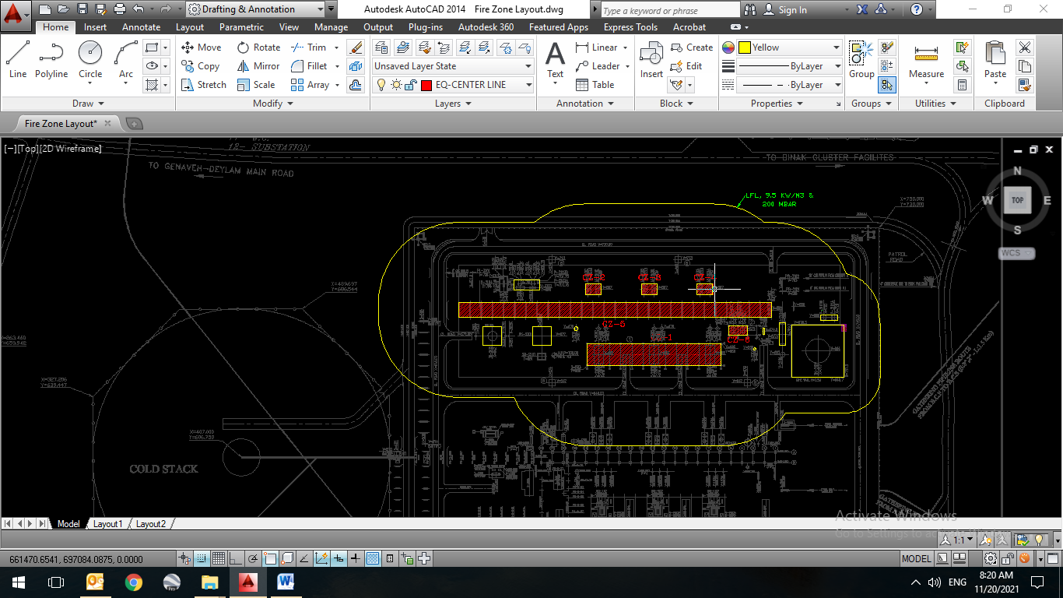

**Figure 7- Fire Zone Layout**

Emergency Shutdown Valves (ESDV)

All ESDVs should be protected against radiation higher than 15.9 kW/m2 and overpressure higher than 300 mbar. According to obtained results, the mentioned overpressure level will extend up to 22.5 m. Also jet fire radiation results in a 24 m extent.

Based on the result, ESDVs affected by some IPSs are shown in Figure 8 as well as Appendix A.

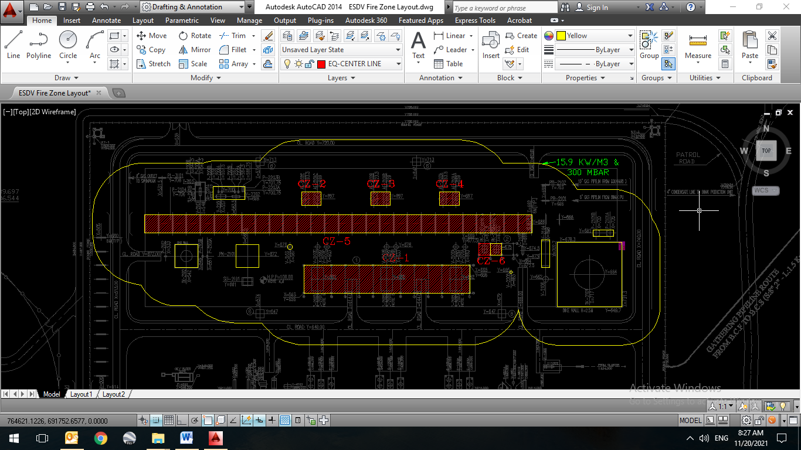

**Figure 8- Fire Zone Layout for ESDVs**

## Restricted Area

Results indicate that restricted area extent is 158 m which is related to toxic gas clouds LC1%. explosion scenario.

The restricted area contours and graphs is provided in Figure 9 as well as Appendix A. Other scenarios including VCE, LFL dispersion and jet fire radiation lead to 100.5 m, 60 m and 48 m radius respectively.

Regarding existing distance of fence from new GCS (30 m from North and 18 m from West), beyond the fence and road ways will be exposed to Toxicity, fire and explosion scenarios.

According to the LC1% restricted area and other scenarios, fire and explosion impacts can extend beyond the fence. Therefore, no residential area should be constructed in these regions.

It is notable that emergency planning within plant shall be performed by CLIENT in case of occurrence of a major accident containing Fire, Explosion or Gas Dispersion.

In addition, it’s recommended to consider integrated F&G system including gas detectors nearby fences which can initiates emergency shutdown.

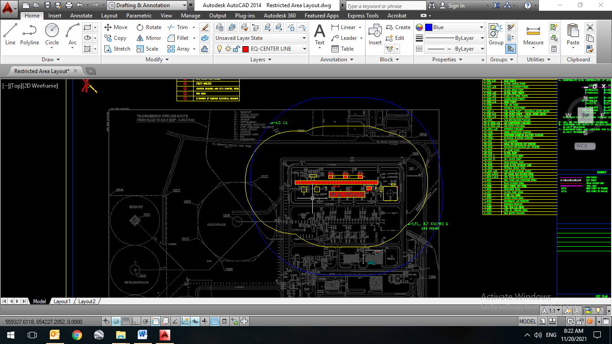

Figure 9 - Restricted affected area

## Impacted Area

Impacted area is defined for public areas in the vicinity of process plants. Impacted area is calculated as 283 m and 322 which corresponds to vapor cloud explosion and IDLH.

The impacted area layout is provided in Figure 10 as well as Appendix A.

Existing fence has a 30 m distance from new GCS in North side, and 19 m from East side respectively. So, some areas beyond GCS fence will be exposed to toxic, fire and explosion impacts.

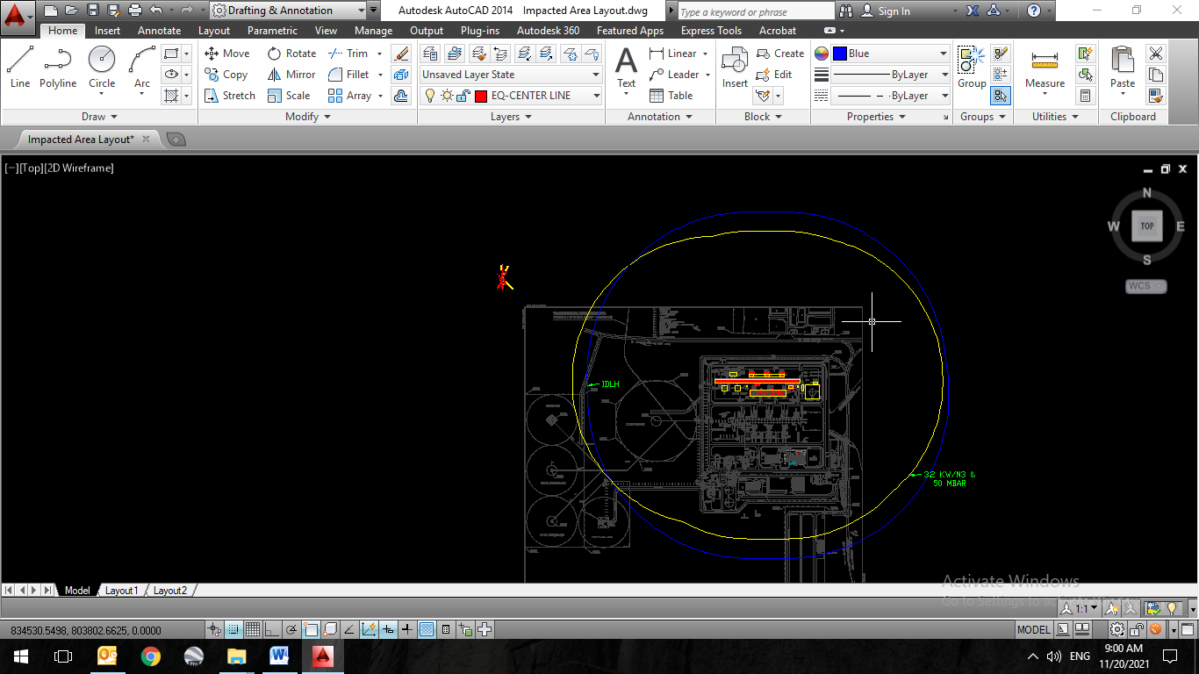

**Figure 10- Impacted Area Layout**

1. **APPENDIX a – FIRE ZONE, IMPACTED AND RESTRICTED AREA LAYOUTS**
2. **Appendix b – simulation (phast) files**