|  |  |  |  |  |  |  |  |
| --- | --- | --- | --- | --- | --- | --- | --- |
| **طرح نگهداشت و افزایش تولید 27 مخزن** | | | | | | | |
| **CALCULATION NOTE FOR HELI PAD, WELL PAD**  **DIESEL STORAGE PAD - W007S**  **نگهداشت و افزایش تولید میدان نفتی بینک** | | | | | | | |
|  | |  |  |  |  |  |  |
|  | |  |  |  |  |  |  |
|  | |  |  |  |  |  |  |
| D01 | | OCT. 2023 | AFC | R.Berlouie | M.Fakharian | S.Faramarzpour |  |
| D00 | | SEP. 2023 | IFC | R.Berlouie | M.Fakharian | A.M.Mohseni |  |
| **Rev.** | | **Date** | **Purpose of Issue/Status** | **Prepared by:** | **Checked by:** | **Approved by:** | **CLIENT Approval** |
| **Class:1** | | | **COMPANY Doc. Number:F0Z-707656** | | | | |
| **Status:** | | **IDC: Inter-Discipline Check**  **IFC: Issued For Comment**  **IFA: Issued For Approval**  **AFD: Approved For Design**  **AFC: Approved For Construction**  **AFP: Approved For Purchase**  **AFQ:** Approved For Quotation  **IFI: Issued For Information**  **AB-R: As-Built for CLIENT Review**  **AB-A: As-Built –Approved** | | | | | |

|  |  |  |  |  |  |  |  |  |  |  |  |  |
| --- | --- | --- | --- | --- | --- | --- | --- | --- | --- | --- | --- | --- |
| **PAGE** | **D00** | **D01** | **D02** | **D03** | **D04** |  | **PAGE** | **D00** | **D01** | **D02** | **D03** | **D04** |
| **1** | X | X |  |  |  | **66** |  |  |  |  |  |
| **2** | X | X |  |  |  | **67** |  |  |  |  |  |
| **3** | X |  |  |  |  | **68** |  |  |  |  |  |
| **4** | X |  |  |  |  | **69** |  |  |  |  |  |
| **5** | X |  |  |  |  | **70** |  |  |  |  |  |
| **6** | X |  |  |  |  | **71** |  |  |  |  |  |
| **7** | X |  |  |  |  | **72** |  |  |  |  |  |
| **8** | X |  |  |  |  | **73** |  |  |  |  |  |
| **9** | X |  |  |  |  | **74** |  |  |  |  |  |
| **10** | X |  |  |  |  | **75** |  |  |  |  |  |
| **11** | X |  |  |  |  | **76** |  |  |  |  |  |
| **12** | X |  |  |  |  | **77** |  |  |  |  |  |
| **13** | X |  |  |  |  | **78** |  |  |  |  |  |
| **14** | X |  |  |  |  | **79** |  |  |  |  |  |
| **15** | X |  |  |  |  | **80** |  |  |  |  |  |
| **16** | X |  |  |  |  | **81** |  |  |  |  |  |
| **17** |  |  |  |  |  | **82** |  |  |  |  |  |
| **18** |  |  |  |  |  | **83** |  |  |  |  |  |
| **19** |  |  |  |  |  | **84** |  |  |  |  |  |
| **20** |  |  |  |  |  | **85** |  |  |  |  |  |
| **21** |  |  |  |  |  | **86** |  |  |  |  |  |
| **22** |  |  |  |  |  | **87** |  |  |  |  |  |
| **23** |  |  |  |  |  | **88** |  |  |  |  |  |
| **24** |  |  |  |  |  | **89** |  |  |  |  |  |
| **25** |  |  |  |  |  | **90** |  |  |  |  |  |
| **26** |  |  |  |  |  | **91** |  |  |  |  |  |
| **27** |  |  |  |  |  | **92** |  |  |  |  |  |
| **28** |  |  |  |  |  | **93** |  |  |  |  |  |
| **29** |  |  |  |  |  | **94** |  |  |  |  |  |
| **30** |  |  |  |  |  | **95** |  |  |  |  |  |
| **31** |  |  |  |  |  | **96** |  |  |  |  |  |
| **32** |  |  |  |  |  | **97** |  |  |  |  |  |
| **33** |  |  |  |  |  | **98** |  |  |  |  |  |
| **34** |  |  |  |  |  | **99** |  |  |  |  |  |
| **35** |  |  |  |  |  | **100** |  |  |  |  |  |
| **36** |  |  |  |  |  | **101** |  |  |  |  |  |
| **37** |  |  |  |  |  | **102** |  |  |  |  |  |
| **38** |  |  |  |  |  | **103** |  |  |  |  |  |
| **39** |  |  |  |  |  | **104** |  |  |  |  |  |
| **40** |  |  |  |  |  | **105** |  |  |  |  |  |
| **41** |  |  |  |  |  | **106** |  |  |  |  |  |
| **42** |  |  |  |  |  | **107** |  |  |  |  |  |
| **43** |  |  |  |  |  | **108** |  |  |  |  |  |
| **44** |  |  |  |  |  | **109** |  |  |  |  |  |
| **45** |  |  |  |  |  | **110** |  |  |  |  |  |
| **46** |  |  |  |  |  | **111** |  |  |  |  |  |
| **47** |  |  |  |  |  | **112** |  |  |  |  |  |
| **48** |  |  |  |  |  | **113** |  |  |  |  |  |
| **49** |  |  |  |  |  | **114** |  |  |  |  |  |
| **50** |  |  |  |  |  | **115** |  |  |  |  |  |
| **51** |  |  |  |  |  | **116** |  |  |  |  |  |
| **52** |  |  |  |  |  | **117** |  |  |  |  |  |
| **53** |  |  |  |  |  | **118** |  |  |  |  |  |
| **54** |  |  |  |  |  | **119** |  |  |  |  |  |
| **55** |  |  |  |  |  | **120** |  |  |  |  |  |
| **56** |  |  |  |  |  | **121** |  |  |  |  |  |
| **57** |  |  |  |  |  | **122** |  |  |  |  |  |
| **58** |  |  |  |  |  | **123** |  |  |  |  |  |
| **59** |  |  |  |  |  | **124** |  |  |  |  |  |
| **60** |  |  |  |  |  | **125** |  |  |  |  |  |
| **61** |  |  |  |  |  | **126** |  |  |  |  |  |
| **62** |  |  |  |  |  | **127** |  |  |  |  |  |
| **63** |  |  |  |  |  | **128** |  |  |  |  |  |
| **64** |  |  |  |  |  | **129** |  |  |  |  |  |
| **65** |  |  |  |  |  | **130** |  |  |  |  |  |

**CONTENTS**

1 INTRODUCTION 4

2 scope 4

3 NORMATIVE REFERENCES 4

4 MATERIAL PROPERTIES 5

5 computer software 5

6 Soil 5

7 load combination 6

8 Concrete slab(th=20 cm): 7

9 GAS OIL STORAGE FOUNDATION (20m x 12m x 0.2m) 12

10 edge beam Design 15

1. **INTRODUCTION**

Binak oilfield in Bushehr province is a part of the southern oilfields of Iran, is located 20 km northwest of Genaveh city.

With the aim of increasing production of oil from Binak oilfield, an EPC/EPD Project has been defined by NIOC/NISOC and awarded to Petro Iran Development Company (PEDCO). Also PEDCO (as General Contractor) has assigned the EPC-packages of the Project to "Hirgan Energy - Design and Inspection" JV.

1. **scope**

This document covers minimum necessary requirements for the check and design of helipad, well pad & diesel Storage Pad relating to well007S.

1. **NORMATIVE REFERENCES**
   1. **Local** **Codes and Standards**

* IPS-C-CE-200 Construction standard for concrete structures”.
* IPS-E-CE-500 Engineering standard for loads”.
* Iranian Seismic design code for Petroleum facilities .pub.No.038 (3rd edition)
* Iranian National Building Code .INBC No. 9
* Iranian Code of Practice for seismic Resistant Design of Building Standard No.2800 (4th edition)
  1. **International Codes and Standards**

ACI 318-14 “Building Code Requirements for reinforced concrete “. American Concrete institute.

* 1. **The Project Documents**
* BK-GNRAL-PEDCO-000-ST-SP-0001 Specification for Concrete Work
* BK-W007S-PEDCO-110-SV-PY-0002 Civil & structural Drawings-W007S

1. **MATERIAL PROPERTIES**

Material properties are delivered in the following table:

**Table 1.Material Propertie**

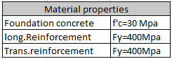

1. **computer software**

Computer software which is used in analysis & design of structure and foundation of storage tank, is defined in the following table.

**Table 2.Computer software:**

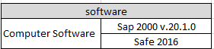

1. **Soil**

Assumption for soil parameters such as allowable soil bearing capacity, allowable settlement and subgrade Modulus are experimental and after completing the Geotechnical report will be finalized.

qa= 1.2kg/cm2 =0.12 N/mm2(Allowable Soil Bearing Capacity)

δa= 25 mm (Allowable Settlement)

Ks= 1.44 kg/cm3=0.000144 N/mm3 (Subgrade Modulus)

1. **load combination**

The following combinations of loads shall be used in the design of foundations, and shall be used for displacement and soil reaction forces. (According to ASCE07-10)

* 1. **-Ultimate Load Combinations**

For the design of the structural elements the following load combinations are considered.

- 1.4(D±T) +1.6H

- 1.2(D±T) +1.6L+0.5S +1.6H

- 1.2(D±T) +1.6S+L+1.6H

- 1.2(D±T) +L+0.5S+1.6H

- 1.2(D±T) +1.0E + L + 0.2S+1.6H

- 0.9(D±T) +1.0E+1.6H

- 0.9(D±T) +W+1.6H

* 1. **Serviceability Load Combinations**

To check the deflection and displacements, structural stability and soil pressure, the following load combinations are considered.

- (D±T) + H

- (D±T) +L+ H

- (D±T) +S + H

- (D±T) +0.75L+0.75S + H

- (D±T) +0.7E + H

- 0.6(D±T) + H

- 0.6(D±T) +E + H

Effect of lateral soil pressure & water pressure (H) applied with coefficient of 1.6 in ultimate load combinations and coefficient of 1.0 in service load combination.

1. **Concrete slab(th=20 cm):**

One of the panel (15.9x20m) which the wellhead machine are located on, has been modeled in safe 2016 software and the software output have been shown in the following:

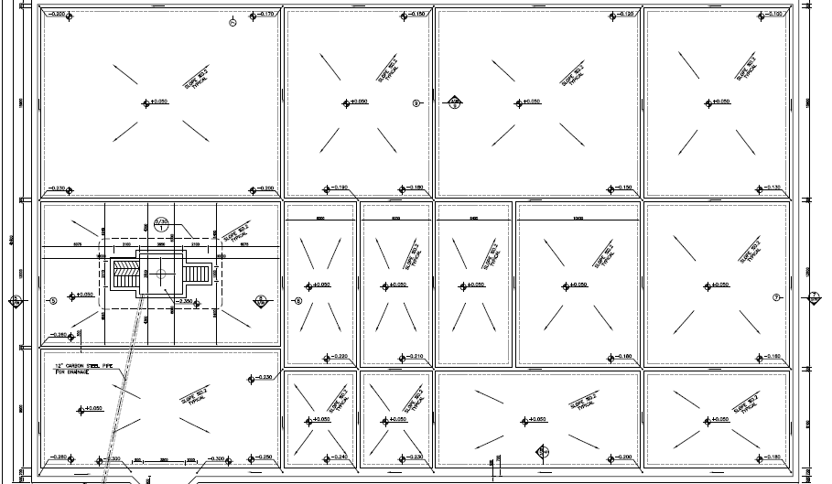

Figure 1-plan of all panels

* 1. **Loads:**
     1. **DEAD load (D)**

Overhead caused by equipment located during drilling assumed 500kg/m2.

* + 1. **Thermal Load(t)**

The ambient thermal load has been assumed based on the thermal variation for structure of 28 ºC.

* + 1. **Live load (L):**

For bottom distributed load about 200kg/m2, has been considered for design of structure

* + 1. **Snow loads(S):**

According to Iranian National Building Code No.6 table 6-7-1 this site location is in Zine 1 so

Pg = 0.25 KN/m2 = 25 kg/m2

* + 1. **machinery load(ML)**

Apply 45 ton of truck load with 10.1 m x 2.99 m dimension on concrete pad.

$ML=\frac{45000}{10.1x2.9}=1536kg/m2$ =1.536e-2 $N/mm2$

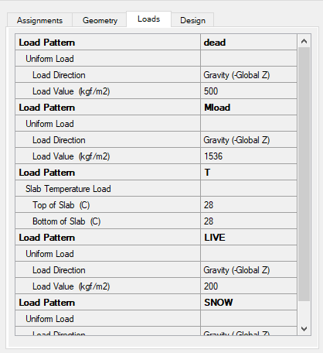

Figure2 –loading on Pads (Thick =200 mm)

* 1. **Soil Pressure Control**

Soil pressures in different service load combinations should be checked by allowable value. The following figure is extracted from “SAFE” model.

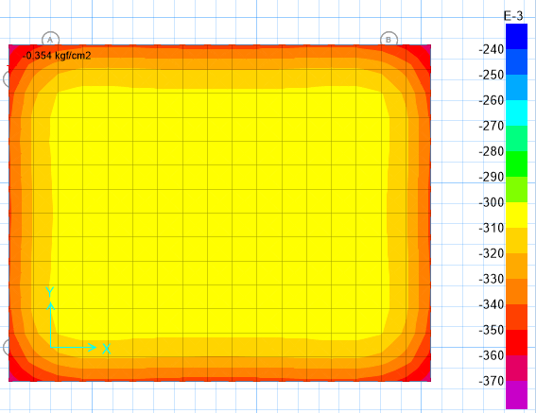

Figure3 –Soil Pressure diagram (0.0354N/mm2)

Maximum soil pressure of foundation under critical load combination is equals to 0.0354 N/mm2, which is less than allowable bearing capacity of soil.

* 1. **Settlement Control**

Settlement in different service load combinations should be checked by allowable value. The following figure is extracted from “SAFE” model.

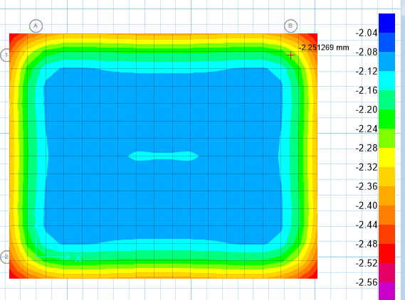

Figure4 –Displacement under service load combination(2.25 mm)

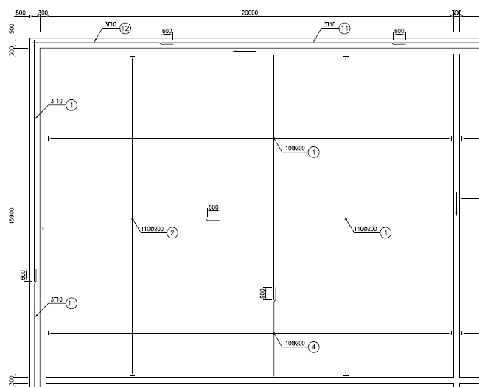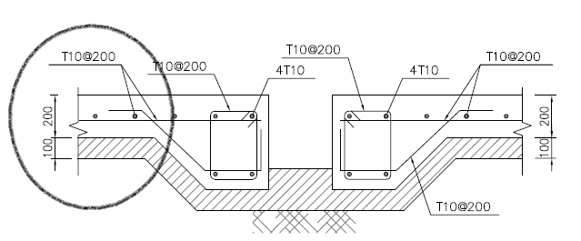

Figure5 –Slab Reinforcement

According to above figure use $φ10@200$ for this slab and design out puts shows as below:

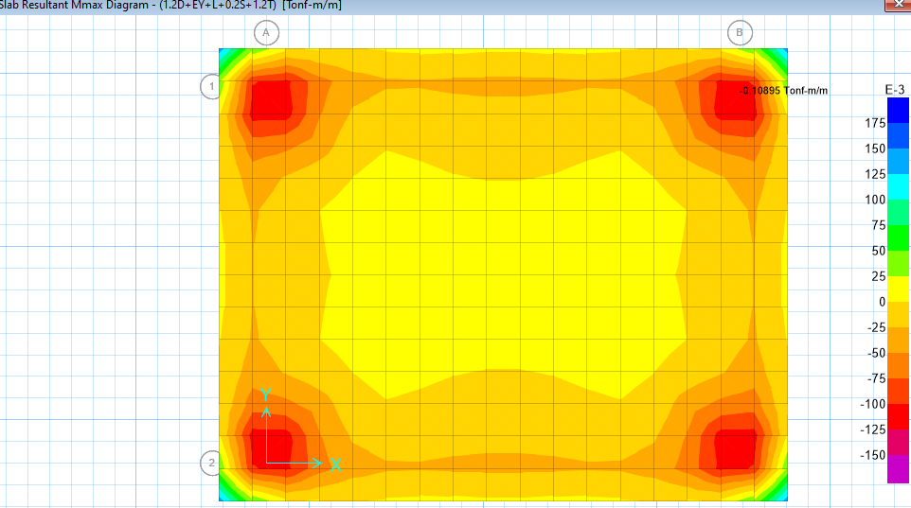

Figure6 –Slab Resultant Reinforcement (Mmax=0.1089 ton-m/m=1067.22 N-mm/mm)

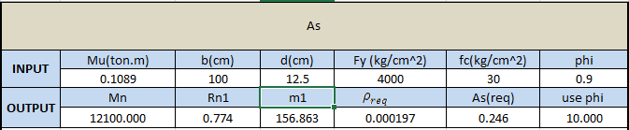

$M_{n}=\frac{M_{u}}{∅}$ =12100

$R_{n1}=\frac{M_{n1}}{{bd}^{2}}$ =0.774

$$m_{1}=\frac{f_{y}}{0.85f_{c}}=156.865$$

$$ρ_{req}=\frac{1}{m_{1}}\left(1-\sqrt{1-\frac{2m_{1}R_{n1}}{f_{y}}}\right)=0.000197$$

$$A_{s}=ρ_{req}.b.d=0.246 cm^{2}$$

$Used A_{s used}=∅10@200 mm=3.9cm2$ > $A_{s}=0.246 cm2$ ok

Due to the minimum required amount of reinforcement , minimum reinforcement has been used .

1. **GAS** **OIL STORAGE FOUNDATION (20m x 12m x 0.2m)**

Gas Oil Storage foundation has been modeled as a concrete pad with thickness 0.2 m in safe 2016 software.

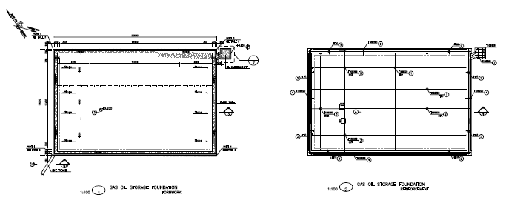

Figure7–Gas Oil Storage Foundation (20mx12mx0.2m)

A concrete pad with thickness 0.2m has been modelled in safe software 2016 as bellow:

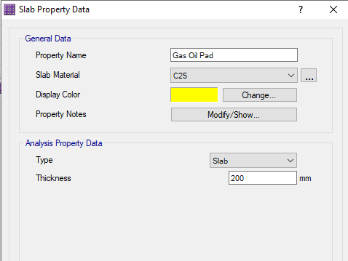

Figure8 –Slab Property Data (th=0.2m)

* 1. **Thermal Load (T)**

The ambient thermal load has been assumed based on the thermal variation for structure of 28 ºC.

* 1. **Live load (L)**

For bottom distributed load about 600kg/m2 ,has been considered for design of structure

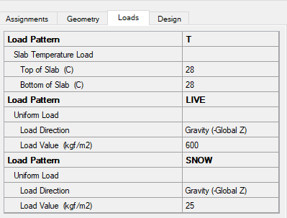

Figure9–Load applied on Pad

* 1. **Settlement Control**

Settlement in different service load combinations should be checked by allowable value. The following figure is extracted from “SAFE” model.

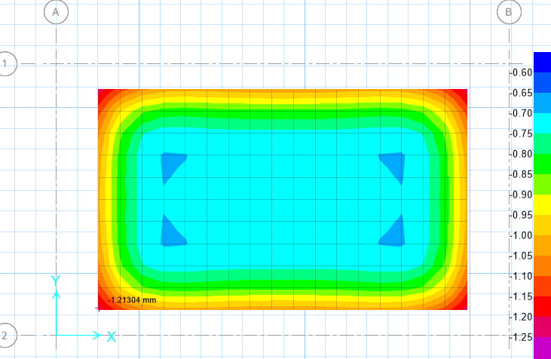

Figure10 –Displacement under service load combination(1.21 mm)

* 1. **Soil Pressure Control**

Soil pressures in different service load combinations should be checked by allowable value. The following figure is extracted from “SAFE” model.

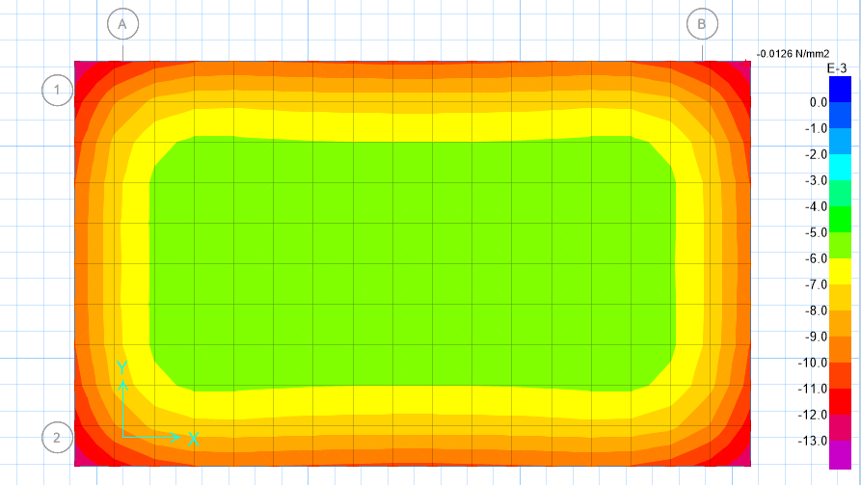

Figure11–soil Pressure under service load combination (max=0.126kg/cm2=0.0126 N/mm2)

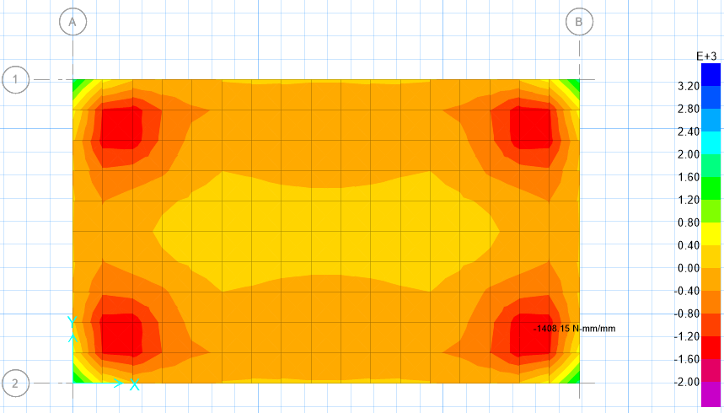

Figure12–slab Resultant Mmax (=0.14 t-m/m,1408.15 N-mm/mm)

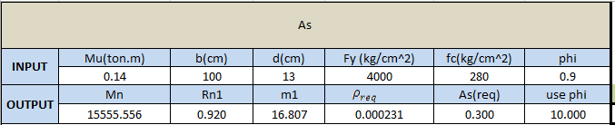

$M_{n}=\frac{M_{u}}{∅}$ =15555.556

$R_{n1}=\frac{M_{n1}}{{bd}^{2}}$ =0.920

$$m_{1}=\frac{f_{y}}{0.85f_{c}}=16.807$$

$$ρ_{req}=\frac{1}{m_{1}}\left(1-\sqrt{1-\frac{2m_{1}R_{n1}}{f_{y}}}\right)=0.000231$$

$$A_{s}=ρ_{req}.b.d=0.30 cm^{2}$$

$Used A_{s used}=∅10@200 mm=3.29 cm2>A_{s}=0.30 ok$

Due to the minimum required amount of reinforcement, minimum reinforcement has been used.

1. **edge beam Design**

Edge beam has been modeled as a concrete beam with width of 0.5 m and height of 0.45 in safe 2016 software .load of two wheels of truck applied on edge beam.

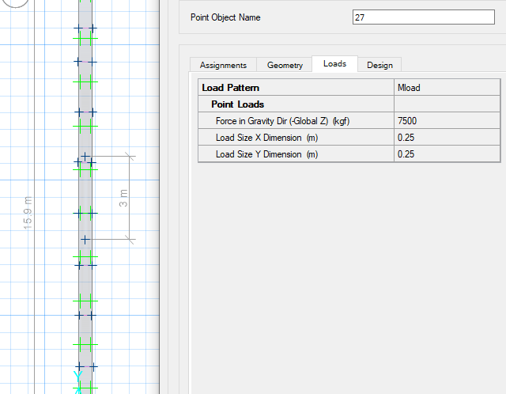

Figure13 –edge beam model

Each wheel load assumed about 7.5ton (7500kg) and apply in 2 points with distance of 3m.

* 1. **Soil Pressure Control**

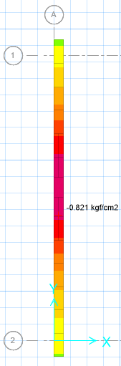

Figure14 –soil pressure under service load combination (q=0.821kg /cm2)

* 1. **Settlement Control**

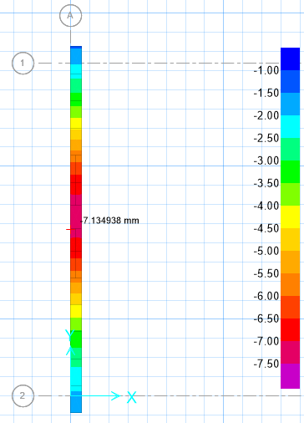

Figure15 –soil displacement under service load combination (7.13mm)