|  |  |  |  |  |  |  |  |
| --- | --- | --- | --- | --- | --- | --- | --- |
| **طرح نگهداشت و افزایش تولید 27 مخزن** | | | | | | | |
| **Calculation Note for Oily Water Sump Pit (SU-2201 B)**  **نگهداشت و افزایش تولید میدان نفتی بینک** | | | | | | | |
|  | |  |  |  |  |  |  |
|  | |  |  |  |  |  |  |
|  | |  |  |  |  |  |  |
|  | |  |  |  |  |  |  |
| D00 | | NOV.2023 | IFC | R.Berlouie | M.Fakharian | S.Faramarzpour |  |
| **Rev.** | | **Date** | **Purpose of Issue/Status** | **Prepared by:** | **Checked by:** | **Approved by:** | **CLIENT Approval** |
| **Class:2** | | | **COMPANY Doc. Number: F0Z-709128** | | | | |
| **Status:** | | **IDC: Inter-Discipline Check**  **IFC: Issued For Comment**  **IFA: Issued For Approval**  **AFD: Approved For Design**  **AFC: Approved For Construction**  **AFP: Approved For Purchase**  **AFQ:** Approved For Quotation  **IFI: Issued For Information**  **AB-R: As-Built for CLIENT Review**  **AB-A: As-Built –Approved** | | | | | |

**REVISION RECORD SHEET**

|  |  |  |  |  |  |  |  |  |  |  |  |  |
| --- | --- | --- | --- | --- | --- | --- | --- | --- | --- | --- | --- | --- |
| **PAGE** | **D00** | **D01** | **D02** | **D03** | **D04** |  | **PAGE** | **D00** | **D01** | **D02** | **D03** | **D04** |
| **1** | X |  |  |  |  | **66** |  |  |  |  |  |
| **2** | X |  |  |  |  | **67** |  |  |  |  |  |
| **3** | X |  |  |  |  | **68** |  |  |  |  |  |
| **4** | X |  |  |  |  | **69** |  |  |  |  |  |
| **5** | X |  |  |  |  | **70** |  |  |  |  |  |
| **6** | X |  |  |  |  | **71** |  |  |  |  |  |
| **7** | X |  |  |  |  | **72** |  |  |  |  |  |
| **8** | X |  |  |  |  | **73** |  |  |  |  |  |
| **9** | X |  |  |  |  | **74** |  |  |  |  |  |
| **10** | X |  |  |  |  | **75** |  |  |  |  |  |
| **11** | X |  |  |  |  | **76** |  |  |  |  |  |
| **12** | X |  |  |  |  | **77** |  |  |  |  |  |
| **13** | X |  |  |  |  | **78** |  |  |  |  |  |
| **14** | X |  |  |  |  | **79** |  |  |  |  |  |
| **15** | X |  |  |  |  | **80** |  |  |  |  |  |
| **16** | X |  |  |  |  | **81** |  |  |  |  |  |
| **17** | X |  |  |  |  | **82** |  |  |  |  |  |
| **18** | X |  |  |  |  | **83** |  |  |  |  |  |
| **19** | X |  |  |  |  | **84** |  |  |  |  |  |
| **20** | X |  |  |  |  | **85** |  |  |  |  |  |
| **21** | X |  |  |  |  | **86** |  |  |  |  |  |
| **22** | X |  |  |  |  | **87** |  |  |  |  |  |
| **23** | X |  |  |  |  | **88** |  |  |  |  |  |
| **24** | X |  |  |  |  | **89** |  |  |  |  |  |
| **25** |  |  |  |  |  | **90** |  |  |  |  |  |
| **26** |  |  |  |  |  | **91** |  |  |  |  |  |
| **27** |  |  |  |  |  | **92** |  |  |  |  |  |
| **28** |  |  |  |  |  | **93** |  |  |  |  |  |
| **29** |  |  |  |  |  | **94** |  |  |  |  |  |
| **30** |  |  |  |  |  | **95** |  |  |  |  |  |
| **31** |  |  |  |  |  | **96** |  |  |  |  |  |
| **32** |  |  |  |  |  | **97** |  |  |  |  |  |
| **33** |  |  |  |  |  | **98** |  |  |  |  |  |
| **34** |  |  |  |  |  | **99** |  |  |  |  |  |
| **35** |  |  |  |  |  | **100** |  |  |  |  |  |
| **36** |  |  |  |  |  | **101** |  |  |  |  |  |
| **37** |  |  |  |  |  | **102** |  |  |  |  |  |
| **38** |  |  |  |  |  | **103** |  |  |  |  |  |
| **39** |  |  |  |  |  | **104** |  |  |  |  |  |
| **40** |  |  |  |  |  | **105** |  |  |  |  |  |
| **41** |  |  |  |  |  | **106** |  |  |  |  |  |
| **42** |  |  |  |  |  | **107** |  |  |  |  |  |
| **43** |  |  |  |  |  | **108** |  |  |  |  |  |
| **44** |  |  |  |  |  | **109** |  |  |  |  |  |
| **45** |  |  |  |  |  | **110** |  |  |  |  |  |
| **46** |  |  |  |  |  | **111** |  |  |  |  |  |
| **47** |  |  |  |  |  | **112** |  |  |  |  |  |
| **48** |  |  |  |  |  | **113** |  |  |  |  |  |
| **49** |  |  |  |  |  | **114** |  |  |  |  |  |
| **50** |  |  |  |  |  | **115** |  |  |  |  |  |
| **51** |  |  |  |  |  | **116** |  |  |  |  |  |
| **52** |  |  |  |  |  | **117** |  |  |  |  |  |
| **53** |  |  |  |  |  | **118** |  |  |  |  |  |
| **54** |  |  |  |  |  | **119** |  |  |  |  |  |
| **55** |  |  |  |  |  | **120** |  |  |  |  |  |
| **56** |  |  |  |  |  | **121** |  |  |  |  |  |
| **57** |  |  |  |  |  | **122** |  |  |  |  |  |
| **58** |  |  |  |  |  | **123** |  |  |  |  |  |
| **59** |  |  |  |  |  | **124** |  |  |  |  |  |
| **60** |  |  |  |  |  | **125** |  |  |  |  |  |
| **61** |  |  |  |  |  | **126** |  |  |  |  |  |
| **62** |  |  |  |  |  | **127** |  |  |  |  |  |
| **63** |  |  |  |  |  | **128** |  |  |  |  |  |
| **64** |  |  |  |  |  | **129** |  |  |  |  |  |
| **65** |  |  |  |  |  | **130** |  |  |  |  |  |

**CONTENTS**

1.0 INTRODUCTION 4

2.0 Scope 4

3.0 CODES, SPECIFICATIONS AND REFERENCE DOCUMENTS 4

4.0 MATERIAL PROPERTIES 4

5.0 DESIGN INFORMATIOn 5

6.0 STRUCTURE 3D ANALYSIS MODEL 6

7.0 Calculation 6

8.0 fOUNDATION design load 8

9.0 P-Delta Effects 14

10.0 ANALYSIS AND DESIGN 16

11.0 Shear Control Under walls : 20

12.0 Uplift Control Under Foundation : 25

1. **INTRODUCTION**

Binak oilfield in Bushehr province is a part of the southern oilfields of Iran, is located 20 km northwest of Genaveh city.

With the aim of increasing production of oil from Binak oilfield, an EPC/EPD Project has been defined by NIOC/NISOC and awarded to Petro Iran Development Company (PEDCO). Also PEDCO (as General Contractor) has assigned the EPC-packages of the Project to "Hirgan Energy - Design and Inspection" JV.

1. **Scope**

This report covers the foundation calculation report of the “Oily water sump pit ”. The foundation modelled by “SAP v21.1.0 ” software.

1. **CODES, SPECIFICATIONS AND REFERENCE DOCUMENTS**

The following codes and specifications are adopted in this report:

1. Design and Analysis of Ground Concrete Water Reservoirs No.123
2. ACI 318M-14 “Building Code Requirements for Structural Concrete”
3. INBC Part 6 “Iranian National Building Code, Part 6 (3rd Edition)”
4. INBC Part 9 “Iranian National Building Code, Part 9 (4th Edition)”
5. Iranian Standard No. 2800 “Iranian Code of practice for Seismic Resistant Design of Buildings (Iranian Standard No. 2800, 4th Edition)”
6. **MATERIAL PROPERTIES**

4.1.Concrete Grade

f’c = 30 MPa (Min. compressive characteristic strength at 28 days on cylinder specimen)

4.2.Reinforcing Steel

Deformed High Tensile Strength Steel Bars, Grade III in accordance with ASTM A706 (Fy=4000 kg/cm2) or ASTM A615 Grade 60 (Fy=4000 kg/cm2) and with minimum tensile strength of 6000 kg/cm2 meeting the specific requirements set forth in ACI 318 or approved equivalent.

Material properties are delivered in the following table.

table 1 -Material Properties

|  |  |
| --- | --- |
| Foundation Concrete | F'c = 30 Mpa(28- day cylindrical sample) |
| Long. reinforcement bar | Fy = 400 Mpa(AIII) |
| Trans. reinforcement bar | Fy = 400 Mpa(AIII) |
| Bolt Type | HV 8.8 |
| Electrode Type | E 70 |

1. **DESIGN INFORMATIOn**

5.1.Location of the Structure

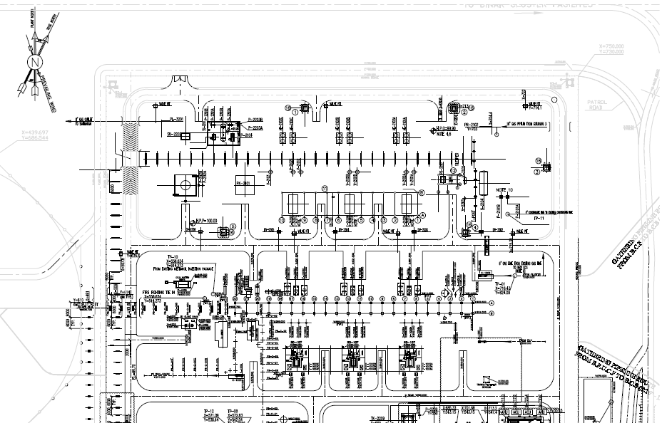

THIS DRAWING

1. Location of Structure
2. **STRUCTURE 3D ANALYSIS MODEL**

SAP2000 have been used in order to modeling, analyses and design of this structure and its foundation.

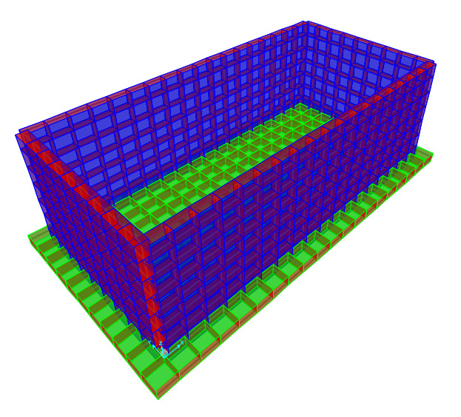

1. Structure 3D Model in SAP2000
2. **Calculation**

7.1.Method of Design

structural elements have been designed in two analytical models.

Model One (Main Model): It has been designed with considering the loads.

In this case seismic load should be calculated by SAP2000 and the water load soil pressure and oil have been applied on model.

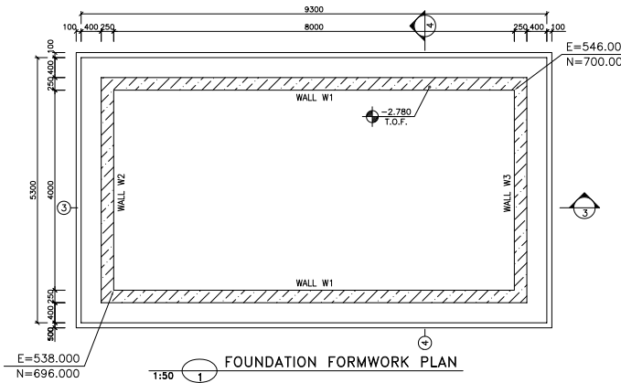

1. Foundation Formwork Plan

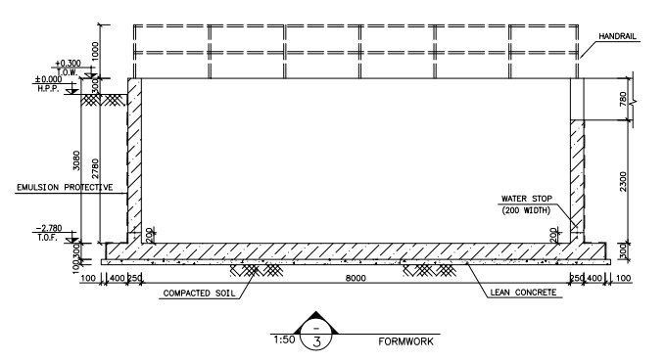

1. Elevation View
2. **fOUNDATION design load**

8.1.Self-Weight (DL)

The self-weight of structural elements (introduced Dead Load/DL in SAP) is automatically considered by SAP program with the specific weights below:

* Reinforced Concrete : 2500 kg/m³

**8.2. Temperature load : ${28}^{°c}$**

**8.3.Live load**

For bottom distributed load about 200 $kg/m2$, has been considered for design of structure.

**8.4.Snow loads:**

For roof distributed snow loads 25 $/m2$, has been considered for design of structure.

**8.5-Seismic Load**

Seismic Loads are calculated according to standard 038.3rd that is summarized in below :

The structure doesn’t have any irregularities and its height is less than 50 m from base level.so, both static equivalent Lateral procedures could be used.

$V$ = $C_{s}$ 𝑊

Where:

$C_{s}$ = the seismic response coefficient from Equation below:

𝑊 = the effective seismic weight of the structure

This weight includes dead weight of the supporting structure and supported components, plus operational weight of the contents of the components such as tanks, vessels, pipes, etc. In addition, where the snow or ice load is more than 0.25𝑊, it shall be included in 𝑊.

$C_{s}$ = $\frac{S_{a}}{R/{I_{e}}}$

Where:

𝑆𝑎= mapped spectral response acceleration parameter (g), determined from hazard analysis.

R= the response modification factor for structure

$I_{e}$ = the importance factor for structure

Vertical seismic component

The vertical seismic load effect, 𝐸𝑣, shall be determined in accordance with the following Equation :

𝐸𝑣 = 0.2 $S_{DS}$ 𝐷

$S_{DS}$ = Design, 5% damped, spectral response acceleration parameter (g) at short periods (0.2 sec).

D = effect of dead load

Loads case name: EQZ=0.2×0.75×W=0.15×W (where W=DL loads)

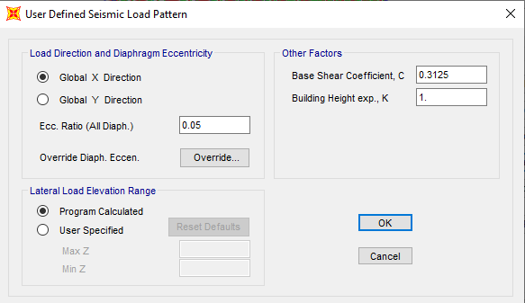

1. X Direction Seismic Load

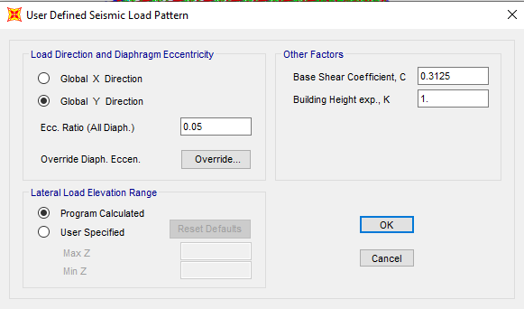

1. Y Direction Seismic Load

This Earthquake coefficient will apply in SAP2000 model to be multiplied in W (seismic weight of structure) that will compute automatically by SAP2000 software by "mass source multiplier" definition as below:

Dead and Live Load

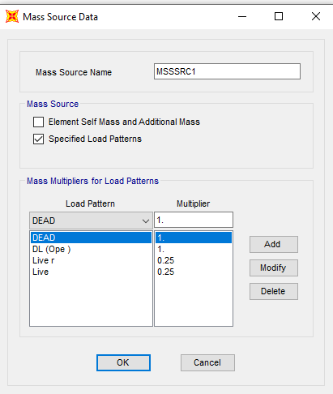

1. Mass Source

* **According to Geotechnical report :**

Soil Type :II

$I(importance factor according to table 12-1$)= $1.25$

$T=0.05 H^{\frac{3}{4}}$ = $0.05×3^{0.75}=0.114$ s

$$T0=0.1$$

$$Ts=0.5 S=1.5 S0=1$$

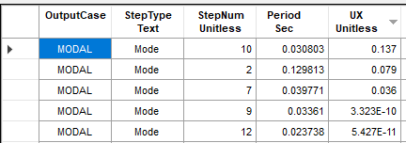

1. Period in X Direction(mode 10 ,T=0.030803)

0<T<T0 $Sax=S_{DS}(0.4+\frac{0.6T}{T0})=0.75(0.4+0.6\left(\frac{0.0308}{0.1}\right)=0.43$

$$C_{x}=\frac{SaI}{R} Cx=\frac{0.43×1.25}{2.5}=0.215$$

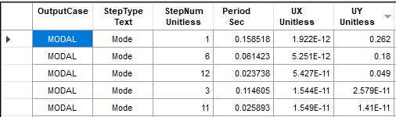

1. Period in Y Direction(mode 1 ,T=0.1585)

T0<T<Ts $Say=S_{DS}=0.75$

$$C_{x}=\frac{SaI}{R} Cx=\frac{0.75×1.25}{2.5}=0.375$$

**8.6.Seismic Load of wall :**

$$C_{x\&y}=\frac{SaI}{R} Cx\&y=\frac{0.75×1.25}{3}=0.3125$$

Seismic load of each wall applied as follow on each area:

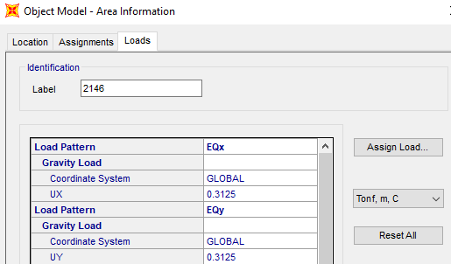

1. Applied wall seismic coefficient

8.7.Wall Design Load

Lateral soil pressure load due to buried soil is applied as follow in two directions:

## 8.7.1.Apply Wall Design Load (SOIL X&Y)

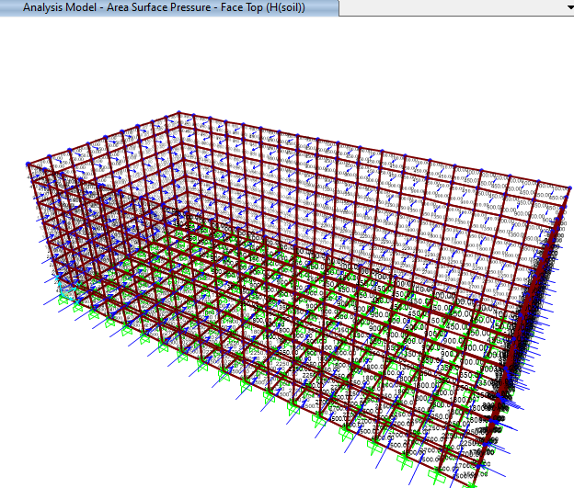

1. **applied Soil pressure**

Calculation of soil pressure in height is as below**:**

$$γ_{sat}=2 ton/m3$$

$$k_{0}=0.5$$

|  |  |  |  |
| --- | --- | --- | --- |
| z= | 0 | Soil pressure(kg/m2): | 2500 |
| z= | 2.3 | Soil pressure(kg/m2): | 0 |

## 8.7.2.Apply Wall Design Load (water X&Y)

Water pressure is applied from a height of 1 m below the ground level.

|  |  |  |  |
| --- | --- | --- | --- |
| z= | 0 | water pressure(kg/m2): | 2300 |
| z= | 2.3 | Water pressure(kg/m2): | 0 |

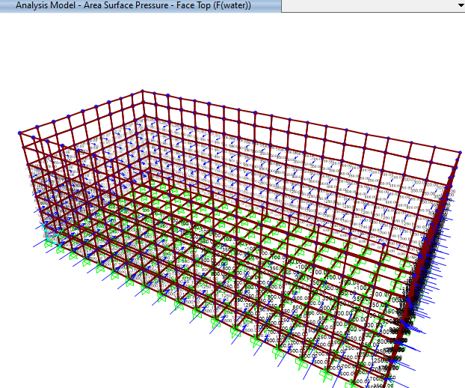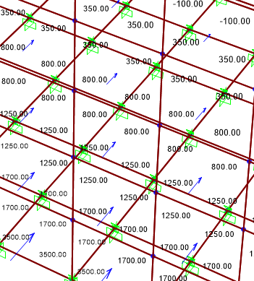

1. **applied water pressure**

## 8.7.3.Apply Wall Design Load (oil pressure)

oil pressure is applied from a height of 1 m below the ground level.

|  |  |  |  |
| --- | --- | --- | --- |
| z= | 0 | water pressure(kg/m2): | 1265 |
| z= | 2.3 | Water pressure(kg/m2): | 0 |

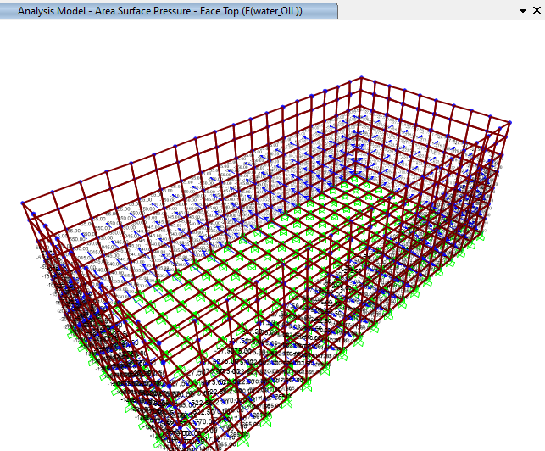

1. **applied oil pressure**

8.8.Bottom Design Load

Vertical oil pressure load is applied as a dead load on bottom of sump pit.

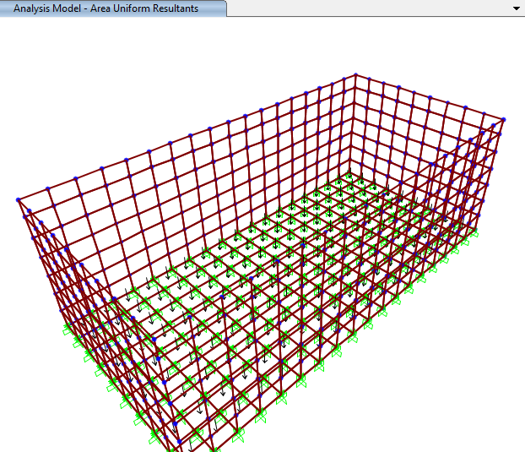

1. **applied oil weight on bottom of sump(2530kg/m2)**
2. **P-Delta Effect**

P-Delta effect on model applied as follow:

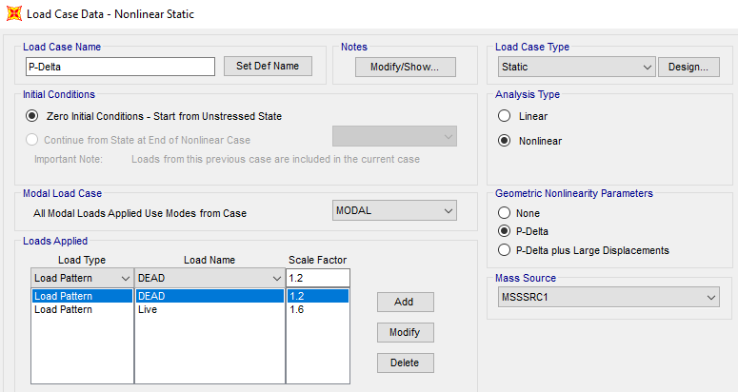

1. P-Delta
2. **LOADING COMBINATIONS**

Foundations, structures and members of structures shall be designed for the most severe loading combination given in below Table. Loads shall be combined as specified in the Table(According to Iranian Seismic Design Code for Petroleum Facilities(3 rd edition)

**10.1.Strength Design:**

$1.4D$ +1.4F+1.6H+TLst

$1.2D$ +1.6L+0.5(Lr or S)+1.2F+1.6H+TLst

$1.2D$ +1.6(Lr or S)+(L)+1.2F+1.6H+TLst

$$1.2D+L+.5\left(Lr or S\right)+1.2F+1.6H+TLst$$

$1.2D$ +E+L+0.2S+1.2F+1.6H+TLst

$0.9D+1.6H$ +TLst

$0.9D+E+0.9F+1.6H$ +TLst

**10.2.Alloawable Design:**

$$D+F+H+TLst$$

$$D+L+F+H+TLst$$

$$D+F+H+(Lr OR S)$$

$$D+F+H+0.75L+0.75(Lr or S)$$

$D+F+H$ +0.7E

$D+F+H$ +0.75(0.7E)+0.75L+0.75S

$$0.6D+H$$

$$0.6D+0.7E+0.6F+H$$

**F is Water load And H load is soil load

1. **ANALYSIS AND DESIGN**

### 11.1.foundation CONTROLS

Model analysis is done by Sap 2000 software.in model loads are applied, some graphical

outputs from modeling are shown as follows.:

According to Sap 2000 results Maximum moment for foundation slab is approximately 6.017 ton.m

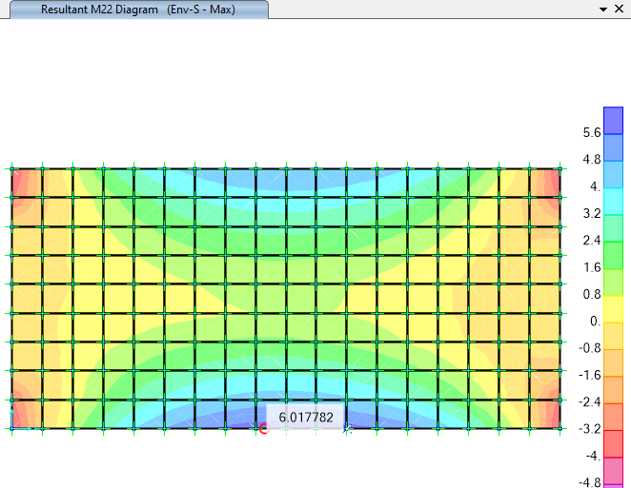

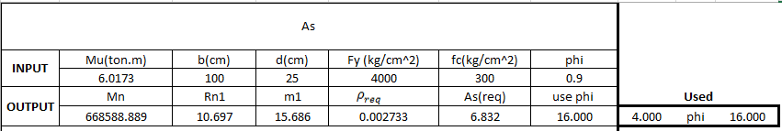

1. **Foundation Moment (Mmax) ton.m**

$$foundation thickness=30cm$$

$$A_{s_{min }}= {0.0018×100×30=5.4 \frac{cm2}{m} }^{}$$

So for foundation $∅16@200 mm$ is used.

### 11.2.wall design

$∅16@200 mm$ moment capacity is :

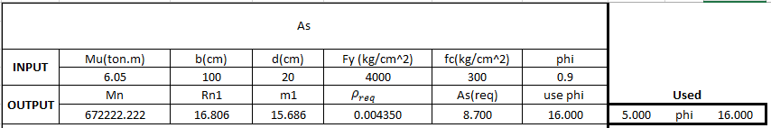

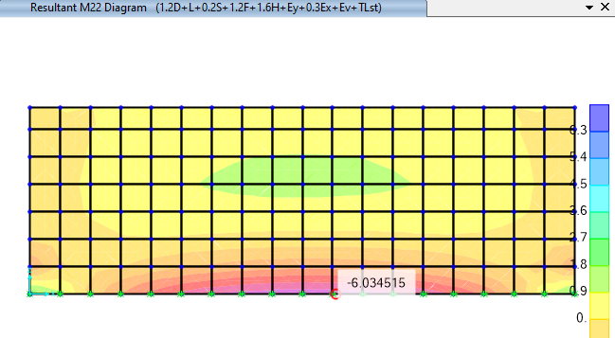

1. **M max under critical load combination on wall (M22=6.034 ton.m)**

According to Sap 2000 results Maximum moment for wall slab is approximately 6.034 ton.m so we used Ø16@200 at lower part of wall and Ø16@200 at upper part of wall as follows:

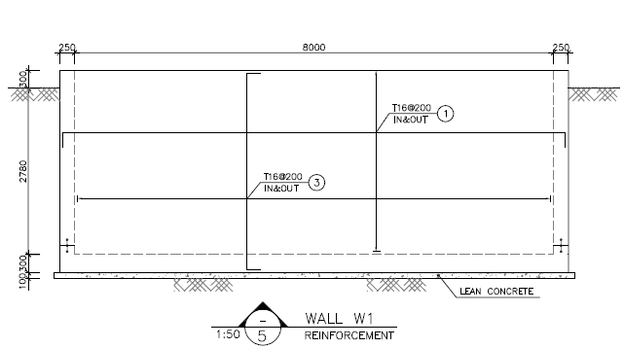

**Wall 3 Reinforcement(Ø16@200)**

### 11.3.TEMPRATURE AND SHRINKAGE REINFORCEMENT CONTROL

$$A_{s used}=∅16@200 mm=10.05\frac{cm^{2}}{m}$$

$$ρ_{used}=\frac{10.05}{20×100}=0.005025$$

$$S_{max}=\frac{K.∅}{2.ρ}=\frac{0.67×16}{2×0.005025}=1066.66 mm=106.6 cm$$

$$ε_{T}=0.5×\left(T_{1}+T_{2}\right).α=0.5×28×12×{10}^{-6}=16.8×{10}^{-5}$$

$$ω=S_{max}.ε_{t}=1066×16.8×{10}^{-5}=0.179mm$$

$$ρ_{critical}=\frac{0.82\sqrt{f'c}}{f_{y}}=\frac{0.82\sqrt{300}}{4000}=0.00355$$

$$ρ_{cal}=\frac{K.∅.ε_{T}}{2.ω}=\frac{0.67×16×16.8×{10}^{-5}}{2×0.179}=0.00503>ρ_{critical}=0.0035 ok.$$

### 10.4.DISTRIBUTION OF FLEXTURAL REINFORCEMENT

According to code 123 section 4-6-1 part 3 :

$$f_{s,max}=\frac{56000}{β\sqrt{s^{2}+4{\left(50+\frac{db}{2}\right)}^{2}}}=\frac{56000}{1.35×\sqrt{{200}^{2}+4{\left(50+\frac{16}{2}\right)}^{2}}}=179.414N/mm2$$

$$f_{s cal}=\frac{M_{service}}{d.A_{s}}=\frac{0.19×10^5}{20×10.05}=94.527\frac{N}{mm^{2}}$$

According to ACI-350-10.6.5 Maximum allowable reinforcement space is:

$$C_{c}=concrete cover in roof slab=7.5 cm$$

$s=min\left\{300,\frac{94600}{fs}-2.5C_{c}\right\}$ =min $\left\{300,\frac{94600}{94.5273}-2.5*75\right\}=300>200$

According to code 123 section

$$z=f_{s}\sqrt[3]{d_{c}.A}=94.527\sqrt[3]{80*200*150}=12655 <23500 ok$$

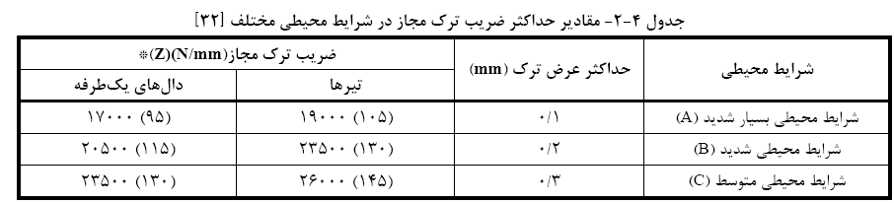

1. **-Allowable Width Crack (code 123)**
2. **Shear Control Under walls :**

$$F_{soil}=\frac{1}{2}K_{0}γh^{2}=0.5×0.5×2×1000×{2.3}^{2}=2645 kg/m$$

$$F_{w}=\frac{1}{2}γ_{w}h^{2}=0.5×1×1000×1×{2.3}^{2}=2645 kg/m$$

$$F_{t}=Fw+Fsoil=5290 \frac{kg}{m} in 1 m= 5290kg=5.290 ton$$

$$V_{c}=0.53\sqrt{fc} bw d=0.53\sqrt{300}×100×25=22949 kg=22.949 ton \left(in 1 m \right)≫Ft ok$$

According to sap analysis result maximum shear on wall is under critical load combination is a follows

|  |  |  |  |  |  |  |  |  |
| --- | --- | --- | --- | --- | --- | --- | --- | --- |
| **TABLE: Element Forces - Area Shells** | | | | | | | | |
| **Area** | **OutputCase** | **CaseType** | **StepType** | **F11** | **F22** | **F12** | **V13** | **V23** |
| Text | Text | Text | Text | Tonf/m | Tonf/m | Tonf/m | Tonf/m | Tonf/m |
| 2283 | Env-A | Combination | Max | -18.475 | 59.535 | -50.866 | -6.803 | 13.827 |
| 2283 | Env-A | Combination | Max | -169.776 | 29.346 | -42.029 | -0.021 | 13.827 |
| 2283 | Env-A | Combination | Max | -177.701 | -10.28 | -33.109 | -0.021 | 7.477 |
| 2283 | Env-A | Combination | Max | -26.512 | 19.725 | -41.946 | -6.803 | 7.477 |
| 2283 | Env-A | Combination | Min | -20.145 | 57.347 | -53.286 | -7.281 | 13.385 |
| 2283 | Env-A | Combination | Min | -170.191 | 27.272 | -43.359 | -0.525 | 13.385 |
| 2283 | Env-A | Combination | Min | -178.054 | -12.042 | -35.114 | -0.525 | 6.743 |
| 2283 | Env-A | Combination | Min | -27.68 | 18.218 | -45.041 | -7.281 | 6.743 |
| 2285 | Env-A | Combination | Max | -72.897 | 10.48 | -48.048 | 1.892 | 4.94 |
| 2285 | Env-A | Combination | Max | -177.701 | -10.28 | -40.552 | 2.599 | 4.94 |
| 2285 | Env-A | Combination | Max | -179.181 | -17.679 | -35.861 | 2.599 | 0.122 |
| 2285 | Env-A | Combination | Max | -74.401 | 3.081 | -43.357 | 1.892 | 0.122 |
| 2285 | Env-A | Combination | Min | -73.904 | 8.95 | -50.82 | 1.399 | 4.372 |
| 2285 | Env-A | Combination | Min | -178.054 | -12.042 | -42.31 | 1.931 | 4.372 |
| 2285 | Env-A | Combination | Min | -179.637 | -19.956 | -37.276 | 1.931 | -0.83 |
| 2285 | Env-A | Combination | Min | -75.384 | 1.035 | -45.786 | 1.399 | -0.83 |
| 2303 | Env-A | Combination | Max | -102.794 | -2.52 | -39.662 | 1.763 | 0.232 |
| 2303 | Env-A | Combination | Max | -179.181 | -17.679 | -30.269 | 1.977 | 0.232 |
| 2303 | Env-A | Combination | Max | -178.155 | -12.551 | -22.911 | 1.977 | -1.674 |
| 2303 | Env-A | Combination | Max | -101.734 | 2.608 | -32.303 | 1.763 | -1.674 |
| 2303 | Env-A | Combination | Min | -103.389 | -4.62 | -41.79 | 1.157 | -0.775 |
| 2303 | Env-A | Combination | Min | -179.637 | -19.956 | -31.7 | 1.259 | -0.775 |
| 2303 | Env-A | Combination | Min | -178.62 | -14.874 | -24.128 | 1.259 | -3.14 |
| 2303 | Env-A | Combination | Min | -102.363 | 0.462 | -34.219 | 1.157 | -3.14 |
| 2305 | Env-A | Combination | Max | -117.885 | -0.583 | -27.143 | 1.4 | -1.556 |
| 2305 | Env-A | Combination | Max | -178.155 | -12.551 | -21.012 | 1.564 | -1.556 |
| 2305 | Env-A | Combination | Max | -177.704 | -10.291 | -13.936 | 1.564 | -2.436 |
| 2305 | Env-A | Combination | Max | -117.401 | 1.676 | -20.061 | 1.4 | -2.436 |
| 2305 | Env-A | Combination | Min | -118.328 | -2.747 | -28.834 | 0.821 | -3.036 |
| 2305 | Env-A | Combination | Min | -178.62 | -14.874 | -22.165 | 0.922 | -3.036 |
| 2305 | Env-A | Combination | Min | -178.148 | -12.513 | -15.214 | 0.922 | -4.233 |
| 2305 | Env-A | Combination | Min | -117.892 | -0.386 | -21.888 | 0.821 | -4.233 |
| 2323 | Env-A | Combination | Max | -126.054 | -0.03 | -16.391 | 1.061 | -2.407 |
| 2323 | Env-A | Combination | Max | -177.704 | -10.291 | -12.453 | 1.137 | -2.407 |
| 2323 | Env-A | Combination | Max | -177.262 | -8.082 | -8.263 | 1.137 | -2.858 |
| 2323 | Env-A | Combination | Max | -125.584 | 2.18 | -12.201 | 1.061 | -2.858 |
| 2323 | Env-A | Combination | Min | -126.443 | -2.106 | -18.363 | 0.569 | -4.201 |
| 2323 | Env-A | Combination | Min | -178.148 | -12.513 | -13.769 | 0.611 | -4.201 |
| 2323 | Env-A | Combination | Min | -177.678 | -10.161 | -9.71 | 0.611 | -4.852 |
| 2323 | Env-A | Combination | Min | -126.007 | 0.245 | -14.304 | 0.569 | -4.852 |
| 2325 | Env-A | Combination | Max | -130.823 | 1.13 | -9.323 | 0.767 | -2.827 |
| 2325 | Env-A | Combination | Max | -177.262 | -8.082 | -7.353 | 0.813 | -2.827 |
| 2325 | Env-A | Combination | Max | -176.987 | -6.708 | -4.036 | 0.813 | -3.062 |
| 2325 | Env-A | Combination | Max | -130.519 | 2.505 | -6.006 | 0.767 | -3.062 |
| 2325 | Env-A | Combination | Min | -131.271 | -0.805 | -11.545 | 0.382 | -4.812 |
| 2325 | Env-A | Combination | Min | -177.678 | -10.161 | -8.831 | 0.411 | -4.812 |
| 2325 | Env-A | Combination | Min | -177.375 | -8.65 | -5.65 | 0.411 | -5.17 |
| 2325 | Env-A | Combination | Min | -130.998 | 0.707 | -8.364 | 0.382 | -5.17 |
| 2343 | Env-A | Combination | Max | -133.363 | 1.937 | -4.331 | 0.525 | -3.051 |
| 2343 | Env-A | Combination | Max | -176.987 | -6.708 | -3.415 | 0.544 | -3.051 |
| 2343 | Env-A | Combination | Max | -176.794 | -5.744 | -1.616 | 0.544 | -3.174 |
| 2343 | Env-A | Combination | Max | -133.148 | 2.901 | -2.531 | 0.525 | -3.174 |
| 2343 | Env-A | Combination | Min | -133.847 | 0.136 | -6.773 | 0.247 | -5.151 |
| 2343 | Env-A | Combination | Min | -177.375 | -8.65 | -5.055 | 0.258 | -5.151 |
| 2343 | Env-A | Combination | Min | -177.16 | -7.572 | -3.332 | 0.258 | -5.347 |
| 2343 | Env-A | Combination | Min | -133.654 | 1.213 | -5.05 | 0.247 | -5.347 |
| 2345 | Env-A | Combination | Max | -134.778 | 2.572 | -1.29 | 0.321 | -3.162 |
| 2345 | Env-A | Combination | Max | -176.794 | -5.744 | -1.268 | 0.332 | -3.162 |
| 2345 | Env-A | Combination | Max | -176.706 | -5.306 | 0.115 | 0.332 | -3.224 |
| 2345 | Env-A | Combination | Max | -134.672 | 3.01 | 0.094 | 0.321 | -3.224 |
| 2345 | Env-A | Combination | Min | -135.306 | 0.886 | -3.878 | 0.145 | -5.329 |
| 2345 | Env-A | Combination | Min | -177.16 | -7.572 | -3.001 | 0.152 | -5.329 |
| 2345 | Env-A | Combination | Min | -177.052 | -7.036 | -1.692 | 0.152 | -5.43 |
| 2345 | Env-A | Combination | Min | -135.218 | 1.422 | -2.568 | 0.145 | -5.43 |
| 2363 | Env-A | Combination | Max | -135.321 | 2.882 | 0.784 | 0.165 | -3.22 |
| 2363 | Env-A | Combination | Max | -176.706 | -5.306 | 0.381 | 0.166 | -3.22 |
| 2363 | Env-A | Combination | Max | -176.682 | -5.185 | 1.294 | 0.166 | -3.247 |
| 2363 | Env-A | Combination | Max | -135.283 | 3.003 | 1.697 | 0.165 | -3.247 |
| 2363 | Env-A | Combination | Min | -135.86 | 1.291 | -1.915 | 0.044 | -5.422 |
| 2363 | Env-A | Combination | Min | -177.052 | -7.036 | -1.439 | 0.046 | -5.422 |
| 2363 | Env-A | Combination | Min | -177.014 | -6.845 | -0.553 | 0.046 | -5.465 |
| 2363 | Env-A | Combination | Min | -135.836 | 1.482 | -1.03 | 0.044 | -5.465 |
| 2365 | Env-A | Combination | Max | -135.264 | 3.01 | 2.42 | 0.03 | -3.245 |
| 2365 | Env-A | Combination | Max | -176.682 | -5.185 | 1.476 | 0.03 | -3.245 |
| 2365 | Env-A | Combination | Max | -176.744 | -5.494 | 2.408 | 0.03 | -3.245 |
| 2365 | Env-A | Combination | Max | -135.314 | 2.701 | 3.353 | 0.03 | -3.245 |
| 2365 | Env-A | Combination | Min | -135.8 | 1.486 | -0.333 | -0.063 | -5.461 |
| 2365 | Env-A | Combination | Min | -177.014 | -6.845 | -0.375 | -0.063 | -5.461 |
| 2365 | Env-A | Combination | Min | -177.065 | -7.099 | 0.498 | -0.063 | -5.458 |
| 2365 | Env-A | Combination | Min | -135.863 | 1.233 | 0.539 | -0.063 | -5.458 |
| 2383 | Env-A | Combination | Max | -134.618 | 2.846 | 4.032 | -0.086 | -3.245 |
| 2383 | Env-A | Combination | Max | -176.744 | -5.494 | 2.67 | -0.092 | -3.245 |
| 2383 | Env-A | Combination | Max | -176.871 | -6.127 | 4.004 | -0.092 | -3.215 |
| 2383 | Env-A | Combination | Max | -134.738 | 2.213 | 5.366 | -0.086 | -3.215 |
| 2383 | Env-A | Combination | Min | -135.135 | 1.373 | 1.183 | -0.198 | -5.459 |
| 2383 | Env-A | Combination | Min | -177.065 | -7.099 | 0.749 | -0.207 | -5.459 |
| 2383 | Env-A | Combination | Min | -177.186 | -7.704 | 2.058 | -0.207 | -5.404 |
| 2383 | Env-A | Combination | Min | -135.262 | 0.768 | 2.492 | -0.198 | -5.404 |
| 2385 | Env-A | Combination | Max | -133.061 | 2.558 | 6.561 | -0.183 | -3.222 |
| 2385 | Env-A | Combination | Max | -176.871 | -6.127 | 4.34 | -0.191 | -3.222 |
| 2385 | Env-A | Combination | Max | -177.101 | -7.276 | 6.09 | -0.191 | -3.142 |
| 2385 | Env-A | Combination | Max | -133.293 | 1.458 | 8.311 | -0.183 | -3.142 |
| 2385 | Env-A | Combination | Min | -133.528 | 1.105 | 3.671 | -0.399 | -5.415 |
| 2385 | Env-A | Combination | Min | -177.186 | -7.704 | 2.39 | -0.414 | -5.415 |
| 2385 | Env-A | Combination | Min | -177.423 | -8.889 | 4.132 | -0.414 | -5.279 |
| 2385 | Env-A | Combination | Min | -133.764 | -0.13 | 5.413 | -0.399 | -5.279 |
| 2403 | Env-A | Combination | Max | -130.383 | 2.035 | 9.913 | -0.312 | -3.149 |
| 2403 | Env-A | Combination | Max | -177.101 | -7.276 | 6.691 | -0.336 | -3.149 |
| 2403 | Env-A | Combination | Max | -177.404 | -8.794 | 9.889 | -0.336 | -2.976 |
| 2403 | Env-A | Combination | Max | -130.707 | 0.518 | 13.11 | -0.312 | -2.976 |
| 2403 | Env-A | Combination | Min | -130.803 | 0.467 | 7.025 | -0.641 | -5.291 |
| 2403 | Env-A | Combination | Min | -177.423 | -8.889 | 4.734 | -0.679 | -5.291 |
| 2403 | Env-A | Combination | Min | -177.763 | -10.59 | 7.954 | -0.679 | -5.016 |
| 2403 | Env-A | Combination | Min | -131.122 | -1.234 | 10.245 | -0.641 | -5.016 |
| 2405 | Env-A | Combination | Max | -125.359 | 1.576 | 15.884 | -0.498 | -3.004 |
| 2405 | Env-A | Combination | Max | -177.404 | -8.794 | 10.771 | -0.529 | -3.004 |
| 2405 | Env-A | Combination | Max | -177.886 | -11.203 | 14.841 | -0.529 | -2.642 |
| 2405 | Env-A | Combination | Max | -125.867 | -0.834 | 19.954 | -0.498 | -2.642 |
| 2405 | Env-A | Combination | Min | -125.732 | -0.152 | 13.046 | -0.945 | -5.051 |
| 2405 | Env-A | Combination | Min | -177.763 | -10.59 | 8.845 | -1.006 | -5.051 |
| 2405 | Env-A | Combination | Min | -178.274 | -13.143 | 12.962 | -1.006 | -4.513 |
| 2405 | Env-A | Combination | Min | -126.221 | -2.705 | 17.163 | -0.945 | -4.513 |
| 2423 | Env-A | Combination | Max | -117.073 | 0.895 | 23.466 | -0.764 | -2.673 |
| 2423 | Env-A | Combination | Max | -177.886 | -11.203 | 16.295 | -0.845 | -2.673 |
| 2423 | Env-A | Combination | Max | -178.387 | -13.711 | 23.278 | -0.845 | -1.915 |
| 2423 | Env-A | Combination | Max | -117.596 | -1.612 | 30.471 | -0.764 | -1.915 |
| 2423 | Env-A | Combination | Min | -117.485 | -0.947 | 20.737 | -1.321 | -4.549 |
| 2423 | Env-A | Combination | Min | -178.274 | -13.143 | 14.428 | -1.455 | -4.549 |
| 2423 | Env-A | Combination | Min | -178.78 | -15.672 | 21.361 | -1.455 | -3.503 |
| 2423 | Env-A | Combination | Min | -117.973 | -3.476 | 27.648 | -1.321 | -3.503 |
| 2425 | Env-A | Combination | Max | -101.263 | 1.609 | 35.781 | -1.151 | -2.05 |
| 2425 | Env-A | Combination | Max | -178.387 | -13.711 | 25.199 | -1.217 | -2.05 |
| 2425 | Env-A | Combination | Max | -179.472 | -19.136 | 32.591 | -1.217 | -0.284 |
| 2425 | Env-A | Combination | Max | -102.373 | -3.816 | 43.173 | -1.151 | -0.284 |
| 2425 | Env-A | Combination | Min | -101.787 | -0.217 | 32.809 | -1.781 | -3.628 |
| 2425 | Env-A | Combination | Min | -178.78 | -15.672 | 23.247 | -1.942 | -3.628 |
| 2425 | Env-A | Combination | Min | -179.847 | -21.011 | 30.541 | -1.942 | -1.436 |
| 2425 | Env-A | Combination | Min | -102.872 | -5.556 | 40.103 | -1.781 | -1.436 |
| 2443 | Env-A | Combination | Max | -73.77 | 1.833 | 46.821 | -1.564 | -0.462 |
| 2443 | Env-A | Combination | Max | -179.472 | -19.136 | 38.265 | -2.003 | -0.462 |
| 2443 | Env-A | Combination | Max | -177.978 | -11.664 | 42.782 | -2.003 | 4.331 |
| 2443 | Env-A | Combination | Max | -72.252 | 9.304 | 51.339 | -1.564 | 4.331 |
| 2443 | Env-A | Combination | Min | -74.629 | 0.154 | 43.617 | -2.173 | -1.605 |
| 2443 | Env-A | Combination | Min | -179.847 | -21.011 | 36.213 | -2.748 | -1.605 |
| 2443 | Env-A | Combination | Min | -178.26 | -13.075 | 40.611 | -2.748 | 3.617 |
| 2443 | Env-A | Combination | Min | -73.135 | 8.09 | 48.015 | -2.173 | 3.617 |
| 2445 | Env-A | Combination | Max | -26.477 | 18.501 | 45.27 | 6.866 | 6.676 |
| 2445 | Env-A | Combination | Max | -177.978 | -11.664 | 34.912 | 0.162 | 6.676 |
| 2445 | Env-A | Combination | Max | -169.439 | 31.03 | 42.646 | 0.162 | 13.593 |
| 2445 | Env-A | Combination | Max | -17.966 | 61.282 | 53.005 | 6.866 | 13.593 |
| 2445 | Env-A | Combination | Min | -27.569 | 17.177 | 41.735 | 5.939 | 5.773 |
| 2445 | Env-A | Combination | Min | -178.26 | -13.075 | 32.705 | -0.553 | 5.773 |
| 2445 | Env-A | Combination | Min | -170.012 | 28.169 | 41.326 | -0.553 | 13.116 |
| 2445 | Env-A | Combination | Min | -19.395 | 58.334 | 50.356 | 5.939 | 13.116 |
|  |  |  |  |  |  | max | 6.866 |  |
|  |  |  |  |  |  | min | -7.281 |  |

:

Maximum shear load is less than shear capacity of wall that is acceptable.

1. **Uplift Control Under Foundation :**

$$U_{water}=γh=2.3×1000=2300\frac{kg}{m2}$$

$$U_{water}=2300×8×4=73600 kg=73.600 ton$$

Weight of walls = $2500×\left(2×\left(8.25+4.25\right)×0.25×3.1\right)=4843.75 kg=4.84 ton$

Weight of Soil on Foundation= $\left[\left(8.80×4.80\right)-\left(8×4\right)\right]×2.70×1.90=52.53 ton$

Weight of Foundation= $2.50×\left(8.80×4.80\right)×0.3=31.68ton$

$$SF=\frac{4.84+52.53+31.68}{73.600}=1.21>1.2 ok$$