|  |  |  |  |  |  |  |  |
| --- | --- | --- | --- | --- | --- | --- | --- |
| **طرح نگهداشت وافزایش تولید 27 مخزن** | | | | | | | |
| **Calculation Report for Gas Compressors Shelter**  **نگهداشت و افزایش تولید میدان نفتی بینک** | | | | | | | |
|  | |  |  |  |  |  |  |
|  | |  |  |  |  |  |  |
|  | |  |  |  |  |  |  |
| D01 | | NOV. 2023 | IFC | R.Berlouie | M.Fakharian | S.Faramarzpour |  |
| D00 | | JUL. 2022 | IFC | R.Berlouie | M.Fakharian | M.Mehrshad |  |
| **Rev.** | | **Date** | **Purpose of Issue/Status** | **Prepared by:** | **Checked by:** | **Approved by:** | **CLIENT Approval** |
| **Class:2** | | | **COMPANY Doc. Number:** **F0Z-709119** | | | | |
| **Status:** | | **IDC: Inter-Discipline Check**  **IFC: Issued For Comment**  **IFA: Issued For Approval**  **AFD: Approved For Design**  **AFC: Approved For Construction**  **AFP: Approved For Purchase**  **AFQ:** Approved For Quotation  **IFI: Issued For Information**  **AB-R: As-Built for CLIENT Review**  **AB-A: As-Built –Approved** | | | | | |

**REVISION RECORD SHEET**

|  |  |  |  |  |  |  |  |  |  |  |  |  |
| --- | --- | --- | --- | --- | --- | --- | --- | --- | --- | --- | --- | --- |
| **PAGE** | **D00** | **D01** | **D02** | **D03** | **D04** |  | **PAGE** | **D00** | **D01** | **D02** | **D03** | **D04** |
| **1** | X |  |  |  |  | **66** |  |  |  |  |  |
| **2** | X |  |  |  |  | **67** |  |  |  |  |  |
| **3** | X |  |  |  |  | **68** |  |  |  |  |  |
| **4** | X |  |  |  |  | **69** |  |  |  |  |  |
| **5** | X |  |  |  |  | **70** |  |  |  |  |  |
| **6** | X |  |  |  |  | **71** |  |  |  |  |  |
| **7** | X |  |  |  |  | **72** |  |  |  |  |  |
| **8** | X |  |  |  |  | **73** |  |  |  |  |  |
| **9** | X |  |  |  |  | **74** |  |  |  |  |  |
| **10** | X |  |  |  |  | **75** |  |  |  |  |  |
| **11** | X |  |  |  |  | **76** |  |  |  |  |  |
| **12** | X |  |  |  |  | **77** |  |  |  |  |  |
| **13** | X |  |  |  |  | **78** |  |  |  |  |  |
| **14** | X |  |  |  |  | **79** |  |  |  |  |  |
| **15** | X |  |  |  |  | **80** |  |  |  |  |  |
| **16** | X |  |  |  |  | **81** |  |  |  |  |  |
| **17** | X |  |  |  |  | **82** |  |  |  |  |  |
| **18** | X |  |  |  |  | **83** |  |  |  |  |  |
| **19** | X |  |  |  |  | **84** |  |  |  |  |  |
| **20** | X |  |  |  |  | **85** |  |  |  |  |  |
| **21** | X |  |  |  |  | **86** |  |  |  |  |  |
| **22** | X |  |  |  |  | **87** |  |  |  |  |  |
| **23** | X |  |  |  |  | **88** |  |  |  |  |  |
| **24** | X |  |  |  |  | **89** |  |  |  |  |  |
| **25** | X |  |  |  |  | **90** |  |  |  |  |  |
| **26** | X |  |  |  |  | **91** |  |  |  |  |  |
| **27** | X |  |  |  |  | **92** |  |  |  |  |  |
| **28** | X |  |  |  |  | **93** |  |  |  |  |  |
| **29** | X |  |  |  |  | **94** |  |  |  |  |  |
| **30** | X |  |  |  |  | **95** |  |  |  |  |  |
| **31** | X |  |  |  |  | **96** |  |  |  |  |  |
| **32** | X |  |  |  |  | **97** |  |  |  |  |  |
| **33** | X |  |  |  |  | **98** |  |  |  |  |  |
| **34** | X |  |  |  |  | **99** |  |  |  |  |  |
| **35** | X |  |  |  |  | **100** |  |  |  |  |  |
| **36** | X |  |  |  |  | **101** |  |  |  |  |  |
| **37** | X |  |  |  |  | **102** |  |  |  |  |  |
| **38** | X |  |  |  |  | **103** |  |  |  |  |  |
| **39** | X |  |  |  |  | **104** |  |  |  |  |  |
| **40** | X |  |  |  |  | **105** |  |  |  |  |  |
| **41** | X |  |  |  |  | **106** |  |  |  |  |  |
| **42** | X |  |  |  |  | **107** |  |  |  |  |  |
| **43** | X |  |  |  |  | **108** |  |  |  |  |  |
| **44** | X |  |  |  |  | **109** |  |  |  |  |  |
| **45** | X |  |  |  |  | **110** |  |  |  |  |  |
| **46** | X |  |  |  |  | **111** |  |  |  |  |  |
| **47** | X |  |  |  |  | **112** |  |  |  |  |  |
| **48** | X |  |  |  |  | **113** |  |  |  |  |  |
| **49** | X |  |  |  |  | **114** |  |  |  |  |  |
| **50** | X |  |  |  |  | **115** |  |  |  |  |  |
| **51** | X |  |  |  |  | **116** |  |  |  |  |  |
| **52** | X |  |  |  |  | **117** |  |  |  |  |  |
| **53** | X |  |  |  |  | **118** |  |  |  |  |  |
| **54** | X |  |  |  |  | **119** |  |  |  |  |  |
| **55** | X |  |  |  |  | **120** |  |  |  |  |  |
| **56** |  |  |  |  |  | **121** |  |  |  |  |  |
| **57** |  |  |  |  |  | **122** |  |  |  |  |  |
| **58** |  |  |  |  |  | **123** |  |  |  |  |  |
| **59** |  |  |  |  |  | **124** |  |  |  |  |  |
| **60** |  |  |  |  |  | **125** |  |  |  |  |  |
| **61** |  |  |  |  |  | **126** |  |  |  |  |  |
| **62** |  |  |  |  |  | **127** |  |  |  |  |  |
| **63** |  |  |  |  |  | **128** |  |  |  |  |  |
| **64** |  |  |  |  |  | **129** |  |  |  |  |  |
| **65** |  |  |  |  |  | **130** |  |  |  |  |  |

**CONTENTS**

1.0 INTRODUCTION 4

2.0 Scope 4

**2.1** **Local Codes and Standards** 4

**2.2** **International Codes and Standards** 4

3.0 Material properties 5

4.0 STRUCTURE ‘s systems 5

5.0 DESIGN LOAD 6

**5.1** **Dead load** 6

**5.2** **Live Loads** 7

**5.3** **SNOW LOADS** 8

**5.4** **Seismic loads** 10

**5.5** **CRANE load** 12

**5.6** **WIND loads** 15

**5.7** **Thermal Load:** 21

6.0 SAP2000 LOAD PATTERN 22

7.0 LOAD COMBINATIONS 23

8.0 STRUCTURE ANALYSIS AND DESIGN 24

**8.1** **ANALYSIS** 24

**8.2** **Displacement and Drift CONTROL:** 26

10. Structural Design Results 30

**11.** **Flextural design of crane beam** 30

**12.** **PURLIN DESIGN** 33

12.1. Property of Purlin (Z180x2.5) 33

12.2. Undeformed shape CONTROL: 34

13. STRUCTURE CONNECTIONS 35

**13.1.** **Beam To Column** 35

14. FOUNDATION DESIGN 49

**14.1.** **Soil pressure and settlement** 49

**14.2.** **DESIGN** 49

**14.3.** **FOUNDATION DESIGN CONTROL** 50

14.3.1. Check of Stress for Foundation 50

14.3.2. REINFORCING CONTROL 51

14.3.3. Punching shear control Shear Control: 53

1. **INTRODUCTION**

Binak oilfield in Bushehr province is a part of the southern oilfields of Iran, is located 20 km northwest of Genaveh city.

With the aim of increasing production of oil from Binak oilfield, an EPC/EPD Project has been defined by NIOC/NISOC and awarded to Petro Iran Development Company (PEDCO). Also PEDCO (as General Contractor) has assigned the EPC-packages of the Project to "Hirgan Energy - Design and Inspection" JV.

1. **Scope**

This report covers the structure & foundation calculation report of the “Gas Compressors Shelter”. The structure & the foundation modelled by “SAP2000” software.

**NORMATIVE REFERENCE**

* 1. **Local Codes and Standards**
* INBC Part 6 “Iranian National Building Code
* INBC Part 7 “Iranian National Building Code
* INBC Part 9 “Iranian National Building Code
* INBC Part 10 “Iranian National Building Code
* Iranian Seismic Design Code for Petroleum Facilities(3rd edition)
  1. **International Codes and Standards**
* ASCE 7-10 “Minimum Design Loads and Associated Criteria for Buildings and Other Structures-American Society of Civil Engineers”.
* ACI 318. “Building Code Requirements for Reinforced Concrete”, American Concrete Institute.
* AISC 358 “Prequalified Connections for Special and Intermediate Steel Moment Frames for Seismic Applications.” American Institute of Steel Construction, Inc.
* AISC 360 - “Specification for Structural Steel Buildings”. American Institute of Steel Construction, Inc.

1. **Material properties**

Material properties are delivered in the following table.

table 1 -Material Properties

|  |  |
| --- | --- |
| Foundation Concrete | F'c = 30 Mpa(28- day cylindrical sample) |
| Long. reinforcement bar | Fy = 400 Mpa(AIII) |
| Trans. reinforcement bar | Fy = 400 Mpa(AIII) |
| Bolt Type | HV 8.8 |
| Electrode Type | E 70 |

1. **STRUCTURE ‘s systems**

The Structure’s System is SMF in Y direction and OCBF system in X direction. Seismic Parameters according to Iranian Seismic Design Code for Petroleum Facilities (3th Edition) listed at below table.

table 2 - Design Coefficients and Factors for Seismic Force-Resisting Systems

|  |  |  |  |  |
| --- | --- | --- | --- | --- |
| Cd | Ω | R | Structure System |  |
| 5.5 | 3 | 3.25 | OCBF | X Dir |
| 4 | 3 | 8 | SMF | Y Dir |

1. **DESIGN LOAD**
   1. **Dead load**

Dead loads include the self-weight of the structure and all the permanent equipment which are supported by the structures

$$Corrugated sheet :8 kg/m^{2}$$

$$Z Purlin : 8 kg/m^{2}$$

$$Insulation :10 kg/m^{2}$$

$$\sum{sum= 26 kg/m^{2}}$$

Roof weight is assigned in software 50 kg/m2.

* At first & end frame : $50×3=150 kg/m$
* At middle frame : $50×6=300 kg/m$

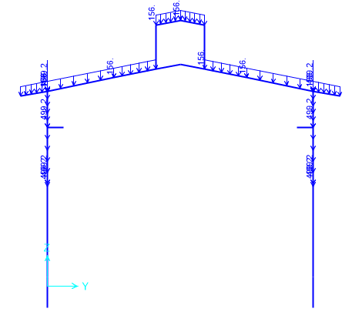

**Figure 1-**Applied Dead load on ended axe(A,H,I,N) (150 kg/m)

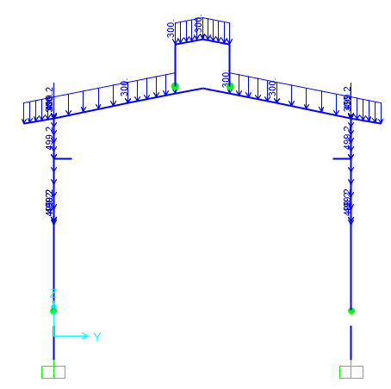

**Figure 2-**Applied Dead load on middle axe(B,C,D,E,F,G,M,J,K,L,M) (300kg/m)

* 1. **Live Loads**

The design live load on an area shall be defined as the weight of all movable loads, including personnel, tools, and parts of dismantled equipment, cranes, hoist, and temporarily stored materials.

According to Iranian National Building Code No.6 Live load in light slop roof is 50kg/m2 and has been applied at frame.

* At first & end frame : $50×3=150 kg/m$
* At middle frame : $50×6=300 kg/m$

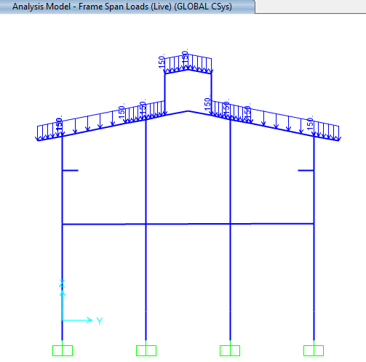

**Figure 3-** Applied Live load on ended axe(A,N) (150kg/m)

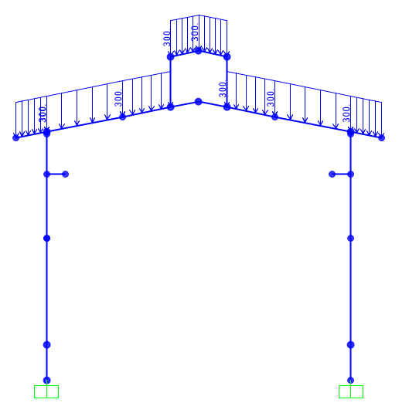

**Figure 4-** Applied Live load on middle axe(B,C,D,E,F,G,M,J,K,L,M) (300kg/m)

* 1. **SNOW LOADS**

Snow load of this structure is calculated in accordance with Iranian National Building Code No.6 Latest edition. Parameters which are used in calculation of snow force is presented in below:

$$P_{r}=P_{s}C_{n}C_{h}I_{S}C_{s}$$

Ps=25 kg/m2 , Is=1

Cs= 0.91 (slope 11.31o)=1-

Ch=1

Cn=0.8

$$P_{r}=P_{s}C_{n}C_{h}I_{S}C_{s}=18.2\frac{kg}{m2}$$

* At first & end frame: $18.2×3=54.6 kg/m$
* At middle frame: $18.2×6=109.2 kg/m$

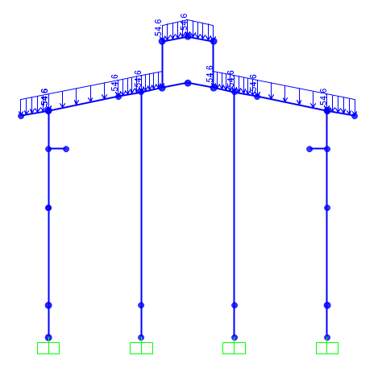

**Figure 5-** Applied Snow load on ended axe(A,H,I,N) (kg/m)

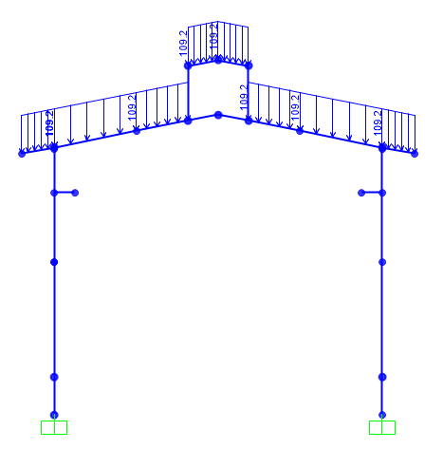

**Figure 6-** Applied Snow load on middle axe(B,C,D,E,F,G,M,J,K,L,M) (kg/m)

* 1. **Seismic loads**

All structures are in area with high-risk zone of seismic and until finalizing of “Geotechnical Final Report” soil type consider is type II. Equivalent static method is used for calculation of seismic loads. Parameters which are used in calculation of earthquake force and seismic coefficient is presented in below.

According to Seismic Parameters according to Iranian Seismic Design Code for Petroleum Facilities (3th Edition).

|  |  |  |
| --- | --- | --- |
| Parameter | X-Direction | Y-Direction |
| Importance factor, $I_{e}$ | 1.25 | 1.25 |
| Structural system | OCBF | SMF |
| R | 3.25 | 8 |
| Ω | 2 | 3 |
| Cd | 3.25 | 5.5 |
| A | 0.3 | 0.3 |
| Soil Type | II | |
| T0(s) | 0.1 | 0.1 |
| Ts(s) | 0.5 | 0.5 |
| $S$ | 1.5 | 1.5 |
| $S_{0}$ | 1 | 1 |
| $S_{Ds}$ | 0.75 | 0.75 |
| $S_{D1}$ | 0.375 | 0.375 |
| $Ta$ = Calculated Period | =0.05 ${(10)}^{0.75}=0.281$* | =0.072 ${(10)}^{0.8}=0.454$* |
| $Tm$ = Analytical Period | 0.216 (Mode 19) | 0.4996(Mode 1) |
| Ta=min($C_{Tu}\left(1.4\right)*{Ta}_{\left(Calculated Period\right),}; ,, {Ta}_{(Analytical Period)}$) | 0.216 | 0.4996 |
| $k$ | 1.00 | 1.00 |
| $S_{a}$ | 0.75 | 0.75 |
| $$C_{s}=\frac{SaI}{Ru}$$ | 0.288 | 0.117 |

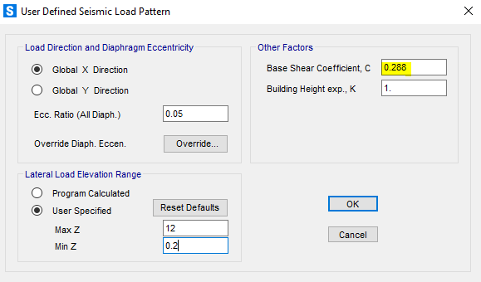

Fig 7- X Direction Seismic Load

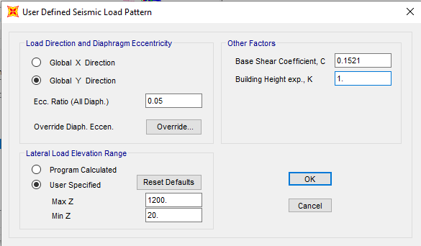

Fig 8- Y Direction Seismic Load with applied $ρ$ (1.3×0.117)

* According to Iranian seismic Design code for Petroleum facilities code 038 $ρ$ in Y directions assumed 1.3.

**to drift check of point in structure uses Ex coefficient without Rho factor.

* 1. **CRANE load**

Distribution of crane load is as below:

* **CRO** is the operating load of crane which shall be defined as the Crane Dead Load plus the crane capacity with considering the vertical, lateral and longitudinal Impact factor.

|  |  |  |
| --- | --- | --- |
| **Input Data** | | |
| Lifted Crane Load = LCL | 10 | ton |
| Crane Weight = CW | 0.117 | ton/m |
| Trolley and Hoist Weight = THW | 3.5 | ton |
| Crane Approach = CAD | 0.75 | m |
| Shelter Width | 12 | m |
| The Maximum Load Factor for this span based on the side approach is | 0.9375 | - |
| The Minimum Load Factor for this span based on the side approach is | 0.0625 | - |
| **There are 2 wheels per truck and 2 trucks per crane for a total of 4 wheels for this crane.** | | |
| Wheels per Truck = TrW | 2 | - |
| Total number of Wheels = TTrW | 4 | - |
| Maximum Wheel Load | 6.679 | ton |
| Minimum Wheel Load | 0.772 | ton |
| The sum of all wheel loads | 14.904 | ton |
| Check the sum of the lifted load + the crane, trolley and hoist weight | 14.904 | **Ok** |
| The distance between frames is the bay size (Lf) | 6 | m |
| The Wheel Spacing (s) | 2 | m |
| **Impact factor** | | |
| Vertical Impact factor (Kv) | 1.25 | - |
| Horizontal Impact factor (kh) | 0.2 | - |
| Longitudinal Impact factor (kl) | 0.1 | - |
| **Vertical Frame Load:** | | |
| Maximum Live Load | 8.348 | ton |
| Minimum Live Load | 0.966 | ton |

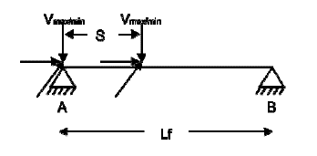Frame Analysis Data:

|  |  |  |
| --- | --- | --- |
| **CRO** | | |
| Left | | |
| RAv (max) | 13.91 | ton |
| RAh (max) | 2.226 | ton |
| RAl (max) | 0.667 | ton |
| RBv (min) | 2.782 | ton |
| RBh (min) | 0.445 | ton |
| RBl (min) | 0.667 | ton |
| Right | | |
| RAv (max) | 1.61 | ton |
| RAh (max) | 0.257 | ton |
| Ral (max) | 0.077 | ton |
| RBv (min) | 0.322 | ton |
| RBh (min) | 0.051 | ton |
| RBl (min) | 0.077 | ton |

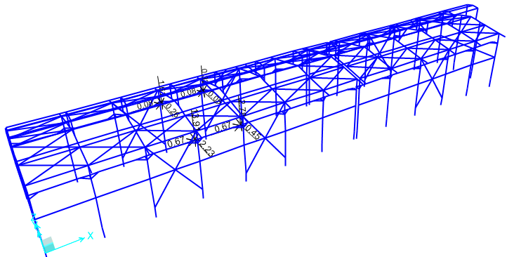

**Figure 9-**Applied Crane Operating load (CRO1) on Structure (ton)

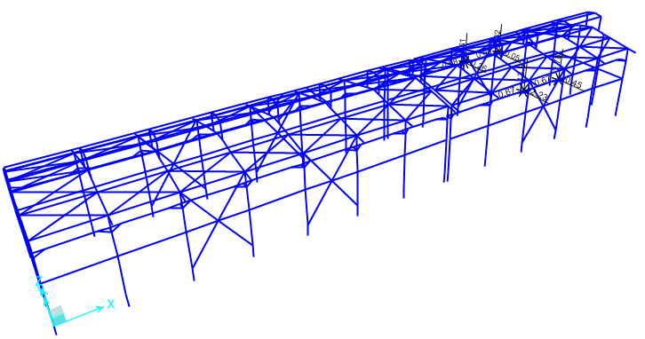

**Figure 10-**Applied Crane Operating load (CRO2) on Structure (ton)

* **CRD (Crane Dead Load)** Crd is the weight of Crane Bridge plus crab and trolley weight which is as follow:

|  |  |  |
| --- | --- | --- |
| **CRD** | | |
| Vmax | 1.99 | ton |
| Vmin | 0.46 | ton |
| **Left** | | |
| RAv (max) | 3.31 | ton |
| RBv (min) | 0.663 | ton |
| **Right** | | |
| RAv (max) | 0.767 | ton |
| RBv (min) | 0.153 | ton |

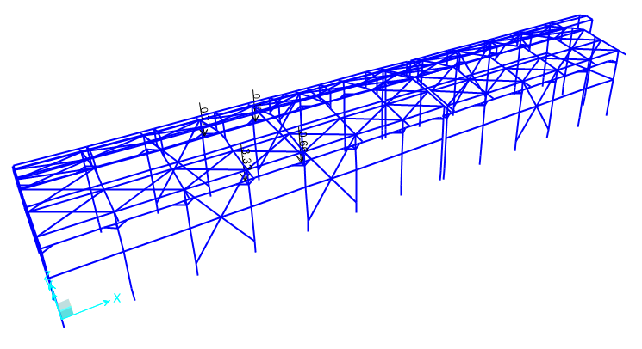

**Figure 11-**Applied Crane Dead load (CRD) on Structure (ton)

* 1. **WIND loads**

Wind loads are calculated for Gas Compressors Shelter (according to Iranian National Building Code No.6 last edition) and applied at model as below:

|  |  |  |
| --- | --- | --- |
| سرعت باد (Km/h) | 120 | Km/h |
| فشار مبنای باد(q) | 0.681 | kPa |
| ضریب اهمیت(I) | 1 | جدول 6-1-2 |
| ارتفاع متوسط بام (کمتر از 6m نباشد) (H) | 9.4 | m |
| ارتفاع بازشو از سطح زمین | 4 | m |
| عرض سوله (کمترین بعد افقی در پلان) | 12 | m |
| نوع زمین | باز | بند 6-10-6-1 |
| Ce | 0.987701176 | - |
| Cgi | 2 | بند 6-10-8-1 |
| (گروه 1، 2، یا 3) Cpi | 3 | بند 6-10-11 |
| Cpi (positive) | 0.7 | بند 6-10-11 |
| Cpi (Negative) | -0.7 | بند 6-10-11 |
| شیب بام | 11.3 | درجه |
| (فاصله قابها) y | 6 | صفحه 87 مبحث ششم (m) |
| z | 1.2 | صفحه 87 مبحث ششم (m) |
| Cd | 0.85 | بند 6-10-12 |
| Ct | 1 | بند 6-10-7 |

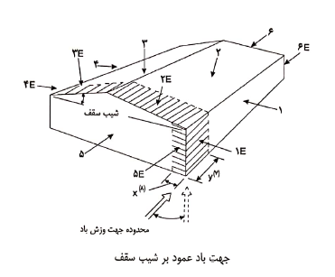

|  |  |  |  |  |  |  |  |  |  |  |  |  |
| --- | --- | --- | --- | --- | --- | --- | --- | --- | --- | --- | --- | --- |
|  | **1** | **1E** | **2** | **2E** | **3** | **3E** | **4** | **4E** | **5** | **5E** | **6** | **6E** |
| CgCp-شکل ب | -0.85 | -0.90 | -1.30 | -2.00 | -0.70 | -1.00 | -0.85 | -0.90 | 0.75 | 1.15 | -0.55 | -0.80 |
| P=I*q*Ce*CgCp*Ct*Cd (kPa) | -0.49 | -0.51 | -0.74 | -1.14 | -0.40 | -0.57 | -0.49 | -0.51 | 0.43 | 0.66 | -0.31 | -0.46 |
| Pi (kPa) | -0.94 | -0.94 | -0.94 | -0.94 | -0.94 | -0.94 | -0.94 | -0.94 | 0.94 | 0.94 | -0.94 | -0.94 |
| P+Pi (kPa) | -1.43 | -1.46 | -1.68 | -2.09 | -1.34 | -1.51 | -1.43 | -1.46 | 1.37 | 1.60 | -1.26 | -1.40 |
| WY (kg/m2) | -142.76 | -145.62 | -168.49 | -208.51 | -134.19 | -151.34 | -142.76 | -145.62 | 137.05 | 159.92 | -125.61 | -139.91 |

Wind load (WLX1) for frame in X-Direction according to INBC No.6:



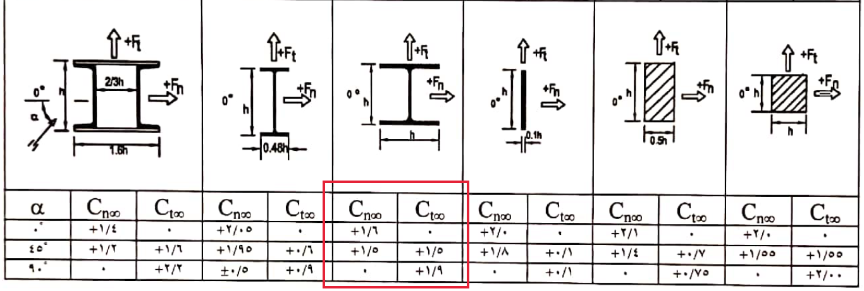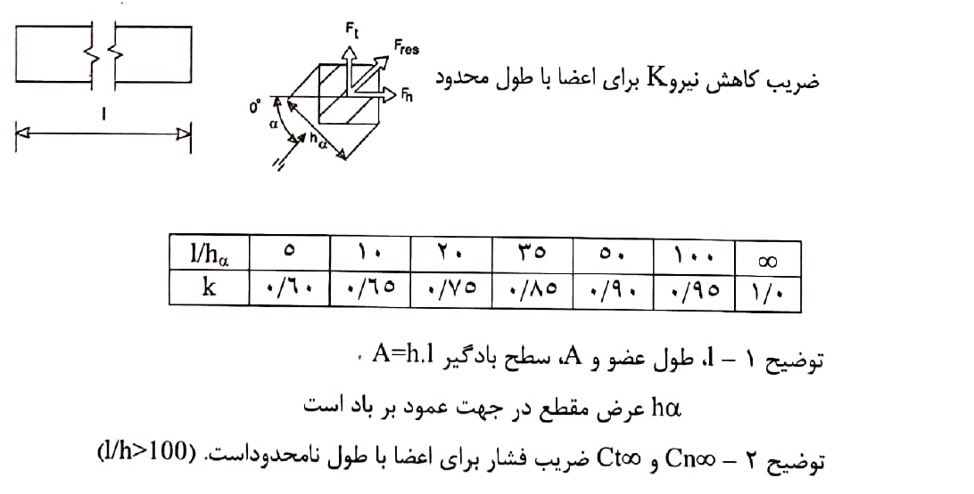L=300 cm

$$h_{∝}=30 cm$$

$$L/h_{∝}=10$$

$$F_{n}=k.C_{n∞}.q.C_{g}.C_{e}.A.I_{w}=0.65*1.6*0.00694*2*0.941*40*1=0.543 kg/cm$$

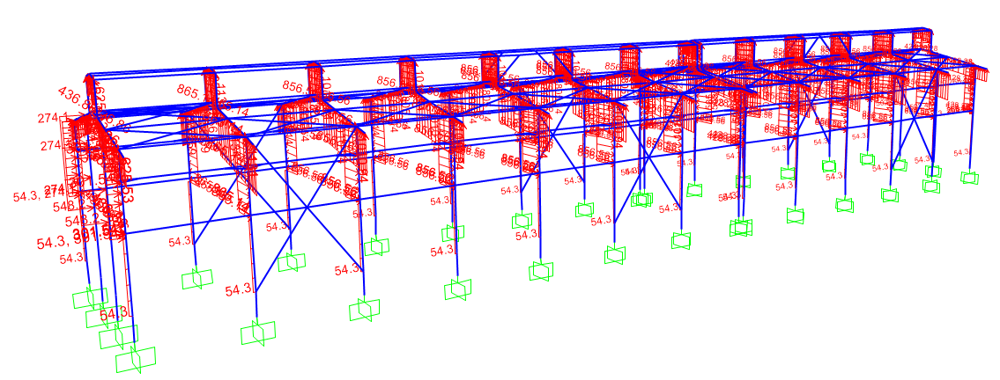

**Figure 12-**Applied Wind Load (WLX1) on Structure (Kg/m)

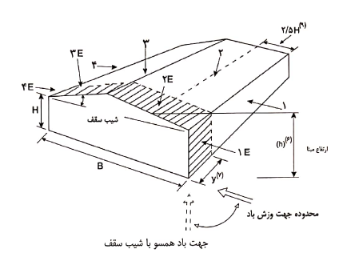

|  |  |  |  |  |  |  |  |  |
| --- | --- | --- | --- | --- | --- | --- | --- | --- |
|  | **1** | **1E** | **2** | **2E** | **3** | **3E** | **4** | **4E** |
| CgCp-شکل الف | 0.86 | 1.30 | -1.30 | -2.00 | -0.78 | -1.13 | -0.66 | -0.97 |
| P=I*q*Ce*CgCp*Ct*Cd (kPa) | 0.49 | 0.74 | -0.74 | -1.14 | -0.45 | -0.64 | -0.37 | -0.55 |
| Pi (kPa) | 0.94 | 0.94 | -0.94 | -0.94 | -0.94 | -0.94 | -0.94 | -0.94 |
| P+Pi (kPa) | 1.43 | 1.68 | -1.68 | -2.09 | -1.39 | -1.59 | -1.32 | -1.50 |
| WX (kg/m2) | 143.05 | 168.32 | -168.49 | -208.51 | -138.99 | -158.54 | -131.62 | -149.51 |

Wind load (WLY1) for frame in Y-Direction according to INBC No.6:

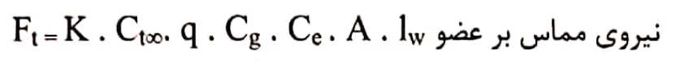



L=300 cm

$$h_{∝}=30 cm$$

$$L/h_{∝}=10$$

$$F_{t}=k.C_{t∞}.q.C_{g}.C_{e}.A.I_{w}=0.65*1.9*0.00694*2*0.941*30*1=0.483 kg/cm$$

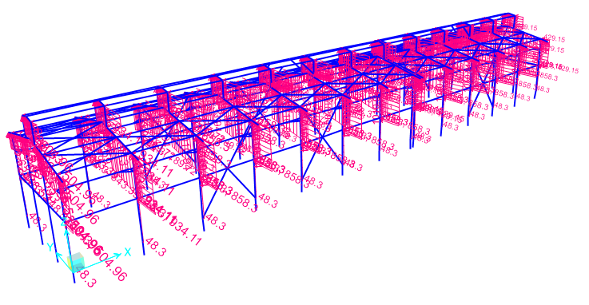

**Figure 13-**Applied Wind Load (WLY1) on Structure (Kg/m)

* 1. **Thermal Load:**

Thermal loads are those forces caused by a change in temperature. for this area assumed ${ 28}^{℃}$.

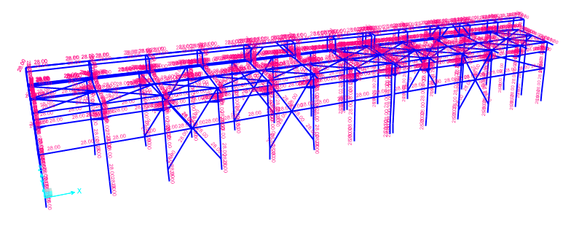

**Figure 14-**Applied Thermal Load (TLst) on Structure

1. **SAP2000 LOAD PATTERN**

|  |  |
| --- | --- |
| **TABLE:** | |
| **LoadPat** | **Notes** |
| DEAD | Dead Load |
| Live | Live Load |
| S | Snow Load |
| EQX | Seismic Load in Dir X |
| EQY | Seismic Load in Dir Y |
| WLX1 | Wind Load in in Dir X (senario 1) |
| WLY1 | Wind Load in in Dir Y (senario 1) |
| CRD | Crane Dead Load |
| CRO1 | Crane Operation Load (Senario 1) |
| TLst | Temperature Load |
| NotionalX(DL) | Notional Dead Load in Dir X |
| NotionalY(DL) | Notional Dead Load in Dir Y |
| NotionalX(LL) | Notional Live Load in Dir X |
| NotionalY(LL) | Notional Live Load in Dir Y |
| CRO2 | Crane Operation Load (Senario 2) |
| Soil | Soil Load |
| Ev | Vertical Sesimic Load |
| NotionalX(CRO1) | Notional CRO1 Load in Dir X |
| NotionalY(CRO1) | Notional CRO1 Load in Dir Y |
| NotionalX(CRO2) | Notional CRO2 Load in Dir X |
| NotionalY(CRO2) | Notional CRO2 Load in Dir Y |
| NotionalX(CRD) | Notional CRD Load in Dir X |
| NotionalY(CRD) | Notional CRD Load in Dir Y |

1. **LOAD COMBINATIONS**

According to code INBC No.6 structures, components, and foundations shall be designed, so that their design strength equals or exceeds that effect of factored loads in the following combination:

* *1.4(D)*
* *(1.2D) +1.6(L)+0.5(Lr/S/R)*
* *1.2D+1.6(Lr/S/R) + (L/0.5W)*
* *1.2D+1.0(W) + L+.5(Lr/S)*
* *1.2D+1.0E+L+0.2S*
* *0.9D+1.0W*
* *0.9D+1.0E*

Load listed herein shall be considered to act in the following combinations; whichever produces the most unfavourable effect considering soil reactions.

* *D*
* *D+L*
* *D+(Lr/S/R)*
* *D+0.75(L)+0.75(Lr/R/S)*
* *D+(0.6W or 0.7E)*
* *D+0.75L+0.75(0.6W)+0.75(Lr/S/R)*
* *D+0.75L+0.75(0.7E)+0.75S*
* *0.6D+0.6W*
* *0.6D+0.7E*

1. **STRUCTURE ANALYSIS AND DESIGN** 
   1. **ANALYSIS**

Structural analysis is done by SAP2000 software. In model loads are applied, some graphical outputs from model are shown as follows.

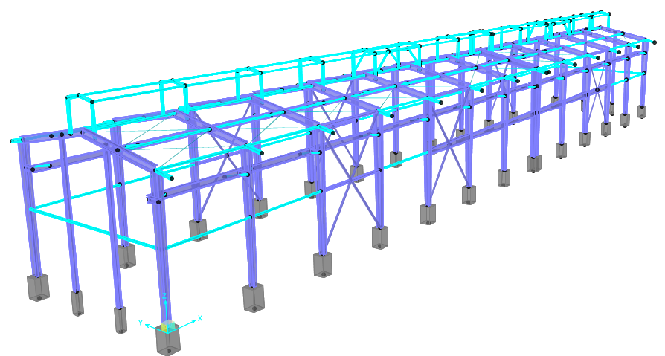

**Figure 15-3D view of SAP model**

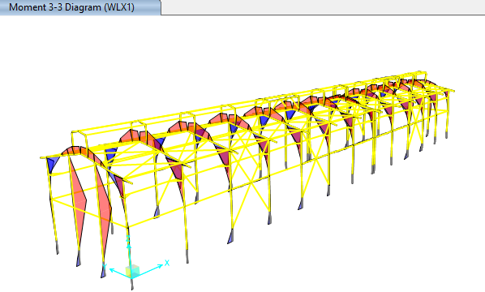

**Figure 16: Moment 3-3 WLx1 load**

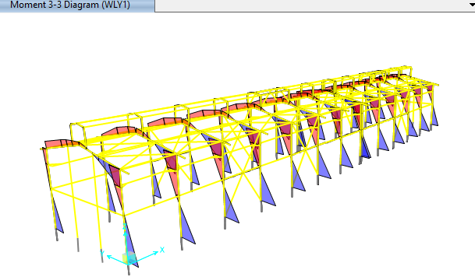

**Figure 17: Moment 3-3 WLY1 load**

* 1. **Displacement and Drift CONTROL:**

According to “Civil & Structural Design Criteria”, horizontal displacements for shelter shall not exceed H/200.

$$allowable Displacement is \frac{h}{200}=\frac{880-20}{200}=4.3cm=\frac{4.4}{0.8}=5.375 cm$$

The maximum displacement is less than H/200, so the displacement values are acceptable.

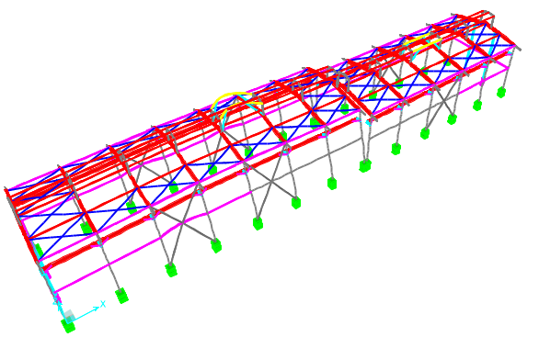

|  |  |  |  |  |  |  |
| --- | --- | --- | --- | --- | --- | --- |
| **TABLE: Joint Displacements** | | | | | | |
| **Joint** | **OutputCase** | **CaseType** | **U1** | **U2** | **\*\*h/200/0.8** | **check** |
| Text | Text | Text | cm | cm |
| 2 | Drift-WLX1-2 | Combination | -0.80234 | -0.23445 | 5.375 | Ok |
| 2 | Drift-WLX2-1 | Combination | -0.69988 | -0.20651 | 5.375 | Ok |
| 2 | Drift-WLY1-2 | Combination | -0.76121 | -3.9297 | 5.375 | Ok |
| 3 | Drift-WLX1-2 | Combination | -0.79232 | 0.372912 | 5.375 | Ok |
| 3 | Drift-WLX2-1 | Combination | -0.69261 | 0.258957 | 5.375 | Ok |
| 3 | Drift-WLY1-2 | Combination | -0.64785 | -3.28219 | 5.375 | Ok |
| 5 | Drift-WLX1-2 | Combination | -0.421 | -0.37612 | 5.375 | Ok |
| 5 | Drift-WLX2-1 | Combination | -0.29348 | -0.30259 | 5.375 | Ok |
| 5 | Drift-WLY1-2 | Combination | -0.33689 | -4.41896 | 5.375 | Ok |
| 6 | Drift-WLX1-2 | Combination | -0.43468 | 0.475559 | 5.375 | Ok |
| 6 | Drift-WLX2-1 | Combination | -0.30275 | 0.331229 | 5.375 | Ok |
| 6 | Drift-WLY1-2 | Combination | -0.26792 | -3.41031 | 5.375 | Ok |
| 22 | Drift-WLX1-2 | Combination | -0.5979 | -0.37036 | 5.375 | Ok |
| 22 | Drift-WLX2-1 | Combination | -0.49778 | -0.28824 | 5.375 | Ok |
| 22 | Drift-WLY1-2 | Combination | -0.5561 | -4.39147 | 5.375 | Ok |
| 23 | Drift-WLX1-2 | Combination | -0.5894 | 0.511255 | 5.375 | Ok |
| 23 | Drift-WLX2-1 | Combination | -0.49173 | 0.343553 | 5.375 | Ok |
| 23 | Drift-WLY1-2 | Combination | -0.44636 | -3.34666 | 5.375 | Ok |
| 34 | Drift-WLX1-2 | Combination | -0.3686 | -0.35026 | 5.375 | Ok |
| 34 | Drift-WLX2-1 | Combination | -0.2892 | -0.27659 | 5.375 | Ok |
| 34 | Drift-WLY1-2 | Combination | -0.32526 | -4.75089 | 5.375 | Ok |
| 35 | Drift-WLX1-2 | Combination | -0.36217 | 0.513574 | 5.375 | Ok |
| 35 | Drift-WLX2-1 | Combination | -0.28402 | 0.363397 | 5.375 | Ok |
| 35 | Drift-WLY1-2 | Combination | -0.2632 | -3.72299 | 5.375 | Ok |
| 53 | Drift-WLX1-2 | Combination | -0.21244 | -0.38143 | 5.375 | Ok |
| 53 | Drift-WLX2-1 | Combination | -0.09622 | -0.30555 | 5.375 | Ok |
| 53 | Drift-WLY1-2 | Combination | -0.10835 | -4.6889 | 5.375 | Ok |
| 60 | Drift-WLX1-2 | Combination | -0.22337 | 0.489323 | 5.375 | Ok |
| 60 | Drift-WLX2-1 | Combination | -0.10396 | 0.338439 | 5.375 | Ok |
| 60 | Drift-WLY1-2 | Combination | -0.09817 | -3.65896 | 5.375 | Ok |
| 70 | Drift-WLX1-2 | Combination | 0.222264 | -0.36251 | 5.375 | Ok |
| 70 | Drift-WLX2-1 | Combination | 0.280244 | -0.2915 | 5.375 | Ok |
| 70 | Drift-WLY1-2 | Combination | 0.321684 | -4.80819 | 5.375 | Ok |
| 71 | Drift-WLX1-2 | Combination | 0.23293 | 0.506315 | 5.375 | Ok |
| 71 | Drift-WLX2-1 | Combination | 0.288384 | 0.35349 | 5.375 | Ok |
| 71 | Drift-WLY1-2 | Combination | 0.2589 | -3.77783 | 5.375 | Ok |
| 82 | Drift-WLX1-2 | Combination | 0.421601 | -0.3722 | 5.375 | Ok |
| 82 | Drift-WLX2-1 | Combination | 0.484342 | -0.29527 | 5.375 | Ok |
| 82 | Drift-WLY1-2 | Combination | 0.551684 | -4.46345 | 5.375 | Ok |
| 83 | Drift-WLX1-2 | Combination | 0.436307 | 0.483724 | 5.375 | Ok |
| 83 | Drift-WLX2-1 | Combination | 0.495474 | 0.338795 | 5.375 | Ok |
| 83 | Drift-WLY1-2 | Combination | 0.43617 | -3.4539 | 5.375 | Ok |
| 94 | Drift-WLX1-2 | Combination | 0.612135 | -0.28025 | 5.375 | Ok |
| 94 | Drift-WLX2-1 | Combination | 0.674908 | -0.25433 | 5.375 | Ok |
| 94 | Drift-WLY1-2 | Combination | 0.745716 | -4.01293 | 5.375 | Ok |
| 95 | Drift-WLX1-2 | Combination | 0.628186 | 0.363769 | 5.375 | Ok |
| 95 | Drift-WLX2-1 | Combination | 0.687426 | 0.277758 | 5.375 | Ok |
| 95 | Drift-WLY1-2 | Combination | 0.621572 | -3.27892 | 5.375 | Ok |
| 114 | Drift-WLX1-2 | Combination | -0.14941 | -0.32169 | 5.375 | Ok |
| 114 | Drift-WLX2-1 | Combination | -0.08129 | -0.24806 | 5.375 | Ok |
| 114 | Drift-WLY1-2 | Combination | -0.09486 | -4.91333 | 5.375 | Ok |
| 115 | Drift-WLX1-2 | Combination | -0.14451 | 0.535643 | 5.375 | Ok |
| 115 | Drift-WLX2-1 | Combination | -0.07681 | 0.388564 | 5.375 | Ok |
| 115 | Drift-WLY1-2 | Combination | -0.06763 | -3.8904 | 5.375 | Ok |
| 126 | Drift-WLX1-2 | Combination | 0.013497 | -0.34306 | 5.375 | Ok |
| 126 | Drift-WLX2-1 | Combination | 0.075922 | -0.27592 | 5.375 | Ok |
| 126 | Drift-WLY1-2 | Combination | 0.093943 | -4.94957 | 5.375 | Ok |
| 127 | Drift-WLX1-2 | Combination | 0.021094 | 0.523948 | 5.375 | Ok |
| 127 | Drift-WLX2-1 | Combination | 0.081491 | 0.364185 | 5.375 | Ok |
| 127 | Drift-WLY1-2 | Combination | 0.06499 | -3.92271 | 5.375 | Ok |
| 130 | Drift-WLX1-2 | Combination | 0.001918 | -0.38221 | 5.375 | Ok |
| 130 | Drift-WLX2-1 | Combination | 0.116141 | -0.30644 | 5.375 | Ok |
| 130 | Drift-WLY1-2 | Combination | 0.13417 | -4.69202 | 5.375 | Ok |
| 131 | Drift-WLX1-2 | Combination | -0.00666 | 0.487737 | 5.375 | Ok |
| 131 | Drift-WLX2-1 | Combination | 0.110595 | 0.339053 | 5.375 | Ok |
| 131 | Drift-WLY1-2 | Combination | 0.103912 | -3.66047 | 5.375 | Ok |
| 142 | Drift-WLX1-2 | Combination | 0.185197 | -0.37529 | 5.375 | Ok |
| 142 | Drift-WLX2-1 | Combination | 0.317736 | -0.29961 | 5.375 | Ok |
| 142 | Drift-WLY1-2 | Combination | 0.370587 | -4.42353 | 5.375 | Ok |
| 143 | Drift-WLX1-2 | Combination | 0.176 | 0.476954 | 5.375 | Ok |
| 143 | Drift-WLX2-1 | Combination | 0.311286 | 0.332236 | 5.375 | Ok |
| 143 | Drift-WLY1-2 | Combination | 0.275699 | -3.41797 | 5.375 | Ok |
| 154 | Drift-WLX1-2 | Combination | 0.377984 | -0.23675 | 5.375 | Ok |
| 154 | Drift-WLX2-1 | Combination | 0.516665 | -0.21467 | 5.375 | Ok |
| 154 | Drift-WLY1-2 | Combination | 0.575506 | -3.90619 | 5.375 | Ok |
| 155 | Drift-WLX1-2 | Combination | 0.368968 | 0.330904 | 5.375 | Ok |
| 155 | Drift-WLX2-1 | Combination | 0.509816 | 0.252502 | 5.375 | Ok |
| 155 | Drift-WLY1-2 | Combination | 0.466784 | -3.28514 | 5.375 | Ok |
| 180 | Drift-WLX1-2 | Combination | -0.61042 | -0.28899 | 5.375 | Ok |
| 180 | Drift-WLX2-1 | Combination | -0.48222 | -0.25712 | 5.375 | Ok |
| 180 | Drift-WLY1-2 | Combination | -0.53016 | -3.99468 | 5.375 | Ok |
| 181 | Drift-WLX1-2 | Combination | -0.62514 | 0.365016 | 5.375 | Ok |
| 181 | Drift-WLX2-1 | Combination | -0.49225 | 0.27236 | 5.375 | Ok |
| 181 | Drift-WLY1-2 | Combination | -0.44908 | -3.26184 | 5.375 | Ok |
|  |  | Max | -0.80234 | -4.94957 | 5.375 | Ok |

-Checked drift with Envelope A includes Ex & Ey

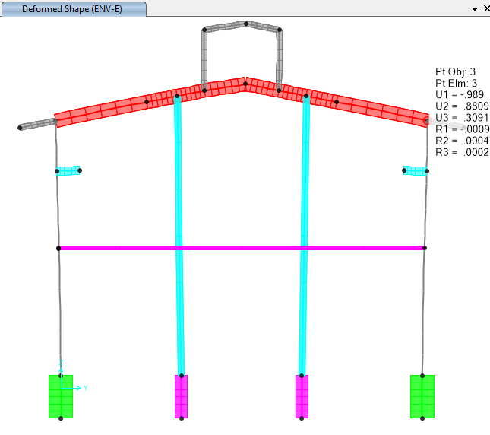

**Figure 18: Displacement (Combo : Envelope E)**



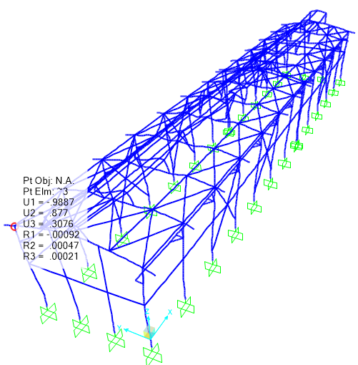

**Figure 19: Displacement (Envelope E)**

1. Structural Design Results

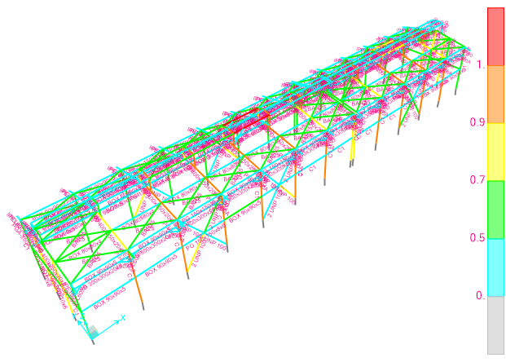

**Figure 20: M-P interaction Ratio of Shelter Elements**

1. **Flextural design of crane beam**

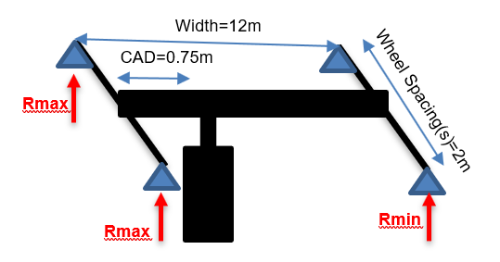

|  |  |  |
| --- | --- | --- |
| Lifted Crane Load = LCL | 10 | ton |
| Crane Weight = CW | 0.117 | ton/m |
| Trolley and Hoist Weight = THW | 3.5 | ton |
| Crane Approach = CAD | 0.75 | m |
| Shelter Width | 12 | m |
| The Maximum Load Factor for this span based on the side approach is | 0.9375 | - |
| The Minimum Load Factor for this span based on the side approach is | 0.0625 | - |
| **There are 2 wheels per truck and 2 trucks per crane for a total of 4 wheels for this crane.** | | |
| Wheels per Truck = TrW | 2 | - |
| Total number of Wheels = TTrW | 4 | - |
| Maximum Wheel Load (Rmax) | 6.679 | ton |
| Minimum Wheel Load (Rmin) | 0.772 | ton |

$\left(R1,R2\right)max$ =(6.679, 6.679)=13.358 ton

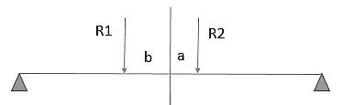

$$b=\frac{6.679×\left(a+b\right)+6.679×0}{13.358×1.25}=\frac{6.679×\left(2\right)+6.679×0}{13.358×1.25}=0.8m$$

b = 2 - 0.8 = 1.2m

According to below moment diagram under R2 load calculation is:

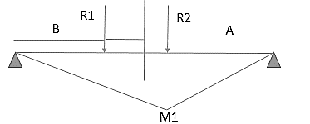.

$$M1=\frac{P1AB}{L}=\frac{6.679×2.4×3.6}{6}=9.61776 ton.m$$

According to below moment diagram under R2 load calculation is:

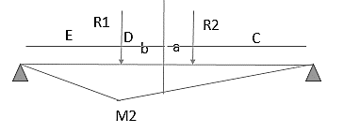

$$M2=\frac{C}{C+D}\frac{P2.E.(D+C)}{L}=\frac{2.4}{4.4}×\frac{6.679×0.6×4.4}{6}=1.603 ton.m$$

$$Mu=9.61776+1.603=11.22 ton.m$$

$$f=0.6Fy=\frac{M}{S} Sreq=\frac{11.22×1000×100}{0.6×2400}=779.16 cm³$$

According to above calculation crane support beam needs $779.16$ cm³ modulus.

$Sused=1915.29 cm³ OK$ (PG 300x300x20x8)

×

=

×

=

* 1. DEFLECTION CONTROL

Maximum beam deflection under crane live load on shelter is:

$δ_{max}=\frac{PL^{3}}{48EI}=\frac{13.300 ×1000×{600}^{3}}{48×2.1×{10}^{6}×43968.5}=0.6 cm$ < $δ_{all} SAY OK$

$$δ_{all}=\frac{L}{1000}=\frac{600}{1000}=0.6cm$$

1. **PURLIN DESIGN**

## Property of Purlin (Z180x2.5)

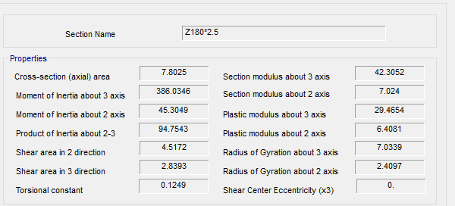

**Figure 21-**Section Property Of Purlin

According to above table:

$$A=7.80 cm2$$

$$J=0.12 cm4$$

$$Ix=386.06 cm4$$

$$Iy=45.304 cm4$$

$$rx=7.033 cm$$

$$ry=2.41 cm$$

$$ho=18 cm$$

$$SY=42.305 cm3$$

$$SX=7.024 cm3$$

FOR Z 180 :

$$D+L=26+50=76 kg/m^{2}$$

$$P_{y}=76.\cos{11}=74.6 kg/m^{2}$$

$$P_{x}=76.\sin{11}=14.5 kg/m^{2}$$

$$middle of span : M_{y}=\frac{w.L^{2}}{8}=\frac{74.6×1.0×6^{2}}{8}=335.7 kg.m$$

$$middle of span : M_{x}=\frac{w.L^{2}}{360}=\frac{14.5×1×6^{2}}{360}=1.45 kg.m$$

$$f_{b}=\frac{M_{y}}{s_{y}}+2\frac{M_{x}}{s_{x}}=\frac{335.7×100}{42.305}+2\frac{1.45×100}{7.024}=793.52+41.28=834.8<1440 ok$$

$$moment on sagrod support : M_{y}=\frac{w.L^{2}}{9}=\frac{74.6×1.0×6^{2}}{9}=298.4 kg.m$$

$$moment on sagrod support : M_{x}=\frac{w.L^{2}}{90}=\frac{14.5×1.0×6^{2}}{90}=5.8 kg.m$$

$$f_{b}=\frac{M_{y}}{s_{y}}+2\frac{M_{x}}{s_{x}}=\frac{298.4×100}{42.305}+2\frac{5.8×100}{7.024}=705.35+165.14=870.49< 1440 ok$$

## Undeformed shape CONTROL:

$$dead+live loads : ∆=\frac{5×q×L^{4}}{384×E×I}=\frac{5×0.76×1.0×{600}^{4}}{384×2.04×{10}^{6}×1350}=0.46cm < \frac{L}{240}=2.0cm$$

$$for live loads : ∆=\frac{5×q×L^{4}}{384×E×I}=\frac{5×0.5×1.0×{600}^{4}}{384×2.04×{10}^{6}×1350}=0.3cm < \frac{L}{360}=1.3 cm$$

1. **STRUCTURE CONNECTIONS**
   1. **Beam To Column**

**Input Data:**

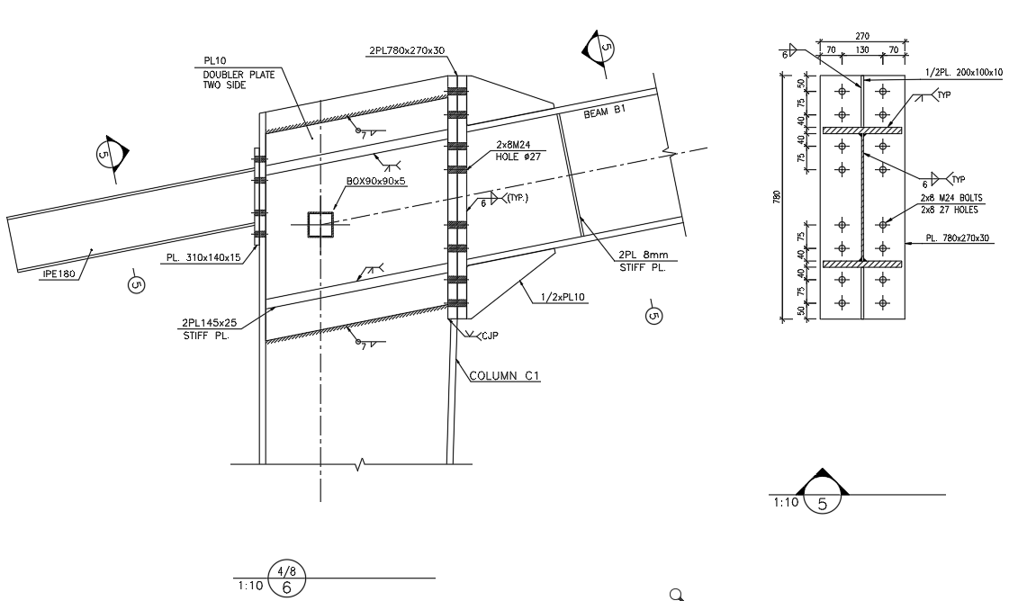Connection Type: Moment End Plate of PG 400x250x20x8 (Rigid Connection)

|  |  |  |  |  |  |  |  |
| --- | --- | --- | --- | --- | --- | --- | --- |
| **Member** | **Section Name** | **d** | **Bf** | **tf** | **tw** | **Area** | **Z33** |
| cm | cm | cm | cm | cm2 | cm3 |
| Beam | PG 400x250x20x8 | 44 | 25 | 2 | 0.8 | 132 | 2420 |
| Column | PG 550x300x20x8 | 64 | 30 | 2 | 0.8 | 168 | 4440 |

Design Load: (Based on Capacity of Member)

According to AISC360-16:

$M_{pr}=Z_{3-3}F_{y}=2420*2400=5808000 kgf-cm$ (F2-1)

$M_{u}=1.1RyMpr=1.1*1.15*5808000=7347120 kgf-cm$

$$V_{u}=\frac{{2M}_{u}}{L_{B}}=\frac{2*7347120}{600}=24490.4 kgf$$

|  |  |  |
| --- | --- | --- |
| Load | Vu | Mu |
| Unit(Ton, m) | 24.49 | $$73.47$$ |

**Units system:** Metric

Steel connections

**Results**

**Connection name : END PLATE PG400X250X20X8**

**Connection ID : 1**

Family: Beam - Column flange (BCF)

Type: Moment end plate

Description: Beam to Column

Design code: AISC 360-16 LRFD

**DEMANDS**

Beam Right beam Left beam Column Panel

**Description Ru Pu Mu PufTop PufBot PufTop PufBot Pu Vu Load type**

[T] [T] [T*m] [T] [T] [T] [T] [T] [T]

DL 24.49 0.00 73.47 -174.93 174.93 0.00 0.00 0.00 174.93 Design

**GEOMETRIC CONSIDERATIONS**

**Dimensions Unit Value Min. value Max. value Sta. References**

Extended end plate

End plate stiffener thickness [cm] 1.00 1.00 --  DG4 Eq. 3.15,

AISC 358-10 Eq. 6.10-9,

Eq. 6.10-10

tsmin = max(twb*(Fyb/Fys), (hst/0.56)*(Fys/E)1/2)

= max(0.8[cm]*(2400[kg/cm2]/2400[kg/cm2]), (16.5[cm]/0.56)*(2400[kg/cm2]/2.10E+06[kg/cm2])1/2)

= **0.996**[cm] DG4 Eq. 3.15,

AISC 358-10 Eq. 6.10-9,

Eq. 6.10-10

Vertical edge distance [cm] 5.00 3.04 15.24  Sec. J3.5

Lemin = edmin + C2

= 3.035[cm] + 0[cm]

= **3.035**[cm] Tables J3.4,

J3.5

Lemax = min(12*tp, 6 [in])

= min(12*3[cm], 6 [in])

= **15.24**[cm] Sec. J3.5

Horizontal edge distance [cm] 7.00 3.04 15.24  Sec. J3.5

Lemin = edmin + C2

= 3.035[cm] + 0[cm]

= **3.035**[cm] Tables J3.4,

J3.5

Lemax = min(12*tp, 6 [in])

= min(12*3[cm], 6 [in])

= **15.24**[cm] Sec. J3.5

Vertical bolt spacing (external flange) [cm] 7.50 6.40 --  Sec. J3.3

smin = 8/3*d

= 8/3*2.4[cm]

= **6.4**[cm] Sec. J3.3

Vertical bolt spacing (internal flange) [cm] 7.50 6.40 --  Sec. J3.3

smin = 8/3*d

= 8/3*2.4[cm]

= **6.4**[cm] Sec. J3.3

Horizontal center-to-center spacing (gage) [cm] 13.00 6.40 25.00  Sec. J3.3,

DG4 Sec. 2.4,

DG4 Sec. 2.1,

2.4,

DG16 Sec. 2.5

gmin = Max(8/3*d, 2*k1c + 2*d, twb + 2*w + dh)

= Max(8/3*2.4[cm], 2*0.4[cm] + 2*2.4[cm], 0.8[cm] + 2*0.953[cm] + 2.718[cm])

= **6.4**[cm] Sec. J3.3,

DG4 Sec. 2.4

gmax = bfb

= **25**[cm] DG4 Sec. 2.1,

2.4,

DG16 Sec. 2.5

Outer bolt distance (external flange) [cm] 4.00 3.67 --  DG4 Sec. 2.1

d< = 1 [in]  2.4[cm]<

= 1 [in]  **True**

pfmin = d + 1/2 [in]

= 2.4[cm] + 1/2 [in]

= **3.67**[cm] DG4 Sec. 2.1

Inner bolt distance (external flange) [cm] 4.00 3.67 --  DG4 Sec. 2.1

d< = 1 [in]  2.4[cm]<

= 1 [in]  **True**

pfmin = d + 1/2 [in]

= 2.4[cm] + 1/2 [in]

= **3.67**[cm] DG4 Sec. 2.1

Outer bolt distance (internal flange) [cm] 4.00 3.67 --  DG4 Sec. 2.1

d< = 1 [in]  2.4[cm]<

= 1 [in]  **True**

pfmin = d + 1/2 [in]

= 2.4[cm] + 1/2 [in]

= **3.67**[cm] DG4 Sec. 2.1

Inner bolt distance (internal flange) [cm] 4.00 3.67 --  DG4 Sec. 2.1

d< = 1 [in]  2.4[cm]<

= 1 [in]  **True**

pfmin = d + 1/2 [in]

= 2.4[cm] + 1/2 [in]

= **3.67**[cm] DG4 Sec. 2.1

Bolt diameter [cm] 2.40 -- 3.81  DG4 Sec. 1.1

dbmax = 1.5 [in] DG4 Sec. 1.1

- Use CJP weld for the end plate stiffener

Beam

Web [1/16in] 6 3 --  table J2.4

wmin = wmin

= **0.004763** table J2.4

Support

Horizontal edge distance [cm] 8.50 3.04 15.24  Sec. J3.5

Lemin = edmin + C2

= 3.035[cm] + 0[cm]

= **3.035**[cm] Tables J3.4,

J3.5

Lemax = min(12*tp, 6 [in])

= min(12*3[cm], 6 [in])

= **15.24**[cm] Sec. J3.5

Transverse stiffeners

Length [cm] 58.00 29.00 58.00  Sec. J10.8

lsmin = (dc - 2*tcf)/2

= (64[cm] - 2*3[cm])/2

= **29**[cm] Sec. J10.8

lsmax = dc - 2*tcf

= 64[cm] - 2*3[cm]

= **58**[cm] Sec. J10.8

Width [cm] 15.00 8.60 --  Sec. J10.8

bsmin = b/3 - tw/2

= 27[cm]/3 - 0.8[cm]/2

= **8.6**[cm] Sec. J10.8

Doublers

Recommended thickness for beveling and welding [cm] 1.00 0.80 --  Sec. G2.1,

DG 13 Eq. 4.4-4

h = dc - 2*k

= 64[cm] - 2*3[cm]

= **58**[cm] Sec. G2.1

tmin = h/(1.1*(5*E/Fy)1/2)

= 58[cm]/(1.1*(5*2.10E+06[kg/cm2]/2400[kg/cm2])1/2)

= **0.797**[cm] Sec. G2.1

tmin = k - tf - re

= 3[cm] - 3[cm] - 0.318[cm]

= **-0.318**[cm] DG 13 Eq. 4.4-4

**PLATE / COLUMN BEHAVIOR**

End plate behaviour (external flange)

Thick plate behavior controlled by no prying bolt rupture

End plate behaviour (internal flange)

Thick plate behavior controlled by no prying bolt rupture

Column flange behavior (external flange)

Thick plate behavior controlled by no prying bolt rupture

Column flange behavior (internal flange)

Thick plate behavior controlled by no prying bolt rupture

**DESIGN CHECK**

**Verification Unit Capacity Demand Ctrl EQ Ratio References**

Moment end plate (external flange)

Flexural yielding [Ton*m] 113.83 0.00 DL **0.00** DG4 Table 3.3,

AISC 358 Table 6.4,

DG4 Eq. 3.10,

Sec. 2.2.3

s = 0.5*(bp*g)1/2

= 0.5*(27[cm]*13[cm])1/2

= **9.367**[cm] DG4 Table 3.1,

AISC 358 Table 6.2

pfi = min(pfi, s)

= min(4[cm], 9.367[cm])

= **4**[cm] DG4 Table 3.1,

AISC 358 Table 6.2

de< = s  5[cm]<

= 9.367[cm]  **True**

Yp = bp/2*(h1*(1/(2*de)) + h2*(1/pf0) + h3*(1/pfi) + h4*(1/s)) + 2/g*(h1*(de + pb/4) + h2*(pf0 + 3*pb/4) + h3*(pfi + pb/4) + h4*(s + 3*pb/4) + pb2) + g

= 27[cm]/2*(54.5[cm]*(1/(2*5[cm])) + 47[cm]*(1/4[cm]) + 37[cm]*(1/4[cm]) + 29.5[cm]*(1/9.367[cm])) + 2/

13[cm]*(54.5[cm]*(5[cm] + 7.5[cm]/4) + 47[cm]*(4[cm] + 3*7.5[cm]/4) + 37[cm]*(4[cm] + 7.5[cm]/4) +

29.5[cm]*(9.367[cm] + 3*7.5[cm]/4) + 7.5[cm]2) + 13[cm]

= **649.968**[cm] DG4 Table 3.3,

AISC 358 Table 6.4

Mn = Fyp*Yp*tp2

= 2400[kg/cm2]*649.968[cm]*3[cm]2

= **140.393**[T*m] DG4 Eq. 3.10,

Sec. 2.2.3

Mn = (b*Mn)/1.11

= (0.9*140.393[T*m])/1.11

= **113.832**[T*m] DG4 Eq. 3.10,

Sec. 2.2.3

No prying bolt moment strength [Ton*m] 72.14 0.00 DL **0.00** DG4 Eq. 3.8,

DG4 Eq. 3.7

Mnp = 2*Pt*(h1 + h2 + h3 + h4)

= 2*28.625[T]*(54.5[cm] + 47[cm] + 37[cm] + 29.5[cm])

= **96.182**[T*m] DG4 Eq. 3.8

Mn = *Mnp

= 0.75*96.182[T*m]

= **72.136**[T*m] DG4 Eq. 3.7

Bolts shear [Ton] 113.38 24.49 DL **0.22** Tables (7-1..14)

ksc = max(1 - Tu/(*Du*Tb*Nb), 0.0)

= max(1 - 0[T]/(1*1.13*20.904[T]*16), 0.0)

= **1** Eq. J3-5

Rn = **Du*hf*Tb*ns*ksc

= 1*0.3*1.13*1*20.904[T]*1*1

= **7.087**[T] Eq. J3-4

Rn = C*Rn

= 16*7.087[T]

= **113.384**[T] Tables (7-1..14)

Bolt bearing under shear load [Ton] 359.42 24.49 DL **0.07** Eq. J3-6

Lc-end = Max(0.0, Le - dh/2)

= Max(0.0, 5[cm] - 2.718[cm]/2)

= **3.641**[cm] Sec. J3.10

Lc-spa = Max(0.0, s - dh)

= Max(0.0, 7.5[cm] - 2.718[cm])

= **4.783**[cm] Sec. J3.10

Rn = *(min(k1*Lc-end, k2*d) + min(k1*Lc-spa, k2*d)*(n - 1))*tp*Fu*nc

= 0.75*(min(1.2*3.641[cm], 2.4*2.4[cm]) + min(1.2*4.783[cm], 2.4*2.4[cm])*(4 - 1))*3[cm]*3700[kg/cm2]*2

= **359.415**[T] Eq. J3-6

Moment end plate (internal flange)

Flexural yielding [Ton*m] 113.83 73.47 DL **0.65** DG4 Table 3.3,

AISC 358 Table 6.4,

DG4 Eq. 3.10,

Sec. 2.2.3

s = 0.5*(bp*g)1/2

= 0.5*(27[cm]*13[cm])1/2

= **9.367**[cm] DG4 Table 3.1,

AISC 358 Table 6.2

pfi = min(pfi, s)

= min(4[cm], 9.367[cm])

= **4**[cm] DG4 Table 3.1,

AISC 358 Table 6.2

de< = s  5[cm]<

= 9.367[cm]  **True**

Yp = bp/2*(h1*(1/(2*de)) + h2*(1/pf0) + h3*(1/pfi) + h4*(1/s)) + 2/g*(h1*(de + pb/4) + h2*(pf0 + 3*pb/4) + h3*(pfi + pb/4) + h4*(s + 3*pb/4) + pb2) + g

= 27[cm]/2*(54.5[cm]*(1/(2*5[cm])) + 47[cm]*(1/4[cm]) + 37[cm]*(1/4[cm]) + 29.5[cm]*(1/9.367[cm])) + 2/

13[cm]*(54.5[cm]*(5[cm] + 7.5[cm]/4) + 47[cm]*(4[cm] + 3*7.5[cm]/4) + 37[cm]*(4[cm] + 7.5[cm]/4) +

29.5[cm]*(9.367[cm] + 3*7.5[cm]/4) + 7.5[cm]2) + 13[cm]

= **649.968**[cm] DG4 Table 3.3,

AISC 358 Table 6.4

Mn = Fyp*Yp*tp2

= 2400[kg/cm2]*649.968[cm]*3[cm]2

= **140.393**[T*m] DG4 Eq. 3.10,

Sec. 2.2.3

Mn = (b*Mn)/1.11

= (0.9*140.393[T*m])/1.11

= **113.832**[T*m] DG4 Eq. 3.10,

Sec. 2.2.3

No prying bolt moment strength [Ton*m] 75.60 73.47 DL **0.97** DG4 Eq. 3.8,

DG4 Eq. 3.7

Mnp = 2*Pt*(h1 + h2 + h3 + h4)

= 2*30[T]*(54.5[cm] + 47[cm] + 37[cm] + 29.5[cm])

= **100.80**[T*m] DG4 Eq. 3.8

Mn = *Mnp

= 0.75*100.80[T*m]

= **72.136**[T*m] DG4 Eq. 3.7

Bolts shear [Ton] 113.38 0.00 DL **0.00** Tables (7-1..14)

ksc = max(1 - Tu/(*Du*Tb*Nb), 0.0)

= max(1 - 0[T]/(1*1.13*20.904[T]*16), 0.0)

= **1** Eq. J3-5

Rn = **Du*hf*Tb*ns*ksc

= 1*0.3*1.13*1*20.904[T]*1*1

= **7.087**[T] Eq. J3-4

Rn = C*Rn

= 16*7.087[T]

= **113.384**[T] Tables (7-1..14)

Bolt bearing under shear load [Ton] 359.42 24.49 DL **0.07** Eq. J3-6

Lc-end = Max(0.0, Le - dh/2)

= Max(0.0, 5[cm] - 2.718[cm]/2)

= **3.641**[cm] Sec. J3.10

Lc-spa = Max(0.0, s - dh)

= Max(0.0, 7.5[cm] - 2.718[cm])

= **4.783**[cm] Sec. J3.10

Rn = *(min(k1*Lc-end, k2*d) + min(k1*Lc-spa, k2*d)*(n - 1))*tp*Fu*nc

= 0.75*(min(1.2*3.641[cm], 2.4*2.4[cm]) + min(1.2*4.783[cm], 2.4*2.4[cm])*(4 - 1))*3[cm]*3700[kg/cm2]*2

= **359.415**[T] Eq. J3-6

Beam

Web weld shear strength [Ton] 59.66 24.49 DL **0.41** Eq. J2-4

Fw = 0.6*FEXX

= 0.6*4921.46[kg/cm2]

= **2952.88**[kg/cm2] Sec. J2.4

Aw = (2)1/2/2*D/16 [in]*L

= (2)1/2/2*6/16 [in]*20[cm]

= **13.47**[cm2] Sec. J2.4

Rn = 2 * (*Fw*Aw)

= 2 * (0.75*2952.88[kg/cm2]*13.47[cm2])

= **59.665**[T] Eq. J2-4

Web weld strength to reach yield stress [Ton/m] 447.48 172.80 DL **0.39** Eq. J2-4,

Eq. J4-1

LoadAngleFactor = 1 + 0.5*(sin())1.5

= 1 + 0.5*(sin(1.571))1.5

= **1.5** p. 8-9

Fw = 0.6*FEXX*LoadAngleFactor

= 0.6*4921.46[kg/cm2]*1.5

= **4429.32**[kg/cm2] Sec. J2.5

Rw = 2 * (*Fw*(2)1/2/2*D/16 [in])

= 2 * (0.75*4429.32[kg/cm2]*(2)1/2/2*6/16 [in])

= **4.475**[T/cm] Eq. J2-4

Rn = *Fy*tw

= 0.9*2400[kg/cm2]*0.8[cm]

= **1.728**[T/cm] Eq. J4-1

Shear yielding [Ton] 50.69 24.49 DL **0.48** Eq. J4-3

Ag = Lp*tp

= 44[cm]*0.8[cm]

= **35.2**[cm2] Sec. D3-1

Rn = *0.60*Fy*Ag

= 1*0.60*2400[kg/cm2]*35.2[cm2]

= **50.688**[T] Eq. J4-3

Support

Flexural yielding (external flange) [Ton*m] 128.34 0.00 DL **0.00** DG4 Eq. 3.20,

Sec. 2.2.3

s = 0.5*(bp*g)1/2

= 0.5*(30[cm]*13[cm])1/2

= **9.874**[cm] DG4 Table 3.1,

AISC 358 Table 6.2

c = pf0 + pfi + tbf

= 4[cm] + 4[cm] + 2[cm]

= **10**[cm] DG4 Table 3.4,

AISC 358 Table 6.5

psi = min(psi, s)

= min(3.5[cm], 9.874[cm])

= **3.5**[cm] DG4 Table 3.1,

AISC 358 Table 6.2

s> = Lev  9.874[cm]>

= 5[cm]  **True**

Yc = bcf/2*(h1*(1/(2*Lev)) + h2*(1/ps0) + h3*(1/psi) + h4*(1/s)) + 2/g*(h1*(Lev + pb/4) + h2*(ps0 + 3*pb/4) + h3*(psi + pb/4) + h4*(s + 3*pb/4) + pb2) + g

= 30[cm]/2*(54.5[cm]*(1/(2*5[cm])) + 47[cm]*(1/3.5[cm]) + 37[cm]*(1/3.5[cm]) + 29.5[cm]*(1/9.874[cm])) +

2/13[cm]*(54.5[cm]*(5[cm] + 7.5[cm]/4) + 47[cm]*(3.5[cm] + 3*7.5[cm]/4) + 37[cm]*(3.5[cm] + 7.5[cm]/

4) + 29.5[cm]*(9.874[cm] + 3*7.5[cm]/4) + 7.5[cm]2) + 13[cm]

= **732.781**[cm] DG4 Table 3.5,

AISC 358 Table 6.6

Mn = Fyc*Yc*tcf2

= 2400[kg/cm2]*732.781[cm]*3[cm]2

= **158.281**[T*m] DG4 Eq. 3.20,

Sec. 2.2.3

Mn = (b*Mn)/1.11

= (0.9*158.281[T*m])/1.11

= **128.336**[T*m] DG4 Eq. 3.20,

Sec. 2.2.3

Support bolt bearing (external flange) [Ton] 359.42 24.49 DL **0.07** Eq. J3-6

Lc-end = Max(0.0, Le - dh/2)

= Max(0.0, 5[cm] - 2.718[cm]/2)

= **3.641**[cm] Sec. J3.10

Lc-spa = Max(0.0, s - dh)

= Max(0.0, 7.5[cm] - 2.718[cm])

= **4.783**[cm] Sec. J3.10

Rn = *(min(k1*Lc-end, k2*d) + min(k1*Lc-spa, k2*d)*(n - 1))*tp*Fu*nc

= 0.75*(min(1.2*3.641[cm], 2.4*2.4[cm]) + min(1.2*4.783[cm], 2.4*2.4[cm])*(4 - 1))*3[cm]*3700[kg/cm2]*2

= **359.415**[T] Eq. J3-6

Flexural yielding (internal flange) [Ton*m] 135.68 73.47 DL **0.54** DG4 Eq. 3.20,

Sec. 2.2.3

s = 0.5*(bp*g)1/2

= 0.5*(30[cm]*13[cm])1/2

= **9.874**[cm] DG4 Table 3.1,

AISC 358 Table 6.2

c = pf0 + pfi + tbf

= 4[cm] + 4[cm] + 2[cm]

= **10**[cm] DG4 Table 3.4,

AISC 358 Table 6.5

psi = min(psi, s)

= min(3.5[cm], 9.874[cm])

= **3.5**[cm] DG4 Table 3.1,

AISC 358 Table 6.2

Yc = bcf/2*(h1*(1/s) + h2*(1/ps0) + h3*(1/psi) + h4*(1/s)) + 2/g*(h1*(s + pb/4) + h2*(ps0 + 3*pb/4) + h3*(psi + pb/4) + h4*(s + 3*pb/4) + pb2) + g

= 30[cm]/2*(54.5[cm]*(1/9.874[cm]) + 47[cm]*(1/3.5[cm]) + 37[cm]*(1/3.5[cm]) + 29.5[cm]*(1/9.874[cm])) +

2/13[cm]*(54.5[cm]*(9.874[cm] + 7.5[cm]/4) + 47[cm]*(3.5[cm] + 3*7.5[cm]/4) + 37[cm]*(3.5[cm] +

7.5[cm]/4) + 29.5[cm]*(9.874[cm] + 3*7.5[cm]/4) + 7.5[cm]2) + 13[cm]

= **774.691**[cm] DG4 Table 3.5,

AISC 358 Table 6.6

Mn = Fyc*Yc*tcf2

= 2400[kg/cm2]*774.691[cm]*3[cm]2

= **167.333**[T*m] DG4 Eq. 3.20,

Sec. 2.2.3

Mn = (b*Mn)/1.11

= (0.9*167.333[T*m])/1.11

= **135.676**[T*m] DG4 Eq. 3.20,

Sec. 2.2.3

Support bolt bearing (internal flange) [Ton] 382.57 24.49 DL **0.06** Eq. J3-6

Lc-end = Max(0.0, Le - dh/2)

= Max(0.0, 7.5[cm] - 2.718[cm]/2)

= **6.141**[cm] Sec. J3.10

Lc-spa = Max(0.0, s - dh)

= Max(0.0, 7.5[cm] - 2.718[cm])

= **4.783**[cm] Sec. J3.10

Rn = *(min(k1*Lc-end, k2*d) + min(k1*Lc-spa, k2*d)*(n - 1))*tp*Fu*nc

= 0.75*(min(1.2*6.141[cm], 2.4*2.4[cm]) + min(1.2*4.783[cm], 2.4*2.4[cm])*(4 - 1))*3[cm]*3700[kg/cm2]*2

= **382.567**[T] Eq. J3-6

Panel web shear [Ton] 256.10 174.93 DL **0.68** Sec. J10-6,

Eq. J10-11

Pc = *Fy*A

= 1*2400[kg/cm2]*226.4[cm2]

= **543.36**[T] Sec. J10-6

IsPanelZoneDeformationConsidered = IsPanelZoneDeformationConsidered

= **True** Sec. J10-6

*Pr< = 0.75*Pc  1*0[T]<

= 0.75*543.36[T]  **True**

Rn = *0.60*Fy*dc*tw*(1 + 3*bcf*tcf2/(db*dc*tw))

= 0.9*0.60*2400[kg/cm2]*64[cm]*0.8[cm]*(1 + 3*30[cm]*3[cm]2/(44[cm]*64[cm]*0.8[cm]))

= **90.213**[T] Eq. J10-11

Rndp = 2 * (*0.6*Fy*dc*tp)

= 2 * (0.9*0.6*2400[kg/cm2]*64[cm]*1[cm])

= **165.888**[T] DG13 Eq. 4.4-1

Rn = Rn + Rndp

= 90.213[T] + 165.888[T]

= **256.101**[T] Sec. J10

Support - right side

Local web yielding [Ton] 247.44 174.93 DL **0.71** DG4 eq. 3.24,

Eq. J10-3,

Sec. J10,

DG13 Eq. 4.3-1

IsBeamReaction  **False**

lb = N

= **2**[cm] Sec. J10-2

IsMemberEnd  **True**

Rn = *(0.5*(6*k + 2*tp) + N)*Fyw*tw

= 1*(0.5*(6*3[cm] + 2*3[cm]) + 2[cm])*2400[kg/cm2]*0.8[cm]

= **26.88**[T] DG4 eq. 3.24

IsMemberEnd  **True**

Rndp = 2 * (*(2.5*k + N)*Fy*tp)

= 2 * (1*(2.5*3[cm] + 2[cm])*2400[kg/cm2]*1[cm])

= **45.6**[T] Eq. J10-3

Rn = Rn + Rndp

= 26.88[T] + 45.6[T]

= **72.48**[T] Sec. J10

Ast = tp*(bs - clip)

= 3[cm]*(15[cm] - 1.5[cm])

= **40.5**[cm2] DG13 Sec. 4.3

Rnts = 2 * (*Fy*Ast)

= 2 * (0.9*2400[kg/cm2]*40.5[cm2])

= **174.96**[T] DG13 Eq. 4.3-1

Rn = Rn + Rnts

= 72.48[T] + 174.96[T]

= **247.44**[T] Sec. J10

Transverse stiffeners - top

Yielding strength due to axial load [Ton] 174.96 0.00 DL **0.00** Eq. J4-1

Ag = 2 * ((bs - clip)*tp)

= 2 * ((15[cm] - 1.5[cm])*3[cm])

= **81**[cm2] Sec. D3.1

Rn = *Fy*Ag

= 0.9*2400[kg/cm2]*81[cm2]

= **174.96**[T] Eq. J4-1

Compression [Ton] 159.61 148.19 DL **0.93** Sec. J4.4

r = tp/(12)1/2

= 3[cm]/(12)1/2

= **0.866**[cm] Sec. E2

Ag = Lp*tp

= 13.5[cm]*3[cm]

= **40.5**[cm2] Sec. D3-1

K*L/r>25  0.65*58[cm]/0.866[cm]>25  **True**

Fe = π2*E/(K*L/r)2

= π2*2.10E+06[kg/cm2]/(0.65*58[cm]/0.866[cm])2

= **10936.98**[kg/cm2] Eq. E3-4

Fe> = 0.44*Q*Fy  10936.98[kg/cm2]>

= 0.44*1*2400[kg/cm2]  **True**

Fcr = 0.658(Q*Fy/Fe)*Fy

= 0.658(1*2400[kg/cm2]/10936.98[kg/cm2])*2400[kg/cm2]

= **2189.39**[kg/cm2] Eq. E7-2

Pn = 2 * (*Fcr*Ag)

= 2 * (0.9*2189.39[kg/cm2]*40.5[cm2])

= **159.606**[T] Sec. J4.4

Transverse stiffeners - bottom

Yielding strength due to axial load [Ton] 174.96 102.45 DL **0.59** Eq. J4-1

Ag = 2 * ((bs - clip)*tp)

= 2 * ((15[cm] - 1.5[cm])*3[cm])

= **81**[cm2] Sec. D3.1

Rn = *Fy*Ag

= 0.9*2400[kg/cm2]*81[cm2]

= **174.96**[T] Eq. J4-1

Compression [Ton] 159.61 0.00 DL **0.00** Sec. J4.4

r = tp/(12)1/2

= 3[cm]/(12)1/2

= **0.866**[cm] Sec. E2

Ag = Lp*tp

= 13.5[cm]*3[cm]

= **40.5**[cm2] Sec. D3-1

K*L/r>25  0.65*58[cm]/0.866[cm]>25  **True**

Fe = π2*E/(K*L/r)2

= π2*2.10E+06[kg/cm2]/(0.65*58[cm]/0.866[cm])2

= **10936.98**[kg/cm2] Eq. E3-4

Fe> = 0.44*Q*Fy  10936.98[kg/cm2]>

= 0.44*1*2400[kg/cm2]  **True**

Fcr = 0.658(Q*Fy/Fe)*Fy

= 0.658(1*2400[kg/cm2]/10936.98[kg/cm2])*2400[kg/cm2]

= **2189.39**[kg/cm2] Eq. E7-2

Pn = 2 * (*Fcr*Ag)

= 2 * (0.9*2189.39[kg/cm2]*40.5[cm2])

= **159.606**[T] Sec. J4.4

**Global critical strength ratio 1.02**

**NOTATION**

A: Column cross-sectional area

Ag: Gross area

Ast: Transverse stiffener cross-sectional area

Aw: Effective area of the weld

: Factor to limit nominal strength according to method used

b: Plate, connector or member width

bcf: Width of column flange

bfb: Beam flange breadth

bp: Plate width

bs: Transverse stiffener width

bsmin: Minimum transverse stiffener width

N: Bearing length

C: Bolt group coefficient

C2: Edge distance increment

c: Vertical bolt spacing

clip: Transverse stiffener corner clip dimension

d: Nominal bolt diameter

dbmax: Maximum bolt diameter

de: Distance from the first bolt row to the top plate edge

dh: Nominal hole dimension

Du: Bolt pretension ratio

d: Beam depth

db: Beam depth

dc: Column depth

D: Number of sixteenths of an inch in the weld size

E: Elastic modulus

Fcr: Critical stress, flexural stress buckling

Fe: Elastic critical buckling stress

FEXX: Electrode classification number

Fu: Specified minimum tensile strength

Fw: Nominal strength of the weld metal per unit area

Fy: Specified minimum yield stress

Fyb: Specified minimum yield stress of beam, plate or branch material

Fyc: Specified minimum yield stress of column material

Fyp: Specified minimum yield stress of plate

Fys: Specified minimum yield stress of stiffener material

Fyw: Specified minimum yield stress of web

g: Transversal gage between bolts

gmax: Maximum bolt gage

gmin: Minimum bolt gage

h: Clear distance between flanges

h1: Distance from the centerline of a compression flange to the tension side inner bolt rows

h1: Distance from the centerline of the beam compression flange to the centerline of the 1 tension bolt row

h2: Distance from the centerline of the beam compression flange to the centerline of the 2 tension bolt row

h3: Distance from the centerline of the beam compression flange to the centerline of the 3 tension bolt row

h4: Distance from the centerline of the beam compression flange to the centerline of the 4 tension bolt row

hf: Factor for fillers

hst: Stiffener height

HasPlateThickBehaviour: The plate has thick behavior

IsBeamReaction: Is beam reaction

IsMemberEnd: Is member end

IsPanelZoneDeformationConsidered: Is panel zone deformation considered on frame stability

K: Effective length factor

k1: Bearing factor

k1c: Distance from column web centerline to flange toe of fillet

k2: Bearing factor

k: Distance from outer face of flange to the web toe of fillet

k: Outside corner radius

ksc: Slip resistance factor

L: Length

lb: Bearing length

Lc-end: Clear distance

Le: Edge distance

Lemax: Maximum edge distance

Lemin: Minimum edge distance

Lev: Vertical edge distance

Lp: Plate length

lsmin: Stiffener minimum length

L: Length of weld

LoadAngleFactor: Load angle factor

Mn: Nominal moment

Mnp: No prying moment

Mpl: End plate or column flange flexural strength

edmin: Minimum edge distance

: Mean slip coefficient

n: Bolts rows number

N: Bearing length

Nb: Number of bolts carrying the applied tension

nc: Number of bolt columns

ns: Number of slip planes

pb: Pitch between the inner and the outer row of bolts

Pc: Available axial compressive strength

pf0: Distance from the inside of a beam tension flange to the nearest outside bolt row

pfi: Distance from the inside of a beam tension flange to the nearest inside bolt row

pfmin: Minimum distance from the inside of a beam tension flange to the nearest inside bolt row

Pr: Required axial stress

ps0: Distance from the outside face of column stiffener to the nearest outside bolt row

psi: Distance from the inside face of column stiffener to the nearest inside bolt row

Pt: Bolt tensile strength

: Design factors

b: Design factor for bending

Mn: Design or allowable strength

Pn: Design or allowable strength

Rn: Design or allowable strength

Rn: Design or allowable strength per unit length

Rndp: Doubler plate design or allowable strength

Rnts: Transverse stiffener design or allowable strength

Rw: Fillet weld capacity per unit length

Q: Prying action coefficient

Qf: Chord stress interaction parameter

r: Radius of gyration

re: Permissible encroachment

s: Distance from the most inside or outside tension bolt row to the edge of a yield line

smin: Minimum spacing

s: Longitudinal bolt spacing

Lc-spa: Distance between adjacent holes edges

tp: Thickness of the connected material

Tb: Minimum fastener pretension

tbf: Thickness of the flange

tcf: Thickness of the column flange

tf: Thickness of the loaded flange

tmin: Minimum thickness

tp: Plate thickness

tsmin: Minimum plate stiffener thickness

Tu: Tension force

tw: Web thickness

twb: Thickness of beam web

: Load angle

wmin: Minimum weld size required

w: Weld size

Yc: Column yield line mechanism parameter

Yp: Yield line mechanism parameter

lsmax: Stiffener maximum length

1. **FOUNDATION DESIGN**
   1. **Soil pressure and settlement**

Until finalize of geotechnical report for this area we consider => qa= 2 Kg/cm2

Based on Bowels experimental formula for subgrade modulus => Ks = 1 Kg/cm3

Loading used for foundation design, have been received from SAP2000 analysis.

|  |  |  |  |  |
| --- | --- | --- | --- | --- |
| مدول عکس­العمل بستر پی سطحی (kg/cm3) | | | | B(m) |
| L/B=10 | L/B=5 | L/B=2 | L/B=1 |
| 1.09 | 1.14 | 1.33 | 1.69 | 1.0 |
| 0.77 | 0.78 | 0.85 | 1.00 | 2.0 |
| 0.64 | 0.65 | 0.69 | 0.78 | 3.0 |
| 0.57 | 0.57 | 0.60 | 0.68 | 4.0 |
| 0.53 | 0.53 | 0.55 | 0.61 | 5.0 |

* 1. **DESIGN**

Concrete Foundation are designed according to ACI 318-14. Required loads are derived from SAP data, and design process will be done according to ACI code based on ultimate strength procedure.

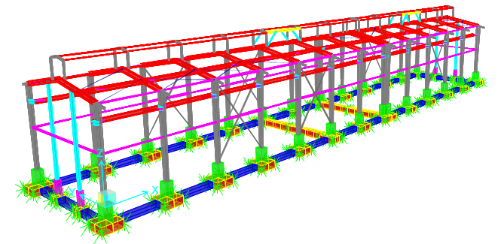

* 1. **FOUNDATION DESIGN CONTROL**

### Check of Stress for Foundation

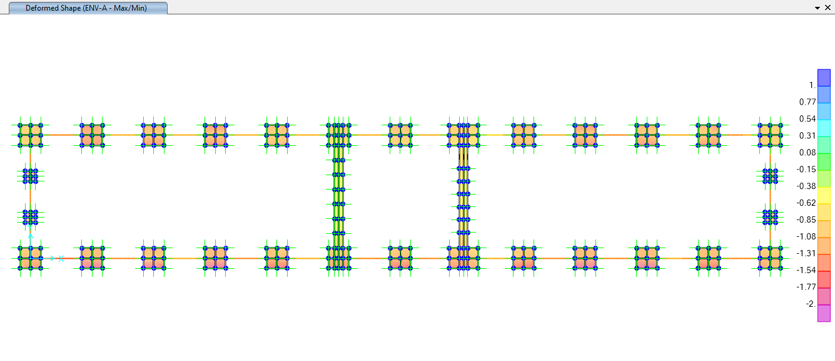

**Figure 22** **-** Check of Displacement for Foundation (cm)

|  |  |  |  |  |  |  |  |  |
| --- | --- | --- | --- | --- | --- | --- | --- | --- |
| **TABLE: Joint Displacements** | | | | | | | | |
| **Joint** | **OutputCase** | **CaseType** | **StepType** | **U3** | **ks** | **Q** | **Q all** | **CONTROL** |
| Text | Text | Text | Text | cm | kg/cm3 | kg/cm2 | kg/cm2 |
| … | … | … | … | … | … | … | … | … |
| 552 | A.A.4.2-NL | NonStatic | Max | -1.21495 | 1 | 1.214947 | 2 | OK |
| 552 | A.A.4.2-NL | NonStatic | Min | -1.21495 | 1 | 1.214947 | 2 | OK |
| 552 | A.A.4.3-NL | NonStatic | Max | -0.98746 | 1 | 0.987457 | 2 | OK |
| 552 | A.A.4.3-NL | NonStatic | Min | -0.98746 | 1 | 0.987457 | 2 | OK |
| 552 | A.A.4.4-NL | NonStatic | Max | -0.98746 | 1 | 0.987457 | 2 | OK |
| 552 | A.A.4.4-NL | NonStatic | Min | -0.98746 | 1 | 0.987457 | 2 | OK |
| 552 | A.A.4.5-NL | NonStatic | Max | -0.09284 | 1 | 0.092841 | 2 | OK |
| 552 | A.A.4.5-NL | NonStatic | Min | -0.09284 | 1 | 0.092841 | 2 | OK |
| 552 | A.A.4.6-NL | NonStatic | Max | -1.87799 | 1 | 1.877993 | 2 | OK |
| 552 | A.A.4.6-NL | NonStatic | Min | -1.87799 | 1 | 1.877993 | 2 | OK |
| 552 | A.A.4.7-NL | NonStatic | Max | -0.98746 | 1 | 0.987457 | 2 | OK |
| 552 | A.A.4.7-NL | NonStatic | Min | -0.98746 | 1 | 0.987457 | 2 | OK |
| 552 | A.A.4.8-NL | NonStatic | Max | -0.98746 | 1 | 0.987457 | 2 | OK |
| 552 | A.A.4.8-NL | NonStatic | Min | -0.98746 | 1 | 0.987457 | 2 | OK |
| 552 | A.A.5.1-NL | NonStatic | Max | -0.87071 | 1 | 0.870713 | 2 | OK |
| 552 | A.A.5.1-NL | NonStatic | Min | -0.87071 | 1 | 0.870713 | 2 | OK |
| 552 | A.A.5.2-NL | NonStatic | Max | -1.21188 | 1 | 1.211876 | 2 | OK |
| … | … | … | … | … | … | … | … | … |

According to SAP2000 report, Max soil pressure under the foundation is:

$$q_{n}=1.87kg/{cm}^{2} < 2 kg/{cm}^{2} ok$$

### REINFORCING CONTROL

Foundation Reinforcement in “*ENV-S”* (Critical) Load Combination have been reported in the following figure:

For foundation with dimension of 2*2:

$$A_{s used= }∅16@200=\frac{2.01 cm2}{20 cm}=0.1005 \frac{{cm}^{2}}{cm}$$

$${According to analysis; A}_{s,required}=0.1 \frac{{cm}^{2}}{cm}$$

$A_{s used}>A_{s, required}$   OK

As noted before, both foundation and structure is modeled in a single model in sap2000. T16@200mm at each side of section is adequate.

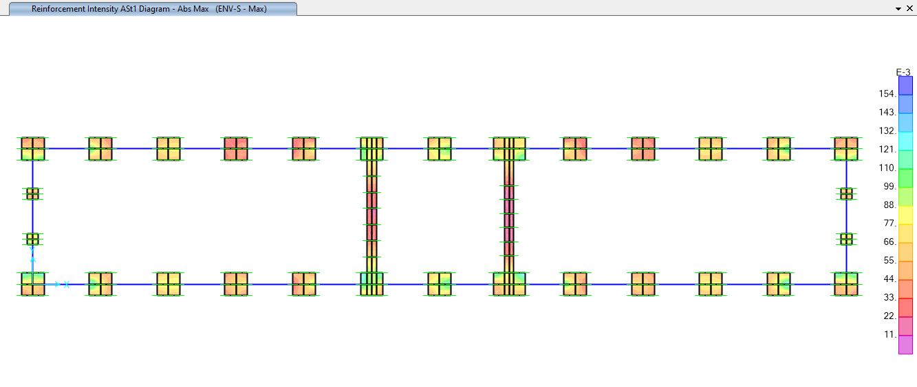

**Figure 23:** Foundation Reinforcement Intensity Ast1 (Unit: $\frac{cm2}{cm}$)

For foundation with dimension of 2.5m*2.5m :

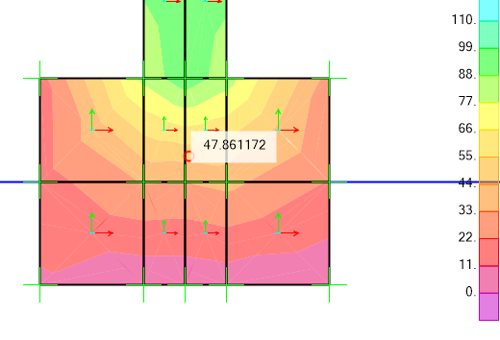

**Figure 24:** Foundation moment at F3 (Unit: ton.m)

As noted before, both foundation and structure is modeled in a single model in sap2000. T16@200mm with add bar T16@200mm at each side of section is adequate.

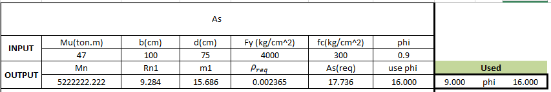

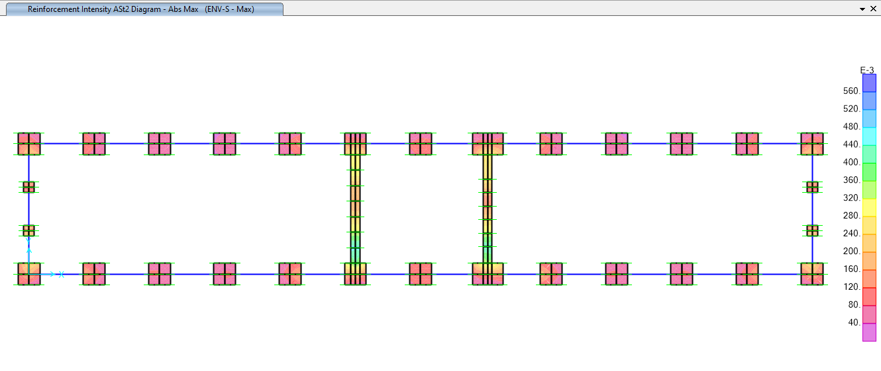

**Figure 24:** Foundation Reinforcement Intensity Ast2 (Unit: $\frac{cm2}{cm}$)

### Punching shear control Shear Control:

**“PED1”:**

|  |  |  |  |  |  |  |  |  |  |  |
| --- | --- | --- | --- | --- | --- | --- | --- | --- | --- | --- |
| **TABLE: Element Forces - Frames** | | | | | | | | | | |
| **Frame** | **Station** | **OutputCase** | **CaseType** | **StepType** | **P** | **V2** | **V3** | **T** | **M2** | **M3** |
| Text | cm | Text | Text | Text | Kgf | Kgf | Kgf | Kgf-cm | Kgf-cm | Kgf-cm |
| 16 | 0 | ENV-S | Combination | Max | 7347.46 | 20.25 | 8811.65 | 485.28 | 4190734 | 2492.9 |
| 16 | 0 | ENV-S | Combination | Min | -21501.3 | -228.02 | -10530.3 | -455.19 | -5382654 | -30523.3 |
| 26 | 0 | ENV-S | Combination | Max | 7516.56 | 273.7 | 8327.37 | 441.7 | 2919919 | 38059.67 |
| 26 | 0 | ENV-S | Combination | Min | -37037.8 | -8923.14 | -10025.8 | -408.02 | -3886188 | -1252910 |
| 36 | 0 | ENV-S | Combination | Max | 10713.27 | 3108.99 | 8077.87 | 251.03 | 2662931 | 435794 |
| 36 | 0 | ENV-S | Combination | Min | -22602.9 | -6151.81 | -9822.9 | -185.24 | -3450864 | -860821 |
| 40 | 0 | ENV-S | Combination | Max | 8257.76 | 57.63 | 8234.61 | 733.26 | 3152664 | 7708.34 |
| 40 | 0 | ENV-S | Combination | Min | -28800.9 | -290.51 | -9698.67 | -682.55 | -3728750 | -40037.3 |
| 54 | 0 | ENV-S | Combination | Max | 8995.99 | 121.05 | 7968 | 196.44 | 2711947 | 16787.09 |
| 54 | 0 | ENV-S | Combination | Min | -35335.5 | -228.67 | -9578.29 | -179.76 | -3401205 | -31694.9 |
| 66 | 0 | ENV-S | Combination | Max | 12544.03 | 6366.6 | 11997.99 | 298.62 | 5987625 | 890208.1 |
| 66 | 0 | ENV-S | Combination | Min | -22601.4 | -3586.24 | -13078.9 | -418.84 | -6289568 | -503330 |
| 76 | 0 | ENV-S | Combination | Max | 7537.18 | 9858.99 | 8552.58 | 228.38 | 3673382 | 1382194 |
| 76 | 0 | ENV-S | Combination | Min | -37104.8 | -690.27 | -9723.82 | -266.81 | -4084626 | -96897.1 |
| 86 | 0 | ENV-S | Combination | Max | 5008.37 | 273.7 | 7707.71 | 343.48 | 3946012 | 38090.8 |
| 86 | 0 | ENV-S | Combination | Min | -19248.1 | -84.71 | -8411.1 | -393.88 | -4043586 | -12473.2 |
| 97 | 0 | ENV-S | Combination | Max | 6349.41 | 177.69 | 8067.74 | 86.66 | 2783186 | 24592.45 |
| 97 | 0 | ENV-S | Combination | Min | -35512.3 | -157.2 | -10115.7 | -99.65 | -3608007 | -21463.4 |
| 107 | 0 | ENV-S | Combination | Max | 8692.02 | 172.54 | 8836.33 | 395.26 | 3445535 | 23791.99 |
| 107 | 0 | ENV-S | Combination | Min | -30228.6 | -151.27 | -10327.1 | -453.38 | -4033339 | -22235.3 |
| 116 | 0 | ENV-S | Combination | Max | 10528.62 | 5084.58 | 7895.11 | 147.36 | 2632072 | 710910.9 |
| 116 | 0 | ENV-S | Combination | Min | -31161.5 | -7672.28 | -9633.56 | -153 | -3429609 | -1077062 |
| 126 | 0 | ENV-S | Combination | Max | 8305.4 | 8155.9 | 8037.45 | 413.05 | 2868136 | 1144331 |
| 126 | 0 | ENV-S | Combination | Min | -29209.2 | -4911.74 | -9854.36 | -378.12 | -3831343 | -687343 |
| 136 | 0 | ENV-S | Combination | Max | 6018.59 | 253.78 | 8400.99 | 486.87 | 4059557 | 35287.94 |
| 136 | 0 | ENV-S | Combination | Min | -20314 | -14.2 | -10123.1 | -413.46 | -5245488 | -3069.16 |
| 199 | 0 | ENV-S | Combination | Max | 6127.65 | 32.5 | 9037.21 | 521.5 | 4680770 | 4134.17 |
| 199 | 0 | ENV-S | Combination | Min | -20000.6 | -326.51 | -9467.16 | -517.08 | -4701822 | -46119 |
|  | | | | | -37104.8 | 9858.99 | -13078.9 | 733.26 | -6289568 | 1382194 |

**One-way Shear Control:**

$$V_{u}≤∅V_{n}$$

$$V_{n}=V_{c}+V_{s}$$

$$V_{c}=\left(0.17λ\sqrt{f_{c}^{'}}\right)b_{w}d$$

Axes X:

$V_{c}=\left(0.17*1*\sqrt{300}\right)200*72.5=42.695ton$

$V_{ux}=13.078 ton$

$$V_{ux}≤∅V_{n}→13.078≤0.75*42.695=32.02 ok$$

Axes Y:

$V_{c}=\left(0.17*1*\sqrt{300}\right)200*72.5=42.695 ton$

$V_{uy}=9.858 ton$

$$V_{uy}≤∅V_{n}→9.858≤0.75*42.695=32.02 ok$$

**Two-way Shear Control:**

$$V_{u}≤∅V_{n}$$

$$V_{n}=V_{c}+V_{s}$$

$$V_{c}=min\left\{\begin{aligned}0.33λ_{s}λ\sqrt{f_{c}^{'}} =0.33*1*1*\sqrt{300}=5.71 \\ 0.17\left(1+\frac{2}{β}\right)λ_{s}λ\sqrt{f_{c}^{'}}=0.17*\left(1+\frac{2}{1.3}\right)*1*1*\sqrt{300}=7.47 \\ 0.083\left(2+\frac{α_{s}d}{b_{0}}\right)λ_{s}λ\sqrt{f_{c}^{'}}=0.083*\left(2+\frac{40*72.5}{200}\right)*1*1*\sqrt{300}=23.72\end{aligned}\right.$$

$$V_{c}=0.33λ_{s}λ\sqrt{f_{c}^{'}}bd =0.33*1*1*\sqrt{300}\left(200*72.5\right)=82.88 ton$$

$$v_{u}=\frac{V_{u}}{A_{c}}±\frac{M_{uv,x}C_{y}}{J_{cx}}±\frac{M_{uv,y}C_{x}}{J_{cy}}$$

$$V_{u}=13078.9 kgf$$

$$M_{ux}=1382194 kgf-cm$$

$$M_{uy}=6289568 kgf-cm$$

$$γ_{v}=1-γ_{f}=1-\frac{1}{1+\frac{2}{3}\sqrt{\frac{b_{1}}{b_{2}}}}=0.39$$

$$M_{uv,x}=γ_{v}M_{ux}=0.39*1382194=539055.66 kgf-cm$$

$$M_{uv,y}=γ_{v}M_{uy}=0.39*6289568=2452931.52 kgf-cm$$

$$\frac{J_{cx}}{C_{y}}=\frac{1}{3}\left[b_{1}d\left(b_{1}+3b_{2}\right)+d^{3}\right]=\frac{1}{3}\left[160*72.5\left(160+3*160\right)+{72.5}^{3}\right] =2601692.7$$

$$\frac{J_{cy}}{C_{x}}=\frac{1}{3}\left[b_{2}d\left(b_{2}+3b_{1}\right)+d^{3}\right]=\frac{1}{3}\left[160*72.5\left(160+3*160\right)+{72.5}^{3}\right] =2601692.7$$

$$v_{u}=\frac{13078.9}{640*72.5}+\frac{539055.66}{2601692.7}+\frac{2452931.52}{2601692.7}=0.28+0.21+0.94=1.43$$

Shear Ratio= $\frac{v_{u}}{{∅v}_{c}}=\frac{1.43}{0.75*5.71}=0.333 ok$