|  |  |  |  |  |  |  |  |
| --- | --- | --- | --- | --- | --- | --- | --- |
| **طرح نگهداشت و افزایش تولید 27 مخزن** | | | | | | | |
| **CALCULATION NOTE FOR CHEMICAL INJECTION AND STORAGE SHELTER**  **نگهداشت و افزایش تولید میدان نفتی بینک** | | | | | | | |
|  | |  |  |  |  |  |  |
| D03 | | NOV. 2023 | IFA | R.Berlouie | M.Fakharian | S.Faramarzpour |  |
| D02 | | SEP. 2023 | IFA | R.Berlouie | M.Fakharian | S.Faramarzpour |  |
| D01 | | JUN. 2023 | IFC | R.Berlouie | M.Fakharian | A.M.Mohseni |  |
| D00 | | AUG. 2022 | IFC | R.Berlouie | M.Fakharian | M.Mehrshad |  |
| **Rev.** | | **Date** | **Purpose of Issue/Status** | **Prepared by:** | **Checked by:** | **Approved by:** | **CLIENT Approval** |
| **Class:2** | | | **COMPANY Doc. Number:F0Z-709141** | | | | |
| **Status:** | | **IDC: Inter-Discipline Check**  **IFC: Issued For Comment**  **IFA: Issued For Approval**  **AFD: Approved For Design**  **AFC: Approved For Construction**  **AFP: Approved For Purchase**  **AFQ:** Approved For Quotation  **IFI: Issued For Information**  **AB-R: As-Built for CLIENT Review**  **AB-A: As-Built –Approved** | | | | | |

**REVISION RECORD SHEET**

|  |  |  |  |  |  |  |  |  |  |  |  |  |
| --- | --- | --- | --- | --- | --- | --- | --- | --- | --- | --- | --- | --- |
| **PAGE** | **D00** | **D01** | **D02** | **D03** | **D04** |  | **PAGE** | **D00** | **D01** | **D02** | **D03** | **D04** |
| **1** | X | X | X | X |  | **66** |  |  |  |  |  |
| **2** | X | X | X | X |  | **67** |  |  |  |  |  |
| **3** | X | X | X | X |  | **68** |  |  |  |  |  |
| **4** | X | X |  |  |  | **69** |  |  |  |  |  |
| **5** | X | X |  |  |  | **70** |  |  |  |  |  |
| **6** | X | X |  |  |  | **71** |  |  |  |  |  |
| **7** | X | X | X |  |  | **72** |  |  |  |  |  |
| **8** | X | X | X |  |  | **73** |  |  |  |  |  |
| **9** | X | X | X |  |  | **74** |  |  |  |  |  |
| **10** | X | X | X | X |  | **75** |  |  |  |  |  |
| **11** | X | X | X |  |  | **76** |  |  |  |  |  |
| **12** | X | X | X |  |  | **77** |  |  |  |  |  |
| **13** | X | X | X |  |  | **78** |  |  |  |  |  |
| **14** | X | X | X |  |  | **79** |  |  |  |  |  |
| **15** | X | X | X |  |  | **80** |  |  |  |  |  |
| **16** | X | X | X |  |  | **81** |  |  |  |  |  |
| **17** | X | X | X |  |  | **82** |  |  |  |  |  |
| **18** | X | X | X |  |  | **83** |  |  |  |  |  |
| **19** | X | X | X |  |  | **84** |  |  |  |  |  |
| **20** | X | X | X |  |  | **85** |  |  |  |  |  |
| **21** | X | X | X |  |  | **86** |  |  |  |  |  |
| **22** | X | X | X |  |  | **87** |  |  |  |  |  |
| **23** | X | X | X |  |  | **88** |  |  |  |  |  |
| **24** | X | X | X | X |  | **89** |  |  |  |  |  |
| **25** | X | X | X |  |  | **90** |  |  |  |  |  |
| **26** | X | X | X |  |  | **91** |  |  |  |  |  |
| **27** | X | X | X | X |  | **92** |  |  |  |  |  |
| **28** | X | X | X | X |  | **93** |  |  |  |  |  |
| **29** | X | X | X |  |  | **94** |  |  |  |  |  |
| **30** | X | X | X |  |  | **95** |  |  |  |  |  |
| **31** | X | X | X |  |  | **96** |  |  |  |  |  |
| **32** | X | X | X | X |  | **97** |  |  |  |  |  |
| **33** | X | X | X | X |  | **98** |  |  |  |  |  |
| **34** | X | X | X |  |  | **99** |  |  |  |  |  |
| **35** | X | X | X |  |  | **100** |  |  |  |  |  |
| **36** | X | X | X |  |  | **101** |  |  |  |  |  |
| **37** | X | X | X |  |  | **102** |  |  |  |  |  |
| **38** | X | X | X |  |  | **103** |  |  |  |  |  |
| **39** | X | X | X |  |  | **104** |  |  |  |  |  |
| **40** |  | X | X |  |  | **105** |  |  |  |  |  |
| **41** |  | X | X |  |  | **106** |  |  |  |  |  |
| **42** |  | X | X |  |  | **107** |  |  |  |  |  |
| **43** |  | X | X |  |  | **108** |  |  |  |  |  |
| **44** |  | X | X |  |  | **109** |  |  |  |  |  |
| **45** |  | X | X |  |  | **110** |  |  |  |  |  |
| **46** |  | X | X |  |  | **111** |  |  |  |  |  |
| **47** |  |  |  |  |  | **112** |  |  |  |  |  |
| **48** |  |  |  |  |  | **113** |  |  |  |  |  |
| **49** |  |  |  | X |  | **114** |  |  |  |  |  |
| **50** |  |  |  |  |  | **115** |  |  |  |  |  |
| **51** |  |  |  |  |  | **116** |  |  |  |  |  |
| **52** |  |  |  |  |  | **117** |  |  |  |  |  |
| **53** |  |  |  |  |  | **118** |  |  |  |  |  |
| **54** |  |  |  |  |  | **119** |  |  |  |  |  |
| **55** |  |  |  |  |  | **120** |  |  |  |  |  |
| **56** |  |  |  |  |  | **121** |  |  |  |  |  |
| **57** |  |  |  |  |  | **122** |  |  |  |  |  |
| **58** |  |  |  |  |  | **123** |  |  |  |  |  |
| **59** |  |  |  |  |  | **124** |  |  |  |  |  |
| **60** |  |  |  |  |  | **125** |  |  |  |  |  |
| **61** |  |  |  |  |  | **126** |  |  |  |  |  |
| **62** |  |  |  |  |  | **127** |  |  |  |  |  |
| **63** |  |  |  |  |  | **128** |  |  |  |  |  |
| **64** |  |  |  |  |  | **129** |  |  |  |  |  |
| **65** |  |  |  |  |  | **130** |  |  |  |  |  |

**CONTENTS**

1.0 INTRODUCTION 4

2.0 Scope 4

3.0 NORMATIVE REFERENCE 4

4.0 Material properties 5

5.0 STRUCTURE ‘s systems 5

6.0 DESIGN LOAD 6

7.0 SAP loading table 18

8.0 Load combinations 20

9.0 STRUCTURE ANALYSIS AND DESIGN 21

10.0 Structural Design Results 26

11.0 STRUCTURE CONNECTIONS 30

12.0 FOUNDATION DESIGN 43

1. **INTRODUCTION**

Binak oilfield in Bushehr province is a part of the southern oilfields of Iran, is located 20 km northwest of Genaveh city.

With the aim of increasing production of oil from Binak oilfield, an EPC/EPD Project has been defined by NIOC/NISOC and awarded to Petro Iran Development Company (PEDCO). Also PEDCO (as General Contractor) has assigned the EPC-packages of the Project to "Hirgan Energy - Design and Inspection" JV.

1. **Scope**

This report covers the structure & foundation calculation report of the “Chemical injection and Storage Shelter”. The structure modelled by “SAP” software & the foundation modelled by “SAP” software too.

1. **NORMATIVE REFERENCE**
   1. **Local Codes and Standards**

* INBC Part 6 “Iranian National Building Code
* INBC Part 7 “Iranian National Building Code
* INBC Part 9 “Iranian National Building Code
* INBC Part 10 “Iranian National Building Code
* Iranian Seismic Design Code for Petroleum Facilities(3rd edition)
  1. **International Codes and Standards**
* ASCE 7-10 “Minimum Design Loads and Associated Criteria for Buildings and Other Structures-American Society of Civil Engineers”.
* ACI 318. “Building Code Requirements for Reinforced Concrete”, American Concrete Institute.
* AISC 358 “Prequalified Connections for Special and Intermediate Steel Moment Frames for Seismic Applications.” American Institute of Steel Construction, Inc.
* AISC 360 - “Specification for Structural Steel Buildings”. American Institute of Steel Construction, Inc.
  1. **The Project Documents**

## BK-GNRAL-PEDCO-000-ST-SP-0001 SPECIFICATION FOR CONCRETE WORK

## BK-gcs-PEDCO-120-ST-DW-0058 Structural drawing for chemical injection & storage shelter

## BK-GNRAL-PEDCO-000-ST-DC-0001 Structural Design Criteria

## BK-GNRAL-PEDCO-000-CV-SP-0004 Specification For Earth Work

## BK-GCS-PEDCO-120-GT-RT-0001 Geotechnical Investigation Report for

## Compressor Station

1. **Material properties**

Material properties are delivered in the following table.

table 1 -Material Properties

|  |  |
| --- | --- |
| Foundation Concrete | F'c = 30 Mpa(28- day cylindrical sample) |
| Long. reinforcement bar | Fy = 400 Mpa(AIII) |
| Trans. reinforcement bar | Fy = 400 Mpa(AIII) |
| Bolt Type | HV 8.8 |
| Electrode Type | E 70 |

1. **STRUCTURE ‘s systems**

The Structure’s System is OMF in X direction and OCBF system in Y direction .Seismic Parameters according to Iranian Code of practice Fr Seismic resistant Design Of building StandardNo.2800 (4th edition)listed at below table.

table 2 –structural system

|  |  |  |  |  |
| --- | --- | --- | --- | --- |
|  | system | R | Omega | Cd |
| x dir | Omf | 3.5 | 3 | 3 |
| y dir | ocbf | 3.25 | 2 | 3.25 |

1. **DESIGN LOAD**
   1. **Dead load**

Dead loads include the self-weight of the structure and all the permanent equipment which are supported by the structures

$$Corogated sheet :8 kg/m^{2}$$

$$Z Purlin : 8 kg/m^{2}$$

$$Insulation :10 kg/m^{2}$$

$$\sum{sum= 26 kg/m^{2}}$$

Roof weight is assigned in software 50 kg/m2.

* At ended frame : $50×2.5=125 kg/m$
* At middle frame : $50×5 =250 kg/m$

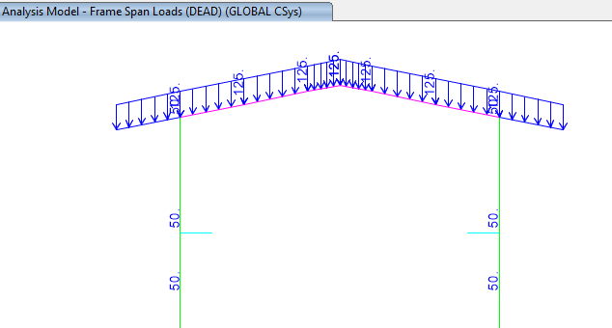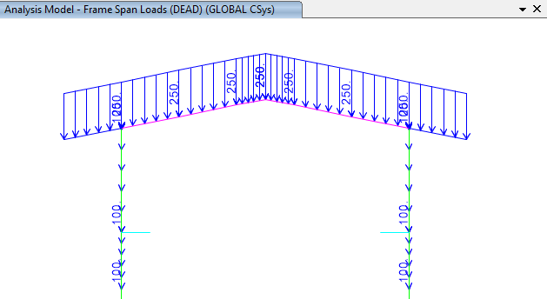

**Figure 1-applied Dead load on ended axe(1&3) (kg/m) Figure 2-applied Dead load on middle axe 2(kg/m)**

* 1. Live Loads

The design live load on an area shall be defined as the weight of all movable loads, including personnel, tools, and parts of dismantled equipment, cranes, hoist, and temporarily stored materials.

According to structural design criteria Live load in light slop roof is 100 kg/m2 and assumed 1KN concentrated load has been applied at critical frame.

* At ended frame : $100×2.5=250 kg/m$
* At middle frame : $100×5=500 kg/m$

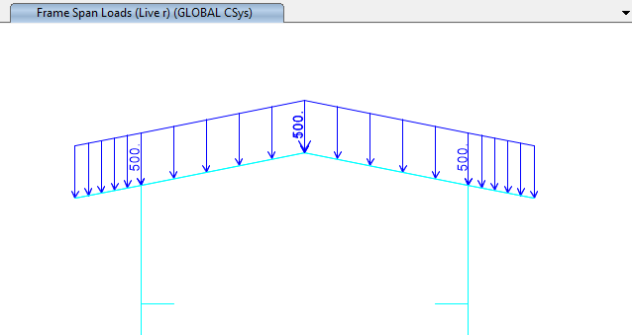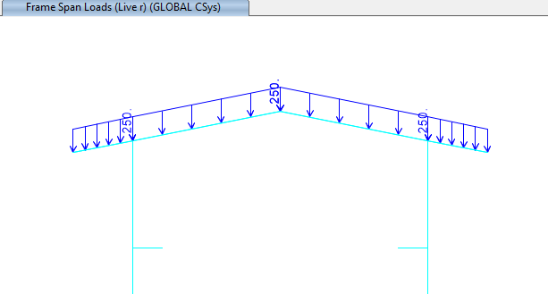

**Figure 3-Applied live Load on frame 2 (kg/m) Figure 4-Applied live Load on frame 1&3 (kg/m)**

* 1. **SNOW LOADS**

Snow load of this structure is calculated in accordance with Iranian National Building Code No.6 Latest edition.. Parameters which are used in calculation of snow force is presented in below:

$$P_{r}=P_{s}C_{n}C_{h}I_{S}C_{s}$$

Ps=25 kg/m2 , Is=1

Cs= 0.91 (slope 11.31o)=1-

Ch=1

Cn=0.8

$$P_{r}=P_{s}C_{n}C_{h}I_{S}C_{s}=18.06\frac{kg}{m2}$$

* At ended frame : $18.06×2.5=45.15 kg/m$
* At middle frame : $18.06×5=90.3 kg/m$

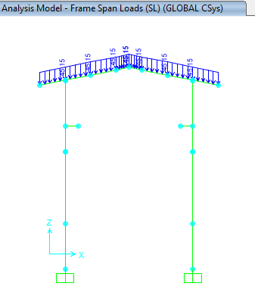 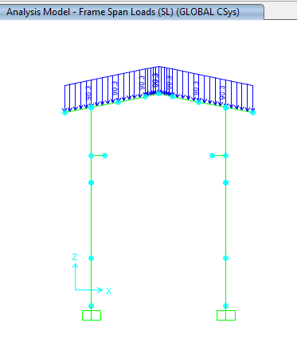

**Figure 5-applied Snow load on ended axe(1&3) (kg/m) Figure 6-applied Snow load on middle axe 2(kg/m)**

* 1. **-Unbalanced SNOW LOADS**

According to Iranian National Building Code No.6 (latest edition)) Unbalanced snow load have been considered for roof slope between 4%~60%..in this structure Calculation of this load represents as below:

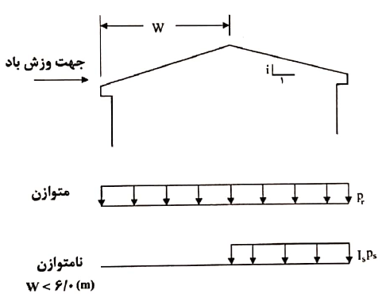

$${ for lu<6 m P}_{r}={I_{s}P}_{g}=25\frac{kg}{m2}$$

`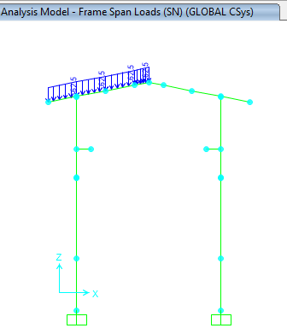 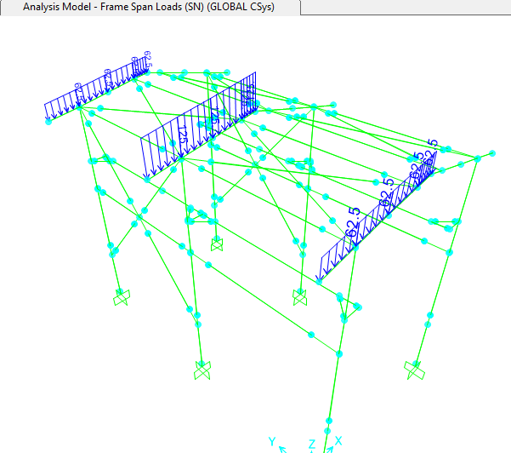

**Figure 7-applied unbalanced Snow Load(SN)**

* At ended frame : $25×2.5=62.5 kg/m$
* At middle frame : $25×5=125 kg/m$

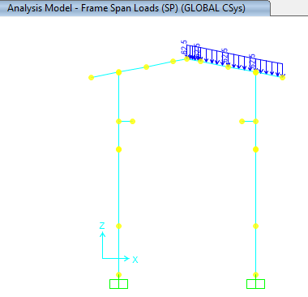 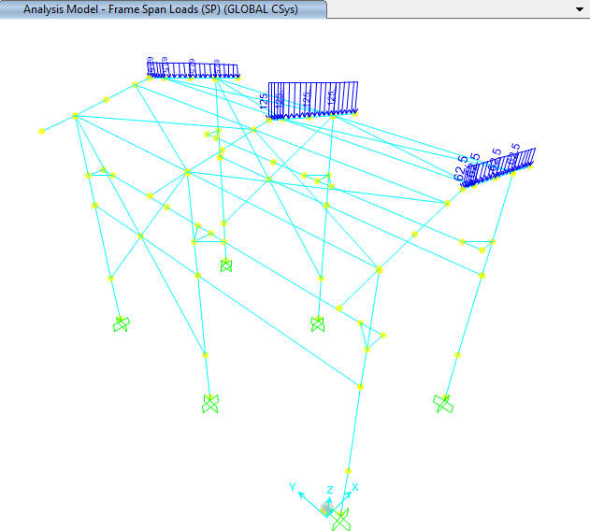

**Figure 8-applied unbalanced Snow Load(SP)**

* 1. **Seismic loads**

All structures are in area with high risk zone of seismic and until finalizing of “Geotechnical Final Report” soil type consider is type II. Equivalent static method is used for calculation of seismic loads. Parameters which are used in calculation of earthquake force and seismic coefficient is presented in below According to Iranian seismic design code for Petroleum facilities (3rd edition )

**D03**

$V$ = $\frac{S_{a}}{R/{I_{e}}}$ w

Where:

$C_{s}$ = the seismic response coefficient from Equation below:

𝑊 = the effective seismic weight of the structure

$C_{s}$ = $\frac{S_{a}}{R/{I_{e}}}$

Where:

𝑆𝑎= mapped spectral response acceleration parameter (g), determined from hazard analysis.

$$S_{DS}=0.75$$

$S_{D1}=0.375$

R= the response modification factor for structure

$I=$ the importance factor for structure:1.25

Seismic loads are calculated according to Iranian seismic design code

Soil Type : Type II

**For Y direction**(**OCBF system)** :

**D03**

Ruy=3.25

Omega=2

Cd=3.25

$T_{0}=0.2\frac{S_{D1}}{S_{DS}}$ =0.1 S

$T_{S}=\frac{S_{D1}}{S_{DS}}=0.5$ S

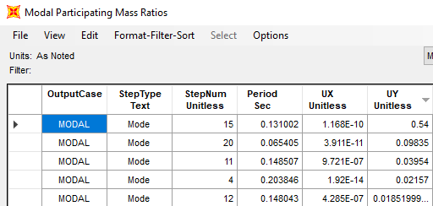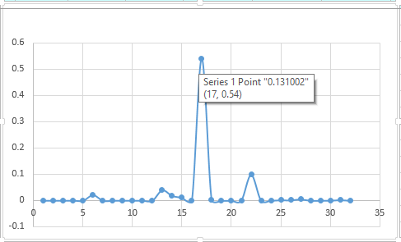

**Figure 9- Period in y direction(Mode 15)**

Ty(Mode no. 15 )=0.131 s <Ts=0.5 s , for T<0.5 s uses k=1

**D03**

$S_{a}=S_{DS}=0.75$

$C_{uy}=\frac{0.75×1.25}{3.25}$ =0.28846

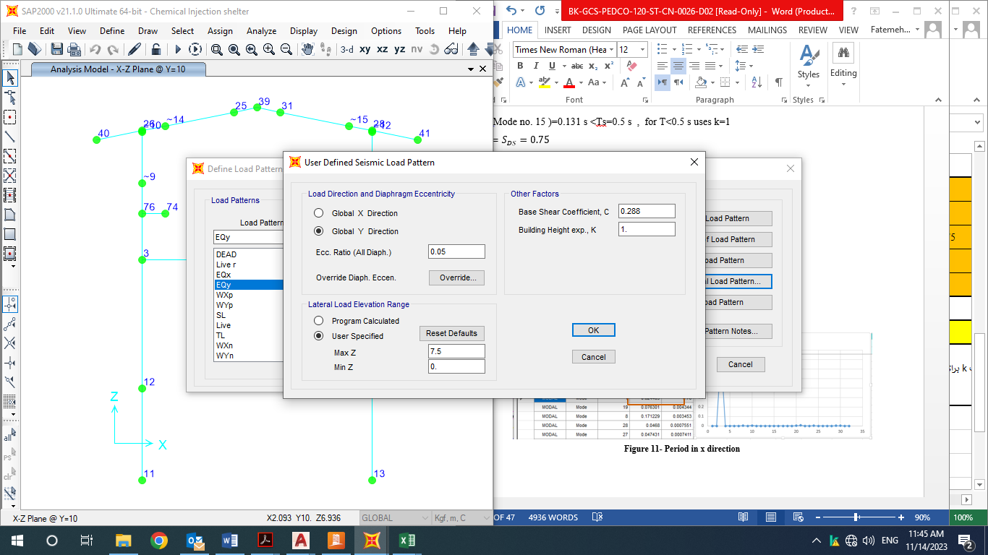

**Figure 10- Period in Y direction**

**For X direction** OMF system :

Rux=3.5

Omega=3

Cd=3

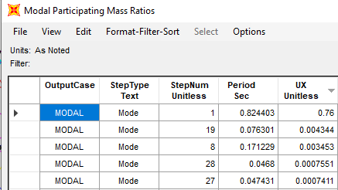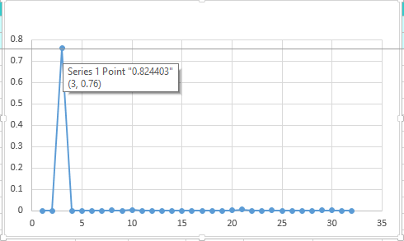

**Figure 11- Period in x direction**

Tx(Mode 1 )=0.8285 s >Ts

$$S_{a}=\frac{S_{D1}}{T}=0.45$$

$C_{ux}=\frac{0.45×1.25}{3.5}$ =0.16

According to Iranian seismic design code(code.038) section 4-6 $ρ$ factor applied on Ex coefficient as follow:

$$C_{ux}=0.16*1.3=0.208$$

Y direction : T<0.5 then k=1

**D03**

X direction : 0.5<T<2.5 K=0.5×0.824+0.75=1.162

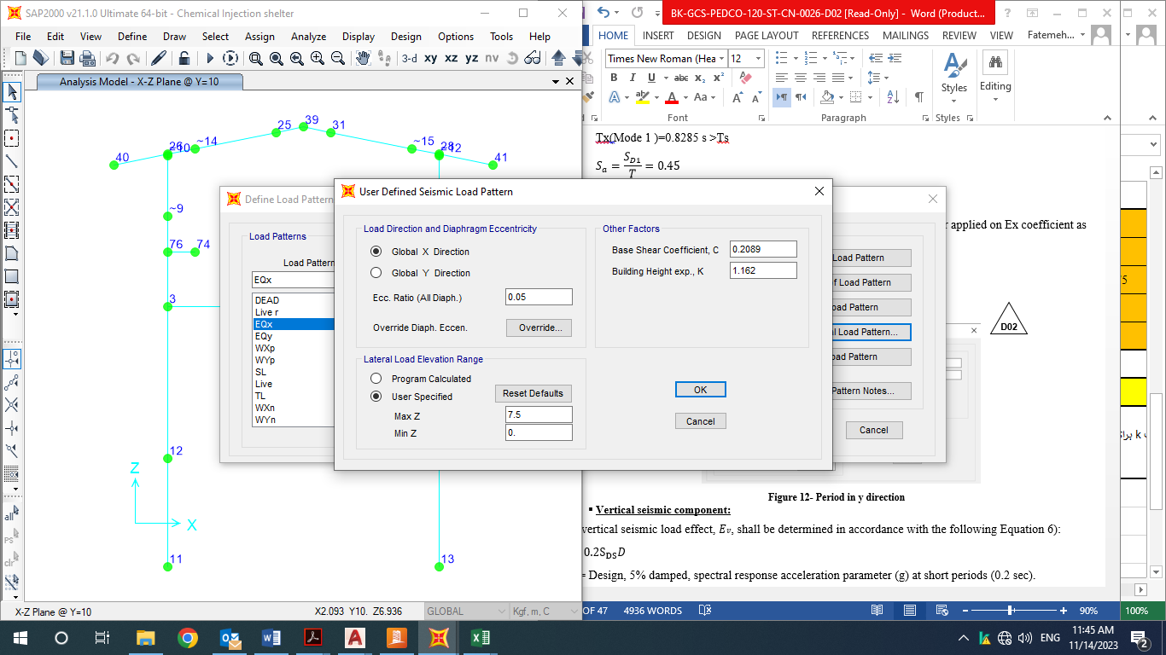

**Figure 12- Period in x direction**

* **Vertical seismic component:**

The vertical seismic load effect, 𝐸𝑣, shall be determined in accordance with the following Equation 6):

𝐸𝑣 = 0.2 $S_{DS}$ 𝐷

$S_{DS}$ = Design, 5% damped, spectral response acceleration parameter (g) at short periods (0.2 sec).

D = effect of dead load

Loads case name: EQZ=0.2×0.75×W=0.15×W

-Ev : Vertical seismic load applied at model:

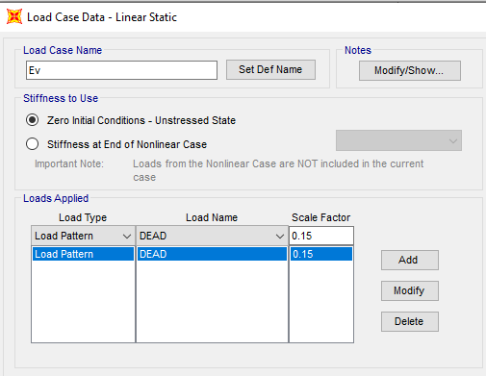

**Figure 13-applied Ev load**

Ev applied at model as a portion of dead load as above.

This Earthquake coefficient will apply in SAP2000 model to be multiplied in W (seismic weight of structure) that will compute automatically by SAP2000 software by "mass source multiplier" definition as below:

1Dead+Crv and+0.2 Live Load

Ev applied at model as a portion of dead load as above.

$ρ=1.3$ has been applied on earthquake load case

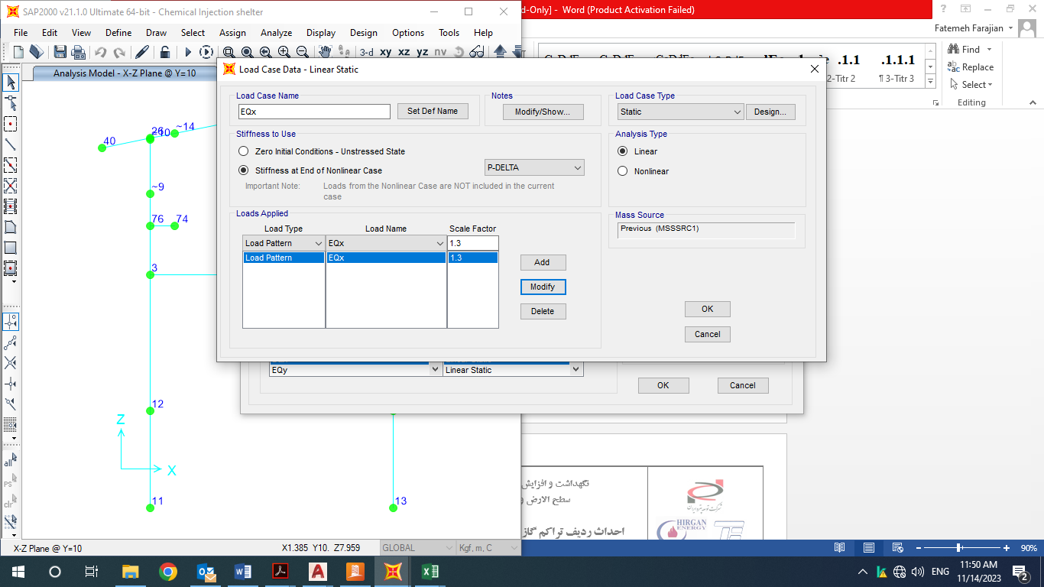

**Figure 14 -applied $ρ$ coefficient**

* 1. **CRANE load**

Distribution of crane load is as below :

Capacity : 2000 kg

At critical condition maximum force is 1500 and 450 kg on each wheel of crane.

Kvs =1.25 (according to INBC no.6)

${case 1 : F}_{T}=0.2×1500×1.25=375 kg F_{l}=0.1×1500×1.25=187.5 kg$

$${case 2 : F}_{T}=0.2×450×1.25=112.5kg F_{l}=0.1×450×1.25=56.25 kg$$

Mentioned load applied in two case (assumed critical condition on left & right side) 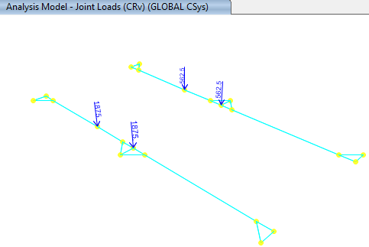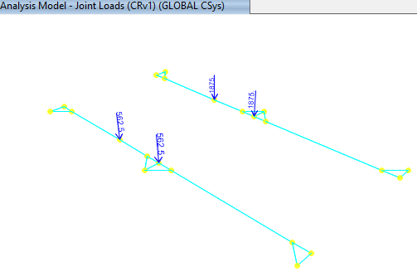

**Figure15 -applied CRv & CRv1 load**

* 1. **WIND loads**

Wind loads are calculated according to Code No.6 and applied at model as below:

V=120 km/h(According to Iranian National Building Code No.6 last edition)

$q=0.0000613V^{2}×0.772=0.681$

$I=1$

$width=5m$

Mean $height=7m$

$C_{e}$ =0.93

Cgi=2

Roof slope=11.3 degree

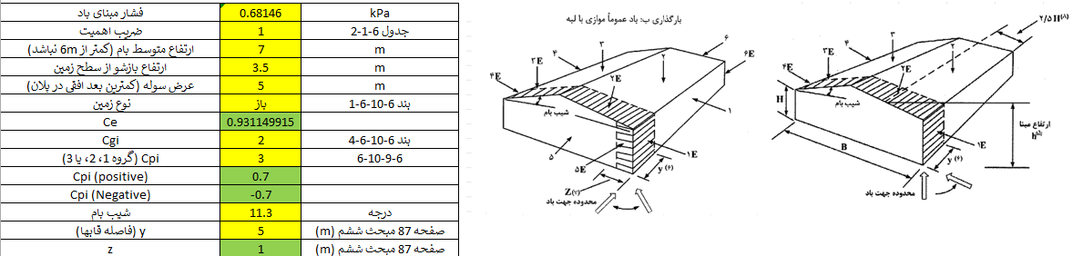

**Figure 16-Wind Load Direction**

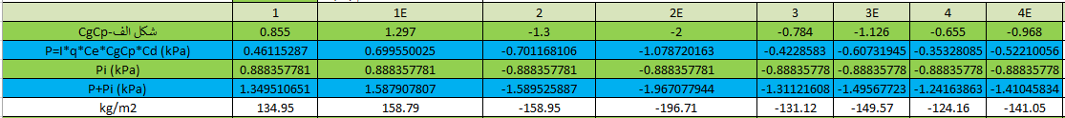



* Element numbering for apply wind load is as below:

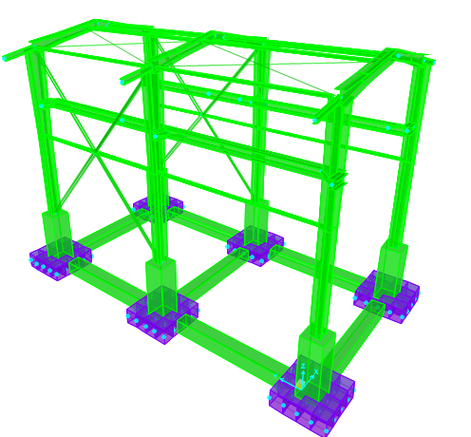

B6

B5

B2

B1

B4

B3

C6

C5

C2

C1

C4

C3

**Figure 17-Element Numbering**

* For columns wind load applied as below (according to INBC no.6)

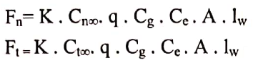

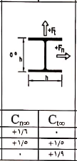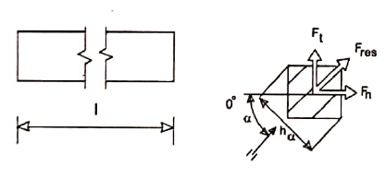

$α=0 C_{n∞}=1.6$

$$α=90 C_{t∞}=1.9$$

$$F_{n}=Fx=0.75×1.6×q×C_{g}C_{e}AI_{w}=45.64 \frac{kg}{m}$$

$$F_{t}=Fy=0.75×1.9×q×C_{g}C_{e}AI_{w}=54.21 \frac{kg}{m}$$

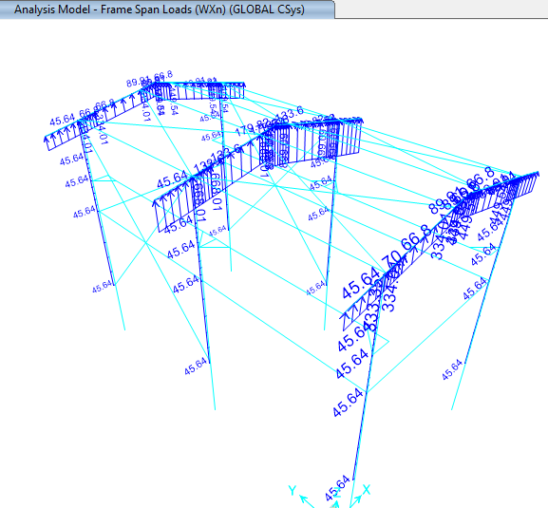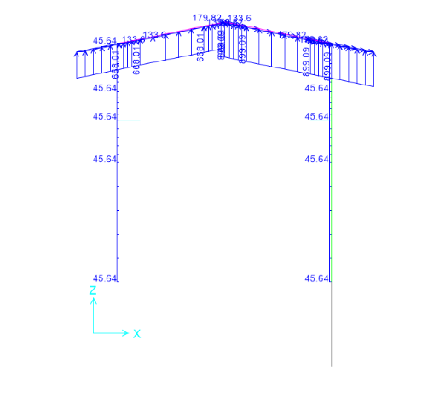

**Figure 18-Apply Wxn Load on Column(45.64kg/m)**

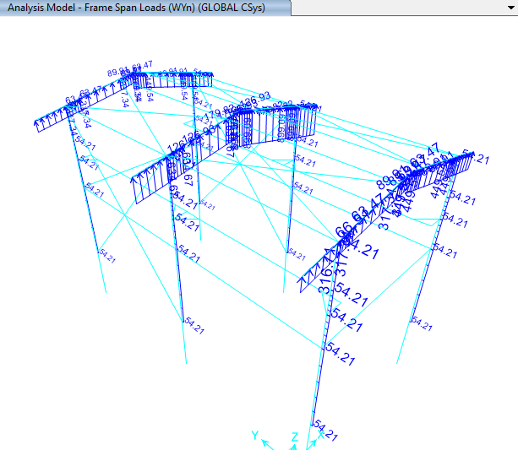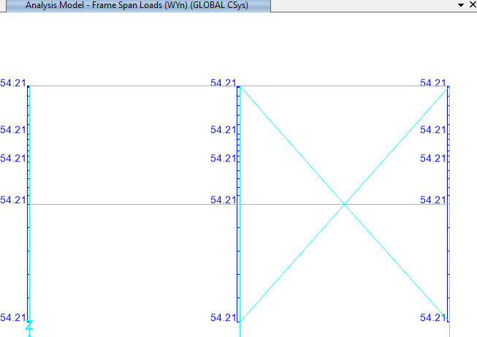

**Figure 19-Apply Wyn Load on Columns(54.21 kg/m)**

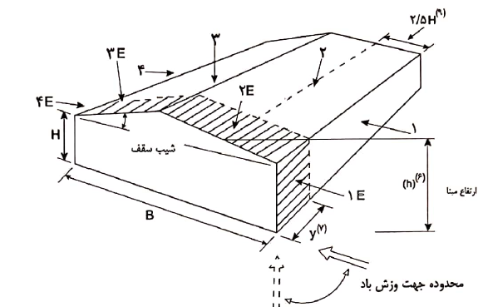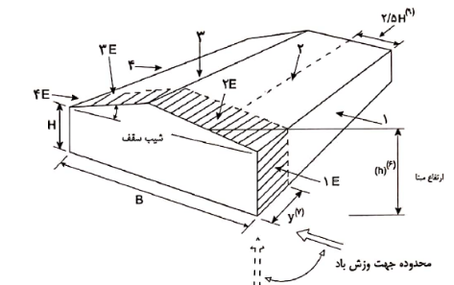

B3:

B4:

* 1. **Thermal Load of structure (TLst)**

According to “Specification for Civil and Structural Design Criteria”. Maximum temperature of 28 ºC shall be considered for computing the thermal load in all components of shelter.

1. **SAP loading table**

* **Load pattern:**

|  |  |  |  |
| --- | --- | --- | --- |
| **LoadPat** | **DesignType** | **SelfWtMult** | **AutoLoad** |
|  |  |  |  |
| DEAD | Dead | 1 |  |
| Live r | Roof Live | 0 |  |
| EQx | Quake | 0 | USER COEFF |
| EQy | Quake | 0 | USER COEFF |
| WXp | Wind | 0 | None |
| WYp | Wind | 0 | None |
| SL | Snow | 0 |  |
| Live | Live | 0 |  |
| TL | Temperature | 0 |  |
| WXn | Wind | 0 | None |
| WYn | Wind | 0 | None |
| SP | Snow | 0 |  |
| SN | Snow | 0 |  |
| WXp1 | Wind | 0 | None |
| WYp1 | Wind | 0 | None |
| WYn1 | Wind | 0 | None |
| WXn1 | Wind | 0 | None |
| CRv | Live | 0 |  |
| FT | Live | 0 |  |
| FL | Live | 0 |  |
| CRv1 | Live | 0 |  |
| FT1 | Live | 0 |  |
| FL1 | Live | 0 |  |
| Ev | Dead | 0 |  |
| TLst | Temperature | 0 |  |
| DL empty | Dead | 0 |  |
| LLop | Live | 0 |  |
| FRx | Other | 0 |  |
| FRy | Other | 0 |  |
| ML | Other | 0 |  |
| Test | Dead | 0 |  |
| ER | Other | 0 |  |
| Soil | Dead | 0 |  |
| Notionalx(DL) | Notional | 0 |  |
| Notionaly(DL) | Notional | 0 |  |
| Notionalx(LL) | Notional | 0 |  |
| Notionaly(LL) | Notional | 0 |  |
| Notionalx(Lr) | Notional | 0 |  |
| Notionaly(Lr) | Notional | 0 |  |
| Notionalx(Lop) | Notional | 0 |  |
| Notionaly(Lop) | Notional | 0 |  |
| Notionalx(Test) | Notional | 0 |  |
| Notionaly(Test) | Notional | 0 |  |
| Notionalx(DLempty) | Notional | 0 |  |
| Notionaly(DLempty) | Notional | 0 |  |
| Notionalx(CR) | Notional | 0 |  |
| Notionaly(CR) | Notional | 0 |  |
| Notionalx(CR1) | Notional | 0 |  |
| Notionaly(CR1) | Notional | 0 |  |

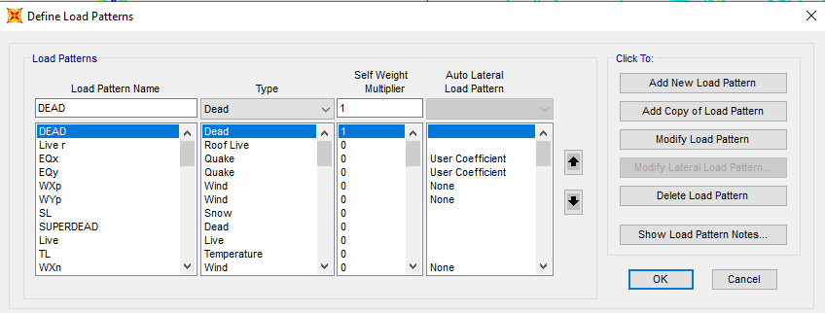

1. **Load combinations**

According to code INBC No.60(4 th edition) structures, components, and foundations shall be designed, so that their design strength equals or exceeds that effect of factored loads in the following combination:

* 1.4(D)
* (1.2D) +1.6(L)+0.5(Lr/S/R)
* 1.2D+1.6(Lr/S/R) + (L/0.5W)
* 1.2D+1.0(W) + L+.5(Lr/S)
* 1.2D+1.0E+L+0.2S
* 0.9D+1.0W
* 0.9D+1.0E

Load listed herein shall be considered to act in the following combinations; whichever produces the most unfavorable effect considering soil reactions.

* *D*
* *D+L*
* *D+(Lr/S/R)*
* *D+0.75(L)+0.75(Lr/R/S)*
* *D+(0.6W or 0.7E)*
* *D+0.75L+0.75(0.6W)+0.75(Lr/S/R)*
* *D+0.75L+0.75(0.7E)+0.75S*
* *0.6D+0.6W*
* *0.6D+0.7E*

1. **STRUCTURE ANALYSIS AND DESIGN** 
   1. **ANALYSIS**

Structural analysis is done by SAP2000 software. In model loads are applied, some graphical outputs from model are shown as follows.

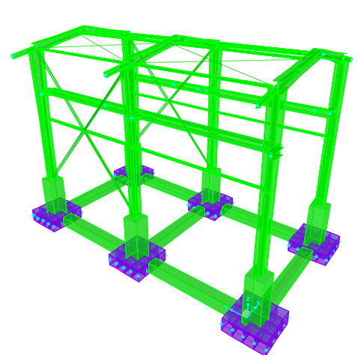

**Figure 20-3D view of SAP model**

:

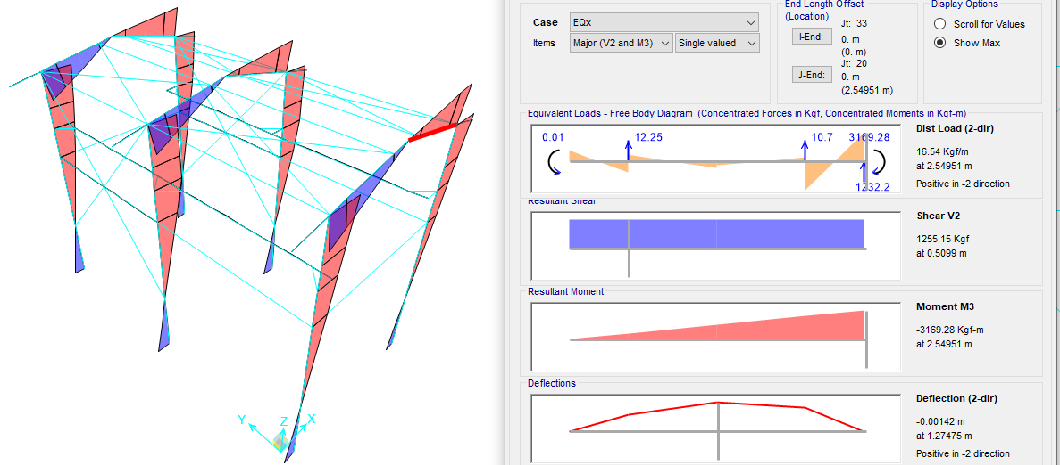

**Figure 21:** **Moment 3-3 under Ex load**

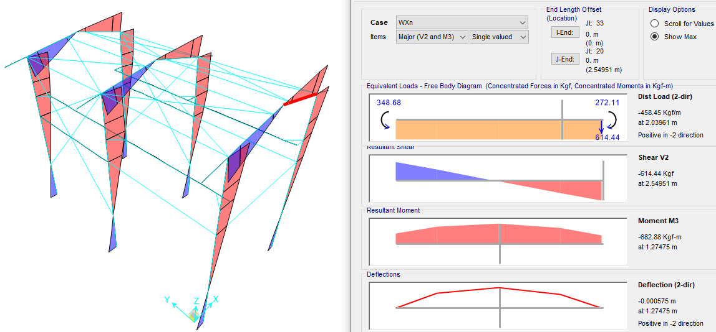

**Figure 22: Moment 3-3 WX load**

* 1. **Flextural design of crane beam**

According to below output from sap software maximum crane beam moment under critical load combination is 452696.49 kg.cm :

$$∅Mn=0.9xZxFy=0.9x2400x677=1462320 kg.cm$$

$$M_{u}=452696.49kg.cm$$

$$s=\frac{452696.49}{1462320}=0.309 <1 ok$$

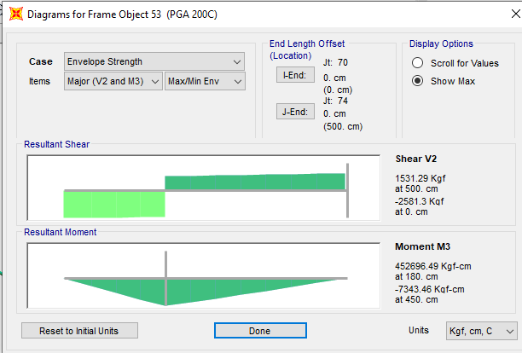

**Figure 23: Moment 3-3 criticalload combination on crane beam**

* 1. **Deflection control :**

Maximum beam deflection under crane live load on shelter is :

$δ=\frac{PL^{3}}{48EI}=\frac{3900*500^3}{48*2.01*10^{6}*9545.12}=0.49$ cm < 0.50 ok

* 1. **BEAM LATERAL RESTRAINT**

Beam lateral restraint should be designed for 0.02 of compressive flange capacity.

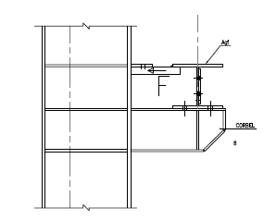

$F=0.02Agf*Fy=0.02*20*1.2*2400=1152 kg$ >593.08 kg OK

|  |  |  |  |  |  |
| --- | --- | --- | --- | --- | --- |
| **TABLE: Element Forces - Frames** | | | | | |
| **Frame** | **Station** | **OutputCase** | **CaseType** | **StepType** | **P** |
| Text | m | Text | Text | Text | Kgf |
| 42 | 0 | Envelope Strength | Combination | Max | 593.08 |
| 42 | 0.5 | Envelope Strength | Combination | Max | 593.03 |
| 42 | 0 | Envelope Strength | Combination | Min | -366.38 |
| 42 | 0.5 | Envelope Strength | Combination | Min | -366.41 |
|  |  |  |  | Max= | 593.08 |

* 1. **Drift control :**

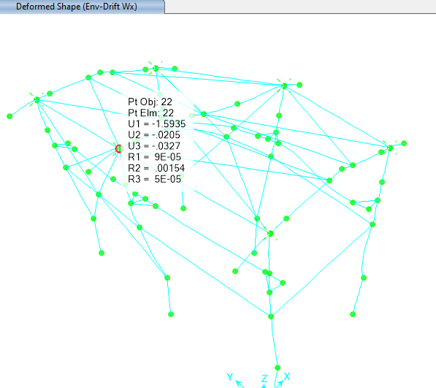

**Figure 24: Deformed shape (maximum Drift critical Wx)**

Maximum displacement according to above output from sap model under critical service load combination with wind load case is about 1.59 cm which is less than allowable drift.

$$allowable drift is \frac{680-100}{200}=2.9 cm$$

According to “Civil & Structural Design Criteria”, horizontal displacements shall not exceed H/200.

The maximum displacement is less than H/200, so the displacement values are acceptable.

|  |  |  |  |  |  |  |
| --- | --- | --- | --- | --- | --- | --- |
| **TABLE: Joint Displacements** | | | | | | |
| **Joint** | **OutputCase** | **CaseType** | **StepType** | **U1** | H/200/0.8 | check |
| Text | Text | Text | Text | cm |
| 19 | Env-Drift Wx | Combination | Max | 1.42104 | 3.631 | ok |
| 19 | Env-Drift Wx | Combination | Min | -1.518657 | 3.631 | ok |
| 20 | Env-Drift Wx | Combination | Max | 1.415991 | 3.631 | ok |
| 20 | Env-Drift Wx | Combination | Min | -1.455132 | 3.631 | ok |
| 22 | Env-Drift Wx | Combination | Max | 1.452719 | 3.631 | ok |
| 22 | Env-Drift Wx | Combination | Min | -1.593499 | 3.631 | ok |
| 24 | Env-Drift Wx | Combination | Max | 1.429044 | 3.631 | ok |
| 24 | Env-Drift Wx | Combination | Min | -1.427127 | 3.631 | ok |
| 26 | Env-Drift Wx | Combination | Max | 1.428719 | 3.631 | ok |
| 26 | Env-Drift Wx | Combination | Min | -1.525487 | 3.631 | ok |
| 28 | Env-Drift Wx | Combination | Max | 1.422523 | 3.631 | ok |
| 28 | Env-Drift Wx | Combination | Min | -1.463213 | 3.631 | ok |
|  |  |  | max + | 1.452719 |  |  |
|  |  |  | max - | -1.593499 |  |  |

**Drift Control According to Iranian Seismic Design Code for petroleum facilities(038)**

According to “Iranian seismic design code(Code.038)” table 4-8 ,drift shall not exceed 0.02.

The maximum drift is less than 0.02, so the displacement values are acceptable.

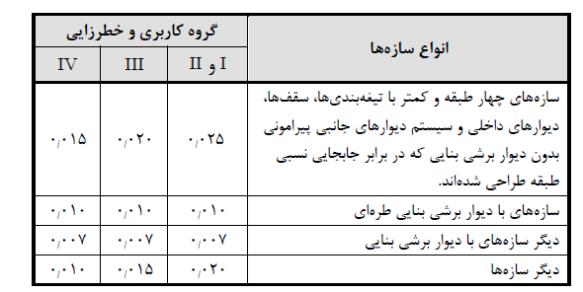

The deflection at level x ($δ_{x}$) (in. or mm) used to compute the design story drift, Δ, shall be determined in accordance with the following equation:

Maximum displacement by EY load case is 4.15 cm which Reduced stiffness values used in the direct analysis method are not intended for use in beam vertical deflection ,drift ,and period of structure.

$δ_{x}=\frac{C_{d}δ_{xe}}{I}=\frac{3×2.69×0.8}{1.25}=5.16cm$, $∆=\frac{5.16}{580}=0.0088<0.02 ok$

${Drift}_{allowable}$ = According to table4-8 of Iranian seismic Design code(code No.038) is 0.02 $h_{sx}$

$h_{sx}$ =is the story height below level x

* 1. **rater beam vertical deflection**

|  |  |  |  |  |  |
| --- | --- | --- | --- | --- | --- |
| **Joint** | **OutputCase** | **CaseType** | **U3** | **allowable deflection (L/240)** | check |
| Text | Text | Text | cm |
| 33 | beam vertical def | Combination | 0.1333 | -2.083 | ok |
| 36 | beam vertical def | Combination | -0.0491 | -2.083 | ok |
| 39 | beam vertical def | Combination | 0.1408 | -2.083 | ok |

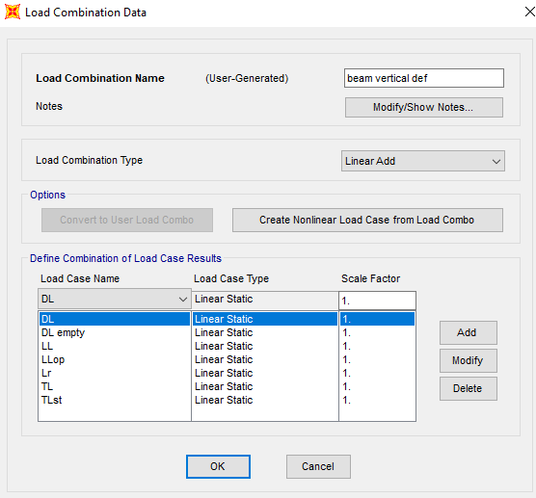

1. **Structural Design Results**
   1. **Graphical output**

The steel structure is checked in accordance with LRFD method. Frame analysis and Structural checks are based on the 3D model that covers all the Load Combinations. All members designed by SAP2000, and code requirements have been checked accordingly. The following figures show the members ratios which are obtained from SAP2000 model analysis and design. All the acceptable ratios for beams & columns have been considered less than 1.0.

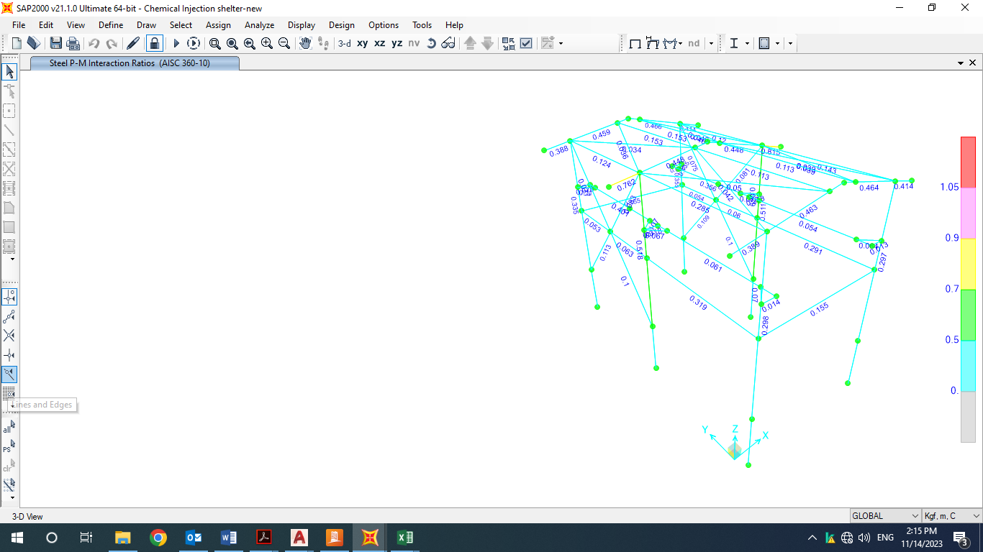

**Figure 25: Steel Design Output**

* 1. **COLUMN DESIGN**

**D03**

AISC 360-10 STEEL SECTION CHECK (Summary for Combo and Station)

Units : Kgf, m, C

Frame : 12 X Mid: 5.6 Combo: Envelope StrengtDesign Type: Column

Length: 5.61 Y Mid: 0. Shape: col Frame Type: OMF

Loc : 5.58 Z Mid: 4.005 Class: Compact Princpl Rot: 0. degrees

Provision: LRFD Analysis: Direct Analysis

D/C Limit=0.95 2nd Order: General 2nd Order Reduction: Tau-b Fixed

AlphaPr/Py=0.021 AlphaPr/Pe=0.009 Tau_b=1. EA factor=0.8 EI factor=0.8

PhiB=0.9 PhiC=0.9 PhiTY=0.9 PhiTF=0.75

PhiS=0.9 PhiS-RI=1. PhiST=0.9

A=0.007 I33=9.743E-05 r33=0.119 S33=6.959E-04 Av3=0.004

J=0. I22=1.601E-05 r22=0.048 S22=1.601E-04 Av2=0.002

E=2.039E+10 Fy=24000000. Ry=1.611 z33=7.743E-04 Cw=0.

RLLF=1. Fu=37000000. z22=2.441E-04

STRESS CHECK FORCES & MOMENTS (Combo Envelope Strength)

Location Pu Mu33 Mu22 Vu2 Vu3 Tu

5.58 -3520.961 -4710.314 9.112 819.432 -160.186 -0.862

PMM DEMAND/CAPACITY RATIO (H1-1b)

D/C Ratio: 0.297 = 0.014 + 0.282 + 0.002

= (1/2)(Pr/Pc) + (Mr33/Mc33) + (Mr22/Mc22)

AXIAL FORCE & BIAXIAL MOMENT DESIGN (H1-1b)

Factor L K1 K2 B1 B2 Cm

Major Bending 0.499 1. 1. 1. 1. 0.739

Minor Bending 0.499 1. 1. 1. 1. 1.

Lltb Kltb Cb

LTB 0.499 1. 1.329

Pu phi*Pnc phi*Pnt

Force Capacity Capacity

Axial -3520.961 125118.487 147916.8

Mu phi*Mn phi*Mn phi*Mn

Moment Capacity No LTB Cb=1

Major Moment -4710.314 16724.275 16724.275 16383.602

Minor Moment 9.112 5272.474

SHEAR CHECK

Vu phi*Vn Stress Status

Force Capacity Ratio Check

Major Shear 819.432 29030.4 0.028 OK

Minor Shear 210.664 62208. 0.003 OK

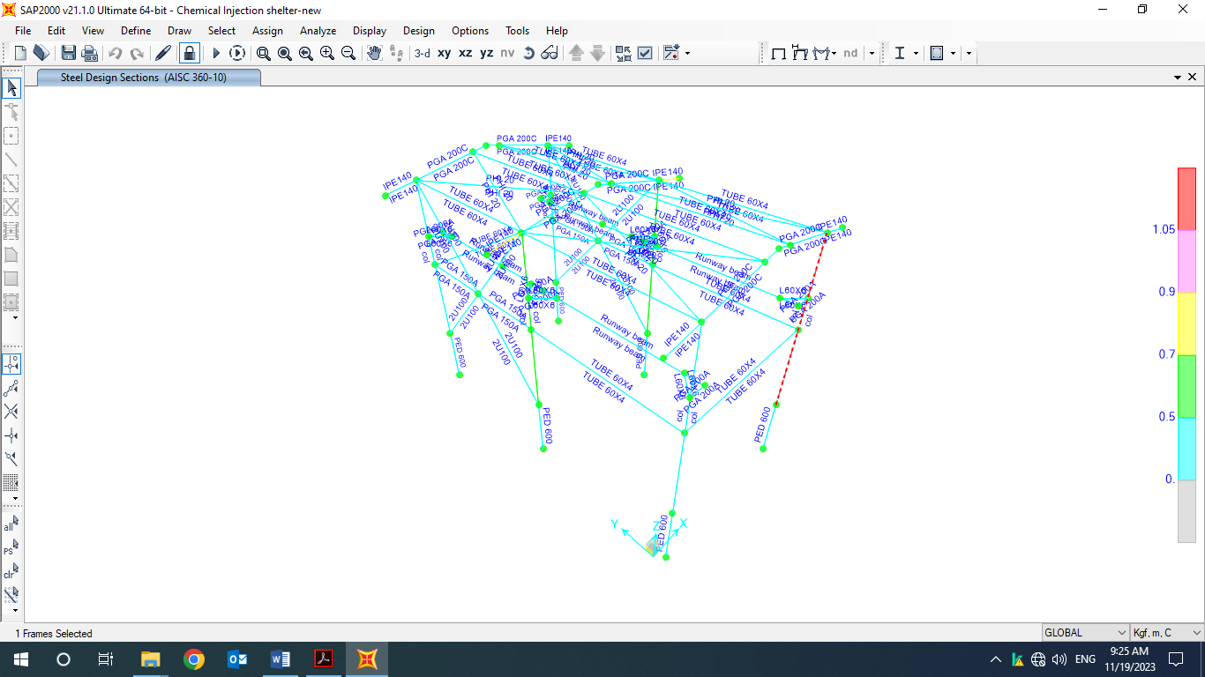

**Figure 26: Column Design**

* 1. **BEAM DESIGN**

**D03**

AISC 360-10 STEEL SECTION CHECK (Summary for Combo and Station)

Units : Kgf, m, C

Frame : 51 X Mid: 1.85 Combo: Envelope StrengtDesign Type: Brace

Length: 2.55 Y Mid: 0. Shape: PGA 200C Frame Type: OMF

Loc : 2.55 Z Mid: 7.06 Class: Compact Princpl Rot: 0. degrees

Provision: LRFD Analysis: Direct Analysis

D/C Limit=0.95 2nd Order: General 2nd Order Reduction: Tau-b Fixed

AlphaPr/Py=0.009 AlphaPr/Pe=0.002 Tau_b=1. EA factor=0.8 EI factor=0.8

PhiB=0.9 PhiC=0.9 PhiTY=0.9 PhiTF=0.75

PhiS=0.9 PhiS-RI=1. PhiST=0.9

A=0.006 I33=4.947E-05 r33=0.094 S33=4.497E-04 Av3=0.003

J=0. I22=1.334E-05 r22=0.049 S22=1.334E-04 Av2=0.002

E=2.039E+10 Fy=24000000. Ry=1.15 z33=5.000E-04 Cw=0.

RLLF=1. Fu=37000000. z22=2.032E-04

STRESS CHECK FORCES & MOMENTS (Combo Envelope Strength)

Location Pu Mu33 Mu22 Vu2 Vu3 Tu

2.55 -1252.516 -4798.967 -55.06 -1615.825 -59.607 -0.914

PMM DEMAND/CAPACITY RATIO (H1-1b)

D/C Ratio: 0.463 = 0.006 + 0.444 + 0.013

= (1/2)(Pr/Pc) + (Mr33/Mc33) + (Mr22/Mc22)

AXIAL FORCE & BIAXIAL MOMENT DESIGN (H1-1b)

Factor L K1 K2 B1 B2 Cm

Major Bending 1. 1. 1. 1. 1. 1.

Minor Bending 0.8 1. 1. 1. 1. 1.

Lltb Kltb Cb

LTB 0.8 1. 1.668

Pu phi*Pnc phi*Pnt

Force Capacity Capacity

Axial -1252.516 110863.29 120960.

Mu phi*Mn phi*Mn phi*Mn

Moment Capacity No LTB Cb=1

Major Moment -4798.967 10800. 10800. 10800.

Minor Moment -55.06 4389.12

SHEAR CHECK

Vu phi*Vn Stress Status

Force Capacity Ratio Check

Major Shear 2868.402 22809.6 0.126 OK

Minor Shear 59.607 51840. 0.001 OK

**BRACE MAXIMUM AXIAL LOADS**

P P

Comp Tens

Axial -1252.516 752.292

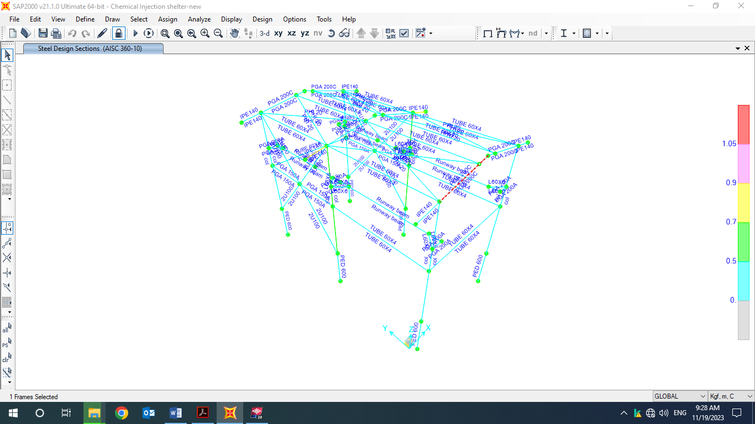

**Figure 27: Beam Design**

1. **STRUCTURE CONNECTIONS**
   1. **Description of Design Procedure & Parameters**

**11.1.1.Rafter to rafter connection (top of shelter):**

According to Iranian National Building code section 10-3-7-2:

$$M_{p}=Z.Fy=450×2400=1080000 kg.cm=10.80 ton.m$$

$$M_{u}=1.1 Ry. Mp=1.1Ry.Z.Fy=1.1×1.15×450×2400=1366200kg.cm=13.662 ton.m$$

$$V=\frac{2[1.1 Ry Mp]}{L_{cf}}=\frac{2×1.1×1.15×450×2400}{1000}=2732.400 kg=2.73 ton$$

According to sap model M3-3 and V2-2 under critical load combination (Envelope Strength) is as follow:

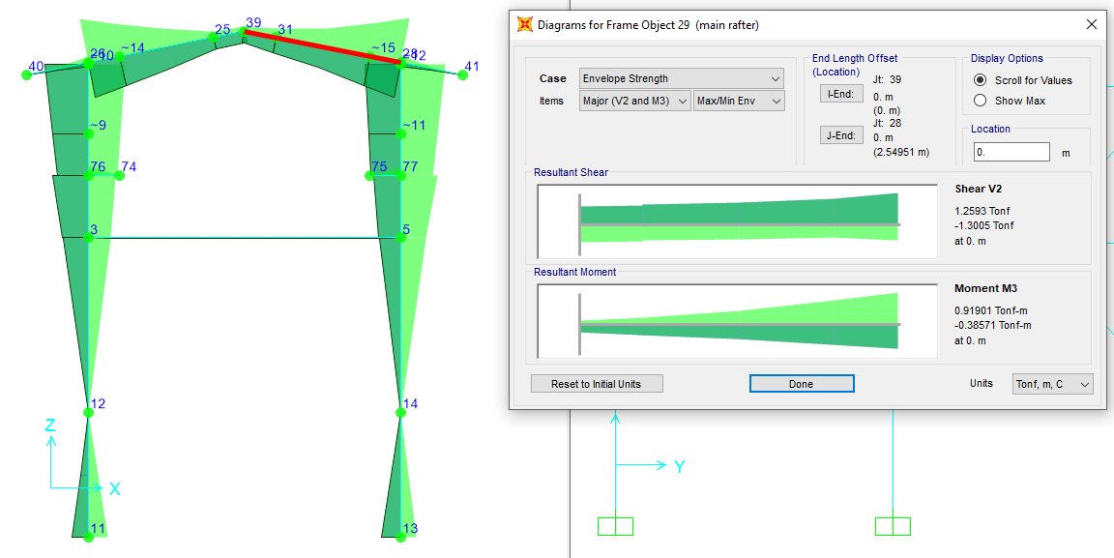

$$M_{3-3design \left(envelope combo\right)}=0.9 ton.m$$

$$V_{2-2design \left(envelope combo\right)}=1.25 ton$$

$$M_{3-3design \left(omega factor \right)}=1.2 ton.m$$

$$V_{2-2design \left(omega factor \right)}=3.6 ton$$

moment of design should not be less than of 0.5Mp=5.4 ton-m.

$$F_{u}=8000\frac{kg}{cm2}$$

$$f_{n}=\frac{R_{n}}{Anb}=∅F_{nt}=4500kg/cm2$$

$Ab=4.52 cm2$

$$I_{bolt}=4Ib=4×4.52×\left({4.5}^{2}+{17.5}^{2}\right)=5903.12cm^{4}$$

$f_{b}$ = $\frac{MC}{I}$

$fb=5.4*\frac{17.5}{4947}*{10}^{5}=1910.248kg/cm2$ <4500kg/cm2 ok

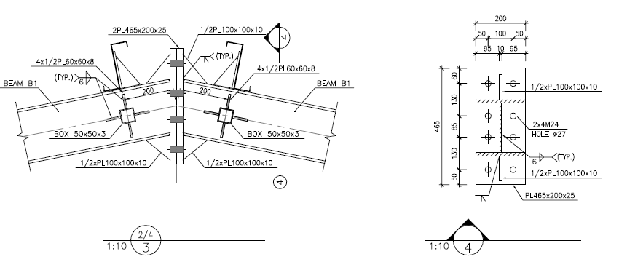

**Figure 26: Connections Details**

**11.1.2 : Rafter to Colum Connection**

**D03**

According to Iranian National Building code No.10 section 10-3-7-2:

$$M_{p}=Z.Fy=500×2400=1200000kg.cm=12.0 ton.m$$

$$M_{u}=1.1 Ry. Mp=1.1Ry.Z.Fy=1.1×1.15×770×2400=1518000 kg.cm=15.18 ton.m$$

$$V=\frac{2[1.1 Ry Mp]}{L_{cf}}=\frac{2×1.1×1.15×500×2400}{1000}=3036 kg=3.036 ton$$

According to sap model M3-3 and V2-2 under critical load combination (Envelope Strength) is as follow:

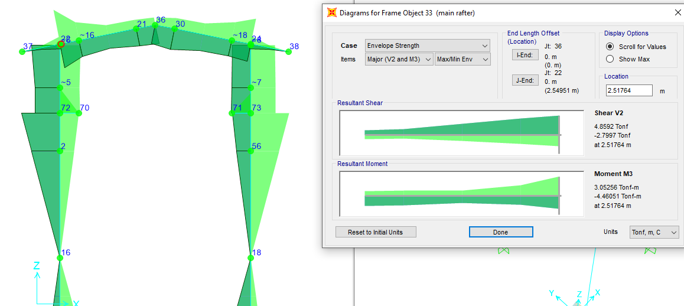

**D03**

$$M_{3-3design \left(envelope combo\right)}=4.038 ton.m$$

$$V_{2-2design \left(envelope combo\right)}=2.86 ton$$

$$M_{3-3design \left(envelope combo\right)}=12.41 ton.m$$

$$V_{2-2design \left(envelope combo\right)}=5.78 ton$$

Moment of design should not be less than of 0.5Mp=6.00 ton-m.

$$F_{u}=8000\frac{kg}{cm2}$$

$$f_{n}=\frac{R_{n}}{Anb}=∅F_{nt}=4500kg/cm2$$

$$Ab=4.52 cm2$$

$$I_{bolt}=4Ib=4×4.52×\left({4.3}^{2}+{17.2}^{2}\right)=5678.814 cm^{4}$$

$f_{b}$ = $\frac{MC}{I}$

$fb=12×17.2×{10}^{5}/5678.814=3628.811 kg/cm2$ <4500kg/cm2 ok

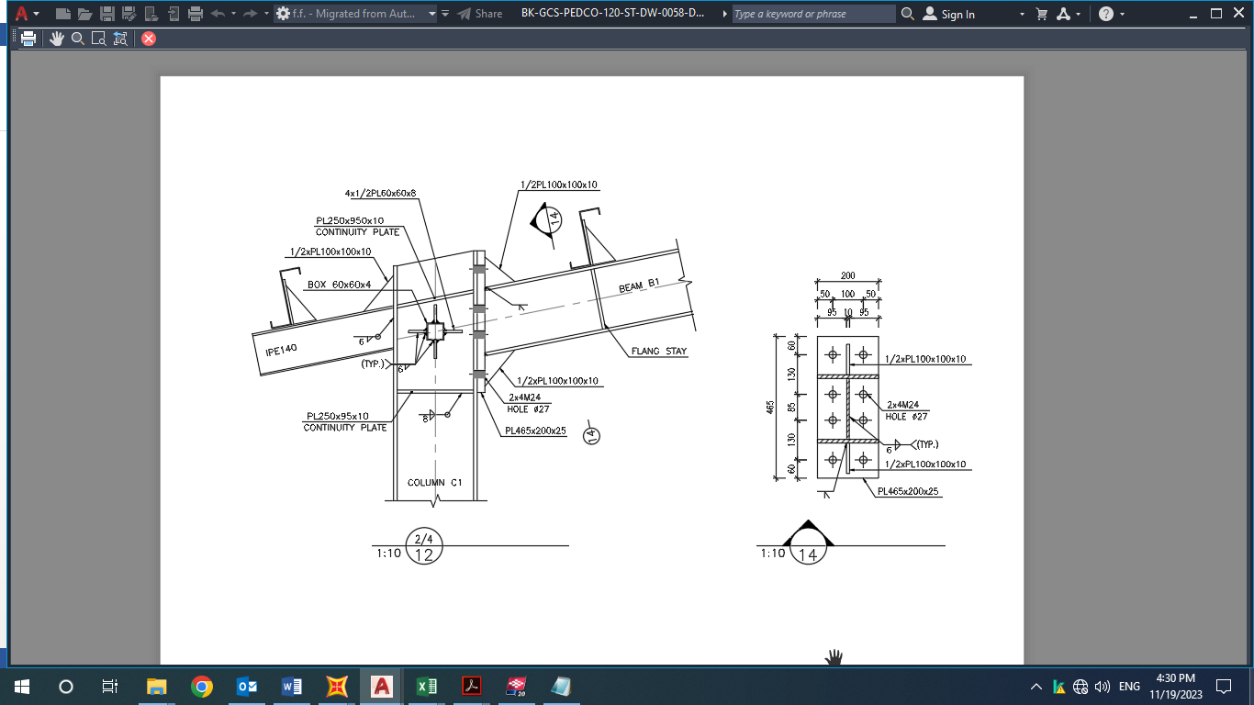

**Figure 27: Connections Details**

* 1. **PURLIN DESIGN**

## 11.13.1. Property of Purlin(Z180x2.5)

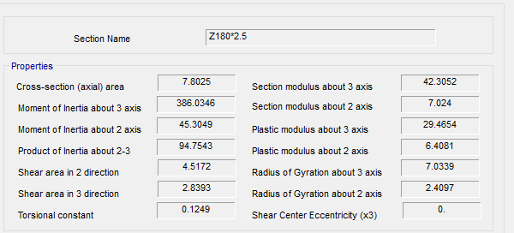

**Figure 28-Section Property Of Purlin**

According to above table :

$$A=7.80 cm2$$

$$J=0.12 cm4$$

$$Ix=386.06 cm4$$

$$Iy=45.304 cm4$$

$$rx=7.033 cm$$

$$ry=2.41 cm$$

$$ho=18 cm$$

$$SY=42.305 cm3$$

$$SX=7.024 cm3$$

FOR Z 180 :

$$D+L=50+50=100 kg/m^{2}$$

$$P_{y}=100 \cos{11}=98.16 kg/m^{2}$$

$$P_{x}=100\sin{11}=19.081 kg/m^{2}$$

$$middle of span : M_{y}=\frac{w.L^{2}}{8}=\frac{100×1.0×5^{2}}{8}=312.5 kg.m$$

$$middle of span : M_{x}=\frac{w.L^{2}}{360}=\frac{19×1×5^{2}}{360}=1.31 kg.m$$

$$f_{b}=\frac{M_{y}}{s_{y}}+2\frac{M_{x}}{s_{x}}=\frac{312.5×100}{42.305}+2\frac{1.31×100}{7.024}=739+38=777<1440 ok$$

$$moment on sagrod support : M_{y}=\frac{w.L^{2}}{9}=\frac{100×1.0×5^{2}}{9}=277 kg.m$$

$$moment on sagrod support : M_{x}=\frac{w.L^{2}}{90}=\frac{19×1.0×5^{2}}{90}=5.3 kg.m$$

$$f_{b}=\frac{M_{y}}{s_{y}}+2\frac{M_{x}}{s_{x}}=\frac{277×100}{42.305}+2\frac{5.3×100}{7.024}=655+151=806< 1440 ok$$

FOR Z 180 :

0.6 $D+w=30+158=188 kg/m^{2}$

$$P_{y}=188.\cos{11}=184 kg/m^{2}$$

$$P_{x}=188.\sin{11}=35kg/m^{2}$$

$$middle of span : M_{y}=\frac{w.L^{2}}{8}=\frac{188×0.9×5^{2}}{8}=528 kg.m$$

$$middle of span : M_{x}=\frac{w.L^{2}}{360}=\frac{35×1×5^{2}}{360}=2.4kg.m$$

$$f_{b}=\frac{M_{y}}{s_{y}}+2\frac{M_{x}}{s_{x}}=\frac{528×100}{42.305}+2\frac{2.6×100}{7.024}=1248+968=1316 <1440 ok$$

$$moment on sagrod support : M_{y}=\frac{w.L^{2}}{9}=\frac{184×0.9×5^{2}}{9}=255.55 kg.m$$

$$moment on sagrod support : M_{x}=\frac{w.L^{2}}{90}=\frac{35×0.9×5^{2}}{90}=8.75 kg.m$$

$$f_{b}=\frac{M_{y}}{s_{y}}+2\frac{M_{x}}{s_{x}}=\frac{255.55×100}{42.305}+2\frac{8.75×100}{7.024}=604+249=853< 1440 ok$$

### 11.13.2.Un deformed shape CONTROL:

* 1. **Roof bracing Design**

According to INBC No.10 section 10-2-3-4 for tensile member :

Roof brace = $∅20$

$${ ∅}_{t}P_{n}=∅_{t}F_{y}A_{g}=0.9×4000×3.14=11304 kg$$

According to sap model maximum tensile force is 773 kg & it’s OK.

|  |  |  |  |  |
| --- | --- | --- | --- | --- |
| **TABLE: Element Forces - Frames** | | | | |
| **Frame** | **Station** | **OutputCase** | **StepType** | **P** |
| Text | m | Text | Text | Kgf |
| 43 | 0 | Envelope Strength | Max | 686.66 |
| 43 | 2.7 | Envelope Strength | Max | 686.23 |
| 43 | 5.4 | Envelope Strength | Max | 685.8 |
| 43 | 0 | Envelope Strength | Min | -549.84 |
| 43 | 2.7 | Envelope Strength | Min | -550.27 |
| 43 | 5.4 | Envelope Strength | Min | -550.7 |
| 44 | 0 | Envelope Strength | Max | 538.46 |
| 44 | 2.7 | Envelope Strength | Max | 538.91 |
| 44 | 5.4 | Envelope Strength | Max | 539.36 |
| 44 | 0 | Envelope Strength | Min | -636.9 |
| 44 | 2.7 | Envelope Strength | Min | -636.45 |
| 44 | 5.4 | Envelope Strength | Min | -636 |
| 47 | 0 | Envelope Strength | Max | 585.28 |
| 47 | 2.7 | Envelope Strength | Max | 585.7 |
| 47 | 5.4 | Envelope Strength | Max | 586.13 |
| 47 | 0 | Envelope Strength | Min | -423.5 |
| 47 | 2.7 | Envelope Strength | Min | -423.07 |
| 47 | 5.4 | Envelope Strength | Min | -422.64 |
| 48 | 0 | Envelope Strength | Max | 689.36 |
| 48 | 2.7 | Envelope Strength | Max | 688.91 |
| 48 | 5.4 | Envelope Strength | Max | 688.46 |
| 48 | 0 | Envelope Strength | Min | -296.22 |
| 48 | 2.7 | Envelope Strength | Min | -296.67 |
| 48 | 5.4 | Envelope Strength | Min | -297.12 |
| 49 | 0 | Envelope Strength | Max | 690.06 |
| 49 | 2.7 | Envelope Strength | Max | 690.52 |
| 49 | 5.4 | Envelope Strength | Max | 690.98 |
| 49 | 0 | Envelope Strength | Min | -338.73 |
| 49 | 2.7 | Envelope Strength | Min | -338.12 |
| 49 | 5.4 | Envelope Strength | Min | -337.51 |
| 50 | 0 | Envelope Strength | Max | 772.13 |
| 50 | 2.7 | Envelope Strength | Max | 772.71 |
| 50 | 5.4 | Envelope Strength | Max | 773.29 |
| 50 | 0 | Envelope Strength | Min | -551.51 |
| 50 | 2.7 | Envelope Strength | Min | -551.07 |
| 50 | 5.4 | Envelope Strength | Min | -550.63 |
| 52 | 0 | Envelope Strength | Max | 605.02 |
| 52 | 2.7 | Envelope Strength | Max | 604.44 |
| 52 | 5.4 | Envelope Strength | Max | 603.85 |
| 52 | 0 | Envelope Strength | Min | -480.24 |
| 52 | 2.7 | Envelope Strength | Min | -480.82 |
| 52 | 5.4 | Envelope Strength | Min | -481.41 |
| 55 | 0 | Envelope Strength | Max | 600.58 |
| 55 | 2.7 | Envelope Strength | Max | 599.97 |
| 55 | 5.4 | Envelope Strength | Max | 599.35 |
| 55 | 0 | Envelope Strength | Min | -665.7 |
| 55 | 2.7 | Envelope Strength | Min | -666.32 |
| 55 | 5.4 | Envelope Strength | Min | -666.93 |
|  |  |  | max= | 773.29 |

* 1. **Base Plate**

**Design force:**

$$V_{tr}=\frac{M_{p}}{H}=\frac{ZF_{y}}{H}=\frac{775×2400×{10}^{-5}}{5.5}=3.38 ton$$

$$V_{long}=R_{y}A_{g}F_{y}cosθ=1.25×4000×27×cos 50=86.776ton$$

**Shear check in transverse direction:**

According to INBC No.10 section 10-2-6-2-1

$$∅V_{n}=0.6F_{y}A_{w}C_{v } ∅_{v}$$

$\frac{h}{t_{w}}=\frac{28}{0.8}=35<2.24\sqrt{\frac{2.06×{10}^{6}}{2400}=65}$ then $C_{v}=1 ∅_{v}=1$

$${∅V}_{n}=0.6×2400×\left(28×0.8\right)×1×1=32.25 ton>3.38 ton$$

**Shear check in longitudinal direction:**

According to INBC No.10 section 10-2-6-7-2

$$K_{v}=1.2$$

$$\frac{h}{t_{w}}=\frac{\frac{b}{2}}{t_{f}}=\frac{15}{1.5}=10$$

$$A_{w}=2b_{f}t_{f}=2×30×1.5=90 cm2$$

$$\frac{h}{t_{w}}<1.1\sqrt{\frac{K_{v}E}{F_{y}}}=35.3 then C_{v}=1 ∅_{v}=0.9$$

$$∅V_{n}=0.9×0.6×2400×90×1=116640 kg=116.64 ton>86.776ton$$

According to above calculation The column section is ok for shear check .

**Bolt control in shear**

$$V_{max}=43.96 ton$$

$$F_{nv}=0.55F_{u}=3300 kg$$

$$∅=0.75$$

$$A_{nb}=\frac{V_{max}}{∅F_{nv}}=\frac{43960}{0.75×3300}=17.76 cm^{2} USE 4M24=18.09cm2$$

$Mpc=F_{y}Z_{3-3}=2400×775×{10}^{-5}=18.6ton$

$$\frac{\sum{Mpc}}{Hs}=\frac{18.6}{5.5}=3.38 Vc$$

$$Mp=1.1RyFyZc=1.1×1.2×2400×775×{10}^{-5}=24.552 ton.m$$

$$M_{cx}=\min\left(18.6,3.38\right)=3.38 ton.m$$

$$f_{c}=300 kg/cm2$$

$$\frac{A2}{A1}=1 , ∅_{c}=0.65 f_{pmax}=∅_{c} 0.85 f^{'}c\sqrt{\frac{A2}{A1}}=165.75 kg/cm2$$

$$q_{max}=f_{pmax}×B=7458 kg/cm2$$

**For ordinary & critical load combination**

$$M_{u}=11.8 ton.m$$

$$P_{u}=8.13 ton$$

$$Y_{min}=\frac{P_{u}}{q_{max}}=\frac{8130}{7458}=1.09 cm$$

$$ε_{max}=\frac{N}{2}-\frac{Ymin}{2}=22 cm$$

$$e=\frac{M_{u}}{P_{u}}=\frac{11.8}{8.13}=1.45m=145cm>ε_{max}=22 cm tension applied.$$

$$d=6cm$$

$$f=\frac{N}{2}-d=\frac{45}{2}-6=16.5 cm$$

$$Y=3.36 cm$$

$$\sum{T=qmaxY-Pu=7458×3.36=25.058 ton.m}$$

**Tension Strength control of anchor bolts :**

$$d_{b}=24mm$$

$$A_{nb}=4.52 cm2$$

$$T_{u}=\frac{25.058}{2}=12.529 ton$$

$$f_{uT}=\frac{T_{u}}{A_{nb}}=\frac{12.529×1000}{4.52}=2771 kg/cm2$$

$$F_{nT}=0.75F_{u}=4500kg/cm2$$

$$∅=0.75$$

$$R_{nt}=F_{nt}A_{nb}=4500×4.52×{10}^{-3}=20.34 ton$$

$$∅R_{nt}=15.25 ton ≥Tu=13.92 ton ok$$

**Shear control of Anchor Bolts:**

* 1. **General requirements of embedment in concrete**:

**According to ACI318 appendix D:**

Concrete breakout strength of anchor in tension : the nominal concrete breakout strength Ncbg shall not exceed

$$N_{cbg}=\frac{A_{NC}}{A_{NCO}}ω_{ec}ω_{ed,N}ω_{c,N}ω_{cp,N}N_{b}$$

$$A_{CNO}=9hef^{2}$$

$$A_{NC}=(S1+3hef)(S2+3hef)$$

$$K_{c}=10$$

$$N_{b}=10γ_{a}\sqrt{f_{c}}h_{ef}^{1.5}=10×1×\sqrt{25}×{126.6}^{1.5}=71.2 KN$$

$$λ_{ef}=\max\left(\frac{Ca,max}{1.5},\frac{S1}{3},\frac{S2}{3}\right)=\left(\frac{\frac{60}{1.5,380}}{3}\right)=126.6mm$$

$$C_{a,max}=\max\left(Ca1,Ca2,Ca3,Ca4\right)=60 mm$$

$$A_{NCO}=9×{126.6}^{2}=144248.04 mm2$$

$$A_{NC}=\left(60+3×126.6\right)×\left(60+3×126.6\right)=193424.04mm2$$

$$ω_{ec,N}=1$$

$$C_{a,min}=60 mm$$

$$h_{ef}=126.6 mm$$

$$ω_{ed,N}=0.7+0.3×\frac{60}{1.5×126.6}=0.79$$

$$ω_{c,N}=1$$

$$ω_{cp,N}=1$$

$$N_{cbg}=\frac{A_{NC}}{A_{NCO}}ω_{ec}ω_{ed,N}ω_{c,N}ω_{cp,N}N_{b}=\frac{193424.04}{144248.04}×1×0.79×1.25×71.2=94.27 KN$$

$$∅=0.7$$

$$∅N_{cbg}=6.72ton>1.75 ok$$

Concrete strength to withstand against tension in braced frame column under combination with Ω factor is acceptable.

**Concrete breakout of anchor in shear :**

The nominal concrete breakout strength Vcbg in shear shall not exceed :

$$V_{cbg}=\frac{A_{VC}}{A_{VCO}}ω_{ec,V}ω_{ed,V}ω_{c,V}ω_{h,V}V_{b}$$

$$A_{Vco}=4.5{Ca1}^{2}$$

$$\frac{A_{V}}{A_{Vco}}=0.66<n=2$$

$$h_{a}=\min\left(t_{f},1.5{Ca}_{1,2}\right)=\left(1600,1.5×60\right)=90mm$$

$$A_{vc}=120×90=10800 mm2$$

$$A_{vco}=4.5{Ca1}^{2}=16200mm2$$

$$ω_{ed,V}=1$$

$$ω_{e,v}=1.4$$

$$ω_{h,v}=\sqrt{\frac{1.5{Ca}_{1}}{ha}}=1$$

$$V_{b}=\min\left(0.6{\left(\frac{l_{e}}{d_{a}}\right)}^{0.2}\sqrt{d_{a} }λ_{a}\sqrt{fc }{Ca1}^{1.5} , 3.7λ_{a}\sqrt{fc }{Ca1}^{1.5}\right)=\min\left( 10.353 KN,8.5KN\right)=8.5 KN$$

$$λ_{a}=1$$

$$V_{cbg}=\frac{A_{VC}}{A_{VCO}}ω_{ec,V}ω_{ed,V}ω_{c,V}ω_{h,V}V_{b}=\frac{10800}{16200}×1×1.4×1×8.5=7.93 ton ok$$

### -REQUIRED THICKNESS

Maximum Axial Load according to SAP2000 model is about 8.13 ton Under critical load combination:

$t=l\sqrt{\frac{2P_{U}}{0.9F_{y}BN} }$ =13 $\sqrt{\frac{2x8130}{0.9x2400x45x45}}=0.8$ cm used th=2 cm

$m=\frac{N-0.95d}{2}$ = $\frac{450-0.95*280}{2}$ =92

$n=\frac{B-0.8bf}{2}$ = $\frac{450-0.8*250}{2}$ =125

$${λn}^{'}=λ\frac{\sqrt{dbf}}{4}=1*\frac{\sqrt{240*250}}{4}=61$$

L=max(m,n,λn)=125

1. **FOUNDATION DESIGN**

SAP2000 has been used in order to modeling, analyses and design of this foundation.

DETAILS” property of piles has been shown in the following FIG:

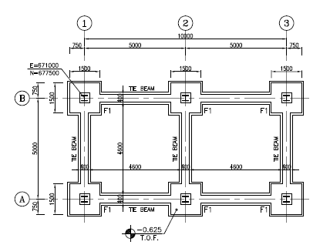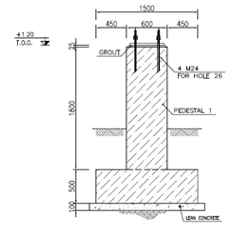

**Figure 29-Foundation Plan**

* 1. **Soil pressure and settlement**

Until finalize of geotechnical report for this area we consider => qa= 2kg/cm2

Based on geotechnical report for subgrade modulus is => Ks = 1.34 kg/cm3

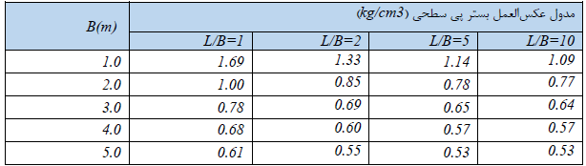

**Figure 30-Subgrade Modulus**

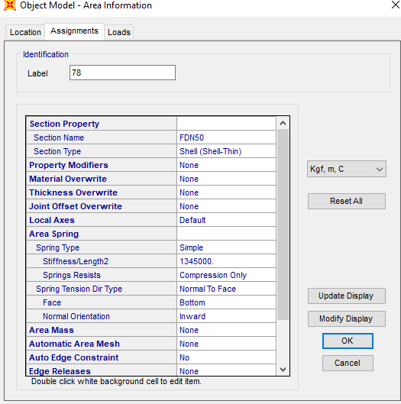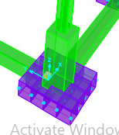

**Figure 31-Assign Spring to Foundation**

* 1. **DESIGN**

Concrete Foundation are designed according to ACI 318-14. Required loads are derived from SAP data, and design process will be done according to ACI code based on ultimate strength procedure.

${f^{'}}_{c}=30Mpa$ $f_{y}=400Ma$

Soil load applied on model as below:

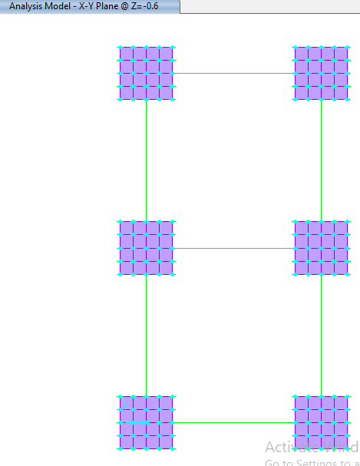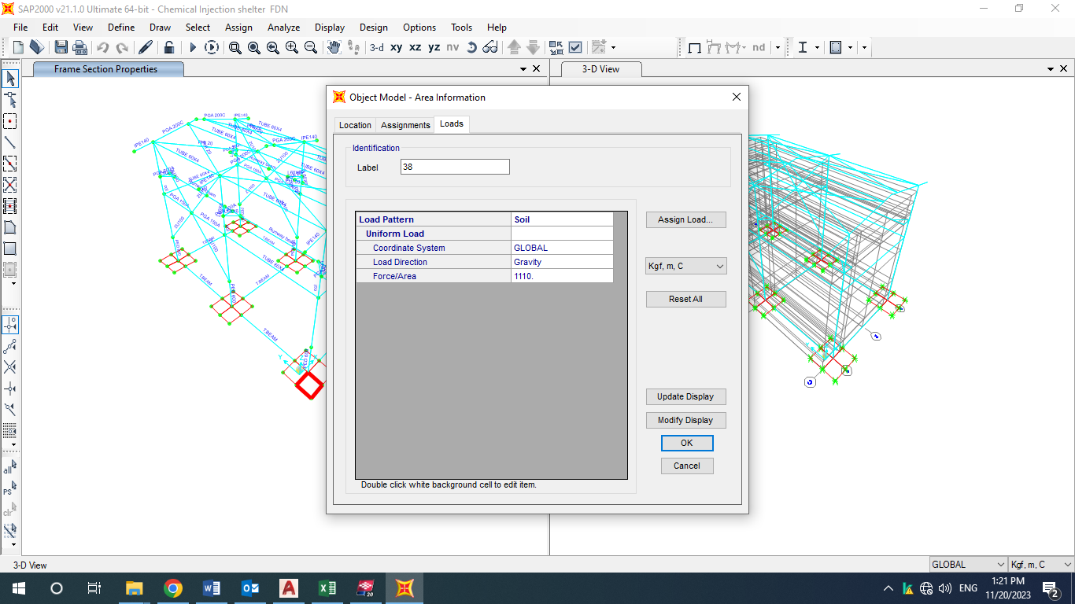

**Figure 32-Applied soil load on Foundation**

Soil dead load is

* 1. **FOUNDATION DESIGN CONTROL**

### 12.3.1 Check of Stress for Foundation

|  |  |  |  |  |  |  |  |  |  |
| --- | --- | --- | --- | --- | --- | --- | --- | --- | --- |
| **TABLE: Joint Displacements** | | | | | | | | | |
| **Joint** | **OutputCase** | **CaseType** | **StepType** | **U1** | **U2** | **U3** | **R1** | **R2** | **R3** |
| Text | Text | Text | Text | cm | cm | cm | Radians | Radians | Radians |
| 7 | Envelope allowable | Combination | Max | 0.00000183 | 1.032E-07 | 0 | 4.696E-16 | 0.000206 | 9.804E-10 |
| 7 | Envelope allowable | Combination | Min | -0.000002434 | -0.000000519 | -0.52266 | -0.000175 | -0.000154 | -5.06E-10 |
| 9 | Envelope allowable | Combination | Max | 0.000002504 | 1.037E-07 | 0.000442 | 6.318E-09 | 0.00016 | 6.291E-10 |
| 9 | Envelope allowable | Combination | Min | -0.000001767 | -5.189E-07 | -0.506712 | -0.000176 | -0.0002 | -1.006E-09 |
| 11 | Envelope allowable | Combination | Max | 0.000002078 | 0.000019 | 0 | 0.000437 | 0.000204 | 1.13E-09 |
| 11 | Envelope allowable | Combination | Min | -0.000002682 | -0.000004517 | -0.566262 | -0.000452 | -0.000159 | -1.81E-09 |
| 13 | Envelope allowable | Combination | Max | 0.000002702 | 0.000018 | 0.000435 | 0.000433 | 0.000157 | 1.683E-09 |
| 13 | Envelope allowable | Combination | Min | -0.000001961 | -0.000004144 | -0.582159 | -0.000448 | -0.000205 | -8.124E-10 |
| 15 | Envelope allowable | Combination | Max | 0.000002515 | 0.000006088 | 0 | 0.000235 | 0.000213 | 8.118E-10 |
| 15 | Envelope allowable | Combination | Min | -0.000004471 | -0.00002 | -0.547466 | -0.000185 | -0.000175 | -3.142E-10 |
| 17 | Envelope allowable | Combination | Max | 0.000004551 | 0.000005985 | 0.000442 | 0.000234 | 0.000179 | 5.666E-10 |
| 17 | Envelope allowable | Combination | Min | -0.000002425 | -0.00002 | -0.541006 | -0.000184 | -0.000207 | -9.737E-10 |
| 32 | Envelope allowable | Combination | Max | 0 | 0 | 0 | 0.000435 | 0.000206 | 0 |
| 32 | Envelope allowable | Combination | Min | 0 | 0 | -0.545499 | -0.000445 | -0.000157 | 0 |
| 42 | Envelope allowable | Combination | Max | 0 | 0 | 0 | 0.000435 | 0.000202 | 0 |
| 42 | Envelope allowable | Combination | Min | 0 | 0 | -0.54516 | -0.000444 | -0.00016 | 0 |
| 45 | Envelope allowable | Combination | Max | 0 | 0 | 0 | 0.000435 | 0.000201 | 0 |
| 45 | Envelope allowable | Combination | Min | 0 | 0 | -0.587041 | -0.000445 | -0.000159 | 0 |
| 46 | Envelope allowable | Combination | Max | 0 | 0 | 0 | 0.000435 | 0.000205 | 0 |
| 46 | Envelope allowable | Combination | Min | 0 | 0 | -0.587341 | -0.000445 | -0.000157 | 0 |
| 81 | Envelope allowable | Combination | Max | 0 | 0 | 0 | 0.000424 | 0.000203 | 0 |
| 81 | Envelope allowable | Combination | Min | 0 | 0 | -0.545585 | -0.000416 | -0.000159 | 0 |
| 82 | Envelope allowable | Combination | Max | 0 | 0 | 0 | 0.000433 | 0.000205 | 0 |
| 82 | Envelope allowable | Combination | Min | 0 | 0 | -0.566298 | -0.000436 | -0.000157 | 0 |
| 86 | Envelope allowable | Combination | Max | 0 | 0 | 0 | 0.000435 | 0.000202 | 0 |
| 86 | Envelope allowable | Combination | Min | 0 | 0 | -0.587359 | -0.000441 | -0.000158 | 0 |
| 90 | Envelope allowable | Combination | Max | 0 | 0 | 0 | 0.000432 | 0.000196 | 0 |
| 90 | Envelope allowable | Combination | Min | 0 | 0 | -0.565978 | -0.000436 | -0.000158 | 0 |
| 92 | Envelope allowable | Combination | Max | 0 | 0 | 0.0003 | 0.000432 | 0.000159 | 0 |
| 92 | Envelope allowable | Combination | Min | 0 | 0 | -0.556583 | -0.000441 | -0.000203 | 0 |
| 93 | Envelope allowable | Combination | Max | 0 | 0 | 0.000571 | 0.000432 | 0.000154 | 0 |
| 93 | Envelope allowable | Combination | Min | 0 | 0 | -0.566941 | -0.000441 | -0.000206 | 0 |
| 94 | Envelope allowable | Combination | Max | 0 | 0 | 0.000569 | 0.000432 | 0.000155 | 0 |
| 94 | Envelope allowable | Combination | Min | 0 | 0 | -0.60768 | -0.000441 | -0.000205 | 0 |
| 95 | Envelope allowable | Combination | Max | 0 | 0 | 0.000298 | 0.000432 | 0.000158 | 0 |
| 95 | Envelope allowable | Combination | Min | 0 | 0 | -0.597453 | -0.000441 | -0.000203 | 0 |
| 96 | Envelope allowable | Combination | Max | 0 | 0 | 0.000436 | 0.000421 | 0.000157 | 0 |
| 96 | Envelope allowable | Combination | Min | 0 | 0 | -0.562012 | -0.000413 | -0.000203 | 0 |
| 97 | Envelope allowable | Combination | Max | 0 | 0 | 0.0003 | 0.000429 | 0.000156 | 0 |
| 97 | Envelope allowable | Combination | Min | 0 | 0 | -0.576919 | -0.000433 | -0.000198 | 0 |
| 98 | Envelope allowable | Combination | Max | 0 | 0 | 0.000434 | 0.000431 | 0.000155 | 0 |
| 98 | Envelope allowable | Combination | Min | 0 | 0 | -0.602714 | -0.000437 | -0.000203 | 0 |
| 99 | Envelope allowable | Combination | Max | 0 | 0 | 0.000571 | 0.000429 | 0.000155 | 0 |
| 99 | Envelope allowable | Combination | Min | 0 | 0 | -0.587196 | -0.000433 | -0.000205 | 0 |
| 100 | Envelope allowable | Combination | Max | 0 | 0 | 0.000305 | 0.000223 | 0.000177 | 0 |
| 100 | Envelope allowable | Combination | Min | 0 | 0 | -0.538844 | -0.00018 | -0.00021 | 0 |
| 101 | Envelope allowable | Combination | Max | 0 | 0 | 0.00058 | 0.000223 | 0.000178 | 0 |
| 101 | Envelope allowable | Combination | Min | 0 | 0 | -0.546529 | -0.00018 | -0.000204 | 0 |
| 102 | Envelope allowable | Combination | Max | 0 | 0 | 0.000578 | 0.000229 | 0.000177 | 0 |
| 102 | Envelope allowable | Combination | Min | 0 | 0 | -0.542081 | -0.000183 | -0.000205 | 0 |
| 103 | Envelope allowable | Combination | Max | 0 | 0 | 0.000303 | 0.000229 | 0.000177 | 0 |
| 103 | Envelope allowable | Combination | Min | 0 | 0 | -0.534378 | -0.000183 | -0.000209 | 0 |
| 104 | Envelope allowable | Combination | Max | 0 | 0 | 0.000443 | 0.000174 | 0.000175 | 0 |
| 104 | Envelope allowable | Combination | Min | 0 | 0 | -0.542429 | -0.000153 | -0.000206 | 0 |
| 105 | Envelope allowable | Combination | Max | 0 | 0 | 0.000305 | 0.000218 | 0.000177 | 0 |
| 105 | Envelope allowable | Combination | Min | 0 | 0 | -0.536988 | -0.00018 | -0.000203 | 0 |
| 106 | Envelope allowable | Combination | Max | 0 | 0 | 0.000441 | 0.000252 | 0.000175 | 0 |
| 106 | Envelope allowable | Combination | Min | 0 | 0 | -0.538035 | -0.000211 | -0.000206 | 0 |
| 107 | Envelope allowable | Combination | Max | 0 | 0 | 0.00058 | 0.000218 | 0.000175 | 0 |
| 107 | Envelope allowable | Combination | Min | 0 | 0 | -0.544734 | -0.00018 | -0.000207 | 0 |
| 108 | Envelope allowable | Combination | Max | 0 | 0 | 0.000305 | 1.212E-08 | 0.000159 | 0 |
| 108 | Envelope allowable | Combination | Min | 0 | 0 | -0.494605 | -0.000176 | -0.000198 | 0 |
| 109 | Envelope allowable | Combination | Max | 0 | 0 | 0.000579 | 1.176E-08 | 0.000159 | 0 |
| 109 | Envelope allowable | Combination | Min | 0 | 0 | -0.493966 | -0.000176 | -0.0002 | 0 |
| 110 | Envelope allowable | Combination | Max | 0 | 0 | 0.00058 | 5.619E-10 | 0.000159 | 0 |
| 110 | Envelope allowable | Combination | Min | 0 | 0 | -0.518571 | -0.000176 | -0.0002 | 0 |
| 111 | Envelope allowable | Combination | Max | 0 | 0 | 0.000306 | 1.655E-11 | 0.00016 | 0 |
| 111 | Envelope allowable | Combination | Min | 0 | 0 | -0.519064 | -0.000175 | -0.000199 | 0 |
| 112 | Envelope allowable | Combination | Max | 0 | 0 | 0.000442 | 9.543E-09 | 0.000159 | 0 |
| 112 | Envelope allowable | Combination | Min | 0 | 0 | -0.49432 | -0.000177 | -0.000198 | 0 |
| 113 | Envelope allowable | Combination | Max | 0 | 0 | 0.000305 | 5.246E-09 | 0.000159 | 0 |
| 113 | Envelope allowable | Combination | Min | 0 | 0 | -0.506903 | -0.000173 | -0.000193 | 0 |
| 114 | Envelope allowable | Combination | Max | 0 | 0 | 0.000443 | 2.487E-09 | 0.00016 | 0 |
| 114 | Envelope allowable | Combination | Min | 0 | 0 | -0.518851 | -0.00017 | -0.000199 | 0 |
| 115 | Envelope allowable | Combination | Max | 0 | 0 | 0.00058 | 6.041E-09 | 0.000158 | 0 |
| 115 | Envelope allowable | Combination | Min | 0 | 0 | -0.506321 | -0.000175 | -0.0002 | 0 |
| 116 | Envelope allowable | Combination | Max | 0 | 0 | 0 | 0.000224 | 0.000213 | 0 |
| 116 | Envelope allowable | Combination | Min | 0 | 0 | -0.560793 | -0.000181 | -0.000176 | 0 |
| 117 | Envelope allowable | Combination | Max | 0 | 0 | 0 | 0.000224 | 0.000212 | 0 |
| 117 | Envelope allowable | Combination | Min | 0 | 0 | -0.548543 | -0.000181 | -0.000169 | 0 |
| 118 | Envelope allowable | Combination | Max | 0 | 0 | 0 | 0.000231 | 0.000212 | 0 |
| 118 | Envelope allowable | Combination | Min | 0 | 0 | -0.539709 | -0.000185 | -0.00017 | 0 |
| 119 | Envelope allowable | Combination | Max | 0 | 0 | 0 | 0.000231 | 0.000213 | 0 |
| 119 | Envelope allowable | Combination | Min | 0 | 0 | -0.5536 | -0.000185 | -0.000175 | 0 |
| 120 | Envelope allowable | Combination | Max | 0 | 0 | 0 | 0.000175 | 0.000211 | 0 |
| 120 | Envelope allowable | Combination | Min | 0 | 0 | -0.554207 | -0.000154 | -0.00017 | 0 |
| 121 | Envelope allowable | Combination | Max | 0 | 0 | 0 | 0.000219 | 0.000213 | 0 |
| 121 | Envelope allowable | Combination | Min | 0 | 0 | -0.554295 | -0.000181 | -0.000171 | 0 |
| 122 | Envelope allowable | Combination | Max | 0 | 0 | 0 | 0.000254 | 0.000211 | 0 |
| 122 | Envelope allowable | Combination | Min | 0 | 0 | -0.546493 | -0.000212 | -0.000171 | 0 |
| 123 | Envelope allowable | Combination | Max | 0 | 0 | 0 | 0.000219 | 0.000209 | 0 |
| 123 | Envelope allowable | Combination | Min | 0 | 0 | -0.540395 | -0.000181 | -0.000171 | 0 |
| 124 | Envelope allowable | Combination | Max | 0 | 0 | 0 | 4.718E-16 | 0.000206 | 0 |
| 124 | Envelope allowable | Combination | Min | 0 | 0 | -0.514849 | -0.000176 | -0.000152 | 0 |
| 125 | Envelope allowable | Combination | Max | 0 | 0 | 0 | 4.679E-16 | 0.000205 | 0 |
| 125 | Envelope allowable | Combination | Min | 0 | 0 | -0.508335 | -0.000176 | -0.000153 | 0 |
| 126 | Envelope allowable | Combination | Max | 0 | 0 | 0 | 4.648E-16 | 0.000206 | 0 |
| 126 | Envelope allowable | Combination | Min | 0 | 0 | -0.530078 | -0.000174 | -0.000154 | 0 |
| 127 | Envelope allowable | Combination | Max | 0 | 0 | 0 | 4.698E-16 | 0.000206 | 0 |
| 127 | Envelope allowable | Combination | Min | 0 | 0 | -0.539383 | -0.000175 | -0.000153 | 0 |
| 128 | Envelope allowable | Combination | Max | 0 | 0 | 0 | 4.681E-16 | 0.000204 | 0 |
| 128 | Envelope allowable | Combination | Min | 0 | 0 | -0.510298 | -0.000176 | -0.000152 | 0 |
| 129 | Envelope allowable | Combination | Max | 0 | 0 | 0 | 4.691E-16 | 0.000206 | 0 |
| 129 | Envelope allowable | Combination | Min | 0 | 0 | -0.527176 | -0.000175 | -0.000152 | 0 |
| 130 | Envelope allowable | Combination | Max | 0 | 0 | 0 | 4.645E-16 | 0.000205 | 0 |
| 130 | Envelope allowable | Combination | Min | 0 | 0 | -0.534758 | -0.000169 | -0.000154 | 0 |
| 131 | Envelope allowable | Combination | Max | 0 | 0 | 0 | 4.583E-16 | 0.000199 | 0 |
| 131 | Envelope allowable | Combination | Min | 0 | 0 | -0.517963 | -0.000173 | -0.000153 | 0 |
|  |  |  |  |  | MIN= | -0.60768 |  |  |  |

According to above output, Max soil pressure under the foundation is:

$$q_{n}=0.6×1.345=0.807 kg/{cm}^{2} < 2 kg/{cm}^{2} ok$$

### 12.3.2. Check of Displacement for Foundation

According to above outputs, Max soil displacement under the foundation is:

$$d_{n}=8.07 mm < 25 cm ok$$

### 12.3.3 REINFORCING CONTROL

Minimum rebar for foundation:

$$A_{s min}=0.0018bh$$

$$A_{smin}=\frac{1}{2}0.0018 bh=\frac{1}{2}0.0018×100×50=4.5 cm^{2}/m$$

$$A_{s used}=∅16@200=10.05cm^{2}$$

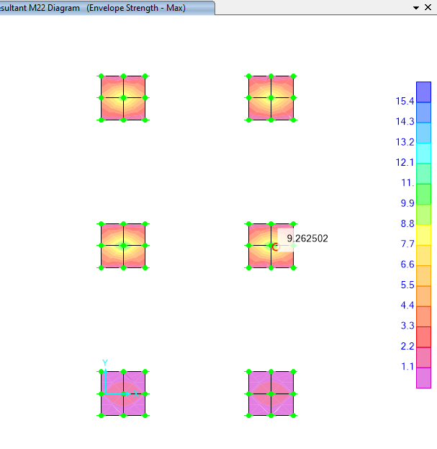

**D02**

**Figure 33- M22 result**

According to above figures max Moment is about 9.41 ton.m= 941000 kg-cm

$${Mu}_{1}=926200 kg.cm$$

$$b=100 cm$$

$$f_{c}=2300$$

$$f_{y}=4000$$

$$d=45cm$$

$$∅=0.9$$

$$M_{n}=\frac{M_{u}}{∅}=1029111.11 kg.cm$$

$$R_{n1}=\frac{M_{n1}}{b.d^{2}}=5.082$$

$$m_{1}=\frac{f_{y}}{0.85f_{c}}=15.686$$

$$ρ_{req}=\frac{1}{m_{1}}\left(1-\sqrt{1-\frac{{2m}_{1}R_{n1}}{f_{y}}}\right)=0.001283$$

$$A_{s(req)}=ρ_{req}.b.d$$

$$A_{s}=0.001283× 100×45 cm^{2}=5.775 cm^{2}$$

$used ∅16@ 200$

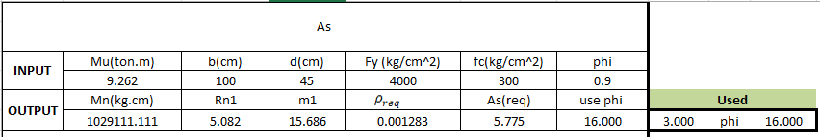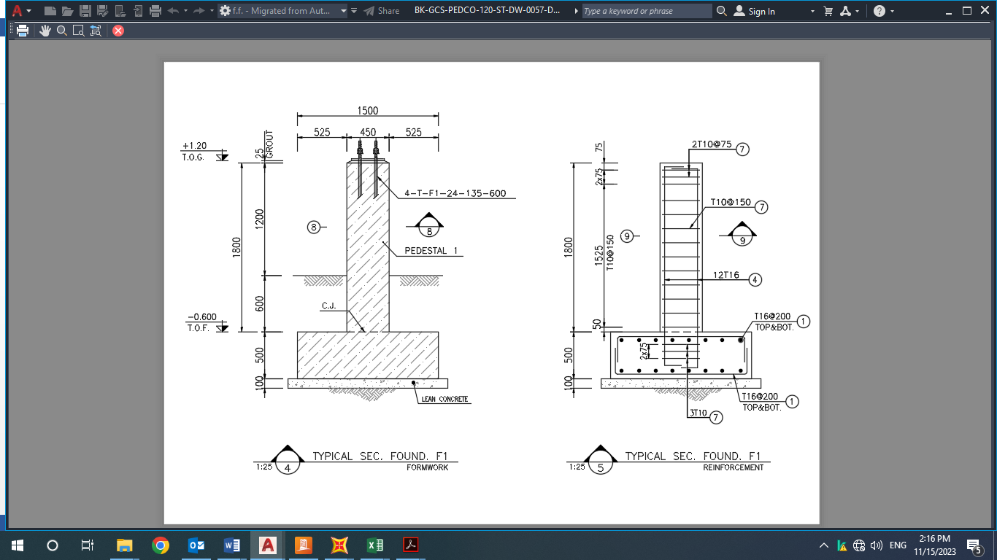

**Figure 34-reinforcement ($∅16@ 200)$**