|  |  |  |  |  |  |  |
| --- | --- | --- | --- | --- | --- | --- |
| **طرح نگهداشت و افزایش تولید 27 مخزن** | | | | | | |
| **MTO FOR TRAY/LADDER AND ACCESSORIES**  **نگهداشت و افزایش تولید میدان نفتی بینک** | | | | | | |
|  |  |  |  |  |  |  |
|  |  |  |  |  |  |  |
|  |  |  |  |  |  |  |
|  |  |  |  |  |  |  |
| D00 | Dec. 2023 | IFI | H.Shakiba | M.Fakharian | S.Faramarzpour |  |
| **Rev.** | **Date** | **Purpose of Issue/Status** | **Prepared by:** | **Checked by:** | **Approved by:** | **Client Approval** |
| **Class:3** | | **Client Doc. Number: F8Z-709076** | | | | |
| **Status:** | **IDC: Inter-Discipline Check**  **IFC: Issued For Comment**  **IFA: Issued For Approval**  **AFD: Approved For Design**  **AFC: Approved For Construction**  **AFP: Approved For Purchase**  **AFQ: Approved For Quotation**  **IFI: Issued For Information**  **AB-R: As-Built for CLIENT Review**  **AB-A: As-Built –Approved** | | | | | |

**REVISION RECORD SHEET**

|  |  |  |  |  |  |  |  |  |  |  |  |  |
| --- | --- | --- | --- | --- | --- | --- | --- | --- | --- | --- | --- | --- |
| **PAGE** | **D00** | **D01** | **D02** | **D03** | **D04** |  | **PAGE** | **D00** | **D01** | **D02** | **D03** | **D04** |
| **1** | X |  |  |  |  | **51** |  |  |  |  |  |
| **2** | X |  |  |  |  | **52** |  |  |  |  |  |
| **3** | X |  |  |  |  | **53** |  |  |  |  |  |
| **4** | X |  |  |  |  | **54** |  |  |  |  |  |
| **5** | X |  |  |  |  | **55** |  |  |  |  |  |
| **6** | X |  |  |  |  | **56** |  |  |  |  |  |
| **7** | X |  |  |  |  | **57** |  |  |  |  |  |
| **8** |  |  |  |  |  | **58** |  |  |  |  |  |
| **9** |  |  |  |  |  | **59** |  |  |  |  |  |
| **10** |  |  |  |  |  | **60** |  |  |  |  |  |
| **11** |  |  |  |  |  | **61** |  |  |  |  |  |
| **12** |  |  |  |  |  | **62** |  |  |  |  |  |
| **13** |  |  |  |  |  | **63** |  |  |  |  |  |
| **14** |  |  |  |  |  | **64** |  |  |  |  |  |
| **15** |  |  |  |  |  | **65** |  |  |  |  |  |
| **16** |  |  |  |  |  | **66** |  |  |  |  |  |
| **17** |  |  |  |  |  | **67** |  |  |  |  |  |
| **18** |  |  |  |  |  | **68** |  |  |  |  |  |
| **19** |  |  |  |  |  | **69** |  |  |  |  |  |
| **20** |  |  |  |  |  | **70** |  |  |  |  |  |
| **21** |  |  |  |  |  | **71** |  |  |  |  |  |
| **22** |  |  |  |  |  | **72** |  |  |  |  |  |
| **23** |  |  |  |  |  | **73** |  |  |  |  |  |
| **24** |  |  |  |  |  | **74** |  |  |  |  |  |
| **25** |  |  |  |  |  | **75** |  |  |  |  |  |
| **26** |  |  |  |  |  | **76** |  |  |  |  |  |
| **27** |  |  |  |  |  | **77** |  |  |  |  |  |
| **28** |  |  |  |  |  | **78** |  |  |  |  |  |
| **29** |  |  |  |  |  | **79** |  |  |  |  |  |
| **30** |  |  |  |  |  | **80** |  |  |  |  |  |
| **31** |  |  |  |  |  | **81** |  |  |  |  |  |
| **32** |  |  |  |  |  | **82** |  |  |  |  |  |
| **33** |  |  |  |  |  | **83** |  |  |  |  |  |
| **34** |  |  |  |  |  | **84** |  |  |  |  |  |
| **35** |  |  |  |  |  | **85** |  |  |  |  |  |
| **36** |  |  |  |  |  | **86** |  |  |  |  |  |
| **37** |  |  |  |  |  | **87** |  |  |  |  |  |
| **38** |  |  |  |  |  | **88** |  |  |  |  |  |
| **39** |  |  |  |  |  | **89** |  |  |  |  |  |
| **40** |  |  |  |  |  | **90** |  |  |  |  |  |
| **41** |  |  |  |  |  | **91** |  |  |  |  |  |
| **42** |  |  |  |  |  | **92** |  |  |  |  |  |
| **43** |  |  |  |  |  | **93** |  |  |  |  |  |
| **44** |  |  |  |  |  | **94** |  |  |  |  |  |
| **45** |  |  |  |  |  | **95** |  |  |  |  |  |
| **46** |  |  |  |  |  | **96** |  |  |  |  |  |
| **47** |  |  |  |  |  | **97** |  |  |  |  |  |
| **48** |  |  |  |  |  | **98** |  |  |  |  |  |
| **49** |  |  |  |  |  | **99** |  |  |  |  |  |
| **50** |  |  |  |  |  | **100** |  |  |  |  |  |

| **Cable Tray/Ladder Specification** | | | | |
| --- | --- | --- | --- | --- |
| Mild Steel Sheet, Hot Dip Galvanized Steel Material as per ASTM A 123, 4 Fold, Minimum Galvanizing Thickness 65 Micron | | | | |
| Standard Length of Tray/Ladder is 3000mm & Height is 100mm. | | | | |
| Cable Tray/Ladder Shall be Capable of Supporting Following Loads | | | | |
| 150 mm Width: 30 KG/Linear Meter Thickness: 2mm | | | | |
| 300 mm Width: 60 KG/Linear Meter Thickness: 2mm | | | | |
| 500 mm Width: 75 KG/Linear Meter Thickness: 2mm | | | | |
| 600 mm Width: 90 KG/Linear Meter Thickness: 2.5mm | | | | |
| 750 mm Width: 120 KG/Linear Meter Thickness: 2.5mm | | | | |
| 900 mm Width: 150 KG/Linear Meter Thickness: 2.5mm | | | | |
| **Item** | **Rev** | **Technical data** | **Unit** | **Quantity** |
| 1. **Cable Ladder & Accessories** | | | | |
|  | D00 | Cable Ladder Straight,12 Steps, 600Wx100Hx3000L | PCS | 70 |
|  | D00 | Cable Ladder 900 Horizontal Bend, 600w x 100h x Radius 600mm | PCS | 5 |
|  | D00 | Cable Ladder 900 Vertical Inside Bend, 600w x 100h x Radius 600mm | PCS | 5 |
|  | D00 | Cable Ladder 900 Vertical Outside Bend, 600w x 100h x Radius 600mm | PCS | 3 |
|  | D00 | Cable Ladder Tee 900, 600w x 100h x Radius 600mm | PCS | 5 |
|  | D00 | Cable Ladder Cross, 600w x 100h x Radius 600mm | PCS | 10 |
|  | D00 | Cable Ladder Vertical Adjustable Riser, 600w x 100h | PCS | 6 |
|  | D00 | Cable Ladder Reducer Left Hand Side, 600w x 100h | PCS | 8 |
|  | D00 | Cable Ladder Reducer Right Hand Side, 600w x 100h | PCS | 8 |
|  | D00 | Side L Joint Type, 200l x 100h mm, with Mushroom Bolt, Nuts & Flat/Spring Washer | PCS | 250 |
|  | D00 | Holding Clamp Ladder with Hex Bolt, Nuts & Flat/Spring Washer | PCS | 200 |
|  | D00 | Double C Channel Support, 2700l, Thickness 2.5mm, 80 x 50 x50, With Base Plate Welded to C Channel, with 4 No, M12 x 60 with Bolt & Nut & Washer (Expansion) | PCS | 300 |
|  | D00 | Base Plate, with 4 No, M12 x 60 with Bolt & Nut & Washer (Self-Drilling Expansion) | PCS | 100 |
|  | D00 | Bracket Suitable for item 1.14, Thickness 2.5mm, 630l x 150h | PCS | 250 |
| 1. **Cable Tray & Accessories** | | | | |
|  | D00 | Perforated Tray Straight with Cover, 500Wx100Hx3000L | PCS | 20 |
|  | D00 | Perforated Tray 900 Horizontal Bend with Cover, 600w x 100h x Radius 600mm | PCS | 5 |
|  | D00 | Perforated Tray 900 Vertical Inside Bend with Cover, 600w x 100h x Radius 600mm | PCS | 5 |
|  | D00 | Perforated Tray 900 Vertical Outside Bend with Cover, 600w x 100h x Radius 600mm | PCS | 5 |
|  | D00 | Perforated Tray Tee 900, with Cover, 600w x 100h x Radius 600mm | PCS | 5 |
|  | D00 | Perforated Tray Cross, with Cover 600w x 100h x Radius 600mm | PCS | 10 |
|  | D00 | Holding Clamp Tray with Bolt, Nuts & Flat/Spring Washer | PCS | 500 |
|  | D00 | Bracket Suitable for item 1.14, Thickness 2.5mm, 530l x 150h | PCS | 250 |

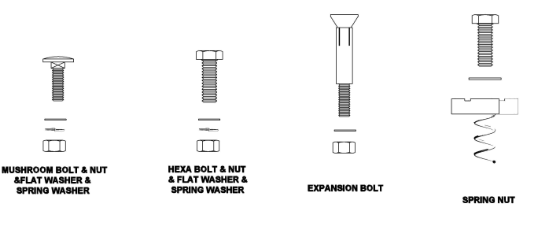

Bolt & Nut, Flat Washer & Spring Washer

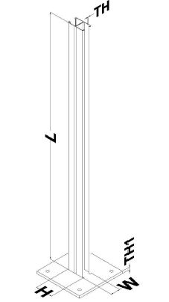

Double C Channel with

Base Plate

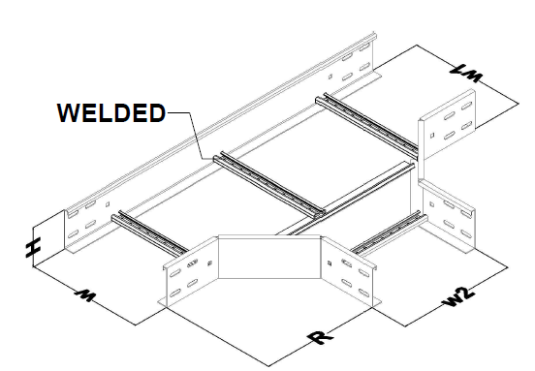

Cable Ladder Tee

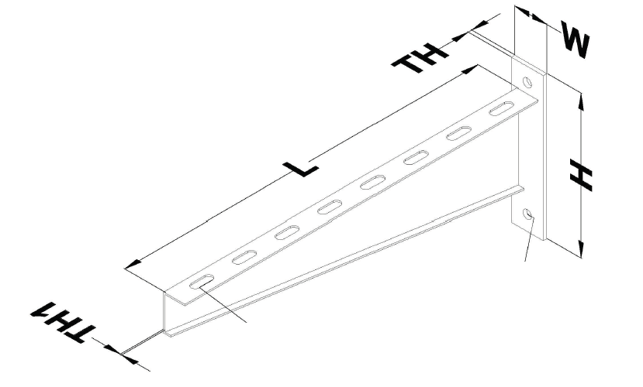

Multi Bracket

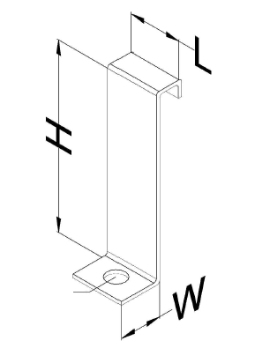

Holding Clamp Tray

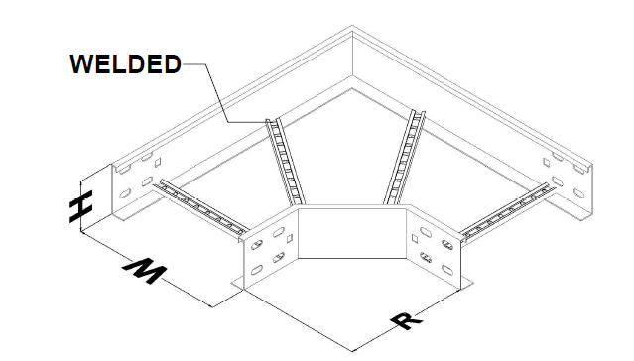

Ladder Horizontal Bend

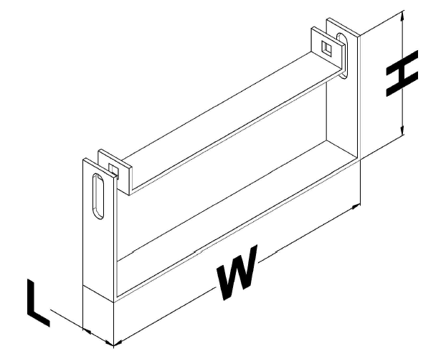

Cover Tray Clamp

s

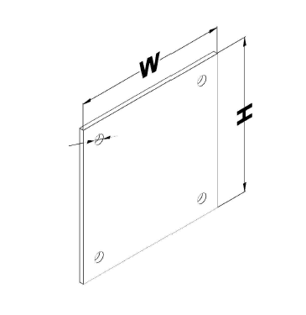

Base Plate

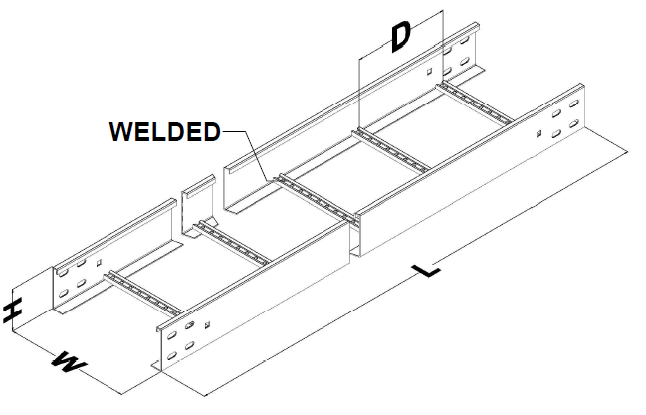

Cable Ladder

Cable Ladder Cross

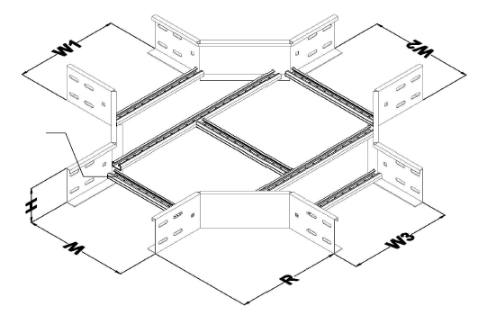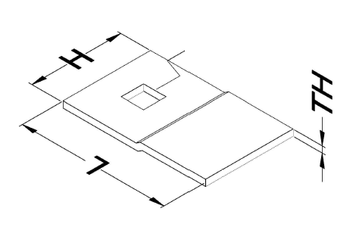

Holding Clamp Ladder

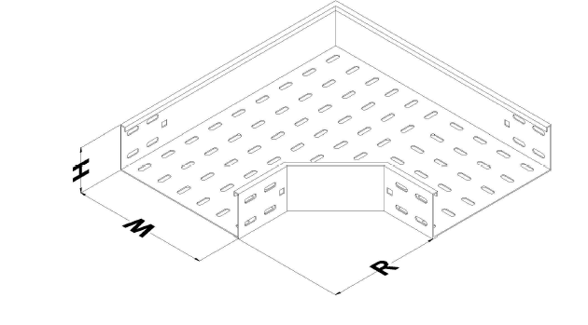

Cable Tray Horizontal Bend

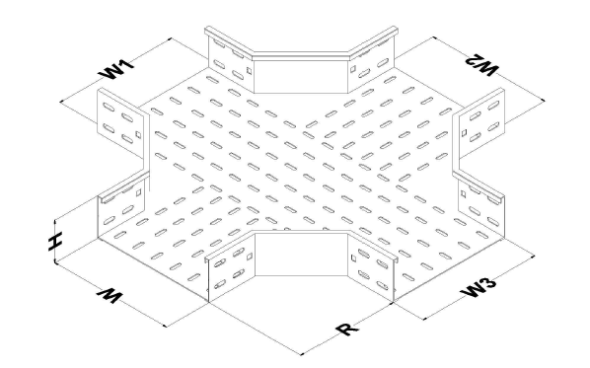

Cable Tray Cross

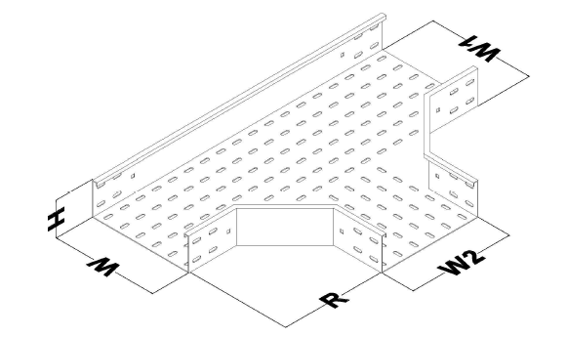

Cable Tray Horizontal Tee

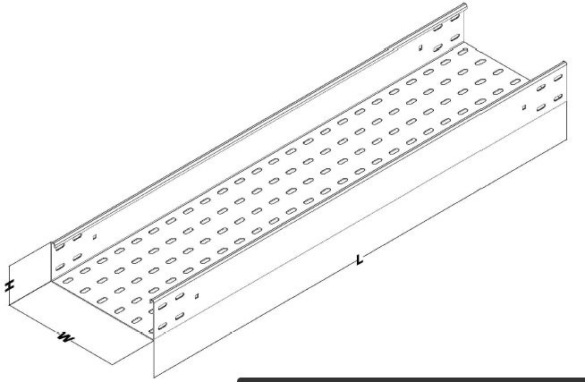

Tray

Notes:

1. This document shall be Based on below references:

Document Title: “Electrical Cable Route & Section Layout for Building & Shelter”

Document No.: “BK-GCS-PEDCO-120-EL-PY-0006”

Document Title: “Area Electrical Cable Route & Section Layout”

Document No.: “BK-GCS-PEDCO-120-EL-PY-0005”