|  |  |  |  |  |  |  |  |
| --- | --- | --- | --- | --- | --- | --- | --- |
| **طرح نگهداشت و افزایش تولید 27 مخزن** | | | | | | | |
| **CALCULATION NOTE FOR CCTV CONTROL ROOM- BINAK DU**  **نگهداشت و افزایش تولید میدان نفتی بینک** | | | | | | | |
|  | |  |  |  |  |  |  |
|  | |  |  |  |  |  |  |
|  | |  |  |  |  |  |  |
| D01 | | JAN. 2024 | IFA | R.Berlouie | M.Fakharian | S.Faramarzpour |  |
| D00 | | SEP. 2023 | IFC | R.Berlouie | M.Fakharian | S.Faramarzpour |  |
| **Rev.** | | **Date** | **Purpose of Issue/Status** | **Prepared by:** | **Checked by:** | **Approved by:** | **CLIENT Approval** |
| **Class:2** | | | **COMPANY Doc. Number:** **F0Z-709400** | | | | |
| **Status:** | | **IDC: Inter-Discipline Check**  **IFC: Issued For Comment**  **IFA: Issued For Approval**  **AFD: Approved For Design**  **AFC: Approved For Construction**  **AFP: Approved For Purchase**  **AFQ:** Approved For Quotation  **IFI: Issued For Information**  **AB-R: As-Built for CLIENT Review**  **AB-A: As-Built –Approved** | | | | | |

**REVISION RECORD SHEET**

|  |  |  |  |  |  |  |  |  |  |  |  |  |
| --- | --- | --- | --- | --- | --- | --- | --- | --- | --- | --- | --- | --- |
| **PAGE** | **D00** | **D01** | **D02** | **D03** | **D04** |  | **PAGE** | **D00** | **D01** | **D02** | **D03** | **D04** |
| **1** | X | X |  |  |  | **66** |  |  |  |  |  |
| **2** | X | X |  |  |  | **67** |  |  |  |  |  |
| **3** | X |  |  |  |  | **68** |  |  |  |  |  |
| **4** | X |  |  |  |  | **69** |  |  |  |  |  |
| **5** | X |  |  |  |  | **70** |  |  |  |  |  |
| **6** | X |  |  |  |  | **71** |  |  |  |  |  |
| **7** | X |  |  |  |  | **72** |  |  |  |  |  |
| **8** | X |  |  |  |  | **73** |  |  |  |  |  |
| **9** | X |  |  |  |  | **74** |  |  |  |  |  |
| **10** | X |  |  |  |  | **75** |  |  |  |  |  |
| **11** | X |  |  |  |  | **76** |  |  |  |  |  |
| **12** | X |  |  |  |  | **77** |  |  |  |  |  |
| **13** | X |  |  |  |  | **78** |  |  |  |  |  |
| **14** | X |  |  |  |  | **79** |  |  |  |  |  |
| **15** | X | X |  |  |  | **80** |  |  |  |  |  |
| **16** | X |  |  |  |  | **81** |  |  |  |  |  |
| **17** | X |  |  |  |  | **82** |  |  |  |  |  |
| **18** | X |  |  |  |  | **83** |  |  |  |  |  |
| **19** | X |  |  |  |  | **84** |  |  |  |  |  |
| **20** | X |  |  |  |  | **85** |  |  |  |  |  |
| **21** | X |  |  |  |  | **86** |  |  |  |  |  |
| **22** | X |  |  |  |  | **87** |  |  |  |  |  |
| **23** | X |  |  |  |  | **88** |  |  |  |  |  |
| **24** | X |  |  |  |  | **89** |  |  |  |  |  |
| **25** | X |  |  |  |  | **90** |  |  |  |  |  |
| **26** | X |  |  |  |  | **91** |  |  |  |  |  |
| **27** | X |  |  |  |  | **92** |  |  |  |  |  |
| **28** | X |  |  |  |  | **93** |  |  |  |  |  |
| **29** | X |  |  |  |  | **94** |  |  |  |  |  |
| **30** |  |  |  |  |  | **95** |  |  |  |  |  |
| **31** |  |  |  |  |  | **96** |  |  |  |  |  |
| **32** |  |  |  |  |  | **97** |  |  |  |  |  |
| **33** |  |  |  |  |  | **98** |  |  |  |  |  |
| **34** |  |  |  |  |  | **99** |  |  |  |  |  |
| **35** |  |  |  |  |  | **100** |  |  |  |  |  |
| **36** |  |  |  |  |  | **101** |  |  |  |  |  |
| **37** |  |  |  |  |  | **102** |  |  |  |  |  |
| **38** |  |  |  |  |  | **103** |  |  |  |  |  |
| **39** |  |  |  |  |  | **104** |  |  |  |  |  |
| **40** |  |  |  |  |  | **105** |  |  |  |  |  |
| **41** |  |  |  |  |  | **106** |  |  |  |  |  |
| **42** |  |  |  |  |  | **107** |  |  |  |  |  |
| **43** |  |  |  |  |  | **108** |  |  |  |  |  |
| **44** |  |  |  |  |  | **109** |  |  |  |  |  |
| **45** |  |  |  |  |  | **110** |  |  |  |  |  |
| **46** |  |  |  |  |  | **111** |  |  |  |  |  |
| **47** |  |  |  |  |  | **112** |  |  |  |  |  |
| **48** |  |  |  |  |  | **113** |  |  |  |  |  |
| **49** |  |  |  |  |  | **114** |  |  |  |  |  |
| **50** |  |  |  |  |  | **115** |  |  |  |  |  |
| **51** |  |  |  |  |  | **116** |  |  |  |  |  |
| **52** |  |  |  |  |  | **117** |  |  |  |  |  |
| **53** |  |  |  |  |  | **118** |  |  |  |  |  |
| **54** |  |  |  |  |  | **119** |  |  |  |  |  |
| **55** |  |  |  |  |  | **120** |  |  |  |  |  |
| **56** |  |  |  |  |  | **121** |  |  |  |  |  |
| **57** |  |  |  |  |  | **122** |  |  |  |  |  |
| **58** |  |  |  |  |  | **123** |  |  |  |  |  |
| **59** |  |  |  |  |  | **124** |  |  |  |  |  |
| **60** |  |  |  |  |  | **125** |  |  |  |  |  |
| **61** |  |  |  |  |  | **126** |  |  |  |  |  |
| **62** |  |  |  |  |  | **127** |  |  |  |  |  |
| **63** |  |  |  |  |  | **128** |  |  |  |  |  |
| **64** |  |  |  |  |  | **129** |  |  |  |  |  |
| **65** |  |  |  |  |  | **130** |  |  |  |  |  |

**CONTENTS**

1.0 INTRODUCTION 5

2.0 Scope 5

3.0 NORMATIVE REFERENCE 5

**3.1** **Local Codes and Standards** 5

**3.2** **International Codes and Standards** 5

**3.3** **The Project Documents** 6

4.0 Material properties 6

5.0 Computer software 6

6.0 DESIGN INFORMATION 7

**6.1** **Architectural Plans** 7

7.0 material properties 8

**7.1** **Reinforced Concrete** 8

**7.2** **Stiffness Modification** 9

8.0 design loads 9

**8.1** **General** 9

9.0 Dead Load 9

**9.1** **For CCTV Control Room** 9

10.0 Live Load 12

11.0 Snow Load 13

**11.1** **For CCTV CONTROL ROOM** 13

12.0 Seismic Load 13

**12.1** **Horizontal Seismic Load** 13

**12.2** **Vertical seismic load** 15

13.0 Redundancy Factor $ρ$ 15

14.0 loading table 16

15.0 Load combinations 17

16.0 STRUCTURE ANALYSIS AND DESIGN 20

17.0 Structural Design Results 21

18.0 DRIFT CONTROL 22

19.0 Joist shear capacity ratio CONTROL 22

20.0 Strong Column-Weak Beam Requirements in SPECIAL CONCRETE Moment Frame 23

21.0 FOUNDATION DESIGN AND RESULTS 24

**21.1** **Foundation Model** 24

**21.2** **Soil Characteristic** 24

**21.3** **Loads** 26

**21.4** **Settlement Control** 27

**21.5** **Soil pressure control** 28

**21.6** **Punching Shear Control** 29

**21.7** **Foundation Design** 29

1. **INTRODUCTION**

Binak oilfield in Bushehr province is a part of the southern oilfields of Iran, is located 20 km northwest of Genaveh city.

With the aim of increasing production of oil from Binak oilfield, an EPC/EPD Project has been defined by NIOC/NISOC and awarded to Petro Iran Development Company (PEDCO). Also PEDCO (as General Contractor) has assigned the EPC-packages of the Project to "Hirgan Energy - Design and Inspection" JV.

1. **Scope**

This report covers designing of structure & foundation calculations of the “CCTV Control Room- Binak DU”. The structure calculation is performed by “ETABS” & calculation of foundation is performed by “SAFE” software’s.

1. **NORMATIVE REFERENCE**
   1. **Local Codes and Standards**

* INBC Part 6 “Iranian National Building Code
* INBC Part 7 “Iranian National Building Code
* INBC Part 9 “Iranian National Building Code
* INBC Part 10 “Iranian National Building Code
* Iranian Seismic Design Code for Petroleum Facilities(3rd edition)
  1. **International Codes and Standards**
* ASCE 7-10 “Minimum Design Loads and Associated Criteria for Buildings and Other Structures-American Society of Civil Engineers”.
* ACI 318. “Building Code Requirements for Reinforced Concrete”, American Concrete Institute.
* AISC 358 “Prequalified Connections for Special and Intermediate Steel Moment Frames for Seismic Applications.” American Institute of Steel Construction, Inc.
* AISC 360 - “Specification for Structural Steel Buildings”. American Institute of Steel Construction, Inc.
  1. **The Project Documents**
* BK-GNRAL-PEDCO-000-ST-SP-0001 SPECIFICATION FOR CONCRETE WORK
* BK-GNRAL-PEDCO-000-ST-DC-0001 Structural Design Criteria
* BK-GNRAL-PEDCO-000-CV-SP-0004 Specification For Earth Work
* BK-GCS-PEDCO-120-GT-RT-0001 Geotechnical Investigation Report for Compressor Station
* BK-GCS-PEDCO-120-AR-DW-0009 Architectural Drawing For CCTV Control Room- Binak DU

1. **Material properties**

Material properties are delivered in the following table.

|  |  |
| --- | --- |
| Material properties | |
| Structure and Foundation concrete | F’c=300kg/cm²(28 days cylindrical sample) |
| Long. Reinforcement | Fy=4000 kg/cm² (AIII) |
| Trans. Reinforcement | Fy=4000 kg/cm² (AIII) |

1. **Computer software**

Computer’s Software, which is used in structure and foundation analysis and design, are defined in the following table.

|  |  |
| --- | --- |
| Computer software | |
| analysis and design of structure | ETABS 16.2.1 |
| analysis and design of foundation | SAFE 16.0.2 |

1. **DESIGN INFORMATION**
   1. **Architectural Plans**

**Figure 2: Plan of CCTV control room**



**Figure 3: Elevation 1**



**Figure 4: Elevation 2**

1. **material properties**
   1. **Reinforced Concrete**

Concrete shall generally conform to the specification for Concrete Work, Document No:

BK-GNRAL-PEDCO-000-ST-SP-0001. The following properties of concrete are used.

Lean concrete: f’c =150 kg/cm2

Cast in place concrete: f’c =300 kg/cm2

Where f'c is the minimum compressive characteristic strength of a cylinder specimen at 28 days.

Young Modulus of concrete: kg/cm2 =261540 kg/cm2

Poisson's Ratio: ν = 0.2

Unit weight of reinforced concrete: 2500 kg/m3

Reinforcing Steel: fy = 4000 kg/cm3 (Minimum yield stress)

* 1. **Stiffness Modification**

For analysis of concrete structure, the following modifications for flexural stiffness of elements are considered.

Columns………………………………..0.7Ig

Beams………………………………….0.35Ig

1. **design loads**
   1. **General**

Structural elements stability and stress checking have been performed considering the following load conditions.

* Dead Load
* Live Load
* Seismic Load
* Snow Load

1. **Dead Load**
   1. **For CCTV Control Room**

Dead Load is considered as the weight of materials forming a permanent part of the structure plant. The weight of materials of construction incorporated into the building, including but not limited to walls, floors, roofs, ceilings, stairways, built-in partitions, finishes, cladding and other similarly incorporated architectural and structural items, and the weight of fixed service equipment, such as plumbing stacks and risers, electrical feeders, heating, ventilating and air-conditioning systems.

Specific weight of materials which will be used is based on Iranian National Building Code, Part 6, where applicable. Other weights are in accordance with the specifications and/or drawings of vendors and manufacturers.

As it mentioned above the self-weight of structural elements (introduced Dead Load in software) is automatically considered by ETABS program with the specific weights below:

Reinforced Concrete: 2500 kg/m³

Structural Steel and Bars: 7850 kg/m³

Here is the calculation of design dead load for floors and walls.

$dead load for parapet wall( for 120cm height) :$

(Pressed brick = 20cm $×$ 1700 = 340→340 $×1.2$ = 408 kg/m) + (Travertine stone= 2500 $×$ 2cm = 50→50 $×$ 1.2 = 60 kg/m) + (mortar = 1cm $×$ 2100 = 21 → 21 $×$ 1.2 = 25.2 kg/m) + (Terrazzo tile (30*30*2.5)= 2500 $×$ 2cm = 50→50 $×$ 0.3 = 15 kg/m) + (mortar = 1cm $×$ 2100 = 21 → 21 $×$ 0.3 = 6.3 kg/m) + (cement = 3cm $×2100$ = 63→63 $×$ 1 = 63 kg/m) + (Waterproofing (Isolation or Similar = 15 kg/m² $×$ 30cm =4.5 kg/m) → totally ≈ 585 kg/m

* $dead load for wall (for supper dead load(wall)$) :

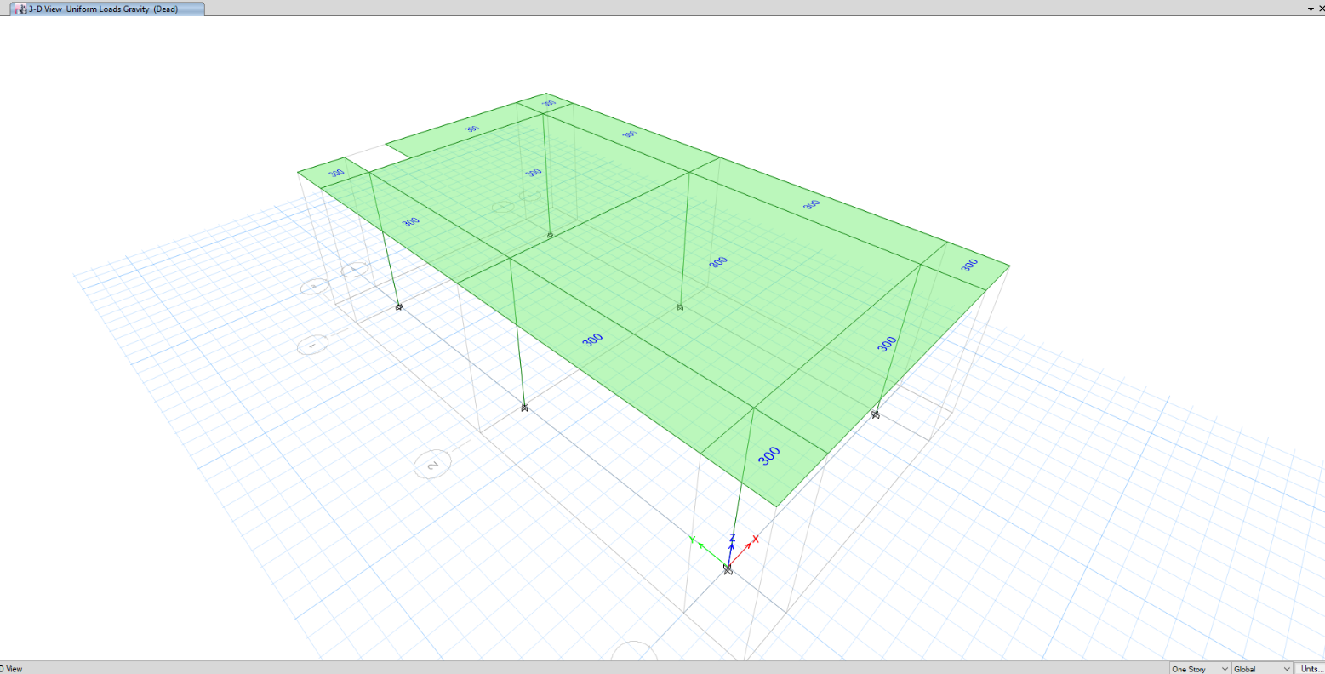(Face Brick = 5cm $×$ 1700 = 85) + (Pressed brick = 20cm $×$ 1700 = 340) + (plaster and soil mortar = 3cm $×$ 1600 = 48) → totally ≈ 475 kg/m²



$dead load for roof :$

$\left(mosaic=2.5cm × 2250=56.5\right)+\left(mortar=2.5cm × 2100=52.5\right)++( pumice=9cm × 600=54$) + (clay block = 8 $×$ 10 = 80) + (facilities = 20) + (waterproofing = 15) → totally ≈ 300 kg/m²

**Figure 5: Dead load on roof**

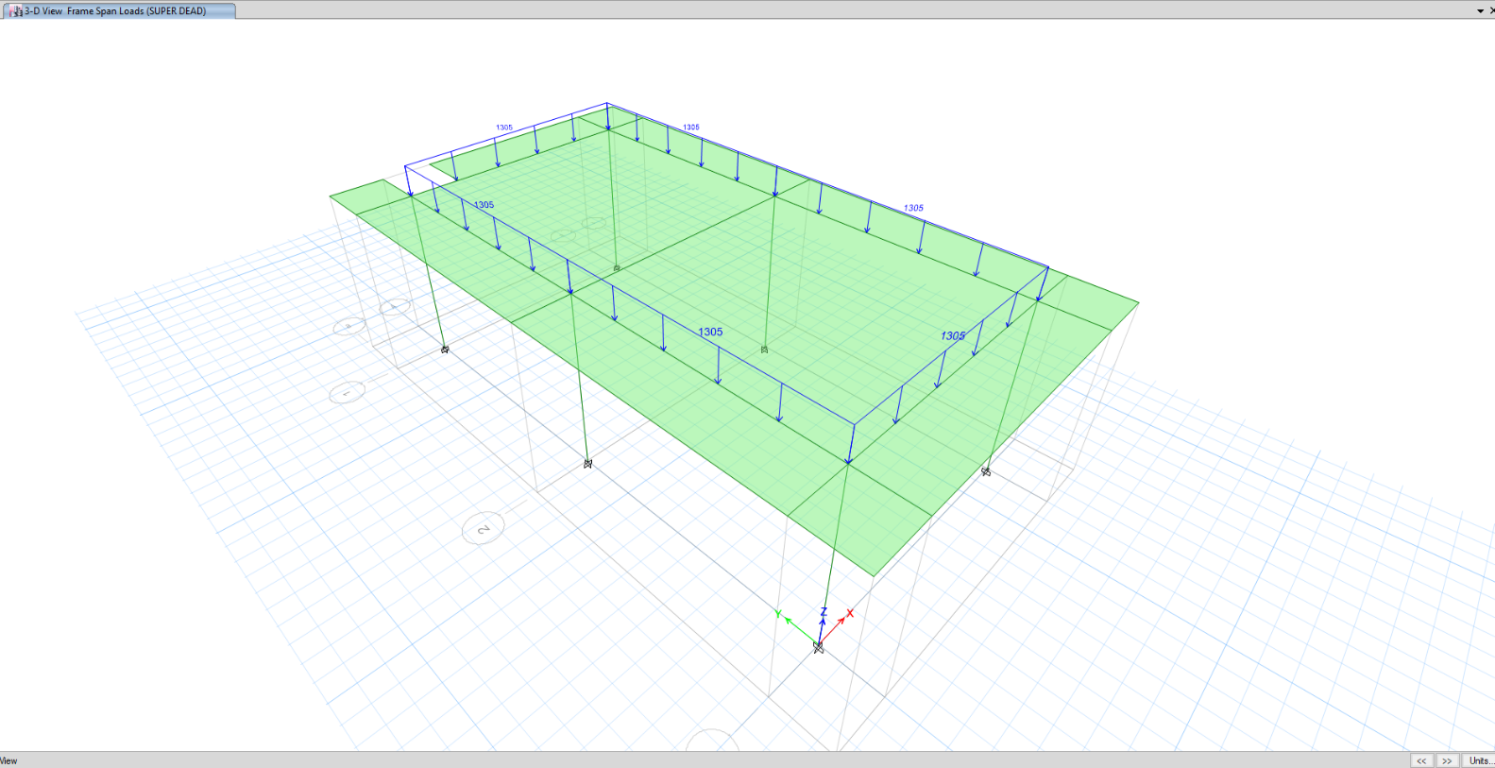**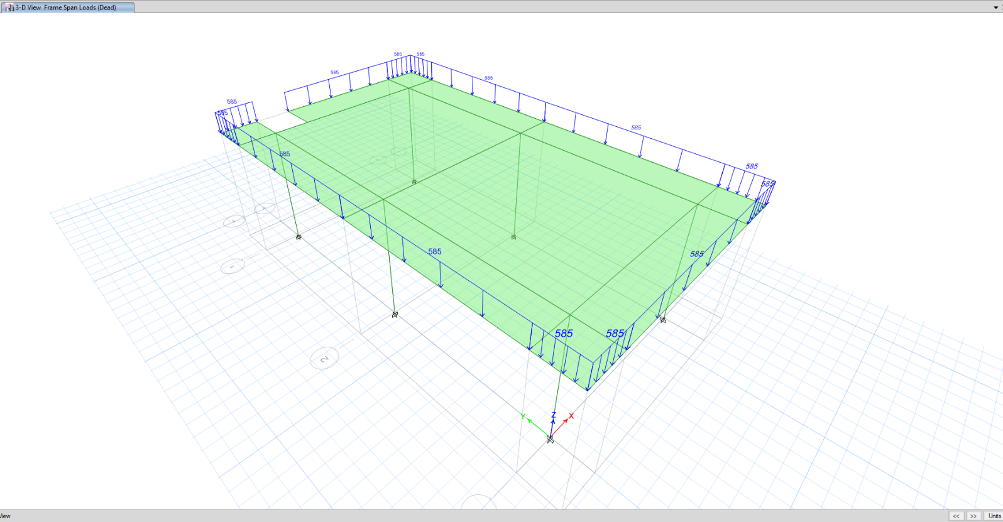Figure 6: Parapet dead load**

**Figure 7: Dead load for wall**

1. **Live Load**

Live Load is defined as the weight of all movable loads, including partition walls, personnel, tools, miscellaneous equipment and temporarily stored materials.

Generally where applicable, the live loads shall be in accordance with Iranian National Building Code, Part 6. The Live Loads is generally considered as uniformly distributed over the horizontal projection of the loaded areas, except for the loads with a concentrated nature.

The live load has been considered according to the following table.

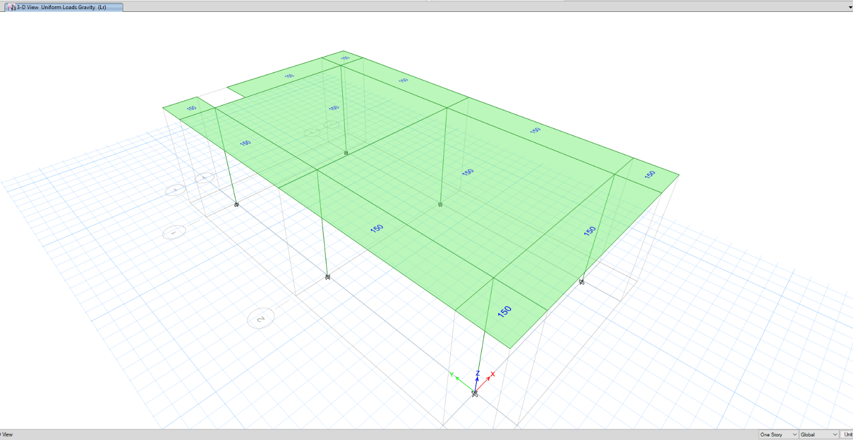**Table 1- Live Load**

|  |  |  |
| --- | --- | --- |
| NO. | Level | kg/m2 |
| 1 | Roof | 150 |

**Figure 7: Live load on roof**

1. **Snow Load**
   1. **For CCTV Control Room**

Snow load of this structure is calculated in accordance with Iranian National Building Code No.6 Latest edition. Parameters which are used in calculation of snow force is presented in below:

Pr=Is.Cn.Ch.Cs.Ps Ps=25 kg/m2

Is=1, Cn= 1, Ch= 1, Cs= 1 → Pr=Ps = 25 kg/m2

**Figure 8: Snow load on roof**

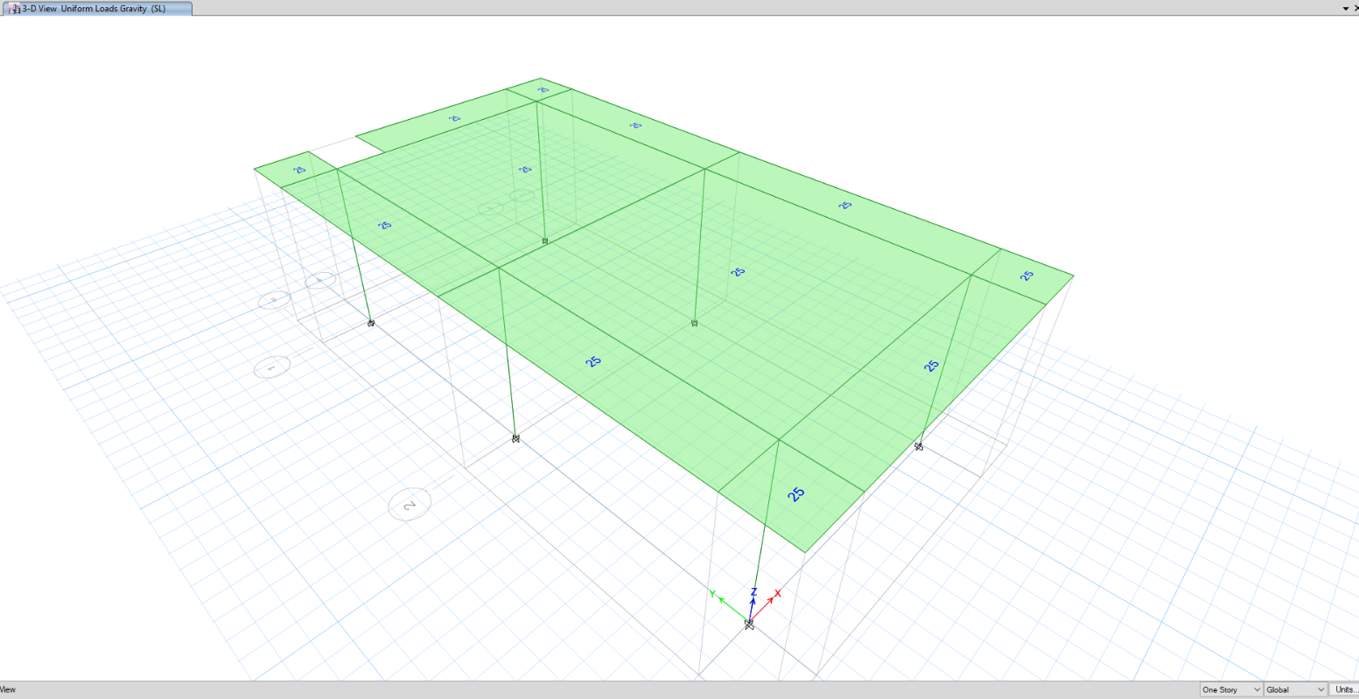

1. **Seismic Load**
   1. **Horizontal Seismic Load**

According to Iranian Seismic Design Code for Petroleum Facilities (Pub.038-3rd edition) the structure shall be designed for earthquake load in two orthogonal directions.

Base level is defined as the level below which the structure does not move relative to the ground during an earthquake.

Basic parameters which are used in calculation of earthquake forces are presented below.

Following formula is used for calculations according to Iranian Seismic Design Code for Petroleum Facilities (Pub.038-3rd edition)

$$V_{u}=\frac{S_{a}}{{R_{u}}/I}W$$

In which:

$V_{u}$: Basic Shear

Sa: Mapped Spectral Response Acceleration Parameter (𝑔)

I: Importance Factor of Structure

Ru: Structural System Factor

W= Effective Seismic Weight of the structure, including dead loads and other loads, calculated from base level.

**Table 6- B Table 6- Basic Parameters Used for Earthquake Loads**

|  |  |
| --- | --- |
| Height of the structure from the base level (m) | 4.35 |
| Importance factor, I | 1.25 |
| Structural System | Special Moment Frame at Both Direction |
| Soil type | II |
| Ru | 8 |
| $C_{t}$ (Based on table (4-6) Pub.038) | 0.047 |
| X (Based on table (4-6) Pub.038) | 0.9 |
| $$T_{x\&Y (calculation) }=C_{t}.H^{x}$$ | 0.176 |
| Based on part (4-8-3) Pub.038 : $T_{x\&Y (calculation) }$ | = 0.176*1.4 = 0.247 |
| $T_{y}$ (analysis) – mode 1 | 0.59 |
| $T_{x}$ (analysis) – mode 2 | 0.58 |
| $$T_{x \left(select for design\right)}$$ | 0.247 |
| $$T_{Y \left(select for design\right)}$$ | 0.247 |
| $${Sa}_{x}$$ | 0.75 |
| ${Sa}_{y}$ | 0.75 |
| $$C_{min}=0.044S_{DS}I$$ | 0.04125 |
| $$C_{x}=\frac{{S_{a}}_{x}}{{R_{u}}/I}$$ | 0.136 |
|  | 0.136 |

**Capture**

**D01**

* 1. **Vertical Seismic Load**

Ev: Vertical seismic load applied at model according to section 2-2-3-2 (code 038)

$${ E}_{v}=αS_{DS}D=0.2*0.75D=0.15D$$

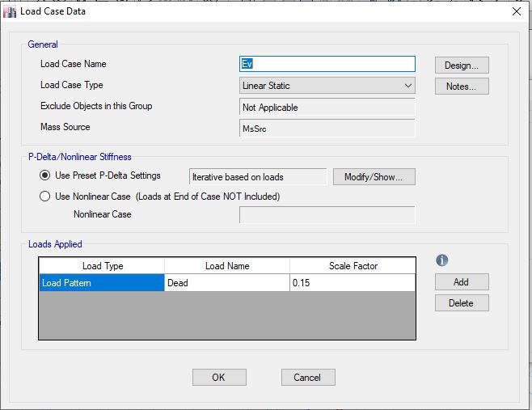

1. **Redundancy Factor $ρ$**

According to Iranian Seismic Design Code for Petroleum Facilities (Pub.038-3rd edition Paragraph 4-6) - $ρ$ =1.0

1. **loading table**

Loading for structure and foundation for CCTV control room is defined as below table.

|  |  |  |  |  |  |  |
| --- | --- | --- | --- | --- | --- | --- |
| **TABLE** | | | | | | |
| **Load Pat** | **Design Type** | **Self Wt Mult** | **Auto Load** | **Not Base Pat** | **Not Ratio** | **Not Dir.** |
| DL | Dead | 1 |  |  |  |  |
| Lr | Roof Live | 0 |  |  |  |  |
| EX | Quake | 0 | USER COEFF |  |  |  |
| EY | Quake | 0 | USER COEFF |  |  |  |
| SL | Snow | 0 |  |  |  |  |
| SUPERDEAD | Dead | 0 |  |  |  |  |
| T | Temperature | 0 |  |  |  |  |
| Ev | Quake | 0 | None |  |  |  |
| NotionalX(DL) | Notional | 0 |  | DL | 0.002 | Global X |
| NotionalY(DL) | Notional | 0 |  | DL | 0.002 | Global Y |
| NotionalX(Lr) | Notional | 0 |  | Lr | 0.002 | Global X |
| NotionalY(Lr) | Notional | 0 |  | Lr | 0.002 | Global Y |
| NotionalX (SUPERDEAD) | Notional | 0 |  | SUPERDEAD | 0.002 | Global X |
| NotionalY (SUPERDEAD) | Notional | 0 |  | SUPERDEAD | 0.002 | Global Y |
| Soil | Other | 0 |  |  |  |  |

Notional loads must be added with the same coefficient in all combinations of loads that have gravity loads. Although this type is not necessary for concrete building, it has been considered.

1. **Load combinations**

For foundations, structures and members of structures, according to structural design criteria & Iranian National Building Code Part 6, the following load combinations have been considered:

1) 1.4D

2) 1.2D + 1.6L + 0.5 (Lr or S)

3) 1.2D + 1.6 (Lr or S) + (L or 0.5(1.6W))

4) 1.2D +1.6 W + L + 0.5 (Lr or S)

5) 1.2D+(Eh + Ev)+ L + 0.2S

6) 0.9D + 1.6W

7) 0.9D + (Eh – Ev)

Load listed herein shall be considered to act in the following combinations; whichever produces the most unfavourable effect considering soil reactions.

**Allowable Stress Design:**

| **Category** | | **Load Combination** |
| --- | --- | --- |
| Category A | Operation Without Wind | 1.0(DL+ DLempty + LLop) |
| 1.0(DL+ DLempty + LLop + LL + TL ± TLst ± FR) |
| 1.0(DL+ DLempty + LLop + TL ± TLst ± FR) + 0.75LL + 0.75S |
| Operation With Wind | 1.0(DL+ DLempty + LLop + TL ± FR) ± WL |
| 1.0(DL+ DLempty + LLop + TL ± FR) + 0.75LL ± 0.75WL |
| 1.0(DL+ DLempty + LLop + TL ± FR) + 0.75LL ± 0.75WL + 0.75S |
| 0.6(DL+ DLempty + LLop+TL + FR) ± WL |
| Category B | Test | 1.0(DL+ DLempty + Test) ± 0.25WL |
| 1.0(DL+ DLempty + Test) + 0.75LL ± 0.25WL + 0.75S |
| 0.6(DL+ DLempty + Test) ± 0.25WL |
| Category C | Erection | 1.0(DL+ DLempty + ER ± WL) |
| 1.0(DL+ DLempty + ER) + 0.75LL ± 0.75WL |
| 0.6(DL+ DLempty + ER) ± WL |
| Category D | Earthquake | 1.0(DL+ DLempty + LLop + TL) ± 0.7EQ |
| 1.0(DL+ DLempty + LLop + TL) ± 0.525EQ + 0.75LL + 0.75S |
| 0.6(DL+ DLempty + LLop+ TL) ± 0.7EQ |
| Category E | Maintenance | 1.0(DL+ DLempty + ML) |
| 1.0(DL+ DLempty+ ML) + 0.75LL ± 0.25WL |
| 0.6(DL+ DLempty+ ML) ± 0.25WL |

**Strength Design:**

| Category | | Load Combination |
| --- | --- | --- |
| Category A | Operation Without Wind | 1.4(DL+ DLempty + LLop) |
| 1.2(DL+ DLempty + LLop ± FR + TL ± TLst) +1.6LL |
| 1.2(DL+ DLempty + LLop ± FR + TL ± TLst) +1.6LL + 0.5S |
| Operation With Wind | 1.2(DL+ DLempty + LLop ± FR + TL) + 1.0LL ± 1.6WL + 0.5S |
| 1.2(DL+ DLempty + LLop ± FR + TL) ± 0.8WL + 1.6S |
| 0.9(DL+ DLempty + LLop ± FR + TL) ± 1.6WL |
| Category B | Test | 1.2(DL+ DLempty + Test ) + 1.0LL ± 1.6(0.25WL) + 0.5S |
| 1.2(DL+ DLempty + Test ) + 1.6LL + 0.5S |
| 0.9(DL+ DLempty + Test ) ± 1.6(0.25WL) |
| Category C | Erection | 1.2(DL+ DLempty + ER) + 1.6LL |
| 1.2(DL+ DLempty + ER) + 1.0LL ± 0.8WL |
| 0.9(DL+ DLempty + ER) ± 1.6WL |
| Category D | Earthquake | 1.2( DL+ DLempty + LLop + TL) + 1.0LL ± 1.0EQ + 0.2S |
| 0.9( DL+ DLempty + LLop+ TL) ± 1.0EQ |
| Category E | Maintenance | 1.2(DL+ DLempty + ML ) + 1.0LL ± 1.6(0.25WL) |
| 1.2(DL+ DLempty + ML ) + 1.6(LL) |
| 0.9(DL+ DLempty+ ML) ± 1.6(0.25WL) |

1. **STRUCTURE ANALYSIS AND DESIGN**

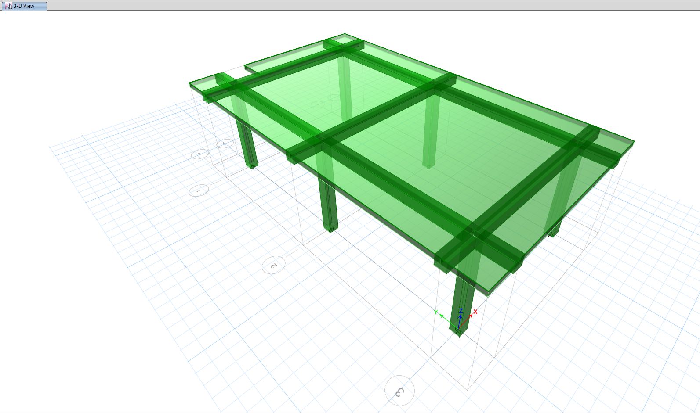The steel structure is checked in accordance with LRFD method. Frame analysis and structural checks are based on the 3D model that covers all the Load Combinations.

**Figure 9: 3D model of ETABS**

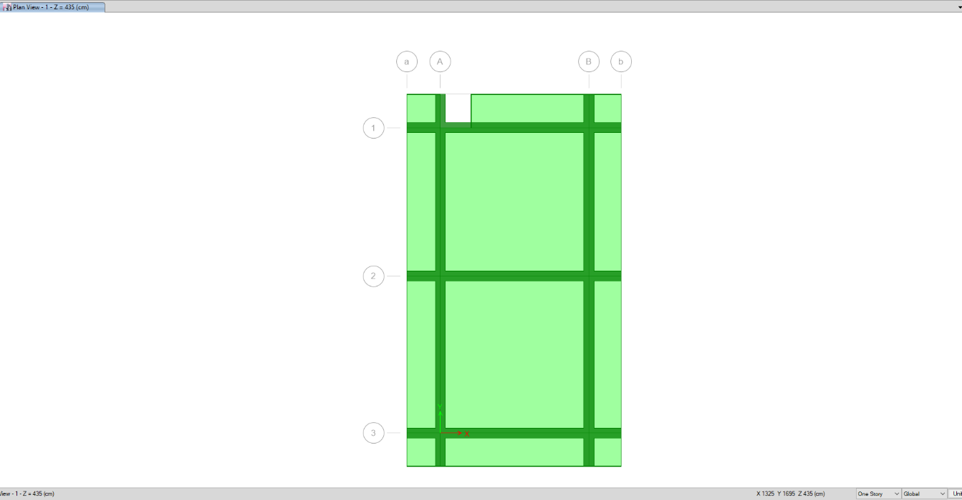

**Figure 10: Plan View**

1. **Structural Design Results**

The design of these elements is done by software facilities according to Code ACI-318-14. Summary of the results for columns and beams design is shown in the following figures.

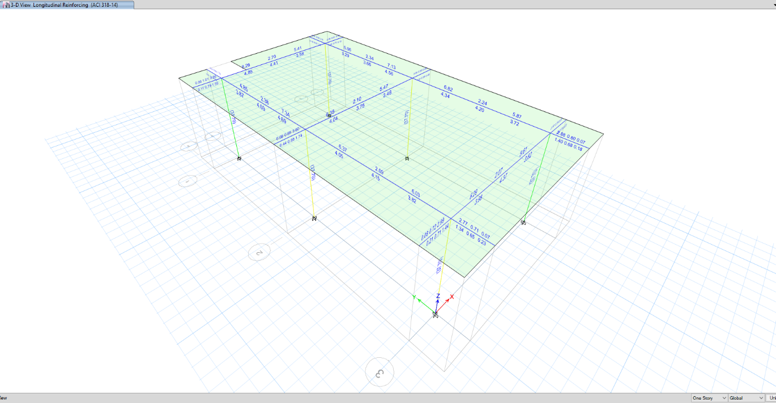

**Figure 11: Ratio Check**

For all elements D/C ratio shall be ≤ 1, according to above output all elements are ok.

1. **DRIFT CONTROL**

According to “Iranian Seismic Design Code for Petroleum Facilities (Pub.038-3rd edition)” Table 4-8, drift shall not exceed 0.02.

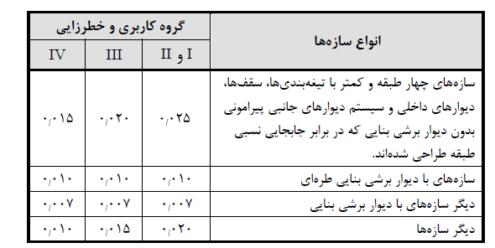

The deflection at level X ($δ_{x}$) (in. or mm) used to compute the design story drift, Δ, shall be determined in accordance with the following equation:

Equation 4-22 (Pub.038-3rd edition, part 4-14-1):

$δ_{xe}=$ Maximum displacement in x direction due to earthquake: 11.9 mm

$δ_{x}=\frac{C_{d}δ_{xe}}{I}=\frac{5.5×1.19}{1.25}=5.23 cm$ $→$ $∆x=\frac{5.23}{435}=0.012<0.02 ok$

Also

$δ_{ye}=$ Maximum displacement in y direction due to earthquake: 11.6mm

$δ_{y}=\frac{C_{d}δ_{ye}}{I}=\frac{5.5×1.16}{1.25}=5.10 cm$, $∆y=\frac{5.10}{435}=0.011<0.02 ok$

1. **Joist shear capacity ratio CONTROL**

According to ACI 318-14 part 18-8-4, shear strength of connection has been controlled and for two columns (Axis 4C & D1) as a sample have been shown below.

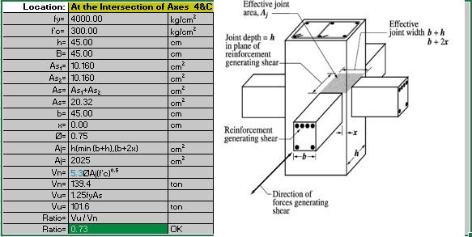

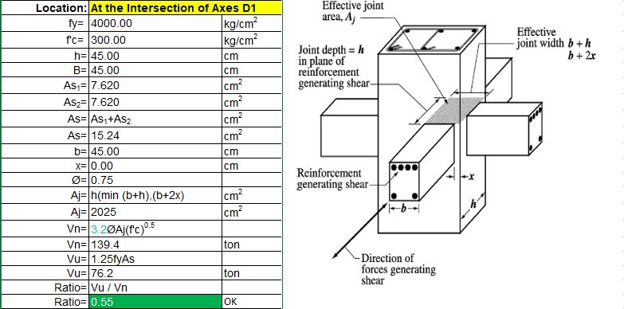

1. **Strong Column-Weak Beam Requirements in SPECIAL CONCRETE Moment Frame**

According to INBC Part 9 (section: 9-20-60-4), the flexural strength of columns shall satisfy:

ΣMnc ≥ 1.2 ΣMnb

Based on Etabs report, maximum force due to seismic load combination is equal to 48.6 ton which is smaller than 0.1Ag f’c, so according to section 9-20-6-4-5 could be ignored above equation for one story building.

1. **FOUNDATION DESIGN AND RESULTS**









12. 1. **Foundation Model**

Foundation model, analyse and design has been done by SAFE2016 software.

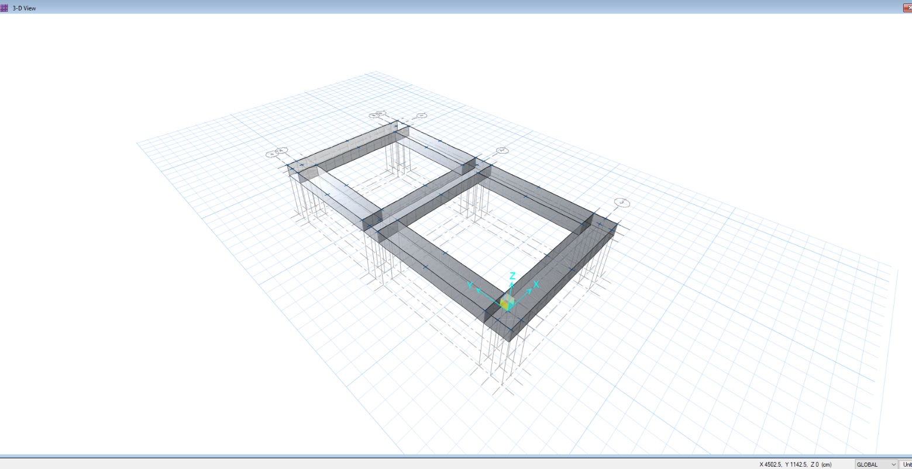**Figure 11: Foundation 3D plan in SAFE**

* 1. **Soil** **Characteristic**

Based on Geotechnical Report (Attachment 4, 5):

q allowable = 1.75 kg/cm2 (Allowable Soil Bearing Capacity)

δ allowable = 1.6 cm (Allowable Settlement)

Ks = 1.6 kg/cm3 (Subgrade Modulus)

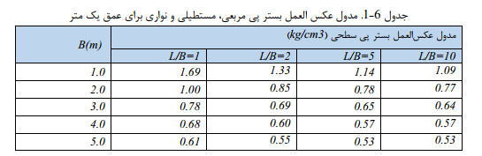

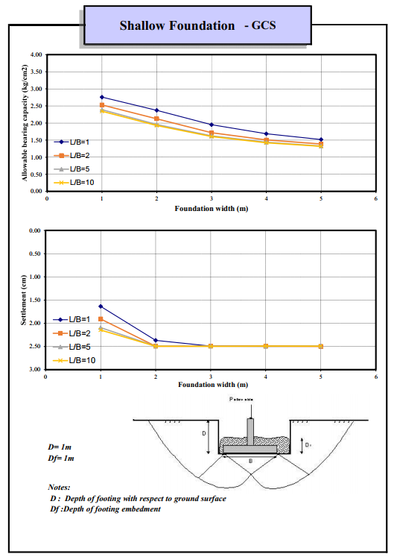

* 1. **Loads**

The loads have been imported from ETABS analysis.

Reinforced concrete unit weight equals 2500 kg/m3 and defined for SAFE, so the program calculated the foundation weight automatically.

Soil unit weight equals to 1900 kg/m3. The soil height above foundation is 0.95 m, so distributed soil weight:

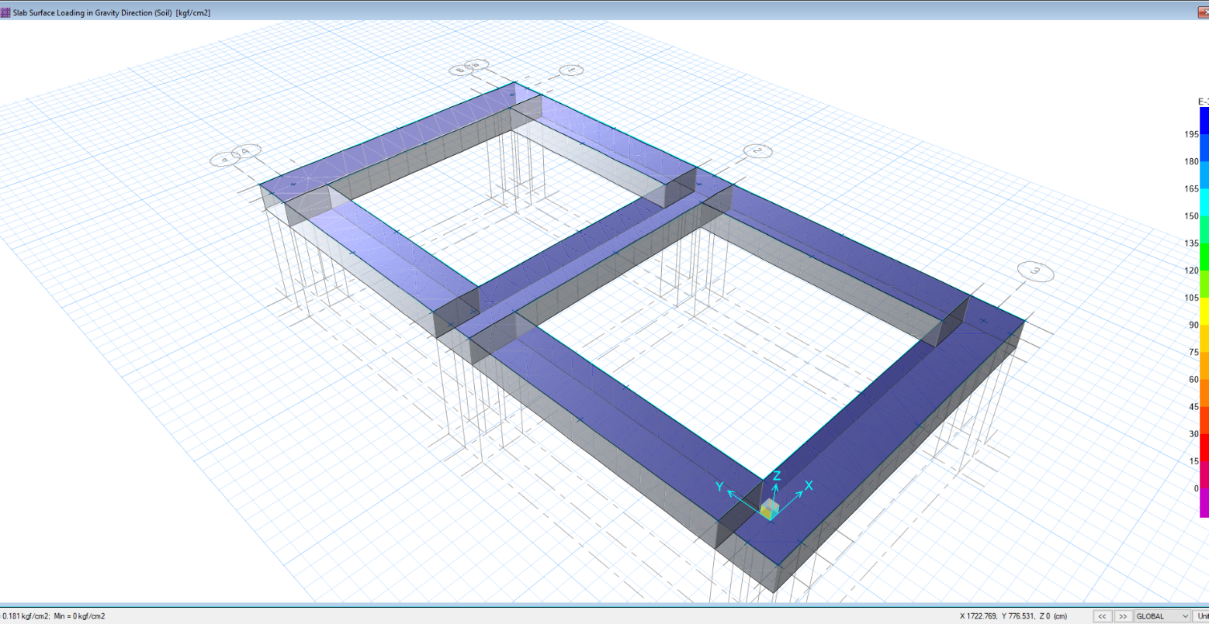Ws = 0.95×1900 = 1805 kg/m2

**Figure 12: soil weight on foundation**

* 1. **Settlement Control**

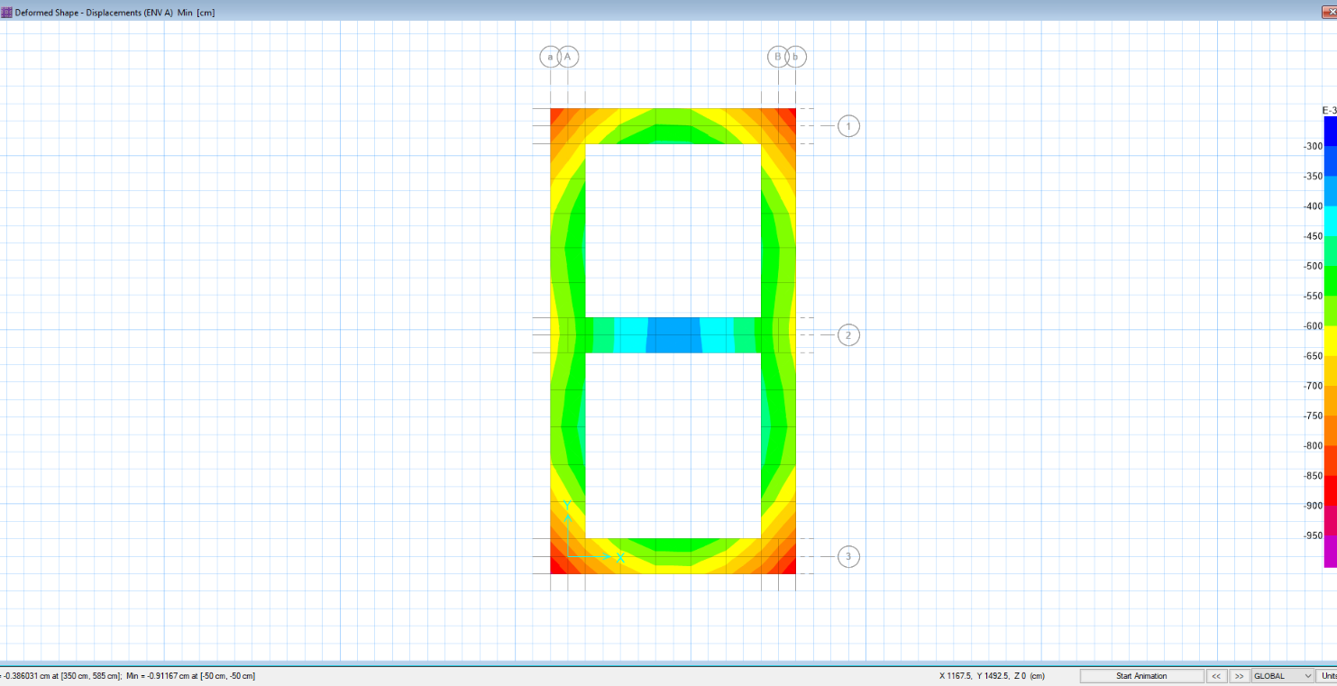Settlement in different service load combinations should be checked by allowable value.

**Figure 13: Foundation Settlement**

Maximum settlement of foundation equals to 0.91 cm, which is less than allowable 1.6 cm.

* 1. **Soil Pressure Control**

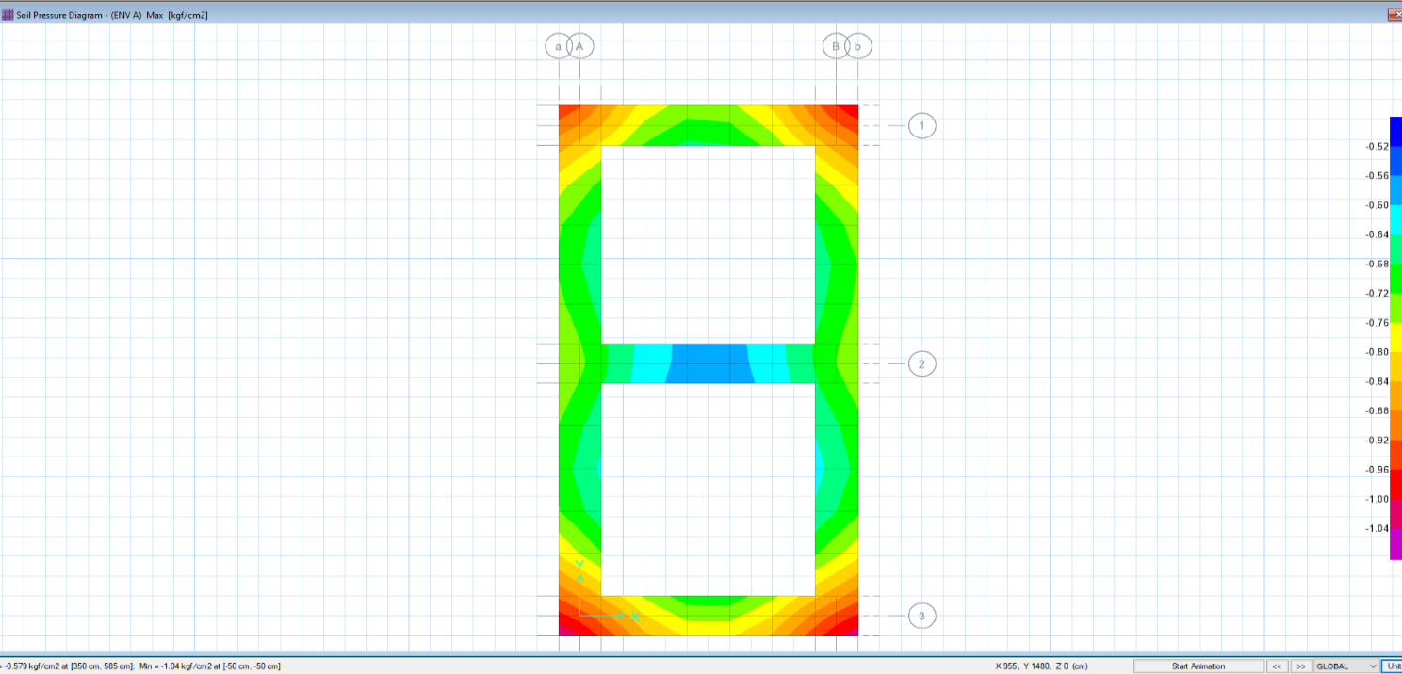Soil pressures in different service load combinations should be checked by allowable value.

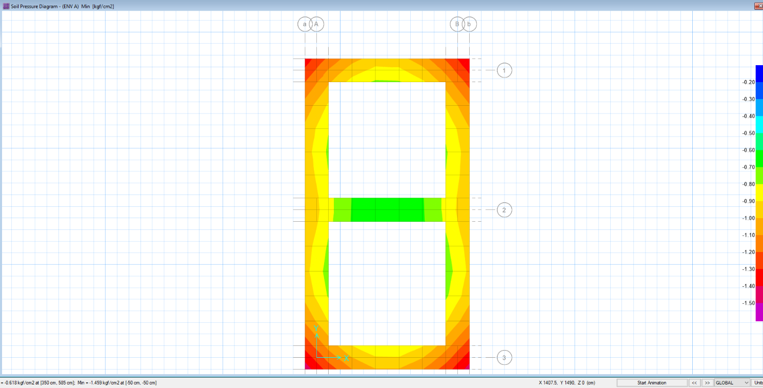

**Figure 14: Soil Pressure under Foundation**

Maximum soil pressure under foundation equals to 1.43 kg/cm2, which is less than1.75 kg/cm2.

* 1. **Punching Shear Control**

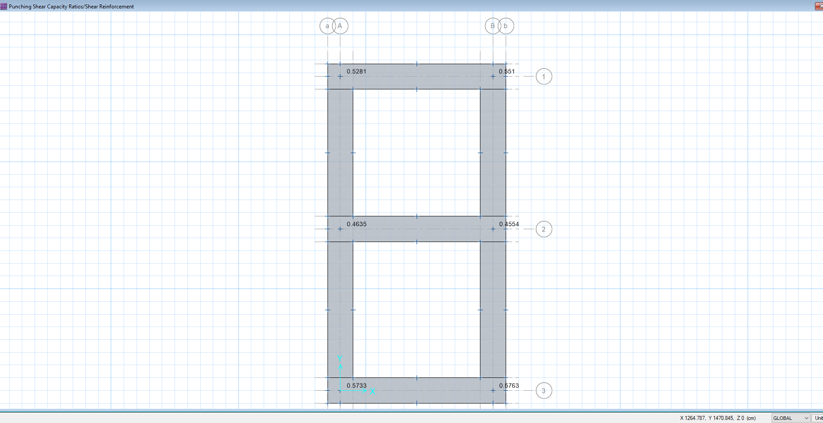The punching shear control ratio of foundation is shown below. As seen the punching shear ratio in all columns base which is calculated by software is less than allowable range (1.0), so the footing thickness is acceptable.

**Figure 15: Punching Shear Capacity Ratios**

* 1. **Foundation Design**

Foundation reinforcement is calculated by software and add bars in X, Y direction are shown at below figure. Uniform Ф16@150 pattern is assigned for top and bottom of foundation in both directions and needed additional bars at some part that is presented in below pictures.

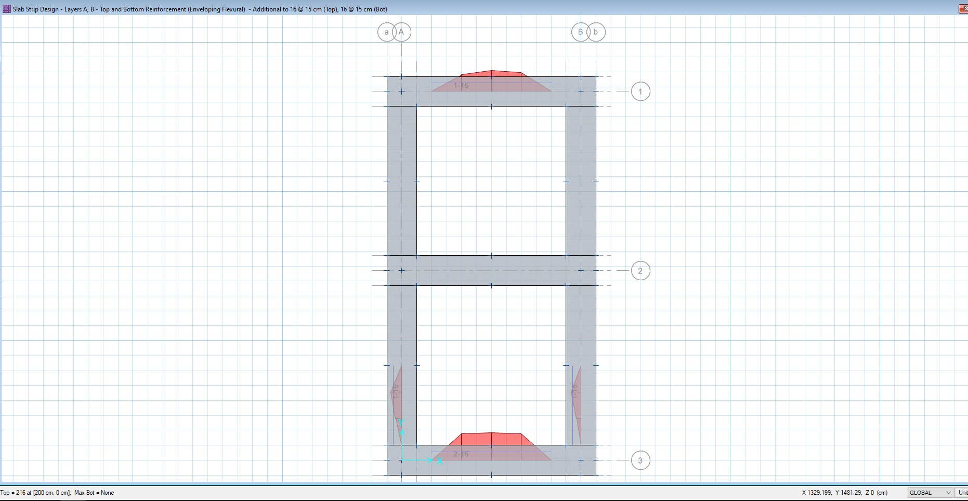

**Figure 16: Reinforcement in X, Y Direction**

In Both Directions:

Top Bar USE Φ16@150 mm

Bottom Bar USE Φ16@150 mm

Minimum rebar for strip foundation:

$${ A}_{smin}=0.0018 bh=0.0018×100×60=10.8 cm^{2}/m$$

$$A_{s used}=∅16@150=12.06 cm^{2}$$