|  |  |  |  |  |  |  |  |
| --- | --- | --- | --- | --- | --- | --- | --- |
| **طرح نگهداشت و افزایش تولید 27 مخزن** | | | | | | | |
| **CALCULATION NOTE FOR UTILITY SHELTER**  **نگهداشت و افزایش تولید میدان نفتی بینک** | | | | | | | |
|  | |  |  |  |  |  |  |
| D03 | | FEB. 2024 | AFD | R.Berlouie | M.Fakharian | S.Faramarzpour |  |
| D02 | | JAN. 2024 | AFD | R.Berlouie | M.Fakharian | S.Faramarzpour |  |
| D01 | | OCT. 2023 | IFA | R.Berlouie | M.Fakharian | S.Faramarzpour |  |
| D00 | | June. 2023 | IFC | R.Berlouie | M.Fakharian | A.M.Mohseni |  |
| **Rev.** | | **Date** | **Purpose of Issue/Status** | **Prepared by:** | **Checked by:** | **Approved by:** | **CLIENT Approval** |
| **Class:2** | | | **CLIENT Doc. Number: F0Z-709123** | | | | |
| **Status:** | | **IDC: Inter-Discipline Check**  **IFC: Issued For Comment**  **IFA: Issued For Approval**  **AFD: Approved For Design**  **AFC: Approved For Construction**  **AFP: Approved For Purchase**  **AFQ:** Approved For Quotation  **IFI: Issued For Information**  **AB-R: As-Built for CLIENT Review**  **AB-A: As-Built –Approved** | | | | | |

**REVISION RECORD SHEET**

|  |  |  |  |  |  |  |  |  |  |  |  |  |
| --- | --- | --- | --- | --- | --- | --- | --- | --- | --- | --- | --- | --- |
| **PAGE** | **D00** | **D01** | **D02** | **D03** | **D04** |  | **PAGE** | **D00** | **D01** | **D02** | **D03** | **D04** |
| **1** | X | X | X | X |  | **66** | X | X |  |  |  |
| **2** | X | X | X | X |  | **67** | X | X |  |  |  |
| **3** | X | X |  |  |  | **68** | X | X |  |  |  |
| **4** | X | X | X |  |  | **69** | X | X |  |  |  |
| **5** | X | X |  |  |  | **70** | X | X |  |  |  |
| **6** | X | X |  |  |  | **71** | X | X |  |  |  |
| **7** | X | X |  |  |  | **72** | X | X |  |  |  |
| **8** | X | X |  |  |  | **73** | X | X |  |  |  |
| **9** | X | X |  |  |  | **74** | X | X |  |  |  |
| **10** | X | X |  |  |  | **75** | X | X |  |  |  |
| **11** | X | X |  |  |  | **76** | X | X |  |  |  |
| **12** | X | X |  |  |  | **77** | X | X |  |  |  |
| **13** | X | X |  |  |  | **78** | X | X |  |  |  |
| **14** | X | X |  |  |  | **79** | X | X |  |  |  |
| **15** | X | X |  |  |  | **80** | X | X |  |  |  |
| **16** | X | X |  |  |  | **81** | X | X |  |  |  |
| **17** | X | X | X |  |  | **82** | X | X |  |  |  |
| **18** | X | X | X |  |  | **83** | X | X |  |  |  |
| **19** | X | X | X |  |  | **84** | X | X |  |  |  |
| **20** | X | X |  |  |  | **85** | X | X |  |  |  |
| **21** | X | X |  |  |  | **86** | X | X |  |  |  |
| **22** | X | X |  |  |  | **87** | X | X |  |  |  |
| **23** | X | X |  |  |  | **88** | X |  |  |  |  |
| **24** | X | X |  |  |  | **89** | X |  |  |  |  |
| **25** | X | X |  |  |  | **90** | X |  |  |  |  |
| **26** | X | X |  |  |  | **91** | X |  |  |  |  |
| **27** | X | X |  |  |  | **92** | X |  |  |  |  |
| **28** | X | X | X |  |  | **93** |  |  |  |  |  |
| **29** | X | X |  |  |  | **94** |  |  |  |  |  |
| **30** | X | X |  |  |  | **95** |  |  |  |  |  |
| **31** | X | X |  |  |  | **96** |  |  |  |  |  |
| **32** | X | X |  |  |  | **97** |  |  |  |  |  |
| **33** | X | X |  |  |  | **98** |  |  |  |  |  |
| **34** | X | X |  |  |  | **99** |  |  |  |  |  |
| **35** | X | X |  |  |  | **100** |  |  |  |  |  |
| **36** | X | X |  |  |  | **101** |  |  |  |  |  |
| **37** | X | X |  |  |  | **102** |  |  |  |  |  |
| **38** | X | X |  |  |  | **103** |  |  |  |  |  |
| **39** | X | X |  |  |  | **104** |  |  |  |  |  |
| **40** | X | X |  |  |  | **105** |  |  |  |  |  |
| **41** | X | X |  |  |  | **106** |  |  |  |  |  |
| **42** | X | X |  |  |  | **107** |  |  |  |  |  |
| **43** | X | X |  |  |  | **108** |  |  |  |  |  |
| **44** | X | X |  |  |  | **109** |  |  |  |  |  |
| **45** | X | X |  |  |  | **110** |  |  |  |  |  |
| **46** | X | X |  |  |  | **111** |  |  |  |  |  |
| **47** | X | X |  |  |  | **112** |  |  |  |  |  |
| **48** | X | X |  |  |  | **113** |  |  |  |  |  |
| **49** | X | X |  |  |  | **114** |  |  |  |  |  |
| **50** | X | X |  |  |  | **115** |  |  |  |  |  |
| **51** | X | X |  |  |  | **116** |  |  |  |  |  |
| **52** | X | X |  |  |  | **117** |  |  |  |  |  |
| **53** | X | X |  |  |  | **118** |  |  |  |  |  |
| **54** | X | X |  |  |  | **119** |  |  |  |  |  |
| **55** | X | X |  |  |  | **120** |  |  |  |  |  |
| **56** | X | X |  |  |  | **121** |  |  |  |  |  |
| **57** | X | X |  |  |  | **122** |  |  |  |  |  |
| **58** | X | X |  |  |  | **123** |  |  |  |  |  |
| **59** | X | X |  |  |  | **124** |  |  |  |  |  |
| **60** | X | X |  |  |  | **125** |  |  |  |  |  |
| **61** | X | X |  |  |  | **126** |  |  |  |  |  |
| **62** | X | X |  |  |  | **127** |  |  |  |  |  |
| **63** | X | X |  |  |  | **128** |  |  |  |  |  |
| **64** | X | X |  |  |  | **129** |  |  |  |  |  |
| **65** | X | X |  |  |  | **130** |  |  |  |  |  |

**CONTENTS**

1.0 INTRODUCTION 4

2.0 Scope 4

3.0 NORMATIVE REFERENCE 4

4.0 Material properties 5

5.0 STRUCTURE ‘s systems 5

6.0 DESIGN LOAD 6

7.0 SAP2000 Load Pattern 22

8.0 Load combinations 23

9.0 STRUCTURE ANALYSIS AND DESIGN 24

10. Structural Design Results 28

**11. Flextural design of crane beam 29**

**12. PURLIN DESIGN 31**

13. STRUCTURE CONNECTIONS 33

14. FOUNDATION DESIGN 77

1. **INTRODUCTION**

Binak oilfield in Bushehr province is a part of the southern oilfields of Iran, is located 20 km northwest of Genaveh city.

With the aim of increasing production of oil from Binak oilfield, an EPC/EPD Project has been defined by NIOC/NISOC and awarded to Petro Iran Development Company (PEDCO). Also PEDCO (as General Contractor) has assigned the EPC-packages of the Project to "Hirgan Energy - Design and Inspection" JV.

1. **Scope**

This report covers the structure & foundation calculation report of the “Utility Shelter ”. The structure modelled by “SAP” software & the foundation modelled by “SAFE” software.

1. **NORMATIVE REFERENCE**
   1. **Local Codes and Standards**

* INBC Part 6 “Iranian National Building Code
* INBC Part 7 “Iranian National Building Code
* INBC Part 9 “Iranian National Building Code
* INBC Part 10 “Iranian National Building Code
* Iranian Seismic Design Code for Petroleum Facilities(3rd edition)
  1. **International Codes and Standards**
* ASCE 7-10 “Minimum Design Loads and Associated Criteria for Buildings and Other Structures-American Society of Civil Engineers”.
* ACI 318. “Building Code Requirements for Reinforced Concrete”, American Concrete Institute.
* AISC 358 “Prequalified Connections for Special and Intermediate Steel Moment Frames for Seismic Applications.” American Institute of Steel Construction, Inc.
* AISC 360 - “Specification for Structural Steel Buildings”. American Institute of Steel Construction, Inc.
  1. **The Project Documents**

## BK-GNRAL-PEDCO-000-ST-SP-0001 SPECIFICATION FOR CONCRETE WORK

## BK-gcs-PEDCO-120-ST-DW-0068 STRUCTURAL drawing for UTILITY shelter

## BK-GNRAL-PEDCO-000-ST-SP-0006 Specification for Fireproofing

1. **Material properties**

Material properties are delivered in the following table.

table 1 -Material Properties

|  |  |
| --- | --- |
| Foundation Concrete | F'c = 30 Mpa(28- day cylindrical sample) |
| Long. reinforcement bar | Fy = 400 Mpa(AIII) |
| Trans. reinforcement bar | Fy = 400 Mpa(AIII) |
| Bolt Type | HV 8.8 |
| Electrode Type | E 70 |

1. **STRUCTURE ‘s systems**

The Structure’s System is OMF in X direction and OCBF system in Y direction. Seismic Parameters according to Iranian Code of Practice for Seismic Resistant Design of Building Standard No. 038 (3th Edition) listed at below table.

table 2 - Design Coefficients and Factors for Seismic Force-Resisting Systems

|  |  |  |  |  |
| --- | --- | --- | --- | --- |
| Cd | Ω | R | Structure System |  |
| 3 | 3 | 3.5 | OMF | X Dir |
| 3.25 | 2 | 3.25 | OCBF | Y Dir |

1. **DESIGN LOAD**
   1. **Dead load**

Dead loads include the self-weight of the structure and all the permanent equipment which are supported by the structures

$$Corrugated sheet :8 kg/m^{2}$$

$$Z Purlin : 8 kg/m^{2}$$

$$Insulation :10 kg/m^{2}$$

$$\sum{sum= 26 kg/m^{2}}$$

According to NISOC comment Roof weight is assigned in software 50kg/m2.

* At ended frame : $50×2=100 kg/m$
* At middle frame : $50×5=250 kg/m$

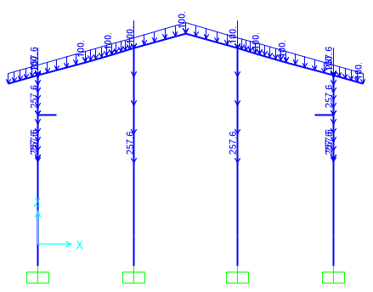 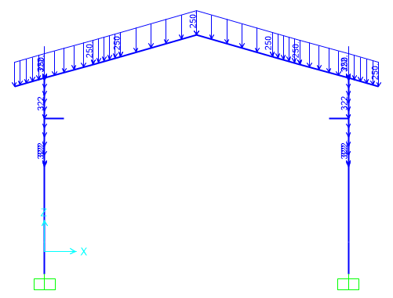

**Figure 1-**Applied Dead load on ended axe(1&4) (kg/m) **Figure 2-**Applied Dead load on middle axe 2(kg/m)

* 1. **Live Loads**

The design live load on an area shall be defined as the weight of all movable loads, including personnel, tools, and parts of dismantled equipment, cranes, hoist, and temporarily stored materials.

According to Iranian National Building Code No.6 Live load in light slop roof is 50kg/m2 and has been applied at frame.

* At ended frame : $50×2=100 kg/m$
* At middle frame : $50×5=250 kg/m$

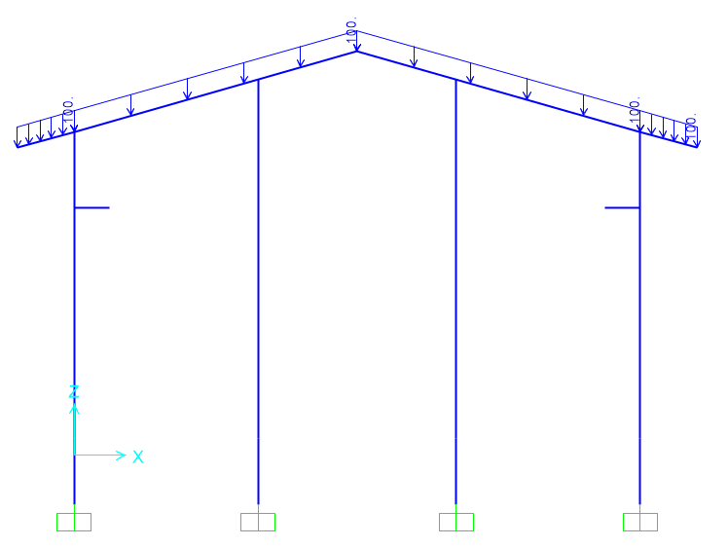 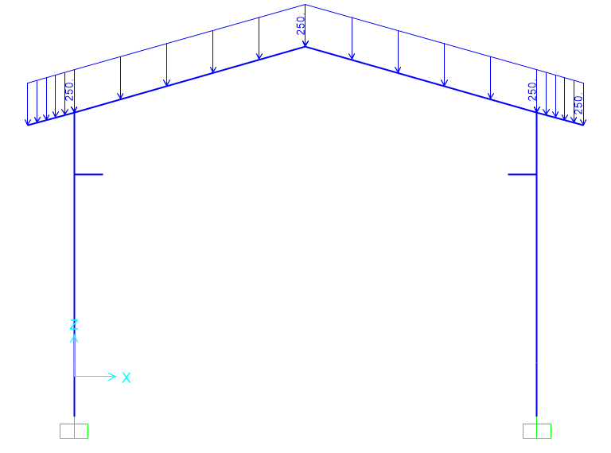

**Figure 3-** Applied Live load on ended axes 1&4 (kg/m) **Figure 4-** Applied Live load on middle axes 2&3 (kg/m)

* 1. **SNOW LOADS**

Snow load of this structure is calculated in accordance with Iranian National Building Code No.6 Latest edition. Parameters which are used in calculation of snow force is presented in below:

$$P_{r}=P_{s}C_{n}C_{h}I_{S}C_{s}$$

Ps=25 kg/m2 , Is=1

Cs= 0.91 (slope 11.31o)=1-

Ch=1

Cn=0.8

$$P_{r}=P_{s}C_{n}C_{h}I_{S}C_{s}=18.06\frac{kg}{m2}$$

* At ended frame: $18.06×2=36.12 kg/m$
* At middle frame: $18.06×5=90.3 kg/m$

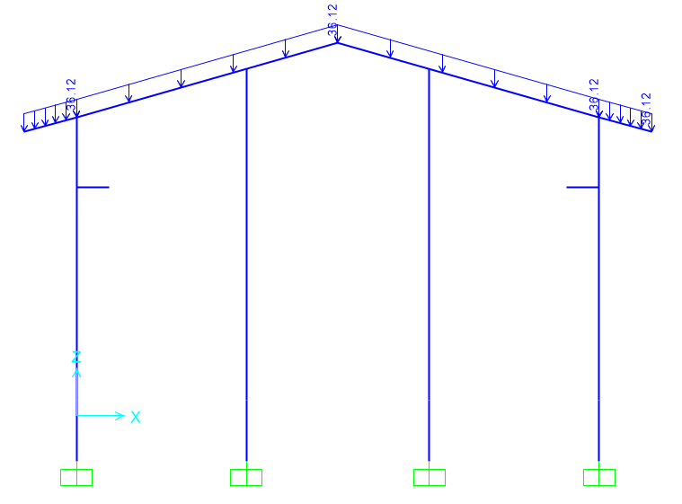 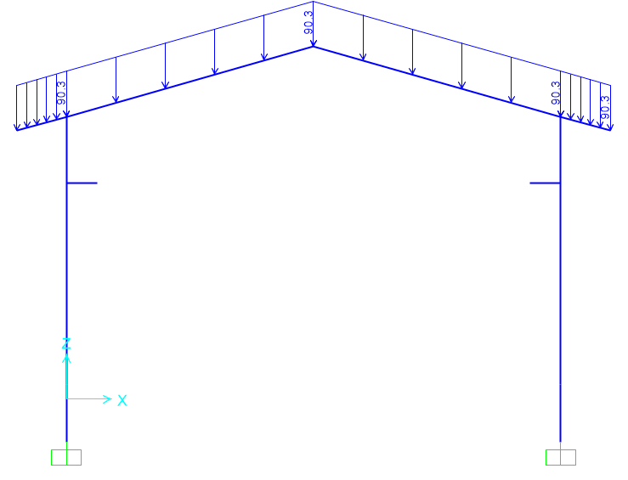

**Figure 5-**Applied Snow load on ended axes 1&4 (kg/m) **Figure 6-**Applied Snow load on middle axes 2&3 (kg/m)

* 1. **Seismic loads**

All structures are in area with high-risk zone of seismic and until finalizing of “Geotechnical Final Report” soil type consider is type II. Equivalent static method is used for calculation of seismic loads. Parameters which are used in calculation of earthquake force and seismic coefficient is presented in below.

According to Iranian Code of Practice for Seismic Resistant Design of Building Standard No. 038 (3th Edition)

|  |  |  |
| --- | --- | --- |
| Parameter | Y-Direction | X-Direction |
| Importance factor, $I_{e}$ | 1.25 | 1.25 |
| Structural system | OCBF | OMF |
| R | 3.25 | 3.5 |
| Ω | 2 | 3 |
| Cd | 3.25 | 3 |
| A | 0.3 | 0.3 |
| Soil Type | II | |
| T0(s) | 0.10 | 0.10 |
| Ts(s) | 0.5 | 0.5 |
| $Ta$ = Calculated Period | =0.05 ${(8.5)}^{0.75}=0.248$* | =0.072 ${(8.5)}^{0.8}=0.398$* |
| $Tm$ = Analytical Period | 0.158(Mode 13) | 0.829 (Mode 1) |
| Ta=min($1.4{Ta}_{(Calculated Period)} , {Ta}_{(Analytical Period)}$) | 0.158 | 0.5572 |
| $k$ | 1.00 | 1.03 |
| $$C_{s_{min}}=0.12AI$$ | 0.045 | 0.045 |
| $$SD1$$ | 0.375 | 0.375 |
| $$SDs$$ | 0.75 | 0.75 |
| $$Sa$$ | 0.75 | 0.673 |
| $$C_{s}=\frac{Sa.I}{R}$$ | 0.288 | 0.2403 |

* According to Iranian seismic Design code for Petroleum facilities code 038 $ρ$ in X directions assumed 1.3.

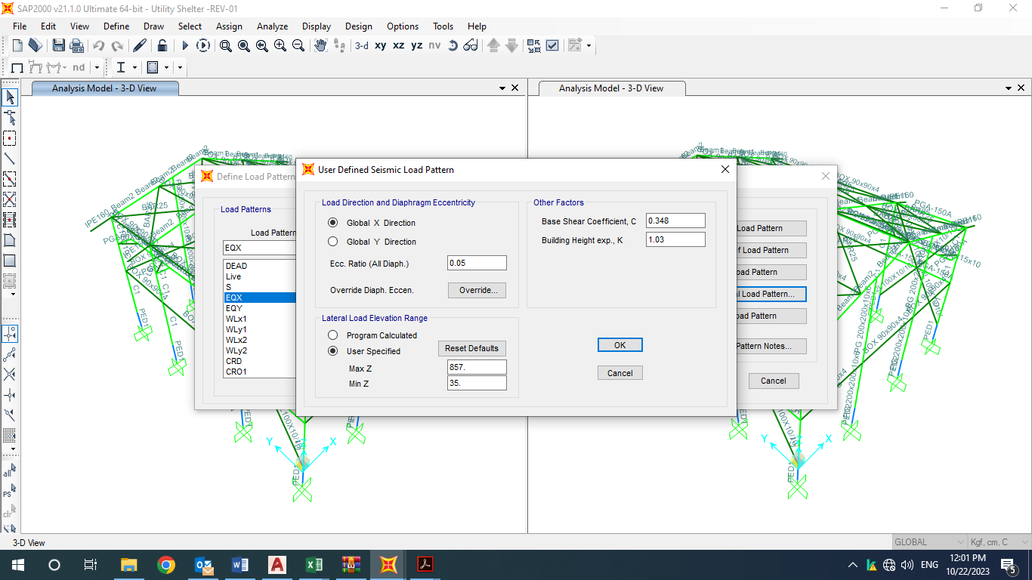

Fig 7- X Direction Seismic Load

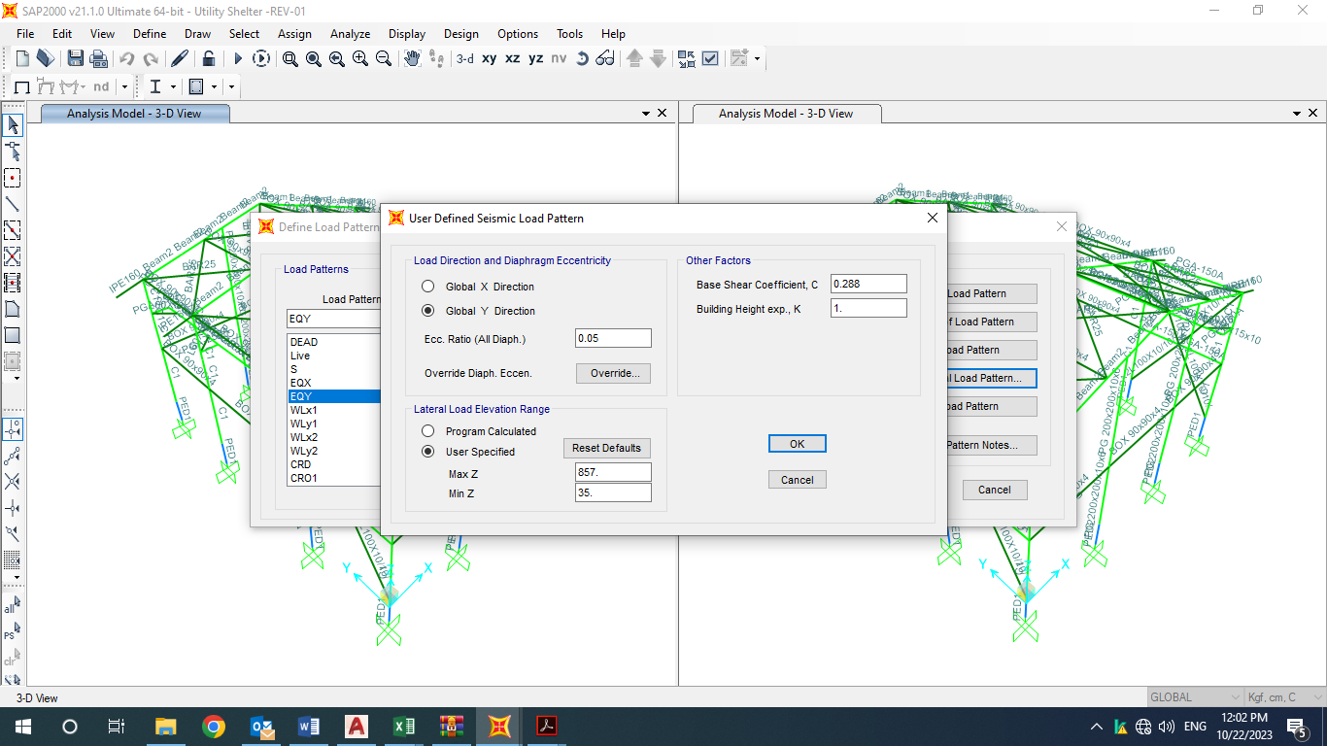

Fig 8- Y Direction Seismic Load

* 1. **CRANE load**

Distribution of crane load is as below:

* **CRO** is the operating load of crane which shall be defined as the Crane Dead Load plus the crane capacity with considering the vertical, lateral and longitudinal Impact factor.

|  |  |  |
| --- | --- | --- |
| **Input Data** | | |
| Lifted Crane Load = LCL | 2 | ton |
| Crane Weight = CW | 0.117 | ton/m |
| Trolley and Hoist Weight = THW | 2 | ton |
| Crane Approach = CAD | 0.75 | m |
| Shelter Width | 12 | m |
| The Maximum Load Factor for this span based on the side approach is | 0.9375 | - |
| The Minimum Load Factor for this span based on the side approach is | 0.0625 | - |
| **There are 2 wheels per truck and 2 trucks per crane for a total of 4 wheels for this crane.** | | |
| Wheels per Truck = TrW | 2 | - |
| Total number of Wheels = TTrW | 4 | - |
| Maximum Wheel Load | 2.226 | ton |
| Minimum Wheel Load | 0.476 | ton |
| The sum of all wheel loads | 5.404 | ton |
| Check the sum of the lifted load + the crane, trolley and hoist weight | 5.404 | **Ok** |
| The distance between frames is the bay size (Lf) | 6 | m |
| The Wheel Spacing (s) | 2 | m |
| **Impact factor** | | |
| Vertical Impact factor (Kv) | 1.25 | - |
| Horizontal Impact factor (kh) | 0.2 | - |
| Longitudinal Impact factor (kl) | 0.1 | - |
| **Vertical Frame Load:** | | |
| Maximum Live Load | 2.7825 | ton |
| Minimum Live Load | 0.595 | ton |

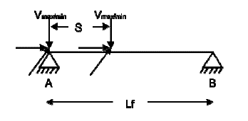Frame Analysis Data:

|  |  |  |
| --- | --- | --- |
| **CRO** | | |
| Left | | |
| RAv (max) | 4.6375 | ton |
| RAh (max) | 0.742 | ton |
| RAl (max) | 0.2226 | ton |
| RBv (min) | 0.9275 | ton |
| RBh (min) | 0.1484 | ton |
| RBl (min) | 0.2226 | ton |
| Right | | |
| RAv (max) | 0.991666667 | ton |
| RAh (max) | 0.158666667 | ton |
| Ral (max) | 0.0476 | ton |
| RBv (min) | 0.198333333 | ton |
| RBh (min) | 0.031733333 | ton |
| RBl (min) | 0.0476 | ton |

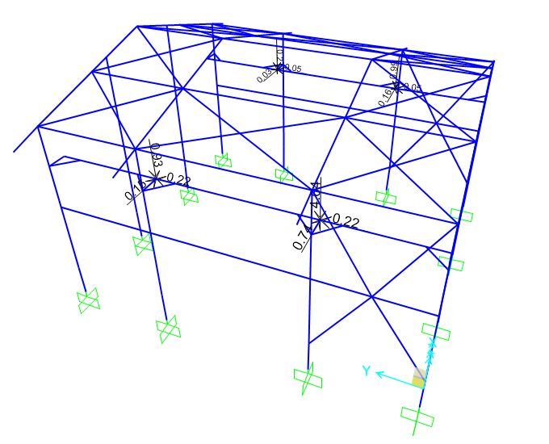

**Figure 9-**Applied Crane Operating load (CRO1) on Structure (ton)

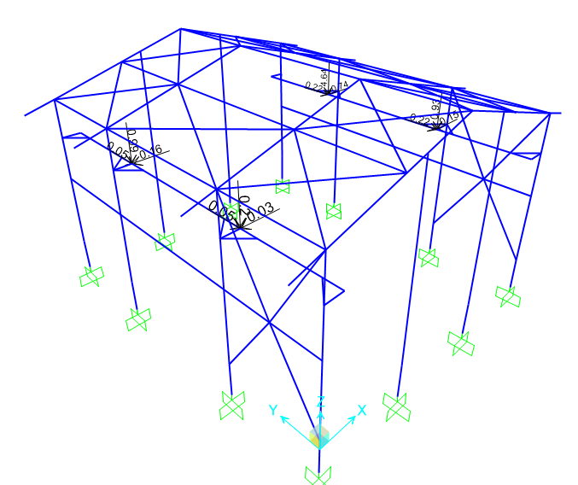

**Figure 10-**Applied Crane Operating load (CRO2) on Structure (ton)

* **CRD (Crane Dead Load)** Crd is the weight of Crane Bridge plus crab and trolley weight which is as follow:

|  |  |  |
| --- | --- | --- |
| **CRD** | | |
| Vmax | 1.2885 | ton |
| Vmin | 0.4135 | ton |
| **Left** | | |
| RAv (max) | 2.1475 | ton |
| RBv (min) | 0.4295 | ton |
| **Right** | | |
| RAv (max) | 0.689167 | ton |
| RBv (min) | 0.137833 | ton |

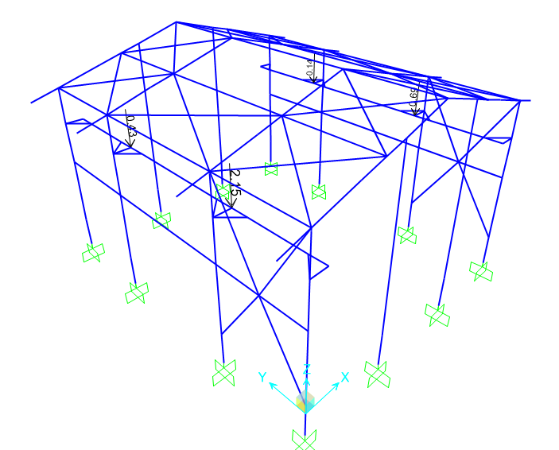

**Figure 11-**Applied Crane Dead load (CRD) on Structure (ton)

* 1. **WIND loads**

Wind loads are calculated for shelter building (according to Iranian National Building Code No.6 last edition) and applied at model as below:

|  |  |  |
| --- | --- | --- |
| سرعت باد (Km/h) | 120 | Km/h |
| فشار مبنای باد(q) | 0.681 | kPa |
| ضریب اهمیت(I) | 1 | جدول 6-1-2 |
| ارتفاع متوسط بام (کمتر از 6m نباشد) (H) | 7.4 | m |
| ارتفاع بازشو از سطح زمین | 3 | m |
| عرض سوله (کمترین بعد افقی در پلان) | 12 | m |
| نوع زمین | باز | بند 6-10-6-1 |
| Ce | 0.941556409 | - |
| Cgi | 2 | بند 6-10-8-1 |
| (گروه 1، 2، یا 3) Cpi | 3 | بند 6-10-11 |
| Cpi (positive) | 0.7 | بند 6-10-11 |
| Cpi (Negative) | -0.7 | بند 6-10-11 |
| شیب بام | 11 | درجه |
| (فاصله قابها) y | 4 | صفحه 87 مبحث ششم (m) |
| z | 1.2 | صفحه 87 مبحث ششم (m) |
| Cd | 0.85 | بند 6-10-12 |
| Ct | 1 | بند 6-10-7 |

|  |  |  |  |  |  |  |  |  |
| --- | --- | --- | --- | --- | --- | --- | --- | --- |
|  | 1 | 1E | 2 | 2E | 3 | 3E | 4 | 4E |
| CgCp-شکل الف | 0.85 | 1.29 | -1.3 | -2 | -0.78 | -1.12 | -0.65 | -0.96 |
| P=I*q*Ct*Ce*CgCp*Cd(kPa) | 0.463 | 0.703 | -0.708 | -1.090 | -0.425 | -0.610 | -0.354 | -0.523 |
| Pi (kPa) | 0.763 | 0.763 | -0.763 | -0.763 | -0.763 | -0.763 | -0.763 | -0.763 |
| P+Pi (kPa) | 1.226 | 1.466 | -1.471 | -1.853 | -1.188 | -1.373 | -1.117 | -1.286 |
| **WLX & WLX1 (kg/m2)** | **122.63** | **146.61** | **-147.16** | **-185.31** | **-118.81** | **-137.35** | **-111.73** | **-128.62** |

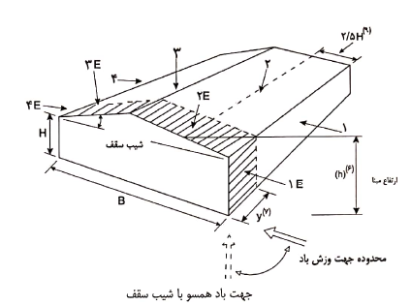

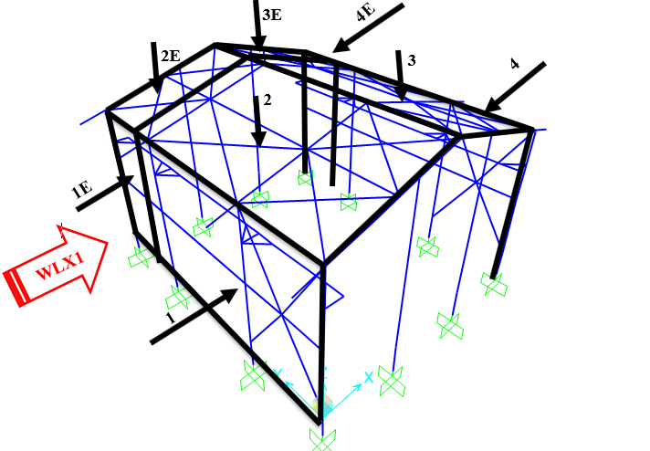 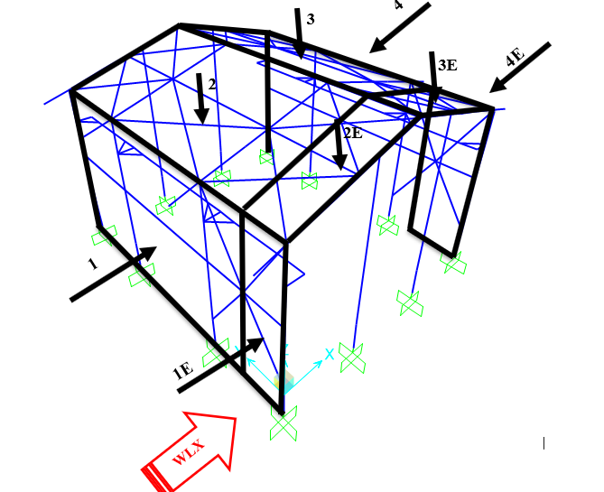

|  |  |  |  |  |  |  |  |  |  |  |  |  |
| --- | --- | --- | --- | --- | --- | --- | --- | --- | --- | --- | --- | --- |
|  | 1 | 1E | 2 | 2E | 3 | 3E | 4 | 4E | 5 | 5E | 6 | 6E |
| CgCp-شکل ب | -0.85 | -0.9 | -1.3 | -2 | -0.7 | -1 | -0.85 | -0.9 | 0.75 | 1.15 | -0.55 | -0.8 |
| P=I*q*Ct*Ce*CgCp*Cd (kPa) | -0.463 | -0.490 | -0.708 | -1.090 | -0.381 | -0.545 | -0.463 | -0.490 | 0.408 | 0.626 | -0.299 | -0.436 |
| Pi (kPa) | -0.763 | -0.763 | -0.763 | -0.763 | -0.763 | -0.763 | -0.763 | -0.763 | 0.763 | 0.763 | -0.763 | -0.763 |
| P+Pi (kPa) | -1.226 | -1.253 | -1.471 | -1.853 | -1.144 | -1.308 | -1.2267 | -1.253 | 1.171 | 1.389 | -1.062 | -1.199 |
| **WLY & WLY1 (kg/m2)** | **-122.63** | **-125.35** | **-147.16** | **-185.31** | **-114.45** | **-130.80** | **-122.63** | **-125.35** | **117.18** | **138.98** | **-106.28** | **-119.90** |

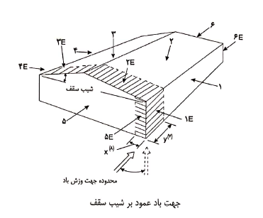

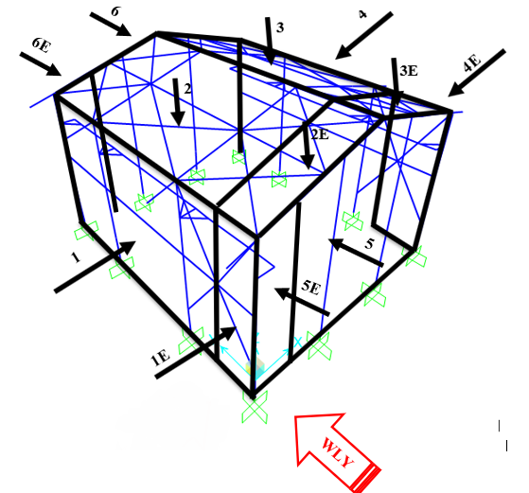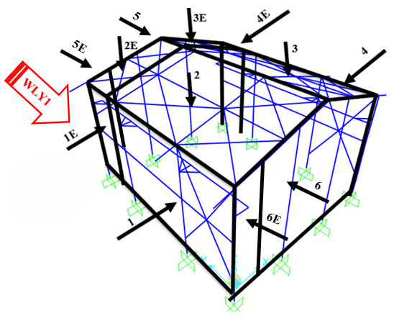

* + 1. Wind loading on Frame “1,4”:

|  |
| --- |
|  |
| WLX1 (kg/m) |
|  |
| WLY1 (kg/m) |

* + 1. Wind loading on Frame “2,3”:

|  |
| --- |
|  |
| WLX1 (kg/m) |
|  |
| WLY1 (kg/m) |

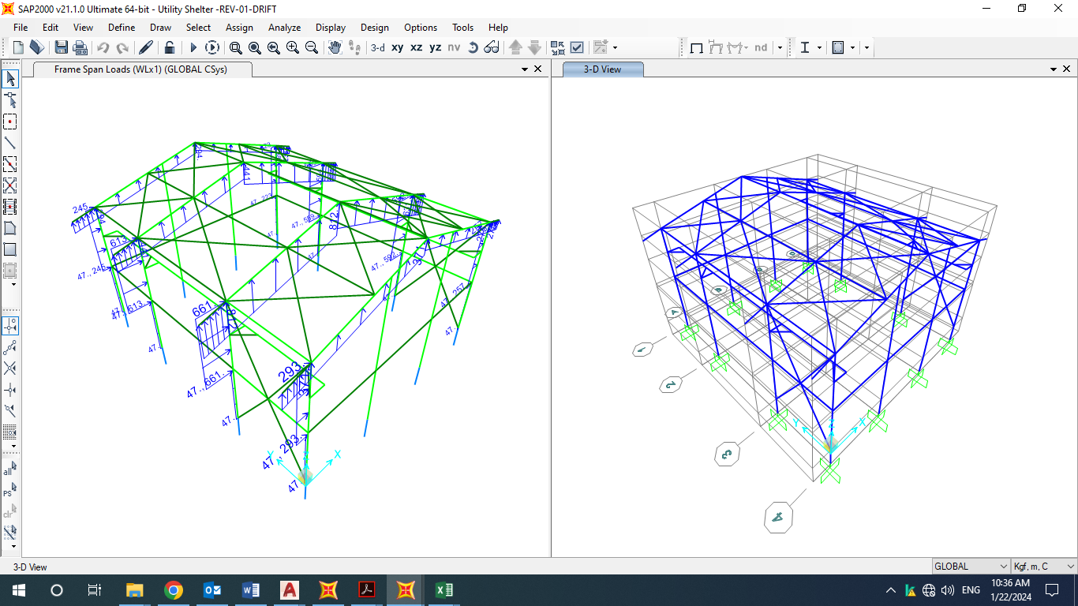

**Figure 12-**Applied Wind load (WLX1) on Structure (kg/m)

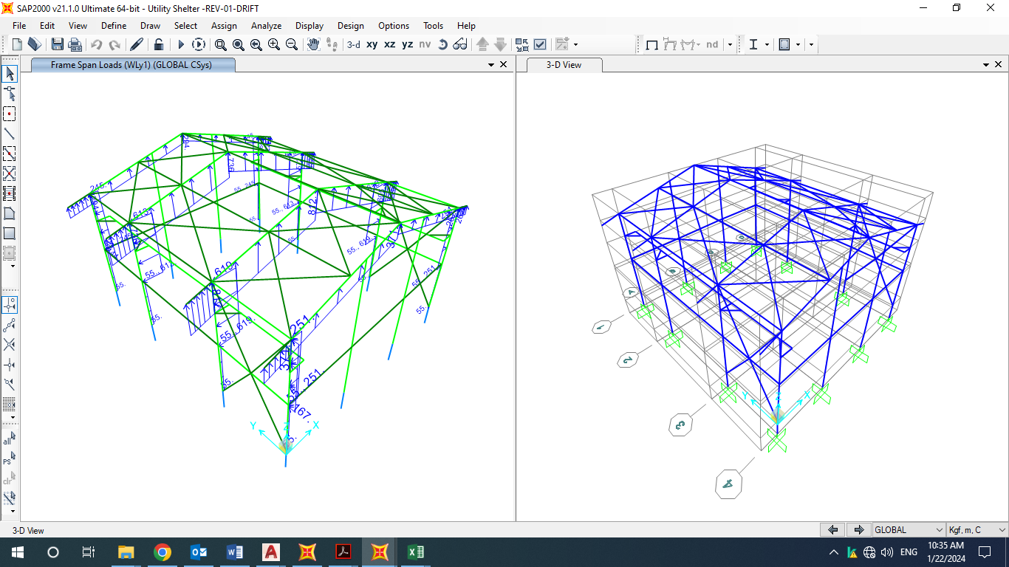

**Figure 14-**Applied Wind load (WLY1) on Structure (kg/m)

* For columns wind load applied as below (according to INBC no.6)

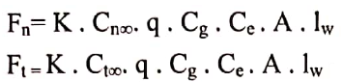

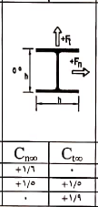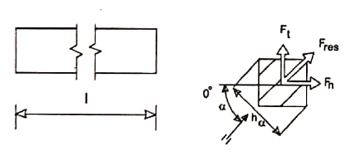

* 1. **Thermal Load:**

Thermal loads are those forces caused by a change in temperature. for this area assumed ${ 28}^{℃}$.

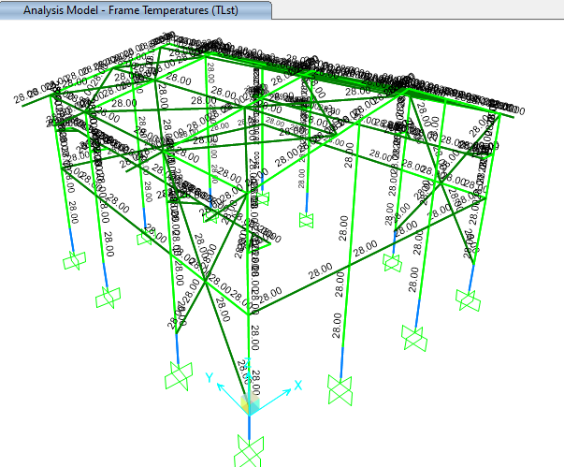

**Figure 16-**Applied Thermal Load (TLst) on Structure

1. **SAP2000 Load Pattern**

|  |  |
| --- | --- |
| **TABLE:** | |
| **LoadPat** | **Notes** |
| DEAD | Dead Load |
| Live | Live Load |
| S | Snow Load |
| EQX | Seismic Load in Dir X |
| EQY | Seismic Load in Dir Y |
| WLX1 | Wind Load in in Dir X (senario 1) |
| WLY1 | Wind Load in in Dir Y (senario 1) |
| WLX2 | Wind Load in in Dir X (senario 2) |
| WLY2 | Wind Load in in Dir Y (senario 2) |
| CRD | Crane Dead Load |
| CRO1 | Crane Operation Load (Senario 1) |
| TLst | Temperature Load |
| NotionalX(DL) | Notional Dead Load in Dir X |
| NotionalY(DL) | Notional Dead Load in Dir Y |
| NotionalX(LL) | Notional Live Load in Dir X |
| NotionalY(LL) | Notional Live Load in Dir Y |
| CRO2 | Crane Operation Load (Senario 2) |
| Soil | Soil Load |
| Ev | Vertical Sesimic Load |
| NotionalX(CRO1) | Notional CRO1 Load in Dir X |
| NotionalY(CRO1) | Notional CRO1 Load in Dir Y |
| NotionalX(CRO2) | Notional CRO2 Load in Dir X |
| NotionalY(CRO2) | Notional CRO2 Load in Dir Y |
| NotionalX(CRD) | Notional CRD Load in Dir X |
| NotionalY(CRD) | Notional CRD Load in Dir Y |

1. **Load combinations**

According to code INBC No.6 structures, components, and foundations shall be designed, so that their design strength equals or exceeds that effect of factored loads in the following combination:

* *1.4(D)*
* *(1.2D) +1.6(L)+0.5(Lr/S/R)*
* *1.2D+1.6(Lr/S/R) + (L/0.5W)*
* *1.2D+1.0(W) + L+.5(Lr/S)*
* *1.2D+1.0E+L+0.2S*
* *0.9D+1.0W*
* *0.9D+1.0E*

Load listed herein shall be considered to act in the following combinations; whichever produces the most unfavourable effect considering soil reactions.

* *D*
* *D+L*
* *D+(Lr/S/R)*
* *D+0.75(L)+0.75(Lr/R/S)*
* *D+(0.6W or 0.7E)*
* *D+0.75L+0.75(0.6W)+0.75(Lr/S/R)*
* *D+0.75L+0.75(0.7E)+0.75S*
* *0.6D+0.6W*
* *0.6D+0.7E*

1. **STRUCTURE ANALYSIS AND DESIGN** 
   1. **ANALYSIS**

Structural analysis is done by SAP2000 software. In model loads are applied, some graphical outputs from model are shown as follows.

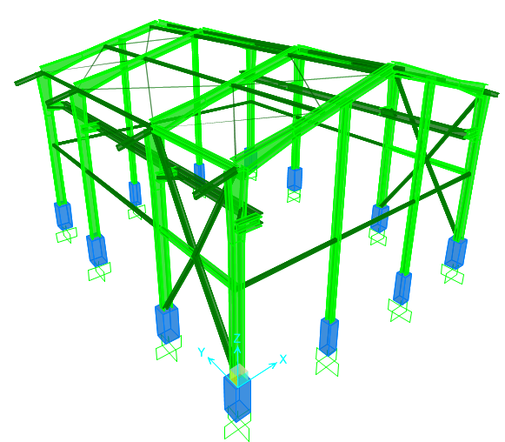

**Figure 12-3D view of SAP model**

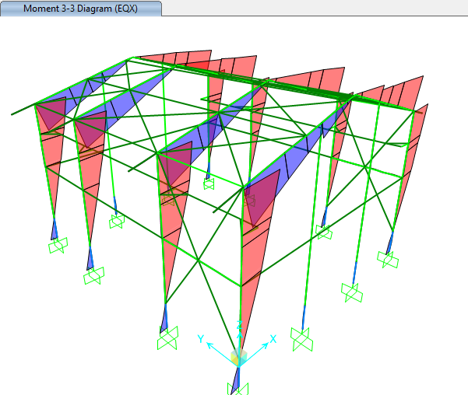

**Figure 13:** **Moment 3-3 under EQx load**

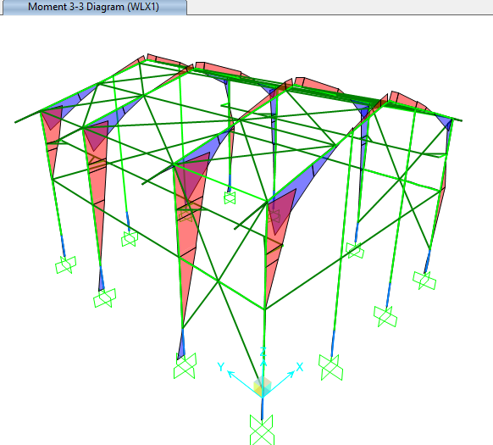

**Figure 14: Moment 3-3 WLx1 load**

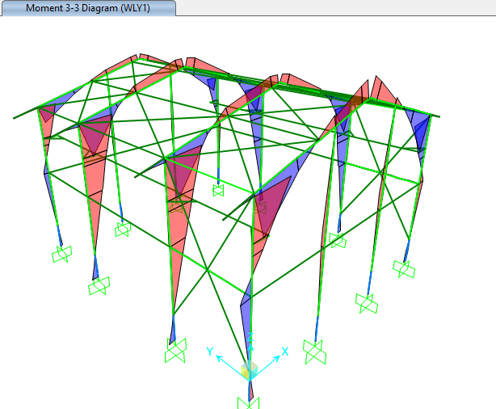

**Figure 15: Moment 3-3 WLY1 load**

* 1. **Drift CONTROL:**

According to “Civil & Structural Design Criteria”, horizontal displacements for shelter shall not exceed H/200.

$$allowable drift is \frac{h}{200}=\frac{686}{200}=3.43cm$$

The maximum displacement is less than H/200, so the displacement values are acceptable

|  |  |  |  |  |  |  |
| --- | --- | --- | --- | --- | --- | --- |
| **TABLE: Joint Displacements** | | | | | | |
| **Joint** | **OutputCase** | **CaseType** | **StepType** | **U1** | **U2** | **U3** |
| Text | Text | Text | Text | cm | cm | cm |
| 17 | ENV-A | Combination | Max | 2.899 | 0.045 | 0.225 |
| 17 | ENV-A | Combination | Min | -3.286 | -0.172 | 0.119 |
| 18 | ENV-A | Combination | Max | 3.428 | 0.038 | 0.225 |
| 18 | ENV-A | Combination | Min | -2.790 | -0.167 | 0.123 |
| 38 | ENV-A | Combination | Max | 2.910 | 0.191 | 0.219 |
| 38 | ENV-A | Combination | Min | -3.355 | -0.039 | 0.109 |
| 39 | ENV-A | Combination | Max | 3.401 | 0.184 | 0.220 |
| 39 | ENV-A | Combination | Min | -2.805 | -0.035 | 0.114 |
| 43 | ENV-A | Combination | Max | 2.846 | 0.429 | 0.218 |
| 43 | ENV-A | Combination | Min | -3.314 | 0.119 | 0.107 |
| 44 | ENV-A | Combination | Max | 3.402 | 0.421 | 0.214 |
| 44 | ENV-A | Combination | Min | -2.765 | 0.126 | 0.111 |
| 48 | ENV-A | Combination | Max | 2.846 | 0.568 | 0.217 |
| 48 | ENV-A | Combination | Min | -3.248 | 0.195 | 0.114 |
| 49 | ENV-A | Combination | Max | 3.376 | 0.559 | 0.213 |
| 49 | ENV-A | Combination | Min | -2.746 | 0.211 | 0.119 |
|  |  |  | MAX | 3.4276 |  |  |

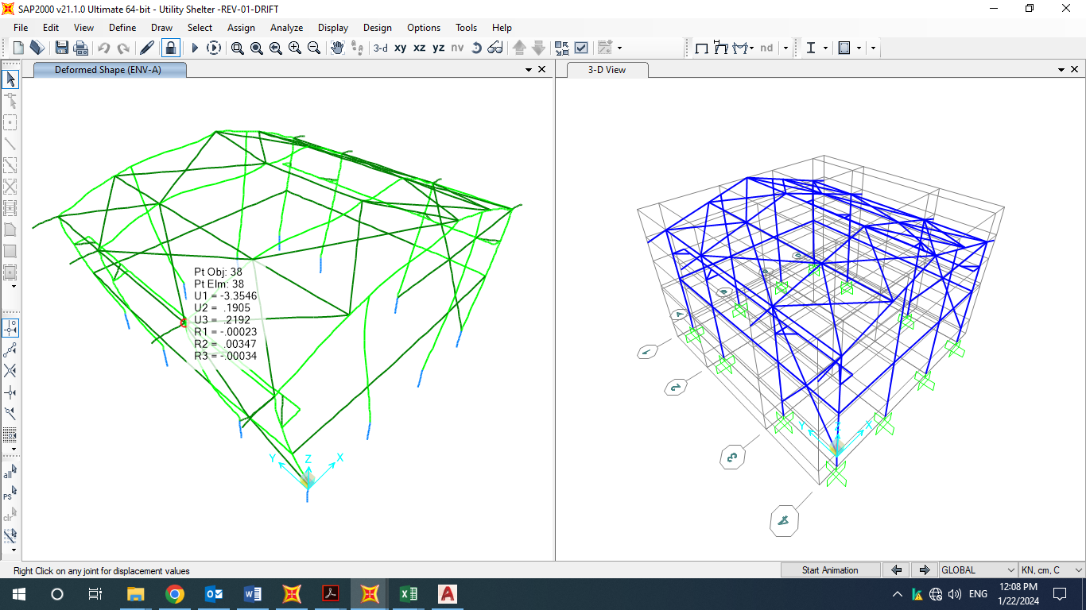

**Figure 16: Maximum displacement (Envelope Allowable)**

1. Structural Design Results

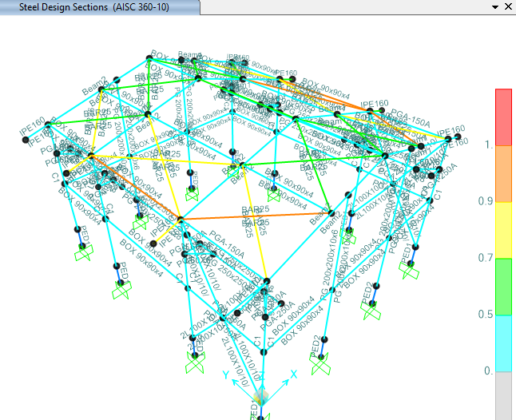

**Figure 17: M-P interaction Ratio of Shelter Elements**

1. **Flextural design of crane beam**

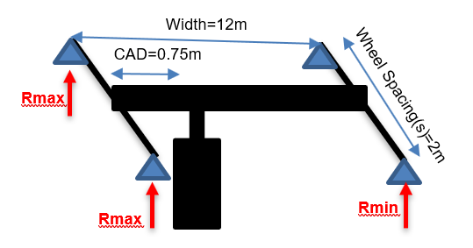

|  |  |  |
| --- | --- | --- |
| Lifted Crane Load = LCL | 2 | ton |
| Crane Weight = CW | 0.117 | ton/m |
| Trolley and Hoist Weight = THW | 2 | ton |
| Crane Approach = CAD | 0.75 | m |
| Shelter Width | 12 | m |
| The Maximum Load Factor for this span based on the side approach is | 0.9375 | - |
| The Minimum Load Factor for this span based on the side approach is | 0.0625 | - |
| **There are 2 wheels per truck and 2 trucks per crane for a total of 4 wheels for this crane.** | | |
| Wheels per Truck = TrW | 2 | - |
| Total number of Wheels = TTrW | 4 | - |
| Maximum Wheel Load (Rmax) | 2.226 | ton |
| Minimum Wheel Load (Rmin) | 0.476 | ton |

$\left(R1,R2\right)max$ =(2.226,2.226)=4.452ton

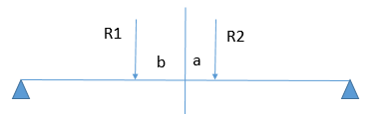

$$b=\frac{2.226×\left(a+b\right)+2.226×0}{4.452×1.25}=\frac{2.226×\left(2\right)+2.226×0}{4.452×1.25}=0.8m$$

b = 2 - 0.8 = 1.2m

According to below moment diagram under R2 load calculation is:

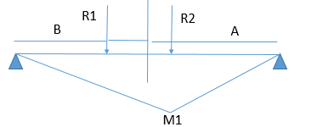.

$$M1=\frac{P1AB}{L}=\frac{2.226×2.4×3.6}{6}=3.205 ton.m$$

According to below moment diagram under R2 load calculation is:

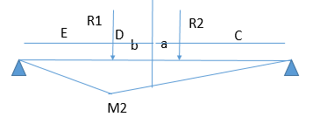

$$M2=\frac{C}{C+D}\frac{P2.E.(D+C)}{L}=\frac{2.4}{4.4}×\frac{2.226×0.6×4.4}{6}=0.534 ton.m$$

$$Mu=3.205+0.534=3.739 ton.m$$

$$f=0.6Fy=\frac{M}{S} Sreq=\frac{3.739×1000×100}{0.6×2400}=259.652 cm³$$

According to above calculation crane support beam needs 259.652 cm³ modulus.

×

=

×

=

* 1. Deflection control

Maximum beam deflection under crane live load on shelter is:

$$δ_{max}=\frac{PL^{3}}{48EI}=\frac{4.452×1000×{600}^{3}}{48×2.1×{10}^{6}×17085}=0.55 cm$$

$$δ_{all}=\frac{L}{1000}=\frac{600}{1000}=0.6 cm>0.55 cm ok$$

1. **PURLIN DESIGN**

## Property of Purlin(Z180x2.5)

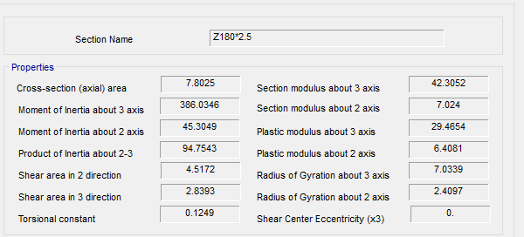

**Figure 18-**Section Property Of Purlin

According to above table :

$$A=7.80 cm2$$

$$J=0.12 cm4$$

$$Ix=386.06 cm4$$

$$Iy=45.304 cm4$$

$$rx=7.033 cm$$

$$ry=2.41 cm$$

$$ho=18 cm$$

$$SY=42.305 cm3$$

$$SX=7.024 cm3$$

FOR Z 180 :

$$D+L=26+50=76 kg/m^{2}$$

$$P_{y}=76.\cos{11}=74.6 kg/m^{2}$$

$$P_{x}=76.\sin{11}=14.5 kg/m^{2}$$

$$middle of span : M_{y}=\frac{w.L^{2}}{8}=\frac{74.6×1.0×6^{2}}{8}=335.7 kg.m$$

$$middle of span : M_{x}=\frac{w.L^{2}}{360}=\frac{14.5×1×6^{2}}{360}=1.45 kg.m$$

$$f_{b}=\frac{M_{y}}{s_{y}}+2\frac{M_{x}}{s_{x}}=\frac{335.7×100}{42.305}+2\frac{1.45×100}{7.024}=793.52+41.28=834.8<1440 ok$$

$$moment on sagrod support : M_{y}=\frac{w.L^{2}}{9}=\frac{74.6×1.0×6^{2}}{9}=298.4 kg.m$$

$$moment on sagrod support : M_{x}=\frac{w.L^{2}}{90}=\frac{14.5×1.0×6^{2}}{90}=5.8 kg.m$$

$$f_{b}=\frac{M_{y}}{s_{y}}+2\frac{M_{x}}{s_{x}}=\frac{298.4×100}{42.305}+2\frac{5.8×100}{7.024}=705.35+165.14=870.49< 1440 ok$$

1. **STRUCTURE CONNECTIONS**
   1. **Beam To Column**

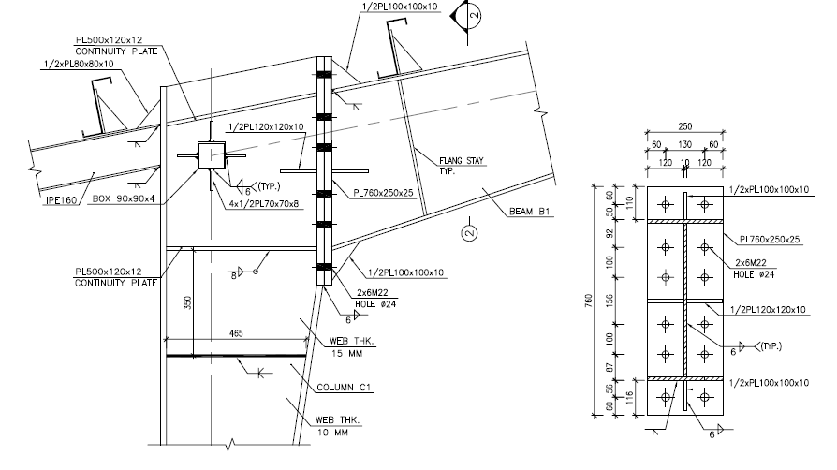

**Input Data:**

Connection Type: Moment End Plate of PG 550x250x20x8 (Rigid Connection)

|  |  |  |  |  |  |  |  |
| --- | --- | --- | --- | --- | --- | --- | --- |
| **Member** | **Section Name** | **d** | **Bf** | **tf** | **tw** | **Area** | **Z33** |
| cm | cm | cm | cm | cm2 | cm3 |
| Beam | PG 500x300x12x8 | 52.4 | 30 | 1.2 | 1 | 122 | 2468.2 |
| Column | PG 500x300x20x10 | 54 | 30 | 2 | 1 | 170 | 3745 |

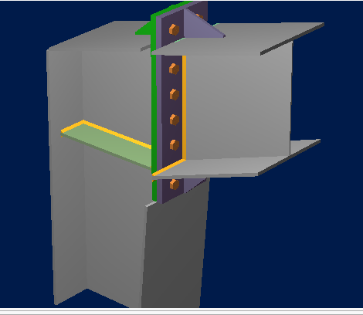

Design Load: (Based on Capacity of Member)

According to AISC360-16:

$M_{pr}=Z_{3-3}F_{y}=2468*2400=5923200 kgf-cm$ (F2-1)

$M_{u}=1.1RyMpr=1.1*1.15*5923200=7492848 kgf-cm$

$$V_{u}=\frac{{2M}_{u}}{L_{B}}=\frac{2*7492848}{600}=24976 kgf$$

|  |  |  |
| --- | --- | --- |
| Load | Vu | Mu |
| Unit(Ton, m) | 21.42 | $$64.25$$ |



**Current Date:** 10/16/2023 10:47 AM

**Units system:** SI

Steel connections

**Results**

**Connection name : MEP_KNEE_BCF_VERTICAL_EU_1/4_PL_2B_1B1/2**

**Connection ID : 1**

Family: Beam - Column flange (BCF)

Type: Knee moment end plate

Design code: AISC 360-16 LRFD

**DEMANDS**

Beam Right beam Left beam Column Panel

**Description Ru Pu Mu PufTop PufBot PufTop PufBot Pu Vu Load type**

[kN] [kN] [kN*m] [kN] [kN] [kN] [kN] [kN] [kN]

DL 105.13 20.44 321.25 -648.46 668.89 0.00 0.00 0.00 668.89 Design

**GEOMETRIC CONSIDERATIONS**

**Dimensions Unit Value Min. value Max. value Sta. References**

Extended end plate

End plate stiffener thickness [mm] 12.00 8.00 --  DG4 Eq. 3.15,

AISC 358-10 Eq. 6.10-9,

Eq. 6.10-10

Vertical edge distance [mm] 60.00 29.94 152.40  Sec. J3.5

Horizontal edge distance [mm] 60.00 29.94 152.40  Sec. J3.5

Vertical bolt spacing (external flange) [mm] 100.00 58.67 --  Sec. J3.3

Vertical bolt spacing (internal flange) [mm] 100.00 58.67 --  Sec. J3.3

Horizontal center-to-center spacing (gage) [mm] 130.00 58.67 250.00  Sec. J3.3,

DG4 Sec. 2.4,

DG4 Sec. 2.1,

2.4,

DG16 Sec. 2.5

Outer bolt distance (external flange) [mm] 50.00 34.70 --  DG4 Sec. 2.1

Inner bolt distance (external flange) [mm] 87.00 34.70 --  DG4 Sec. 2.1

Outer bolt distance (internal flange) [mm] 60.00 34.70 --  DG4 Sec. 2.1

Inner bolt distance (internal flange) [mm] 87.00 34.70 --  DG4 Sec. 2.1

Bolt diameter [mm] 22.00 -- 38.10  DG4 Sec. 1.1

- Use CJP weld for the end plate stiffener

Beam

Weld size (internal flange) [1/16in] 6 3 --  table J2.4

Web [1/16in] 6 3 --  table J2.4

Support

Horizontal edge distance [mm] 60.00 28.35 152.40  Sec. J3.5

**PLATE / COLUMN BEHAVIOR**

End plate behaviour (external flange)

Thin plate behavior controlled by bolt rupture with prying action

End plate behaviour (internal flange)

Thin plate behavior controlled by bolt rupture with prying action

Connection plate behavior (external flange)

Thick plate behavior controlled by no prying bolt rupture

Connection plate behavior (internal flange)

Thick plate behavior controlled by no prying bolt rupture

**DESIGN CHECK**

**Verification Unit Capacity Demand Ctrl EQ Ratio References**

Moment end plate (external flange)

Flexural yielding [KN*m] 544.80 0.00 DL **0.00** DG16 Sec 2.5

No prying bolt moment strength [KN*m] 436.28 0.00 DL **0.00** DG16 Sec 2.5

Bolt rupture with prying moment strength [KN*m] 345.01 0.00 DL **0.00** DG16 Sec 2.5

Bolts shear [KN] 608.57 105.13 DL **0.17** Tables (7-1..14)

Bolt bearing under shear load [KN] 2375.37 0.00 DL **0.00** Eq. J3-6

Shear yielding [KN] 837.71 324.23 DL **0.39** DG4 Eq. 3.12

Shear rupture [KN] 869.62 324.23 DL **0.37** DG4 Eq 3.14,

AISC 358 Eq. 6.9-12,

DG4 Eq. 3.13

Moment end plate (internal flange)

Flexural yielding [KN*m] 515.61 326.23 DL **0.63** DG16 Sec 2.5

No prying bolt moment strength [KN*m] 439.80 326.23 DL **0.74** DG16 Sec 2.5

Bolt rupture with prying moment strength [KN*m] 346.91 326.23 DL **0.94** DG16 Sec 2.5

Bolts shear [KN] 608.57 0.00 DL **0.00** Tables (7-1..14)

Bolt bearing under shear load [KN] 2375.37 105.13 DL **0.04** Eq. J3-6

Shear yielding [KN] 837.71 334.45 DL **0.40** DG4 Eq. 3.12

Shear rupture [KN] 869.62 334.45 DL **0.38** DG4 Eq 3.14,

AISC 358 Eq. 6.9-12,

DG4 Eq. 3.13

Beam

Web weld shear strength [KN] 709.31 105.13 DL **0.15** Eq. J2-4

Web weld strength to reach yield stress [KN/m] 4348.20 1787.11 DL **0.41** Eq. J2-4,

Eq. J4-1

Shear yielding [KN] 595.70 105.13 DL **0.18** Eq. J4-3

Flange weld capacity (internal flange) [KN] 1079.53 668.89 DL **0.62** Eq. J2-4

Support

Flexural yielding (external flange) [KN*m] 834.58 0.00 DL **0.00** DG4 Eq. 3.20,

Sec. 2.2.3,

DG4 Eq. 3.21

Support bolt bearing (external flange) [KN] 2662.05 0.00 DL **0.00** Eq. J3-6

Flexural yielding (internal flange) [KN*m] 1129.30 326.23 DL **0.29** DG4 Eq. 3.20,

Sec. 2.2.3,

DG4 Eq. 3.21

Support bolt bearing (internal flange) [KN] 2662.05 105.13 DL **0.04** Eq. J3-6

Support - right side

Local web yielding [KN] 1012.87 668.89 DL **0.66** DG4 eq. 3.24,

DG13 Eq. 4.3-1,

Sec. J10

Transverse stiffeners - bottom

Yielding strength due to axial load [KN] 664.81 320.83 DL **0.48** Eq. J4-1

Compression [KN] 447.36 0.00 DL **0.00** Sec. J4.4

Flange weld capacity [KN] 983.81 320.83 DL **0.33** Eq. J2-4

Web weld capacity [KN] 2509.83 320.83 DL **0.13** Eq. J2-4

**Global critical strength ratio 1.90**



**Current Date:** 10/16/2023 10:47 AM

**Units system:** SI

Steel connections

**Results**

**Connection name : MEP_KNEE_BCF_VERTICAL_EU_1/4_PL_2B_1B1/2**

**Connection ID : 1**

Family: Beam - Column flange (BCF)

Type: Knee moment end plate

Design code: AISC 360-16 LRFD

**DEMANDS**

Beam Right beam Left beam Column Panel

**Description Ru Pu Mu PufTop PufBot PufTop PufBot Pu Vu Load type**

[kN] [kN] [kN*m] [kN] [kN] [kN] [kN] [kN] [kN]

DL 105.13 20.44 321.25 -648.46 668.89 0.00 0.00 0.00 668.89 Design

**GEOMETRIC CONSIDERATIONS**

**Dimensions Unit Value Min. value Max. value Sta. References**

Extended end plate

End plate stiffener thickness [mm] 12.00 8.00 --  DG4 Eq. 3.15,

AISC 358-10 Eq. 6.10-9,

Eq. 6.10-10

tsmin = max(twb*(Fyb/Fys), (hst/0.56)*(Fys/E)1/2)

= max(8[mm]*(248.21[N/mm2]/248.21[N/mm2]), (110[mm]/0.56)*(248.21[N/mm2]/2.00E+05[N/mm2])1/2)

= **8**[mm] DG4 Eq. 3.15,

AISC 358-10 Eq. 6.10-9,

Eq. 6.10-10

Vertical edge distance [mm] 60.00 29.94 152.40  Sec. J3.5

Lemin = edmin + C2

= 28.35[mm] + 1.588[mm]

= **29.938**[mm] Tables J3.4,

J3.5

Lemax = min(12*tp, 6 [in])

= min(12*25[mm], 6 [in])

= **152.4**[mm] Sec. J3.5

Horizontal edge distance [mm] 60.00 29.94 152.40  Sec. J3.5

Lemin = edmin + C2

= 28.35[mm] + 1.588[mm]

= **29.938**[mm] Tables J3.4,

J3.5

Lemax = min(12*tp, 6 [in])

= min(12*25[mm], 6 [in])

= **152.4**[mm] Sec. J3.5

Vertical bolt spacing (external flange) [mm] 100.00 58.67 --  Sec. J3.3

smin = 8/3*d

= 8/3*22[mm]

= **58.667**[mm] Sec. J3.3

Vertical bolt spacing (internal flange) [mm] 100.00 58.67 --  Sec. J3.3

smin = 8/3*d

= 8/3*22[mm]

= **58.667**[mm] Sec. J3.3

Horizontal center-to-center spacing (gage) [mm] 130.00 58.67 250.00  Sec. J3.3,

DG4 Sec. 2.4,

DG4 Sec. 2.1,

2.4,

DG16 Sec. 2.5

gmin = Max(8/3*d, 2*k1c + 2*d, twb + 2*w + dh)

= Max(8/3*22[mm], 2*2.381[mm] + 2*22[mm], 8[mm] + 2*9.525[mm] + 26.763[mm])

= **58.667**[mm] Sec. J3.3,

DG4 Sec. 2.4

gmax = bfb

= **250**[mm] DG4 Sec. 2.1,

2.4,

DG16 Sec. 2.5

Outer bolt distance (external flange) [mm] 50.00 34.70 --  DG4 Sec. 2.1

d< = 1 [in]  22[mm]<

= 1 [in]  **True**

pfmin = d + 1/2 [in]

= 22[mm] + 1/2 [in]

= **34.7**[mm] DG4 Sec. 2.1

Inner bolt distance (external flange) [mm] 87.00 34.70 --  DG4 Sec. 2.1

d< = 1 [in]  22[mm]<

= 1 [in]  **True**

pfmin = d + 1/2 [in]

= 22[mm] + 1/2 [in]

= **34.7**[mm] DG4 Sec. 2.1

Outer bolt distance (internal flange) [mm] 60.00 34.70 --  DG4 Sec. 2.1

d< = 1 [in]  22[mm]<

= 1 [in]  **True**

pfmin = d + 1/2 [in]

= 22[mm] + 1/2 [in]

= **34.7**[mm] DG4 Sec. 2.1

Inner bolt distance (internal flange) [mm] 87.00 34.70 --  DG4 Sec. 2.1

d< = 1 [in]  22[mm]<

= 1 [in]  **True**

pfmin = d + 1/2 [in]

= 22[mm] + 1/2 [in]

= **34.7**[mm] DG4 Sec. 2.1

Bolt diameter [mm] 22.00 -- 38.10  DG4 Sec. 1.1

dbmax = 1.5 [in] DG4 Sec. 1.1

- Use CJP weld for the end plate stiffener

Beam

Weld size (internal flange) [1/16in] 6 3 --  table J2.4

wmin = wmin

= **0.004763** table J2.4

Web [1/16in] 6 3 --  table J2.4

wmin = wmin

= **0.004763** table J2.4

Support

Horizontal edge distance [mm] 60.00 28.35 152.40  Sec. J3.5

Lemin = edmin + C2

= 28.35[mm] + 0[mm]

= **28.35**[mm] Tables J3.4,

J3.5

Lemax = min(12*tp, 6 [in])

= min(12*25[mm], 6 [in])

= **152.4**[mm] Sec. J3.5

Transverse stiffeners

Length [mm] 462.30 225.00 450.00  Sec. J10.8

lsmin = (dc - 2*tcf)/2

= (500[mm] - 2*25[mm])/2

= **225**[mm] Sec. J10.8

lsmax = dc - 2*tcf

= 500[mm] - 2*25[mm]

= **450**[mm] Sec. J10.8

Width [mm] 125.00 80.95 --  Sec. J10.8

bsmin = b/3 - tw/2

= 250[mm]/3 - 4.762[mm]/2

= **80.952**[mm] Sec. J10.8

Weld size [1/16in] 6 4 --  DG 13 Eq. 4.3-6

wmin = (0.943*Fys*tp)/FEXX

= (0.943*248.21[N/mm2]*12[mm])/482.631[N/mm2]

= **5.82**[mm] DG 13 Eq. 4.3-6

**PLATE / COLUMN BEHAVIOR**

End plate behaviour (external flange)

Thin plate behavior controlled by bolt rupture with prying action

End plate behaviour (internal flange)

Thin plate behavior controlled by bolt rupture with prying action

Connection plate behavior (external flange)

Thick plate behavior controlled by no prying bolt rupture

Connection plate behavior (internal flange)

Thick plate behavior controlled by no prying bolt rupture

**DESIGN CHECK**

**Verification Unit Capacity Demand Ctrl EQ Ratio References**

Moment end plate (external flange)

Flexural yielding [KN*m] 544.80 0.00 DL **0.00** DG16 Sec 2.5

s = 0.5*(bp*g)1/2

= 0.5*(250[mm]*130[mm])1/2

= **90.139**[mm] DG16 Table 3-2

pfi = min(pfi, s)

= min(87[mm], 90.139[mm])

= **87**[mm] DG16 Table 4-2

Yp = bp/2*(h1*(1/pfi) + h2*(1/s) + h0*(1/pf0) - 1/2) + 2/g*(h1*(pfi + 0.75*pb) + h2*(s + 0.25*pb)) + g/2

= 250[mm]/2*(400.775[mm]*(1/87[mm]) + 300.775[mm]*(1/90.139[mm]) + 550[mm]*(1/50[mm]) - 1/2) + 2/130[mm]*

(400.775[mm]*(87[mm] + 0.75*100[mm]) + 300.775[mm]*(90.139[mm] + 0.25*100[mm])) + 130[mm]/2

= **3902.07**[mm] DG16 Table 4-4

Mpl = Fyp*tp2*Yp

= 248.21[N/mm2]*25[mm]2*3902.07[mm]

= **605.332**[kN*m] DG16 Sec 2.5

IsFlushConnection  **False**

r = 1 DG16 Sec 2.5

Mn = b*Mpl/r

= 0.9*605.332[kN*m]/1

= **544.799**[kN*m] DG16 Sec 2.5

No prying bolt moment strength [KN*m] 436.28 0.00 DL **0.00** DG16 Sec 2.5

Pt = Ab*Fnt

= 380.133[mm2]*620.528[N/mm2]

= **235.883**[kN] DG16 Sec 2.5

Mnp = 2*Pt*(dn)

= 2*235.883[kN]*(1233.05[mm])

= **581.713**[kN*m] DG16 Sec 2.5

Mn = *Mnp

= 0.75*581.713[kN*m]

= **436.285**[kN*m] DG16 Sec 2.5

Bolt rupture with prying moment strength [KN*m] 345.01 0.00 DL **0.00** DG16 Sec 2.5

Pt = Ab*Fnt

= 380.133[mm2]*620.528[N/mm2]

= **235.883**[kN] DG16 Sec 2.5

w' = bp/2 - (d + 1/16 [in])

= 250[mm]/2 - (22[mm] + 1/16 [in])

= **101.413**[mm] DG16 Sec 2.5

ai = 3.682*(tp/d)3 [in] - 0.085 [in]

= 3.682*(25[mm]/22[mm])3 [in] - 0.085 [in]

= **135.077**[mm] DG16 Sec 2.5

Fi' = (tp2*Fyp*(0.85*bp/2 + 0.80*w') + π*d3*Fnt/8)/(4*pfi)

= (25[mm]2*248.21[N/mm2]*(0.85*250[mm]/2 + 0.80*101.413[mm]) + π*22[mm]3*620.528[N/mm2]/8)/(4*87[mm])

= **90.986**[kN] DG16 Sec 2.5

discr = Fyp2 - 3*(Fi'/(w'*tp))2

= 248.21[N/mm2]2 - 3*(90.986[kN]/(101.413[mm]*25[mm]))2

= **5.77E+10**[kN] DG16 Sec 2.5

Qmaxi = (w'*tp2)/(4*ai)*(Fyp2 - 3*(Fi'/(w'*tp))2)1/2

= (101.413[mm]*25[mm]2)/(4*135.077[mm])*(248.21[N/mm2]2 - 3*(90.986[kN]/(101.413[mm]*25[mm]))2)1/2

= **28.189**[kN] DG16 Sec 2.5

w' = bp/2 - (d + 1/16 [in])

= 250[mm]/2 - (22[mm] + 1/16 [in])

= **101.413**[mm] DG16 Sec 2.5

Fo' = (tp2*Fyp*(0.85*bp/2 + 0.80*w') + π*d3*Fnt/8)/(4*pf0)

= (25[mm]2*248.21[N/mm2]*(0.85*250[mm]/2 + 0.80*101.413[mm]) + π*22[mm]3*620.528[N/mm2]/8)/(4*50[mm])

= **158.316**[kN] DG16 Sec 2.5

discr = Fyp2 - 3*(Fo'/(w'*tp))2

= 248.21[N/mm2]2 - 3*(158.316[kN]/(101.413[mm]*25[mm]))2

= **4.99E+10**[kN] DG16 Sec 2.5

ao = min(3.682*(tp/d)3 [in] - 0.085 [in], pext - pf0)

= min(3.682*(25[mm]/22[mm])3 [in] - 0.085 [in], 110[mm] - 50[mm])

= **60**[mm] DG16 Sec 2.5

Qmaxo = (w'*tp2)/(4*ao)*(Fyp2 - 3*(Fo'/(w'*tp))2)1/2

= (101.413[mm]*25[mm]2)/(4*60[mm])*(248.21[N/mm2]2 - 3*(158.316[kN]/(101.413[mm]*25[mm]))2)1/2

= **59**[kN] DG16 Sec 2.5

Mq = Max(2*(Pt - Qmaxo)*d0 + 2*(Pt - Qmaxi)*(d1 + d3) + 2*Tb*d2, 2*(Pt - Qmaxo)*d0 + 2*Tb*(d1 + d2 + d3), 2*(Pt - Qmaxi)*(d1 + d3) + 2*Tb*(d0 + d2), 2*Tb*(d0 + d1 + d2 + d3))

= Max(2*(235.883[kN] - 59[kN])*543.834[mm] + 2*(235.883[kN] - 28.189[kN])*(394.609[mm] + 0[mm]) + 2*

176[kN]*294.609[mm], 2*(235.883[kN] - 59[kN])*543.834[mm] + 2*176[kN]*(394.609[mm] +

294.609[mm] + 0[mm]), 2*(235.883[kN] - 28.189[kN])*(394.609[mm] + 0[mm]) + 2*176[kN]*

(543.834[mm] + 294.609[mm]), 2*176[kN]*(543.834[mm] + 394.609[mm] + 294.609[mm] + 0[mm]))

= **460.008**[kN*m] DG16 Sec 2.5

Mn = *Mq

= 0.75*460.008[kN*m]

= **345.006**[kN*m] DG16 Sec 2.5

Bolts shear [KN] 608.57 105.13 DL **0.17** Tables (7-1..14)

ksc = max(1 - Tu/(*Du*Tb*Nb), 0.0)

= max(1 - 0[kN]/(1*1.13*176[kN]*12), 0.0)

= **1** Eq. J3-5

Rn = **Du*hf*Tb*ns*ksc

= 0.85*0.3*1.13*1*176[kN]*1*1

= **50.714**[kN] Eq. J3-4

Rn = C*Rn

= 12*50.714[kN]

= **608.573**[kN] Tables (7-1..14)

Bolt bearing under shear load [KN] 2375.37 0.00 DL **0.00** Eq. J3-6

Lc-end = Max(0.0, Le - dh/2)

= Max(0.0, 60[mm] - 26.763[mm]/2)

= **46.619**[mm] Sec. J3.10

Lc-spa = Max(0.0, s - dh)

= Max(0.0, 100[mm] - 26.763[mm])

= **73.238**[mm] Sec. J3.10

Rn = *(min(k1*Lc-end, k2*d) + min(k1*Lc-spa, k2*d)*(n - 1))*tp*Fu*nc

= 0.75*(min(1.2*46.619[mm], 2.4*22[mm]) + min(1.2*73.238[mm], 2.4*22[mm])*(3 - 1))*25[mm]*399.894[N/mm2]*2

= **2375.37**[kN] Eq. J3-6

Shear yielding [KN] 837.71 324.23 DL **0.39** DG4 Eq. 3.12

Rn = *0.6*Fyp*bp*tp

= 0.9*0.6*248.21[N/mm2]*250[mm]*25[mm]

= **837.709**[kN] DG4 Eq. 3.12

Shear rupture [KN] 869.62 324.23 DL **0.37** DG4 Eq 3.14,

AISC 358 Eq. 6.9-12,

DG4 Eq. 3.13

Lh = dh + 1/16 [in]

= 26.763[mm] + 1/16 [in]

= **28.35**[mm] Sec. D3-2

An = (bp - 2*Lh)*tp

= (250[mm] - 2*28.35[mm])*25[mm]

= **4832.5**[mm2] DG4 Eq 3.14,

AISC 358 Eq. 6.9-12

Rn = *0.6*Fup*An

= 0.75*0.6*399.894[N/mm2]*4832.5[mm2]

= **869.619**[kN] DG4 Eq. 3.13

Moment end plate (internal flange)

Flexural yielding [KN*m] 515.61 326.23 DL **0.63** DG16 Sec 2.5

s = 0.5*(bp*g)1/2

= 0.5*(250[mm]*130[mm])1/2

= **90.139**[mm] DG16 Table 3-2

pfi = min(pfi, s)

= min(87[mm], 90.139[mm])

= **87**[mm] DG16 Table 4-2

Yp = bp/2*(h1*(1/pfi) + h2*(1/s) + h0*(1/pf0) - 1/2) + 2/g*(h1*(pfi + 0.75*pb) + h2*(s + 0.25*pb)) + g/2

= 250[mm]/2*(400.668[mm]*(1/87[mm]) + 300.668[mm]*(1/90.139[mm]) + 560[mm]*(1/60[mm]) - 1/2) + 2/130[mm]*

(400.668[mm]*(87[mm] + 0.75*100[mm]) + 300.668[mm]*(90.139[mm] + 0.25*100[mm])) + 130[mm]/2

= **3692.97**[mm] DG16 Table 4-4

Mpl = Fyp*tp2*Yp

= 248.21[N/mm2]*25[mm]2*3692.97[mm]

= **572.895**[kN*m] DG16 Sec 2.5

IsFlushConnection  **False**

r = 1 DG16 Sec 2.5

Mn = b*Mpl/r

= 0.9*572.895[kN*m]/1

= **515.606**[kN*m] DG16 Sec 2.5

No prying bolt moment strength [KN*m] 439.80 326.23 DL **0.74** DG16 Sec 2.5

Pt = Ab*Fnt

= 380.133[mm2]*620.528[N/mm2]

= **235.883**[kN] DG16 Sec 2.5

Mnp = 2*Pt*(dn)

= 2*235.883[kN]*(1243[mm])

= **586.405**[kN*m] DG16 Sec 2.5

Mn = *Mnp

= 0.75*586.405[kN*m]

= **439.804**[kN*m] DG16 Sec 2.5

Bolt rupture with prying moment strength [KN*m] 346.91 326.23 DL **0.94** DG16 Sec 2.5

Pt = Ab*Fnt

= 380.133[mm2]*620.528[N/mm2]

= **235.883**[kN] DG16 Sec 2.5

w' = bp/2 - (d + 1/16 [in])

= 250[mm]/2 - (22[mm] + 1/16 [in])

= **101.413**[mm] DG16 Sec 2.5

ai = 3.682*(tp/d)3 [in] - 0.085 [in]

= 3.682*(25[mm]/22[mm])3 [in] - 0.085 [in]

= **135.077**[mm] DG16 Sec 2.5

Fi' = (tp2*Fyp*(0.85*bp/2 + 0.80*w') + π*d3*Fnt/8)/(4*pfi)

= (25[mm]2*248.21[N/mm2]*(0.85*250[mm]/2 + 0.80*101.413[mm]) + π*22[mm]3*620.528[N/mm2]/8)/(4*87[mm])

= **90.986**[kN] DG16 Sec 2.5

discr = Fyp2 - 3*(Fi'/(w'*tp))2

= 248.21[N/mm2]2 - 3*(90.986[kN]/(101.413[mm]*25[mm]))2

= **5.77E+10**[kN] DG16 Sec 2.5

Qmaxi = (w'*tp2)/(4*ai)*(Fyp2 - 3*(Fi'/(w'*tp))2)1/2

= (101.413[mm]*25[mm]2)/(4*135.077[mm])*(248.21[N/mm2]2 - 3*(90.986[kN]/(101.413[mm]*25[mm]))2)1/2

= **28.189**[kN] DG16 Sec 2.5

w' = bp/2 - (d + 1/16 [in])

= 250[mm]/2 - (22[mm] + 1/16 [in])

= **101.413**[mm] DG16 Sec 2.5

Fo' = (tp2*Fyp*(0.85*bp/2 + 0.80*w') + π*d3*Fnt/8)/(4*pf0)

= (25[mm]2*248.21[N/mm2]*(0.85*250[mm]/2 + 0.80*101.413[mm]) + π*22[mm]3*620.528[N/mm2]/8)/(4*60[mm])

= **131.93**[kN] DG16 Sec 2.5

discr = Fyp2 - 3*(Fo'/(w'*tp))2

= 248.21[N/mm2]2 - 3*(131.93[kN]/(101.413[mm]*25[mm]))2

= **5.35E+10**[kN] DG16 Sec 2.5

ao = min(3.682*(tp/d)3 [in] - 0.085 [in], pext - pf0)

= min(3.682*(25[mm]/22[mm])3 [in] - 0.085 [in], 120[mm] - 60[mm])

= **60**[mm] DG16 Sec 2.5

Qmaxo = (w'*tp2)/(4*ao)*(Fyp2 - 3*(Fo'/(w'*tp))2)1/2

= (101.413[mm]*25[mm]2)/(4*60[mm])*(248.21[N/mm2]2 - 3*(131.93[kN]/(101.413[mm]*25[mm]))2)1/2

= **61.077**[kN] DG16 Sec 2.5

Mq = Max(2*(Pt - Qmaxo)*d0 + 2*(Pt - Qmaxi)*(d1 + d3) + 2*Tb*d2, 2*(Pt - Qmaxo)*d0 + 2*Tb*(d1 + d2 + d3), 2*(Pt - Qmaxi)*(d1 + d3) + 2*Tb*(d0 + d2), 2*Tb*(d0 + d1 + d2 + d3))

= Max(2*(235.883[kN] - 61.077[kN])*553.888[mm] + 2*(235.883[kN] - 28.189[kN])*(394.556[mm] + 0[mm]) + 2*

176[kN]*294.556[mm], 2*(235.883[kN] - 61.077[kN])*553.888[mm] + 2*176[kN]*(394.556[mm] +

294.556[mm] + 0[mm]), 2*(235.883[kN] - 28.189[kN])*(394.556[mm] + 0[mm]) + 2*176[kN]*

(553.888[mm] + 294.556[mm]), 2*176[kN]*(553.888[mm] + 394.556[mm] + 294.556[mm] + 0[mm]))

= **462.546**[kN*m] DG16 Sec 2.5

Mn = *Mq

= 0.75*462.546[kN*m]

= **346.909**[kN*m] DG16 Sec 2.5

Bolts shear [KN] 608.57 0.00 DL **0.00** Tables (7-1..14)

ksc = max(1 - Tu/(*Du*Tb*Nb), 0.0)

= max(1 - 0[kN]/(1*1.13*176[kN]*12), 0.0)

= **1** Eq. J3-5

Rn = **Du*hf*Tb*ns*ksc

= 0.85*0.3*1.13*1*176[kN]*1*1

= **50.714**[kN] Eq. J3-4

Rn = C*Rn

= 12*50.714[kN]

= **608.573**[kN] Tables (7-1..14)

Bolt bearing under shear load [KN] 2375.37 105.13 DL **0.04** Eq. J3-6

Lc-end = Max(0.0, Le - dh/2)

= Max(0.0, 60[mm] - 26.763[mm]/2)

= **46.619**[mm] Sec. J3.10

Lc-spa = Max(0.0, s - dh)

= Max(0.0, 100[mm] - 26.763[mm])

= **73.238**[mm] Sec. J3.10

Rn = *(min(k1*Lc-end, k2*d) + min(k1*Lc-spa, k2*d)*(n - 1))*tp*Fu*nc

= 0.75*(min(1.2*46.619[mm], 2.4*22[mm]) + min(1.2*73.238[mm], 2.4*22[mm])*(3 - 1))*25[mm]*399.894[N/mm2]*2

= **2375.37**[kN] Eq. J3-6

Shear yielding [KN] 837.71 334.45 DL **0.40** DG4 Eq. 3.12

Rn = *0.6*Fyp*bp*tp

= 0.9*0.6*248.21[N/mm2]*250[mm]*25[mm]

= **837.709**[kN] DG4 Eq. 3.12

Rn = *0.6*Fyp*bp*tp

= 0.9*0.6*248.21[N/mm2]*250[mm]*25[mm]

= **837.709**[kN] DG4 Eq. 3.12

Shear rupture [KN] 869.62 334.45 DL **0.38** DG4 Eq 3.14,

AISC 358 Eq. 6.9-12,

DG4 Eq. 3.13

Lh = dh + 1/16 [in]

= 26.763[mm] + 1/16 [in]

= **28.35**[mm] Sec. D3-2

An = (bp - 2*Lh)*tp

= (250[mm] - 2*28.35[mm])*25[mm]

= **4832.5**[mm2] DG4 Eq 3.14,

AISC 358 Eq. 6.9-12

Rn = *0.6*Fup*An

= 0.75*0.6*399.894[N/mm2]*4832.5[mm2]

= **869.619**[kN] DG4 Eq. 3.13

Beam

Web weld shear strength [KN] 709.31 105.13 DL **0.15** Eq. J2-4

Fw = 0.6*FEXX

= 0.6*482.631[N/mm2]

= **289.578**[N/mm2] Sec. J2.4

Aw = (2)1/2/2*D/16 [in]*L

= (2)1/2/2*6/16 [in]*242.455[mm]

= **1632.98**[mm2] Sec. J2.4

Rn = 2 * (*Fw*Aw)

= 2 * (0.75*289.578[N/mm2]*1632.98[mm2])

= **709.313**[kN] Eq. J2-4

Web weld strength to reach yield stress [KN/m] 4348.20 1787.11 DL **0.41** Eq. J2-4,

Eq. J4-1

LoadAngleFactor = 1 + 0.5*(sin())1.5

= 1 + 0.5*(sin(1.379))1.5

= **1.486** p. 8-9

Fw = 0.6*FEXX*LoadAngleFactor

= 0.6*482.631[N/mm2]*1.486

= **430.396**[N/mm2] Sec. J2.5

Rw = 2 * (*Fw*(2)1/2/2*D/16 [in])

= 2 * (0.75*430.396[N/mm2]*(2)1/2/2*6/16 [in])

= **4.348**[kN/mm] Eq. J2-4

Rn = *Fy*tw

= 0.9*248.21[N/mm2]*8[mm]

= **1.787**[kN/mm] Eq. J4-1

Shear yielding [KN] 595.70 105.13 DL **0.18** Eq. J4-3

Ag = Lp*tp

= 500[mm]*8[mm]

= **4000**[mm2] Sec. D3-1

Rn = *0.60*Fy*Ag

= 1*0.60*248.21[N/mm2]*4000[mm2]

= **595.704**[kN] Eq. J4-3

Flange weld capacity (internal flange) [KN] 1079.53 668.89 DL **0.62** Eq. J2-4

LoadAngleFactor = 1 + 0.5*(sin())1.5

= 1 + 0.5*(sin(1.571))1.5

= **1.5** p. 8-9

Fw = 0.6*FEXX*LoadAngleFactor

= 0.6*482.631[N/mm2]*1.5

= **434.367**[N/mm2] Sec. J2.5

Aw = (2)1/2/2*D/16 [in]*L

= (2)1/2/2*6/16 [in]*492[mm]

= **3313.71**[mm2] Sec. J2.4

Rn = *Fw*Aw

= 0.75*434.367[N/mm2]*3313.71[mm2]

= **1079.53**[kN] Eq. J2-4

Support

Flexural yielding (external flange) [KN*m] 834.58 0.00 DL **0.00** DG4 Eq. 3.20,

Sec. 2.2.3,

DG4 Eq. 3.21

c = pf0 + pfi + tbf

= 50[mm] + 87[mm] + 12.225[mm]

= **149.225**[mm] DG4 Table 3.4,

AISC 358 Table 6.5

s = 0.5*(bp*g)1/2

= 0.5*(250[mm]*130[mm])1/2

= **90.139**[mm] DG16 Table 3-2

Yc = bcf/2*(h0*(1/s) + h2*(1/s)) + 2/g*(h0*(s + c) + h1*(pb) + h2*(s)) + g/2

= 250[mm]/2*(550[mm]*(1/90.139[mm]) + 300.775[mm]*(1/90.139[mm])) + 2/130[mm]*(550[mm]*(90.139[mm] +

149.225[mm]) + 400.775[mm]*(100[mm]) + 300.775[mm]*(90.139[mm])) + 130[mm]/2

= **4303.87**[mm] Yield line Meth.

Mn = Fyc*Yc*tcf2

= 344.736[N/mm2]*4303.87[mm]*25[mm]2

= **927.313**[kN*m] DG4 Eq. 3.20,

Sec. 2.2.3

Mn = *Mn

= 0.9*927.313[kN*m]

= **834.582**[kN*m] DG4 Eq. 3.21

Support bolt bearing (external flange) [KN] 2662.05 0.00 DL **0.00** Eq. J3-6

Lc-end = Max(0.0, Le - dh/2)

= Max(0.0, 100[mm] - 23.588[mm]/2)

= **88.206**[mm] Sec. J3.10

Lc-spa = Max(0.0, s - dh)

= Max(0.0, 100[mm] - 23.588[mm])

= **76.413**[mm] Sec. J3.10

Rn = *(min(k1*Lc-end, k2*d) + min(k1*Lc-spa, k2*d)*(n - 1))*tp*Fu*nc

= 0.75*(min(1.2*88.206[mm], 2.4*22[mm]) + min(1.2*76.413[mm], 2.4*22[mm])*(3 - 1))*25[mm]*448.157[N/mm2]*2

= **2662.05**[kN] Eq. J3-6

Flexural yielding (internal flange) [KN*m] 1129.30 326.23 DL **0.29** DG4 Eq. 3.20,

Sec. 2.2.3,

DG4 Eq. 3.21

psi = pfi + tfb/2 - ts/2

= 87[mm] + 12.332[mm]/2 - 12[mm]/2

= **87.166**[mm] DG4 Table 3.4

ps0 = pf0 + tfb/2 - ts/2

= 60[mm] + 12.332[mm]/2 - 12[mm]/2

= **60.166**[mm] DG4 Table 3.4

c = pf0 + pfi + tbf

= 60[mm] + 87[mm] + 12.332[mm]

= **159.332**[mm] DG4 Table 3.4,

AISC 358 Table 6.5

s = 0.5*(bp*g)1/2

= 0.5*(250[mm]*130[mm])1/2

= **90.139**[mm] DG16 Table 3-2

Yc = bcf/2*(h1*(1/psi) + h2*(1/s) + h0*(1/ps0 + 1/s)) + 2/g*(h1*(psi + 3*pb/4) + h2*(s + pb/4) + h0*(s + ps0)) + g/2

= 250[mm]/2*(400.668[mm]*(1/87.166[mm]) + 300.668[mm]*(1/90.139[mm]) + 560[mm]*(1/60.166[mm] + 1/

90.139[mm])) + 2/130[mm]*(400.668[mm]*(87.166[mm] + 3*100[mm]/4) + 300.668[mm]*(90.139[mm] +

100[mm]/4) + 560[mm]*(90.139[mm] + 60.166[mm])) + 130[mm]/2

= **5823.69**[mm] Yield line Meth.

Mn = Fyc*Yc*tcf2

= 344.736[N/mm2]*5823.69[mm]*25[mm]2

= **1254.77**[kN*m] DG4 Eq. 3.20,

Sec. 2.2.3

Mn = *Mn

= 0.9*1254.77[kN*m]

= **1129.3**[kN*m] DG4 Eq. 3.21

Support bolt bearing (internal flange) [KN] 2662.05 105.13 DL **0.04** Eq. J3-6

Lc-end = Max(0.0, Le - dh/2)

= Max(0.0, 100[mm] - 23.588[mm]/2)

= **88.206**[mm] Sec. J3.10

Lc-spa = Max(0.0, s - dh)

= Max(0.0, 100[mm] - 23.588[mm])

= **76.413**[mm] Sec. J3.10

Rn = *(min(k1*Lc-end, k2*d) + min(k1*Lc-spa, k2*d)*(n - 1))*tp*Fu*nc

= 0.75*(min(1.2*88.206[mm], 2.4*22[mm]) + min(1.2*76.413[mm], 2.4*22[mm])*(3 - 1))*25[mm]*448.157[N/mm2]*2

= **2662.05**[kN] Eq. J3-6

Panel web shear [KN] 352.23 668.89 DL **1.90** Sec. G1

kvLimit = (av/h>3.0) or (av/h>(260.0/(h/tw))2.0)

= (500[mm]/500[mm]>3.0) or (500[mm]/500[mm]>(260.0/(500[mm]/4.762[mm]))2.0)

= **False** Sec. G2.1

kv = 5.0 + 5.0/(av/h)2.0

= 5.0 + 5.0/(500[mm]/500[mm])2.0

= **10** Sec. G2.1

CvLimit = h/tw<1.10*(kv*E/Fy)1/2

= 500[mm]/4.762[mm]<1.10*(10*2.00E+05[N/mm2]/344.736[N/mm2])1/2

= **False** Sec. G2.1

CvLimit = (h/tw>1.10*(kv*E/Fy)1/2) and (h/tw<=1.37*(kv*E/Fy)1/2)

= (500[mm]/4.762[mm]>1.10*(10*2.00E+05[N/mm2]/344.736[N/mm2])1/2) and (500[mm]/4.762[mm]<

= 1.37*(10*2.00E+05[N/mm2]/344.736[N/mm2])1/2)

= **False** Sec. G2.1

CvLimit = h/tw>1.37*(kv*E/Fy)1/2

= 500[mm]/4.762[mm]>1.37*(10*2.00E+05[N/mm2]/344.736[N/mm2])1/2

= **True** Sec. G2.1

Cv = 1.51*E*kv/((h/tw)2*Fy)

= 1.51*2.00E+05[N/mm2]*10/((500[mm]/4.762[mm])2*344.736[N/mm2])

= **0.795** Sec. G2.1

kvLimit = (av/h>3.0) or (av/h>(260.0/(h/tw))2.0)

= (500[mm]/500[mm]>3.0) or (500[mm]/500[mm]>(260.0/(500[mm]/4.762[mm]))2.0)

= **False** Sec. G2.1

kv = 5.0 + 5.0/(av/h)2.0

= 5.0 + 5.0/(500[mm]/500[mm])2.0

= **10** Sec. G2.1

h/tw< = 1.10*(kv*E/Fy)1/2  500[mm]/4.762[mm]<

= 1.10*(10*2.00E+05[N/mm2]/344.736[N/mm2])1/2  **False**

Vn = 0.6*av*tw*Fy*Cv

= 0.6*500[mm]*4.762[mm]*344.736[N/mm2]*0.795

= **391.361**[kN] Sec. G2.1

Vn = *Vn

= 0.9*391.361[kN]

= **352.225**[kN] Sec. G1

Support - right side

Local web yielding [KN] 1012.87 668.89 DL **0.66** DG4 eq. 3.24,

DG13 Eq. 4.3-1,

Sec. J10

IsBeamReaction  **False**

lb = N

= **12**[mm] Sec. J10-2

IsMemberEnd  **False**

Rn = *(1*(6*k + 2*tp) + N)*Fyw*tw

= 1*(1*(6*25[mm] + 2*25[mm]) + 12[mm])*344.736[N/mm2]*4.762[mm]

= **348.063**[kN] DG4 eq. 3.24

Ast = tp*(bs - clip)

= 12[mm]*(125[mm] - 1[mm])

= **1488**[mm2] DG13 Sec. 4.3

Rnts = 2 * (*Fy*Ast)

= 2 * (0.9*248.21[N/mm2]*1488[mm2])

= **664.806**[kN] DG13 Eq. 4.3-1

Rn = Rn + Rnts

= 348.063[kN] + 664.806[kN]

= **1012.87**[kN] Sec. J10

Transverse stiffeners - bottom

Yielding strength due to axial load [KN] 664.81 320.83 DL **0.48** Eq. J4-1

Ag = 2 * ((bs - clip)*tp)

= 2 * ((125[mm] - 1[mm])*12[mm])

= **2976**[mm2] Sec. D3.1

Rn = *Fy*Ag

= 0.9*248.21[N/mm2]*2976[mm2]

= **664.806**[kN] Eq. J4-1

Compression [KN] 447.36 0.00 DL **0.00** Sec. J4.4

r = tp/(12)1/2

= 12[mm]/(12)1/2

= **3.464**[mm] Sec. E2

Ag = Lp*tp

= 124[mm]*12[mm]

= **1488**[mm2] Sec. D3-1

K*L/r>25  0.65*462.3[mm]/3.464[mm]>25  **True**

Fe = π2*E/(K*L/r)2

= π2*2.00E+05[N/mm2]/(0.65*462.3[mm]/3.464[mm])2

= **262.253**[N/mm2] Eq. E3-4

Fe> = 0.44*Q*Fy  262.253[N/mm2]>

= 0.44*1*248.21[N/mm2]  **True**

Fcr = 0.658(Q*Fy/Fe)*Fy

= 0.658(1*248.21[N/mm2]/262.253[N/mm2])*248.21[N/mm2]

= **167.024**[N/mm2] Eq. E7-2

Pn = 2 * (*Fcr*Ag)

= 2 * (0.9*167.024[N/mm2]*1488[mm2])

= **447.357**[kN] Sec. J4.4

Flange weld capacity [KN] 983.81 320.83 DL **0.33** Eq. J2-4

L = bst - clip - w

= 122.619[mm] - 1[mm] - 9.525[mm]

= **112.094**[mm] Comm. J10.8

LoadAngleFactor = 1 + 0.5*(sin())1.5

= 1 + 0.5*(sin(1.571))1.5

= **1.5** p. 8-9

Fw = 0.6*FEXX*LoadAngleFactor

= 0.6*482.631[N/mm2]*1.5

= **434.367**[N/mm2] Sec. J2.5

Aw = (2)1/2/2*D/16 [in]*L

= (2)1/2/2*6/16 [in]*112.094[mm]

= **754.973**[mm2] Sec. J2.4

Rn = 4 * (*Fw*Aw)

= 4 * (0.75*434.367[N/mm2]*754.973[mm2])

= **983.807**[kN] Eq. J2-4

Web weld capacity [KN] 2509.83 320.83 DL **0.13** Eq. J2-4

L = l - 2.0*clip - 2.0*w

= 450[mm] - 2.0*1[mm] - 2.0*9.525[mm]

= **428.95**[mm] Comm. J10.8

Fw = 0.6*FEXX

= 0.6*482.631[N/mm2]

= **289.578**[N/mm2] Sec. J2.4

Aw = (2)1/2/2*D/16 [in]*L

= (2)1/2/2*6/16 [in]*428.95[mm]

= **2889.06**[mm2] Sec. J2.4

Rn = 4 * (*Fw*Aw)

= 4 * (0.75*289.578[N/mm2]*2889.06[mm2])

= **2509.83**[kN] Eq. J2-4

**Global critical strength ratio 1.90**

**NOTATION**

Ab: Nominal bolt area

Ag: Gross area

ai: Distance from the interior bolt centerline to the prying force

An: Net area

ao: Distance from the outer bolt centerline to the prying force

Ast: Transverse stiffener cross-sectional area

av: Clear distance between transverse stiffeners

Aw: Effective area of the weld

b: Plate, connector or member width

bcf: Width of column flange

bfb: Beam flange breadth

bp: Plate width

bs: Transverse stiffener width

bsmin: Minimum transverse stiffener width

bst: Contact length between transverse stiffener and support flange

N: Bearing length

C: Bolt group coefficient

C2: Edge distance increment

c: Vertical bolt spacing

Cv: Web shear coefficient

clip: Transverse stiffener corner clip dimension

CvLimit: Limit for the calculation of the web shear coefficient

d: Nominal bolt diameter

d0: Distance from the center of the beam compression flange to the outer bolt centerline in extended end-plate configurations

d1: Distance from the center of the beam compression flange to the farthest inner load-carrying bolt centerline

d2: Distance from the center of the beam compression flange to the second farthest inner load-carrying bolt centerline

d3: Distance from the center of the beam compression flange to the third farthest inner load-carrying bolt centerline

dbmax: Maximum bolt diameter

dh: Nominal hole dimension

Du: Bolt pretension ratio

d: Beam depth

dc: Column depth

discr: Discriminant under the root sign for the calculation of Qmaxi, Qmaxo

D: Number of sixteenths of an inch in the weld size

E: Elastic modulus

Fcr: Critical stress, flexural stress buckling

Fe: Elastic critical buckling stress

FEXX: Electrode classification number

Fnt: Nominal tensile stress

Fi': Flange force per bolt at the thin plate limit when calculating Qmaxi for end-plate configurations with large inner pitch distances

Fo': Flange force per bolt at the thin plate limit when calculating Qmaxo for end-plate configurations with large inner pitch distances

Fu: Specified minimum tensile strength

Fup: Specified minimum tensile strength of the plate

Fw: Nominal strength of the weld metal per unit area

Fy: Specified minimum yield stress

Fyb: Specified minimum yield stress of beam, plate or branch material

Fyc: Specified minimum yield stress of column material

Fyp: Specified minimum yield stress of plate

Fys: Specified minimum yield stress of stiffener material

Fyw: Specified minimum yield stress of web

g: Transversal gage between bolts

gmax: Maximum bolt gage

gmin: Minimum bolt gage

r: Load factor to limit connection rotation at ultimate moment to 10% of simple span rotation

h: Clear distance between flanges

h0: Distance from the compression side of the beam to the outer bolt centerline in extended end-plate configurations

h1: Distance from the compression side of the beam to the farthest inner load-carrying bolt line

h2: Distance from the compression side of the beam to the second farthest inner load-carrying bolt line

hf: Factor for fillers

hst: Stiffener height

IsBeamReaction: Is beam reaction

IsFlushConnection: Is flush connection

IsMemberEnd: Is member end

K: Effective length factor

k1: Bearing factor

k1c: Distance from column web centerline to flange toe of fillet

k2: Bearing factor

k: Outside corner radius

ksc: Slip resistance factor

kv: Web plate buckling coefficient

kvLimit: Limit of the clear distance between stiffeners to clear distance between flanges ratio

l: Length

L: Length

lb: Bearing length

Lc-end: Clear distance

Le: Edge distance

Lemax: Maximum edge distance

Lemin: Minimum edge distance

Lh: Hole dimension for tension and shear net area

Lp: Plate length

lsmin: Stiffener minimum length

L: Length of weld

LoadAngleFactor: Load angle factor

Mn: Nominal moment

Mnp: No prying moment

Mpl: End plate or column flange flexural strength

Mq: Connection strength for the limit state of bolt fracture with prying action

edmin: Minimum edge distance

: Mean slip coefficient

n: Bolts rows number

N: Bearing length

Nb: Number of bolts carrying the applied tension

nc: Number of bolt columns

ns: Number of slip planes

pb: Pitch between the inner and the outer row of bolts

pext: End-plate extension beyond the exterior face of the beam tension flange

pf0: Distance from the inside of a beam tension flange to the nearest outside bolt row

pfi: Distance from the inside of a beam tension flange to the nearest inside bolt row

pfmin: Minimum distance from the inside of a beam tension flange to the nearest inside bolt row

ps0: Distance from the outside face of column stiffener to the nearest outside bolt row

psi: Distance from the inside face of column stiffener to the nearest inside bolt row

Pt: Bolt tensile strength

: Design factors

b: Design factor for bending

Mn: Design or allowable strength

Pn: Design or allowable strength

Rn: Design or allowable strength

Rn: Design or allowable strength per unit length

Rnts: Transverse stiffener design or allowable strength

Rw: Fillet weld capacity per unit length

Vn: Design or allowable shear strength

Q: Prying action coefficient

Qf: Chord stress interaction parameter

Qmaxi: Maximum possible prying force for interior bolts

Qmaxo: Maximum possible prying force for outer bolts

r: Radius of gyration

s: Distance from the most inside or outside tension bolt row to the edge of a yield line

smin: Minimum spacing

s: Longitudinal bolt spacing

Lc-spa: Distance between adjacent holes edges

dn: Sum of all distances from centerline of compression flange to the nth bolt row

tp: Thickness of the connected material

Tb: Minimum fastener pretension

tbf: Thickness of the flange

tcf: Thickness of the column flange

tf: Thickness of the loaded flange

tfb: Beam flange thickness

tp: Plate thickness

ts: Column stiffener thickness

tsmin: Minimum plate stiffener thickness

Tu: Tension force

tw: Web thickness

twb: Thickness of beam web

: Load angle

ThickPlateSmallerBoltsBehaviorApply: Thick plate behavior controled by bolt rupturwe without prying action apply

ThinPlateYieldingApply: Thin plate behavior controlled by end-plate yielding apply

Vn: Nominal shear strength

wmin: Minimum weld size required

wmin: Minimum weld size required

w': Width of end-plate per bolt minus the bolt hole diameter

w: Weld size

Yc: Column yield line mechanism parameter

Yp: Yield line mechanism parameter

lsmax: Stiffener maximum length

* 1. **Beam to Beam:**

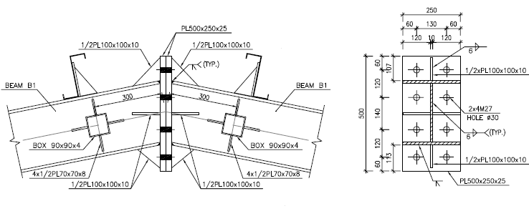

**Input Data:**

Connection Type: Moment End Plate of PG 250x250x20x8 ( Rigid Connection )

|  |  |  |  |  |  |  |  |
| --- | --- | --- | --- | --- | --- | --- | --- |
| **Member** | **Section Name** | **d** | **Bf** | **tf** | **tw** | **Area** | **Z33** |
| cm | cm | cm | cm | cm2 | cm3 |
| Beam | PG 250x250x12x8 | 27.4 | 25 | 1.2 | 0.8 | 84.48 | 1141.272 |
| Beam | PG 250x250x12x8 | 27.4 | 25 | 1.2 | 0.8 | 84.48 | 1141.272 |

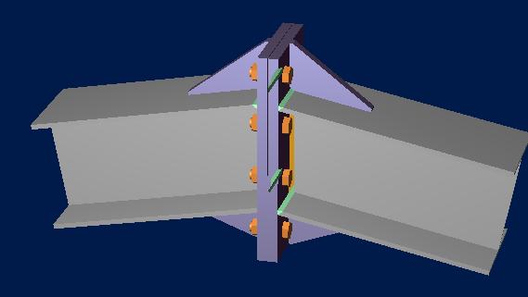

Design Load: (Based on Capacity of Member)

According to AISC360-16:

$M_{pr}=Z_{3-3}F_{y}=1141.272*2400=2739053kgf-cm$ (F2-1)

$M_{u}=1.1RyMpr=1.1*1.15*2739053=3464902 kgf-cm$

$$V_{u}=\frac{{2M}_{u}}{L_{B}}=\frac{2*3464902 }{600}=11549.67.75kgf$$

|  |  |  |
| --- | --- | --- |
| Load | Vu | Mu |
| Unit(Ton, m) | 5.774 | $$17.324$$ |



**Current Date:** 10/16/2023 11:32 AM

**Units system:** SI

**File name:** C:\Users\n.razani\Desktop\RAM CON\RAFTER TO COL.rcnx

Steel connections

**Results**

**Connection name : MEP_BS_APEX_EU_3/8_PL_2B_1B1/2**

**Connection ID : 2**

Family: Beam splice (BS)

Type: Moment end plate

Design code: AISC 360-16 LRFD

**DEMANDS**

**Description Ru Pu Mu PufTop PufBot Load type**

[kN] [kN] [kN*m] [kN] [kN]

DL 56.68 -11.02 173.24 -654.58 643.56 Design

**GEOMETRIC CONSIDERATIONS**

**Dimensions Unit Value Min. value Max. value Sta. References**

Extended end plate

End plate stiffener thickness [mm] 25.00 8.00 --  DG4 Eq. 3.15,

AISC 358-10 Eq. 6.10-9,

Eq. 6.10-10

tsmin = max(twb*(Fyb/Fys), (hst/0.56)*(Fys/E)1/2)

= max(8[mm]*(248.21[N/mm2]/248.21[N/mm2]), (117[mm]/0.56)*(248.21[N/mm2]/2.00E+05[N/mm2])1/2)

= **8**[mm] DG4 Eq. 3.15,

AISC 358-10 Eq. 6.10-9,

Eq. 6.10-10

Vertical edge distance [mm] 60.00 30.35 152.40  Sec. J3.5

Lemin = edmin + C2

= 30.35[mm] + 0[mm]

= **30.35**[mm] Tables J3.4,

J3.5

Lemax = min(12*tp, 6 [in])

= min(12*25[mm], 6 [in])

= **152.4**[mm] Sec. J3.5

Horizontal edge distance [mm] 60.00 30.35 152.40  Sec. J3.5

Lemin = edmin + C2

= 30.35[mm] + 0[mm]

= **30.35**[mm] Tables J3.4,

J3.5

Lemax = min(12*tp, 6 [in])

= min(12*25[mm], 6 [in])

= **152.4**[mm] Sec. J3.5

Vertical bolt spacing (external flange) [mm] 129.22 64.00 --  Sec. J3.3

smin = 8/3*d

= 8/3*24[mm]

= **64**[mm] Sec. J3.3

Vertical bolt spacing (internal flange) [mm] 137.22 64.00 --  Sec. J3.3

smin = 8/3*d

= 8/3*24[mm]

= **64**[mm] Sec. J3.3

Horizontal center-to-center spacing (gage) [mm] 130.00 64.00 250.00  Sec. J3.3,

DG4 Sec. 2.4,

DG4 Sec. 2.1,

2.4,

DG16 Sec. 2.5

gmin = Max(8/3*d, 2*k1c + 2*d, twb + 2*w + dh)

= Max(8/3*24[mm], 2*0[mm] + 2*24[mm], 8[mm] + 2*9.525[mm] + 27.175[mm])

= **64**[mm] Sec. J3.3,

DG4 Sec. 2.4

gmax = bfb

= **250**[mm] DG4 Sec. 2.1,

2.4,

DG16 Sec. 2.5

Outer bolt distance (external flange) [mm] 57.00 36.70 --  DG4 Sec. 2.1

d< = 1 [in]  24[mm]<

= 1 [in]  **True**

pfmin = d + 1/2 [in]

= 24[mm] + 1/2 [in]

= **36.7**[mm] DG4 Sec. 2.1

Inner bolt distance (external flange) [mm] 60.00 36.70 --  DG4 Sec. 2.1

d< = 1 [in]  24[mm]<

= 1 [in]  **True**

pfmin = d + 1/2 [in]

= 24[mm] + 1/2 [in]

= **36.7**[mm] DG4 Sec. 2.1

Outer bolt distance (internal flange) [mm] 65.00 36.70 --  DG4 Sec. 2.1

d< = 1 [in]  24[mm]<

= 1 [in]  **True**

pfmin = d + 1/2 [in]

= 24[mm] + 1/2 [in]

= **36.7**[mm] DG4 Sec. 2.1

Inner bolt distance (internal flange) [mm] 60.00 36.70 --  DG4 Sec. 2.1

d< = 1 [in]  24[mm]<

= 1 [in]  **True**

pfmin = d + 1/2 [in]

= 24[mm] + 1/2 [in]

= **36.7**[mm] DG4 Sec. 2.1

Bolt diameter [mm] 24.00 -- 38.10  DG4 Sec. 1.1

dbmax = 1.5 [in] DG4 Sec. 1.1

- Use CJP weld for the end plate stiffener

Beam

Web [1/16in] 6 3 --  table J2.4

wmin = wmin

= **0.004763** table J2.4

**DESIGN CHECK**

**Verification Unit Capacity Demand Ctrl EQ Ratio References**

Moment end plate (external flange)

Flexural yielding [KN*m] 386.90 0.00 DL **0.00** DG16 Sec 2.5

s = 0.5*(bp*g)1/2

= 0.5*(250[mm]*130[mm])1/2

= **90.139**[mm] DG16 Table 3-2

pfi = min(pfi, s)

= min(60[mm], 90.139[mm])

= **60**[mm] DG16 Table 4-2

s> = de  90.139[mm]>

= 60[mm]  **True**

Yp = bp/2*(h1*(1/pfi + 1/s) + h0*(1/pf0 + 1/(2*s))) + 2/g*(h1*(pfi + s) + h0*(de + pf0))

= 250[mm]/2*(206.904[mm]*(1/60[mm] + 1/90.139[mm]) + 336.128[mm]*(1/57[mm] + 1/(2*90.139[mm]))) + 2/

130[mm]*(206.904[mm]*(60[mm] + 90.139[mm]) + 336.128[mm]*(60[mm] + 57[mm]))

= **2771.1**[mm] DG16 Table 4-3

Mpl = Fyp*tp2*Yp

= 248.21[N/mm2]*25[mm]2*2771.1[mm]

= **429.885**[kN*m] DG16 Sec 2.5

IsFlushConnection  **False**

r = 1 DG16 Sec 2.5

Mn = b*Mpl/r

= 0.9*429.885[kN*m]/1

= **386.896**[kN*m] DG16 Sec 2.5

No prying bolt moment strength [KN*m] 223.51 0.00 DL **0.00** DG16 Sec 2.5

Pt = Ab*Fnt

= 452.389[mm2]*620.528[N/mm2]

= **280.72**[kN] DG16 Sec 2.5

Mnp = 2*Pt*(dn)

= 2*280.72[kN]*(530.808[mm])

= **298.017**[kN*m] DG16 Sec 2.5

Mn = *Mnp

= 0.75*298.017[kN*m]

= **223.513**[kN*m] DG16 Sec 2.5

Bolts shear [KN] 505.30 56.68 DL **0.11** Tables (7-1..14)

Rn = *Fnv*Ab

= 0.75*372.317[N/mm2]*452.389[mm2]

= **126.324**[kN] Eq. J3-1

Rn = C*Rn

= 4*126.324[kN]

= **505.296**[kN] Tables (7-1..14)

Bolt bearing under shear load [KN] 1698.97 0.00 DL **0.00** Eq. J3-6

Lc-end = Max(0.0, Le - dh/2)

= Max(0.0, 60[mm] - 27.175[mm]/2)

= **46.413**[mm] Sec. J3.10

Lc-spa = Max(0.0, s - dh)

= Max(0.0, 129.225[mm] - 27.175[mm])

= **102.05**[mm] Sec. J3.10

Rn = *(min(k1*Lc-end, k2*d) + min(k1*Lc-spa, k2*d)*(n - 1))*tp*Fu*nc

= 0.75*(min(1.2*46.413[mm], 2.4*24[mm]) + min(1.2*102.05[mm], 2.4*24[mm])*(2 - 1))*25[mm]*399.894[N/mm2]*2

= **1698.97**[kN] Eq. J3-6

Shear yielding [KN] 837.71 327.29 DL **0.39** DG4 Eq. 3.12

Rn = *0.6*Fyp*bp*tp

= 0.9*0.6*248.21[N/mm2]*250[mm]*25[mm]

= **837.709**[kN] DG4 Eq. 3.12

Shear rupture [KN] 865.91 327.29 DL **0.38** DG4 Eq 3.14,

AISC 358 Eq. 6.9-12,

DG4 Eq. 3.13

Lh = dh + 1/16 [in]

= 27.175[mm] + 1/16 [in]

= **28.763**[mm] Sec. D3-2

An = (bp - 2*Lh)*tp

= (250[mm] - 2*28.763[mm])*25[mm]

= **4811.88**[mm2] DG4 Eq 3.14,

AISC 358 Eq. 6.9-12

Rn = *0.6*Fup*An

= 0.75*0.6*399.894[N/mm2]*4811.88[mm2]

= **865.908**[kN] DG4 Eq. 3.13

Moment end plate (internal flange)

Flexural yielding [KN*m] 385.08 171.77 DL **0.45** DG16 Sec 2.5

s = 0.5*(bp*g)1/2

= 0.5*(250[mm]*130[mm])1/2

= **90.139**[mm] DG16 Table 3-2

pfi = min(pfi, s)

= min(60[mm], 90.139[mm])

= **60**[mm] DG16 Table 4-2

s> = de  90.139[mm]>

= 60[mm]  **True**

Yp = bp/2*(h1*(1/pfi + 1/s) + h0*(1/pf0 + 1/(2*s))) + 2/g*(h1*(pfi + s) + h0*(de + pf0))

= 250[mm]/2*(206.904[mm]*(1/60[mm] + 1/90.139[mm]) + 344.128[mm]*(1/65[mm] + 1/(2*90.139[mm]))) + 2/

130[mm]*(206.904[mm]*(60[mm] + 90.139[mm]) + 344.128[mm]*(60[mm] + 65[mm]))

= **2758.07**[mm] DG16 Table 4-3

Mpl = Fyp*tp2*Yp

= 248.21[N/mm2]*25[mm]2*2758.07[mm]

= **427.862**[kN*m] DG16 Sec 2.5

IsFlushConnection  **False**

r = 1 DG16 Sec 2.5

Mn = b*Mpl/r

= 0.9*427.862[kN*m]/1

= **385.076**[kN*m] DG16 Sec 2.5

No prying bolt moment strength [KN*m] 226.88 171.77 DL **0.76** DG16 Sec 2.5

Pt = Ab*Fnt

= 452.389[mm2]*620.528[N/mm2]

= **280.72**[kN] DG16 Sec 2.5

Mnp = 2*Pt*(dn)

= 2*280.72[kN]*(538.808[mm])

= **302.508**[kN*m] DG16 Sec 2.5

Mn = *Mnp

= 0.75*302.508[kN*m]

= **226.881**[kN*m] DG16 Sec 2.5

Bolts shear [KN] 505.30 0.00 DL **0.00** Tables (7-1..14)

Rn = *Fnv*Ab

= 0.75*372.317[N/mm2]*452.389[mm2]

= **126.324**[kN] Eq. J3-1

Rn = C*Rn

= 4*126.324[kN]

= **505.296**[kN] Tables (7-1..14)

Bolt bearing under shear load [KN] 1698.97 56.68 DL **0.03** Eq. J3-6

Lc-end = Max(0.0, Le - dh/2)

= Max(0.0, 60[mm] - 27.175[mm]/2)

= **46.413**[mm] Sec. J3.10

Lc-spa = Max(0.0, s - dh)

= Max(0.0, 137.225[mm] - 27.175[mm])

= **110.05**[mm] Sec. J3.10

Rn = *(min(k1*Lc-end, k2*d) + min(k1*Lc-spa, k2*d)*(n - 1))*tp*Fu*nc

= 0.75*(min(1.2*46.413[mm], 2.4*24[mm]) + min(1.2*110.05[mm], 2.4*24[mm])*(2 - 1))*25[mm]*399.894[N/mm2]*2

= **1698.97**[kN] Eq. J3-6

Shear yielding [KN] 837.71 321.78 DL **0.38** DG4 Eq. 3.12

Rn = *0.6*Fyp*bp*tp

= 0.9*0.6*248.21[N/mm2]*250[mm]*25[mm]

= **837.709**[kN] DG4 Eq. 3.12

Rn = *0.6*Fyp*bp*tp

= 0.9*0.6*248.21[N/mm2]*250[mm]*25[mm]

= **837.709**[kN] DG4 Eq. 3.12

Shear rupture [KN] 865.91 321.78 DL **0.37** DG4 Eq 3.14,

AISC 358 Eq. 6.9-12,

DG4 Eq. 3.13

Lh = dh + 1/16 [in]

= 27.175[mm] + 1/16 [in]

= **28.763**[mm] Sec. D3-2

An = (bp - 2*Lh)*tp

= (250[mm] - 2*28.763[mm])*25[mm]

= **4811.88**[mm2] DG4 Eq 3.14,

AISC 358 Eq. 6.9-12

Rn = *0.6*Fup*An

= 0.75*0.6*399.894[N/mm2]*4811.88[mm2]

= **865.908**[kN] DG4 Eq. 3.13

Beam

Web weld shear strength [KN] 372.54 56.68 DL **0.15** Eq. J2-4

Fw = 0.6*FEXX

= 0.6*482.631[N/mm2]

= **289.578**[N/mm2] Sec. J2.4

Aw = (2)1/2/2*D/16 [in]*L

= (2)1/2/2*6/16 [in]*127.34[mm]

= **857.657**[mm2] Sec. J2.4

Rn = 2 * (*Fw*Aw)

= 2 * (0.75*289.578[N/mm2]*857.657[mm2])

= **372.538**[kN] Eq. J2-4

Web weld strength to reach yield stress [KN/m] 4348.20 1787.11 DL **0.41** Eq. J2-4,

Eq. J4-1

LoadAngleFactor = 1 + 0.5*(sin())1.5

= 1 + 0.5*(sin(1.763))1.5

= **1.486** p. 8-9

Fw = 0.6*FEXX*LoadAngleFactor

= 0.6*482.631[N/mm2]*1.486

= **430.396**[N/mm2] Sec. J2.5

Rw = 2 * (*Fw*(2)1/2/2*D/16 [in])

= 2 * (0.75*430.396[N/mm2]*(2)1/2/2*6/16 [in])

= **4.348**[kN/mm] Eq. J2-4

Rn = *Fy*tw

= 0.9*248.21[N/mm2]*8[mm]

= **1.787**[kN/mm] Eq. J4-1

Shear yielding [KN] 326.45 56.68 DL **0.17** Eq. J4-3

Ag = Lp*tp

= 274[mm]*8[mm]

= **2192**[mm2] Sec. D3-1

Rn = *0.60*Fy*Ag

= 1*0.60*248.21[N/mm2]*2192[mm2]

= **326.446**[kN] Eq. J4-3

**Global critical strength ratio 0.76**

**NOTATION**

Ab: Nominal bolt area

Ag: Gross area

ai: Distance from the interior bolt centerline to the prying force

An: Net area

ao: Distance from the outer bolt centerline to the prying force

Aw: Effective area of the weld

bfb: Beam flange breadth

bp: Plate width

C: Bolt group coefficient

C2: Edge distance increment

d: Nominal bolt diameter

d0: Distance from the center of the beam compression flange to the outer bolt centerline in extended end-plate configurations

d1: Distance from the center of the beam compression flange to the farthest inner load-carrying bolt centerline

d2: Distance from the center of the beam compression flange to the second farthest inner load-carrying bolt centerline

d3: Distance from the center of the beam compression flange to the third farthest inner load-carrying bolt centerline

dbmax: Maximum bolt diameter

de: Distance from the first bolt row to the top plate edge

dh: Nominal hole dimension

discr: Discriminant under the root sign for the calculation of Qmaxi, Qmaxo

D: Number of sixteenths of an inch in the weld size

E: Elastic modulus

FEXX: Electrode classification number

Fnt: Nominal tensile stress

Fnv: Nominal shear stress

Fi': Flange force per bolt at the thin plate limit when calculating Qmaxi for end-plate configurations with large inner pitch distances

Fo': Flange force per bolt at the thin plate limit when calculating Qmaxo for end-plate configurations with large inner pitch distances

Fu: Specified minimum tensile strength

Fup: Specified minimum tensile strength of the plate

Fw: Nominal strength of the weld metal per unit area

Fy: Specified minimum yield stress

Fyb: Specified minimum yield stress of beam, plate or branch material

Fyp: Specified minimum yield stress of plate

Fys: Specified minimum yield stress of stiffener material

g: Transversal gage between bolts

gmax: Maximum bolt gage

gmin: Minimum bolt gage

r: Load factor to limit connection rotation at ultimate moment to 10% of simple span rotation

h0: Distance from the compression side of the beam to the outer bolt centerline in extended end-plate configurations

h1: Distance from the compression side of the beam to the farthest inner load-carrying bolt line

hst: Stiffener height

IsFlushConnection: Is flush connection

k1: Bearing factor

k1c: Distance from column web centerline to flange toe of fillet

k2: Bearing factor

Lc-end: Clear distance

Le: Edge distance

Lemax: Maximum edge distance

Lemin: Minimum edge distance

Lh: Hole dimension for tension and shear net area

Lp: Plate length

L: Length of weld

LoadAngleFactor: Load angle factor

Mnp: No prying moment

Mpl: End plate or column flange flexural strength

Mq: Connection strength for the limit state of bolt fracture with prying action

edmin: Minimum edge distance

n: Bolts rows number

nc: Number of bolt columns

pext: End-plate extension beyond the exterior face of the beam tension flange

pf0: Distance from the inside of a beam tension flange to the nearest outside bolt row

pfi: Distance from the inside of a beam tension flange to the nearest inside bolt row

pfmin: Minimum distance from the inside of a beam tension flange to the nearest inside bolt row

Pt: Bolt tensile strength

: Design factors

b: Design factor for bending

Mn: Design or allowable strength

Rn: Design or allowable strength

Rn: Design or allowable strength per unit length

Rw: Fillet weld capacity per unit length

Qmaxi: Maximum possible prying force for interior bolts

Qmaxo: Maximum possible prying force for outer bolts

s: Distance from the most inside or outside tension bolt row to the edge of a yield line

smin: Minimum spacing

s: Longitudinal bolt spacing

Lc-spa: Distance between adjacent holes edges

dn: Sum of all distances from centerline of compression flange to the nth bolt row

tp: Thickness of the connected material

Tb: Minimum fastener pretension

tp: Plate thickness

tsmin: Minimum plate stiffener thickness

tw: Web thickness

twb: Thickness of beam web

: Load angle

ThickPlateSmallerBoltsBehaviorApply: Thick plate behavior controled by bolt rupturwe without prying action apply

wmin: Minimum weld size required

w': Width of end-plate per bolt minus the bolt hole diameter

w: Weld size

Yp: Yield line mechanism parameter

* 1. **PURLIN DESIGN**

## 13.4 Property of Purlin(Z180x2.5)



**Figure 19-**Section Property Of Purlin

According to above table :

$$A=7.80 cm2$$

$$J=0.12 cm4$$

$$Ix=386.06 cm4$$

$$Iy=45.304 cm4$$

$$rx=7.033 cm$$

$$ry=2.41 cm$$

$$ho=18 cm$$

$$SY=42.305 cm3$$

$$SX=7.024 cm3$$

FOR Z 180 :

$$D+L=26+50=76 kg/m^{2}$$

$$P_{y}=76.\cos{11}=74.6 kg/m^{2}$$

$$P_{x}=76.\sin{11}=14.5 kg/m^{2}$$

$$middle of span : M_{y}=\frac{w.L^{2}}{8}=\frac{76×1.0×5^{2}}{8}=237.5 kg.m$$

$$middle of span : M_{x}=\frac{w.L^{2}}{360}=\frac{14.5×1×5^{2}}{360}=1.00kg.m$$

$$f_{b}=\frac{M_{y}}{s_{y}}+2\frac{M_{x}}{s_{x}}=\frac{237.5×100}{42.305}+2\frac{1.00×100}{7.024}=561.39+28.47=589.86<1440 ok$$

$$moment on sagrod support : M_{y}=\frac{w.L^{2}}{9}=\frac{76×1.0×5^{2}}{9}=211.11 kg.m$$

$$moment on sagrod support : M_{x}=\frac{w.L^{2}}{90}=\frac{14.5×1.0×5^{2}}{90}=4.02 kg.m$$

$$f_{b}=\frac{M_{y}}{s_{y}}+2\frac{M_{x}}{s_{x}}=\frac{211.11×100}{42.305}+2\frac{4.02×100}{7.024}=498.99+114.46=613.45< 1440 ok$$

### 13.4.1 .Undeformed shape CONTROL:

* 1. **Base Plate****:**

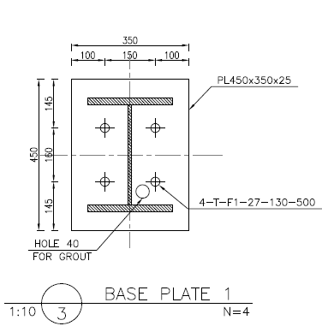

Design Code: AISC-360-16 LRFD

Connection Type: Base plate of column PG 300x250x20x8 (Simple Connection)

|  |  |  |  |  |  |  |  |  |  |  |
| --- | --- | --- | --- | --- | --- | --- | --- | --- | --- | --- |
| **Member** | **Section Name** | **d** | **Bf** | **tf** | **tw** | **h** | **Area** | **Z33** | **Z22** | **r**min |
| cm | cm | cm | cm | cm | cm2 | cm3 | cm3 | cm |
| Column | PG 300x250x20x10 | 34 | 25 | 2 | 1 | 30 | 130 | 1825 | 632.5 | 6.33 |

Design Load:

$$\frac{kL_{c}}{r_{min}}=\frac{1*360}{6.33}=56.87 ≤4.71\sqrt{\frac{2*{10}^{6}}{2400}}=135.9 ok$$

$F_{e}=\frac{π^{2}E}{{(\frac{kL_{c}}{r_{min}})}^{2}}=6401.489 kgf$ $F_{cr}=\left[{0.658}^{\frac{F_{y}}{F_{e}}}\right]F_{y}=2051.43$

$P_{u}=φF_{cr}A_{g}=0.9*2051.43*130=240017.3 kgf$

$M_{p3-3}=Z_{3-3}F_{y}=1825*2400=4380000 kgf-cm$

$M_{p2-2}=Z_{2-2}F_{y}=632.5*2400=1518000 kgf-cm$

$$V_{2-2}=\frac{M_{p3-3}}{L_{c}}=\frac{4380000}{650}=6738.46 kgf$$

$$V_{3-3}=\frac{M_{p2-2}}{L_{c}}=\frac{1518000}{650}=2335.385kgf$$

|  |  |  |  |  |  |
| --- | --- | --- | --- | --- | --- |
| **Section** | **P (Ton)** | **V2 (Ton)** | **V3 (Ton)** | **M2 (Ton-m)** | **M3 (Ton-m)** |
| **PG 300x250X20X10** | 240.017 | 6.74 | 2.335 | ------ | ----- |

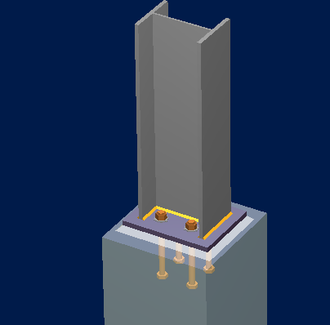



Steel connections

**Results**

**Connection name : Pinned BP - HSS Member**

**Connection ID : 101**

Family: Column - Base (CB)

Type: Base plate

Description: BS1-PG 300X300X20x10

Design code: AISC 360-16 LRFD, ACI 318-11

**DEMANDS**

**Description Pu Mu22 Mu33 Vu2 Vu3 Load type**

[T] [T*m] [T*m] [T] [T]

BS1 -240 0.00 0.00 6.7 2.335 Design

BS2 0.00 0.00 0.00 0.00 0.00 Design

BS3 0.00 0.00 0.00 0.00 0.00 Design

BS4 0.00 0.00 0.00 0.00 0.00 Design

BS5 0.00 0.00 0.00 0.00 0.00 Design

**Design for major axis**

**Base plate (AISC 360-16 LRFD)**

**GEOMETRIC CONSIDERATIONS**

**Dimensions Unit Value Min. value Max. value Sta. References**

Base plate

Distance from anchor to edge [cm] 11.00 0.64 -- 

Weld size [1/16in] 8 3 --  table J2.4

wmin = wmin

= **0.004763** table J2.4

**DESIGN CHECK**

**Verification Unit Capacity Demand Ctrl EQ Ratio References**

Pedestal

Axial bearing [Ton/cm2] 0.17 0.17 BS1 **1.00** DG1 3.1.1;

fp, max = *min(0.85*f'c*(A2/A1)1/2, 1.7*f'c)

= 0.65*min(0.85*300[kg/cm2]*(1)1/2, 1.7*300[kg/cm2])

= **165.75**[kg/cm2] DG1 3.1.1

A1 (req) = P/fp, max

= 220.4[T]/165.75[kg/cm2]

= **1329.71**[cm2] DG1 Sec 3.1.1

 = (0.95*dc - 0.8*bc)/2

= (0.95*34[cm] - 0.8*30[cm])/2

= **4.15**[cm] DG1 Sec 3.1.4

Neff1 = (A1 (req))1/2 + 

= (1329.71[cm2])1/2 + 4.15[cm]

= **40.615**[cm] DG1 Sec 3.1.4

Beff1 = A1 (req)/Neff

= 1329.71[cm2]/40.615[cm]

= **32.739**[cm] DG1 Sec 3.1.4

Neff2 = (dc*bc)1/2 + 

= (34[cm]*30[cm])1/2 + 4.15[cm]

= **36.087**[cm]

Beff2 = bc

= **30**[cm]

Neff3 = dc

= **34**[cm]

Beff3 = (dc - )2/dc

= (34[cm] - 4.15[cm])2/34[cm]

= **26.207**[cm]

N = min(Neff, Ndim)

= min(40.615[cm], 50[cm])

= **40.615**[cm]

B = min(Beff, Bdim)

= min(32.739[cm], 42[cm])

= **32.739**[cm]

Base plate

Flexural yielding (bearing interface) [Ton*m/m] 6.62 5.28 BS1 **0.80** DG1 Sec 3.1.2

Mn = *Fy*tp2/4

= 0.9*2400[kg/cm2]*3.5[cm]2/4

= **6.615**[T*m/m] DG1 Eq. 3.3.13

m = (N - 0.95*dc)/2

= (40.615[cm] - 0.95*34[cm])/2

= **4.158**[cm] DG1 Sec 3.1.2

n = (B - 0.8*bc)/2

= (32.739[cm] - 0.8*30[cm])/2

= **4.37**[cm] DG1 Sec 3.1.2

Pp = 0.85*f'c*A1

= 0.85*300[kg/cm2]*1329.71[cm2]

= **339.077**[T] Eq. J8-1

X = (4*dc*bc/(dc + bc)2)*P/(*Pp)

= (4*34[cm]*30[cm]/(34[cm] + 30[cm])2)*220.4[T]/(0.65*339.077[T])

= **0.996** DG1 Sec 3.1.2

● = min(2*(X)1/2/(1 + (1 - X)1/2), 1.0)

= min(2*(0.996)1/2/(1 + (1 - 0.996)1/2), 1.0)

= **1** DG1 Sec 3.1.2

n' = *(dc*bc)1/2/4

= 1*(34[cm]*30[cm])1/2/4

= **7.984**[cm] DG1 Sec 3.1.2

l = max(m, n, n')

= max(4.158[cm], 4.37[cm], 7.984[cm])

= **7.984**[cm] DG1 Sec 3.1.2

fp = P/(B*N)

= 220.4[T]/(32.739[cm]*40.615[cm])

= **165.75**[kg/cm2] DG1 Sec 3.1.2

Mpl = fp*(l2/2)

= 165.75[kg/cm2]*(7.984[cm]2/2)

= **5.283**[T*m/m] DG1 Sec 3.1.2

Flexural yielding (tension interface) [Ton*m/m] 6.62 0.00 BS1 **0.00** DG1 Eq. 3.3.13

Mn = *Fy*tp2/4

= 0.9*2400[kg/cm2]*3.5[cm]2/4

= **6.615**[T*m/m] DG1 Eq. 3.3.13

MpT = Mstrip/Beff

= 0[T*m]/16[cm]

= **0**[T*m/m]

Friction shear capacity [Ton] 79.78 7.75 BS1 **0.10** DG1 Sec 3.5.1

Vfn = min(*mu*Pu, 0.2*f'c*Ac)

= min(0.75*0.55*220.4[T], 0.2*300[kg/cm2]*1329.71[cm2])

= **79.783**[T] DG1 Sec 3.5.1

Column

Weld capacity [Ton/m] 298.32 0.00 BS1 **0.00** p. 8-9,

Sec. J2.5,

Sec. J2.4

LoadAngleFactor = 1 + 0.5*(sin())1.5

= 1 + 0.5*(sin(1.571))1.5

= **1.5** p. 8-9

Fw = 0.6*FEXX*LoadAngleFactor

= 0.6*4921.46[kg/cm2]*1.5

= **4429.32**[kg/cm2] Sec. J2.5

Aw = (2)1/2/2*D/16 [in]*L

= (2)1/2/2*8/16 [in]*100[cm]

= **89.803**[cm2] Sec. J2.4

Rw = *Fw*Aw/L

= 0.75*4429.32[kg/cm2]*89.803[cm2]/100[cm]

= **2.983**[T/cm]

Elastic method weld shear capacity [Ton/m] 198.88 12.92 BS1 **0.06** p. 8-9,

Sec. J2.5,

Sec. J2.4

LoadAngleFactor = 1 + 0.5*(sin())1.5

= 1 + 0.5*(sin(0))1.5

= **1** p. 8-9

Fw = 0.6*FEXX*LoadAngleFactor

= 0.6*4921.46[kg/cm2]*1

= **2952.88**[kg/cm2] Sec. J2.5

Aw = (2)1/2/2*D/16 [in]*L

= (2)1/2/2*8/16 [in]*100[cm]

= **89.803**[cm2] Sec. J2.4

Rw = *Fw*Aw/L

= 0.75*2952.88[kg/cm2]*89.803[cm2]/100[cm]

= **1.989**[T/cm]

fv = V/Lshear

= 7.753[T]/60[cm]

= **0.129**[T/cm]

Elastic method weld axial capacity [Ton/m] 298.32 0.00 BS1 **0.00** p. 8-9,

Sec. J2.5,

Sec. J2.4

LoadAngleFactor = 1 + 0.5*(sin())1.5

= 1 + 0.5*(sin(1.571))1.5

= **1.5** p. 8-9

Fw = 0.6*FEXX*LoadAngleFactor

= 0.6*4921.46[kg/cm2]*1.5

= **4429.32**[kg/cm2] Sec. J2.5

Aw = (2)1/2/2*D/16 [in]*L

= (2)1/2/2*8/16 [in]*100[cm]

= **89.803**[cm2] Sec. J2.4

Rw = *Fw*Aw/L

= 0.75*4429.32[kg/cm2]*89.803[cm2]/100[cm]

= **2.983**[T/cm]

fa = P/L

= -220.4[T]/118.4[cm]

= **-1.861**[T/cm]

fb = M*c/I

= 0[T*m]*17[cm]/34980[cm3]

= **0**[T/cm]

f = max(fb + fa, 0.0)

= max(0[T/cm] + -1.861[T/cm], 0.0)

= **0**[T/cm]

**Ratio 1.00**

**Major axis**

**Anchors**

**GEOMETRIC CONSIDERATIONS**

**Dimensions Unit Value Min. value Max. value Sta. References**

Anchors

Anchor spacing [cm] 14.00 8.00 --  Sec. D.8.1

smin = 4*da

= 4*2[cm]

= **8**[cm] Sec. D.8.1

Concrete cover [cm] 20.00 5.08 --  Sec. 7.7.1

IsConcreteCastAgainstEarth  **False**

Cover = 2 [in] Sec. 7.7.1

Effective length [cm] 51.30 -- 123.70 

**DESIGN CHECK**

**Verification Unit Capacity Demand Ctrl EQ Ratio References**

Anchor tension [Ton] 7.49 0.00 BS1 **0.00** Eq. D-2

Ase = π/4.0*(da - 0.9743 [in]/nt)2

= π/4.0*(2[cm] - 0.9743 [in]/10.58)2

= **2.45**[cm2] Sec. D.5.1.1,

D.6.1.2

futa = min(futa, 1.9*fya, 125 [ksi])

= min(4077.78[kg/cm2], 1.9*2531.04[kg/cm2], 125 [ksi])

= **4077.78**[kg/cm2] Sec. D.5.1.2

Nsa = *Ase,N*futa

= 0.75*2.45[cm2]*4077.78[kg/cm2]

= **7.492**[T] Eq. D-2

Breakout of anchor in tension [Ton] 11.13 0.00 BS1 **0.00** Eq. D-3,

Sec. D.3.3.4.4

ca1Left<1.5*hef  21[cm]<1.5*50[cm]  **True**

ca1Left = ca1Left

= **21**[cm] Sec. D.5.2.1

ca1Right<1.5*hef  39[cm]<1.5*50[cm]  **True**

ca1Right = ca1Right

= **39**[cm] Sec. D.5.2.1

ca2Top<1.5*hef  37[cm]<1.5*50[cm]  **True**

ca2Top = ca2Top

= **37**[cm] Sec. D.5.2.1

ca2Bot<1.5*hef  23[cm]<1.5*50[cm]  **True**

ca2Bot = ca2Bot

= **23**[cm] Sec. D.5.2.1

IsCloseToThreeEdges  **True**

hef = camax/1.5

= 39[cm]/1.5

= **26**[cm] Sec. D.5.2.3

ca1Left<1.5*hef  21[cm]<1.5*26[cm]  **True**

ca1Left = ca1Left

= **21**[cm] Sec. D.5.2.1

ca1Right<1.5*hef  39[cm]<1.5*26[cm]  **False**

ca1Right = 1.5*hef

= 1.5*26[cm]

= **39**[cm] Sec. D.5.2.1

ca2Top<1.5*hef  37[cm]<1.5*26[cm]  **True**

ca2Top = ca2Top

= **37**[cm] Sec. D.5.2.1

ca2Bot<1.5*hef  23[cm]<1.5*26[cm]  **True**

ca2Bot = ca2Bot

= **23**[cm] Sec. D.5.2.1

ANc = (ca1Left + ca1Right)*(ca2Top + ca2Bot)

= (21[cm] + 39[cm])*(37[cm] + 23[cm])

= **3600**[cm2] Sec. RD.5.2.1

ANco = 9*hef2

= 9*26[cm]2

= **6084**[cm2] Eq. D-5

ca,min<1.5*hef  21[cm]<1.5*26[cm]  **True**

ed,N = 0.7 + 0.3*ca,min/(1.5*hef)

= 0.7 + 0.3*21[cm]/(1.5*26[cm])

= **0.862** Eq. D-10

CrackedConcrete  **False**

c,N = 1.25 Sec. D.5.2.6

IsCastInPlaceAnchor  **True**

cp,N = 1 Sec. D.5.2.7

IsCastInPlaceAnchor  **True**

kc = 24 Sec. D.5.2.2

(IsCastInPlaceAnchor) and (IsHeadedBolt) and (hef>=11 [in]) and (hef<=25 [in])  (True) and (True) and (26[cm]> = 11 [in]) and (26[cm]<

= 25 [in])  **False**

Nb = kc*a*(fc/(1 [psi]))1/2*(hef/(1 [in]))1.5 [lb]

= 24*1*(300[kg/cm2]/(1 [psi]))1/2*(26[cm]/(1 [in]))1.5 [lb]

= **23.289**[T] Eq. D-6

Ncb = (ANc/ANco)*ed,N*c,N*cp,N*Nb

= (3600[cm2]/6084[cm2])*0.862*1.25*1*23.289[T]

= **14.84**[T] Eq. D-3

HighSeismicDesignCategory  **False**

Ncb = *Ncb

= 0.75*14.84[T]

= **11.13**[T] Sec. D.3.3.4.4

Pullout of anchor in tension [Ton] 10.95 0.00 BS1 **0.00** Sec. D.3.3.4.4

Abrg = 0.866025*F2 - Ag

= 0.866025*3[cm]2 - 3.14[cm2]

= **4.654**[cm2]

IsHeadedBolt  **True**

Np = 8*Abrg*fc

= 8*4.654[cm2]*300[kg/cm2]

= **11.17**[T] Eq. D-14

CrackedConcrete  **False**

c,P = 1.4 Sec. D.5.3.6

Npn = c,P*Np

= 1.4*11.17[T]

= **15.638**[T] Eq. D-13

HighSeismicDesignCategory  **False**

Npn = *Npn

= 0.7*15.638[T]

= **10.947**[T] Sec. D.3.3.4.4

Anchor shear [Ton] 3.12 0.00 BS1 **0.00** Eq. D-29,

Sec. D.6.1.3

Ase = π/4.0*(da - 0.9743 [in]/nt)2

= π/4.0*(2[cm] - 0.9743 [in]/10.58)2

= **2.45**[cm2] Sec. D.5.1.1,

D.6.1.2

futa = min(futa, 1.9*fya, 125 [ksi])

= min(4077.78[kg/cm2], 1.9*2531.04[kg/cm2], 125 [ksi])

= **4077.78**[kg/cm2] Sec. D.5.1.2

HasGroutPad  **True**

Vsa = 0.8**0.6*n*Ase,V*futa

= 0.8*0.65*0.6*1*2.45[cm2]*4077.78[kg/cm2]

= **3.117**[T] Eq. D-29,

Sec. D.6.1.3

Breakout of anchor in shear [Ton] 5.42 0.00 BS1 **0.00** Table D.4.1.1,

Sec. D.4.3

ca2Left<1.5*ca1  21[cm]<1.5*23[cm]  **True**

ca2Left = ca2Left

= **21**[cm] Sec. D.6.2.1

ca2Right<1.5*ca1  39[cm]<1.5*23[cm]  **False**

ca2Right = 1.5*ca1

= 1.5*23[cm]

= **34.5**[cm] Sec. D.5.2.1

ha<1.5*ca1  125[cm]<1.5*23[cm]  **False**

ha = 1.5*ca1

= 1.5*23[cm]

= **34.5**[cm] Sec. D.5.2.1

IsCloseToThreeEdges  **False**

ca1 = ca1

= **23**[cm] Sec. D.6.2.4

LVc = ca2Left + ca2Right

= 21[cm] + 34.5[cm]

= **55.5**[cm] Sec. RD.6.2.1

AVc = LVc*min(ha, 1.5*ca1)

= 55.5[cm]*min(125[cm], 1.5*23[cm])

= **1914.75**[cm2] Sec. RD.6.2.1

AVco = 4.5*ca12

= 4.5*23[cm]2

= **2380.5**[cm2] Eq. D-32

ca2<1.5*ca1  21[cm]<1.5*23[cm]  **True**

ed,V = 0.7 + 0.3*(ca2/(1.5*ca1))

= 0.7 + 0.3*(21[cm]/(1.5*23[cm]))

= **0.883** Eq. D-28

CrackedConcrete  **False**

c,V = 1.4 Sec. D.6.2.7

ha<1.5*ca1  125[cm]<1.5*23[cm]  **False**

h,V = 1 Sec. D.6.2.8

le = min(hef, 8*da)

= min(50[cm], 8*2[cm])

= **16**[cm] Sec. D.6.2.2

Vb = min((7*(le/da)0.2*(da/(1 [in]))1/2)*a*(fc/(1 [psi]))1/2*(ca1/(1 [in]))1.5 [lb], 9*a*(fc/(1 [psi]))1/2*(ca1/(1 [in]))1.5 [lb])

= min((7*(16[cm]/2[cm])0.2*(2[cm]/(1 [in]))1/2)*1*(300[kg/cm2]/(1 [psi]))1/2*(23[cm]/

(1 [in]))1.5 [lb], 9*1*(300[kg/cm2]/(1 [psi]))1/2*(23[cm]/

(1 [in]))1.5 [lb])

= **7.266**[T] Eq. D-33, D-34

Vcb = (AVc/AVco)*ed,V*c,V*h,V*Vb

= (1914.75[cm2]/2380.5[cm2])*0.883*1.4*1*7.266[T]

= **7.222**[T] Eq. D-30

Vcb = *Vcb

= 0.75*7.222[T]

= **5.416**[T] Table D.4.1.1,

Sec. D.4.3

Pryout of anchor in shear [Ton] 20.78 0.00 BS1 **0.00** Eq. D-3,

Table D.4.1.1,

Sec. D.4.3

hef<2.5 [in]  50[cm]<2.5 [in]  **False**

kcp = 2 Sec. D.6.3.1

ca1Left<1.5*hef  21[cm]<1.5*50[cm]  **True**

ca1Left = ca1Left

= **21**[cm] Sec. D.5.2.1

ca1Right<1.5*hef  39[cm]<1.5*50[cm]  **True**

ca1Right = ca1Right

= **39**[cm] Sec. D.5.2.1

ca2Top<1.5*hef  37[cm]<1.5*50[cm]  **True**

ca2Top = ca2Top

= **37**[cm] Sec. D.5.2.1

ca2Bot<1.5*hef  23[cm]<1.5*50[cm]  **True**

ca2Bot = ca2Bot

= **23**[cm] Sec. D.5.2.1

IsCloseToThreeEdges  **True**

hef = camax/1.5

= 39[cm]/1.5

= **26**[cm] Sec. D.5.2.3

ca1Left<1.5*hef  21[cm]<1.5*26[cm]  **True**

ca1Left = ca1Left

= **21**[cm] Sec. D.5.2.1

ca1Right<1.5*hef  39[cm]<1.5*26[cm]  **False**

ca1Right = 1.5*hef

= 1.5*26[cm]

= **39**[cm] Sec. D.5.2.1

ca2Top<1.5*hef  37[cm]<1.5*26[cm]  **True**

ca2Top = ca2Top

= **37**[cm] Sec. D.5.2.1

ca2Bot<1.5*hef  23[cm]<1.5*26[cm]  **True**

ca2Bot = ca2Bot

= **23**[cm] Sec. D.5.2.1

ANc = (ca1Left + ca1Right)*(ca2Top + ca2Bot)

= (21[cm] + 39[cm])*(37[cm] + 23[cm])

= **3600**[cm2] Sec. RD.5.2.1

ANco = 9*hef2

= 9*26[cm]2

= **6084**[cm2] Eq. D-5

ca,min<1.5*hef  21[cm]<1.5*26[cm]  **True**

ed,N = 0.7 + 0.3*ca,min/(1.5*hef)

= 0.7 + 0.3*21[cm]/(1.5*26[cm])

= **0.862** Eq. D-10

CrackedConcrete  **False**

c,N = 1.25 Sec. D.5.2.6

IsCastInPlaceAnchor  **True**

cp,N = 1 Sec. D.5.2.7

IsCastInPlaceAnchor  **True**

kc = 24 Sec. D.5.2.2

(IsCastInPlaceAnchor) and (IsHeadedBolt) and (hef>=11 [in]) and (hef<=25 [in])  (True) and (True) and (26[cm]> = 11 [in]) and (26[cm]<

= 25 [in])  **False**

Nb = kc*a*(fc/(1 [psi]))1/2*(hef/(1 [in]))1.5 [lb]

= 24*1*(300[kg/cm2]/(1 [psi]))1/2*(26[cm]/(1 [in]))1.5 [lb]

= **23.289**[T] Eq. D-6

Ncb = (ANc/ANco)*ed,N*c,N*cp,N*Nb

= (3600[cm2]/6084[cm2])*0.862*1.25*1*23.289[T]

= **14.84**[T] Eq. D-3

Vcp = kcp*Ncb

= 2*14.84[T]

= **29.681**[T] Eq. D-40

Vcp = *Vcp

= 0.7*29.681[T]

= **20.777**[T] Table D.4.1.1,

Sec. D.4.3

**Ratio 0.00**

**Global critical strength ratio 1.00**

**Major axis**

**Maximum compression and tension (BS1)**

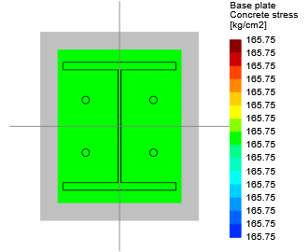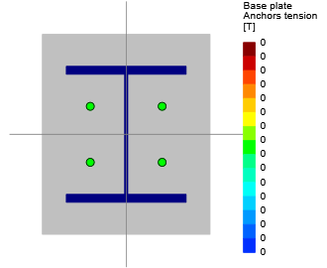

Maximum bearing pressure 165.75 [kg/cm2]

Minimum bearing pressure 165.75 [kg/cm2]

Maximum anchor tension 0.00 [T]

Minimum anchor tension 0.00 [T]

Neutral axis angle 0.00 [deg]

Bearing length 1E32 [cm]

**Anchors tensions**

**Anchor Transverse Longitudinal Shear Tension**

[cm] [cm] [T] [T]

1 -9.00 -7.00 1.94 0.00

2 -9.00 7.00 1.94 0.00

3 9.00 7.00 1.94 0.00

4 9.00 -7.00 1.94 0.00

**NOTATION**

A1: Base plate area

A1 (req): Base plate required area

Aw: Effective area of the weld

A2/A1: Ratio between the concrete support area and the base plate area

B: Base plate design width

Bdim: Base plate width perpendicular to moment design direction

Beff: Effective bearing width

bc: Width of column section

Beff: Controlling effective width

Beff1: Base plate effective bearing width

Beff2: Base plate effective bearing width due column rigid width

Beff3: Base plate effective bearing width due column rigid depth

c: Distance to weld group

: Auxiliary variable to optimize the plate dimension

dc: Column depth

D: Number of sixteenths of an inch in the weld size

fa: Axial stress on welds

fb: Bending stress on welds

f'c: Specified compressive strength of concrete

f: Combined stress on welds

FEXX: Electrode classification number

fp: Uniformly bearing stress under base plate

fp, max: Maximum uniformly bearing stress under base plate

fv: Vertical shear force on weld

Fw: Nominal strength of the weld metal per unit area

Fy: Specified minimum yield stress

I: Inertia of weld group

l: Critical base plate cantilever dimension

L: Length of weld

Lshear: Length of weld receiving shear

: Auxiliary variable to calculate the critical base plate cantilever dimension

LoadAngleFactor: Load angle factor

M: Bending required

m: Base plate bearing interface cantilever direction parallel to moment direction

Mpl: Plate bending moment per unit width

MpT: Plate bending moment per unit width at tension unstiffened strip interface

Mstrip: Maximum bending moment at the strip

N: Base plate design length

Ndim: Base plate length parallel to design moment direction

n: Base plate bearing interface cantilever direction perpendicular to moment direction

n': Yield line theory cantilever distance from column web or column flange

Neff: Effective bearing length

Neff1: Base plate effective bearing length

Neff2: Base plate effective bearing length due column rigid width

Neff3: Base plate effective bearing length due column rigid depth

P: Required axial force

Pp: Nominal bearing stress

: Design factors

Mn: Design or allowable strength per unit length

Rw: Fillet weld capacity per unit length

tp: Plate thickness

: Load angle

V: Shear load

wmin: Minimum weld size required

X: Auxiliary variable to calculate the critical base plate cantilever dimension

Abrg: Net bearing area of the head of stud or anchor bolt

Ag: Gross area of anchor

Ac: Area of concrete section resisting shear transfer

ANc: Projected concrete failure area of a single anchor or group of anchors, for calculation of strength in tension

ANco: Projected concrete failure area of a single anchor, for calculation of strength in tension if not limited by edge distance or spacing

Ase: Effective cross-sectional area of anchor

Ase,N: Effective cross-sectional area of anchor in tension

Ase,V: Effective cross-sectional area of anchor in shear

AVc: Projected concrete failure area of a single anchor or group of anchors , for calculation of strength in shear

AVco: Projected concrete failure area of a single anchor, for calculation of strength in shear, if not limited by corner influences, spacing, or member thickness

ca1: Distance from the anchor center to the concrete edge

ca1Left: Distance from the anchor center to the left edge of the concrete base

ca1Right: Distance from the anchor center to the right edge of the concrete base

ca2: Distance from the anchor center to the concrete edge in perpendicular direction

ca2Bot: Distance from the anchor center to the bottom edge of the concrete base

ca2Left: Distance from the anchor center to the left edge of the concrete base

ca2Right: Distance from the anchor center to the right edge of the concrete base

ca2Top: Distance from the anchor center to the top edge of the concrete base

camax: Maximum distance from center of an anchor shaft to the edge of concrete

ca,min: Minimum distance from center of an anchor shaft to the edge of concrete

Cover: Concrete cover

CrackedConcrete: Cracked concrete at service loads

da: Outside diameter of anchor or shaft diameter of headed stud, headed bolt, or hooked bolt

F: Distance between head flat sides

fc: Specified compressive strength of concrete

futa: Specified tensile strength of anchor steel

fya: Specified yield strength of anchor steel

f'c: Specified compressive strength of concrete

ha: Thickness of member in which an anchor is located, measured parallel to anchor axis

hef: Effective embedment depth of anchor

HasGroutPad: Has grout pad

HighSeismicDesignCategory: High seismic design category (i.e. C, D, E or F)

IsCastInPlaceAnchor: Is cast in place anchor

IsCloseToThreeEdges: Anchor is close to three or more edges

IsConcreteCastAgainstEarth: Is concrete cast against and permanently exposed to earth

IsHeadedBolt: Is anchor headed stud

kc: Coefficient for concrete pry out basic strength

kcp: Coefficient for pry out strength

le: Load-bearing length of the anchor for shear

LVc: Projected concrete failure length of a single anchor or group of anchors , for calculation of strength in shear

a: Lightweight concrete modification factor

mu: Friction coefficient

n: Number of anchors in the group

Nb: Basic concrete breakout strength in tension of a single anchor in cracked concrete

Ncb: Nominal concrete breakout strength in tension of a single anchor

Np: Pullout strength in tension of a single anchor in cracked concrete

Npn: Nominal pullout strength of a single anchor in tension

nt: Number of threads per inch

Pu: Factored compressive load

: Strength reduction factor

Ncb: Concrete breakout strength in tension of a single anchor

Npn: Pullout strength in tension of a single anchor

Nsa: Strength of a single anchor or group of anchors in tension

Vcb: Concrete breakout strength in shear of a single anchor

Vcp: Concrete pryout strength of a single anchor

Vfn: Shear strength due to friction

Vsa: Strength in shear of a single anchor or group of anchors as governed by the steel strength

c,N: Factor used to modify tensile strength of anchors based on presence or absence of cracks in concrete

c,P: Factor used to modify pullout strength of anchors based on presence or absence of cracks in concrete

cp,N: Factor used to modify tensile strength of postinstalled anchors intended for use in uncracked concrete without supplementary reinforcement

c,V: Factor used to modify shear strength of anchors based on presence or absence of cracks in concrete and presence or absence of supplementary reinforcement

ed,N: Factor used to modify tensile strength of anchors based on proximity to edges of concrete member

ed,V: Factor used to modify shear strength of anchors based on proximity to edges of concrete member

h,V: Factor used to modify shear strength of anchors located in concrete members with ha < 1.5ca1

smin: Center-to-center anchor minimum spacing

SideFaceBlowoutApply: Side-face blowout apply

Vb: Basic concrete breakout strength in shear of a single anchor in cracked concrete

Vcb: Concrete nominal breakout strength in shear of a single anchor

Vcp: Nominal pryout strength of a anchor in shear

1. **FOUNDATION DESIGN**
   1. **Soil pressure and settlement**

Until finalize of geotechnical report for this area we consider (page 41 section 6 of geotechnical report) => qa= 2kg/cm2

Based on Bowels experimental formula for subgrade modulus (Based on geotechnical report as follow) => Ks = 1.69 qall

Loading used for foundation design, have been received from SAP analysis.

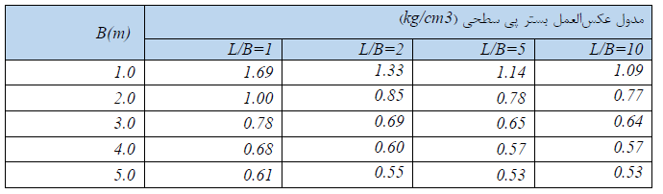

* 1. **DESIGN**

Concrete Foundation are designed according to ACI 318-14. Required loads are derived from SAP data, and design process will be done according to ACI code based on ultimate strength procedure.

* 1. **FOUNDATION DESIGN CONTROL**

### 14.3.1 Check of Stress for Foundation

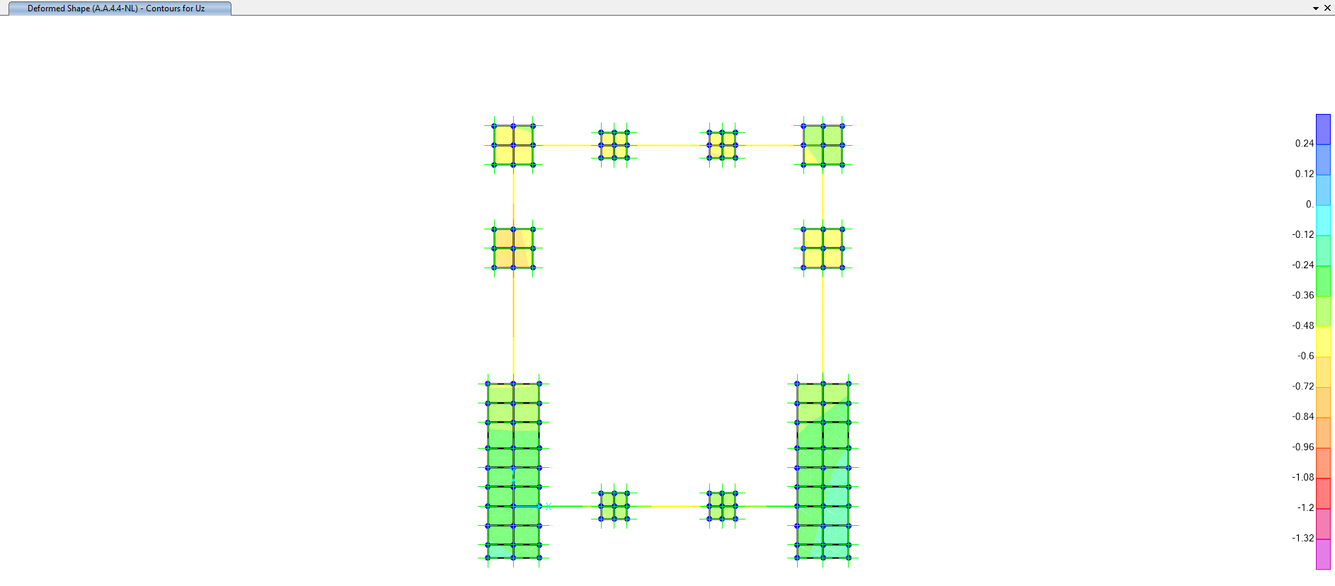

**Figure 20** **-** Check of Displacement for Foundation (cm)

| **TABLE: Joint Displacements** | | | | | | | | |
| --- | --- | --- | --- | --- | --- | --- | --- | --- |
| **Joint** | **OutputCase** | **CaseType** | **StepType** | **U3** | **ks** | **Q** | **Q all** | **Control** |
| Text | Text | Text | Text | cm | kg/cm3 | kg/cm2 | kg/cm2 |
| … | … | … | … | … | … | … | … | … |
| 121 | A.D.3.1-NL | NonStatic | Min | -0.31975 | 1.69 | -0.54037 | -2 | Ok |
| 121 | A.D.3.2-NL | NonStatic | Min | -0.29259 | 1.69 | -0.49448 | -2 | Ok |
| 121 | A.D.3.3-NL | NonStatic | Min | -0.31548 | 1.69 | -0.53316 | -2 | Ok |
| 121 | A.D.3.4-NL | NonStatic | Min | -0.28815 | 1.69 | -0.48697 | -2 | Ok |
| 121 | A.D.3.5-NL | NonStatic | Min | -0.35003 | 1.69 | -0.59155 | -2 | Ok |
| 121 | A.D.3.6-NL | NonStatic | Min | -0.34882 | 1.69 | -0.5895 | -2 | Ok |
| 121 | A.D.3.7-NL | NonStatic | Min | -0.25932 | 1.69 | -0.43825 | -2 | Ok |
| 121 | A.D.3.8-NL | NonStatic | Min | -0.25798 | 1.69 | -0.43598 | -2 | Ok |
| 122 | A.A.1.1-NL | NonStatic | Min | -0.46004 | 1.69 | -0.77746 | -2 | Ok |
| 122 | A.A.2.1-NL | NonStatic | Min | -0.53147 | 1.69 | -0.89818 | -2 | Ok |
| 122 | A.A.2.2-NL | NonStatic | Min | -0.52839 | 1.69 | -0.89298 | -2 | Ok |
| 122 | A.A.3.1-NL | NonStatic | Min | -0.52426 | 1.69 | -0.886 | -2 | Ok |
| 122 | A.A.3.2-NL | NonStatic | Min | -0.52196 | 1.69 | -0.88212 | -2 | Ok |
| 122 | A.A.4.1-NL | NonStatic | Min | -0.27108 | 1.69 | -0.45813 | -2 | Ok |
| 122 | A.A.4.2-NL | NonStatic | Min | -0.65062 | 1.69 | -1.09954 | -2 | Ok |
| 122 | A.A.4.3-NL | NonStatic | Min | -0.21987 | 1.69 | -0.37158 | -2 | Ok |
| 122 | A.A.4.4-NL | NonStatic | Min | -0.70106 | 1.69 | -1.18479 | -2 | **Ok** |
| 122 | A.A.4.5-NL | NonStatic | Min | -0.3855 | 1.69 | -0.65149 | -2 | Ok |
| 122 | A.A.4.6-NL | NonStatic | Min | -0.53295 | 1.69 | -0.90068 | -2 | Ok |
| 122 | A.A.4.7-NL | NonStatic | Min | -0.23827 | 1.69 | -0.40268 | -2 | Ok |
| 122 | A.A.4.8-NL | NonStatic | Min | -0.68187 | 1.69 | -1.15235 | -2 | Ok |
| 122 | A.A.5.1-NL | NonStatic | Min | -0.35963 | 1.69 | -0.60778 | -2 | Ok |
| … | … | … | … | … | … | … | … | … |

According to SAFE report, Max soil pressure under the foundation is:

$$q_{n}=1.18kg/{cm}^{2} < 2 kg/{cm}^{2} ok$$

### 14.4 REINFORCING CONTROL

Foundation Reinforcement in “*ENV-S”* (Critical) Load Combination have been reported in the following figure:

* 1. OK

As noted before, both foundation and structure is modeled in a single model in sap2000. T16@200mm at each side of section is adequate.



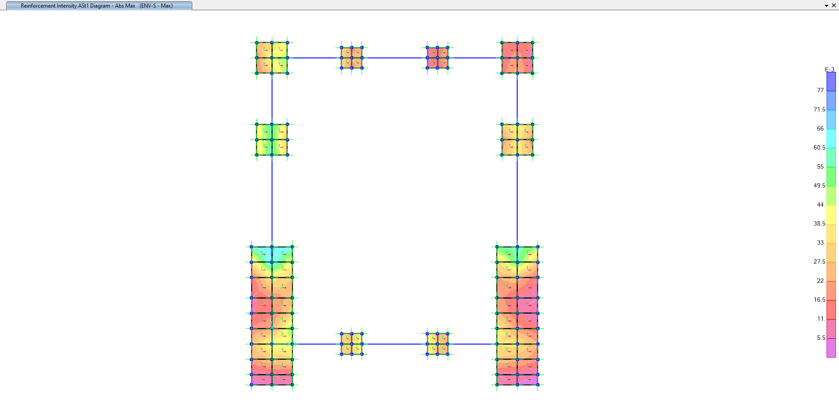

**Figure 21:** Foundation Reinforcement Intensity Ast1 (Unit: $\frac{cm2}{cm}$)

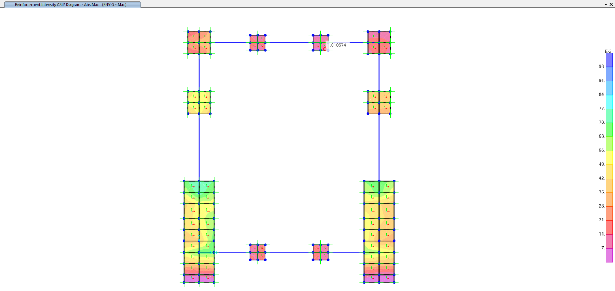

**Figure 22:** Foundation Reinforcement Intensity Ast2 (Unit: $\frac{cm2}{cm}$)

### 14.5 Punching shear control

**Shear Control:**

**“PED1”:**

|  |  |  |  |  |  |  |  |  |  |  |
| --- | --- | --- | --- | --- | --- | --- | --- | --- | --- | --- |
| **TABLE: Element Forces - Frames** | | | | | | | | | | |
| **Frame** | **Station** | **OutputCase** | **CaseType** | **StepType** | **P** | **V2** | **V3** | **T** | **M2** | **M3** |
| Text | cm | Text | Text | Text | Kgf | Kgf | Kgf | Kgf-cm | Kgf-cm | Kgf-cm |
| 1 | 0 | ENV-S | Combination | Max | 514.26 | 1948.33 | 331.8 | 128.3 | 41352.74 | 243402.2 |
| 1 | 0 | ENV-S | Combination | Min | -10343.9 | -1012.06 | 132.65 | -59.45 | 16422.62 | -126641 |
| 2 | 0 | ENV-S | Combination | Max | 2411.46 | 2205.95 | 245.43 | 93.81 | 30555.11 | 275599.4 |
| 2 | 0 | ENV-S | Combination | Min | -16734.2 | -684.25 | 37.05 | -58.68 | 4471.08 | -85670.4 |
| 3 | 0 | ENV-S | Combination | Max | 18064.78 | 2073.63 | 6973.04 | 144.56 | 872102.4 | 259061.8 |
| 3 | 0 | ENV-S | Combination | Min | -33419.3 | -520.6 | -3859.01 | -150.79 | -482299 | -65198.6 |
| 4 | 0 | ENV-S | Combination | Max | 16695.42 | 1861.11 | 3823.86 | 183.77 | 477678.7 | 232501.1 |
| 4 | 0 | ENV-S | Combination | Min | -27124.9 | -925.73 | -7640.09 | -259.05 | -955735 | -115849 |
| 5 | 0 | ENV-S | Combination | Max | 2952.45 | 3066.75 | 351.03 | 110.88 | 43754.87 | 383192.9 |
| 5 | 0 | ENV-S | Combination | Min | -12668 | -3938.76 | 108.47 | -197.57 | 13399.16 | -492639 |
| 6 | 0 | ENV-S | Combination | Max | 5581.68 | 4127.8 | 229.22 | 95.11 | 28527.6 | 515784.4 |
| 6 | 0 | ENV-S | Combination | Min | -19611.8 | -5494.7 | 48.1 | -145.3 | 5852.68 | -687288 |
| 7 | 0 | ENV-S | Combination | Max | 20188.06 | 3990 | 7964.94 | 172.38 | 996288.6 | 498578.7 |
| 7 | 0 | ENV-S | Combination | Min | -38328 | -5682.12 | -4801.37 | -158.56 | -600018 | -710770 |
| 8 | 0 | ENV-S | Combination | Max | 19542.04 | 3104.89 | 4722.73 | 237.14 | 589957.9 | 387964.2 |
| 8 | 0 | ENV-S | Combination | Min | -29887.7 | -3960.04 | -8651.1 | -156.69 | -1082251 | -495300 |
|  |  |  |  |  | **-38328** | **-5682.12** | **-8651.1** | **-259.05** | **-1082251** | **-710770** |

**One-way Shear Control:**

$$V_{u}≤∅V_{n}$$

$$V_{n}=V_{c}+V_{s}$$

$$V_{c}=\left(0.17λ\sqrt{f_{c}^{'}}\right)b_{w}d$$

Axes X:

$V_{c}=\left(0.17*1*\sqrt{300}\right)145*42.5=18.145ton$

$V_{ux}=5.68ton$

$$V_{ux}≤∅V_{n}→5.68≤0.75*18.145=13.6 ok$$

Axes Y:

$V_{c}=\left(0.17*1*\sqrt{300}\right)145*42.5=18.145 ton$

$V_{uy}=8.65 ton$

$$V_{uy}≤∅V_{n}→8.65≤0.75*18.145=13.6 ok$$

**Two-way Shear Control:**

$$V_{u}≤∅V_{n}$$

$$V_{n}=V_{c}+V_{s}$$

$$V_{c}=min\left\{\begin{aligned}0.33λ_{s}λ\sqrt{f_{c}^{'}} =0.33*1*1*\sqrt{300}=5.71 \\ 0.17\left(1+\frac{2}{β}\right)λ_{s}λ\sqrt{f_{c}^{'}}=0.17*\left(1+\frac{2}{1.3}\right)*1*1*\sqrt{300}=7.47 \\ 0.083\left(2+\frac{α_{s}d}{b_{0}}\right)λ_{s}λ\sqrt{f_{c}^{'}}=0.083*\left(2+\frac{40*42.5}{290}\right)*1*1*\sqrt{300}=11.3\end{aligned}\right.$$

$$V_{c}=0.33λ_{s}λ\sqrt{f_{c}^{'}}bd =0.33*1*1*\sqrt{300}\left(290*42.5\right)=70.375 ton$$

$$v_{u}=\frac{V_{u}}{A_{c}}±\frac{M_{uv,x}C_{y}}{J_{cx}}±\frac{M_{uv,y}C_{x}}{J_{cy}}$$

$$V_{u}=8651.1 kgf$$

$$M_{ux}=1082251 kgf-cm$$

$$M_{uy}=710770 kgf-cm$$

$$γ_{v}=1-γ_{f}=1-\frac{1}{1+\frac{2}{3}\sqrt{\frac{b_{1}}{b_{2}}}}=0.39$$

$$M_{uv,x}=γ_{v}M_{ux}=0.39*1082251=422,077.89 kgf-cm$$

$$M_{uv,y}=γ_{v}M_{uy}=0.39*710770=277,200.3 kgf-cm$$

$$\frac{J_{cx}}{C_{y}}=\frac{1}{3}\left[b_{1}d\left(b_{1}+3b_{2}\right)+d^{3}\right]=\frac{1}{3}\left[145*42.5\left(145+3*145\right)+{42.5}^{3}\right] =1,217,005.2$$

$$\frac{J_{cy}}{C_{x}}=\frac{1}{3}\left[b_{2}d\left(b_{2}+3b_{1}\right)+d^{3}\right]=\frac{1}{3}\left[145*42.5\left(145+3*145\right)+{42.5}^{3}\right] =1,217,005.2$$

$$v_{u}=\frac{8651.1}{290*42.5}+\frac{422,077.89}{1,217,005.2}+\frac{277,200.3}{1,217,005.2}=0.7+0.34+0.34=1.38$$

Shear Ratio= $\frac{v_{u}}{{∅v}_{c}}=\frac{1.38}{0.75*5.71}=0.322 ok$