|  |  |  |  |  |  |  |  |
| --- | --- | --- | --- | --- | --- | --- | --- |
| **طرح نگهداشت و افزایش تولید 27 مخزن** | | | | | | | |
| **PDMS Model Review Report (90%)**  **نگهداشت و افزایش تولید میدان نفتی بینک** | | | | | | | |
|  |  |  |  |  |  |  |
|  |  |  |  |  |  |  |
|  |  |  |  |  |  |  |
| D01 | FEB.2024 | AFD | M.Noori | M.Fakharian | S.Faramarzpour |  |
| D00 | OCT.2023 | IFC | M.Noori | M.Fakharian | S.Faramarzpour |  |
| **Rev.** | **Date** | **Purpose of Issue/Status** | **Prepared by:** | **Checked by:** | **Approved by:** | **CLIENT Approval** |
| **Class:2** | | **CLIENT Doc. Number:** **F0Z-708909** | | | | |
| **Status:** | **IDC: Inter-Discipline Check**  **IFC: Issued For Comment**  **IFA: Issued For Approval**  **AFD: Approved For Design**  **AFC: Approved For Construction**  **AFP: Approved For Purchase**  **AFQ:** Approved For Quotation  **IFI: Issued For Information**  **AB-R: As-Built for CLIENT Review**  **AB-A: As-Built –Approved** | | | | | |

**REVISION RECORD SHEET**

|  |  |  |  |  |  |  |  |  |  |  |  |  |
| --- | --- | --- | --- | --- | --- | --- | --- | --- | --- | --- | --- | --- |
| **PAGE** | **D00** | **D01** | **D02** | **D03** | **D04** |  | **PAGE** | **D00** | **D01** | **D02** | **D03** | **D04** |
| **1** | X | X |  |  |  | **66** |  |  |  |  |  |
| **2** | X | X |  |  |  | **67** |  |  |  |  |  |
| **3** | X |  |  |  |  | **68** |  |  |  |  |  |
| **4** | X |  |  |  |  | **69** |  |  |  |  |  |
| **5** | X |  |  |  |  | **70** |  |  |  |  |  |
| **6** | X |  |  |  |  | **71** |  |  |  |  |  |
| **7** | X |  |  |  |  | **72** |  |  |  |  |  |
| **8** | X |  |  |  |  | **73** |  |  |  |  |  |
| **9** | X |  |  |  |  | **74** |  |  |  |  |  |
| **10** | X |  |  |  |  | **75** |  |  |  |  |  |
| **11** | X |  |  |  |  | **76** |  |  |  |  |  |
| **12** | X |  |  |  |  | **77** |  |  |  |  |  |
| **13** | X | X |  |  |  | **78** |  |  |  |  |  |
| **14** |  |  |  |  |  | **79** |  |  |  |  |  |
| **15** |  |  |  |  |  | **80** |  |  |  |  |  |
| **16** |  |  |  |  |  | **81** |  |  |  |  |  |
| **17** |  |  |  |  |  | **82** |  |  |  |  |  |
| **18** |  |  |  |  |  | **83** |  |  |  |  |  |
| **19** |  |  |  |  |  | **84** |  |  |  |  |  |
| **20** |  |  |  |  |  | **85** |  |  |  |  |  |
| **21** |  |  |  |  |  | **86** |  |  |  |  |  |
| **22** |  |  |  |  |  | **87** |  |  |  |  |  |
| **23** |  |  |  |  |  | **88** |  |  |  |  |  |
| **24** |  |  |  |  |  | **89** |  |  |  |  |  |
| **25** |  |  |  |  |  | **90** |  |  |  |  |  |
| **26** |  |  |  |  |  | **91** |  |  |  |  |  |
| **27** |  |  |  |  |  | **92** |  |  |  |  |  |
| **28** |  |  |  |  |  | **93** |  |  |  |  |  |
| **29** |  |  |  |  |  | **94** |  |  |  |  |  |
| **30** |  |  |  |  |  | **95** |  |  |  |  |  |
| **31** |  |  |  |  |  | **96** |  |  |  |  |  |
| **32** |  |  |  |  |  | **97** |  |  |  |  |  |
| **33** |  |  |  |  |  | **98** |  |  |  |  |  |
| **34** |  |  |  |  |  | **99** |  |  |  |  |  |
| **35** |  |  |  |  |  | **100** |  |  |  |  |  |
| **36** |  |  |  |  |  | **101** |  |  |  |  |  |
| **37** |  |  |  |  |  | **102** |  |  |  |  |  |
| **38** |  |  |  |  |  | **103** |  |  |  |  |  |
| **39** |  |  |  |  |  | **104** |  |  |  |  |  |
| **40** |  |  |  |  |  | **105** |  |  |  |  |  |
| **41** |  |  |  |  |  | **106** |  |  |  |  |  |
| **42** |  |  |  |  |  | **107** |  |  |  |  |  |
| **43** |  |  |  |  |  | **108** |  |  |  |  |  |
| **44** |  |  |  |  |  | **109** |  |  |  |  |  |
| **45** |  |  |  |  |  | **110** |  |  |  |  |  |
| **46** |  |  |  |  |  | **111** |  |  |  |  |  |
| **47** |  |  |  |  |  | **112** |  |  |  |  |  |
| **48** |  |  |  |  |  | **113** |  |  |  |  |  |
| **49** |  |  |  |  |  | **114** |  |  |  |  |  |
| **50** |  |  |  |  |  | **115** |  |  |  |  |  |
| **51** |  |  |  |  |  | **116** |  |  |  |  |  |
| **52** |  |  |  |  |  | **117** |  |  |  |  |  |
| **53** |  |  |  |  |  | **118** |  |  |  |  |  |
| **54** |  |  |  |  |  | **119** |  |  |  |  |  |
| **55** |  |  |  |  |  | **120** |  |  |  |  |  |
| **56** |  |  |  |  |  | **121** |  |  |  |  |  |
| **57** |  |  |  |  |  | **122** |  |  |  |  |  |
| **58** |  |  |  |  |  | **123** |  |  |  |  |  |
| **59** |  |  |  |  |  | **124** |  |  |  |  |  |
| **60** |  |  |  |  |  | **125** |  |  |  |  |  |
| **61** |  |  |  |  |  | **126** |  |  |  |  |  |
| **62** |  |  |  |  |  | **127** |  |  |  |  |  |
| **63** |  |  |  |  |  | **128** |  |  |  |  |  |
| **64** |  |  |  |  |  | **129** |  |  |  |  |  |
| **65** |  |  |  |  |  | **130** |  |  |  |  |  |

**CONTENTS**

1.0 INTRODUCTION 4

2.0 Scope 4

3.0 NORMATIVE REFERENCES 5

**3.1** The Project Documents 5

**3.2** Order of Precedence 5

4.0 KEY OBJECTIVES 5

5.0 STATISTICS 5

6.0 DESCRIPTION AND CONCLUSIONS 6

7.0 ATTACHEMENT 1 13

8.0 ATTACHEMENT 2 13

9.0 ATTACHEMENT 3 13

1. **INTRODUCTION**

Binak oilfield in Bushehr province is a part of the southern oilfields of Iran, is located 20 km northwest of Genaveh city.

With the aim of increasing production of oil from Binak oilfield, an EPC/EPD Project has been defined by NIOC/NISOC and awarded to Petro Iran Development Company (PEDCO). Also PEDCO (as General Contractor) has assigned the EPC-packages of the Project to "Hirgan Energy - Design and Inspection" JV.

As a part of the Project, a New Gas Compressor Station (adjacent to existing Binak GCS) shall be constructed to gather of 15 MMSCFD (approx.) associated gases and compress & transfer them to Siahmakan GIS.

**GENERAL DEFINITION**

The following terms shall be used in this document.

|  |  |
| --- | --- |
| CLIENT: | National Iranian South Oilfields Company (NISOC) |
| PROJECT: | Binak Oilfield Development – Surface Facilities; New Gas Compressor Station |
| EPD/EPC CONTRACTOR (GC): | Petro Iran Development Company (PEDCO) |
| EPC CONTRACTOR: | Joint Venture of : Hirgan Energy – Design & Inspection (D&I) Companies |
| VENDOR: | The firm or person who will fabricate the equipment or material. |
| EXECUTOR: | Executor is the party which carries out all or part of construction and/or commissioning for the project. |
| THIRD PARTY INSPECTOR (TPI): | The firm appointed by EPD/EPC CONTRACTOR (GC) and approved by CLIENT (in writing) for the inspection of goods. |
| SHALL: | Is used where a provision is mandatory. |
| SHOULD: | Is used where a provision is advisory only. |
| WILL: | Is normally used in connection with the action by CLIENT rather than by an EPC/EPD CONTRACTOR, supplier or VENDOR. |
| MAY: | Is used where a provision is completely discretionary. |

1. **Scope**

This document presents all raised issues and made decisions during 90% model review session of PROJECT which should be followed and performed during continuation of PROJECT.

1. **NORMATIVE REFERENCES**

## The Project Documents

* BK-GNRAL-PEDCO-000-PI-PR-0001 3D-Model (PDMS) Review Procedure

## Order of Precedence

In case of any conflict between the contents of this document or any discrepancy between this document and other project documents or reference standards, this issue must be reported to the CLIENT. The final decision in this situation will be made by CLIENT.

1. **KEY OBJECTIVES**

The purpose of 90% Model Review is to confirm that all comments raised in the previous review have properly been followed and updated. In principle, re-study of the comments raised in previous model reviews should not be executed as far as such comments have properly been followed.

The model minimum content for the 90% model review shall be:

* + Actions resulting from 60% model review.
  + Vendor data incorporation and modifying relevant lines to adjust for equipment final condition.
  + Remaining piping (line sizes below 2") with insulation and steam tracing information completed.
  + Remaining platforms, stairs, ladders, hoisting beams, davits, limited hand rails/ladder cages.
  + The model will be substantially completed including instrument/F&G and electrical equipment and cable tray routes.

1. **STATISTICS**

The followings indicate the number of modeled major items which were reviewed during 60% model review:

* + Number of modeled equipment: 68
  + Number of modeled A/G and U/G Lines: 470
  + Number of hydrant and monitor: 16
  + Number of modeled shelter, structure and building: 14
  + Electrical main trench
  + Instrument main cable trench
  + Instrument junction boxes

1. **DESCRIPTION AND CONCLUSIONS**

The 90% model review for “Binak Oilfield Development – Surface Facilities; New Gas Compressor Station” was held with representatives of CLIENT, EPD/EPC CONTRACTOR (GC) and EPC CONTRACTOR, on 1402/07/24. The subjects of discussion for the meeting were organized and considered based on the following issues:

* Re-study of the comments raised in 60%
* General layout and arrangement,
* Operation access rooms,
* Maintenance requirements,
* Installing location for instruments, platforms, and access to instruments,
* Lineup of process lines.
* Instrument cable route and junction boxes location

It was stated that following items should be checked and corrected during 90% modeling and would be reviewed in 90% model review meeting:

## For better access to valves and psv flanges, Platforms shall be extended. This item should be checked for all platforms and if required applied if required. For example, v-2105 platform shall be modified by moving the valve or extending of platform.

## 

## Hand wheel of manual valve which is located before FCV-2101 shall be rotated 180 degrees. (To have more distance of hand wheel from JB)

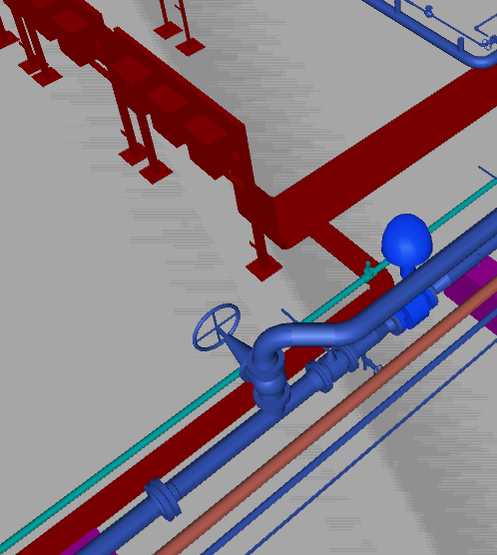

## All drain valves shall be installed at elevation higher than the closed drain header. The route of connection to CDH header shall be finalized at site.

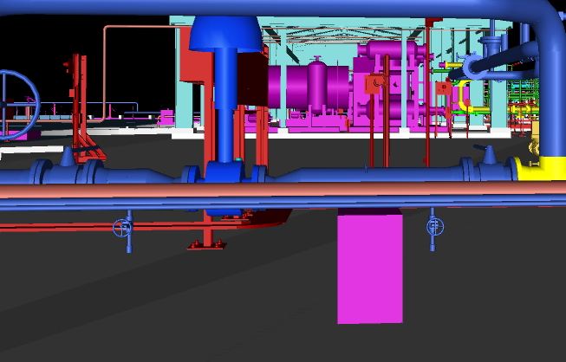

## Details of sampling connection shall be illustrated in 3d model.

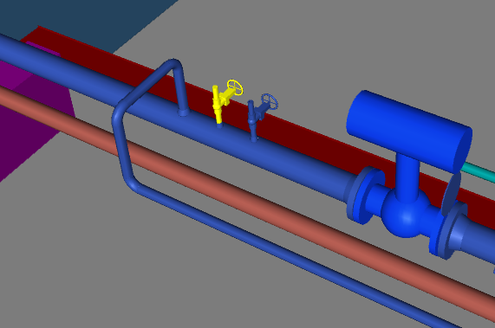

## 3D model of gas compressor package and dehydration package will be finalized after related 3d model meeting.

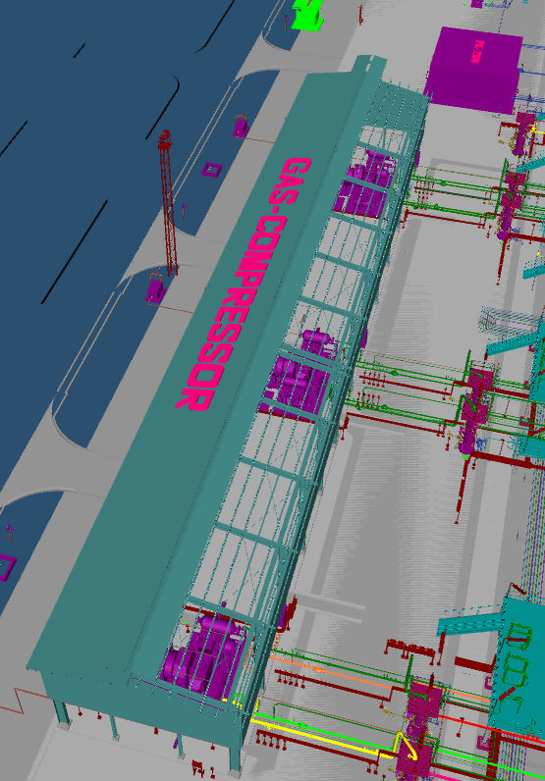

## A Removable Spool shall be added on inlet line of V-2101 (A/B/C).

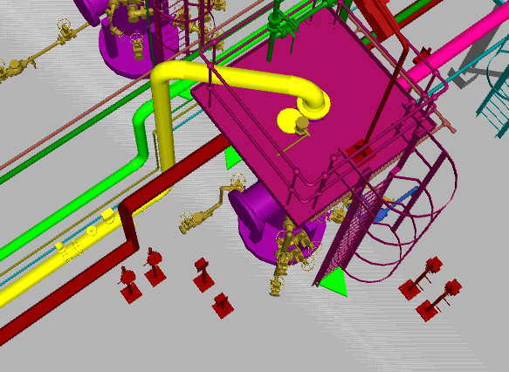

## All instrument branch of gas cooler outlet line shall be moved to near of related platform.

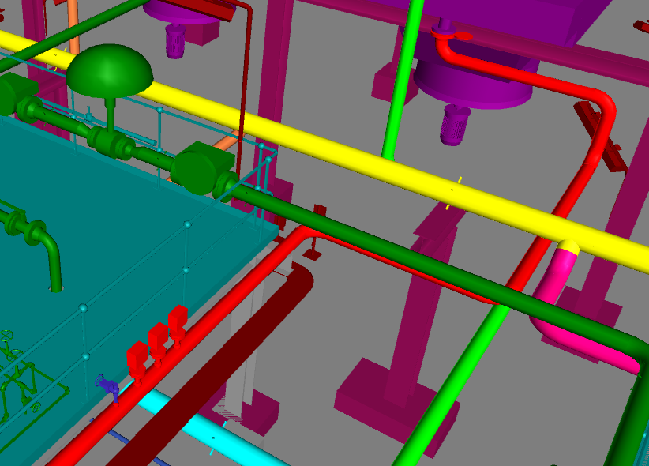

## Client suggestion about removing of expansion loop which located on inlet line of gas compressors shall be checked.

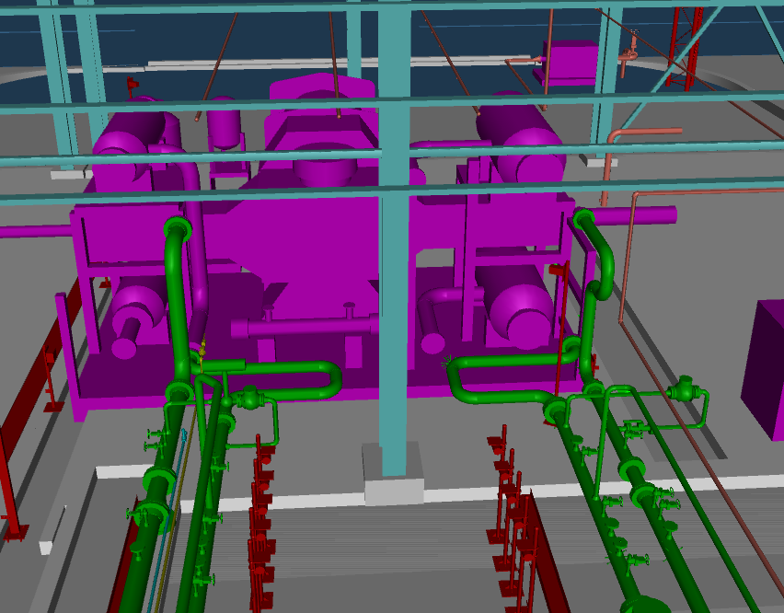

## All hydrostatic test vent and drain shall be added to 3D model.

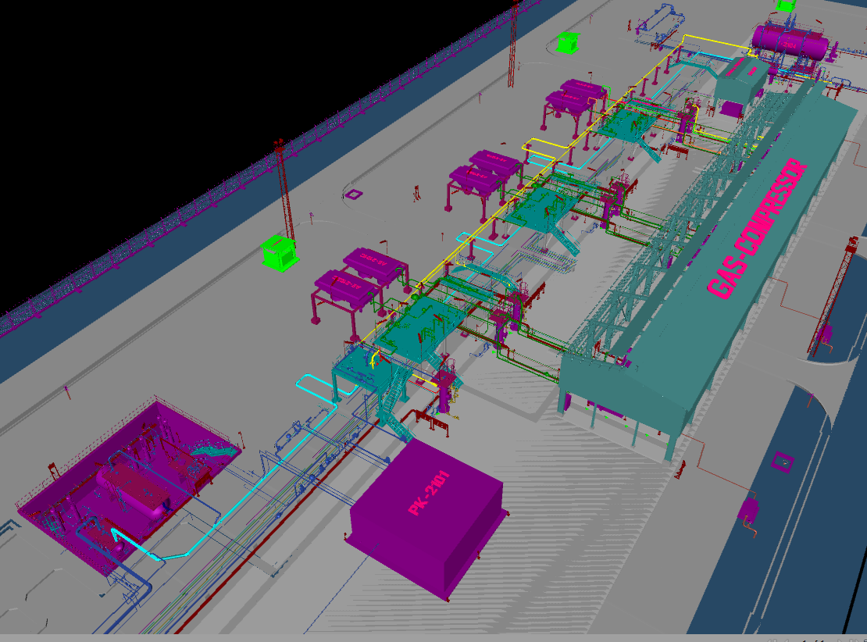

## The requirement to have 2” manual valve on outlet line of gas cooler shall be checked

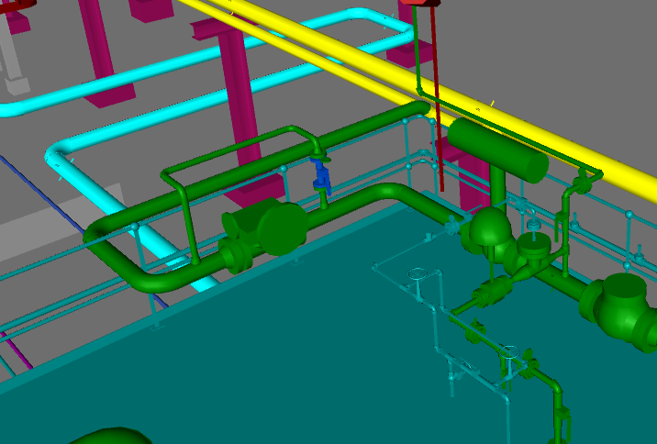

## Client suggestion about requirement of adding balance valve, PIT and purge item for inlet line of V-2101A/B/C shall be checked by vendor.

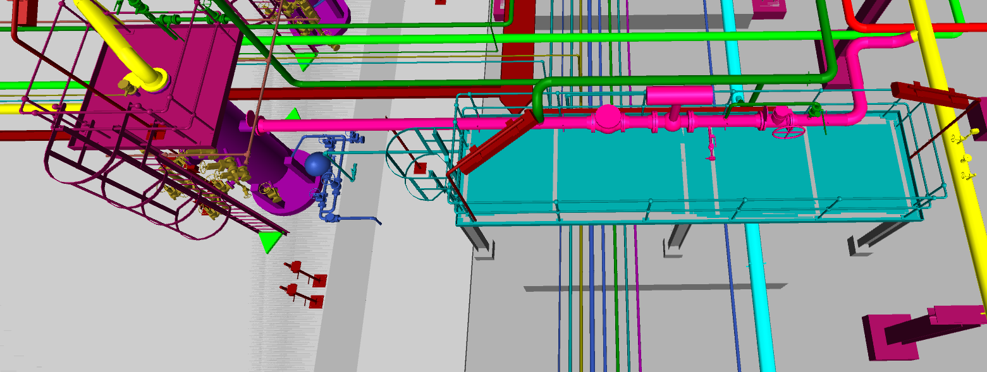

## Location of FGD-6003 and TGD-6003 shall be revised and access area for PR-2002 shall be provided

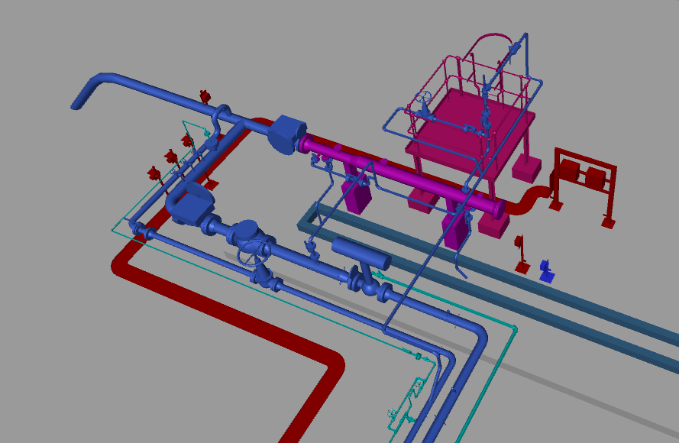

## HN-3001 and MAC-3001 shall be moved from access way of chemical shelter and moved to the side of the road.

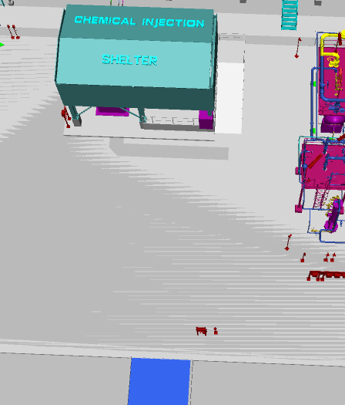

## Sunshade shall be considered to condensate pumps (P-2101A/B)

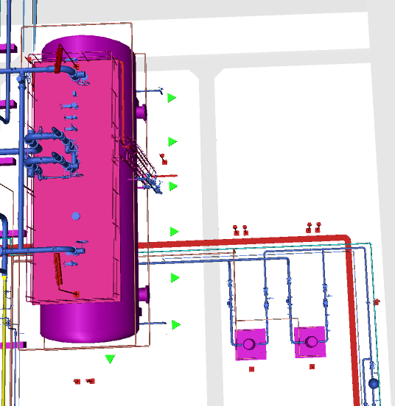

## Instrument and electrical trench shall be revised due to client suggestion which is based on firefighting pumps power supply system.

## 3D model of Instrument and electrical trench shall be revised after overall cable route of instrument and electrical are finalized.

1. **ATTACHEMENT 1**
2. **ATTACHEMENT 2**
3. **ATTACHEMENT 3**