|  |  |  |  |  |  |  |  |
| --- | --- | --- | --- | --- | --- | --- | --- |
| **طرح نگهداشت و افزایش تولید 27 مخزن** | | | | | | | |
| **CALCULATION NOTE FOR SPECIAL PIPE SUPPORTS**  **نگهداشت و افزایش تولید میدان نفتی بینک** | | | | | | | |
|  | |  |  |  |  |  |  |
|  | |  |  |  |  |  |  |
|  | |  |  |  |  |  |  |
|  | |  |  |  |  |  |  |
| D00 | | MAR. 2024 | IFC | R.Berlouie | M.Fakharian | S.Faramarzpour |  |
| **Rev.** | | **Date** | **Purpose of Issue/Status** | **Prepared by:** | **Checked by:** | **Approved by:** | **CLIENT Approval** |
| **Class:2** | | | **COMPANY Doc. Number:F0Z-709131** | | | | |
| **Status:** | | **IDC: Inter-Discipline Check**  **IFC: Issued For Comment**  **IFA: Issued For Approval**  **AFD: Approved For Design**  **AFC: Approved For Construction**  **AFP: Approved For Purchase**  **AFQ:** Approved For Quotation  **IFI: Issued For Information**  **AB-R: As-Built for CLIENT Review**  **AB-A: As-Built –Approved** | | | | | |

**REVISION RECORD SHEET**

|  |  |  |  |  |  |  |  |  |  |  |  |  |
| --- | --- | --- | --- | --- | --- | --- | --- | --- | --- | --- | --- | --- |
| **PAGE** | **D00** | **D01** | **D02** | **D03** | **D04** |  | **PAGE** | **D00** | **D01** | **D02** | **D03** | **D04** |
| **1** | X |  |  |  |  | **66** |  |  |  |  |  |
| **2** | X |  |  |  |  | **67** |  |  |  |  |  |
| **3** | X |  |  |  |  | **68** |  |  |  |  |  |
| **4** | X |  |  |  |  | **69** |  |  |  |  |  |
| **5** | X |  |  |  |  | **70** |  |  |  |  |  |
| **6** | X |  |  |  |  | **71** |  |  |  |  |  |
| **7** | X |  |  |  |  | **72** |  |  |  |  |  |
| **8** | X |  |  |  |  | **73** |  |  |  |  |  |
| **9** | X |  |  |  |  | **74** |  |  |  |  |  |
| **10** | X |  |  |  |  | **75** |  |  |  |  |  |
| **11** | X |  |  |  |  | **76** |  |  |  |  |  |
| **12** | X |  |  |  |  | **77** |  |  |  |  |  |
| **13** | X |  |  |  |  | **78** |  |  |  |  |  |
| **14** | X |  |  |  |  | **79** |  |  |  |  |  |
| **15** | X |  |  |  |  | **80** |  |  |  |  |  |
| **16** | X |  |  |  |  | **81** |  |  |  |  |  |
| **17** | X |  |  |  |  | **82** |  |  |  |  |  |
| **18** | X |  |  |  |  | **83** |  |  |  |  |  |
| **19** |  |  |  |  |  | **84** |  |  |  |  |  |
| **20** |  |  |  |  |  | **85** |  |  |  |  |  |
| **21** |  |  |  |  |  | **86** |  |  |  |  |  |
| **22** |  |  |  |  |  | **87** |  |  |  |  |  |
| **23** |  |  |  |  |  | **88** |  |  |  |  |  |
| **24** |  |  |  |  |  | **89** |  |  |  |  |  |
| **25** |  |  |  |  |  | **90** |  |  |  |  |  |
| **26** |  |  |  |  |  | **91** |  |  |  |  |  |
| **27** |  |  |  |  |  | **92** |  |  |  |  |  |
| **28** |  |  |  |  |  | **93** |  |  |  |  |  |
| **29** |  |  |  |  |  | **94** |  |  |  |  |  |
| **30** |  |  |  |  |  | **95** |  |  |  |  |  |
| **31** |  |  |  |  |  | **96** |  |  |  |  |  |
| **32** |  |  |  |  |  | **97** |  |  |  |  |  |
| **33** |  |  |  |  |  | **98** |  |  |  |  |  |
| **34** |  |  |  |  |  | **99** |  |  |  |  |  |
| **35** |  |  |  |  |  | **100** |  |  |  |  |  |
| **36** |  |  |  |  |  | **101** |  |  |  |  |  |
| **37** |  |  |  |  |  | **102** |  |  |  |  |  |
| **38** |  |  |  |  |  | **103** |  |  |  |  |  |
| **39** |  |  |  |  |  | **104** |  |  |  |  |  |
| **40** |  |  |  |  |  | **105** |  |  |  |  |  |
| **41** |  |  |  |  |  | **106** |  |  |  |  |  |
| **42** |  |  |  |  |  | **107** |  |  |  |  |  |
| **43** |  |  |  |  |  | **108** |  |  |  |  |  |
| **44** |  |  |  |  |  | **109** |  |  |  |  |  |
| **45** |  |  |  |  |  | **110** |  |  |  |  |  |
| **46** |  |  |  |  |  | **111** |  |  |  |  |  |
| **47** |  |  |  |  |  | **112** |  |  |  |  |  |
| **48** |  |  |  |  |  | **113** |  |  |  |  |  |
| **49** |  |  |  |  |  | **114** |  |  |  |  |  |
| **50** |  |  |  |  |  | **115** |  |  |  |  |  |
| **51** |  |  |  |  |  | **116** |  |  |  |  |  |
| **52** |  |  |  |  |  | **117** |  |  |  |  |  |
| **53** |  |  |  |  |  | **118** |  |  |  |  |  |
| **54** |  |  |  |  |  | **119** |  |  |  |  |  |
| **55** |  |  |  |  |  | **120** |  |  |  |  |  |
| **56** |  |  |  |  |  | **121** |  |  |  |  |  |
| **57** |  |  |  |  |  | **122** |  |  |  |  |  |
| **58** |  |  |  |  |  | **123** |  |  |  |  |  |
| **59** |  |  |  |  |  | **124** |  |  |  |  |  |
| **60** |  |  |  |  |  | **125** |  |  |  |  |  |
| **61** |  |  |  |  |  | **126** |  |  |  |  |  |
| **62** |  |  |  |  |  | **127** |  |  |  |  |  |
| **63** |  |  |  |  |  | **128** |  |  |  |  |  |
| **64** |  |  |  |  |  | **129** |  |  |  |  |  |
| **65** |  |  |  |  |  | **130** |  |  |  |  |  |

**CONTENTS**

1.0 INTRODUCTION 4

2.0 Scope 4

3.0 NORMATIVE REFERENCE 4

4.0 Material properties 5

5.0 STRUCTURE ‘s systems 5

6.0 DESIGN LOAD 5

7.0 SAP loading table 17

8.0 Load combinations 19

9.0 STRUCTURE ANALYSIS AND DESIGN 20

10.0 Structural Design Results 25

11.0 STRUCTURE CONNECTIONS 28

12.0 FOUNDATION DESIGN 41

1. **INTRODUCTION**

Binak oilfield in Bushehr province is a part of the southern oilfields of Iran, is located 20 km northwest of Genaveh city.

With the aim of increasing production of oil from Binak oilfield, an EPC/EPD Project has been defined by NIOC/NISOC and awarded to Petro Iran Development Company (PEDCO). Also PEDCO (as General Contractor) has assigned the EPC-packages of the Project to "Hirgan Energy - Design and Inspection" JV.

1. **Scope**

This report covers the structure & foundation calculation report of the “Chemical injection and Storage Shelter”. The structure modelled by “SAP” software & the foundation modelled by “SAP” software too.

1. **NORMATIVE REFERENCE**
   1. **Local Codes and Standards**

* INBC Part 6 “Iranian National Building Code
* INBC Part 7 “Iranian National Building Code
* INBC Part 9 “Iranian National Building Code
* INBC Part 10 “Iranian National Building Code
* Iranian Seismic Design Code for Petroleum Facilities(3rd edition)
  1. **International Codes and Standards**
* ASCE 7-10 “Minimum Design Loads and Associated Criteria for Buildings and Other Structures-American Society of Civil Engineers”.
* ACI 318. “Building Code Requirements for Reinforced Concrete”, American Concrete Institute.
* AISC 358 “Prequalified Connections for Special and Intermediate Steel Moment Frames for Seismic Applications.” American Institute of Steel Construction, Inc.
* AISC 360 - “Specification for Structural Steel Buildings”. American Institute of Steel Construction, Inc.
  1. **The Project Documents**

## BK-GNRAL-PEDCO-000-ST-SP-0001 SPECIFICATION FOR CONCRETE WORK

## BK-gcs-PEDCO-120-ST-DW-0058 STRUCTURAL drawing for chemical injection & storage shelter

## BK-GNRAL-PEDCO-000-ST-DC-0001 Structural Design Criteria

## BK-GNRAL-PEDCO-000-CV-SP-0004 Specification For Earth Work

## BK-GCS-PEDCO-120-GT-RT-0001 Geotechnical Investigation Report for

## Compressor Station

1. **Material properties**

Material properties are delivered in the following table.

table 1 -Material Properties

|  |  |
| --- | --- |
| Foundation Concrete | F'c = 30 Mpa(28- day cylindrical sample) |
| Long. reinforcement bar | Fy = 400 Mpa(AIII) |
| Trans. reinforcement bar | Fy = 400 Mpa(AIII) |
| Bolt Type | HV 8.8 |
| Electrode Type | E 70 |
| Structural Steel shapes and plates: | St 37(Fy=2400kg/cm2 , Fu=3700 kg/cm2) |

1. **STRUCTURE ‘s systems**

The structure’s system is Inverted pendulum.

table 2 –structural system

|  |  |  |  |  |
| --- | --- | --- | --- | --- |
|  | system | R | Omega | Cd |
| x dir | pendulum | 2 | 2 | 2 |
| y dir | pendulum | 2 | 2 | 2 |

1. **INPUT DATA**

Structural elements stability and stress check have been performed considering the following load conditions:

|  |  |  |  |
| --- | --- | --- | --- |
| LoadPat | DesignType | SelfWtMult | Notes |
| DL | Dead | 1 | Weight of the Structural members and permanent attachments or accessories |
| Test | Dead | 0 | The empty weight of the pipes plus the weight of the test medium |
| LL | Live | 0 | Live Load |
| OPR1 | Dead | 0 | The weight of piping, piping insulation, cable tray, process equipment and vessels plus their contents (fluid load) in Thermal load. Operating Load=DLempty+LLop |
| EQX | Quake | 0 | Earthquake load is determined by equivalent static earthquake analysis at axis X |
| EQY | Quake | 0 | Earthquake load is determined by equivalent static earthquake analysis at axis Y |
| OCX | Quake | 0 | Pure seismic load of piping at axis X |
| TL | Other | 0 | Thermal loads are those forces caused by a change in temperature. Such forces shall include those caused by vessel or piping expansion or contraction. |
| OCY | Quake | 0 | Pure seismic load of piping at axis Y |
| FRX | Other | 0 | Friction loads due to thermal expansion of pipes axis X |
| FRY | Other | 0 | Friction loads due to thermal expansion of pipes axis Y |
| EQZ | Quake | 0 | Vertical Earthquake load |
| TLst | Temperature | 0 | Temperature Load |
| NotionalX(DL) | Notional | 0 | Notional load derived from DL load at axis X |
| NotionalY(DL) | Notional | 0 | Notional load derived from DL load at axis Y |
| NotionalX(OPR) | Notional | 0 | Notional load derived from OPR load at axis X |
| NotionalY(OPR) | Notional | 0 | Notional load derived from OPR load at axis Y |
| NotionalX(Test) | Notional | 0 | Notional load derived from Test load at axis X |
| NotionalY(Test) | Notional | 0 | Notional load derived from Test load at axis Y |
| Soil | Dead | 0 | Soil load |

1. **DESIGN LOAD**
   1. **Dead load**

The self-weight of structural elements (introduced Dead Load/DL in SAP) is automatically considered by SAP program.

* 1. **Operation Loads**

Operation load of pipes according to piping documents assign in model.

* 1. **Hydrotest Loads**

Hydrotest load of pipes according to piping documents assign in model.

* 1. **PURE SEISMIC WEIGHT OF PIPING (OCX & OCY)**

Seismic loads of pipes according to piping documents assign in model. In some cases when the earthquake load is not provided by piping, the earthquake coefficient is calculated by Iranian seismic design code for Petroleum facilities (3rd edition). the same behavior as the inverted pendulum.

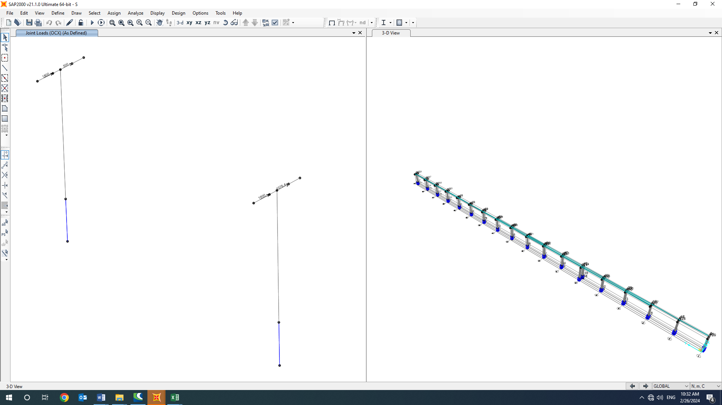

1. PURE SEISMIC WEIGHT OF PIPING (OCX)
   1. **Seismic Load (eqx,eqy)**

All structures are in area with high risk zone of seismic and until finalizing of “Geotechnical Final Report” soil type consider is type II. Equivalent static method is used for calculation of seismic loads. Parameters which are used in calculation of earthquake force and seismic coefficient is presented in below According to Iranian seismic design code for Petroleum facilities (3rd edition). Structures with the same behavior as the inverted pendulum.

$V$ = $\frac{S_{a}}{R/{I_{e}}}$ w

Where:

$C_{s}$ = the seismic response coefficient from Equation below:

𝑊 = the effective seismic weight of the structure

$C_{s}$ = $\frac{S_{a}}{R/{I_{e}}}$

Where:

𝑆𝑎= mapped spectral response acceleration parameter (g), determined from hazard analysis.

$$S_{DS}=0.75$$

$S_{D1}=0.375$

R= the response modification factor for structure (Structures with the same behavior as the inverted pendulum)

$I=$ the importance factor for structure:1.25

Ruy=2

Omega=2

Cd=2

$C_{s}=\frac{0.75×1.25}{2}$ =0.468

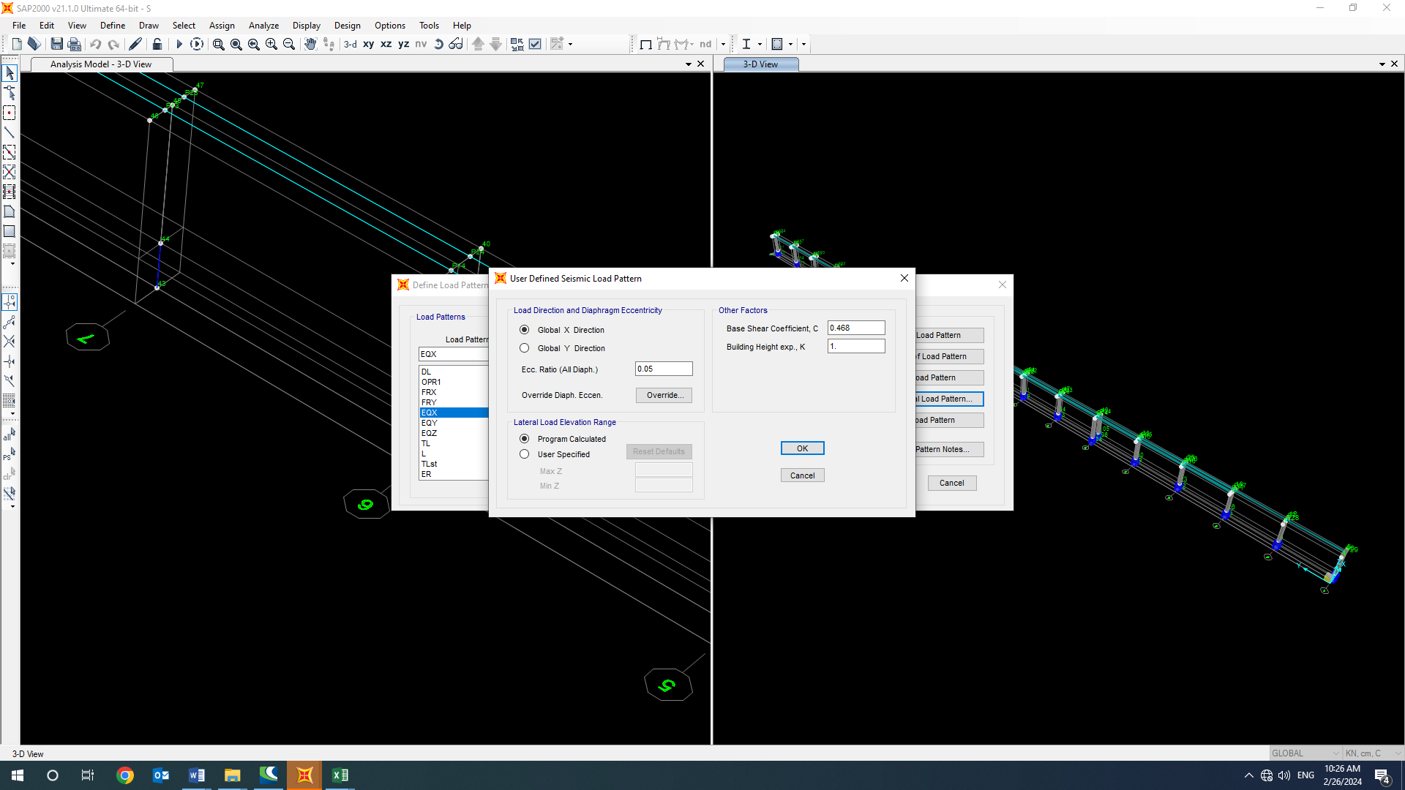 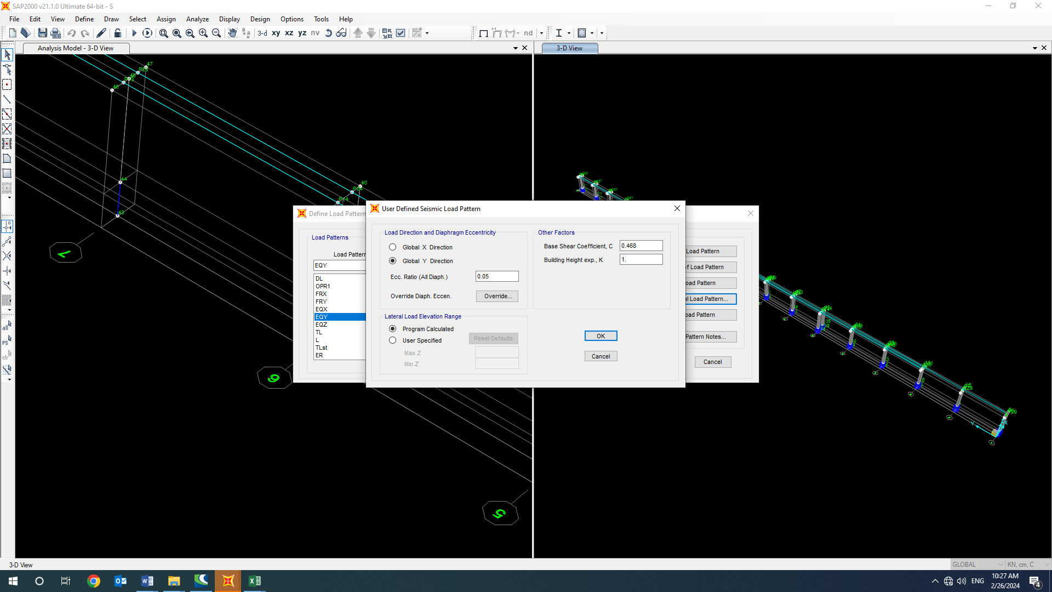

1. Period in x,y direction

* **Vertical seismic component:**

The vertical seismic load effect, 𝐸𝑣, shall be determined in accordance with the following Equation 6):

𝐸𝑣 = 0.2 $S_{DS}$ 𝐷

$S_{DS}$ = Design, 5% damped, spectral response acceleration parameter (g) at short periods (0.2 sec).

D = effect of dead load

Loads case name: EQZ=0.2×0.75×W=0.15×W

-Ev : Vertical seismic load applied at model:

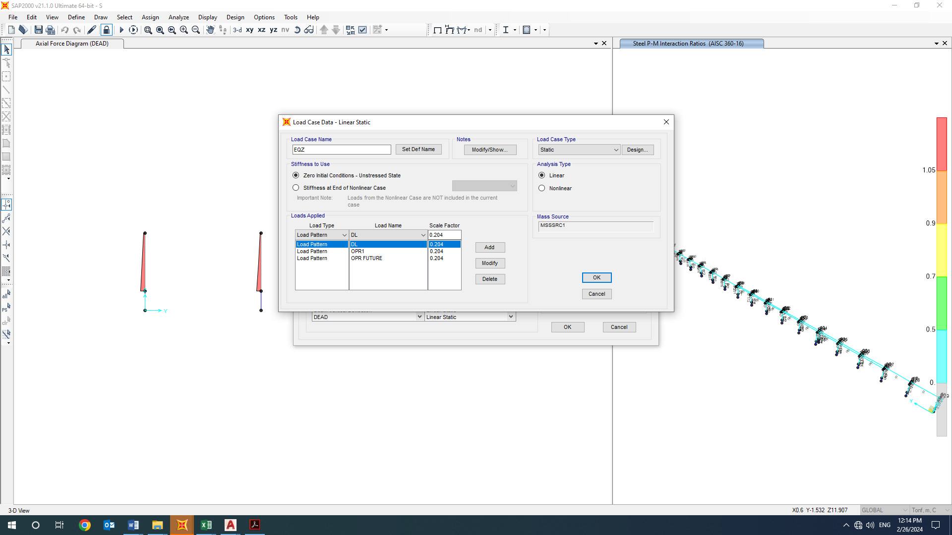

1. applied Ev load

Ev applied at model as a portion of dead load as above.

* 1. **friction loads (FRX, FRy)**

Based on design criteria on pipe racks and pipe supports with 3 or less lines the friction force shall be taken as 30% of the total pipe weight under operating condition.

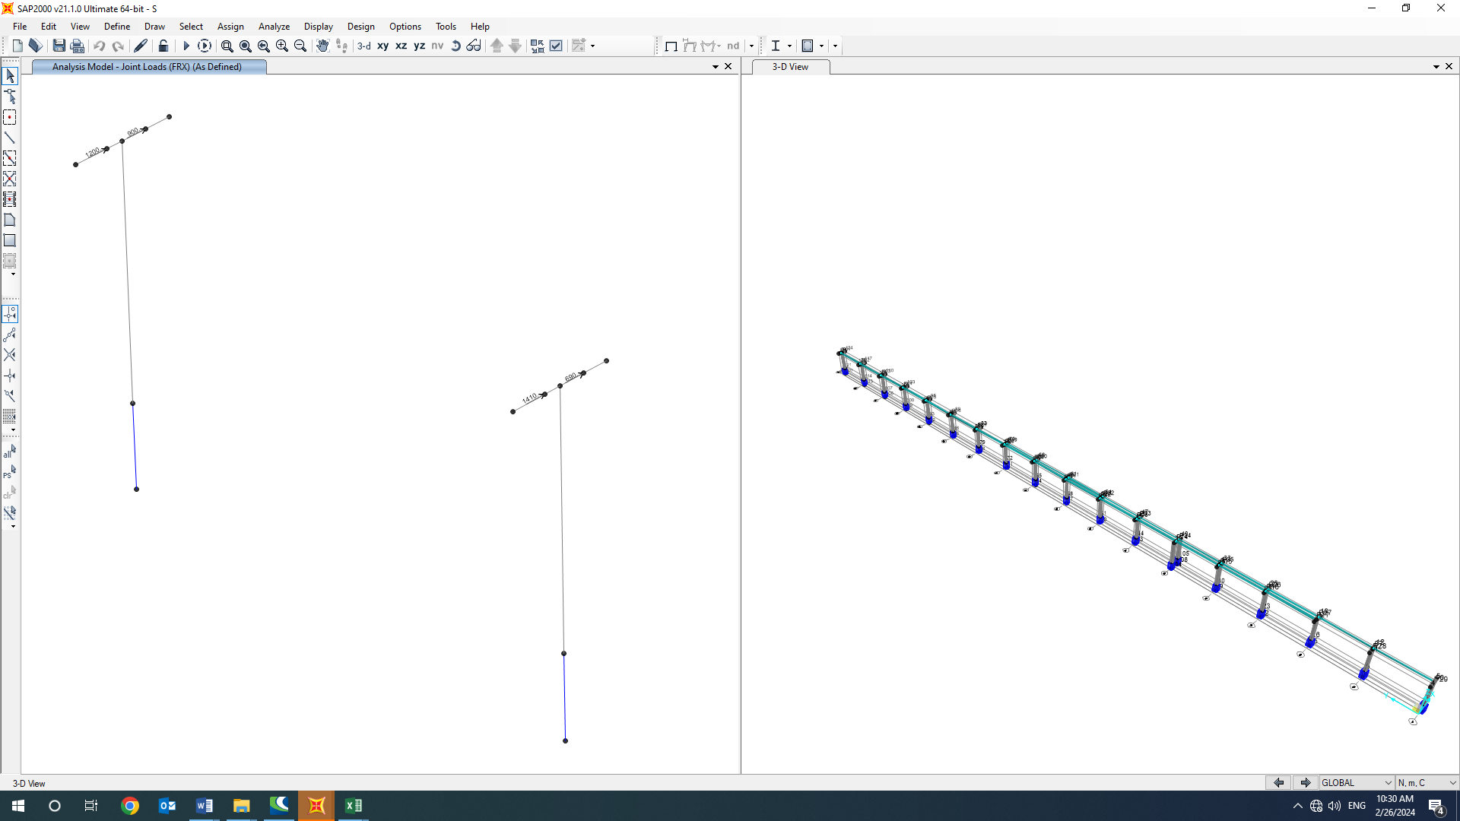 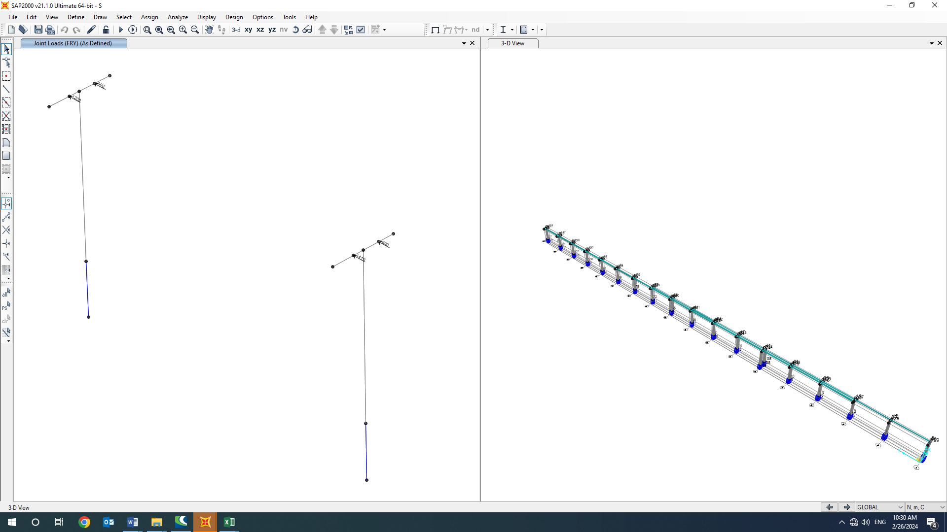

1. friction loads (FRX, FRy)
   1. **Thermal Load of structure (TLst)**

According to “Specification for Civil and Structural Design Criteria”. Maximum temperature of 28 ºC shall be considered for computing the thermal load in all components.

* 1. **SAP loading table**
* **Load pattern:**

| **TABLE: Load Pattern Definitions** | | | | |
| --- | --- | --- | --- | --- |
| **LoadPat** | **DesignType** | **SelfWtMult** | **AutoLoad** | **NotBasePat** |
| Text | Text | Unitless | Text | Text |
| DL | Dead | 1 |  |  |
| OPR1 | Dead | 0 |  |  |
| FRX | Other | 0 |  |  |
| FRY | Other | 0 |  |  |
| EQX | Quake | 0 | USER COEFF |  |
| EQY | Quake | 0 | USER COEFF |  |
| EQZ | Quake | 0 | None |  |
| TL | Other | 0 |  |  |
| L | Live | 0 |  |  |
| Test | Dead | 0 |  |  |
| Soil | Dead | 0 |  |  |
| OCX | Quake | 0 | None |  |
| OCY | Quake | 0 | None |  |
| NotionalX(DL) | Notional | 0 |  | DL |
| NotionalY(DL) | Notional | 0 |  | DL |
| NotionalX(OPR) | Notional | 0 |  | OPR1 |
| NotionalY(OPR) | Notional | 0 |  | OPR1 |
| NotionalX(Test) | Notional | 0 |  | Test |
| NotionalY(Test) | Notional | 0 |  | Test |

1. **Load combinations**

According to code INBC No.60(4 th edition) structures, components, and foundations shall be designed, so that their design strength equals or exceeds that effect of factored loads in the following combination:

* 1.4(D)
* (1.2D) +1.6(L)+0.5(Lr/S/R)
* 1.2D+1.6(Lr/S/R) + (L/0.5W)
* 1.2D+1.0(W) + L+.5(Lr/S)
* 1.2D+1.0E+L+0.2S
* 0.9D+1.0W
* 0.9D+1.0E

Load listed herein shall be considered to act in the following combinations; whichever produces the most unfavorable effect considering soil reactions.

* *D*
* *D+L*
* *D+(Lr/S/R)*
* *D+0.75(L)+0.75(Lr/R/S)*
* *D+(0.6W or 0.7E)*
* *D+0.75L+0.75(0.6W)+0.75(Lr/S/R)*
* *D+0.75L+0.75(0.7E)+0.75S*
* *0.6D+0.6W*
* *0.6D+0.7E*

1. **STRUCTURE ANALYSIS AND DESIGN** 
   1. **ANALYSIS**

Structural analysis is done by SAP2000 software. In model loads are applied, some graphical outputs from model are shown as follows.

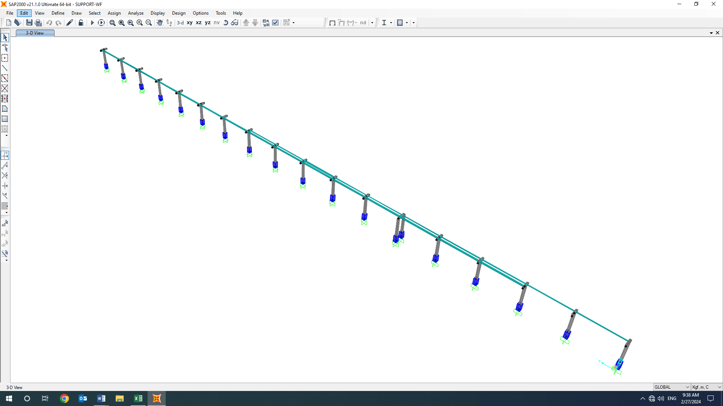

1. 3D VIEW OF SAP MODEL
   1. **Base Plate**



**Current Date:** 2/27/2024 1:21 PM

**Units system:** Metric

**File name:** C:\ProgramData\Bentley\Engineering\RAM Connection\13.7.0\Data\Base Plate Examples.rcnx

Steel connections

**Results**

**Connection name : Pinned BP**

**Connection ID : 1**

Family: Column - Base (CB)

Type: Base plate

Description: DG1 LRFD - Example 4.1

Design code: AISC 360-05 LRFD, ACI 318-08

**DEMANDS**

**Description Pu Mu22 Mu33 Vu2 Vu3 Load type**

[T] [T*m] [T*m] [T] [T]

DC1 -25.00 0.00 0.00 5.00 3.00 Design

**Design for major axis**

**Base plate (AISC 360-05 LRFD)**

**GEOMETRIC CONSIDERATIONS**

**Dimensions Unit Value Min. value Max. value Sta. References**

Base plate

Distance from anchor to edge [cm] 5.80 0.64 -- 

Weld size [1/16in] 7 3 --  table J2.4

**DESIGN CHECK**

**Verification Unit Capacity Demand Ctrl EQ Ratio References**

Pedestal

Axial bearing [Ton/cm2] 0.17 0.01 DC1 **0.04** DG1 3.1.1;

Base plate

Flexural yielding (bearing interface) [Ton*m/m] 3.56 1.06 DC1 **0.30** DG1 Eq. 3.3.13

Flexural yielding (tension interface) [Ton*m/m] 3.56 0.00 DC1 **0.00** DG1 Eq. 3.3.13

Column

Weld capacity [Ton/m] 261.03 0.00 DC1 **0.00** p. 8-9,

Sec. J2.5,

Sec. J2.4

Elastic method weld shear capacity [Ton/m] 174.02 8.33 DC1 **0.05** p. 8-9,

Sec. J2.5,

Sec. J2.4

Elastic method weld axial capacity [Ton/m] 261.03 0.00 DC1 **0.00** p. 8-9,

Sec. J2.5,

Sec. J2.4

**Ratio 0.30**

**Major axis**

**Anchors**

**GEOMETRIC CONSIDERATIONS**

**Dimensions Unit Value Min. value Max. value Sta. References**

Anchors

Anchor spacing [cm] 23.00 9.60 --  Sec. D.8.1

Concrete cover [cm] 13.30 5.08 --  Sec. 7.7.1

Effective length [cm] 51.56 -- 138.44 

**DESIGN CHECK**

**Verification Unit Capacity Demand Ctrl EQ Ratio References**

Anchor tension [Ton] 10.80 0.00 DC1 **0.00** Eq. D-3

Breakout of anchor in tension [Ton] 12.34 0.00 DC1 **0.00** Eq. D-4,

Sec. D.4.1.1

Pullout of anchor in tension [Ton] 15.77 0.00 DC1 **0.00** Sec. D.4.1.1

Side-face blowout of anchor in tension [Ton] 9.66 0.00 DC1 **0.00** Sec. D.5.4.1,

Sec. D.4.1.1

Anchor shear [Ton] 4.49 0.83 DC1 **0.19** Eq. D-20,

Sec. D.6.1.3

Breakout of anchor in shear [Ton] 3.06 0.83 DC1 **0.27** Sec. D.4.1.1

Breakout of group of anchors in shear [Ton] 10.76 5.00 DC1 **0.46** Sec. D.4.1.1

Pryout of anchor in shear [Ton] 24.68 0.83 DC1 **0.03** Eq. D-4,

Sec. D.4.1.1

**Ratio 0.46**

**Global critical strength ratio 0.46**

**Major axis**

**Maximum compression and tension (DC1)**

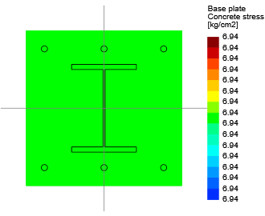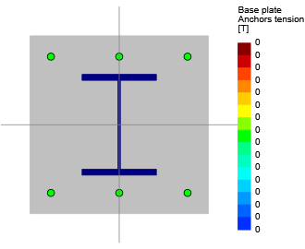

Maximum bearing pressure 6.94 [kg/cm2]

Minimum bearing pressure 6.94 [kg/cm2]

Maximum anchor tension 0.00 [T]

Minimum anchor tension 0.00 [T]

Neutral axis angle 0.00 [deg]

Bearing length 1E32 [cm]

**Anchors tensions**

**Anchor Transverse Longitudinal Shear Tension**

[cm] [cm] [T] [T]

1 -23.00 -23.00 0.83 0.00

2 0.00 -23.00 0.83 0.00

3 23.00 -23.00 0.83 0.00

4 23.00 23.00 0.83 0.00

5 0.00 23.00 0.83 0.00

6 -23.00 23.00 0.83 0.00

**Major axis**

**Results for shear breakout (DC1)**

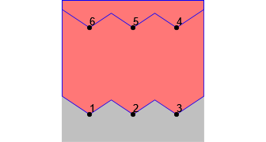

**Group Area Shear Anchors**

[cm2] [T]

1 6806.25 5.00 1, 2, 3, 4, 5, 6

2 1631.25 2.50 4, 5, 6

1. **FOUNDATION DESIGN**

SAFE has been used in order to modeling, analyses and design of this foundation.

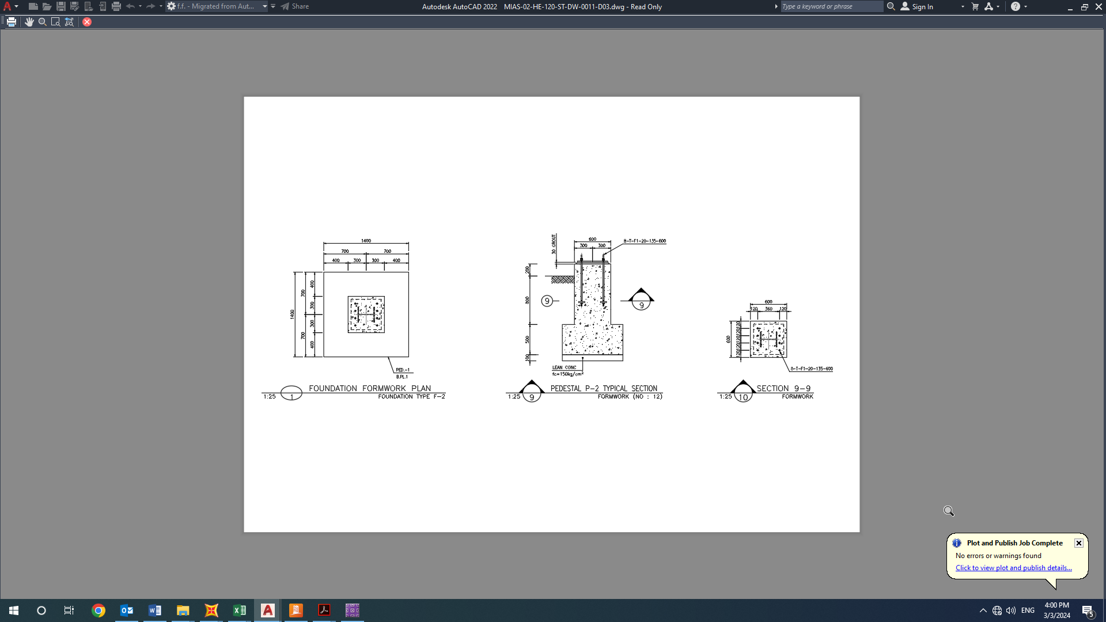

1. Foundation Plan
   1. **Soil pressure and settlement**

Until finalize of geotechnical report for this area we consider => qa= 2kg/cm2

Based on geotechnical report for subgrade modulus is => Ks = 1.69 kg/cm3

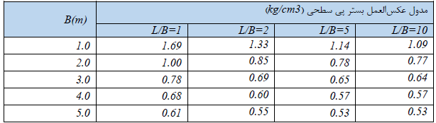

1. Subgrade Modulus

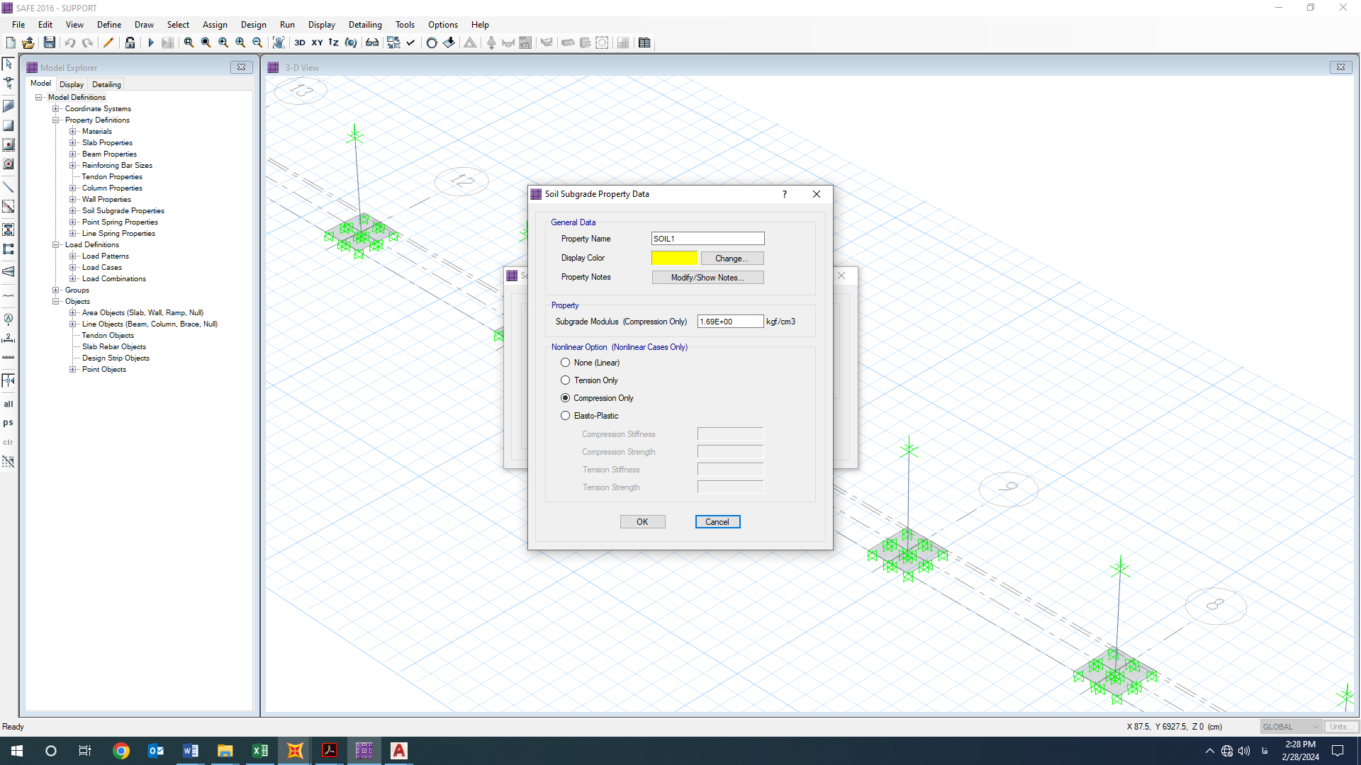

1. Assign Spring to Foundation
   1. **DESIGN**

Concrete Foundation are designed according to ACI 318-14. Required loads are derived from SAP data, and design process will be done according to ACI code based on ultimate strength procedure.

${f^{'}}_{c}=30Mpa$ $f_{y}=400Ma$

Soil load applied on model as below:

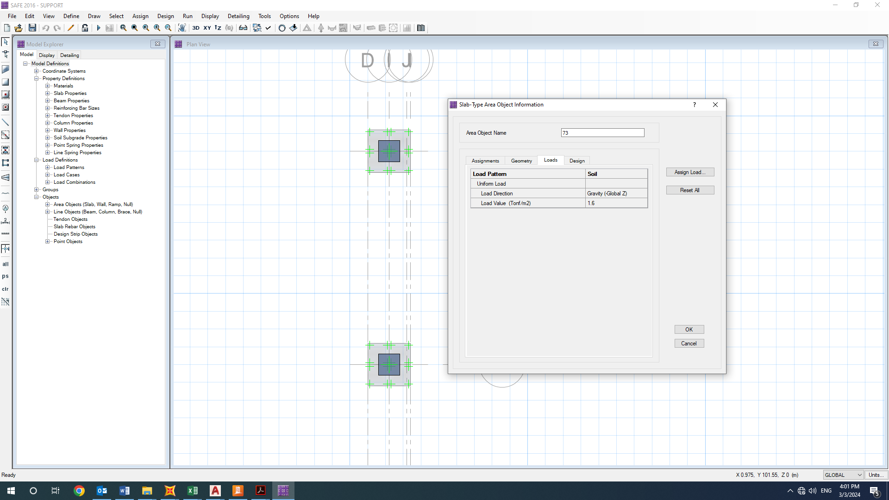

1. Applied soil load on Foundation

Soil dead load is

* 1. **FOUNDATION DESIGN CONTROL**

### 12.3.1 Check of Stress for Foundation

| **TABLE: Nodal Displacements** | | | | | |
| --- | --- | --- | --- | --- | --- |
| **Point** | **OutputCase** | **CaseType** | **Ux** | **Uy** | **Uz** |
| 71 | COMB11 | Combination | 0 | 0 | -0.12303 |
| 239 | COMB11 | Combination | 0 | 0 | -0.12303 |
| 71 | ENV | Combination | 0 | 0 | -0.12303 |
| 239 | ENV | Combination | 0 | 0 | -0.12303 |
| 119 | COMB11 | Combination | 0 | 0 | -0.1227 |
| 119 | ENV | Combination | 0 | 0 | -0.1227 |
| 118 | COMB11 | Combination | 0 | 0 | -0.12267 |
| 123 | COMB11 | Combination | 0 | 0 | -0.12267 |
| 118 | ENV | Combination | 0 | 0 | -0.12267 |
| 123 | ENV | Combination | 0 | 0 | -0.12267 |
| 117 | COMB11 | Combination | 0 | 0 | -0.12264 |
| 117 | ENV | Combination | 0 | 0 | -0.12264 |
| 121 | COMB11 | Combination | 0 | 0 | -0.12264 |
| 124 | COMB11 | Combination | 0 | 0 | -0.12264 |
| 121 | ENV | Combination | 0 | 0 | -0.12264 |
| 124 | ENV | Combination | 0 | 0 | -0.12264 |
| 116 | COMB11 | Combination | 0 | 0 | -0.12258 |
| 122 | COMB11 | Combination | 0 | 0 | -0.12258 |
| 116 | ENV | Combination | 0 | 0 | -0.12258 |
| 122 | ENV | Combination | 0 | 0 | -0.12258 |
| 22 | COMB11 | Combination | 0 | 0 | -0.11921 |
| 232 | COMB11 | Combination | 0 | 0 | -0.11921 |
| 22 | ENV | Combination | 0 | 0 | -0.11921 |
| 232 | ENV | Combination | 0 | 0 | -0.11921 |
| 51 | COMB11 | Combination | 0 | 0 | -0.1189 |
| 51 | ENV | Combination | 0 | 0 | -0.1189 |
| 52 | COMB11 | Combination | 0 | 0 | -0.11886 |
| 56 | COMB11 | Combination | 0 | 0 | -0.11886 |
| 52 | ENV | Combination | 0 | 0 | -0.11886 |
| 56 | ENV | Combination | 0 | 0 | -0.11886 |
| 49 | COMB11 | Combination | 0 | 0 | -0.11884 |
| 55 | COMB11 | Combination | 0 | 0 | -0.11884 |
| 49 | ENV | Combination | 0 | 0 | -0.11884 |
| 55 | ENV | Combination | 0 | 0 | -0.11884 |
|  |  |  |  | MAX | -0.12303 |

According to above output, Max soil pressure under the foundation is:

$$q_{n}=0.123×1.69=0.200 kg/{cm}^{2} < 2 kg/{cm}^{2} ok$$

### 12.3.3 REINFORCING CONTROL

Minimum rebar for foundation:

$$A_{s min}=0.0018bh$$

$$A_{smin}=\frac{1}{2}0.0018 bh=\frac{1}{2}0.0018×100×50=4.5 cm^{2}/m$$

$$A_{s used}=∅16@200=10.05cm^{2}$$

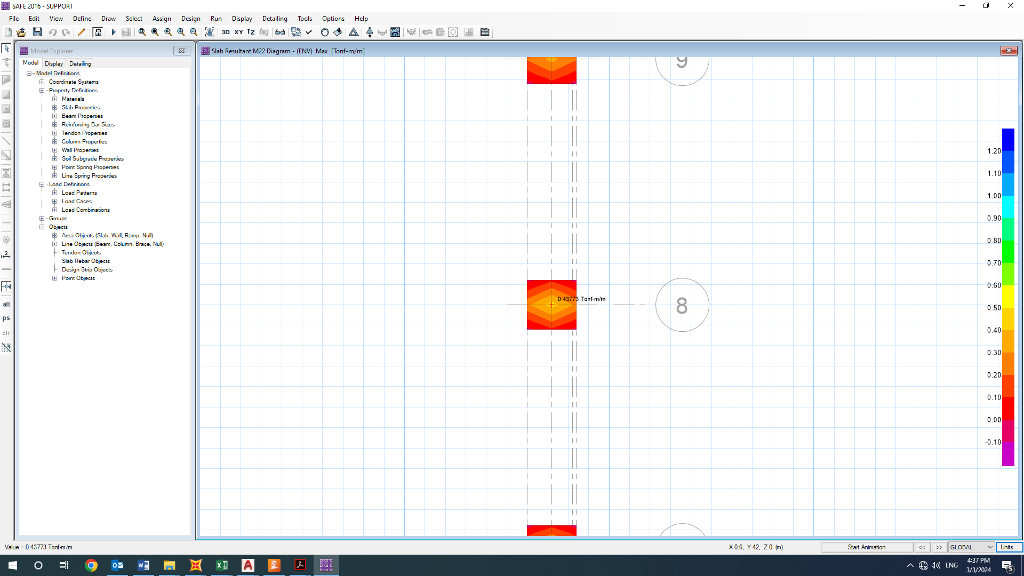

1. M22 result