|  |  |  |  |  |  |  |  |
| --- | --- | --- | --- | --- | --- | --- | --- |
| **طرح نگهداشت و افزایش تولید 27 مخزن** | | | | | | | |
| **CALCULATION NOTE FOR FIRE WATER PUMP SHELTER**  **نگهداشت و افزایش تولید میدان نفتی بینک** | | | | | | | |
|  | |  |  |  |  |  |  |
|  | |  |  |  |  |  |  |
| D02 | | APR.2024 | AFD | R.Berlouie | M.Fakharian | S.Faramarzpour |  |
| D01 | | NOV.2023 | IFA | R.Berlouie | M.Fakharian | S.Faramarzpour |  |
| D00 | | AUG.2023 | IFC | R.Berlouie | M.Fakharian | A.M.Mohseni |  |
| **Rev.** | | **Date** | **Purpose of Issue/Status** | **Prepared by:** | **Checked by:** | **Approved by:** | **CLIENT Approval** |
| **Class:2** | | | **COMPANY Doc. Number:F0Z-709124** | | | | |
| **Status:** | | **IDC: Inter-Discipline Check**  **IFC: Issued For Comment**  **IFA: Issued For Approval**  **AFD: Approved For Design**  **AFC: Approved For Construction**  **AFP: Approved For Purchase**  **AFQ:** Approved For Quotation  **IFI: Issued For Information**  **AB-R: As-Built for CLIENT Review**  **AB-A: As-Built –Approved** | | | | | |

**REVISION RECORD SHEET**

|  |  |  |  |  |  |  |  |  |  |  |  |  |
| --- | --- | --- | --- | --- | --- | --- | --- | --- | --- | --- | --- | --- |
| **PAGE** | **D00** | **D01** | **D02** | **D03** | **D04** |  | **PAGE** | **D00** | **D01** | **D02** | **D03** | **D04** |
| **1** | X | X | X |  |  | **66** |  | X |  |  |  |
| **2** | X | X | X |  |  | **67** |  | X |  |  |  |
| **3** | X | X |  |  |  | **68** |  | X |  |  |  |
| **4** | X |  |  |  |  | **69** |  | X |  |  |  |
| **5** | X |  |  |  |  | **70** |  | X |  |  |  |
| **6** | X | X |  |  |  | **71** |  |  |  |  |  |
| **7** | X |  |  |  |  | **72** |  |  |  |  |  |
| **8** | X |  |  |  |  | **73** |  |  |  |  |  |
| **9** | X |  |  |  |  | **74** |  |  |  |  |  |
| **10** | X |  |  |  |  | **75** |  |  |  |  |  |
| **11** | X |  |  |  |  | **76** |  |  |  |  |  |
| **12** | X |  |  |  |  | **77** |  |  |  |  |  |
| **13** | X |  |  |  |  | **78** |  |  |  |  |  |
| **14** | X |  |  |  |  | **79** |  |  |  |  |  |
| **15** | X |  |  |  |  | **80** |  |  |  |  |  |
| **16** | X |  |  |  |  | **81** |  |  |  |  |  |
| **17** | X |  |  |  |  | **82** |  |  |  |  |  |
| **18** | X |  |  |  |  | **83** |  |  |  |  |  |
| **19** | X |  |  |  |  | **84** |  |  |  |  |  |
| **20** | X |  |  |  |  | **85** |  |  |  |  |  |
| **21** | X |  |  |  |  | **86** |  |  |  |  |  |
| **22** | X |  |  |  |  | **87** |  |  |  |  |  |
| **23** | X |  |  |  |  | **88** |  |  |  |  |  |
| **24** | X |  |  |  |  | **89** |  |  |  |  |  |
| **25** | X | X |  |  |  | **90** |  |  |  |  |  |
| **26** | X | X |  |  |  | **91** |  |  |  |  |  |
| **27** | X | X |  |  |  | **92** |  |  |  |  |  |
| **28** | X |  |  |  |  | **93** |  |  |  |  |  |
| **29** | X |  |  |  |  | **94** |  |  |  |  |  |
| **30** | X |  |  |  |  | **95** |  |  |  |  |  |
| **31** | X |  |  |  |  | **96** |  |  |  |  |  |
| **32** | X |  |  |  |  | **97** |  |  |  |  |  |
| **33** | X |  |  |  |  | **98** |  |  |  |  |  |
| **34** | X | X |  |  |  | **99** |  |  |  |  |  |
| **35** | X | X |  |  |  | **100** |  |  |  |  |  |
| **36** | X |  |  |  |  | **101** |  |  |  |  |  |
| **37** | X |  |  |  |  | **102** |  |  |  |  |  |
| **38** | X |  |  |  |  | **103** |  |  |  |  |  |
| **39** | X |  |  |  |  | **104** |  |  |  |  |  |
| **40** | X |  |  |  |  | **105** |  |  |  |  |  |
| **41** | X |  |  |  |  | **106** |  |  |  |  |  |
| **42** | X |  |  |  |  | **107** |  |  |  |  |  |
| **43** | X |  |  |  |  | **108** |  |  |  |  |  |
| **44** | X |  |  |  |  | **109** |  |  |  |  |  |
| **45** | X |  |  |  |  | **110** |  |  |  |  |  |
| **46** | X |  |  |  |  | **111** |  |  |  |  |  |
| **47** | X |  |  |  |  | **112** |  |  |  |  |  |
| **48** | X |  |  |  |  | **113** |  |  |  |  |  |
| **49** | X |  |  |  |  | **114** |  |  |  |  |  |
| **50** | X | X |  |  |  | **115** |  |  |  |  |  |
| **51** | X | X |  |  |  | **116** |  |  |  |  |  |
| **52** | X | X |  |  |  | **117** |  |  |  |  |  |
| **53** | X | X |  |  |  | **118** |  |  |  |  |  |
| **54** | X | X |  |  |  | **119** |  |  |  |  |  |
| **55** | X | X |  |  |  | **120** |  |  |  |  |  |
| **56** | X | X |  |  |  | **121** |  |  |  |  |  |
| **57** | X | X |  |  |  | **122** |  |  |  |  |  |
| **58** | X | X |  |  |  | **123** |  |  |  |  |  |
| **59** | X | X |  |  |  | **124** |  |  |  |  |  |
| **60** | X | X |  |  |  | **125** |  |  |  |  |  |
| **61** |  | X |  |  |  | **126** |  |  |  |  |  |
| **62** |  | X |  |  |  | **127** |  |  |  |  |  |
| **63** |  | X |  |  |  | **128** |  |  |  |  |  |
| **64** |  | X |  |  |  | **129** |  |  |  |  |  |
| **65** |  | X |  |  |  | **130** |  |  |  |  |  |

**CONTENTS**

1.0 INTRODUCTION 5

2.0 Scope 5

3.0 NORMATIVE REFERENCE 5

**3.1** **Local Codes and Standards** 5

**3.2** **International Codes and Standards** 5

**3.3** **The Project Documents** 6

4.0 Material properties 6

5.0 STRUCTURE ‘s systems 6

6.0 DESIGN LOAD 7

**6.1** **Dead load** 7

**6.2** **Live Loads** 8

**6.3** **SNOW LOADS** 9

**6.4** **-Unbalanced SNOW LOADS** 10

**6.5** **Seismic loads** 11

**6.6** **CRANE load** 15

**6.7** **WIND loads** 15

**6.8** **Thermal Load of structure (TLst)** 20

7.0 SAP loading table 20

8.0 Load combinations 22

9.0 STRUCTURE ANALYSIS AND DESIGN 23

**9.1** **ANALYSIS** 23

**9.2** **Flextural design of crane beam** 24

**9.3** **Deflection control :** 25

**9.4** **BEAM LATERAL RESTRAINT** 26

**9.5** **Drift control :** 27

10.0Structural Design Results 35

**10.1** **Graphical output** 35

11.0STRUCTURECONNECTIONS………………………………………………………………………………………… …36

**11.1** **Description of Design Procedure & Parameters** 36

**11.2** **PURLIN DESIGN** 44

11.2.1. Property of Purlin(Z180x2.5) 44

**11.3** **Roof bracing Design** 47

**11.4** **Base Plate** 50

**11.5** **General requirements of embedment in concrete**: 52

12.0FOUNDATION DESIGN 54

**12.1** **Soil pressure and settlement** 55

**12.2** **DESIGN** 56

**12.3** **FOUNDATION DESIGN CONTROL** 57

1. **INTRODUCTION**

Binak oilfield in Bushehr province is a part of the southern oilfields of Iran, is located 20 km northwest of Genaveh city.

With the aim of increasing production of oil from Binak oilfield, an EPC/EPD Project has been defined by NIOC/NISOC and awarded to Petro Iran Development Company (PEDCO). Also PEDCO (as General Contractor) has assigned the EPC-packages of the Project to "Hirgan Energy - Design and Inspection" JV.

1. **Scope**

This report covers the structure & foundation calculation report of the “Fire Water Pump Shelter ”. The structure& foundation modelled by “SAP” software.

1. **NORMATIVE REFERENCE**
   1. **Local Codes and Standards**

* INBC Part 6 “Iranian National Building Code
* INBC Part 7 “Iranian National Building Code
* INBC Part 9 “Iranian National Building Code
* INBC Part 10 “Iranian National Building Code
* Iranian Seismic Design Code for Petroleum Facilities(3rd edition)
* Iranian Code Of Practice For Seismic Resistant Design Of Building (Standard No.2800 4th edition)
  1. **International Codes and Standards**
* ASCE 7-10 “Minimum Design Loads and Associated Criteria for Buildings and Other Structures-American Society of Civil Engineers”.
* ACI 318. “Building Code Requirements for Reinforced Concrete”, American Concrete Institute.
* AISC 358 “Prequalified Connections for Special and Intermediate Steel Moment Frames for Seismic Applications.” American Institute of Steel Construction, Inc.
* AISC 360 - “Specification for Structural Steel Buildings”. American Institute of Steel Construction, Inc.
  1. **The Project Documents**

## BK-GNRAL-PEDCO-000-ST-SP-0001 SPECIFICATION FOR CONCRETE WORK

## BK-gcs-PEDCO-120-ST-DW-0066 Structural drawing for fire Water pump Shelter

## BK-gcs-PEDCO-120-ST-DW-0065 FOUNDATION drawing for fire Water pump Shelter

## BK-gNRAL-PEDCO-000-ST-DC-0001 STRUCTURAL DESIGN CRITERIA

## BK-gNRAL-PEDCO-000-ST-SP-0005 SPECIFICATION FOR ERECTION OF STEEL STRUCTURES

## BK-gNRAL-PEDCO-000-ST-SP-0003 SPECIFICATION FOR FABRICATION OF STEEL STRUCTURES

1. **Material properties**

Material properties are delivered in the following table.

table 1 -Material Properties

|  |  |
| --- | --- |
| Foundation Concrete | F'c = 30 Mpa(28- day cylindrical sample) |
| Long. reinforcement bar | Fy = 400 Mpa(AIII) |
| Trans. reinforcement bar | Fy = 400 Mpa(AIII) |
| Bolt Type | HV 8.8 |
| Electrode Type | E 70 |
| Structural Steel shapes and plates: | St 37(Fy=2400kg/cm2 , Fu=3700 kg/cm2) |

1. **STRUCTURE ‘s systems**

The Structure’s System is OMF in X direction and OCBF system in Y direction .Seismic Parameters according to Iranian Seismic Design code(Code No.038) listed at below table.

table 2 –structural system

|  |  |  |  |  |
| --- | --- | --- | --- | --- |
|  | system | R | Omega | Cd |
| Y dir | Omf | 3.5 | 3 | 3 |
| X dir | ocbf | 3.25 | 2 | 3.25 |

1. **DESIGN LOAD**
   1. **Dead load**

Dead loads include the self-weight of the structure and all the permanent equipment which are supported by the structures

$$Corogated sheet :8 kg/m^{2}$$

$$Z Purlin : 8 kg/m^{2}$$

$Insulation :10 kg/m^{2}$ Roof weight is assigned in software approximately 50 kg/m2.

* At frame 1&5 : $50×2=100 kg/m$
* At frame 2&4 : $50×5=250 kg/m$
* At frame 3 : $50×6=300 kg/m$

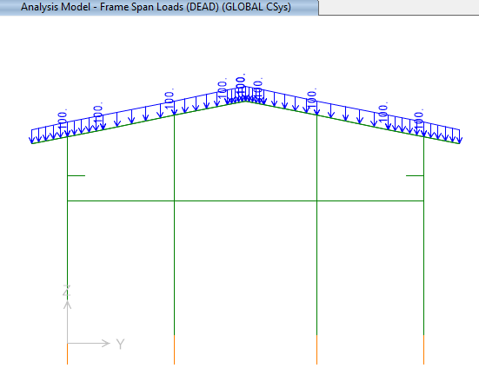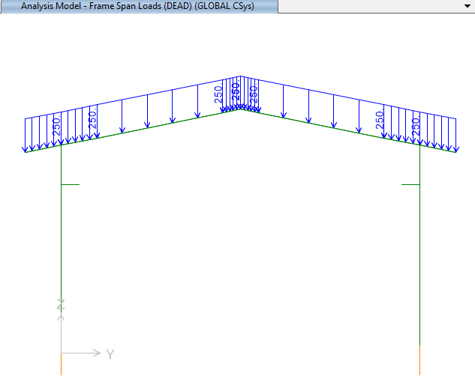

**Figure 1-applied Dead load on frame(1&5) ( 100kg/m) Figure 2-applied Dead load on frame 2&4(250 kg/m)**

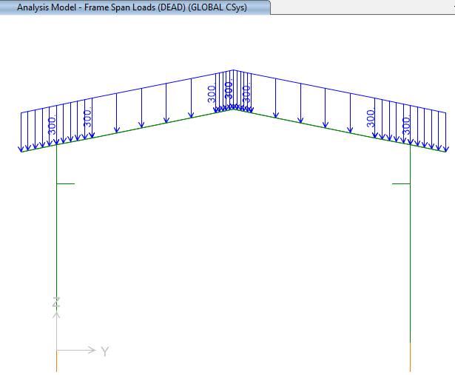

**Figure 3-applied Dead load on frame 3(300 kg/m)**

* 1. **Live Loads**

The design live load on an area shall be defined as the weight of all movable loads, including personnel, tools, and parts of dismantled equipment, cranes, hoist, and temporarily stored materials.

According to Civil Design Live load in slop roof is 100kg/m2 .

* At frame 1&5 : $100×2=200 kg/m$
* At frame 2&4 : $100×5=500 kg/m$
* At frame 3 : $100×6=600 kg/m$

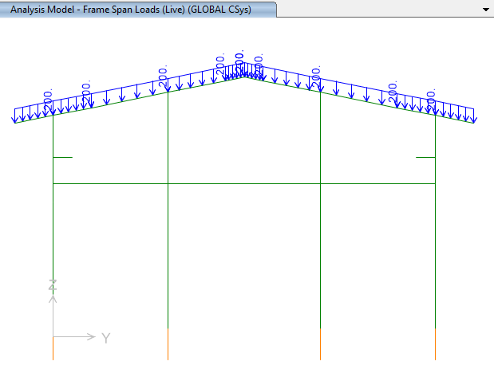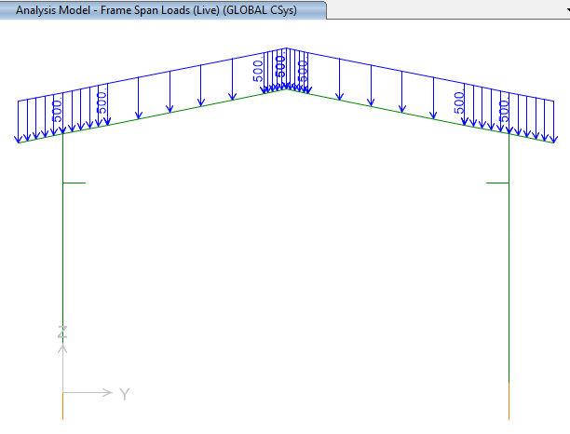

**Figure 4-Applied live Load on frame 1&5 (200kg/m) Figure 5-Applied live Load on frame 2&4 (500kg/m)**

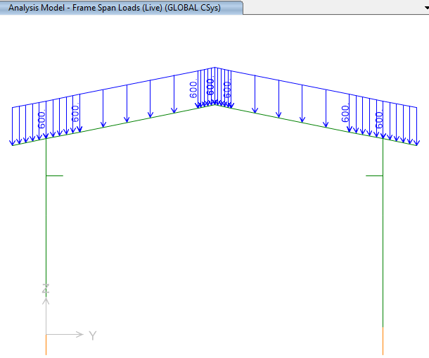

**Figure6-Applied live Load on frame 3 (600kg/m)**

* 1. **SNOW LOADS**

Snow load of this structure is calculated in accordance with Iranian National Building Code No.6 Latest edition.. Parameters which are used in calculation of snow force is presented in below:

$$P_{r}=P_{s}C_{n}C_{h}I_{S}C_{s}$$

Ps=25 kg/m2 , Is=1

Cs= 0.91 (slope 11.31o)=1-

Ch=1

Cn=0.8

$$P_{r}=P_{s}C_{n}C_{h}I_{S}C_{s}=18.06\frac{kg}{m2}$$

* At frame 1&5: $18.06×2=36.12 kg/m$
* At frame 2&4 : $18.06×5=90.3 kg/m$
* At frame 3 : $18.06×6=108.36 kg/m$

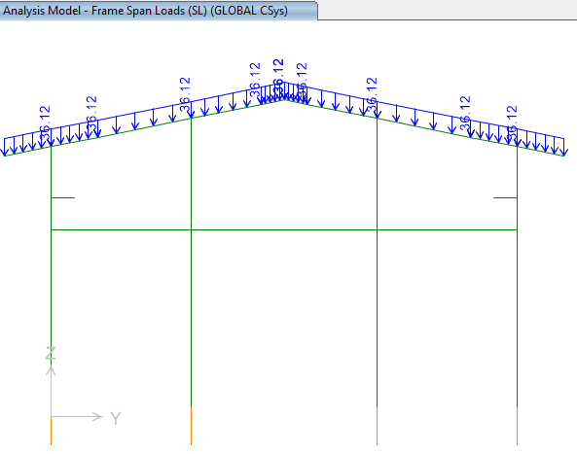 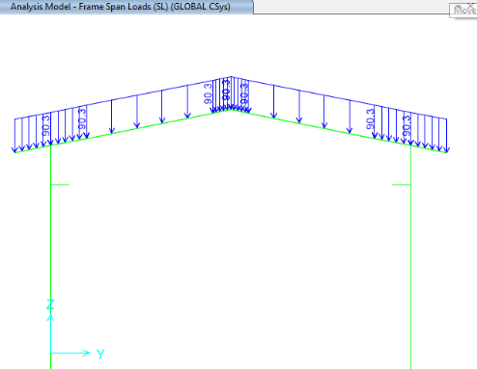

**Figure 7-applied Snow load on ended axe(1&5) (36.12 kg/m) Figure 8-applied Snow load on middle axe 2,4(90.3 kg/m)**

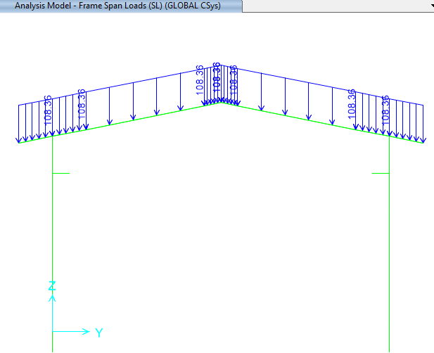

**Figure9-applied Snow load on middle axe 3 (108.36 kg/m)**

* 1. **-Unbalanced SNOW LOADS**

According to Iranian National Building Code No.6 (latest edition)) Unbalanced snow load have been considered for roof slope between 4%~60%..in this structure Calculation of this load represents as below:

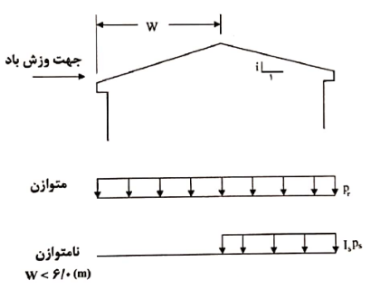

$${ for lu<6 m P}_{r}={I_{s}P}_{g}=25\frac{kg}{m2}$$

* At frame 1&5 : $25×2=50 kg/m$
* At frame 2&4 : $25×5=125 kg/m$
* At frame 3 : $25×6=150 kg/m$

` 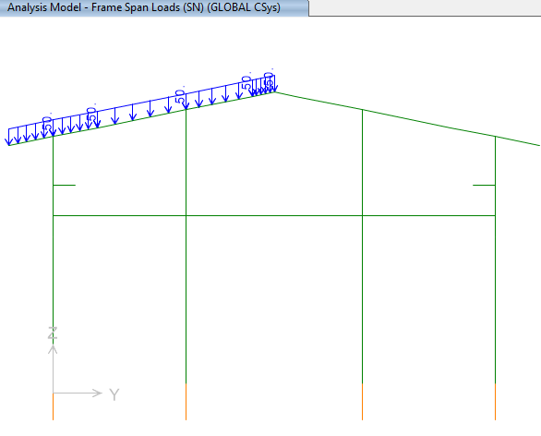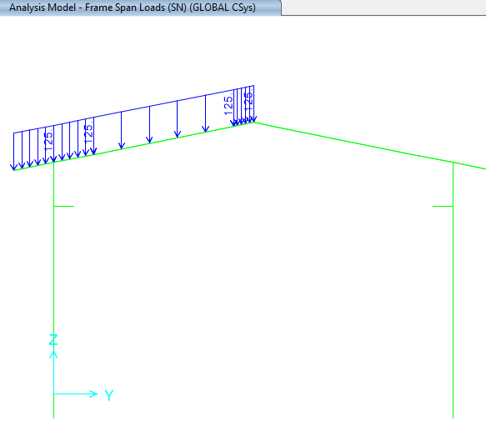

**Figure 10- Unbalanced Snow Load f 1&3(SN : 50 kg/m ) Figure 11- Unbalanced Snow Load f 1&3(SN : 125 kg/m )**

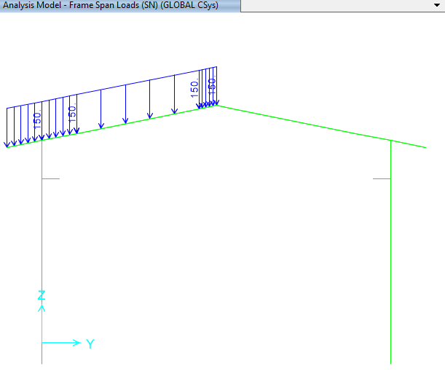

**Figure12- Unbalanced Snow Load f 1&3(SN : 150kg/m )**

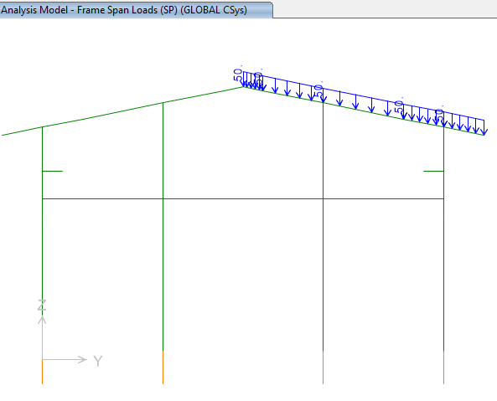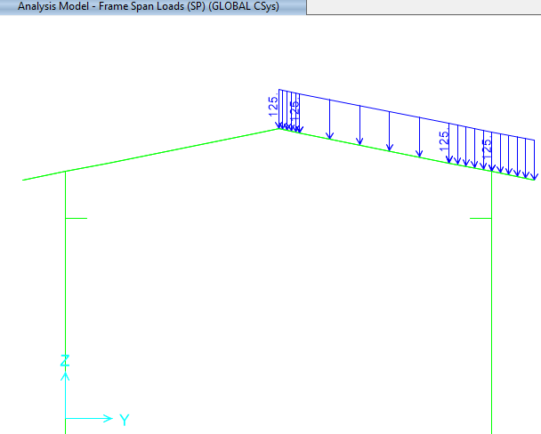

**Figure 13- Unbalanced Snow Load f 1&3(SP : 50 kg/m ) Figure 14- Unbalanced Snow Load f 1&3(SN : 125 kg/m )**

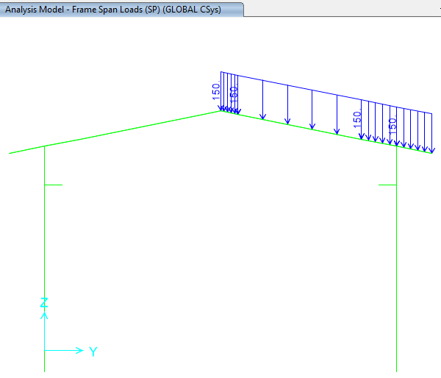

**Figure 15- Unbalanced Snow Load f 1&3(SP : 150kg/m )**

* 1. **Seismic loads**

All structures are in area with high risk zone of seismic and until finalizing of “Geotechnical Final Report” soil type consider is type II. Equivalent static method is used for calculation of seismic loads. Parameters which are used in calculation of earthquake force and seismic coefficient is presented in below.

$V$ = $C_{s}$ 𝑊

Where:

$C_{s}$ = the seismic response coefficient from Equation below:

𝑊 = the effective seismic weight of the structure

$C_{s}$ = $\frac{S_{a}}{R/{I_{e}}}$

Where:

𝑆𝑎= mapped spectral response acceleration parameter (g), determined from hazard analysis. According to Iranian seismic design code for Petroleum facilities (3rd edition )

$$SDs=AB\left(0.2sec\right)=0.75$$

$S_{D1}=AB\left(1sec\right)=0.375$

R= the response modification factor for structure

$I=$ the importance factor for structure:1.25

Seismic loads are calculated according to Iranian seismic design code

Soil Type : Type II

* **For X direction**

|  |  |  |
| --- | --- | --- |
| Parameter | X-Direction | Y-Direction |
| Importance factor, $I_{e}$ | 1.25 | 1.25 |
| Structural system | OCBF | OMF |
| R | 3.25 | 3.5 |
| Ω | 2 | 3 |
| Cd | 3.25 | 3 |
| A | 0.3 | 0.3 |
| Soil Type | II | |
| T0(s)=0.2Sd1/Sds | 0.1 | 0.1 |
| Ts(s)=Sd1/Sds | 0.5 | 0.5 |
| $S$ | 1.5 | 1.5 |
| $S_{0}$ | 1 | 1 |
| $S_{Ds}$ | 0.75 | 0.75 |
| $S_{D1}$ | 0.375 | 0.375 |
| $Ta$ = Calculated Period | =0.05 ${(6.8)}^{0.75}=0.210$* | =0.072 ${(6.8)}^{0.8}=0.33$* |
| $Tm$ = Analytical Period | 0.2264 (Mode 5) | 0.904(Mode 1) |
| Ta=min($C_{Tu}\left(1.4\right)*{Ta}_{\left(Calculated Period\right),}; ,, {Ta}_{(Analytical Period)}$) | 0.2264 | 0.462 |
| $k$ | 1.00 | 1.00 |
| $S_{a}$ | 0.75 | 0.75 |
| $$C_{s}=\frac{SaI}{Ru}$$ | 0.288 | 0.2678 |

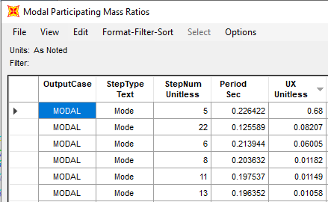

**Figure 16- Period in x direction(Mode 5 )**

* **For Y direction:**

OMF system :

Rux=3.5

Omega=3

Cd=3

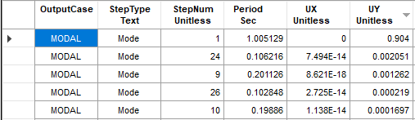

**Figure 17- Period in y direction**

According to Iranian seismic design code(code.038) section 4-6 $ρ$ factor applied on Ey coefficient as follow:

$C_{uy}=$ 0.267×1.3=0.347

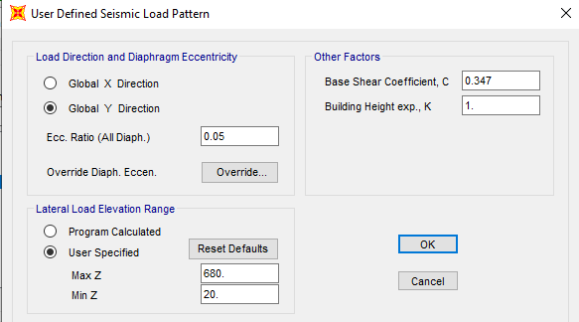

**Figure 18- Period in y direction**

* **Vertical seismic component:**

The vertical seismic load effect, 𝐸𝑣, shall be determined in accordance with the following Equation 6):

𝐸𝑣 = 0.2 $S_{DS}$ 𝐷

$S_{DS}$ = Design, 5% damped, spectral response acceleration parameter (g) at short periods (0.2 sec).

D = effect of dead load

Loads case name: EQZ=0.2×0.75×W=0.15×W

-Ev : Vertical seismic load applied at model:

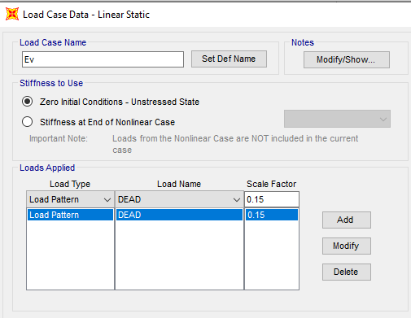

**Figure 20-applied Ev load**

Ev applied at model as a portion of dead load as above.

This Earthquake coefficient will apply in SAP2000 model to be multiplied in W (seismic weight of structure) that will compute automatically by SAP2000 software by "mass source multiplier" definition as below:

1Dead+Crv and+0.2 Live Load

* 1. **CRANE load**

Distribution of crane load is as below :

Capacity : 5000 kg

At critical condition maximum force is 3300 and 750kg on each wheel of crane.

Kvs =1.25 (according to INBC no.6)

${case 1 : F}_{T}=0.2×3300×1.25=825 kg F_{l}=0.1×3300×1.25=412.5 kg$

$${case 2 : F}_{T}=0.2×750×1.25=187.5kg F_{l}=0.1×750×1.25=93.75kg$$

Mentioned load applied in two case (assumed critical condition on left & right side) 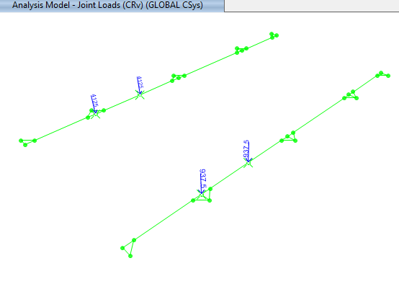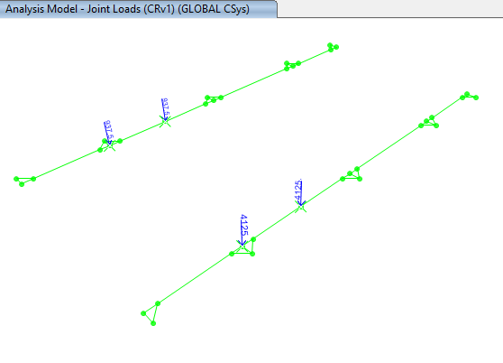

**Figure21-applied CRv & CRv1 load**

* 1. **WIND loads**

Wind loads are calculated according to Code No.6 and applied at model as below:

V=120 km/h(According to Iranian National Building Code No.6 last edition)

$q=0.0000613V^{2}×0.772=0.681$

$I=1$

$width=10m$

Mean $height=6.3 m$

$C_{e}$ =0.917

Cgi=2

Roof slope=11.3 degree

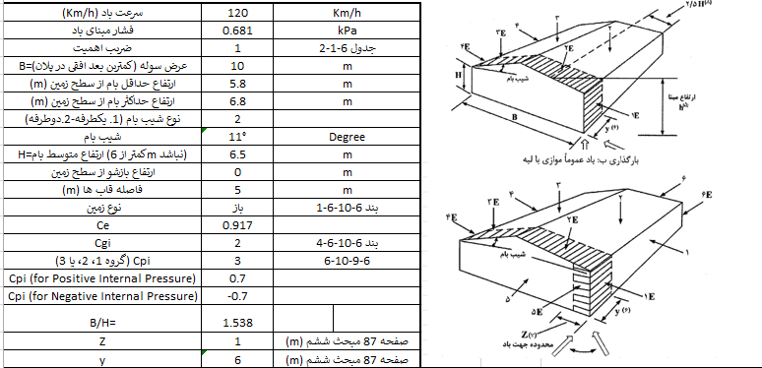

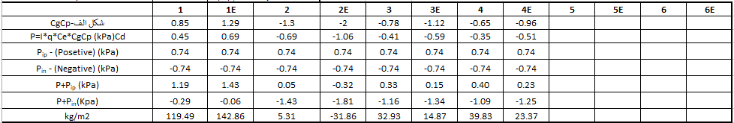

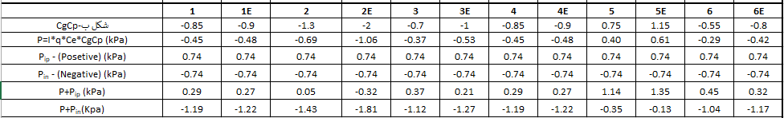

**Figure 22-Wind Load calculation (INBC No.6)**

* For columns wind load applied as below (according to INBC no.6)

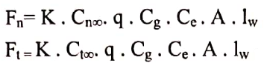

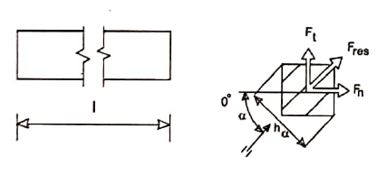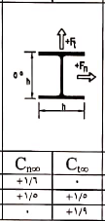

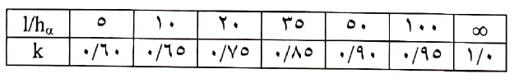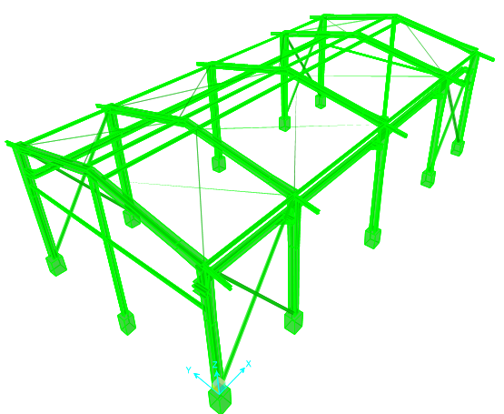

Wx

Wy

B5

B**4**

B**3**

B**1**

B**2**

**Figure 23-Wind Load Direction**

For bottom part of columns:

$α=0 C_{n∞}=1.6$

$$α=90 C_{t∞}=1.9$$

$$F_{n}=F_{x}=K. C_{n∞}.q.Cq.Ce.A.Iw$$

$$F_{t}=F_{x}=K. C_{t∞}.q.Cq.Ce.A.Iw$$

B3

C5

C2

$$F_{n}=F_{x}=0.75×1.6×0.681×2×0.917×0.3×5.8×1=2.6078 KN=260.78 kg$$

$${Wx}_{n}=F_{x}=260.78\frac{100}{5.8}=44.96 kg/m$$

$$Wyn=F_{y}=0.75×1.9×0.681×2×0.917×0.3×5.8×\frac{1}{5.8}=\frac{0.53KN}{m}=53.39kg/m$$

* For beams wind load applied as below (according to INBC no.6)

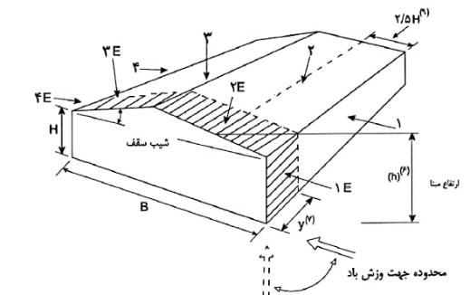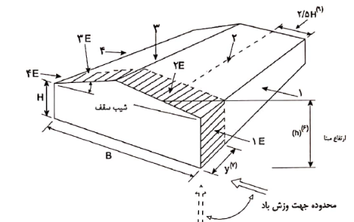

B1,B5 (2E zone) : $1: Wxn=-31.86×2=-63.72 \frac{kg}{m}$

$2: Wxp=-180.56×2=-361.12 \frac{kg}{m}$

$$3: Wyn=-31.86×2=-63.72\frac{ kg}{m}$$

$$4: Wyp=-180.56×2=-361.12 \frac{ kg}{m}$$

B2,B4 (2 zone) : $1: Wxn=-5.31×5=-26.55 \frac{kg}{m}$

$2: Wxp=-143.39×5=-716.95 \frac{kg}{m}$

$$3: Wyn=-5.31×5=-26.55\frac{kg}{m}$$

$$4: Wyp=-143.39×5=-716.95 \frac{ kg}{m}$$

B3(2 zone) : $1: Wxn=-5.31×6=-31.86 \frac{kg}{m}$

$2: Wxp=-143.39×6=-860.34 \frac{kg}{m}$

$$3: Wyn=-5.31×6=-31.86\frac{ kg}{m}$$

$$4: Wyp=-143.39×6=-860.34 \frac{ kg}{m}$$

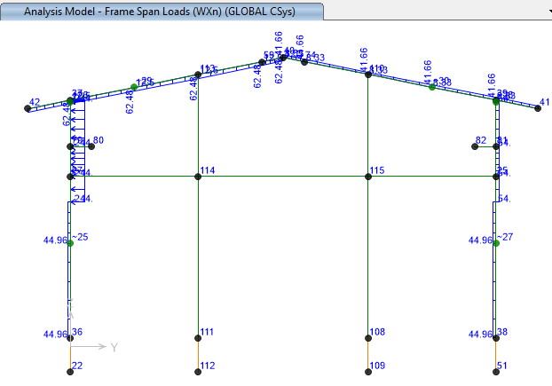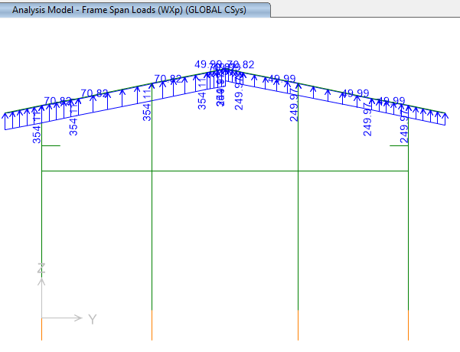

**Figure 24-aplied Wind Load Applied frame A(Wxn:kg/m) Figure 25-aplied Wind Load Appliedframe A(Wxp:kg/m)**

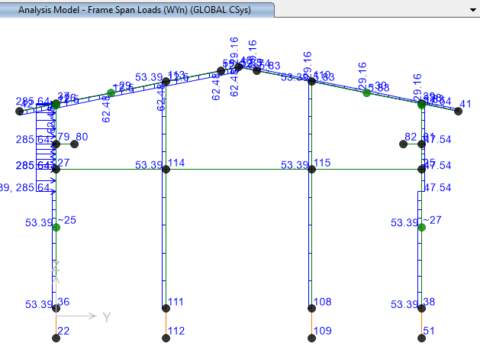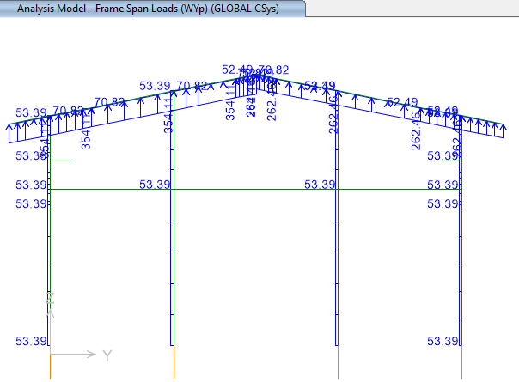

**Figure 26-aplied Wind Load Applied frame A(Wyn :kg/m) Figure27-aplied Wind Load Applied frame A(Wyp :kg/m)**

In mirror side

B1-1 (3E zone) : B5-1 (3E zone) : $1: Wxn=21.24×2= 42.48 \frac{kg}{m}$

$2: Wxp=-127.46×2=-254.922 \frac{kg}{m}$

$$3: Wyn=14.87×2=29.74\frac{ kg}{m}$$

$$4: Wyp=-133.83×2=-267.66 \frac{ kg}{m}$$

B2-1,B4-1 (3 zone) : $1: Wxn=37.17×5=185.85 \frac{kg}{m}$

$2: Wxp=-111.52×5=-557.6 \frac{kg}{m}$

$$3: Wyn=-32.93×5=-164.65\frac{kg}{m}$$

$$4: Wyp=-115.77×5=-578.85 \frac{ kg}{m}$$

B3-1 (2 zone) :

* 1. **Thermal Load of structure (TLst)**

According to “Specification for Civil and Structural Design Criteria”. Maximum temperature of 28 ºC shall be considered for computing the thermal load in all components of shelter.

1. **SAP loading table**

* **Load pattern:**

|  |  |  |  |
| --- | --- | --- | --- |
| **LoadPat** | **DesignType** | **SelfWtMult** | **AutoLoad** |
|  |  |  |  |
| DEAD | Dead | 1 |  |
| Live r | Roof Live | 0 |  |
| EQx | Quake | 0 | USER COEFF |
| EQy | Quake | 0 | USER COEFF |
| WXp | Wind | 0 | None |
| WYp | Wind | 0 | None |
| SL | Snow | 0 |  |
| Live | Live | 0 |  |
| TL | Temperature | 0 |  |
| WXn | Wind | 0 | None |
| WYn | Wind | 0 | None |
| SP | Snow | 0 |  |
| SN | Snow | 0 |  |
| WXp1 | Wind | 0 | None |
| WYp1 | Wind | 0 | None |
| WYn1 | Wind | 0 | None |
| WXn1 | Wind | 0 | None |
| CRv | Live | 0 |  |
| FT | Live | 0 |  |
| FL | Live | 0 |  |
| CRv1 | Live | 0 |  |
| FT1 | Live | 0 |  |
| FL1 | Live | 0 |  |
| Ev | Dead | 0 |  |
| TLst | Temperature | 0 |  |
| DL empty | Dead | 0 |  |
| LLop | Live | 0 |  |
| FRx | Other | 0 |  |
| FRy | Other | 0 |  |
| ML | Other | 0 |  |
| Test | Dead | 0 |  |
| ER | Other | 0 |  |
| Soil | Dead | 0 |  |
| Notionalx(DL) | Notional | 0 |  |
| Notionaly(DL) | Notional | 0 |  |
| Notionalx(LL) | Notional | 0 |  |
| Notionaly(LL) | Notional | 0 |  |
| Notionalx(Lr) | Notional | 0 |  |
| Notionaly(Lr) | Notional | 0 |  |
| Notionalx(Lop) | Notional | 0 |  |
| Notionaly(Lop) | Notional | 0 |  |
| Notionalx(Test) | Notional | 0 |  |
| Notionaly(Test) | Notional | 0 |  |
| Notionalx(DLempty) | Notional | 0 |  |
| Notionaly(DLempty) | Notional | 0 |  |
| Notionalx(CR) | Notional | 0 |  |
| Notionaly(CR) | Notional | 0 |  |
| Notionalx(CR1) | Notional | 0 |  |
| Notionaly(CR1) | Notional | 0 |  |

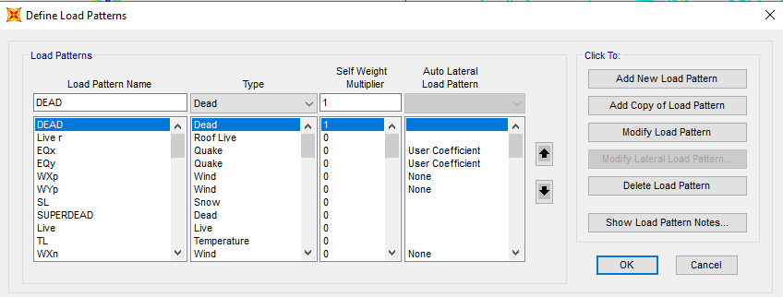

1. **Load combinations**

According to code INBC No.6 structures, components, and foundations shall be designed, so that their design strength equals or exceeds that effect of factored loads in the following combination:

* 1.4(D)
* (1.2D) +1.6(L)+0.5(Lr/S/R)
* 1.2D+1.6(Lr/S/R) + (L/0.5W)
* 1.2D+1.0(W) + L+.5(Lr/S)
* 1.2D+1.0E+L+0.2S
* 0.9D+1.0W
* 0.9D+1.0E

Load listed herein shall be considered to act in the following combinations; whichever produces the most unfavorable effect considering soil reactions.

* *D*
* *D+L*
* *D+(Lr/S/R)*
* *D+0.75(L)+0.75(Lr/R/S)*
* *D+(0.6W or 0.7E)*
* *D+0.75L+0.75(0.6W)+0.75(Lr/S/R)*
* *D+0.75L+0.75(0.7E)+0.75S*
* *0.6D+0.6W*
* *0.6D+0.7E*

1. **STRUCTURE ANALYSIS AND DESIGN** 
   1. **ANALYSIS**

Structural analysis is done by SAP2000 software. In model loads are applied, some graphical outputs from model are shown as follows.

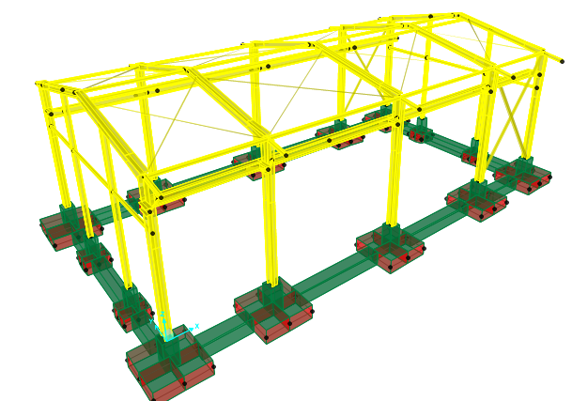

**Figure 28-3D view of SAP model**

:

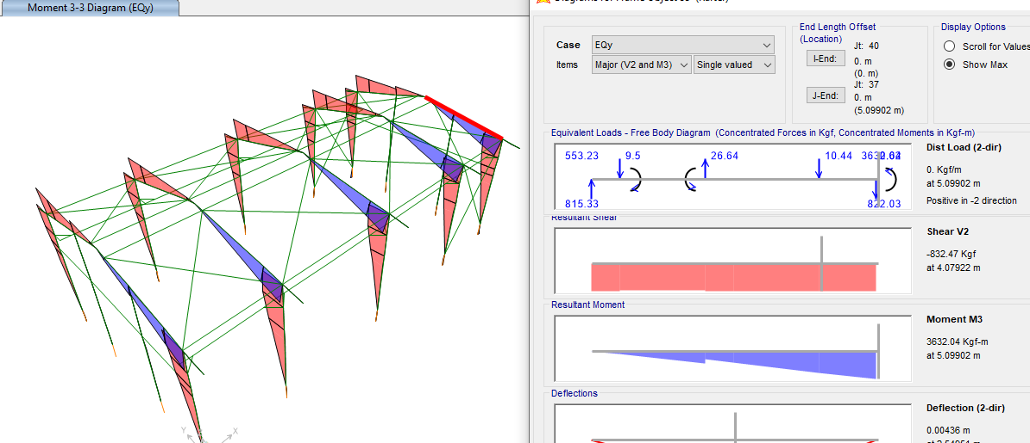

**Figure 29:** **Moment 3-3 under Ey load**

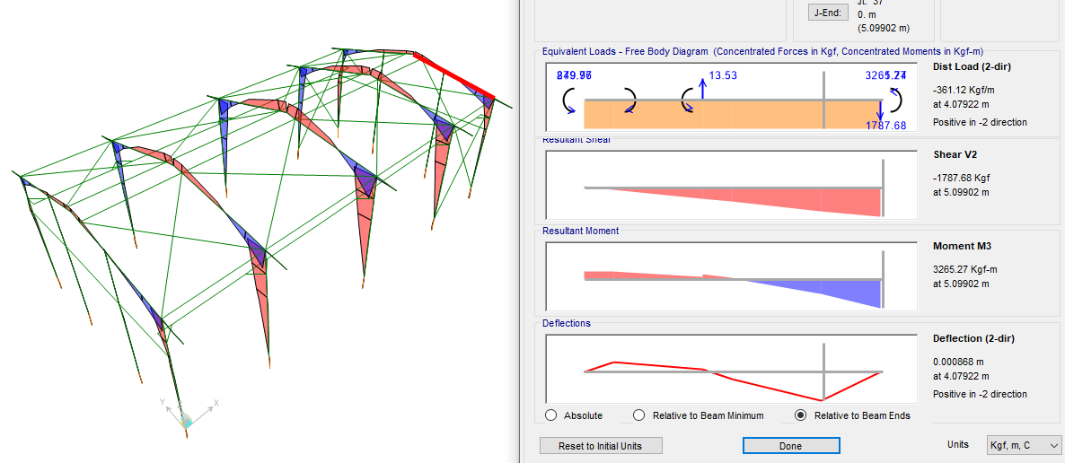

**Figure 30: Moment 3-3 Wy load**

* 1. **Flextural design of crane beam**

According to below output from sap software maximum crane beam moment under critical load combination is 452696.49 kg.cm :

$$∅Mn=0.9×Z×Fy=0.9×2400×1620=3499200 kg.cm$$

$$M_{u}=1277049.65.cm$$

$$S=\frac{1277049.65}{3499200}=0.36 OK$$

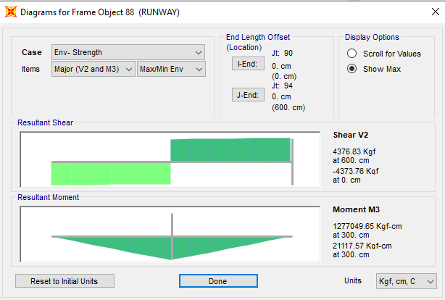

**Figure 31: Moment 3-3 criticalload combination on crane beam**

* 1. **Deflection control :**

Maximum beam deflection under crane live load is :

$δ=\frac{PL^{3}}{48EI}=\frac{7500×600^3}{48×2.1×10^{6}×26916.083}=0.597$ cm< 0.60 cm OK

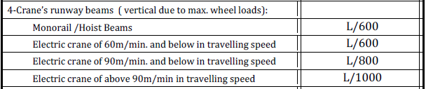

* 1. **rafter beam deflection**

Maximum Rafter beam deflection under D+L load combination is as below:

$$allowable Drift according to civil deand structural design criteria :\frac{L}{240}=\frac{1000}{240}=4.16cm$$

|  |  |  |  |  |  |
| --- | --- | --- | --- | --- | --- |
| **TABLE: Joint Displacements** | | | | | |
| **Joint** | **OutputCase** | **CaseType** | **U3** | **U allowable** | **check** |
| Text | Text | Text | cm | cm |  |
| 40 | Rafter Deflection | Combination | -0.694232 | -4.167 | ok |

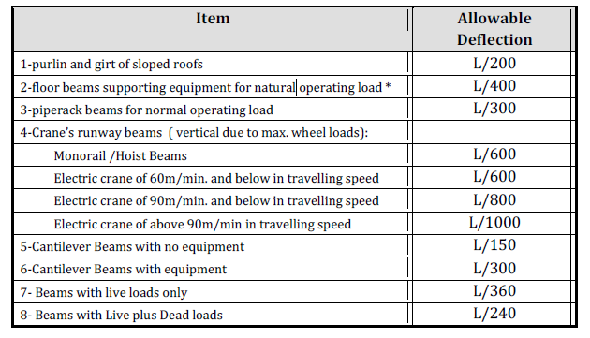

* 1. **BEAM LATERAL RESTRAINT**

Beam lateral restraint should be designed for 0.02 of compressive flange capacity.

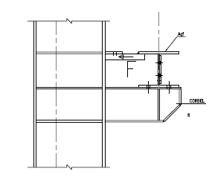

$F=0.02Agf×Fy=0.02×25×1.5×2400=1800kg$ >1591.97 kg OK

|  |  |  |  |  |  |
| --- | --- | --- | --- | --- | --- |
| **TABLE: Element Forces - Frames** | | | | | |
| **Frame** | **Station** | **OutputCase** | **CaseType** | **StepType** | **P** |
| Text | cm | Text | Text | Text | Kgf |
| 80 | 0 | Env- Strength | Combination | Max | 682.98 |
| 80 | 50 | Env- Strength | Combination | Max | 683.02 |
| 80 | 0 | Env- Strength | Combination | Min | -1591.97 |
| 80 | 50 | Env- Strength | Combination | Min | -1591.92 |
| 82 | 0 | Env- Strength | Combination | Max | 1959.33 |
| 82 | 50 | Env- Strength | Combination | Max | 1959.38 |
| 82 | 0 | Env- Strength | Combination | Min | -688.78 |
| 82 | 50 | Env- Strength | Combination | Min | -688.74 |
|  |  |  |  | P= | -1591.97 |

* 1. **Drift control :**

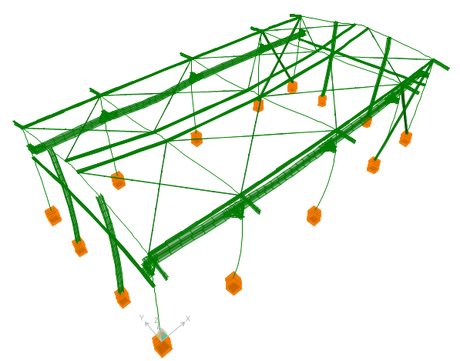

**Figure 32: Deformed shape**

Maximum displacement according to above output from sap model under critical service load combination is about 1.89 cm which is less than allowable drift.

$$allowable drift is \frac{680-20}{200}=3.3cm$$

According to “Civil & Structural Design Criteria”, horizontal displacements shall not exceed H/200.

The maximum displacement is less than H/200, so the displacement values are acceptable.

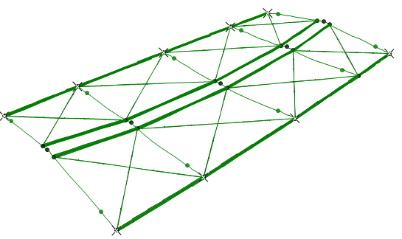

Joint : 16

|  |  |  |  |  |  |
| --- | --- | --- | --- | --- | --- |
| **TABLE: Joint Displacements** | | | | | |
| **Joint** | **OutputCase** | **CaseType** | **U2** | **Allowable** | check |
| Text | Text | Text | cm | H/200(cm) |
| 16 | WYp | LinStatic | 1.214865 | 3.3 | ok |
| 16 | WYn | LinStatic | 0.791405 | 3.3 | ok |
| 16 | WYp1 | LinStatic | 0 | 3.3 | ok |
| 16 | WYn1 | LinStatic | 0 | 3.3 | ok |
| 16 | Drift Y1(INBC no.6)-NL | NonStatic | 0.313884 | 3.3 | ok |
| 16 | Drift Y1(INBC no.6)-NL | NonStatic | 0.313884 | 3.3 | ok |
| 16 | Drift Y2(INBC no.6)-NL | NonStatic | -1.328419 | 3.3 | ok |
| 16 | Drift Y2(INBC no.6)-NL | NonStatic | -1.328419 | 3.3 | ok |
| 16 | Drift Y3(INBC no.6)-NL | NonStatic | -0.510881 | 3.3 | ok |
| 16 | Drift Y3(INBC no.6)-NL | NonStatic | -0.510881 | 3.3 | ok |
| 16 | Drift Y4(INBC no.6)-NL | NonStatic | -0.510881 | 3.3 | ok |
| 16 | Drift Y4(INBC no.6)-NL | NonStatic | -0.510881 | 3.3 | ok |
| 16 | Drift Y5(INBC no.6)-NL | NonStatic | 0.718991 | 3.3 | ok |
| 16 | Drift Y5(INBC no.6)-NL | NonStatic | 0.718991 | 3.3 | ok |
| 16 | Drift Y6(INBC no.6)-NL | NonStatic | -1.820287 | 3.3 | ok |
| 16 | Drift Y6(INBC no.6)-NL | NonStatic | -1.820287 | 3.3 | ok |
| 16 | Drift Y7(INBC no.6)-NL | NonStatic | -0.510881 | 3.3 | ok |
| 16 | Drift Y7(INBC no.6)-NL | NonStatic | -0.510881 | 3.3 | ok |
| 16 | Drift Y8(INBC no.6)-NL | NonStatic | -0.510881 | 3.3 | ok |
| 16 | Drift Y8(INBC no.6)-NL | NonStatic | -0.510881 | 3.3 | ok |
| 16 | Drift Y1-1(INBC no.6)-NL | NonStatic | 0.575693 | 3.3 | ok |
| 16 | Drift Y1-1(INBC no.6)-NL | NonStatic | 0.575693 | 3.3 | ok |
| 16 | Drift Y2-1(INBC no.6)-NL | NonStatic | -1.067623 | 3.3 | ok |
| 16 | Drift Y2-1(INBC no.6)-NL | NonStatic | -1.067623 | 3.3 | ok |
| 16 | Drift Y3-1(INBC no.6)-NL | NonStatic | -0.249588 | 3.3 | ok |
| 16 | Drift Y3-1(INBC no.6)-NL | NonStatic | -0.249588 | 3.3 | ok |
| 16 | Drift Y4-1(INBC no.6)-NL | NonStatic | -0.249588 | 3.3 | ok |
| 16 | Drift Y4-1(INBC no.6)-NL | NonStatic | -0.249588 | 3.3 | ok |
| 16 | Drift Y5-1(INBC no.6)-NL | NonStatic | 0.974991 | 3.3 | ok |
| 16 | Drift Y5-1(INBC no.6)-NL | NonStatic | 0.974991 | 3.3 | ok |
| 16 | Drift Y6-1(INBC no.6)-NL | NonStatic | -1.553349 | 3.3 | ok |
| 16 | Drift Y6-1(INBC no.6)-NL | NonStatic | -1.553349 | 3.3 | ok |
| 16 | Drift Y7-1(INBC no.6)-NL | NonStatic | -0.249588 | 3.3 | ok |
| 16 | Drift Y7-1(INBC no.6)-NL | NonStatic | -0.249588 | 3.3 | ok |
| 16 | Drift Y8-1(INBC no.6)-NL | NonStatic | -0.249588 | 3.3 | ok |
| 16 | Drift Y8-1(INBC no.6)-NL | NonStatic | -0.249588 | 3.3 | ok |
| 16 | Drift Y9(INBC no.6)-NL | NonStatic | 0.287026 | 3.3 | ok |
| 16 | Drift Y9(INBC no.6)-NL | NonStatic | 0.287026 | 3.3 | ok |
| 16 | Drift Y10(INBC no.6)-NL | NonStatic | -1.360101 | 3.3 | ok |
| 16 | Drift Y10(INBC no.6)-NL | NonStatic | -1.360101 | 3.3 | ok |
| 16 | Drift Y11(INBC no.6)-NL | NonStatic | -0.54017 | 3.3 | ok |
| 16 | Drift Y11(INBC no.6)-NL | NonStatic | -0.54017 | 3.3 | ok |
| 16 | Drift Y12(INBC no.6)-NL | NonStatic | -0.54017 | 3.3 | ok |
| 16 | Drift Y12(INBC no.6)-NL | NonStatic | -0.54017 | 3.3 | ok |
| 16 | Drift Y13(INBC no.6)-NL | NonStatic | 0.692701 | 3.3 | ok |
| 16 | Drift Y13(INBC no.6)-NL | NonStatic | 0.692701 | 3.3 | ok |
| 16 | Drift Y14(INBC no.6)-NL | NonStatic | -1.852711 | 3.3 | ok |
| 16 | Drift Y14(INBC no.6)-NL | NonStatic | -1.852711 | 3.3 | ok |
| 16 | Drift Y15(INBC no.6)-NL | NonStatic | -0.54017 | 3.3 | ok |
| 16 | Drift Y15(INBC no.6)-NL | NonStatic | -0.54017 | 3.3 | ok |
| 16 | Drift Y16(INBC no.6)-NL | NonStatic | -0.54017 | 3.3 | ok |
| 16 | Drift Y16(INBC no.6)-NL | NonStatic | -0.54017 | 3.3 | ok |
| 16 | Drift Y9-1(INBC no.6)-NL | NonStatic | 0.549186 | 3.3 | ok |
| 16 | Drift Y9-1(INBC no.6)-NL | NonStatic | 0.549186 | 3.3 | ok |
| 16 | Drift Y10-1(INBC no.6)-NL | NonStatic | -1.098958 | 3.3 | ok |
| 16 | Drift Y10-1(INBC no.6)-NL | NonStatic | -1.098958 | 3.3 | ok |
| 16 | Drift Y11-1(INBC no.6)-NL | NonStatic | -0.278529 | 3.3 | ok |
| 16 | Drift Y11-1(INBC no.6)-NL | NonStatic | -0.278529 | 3.3 | ok |
| 16 | Drift Y12-1(INBC no.6)-NL | NonStatic | -0.278529 | 3.3 | ok |
| 16 | Drift Y12-1(INBC no.6)-NL | NonStatic | -0.278529 | 3.3 | ok |
| 16 | Drift Y13-1(INBC no.6)-NL | NonStatic | 0.948988 | 3.3 | ok |
| 16 | Drift Y13-1(INBC no.6)-NL | NonStatic | 0.948988 | 3.3 | ok |
| 16 | Drift Y14-1(INBC no.6)-NL | NonStatic | -1.585438 | 3.3 | ok |
| 16 | Drift Y14-1(INBC no.6)-NL | NonStatic | -1.585438 | 3.3 | ok |
| 16 | Drift Y15-1(INBC no.6)-NL | NonStatic | -0.278529 | 3.3 | ok |
| 16 | Drift Y15-1(INBC no.6)-NL | NonStatic | -0.278529 | 3.3 | ok |
| 16 | Drift Y16-1(INBC no.6)-NL | NonStatic | -0.278529 | 3.3 | ok |
| 16 | Drift Y16-1(INBC no.6)-NL | NonStatic | -0.278529 | 3.3 | ok |
| 16 | Drift Y17(INBC no.6)-NL | NonStatic | 0.34709 | 3.3 | ok |
| 16 | Drift Y17(INBC no.6)-NL | NonStatic | 0.34709 | 3.3 | ok |
| 16 | Drift Y18(INBC no.6)-NL | NonStatic | -1.298886 | 3.3 | ok |
| 16 | Drift Y18(INBC no.6)-NL | NonStatic | -1.298886 | 3.3 | ok |
| 16 | Drift Y19(INBC no.6)-NL | NonStatic | -0.479527 | 3.3 | ok |
| 16 | Drift Y19(INBC no.6)-NL | NonStatic | -0.479527 | 3.3 | ok |
| 16 | Drift Y20(INBC no.6)-NL | NonStatic | -0.479527 | 3.3 | ok |
| 16 | Drift Y20(INBC no.6)-NL | NonStatic | -0.479527 | 3.3 | ok |
| 16 | Drift Y21(INBC no.6)-NL | NonStatic | 0.750758 | 3.3 | ok |
| 16 | Drift Y21(INBC no.6)-NL | NonStatic | 0.750758 | 3.3 | ok |
| 16 | Drift Y22(INBC no.6)-NL | NonStatic | -1.789439 | 3.3 | ok |
| 16 | Drift Y22(INBC no.6)-NL | NonStatic | -1.789439 | 3.3 | ok |
| 16 | Drift Y23(INBC no.6)-NL | NonStatic | -0.479527 | 3.3 | ok |
| 16 | Drift Y23(INBC no.6)-NL | NonStatic | -0.479527 | 3.3 | ok |
| 16 | Drift Y24(INBC no.6)-NL | NonStatic | -0.479527 | 3.3 | ok |
| 16 | Drift Y24(INBC no.6)-NL | NonStatic | -0.479527 | 3.3 | ok |
| 16 | Drift Y17-1(INBC no.6)-NL | NonStatic | 0.609149 | 3.3 | ok |
| 16 | Drift Y17-1(INBC no.6)-NL | NonStatic | 0.609149 | 3.3 | ok |
| 16 | Drift Y18-1(INBC no.6)-NL | NonStatic | -1.037844 | 3.3 | ok |
| 16 | Drift Y18-1(INBC no.6)-NL | NonStatic | -1.037844 | 3.3 | ok |
| 16 | Drift Y19-1(INBC no.6)-NL | NonStatic | -0.217986 | 3.3 | ok |
| 16 | Drift Y19-1(INBC no.6)-NL | NonStatic | -0.217986 | 3.3 | ok |
| 16 | Drift Y20-1(INBC no.6)-NL | NonStatic | -0.217986 | 3.3 | ok |
| 16 | Drift Y20-1(INBC no.6)-NL | NonStatic | -0.217986 | 3.3 | ok |
| 16 | Drift Y21-1(INBC no.6)-NL | NonStatic | 1.007091 | 3.3 | ok |
| 16 | Drift Y21-1(INBC no.6)-NL | NonStatic | 1.007091 | 3.3 | ok |
| 16 | Drift Y22-1(INBC no.6)-NL | NonStatic | -1.522235 | 3.3 | ok |
| 16 | Drift Y22-1(INBC no.6)-NL | NonStatic | -1.522235 | 3.3 | ok |
| 16 | Drift Y23-1(INBC no.6)-NL | NonStatic | -0.217986 | 3.3 | ok |
| 16 | Drift Y23-1(INBC no.6)-NL | NonStatic | -0.217986 | 3.3 | ok |
| 16 | Drift Y24-1(INBC no.6)-NL | NonStatic | -0.217986 | 3.3 | ok |
| 16 | Drift Y24-1(INBC no.6)-NL | NonStatic | -0.217986 | 3.3 | ok |
| 16 | Drift Y25(INBC no.6)-NL | NonStatic | 0.243504 | 3.3 | ok |
| 16 | Drift Y25(INBC no.6)-NL | NonStatic | 0.243504 | 3.3 | ok |
| 16 | Drift Y26(INBC no.6)-NL | NonStatic | -1.401798 | 3.3 | ok |
| 16 | Drift Y26(INBC no.6)-NL | NonStatic | -1.401798 | 3.3 | ok |
| 16 | Drift Y27(INBC no.6)-NL | NonStatic | -0.582772 | 3.3 | ok |
| 16 | Drift Y27(INBC no.6)-NL | NonStatic | -0.582772 | 3.3 | ok |
| 16 | Drift Y28(INBC no.6)-NL | NonStatic | -0.582772 | 3.3 | ok |
| 16 | Drift Y28(INBC no.6)-NL | NonStatic | -0.582772 | 3.3 | ok |
| 16 | Drift Y29(INBC no.6)-NL | NonStatic | 0.650697 | 3.3 | ok |
| 16 | Drift Y29(INBC no.6)-NL | NonStatic | 0.650697 | 3.3 | ok |
| 16 | Drift Y30(INBC no.6)-NL | NonStatic | -1.896009 | 3.3 | ok |
| 16 | Drift Y30(INBC no.6)-NL | NonStatic | -1.896009 | 3.3 | ok |
| 16 | Drift Y31(INBC no.6)-NL | NonStatic | -0.582772 | 3.3 | ok |
| 16 | Drift Y31(INBC no.6)-NL | NonStatic | -0.582772 | 3.3 | ok |
| 16 | Drift Y32(INBC no.6)-NL | NonStatic | -0.582772 | 3.3 | ok |
| 16 | Drift Y32(INBC no.6)-NL | NonStatic | -0.582772 | 3.3 | ok |
| 16 | Drift Y25-1(INBC no.6)-NL | NonStatic | 0.505548 | 3.3 | ok |
| 16 | Drift Y25-1(INBC no.6)-NL | NonStatic | 0.505548 | 3.3 | ok |
| 16 | Drift Y26-1(INBC no.6)-NL | NonStatic | -1.140769 | 3.3 | ok |
| 16 | Drift Y26-1(INBC no.6)-NL | NonStatic | -1.140769 | 3.3 | ok |
| 16 | Drift Y27-1(INBC no.6)-NL | NonStatic | -0.321245 | 3.3 | ok |
| 16 | Drift Y27-1(INBC no.6)-NL | NonStatic | -0.321245 | 3.3 | ok |
| 16 | Drift Y28-1(INBC no.6)-NL | NonStatic | -0.321245 | 3.3 | ok |
| 16 | Drift Y28-1(INBC no.6)-NL | NonStatic | -0.321245 | 3.3 | ok |
| 16 | Drift Y29-1(INBC no.6)-NL | NonStatic | 0.90694 | 3.3 | ok |
| 16 | Drift Y29-1(INBC no.6)-NL | NonStatic | 0.90694 | 3.3 | ok |
| 16 | Drift Y30-1(INBC no.6)-NL | NonStatic | -1.628857 | 3.3 | ok |
| 16 | Drift Y30-1(INBC no.6)-NL | NonStatic | -1.628857 | 3.3 | ok |
| 16 | Drift Y31-1(INBC no.6)-NL | NonStatic | -0.321245 | 3.3 | ok |
| 16 | Drift Y31-1(INBC no.6)-NL | NonStatic | -0.321245 | 3.3 | ok |
| 16 | Drift Y32-1(INBC no.6)-NL | NonStatic | -0.321245 | 3.3 | ok |
| 16 | Drift Y32-1(INBC no.6)-NL | NonStatic | -0.321245 | 3.3 | ok |
| 16 | Drift Y1(INBC no.6) | Combination | 0.313884 | 3.3 | ok |
| 16 | Drift Y2(INBC no.6) | Combination | -1.328419 | 3.3 | ok |
| 16 | Drift Y3(INBC no.6) | Combination | -0.510881 | 3.3 | ok |
| 16 | Drift Y4(INBC no.6) | Combination | -0.510881 | 3.3 | ok |
| 16 | Drift Y5(INBC no.6) | Combination | 0.718991 | 3.3 | ok |
| 16 | Drift Y6(INBC no.6) | Combination | -1.820287 | 3.3 | ok |
| 16 | Drift Y7(INBC no.6) | Combination | -0.510881 | 3.3 | ok |
| 16 | Drift Y8(INBC no.6) | Combination | -0.510881 | 3.3 | ok |
| 16 | Drift Y1-1(INBC no.6) | Combination | 0.575693 | 3.3 | ok |
| 16 | Drift Y2-1(INBC no.6) | Combination | -1.067623 | 3.3 | ok |
| 16 | Drift Y3-1(INBC no.6) | Combination | -0.249588 | 3.3 | ok |
| 16 | Drift Y4-1(INBC no.6) | Combination | -0.249588 | 3.3 | ok |
| 16 | Drift Y5-1(INBC no.6) | Combination | 0.974991 | 3.3 | ok |
| 16 | Drift Y6-1(INBC no.6) | Combination | -1.553349 | 3.3 | ok |
| 16 | Drift Y7-1(INBC no.6) | Combination | -0.249588 | 3.3 | ok |
| 16 | Drift Y8-1(INBC no.6) | Combination | -0.249588 | 3.3 | ok |
| 16 | Drift Y9(INBC no.6) | Combination | 0.287026 | 3.3 | ok |
| 16 | Drift Y10(INBC no.6) | Combination | -1.360101 | 3.3 | ok |
| 16 | Drift Y11(INBC no.6) | Combination | -0.54017 | 3.3 | ok |
| 16 | Drift Y12(INBC no.6) | Combination | -0.54017 | 3.3 | ok |
| 16 | Drift Y13(INBC no.6) | Combination | 0.692701 | 3.3 | ok |
| 16 | Drift Y14(INBC no.6) | Combination | -1.852711 | 3.3 | ok |
| 16 | Drift Y15(INBC no.6) | Combination | -0.54017 | 3.3 | ok |
| 16 | Drift Y16(INBC no.6) | Combination | -0.54017 | 3.3 | ok |
| 16 | Drift Y9-1(INBC no.6) | Combination | 0.549186 | 3.3 | ok |
| 16 | Drift Y10-1(INBC no.6) | Combination | -1.098958 | 3.3 | ok |
| 16 | Drift Y11-1(INBC no.6) | Combination | -0.278529 | 3.3 | ok |
| 16 | Drift Y12-1(INBC no.6) | Combination | -0.278529 | 3.3 | ok |
| 16 | Drift Y13-1(INBC no.6) | Combination | 0.948988 | 3.3 | ok |
| 16 | Drift Y14-1(INBC no.6) | Combination | -1.585438 | 3.3 | ok |
| 16 | Drift Y15-1(INBC no.6) | Combination | -0.278529 | 3.3 | ok |
| 16 | Drift Y16-1(INBC no.6) | Combination | -0.278529 | 3.3 | ok |
| 16 | Drift Y17(INBC no.6) | Combination | 0.34709 | 3.3 | ok |
| 16 | Drift Y18(INBC no.6) | Combination | -1.298886 | 3.3 | ok |
| 16 | Drift Y19(INBC no.6) | Combination | -0.479527 | 3.3 | ok |
| 16 | Drift Y20(INBC no.6) | Combination | -0.479527 | 3.3 | ok |
| 16 | Drift Y21(INBC no.6) | Combination | 0.750758 | 3.3 | ok |
| 16 | Drift Y22(INBC no.6) | Combination | -1.789439 | 3.3 | ok |
| 16 | Drift Y23(INBC no.6) | Combination | -0.479527 | 3.3 | ok |
| 16 | Drift Y24(INBC no.6) | Combination | -0.479527 | 3.3 | ok |
| 16 | Drift Y17-1(INBC no.6) | Combination | 0.609149 | 3.3 | ok |
| 16 | Drift Y18-1(INBC no.6) | Combination | -1.037844 | 3.3 | ok |
| 16 | Drift Y19-1(INBC no.6) | Combination | -0.217986 | 3.3 | ok |
| 16 | Drift Y20-1(INBC no.6) | Combination | -0.217986 | 3.3 | ok |
| 16 | Drift Y21-1(INBC no.6) | Combination | 1.007091 | 3.3 | ok |
| 16 | Drift Y22-1(INBC no.6) | Combination | -1.522235 | 3.3 | ok |
| 16 | Drift Y23-1(INBC no.6) | Combination | -0.217986 | 3.3 | ok |
| 16 | Drift Y24-1(INBC no.6) | Combination | -0.217986 | 3.3 | ok |
| 16 | Drift Y25(INBC no.6) | Combination | 0.243504 | 3.3 | ok |
| 16 | Drift Y26(INBC no.6) | Combination | -1.401798 | 3.3 | ok |
| 16 | Drift Y27(INBC no.6) | Combination | -0.582772 | 3.3 | ok |
| 16 | Drift Y28(INBC no.6) | Combination | -0.582772 | 3.3 | ok |
| 16 | Drift Y29(INBC no.6) | Combination | 0.650697 | 3.3 | ok |
| 16 | Drift Y30(INBC no.6) | Combination | -1.896009 | 3.3 | ok |
| 16 | Drift Y31(INBC no.6) | Combination | -0.582772 | 3.3 | ok |
| 16 | Drift Y32(INBC no.6) | Combination | -0.582772 | 3.3 | ok |
| 16 | Drift Y25-1(INBC no.6) | Combination | 0.505548 | 3.3 | ok |
| 16 | Drift Y26-1(INBC no.6) | Combination | -1.140769 | 3.3 | ok |
| 16 | Drift Y27-1(INBC no.6) | Combination | -0.321245 | 3.3 | ok |
| 16 | Drift Y28-1(INBC no.6) | Combination | -0.321245 | 3.3 | ok |
| 16 | Drift Y29-1(INBC no.6) | Combination | 0.90694 | 3.3 | ok |
| 16 | Drift Y30-1(INBC no.6) | Combination | -1.628857 | 3.3 | ok |
| 16 | Drift Y31-1(INBC no.6) | Combination | -0.321245 | 3.3 | ok |
| 16 | Drift Y32-1(INBC no.6) | Combination | -0.321245 | 3.3 | ok |

**Drift Control According to Iranian Seismic Design Code for petroleum facilities(038)**

According to “Iranian seismic design code(Code.038)” table 4-8 ,drift shall not exceed 0.02.

The maximum drift is less than 0.02, so the displacement values are acceptable.

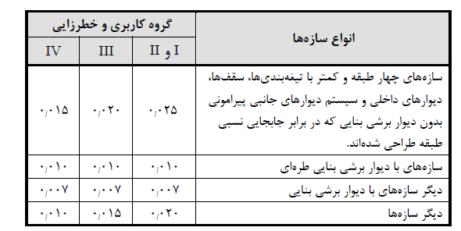

The deflection at level x ($δ_{x}$) (in. or mm) used to compute the design story drift, Δ, shall be determined in accordance with the following equation:

Maximum displacement by EY load case(pure) is 4.89 cm which Reduced stiffness values used in the direct analysis method are not intended for use in beam vertical deflection ,drift ,and period of structure.

$δ_{x}=\frac{C_{d}δ_{ye}}{I}=\frac{3×4.89×0.8}{1.25}=9.39 cm$, $∆=\frac{9.39}{580}=0.016<0.02 ok$

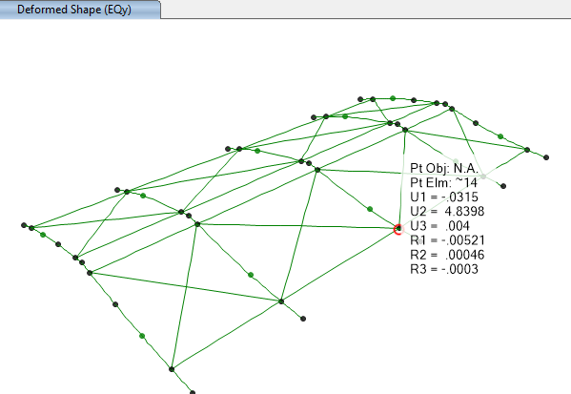

${Drift}_{allowable}$ = According to table4-8 of Iranian seismic Design code(code No.038) is 0.02 $h_{sx}$

$h_{sx}$ =is the story height below level x

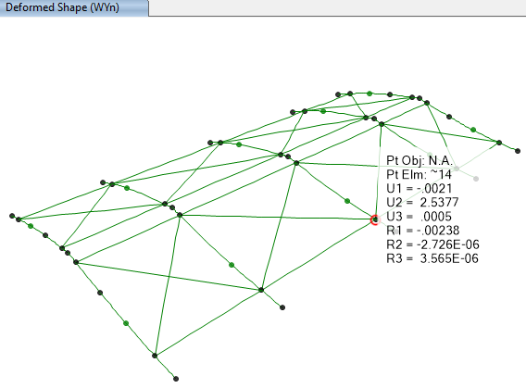

$∆_{all}=\frac{h}{200}=\frac{680-20}{200}=2.4cm$ >> $∆ exist=0.8×2.53=2.024 cm ok$

Maximum displacement by WY load case(pure) is 2.53 cm which Reduced stiffness values used in the direct analysis method are not intended for use in beam vertical deflection ,drift ,and period of structure.

1. **Structural Design Results**

The steel structure is checked in accordance with LRFD method. Frame analysis and Structural checks are based on the 3D model that covers all the Load Combinations .All members designed by SAP2000, and code requirements have been checked accordingly. The following figures show the members ratios which are obtained from SAP2000 model analysis and design. All the acceptable ratios for beams & columns have been considered less than 1.0.

* 1. **Graphical output**

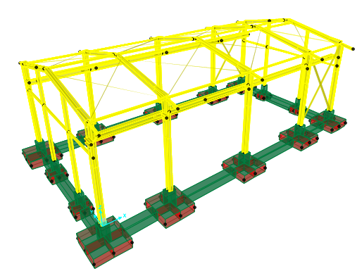

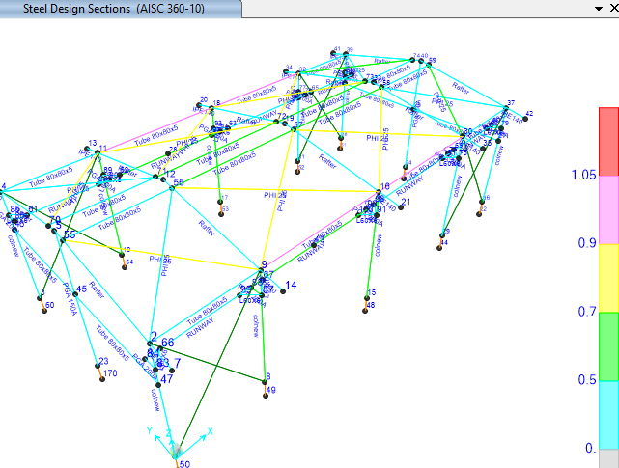

**Figure 33: Steel Design Output**

1. **STRUCTURE CONNECTIONS**
   1. **Description of Design Procedure & Parameters**

**11.1.1.Rafter to rafter connection (top of shelter):**

According to Iranian National Building code section 10-3-7-2:

$$M_{p}=Z.Fy=716×2400=1718400 kg.cm=17.18 ton.m$$

$$M_{u}=1.1 Ry. Mp=1.1Ry.Z.Fy=1.1×1.15×716×2400=2173776 kg.cm=21.737ton.m$$

$$V=\frac{2[1.1 Ry Mp]}{L_{cf}}=\frac{2×1.1×1.15×716×2400}{1000}=4347.55 kg=4.34 ton$$

According to sap model M3-3 and V2-2 under critical load combination (Envelope Strength) is as follow:

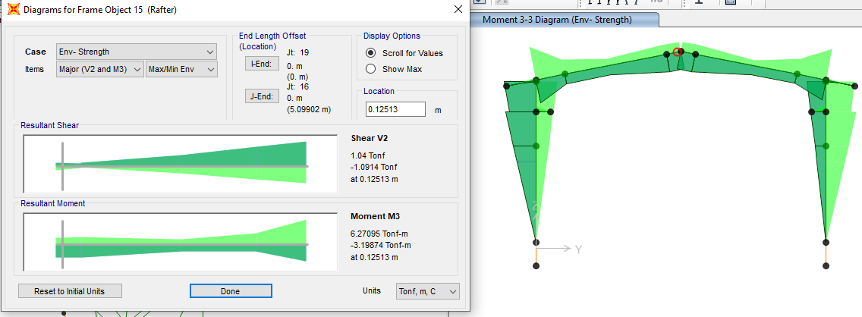

$$M_{3-3design \left(envelope combo\right)}=3.2 ton.m$$

$$V_{2-2design \left(envelope combo\right)}=1.094 ton$$

$$M_{3-3design \left(omega factor \right)}=6.3 ton.m$$

$$V_{2-2design \left(omega factor \right)}=1.7 ton$$

moment of design should not be less than of 0.5Mp=8.592 ton-m.

$$F_{u}=8000\frac{kg}{cm2}$$

$$f_{n}=\frac{R_{n}}{Anb}=∅F_{nt}=4500kg/cm2$$

$Ab=4.52 cm2$

$$I_{bolt}=4Ib=4×4.52×\left({4.5}^{2}+{17.5}^{2}\right)=5903.12cm^{4}$$

$f_{b}$ = $\frac{MC}{I}$

$fb=8.592*\frac{17.5}{5903.12}*{10}^{5}=2457.127kg/cm2$ <4500kg/cm2 ok

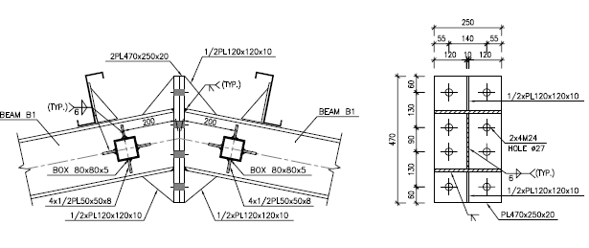

**Figure 34: Connecrtion Details**

**11.1.2 : Rafter to Colum Connection**

According to Iranian National Building code No.10 section 10-3-7-2:

$$M_{p}=Z.Fy=1116×2400=2678400kg.cm=26.784 ton.m$$

$$M_{u}=1.1 Ry. Mp=1.1Ry.Z.Fy=1.1×1.15×1116×2400=3388176 kg.cm=33.88ton.m$$

$$V=\frac{2[1.1 Ry Mp]}{L_{cf}}=\frac{2×1.1×1.15×1116×2400}{1000}=6776.35 kg=6.76 ton$$

According to sap model M3-3 and V2-2 under critical load combination (Envelope Strength) is as follow:

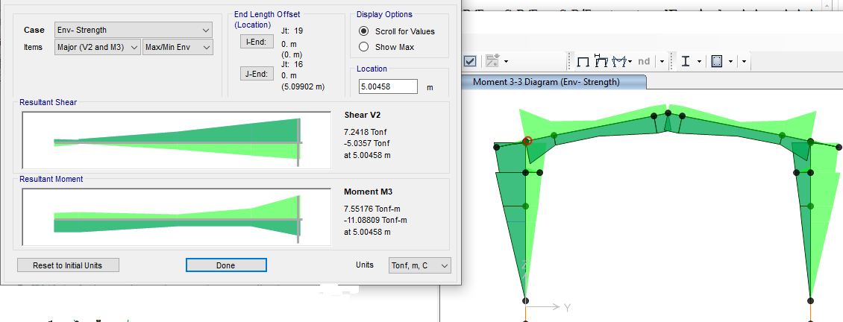

$$M_{3-3design \left(envelope combo\right)}=11.08 ton.m$$

$$V_{2-2design \left(envelope combo\right)}=7.24ton$$

$$M_{3-3design \left(envelope combo\right)}=15.1 ton.m$$

$$V_{2-2design \left(envelope combo\right)}=7.5ton$$

Moment of design should not be less than of 0.5Mp=13.392 ton-m.

$$F_{u}=8000\frac{kg}{cm2}$$

$$f_{n}=\frac{R_{n}}{Anb}=∅F_{nt}=4500kg/cm2$$

$$Ab=4.52 cm2$$

$$I_{bolt}=4Ib=4×4.52×\left({7.5}^{2}+{22.5}^{2}\right)=10170 cm^{4}$$

$f_{b}$ = $\frac{MC}{I}$

$fb=13.392×\frac{22.5}{10170}×{10}^{5}=2962.83 kg/cm2$ <4500kg/cm2 ok

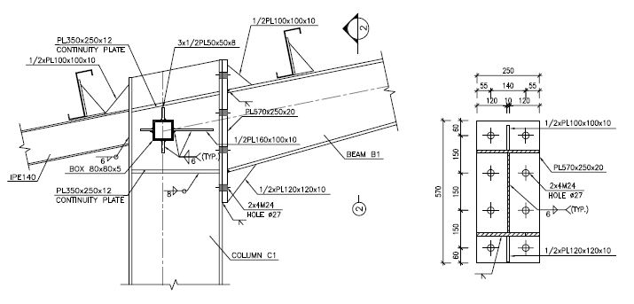

**Figure 35: Connecrtion Details**

**Rafter to Colum Connection**

* **Rafter to column design by omega factor :**



**Current Date:** 11/18/2023 2:22 PM

**Units system:** Metric

**File name:** C:\Users\n.razani\Desktop\Ram Connection\RAFTER TO COL.rcnx

Steel connections

**Results**

**Connection name : MEP_KNEE_BCF_VERTICAL_EU_1/4_PL_2B_1B1/2**

**Connection ID : 1**

Family: Beam - Column flange (BCF)

Type: Knee moment end plate

Design code: AISC 360-16 LRFD

**DEMANDS**

Beam Right beam Left beam Column Panel

**Description Ru Pu Mu PufTop PufBot PufTop PufBot Pu Vu Load type**

[T] [T] [T*m] [T] [T] [T] [T] [T] [T]

DL 5.89 1.14 12.90 -40.81 41.95 0.00 0.00 0.00 41.95 Design

**GEOMETRIC CONSIDERATIONS**

**Dimensions Unit Value Min. value Max. value Sta. References**

Extended end plate

End plate stiffener thickness [cm] 1.20 0.88 --  DG4 Eq. 3.15,

AISC 358-10 Eq. 6.10-9,

Eq. 6.10-10

Vertical edge distance [cm] 6.00 3.35 15.24  Sec. J3.5

Horizontal edge distance [cm] 5.50 3.35 15.24  Sec. J3.5

Vertical bolt spacing (external flange) [cm] 15.00 6.40 --  Sec. J3.3

Vertical bolt spacing (internal flange) [cm] 17.22 6.40 --  Sec. J3.3

Horizontal center-to-center spacing (gage) [cm] 14.00 6.40 25.00  Sec. J3.3,

DG4 Sec. 2.4,

DG4 Sec. 2.1,

2.4,

DG16 Sec. 2.5

Outer bolt distance (external flange) [cm] 8.00 3.67 --  DG4 Sec. 2.1

Inner bolt distance (external flange) [cm] 8.00 3.67 --  DG4 Sec. 2.1

Outer bolt distance (internal flange) [cm] 8.00 3.67 --  DG4 Sec. 2.1

Inner bolt distance (internal flange) [cm] 8.00 3.67 --  DG4 Sec. 2.1

Bolt diameter [cm] 2.40 -- 3.81  DG4 Sec. 1.1

- Use CJP weld for the end plate stiffener

Beam

Weld size (external flange) [1/16in] 6 3 --  table J2.4

Web [1/16in] 6 3 --  table J2.4

Support

Horizontal edge distance [cm] 5.50 3.04 15.24  Sec. J3.5

Transverse stiffeners

Width [cm] 13.00 7.93 --  Sec. J10.8

Weld size [1/16in] 6 4 --  DG 13 Eq. 4.3-6

- The tension flange bolts overlap the compression flange bolts.

**PLATE / COLUMN BEHAVIOR**

End plate behaviour (external flange)

Thin plate behavior controlled by plate yielding

End plate behaviour (internal flange)

Thin plate behavior controlled by bolt rupture with prying action

Connection plate behavior (external flange)

Thick plate behavior controlled by no prying bolt rupture

Connection plate behavior (internal flange)

Thick plate behavior controlled by no prying bolt rupture

**DESIGN CHECK**

**Verification Unit Capacity Demand Ctrl EQ Ratio References**

Moment end plate (external flange)

Flexural yielding [Ton*m] 17.32 0.00 DL **0.00** DG16 Sec 2.5

No prying bolt moment strength [Ton*m] 30.02 0.00 DL **0.00** DG16 Sec 2.5

Bolt rupture with prying moment strength [Ton*m] 24.75 0.00 DL **0.00** DG16 Sec 2.5

Bolts shear [Ton] 60.24 5.89 DL **0.10** Tables (7-1..14)

Bolt bearing under shear load [Ton] 206.73 0.00 DL **0.00** Eq. J3-6

Shear yielding [Ton] 68.34 20.40 DL **0.30** DG4 Eq. 3.12

Shear rupture [Ton] 68.31 20.40 DL **0.30** DG4 Eq 3.14,

AISC 358 Eq. 6.9-12,

DG4 Eq. 3.13

Moment end plate (internal flange)

Flexural yielding [Ton*m] 26.93 13.08 DL **0.49** DG16 Sec 2.5

No prying bolt moment strength [Ton*m] 26.77 13.08 DL **0.49** DG16 Sec 2.5

Bolt rupture with prying moment strength [Ton*m] 22.38 13.08 DL **0.58** DG16 Sec 2.5

Bolts shear [Ton] 60.24 0.00 DL **0.00** Tables (7-1..14)

Bolt bearing under shear load [Ton] 136.27 5.89 DL **0.04** Eq. J3-6

Shear yielding [Ton] 68.34 20.97 DL **0.31** DG4 Eq. 3.12

Shear rupture [Ton] 68.31 20.97 DL **0.31** DG4 Eq 3.14,

AISC 358 Eq. 6.9-12,

DG4 Eq. 3.13

Beam

Web weld shear strength [Ton] 38.78 5.89 DL **0.15** Eq. J2-4

Web weld strength to reach yield stress [Ton/m] 443.39 182.23 DL **0.41** Eq. J2-4,

Eq. J4-1

Shear yielding [Ton] 39.36 5.89 DL **0.15** Eq. J4-3

Support

Flexural yielding (external flange) [Ton*m] 260498.40 0.00 DL **0.00** DG4 Eq. 3.20,

Sec. 2.2.3,

DG4 Eq. 3.21

Support bolt bearing (external flange) [Ton] 21139.22 0.00 DL **0.00** Eq. J3-6

Flexural yielding (internal flange) [Ton*m] 311497.40 13.08 DL **0.00** DG4 Eq. 3.20,

Sec. 2.2.3,

DG4 Eq. 3.21

Support bolt bearing (internal flange) [Ton] 14092.82 5.89 DL **0.00** Eq. J3-6

Panel web shear [Ton] 40.89 41.95 DL **1.03** Sec. G1

Support - right side

Local web yielding [Ton] 2510.85 41.95 DL **0.02** DG4 eq. 3.24,

DG13 Eq. 4.3-1,

Sec. J10

Transverse stiffeners - bottom

Yielding strength due to axial load [Ton] 70.52 0.00 DL **0.00** Eq. J4-1

Compression [Ton] 70.52 0.00 DL **0.00** Sec. J4.4

Flange weld capacity [Ton] 98.87 0.00 DL **0.00** Eq. J2-4

Web weld capacity [Ton] -2176.00 0.00 DL **0.00** Eq. J2-4

**Global critical strength ratio 1.03**

* Beam design :

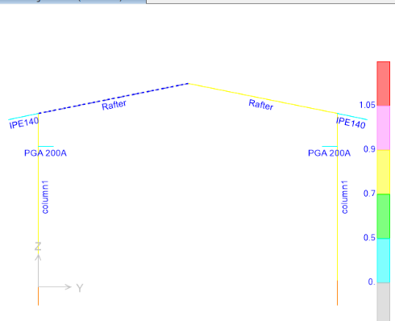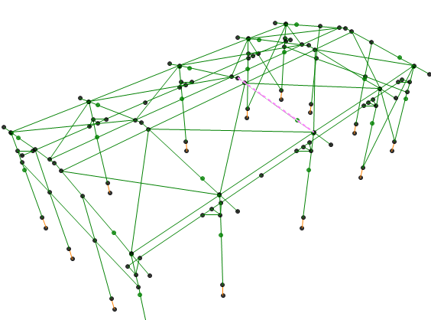

AISC 360-10 STEEL SECTION CHECK (Summary for Combo and Station)

Units : Kgf, m, C

Frame : 15 X Mid: 10. Combo: S.D..5.4.1 Design Type: Brace

Length: 5.099 Y Mid: 2.5 Shape: Rafter Frame Type: OMF

Loc : 5.099 Z Mid: 6.3 Class: Compact Princpl Rot: 0. degrees

Provision: LRFD Analysis: Direct Analysis

D/C Limit=1. 2nd Order: General 2nd Order Reduction: Tau-b Fixed

AlphaPr/Py=0.023 AlphaPr/Pe=0.015 Tau_b=1. EA factor=0.8 EI factor=0.8

PhiB=0.9 PhiC=0.9 PhiTY=0.9 PhiTF=0.75

PhiS=0.9 PhiS-RI=1. PhiST=0.9

A=0.008 I33=1.641E-04 r33=0.14 S33=0.001 Av3=0.005

J=0. I22=3.126E-05 r22=0.061 S22=2.501E-04 Av2=0.003

E=2.039E+10 Fy=24000000. Ry=1.611 z33=0.001 Cw=0.

RLLF=1. Fu=37000000. z22=3.798E-04

STRESS CHECK FORCES & MOMENTS (Combo S.D..5.4.1)

Location Pu Mu33 Mu22 Vu2 Vu3 Tu

5.099 -4607.206 -18053.477 13.032 7199.284 -153.417 0.559

PMM DEMAND/CAPACITY RATIO (H1-1b)

D/C Ratio: 0.767 = 0.017 + 0.749 + 0.002

= (1/2)(Pr/Pc) + (Mr33/Mc33) + (Mr22/Mc22)

AXIAL FORCE & BIAXIAL MOMENT DESIGN (H1-1b)

Factor L K1 K2 B1 B2 Cm

Major Bending 1. 1. 1. 1. 1. 1.

Minor Bending 0.9 1. 1. 1. 1. 1.

Lltb Kltb Cb

LTB 0.9 1. 2.448

Pu phi*Pnc phi*Pnt

Force Capacity Capacity

Axial -4607.206 136791.082 181440.

Mu phi*Mn phi*Mn phi*Mn

Moment Capacity No LTB Cb=1

Major Moment -18053.477 24105.6 24105.6 22126.197

Minor Moment 13.032 8203.68

SHEAR CHECK

Vu phi*Vn Stress Status

Force Capacity Ratio Check

Major Shear 7199.284 33592.32 0.214 OK

Minor Shear 153.417 77760. 0.002 OK

**BRACE MAXIMUM AXIAL LOADS**

P P

Comp Tens

Axial -4607.206 0.

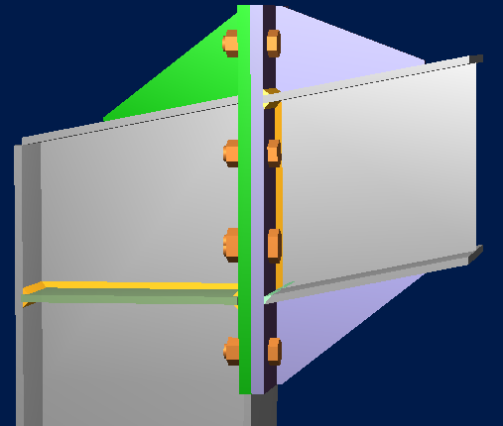

* **Column design :**

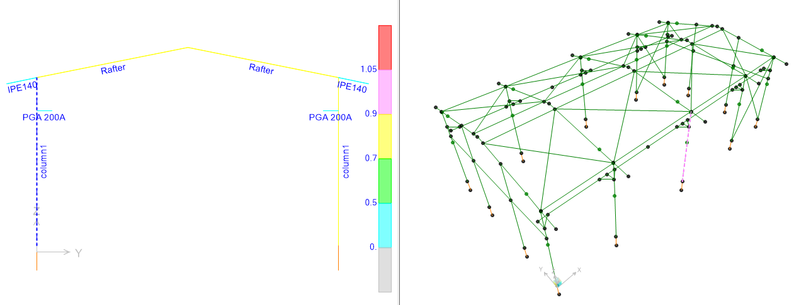

AISC 360-10 STEEL SECTION CHECK (Summary for Combo and Station)

Units : Kgf, m, C

Frame : 13 X Mid: 10. Combo: S.D..5.4.1 Design Type: Column

Length: 5.6 Y Mid: 0. Shape: column1 Frame Type: OMF

Loc : 4.5 Z Mid: 3. Class: Compact Princpl Rot: 0. degrees

Provision: LRFD Analysis: Direct Analysis

D/C Limit=1. 2nd Order: General 2nd Order Reduction: Tau-b Fixed

AlphaPr/Py=0.058 AlphaPr/Pe=0.038 Tau_b=1. EA factor=0.8 EI factor=0.8

PhiB=0.9 PhiC=0.9 PhiTY=0.9 PhiTF=0.75

PhiS=0.9 PhiS-RI=1. PhiST=0.9

A=0.008 I33=1.720E-04 r33=0.14 S33=0.001 Av3=0.005

J=0. I22=3.126E-05 r22=0.061 S22=2.501E-04 Av2=0.003

E=2.039E+10 Fy=24000000. Ry=1.611 z33=0.001 Cw=0.

RLLF=1. Fu=37000000. z22=3.798E-04

STRESS CHECK FORCES & MOMENTS (Combo S.D..5.4.1)

Location Pu Mu33 Mu22 Vu2 Vu3 Tu

4.5 -11716.839 16975.674 353.956 -3453.893 -82.354 2.314

PMM DEMAND/CAPACITY RATIO (H1-1b)

D/C Ratio: 0.78 = 0.042 + 0.695 + 0.043

= (1/2)(Pr/Pc) + (Mr33/Mc33) + (Mr22/Mc22)

AXIAL FORCE & BIAXIAL MOMENT DESIGN (H1-1b)

Factor L K1 K2 B1 B2 Cm

Major Bending 0.804 1. 1. 1. 1. 1.

Minor Bending 0.804 1. 1. 1. 1. 1.

Lltb Kltb Cb

LTB 0.804 1. 1.397

Pu phi*Pnc phi*Pnt

Force Capacity Capacity

Axial -11716.839 138573.483 181844.029

Mu phi*Mn phi*Mn phi*Mn

Moment Capacity No LTB Cb=1

Major Moment 16975.674 24425.715 24425.715 22520.066

Minor Moment 353.956 8204.488

SHEAR CHECK

Vu phi*Vn Stress Status

Force Capacity Ratio Check

Major Shear 3453.893 33834.737 0.102 OK

Minor Shear 82.354 77760. 0.001 OK

* 1. **PURLIN DESIGN**

## 11.2.1. Property of Purlin(Z180x2.5)

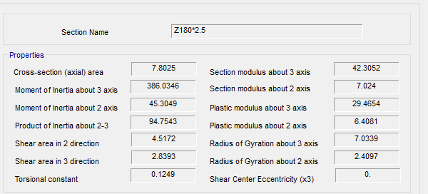

**Figure 36-Section Property Of Purlin**

According to above table :

$$A=7.80 cm2$$

$$J=0.12 cm4$$

$$Ix=386.06 cm4$$

$$Iy=45.304 cm4$$

$$rx=7.033 cm$$

$$ry=2.41 cm$$

$$ho=18 cm$$

$$SY=42.305 cm3$$

$$SX=7.024 cm3$$

FOR Z 180 :

$$D+L=26+50=76 kg/m^{2}$$

$$P_{y}=76.\cos{11}=74.6 kg/m^{2}$$

$$P_{x}=76.\sin{11}=14.5 kg/m^{2}$$

$$middle of span : M_{y}=\frac{w.L^{2}}{8}=\frac{76×1.0×5^{2}}{8}=237.5 kg.m$$

$$middle of span : M_{x}=\frac{w.L^{2}}{360}=\frac{14.5×1×5^{2}}{360}=1.00kg.m$$

$$f_{b}=\frac{M_{y}}{s_{y}}+2\frac{M_{x}}{s_{x}}=\frac{237.5×100}{42.305}+2\frac{1.00×100}{7.024}=561.39+28.47=589.86<1440 ok$$

$$moment on sagrod support : M_{y}=\frac{w.L^{2}}{9}=\frac{76×1.0×5^{2}}{9}=211.11 kg.m$$

$$moment on sagrod support : M_{x}=\frac{w.L^{2}}{90}=\frac{14.5×1.0×5^{2}}{90}=4.02 kg.m$$

$$f_{b}=\frac{M_{y}}{s_{y}}+2\frac{M_{x}}{s_{x}}=\frac{211.11×100}{42.305}+2\frac{4.02×100}{7.024}=498.99+114.46=613.45< 1440 ok$$

FOR Z 180 :

$$0.6D+W=26+143=169 kg/m^{2}$$

$$P_{y}=169.\cos{11}=165 kg/m^{2}$$

$$P_{x}=169.\sin{11}=32.24 kg/m^{2}$$

$$middle of span : M_{y}=\frac{w.L^{2}}{8}=\frac{165×1.0×5^{2}}{8}=515.6 kg.m$$

$$middle of span : M_{x}=\frac{w.L^{2}}{360}=\frac{32.24×1×5^{2}}{360}=2.23kg.m$$

$$f_{b}=\frac{M_{y}}{s_{y}}+2\frac{M_{x}}{s_{x}}=\frac{515.6×100}{42.305}+2\frac{2.23×100}{7.024}=561.39+28.47=1282<1440 ok$$

$$moment on sagrod support : M_{y}=\frac{w.L^{2}}{9}=\frac{165×1.0×5^{2}}{9}=470 kg.m$$

$$moment on sagrod support : M_{x}=\frac{w.L^{2}}{90}=\frac{32.24×1.0×5^{2}}{90}=8.95 kg.m$$

$$f_{b}=\frac{M_{y}}{s_{y}}+2\frac{M_{x}}{s_{x}}=\frac{470×100}{42.305}+2\frac{8.95×100}{7.024}=1110+254=1364< 1440 ok$$

### 11.2.2.Un deformed shape CONTROL:

$$dead+live loads : ∆=\frac{5×q×L^{4}}{384×E×I}=\frac{5×0.76×1.0×{600}^{4}}{384×2.04×{10}^{6}×1350}=0.46cm < \frac{L}{240}=2.0cm$$

$$for live loads : ∆=\frac{5×q×L^{4}}{384×E×I}=\frac{5×0.5×1.0×{600}^{4}}{384×2.04×{10}^{6}×1350}=0.30 cm < \frac{L}{360}=1.3 cm$$

### 11.2.3. deflection check of wallposts:

According to civil & structural design criteria maximum deflection under critical load combination with E or W cases is H/200 that results have been shown as follow:

|  |  |  |  |  |  |  |
| --- | --- | --- | --- | --- | --- | --- |
| **TABLE: Joint Displacements** | | | | | | |
| **Joint** | **OutputCase** | **CaseType** | **StepType** | **U1** | **U allowable** |  |
| Text | Text | Text | Text | cm |  | check |
| 114 | WXp | LinStatic |  | 0.213033 | 2.375 | ok |
| 114 | WXn | LinStatic |  | 0.164488 | 2.375 | ok |
| 114 | WXp1 | LinStatic |  | 0 | 2.375 | ok |
| 114 | WXn1 | LinStatic |  | 0 | 2.375 | ok |
| 114 | EQx | LinStatic |  | 0.205521 | 2.375 | ok |
| 114 | Env- allowable | Combination | Max | 0.194406 | 2.375 | ok |
| 114 | Env- allowable | Combination | Min | -0.22335 | 2.375 | ok |
| 115 | WXp | LinStatic |  | 0.215196 | 2.375 | ok |
| 115 | WXn | LinStatic |  | 0.16665 | 2.375 | ok |
| 115 | WXp1 | LinStatic |  | 0 | 2.375 | ok |
| 115 | WXn1 | LinStatic |  | 0 | 2.375 | ok |
| 115 | EQx | LinStatic |  | 0.205521 | 2.375 | ok |
| 115 | Env- allowable | Combination | Max | 0.195537 | 2.375 | ok |
| 115 | Env- allowable | Combination | Min | -0.226812 | 2.375 | ok |
| 117 | WXp | LinStatic |  | 0.20182 | 2.375 | ok |
| 117 | WXn | LinStatic |  | 0.175725 | 2.375 | ok |
| 117 | WXp1 | LinStatic |  | 0 | 2.375 | ok |
| 117 | WXn1 | LinStatic |  | 0 | 2.375 | ok |
| 117 | EQx | LinStatic |  | 0.244886 | 2.375 | ok |
| 117 | Env- allowable | Combination | Max | 0.200024 | 2.375 | ok |
| 117 | Env- allowable | Combination | Min | -0.378363 | 2.375 | ok |
| 119 | WXp | LinStatic |  | 0.200303 | 2.375 | ok |
| 119 | WXn | LinStatic |  | 0.174209 | 2.375 | ok |
| 119 | WXp1 | LinStatic |  | 0 | 2.375 | ok |
| 119 | WXn1 | LinStatic |  | 0 | 2.375 | ok |
| 119 | EQx | LinStatic |  | 0.244886 | 2.375 | ok |
| 119 | Env- allowable | Combination | Max | 0.206779 | 2.375 | ok |

* 1. **Roof bracing Design**

According to INBC No.10 section 10-2-3-4 for tensile member :

Roof brace = $∅25$

$${ ∅}_{t}P_{n}=∅_{t}F_{y}A_{g}=0.9×4000×4.91=17676 kg$$

According to sap model maximum tensile force is 9942 kg & it’s OK.

|  |  |  |  |  |
| --- | --- | --- | --- | --- |
| **TABLE: Element Forces - Frames** | | | | |
| **Frame** | **Station** | **OutputCase** | **CaseType** | **P** |
| Text | cm | Text | Text | Kgf |
| 53 | 0 | Env- Strength | Combination | 1807.36 |
| 53 | 304.385 | Env- Strength | Combination | 1808.89 |
| 53 | 608.769 | Env- Strength | Combination | 1810.42 |
| 53 | 0 | Env- Strength | Combination | -2.38 |
| 53 | 304.385 | Env- Strength | Combination | -0.008515 |
| 53 | 608.769 | Env- Strength | Combination | 1.28 |
| 54 | 0 | Env- Strength | Combination | 726.55 |
| 54 | 377.69 | Env- Strength | Combination | 724.2 |
| 54 | 755.381 | Env- Strength | Combination | 721.85 |
| 54 | 0 | Env- Strength | Combination | 1.31 |
| 54 | 377.69 | Env- Strength | Combination | -0.00127 |
| 54 | 755.381 | Env- Strength | Combination | -2.35 |
| 55 | 377.69 | Env- Strength | Combination | 1497.21 |
| 55 | 755.381 | Env- Strength | Combination | 1499.49 |
| 55 | 0 | Env- Strength | Combination | -2.29 |
| 55 | 377.69 | Env- Strength | Combination | -0.006682 |
| 55 | 755.381 | Env- Strength | Combination | 1.28 |
| 56 | 0 | Env- Strength | Combination | 1673.15 |
| 56 | 304.385 | Env- Strength | Combination | 1671.59 |
| 56 | 608.769 | Env- Strength | Combination | 1670.03 |
| 56 | 0 | Env- Strength | Combination | 1.3 |
| 56 | 304.385 | Env- Strength | Combination | -0.004084 |
| 56 | 608.769 | Env- Strength | Combination | -2.43 |
| 61 | 0 | Env- Strength | Combination | 3348.05 |
| 61 | 304.385 | Env- Strength | Combination | 3346 |
| 61 | 608.769 | Env- Strength | Combination | 3343.96 |
| 61 | 0 | Env- Strength | Combination | 1.53 |
| 61 | 304.385 | Env- Strength | Combination | -0.001703 |
| 61 | 608.769 | Env- Strength | Combination | -1.53 |
| 62 | 0 | Env- Strength | Combination | 501.32 |
| 62 | 377.69 | Env- Strength | Combination | 502.62 |
| 62 | 755.381 | Env- Strength | Combination | 503.93 |
| 62 | 0 | Env- Strength | Combination | -2.44 |
| 62 | 377.69 | Env- Strength | Combination | -0.00321 |
| 62 | 755.381 | Env- Strength | Combination | 1.3 |
| 63 | 0 | Env- Strength | Combination | 618.01 |
| 63 | 377.69 | Env- Strength | Combination | 616.49 |
| 63 | 755.381 | Env- Strength | Combination | 614.97 |
| 63 | 0 | Env- Strength | Combination | 1.26 |
| 63 | 377.69 | Env- Strength | Combination | -0.007251 |
| 63 | 755.381 | Env- Strength | Combination | -2.37 |
| 64 | 0 | Env- Strength | Combination | 4010.59 |
| 64 | 304.385 | Env- Strength | Combination | 4012.67 |
| 64 | 608.769 | Env- Strength | Combination | 4014.74 |
| 64 | 0 | Env- Strength | Combination | -1.82 |
| 64 | 304.385 | Env- Strength | Combination | -0.001864 |
| 64 | 608.769 | Env- Strength | Combination | 1.3 |
| 65 | 0 | Env- Strength | Combination | 4095.18 |
| 65 | 304.385 | Env- Strength | Combination | 4093.06 |
| 65 | 608.769 | Env- Strength | Combination | 4090.94 |
| 65 | 0 | Env- Strength | Combination | 1.33 |
| 65 | 304.385 | Env- Strength | Combination | -0.002085 |
| 65 | 608.769 | Env- Strength | Combination | -2.12 |
| 66 | 0 | Env- Strength | Combination | 2030.72 |
| 66 | 304.385 | Env- Strength | Combination | 2032.29 |
| 66 | 608.769 | Env- Strength | Combination | 2033.85 |
| 66 | 0 | Env- Strength | Combination | -2.43 |
| 66 | 304.385 | Env- Strength | Combination | -0.004808 |
| 66 | 608.769 | Env- Strength | Combination | 1.3 |
| 67 | 0 | Env- Strength | Combination | 1003.82 |
| 67 | 377.69 | Env- Strength | Combination | 1001.42 |
| 67 | 755.381 | Env- Strength | Combination | 999.03 |
| 67 | 0 | Env- Strength | Combination | 1.34 |
| 67 | 377.69 | Env- Strength | Combination | -0.006733 |
| 67 | 755.381 | Env- Strength | Combination | -2.4 |
| 68 | 0 | Env- Strength | Combination | 707.97 |
| 68 | 377.69 | Env- Strength | Combination | 709.53 |
| 68 | 755.381 | Env- Strength | Combination | 711.09 |
| 68 | 0 | Env- Strength | Combination | -2.42 |
| 68 | 377.69 | Env- Strength | Combination | -0.002417 |
| 68 | 755.381 | Env- Strength | Combination | 1.3 |
| 83 | 0 | Env- Strength | Combination | 1782.11 |
| 83 | 377.69 | Env- Strength | Combination | 1784.44 |
| 83 | 755.381 | Env- Strength | Combination | 1786.78 |
| 83 | 0 | Env- Strength | Combination | -2.33 |
| 83 | 377.69 | Env- Strength | Combination | -0.001727 |
| 83 | 755.381 | Env- Strength | Combination | 1.3 |
| 84 | 0 | Env- Strength | Combination | 787.13 |
| 84 | 377.69 | Env- Strength | Combination | 785.8 |
| 84 | 755.381 | Env- Strength | Combination | 784.47 |
| 84 | 0 | Env- Strength | Combination | 1.34 |
| 84 | 377.69 | Env- Strength | Combination | -0.008554 |
| 84 | 755.381 | Env- Strength | Combination | -2.48 |
| 85 | 0 | Env- Strength | Combination | 3319.42 |
| 85 | 304.385 | Env- Strength | Combination | 3321.5 |
| 85 | 608.769 | Env- Strength | Combination | 3323.58 |
| 85 | 0 | Env- Strength | Combination | -2.08 |
| 85 | 304.385 | Env- Strength | Combination | -0.002082 |
| 85 | 608.769 | Env- Strength | Combination | 1.3 |
| 86 | 0 | Env- Strength | Combination | 2030.41 |
| 86 | 304.385 | Env- Strength | Combination | 2028.82 |
| 86 | 608.769 | Env- Strength | Combination | 2027.23 |
| 86 | 0 | Env- Strength | Combination | 1.33 |
| 86 | 304.385 | Env- Strength | Combination | -0.008007 |
| 86 | 608.769 | Env- Strength | Combination | -2.47 |
| 97 | 0 | Env- Strength | Combination | 9942.5 |
| 97 | 40 | Env- Strength | Combination | 9654.14 |
| 97 | 80 | Env- Strength | Combination | 9365.78 |
| 97 | 0 | Env- Strength | Combination | -7855.16 |
| 97 | 40 | Env- Strength | Combination | -8179.56 |
| 97 | 80 | Env- Strength | Combination | -8503.97 |
|  |  |  | Max(kgf)= | 9942.5 |

* 1. **Base Plate**

**11.4.1 Design force :**

According to AISC341-10 section D2-6b for shear design of base plate :

$$V_{tr}=\frac{M_{p}}{H}=\frac{ZF_{y}}{H}=\frac{1331×2400×{10}^{-5}}{5.8}=5.5ton$$

$$V_{long}=R_{y}A_{g}F_{y}cosθ=1.25×4000×12.56×cos 70.94=20507.8 kg=20.5 ton$$

**11.4.2.Shear check in transverse direction :**

According to INBC No.10 section 10-2-6-2-1

$$∅V_{n}=0.6F_{y}A_{w}C_{v } ∅_{v}$$

$\frac{h}{t_{w}}=\frac{28}{0.8}=35<2.24\sqrt{\frac{2.06×{10}^{6}}{2400}=65}$ then $C_{v}=1 ∅_{v}=1$

$${∅V}_{n}=0.6×2400×\left(25×0.8\right)×1×1=28.80 on>5.5 ton$$

**11.4.3.Shear check in longitudinal direction :**

According to INBC No.10 section 10-2-6-7-2

$$K_{v}=1.2$$

$$\frac{h}{t_{w}}=\frac{\frac{b}{2}}{t_{f}}=\frac{12.5}{1.2}=10.41$$

$$A_{w}=2b_{f}t_{f}=2×25×1.2=60 cm2$$

$$\frac{h}{t_{w}}<1.1\sqrt{\frac{K_{v}E}{F_{y}}}=35.3 then C_{v}=1 ∅_{v}=0.9$$

$$∅V_{n}=0.9×0.6×2400×60×1=77760 kg=77.760 ton>20.5 ton$$

According to above calculation The column section is ok for shear check .

**11.4.4.Bolt control in shear**

$$V_{max}=20.5 ton$$

$$F_{nv}=0.45F_{u}=2700 kg$$

$$∅=0.75$$

$$A_{nb}=\frac{V_{max}}{∅F_{nv}}=\frac{20500}{0.75×2700}=10.1 cm^{2} USE 4M20(Area=12.56cm2)$$

**11.4.5.For ordinary & critical load combination**

To control of maximum axial load in columns must have to analyze structure with amplified earthquake.

$$M_{u}=17.17 ton.m$$

$$P_{u}=15.56 ton$$

$$T=8.92 ton$$

$$qmax=\frac{15560}{30×30}=17.28 kgf/cm2$$

$σ_{c}=0.65×0.85×300=165.75\frac{kgf}{cm2}>17.28\frac{khf}{cm2}$ ok

$$M_{A}=(σ_{c}×B)×{\left(\frac{L-0.95d}{2}\right)}^{2}×\frac{1}{2}$$

$$M_{A}=\left(17.28×30\right)×{\left(3.125\right)}^{2}×0.5=2531.25 kgf.cm$$

$$Z=\frac{30t^{2}}{4}$$

$$S=\frac{30t^{2}}{6}$$

$$M_{n}=Z×Fy<1.6My=1.6S Fy$$

$$7.5t^{2}<1.6×5t^{2}=8t^{2} ok$$

$2531.25=7.5{×2400*t}^{ 2} t= 0.14 cm$ t=20mm

**11.4.6.Tension Strength control of anchor bolts :**

$$d_{b}=20mm$$

$$A_{nb}=3.14 cm2$$

$$F_{nT}=0.75F_{u}=4500kg/cm2$$

$$∅=0.75$$

$$R_{nt}=F_{nt}A_{nb}=4500×4×4.52×{10}^{-3}=81.36 ton$$

$$∅R_{nt}=61.02 ton ≥Tu=8.92 ton ok$$

**11.4.7.Shear control of Anchor Bolts:**

* 1. **General requirements of embedment in concrete**:

**11.5.1.According to ACI318 appendix D:**

Concrete breakout strength of anchor in tension : the nominal concrete breakout strength Ncbg shall not exceed

$$N_{cbg}=\frac{A_{NC}}{A_{NCO}}ω_{ec}ω_{ed,N}ω_{c,N}ω_{cp,N}N_{b}$$

$$A_{CNO}=9hef^{2}$$

$$A_{NC}=(S1+3hef)(S2+3hef)$$

$$K_{c}=10$$

$$N_{b}=10γ_{a}\sqrt{f_{c}}h_{ef}^{1.5}=10×1×\sqrt{25}×{50}^{1.5}=17.67 KN$$

$$λ_{ef}=\max\left(\frac{Ca,max}{1.5},\frac{S1}{3},\frac{S2}{3}\right)=53mm$$

$$C_{a,max}=\max\left(Ca1,Ca2,Ca3,Ca4\right)=170 mm$$

$$A_{NCO}=9×{50}^{2}=22500 mm2$$

$$A_{NC}=\left(160+3×50\right)×\left(160+3×50\right)=96100 mm2$$

$$ω_{ec,N}=1$$

$$C_{a,min}=160 mm$$

$$h_{ef}=50 mm$$

$$ω_{ed,N}=0.7+0.3×\frac{160}{1.5×50}=1.34$$

$$ω_{c,N}=1$$

$$ω_{cp,N}=1$$

$$N_{cbg}=\frac{A_{NC}}{A_{NCO}}ω_{ec}ω_{ed,N}ω_{c,N}ω_{cp,N}N_{b}=\frac{96100}{22500}×1×1.34×1.25×17.67=126 KN$$

$$∅=0.7$$

$$∅N_{cbg}=8.82ton>1.75 ok$$

Concrete strength to withstand against tension in braced frame column under combination with Ω factor is acceptable.

**11.5.2.Concrete breakout of anchor in shear :**

The nominal concrete breakout strength Vcbg in shear shall not exceed :

$$V_{cbg}=\frac{A_{VC}}{A_{VCO}}ω_{ec,V}ω_{ed,V}ω_{c,V}ω_{h,V}V_{b}$$

$$A_{Vco}=4.5{Ca1}^{2}$$

$$\frac{A_{V}}{A_{Vco}}<n=2$$

$$h_{a}=\min\left(t_{f},1.5{Ca}_{1,2}\right)=\left(1600,1.5×70\right)=105mm$$

$$A_{vc}=120×90=10800 mm2$$

$$A_{vco}=4.5{Ca1}^{2}=22050 mm2$$

$$ω_{ed,V}=1$$

$$ω_{e,v}=1.4$$

$$ω_{h,v}=\sqrt{\frac{1.5{Ca}_{1}}{ha}}=1$$

$$V_{b}=\min\left(0.6{\left(\frac{l_{e}}{d_{a}}\right)}^{0.2}\sqrt{d_{a} }λ_{a}\sqrt{fc }{Ca1}^{1.5} , 3.7λ_{a}\sqrt{fc }{Ca1}^{1.5}\right)=10.83KN$$

$$λ_{a}=1$$

$$V_{cbg}=\frac{A_{VC}}{A_{VCO}}ω_{ec,V}ω_{ed,V}ω_{c,V}ω_{h,V}V_{b}=\frac{10800}{22050}×1×1.4×1×10.8=7.4 ton ok$$

### 11.5.3-REQUIRED THICKNESS

Maximum Axial Load according to SAP2000 model is about 8.13 ton Under critical load combination:

$t=l\sqrt{\frac{2P_{U}}{0.9F_{y}BN} }$ =5 $\sqrt{\frac{2x15560}{0.9x2400x30x30}}=0.63$ cm $used th=2 cm$

$m=\frac{N-0.95d}{2}$ = $\frac{300-0.95*250}{2}$ =31.25

$n=\frac{B-0.8bf}{2}$ = $\frac{300-0.8*250}{2}$ =50

$${λn}^{'}=λ\frac{\sqrt{dbf}}{4}=1*\frac{\sqrt{24*300}}{4}=21$$

L=max(m,n,λn)=50

1. **FOUNDATION DESIGN**

SAP2000 has been used in order to modeling, analyses and design of this foundation.

DETAILS” property of piles has been shown in the following FIG:

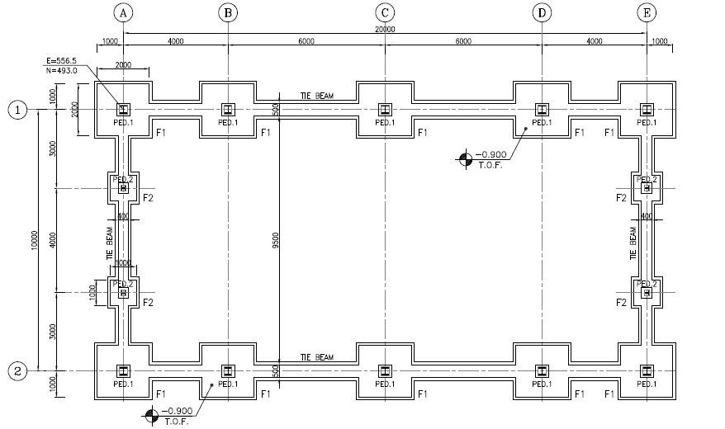

**Figure 37-Foundation Plan**

* 1. **Soil pressure and settlement**

According to geotechnical report for this area allowable bearing capacity is as follow:

For L/B=1 B=1 m $q_{all}=2.75 \frac{kg}{cm2} , ∆_{all}=1.75 cm , k_{s}=1.69 kg/cm3$

For L/B=1 B=2 m $q_{all}=2.40 \frac{kg}{cm2} , ∆_{all}=2.40 cm , k_{s}=1.00 kg/cm3$

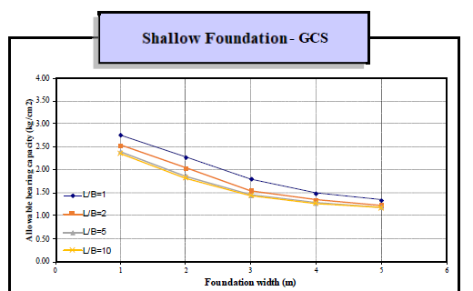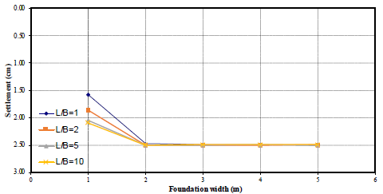

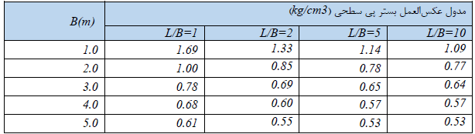

**Figure 38-geotechnical parameters**

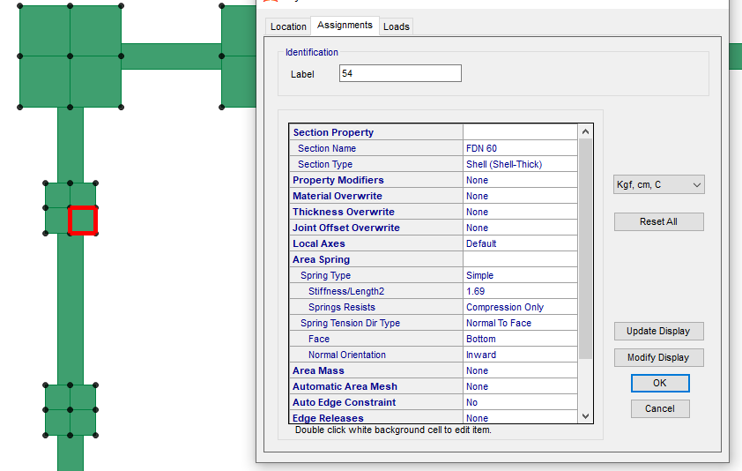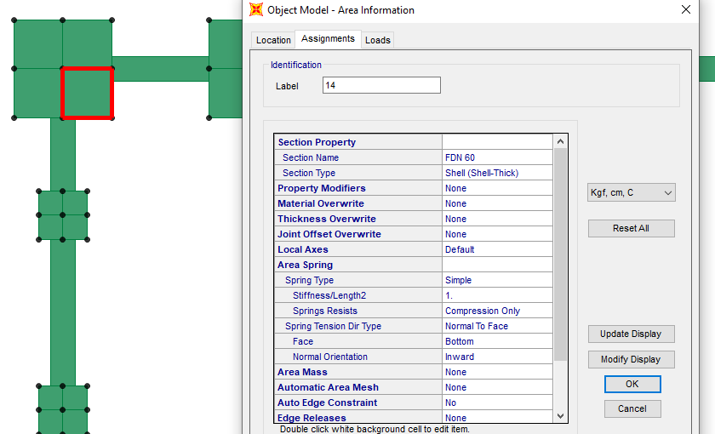

**Figure 39-Assign Spring to Foundation(B=1m (ks=1.69kg/cm3)&B=2m(ks=1kg/cm3))**

* 1. **DESIGN**

Concrete Foundation are designed according to ACI 318-14. Required loads are derived from SAP data, and design process will be done according to ACI code based on ultimate strength procedure.

${f^{'}}_{c}=30Mpa$, $f_{y}=400Ma$

The weight of Soil apply in foundation Model. Weights of this part is shown through the following figure

Soil dead load is $γh=1.85×0.9=1.665\frac{ton}{m2}=1665\frac{kg}{m2}$

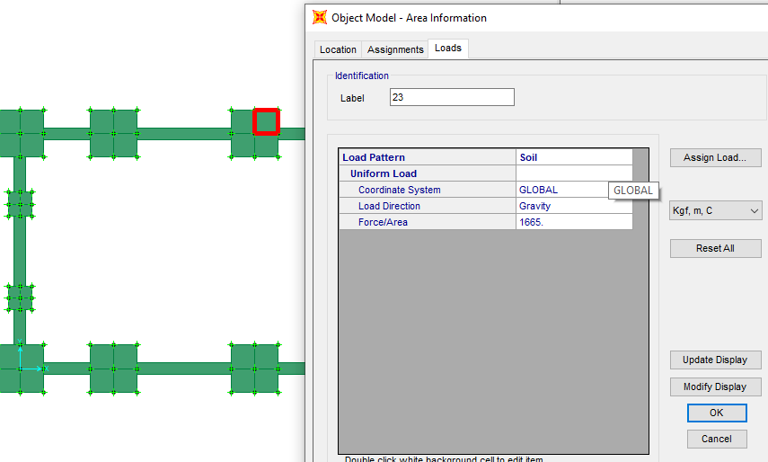

**Figure 40-Applied soil load on Foundation (Soil:1665 kg/m2)**

* 1. **FOUNDATION DESIGN CONTROL**

### 12.3.1 Check of displacement of Foundation

|  |  |  |  |  |  |
| --- | --- | --- | --- | --- | --- |
| **TABLE: Joint Displacements** | | | | | |
| **Joint** | **OutputCase** | **CaseType** | **U3** | **KS** | **Soil Pressure** |
| Text | Text | Text | cm | kg/cm3 | kg/cm2 |
| 172 | Env- allowable | Combination | -0.168915 | 1.69 | 0.285 |
| 172 | Env- allowable | Combination | -0.378349 | 1.69 | 0.639 |
| 173 | Env- allowable | Combination | -0.178069 | 1.69 | 0.301 |
| 173 | Env- allowable | Combination | -0.417572 | 1.69 | 0.706 |
| 174 | Env- allowable | Combination | -0.176702 | 1.69 | 0.299 |
| 174 | Env- allowable | Combination | -0.435625 | 1.69 | 0.736 |
| 175 | Env- allowable | Combination | -0.167385 | 1.69 | 0.283 |
| 175 | Env- allowable | Combination | -0.392064 | 1.69 | 0.663 |
| 177 | Env- allowable | Combination | -0.168181 | 1.69 | 0.284 |
| 177 | Env- allowable | Combination | -0.382568 | 1.69 | 0.647 |
| 179 | Env- allowable | Combination | -0.177413 | 1.69 | 0.300 |
| 179 | Env- allowable | Combination | -0.425056 | 1.69 | 0.718 |
| 204 | Env- allowable | Combination | -0.17225 | 1.69 | 0.291 |
| 204 | Env- allowable | Combination | -0.403999 | 1.69 | 0.683 |
| 205 | Env- allowable | Combination | -0.12661 | 1.69 | 0.214 |
| 205 | Env- allowable | Combination | -0.441077 | 1.69 | 0.745 |
| 208 | Env- allowable | Combination | -0.114588 | 1.69 | 0.194 |
| 208 | Env- allowable | Combination | -0.449227 | 1.69 | 0.759 |
| 211 | Env- allowable | Combination | -0.172874 | 1.69 | 0.292 |
| 211 | Env- allowable | Combination | -0.403745 | 1.69 | 0.682 |
| 216 | Env- allowable | Combination | -0.173568 | 1.69 | 0.293 |
| 216 | Env- allowable | Combination | -0.396878 | 1.69 | 0.671 |
| 218 | Env- allowable | Combination | -0.17222 | 1.69 | 0.291 |
| 218 | Env- allowable | Combination | -0.414749 | 1.69 | 0.701 |
| 219 | Env- allowable | Combination | -0.166122 | 1.69 | 0.281 |
| 219 | Env- allowable | Combination | -0.392681 | 1.69 | 0.664 |
| 220 | Env- allowable | Combination | -0.176758 | 1.69 | 0.299 |
| 220 | Env- allowable | Combination | -0.435231 | 1.69 | 0.736 |
| 221 | Env- allowable | Combination | -0.178092 | 1.69 | 0.301 |
| 221 | Env- allowable | Combination | -0.417429 | 1.69 | 0.705 |
| 222 | Env- allowable | Combination | -0.167615 | 1.69 | 0.283 |
| 222 | Env- allowable | Combination | -0.379593 | 1.69 | 0.642 |
| 223 | Env- allowable | Combination | -0.166896 | 1.69 | 0.282 |
| 223 | Env- allowable | Combination | -0.383749 | 1.69 | 0.649 |
| 224 | Env- allowable | Combination | -0.177452 | 1.69 | 0.300 |
| 224 | Env- allowable | Combination | -0.424805 | 1.69 | 0.718 |
| 225 | Env- allowable | Combination | -0.171616 | 1.69 | 0.290 |
| 225 | Env- allowable | Combination | -0.414856 | 1.69 | 0.701 |
| 226 | Env- allowable | Combination | -0.17293 | 1.69 | 0.292 |
| 226 | Env- allowable | Combination | -0.397234 | 1.69 | 0.671 |
| 227 | Env- allowable | Combination | -0.167455 | 1.69 | 0.283 |
| 227 | Env- allowable | Combination | -0.414444 | 1.69 | 0.700 |
| 228 | Env- allowable | Combination | -0.078536 | 1.69 | 0.133 |
| 228 | Env- allowable | Combination | -0.467397 | 1.69 | 0.790 |
| 229 | Env- allowable | Combination | -0.059803 | 1.69 | 0.101 |
| 229 | Env- allowable | Combination | -0.494013 | 1.69 | 0.835 |
| 230 | Env- allowable | Combination | -0.149126 | 1.69 | 0.252 |
| 230 | Env- allowable | Combination | -0.443602 | 1.69 | 0.750 |
| 231 | Env- allowable | Combination | -0.159203 | 1.69 | 0.269 |
| 231 | Env- allowable | Combination | -0.426894 | 1.69 | 0.721 |
| 232 | Env- allowable | Combination | -0.070099 | 1.69 | 0.118 |
| 232 | Env- allowable | Combination | -0.478691 | 1.69 | 0.809 |
| 233 | Env- allowable | Combination | -0.122719 | 1.69 | 0.207 |
| 233 | Env- allowable | Combination | -0.438652 | 1.69 | 0.741 |
| 234 | Env- allowable | Combination | -0.10409 | 1.69 | 0.176 |
| 234 | Env- allowable | Combination | -0.465472 | 1.69 | 0.787 |
| 235 | Env- allowable | Combination | -0.162159 | 1.69 | 0.274 |
| 235 | Env- allowable | Combination | -0.433903 | 1.69 | 0.733 |
| 236 | Env- allowable | Combination | -0.079234 | 1.69 | 0.134 |
| 236 | Env- allowable | Combination | -0.480669 | 1.69 | 0.812 |
| 237 | Env- allowable | Combination | -0.089749 | 1.69 | 0.152 |
| 237 | Env- allowable | Combination | -0.459941 | 1.69 | 0.777 |
| 238 | Env- allowable | Combination | -0.172867 | 1.69 | 0.292 |
| 238 | Env- allowable | Combination | -0.410432 | 1.69 | 0.694 |
| 239 | Env- allowable | Combination | -0.168132 | 1.69 | 0.284 |
| 239 | Env- allowable | Combination | -0.420248 | 1.69 | 0.710 |
| 240 | Env- allowable | Combination | -0.085125 | 1.69 | 0.144 |
| 240 | Env- allowable | Combination | -0.468541 | 1.69 | 0.792 |
| 241 | Env- allowable | Combination | -0.120432 | 1.69 | 0.204 |
| 241 | Env- allowable | Combination | -0.453956 | 1.69 | 0.767 |
| 242 | Env- allowable | Combination | -0.131183 | 1.69 | 0.222 |
| 242 | Env- allowable | Combination | -0.433007 | 1.69 | 0.732 |

According to above output, Max soil pressure under the foundation with B=1m is:

$$q_{n}=0.494×1.69=0.835 kg/{cm}^{2} < 2.75 kg/{cm}^{2} ok$$

|  |  |  |  |  |  |
| --- | --- | --- | --- | --- | --- |
| **TABLE: Joint Displacements** | | | | | |
| **Joint** | **OutputCase** | **CaseType** | **U3** | **KS** | **Soil Pressure** |
| Text | Text | Text | cm | kg/cm3 | kg/cm2 |
| 22 | Env- allowable | Combination | -0.08404 | 1 | 0.084 |
| 22 | Env- allowable | Combination | -0.549075 | 1 | 0.549 |
| 44 | Env- allowable | Combination | -0.10711 | 1 | 0.107 |
| 44 | Env- allowable | Combination | -0.645705 | 1 | 0.646 |
| 48 | Env- allowable | Combination | -0.162648 | 1 | 0.163 |
| 48 | Env- allowable | Combination | -0.699169 | 1 | 0.699 |
| 49 | Env- allowable | Combination | -0.168076 | 1 | 0.168 |
| 49 | Env- allowable | Combination | -0.66726 | 1 | 0.667 |
| 50 | Env- allowable | Combination | -0.156508 | 1 | 0.157 |
| 50 | Env- allowable | Combination | -0.499652 | 1 | 0.500 |
| 51 | Env- allowable | Combination | -0.036666 | 1 | 0.037 |
| 51 | Env- allowable | Combination | -0.584189 | 1 | 0.584 |
| 52 | Env- allowable | Combination | -0.111296 | 1 | 0.111 |
| 52 | Env- allowable | Combination | -0.63669 | 1 | 0.637 |
| 53 | Env- allowable | Combination | -0.176278 | 1 | 0.176 |
| 53 | Env- allowable | Combination | -0.690913 | 1 | 0.691 |
| 54 | Env- allowable | Combination | -0.187263 | 1 | 0.187 |
| 54 | Env- allowable | Combination | -0.666 | 1 | 0.666 |
| 60 | Env- allowable | Combination | -0.156851 | 1 | 0.157 |
| 60 | Env- allowable | Combination | -0.50104 | 1 | 0.501 |
| 61 | Env- allowable | Combination | -0.15624 | 1 | 0.156 |
| 61 | Env- allowable | Combination | -0.414043 | 1 | 0.414 |
| 62 | Env- allowable | Combination | -0.178799 | 1 | 0.179 |
| 62 | Env- allowable | Combination | -0.507912 | 1 | 0.508 |
| 63 | Env- allowable | Combination | -0.155895 | 1 | 0.156 |
| 63 | Env- allowable | Combination | -0.585596 | 1 | 0.586 |
| 64 | Env- allowable | Combination | -0.134032 | 1 | 0.134 |
| 64 | Env- allowable | Combination | -0.4897 | 1 | 0.490 |
| 69 | Env- allowable | Combination | -0.193844 | 1 | 0.194 |
| 69 | Env- allowable | Combination | -0.567793 | 1 | 0.568 |
| 95 | Env- allowable | Combination | -0.196032 | 1 | 0.196 |
| 95 | Env- allowable | Combination | -0.630491 | 1 | 0.630 |
| 96 | Env- allowable | Combination | -0.17542 | 1 | 0.175 |
| 96 | Env- allowable | Combination | -0.752697 | 1 | 0.753 |
| 97 | Env- allowable | Combination | -0.166768 | 1 | 0.167 |
| 97 | Env- allowable | Combination | -0.695334 | 1 | 0.695 |
| 98 | Env- allowable | Combination | -0.195857 | 1 | 0.196 |
| 98 | Env- allowable | Combination | -0.645984 | 1 | 0.646 |
| 99 | Env- allowable | Combination | -0.151249 | 1 | 0.151 |
| 99 | Env- allowable | Combination | -0.655984 | 1 | 0.656 |
| 100 | Env- allowable | Combination | -0.15486 | 1 | 0.155 |
| 100 | Env- allowable | Combination | -0.737422 | 1 | 0.737 |
| 101 | Env- allowable | Combination | -0.163318 | 1 | 0.163 |
| 101 | Env- allowable | Combination | -0.757562 | 1 | 0.758 |
| 102 | Env- allowable | Combination | -0.060351 | 1 | 0.060 |
| 102 | Env- allowable | Combination | -0.661912 | 1 | 0.662 |
| 103 | Env- allowable | Combination | -0.117984 | 1 | 0.118 |
| 103 | Env- allowable | Combination | -0.5632 | 1 | 0.563 |
| 104 | Env- allowable | Combination | -0.160319 | 1 | 0.160 |
| 104 | Env- allowable | Combination | -0.595073 | 1 | 0.595 |
| 105 | Env- allowable | Combination | -0.121068 | 1 | 0.121 |
| 105 | Env- allowable | Combination | -0.694874 | 1 | 0.695 |
| 106 | Env- allowable | Combination | -0.158183 | 1 | 0.158 |
| 106 | Env- allowable | Combination | -0.489927 | 1 | 0.490 |
| 107 | Env- allowable | Combination | 0.02974 | 1 | 0.030 |
| 107 | Env- allowable | Combination | -0.590829 | 1 | 0.591 |
| 108 | Env- allowable | Combination | 0.082506 | 1 | 0.083 |
| 108 | Env- allowable | Combination | -0.671599 | 1 | 0.672 |
| 109 | Env- allowable | Combination | -0.106858 | 1 | 0.107 |
| 109 | Env- allowable | Combination | -0.581605 | 1 | 0.582 |
| 110 | Env- allowable | Combination | -0.132626 | 1 | 0.133 |
| 110 | Env- allowable | Combination | -0.488437 | 1 | 0.488 |
| 111 | Env- allowable | Combination | -0.156964 | 1 | 0.157 |
| 111 | Env- allowable | Combination | -0.582426 | 1 | 0.582 |
| 112 | Env- allowable | Combination | -0.179493 | 1 | 0.179 |
| 112 | Env- allowable | Combination | -0.506442 | 1 | 0.506 |
| 113 | Env- allowable | Combination | -0.154497 | 1 | 0.154 |
| 113 | Env- allowable | Combination | -0.41442 | 1 | 0.414 |
| 114 | Env- allowable | Combination | -0.146558 | 1 | 0.147 |
| 114 | Env- allowable | Combination | -0.690034 | 1 | 0.690 |
| 115 | Env- allowable | Combination | -0.147712 | 1 | 0.148 |
| 115 | Env- allowable | Combination | -0.754083 | 1 | 0.754 |
| 116 | Env- allowable | Combination | -0.190522 | 1 | 0.191 |
| 116 | Env- allowable | Combination | -0.632288 | 1 | 0.632 |
| 117 | Env- allowable | Combination | -0.189312 | 1 | 0.189 |
| 117 | Env- allowable | Combination | -0.568277 | 1 | 0.568 |
| 118 | Env- allowable | Combination | -0.137571 | 1 | 0.138 |
| 118 | Env- allowable | Combination | -0.776591 | 1 | 0.777 |
| 119 | Env- allowable | Combination | -0.137653 | 1 | 0.138 |
| 119 | Env- allowable | Combination | -0.752534 | 1 | 0.753 |
| 120 | Env- allowable | Combination | -0.167237 | 1 | 0.167 |
| 120 | Env- allowable | Combination | -0.649136 | 1 | 0.649 |
| 121 | Env- allowable | Combination | -0.182282 | 1 | 0.182 |
| 121 | Env- allowable | Combination | -0.639669 | 1 | 0.640 |
| 122 | Env- allowable | Combination | -0.102723 | 1 | 0.103 |
| 122 | Env- allowable | Combination | -0.713953 | 1 | 0.714 |
| 123 | Env- allowable | Combination | -0.149448 | 1 | 0.149 |
| 123 | Env- allowable | Combination | -0.61713 | 1 | 0.617 |
| 124 | Env- allowable | Combination | -0.126163 | 1 | 0.126 |
| 124 | Env- allowable | Combination | -0.56232 | 1 | 0.562 |
| 125 | Env- allowable | Combination | -0.078002 | 1 | 0.078 |
| 125 | Env- allowable | Combination | -0.657645 | 1 | 0.658 |
| 126 | Env- allowable | Combination | -0.155526 | 1 | 0.156 |
| 126 | Env- allowable | Combination | -0.547018 | 1 | 0.547 |
| 127 | Env- allowable | Combination | 0.007588 | 1 | 0.008 |
| 127 | Env- allowable | Combination | -0.616095 | 1 | 0.616 |
| 128 | Env- allowable | Combination | -0.016032 | 1 | 0.016 |
| 128 | Env- allowable | Combination | -0.558719 | 1 | 0.559 |
| 129 | Env- allowable | Combination | -0.178248 | 1 | 0.178 |
| 129 | Env- allowable | Combination | -0.476026 | 1 | 0.476 |
| 130 | Env- allowable | Combination | -0.166655 | 1 | 0.167 |
| 130 | Env- allowable | Combination | -0.462418 | 1 | 0.462 |
| 131 | Env- allowable | Combination | -0.146092 | 1 | 0.146 |
| 131 | Env- allowable | Combination | -0.452002 | 1 | 0.452 |
| 132 | Env- allowable | Combination | -0.144562 | 1 | 0.145 |
| 132 | Env- allowable | Combination | -0.538399 | 1 | 0.538 |
| 133 | Env- allowable | Combination | -0.168491 | 1 | 0.168 |
| 133 | Env- allowable | Combination | -0.547505 | 1 | 0.548 |
| 134 | Env- allowable | Combination | -0.194126 | 1 | 0.194 |
| 134 | Env- allowable | Combination | -0.602356 | 1 | 0.602 |
| 135 | Env- allowable | Combination | -0.186314 | 1 | 0.186 |
| 135 | Env- allowable | Combination | -0.632174 | 1 | 0.632 |
| 136 | Env- allowable | Combination | -0.172858 | 1 | 0.173 |
| 136 | Env- allowable | Combination | -0.728242 | 1 | 0.728 |
| 137 | Env- allowable | Combination | -0.190256 | 1 | 0.190 |
| 137 | Env- allowable | Combination | -0.688661 | 1 | 0.689 |
| 138 | Env- allowable | Combination | -0.177298 | 1 | 0.177 |
| 138 | Env- allowable | Combination | -0.649463 | 1 | 0.649 |
| 139 | Env- allowable | Combination | -0.182057 | 1 | 0.182 |
| 139 | Env- allowable | Combination | -0.694173 | 1 | 0.694 |
| 140 | Env- allowable | Combination | -0.15798 | 1 | 0.158 |
| 140 | Env- allowable | Combination | -0.748523 | 1 | 0.749 |
| 141 | Env- allowable | Combination | -0.17347 | 1 | 0.173 |
| 141 | Env- allowable | Combination | -0.697218 | 1 | 0.697 |
| 142 | Env- allowable | Combination | -0.080807 | 1 | 0.081 |
| 142 | Env- allowable | Combination | -0.619097 | 1 | 0.619 |
| 143 | Env- allowable | Combination | -0.093558 | 1 | 0.094 |
| 143 | Env- allowable | Combination | -0.677359 | 1 | 0.677 |
| 144 | Env- allowable | Combination | -0.141848 | 1 | 0.142 |
| 144 | Env- allowable | Combination | -0.650847 | 1 | 0.651 |
| 145 | Env- allowable | Combination | -0.151168 | 1 | 0.151 |
| 145 | Env- allowable | Combination | -0.577794 | 1 | 0.578 |
| 146 | Env- allowable | Combination | -0.064785 | 1 | 0.065 |
| 146 | Env- allowable | Combination | -0.535007 | 1 | 0.535 |
| 147 | Env- allowable | Combination | -0.131352 | 1 | 0.131 |
| 147 | Env- allowable | Combination | -0.538136 | 1 | 0.538 |
| 148 | Env- allowable | Combination | -0.012356 | 1 | 0.012 |
| 148 | Env- allowable | Combination | -0.626773 | 1 | 0.627 |
| 149 | Env- allowable | Combination | 0.057709 | 1 | 0.058 |
| 149 | Env- allowable | Combination | -0.633754 | 1 | 0.634 |
| 150 | Env- allowable | Combination | -0.144414 | 1 | 0.144 |
| 150 | Env- allowable | Combination | -0.53614 | 1 | 0.536 |
| 151 | Env- allowable | Combination | -0.144493 | 1 | 0.144 |
| 151 | Env- allowable | Combination | -0.451605 | 1 | 0.452 |
| 152 | Env- allowable | Combination | -0.166167 | 1 | 0.166 |
| 152 | Env- allowable | Combination | -0.461801 | 1 | 0.462 |
| 153 | Env- allowable | Combination | -0.169347 | 1 | 0.169 |
| 153 | Env- allowable | Combination | -0.545235 | 1 | 0.545 |
| 154 | Env- allowable | Combination | -0.146117 | 1 | 0.146 |
| 154 | Env- allowable | Combination | -0.7253 | 1 | 0.725 |
| 155 | Env- allowable | Combination | -0.168613 | 1 | 0.169 |
| 155 | Env- allowable | Combination | -0.628696 | 1 | 0.629 |
| 156 | Env- allowable | Combination | -0.189136 | 1 | 0.189 |
| 156 | Env- allowable | Combination | -0.603968 | 1 | 0.604 |
| 157 | Env- allowable | Combination | -0.170254 | 1 | 0.170 |
| 157 | Env- allowable | Combination | -0.693957 | 1 | 0.694 |
| 158 | Env- allowable | Combination | -0.135914 | 1 | 0.136 |
| 158 | Env- allowable | Combination | -0.765927 | 1 | 0.766 |
| 159 | Env- allowable | Combination | -0.166407 | 1 | 0.166 |
| 159 | Env- allowable | Combination | -0.706922 | 1 | 0.707 |
| 160 | Env- allowable | Combination | -0.176924 | 1 | 0.177 |
| 160 | Env- allowable | Combination | -0.642948 | 1 | 0.643 |
| 161 | Env- allowable | Combination | -0.16011 | 1 | 0.160 |
| 161 | Env- allowable | Combination | -0.705017 | 1 | 0.705 |
| 162 | Env- allowable | Combination | -0.119859 | 1 | 0.120 |
| 162 | Env- allowable | Combination | -0.671218 | 1 | 0.671 |
| 163 | Env- allowable | Combination | -0.092832 | 1 | 0.093 |
| 163 | Env- allowable | Combination | -0.685058 | 1 | 0.685 |
| 164 | Env- allowable | Combination | -0.094663 | 1 | 0.095 |
| 164 | Env- allowable | Combination | -0.61625 | 1 | 0.616 |
| 165 | Env- allowable | Combination | -0.141262 | 1 | 0.141 |
| 165 | Env- allowable | Combination | -0.58869 | 1 | 0.589 |
| 166 | Env- allowable | Combination | -0.07419 | 1 | 0.074 |
| 166 | Env- allowable | Combination | -0.581352 | 1 | 0.581 |
| 167 | Env- allowable | Combination | -0.165519 | 1 | 0.166 |
| 167 | Env- allowable | Combination | -0.51407 | 1 | 0.514 |
| 168 | Env- allowable | Combination | -0.097932 | 1 | 0.098 |
| 168 | Env- allowable | Combination | -0.510262 | 1 | 0.510 |
| 169 | Env- allowable | Combination | -0.002588 | 1 | 0.003 |
| 169 | Env- allowable | Combination | -0.590051 | 1 | 0.590 |
|  |  | Max | -0.776591 |  |  |

$$q_{n}=0.7765×1.0=0.777 kg/{cm}^{2} < 2.4 kg/{cm}^{2} ok$$

### 12.3.2. Check of Displacement for Foundation

According to above outputs, Max soil displacement under the foundation is:

$${ for foundation with B=1m :d}_{n}=0.494cm < 2.5 cm ok$$

$${ for foundation with B=2m :d}_{n}=0.77cm < 2.5 cm ok$$

### 12.3.3 REINFORCING CONTROL

Minimum rebar for foundation :

$$A_{s min}=0.0018bh$$

$$A_{smin}=\frac{1}{2}0.0018 bh=\frac{1}{2}0.0018×100×60=5.4 cm^{2}/m$$

$$A_{s used}=∅16@200=10.05cm^{2}$$

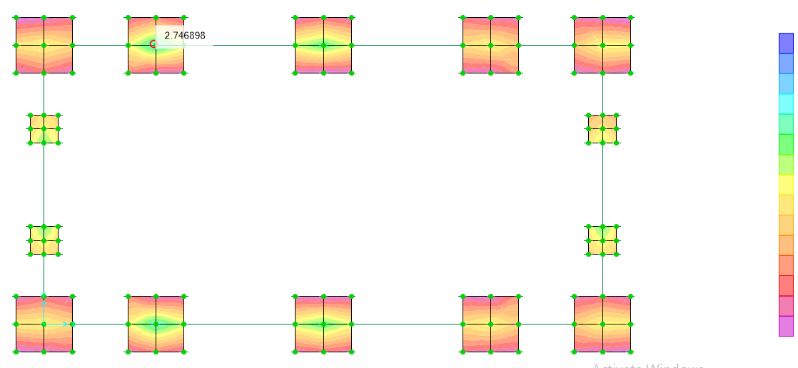

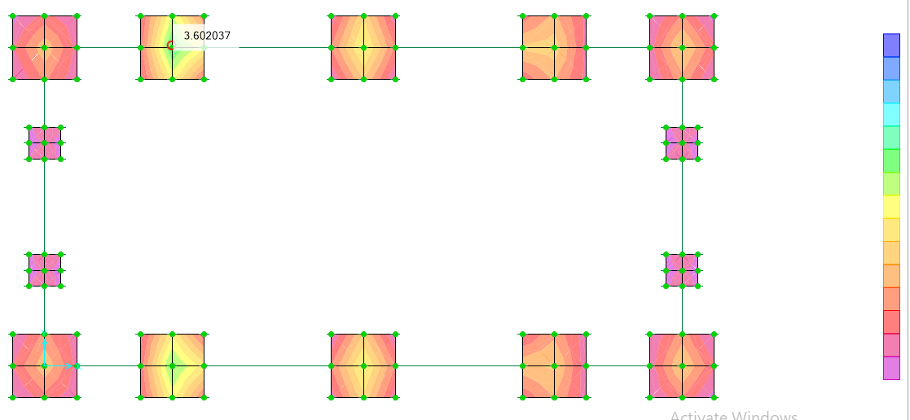

**Figure 41-M22 & M11 result**

According to above figures max Moment is about 2.6 ton.m= 260000.0 kg-cm

$${Mu}_{1}=2600000 kg.cm$$

$$b=100 cm$$

$$f_{c}=300$$

$$f_{y}=4000$$

$$d=54cm$$

$$∅=0.9$$

$$M_{n}=\frac{M_{u}}{∅}=288888.889 kg.cm$$

$$R_{n1}=\frac{M_{n1}}{b.d^{2}}=0.991$$

$$m_{1}=\frac{f_{y}}{0.85f_{c}}=15.686$$

$$ρ_{req}=\frac{1}{m_{1}}\left(1-\sqrt{1-\frac{{2m}_{1}R_{n1}}{f_{y}}}\right)=0.000248$$

$$A_{s(req)}=ρ_{req}.b.d=1.340 used ∅16@ 200 (top \& bot)$$

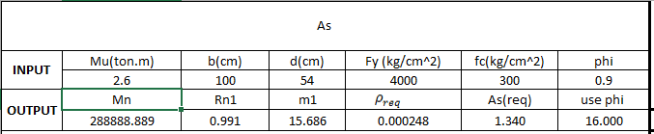

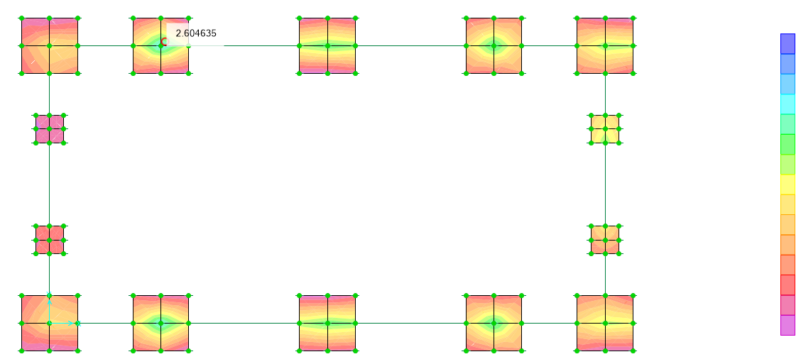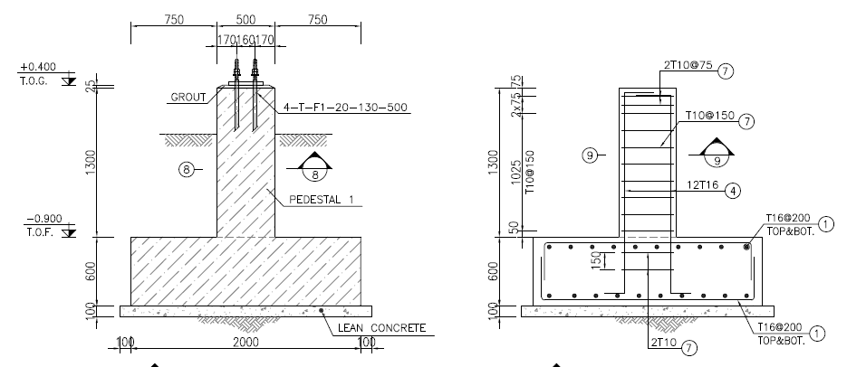

**Figure 42-Reinforcement($∅16@ 200)$**

### Pedestal Design

Pedestal details can be seen in below Figure:

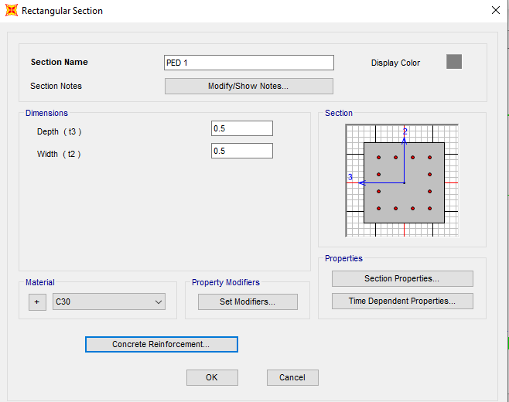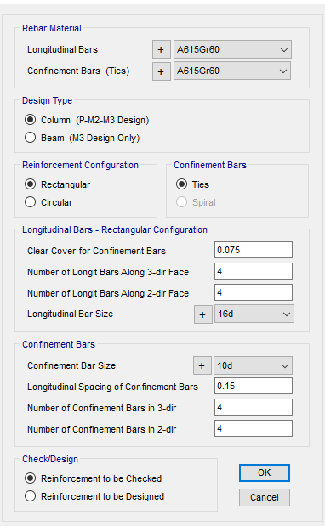

**Figure 43- Pedestal reinforcement detail (Ped1-50x50)**

Because the all pedestals have been modeled by the whole structure in the SAP file so P-Mx-My interaction of pedestal can be checked based on SAP file. As can be seen in Below Figure the P-M interaction ratio is located allowable.

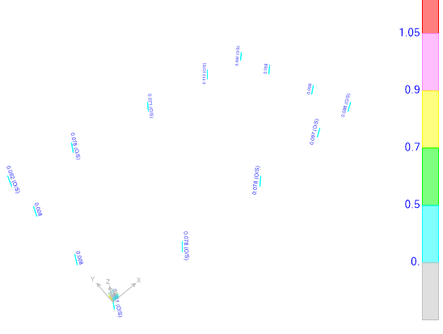

**Figure 44-** **pedestal design**

|  |  |  |  |  |  |  |  |
| --- | --- | --- | --- | --- | --- | --- | --- |
| **TABLE: Concrete Design 1 - Column Summary Data - ACI 318-11** | | | | | | | |
| **Frame** | **DesignSect** | **DesignType** | **DesignOpt** | **Status** | **Location** | **PMMRatio** |  |
| Text | Text | Text | Text | Text | m | Unitless | <1 |
| 23 | PED 1 | Column | Check | No Messages | 0 | 0.031742 | OK |
| 23 | PED 1 | Column | Check | No Messages | 0.4 | 0.046673 | OK |
| 23 | PED 1 | Column | Check | No Messages | 0.8 | 0.086026 | OK |
| 24 | PED 1 | Column | Check | No Messages | 0 | 0.025824 | OK |
| 24 | PED 1 | Column | Check | No Messages | 0.4 | 0.051279 | OK |
| 24 | PED 1 | Column | Check | No Messages | 0.8 | 0.096551 | OK |
| 46 | PED 1 | Column | Check | No Messages | 0 | 0.039772 | OK |
| 46 | PED 1 | Column | Check | No Messages | 0.4 | 0.049568 | OK |
| 46 | PED 1 | Column | Check | No Messages | 0.8 | 0.077547 | OK |
| 47 | PED 1 | Column | Check | No Messages | 0 | 0.040852 | OK |
| 47 | PED 1 | Column | Check | No Messages | 0.4 | 0.04961 | OK |
| 47 | PED 1 | Column | Check | No Messages | 0.8 | 0.077832 | OK |
| 95 | PED 1 | Column | Check | No Messages | 0 | 0.031941 | OK |
| 95 | PED 1 | Column | Check | No Messages | 0.4 | 0.048419 | OK |
| 95 | PED 1 | Column | Check | No Messages | 0.8 | 0.090562 | OK |
| 96 | PED 1 | Column | Check | No Messages | 0 | 0.032292 | OK |
| 96 | PED 1 | Column | Check | No Messages | 0.4 | 0.049982 | OK |
| 96 | PED 1 | Column | Check | No Messages | 0.8 | 0.09214 | OK |
| 97 | PED 1 | Column | Check | No Messages | 0 | 0.025824 | OK |
| 97 | PED 1 | Column | Check | No Messages | 0.4 | 0.062317 | OK |
| 97 | PED 1 | Column | Check | No Messages | 0.8 | 0.113038 | OK |
| 98 | PED 1 | Column | Check | No Messages | 0 | 0.037629 | OK |
| 98 | PED 1 | Column | Check | No Messages | 0.4 | 0.046173 | OK |
| 98 | PED 1 | Column | Check | No Messages | 0.8 | 0.071122 | OK |
| 103 | PED 1 | Column | Check | No Messages | 0 | 0.043502 | OK |
| 103 | PED 1 | Column | Check | No Messages | 0.4 | 0.051341 | OK |
| 103 | PED 1 | Column | Check | No Messages | 0.8 | 0.077832 | OK |
| 104 | PED 1 | Column | Check | No Messages | 0 | 0.03006 | OK |
| 104 | PED 1 | Column | Check | No Messages | 0.4 | 0.044182 | OK |
| 104 | PED 1 | Column | Check | No Messages | 0.8 | 0.081544 | OK |
| 124 | PED2 | Column | Check | No Messages | 0 | 0.001516 | OK |
| 124 | PED2 | Column | Check | No Messages | 0.4 | 0.003961 | OK |
| 124 | PED2 | Column | Check | No Messages | 0.8 | 0.007869 | OK |
| 126 | PED2 | Column | Check | No Messages | 0 | 0.001516 | OK |
| 126 | PED2 | Column | Check | No Messages | 0.4 | 0.003955 | OK |
| 126 | PED2 | Column | Check | No Messages | 0.8 | 0.007825 | OK |
| 128 | PED2 | Column | Check | No Messages | 0 | 0.001516 | OK |
| 128 | PED2 | Column | Check | No Messages | 0.4 | 0.003968 | OK |
| 128 | PED2 | Column | Check | No Messages | 0.8 | 0.007851 | OK |
| 130 | PED2 | Column | Check | No Messages | 0 | 0.001516 | OK |
| 130 | PED2 | Column | Check | No Messages | 0.4 | 0.00396 | OK |
| 130 | PED2 | Column | Check | No Messages | 0.8 | 0.007834 | OK |