|  |  |  |  |  |  |  |  |
| --- | --- | --- | --- | --- | --- | --- | --- |
| **طرح نگهداشت و افزایش تولید 27 مخزن** | | | | | | | |
| **CALCULATION NOTE FOR OILY WATER SUMP PIT (SU-2202)**  **نگهداشت و افزایش تولید میدان نفتی بینک** | | | | | | | |
|  | |  |  |  |  |  |  |
|  | |  |  |  |  |  |  |
| D02 | | JUL.2024 | AFD | R.Berlouie | M.Fakharian | M.Sadeghian |  |
| D01 | | MAY.2024 | IFA | R.Berlouie | M.Fakharian | S.Faramarzpour |  |
| D00 | | NOV.2023 | IFC | R.Berlouie | M.Fakharian | S.Faramarzpour |  |
| **Rev.** | | **Date** | **Purpose of Issue/Status** | **Prepared by:** | **Checked by:** | **Approved by:** | **CLIENT Approval** |
| **Class:2** | | | **COMPANY Doc. Number: F0Z-709128** | | | | |
| **Status:** | | **IDC: Inter-Discipline Check**  **IFC: Issued For Comment**  **IFA: Issued For Approval**  **AFD: Approved For Design**  **AFC: Approved For Construction**  **AFP: Approved For Purchase**  **AFQ:** Approved For Quotation  **IFI: Issued For Information**  **AB-R: As-Built for CLIENT Review**  **AB-A: As-Built –Approved** | | | | | |

**REVISION RECORD SHEET**

|  |  |  |  |  |  |  |  |  |  |  |  |  |
| --- | --- | --- | --- | --- | --- | --- | --- | --- | --- | --- | --- | --- |
| **PAGE** | **D00** | **D01** | **D02** | **D03** | **D04** |  | **PAGE** | **D00** | **D01** | **D02** | **D03** | **D04** |
| **1** | X | X | X |  |  | **66** |  |  |  |  |  |
| **2** | X | X | X |  |  | **67** |  |  |  |  |  |
| **3** | X | X |  |  |  | **68** |  |  |  |  |  |
| **4** | X | X |  |  |  | **69** |  |  |  |  |  |
| **5** | X | X |  |  |  | **70** |  |  |  |  |  |
| **6** | X | X |  |  |  | **71** |  |  |  |  |  |
| **7** | X | X |  |  |  | **72** |  |  |  |  |  |
| **8** | X | X |  |  |  | **73** |  |  |  |  |  |
| **9** | X | X |  |  |  | **74** |  |  |  |  |  |
| **10** | X | X |  |  |  | **75** |  |  |  |  |  |
| **11** | X | X | X |  |  | **76** |  |  |  |  |  |
| **12** | X | X | X |  |  | **77** |  |  |  |  |  |
| **13** | X | X |  |  |  | **78** |  |  |  |  |  |
| **14** | X | X | X |  |  | **79** |  |  |  |  |  |
| **15** | X | X |  |  |  | **80** |  |  |  |  |  |
| **16** | X | X |  |  |  | **81** |  |  |  |  |  |
| **17** | X | X |  |  |  | **82** |  |  |  |  |  |
| **18** | X | X |  |  |  | **83** |  |  |  |  |  |
| **19** | X | X |  |  |  | **84** |  |  |  |  |  |
| **20** | X | X |  |  |  | **85** |  |  |  |  |  |
| **21** | X | X |  |  |  | **86** |  |  |  |  |  |
| **22** | X | X |  |  |  | **87** |  |  |  |  |  |
| **23** | X | X |  |  |  | **88** |  |  |  |  |  |
| **24** | X | X |  |  |  | **89** |  |  |  |  |  |
| **25** |  | X |  |  |  | **90** |  |  |  |  |  |
| **26** |  | X |  |  |  | **91** |  |  |  |  |  |
| **27** |  | X |  |  |  | **92** |  |  |  |  |  |
| **28** |  | X |  |  |  | **93** |  |  |  |  |  |
| **29** |  | X |  |  |  | **94** |  |  |  |  |  |
| **30** |  | X |  |  |  | **95** |  |  |  |  |  |
| **31** |  | X |  |  |  | **96** |  |  |  |  |  |
| **32** |  | X |  |  |  | **97** |  |  |  |  |  |
| **33** |  | X |  |  |  | **98** |  |  |  |  |  |
| **34** |  | X |  |  |  | **99** |  |  |  |  |  |
| **35** |  |  |  |  |  | **100** |  |  |  |  |  |
| **36** |  |  |  |  |  | **101** |  |  |  |  |  |
| **37** |  |  |  |  |  | **102** |  |  |  |  |  |
| **38** |  |  |  |  |  | **103** |  |  |  |  |  |
| **39** |  |  |  |  |  | **104** |  |  |  |  |  |
| **40** |  |  |  |  |  | **105** |  |  |  |  |  |
| **41** |  |  |  |  |  | **106** |  |  |  |  |  |
| **42** |  |  |  |  |  | **107** |  |  |  |  |  |
| **43** |  |  |  |  |  | **108** |  |  |  |  |  |
| **44** |  |  |  |  |  | **109** |  |  |  |  |  |
| **45** |  |  |  |  |  | **110** |  |  |  |  |  |
| **46** |  |  |  |  |  | **111** |  |  |  |  |  |
| **47** |  |  |  |  |  | **112** |  |  |  |  |  |
| **48** |  |  |  |  |  | **113** |  |  |  |  |  |
| **49** |  |  |  |  |  | **114** |  |  |  |  |  |
| **50** |  |  |  |  |  | **115** |  |  |  |  |  |
| **51** |  |  |  |  |  | **116** |  |  |  |  |  |
| **52** |  |  |  |  |  | **117** |  |  |  |  |  |
| **53** |  |  |  |  |  | **118** |  |  |  |  |  |
| **54** |  |  |  |  |  | **119** |  |  |  |  |  |
| **55** |  |  |  |  |  | **120** |  |  |  |  |  |
| **56** |  |  |  |  |  | **121** |  |  |  |  |  |
| **57** |  |  |  |  |  | **122** |  |  |  |  |  |
| **58** |  |  |  |  |  | **123** |  |  |  |  |  |
| **59** |  |  |  |  |  | **124** |  |  |  |  |  |
| **60** |  |  |  |  |  | **125** |  |  |  |  |  |
| **61** |  |  |  |  |  | **126** |  |  |  |  |  |
| **62** |  |  |  |  |  | **127** |  |  |  |  |  |
| **63** |  |  |  |  |  | **128** |  |  |  |  |  |
| **64** |  |  |  |  |  | **129** |  |  |  |  |  |
| **65** |  |  |  |  |  | **130** |  |  |  |  |  |

**CONTENTS**

1.0 INTRODUCTION 4

2.0 Scope 4

3.0 CODES, SPECIFICATIONS AND REFERENCE DOCUMENTS 4

4.0 MATERIAL PROPERTIES 4

5.0 DESIGN INFORMATIOn 5

6.0 STRUCTURE 3D ANALYSIS MODEL 6

7.0 Calculation 7

8.0 fOUNDATION design load 8

9.0 P-Delta Effects 24

10.0 ANALYSIS AND DESIGN 26

11.0 Shear Control Under walls : 28

12.0 Uplift Control Under Foundation : 33

1. **INTRODUCTION**

Binak oilfield in Bushehr province is a part of the southern oilfields of Iran, is located 20 km northwest of Genaveh city.

With the aim of increasing production of oil from Binak oilfield, an EPC/EPD Project has been defined by NIOC/NISOC and awarded to Petro Iran Development Company (PEDCO). Also PEDCO (as General Contractor) has assigned the EPC-packages of the Project to "Hirgan Energy - Design and Inspection" JV.

1. **Scope**

This report covers the foundation calculation report of the “Oily water sump pit ”. The foundation modelled by “SAP v21.1.0 ” software.

1. **CODES, SPECIFICATIONS AND REFERENCE DOCUMENTS**

The following codes and specifications are adopted in this report:

1. Design and Analysis of Ground Concrete Water Reservoirs No.123
2. ACI 318M-14 “Building Code Requirements for Structural Concrete”
3. INBC Part 6 “Iranian National Building Code, Part 6 (3rd Edition)”
4. INBC Part 9 “Iranian National Building Code, Part 9 (4th Edition)”
5. Iranian Standard No. 2800 “Iranian Code of practice for Seismic Resistant Design of Buildings (Iranian Standard No. 2800, 4th Edition)”
6. Iranian seismic design code for Petroleum Facilities(3rd edition)
7. **MATERIAL PROPERTIES**

4.1.Concrete Grade

f’c = 30 MPa (Min. compressive characteristic strength at 28 days on cylinder specimen)

4.2.Reinforcing Steel

Deformed High Tensile Strength Steel Bars, Grade III in accordance with ASTM A706 (Fy=4000 kg/cm2) or ASTM A615 Grade 60 (Fy=4000 kg/cm2) and with minimum tensile strength of 6000 kg/cm2 meeting the specific requirements set forth in ACI 318 or approved equivalent.

Material properties are delivered in the following table.

table 1 -Material Properties

|  |  |
| --- | --- |
| Foundation Concrete | F'c = 30 Mpa(28- day cylindrical sample) |
| Long. reinforcement bar | Fy = 400 Mpa(AIII) |
| Trans. reinforcement bar | Fy = 400 Mpa(AIII) |
| Bolt Type | HV 8.8 |
| Electrode Type | E 70 |

1. **DESIGN INFORMATIOn**

5.1.Location of the Structure

Plan of structure is as follow:

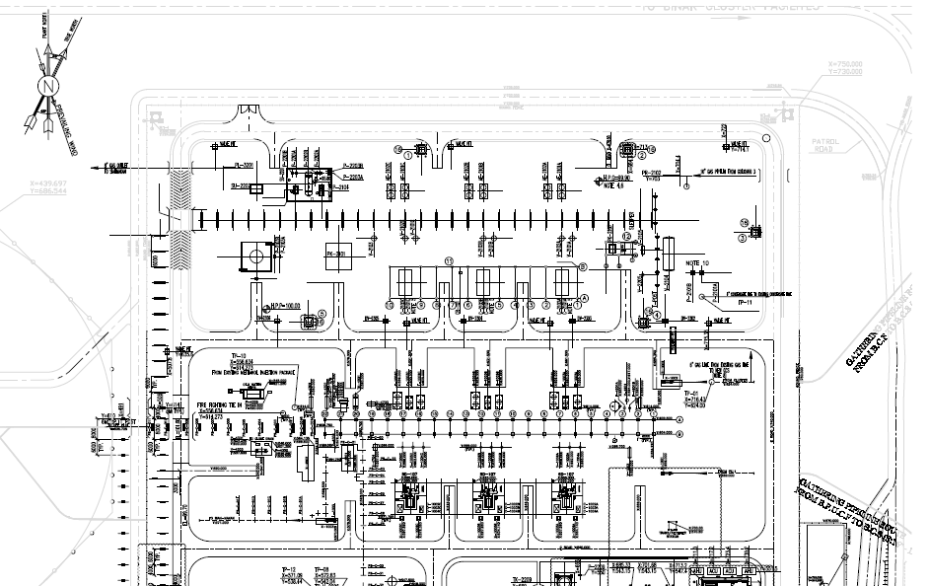

This Drawing

1. Location of Structure
2. **STRUCTURE 3D ANALYSIS MODEL**

SAP2000 have been used in order to modeling, analyses and design of this structure and its foundation.

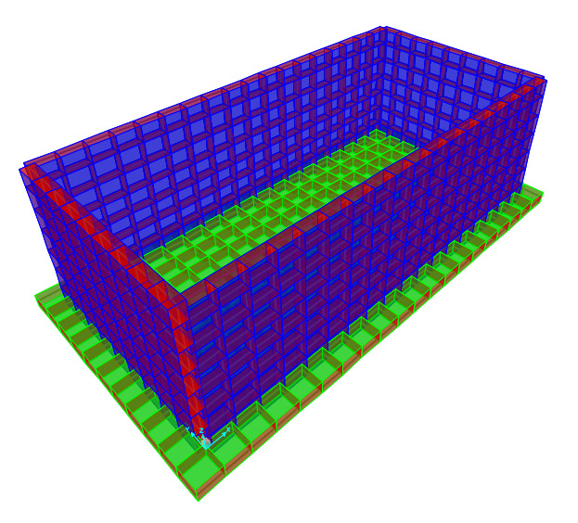

1. Structure 3D Model in SAP2000(SU-2201B)

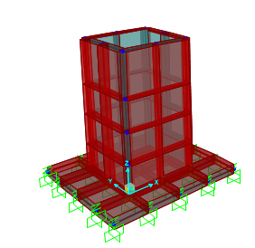

1. Structure 3D Model in SAP2000(Oily Sump Pit)
2. **Calculation**

7.1.Method of Design

structural elements have been designed in two analytical models.

Model One (Main Model): It has been designed with considering the loads.

In this case seismic load should be calculated by SAP2000 and the water load soil pressure and oil have been applied on model.

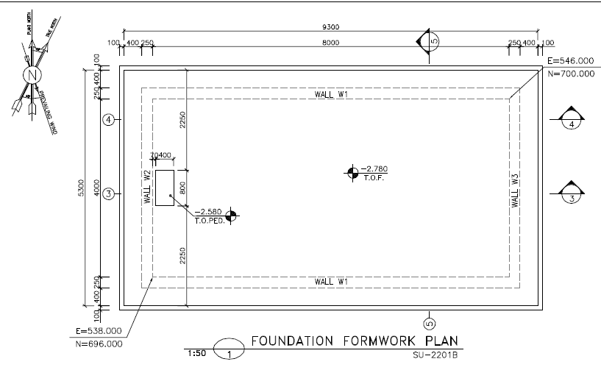

1. Foundation Formwork Plan(SU-2201B)

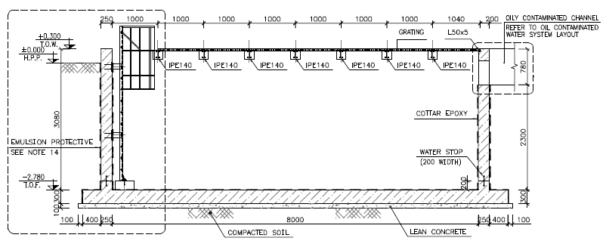

1. Elevation View(SU-2201B)

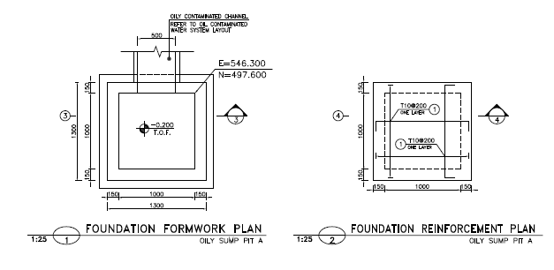

1. Foundation Formwork Plan & Elevation(Oily sump Pit)
2. **fOUNDATION design load**

8.1.Self-Weight (DL)

The self-weight of structural elements (introduced Dead Load/DL in SAP) is automatically considered by SAP program with the specific weights below:

* Reinforced Concrete : 2500 kg/m³

**8.2. Temperature load : ${28}^{°c}$**

**8.3.Live load**

For bottom distributed load about 200 $kg/m2$, has been considered for design of structure.

**8.4.Snow loads:**

For roof distributed snow loads 25 $/m2$, has been considered for design of structure.

**8.5-Seismic Load**

Seismic Loads are calculated according to standard 038.3rd that is summarized in below :

The structure doesn’t have any irregularities and its height is less than 50 m from base level.so, both static equivalent Lateral procedures could be used.

$V$ = $C_{s}$ 𝑊

Where:

$C_{s}$ = the seismic response coefficient from Equation below:

𝑊 = the effective seismic weight of the structure

This weight includes dead weight of the supporting structure and supported components, plus operational weight of the contents of the components such as tanks, vessels, pipes, etc. In addition, where the snow or ice load is more than 0.25𝑊, it shall be included in 𝑊.

$C_{s}$ = $\frac{S_{a}}{R/{I_{e}}}$

Where:

𝑆𝑎= mapped spectral response acceleration parameter (g), determined from hazard analysis.

R= the response modification factor for structure

$I_{e}$ = the importance factor for structure

Vertical seismic component

The vertical seismic load effect, 𝐸𝑣, shall be determined in accordance with the following Equation :

𝐸𝑣 = 0.2 $S_{DS}$ 𝐷

$S_{DS}$ = Design, 5% damped, spectral response acceleration parameter (g) at short periods (0.2 sec).

D = effect of dead load

Loads case name: EQZ=0.2×0.75×W=0.15×W (where W=DL loads)

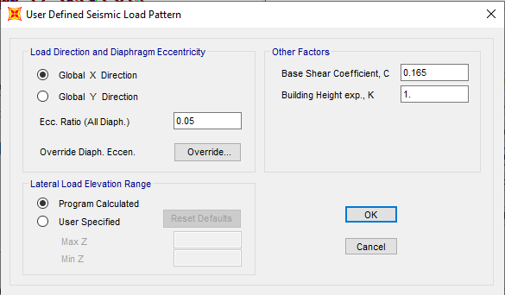

1. X Direction Seismic Load

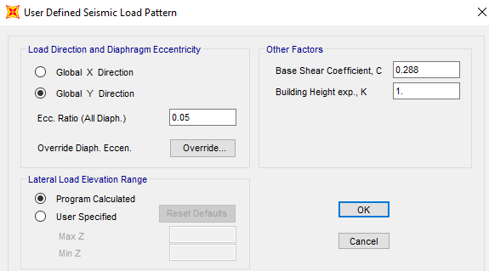

1. Y Direction Seismic Load

This Earthquake coefficient will apply in SAP2000 model to be multiplied in W (seismic weight of structure) that will compute automatically by SAP2000 software by "mass source multiplier" definition as below:

Dead and Live Load

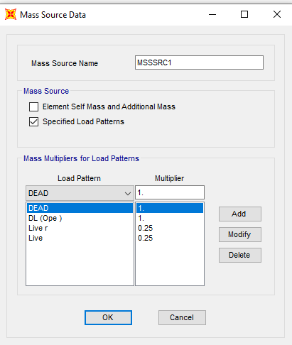

1. Mass Source

* **According to Geotechnical report :**

Soil Type :II

$I(importance factor according to table 12-1$)= $1.25$

$T=0.05 H^{\frac{3}{4}}$ = $0.05×3^{0.75}=0.114$ s

$$T0=0.1$$

$$Ts=0.5 S=1.5 S0=1$$

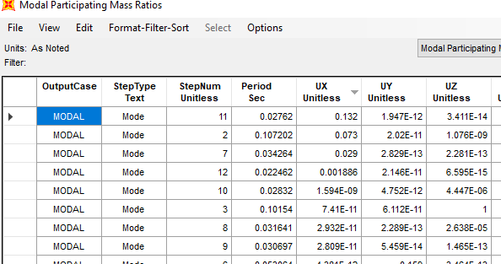

1. Period in X Direction(mode 11 ,T=0.02762)

0<T<T0 $Sax=S_{DS}(0.4+\frac{0.6T}{T0})=0.75(0.4+0.6\left(\frac{0.02762}{0.1}\right)=0.424$

$$C_{x}=\frac{SaI}{R} Cx=\frac{0.424×1.25}{2.8}=0.189$$

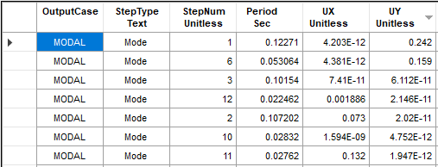

1. Period in Y Direction(mode 1 ,T=0.1227)

T0<T<Ts $Say=S_{DS}=0.75$

**D02**

$$C_{y}=\frac{SaI}{R} Cy=\frac{0.75×1.25}{2.8}=0.334$$

**8.6.Seismic Load of wall :**

**D02**

$$C_{x\&y}=\frac{SaI}{R} Cx\&y=\frac{0.75×1.25}{2.8}=0.334$$

Seismic load of each wall applied as follow on each area:

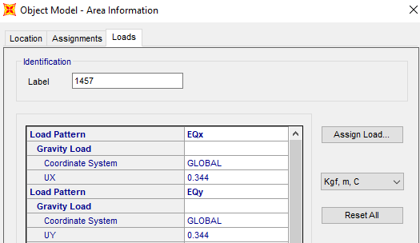

1. Applied wall seismic coefficient

8.7.Wall Design Load

Lateral soil pressure load due to buried soil is applied as follow in two directions:

**8.7**.1 **Lateral static soil pressure (Es)**

Hydrostatic pressure applied from the containing liquid and for this purpose unit weight of liquid is considered 1.0 Ton/m3.

$$γH=0.5×1.85\frac{t}{m3}×0.8=0.74\frac{ton}{m2}=740\frac{kg}{m2}$$

$$K_{0}γH=0.5×1.85\frac{t}{m3}×3.1=2.8675\frac{ton}{m2}=2867.5\frac{kg}{m2}$$

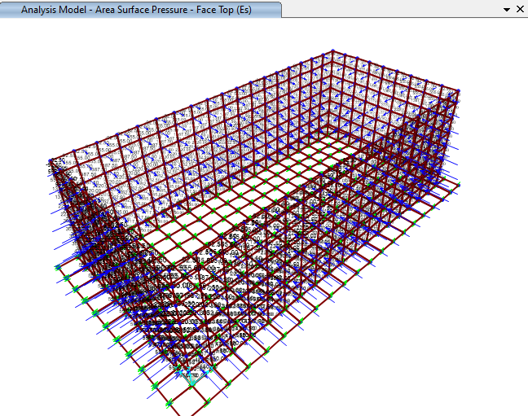

1. Applied Lateral Soil Pressure(SU-2201B)

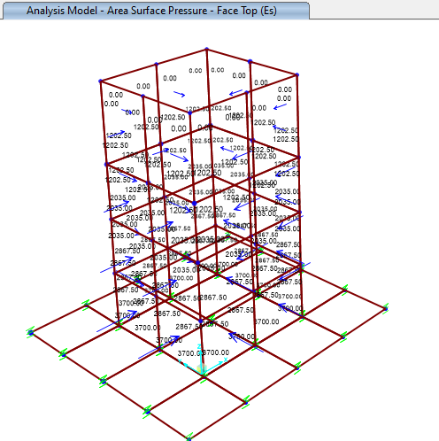

1. Applied Lateral Soil Pressure(Oily Sump Pit)

Also to calculate soil lateral thrust on structure and according to the soil investigation report, soil specific weight is assumed 1.85 T//m3 and the soil lateral pressure factor at rest is:



Lateral pressure of soil is calculated based on the below formula:



Where  denote specific weight and effective specific weight of soil, Ko soil lateral pressure factor at rest and Hs is height of soil :

So lateral soil pressure at wall toe can calculated as follows:

Htotal=3.1 m 🡪 Es= (1.85)×(0.5)×(3.1)= 28.67 Ton/m2

**8.7.2 Lateral dynamic pressure of soil (Ed+x,y*)***

For determination of seismic dynamic loads of soil, Seed & WITHMAN relation is used. Based on their theory, soil extra-dynamic pressure factor during an earthquake can be found from the following equation:

ΔKad=0.75Ai

**D02**

In which Ai is earthquake factor and is equal to:

Ai =

Having ΔKad extra dynamic surface thrust of soil can be found by the following equation:



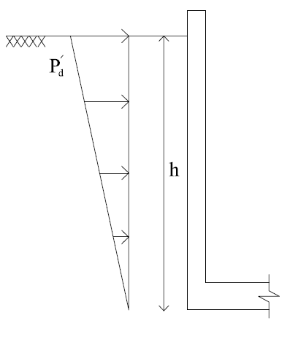Where  is specific weight of soil (1.85 Ton/m3) conservatively, ΔP’d is the extra dynamic surface thrust of soil and h is the wall height.

HS1=0 m

ΔP’d= 0 T/m2

HS2=3.1 m

ΔP’d= (0.75 $×$ 0.334)(1.85)(3.1)=1.436 T/m2

These pressures applied on the surface of the walls with triangular distribution. Maximum pressures on ground surface respectively equal to ΔP’d=1.436 Ton/m2 and at bottom of walls are zero.

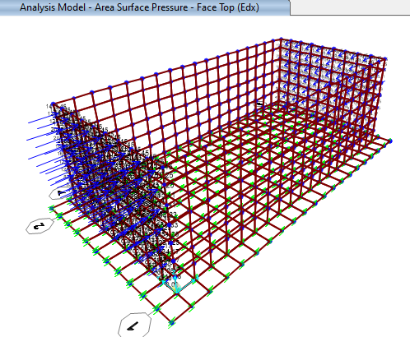

1. Applied Lateral Dynamic Pressure of soil on SU-2201B (X direction )

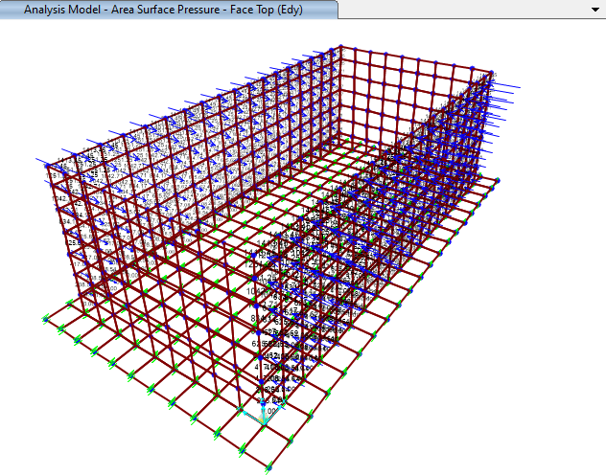

1. Applied Lateral Dynamic Pressure of soil SU-2201B (Y direction )

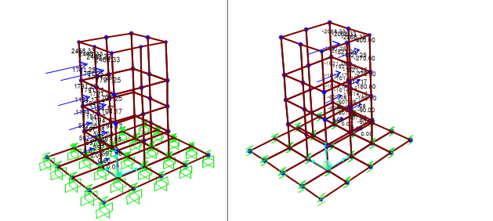

1. Applied Lateral Dynamic Pressure of soil on Oily Sump Pit (X direction )

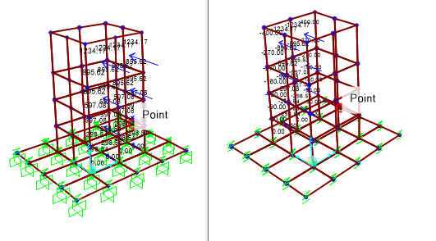

1. Applied Lateral Dynamic Pressure of soil on Oily Sump Pit (X direction )

**8.7.3. Hydrostatic pressure (Fs):**

Hydrostatic pressure applied from the containing liquid and for this purpose unit weight of liquid is considered 1.0 Ton/m3.

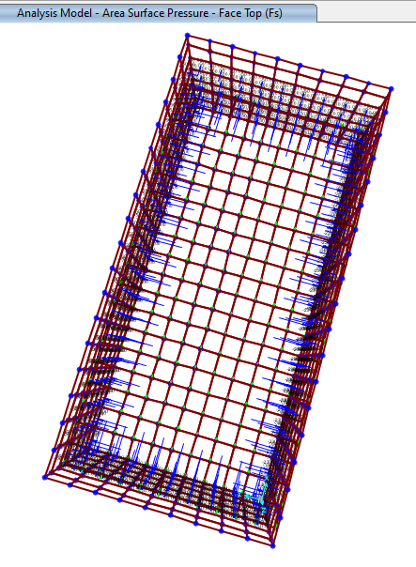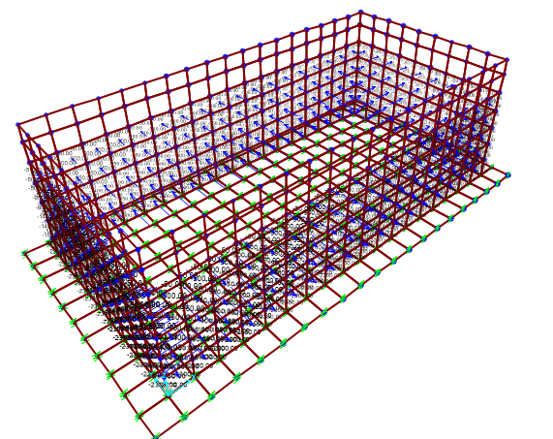

1. Applied hydrostatic pressure on walls(SU-2201B)

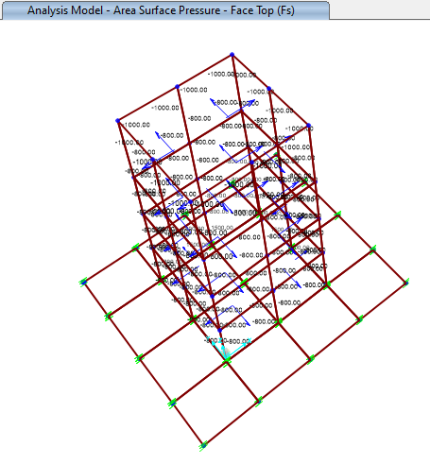

1. Applied hydrostatic pressure on walls(Oily Sump Pit)

**8.7.4. *Lateral Seismic Hydrodynamic Pressure of Fluid (Fdx,y):***

In design of liquid containing structures to resist seismic loads, the hydrodynamic mass of the contained fluid should be considered in the seismic load determination. Hydrodynamic pressures should include both impulsive and convective components. Impulsive pressures are developed by accelerations of the walls acting against the mass of the contained liquid. Convective pressures are those produced by oscillations (slashing) of the liquid within the structure. Methodology for developing hydrodynamic pressures has been developed by G.W. Housner.

Note: Runoff water happens for a limited time a year, so there is no hydrodynamic pressure of fluid applied for maximum wastewater height of the structure.

According to the shape of the structure and height of the fluid, for calculation of hydrodynamic dynamic force we have:

1. ***Calculation of hydrodynamic force on wall :***

Structural Features for SU2201-B:

L=8.5 m HL=2.3 m B=4.5m

WL= =73600kg=73.60 Ton

According to above-mentioned structural characteristics we will have:



According to the diagrams and formulas, different parameters shall be determined.

Equivalent masses of accelerating liquid of rectangular tanks:





Impulsive weight, Wi= (0.3114)×(73600) =22919.04 kg=22.919 Ton

Convective weight, Wc= (0.661)×(73600) =48649.6kg = 48.649Ton

Height to centers of gravity for rectangular tanks:

For tanks with L/HL=3.47>1.333:



For all tanks:



Height to center gravity of impulsive force , hi= (0.38)× (2.3) =0.874 m

Height to center gravity of convective force, hc= (0.53) ×(2.3) =1.219 m





$$Pi=AiWi=0.334*Wi$$

$$Pc=AcWc=0.334*Wc$$

$$P_{iy}=\frac{\frac{p_{i}}{2}[4hl-6Hi-(6Hl-12hi)\frac{L}{H_{L}}}{{H_{L}}^{2}}$$

$$P_{cy}=\frac{\frac{p_{c}}{2}[4hl-6Hi-(6Hl-12hi)\frac{L}{H_{L}}}{{H_{L}}^{2}}$$

The horizontal distribution of the dynamic pressures across the wall width B, is:

 , 

For $\frac{ L}{H_{L}}<1.33 \frac{h_{i}}{H_{L}}=0.5-0.09375L/H_{L}$

$$\frac{ L}{H_{L}}>1.3 \frac{h_{i}}{H_{L}}=0.375$$

$$\frac{h_{c}}{H_{L}}=1-\frac{\cosh\left[3.16\frac{Hl}{L}\right]-1}{3.16\frac{H_{l}}{L} sinh⁡[\frac{3.16H_{l}}{L}]}$$

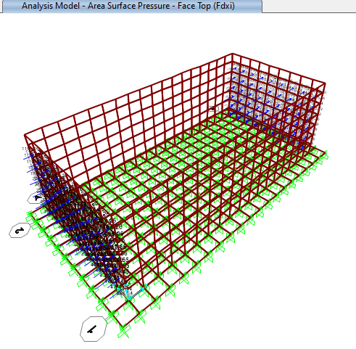

1. Applied hydrodynamic force on wall(Fdxi)

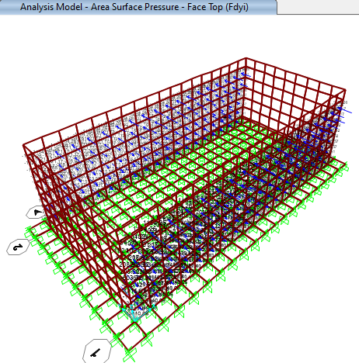

1. Applied hydrodynamic force on wall(Fdyi)

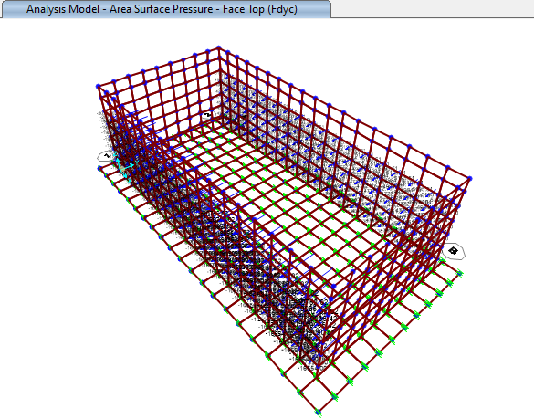

1. Applied hydrodynamic force on wall(Fdyc)

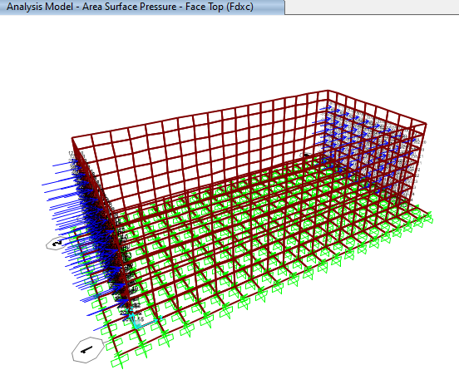

1. Applied hydrodynamic force on wall(Fdxc)

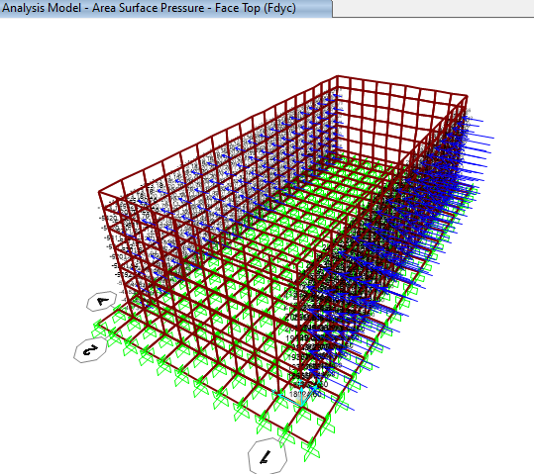

1. Applied hydrodynamic force on wall(Fdyc)

***For Oily Sump Pit:***

Structural Features:

L=1m HL=2.050m B=1 m

WL= =1*1*2*1000=2000kg=2 ton

According to above-mentioned structural characteristics we will have:



According to the diagrams and formulas, different parameters shall be determined.

Equivalent masses of accelerating liquid of rectangular tanks:







For all tanks:





Height to center gravity of impulsive force , hi= 0.675m

Height to center gravity of convective force, hc= 1.2 m



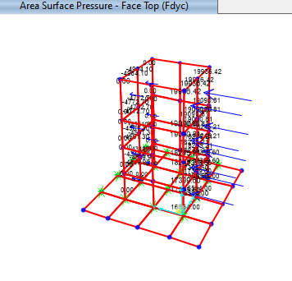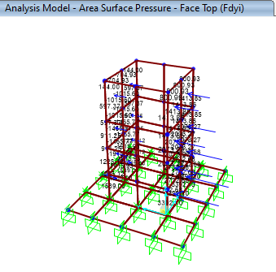

1. Applied hydrodynamic force on wall(Oily sump pit)

8.8.Bottom Design Load

Vertical oil pressure load is applied as a dead load on bottom of sump pit.

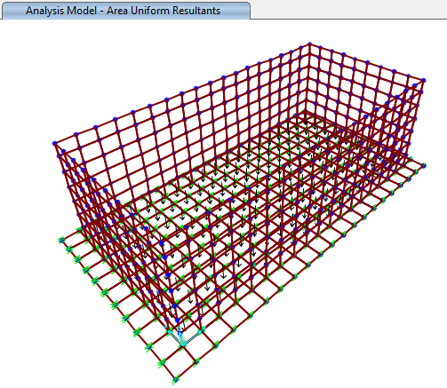

1. **applied oil weight on bottom of sump(2530kg/m2)**

**8.9.UPLIFT pressure of underground water (UP):**

According to underground water level and position of the structure, height of underground water is 0.5 m below the ground level. So an uplift pressure is applied on foundations of the structure with rectangular distribution.

In these calculations, foundations thicknesses are assumed equal to 40 cm conservatively.

Fuplift=2.3Ton/m2 (total Uplift pressure of underground water)

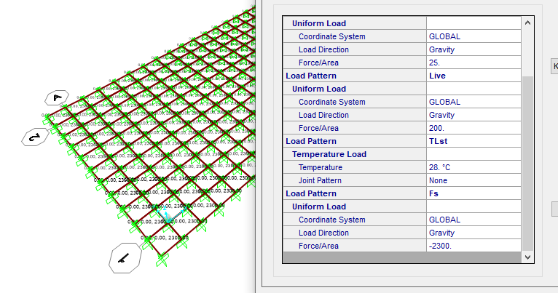

1. **applied uplift load on bottom of sump (2300kg/m2)**
2. **P-Delta Effect**

P-Delta effect on model applied as follow:

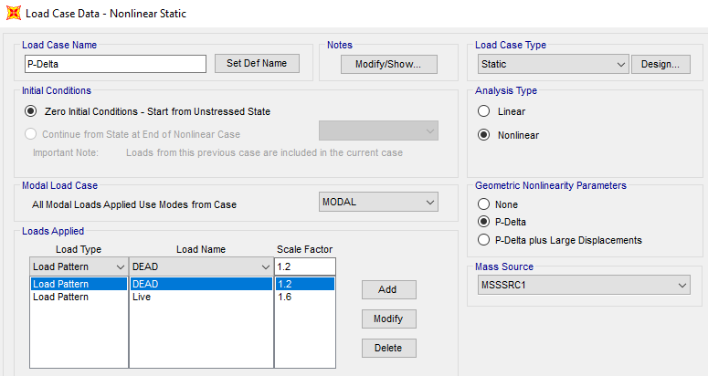

1. P-Delta
2. **LOADING COMBINATIONS**

Foundations, structures and members of structures shall be designed for the most severe loading combination given in below Table. Loads shall be combined as specified in the Table(According to Iranian Seismic Design Code for Petroleum Facilities(3 rd edition)

**10.1.Strength Design:**

$1.4D$ +1.4F+1.6H+TLst

$1.2D$ +1.6L+0.5(Lr or S)+1.2F+1.6H+TLst

$1.2D$ +1.6(Lr or S)+(L)+1.2F+1.6H+TLst

$$1.2D+L+.5\left(Lr or S\right)+1.2F+1.6H+TLst$$

$1.2D$ +E+L+0.2S+1.2F+1.6H+TLst

$0.9D+1.6H$ +TLst

$0.9D+E+0.9F+1.6H$ +TLst

**10.2.Alloawable Design:**

$$D+F+H+TLst$$

$$D+L+F+H+TLst$$

$$D+F+H+(Lr OR S)$$

$$D+F+H+0.75L+0.75(Lr or S)$$

$D+F+H$ +0.7E

$D+F+H$ +0.75(0.7E)+0.75L+0.75S

$$0.6D+H$$

$$0.6D+0.7E+0.6F+H$$

**F is Water load And H load is soil load

1. **ANALYSIS AND DESIGN**

### 11.1.foundation CONTROLS

Model analysis is done by Sap 2000 software.in model loads are applied, some graphical outputs from modeling are shown as follows.:

According to Sap 2000 results Maximum moment for foundation slab is approximately 6.017 ton.m

$$foundation thickness=40cm$$

$$A_{s_{min }}= {0.0018×100×40=7.2 \frac{cm2}{m} }^{}$$

So for foundation $∅16@150 mm$ is used.

### 11.2.wall design

**For lower part of the wall :**

$∅16 @150 mm$ is used:

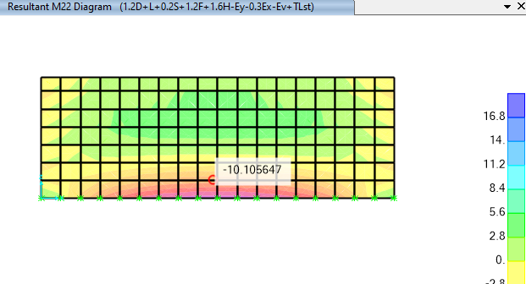

1. Resultant M22 Diagram(ton-m)

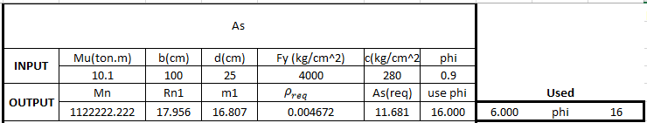

1. **M max under critical load combination on wall (M(mean)10.1 ton.m)**

### 11.3.TEMPRATURE AND SHRINKAGE REINFORCEMENT CONTROL

$$A_{s used}=∅16@150 mm=12.06\frac{cm^{2}}{m}$$

$$ρ_{used}=\frac{12.06}{25*100}=0.0048$$

$$S_{max}=\frac{K.∅}{2.ρ}=\frac{0.67×16}{2×0.0048}=1116mm=11.1cm$$

$$ε_{T}=0.5×\left(T_{1}+T_{2}\right).α=0.5×28×12×{10}^{-6}=16.8×{10}^{-5}$$

$$ω=S_{max}.ε_{t}=1116×16.8×{10}^{-5}=0.187mm$$

$$ρ_{critical}=\frac{0.82\sqrt{f'c}}{f_{y}}=\frac{0.82\sqrt{300}}{4000}=0.00355$$

$$ρ_{cal}=\frac{K.∅.ε_{T}}{2.ω}=\frac{0.67×16×16.8×{10}^{-5}}{2×0.187}=0.0048>ρ_{critical}=0.0035 ok.$$

### 10.4.DISTRIBUTION OF FLEXTURAL REINFORCEMENT

According to code 123 section 4-6-1 part 3 :

$$f_{s,max}=\frac{56000}{β\sqrt{s^{2}+4{\left(50+\frac{db}{2}\right)}^{2}}}=\frac{56000}{1.35×\sqrt{{200}^{2}+4{\left(50+\frac{25}{2}\right)}^{2}}}=175.88 N/mm2$$

$$f_{s cal}=\frac{M_{service}}{d.A_{s}}=\frac{0.20×10^5}{19×12.06}=87.28 \frac{N}{mm^{2}}$$

According to ACI-350-10.6.5 Maximum allowable reinforcement space is:

$$C_{c}=concrete cover in roof slab=7.5 cm$$

$s=min\left\{300,\frac{94600}{fs}-2.5C_{c}\right\}$ =min $\left\{300,\frac{94600}{87.28}-2.5*75\right\}=300>200$

According to code 123 section

$$z=f_{s}\sqrt[3]{d_{c}.A}=87.28\sqrt[3]{80*250*150}=12587<23500 ok$$

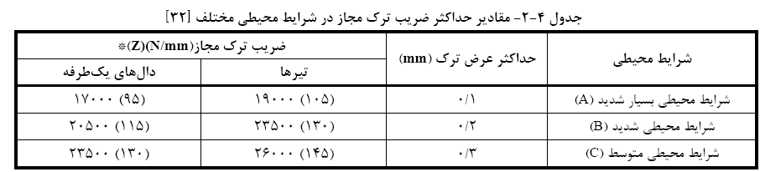

1. **-Allowable Width Crack (code 123)**
2. **Shear Control Under walls :**

$$F_{soil}=\frac{1}{2}K_{0}γh^{2}=0.5×0.5×2×1000×{2.78}^{2}=3864.2 kg/m$$

$$F_{w}=\frac{1}{2}γ_{w}h^{2}=0.5×1×1000×1×{2.3}^{2}=2645 kg/m$$

$$F_{t}=Fw+Fsoil=5290 \frac{kg}{m} in 1 m=6509kg=6.509 ton$$

$$V_{c}=0.53\sqrt{fc} bw d=0.53\sqrt{300}×100×25=22949 kg=22.949 ton \left(in 1 m \right)≫Ft ok$$

According to sap analysis result maximum shear on wall is under critical load combination is a follows

|  |  |  |  |  |  |
| --- | --- | --- | --- | --- | --- |
| **TABLE: Element Forces - Area Shells** | | | | | |
| **Area** | **AreaElem** | **OutputCase** | **CaseType** | **V13** | **V23** |
| Text | Text | Text | Text | Tonf/m | Tonf/m |
| 29 | 29 | Env-A | Combination | 13.609 | -5.626 |
| 29 | 29 | Env-A | Combination | 15.514 | -5.626 |
| 29 | 29 | Env-A | Combination | 15.514 | 2.773 |
| 29 | 29 | Env-A | Combination | 13.609 | 2.773 |
| 29 | 29 | Env-A | Combination | 7.062 | -15.572 |
| 29 | 29 | Env-A | Combination | 14.943 | -15.572 |
| 29 | 29 | Env-A | Combination | 14.943 | 0.595 |
| 29 | 29 | Env-A | Combination | 7.062 | 0.595 |
| 30 | 30 | Env-A | Combination | -8.503 | 4.464 |
| 30 | 30 | Env-A | Combination | 9.314 | 4.464 |
| 30 | 30 | Env-A | Combination | 9.314 | 4.733 |
| 30 | 30 | Env-A | Combination | -8.503 | 4.733 |
| 30 | 30 | Env-A | Combination | -10.327 | 1.931 |
| 30 | 30 | Env-A | Combination | 4.277 | 1.931 |
| 30 | 30 | Env-A | Combination | 4.277 | 0.945 |
| 30 | 30 | Env-A | Combination | -10.327 | 0.945 |
| 31 | 31 | Env-A | Combination | -7.114 | 4.989 |
| 31 | 31 | Env-A | Combination | 0.484 | 4.989 |
| 31 | 31 | Env-A | Combination | 0.484 | 1.293 |
| 31 | 31 | Env-A | Combination | -7.114 | 1.293 |
| 31 | 31 | Env-A | Combination | -7.894 | 1.907 |
| 31 | 31 | Env-A | Combination | -2.183 | 1.907 |
| 31 | 31 | Env-A | Combination | -2.183 | -3.773 |
| 31 | 31 | Env-A | Combination | -7.894 | -3.773 |
| 32 | 32 | Env-A | Combination | -3.304 | 2.52 |
| 32 | 32 | Env-A | Combination | 1.136 | 2.52 |
| 32 | 32 | Env-A | Combination | 1.136 | 2.738 |
| 32 | 32 | Env-A | Combination | -3.304 | 2.738 |
| 32 | 32 | Env-A | Combination | -4.069 | -2.215 |
| 32 | 32 | Env-A | Combination | -0.46 | -2.215 |
| 32 | 32 | Env-A | Combination | -0.46 | -3.561 |
| 32 | 32 | Env-A | Combination | -4.069 | -3.561 |
| 33 | 33 | Env-A | Combination | -2.09 | 3.612 |
| 33 | 33 | Env-A | Combination | 0.928 | 3.612 |
| 33 | 33 | Env-A | Combination | 0.928 | 2.609 |
| 33 | 33 | Env-A | Combination | -2.09 | 2.609 |
| 33 | 33 | Env-A | Combination | -2.589 | -2.612 |
| 33 | 33 | Env-A | Combination | 0.339 | -2.612 |
| 33 | 33 | Env-A | Combination | 0.339 | -3.591 |
| 33 | 33 | Env-A | Combination | -2.589 | -3.591 |
| 34 | 34 | Env-A | Combination | -0.849 | 3.162 |
| 34 | 34 | Env-A | Combination | 0.892 | 3.162 |
| 34 | 34 | Env-A | Combination | 0.892 | 3.266 |
| 34 | 34 | Env-A | Combination | -0.849 | 3.266 |
| 34 | 34 | Env-A | Combination | -1.428 | -3.058 |
| 34 | 34 | Env-A | Combination | 0.612 | -3.058 |
| 34 | 34 | Env-A | Combination | 0.612 | -3.105 |
| 34 | 34 | Env-A | Combination | -1.428 | -3.105 |
| 35 | 35 | Env-A | Combination | -0.416 | 3.569 |
| 35 | 35 | Env-A | Combination | 0.642 | 3.569 |
| 35 | 35 | Env-A | Combination | 0.642 | 3.144 |
| 35 | 35 | Env-A | Combination | -0.416 | 3.144 |
| 35 | 35 | Env-A | Combination | -0.967 | -2.845 |
| 35 | 35 | Env-A | Combination | 0.258 | -2.845 |
| 35 | 35 | Env-A | Combination | 0.258 | -3.003 |
| 35 | 35 | Env-A | Combination | -0.967 | -3.003 |
| 36 | 36 | Env-A | Combination | 0.041 | 3.32 |
| 36 | 36 | Env-A | Combination | 0.491 | 3.32 |
| 36 | 36 | Env-A | Combination | 0.491 | 3.399 |
| 36 | 36 | Env-A | Combination | 0.041 | 3.399 |
| 36 | 36 | Env-A | Combination | -0.591 | -2.859 |
| 36 | 36 | Env-A | Combination | 0.119 | -2.859 |
| 36 | 36 | Env-A | Combination | 0.119 | -2.779 |
| 36 | 36 | Env-A | Combination | -0.591 | -2.779 |
| 37 | 37 | Env-A | Combination | 0.205 | 3.454 |
| 37 | 37 | Env-A | Combination | 0.259 | 3.454 |
| 37 | 37 | Env-A | Combination | 0.259 | 3.28 |
| 37 | 37 | Env-A | Combination | 0.205 | 3.28 |
| 37 | 37 | Env-A | Combination | -0.443 | -2.71 |
| 37 | 37 | Env-A | Combination | -0.136 | -2.71 |
| 37 | 37 | Env-A | Combination | -0.136 | -2.785 |
| 37 | 37 | Env-A | Combination | -0.443 | -2.785 |
| 38 | 38 | Env-A | Combination | 0.469 | 3.25 |
| 38 | 38 | Env-A | Combination | 0.134 | 3.25 |
| 38 | 38 | Env-A | Combination | 0.134 | 3.453 |
| 38 | 38 | Env-A | Combination | 0.469 | 3.453 |
| 38 | 38 | Env-A | Combination | -0.23 | -2.755 |
| 38 | 38 | Env-A | Combination | -0.257 | -2.755 |
| 38 | 38 | Env-A | Combination | -0.257 | -2.709 |
| 38 | 38 | Env-A | Combination | -0.23 | -2.709 |
| 39 | 39 | Env-A | Combination | 0.643 | 3.338 |
| 39 | 39 | Env-A | Combination | -0.099 | 3.338 |
| 39 | 39 | Env-A | Combination | -0.099 | 3.29 |
| 39 | 39 | Env-A | Combination | 0.643 | 3.29 |
| 39 | 39 | Env-A | Combination | -0.093 | -2.718 |
| 39 | 39 | Env-A | Combination | -0.511 | -2.718 |
| 39 | 39 | Env-A | Combination | -0.511 | -2.828 |
| 39 | 39 | Env-A | Combination | -0.093 | -2.828 |
| 40 | 40 | Env-A | Combination | 1.07 | 3.056 |
| 40 | 40 | Env-A | Combination | -0.222 | 3.056 |
| 40 | 40 | Env-A | Combination | -0.222 | 3.495 |
| 40 | 40 | Env-A | Combination | 1.07 | 3.495 |
| 40 | 40 | Env-A | Combination | 0.313 | -2.915 |
| 40 | 40 | Env-A | Combination | -0.678 | -2.915 |
| 40 | 40 | Env-A | Combination | -0.678 | -2.77 |
| 40 | 40 | Env-A | Combination | 0.313 | -2.77 |
| 41 | 41 | Env-A | Combination | 1.526 | 3.135 |
| 41 | 41 | Env-A | Combination | -0.492 | 3.135 |
| 41 | 41 | Env-A | Combination | -0.492 | 3.055 |
| 41 | 41 | Env-A | Combination | 1.526 | 3.055 |
| 41 | 41 | Env-A | Combination | 0.751 | -2.975 |
| 41 | 41 | Env-A | Combination | -1.012 | -2.975 |
| 41 | 41 | Env-A | Combination | -1.012 | -2.952 |
| 41 | 41 | Env-A | Combination | 0.751 | -2.952 |
| 42 | 42 | Env-A | Combination | 2.726 | 2.451 |
| 42 | 42 | Env-A | Combination | -0.222 | 2.451 |
| 42 | 42 | Env-A | Combination | -0.222 | 3.438 |
| 42 | 42 | Env-A | Combination | 2.726 | 3.438 |
| 42 | 42 | Env-A | Combination | 1.952 | -3.433 |
| 42 | 42 | Env-A | Combination | -1.044 | -3.433 |
| 42 | 42 | Env-A | Combination | -1.044 | -2.438 |
| 42 | 42 | Env-A | Combination | 1.952 | -2.438 |
| 43 | 43 | Env-A | Combination | 4.095 | 2.51 |
| 43 | 43 | Env-A | Combination | 0.531 | 2.51 |
| 43 | 43 | Env-A | Combination | 0.531 | 2.329 |
| 43 | 43 | Env-A | Combination | 4.095 | 2.329 |
| 43 | 43 | Env-A | Combination | 3.277 | -3.332 |
| 43 | 43 | Env-A | Combination | -1.207 | -3.332 |
| 43 | 43 | Env-A | Combination | -1.207 | -2.025 |
| 43 | 43 | Env-A | Combination | 3.277 | -2.025 |
| 44 | 44 | Env-A | Combination | 7.972 | 1.042 |
| 44 | 44 | Env-A | Combination | 2.148 | 1.042 |
| 44 | 44 | Env-A | Combination | 2.148 | 4.722 |
| 44 | 44 | Env-A | Combination | 7.972 | 4.722 |
| 44 | 44 | Env-A | Combination | 7.036 | -3.522 |
| 44 | 44 | Env-A | Combination | -0.448 | -3.522 |
| 44 | 44 | Env-A | Combination | -0.448 | 2.175 |
| 44 | 44 | Env-A | Combination | 7.036 | 2.175 |
| 45 | 45 | Env-A | Combination | 10.454 | 4.413 |
| 45 | 45 | Env-A | Combination | -4.468 | 4.413 |
| 45 | 45 | Env-A | Combination | -4.468 | 4.142 |
| 45 | 45 | Env-A | Combination | 10.454 | 4.142 |
| 45 | 45 | Env-A | Combination | 8.375 | 1.266 |
| 45 | 45 | Env-A | Combination | -9.122 | 1.266 |
| 45 | 45 | Env-A | Combination | -9.122 | 2.027 |
| 45 | 45 | Env-A | Combination | 8.375 | 2.027 |
| 46 | 46 | Env-A | Combination | -6.885 | 2.65 |
| 46 | 46 | Env-A | Combination | -14.742 | 2.65 |
| 46 | 46 | Env-A | Combination | -14.742 | -5.275 |
| 46 | 46 | Env-A | Combination | -6.885 | -5.275 |
| 46 | 46 | Env-A | Combination | -13.78 | 0.632 |
| 46 | 46 | Env-A | Combination | -15.689 | 0.632 |
| 46 | 46 | Env-A | Combination | -15.689 | -15.918 |
| 46 | 46 | Env-A | Combination | -13.78 | -15.918 |
| 47 | 47 | Env-A | Combination | -13.944 | 0.085 |
| 47 | 47 | Env-A | Combination | 1.721 | 0.085 |
| 47 | 47 | Env-A | Combination | 1.721 | -13.312 |
| 47 | 47 | Env-A | Combination | -13.944 | -13.312 |
| 47 | 47 | Env-A | Combination | -16.788 | -2.711 |
| 47 | 47 | Env-A | Combination | -7.244 | -2.711 |
| 47 | 47 | Env-A | Combination | -7.244 | -19.484 |
| 47 | 47 | Env-A | Combination | -16.788 | -19.484 |
| 58 | 58 | Env-A | Combination | 17.35 | -13.227 |
| 58 | 58 | Env-A | Combination | 7.172 | -13.227 |
| 58 | 58 | Env-A | Combination | 7.172 | 0.398 |
| 58 | 58 | Env-A | Combination | 17.35 | 0.398 |
| 58 | 58 | Env-A | Combination | 12.757 | -19.57 |
| 58 | 58 | Env-A | Combination | -1.652 | -19.57 |
| 58 | 58 | Env-A | Combination | -1.652 | -3.029 |
| 58 | 58 | Env-A | Combination | 12.757 | -3.029 |
|  |  |  | Max | 17.35 |  |
|  |  |  | Min | -16.788 |  |

V max <22.949 ton ok .

Maximum shear load is less than shear capacity of wall that is acceptable.

1. **Uplift Control Under Foundation :**

$$U_{water}=γh=2.3×1000=2300\frac{kg}{m2}$$

$$U_{water}=2300×8×4=73600 kg=73.600 ton$$

Weight of walls = $\left(8.3+4.3\right)×2×0.3×2.5=18.9 ton$

Weight of Soil on Foundation=(9+5) $×$ 2 $×$ 0.4 $×$ 2.78 $×$ 1.9 $=59.19ton$

Weight of Foundation= $2.50×\left(9.4×5.40\right)×0.3=50.76 ton$

$$SF=\frac{18.90+59.19+50.76}{73.600}=1.75>1.25 ok$$