|  |  |  |  |  |  |  |  |
| --- | --- | --- | --- | --- | --- | --- | --- |
| **طرح نگهداشت و افزایش تولید 27 مخزن** | | | | | | | |
| **CALCULATION NOTE FOR HELI PAD, WELL PAD &**  **DIESEL STORAGE PAD - W028**  **نگهداشت و افزایش تولید میدان نفتی بینک** | | | | | | | |
|  | |  |  |  |  |  |  |
|  | |  |  |  |  |  |  |
| D02 | | AUG. 2024 | AFC | R.Berlouie | M.Fakharian | M.Sadeghian |  |
| D01 | | FEB. 2023 | IFC | R.Berlouie | M.Fakharian | M.Mehrshad |  |
| D00 | | DEC. 2021 | IFC | R.Berlouie | M.Fakharian | M.Mehrshad |  |
| **Rev.** | | **Date** | **Purpose of Issue/Status** | **Prepared by:** | **Checked by:** | **Approved by:** | **CLIENT Approval** |
| **Class:1** | | | **COMPANY Doc. Number:** **F0Z-707550** | | | | |
| **Status:** | | **IDC: Inter-Discipline Check**  **IFC: Issued For Comment**  **IFA: Issued For Approval**  **AFD: Approved For Design**  **AFC: Approved For Construction**  **AFP: Approved For Purchase**  **AFQ:** Approved For Quotation  **IFI: Issued For Information**  **AB-R: As-Built for CLIENT Review**  **AB-A: As-Built –Approved** | | | | | |

|  |  |  |  |  |  |  |  |  |  |  |  |  |
| --- | --- | --- | --- | --- | --- | --- | --- | --- | --- | --- | --- | --- |
| **PAGE** | **D00** | **D01** | **D02** | **D03** | **D04** |  | **PAGE** | **D00** | **D01** | **D02** | **D03** | **D04** |
| **1** | X | X | X |  |  | **66** |  |  |  |  |  |
| **2** | X | X | X |  |  | **67** |  |  |  |  |  |
| **3** | X |  |  |  |  | **68** |  |  |  |  |  |
| **4** | X |  |  |  |  | **69** |  |  |  |  |  |
| **5** | X |  |  |  |  | **70** |  |  |  |  |  |
| **6** | X |  | X |  |  | **71** |  |  |  |  |  |
| **7** | X |  |  |  |  | **72** |  |  |  |  |  |
| **8** | X |  |  |  |  | **73** |  |  |  |  |  |
| **9** | X |  |  |  |  | **74** |  |  |  |  |  |
| **10** | X |  | X |  |  | **75** |  |  |  |  |  |
| **11** | X |  | X |  |  | **76** |  |  |  |  |  |
| **12** | X |  | X |  |  | **77** |  |  |  |  |  |
| **13** | X |  |  |  |  | **78** |  |  |  |  |  |
| **14** | X |  |  |  |  | **79** |  |  |  |  |  |
| **15** | X |  |  |  |  | **80** |  |  |  |  |  |
| **16** | X |  |  |  |  | **81** |  |  |  |  |  |
| **17** | X |  |  |  |  | **82** |  |  |  |  |  |
| **18** | X |  |  |  |  | **83** |  |  |  |  |  |
| **19** | X |  |  |  |  | **84** |  |  |  |  |  |
| **20** | X |  |  |  |  | **85** |  |  |  |  |  |
| **21** | X |  |  |  |  | **86** |  |  |  |  |  |
| **22** | X |  |  |  |  | **87** |  |  |  |  |  |
| **23** | X |  |  |  |  | **88** |  |  |  |  |  |
| **24** | X |  |  |  |  | **89** |  |  |  |  |  |
| **25** | X |  |  |  |  | **90** |  |  |  |  |  |
| **26** | X |  |  |  |  | **91** |  |  |  |  |  |
| **27** | X |  |  |  |  | **92** |  |  |  |  |  |
| **28** | X |  |  |  |  | **93** |  |  |  |  |  |
| **29** | X |  | X |  |  | **94** |  |  |  |  |  |
| **30** | X |  |  |  |  | **95** |  |  |  |  |  |
| **31** | X |  |  |  |  | **96** |  |  |  |  |  |
| **32** | X |  |  |  |  | **97** |  |  |  |  |  |
| **33** | X |  |  |  |  | **98** |  |  |  |  |  |
| **34** | X |  | X |  |  | **99** |  |  |  |  |  |
| **35** | X |  |  |  |  | **100** |  |  |  |  |  |
| **36** | X |  |  |  |  | **101** |  |  |  |  |  |
| **37** | X |  |  |  |  | **102** |  |  |  |  |  |
| **38** | X |  |  |  |  | **103** |  |  |  |  |  |
| **39** | X |  |  |  |  | **104** |  |  |  |  |  |
| **40** |  |  |  |  |  | **105** |  |  |  |  |  |
| **41** |  |  |  |  |  | **106** |  |  |  |  |  |
| **42** |  |  |  |  |  | **107** |  |  |  |  |  |
| **43** |  |  |  |  |  | **108** |  |  |  |  |  |
| **44** |  |  |  |  |  | **109** |  |  |  |  |  |
| **45** |  |  |  |  |  | **110** |  |  |  |  |  |
| **46** |  |  |  |  |  | **111** |  |  |  |  |  |
| **47** |  |  |  |  |  | **112** |  |  |  |  |  |
| **48** |  |  |  |  |  | **113** |  |  |  |  |  |
| **49** |  |  |  |  |  | **114** |  |  |  |  |  |
| **50** |  |  |  |  |  | **115** |  |  |  |  |  |
| **51** |  |  |  |  |  | **116** |  |  |  |  |  |
| **52** |  |  |  |  |  | **117** |  |  |  |  |  |
| **53** |  |  |  |  |  | **118** |  |  |  |  |  |
| **54** |  |  |  |  |  | **119** |  |  |  |  |  |
| **55** |  |  |  |  |  | **120** |  |  |  |  |  |
| **56** |  |  |  |  |  | **121** |  |  |  |  |  |
| **57** |  |  |  |  |  | **122** |  |  |  |  |  |
| **58** |  |  |  |  |  | **123** |  |  |  |  |  |
| **59** |  |  |  |  |  | **124** |  |  |  |  |  |
| **60** |  |  |  |  |  | **125** |  |  |  |  |  |
| **61** |  |  |  |  |  | **126** |  |  |  |  |  |
| **62** |  |  |  |  |  | **127** |  |  |  |  |  |
| **63** |  |  |  |  |  | **128** |  |  |  |  |  |
| **64** |  |  |  |  |  | **129** |  |  |  |  |  |
| **65** |  |  |  |  |  | **130** |  |  |  |  |  |

**CONTENTS**

1 INTRODUCTION 5

2 scope 5

3 NORMATIVE REFERENCES 5

**3.1** **Local** **Codes and Standards** 5

**3.2** **International Codes and Standards** 5

**3.3** **The Project Documents** 5

4 MATERIAL PROPERTIES 5

5 computer software 6

6 Soil 6

7 load combination 6

**7.1** **-Ultimate Load Combinations** 6

**7.2** **Serviceability Load Combinations** 7

8 DESIGN OF CELLAR AREA 7

**8.1** **Loads** 7

**8.1.1** **DEAD load (D)** 7

**8.1.1.1** **Self weight (dead)** 7

**8.1.1.2** **machinery load (M.load)** 8

**8.1.2** **Thermal Load** 8

**8.1.3** **Live load** 9

**8.1.4** **Snow loads** 9

**8.2** **CELLAR AREA DESIGN AND RESULTS** 10

**8.2.1** **Settlement Control** 11

9 PIT DESIGN 14

**9.1** **LOADS** 14

**9.1.1** **DEAD load (D)** 14

**9.1.2** **Thermal Load(T)** 14

**9.1.3** **Live load (L)** 15

**9.1.4** **Snow loads (S):** 15

**9.1.5** **Seismic Load (Ex&Ey)** 15

**9.1.6** **Seismic Load of Wall (Ex&Ey)** 15

**9.1.7** **Soil pressure load (H)** 17

**9.1.8** **Overhead load effect on each wall** 18

**9.1.9** **Seismic design of walls based on Mononobe-Okabe Method** 23

**9.2** **ANALYSIS AND DESIGN** 24

**9.2.1** **Bottom of Pit design :** 24

**9.2.2** **Wall of Pit design :** 25

10 Concrete slab(th=20 cm): 27

**10.1** **Loads:** 27

**10.1.1** **DEAD load (D)** 27

**10.1.2** **Thermal Load(t)** 27

**10.1.3** **Live load (L):** 27

**10.1.4** **Snow loads(S):** 27

**10.1.5** **machinery load(ML)** 28

**10.2** **Soil Pressure Control** 29

**10.3** **Settlement Control** 30

11 GAS OIL STORAGE FOUNDATION (13m x 13m x 0.3m) 32

**11.1** **Thermal Load (T)** 33

**11.2** **Live load (L)** 33

**11.3** **Settlement Control** 34

**11.4** **Soil Pressure Control** 34

12 HELIPAD FOUNDATION (8m x 8m x 0.25m) 36

**12.1** **Loads on foundation** 36

**12.1.1** **Thermal Load(T)** 36

**12.1.2** **Live load (l)** 37

**12.2** **Settlement Control** 38

**12.3** **Soil Pressure Control** 39

**12.4** **Check Additional Reinforcement** 40

13 edge beam Design 40

**13.1** **Soil Pressure Control** 42

**13.2** **Settlement Control** 42

1. **INTRODUCTION**

Binak oilfield in Bushehr province is a part of the southern oilfields of Iran, is located 20 km northwest of Genaveh city.

With the aim of increasing production of oil from Binak oilfield, an EPC/EPD Project has been defined by NIOC/NISOC and awarded to Petro Iran Development Company (PEDCO). Also PEDCO (as General Contractor) has assigned the EPC-packages of the Project to "Hirgan Energy - Design and Inspection" JV.

1. **scope**

This document covers minimum necessary requirements for the check and design of helipad, well pad & diesel Storage Pad relating to well028..

1. **NORMATIVE REFERENCES**
   1. **Local** **Codes and Standards**

* IPS-C-CE-200 Construction Standard For concrete structures”.
* IPS-E-CE-500 Engineering standard For loads”.
* Iranian Seismic design code for Petroleum facilities .pub.No.038 (3rd edition)
* Iranian National Building Code .INBC No. 9
* Iranian Code of Practice for seismic Resistant Design of Building Standard No.2800 (4th edition)
  1. **International Codes and Standards**

ACI 318-14 “Building Code Requirements for reinforced concrete “. American Concrete institute.

* 1. **The Project Documents**
* BK-GNRAL-PEDCO-000-ST-SP-0001 Specification for Concrete Work
* BK-W028-PEDCO-110-SV-PY-0002 Civil & structural Drawings-W028

1. **MATERIAL PROPERTIES**

Material properties are delivered in the following table :

**Table 1.Material Propertie**

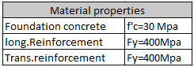

1. **computer software**

Computer software which is used in analysis & design of structure and foundation of storage tank , is defined in the following table.

**Table 2.Computer software:**

**D02**

|  |  |
| --- | --- |
| **software** | |
| computer software | sap 21.0.2 |
| safe 2016 |

1. **Soil**

soil parameters such as allowable soil bearing capacity , allowable settlement and subgrade Modulus are based on Geotechnical report according to L/b and type of foundation .

**D02**

1. **load combination**

The following combinations of loads shall be used in the design of foundations, and shall be used for displacement and soil reaction forces.(according to ASCE07-10)

* 1. **-Ultimate Load Combinations**

For the design of the structural elements the following load combinations are considered.

-1.4(D±T)+1.6H

-1.2(D±T)+ 1.6L + 0.5S +1.6H

-1.2(D±T) + 1.6S + L+1.6H

-1.2(D±T)+L+0.5S+1.6H

-1.2(D±T)+ 1.0E + L + 0.2S+1.6H

-0.9(D±T) + 1.0E+1.6H

-0.9(D±T)+W+1.6H

* 1. **Serviceability Load Combinations**

To check the deflection and displacements, structural stability and soil pressure, the following load combinations are considered.

- (D±T) + H

-(D±T)+L+ H

-(D±T)+S + H

-(D±T)+0.75L+0.75S + H

-(D±T)+0.7E + H

-0.6(D±T) + H

-0.6(D±T)+E + H

Effect of lateral soil pressure & water pressure (H) applied with coefficient of 1.6 in ultimate load combinations and coeeficient of 1.0 in service load combination .

1. **DESIGN OF CELLAR AREA**

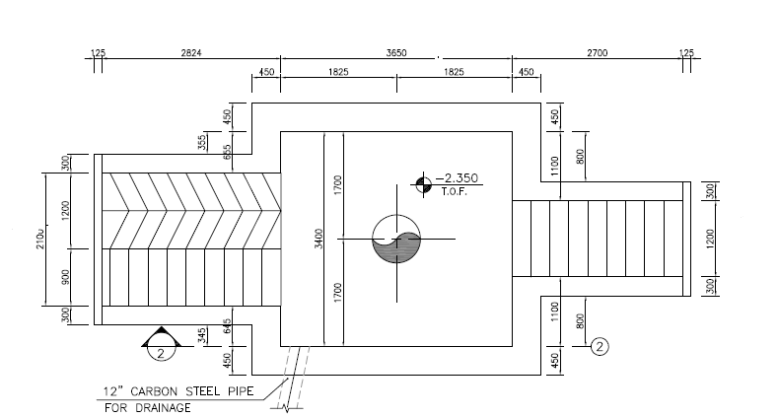

Figure 1-Cellar pit Area

* 1. **Loads**
     1. **DEAD load (D)**
        1. **Self weight (dead)**

Part 1 of Dead loads Include the self -weight of the concrete Pad .

* + - 1. **machinery load (M.load)**

Part 2 of dead load :Assumed 1000 ton load of machine on concrete pad that distributed along it on point that has been shown at bellow .due to the dynamic nature of machine load ,impact load of 1.25 applied at m load as related load case.

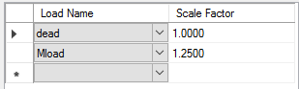

MLoad on each point

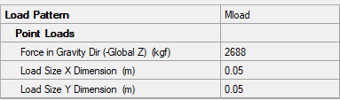

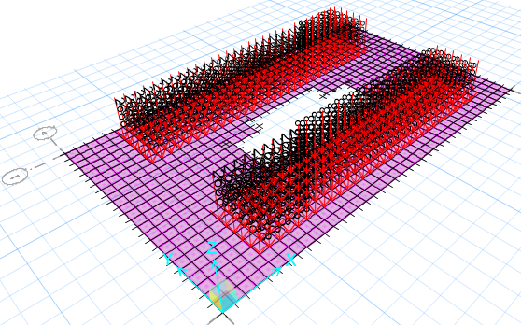

Pad Thickness=300mm

Figure 2-Applied Point Load On Soil

* + 1. **Thermal Load**

The ambient thermal load has been assumed based on the thermal variation for structure of 28 ºC.

* + 1. **Live load**

According to relevant specifications live load about 600 kg/m2 ,has been considered for design of concrete pad.

* + 1. **Snow loads**

According to Iranian National Building Code No.6 table 6-7-1 this site location is in Zone 1 : so

* 1. **CELLAR AREA DESIGN AND RESULTS**

According to geotechnical report soil parameters are as follows:

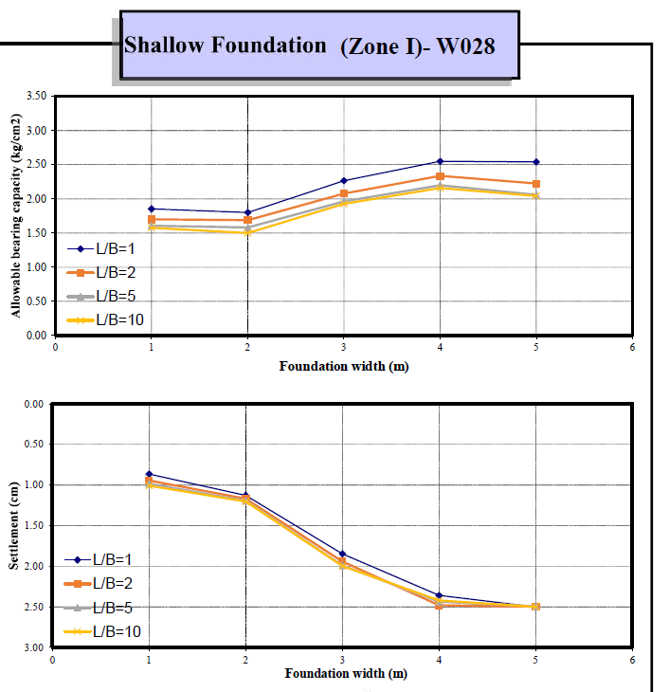

Soil parameters from geotechnical report

$$allowable bearing capacity :2.3 kg/cm2$$

$$allowable settlement :2.5 cm$$

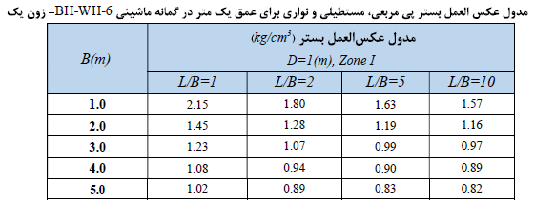

According to above table from geotechnical report .

**D02**

* + 1. **Settlement Control**

Settlement in different service load combinations should be checked by allowable settlement

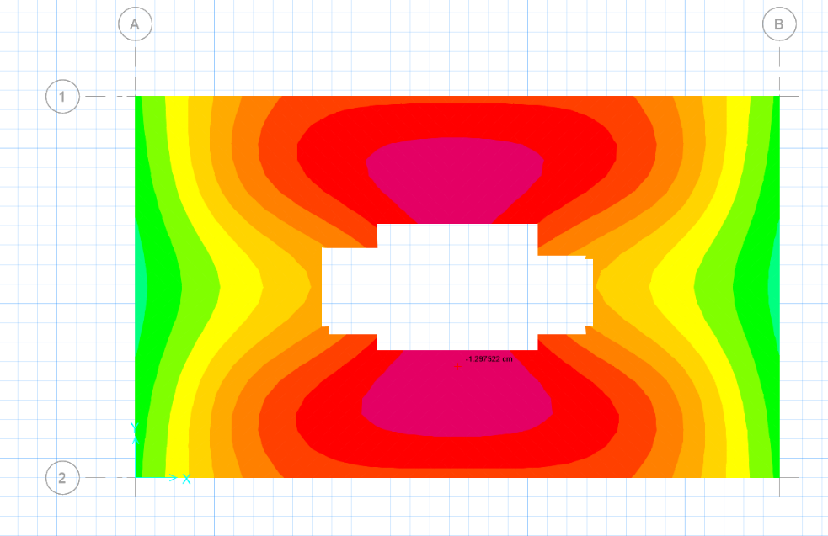

Figure 3 –Settlement Of foundation under service Load Combination(mm)

Maximum settlement of foundation (δ max) under critical load combination is equals to 12.9 mm, which is less than 25mm and that’s acceptable.

**D02**

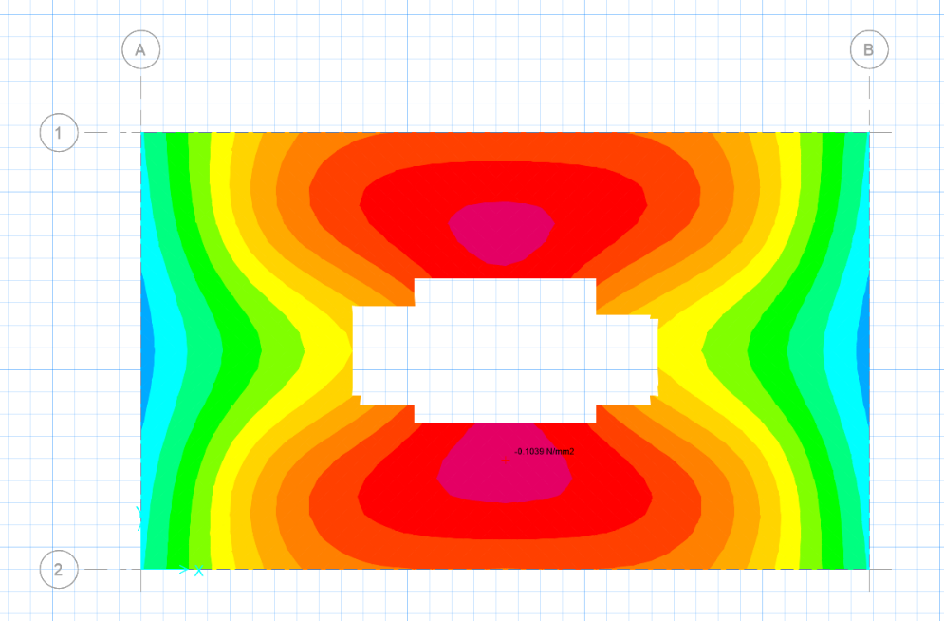

Figure 4 –Soil Pressure under service Load Combination(0.118 N/mm2)

Maximum soil pressure of foundation (q max) under critical load combination is equals to 0.1039 N/mm2, which is less qall=0.23 N/mm2 and that’s acceptable.

**D02**

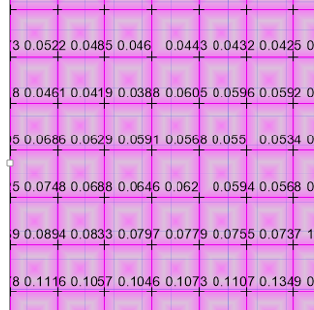

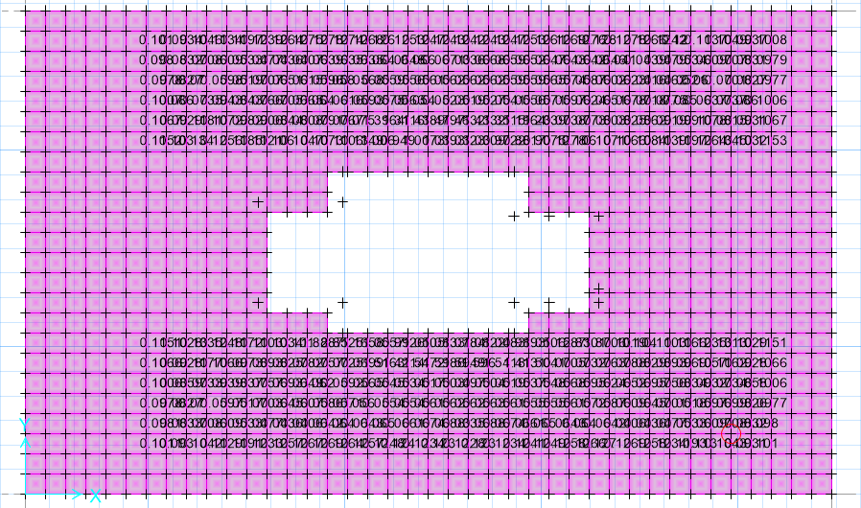

Figure 5 –Punching Shear Control

With assumed loading and with above output from safe 2016 software punching shear checked and result is less than 1 and is acceptable.

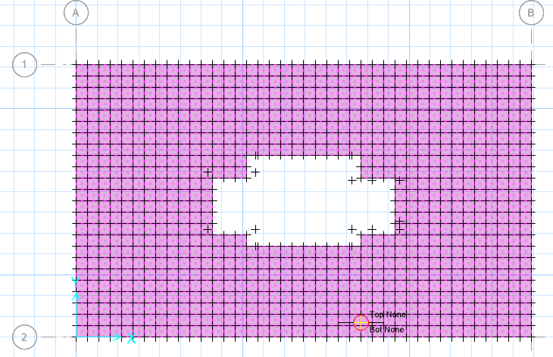

Figure 6 –Additional to Ø12@200 (top & bott) reinforcement

According to above output from safe 2016 software there is no need to additional reinforcement.

1. **PIT DESIGN**

The pit under the rig assumed buried concrete pit that effect of rig loads on this pit considered as follows .This pit has been modeled at sap software..

* 1. **LOADS**
     1. **DEAD load (D)**

Dead loads Include the self -weight of the structure

Reinforced Concrete Density : 2500 kg/m³

Soil density : 1800 kg/m³

* + 1. **Thermal Load(T)**

The ambient thermal load has been assumed based on the thermal variation for structure of 28 ºC.

* + 1. **Live load (L)**

For bottom distributed load about 500 kg/m2 ,has been considered for design of structure

* + 1. **Snow loads (S):**

According to Iranian National Building Code No.6 table 6-7-1 this site location is in Zone 1 so

Pg = 0.25 KN/m2

* + 1. **Seismic Load (Ex&Ey)**

Due to the burial pit the earthquake effects ignored.

* + 1. **Seismic Load of Wall (Ex&Ey)**

Wall gravity seismic load according to code 038. Section 7 for non -building structures applied on each wall .

$$cu=\frac{S_{a}*I}{R_{w}}$$



Wall 3

L=1.5m

Wall 5 L=2.5 m

Wall 1

L=2.5m

Wall 4 L=3.65m

Wall 2 L=3.65m

Sa=0.75

$$I=1.25$$

$$R_{w}=3.5$$

$$cu=\frac{S_{a}*I}{R_{w}}=\frac{0.75*1.25}{3.5}=0.27$$

Wall 1 : ${ E}_{wall}=0.27*2.5*1000*2.5*0.3*h=506.25h$

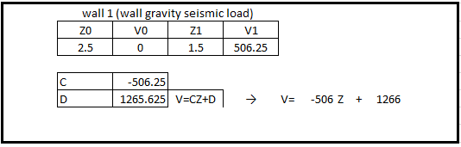

Wall 2,4 : ${ E}_{wall}=0.27*2.5*1000*3.65*0.45*h=1108.3h$

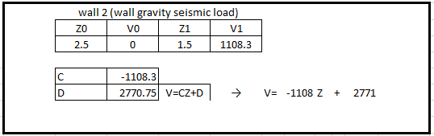

Wall 3 :

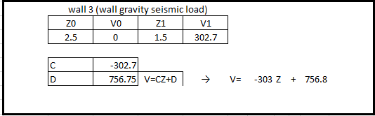

Wall 5 :

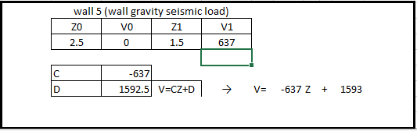

* + 1. **Soil pressure load (H)**

Soil pressure load applied at each area mesh base on joint pattern load .

Soil density =1800 kg/m³

$$φ=33$$

$$K_{0}=1-sinφ=0.455$$

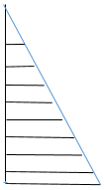

$${σ=K}_{0}γh$$

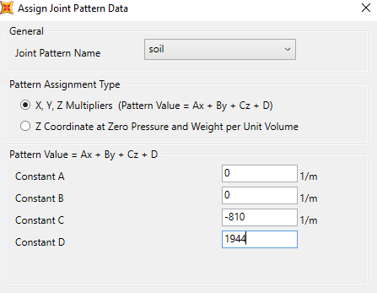

Figure 7-assign joint pattern data

According to above figure static soil pressure applied to model with this pattern values.

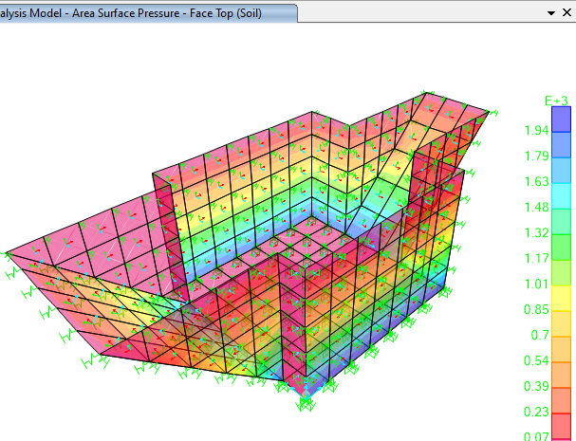

Figure 8 –Applied Soil Pressure Load

* + 1. **Overhead load effect on each wall**

For North and south wall due to each point load on 5 point we should distributed load on bottom of pit :

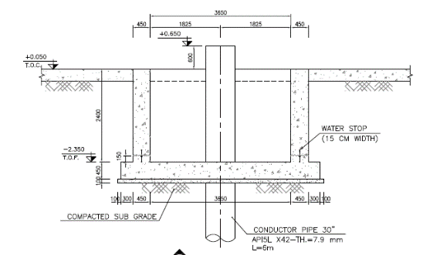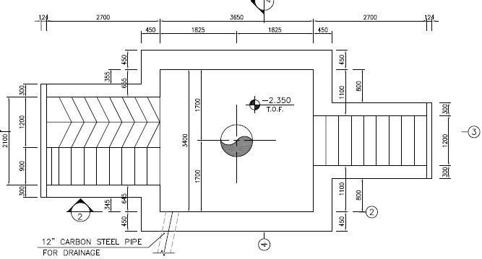

Figure 9 –Plan of Load Area

For determine the lateral pressure of soil due to different overheads on the wall according to the theory of elasticity ,horizontal pressure on the wall at depth z due to linear load q with unlimited length calculate from the following equation:

loading area is assumed about 15m x2.5m thus

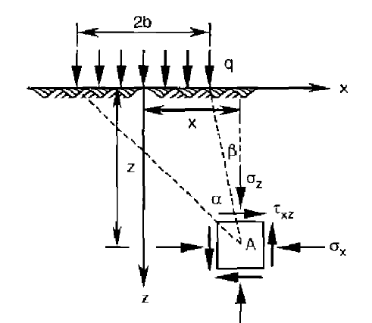

Figure 10–parameters for equation(a & b)

$$∆σ_{z}=\frac{q}{π}(α+\sin{α cos⁡(α+2β))}$$

For determine the lateral pressure of soil due to overheads on north & South wall calculation is:



Wall 5 L=2.5 m

Wall 3

L=1.5m

Wall 1

Wall 4

Wall 2

**horizontal pressure on wall 2 due to overhead load :**

|  |  |  |  |  |  |
| --- | --- | --- | --- | --- | --- |
| z= | 0 | alpha | 0 |  |  |
| beta | 90 |  |  |
| q | 13.33 | vertical pressure(t/m2) | 0 |
| pi | 3.1416 | horizontal pressure(t/m2) | 0 |
| z= | 0.5 | alpha | 35.53768 |  |  |
| beta | 45 |  |  |
| q | 13.33 | vertical pressure(t/m2) | 1.198592 |
| pi | 3.1416 | horizontal pressure(t/m2) | 0.359578 |
| z= | 1 | alpha | 45 |  |  |
| beta | 26.56505 |  |  |
| q | 13.33 | vertical pressure(t/m2) | 2.90892 |
| pi | 3.1416 | horizontal pressure(t/m2) | 0.872676 |
| z= | 1.5 | alpha | 45 |  |  |
| beta | 18.43495 |  |  |
| q | 13.33 | vertical pressure(t/m2) | 3.757747 |
| pi | 3.1416 | horizontal pressure(t/m2) | 1.127324 |
| z= | 2 | alpha | 42.27369 |  |  |
| beta | 14.03624 |  |  |
| q | 13.33 | vertical pressure(t/m2) | 4.091595 |
| pi | 3.1416 | horizontal pressure(t/m2) | 1.227479 |
| z= | 2.5 | alpha | 38.8845 |  |  |
| beta | 11.30993 |  |  |
| q | 13.33 | vertical pressure(t/m2) | 4.151432 |
| pi | 3.1416 | horizontal pressure(t/m2) | 1.24543 |

According to above data overhead load applied at model with these joint patterns.

Joint pattern definition for walls

For wall 2 0<h<1.5 V (Q1 wall 2)= -751.3Z+1878.5 h : from top of soil

For wall 2 01.5<h<2.5 V (Q1 wall 2)= -118Z+1245

**horizontal pressure on wall 1 due to overhead load :**

|  |  |  |  |  |  |
| --- | --- | --- | --- | --- | --- |
| z= | 0 | alpha | 4.09E-08 |  |  |
| beta | 9.00E+01 |  |  |
| q | 1.33E+01 | vertical pressure(t/m2) | 0 |
| pi | 3.14E+00 | horizontal pressure(t/m2) | 0 |
| z= | 0.5 | alpha | 1.84E+01 |  |  |
| beta | 6.34E+01 |  |  |
| q | 1.33E+01 | vertical pressure(t/m2) | 0.262077 |
| pi | 3.14E+00 | horizontal pressure(t/m2) | 0.078623 |
| z= | 1 | alpha | 2.91E+01 |  |  |
| beta | 4.50E+01 |  |  |
| q | 1.33E+01 | vertical pressure(t/m2) | 1.151218 |
| pi | 3.14E+00 | horizontal pressure(t/m2) | 0.345366 |
| z= | 1.5 | alpha | 3.31E+01 |  |  |
| beta | 3.37E+01 |  |  |
| q | 1.33E+01 | vertical pressure(t/m2) | 2.03053 |
| pi | 3.14E+00 | horizontal pressure(t/m2) | 0.609159 |
| z= | 2 | alpha | 3.37E+01 |  |  |
| beta | 2.66E+01 |  |  |
| q | 1.33E+01 | vertical pressure(t/m2) | 2.626149 |
| pi | 3.14E+00 | horizontal pressure(t/m2) | 0.787845 |
| z= | 2.5 | alpha | 3.27E+01 |  |  |
| beta | 2.18E+01 |  |  |
| q | 1.33E+01 | vertical pressure(t/m2) | 2.963193 |
| pi | 3.14E+00 | horizontal pressure(t/m2) | 0.888958 |

For wall 1 0<h<1.5 V (Q1 wall 1)= -406Z+1015 h : from top of soil

For wall 1 01.5<h<2.5 V (Q1 wall 1)= -279Z+888

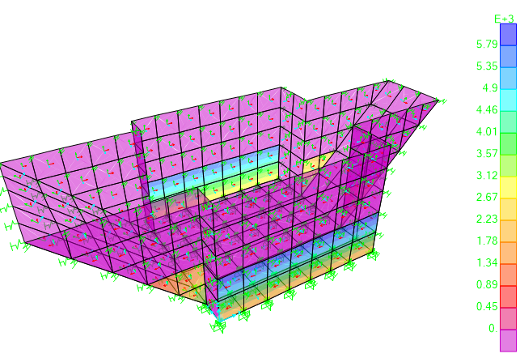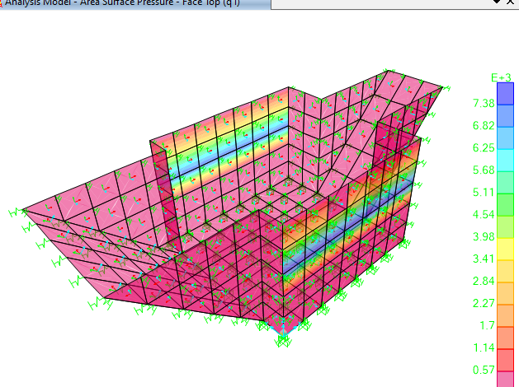

Figure 11–apply overhead load

* + 1. **Seismic design of walls based on Mononobe-Okabe Method**

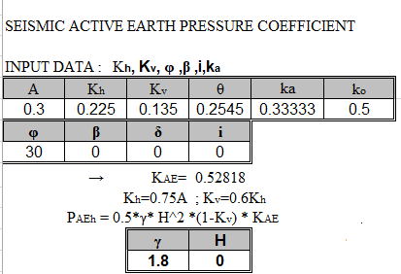

According to above calculations Pactive based on change in height is as below:

V=-1027.97Z+2569.9

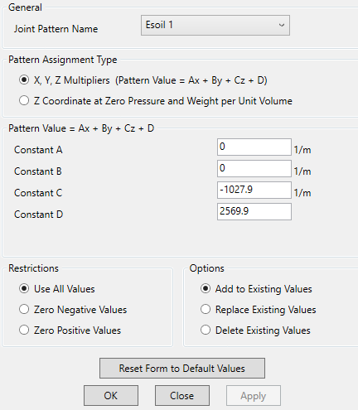

Figure 12–Apply seismic load of soil on model

* 1. **ANALYSIS AND DESIGN**

Model analysis is done by Sap 2000 software.in model loads are applied ,some graphical outputs from modeling are shown as follows.:

* + 1. **Bottom of Pit design :**

According to Sap 2000 results Maximum moment for bottom slab is : 6.84ton.m

So for bottom slab $∅12@200 mm$ is used.

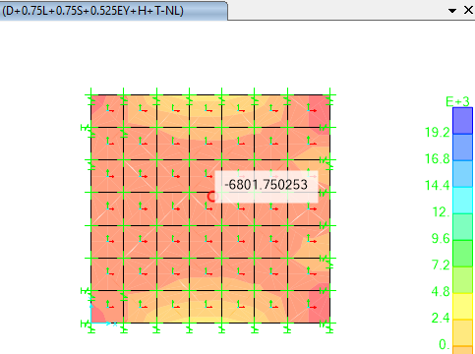

Figure 13–M22 Diagram on bottom of Pit

According to M22 diagram on bottom of pit reinforcement calculation is as follow:

$$M_{n}=\frac{M_{u}}{φ}=755555$$

$R_{n1}=\frac{M_{n1}}{{bd}^{2}}$ =5.373

ok

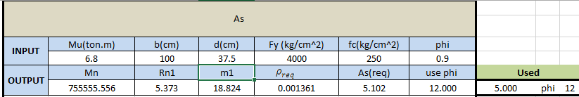

* + 1. **Wall of Pit design :**

According to Sap 2000 results Maximum moment for wall of slab is : 6.8 ton.m

So for bottom slab $∅12@200 mm$ is used.

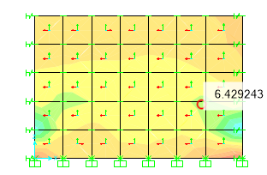

Figure14 –Wall 2 of Pit

According to M22 diagram on bottom of pit reinforcement calculation is as follow:

$M_{n}=\frac{M_{u}}{∅}$ =582222.22

$R_{n1}=\frac{M_{n1}}{{bd}^{2}}$ =4.140

$$m_{1}=\frac{f_{y}}{0.85f_{c}}=18.824$$

$$ρ_{req}=\frac{1}{m_{1}}\left(1-\sqrt{1-\frac{2m_{1}R_{n1}}{f_{y}}}\right)=0.00109$$

$$A_{s}=ρ_{req}.b.d=3.92 cm^{2}$$

$Used A_{s used}=∅12@200 mm$ ok

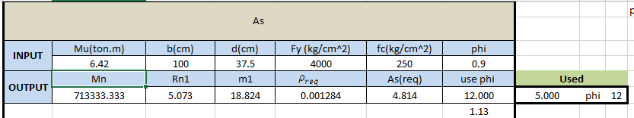

1. **Concrete slab(th=20 cm):**

One of the panel (15.9x20m)which the wellhead machine are located on, has been modeled in safe 2016 software and the software output have been shown in the following :

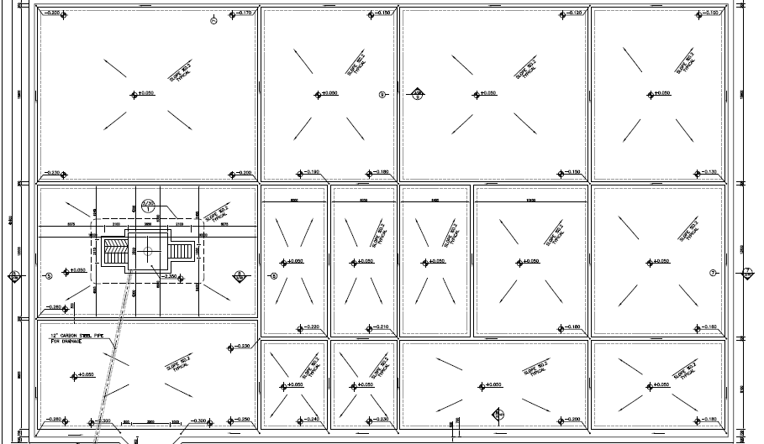

Figure 15-plan of all panels

* 1. **Loads:**
     1. **DEAD load (D)**

Overhead caused by equipment located during drilling assumed 500kg/m2.

* + 1. **Thermal Load(t)**

The ambient thermal load has been assumed based on the thermal variation for structure of 28 ºC.

* + 1. **Live load (L):**

For bottom distributed load about 200kg/m2 ,has been considered for design of structure

* + 1. **Snow loads(S):**

According to Iranian National Building Code No.6 table 6-7-1 this site location is in Zine 1 so

Pg = 0.25 KN/m2 = 25 kg/m2

* + 1. **machinery load(ML)**

Apply 45 ton of truck load with 10.1 m x 2.99 m dimension on concrete pad .

$ML=\frac{45000}{10.1x2.9}=1536kg/m2$ =1.536e-2 $N/mm2$

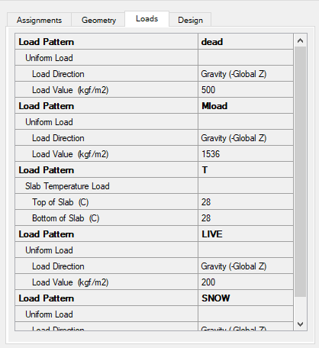

Figure16 –loading on Pads(th=200 mm)

* 1. **Soil Pressure Control**

According to geotechnical report allowable bearing capacity for mat foundation is as follows :

$q_{a}=2.25 ≈2.3 kg/cm2$ =0.23N/mm2

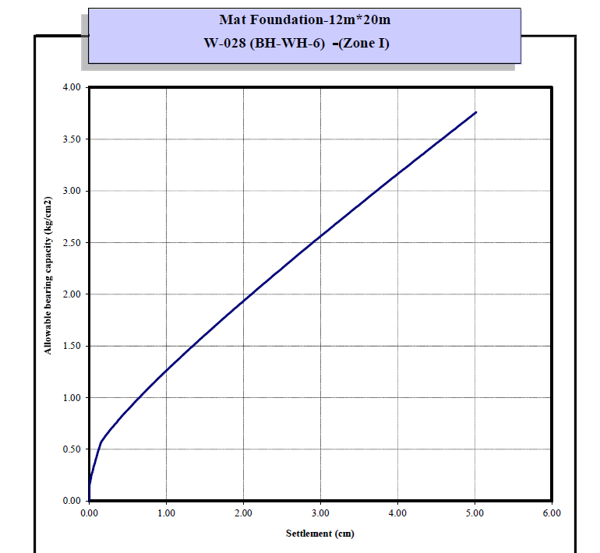

**D02**

Soil pressures in different service load combinations should be checked by allowable value. The following figure is extracted from “SAFE” model.

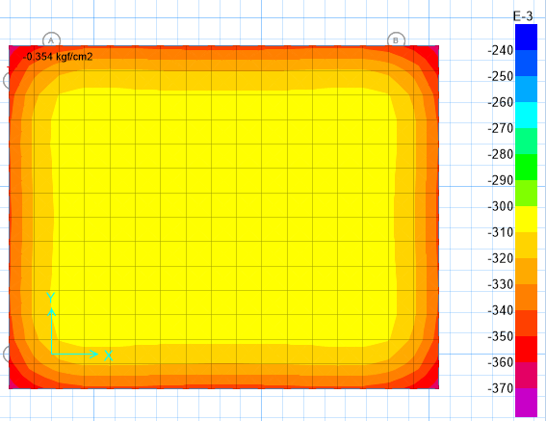

Figure17 –Soil Pressure diagram(0.0354N/mm2)

Maximum soil pressure of foundation under critical load combination is equals to 0.0354 N/mm2, which is less than allowable bearing capacity of soil.

* 1. **Settlement Control**

Settlement in different service load combinations should be checked by allowable value. The following figure is extracted from “SAFE” model.

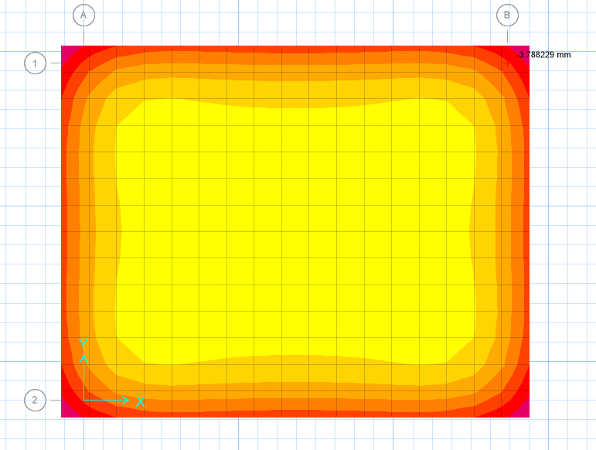

Figure18 –Displacement under service load combination(3.78 mm)

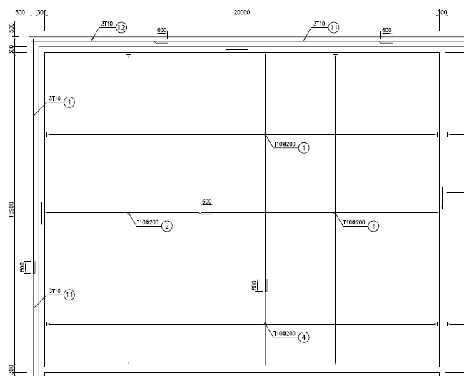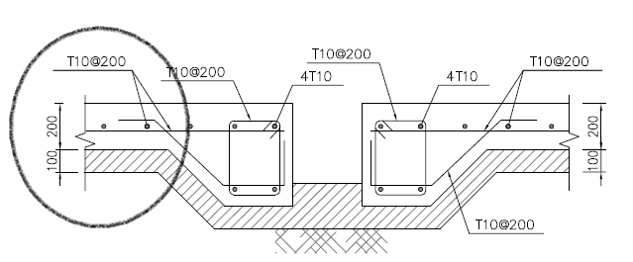

Figure19 –Slab Reinforcement

According to above figure use $φ10@200$ for this slab and design out puts shows as below:

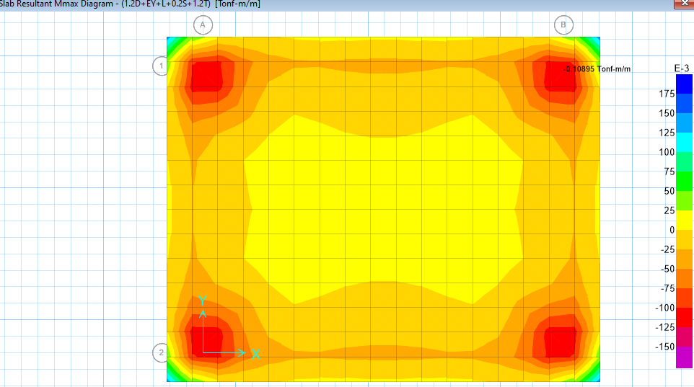

Figure20 –Slab Resultant Reinforcement(Mmax=0.1089 ton-m/m=1067.22 N-mm/mm)

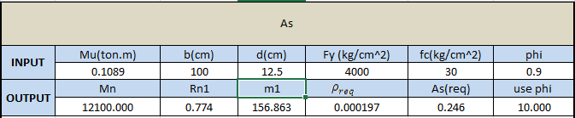

$M_{n}=\frac{M_{u}}{∅}$ =12100

$R_{n1}=\frac{M_{n1}}{{bd}^{2}}$ =0.774

$$m_{1}=\frac{f_{y}}{0.85f_{c}}=156.865$$

$$ρ_{req}=\frac{1}{m_{1}}\left(1-\sqrt{1-\frac{2m_{1}R_{n1}}{f_{y}}}\right)=0.000197$$

$$A_{s}=ρ_{req}.b.d=0.246 cm^{2}$$

$Used A_{s used}=∅10@200 mm=3.9cm2$ > $A_{s}=0.246 cm2$ ok

Due to the minimum required amount of reinforcement , minimum reinforcement has been used .

1. **GAS** **OIL STORAGE FOUNDATION (13m x 13m x 0.3m)**

Gas Oil Storage foundation has been modeled as a concrete pad with thickness 0.3 m in safe 2016 software.

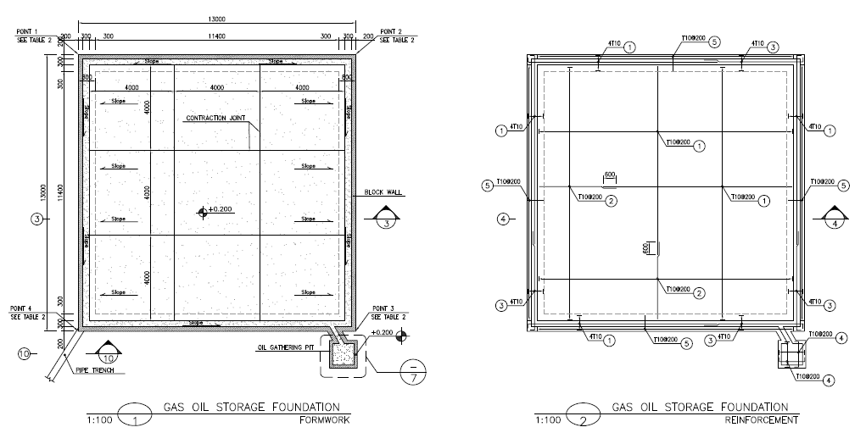

Figure21–Gas Oil Storage Foundation (13mx13mx0.3m)

A concrete pad with thickness 0.3m has been modelled in safe software 2016 as bellow:

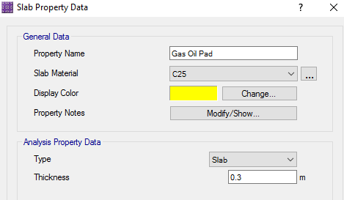

Figure22 –Slab Property Data(th=0.3m)

* 1. **Thermal Load (T)**

The ambient thermal load has been assumed based on the thermal variation for structure of 28 ºC.

* 1. **Live load (L)**

For bottom distributed load about 600kg/m2 ,has been considered for design of structure

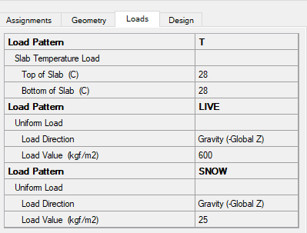

Figure23–Load applied on Pad

* 1. **Settlement Control**

Settlement in different service load combinations should be checked by allowable value. The following figure is extracted from “SAFE” model.

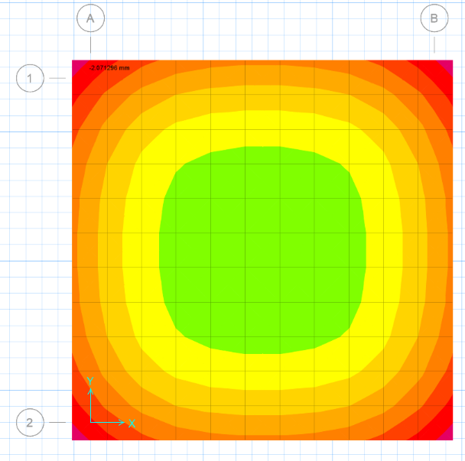

Figure24 –Displacement under service load combination(1.31 mm)

**D02**

* 1. **Soil Pressure Control**

Soil pressures in different service load combinations should be checked by allowable value. The following figure is extracted from “SAFE” model.

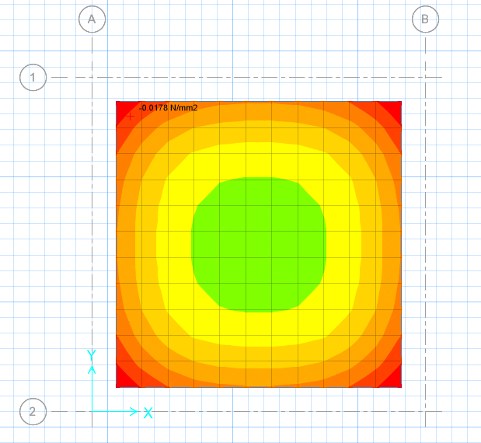

**D02**

Figure25–soil Pressure under service load combination(max=0.0178 N/mm2)

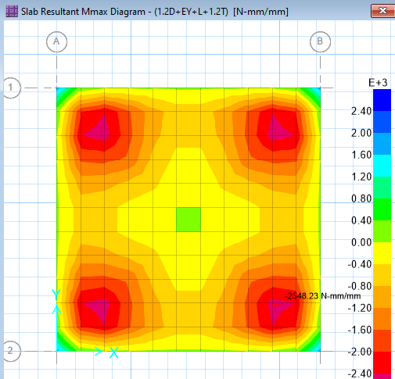

Figure26–slab Resultant Mmax(=0.26 t-m/m,2548.23 N-mm/mm)

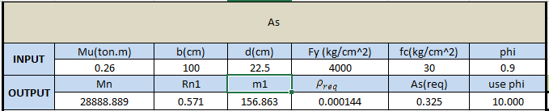

$M_{n}=\frac{M_{u}}{∅}$ =28888.889

$R_{n1}=\frac{M_{n1}}{{bd}^{2}}$ =0.571

$$m_{1}=\frac{f_{y}}{0.85f_{c}}=156.865$$

$$ρ_{req}=\frac{1}{m_{1}}\left(1-\sqrt{1-\frac{2m_{1}R_{n1}}{f_{y}}}\right)=0.000144$$

$$A_{s}=ρ_{req}.b.d=0.325 cm^{2}$$

$Used A_{s used}=∅10@200 mm=3.29 cm2>A_{s}=0.325 ok$

Due to the minimum required amount of reinforcement , minimum reinforcement has been used .

1. **HELIPAD FOUNDATION (8m x 8m x 0.25m)**

Helipad foundation has been modeled as a concrete pad with thickness 0.25 m in safe 2016 software.

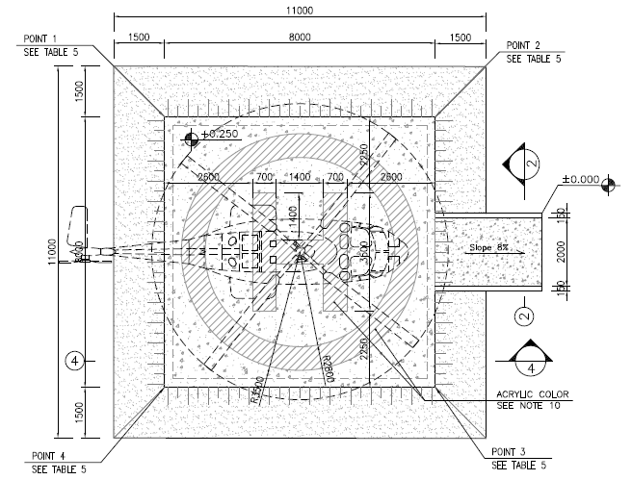

Figure27–Helipad Foundation (8mx8mx0.25m)

A concrete pad with thickness 0.25m has been modelled in safe software 2016 as bellow:

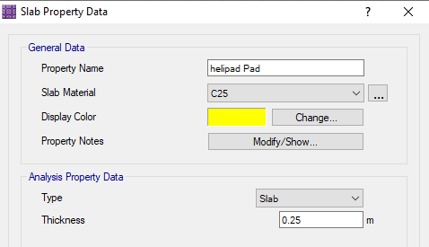

Figure28 –Slab Property Data(th=0.25m)

* 1. **Loads on foundation**
     1. **Thermal Load(T)**

The ambient thermal load has been assumed based on the thermal variation for structure of 28 ºC.

* + 1. **Live load (l)**

For Helipad Live load due to table 6-5-1 code No.6 assumed 3KN/m2 (300kg/m2)

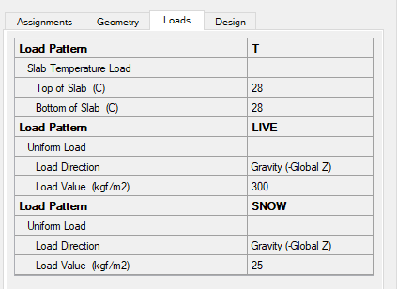

Figure29 –Load applied on Heli Pad

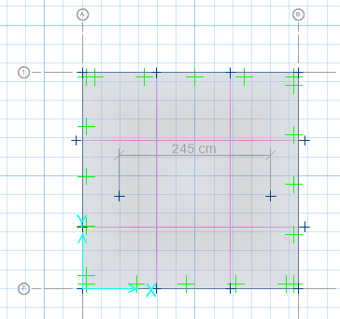

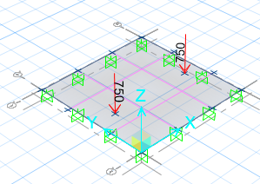

Figure 30–Load applied on Heli Pad

According to Iranian national building code (NO.6) table6-5-1 note 12 two point load with distance of 2.45 m has been applied on helipad model .Each operating load that added to live load is about 750 kg

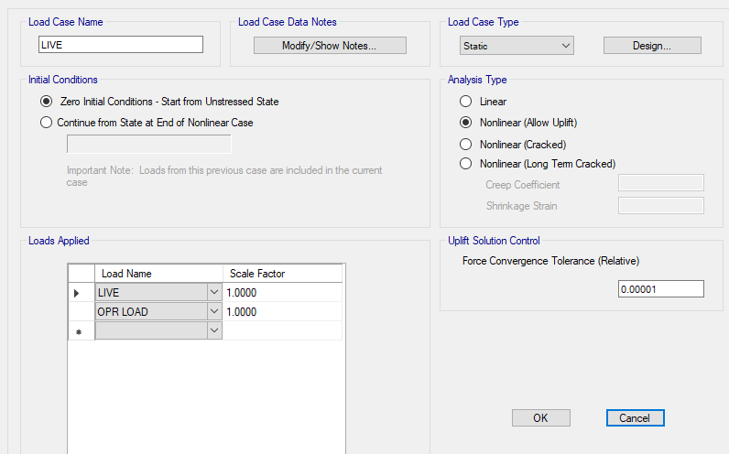

Figure 31–apply operating load

* 1. **Settlement Control**

Settlement in different service load combinations should be checked by allowable value. The following figure is extracted from “SAFE” model.

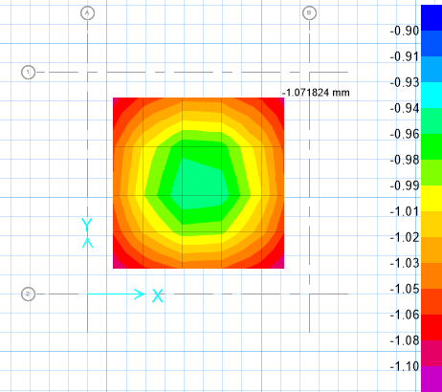

Figure 32 –Displacement under service load combination(1.07 mm)

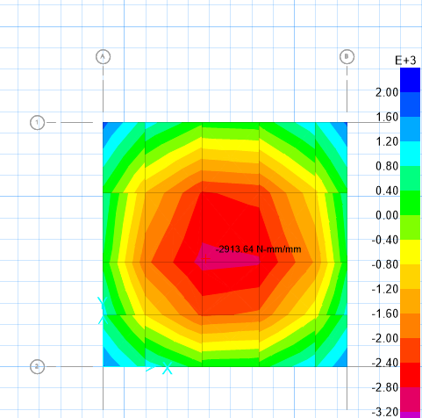

Figure33–slab Resultant Mmax(=0.297 t-m/m,2913.64 N-mm/mm)

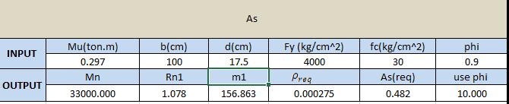

$M_{n}=\frac{M_{u}}{∅}$ =33000

$R_{n1}=\frac{M_{n1}}{{bd}^{2}}$ =1.078

$$m_{1}=\frac{f_{y}}{0.85f_{c}}=156.863$$

$$ρ_{req}=\frac{1}{m_{1}}\left(1-\sqrt{1-\frac{2m_{1}R_{n1}}{f_{y}}}\right)=0.000275$$

$$A_{s}=ρ_{req}.b.d=0.482 cm^{2}$$

$Used A_{s used}=∅10@200 mm=3.29 cm2>A_{s}=0.482 ok$

Due to the minimum required amount of reinforcement , minimum reinforcement has been used .

* 1. **Soil Pressure Control**

Soil pressures in different service load combinations should be checked by allowable value. The following figure is extracted from “SAFE” model

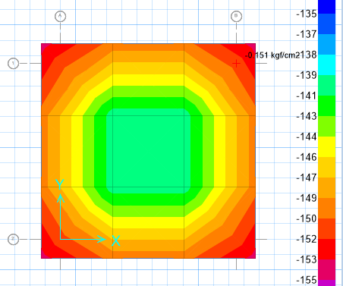

Figure34 –soil Pressure under service load combination(max=0.0151N/mm2)

* 1. **Check Additional Reinforcement**

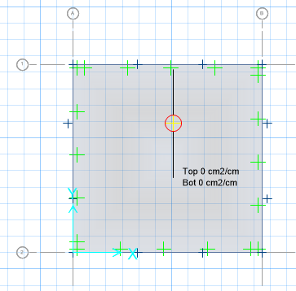

Figure35–Additional reinforcement

According to above output from safe 2016 software there is not need for additional reinforcement to existing reinforcement($∅10@200 top \& bott)$

1. **edge beam Design**

Edge beam has been modeled as a concrete beam with width of 0.5 m and height of 0.45 in safe 2016 software .load of two wheels of truck applied on edge beam .

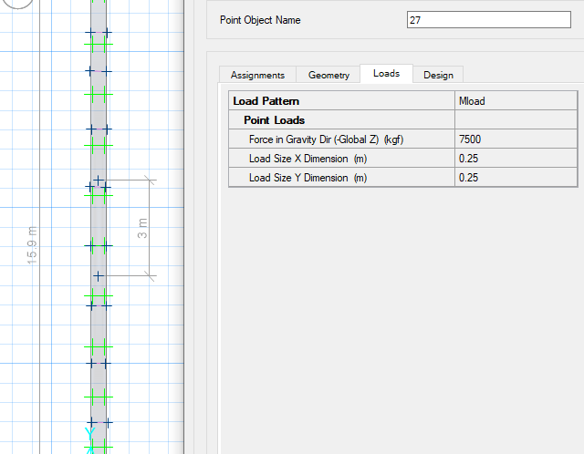

Figure36 –edge beam model

Each wheel load assumed about 7.5ton(7500kg) and apply in 2 points with distance of 3m.

* 1. **Soil Pressure Control**

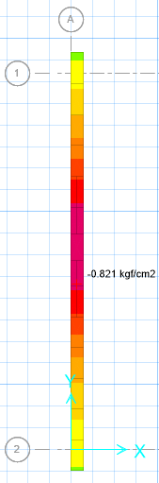

Figure37 –soil pressure under service load combination(q=0.821kg /cm2)

* 1. **Settlement Control**

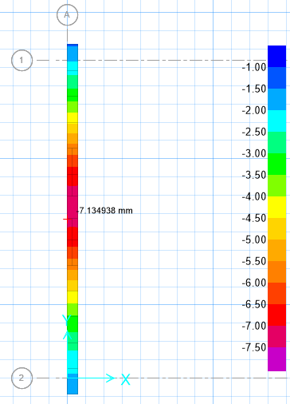

Figure38 –soil displacement under service load combination(7.13mm)