|  |  |  |  |  |  |  |
| --- | --- | --- | --- | --- | --- | --- |
| **طرح نگهداشت و افزایش تولید 27 مخزن** | | | | | | |
| **CALCULATION NOTE FOR EXTENSION OF EXISTING CONTROL BUILDING**  **نگهداشت و افزایش تولید میدان نفتی بینک** | | | | | | |
|  |  |  |  |  |  |  |
|  |  |  |  |  |  |  |
|  |  |  |  |  |  |  |
|  |  |  |  |  |  |  |
| D00 | OCT. 2024 | IFC | R.Berlouie | M.Fakharian | M.Sadeghian |  |
| **Rev.** | **Date** | **Purpose of Issue/Status** | **Prepared by:** | **Checked by:** | **Approved by:** | **CLIENT Approval** |
| **Class:2** | | **CLIENT Doc. Number:** **F0Z-709519** | | | | |
| **Status:** | **IDC: Inter-Discipline Check**  **IFC: Issued For Comment**  **IFA: Issued For Approval**  **AFD: Approved For Design**  **AFC: Approved For Construction**  **AFP: Approved For Purchase**  **AFQ:** Approved For Quotation  **IFI: Issued For Information**  **AB-R: As-Built for CLIENT Review**  **AB-A: As-Built –Approved** | | | | | |

**REVISION RECORD SHEET**

|  |  |  |  |  |  |  |  |  |  |  |  |  |
| --- | --- | --- | --- | --- | --- | --- | --- | --- | --- | --- | --- | --- |
| **PAGE** | **D00** | **D01** | **D02** | **D03** | **D04** |  | **PAGE** | **D00** | **D01** | **D02** | **D03** | **D04** |
| **1** | X |  |  |  |  | **66** |  |  |  |  |  |
| **2** | X |  |  |  |  | **67** |  |  |  |  |  |
| **3** | X |  |  |  |  | **68** |  |  |  |  |  |
| **4** | X |  |  |  |  | **69** |  |  |  |  |  |
| **5** | X |  |  |  |  | **70** |  |  |  |  |  |
| **6** | X |  |  |  |  | **71** |  |  |  |  |  |
| **7** | X |  |  |  |  | **72** |  |  |  |  |  |
| **8** | X |  |  |  |  | **73** |  |  |  |  |  |
| **9** | X |  |  |  |  | **74** |  |  |  |  |  |
| **10** | X |  |  |  |  | **75** |  |  |  |  |  |
| **11** | X |  |  |  |  | **76** |  |  |  |  |  |
| **12** | X |  |  |  |  | **77** |  |  |  |  |  |
| **13** | X |  |  |  |  | **78** |  |  |  |  |  |
| **14** | X |  |  |  |  | **79** |  |  |  |  |  |
| **15** | X |  |  |  |  | **80** |  |  |  |  |  |
| **16** | X |  |  |  |  | **81** |  |  |  |  |  |
| **17** | X |  |  |  |  | **82** |  |  |  |  |  |
| **18** | X |  |  |  |  | **83** |  |  |  |  |  |
| **19** | X |  |  |  |  | **84** |  |  |  |  |  |
| **20** | X |  |  |  |  | **85** |  |  |  |  |  |
| **21** | X |  |  |  |  | **86** |  |  |  |  |  |
| **22** | X |  |  |  |  | **87** |  |  |  |  |  |
| **23** | X |  |  |  |  | **88** |  |  |  |  |  |
| **24** | X |  |  |  |  | **89** |  |  |  |  |  |
| **25** | X |  |  |  |  | **90** |  |  |  |  |  |
| **26** | X |  |  |  |  | **91** |  |  |  |  |  |
| **27** | X |  |  |  |  | **92** |  |  |  |  |  |
| **28** | X |  |  |  |  | **93** |  |  |  |  |  |
| **29** | X |  |  |  |  | **94** |  |  |  |  |  |
| **30** | X |  |  |  |  | **95** |  |  |  |  |  |
| **31** | X |  |  |  |  | **96** |  |  |  |  |  |
| **32** | X |  |  |  |  | **97** |  |  |  |  |  |
| **33** |  |  |  |  |  | **98** |  |  |  |  |  |
| **34** |  |  |  |  |  | **99** |  |  |  |  |  |
| **35** |  |  |  |  |  | **100** |  |  |  |  |  |
| **36** |  |  |  |  |  | **101** |  |  |  |  |  |
| **37** |  |  |  |  |  | **102** |  |  |  |  |  |
| **38** |  |  |  |  |  | **103** |  |  |  |  |  |
| **39** |  |  |  |  |  | **104** |  |  |  |  |  |
| **40** |  |  |  |  |  | **105** |  |  |  |  |  |
| **41** |  |  |  |  |  | **106** |  |  |  |  |  |
| **42** |  |  |  |  |  | **107** |  |  |  |  |  |
| **43** |  |  |  |  |  | **108** |  |  |  |  |  |
| **44** |  |  |  |  |  | **109** |  |  |  |  |  |
| **45** |  |  |  |  |  | **110** |  |  |  |  |  |
| **46** |  |  |  |  |  | **111** |  |  |  |  |  |
| **47** |  |  |  |  |  | **112** |  |  |  |  |  |
| **48** |  |  |  |  |  | **113** |  |  |  |  |  |
| **49** |  |  |  |  |  | **114** |  |  |  |  |  |
| **50** |  |  |  |  |  | **115** |  |  |  |  |  |
| **51** |  |  |  |  |  | **116** |  |  |  |  |  |
| **52** |  |  |  |  |  | **117** |  |  |  |  |  |
| **53** |  |  |  |  |  | **118** |  |  |  |  |  |
| **54** |  |  |  |  |  | **119** |  |  |  |  |  |
| **55** |  |  |  |  |  | **120** |  |  |  |  |  |
| **56** |  |  |  |  |  | **121** |  |  |  |  |  |
| **57** |  |  |  |  |  | **122** |  |  |  |  |  |
| **58** |  |  |  |  |  | **123** |  |  |  |  |  |
| **59** |  |  |  |  |  | **124** |  |  |  |  |  |
| **60** |  |  |  |  |  | **125** |  |  |  |  |  |
| **61** |  |  |  |  |  | **126** |  |  |  |  |  |
| **62** |  |  |  |  |  | **127** |  |  |  |  |  |
| **63** |  |  |  |  |  | **128** |  |  |  |  |  |
| **64** |  |  |  |  |  | **129** |  |  |  |  |  |
| **65** |  |  |  |  |  | **130** |  |  |  |  |  |

**CONTENTS**

1.0 INTRODUCTION 4

2.0 Scope 5

3.0 NORMATIVE REFERENCES 5

3.1 Local Codes and Standards 5

3.2 International Codes and Standards 5

3.3 The Project Documents 5

3.4 Order of Precedence 6

4.0 Structural information 6

5.0 Software packages 6

6.0 Material ParametePrs 6

7.0 STABILITY 7

8.0 Concrete cover 7

9.0 architectural PLAN AND ELEVATION 8

10.0 design Loads 9

10.1 dead Load 9

10.2 LIVE LOAD 10

10.3 EARTHQUAKE LOAD 10

10.4 MASS SOURCE 12

10.5 BLAST PRESSURE 12

11.0 LOAD DEFINITION 18

12.0 LOAD COMBINATION : 18

12.1 SEISMIC DESIGN LOAD COMBINATION 18

12.2 BLAST DESIGN LOAD COMBINATION 18

12.3 FOUNDATION LOAD COMBINATION 19

13.0 DEFLECTION CONTROL LOAD COMBINATIONS 22

13.1 DEFLECTION CONTROL EARTHQUAKE LOAD COMBINATION 22

13.2 DEFLECTION CONTROL BLAST LOAD COMBINATION 22

14.0 Structural model & ANALYSIS 22

15.0 WALL DESIGN 23

16.0 SLAB DESIGN 24

17.0 FOUNDATION DESIGN AND RESULTS 25

17.1 Foundation Model 25

17.2 Soil Characteristic 25

17.3 Loads 27

17.4 Settlement Control 28

17.5 Soil Pressure Control 28

17.6 Punching Shear Control 29

17.7 Foundation Design 30

17.8 OVERTURNING & SLIDING CONTROL 31

1. **INTRODUCTION**

Binak oilfield in Bushehr province is a part of the southern oilfields of Iran, is located 20 km northwest of Genaveh city.

With the aim of increasing production of oil from Binak oilfield, an EPC/EPD Project has been defined by NIOC/NISOC and awarded to Petro Iran Development Company (PEDCO). Also PEDCO (as General Contractor) has assigned the EPC-packages of the Project to "Hirgan Energy - Design and Inspection" JV.

As a part of the Project, a New Gas Compressor Station (adjacent to existing Binak GCS) shall be constructed to gather of 15 MMSCFD (approx.) associated gases and compress & transfer them to Siahmakan GIS.

**GENERAL DEFINITION**

The following terms shall be used in this document.

|  |  |
| --- | --- |
| CLIENT: | National Iranian South Oilfields Company (NISOC) |
| PROJECT: | Binak Oilfield Development – Surface Fcilities; New Gas Compressor Station |
| EPD/EPC CONTRACTOR (GC): | Petro Iran Development Company (PEDCO) |
| EPC CONTRACTOR: | Joint Venture of : Hirgan Energy – Design & Inspection (D&I) Companies |
| VENDOR: | The firm or person who will fabricate the equipment or material. |
| EXECUTOR: | Executor is the party which carries out all or part of construction and/or commissioning for the project. |
| THIRD PARTY INSPECTOR (TPI): | The firm appointed by EPD/EPC CONTRACTOR (GC) and approved by CLIENT (in writing) for the inspection of goods. |
| SHALL: | Is used where a provision is mandatory. |
| SHOULD: | Is used where a provision is advisory only. |
| WILL: | Is normally used in connection with the action by CLIENT rather than by an EPC/EPD CONTRACTOR, supplier or VENDOR. |
| MAY: | Is used where a provision is completely discretionary. |

1. **Scope**

This calculation sheet is prepared for designing of Extension of Existing Control Building which is located at Compressor Station Plant.

This blast proof building includes parts such as Battery Room, Management Room, Conference Room , etc.

1. **NORMATIVE REFERENCES**

## Local Codes and Standards

* INBC Part 6 “Iranian National Building Code”
* INBC Part 7 “Iranian National Building Code”
* INBC Part 9 “Iranian National Building Code”
* IPS-E-CE-500 “Blast loads and Design Criteria”
* Iranian Seismic Design Code for Petroleum Facilities (Pub.038-3rd edition)

## International Codes and Standards

* ASTM “Material Properties: American Society for Testing and Materials”
* ACI 318 “Building Code Requirements for Reinforced Concrete”, American Concrete Institute”
* ASCE 7 “Minimum Design Loads and Associated Criteria for Buildings and Other Structures-American Society of Civil Engineers”

## The Project Documents

* BK-GNRAL-PEDCO-000-ST-DC-0001 Structural Design Criteria
* BK-GNRAL-PEDCO-000-ST-SP-0001 Specification for Concrete Work
* BK-GNRAL-PEDCO-000-ST-SP-0007 Specification for Design of Blast Resistant Buildings
* BK-GNRAL-PEDCO-000-CV-SP-0004 Specification for Earth Work
* BK-GCS-PEDCO-120-GT-RT-0001 Geotechnical Investigation Report for Compressor Station
* BK-GCS-PEDCO-120-AR-DW-0011 Architectural Detail Drawing for Extension of Existing Control Building

## Order of Precedence

In case of any conflict between the contents of this document or any discrepancy between this document and other project documents or reference standards, this issue must be reported to the CLIENT. The final decision in this situation will be made by CLIENT.

1. **Structural information**

* Frame: Reinforced Concrete (RC)
* Floor: RC Slab
* Roof: RC Slab
* Structural System in longitudinal & Transverse Direction: Special Moment Resistance Frame : SMRF
* Foundation: Strip Footing

1. **Software packages**

* The 3-D structural model analysis and design: SAP2000 Version 21.1.0
* Foundation model analysis & design: SAFE2016 Version 16.0.2

1. **Material Parameters**

* Minimum compressive strength of concrete at 28 days on cylinder specimen shall be:
* 300  for Concrete Structure
* 300 for Foundation
* 150  for Lean Concrete
* Minimum yield strength of steel reinforcement shall be:
* 4000 for Deformed High Tensile Bar
* Dynamic Strengths of materials in blast condition shall be:
* 4000 x 1.2 = 4800 for Deformed High Tensile Bar
* 300 x 1.25 = 375 for Concrete Structure & Foundation
* Unit Weight:
* Concrete: 2500
* Steel: 7850
* Earth:1900 
* Module of elasticity:
* Concrete: 
* Concrete in blast condition: 
* Capacity reduction factors can be increased by 10 percent in blast condition.

1. **STABILITY**

* Overturning Stability

The minimum factors of safety against overturning shall be limited to the following tables:

|  |  |
| --- | --- |
| **Design Condition** | **Stability Ratio** |
| Operating condition | 2 |
| Accidental condition | 1.5 |
| Blast condition | 1.2 |

* Sliding Stability

The minimum factor of safety against sliding shall be 1.5 in all loading conditions/combinations except the accidental condition when the factor may be reduced to 1.2

1. **Concrete cover**

The concrete cover for formed concrete should be as the following: (as per design criteria)

* Concrete exposed to ground : 75mm
* not in direct contact with earth: 50mm
* Column & beam: 40mm
* Slab: 35mm

1. **architectural PLAN AND ELEVATION**

Framing plan & elevation are shown in below picture.

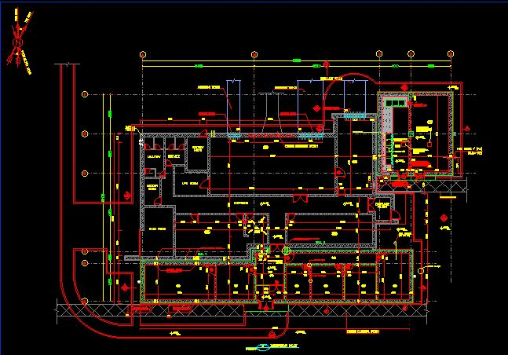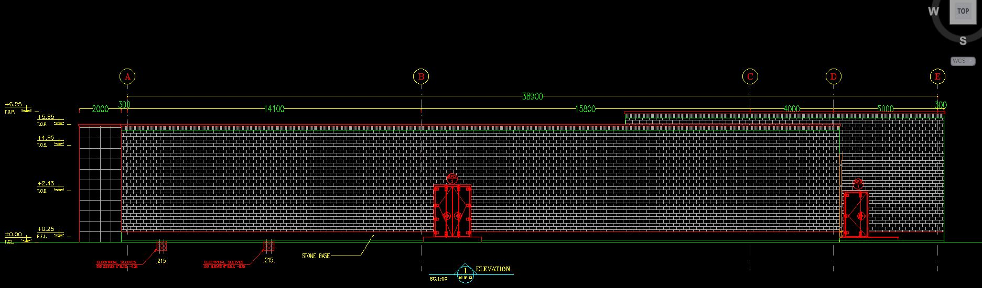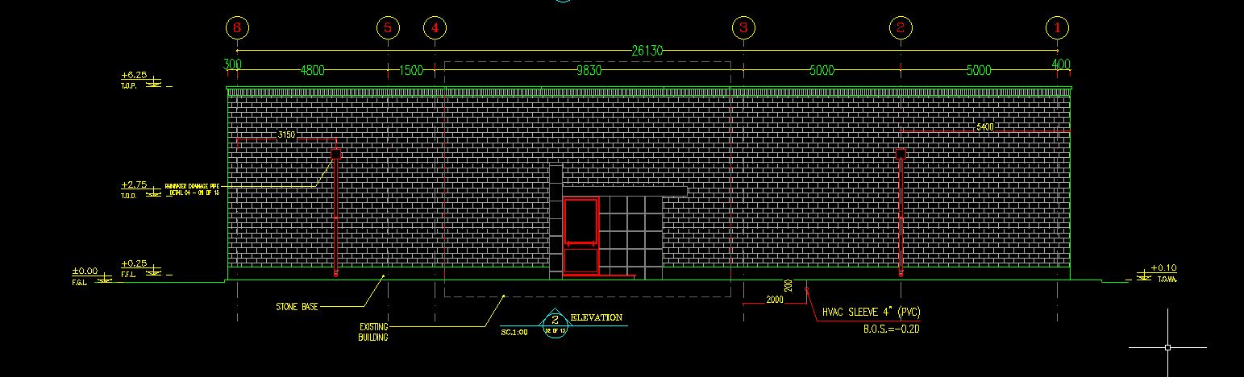

1. **design Loads**

## dead Load

Self weight automatically will be considered by software.

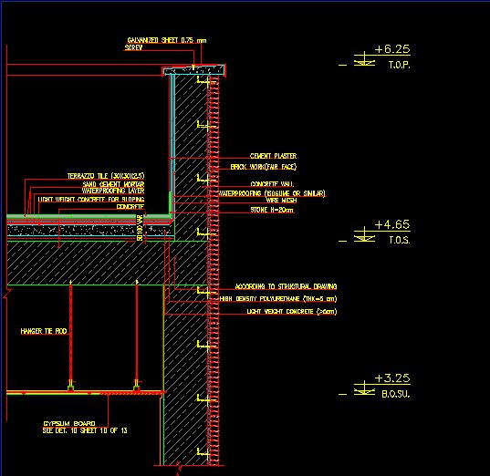

### Roof Slab

* RC Slab(0.4mx2500): 1000 ( T.O.S= 4.10 m , B.O.S=3.70 m)
* Terrazzo Tiles(.025mx2250): 56.25
* Sand(.01mx1600): 16
* Polyethylene Sheet: 2.5
* Waterproofing Membrane: 15
* Sand Cement Mortar(.01mx2100): 21
* Light Weight Concrete(.05mx1700): 85

 (Total weight without RC slab)

### Parapet

* Break Wall (0.3mx2100): 630
* Waterproofing Membrane: 15
* Sand Cement Mortar(.02mx2100): 42



## LIVE LOAD

### Roof Live Load: 150

## EARTHQUAKE LOAD

### 

* E: Earthquake load resulting from combination of horizontal & vertical earthquake components
*  : Redundancy/ reliability factor
* : Horizontal seismic load
* : Vertical seismic load
* Redundancy/ reliability FACTOR ()

 ( For SMRF)

## 12.3.1. Horizontal Seismic Load

According to Iranian Seismic Design Code for Petroleum Facilities (Pub.038-3rd edition) the structure shall be designed for earthquake load in two orthogonal directions.

Base level is defined as the level below which the structure does not move relative to the ground during an earthquake.

Basic parameters which are used in calculation of earthquake forces are presented below.

Following formula is used for calculations according to Iranian Seismic Design Code for Petroleum Facilities (Pub.038-3rd edition)

$$V_{u}=\frac{S_{a}}{{R_{u}}/I}W$$

In which:

$V_{u}$: Basic Shear

Sa: Mapped Spectral Response Acceleration Parameter (𝑔)

I: Importance Factor of Structure

Ru: Structural System Factor

W= Effective Seismic Weight of the structure, including dead loads and other loads, calculated from base level.

**Basic Parameters Used for Earthquake Loads**

|  |  |
| --- | --- |
| Height of the structure from the base level (m) | 5.65 |
| Importance factor, I | 1.25 |
| Structural System | Special Moment Frame at Both Direction |
| Soil type | II |
| Ru | 8 |
| $C_{t}$ (Based on table (4-6) Pub.038) | 0.047 |
| X (Based on table (4-6) Pub.038) | 0.9 |
| $$T_{x\&Y (calculation) }=C_{t}.H^{x}$$ | 0.223 |
| Based on part (4-8-3) Pub.038 : $T_{x\&Y (calculation) }$ | = 0.223*1.4 = 0.312 |
| $T_{y}$ (analysis) – mode 2 | 0.083 |
| $T_{x}$ (analysis) – mode 3 | 0.077 |
| $$T_{x \left(select for design\right)}$$ | 0.312 |
| $$T_{Y \left(select for design\right)}$$ | 0.312 |
| $${Sa}_{x}$$ | 0.75 |
| ${Sa}_{y}$ | 0.75 |
| $$C_{min}=0.044S_{DS}I$$ | 0.04125 |
| $$C_{x}=\frac{{S_{a}}_{x}}{{R_{u}}/I}$$ | 0.117 |
|  | 0.117 |

**1234**

The lateral seismic load is computed by program due to above coefficient.

## 12.3.2. Vertical seismic load

Ev: Vertical seismic load applied at model according to section 2-2-3-2 (code 038)

${ E}_{v}=αS_{DS}D=0.2*0.75D=0.15D$

## MASS SOURCE

The mass source is developed from loads participating in earthquake is shown on table below:

|  |  |
| --- | --- |
| **LOAD** | **MULTIPLIER** |
| DEAD | 1 |
| LIVE ROOF | 0.2 |

## BLAST PRESSURE

The Blast pressure parameters will be taken out from IPS-E-CE-500, Appendix IC which is same as Specification for Design of Blast Resistant Buildings Doc No: BK-GNRAL-PEDCO-000-ST-SP-0007.

### In 20 milliseconds (Peak Blast Pressure for Roof) ~ 6.9 Ton/m2

### In 20 milliseconds at both direction (Peak Blast Pressure for Wall) ~ 17.2 Ton/m2

### In 35 milliseconds at both direction (Peak Blast Pressure for Roof) ~ 3.8 Ton/m2

### (Design Blast pressure)

* R: required dynamic resistance of structural element, expressed as static load equivalent of blast pressure and duration (kpa.)
* P: peak blast load for the element under consideration (kpa.)
* : energy absorption factor = 
* : maximum displacement factor = 
* duration factor = 
*  maximum allowable dynamic displacement (mm)

*  duration of blast load (milliseconds)
* : fundamental period of vibration of structure or element (milliseconds)

|  |  |
| --- | --- |
| Structural Component  (RC Structure) | Displacement Factor  (Xm/Xy) |
| Axial compression | 1.5 |
| Flexure | 3 |
| Shear | 1.5 |

### Load application for blast design is as follows:

* Wall Panel Design

### Each wall shall sustain peak reflected pressure (Pr, equivalent static value).

**Case1**

* Roof Slab Design

### Roof slab and beams shall sustain peak overpressure (Pso, equivalent static value).

**Case2**

* Frame Slab Design

### Structural framing shall sustain peak reflected pressure (equivalent static value) on any one wall + roof subjected peak overpressure (equivalent static value).

**Case3**

### Design loads on structural members are summarized as bellow:

|  |  |  |  |  |  |  |  |  |
| --- | --- | --- | --- | --- | --- | --- | --- | --- |
|  |  |  | **Roof Slab** | | |  |  |  |
|  | **direction** |  | **a** | **t(ms)** | **T(ms)** | **t/T** | **P** | **R** |
| **Flexure** | **x** | **3** | **5** | **20** | **101.753** | **0.1965** | **6.9** | **1.8131** |
| **y** | **3** | **5** | **20** | **101.751** | **0.1965** | **6.9** | **1.8131** |
| **Shear** | **x** | **1.5** | **2** | **20** | **101.753** | **0.1965** | **6.9** | **2.8307** |
| **y** | **1.5** | **2** | **20** | **101.751** | **0.1965** | **6.9** | **2.8307** |
| **Axial** | **x** | **1.5** | **2** | **20** | **101.753** | **0.1965** | **6.9** | **2.8307** |
| **y** | **1.5** | **2** | **20** | **101.751** | **0.1965** | **6.9** | **2.8307** |

|  |  |  |  |  |  |  |  |  |
| --- | --- | --- | --- | --- | --- | --- | --- | --- |
|  |  |  | **Wall** | | |  |  |  |
|  | **direction** |  | **a** | **t(ms)** | **T(ms)** | **t/T** | **P** | **R** |
| **Flexure** | **x** | **3** | **5** | **20** | **101.753** | **0.1965** | **17.2** | **4.5195** |
| **y** | **3** | **5** | **20** | **101.751** | **0.1965** | **17.2** | **4.5196** |
| **Shear** | **x** | **1.5** | **2** | **20** | **101.753** | **0.1965** | **17.2** | **7.0562** |
| **y** | **1.5** | **2** | **20** | **101.751** | **0.1965** | **17.2** | **7.0563** |
| **Axial** | **x** | **1.5** | **2** | **20** | **101.753** | **0.1965** | **17.2** | **7.0562** |
| **y** | **1.5** | **2** | **20** | **101.751** | **0.1965** | **17.2** | **7.0563** |

|  |  |  |  |  |  |  |  |  |
| --- | --- | --- | --- | --- | --- | --- | --- | --- |
|  |  |  | **Roof Slab(Framing Design)** | | |  |  |  |
|  | **direction** |  | **a** | **t(ms)** | **T(ms)** | **t/T** | **P** | **R** |
| **Flexure** | **x** | **3** | **5** | **35** | **101.753** | **0.3438** | **3.8** | **1.6206** |
| **y** | **3** | **5** | **35** | **101.751** | **0.3438** | **3.8** | **1.6206** |
| **Shear** | **x** | **1.5** | **2** | **35** | **101.753** | **0.3438** | **3.8** | **2.4852** |
| **y** | **1.5** | **2** | **35** | **101.751** | **0.3438** | **3.8** | **2.4853** |
| **Axial** | **x** | **1.5** | **2** | **35** | **101.753** | **0.3438** | **3.8** | **2.4852** |
| **y** | **1.5** | **2** | **35** | **101.751** | **0.3438** | **3.8** | **2.4853** |

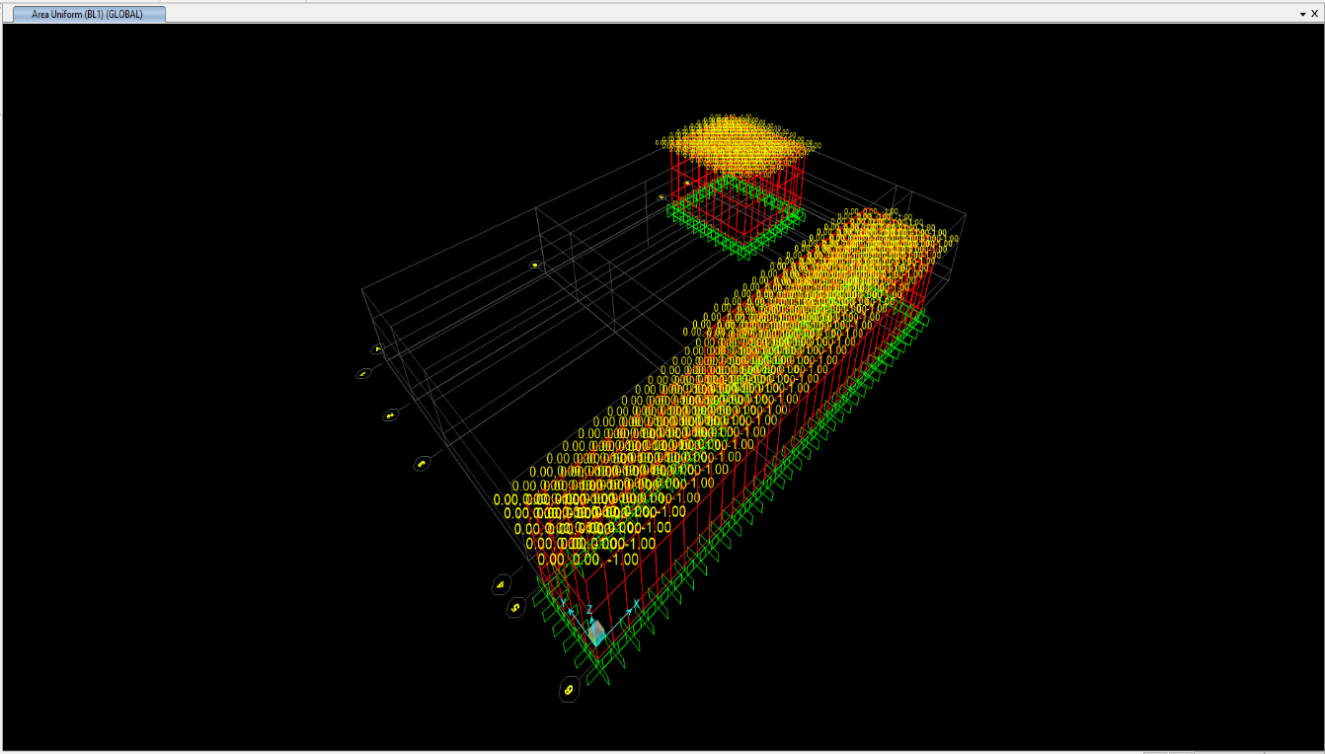

Blast Loading on Roof, BL1 (t.m)

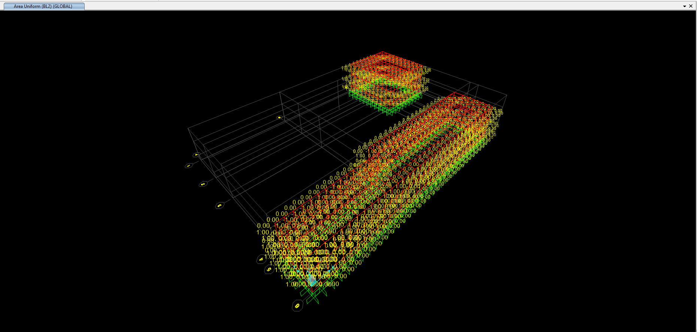

Blast Loading on Wall, BL2 (t.m)

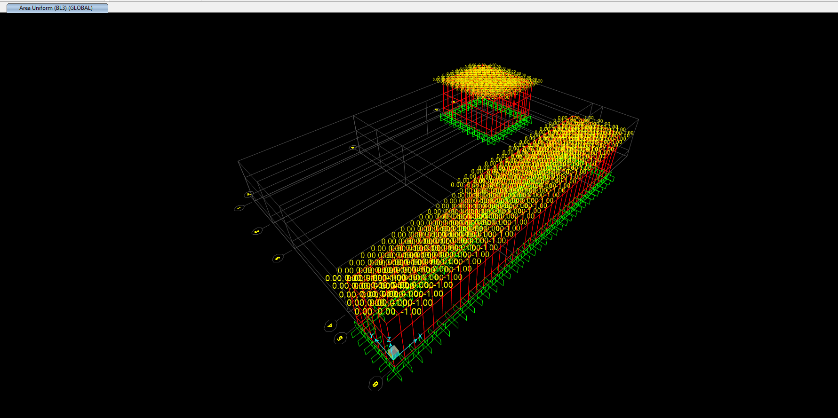

Blast Loading on Roof, BL3 (t.m)

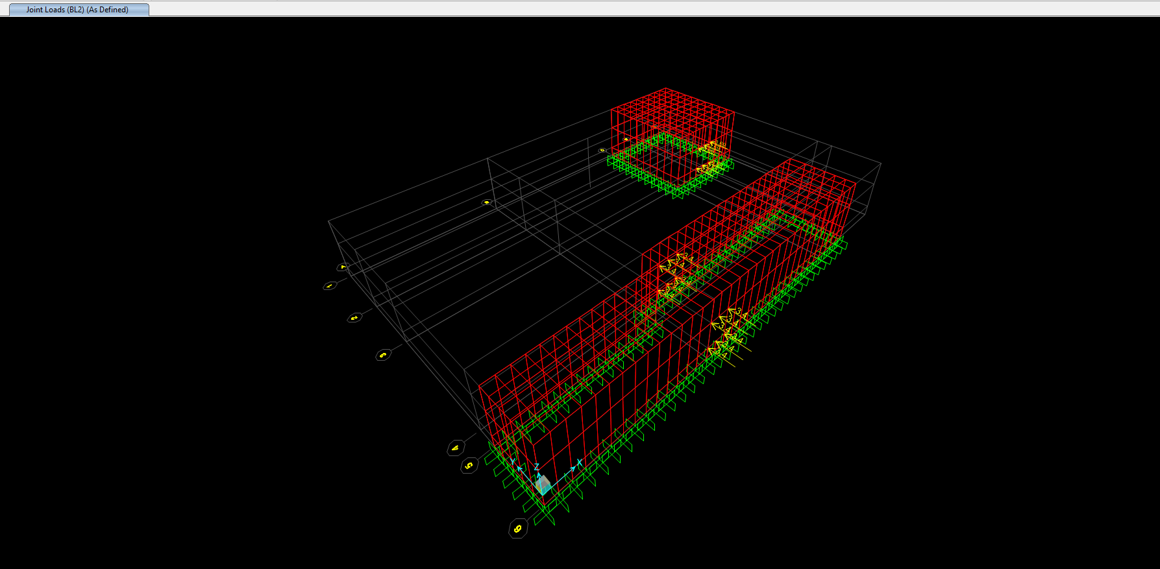

Blast Loading on Opening , Point Load (t.m)

1. **LOAD DEFINITION**
   * Dead: D
   * Live Roof : L
   * Earthquake: E
   * Blast For Roof: BL1
   * Blast For Wall: BL2
   * Blast For Frame: BL3
   * Soil for Foundation : S
2. **LOAD COMBINATION :**

## SEISMIC DESIGN LOAD COMBINATION

* + 1.4D
  + 1.2D+1.6L
  + 1.2D+1.0L±1.0Ex±0.3Ey+EV
  + 1.2D+1.0L ±1.0Ey±0.3Ex+EV
  + 0.9D±1.0Ex±0.3Ey+EV
  + 0.9D±1.0Ey±0.3Ex+EV

## BLAST DESIGN LOAD COMBINATION

## 12.2.1.FLUXURE DESIGN LOAD COMBINATION

* SLAB
  + D+L+1.8131BL1
* WALL
  + D+L±4.5195BL2
* FRAME(AXES 1~2)
  + D+L+1.6206BL3±4.5195BL3

## 12.2.2.SHEAR DESIGN LOAD COMBINATION

* SLAB
  + D+L+2.8307BL1
* WALL
  + D+L±7.0563BL2
* FRAME(AXES 1~2)
  + D+L+2.4853BL3 ±7.0563BL2

## 12.2.3. AXIAL LOAD DESIGN LOAD COMBINATION

* SLAB
  + D+L+2.8307BL1
* WALL
  + D+L±7.0563BL2
* FRAME(AXES 1~2)
  + D+L+2.4852 BL3+7.0563 BL2

## FOUNDATION LOAD COMBINATION

* 1.4D+1.4S
* 1.2D+1.2S+1.6L
* 1.2D+1.2S+1.0L±1.0EX±0.3EY
* 1.2D+1.2S+1.0L±1.0EY±0.3EX
* 0.9D+0.9S+±1.0EX±0.3EY
* 0.9D+0.9S±1.0EY±0.3EX

Max M11 (T.m)

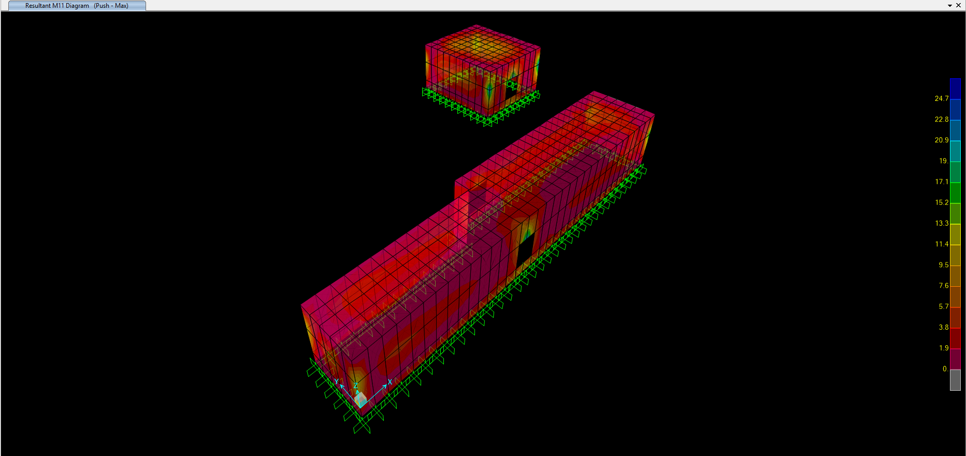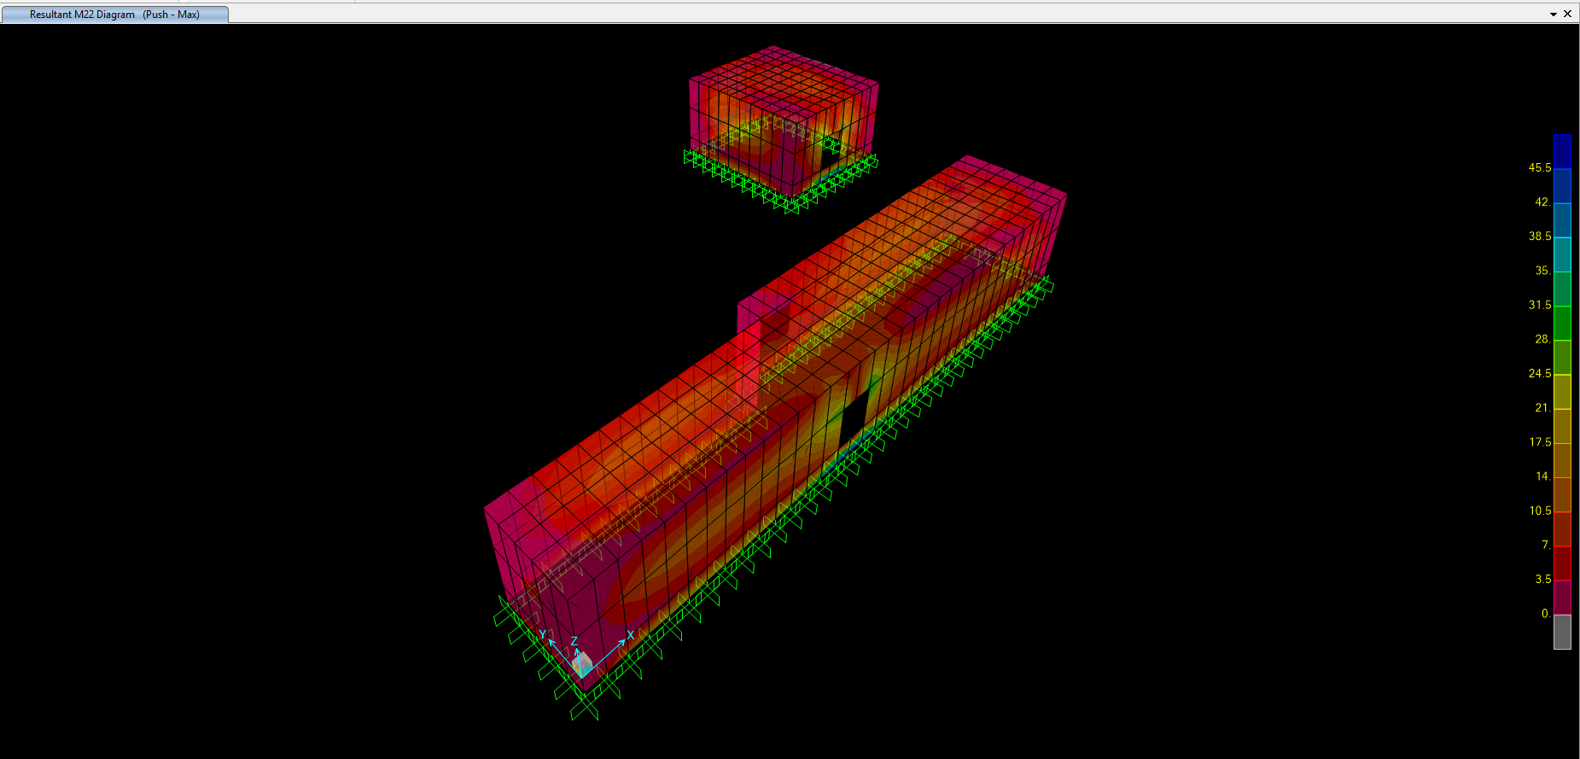

Max M22 (T.m)

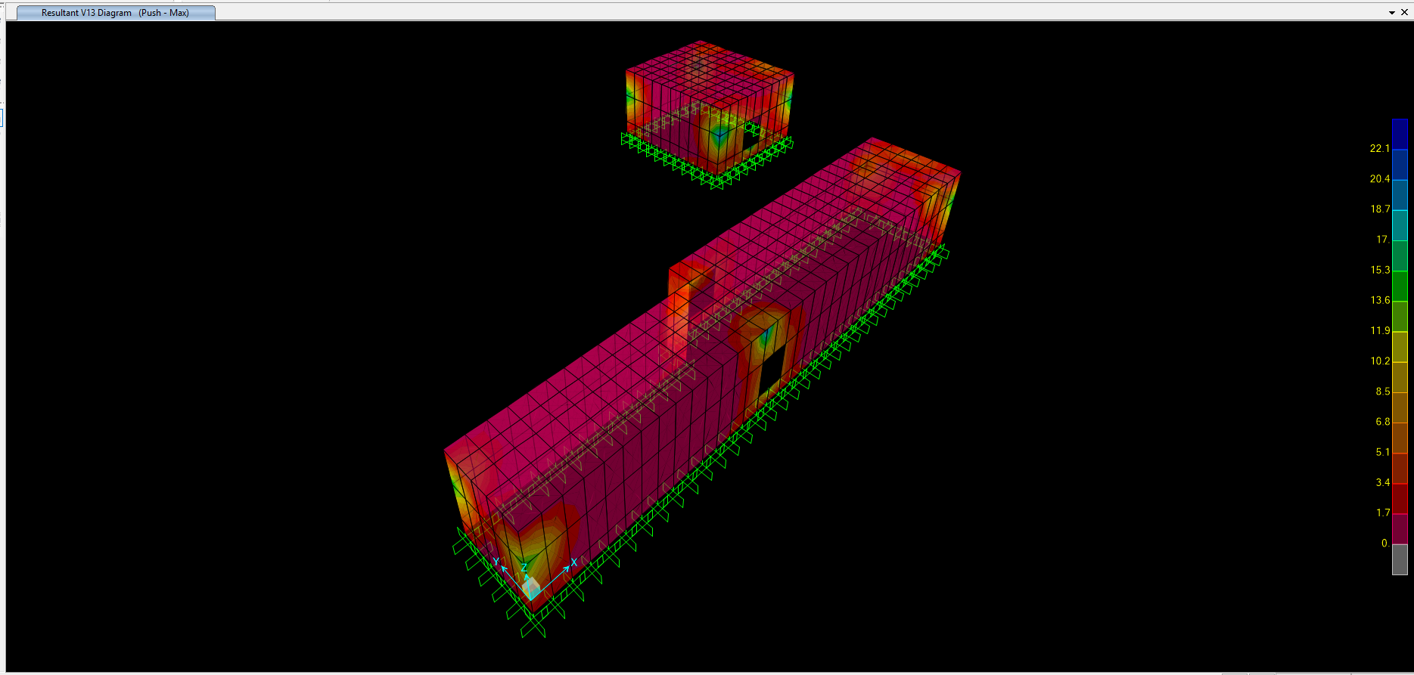

Max V13 (T.m)

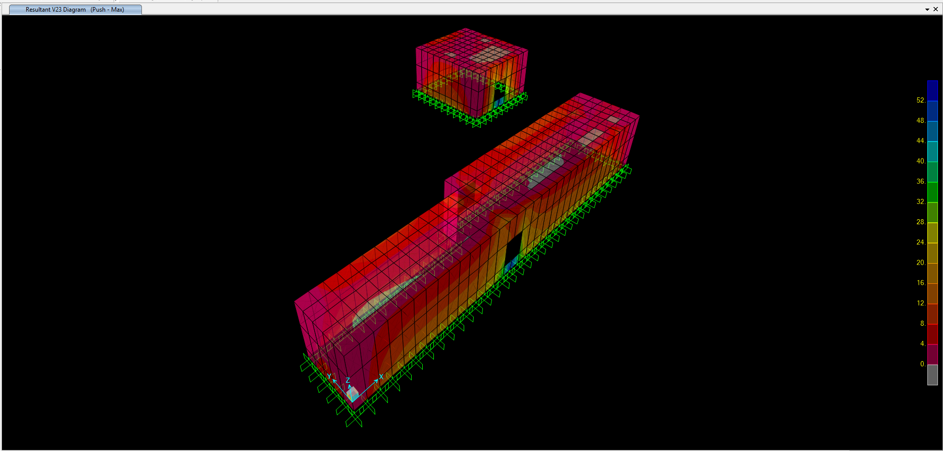

Max V23 (T.m)

1. **DEFLECTION CONTROL LOAD COMBINATIONS**

## DEFLECTION CONTROL EARTHQUAKE LOAD COMBINATION

* + D+L
  + D+L±Ex
  + D+L±Ey
  + 0.9D±Ex
  + 0.9D±Ey

## DEFLECTION CONTROL BLAST LOAD COMBINATION

* SLAB
  + D+L+BL1
* WALL
  + D+L±BL2
* FRAME(AXES 1~2)
  + D+L+BL3±BL2

1. **Structural model & ANALYSIS**

### All analysis is done by assumption of cracked section as per ACI318.

### Modified moment of inertia:

* Beams & Walls 0.35 Ig
* Columns 0.7 Ig
* Flat Plates and Flat Slabs 0.25 Ig

1. **WALL DESIGN**



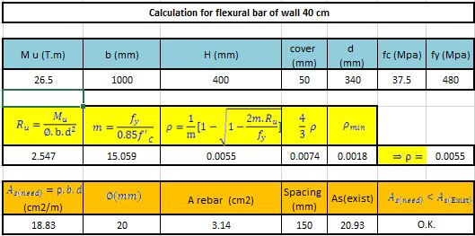





1. **SLAB DESIGN**



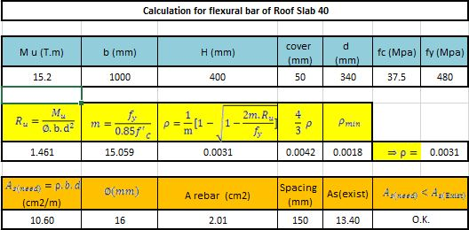





1. **FOUNDATION DESIGN AND RESULTS**

## Foundation Model

### Foundation model, analyse and design has been done by SAFE2016 software.(Version 16.0.2)

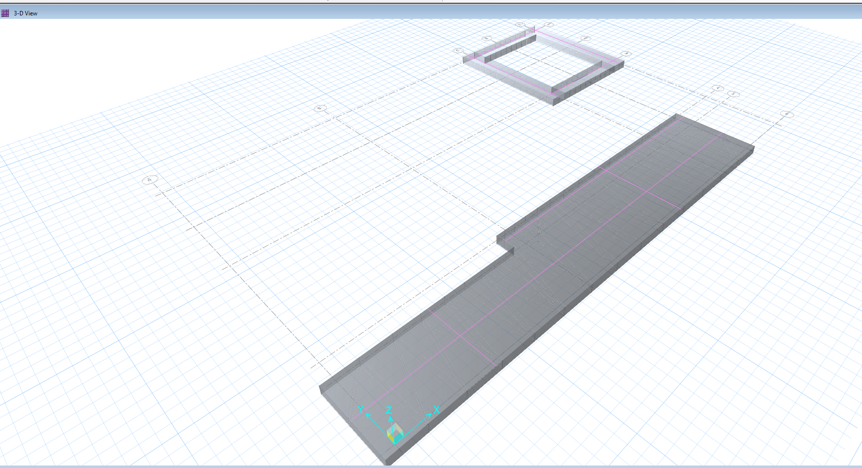

**Foundation 3D plan in SAFE**

## Soil Characteristic

* Allowable soil bearing capacity
*  as per soil investigation report
* ẟa =2.25 cm as per soil investigation report
* Modulus of sub grade reaction value
*  as per soil investigation report

0

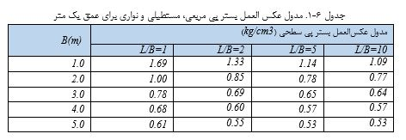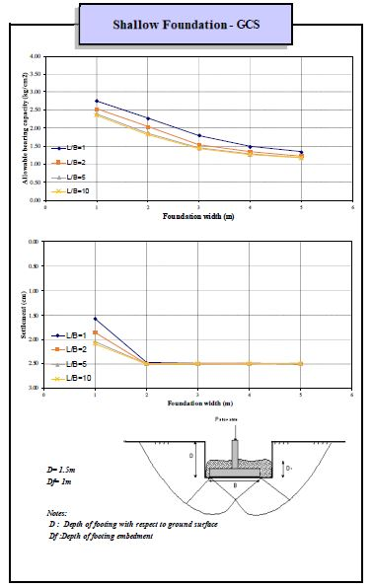

## Loads

### The loads have been imported from ETABS analysis.

### Reinforced concrete unit weight equals 2500 kg/m3 and defined for SAFE, so the program calculated the foundation weight automatically.

### Soil unit weight equals to 1900 kg/m3. The soil height above foundation is 1.0 m, so distributed Soil Weight : 1900 kg/m2

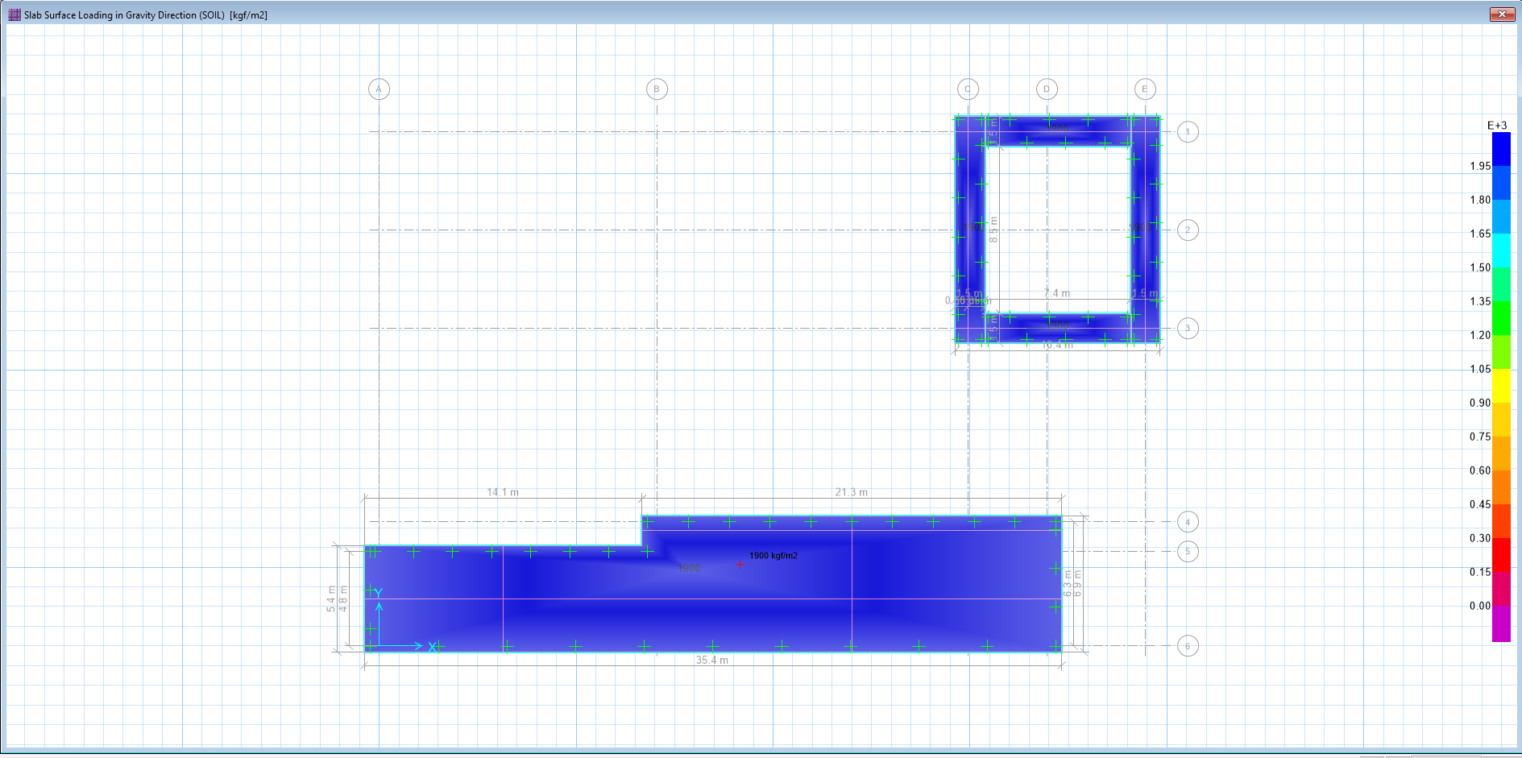

## Settlement Control

### Settlement in different service load combinations should be checked by allowable value.

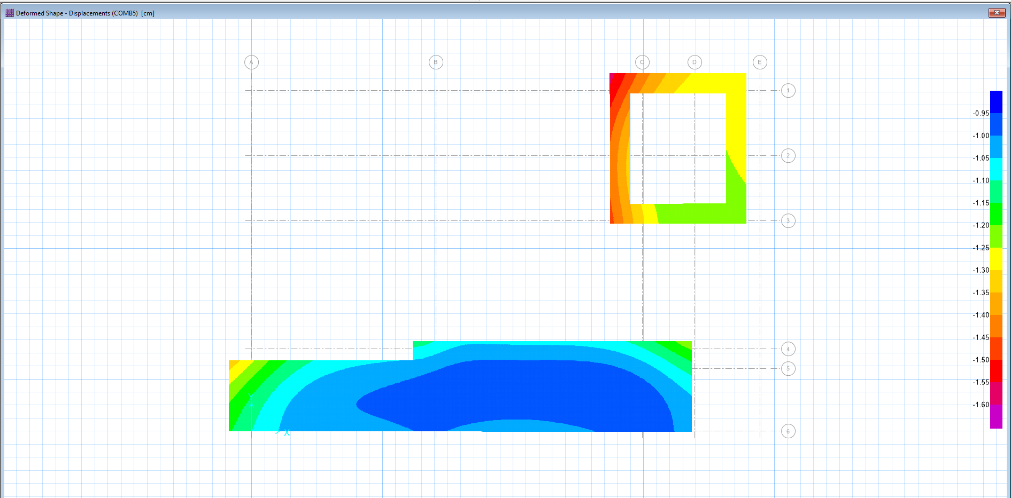

### Maximum settlement of foundation equals to 1.540 cm, which is less than allowable 2.25 cm.

## Soil Pressure Control

### Soil pressures in different service load combinations should be checked by allowable value.

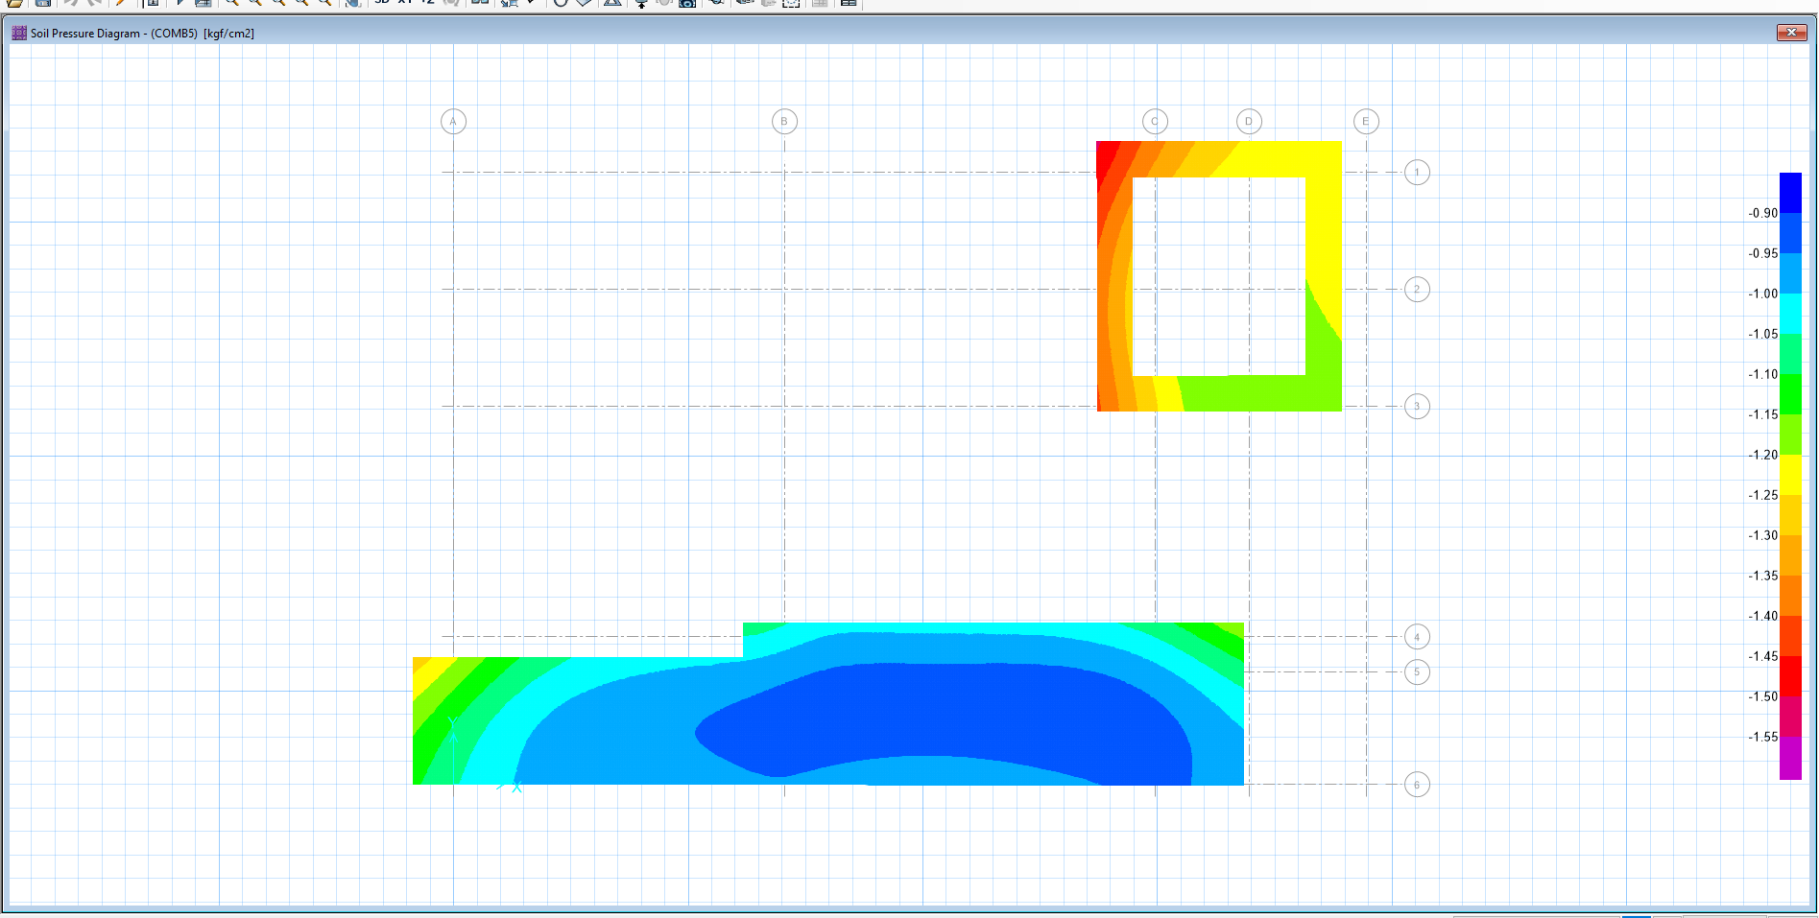

### Maximum soil pressure under foundation equals to 1.863 kg/cm2, which is less than 2.1 kg/cm2.

## Punching Shear Control

### The punching shear control ratio of foundation is shown below. As seen the punching shear ratio in all columns base which is calculated by software is less than allowable range (1.0), so the footing thickness is acceptable.

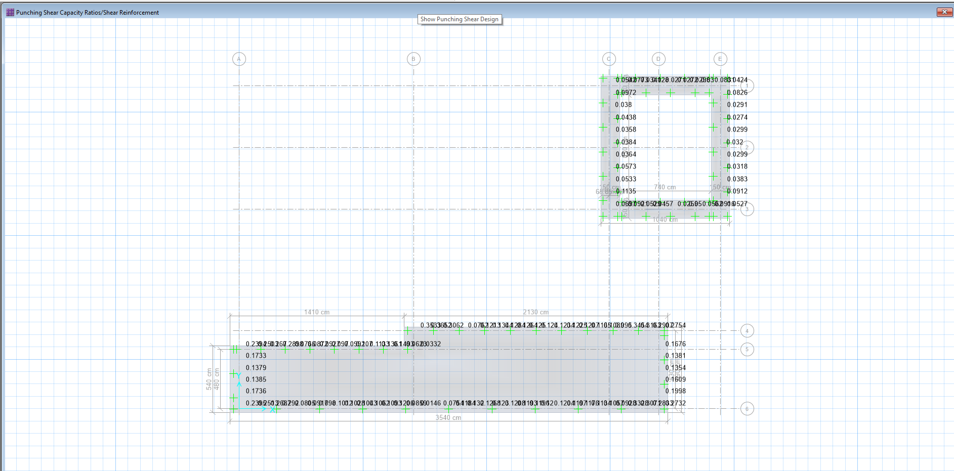

## Foundation Design

### Foundation reinforcement is calculated by software and add bars in X, Y direction are shown at below figure. Uniform Ф16@150 pattern is assigned for top and bottom of foundation in both directions and needed additional bars at some part that is presented in below pictures.

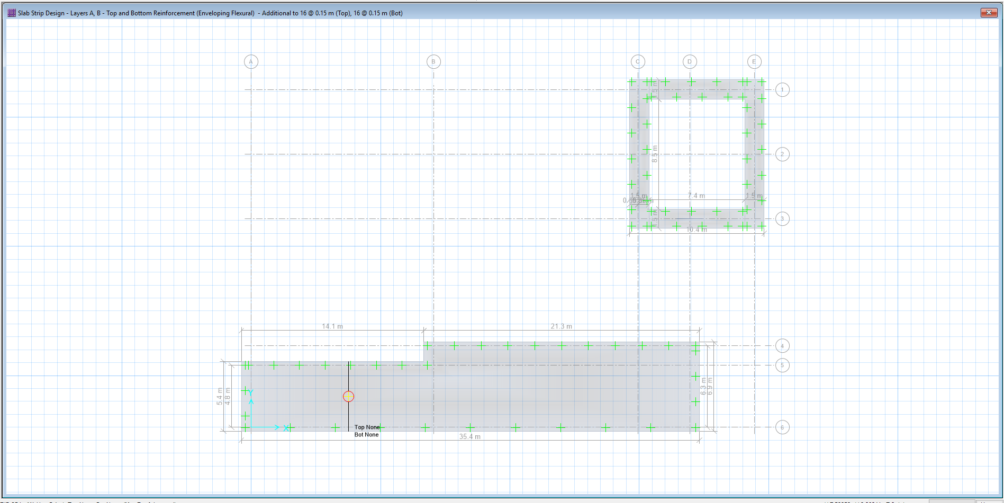

### Reinforcement in X, Y Direction

### In Both Directions:

### Top Bar USE Φ16@150 mm

### Bottom Bar USE Φ16@150 mm

### Minimum rebar for strip foundation:

$${ A}_{smin}=0.0018 bh=0.0018×100×70=12.60 cm^{2}/m$$

$$A_{s used}=∅16@150=2*14.07=28.15 cm^{2}$$

## OVERTURNING & SLIDING CONTROL

Foundations must be checked for overturning and sliding.

Overturning Control:

$$γ_{concrete}=2500 kg/m^{3}$$

Following loads for foundation:

* Southern Part of Building ,

MR =

W Found.1=[(21.3*6.9*0.7)*2.5 T/m3 ] = 257.2 Ton , MR Found.1=257.2*(21.3/2)= 2739.2 T.m

W Found.2=[(14.1*5.4*0.7)*2.5 T/m3 ] = 133.2 Ton , MR Found.2=133.2*(21.3+14.1/2)= 3777.5 T.m

W Wall.10= [(34.3*5.25)-(1.8*2.5) ]*0.4)*2.5 T/m3  = 175.5 Ton , MR Wall.10 =175.5*(34.3/2)= 3010.0 T.m

W Wall.9= [(20.2*5.25)-(2.6*2.5) ]*0.4)*2.5 T/m3 ] =99.5 Ton , MR Wall.9 =99.5*(20.2/2)= 1004.95 T.m

W Wall.8= [(1.1*5.25*0.4)*2.5 T/m3 ] =5.8 Ton , MR Wall.8 =5.8*20.55= 119.2 T.m

W Wall.7= [(14.5*5.25*0.4)*2.5 T/m3 ] = 76.12 Ton , MR Wall.7 =76.12*[ (20.35+14.5/2) ]= 2100.9 T.m

W Wall.6= [(5.9*5.25*0.4)*2.5 T/m3 ] = 31.0 Ton , MR Wall.6 =31.0*(1.5/2) = 23.25 T.m

W Wall.5= [(4.4*5.25*0.4)*2.5 T/m3 ] = 23.10 Ton , MR Wall.5 =23.1*34.65 = 800 T.m

W Roof =[ (14.1*5.2) +(20.2*6.7)]*0.4*2.5 T/m3 = 208.66 Ton , MR roof =208.66* 5.25= 1095.5 T.m

Σ MR= 14670.5 T.m

$$M0(EQ)=Ceq*W*h=0.117*[(175.5+99.5+5.8+76.12+31+23.1)*5.25/2+(208.66 *5.65)]=265 T.m$$

Mo Blast roof  =1.8131*[(14.1*5.2)+(20.2*6.7)]*5.65=2137.5 T.m

Mo Blast wall 10= 4.5195*(33.9*5.65)*(5.65/2) =2445.50 T.m

Σ Mo Blast =2137.5+2445.5=4583 T.m

$$SF BLAST= \frac{M_{R}}{M_{O Blast}}=\frac{14670.5 }{4583.0 }=3.2 > 1 .2 OK$$

$$SF EQ= \frac{M_{R}}{M_{O EQ}}=\frac{14670.5 }{265}=55.3 > 1 .7 OK$$

Sliding Control:

$$P_{Passive soil}=\left(\frac{1}{2}\right)*K_{Passive}*γ_{SOIL}*H^{2}*L_{Found. }=0.5*3*1.9*{1.7}^{2}*6.9=56.83 ton$$

$P_{SLIDING}=tan\left(φ*\frac{2}{3}\right)*W_{R TOTAL}=tan \left(30*0.66\right) *[ \left(257.2+133.2+175.5+99.5+5.8+76.12+31+23.10+208.66\right)]=0.364*1010.08=367.65 ton$

PR roof = (Rroof*Aroof)= 1.8131*[ (14.1*5.2) +(20.2*6.7) ]=378.3 ton

PR Total = 56.83+367.65+378.3 = 802.78 ton

PBlast = (Rwall*Awall1)above ground +(K0* Rwall* Awall1)under ground = [4.5196*(34.3*4.25)]+[0.5*4.5196*(34.3*1)] = 736.35 ton

$$SF sliding= \frac{P_{SLIDING}}{P_{BLAST}}=\frac{802.78}{736.35}=1.1 > 1.0 OK$$