|  |  |  |  |  |  |  |  |
| --- | --- | --- | --- | --- | --- | --- | --- |
| **طرح نگهداشت و افزایش تولید 27 مخزن** | | | | | | | |
| **CALCULATION NOTE FOR INDOOR AREA LIGHTING SYSTEM**  **نگهداشت و افزایش تولید میدان نفتی بینک** | | | | | | | |
| D05 | Oct.2024 | IFA | H.Shakiba | M.Fakharian | M.Sadeghian |  |
| D04 | Apr.2024 | IFA | H.Shakiba | M.Fakharian | S.Faramarzpour |  |
| D03 | May.2023 | IFA | H.Shakiba | M.Fakharian | A.M.Mohseni |  |
| D02 | Jan.2023 | IFA | H.Shakiba | M.Fakharian | M.Mehrshad |  |
| D01 | Nov. 2022 | IFA | H.Shakiba | M.Fakharian | M.Mehrshad |  |
| D00 | Apr. 2022 | IFC | H.Shakiba | M.Fakharian | M.Mehrshad |  |
| **Rev.** | **Date** | **Purpose of Issue/Status** | **Prepared by:** | **Checked by:** | **Approved by:** | **Client Approval** |
| **Class:2** | | **Client Doc. Number: F0Z-709008** | | | | |
| **Status:** | **IDC: Inter-Discipline Check**  **IFC: Issued For Comment**  **IFA: Issued For Approval**  **AFD: Approved For Design**  **AFC: Approved For Construction**  **AFP: Approved For Purchase**  **AFQ: Approved For Quotation**  **IFI: Issued For Information**  **AB-R: As-Built for Client Review**  **AB-A: As-Built –Approved** | | | | | |

**REVISION RECORD SHEET**

|  |  |  |  |  |  |  |  |  |  |  |  |  |
| --- | --- | --- | --- | --- | --- | --- | --- | --- | --- | --- | --- | --- |
| **PAGE** | **D01** | **D02** | **D03** | **D04** | **D05** |  | **PAGE** | **D01** | **D02** | **D03** | **D04** | **D05** |
| **1** | X | X | X | X | X | **51** |  |  |  |  |  |
| **2** | X | X | X | X | X | **52** |  |  |  |  |  |
| **3** |  |  |  |  |  | **53** |  |  |  |  |  |
| **4** |  |  |  |  |  | **54** |  |  |  |  |  |
| **5** | X |  |  | X |  | **55** |  |  |  |  |  |
| **6** | X |  |  |  |  | **56** |  |  |  |  |  |
| **7** | X |  |  |  |  | **57** |  |  |  |  |  |
| **8** | X | X | X |  |  | **58** |  |  |  |  |  |
| **9** |  |  |  | X | X | **59** |  |  |  |  |  |
| **10** |  |  |  | X |  | **60** |  |  |  |  |  |
| **11** |  |  |  |  |  | **61** |  |  |  |  |  |
| **12** |  |  |  |  |  | **62** |  |  |  |  |  |
| **13** |  |  |  |  |  | **63** |  |  |  |  |  |
| **14** |  |  |  |  |  | **64** |  |  |  |  |  |
| **15** |  |  |  |  |  | **65** |  |  |  |  |  |
| **16** |  |  |  |  |  | **66** |  |  |  |  |  |
| **17** |  |  |  |  |  | **67** |  |  |  |  |  |
| **18** |  |  |  |  |  | **68** |  |  |  |  |  |
| **19** |  |  |  |  |  | **69** |  |  |  |  |  |
| **20** |  |  |  |  |  | **70** |  |  |  |  |  |
| **21** |  |  |  |  |  | **71** |  |  |  |  |  |
| **22** |  |  |  |  |  | **72** |  |  |  |  |  |
| **23** |  |  |  |  |  | **73** |  |  |  |  |  |
| **24** |  |  |  |  |  | **74** |  |  |  |  |  |
| **25** |  |  |  |  |  | **75** |  |  |  |  |  |
| **26** |  |  |  |  |  | **76** |  |  |  |  |  |
| **27** |  |  |  |  |  | **77** |  |  |  |  |  |
| **28** |  |  |  |  |  | **78** |  |  |  |  |  |
| **29** |  |  |  |  |  | **79** |  |  |  |  |  |
| **30** |  |  |  |  |  | **80** |  |  |  |  |  |
| **31** |  |  |  |  |  | **81** |  |  |  |  |  |
| **32** |  |  |  |  |  | **82** |  |  |  |  |  |
| **33** |  |  |  |  |  | **83** |  |  |  |  |  |
| **34** |  |  |  |  |  | **84** |  |  |  |  |  |
| **35** |  |  |  |  |  | **85** |  |  |  |  |  |
| **36** |  |  |  |  |  | **86** |  |  |  |  |  |
| **37** |  |  |  |  |  | **87** |  |  |  |  |  |
| **38** |  |  |  |  |  | **88** |  |  |  |  |  |
| **39** |  |  |  |  |  | **89** |  |  |  |  |  |
| **40** |  |  |  |  |  | **90** |  |  |  |  |  |
| **41** |  |  |  |  |  | **91** |  |  |  |  |  |
| **42** |  |  |  |  |  | **92** |  |  |  |  |  |
| **43** |  |  |  |  |  | **93** |  |  |  |  |  |
| **44** |  |  |  |  |  | **94** |  |  |  |  |  |
| **45** |  |  |  |  |  | **95** |  |  |  |  |  |
| **46** |  |  |  |  |  | **96** |  |  |  |  |  |
| **47** |  |  |  |  |  | **97** |  |  |  |  |  |
| **48** |  |  |  |  |  | **98** |  |  |  |  |  |
| **49** |  |  |  |  |  | **99** |  |  |  |  |  |
| **50** |  |  |  |  |  | **100** |  |  |  |  |  |

**CONTENTS**

1.0 INTRODUCTION 4

2.0 GENERAL DEFINITION 4

3.0 Scope 5

4.0 NORMATIVE REFERENCES 5

**4.1** **Codes and Standards** 5

**4.2** **The Project reference Documents** 5

5.0 LANGUAGE AND SYSTEM OF UNITS 5

6.0 Design software 6

7.0 Conclusion 6

8.0 LIGHTING CALCULATION – dETAIL REPORT 9

1. **INTRODUCTION**

Binak oilfield in Bushehr province is a part of the southern oilfields of Iran, is located 20 km northwest of Genaveh city.

With the aim of increasing production of oil from Binak oilfield, an EPC/EPD Project has been defined by NIOC/NISOC and awarded to Petro Iran Development Company (PEDCO). Also PEDCO (as General Contractor) has assigned the EPC-packages of the Project to "Hirgan Energy - Design and Inspection" JV.

As a part of the Project, a New Gas Compressor Station (adjacent to existing Binak GCS) shall be constructed to gather of 15 MMSCFD (approx.) associated gases and compress & transfer them to Siahmakan GIS.

1. **GENERAL DEFINITION**

The following terms shall be used in this document.

|  |  |
| --- | --- |
| CLIENT: | National Iranian South Oilfields Company (NISOC) |
| PROJECT: | Binak Oilfield Development – Surface Fcilities; New Gas Compressor Station |
| EPD/EPC CONTRACTOR (GC): | Petro Iran Development Company (PEDCO) |
| EPC CONTRACTOR: | Joint Venture of : Hirgan Energy – Design & Inspection (D&I) Companies |
| VENDOR: | The firm or person who will fabricate the equipment or material. |
| EXECUTOR: | Executor is the party which carries out all or part of construction and/or commissioning for the project. |
| THIRD PARTY INSPECTOR (TPI): | The firm appointed by EPD/EPC Contractor (GC) and approved by COMPANY (in writing) for the inspection of goods. |
| SHALL: | Is used where a provision is mandatory. |
| SHOULD: | Is used where a provision is advisory only. |
| WILL: | Is normally used in connection with the action by Client rather than by an EPC/EPD Contractor, supplier or Vendor. |
| MAY: | Is used where a provision is completely discretionary. |

1. **Scope**

This specification describes the practices that shall be employed and the Standards that will be required to be met for the Indoor Lightings Illumination

1. **NORMATIVE REFERENCES**
   1. **Codes and Standards**

* IPS-E-EL-100 Engineering Standard For Electrical System Design (Industrial And Non-Industrial)
  1. **The Project reference Documents**
* BK-GNRAL-PEDCO-000-PR-DB-0001 Process Basis Of Design
* BK-GNRAL-PEDCO-000-EL-DC-0001 Electrical System Design Criteria
* BK-GNRAL-PEDCO-000-EL-SP-0007 Specification For Lighting & Small Power System
* BK-GCS-PEDCO-120-SA-PY-0002 Hazardous Area Classification Layout
* BK-GCS-PEDCO-120-AR-DW-0002 Architectural Detail Drawing for Extension of Existing Electrical Building
* BK-GCS-PEDCO-120-AR-DW-0003 Architectural Drawing for Gas Compressors Shelter
* BK-GCS-PEDCO-120-AR-DW-0004 Architectural Drawing for Chemical Injection Packages/Chemical Storage Shelter
* BK-GCS-PEDCO-120-AR-DW-0005 Architectural Drawing for Utility Shelter
* BK-GCS-PEDCO-120-AR-DW-0006 Architectural Drawing for Fire Water Pumps Shelter
* BK-GCS-PEDCO-120-AR-DW-0008 Architectural Drawing for CCTV Control Room-Binak GCS
* BK-GCS-PEDCO-120-AR-DW-0009 Architectural Drawing for CCTV Control Room-Binak DU
* BK-GCS-PEDCO-120-AR-DW-0010 Architectural Drawing for CCTV Rack Room- Binak PU
* BK-GCS-PEDCO-120-AR-DW-0011 Architectural Detail Drawing for Extension of Existing Control Building
* BK-GCS-PEDCO-120-AR-DW-0012 Architectural Detail Drawing for GCS Warehouse

1. **LANGUAGE AND SYSTEM OF UNITS**

All documentation, drawings, data, etc. furnished by the manufacturer shall be in English. SI metric system of measurement shall be used except for pipe and pipe fitting sizes, flange ratings and nozzle dimensions in which inch will be used.

1. **Design software**

Calculation is performed with version 4.13 of DIALUX Software.

1. **Conclusion**

According to IPS-E-EL-100, illumination level for each area has been lighted.

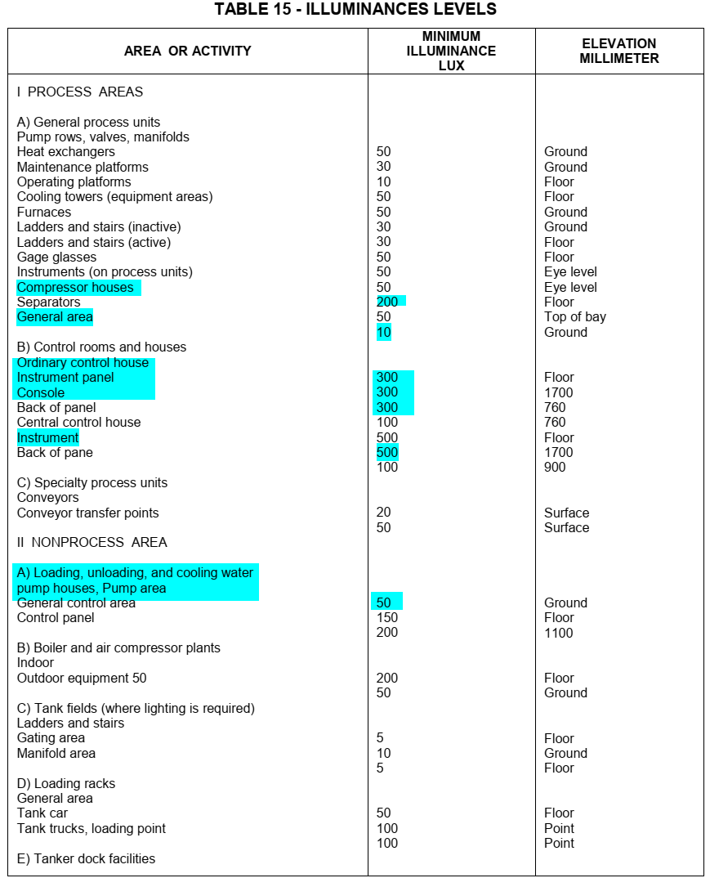

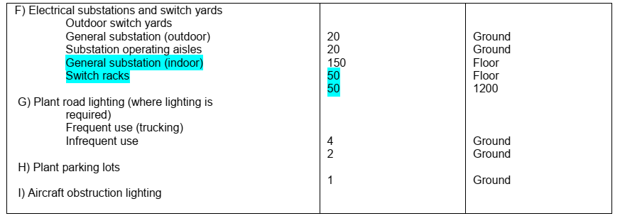

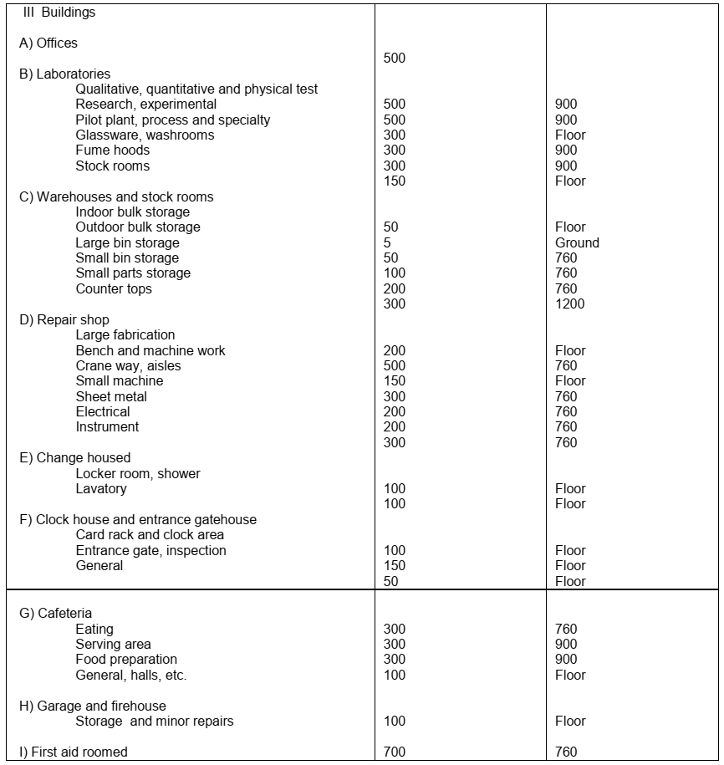

|  |  |  |  |  |
| --- | --- | --- | --- | --- |
| **Comparison of Lighting Between Standard & Calculation (LUX)** | | | | |
| **Item** | **Building** | **Room** | **Standard** | **Calculation (Av)** |
|  | Existing Control Room | UPS | 50 | 294 |
| Battery | 50 | 100 |
| Conference Room | 500 | 586 |
| Management | 500 | 430 |
| Entrance | 50 | 316 |
| Air Lock | 50 | 246 |
| Archive | 300 | 361 |
| Locker | 150 | 245 |
| Prayer Room | 150 | 244 |
| Store | 300 | 448 |
| Corridor | 50 | 291 |
|  | Existing Switchgear | Capacitor | 50 | 168 |
| CO2 | 50 | 89 |
| Transformer | 20 | 113 |
| Diesel Generator | 50 | 94 |
|  | GCS CCTV | Control Room | 500 | 521 |
|  | Rack Room | 200 | 423 |
|  | Corridor | 50 | 372 |
|  | DU CCTV | Control Room | 500 | 521 |
|  | Rack Room | 200 | 423 |
|  | Corridor | 50 | 372 |
|  | PU CCTV | Guard House | 500 | 695 |
|  | Rack Room | 200 | 443 |
|  | Utility Shelter | Shelter | 200 | 236 |
|  | Chemical Package | Shelter | 200 | 261 |
|  | Fire Water Pump | Shelter | 200 | 294 |
|  | Compressor Shelter | Shelter | 200 | 217 |
|  | Ware House | Storage | 100 | 242 |
|  | Instrument Workshop | 100 | 320 |
|  | Instrument Storage | 100 | 219 |

1. **LIGHTING CALCULATION – dETAIL REPORT**

D05

DIALUX report has been attached in “Attachments”

Attachment “01” - Existing Control Room Attachment “05” - CCTV PU

Attachment “02” - Existing Switchgear Attachment “06” - All Shelters Area

Attachment “03” - CCTV GCS Attachment “07” - Warehouse

Attachment “04” - CCTV DU