|  |  |  |  |  |  |  |
| --- | --- | --- | --- | --- | --- | --- |
| **طرح نگهداشت و افزایش تولید 27 مخزن** | | | | | | |
| **DATA SHEETS FOR CATHODIC PROTECTION SYSTEM**  **FOR SIAHMAKAN GAS INJECTION  نگهداشت و افزایش تولید میدان نفتی بینک** | | | | | | |
|  |  |  |  |  |  |  |
|  |  |  |  |  |  |  |
|  |  |  |  |  |  |  |
|  |  |  |  |  |  |  |
| D00 | Nov. 2024 | IFC | M.M.Aki | M.Fakharian | M.Sadegian |  |
| **Rev.** | **Date** | **Purpose of Issue/Status** | **Prepared by:** | **Checked by:** | **Approved by:** | **CLIENT Approval** |
| **Class: 1** | | **CLIENT Doc. Number:** **F0Z-708634** | | | | |
| **Status:** | **IDC: Inter-Discipline Check**  **IFC: Issued For Comment**  **IFA: Issued For Approval**  **AFD: Approved For Design**  **AFC: Approved For Construction**  **AFP: Approved For Purchase**  **AFQ:** Approved For Quotation  **IFI: Issued For Information**  **AB-R: As-Built for CLIENT Review**  **AB-A: As-Built –Approved** | | | | | |

**REVISION RECORD SHEET**

|  |  |  |  |  |  |  |  |  |  |  |  |  |
| --- | --- | --- | --- | --- | --- | --- | --- | --- | --- | --- | --- | --- |
| **PAGE** | **D00** | **D01** | **D02** | **D03** | **D04** |  | **PAGE** | **D00** | **D01** | **D02** | **D03** | **D04** |
| **1** | X |  |  |  |  | **51** |  |  |  |  |  |
| **2** | X |  |  |  |  | **52** |  |  |  |  |  |
| **3** | X |  |  |  |  | **53** |  |  |  |  |  |
| **4** | X |  |  |  |  | **54** |  |  |  |  |  |
| **5** | X |  |  |  |  | **55** |  |  |  |  |  |
| **6** | X |  |  |  |  | **56** |  |  |  |  |  |
| **7** | X |  |  |  |  | **57** |  |  |  |  |  |
| **8** | X |  |  |  |  | **58** |  |  |  |  |  |
| **9** | X |  |  |  |  | **59** |  |  |  |  |  |
| **10** | X |  |  |  |  | **60** |  |  |  |  |  |
| **11** | X |  |  |  |  | **61** |  |  |  |  |  |
| **12** | X |  |  |  |  | **62** |  |  |  |  |  |
| **13** | X |  |  |  |  | **63** |  |  |  |  |  |
| **14** | X |  |  |  |  | **64** |  |  |  |  |  |
| **15** | X |  |  |  |  | **65** |  |  |  |  |  |
| **16** | X |  |  |  |  | **66** |  |  |  |  |  |
| **17** | X |  |  |  |  | **67** |  |  |  |  |  |
| **18** |  |  |  |  |  | **68** |  |  |  |  |  |
| **19** |  |  |  |  |  | **69** |  |  |  |  |  |
| **20** |  |  |  |  |  | **70** |  |  |  |  |  |
| **21** |  |  |  |  |  | **71** |  |  |  |  |  |
| **22** |  |  |  |  |  | **72** |  |  |  |  |  |
| **23** |  |  |  |  |  | **73** |  |  |  |  |  |
| **24** |  |  |  |  |  | **74** |  |  |  |  |  |
| **25** |  |  |  |  |  | **75** |  |  |  |  |  |
| **26** |  |  |  |  |  | **76** |  |  |  |  |  |
| **27** |  |  |  |  |  | **77** |  |  |  |  |  |
| **28** |  |  |  |  |  | **78** |  |  |  |  |  |
| **29** |  |  |  |  |  | **79** |  |  |  |  |  |
| **30** |  |  |  |  |  | **80** |  |  |  |  |  |
| **31** |  |  |  |  |  | **81** |  |  |  |  |  |
| **32** |  |  |  |  |  | **82** |  |  |  |  |  |
| **33** |  |  |  |  |  | **83** |  |  |  |  |  |
| **34** |  |  |  |  |  | **84** |  |  |  |  |  |
| **35** |  |  |  |  |  | **85** |  |  |  |  |  |
| **36** |  |  |  |  |  | **86** |  |  |  |  |  |
| **37** |  |  |  |  |  | **87** |  |  |  |  |  |
| **38** |  |  |  |  |  | **88** |  |  |  |  |  |
| **39** |  |  |  |  |  | **89** |  |  |  |  |  |
| **40** |  |  |  |  |  | **90** |  |  |  |  |  |
| **41** |  |  |  |  |  | **91** |  |  |  |  |  |
| **42** |  |  |  |  |  | **92** |  |  |  |  |  |
| **43** |  |  |  |  |  | **93** |  |  |  |  |  |
| **44** |  |  |  |  |  | **94** |  |  |  |  |  |
| **45** |  |  |  |  |  | **95** |  |  |  |  |  |
| **46** |  |  |  |  |  | **96** |  |  |  |  |  |
| **47** |  |  |  |  |  | **97** |  |  |  |  |  |
| **48** |  |  |  |  |  | **98** |  |  |  |  |  |
| **49** |  |  |  |  |  | **99** |  |  |  |  |  |
| **50** |  |  |  |  |  | **100** |  |  |  |  |  |

**CONTENTS**

1.0 INTRODUCTION 4

2.0 Scope 5

3.0 NORMATIVE REFERENCES 5

3.1 Local Codes and Standards 5

3.2 International Codes and Standards 5

3.3 The Project Documents 6

3.4 ENVIRONMENTAL DATA 6

3.5 Order of Precedence 6

4.0 DATA SHEET for Permanent cathodic protection system 7

4.1 Junctions BOX 7

4.2 MMO TUBULAR ANODE 8

4.3 CABLES 9

4.4 PVDF/HMWPE CABLE 10

4.5 HANDY CAP 12

4.6 PRIMER 13

4.7 COKE 14

4.8 PORTABLE REFERNCE ELECTRODE CU/CUSO4 15

4.9 TRANSFORMER RECTIFIER 16

1. **INTRODUCTION**

Binak oilfield in Bushehr province is a part of the southern oilfields of Iran, is located 20 km northwest of Genaveh city.

With the aim of increasing production of oil from Binak oilfield, an EPC/EPD Project has been defined by NIOC/NISOC and awarded to Petro Iran Development Company (PEDCO). Also PEDCO (as General Contractor) has assigned the EPC-packages of the Project to "Hirgan Energy - Design and Inspection" JV.

As a part of the Project, New Gas/Condensate Pipelines (from Binak New GCS to Siahmakan GIS/Binak PU) shall be constructed.

**GENERAL DEFINITION**

The following terms shall be used in this document.

|  |  |
| --- | --- |
| CLIENT: | National Iranian South Oilfields Company (NISOC) |
| PROJECT: | Binak Oilfield Development – Surface Facilities; Gas & Gas-Condensate Pipelines |
| EPD/EPC CONTRACTOR (GC): | Petro Iran Development Company (PEDCO) |
| EPC CONTRACTOR: | Joint Venture of : Hirgan Energy – Design & Inspection(D&I) Companies |
| VENDOR: | The firm or person who will fabricate the equipment or material. |
| EXECUTOR: | Executor is the party which carries out all or part of construction and/or commissioning for the project. |
| THIRD PARTY INSPECTOR (TPI): | The firm appointed by EPD/EPC CONTRACTOR (GC) and approved by COMPANY (in writing) for the inspection of goods. |
| SHALL: | Is used where a provision is mandatory. |
| SHOULD: | Is used where a provision is advisory only. |
| WILL: | Is normally used in connection with the action by COMPANY rather than by an EPC/EPD CONTRACTOR, supplier or VENDOR. |
| MAY: | Is used where a provision is completely discretionary. |

1. **Scope**

This document covers Data Sheet of cathodic protection system of UG pipeline section from Gas Compressor station to Gas injection facility.

It shall be used in conjunction with data/requisition sheets for present document subject.

1. **NORMATIVE REFERENCES**

## Local Codes and Standards

* IPS-E-TP-820 Engineering Standard for Electrochemical Protection
* IPS-C-TP-820 Construction Standard for Cathodic Protection
* IPS-I-TP-820: Inspection Standard for Monitoring Cathodic Protection
* IPS-M-TP-750 Material and Equipment Standard For Cathodic Protection

## International Codes and Standards

* ASTM American Society for Testing Materials Relevant Parts
* API 610 Centrifugal Pumps for General Refinery Service, 10th Edition
* NACE SP 0169 Control of External Corrosion on Underground or Submerged Metallic Piping System.
* NACE-SP 0286 The Electrical Isolation of Cathodically Protected Pipelines.
* BS 7361(1991) Cathodic Protection Part 1. Code of Practice for Land and Marine Applications.
* NACE SP 0177 Mitigation of Alternating Current and Lightning Effects on Metallic Structures and Corrosion Control Systems.
* ISO 15589,1-2 Cathodic protection of pipeline transportation systems
* NACE SP 0502 External corrosion direct assessment (ECDA) process — assessing and reducing the impact of external corrosion on pipeline integrity.
* NACE SP 0207 Performing Close-Interval Potential Surveys and DC Surface Potential Gradient Surveys on Buried or Submerged Metallic Pipelines.
* NACE-SP0104 The Use of Coupons for Cathodic Protection Monitoring Applications

## The Project Documents

* BK-GCS-PEDCO-120-EL-CN-0008 Specification for Cathodic Protection System
* BK-GNRAL-PEDCO-HD-000-EL-DC-0001 Electrical System Design Criteria
* BK- GCS - PEDCO -320-GT-RT-0001 Geotechnical Report

## ENVIRONMENTAL DATA

Refer to "Process Basis of Design; Doc. No. BK-GNRAL-PEDCO-000-PR-DB-0001".

Cathodic Protection System shall be designed for use under the conditions specified as below:

R01

Ambient temperatures for equipment:

|  |  |
| --- | --- |
| Maximum design temperature indoor/outdoor (under sun shade) | +55°C |
| Minimum design temperature | -5°C |
| Maximum surface temperature exposed to the sun | 85°C |
| Maximum relative humidity | 100% |
| Altitude | <1000m above sea Level |
| Special Atmospheric Condition | dust and salt corrosive |

For the ambient conditions special care will be paid to:

* Enclosures of equipment for outdoor installation
* Painting and coating of metal parts to resist to the severe environmental conditions
* Any environmental derating factors shall be considered by vendor before design

## Order of Precedence

In case of conflict between requirements specified herein & the requirements of any other referenced document, the most approved stringent requirements of below listed items shall be considered based on the approval given by the owner’s representative:

Purchase order

Material Requisition

MTO & Data Sheet

This Specification

Drawing & Other Specification

Reference Project Specification

Iranian Petroleum Standard (IPS)

Reference international Code & Standards

When the term “Authorized”, Authorization”, “Approval”, or “Approved” are used in this specification, it shall mean authorization or Approval from OWNER.

In case of any conflict between the project documents, the most stringent one shall be considered.

1. **DATA SHEET for Permanent cathodic protection system**

## Junctions BOX

|  |  |
| --- | --- |
| TECHNICAL DATA | |
| 1-GENERAL: | REQUIRED |
| 1-1 Explosion Proof/ Industrial | Safe Area |
| 1-2 Location/ Service | Outdoor |
| 1-3 Degree of Ingress Protection (Minimum) | IP55 |
| 1-4 Manufacturer/ Country | AS per Sub vendor list / IRAN |
| 2-ENCLOSURE CHARACTRISTICS: |  |
| 2-1 Enclosure Material | Mild steel |
| 2-2 Enclosure Thickness | 3 mm |
| 2-3 Direction of Door Opening | Full Open Door |
| 3- CABLE ENTRY |  |
| 3-1 Number of Entry | Maximum 8 No. Terminals |
| 4-ACCESSORIES: |  |
| 4-1 Name Plate | yes |
| 5-SUPPORT: |  |
| 5-1 Material | Mild Steel, Hot deep Galvanized U Type |
| 5-2 Approximate Length | 1500 mm |
| 6- PAINT SYSTEM |  |
| Electro Static | 80 micron $□$ |
| 3 Layers Paint | 270 micron as per vendor`s painting procedure ■ |
| RAL Color | 1018 , 7032 ,7035 |

## MMO TUBULAR ANODE

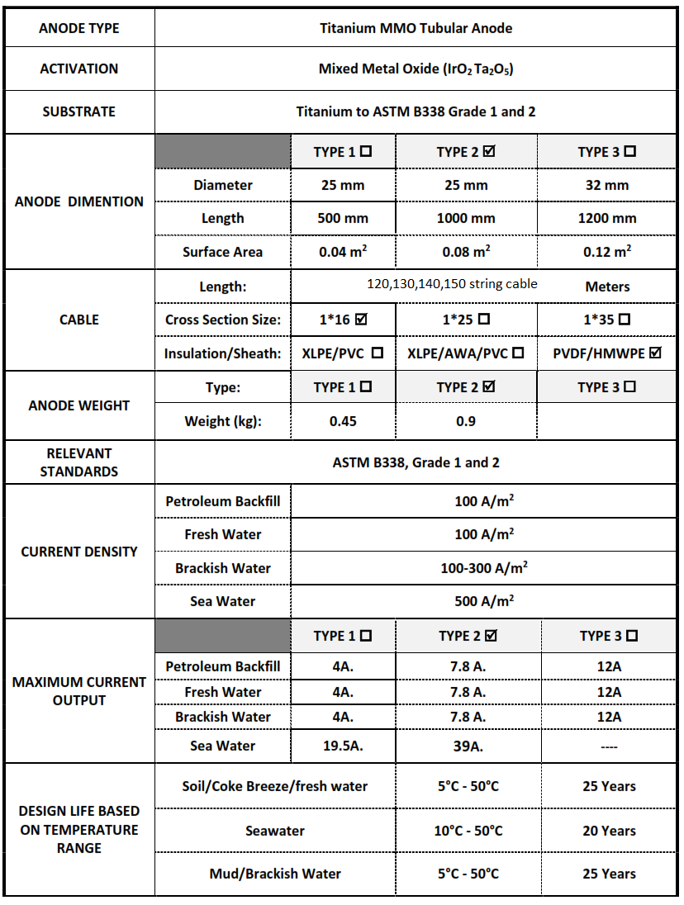

## CABLES

|  |  |
| --- | --- |
| TECHNICAL DATA | |
| 1- GENERAL: |  |
| 1-1 Location/ Service | Buried in Soil/conduit |
| 1-2 Manufacturer/ Country | AS per Sub vendor list / Iran |
| 1-3 Service Life | 25 Years at Least |
| 2- MATERIAL: |  |
| 2-1 Conductor | Annealed Copper |
| 2-2 Insulation | Cross Linked Polyethylene (XLPE) |
| 2-3 Sheath (Jacket) | Poly Vinyl Chloride (PVC) |
| 3- CABLE SIZE: |  |
| 3-1 Negative Cable | 1x35 mm2 |
| 3-2 Test Cable | 1×16 mm2 |
| 3-4 Anode Cable | 1×16 mm2 (PVDF/HMWPE) |
| 4- ELECTERICAL PROPERTIES: |  |
| 4-1 Voltage Rating (U0/Um) | 0.6/1.0 kV |
| 4-2 Max. Conductor Resistance For 1×16mm2 Cable | 1.79 ohm /km (@ 20° C) |
| 4-3 Max. Conductor Resistance For 1×35mm2 Cable | 0.868 ohm /km (@ 20° C) |
| 5- DIMENSION: |  |
| 5-1 App. Overall dia. for 1×16mm2 Cable | 9.2 mm |
| 5-2 App. Overall dia. for 1×25mm2 Cable | 11.1 mm |
| 5-3 App. Overall dia. for 1×50mm2 Cable | 13.7 mm |
| 6- FINAL COLOR: |  |
| 6-1 Negative Cable | Black |
| 6-2 Test Cable | Black |
| 6-3 Anode Cable | Black |

## PVDF/HMWPE CABLE

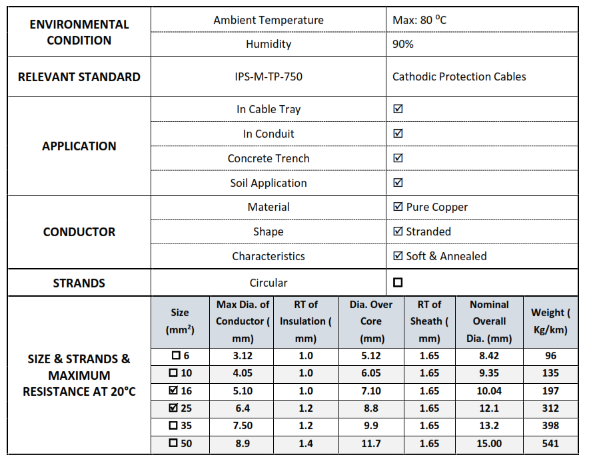

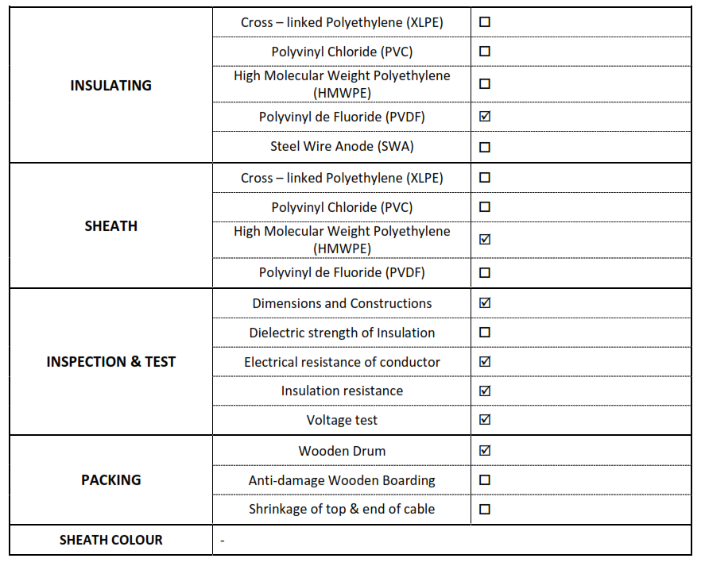

## HANDY CAP

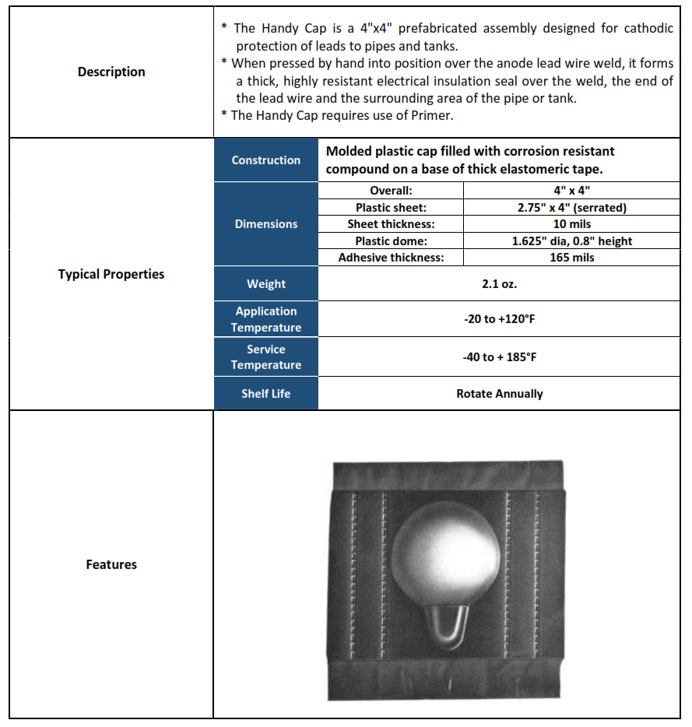

## PRIMER

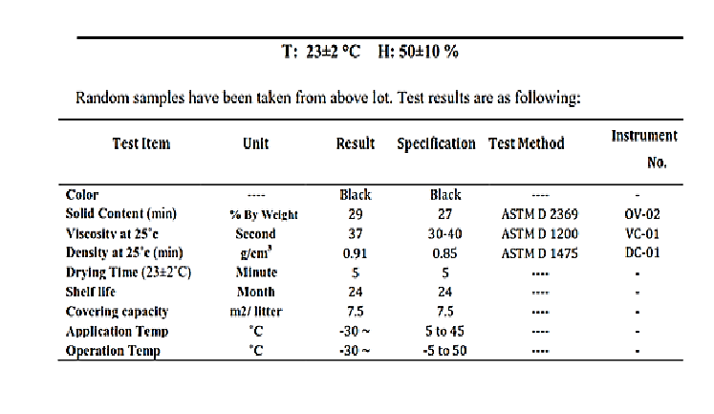

## COKE

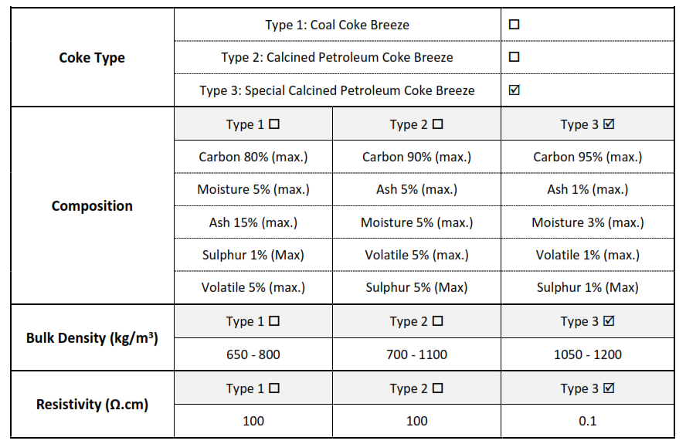

## PORTABLE REFERNCE ELECTRODE CU/CUSO4

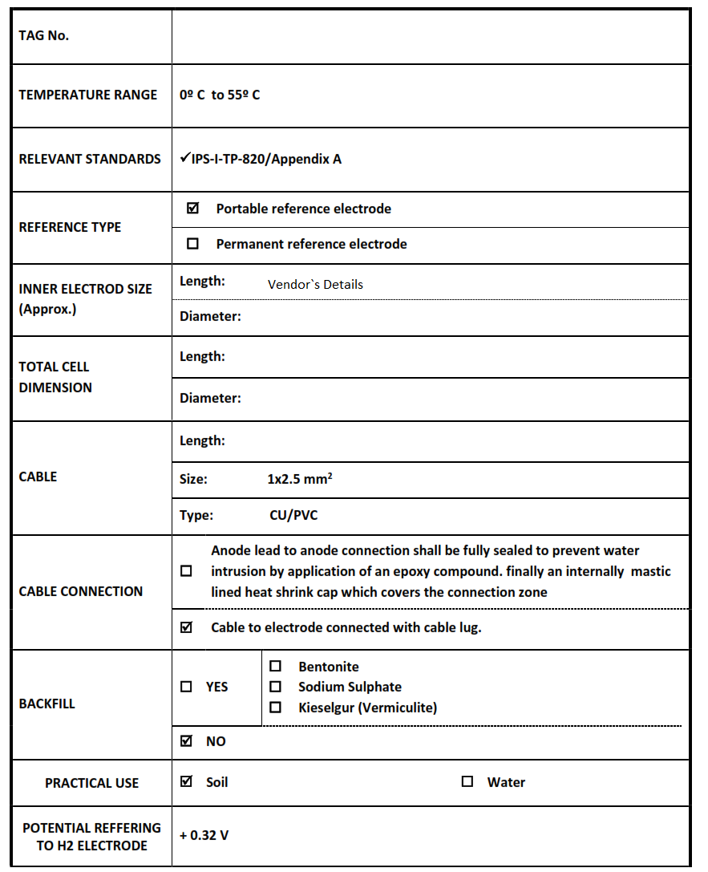

## TRANSFORMER RECTIFIER

| **Data Sheets for Transformer Rectifier of Pipeline**  D02 | | | |
| --- | --- | --- | --- |
| **Item** | **Description** | **Purchaser Requirement** | **Manufacturer Data** |
| **1- General Information** | | | |
|  | Applicable Standards | IPS-M-TP-750  IPS-E-TP-820  IPS-C-TP-820  NIOEC-SP-60-24  IPS-M-EL-150  IEC-60146 |  |
|  | Manufacturer's Name | By Vendor |  |
| **2- Environmental** **Conditions** | | | |
|  | Location | Binak |  |
|  | Hazardous Area Classification | Safe |  |
|  | Max. Outdoor Ambient Temperature | 43.3°C |  |
|  | Minimum Indoor Ambient Temp. | -20°C |  |
|  | Maximum Indoor Relative Humidity | 85% |  |
|  | Installation | Outdoor |  |
|  | Special Atmospheric Condition | Dust and Industrial Corrosive |  |
| **3- Transformer Rectifier** | | | |
|  | Explosion Proof/ Industrial | Safe Outdoor |  |
|  | Manufacturer/ Country | AS per Sub Vendor List / Iran |  |
|  | Enclosure Material | Mild Steel |  |
|  | Enclosure Thickness | 2 mm |  |
|  | Surface Preparation | Sand Blast SA 2.5 |  |
|  | Color: | RAL7032 |  |
| Thickness 270 micron |  |
|  | Name Plate | Stainless Steel & Attached with Mechanical Non‐Corrosive Hardware |  |
|  | Mounting | Plinth mounted |  |
|  | Protection | IP55 |  |
| **3-1 Electrical Characteristics** | | | |
|  | AC Input rating | Ph:3 Current: 2 A Voltage: 400V ± 10% /  Frequency: 50 Hz ± 5 % |  |
|  | DC Output Rating & Control type | Voltage: 50 V Current: 100 A  Ripple Rate (RMS ripple/DC output): 5%  Quantity of channels: 1  DC output control: □ manual ■ Automatic  Constant voltage ■  Constant current ■  Constant Potential (auto-potential) ■  Manual voltage controlled (Variac or Step) □ |  |
|  | Rectifying Unit | Stack elements : Selenium □ Silicon ■  Rectification:  Mode: Full Wave  Ratings: 3P, 1200V |  |
|  | Timer circuit | Internal |  |
|  | Intervals | ON: Multi Range OFF: Multi Range |  |
|  | Terminals | AC : 4 × RTP6 DC: 4 × RTP35 |  |
|  | Auxiliaries & Accessories | Induced filter■ Capacitive filter □ Free Wheeling■ Diode Surge ■ Protection (AC and DC sides) ■  Sunshade ■ Installation base ■ Lifting Hugs ■ Oil drain Valve ■ Oil level Indicator ■ |  |
|  | Double Wound Transformer Rating | Ph: 3 Frequency: 50 Hz Cos Ф: 0.9  Apparent Power: 5 kVA Efficiency: 90 %  Primary input voltage: 400 V  Primary input current: 7.2 A  Second output voltage: 42 V Second output current: 93.1 A  Isolation: Double wounded Electro static shield:  5 KV  Insulation class: F Maximum Inrush current: 15 A |  |
|  | Measuring Instruments | Measurement device: Analogue ■ Digital □  AC input voltmeter ■ scaled from 0 to 500 Vac  DC output Voltmeter ■ scaled from 0 to 25 V  DC output Ammeter ■ scaled from 0 to 25 A  Reference cell voltage ■ scaled from 0 to 3 V |  |
|  | Protections | Input thermo magnetic circuit breaker ■  Rectifier HRC fuse ■  Output HRC fuse ■  Voltmeter fuse ■  Controller fuse ■  Overload protection ■ |  |