|  |  |  |  |  |  |  |  |
| --- | --- | --- | --- | --- | --- | --- | --- |
| **طرح نگهداشت و افزایش تولید 27 مخزن** | | | | | | | |
| **CALCULATION NOTE FOR TANK FOUNDATION (TK-2301 A/B)**  **نگهداشت و افزایش تولید میدان نفتی بینک** | | | | | | | |
| D04 | | DEC. 2024 | AFD | R.Berlouie | M.Fakharian | M.Sadeghian |  |
| D03 | | MAY. 2024 | AFD | R.Berlouie | M.Fakharian | M.Sadeghian |  |
| D02 | | FEB. 2024 | IFA | R.Berlouie | M.Fakharian | S.Faramarzpour |  |
| D01 | | OCT. 2023 | IFA | R.Berlouie | M.Fakharian | S.Faramarzpour |  |
| D00 | | SEP. 2023 | IFC | R.Berlouie | M.Fakharian | A.M.Mohseni |  |
| **Rev.** | | **Date** | **Purpose of Issue/Status** | **Prepared by:** | **Checked by:** | **Approved by:** | **CLIENT Approval** |
| **Class:2** | | | **COMPANY Doc. Number:** **F0Z-709122** | | | | |
| **Status:** | | **IDC: Inter-Discipline Check**  **IFC: Issued For Comment**  **IFA: Issued For Approval**  **AFD: Approved For Design**  **AFC: Approved For Construction**  **AFP: Approved For Purchase**  **AFQ:** Approved For Quotation  **IFI: Issued For Information**  **AB-R: As-Built for CLIENT Review**  **AB-A: As-Built –Approved** | | | | | |

**REVISION RECORD SHEET**

|  |  |  |  |  |  |  |  |  |  |  |  |  |
| --- | --- | --- | --- | --- | --- | --- | --- | --- | --- | --- | --- | --- |
| **PAGE** | **D00** | **D01** | **D02** | **D03** | **D04** |  | **PAGE** | **D00** | **D01** | **D02** | **D03** | **D04** |
| **1** | X | X | X | X | X | **66** |  |  |  |  |  |
| **2** | X | X | X | X | X | **67** |  |  |  |  |  |
| **3** | X | X |  |  |  | **68** |  |  |  |  |  |
| **4** | X |  |  |  |  | **69** |  |  |  |  |  |
| **5** | X |  |  |  |  | **70** |  |  |  |  |  |
| **6** | X |  | X |  | X | **71** |  |  |  |  |  |
| **7** | X |  |  |  | X | **72** |  |  |  |  |  |
| **8** | X |  |  |  | X | **73** |  |  |  |  |  |
| **9** | X |  | X |  | X | **74** |  |  |  |  |  |
| **10** | X |  | X |  | X | **75** |  |  |  |  |  |
| **11** | X |  | X |  | X | **76** |  |  |  |  |  |
| **12** | X |  | X |  | X | **77** |  |  |  |  |  |
| **13** | X |  | X |  | X | **78** |  |  |  |  |  |
| **14** | X |  |  |  |  | **79** |  |  |  |  |  |
| **15** | X |  |  |  | X | **80** |  |  |  |  |  |
| **16** | X |  | X |  | X | **81** |  |  |  |  |  |
| **17** | X |  | X |  | X | **82** |  |  |  |  |  |
| **18** | X |  |  |  | X | **83** |  |  |  |  |  |
| **19** | X |  |  |  | X | **84** |  |  |  |  |  |
| **20** | X |  |  |  | X | **85** |  |  |  |  |  |
| **21** | X |  |  |  | X | **86** |  |  |  |  |  |
| **22** | X |  | X |  | X | **87** |  |  |  |  |  |
| **23** | X |  |  |  | X | **88** |  |  |  |  |  |
| **24** | X |  |  |  | X | **89** |  |  |  |  |  |
| **25** |  | X |  |  | X | **90** |  |  |  |  |  |
| **26** |  | X |  |  | X | **91** |  |  |  |  |  |
| **27** |  | X |  |  | X | **92** |  |  |  |  |  |
| **28** |  |  |  |  | X | **93** |  |  |  |  |  |
| **29** |  |  |  |  | X | **94** |  |  |  |  |  |
| **30** |  |  |  |  |  | **95** |  |  |  |  |  |
| **31** |  |  |  |  |  | **96** |  |  |  |  |  |
| **32** |  |  |  |  |  | **97** |  |  |  |  |  |
| **33** |  |  |  |  |  | **98** |  |  |  |  |  |
| **34** |  |  |  |  |  | **99** |  |  |  |  |  |
| **35** |  |  |  |  |  | **100** |  |  |  |  |  |
| **36** |  |  |  |  |  | **101** |  |  |  |  |  |
| **37** |  |  |  |  |  | **102** |  |  |  |  |  |
| **38** |  |  |  |  |  | **103** |  |  |  |  |  |
| **39** |  |  |  |  |  | **104** |  |  |  |  |  |
| **40** |  |  |  |  |  | **105** |  |  |  |  |  |
| **41** |  |  |  |  |  | **106** |  |  |  |  |  |
| **42** |  |  |  |  |  | **107** |  |  |  |  |  |
| **43** |  |  |  |  |  | **108** |  |  |  |  |  |
| **44** |  |  |  |  |  | **109** |  |  |  |  |  |
| **45** |  |  |  |  |  | **110** |  |  |  |  |  |
| **46** |  |  |  |  |  | **111** |  |  |  |  |  |
| **47** |  |  |  |  |  | **112** |  |  |  |  |  |
| **48** |  |  |  |  |  | **113** |  |  |  |  |  |
| **49** |  |  |  |  |  | **114** |  |  |  |  |  |
| **50** |  |  |  |  |  | **115** |  |  |  |  |  |
| **51** |  |  |  |  |  | **116** |  |  |  |  |  |
| **52** |  |  |  |  |  | **117** |  |  |  |  |  |
| **53** |  |  |  |  |  | **118** |  |  |  |  |  |
| **54** |  |  |  |  |  | **119** |  |  |  |  |  |
| **55** |  |  |  |  |  | **120** |  |  |  |  |  |
| **56** |  |  |  |  |  | **121** |  |  |  |  |  |
| **57** |  |  |  |  |  | **122** |  |  |  |  |  |
| **58** |  |  |  |  |  | **123** |  |  |  |  |  |
| **59** |  |  |  |  |  | **124** |  |  |  |  |  |
| **60** |  |  |  |  |  | **125** |  |  |  |  |  |
| **61** |  |  |  |  |  | **126** |  |  |  |  |  |
| **62** |  |  |  |  |  | **127** |  |  |  |  |  |
| **63** |  |  |  |  |  | **128** |  |  |  |  |  |
| **64** |  |  |  |  |  | **129** |  |  |  |  |  |
| **65** |  |  |  |  |  | **130** |  |  |  |  |  |

**CONTENTS**

1.0 Scope 4

2.0 NORMATIVE REFERENCE 4

3.0 Material properties 5

4.0 Computer software 5

5.0 Geometry 6

6.0 DESIGN LOAD 7

7.0 Design Load Combinations 12

8.0 Tank ANALYSIS AND DESIGN 15

9.0 Reinforcing 21

10.0 ATTACHMENTS 27

**INTRODUCTION**

Binak oilfield in Bushehr province is a part of the southern oilfields of Iran, is located 20 km northwest of Genaveh city.

With the aim of increasing production of oil from Binak oilfield, an EPC/EPD Project has been defined by NIOC/NISOC and awarded to Petro Iran Development Company (PEDCO). Also PEDCO (as General Contractor) has assigned the EPC-packages of the Project to "Hirgan Energy - Design and Inspection" JV.

1. **Scope**

This report covers design of Fire Water Storage Tanks (TK-2301A/B). The calculation of foundation is performed using “SAP” software.

1. **NORMATIVE REFERENCE**
   1. **Local Codes and Standards**

* INBC Part 6 “Iranian National Building Code
* INBC Part 7 “Iranian National Building Code
* INBC Part 9 “Iranian National Building Code
* INBC Part 10 “Iranian National Building Code
* Iranian Seismic Design Code for Petroleum Facilities(3rd edition)
  1. **International Codes and Standards**
* ASCE 7-10 “Minimum Design Loads and Associated Criteria for Buildings and Other Structures-American Society of Civil Engineers”.
* ACI 318. “Building Code Requirements for Reinforced Concrete”, American Concrete Institute.
* AISC 358 “Prequalified Connections for Special and Intermediate Steel Moment Frames for Seismic Applications.” American Institute of Steel Construction, Inc.
* AISC 360 - “Specification for Structural Steel Buildings”. American Institute of Steel Construction, Inc.
  1. **The Project Documents**
* BK-GNRAL-PEDCO-000-ST-SP-0001 SPECIFICATION FOR CONCRETE WORK
* BK-GNRAL-PEDCO-000-ST-DC-0001 Structural Design Criteria
* BK-GNRAL-PEDCO-000-CV-SP-0004 Specification For Earth Work
* BK-GCS-PEDCO-120-GT-RT-0001 Geotechnical Investigation Report for Compressor Station

1. **Material properties**

Material properties are delivered in the following table.

|  |  |
| --- | --- |
| Material properties | |
| Structure and Foundation concrete | F’c=300kg/cm²(28 days cylindrical sample) |
| Long. Reinforcement | Fy=4000 kg/cm² (AIII) |
| Trans. Reinforcement | Fy=4000 kg/cm² (AIII) |

1. **Computer software**

Computer’s Software, which is used in structure and foundation analysis and design, are defined in the following table.

|  |  |
| --- | --- |
| Computer software | |
| analysis and design of structure and foundation | SAP 20.1.0 |

1. **Geometry**

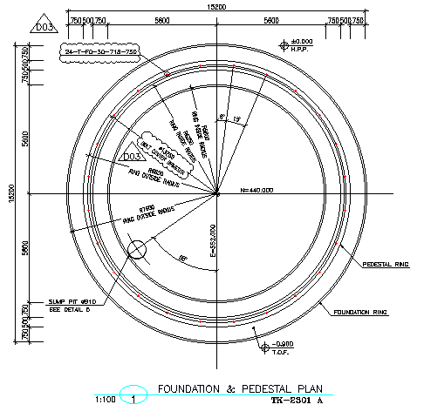

D04

1. **foundation and pedestal plan for TK-2301-A**

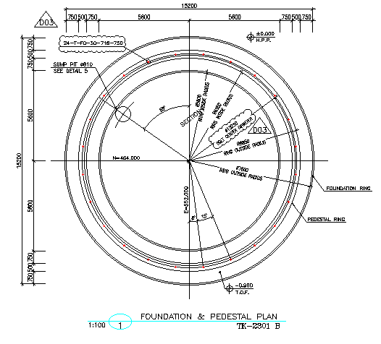

1. **foundation and pedestal plan for TK-2301-B**
2. **DESIGN LOAD**

D04

* 1. Load case for tank foundation design

The loads that apply on the foundation, according to tank design report (annex I), are as following:

|  |  |  |  |  |
| --- | --- | --- | --- | --- |
| Anchor Bolt data | | | | |
| anchor bolt dia. | M30 |  | | |
| No. of anchor bolt | 24 |  | | |
| BCD | 13250 | mm | | |
| foundation load data | | | | |
| Seismic | Shear (N) |  | 1,963,990 | N |
| Moment (N.m) | Ring wall | 6,929,589 | N.m |
| Slab | 10,790,497 | N.m |
| wind | Shear (N) | | 456,771 | N |
| Moment (N.m) | | 2,682,225 | N.m |
| Weight | Empty | | 50,485 | Kg |
| Operating | | 1,090,485 | Kg |
| Hydrotest | | 1,310,485 | Kg |

* 1. **Ds (Total Dead Load of Structure and Foundation & Soil overburden)**

Soil overburden:

Soil Pressure on Ring wall:

Ds = 0.5 × 1.85 × (1.5) = 1.40 ton/m²

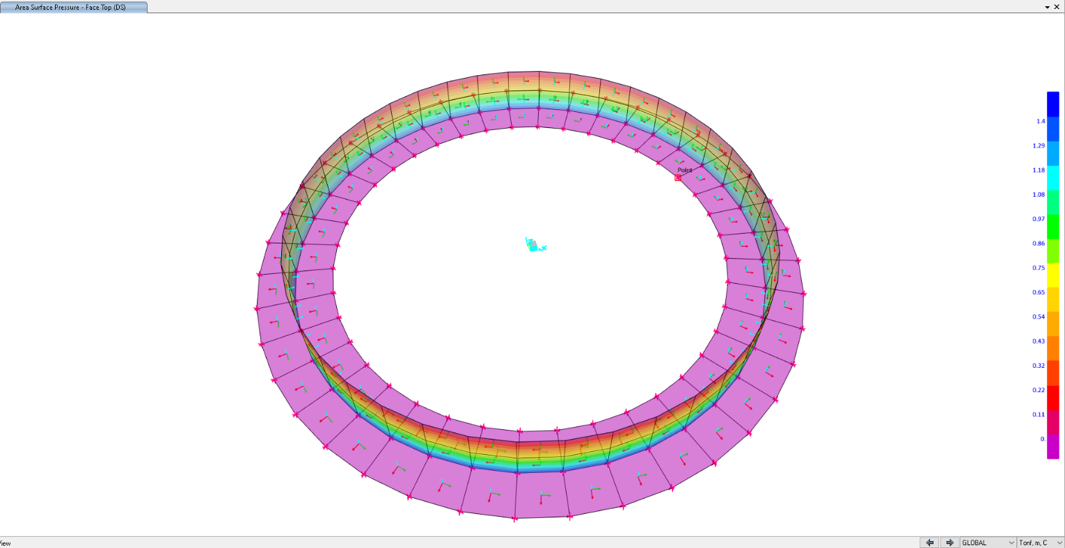

1. **area surface pressure for ring wall (face top)**
   1. **F (Normal Fluid Load)**

Normal Fluid Load on ring foundation:

F = (Ope load / area of ring foundation) → area of ring foundation: (𝜋 × 13.25²)/4=137.88

1090485/137.88=7.90 ton/m²

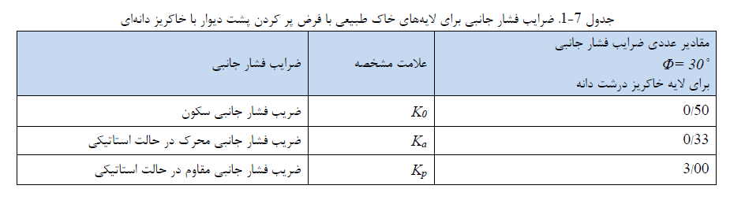

Soil Pressure Due to Normal Fluid Load on Ring wall:

F = 7.90× (Kₒ = 0.5) = 3.954 t/m²

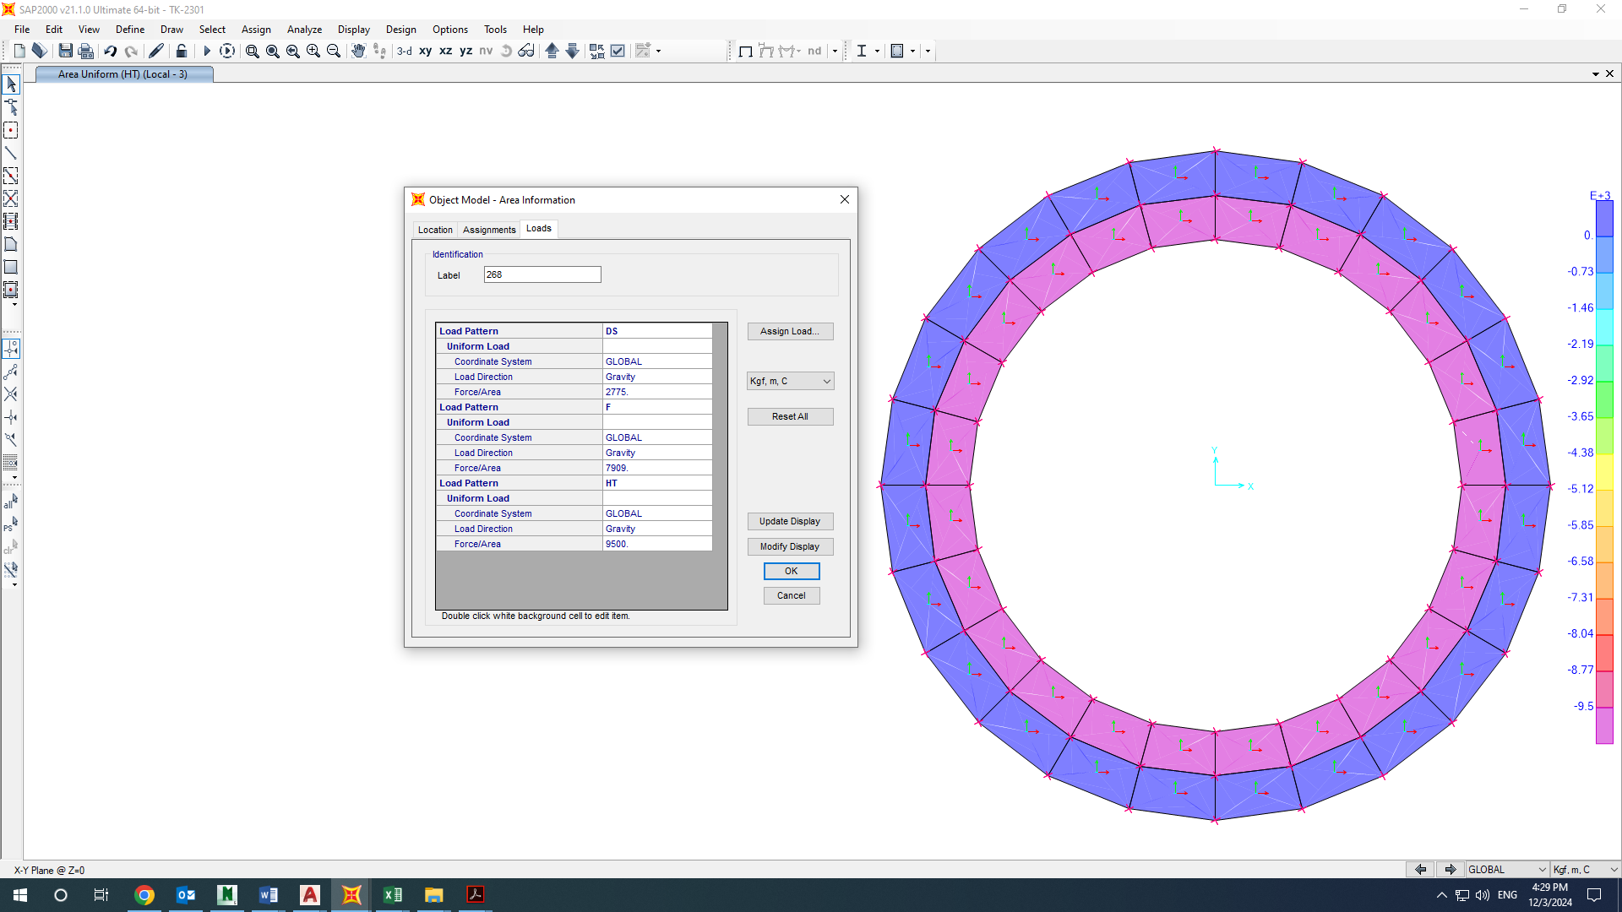

1. **Area uniform F load on the inside ring foundation**

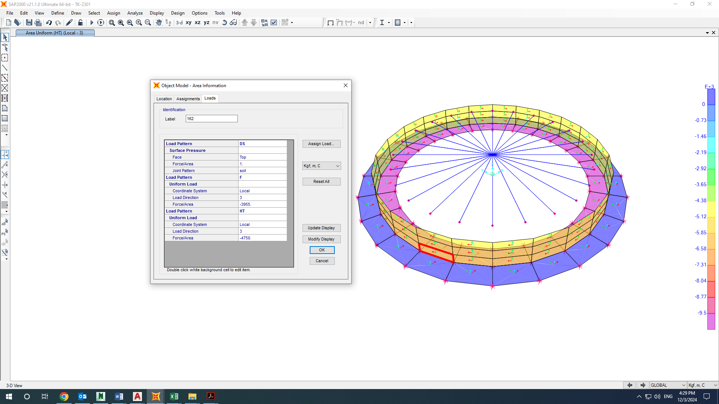

1. **Area uniform F load on the ring wall** 
   1. **HT (Test Fluid Load)**

Test Load on ring foundation:

HT = Hydro test load / area of ring foundation → area of ring foundation: (𝜋 × 13.25²)/4=137.88 m2 → 1310485/ 137.88 = 9.50 ton/m²

Soil Pressure Due to Test Fluid Load on Ring wall:

HT = 9.50 × (Kₒ = 0.5) = 4.75 t/m²

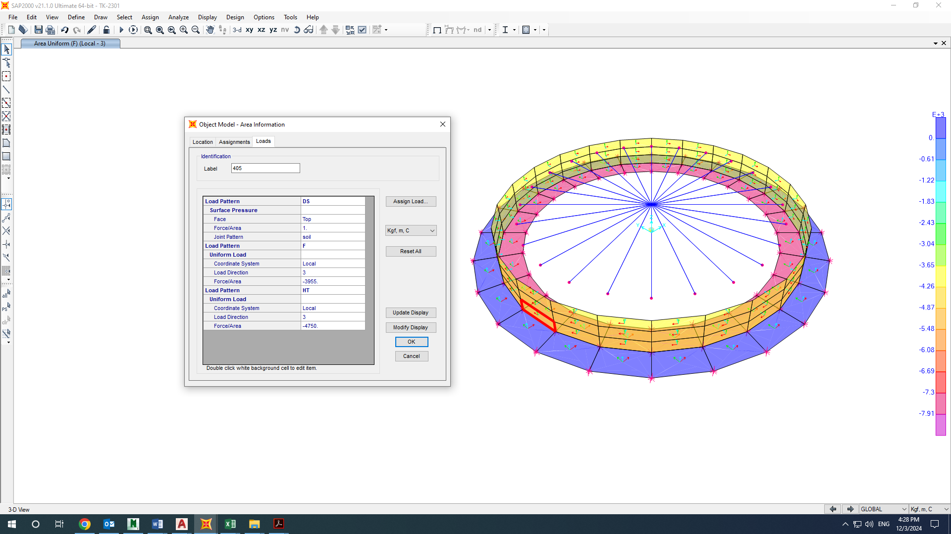

1. **area uniform HT load on the inside ring foundation**

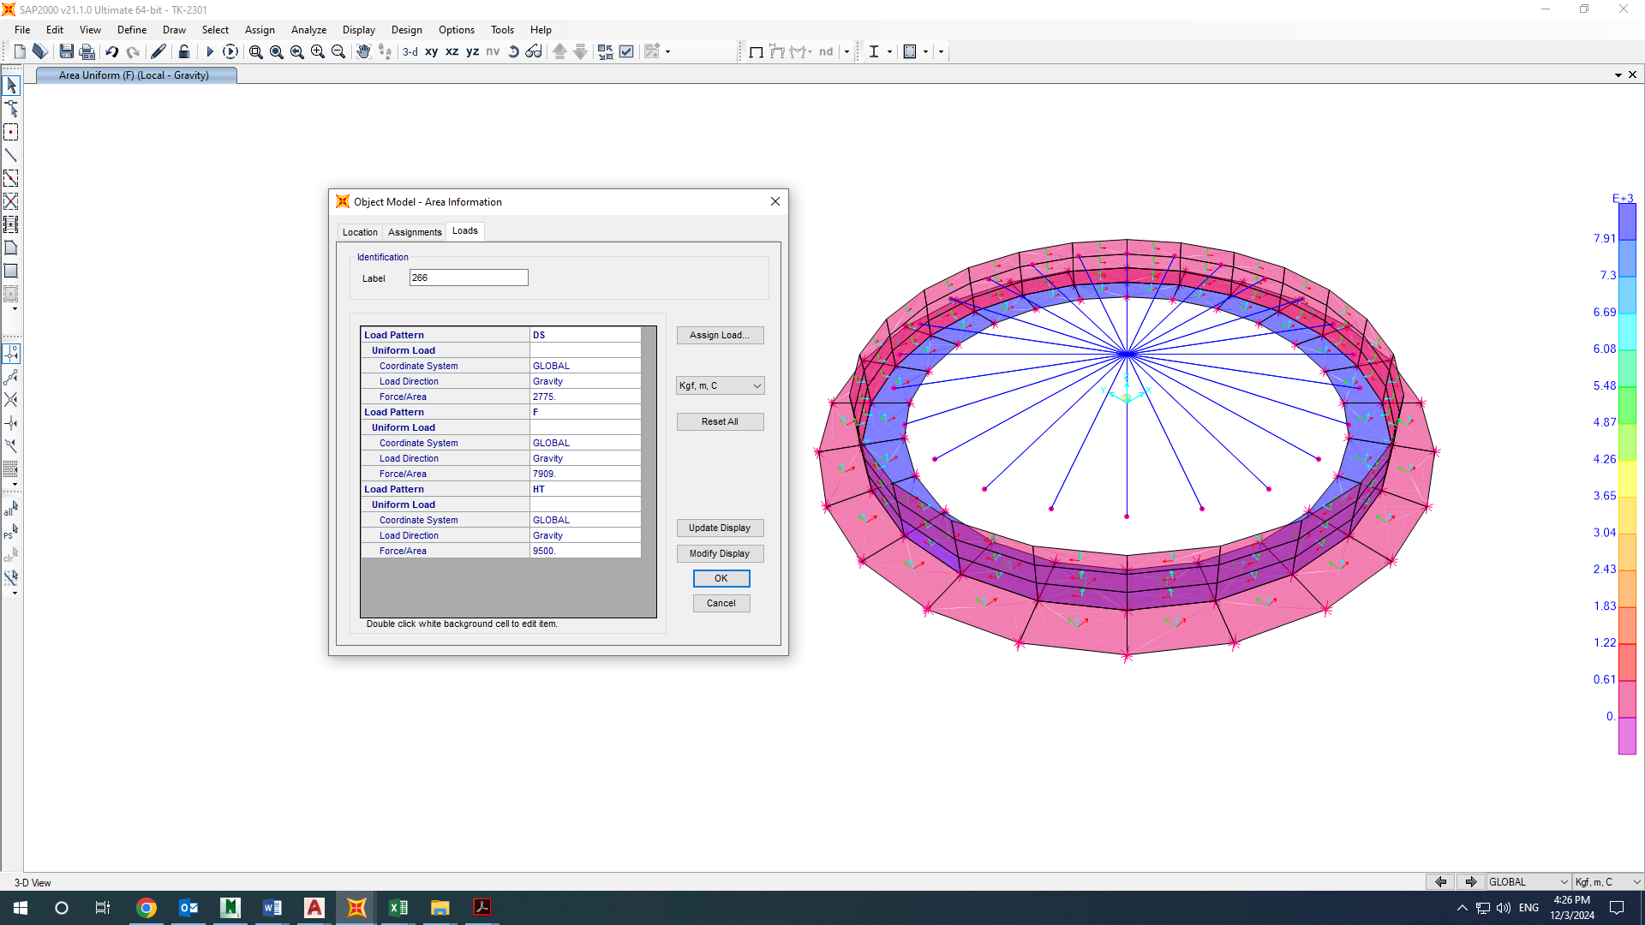

1. **area uniform HT load on the ring wall** 
   1. **E (Earthquake Load)**

Shear load = 1963990 N (based on Mechanical Data Sheet for fire water storage Tanks (TK-2301 A/B).

This shear is based on the datasheet, but we used API650 with ASD behavior coefficient so its value is multiplied by 1.4 → 1963990  1.4 = 2749586 N

Moment = 6929589 N.m (based on Mechanical Data Sheet for fire water storage Tanks (TK-2301 A/B).

This moment is based on the datasheet, but we used API650 with ASD behavior coefficient so its value is multiplied by 1.4 → 6929589  1.4 = 9701424 N.m

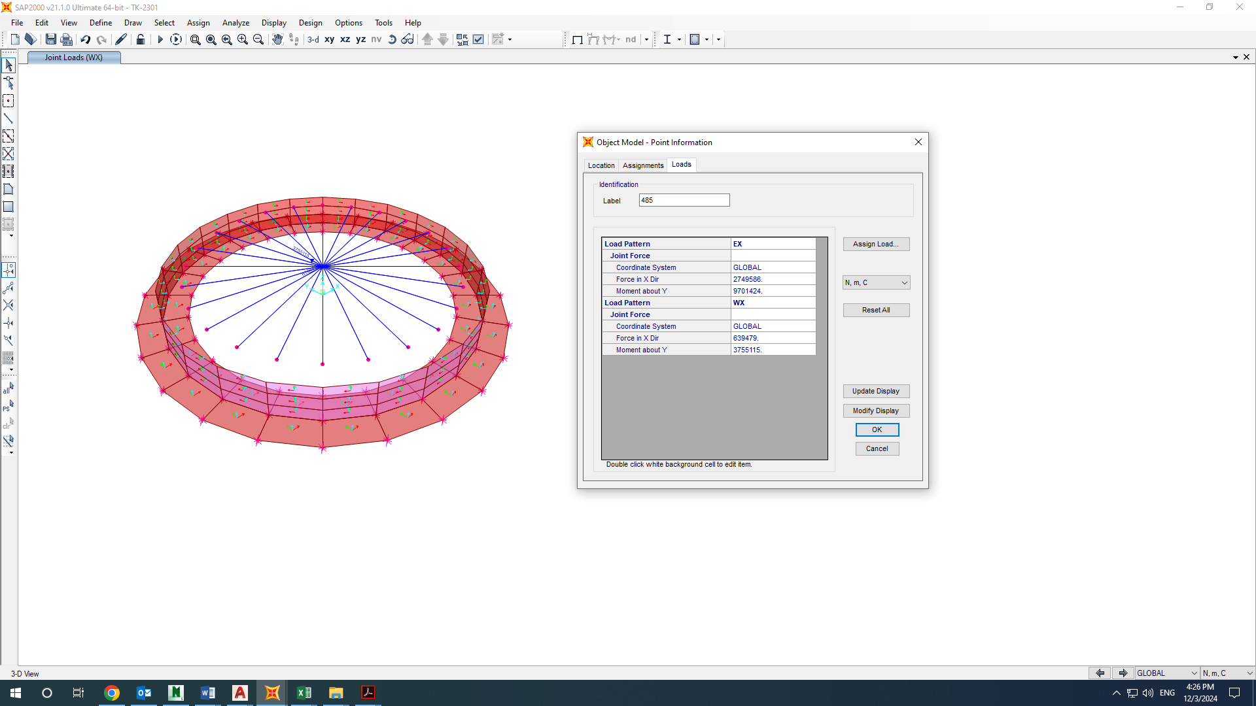

1. **Earthquake Load (EX)**
   1. **W (Wind Load)**

Shear load = 456771 N (based on Mechanical Data Sheet for fire water storage Tanks (TK-2301 A/B).

This shear is based on the datasheet, but we used API650 with ASD behavior coefficient so its value is multiplied by 1.4 → 456771  1.4 = 639479 N

Moment = 2682225 N.m (based on Mechanical Data Sheet for fire water storage Tanks (TK-2301 A/B).

This moment is based on the datasheet, but we used API650 with ASD behavior coefficient so its value is multiplied by 1.4 → 2682225  1.4 = 3755115 N.m



1. **Wind load (WX)**
2. **Design Load Combinations**

| **Load Assignments** | | | |
| --- | --- | --- | --- |
| **Case** | **LoadType** | **LoadName** | **LoadSF** |
| Text | Text | Text | Unitless |
| A.A.O.1-NL | Load pattern | DE | 1 |
| Load pattern | DL | 1 |
| Load pattern | DS | 1 |
| Load pattern | F | 1 |
| A.A.O.2-NL | Load pattern | DE | 1 |
| Load pattern | DL | 1 |
| Load pattern | DS | 1 |
| Load pattern | F | 1 |
| Load pattern | WX | 1 |
| A.B.T.1-NL | Load pattern | DL | 1 |
| Load pattern | DE | 1 |
| Load pattern | DS | 1 |
| Load pattern | HT | 1 |
| Load pattern | WX | 0.25 |
| A.B.T.2-NL | Load pattern | DL | 0.6 |
| Load pattern | DE | 0.6 |
| Load pattern | DS | 0.6 |
| Load pattern | HT | 0.6 |
| Load pattern | WX | 0.25 |
| A.C.E.1-NL | Load pattern | DL | 1 |
| Load pattern | DE | 1 |
| Load pattern | DS | 1 |
| Load pattern | WX | 1 |
| A.C.E.2-NL | Load pattern | DL | 0.6 |
| Load pattern | DE | 0.6 |
| Load pattern | DS | 0.6 |
| Load pattern | WX | 1 |
| A.D.E.1-NL | Load pattern | DL | 1 |
| Load pattern | DS | 1 |
| Load pattern | DE | 1 |
| Load pattern | F | 1 |
| Load pattern | EX | 0.7 |
| A.D.E.2-NL | Load pattern | DL | 0.6 |
| Load pattern | DS | 0.6 |
| Load pattern | DE | 0.6 |
| Load pattern | F | 0.6 |
| Load pattern | EX | 0.7 |
| S.A.O.1-NL | Load pattern | DL | 1.4 |
| Load pattern | DS | 1.4 |
| Load pattern | DE | 1.4 |
| Load pattern | F | 1.4 |
| S.A.O.2-NL | Load pattern | DL | 1.2 |
| Load pattern | DS | 1.2 |
| Load pattern | DE | 1.2 |
| Load pattern | F | 1.2 |
| Load pattern | WX | 1 |
| S.A.O.3-NL | Load pattern | DL | 0.9 |
| Load pattern | DS | 0.9 |
| Load pattern | DE | 0.9 |
| Load pattern | F | 0.9 |
| Load pattern | WX | 1 |
| S.B.T.1-NL | Load pattern | DL | 1.2 |
| Load pattern | DE | 1.2 |
| Load pattern | DS | 1.2 |
| Load pattern | HT | 1.2 |
| Load pattern | WX | 0.25 |
| S.B.T.2-NL | Load pattern | DL | 0.9 |
| Load pattern | DE | 0.9 |
| Load pattern | DS | 0.9 |
| Load pattern | HT | 0.9 |
| Load pattern | WX | 0.25 |
| S.C.E.1-NL | Load pattern | DE | 1.2 |
| Load pattern | DL | 1.2 |
| Load pattern | DS | 1.2 |
| Load pattern | WX | 1 |
| S.C.E.2-NL | Load pattern | DE | 0.9 |
| Load pattern | DL | 0.9 |
| Load pattern | DS | 0.9 |
| Load pattern | WX | 1 |
| S.D.E.1-NL | Load pattern | DE | 1.2 |
| Load pattern | DL | 1.2 |
| Load pattern | DS | 1.2 |
| Load pattern | F | 1.2 |
| Load pattern | EX | 1 |
| S.D.E.2-NL | Load pattern | DE | 0.9 |
| Load pattern | DL | 0.9 |
| Load pattern | DS | 0.9 |
| Load pattern | F | 0.9 |
| Load pattern | EX | 1 |

1. **Tank ANALYSIS AND DESIGN** 
   1. **Tank geometry**

As noted before, the structure has modelled and analysed by SAP2000. This figure shows a 3D view of the model in software.

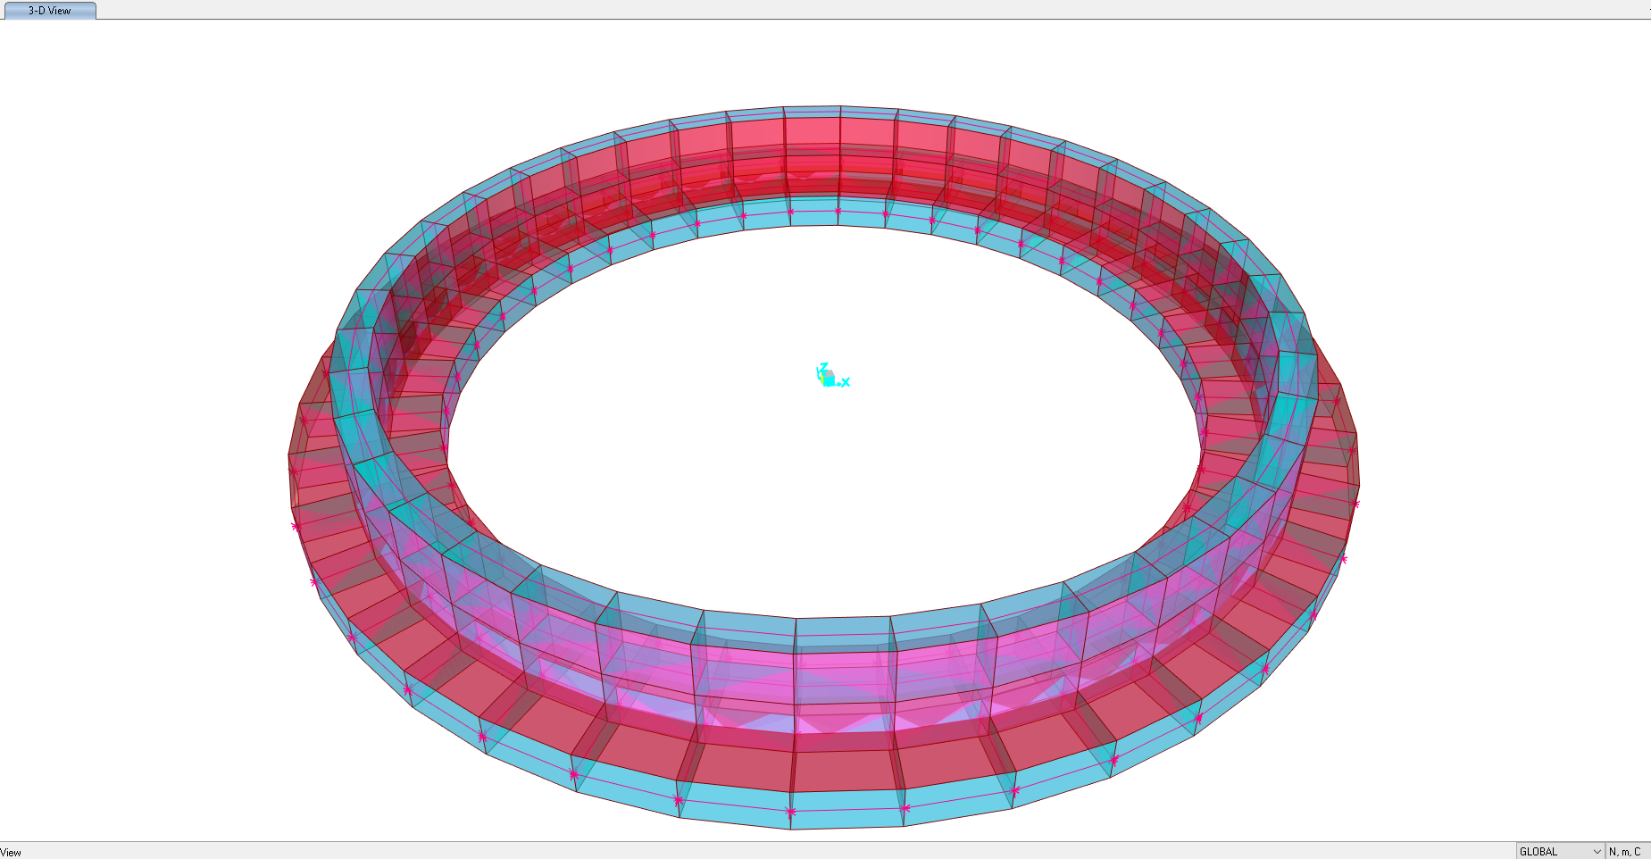

1. **3D model** 
   1. **Tank Design Results**







10. 2. 1. Soil Pressure Control

Soil pressures in different service load combinations should be checked by allowable value. The following figure is extracted from “SAP” model.

According to Geotechnical report Ks = 0.73 Kg/cm³ ,allowable settlement = 2.5 cm and Max soil pressure for this foundation is 2.00 Kg/cm², in this foundation maximum existing settlement is 1.76 cm and maximum existing stress is about 1.50 Kg/cm² .

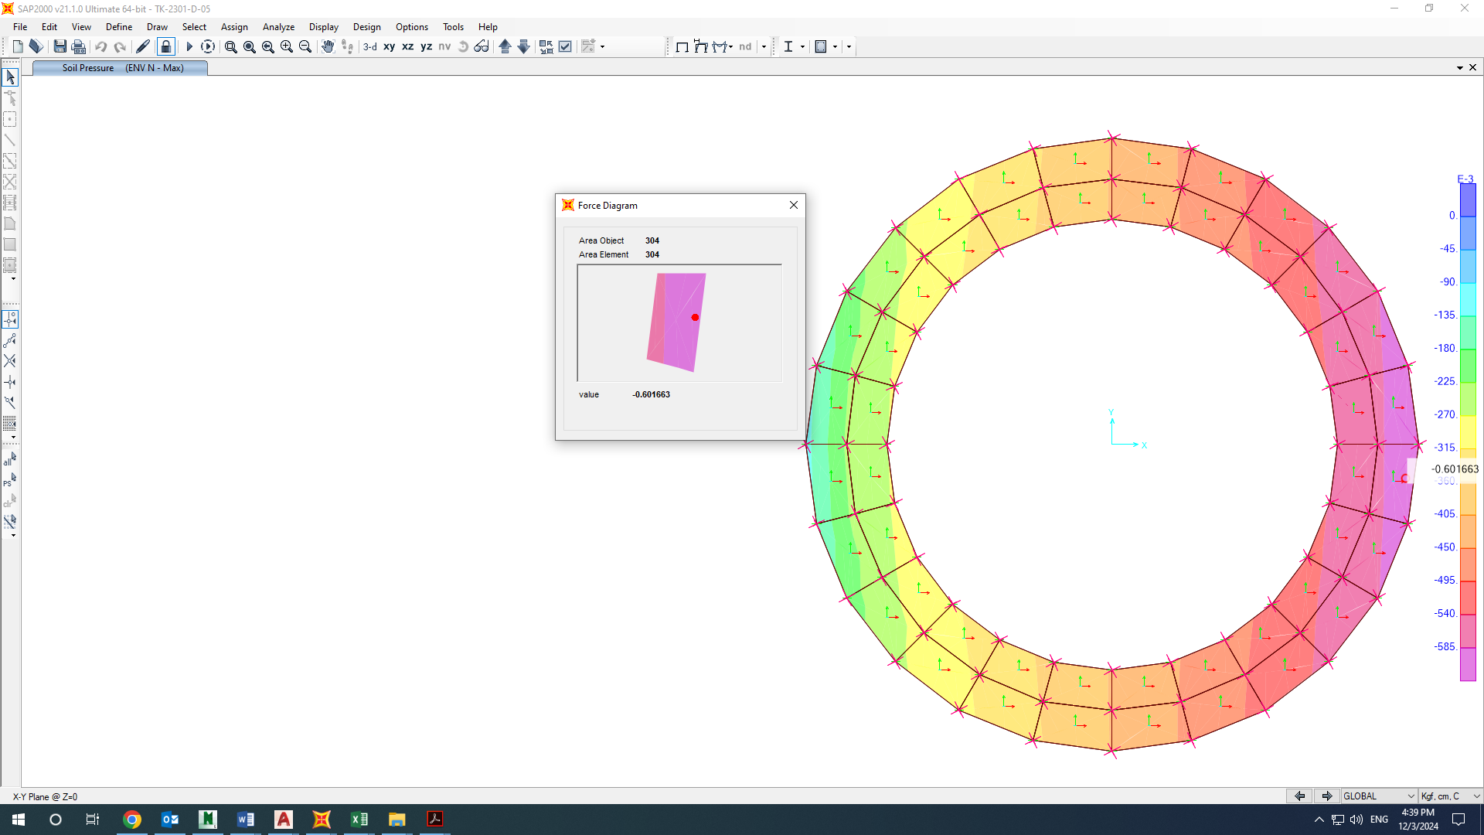

1. Soil pressure

According to Geotechnical report allowable soil pressure in mat foundation (middle of tank) is 0.60 Kg/cm²

In this foundation maximum soil pressure is:

Qliquid<Qall(Circular Mat)

(Operation load / tank area) 1074765/ 1330000 =0.808 Kg/cm² < 0.88 Kg/cm²

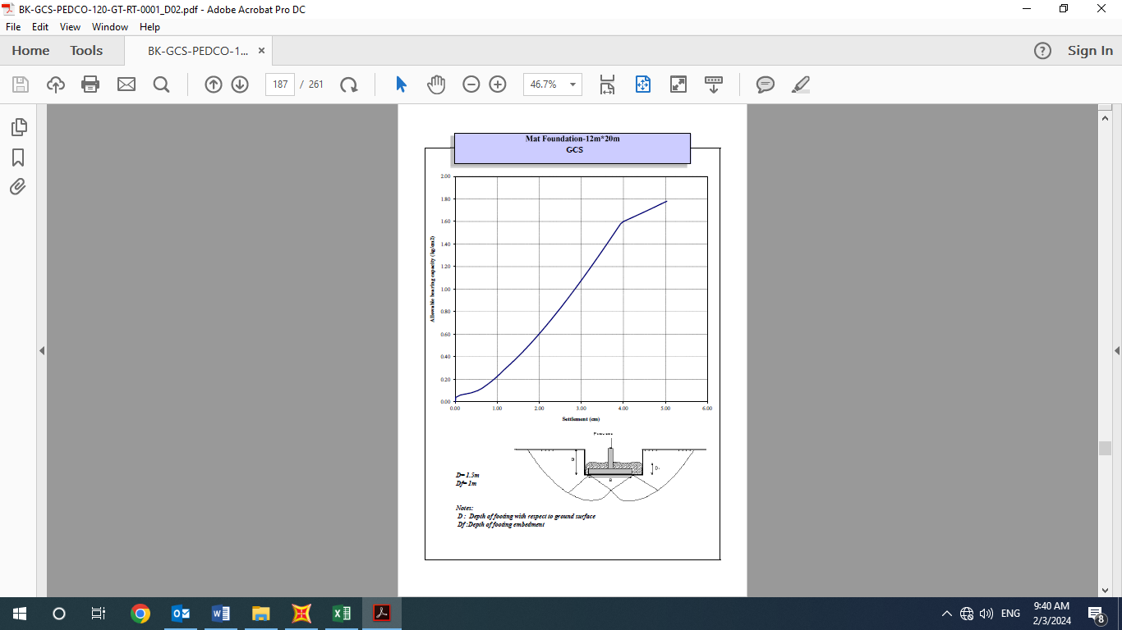

* + 1. Displacement check

Based on SAP2000 output the maximum deflection in foundation is 0.41 cm and the maximum drift is 1.64 cm.

| **TABLE: Joint Displacements** | | | | | | |
| --- | --- | --- | --- | --- | --- | --- |
| **Joint** | **OutputCase** | **CaseType** | **StepType** | **U1** | **U2** | **U3** |
| Text | Text | Text | Text | cm | cm | cm |
| 256 | ENV A | Combination | Min | 0 | 0 | -1.553913 |
| 257 | ENV A | Combination | Min | 0 | 0 | -1.539193 |
| 258 | ENV A | Combination | Min | 0 | 0 | -1.496036 |
| 259 | ENV A | Combination | Max | 0 | 0 | -0.487966 |
| 259 | ENV A | Combination | Min | 0 | 0 | -1.427384 |
| 260 | ENV A | Combination | Min | 0 | 0 | -1.337915 |
| 261 | ENV A | Combination | Min | 0 | 0 | -1.233726 |
| 262 | ENV A | Combination | Min | 0 | 0 | -1.210166 |
| 263 | ENV A | Combination | Max | 0 | 0 | -0.310527 |
| 263 | ENV A | Combination | Min | 0 | 0 | -1.198277 |
| 264 | ENV A | Combination | Min | 0 | 0 | -1.187199 |
| 270 | ENV A | Combination | Min | 0 | 0 | -1.170385 |
| 271 | ENV A | Combination | Min | 0 | 0 | -1.177685 |
| 272 | ENV A | Combination | Min | 0 | 0 | -1.187199 |
| 273 | ENV A | Combination | Min | 0 | 0 | -1.198277 |
| 274 | ENV A | Combination | Min | 0 | 0 | -1.210166 |
| 275 | ENV A | Combination | Min | 0 | 0 | -1.233726 |
| 276 | ENV A | Combination | Min | 0 | 0 | -1.337915 |
| 277 | ENV A | Combination | Min | 0 | 0 | -1.427384 |
| 278 | ENV A | Combination | Min | 0 | 0 | -1.496036 |
| 279 | ENV A | Combination | Min | 0 | 0 | -1.539193 |
| 280 | ENV A | Combination | Min | 0 | 0 | -1.660392 |
| 281 | ENV A | Combination | Min | 0 | 0 | -1.641737 |
| 282 | ENV A | Combination | Min | 0 | 0 | -1.587041 |
| 283 | ENV A | Combination | Min | 0 | 0 | -1.500033 |
| 284 | ENV A | Combination | Min | 0 | 0 | -1.386641 |
| 285 | ENV A | Combination | Min | 0 | 0 | -1.254594 |
| 286 | ENV A | Combination | Min | 0 | 0 | -1.199891 |
| 287 | ENV A | Combination | Min | 0 | 0 | -1.18515 |
| 288 | ENV A | Combination | Min | 0 | 0 | -1.171413 |
| 289 | ENV A | Combination | Min | 0 | 0 | -1.159617 |
| 290 | ENV A | Combination | Min | 0 | 0 | -1.150565 |
| 291 | ENV A | Combination | Min | 0 | 0 | -1.144874 |
| 292 | ENV A | Combination | Min | 0 | 0 | -1.142933 |
| 293 | ENV A | Combination | Min | 0 | 0 | -1.144874 |
| 294 | ENV A | Combination | Min | 0 | 0 | -1.150565 |
| 295 | ENV A | Combination | Min | 0 | 0 | -1.159617 |
| 296 | ENV A | Combination | Min | 0 | 0 | -1.171413 |
| 297 | ENV A | Combination | Min | 0 | 0 | -1.18515 |
| 298 | ENV A | Combination | Min | 0 | 0 | -1.199891 |
| 299 | ENV A | Combination | Min | 0 | 0 | -1.254594 |
| 300 | ENV A | Combination | Min | 0 | 0 | -1.386641 |
| 301 | ENV A | Combination | Min | 0 | 0 | -1.500033 |
| 302 | ENV A | Combination | Min | 0 | 0 | -1.587041 |
| 303 | ENV A | Combination | Min | 0 | 0 | -1.641737 |
| 304 | ENV A | Combination | Min | 0 | 0 | -1.762392 |
| 305 | ENV A | Combination | Min | 0 | 0 | -1.739941 |
| 306 | ENV A | Combination | Min | 0 | 0 | -1.674118 |
| 307 | ENV A | Combination | Min | 0 | 0 | -1.569408 |
| 308 | ENV A | Combination | Max | 0 | 0 | -0.491536 |
| 308 | ENV A | Combination | Min | 0 | 0 | -1.432948 |
| 309 | ENV A | Combination | Min | 0 | 0 | -1.274037 |
| 310 | ENV A | Combination | Min | 0 | 0 | -1.189318 |
| 311 | ENV A | Combination | Min | 0 | 0 | -1.171832 |
| 312 | ENV A | Combination | Min | 0 | 0 | -1.155537 |
| 313 | ENV A | Combination | Min | 0 | 0 | -1.141544 |
| 314 | ENV A | Combination | Min | 0 | 0 | -1.130806 |
| 315 | ENV A | Combination | Min | 0 | 0 | -1.124056 |
| 316 | ENV A | Combination | Min | 0 | 0 | -1.121754 |
| 317 | ENV A | Combination | Min | 0 | 0 | -1.124056 |
| 318 | ENV A | Combination | Min | 0 | 0 | -1.130806 |
| 319 | ENV A | Combination | Min | 0 | 0 | -1.141544 |
| 320 | ENV A | Combination | Min | 0 | 0 | -1.155537 |
| 321 | ENV A | Combination | Min | 0 | 0 | -1.171832 |
| 322 | ENV A | Combination | Min | 0 | 0 | -1.189318 |
| 323 | ENV A | Combination | Min | 0 | 0 | -1.274037 |
| 324 | ENV A | Combination | Min | 0 | 0 | -1.432948 |
| 325 | ENV A | Combination | Min | 0 | 0 | -1.569408 |
| 326 | ENV A | Combination | Min | 0 | 0 | -1.674118 |
| 327 | ENV A | Combination | Min | 0 | 0 | -1.739941 |
|  |  |  |  |  | MAX | -1.762392 |

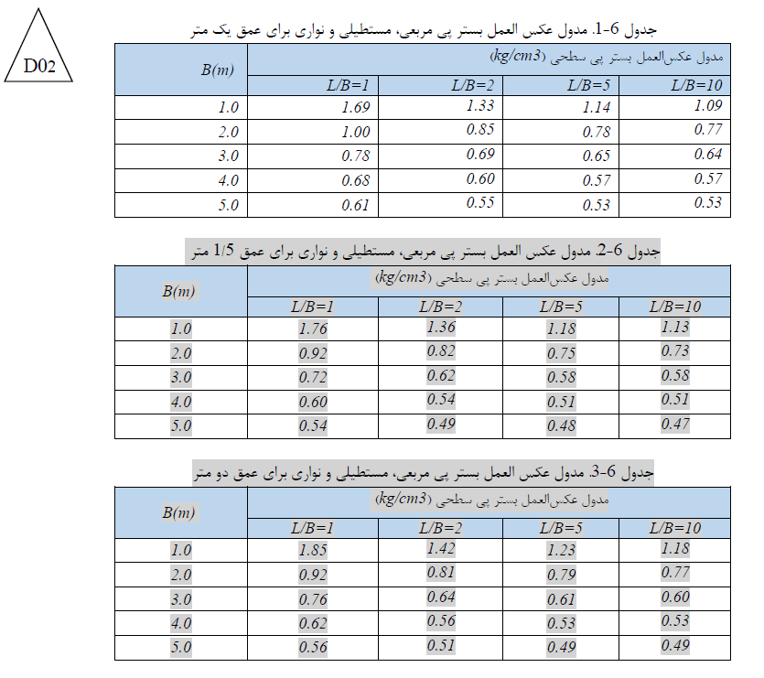

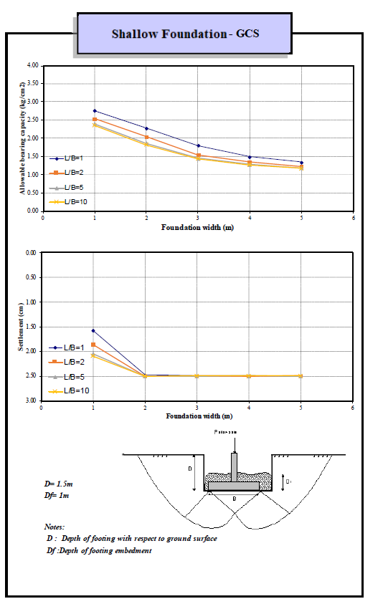

1. Reinforcing
   1. Hoop tension control

Ph=k0hQliquid+0.5k0Ɣh2=0.5*2.1*7.90+0.5*0.5*1.85*2.12=10.33 T/m

T HOOP=PHD/2=10.33*13.25=77.99 T

T HOOP=As Fy= As= THOOP /Fy =77990/4000=19.49 cm

Use 10T16 As=20 OK

* 1. Dowel reinforcement of ring wall

$$A_{S}≥\frac{{(0.75F}_{u}A)anchor}{\left(φF_{y}\right)rein.}=\frac{0.75*4000*3.1415*3*\frac{3}{4}}{0.9*4000}=5.89$$

Use T16@200 As=20.00 OK

* 1. Foundation reinforcement

According to ACI-318-08:

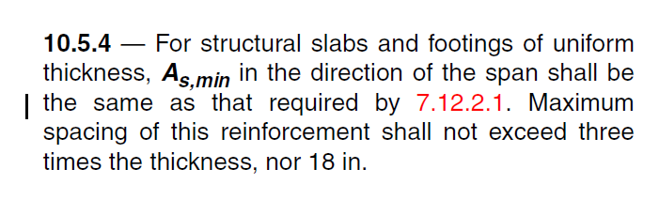

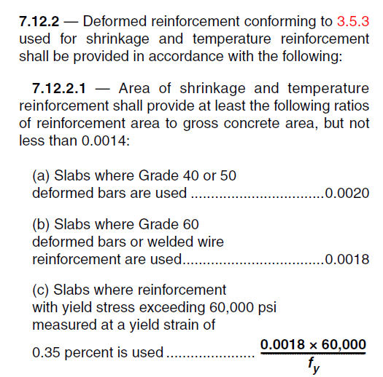

$$A_{S,min}=0.0018×60×100=10.8{cm}^{2} for top and bottom$$ → If use Φ 12@200 → A = 5.65cm² → 5.65 cm² ≤ 10.8/2 = 5.4 cm² → ok

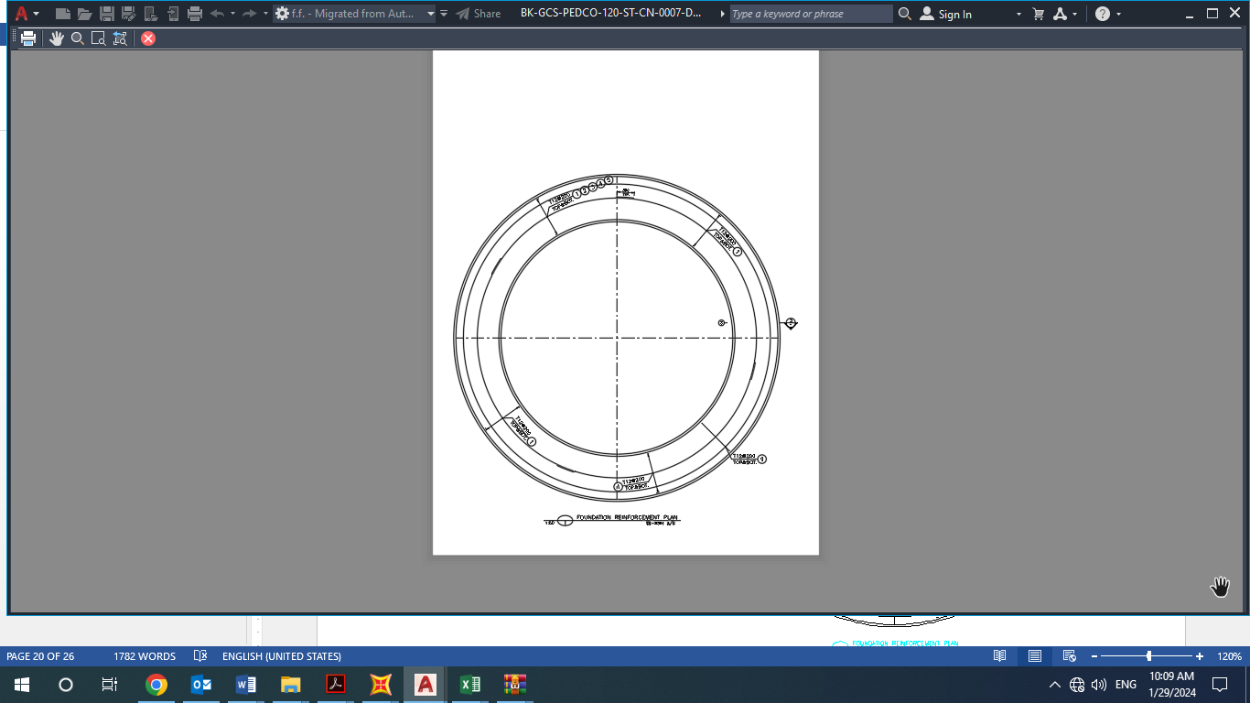

1. Foundation reinforcement plan

$$fc=300 kg/cm²$$

$$fy=4000 kg/cm²$$

$$φ=0.9$$

$$As used=T12@200=5.6cm²$$

$$cover=75mm$$

$$h=600 mm$$

$$a=\frac{A_{s}f_{y}}{0.85b{fc}^{'}}=\frac{5.6*4000}{0.85*100*300}=0.9cm$$

$$M_{n}=0.9×5.6×4000×50.1=10.1 ton.m$$

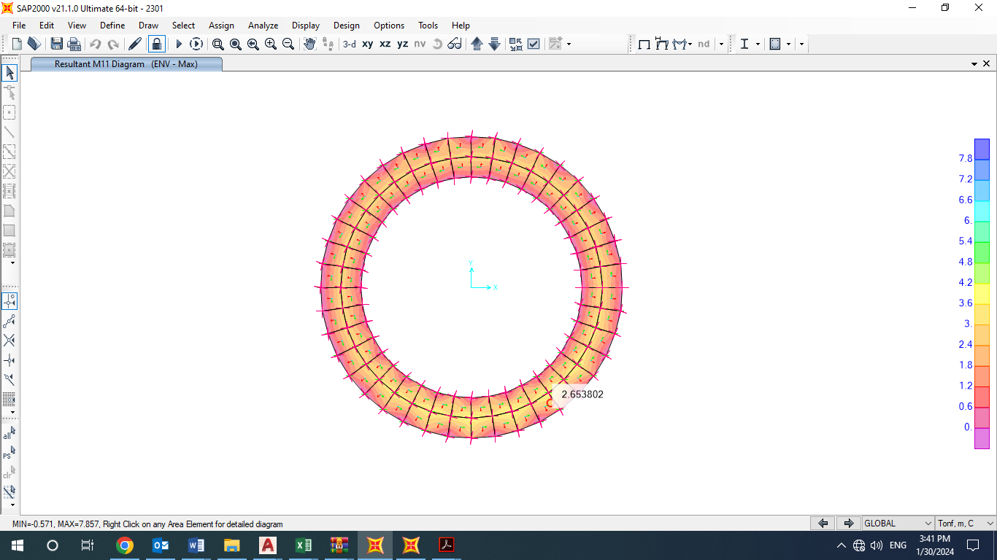

1. **M11 Max**

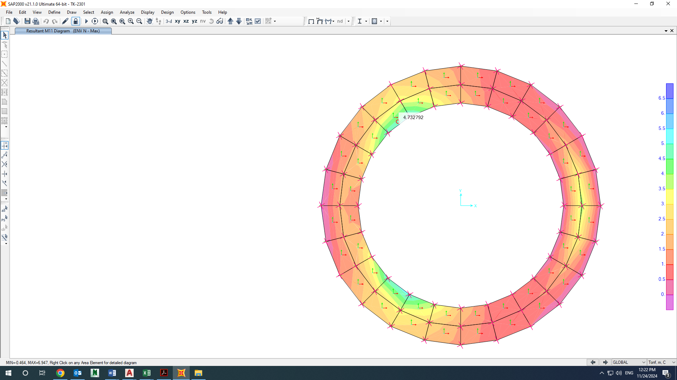

1. **M11 Min**

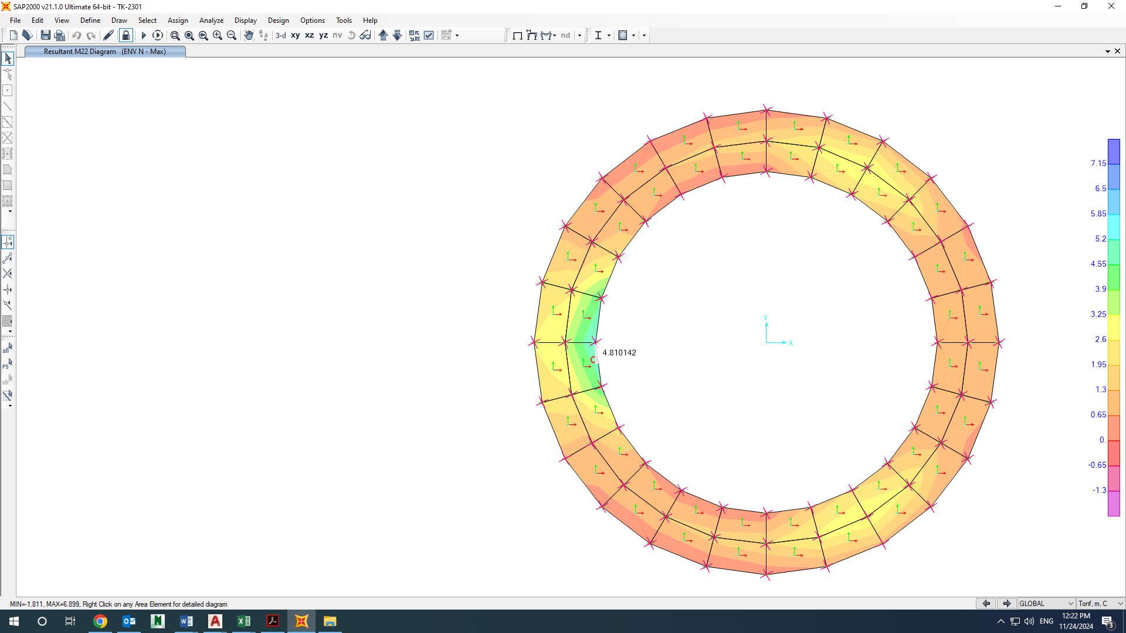

1. **M22 Max**

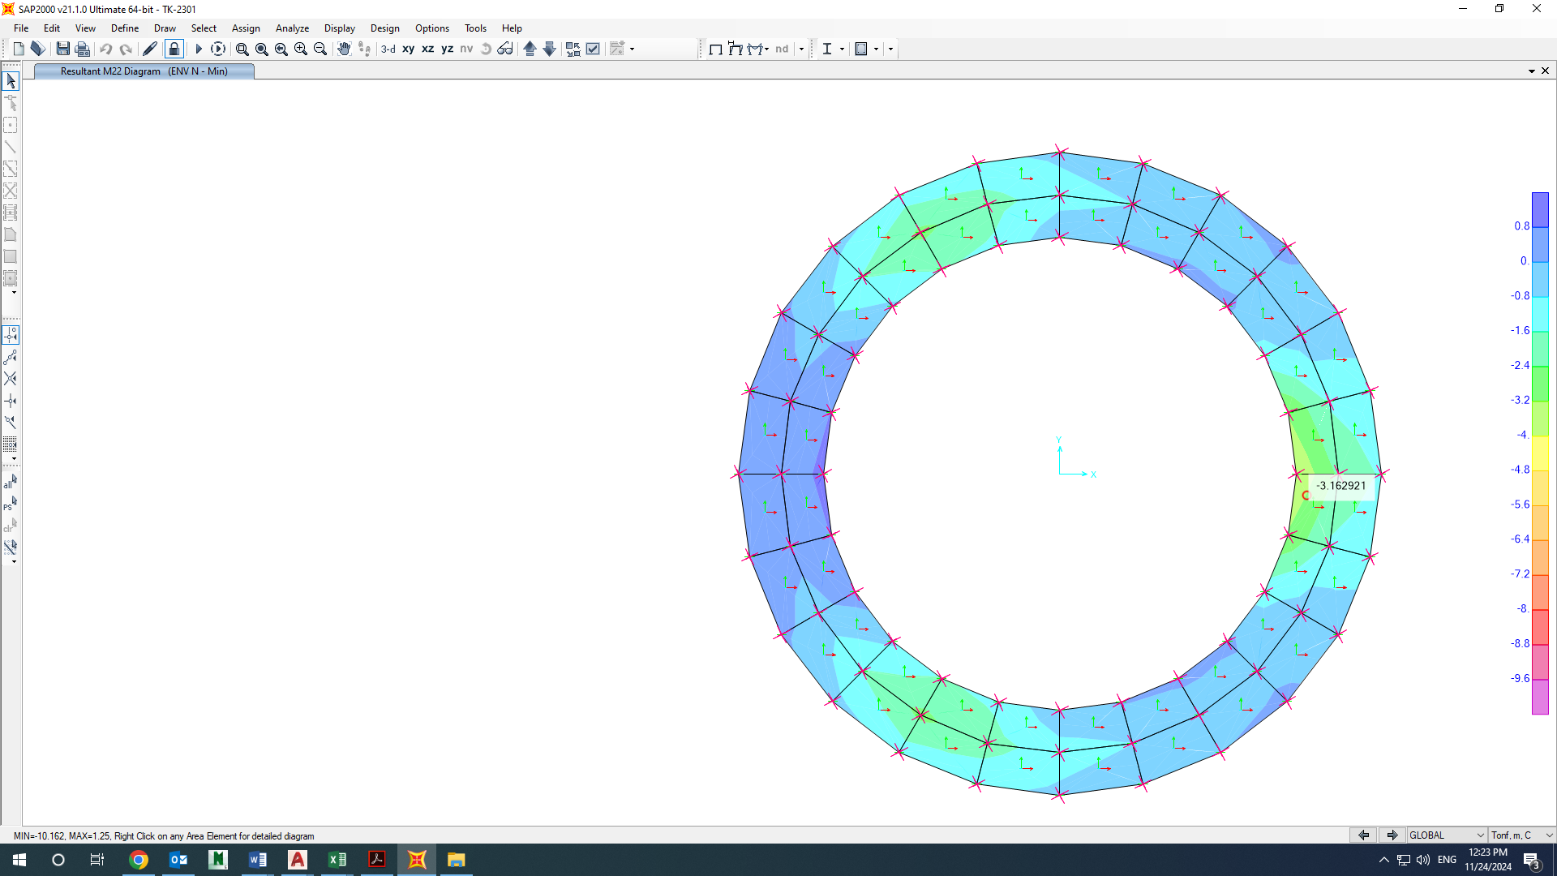

1. **M22 Min**

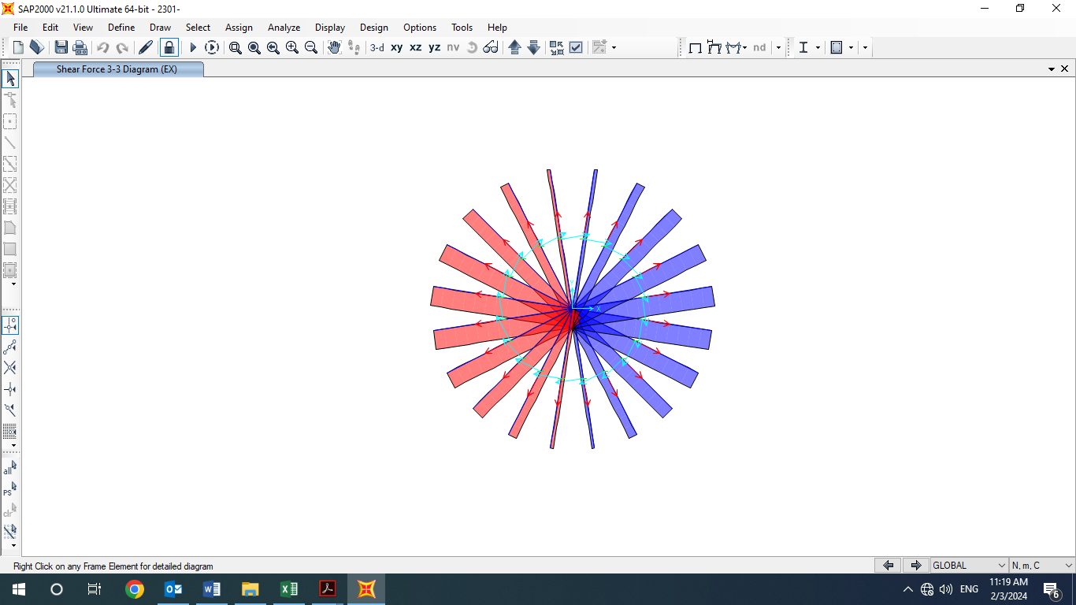

1. **V3-3 EX**

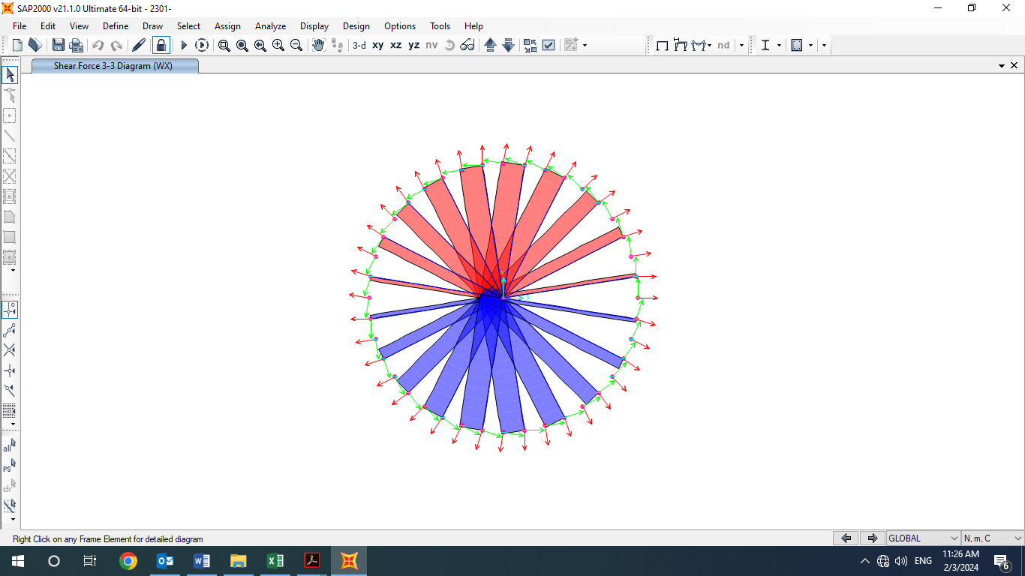

1. **V3-3 WX**
2. ATTACHMENTS
   1. **SOWFTWARE FILE**

“SAP” software file is attached.

* 1. **MECHANICAL DATA SHEET**

Mechanical data sheet is attached.

* 1. **VENDOR LOAD DATA**

Vendor load data is attached.