|  |  |  |  |  |  |  |
| --- | --- | --- | --- | --- | --- | --- |
| **طرح نگهداشت و افزایش تولید 27 مخزن** | | | | | | |
| **CALCULATION NOTE FOR CATHODIC PROTECTION SYSTEM**  **نگهداشت و افزایش تولید میدان نفتی بینک** | | | | | | |
| D04 | Dec.2024 | IFA | M.Fahimi | M.Fakharian | S.Faramarzpour |  |
| D03 | Oct.2024 | IFA | H.Shakiba | M.Fakharian | M.Sadegian |  |
| D02 | Sep.2023 | IFA | H.Shakiba | M.Fakharian | A.M.Mohseni |  |
| D01 | Jan.2023 | IFA | H.Shakiba | M.Fakharian | M.Mehrshad |  |
| D00 | Apr.2022 | IFC | H.Shakiba | M.Aki | M.Mehrshad |  |
| **Rev.** | **Date** | **Purpose of Issue/Status** | **Prepared by:** | **Checked by:** | **Approved by:** | **Client Approval** |
| **Class: 2** | | **Client Doc. Number: F0Z-709014** | | | | |
| **Status:** | **IDC: Inter-Discipline Check**  **IFC: Issued For Comment**  **IFA: Issued For Approval**  **AFD: Approved For Design**  **AFC: Approved For Construction**  **AFP: Approved For Purchase**  **AFQ: Approved For Quotation**  **IFI: Issued For Information**  **AB-R: As-Built for Client Review**  **AB-A: As-Built –Approved** | | | | | |

**REVISION RECORD SHEET**

|  |  |  |  |  |  |  |  |  |  |  |  |  |
| --- | --- | --- | --- | --- | --- | --- | --- | --- | --- | --- | --- | --- |
| **PAGE** | **D00** | **D01** | **D02** | **D03** | **D04** |  | **PAGE** | **D00** | **D01** | **D02** | **D03** | **D04** |
| **1** | X | X | X | X |  | **51** |  |  |  |  |  |
| **2** | X | X | X | X |  | **52** |  |  |  |  |  |
| **3** | X |  |  |  |  | **53** |  |  |  |  |  |
| **4** | X |  |  |  |  | **54** |  |  |  |  |  |
| **5** | X |  |  |  |  | **55** |  |  |  |  |  |
| **6** | X |  |  |  |  | **56** |  |  |  |  |  |
| **7** | X |  |  |  |  | **57** |  |  |  |  |  |
| **8** | X |  |  |  |  | **58** |  |  |  |  |  |
| **9** | X | X |  |  |  | **59** |  |  |  |  |  |
| **10** | X |  |  |  |  | **60** |  |  |  |  |  |
| **11** | X | X |  |  |  | **61** |  |  |  |  |  |
| **12** | X | X |  |  |  | **62** |  |  |  |  |  |
| **13** | X | X | X |  |  | **63** |  |  |  |  |  |
| **14** | X | X | X |  |  | **64** |  |  |  |  |  |
| **15** | X | X | X |  |  | **65** |  |  |  |  |  |
| **16** | X | X | X |  |  | **66** |  |  |  |  |  |
| **17** | X | X | X |  |  | **67** |  |  |  |  |  |
| **18** | X | X | X | X |  | **68** |  |  |  |  |  |
| **19** |  |  |  |  | X | **69** |  |  |  |  |  |
| **20** |  |  |  |  | X | **70** |  |  |  |  |  |
| **21** |  |  |  |  | X | **71** |  |  |  |  |  |
| **22** |  |  | X |  |  | **72** |  |  |  |  |  |
| **23** |  |  | X |  |  | **73** |  |  |  |  |  |
| **24** |  |  |  |  |  | **74** |  |  |  |  |  |
| **25** |  |  |  |  |  | **75** |  |  |  |  |  |
| **26** |  |  |  |  |  | **76** |  |  |  |  |  |
| **27** |  |  |  |  |  | **77** |  |  |  |  |  |
| **28** |  |  |  |  |  | **78** |  |  |  |  |  |
| **29** |  |  |  |  |  | **79** |  |  |  |  |  |
| **30** |  |  |  |  |  | **80** |  |  |  |  |  |
| **31** |  |  |  |  |  | **81** |  |  |  |  |  |
| **32** |  |  |  |  |  | **82** |  |  |  |  |  |
| **33** |  |  |  |  |  | **83** |  |  |  |  |  |
| **34** |  |  |  |  |  | **84** |  |  |  |  |  |
| **35** |  |  |  |  |  | **85** |  |  |  |  |  |
| **36** |  |  |  |  |  | **86** |  |  |  |  |  |
| **37** |  |  |  |  |  | **87** |  |  |  |  |  |
| **38** |  |  |  |  |  | **88** |  |  |  |  |  |
| **39** |  |  |  |  |  | **89** |  |  |  |  |  |
| **40** |  |  |  |  |  | **90** |  |  |  |  |  |
| **41** |  |  |  |  |  | **91** |  |  |  |  |  |
| **42** |  |  |  |  |  | **92** |  |  |  |  |  |
| **43** |  |  |  |  |  | **93** |  |  |  |  |  |
| **44** |  |  |  |  |  | **94** |  |  |  |  |  |
| **45** |  |  |  |  |  | **95** |  |  |  |  |  |
| **46** |  |  |  |  |  | **96** |  |  |  |  |  |
| **47** |  |  |  |  |  | **97** |  |  |  |  |  |
| **48** |  |  |  |  |  | **98** |  |  |  |  |  |
| **49** |  |  |  |  |  | **99** |  |  |  |  |  |
| **50** |  |  |  |  |  | **100** |  |  |  |  |  |

**CONTENTS**

1.0 INTRODUCTION 4

2.0 Scope 5

3.0 NORMATIVE REFERENCES 5

3.1 Local Codes and Standards 5

3.2 International Codes and Standards 5

3.3 The Project Documents 6

3.4 ENVIRONMENTAL DATA 6

3.5 Order of Precedence 6

4.0 Abbreviations 7

5.0 Cathodic Protection 7

5.1 Definition 7

5.2 Design Life 8

5.3 Current Densities 8

5.4 CP Potential Ranges 8

5.5 Ground Bed 9

5.6 Structure Data 9

6.0 Calculation for pipeline 9

6.1 Surface Calculation 9

6.2 Current Calculation 9

6.3 Current Required 10

6.4 Required Anode Calculation 10

6.5 Ground Bed Design and Resistance 11

6.5.1 The First Ground Bed Design 11

6.5.2 The Second Ground Bed Design 11

6.6 Transformer Rectifier Calculation 13

6.7 Attenuation Check 13

6.8 Temporary Cathodic Protection Calculation 18

6.9 Other Considerations and Summery 21

7.0 Appendix 21

8.0 Soil Resistivity Average in 3m depth. 25

1. **INTRODUCTION**

Binak oilfield in Bushehr province is a part of the southern oilfields of Iran, is located 20 km northwest of Genaveh city.

With the aim of increasing production of oil from Binak oilfield, an EPC/EPD Project has been defined by NIOC/NISOC and awarded to Petro Iran Development Company (PEDCO). Also PEDCO (as General Contractor) has assigned the EPC-packages of the Project to "Hirgan Energy - Design and Inspection" JV.

As a part of the Project, New Gas/Condensate Pipelines (from Binak New GCS to Siahmakan GIS/Binak PU) shall be constructed.

**GENERAL DEFINITION**

The following terms shall be used in this document.

|  |  |
| --- | --- |
| CLIENT: | National Iranian South Oilfields Company (NISOC) |
| PROJECT: | Binak Oilfield Development – Surface Facilities; Gas & Gas-Condensate Pipelines |
| EPD/EPC CONTRACTOR (GC): | Petro Iran Development Company (PEDCO) |
| EPC CONTRACTOR: | Joint Venture of : Hirgan Energy – Design & Inspection(D&I) Companies |
| VENDOR: | The firm or person who will fabricate the equipment or material. |
| EXECUTOR: | Executor is the party which carries out all or part of construction and/or commissioning for the project. |
| THIRD PARTY INSPECTOR (TPI): | The firm appointed by EPD/EPC CONTRACTOR (GC) and approved by COMPANY (in writing) for the inspection of goods. |
| SHALL: | Is used where a provision is mandatory. |
| SHOULD: | Is used where a provision is advisory only. |
| WILL: | Is normally used in connection with the action by COMPANY rather than by an EPC/EPD CONTRACTOR, supplier or VENDOR. |
| MAY: | Is used where a provision is completely discretionary. |

1. **Scope**

This document covers minimum required calculations for the design, selection, manufacture,   
and delivery of cathodic protection system of UG pipeline section from Gas Compressor station to Gas injection facility.

It shall be used in conjunction with data/requisition sheets for present document subject.

1. **NORMATIVE REFERENCES**

## Local Codes and Standards

* IPS-E-TP-820 Engineering Standard for Electrochemical Protection
* IPS-C-TP-820 Construction Standard for Cathodic Protection
* IPS-I-TP-820: Inspection Standard for Monitoring Cathodic Protection
* IPS-M-TP-750 Material and Equipment Standard For Cathodic Protection

## International Codes and Standards

* ASTM American Society for Testing Materials Relevant Parts
* API 610 Centrifugal Pumps for General Refinery Service, 10th Edition
* NACE SP 0169 Control of External Corrosion on Underground or Submerged Metallic Piping System.
* NACE-SP 0286 the Electrical Isolation of Cathodically Protected Pipelines.
* BS 7361(1991) Cathodic Protection Part 1. Code of Practice for Land and Marine Applications.
* NACE SP 0177 Mitigation of Alternating Current and Lightning Effects on Metallic Structures and Corrosion Control Systems.
* ISO 15589,1-2 Cathodic protection of pipeline transportation systems
* NACE SP 0502 External corrosion direct assessment (ECDA) process — assessing and reducing the impact of external corrosion on pipeline integrity.
* NACE SP 0207 Performing Close-Interval Potential Surveys and DC Surface Potential Gradient Surveys on Buried or Submerged Metallic Pipelines.
* NACE-SP0104 The Use of Coupons for Cathodic Protection Monitoring Applications

## The Project Documents

* BK-GCS-PEDCO-120-EL-CN-0008 Specification for Cathodic Protection System
* BK-GNRAL-PEDCO-HD-000-EL-DC-0001 Electrical System Design Criteria
* BK-GCS-PEDCO-320-GT-RT-0001 Geotechnical Report

## ENVIRONMENTAL DATA

Refer to "Process Basis of Design; Doc. No. BK-GNRAL-PEDCO-000-PR-DB-0001".

Cathodic Protection System shall be designed for use under the conditions specified as below:

R01

Ambient temperatures for equipment:

|  |  |
| --- | --- |
| Maximum design temperature indoor/outdoor (under sun shade) | +50°C |
| Minimum design temperature | -5°C |
| Maximum surface temperature exposed to the sun | 85°C |
| Maximum relative humidity | 100% |
| Altitude | <1000m above sea Level |
| Special Atmospheric Condition | dust and salt corrosive |

For the ambient conditions special care will be paid to:

* Enclosures of equipment for outdoor installation
* Painting and coating of metal parts to resist to the severe environmental conditions
* Any environmental derating factors shall be considered by vendor before design

## Order of Precedence

In case of conflict between requirements specified herein & the requirements of any other referenced document, the most approved stringent requirements of below listed items shall be considered based on the approval given by the owner’s representative:

Purchase order

Material Requisition

MTO & Data Sheet

This Specification

Drawing & Other Specification

Reference Project Specification

Iranian Petroleum Standard (IPS)

Reference international Code & Standards

When the term “Authorized”, Authorization”, “Approval”, or “Approved” are used in this specification, it shall mean authorization or Approval from OWNER.

In case of any conflict between the project documents, the most stringent one shall be considered.

1. **Abbreviations**

CP-Cathodic protection

ICCP-Impressed current cathodic protection

Ti-MMO- Titanium substrate with Mixed Metal Oxide Anode

HSCI High Silicon Cast Iron Anode

T/R-Transformer rectifier

AST –Above ground Storage Tank

AC –Alternative Current

DC-Direct Current

U/G or UG- Under Ground

A/G or AG -Above Ground

PE- Polyethylene

PP- Polypropylene

SRB- Sulphate reduction bacteria

CB- Coating Breakdown

CE- Coating Efficiency

PCM- Pipe Current Mapper

1. **Cathodic Protection**

## Definition

Cathodic Protection (CP) is an electrochemical method used to prevent or control corrosion of buried or submerged metallic structures. CP systems are active systems that rely on the application of electric current to control corrosion. If current is interrupted, corrosion will progress at a normal rate for the material/environment combination; if supplied current is inadequate for complete protection, corrosion will progress at a reduced rate. After a CP system is installed and adjusted to provide adequate protection, currents and potentials should remain relatively stable; changes in currents or potentials indicate a problem.

The essential features of cathodic protection to metals that are surrounded by a conducting electrolyte, in each of the two types of system are as follows:

a) A galvanic system requires:

i) Sacrificial anodes

ii) Connecting the anode to the structure (Through Junction Box)

iii) Secure and minimum resistance connections between conductor and structure, and between conductor and anode.

b) An impressed-current system requires:

i) Inert anodes (clusters of which, connected together often in a backfill, are called the “ground bed”).

ii) A dc power source (called the “Transformer rectifier”).

iii) Electrically well insulated, minimum resistance and secure conductors between anodes and power source.

iv) Secure and minimum resistance connections between power source and structure.

## Design Life

The design life for the permanent cathodic protection systems for these Pipelines is 25 years.

## Current Densities

Current density for cathodic protection system of pipeline which is as per Table No. 1.

|  |  |
| --- | --- |
| Table 1: Current Density | |
| **Structure** | **Current Density for Steel (mA/m2)** |
| Un coated Steel in Dry Soil/Sand @ 30◦ C | 20 |
| Coated pipeline: Fusion bonded epoxy@ 30◦ C | 1.25 |

## CP Potential Ranges

The effectiveness of the CP system is determined by the potential shift. The instant-off potentials or IR free applied in the design is given as below as per part 6.2.2.1 of NACE SP-0169 or Part 7.1 IPS-E-TP-820:

A target IR free potential value for protection shall be according to one of bellow:

A negative polarized (Instant-off) potential of at least -850 mV (or more negative) relative to a saturated copper/copper sulfate reference electrode. (And -950 mV/in the presences of SRB)

Attaining the IR drop free results, all measurements shall be carried out in accordance with NACE TM-0497.

## Ground Bed

Remote Shallow or deep Ground beds is most suitable for Pipelines in such environments.

## Structure Data

Refer to "Process Basis of Design; Doc. No. BK-GNRAL-PEDCO-000-PR-DB-0001" Required data of Structure for cathodic protection design are shown in Table 2.

|  |  |  |  |
| --- | --- | --- | --- |
| Table 2: Briefly Pipeline Data | | | |
| Item | Pipe size NPS | Operating Temperature (max) | Quantity |
| Inch/m | °C | M |
| Pipeline | 8” (0.203) thickness 11 mm | 60 (88.41 F) | 43897 |

Other required data are based ON BK-PPL-PEDCO-320-SU-DW-0001- plan profile drawing.

1. **Calculation for pipeline**

## Surface Calculation

Below formula is used for calculating the effective surface of pipelines.



Where:

S= Total surface (m2)

D= Pipeline Diameter (m)

L= Pipeline Length (m)

Outer diameter of pipeline is considered for calculating the total surface area.

$$S=π*\left(8*0.0254+0.011\right)*43897=29525 sqm$$

## Current Calculation

Taking the relevant standards such as IPS-E-TP-820 and ISO 15589-1, current density can be calculated based on operation temperature as below formula:



Where:

JCD= Current Density at Maximum Operating Temperature (mA/m2)

J30= Current Density at 30◦C (mA/m2)

T= Maximum Operating Temperature (60◦C)

|  |  |
| --- | --- |
| **Structure** | **Current Density for Steel (mA/m2)** |
| Un coated Steel in Dry Soil/Sand @ 60◦ C | 35 |
| Coated pipeline: Fusion bonded epoxy@ 60◦ C | 2.18 |

## Current Required

Current requirement for protection of Pipeline surface as below formula:



Where:

ICR= Current Requirement (A)

S= Total Surface (m2)

CB= Coating Breakdown (%) = 7.5% based on ISO 15589-1 section 8.4.2 and Table 2

CE= Coating Efficiency (1-CB) (%) = 92.5 %

J1CD= Uncoated Current Density at maximum operating temperature (mA/m2)= 35 mA/m2

J2CD= Coated Current Density at maximum operating temperature (mA/m2)= 2.18 mA/m2

Required current for each cathodic protection station are calculated:

The total current required is about 138 A.

Since there is possibility of current leakage to other metallic subjects, 25 % safety factor will be considered for calculating Current demand of CP system.

The total current demand is about 172 A.

## Required Anode Calculation

Selected anode is MMO Tubular anodes. These anodes are Suitable for long life applications. These anodes can produce 4 A output when backfilled by coke breeze depending on soil resistivity;

According to Part C.1.2.2.2 of IPS-E-TP-820, we have:

$$N=\frac{I_{r} (Total Current required, A) }{I_{a} (Current output of anode, 4 A)}=43$$

Considering 2 separate Anode ground beds, Minimum anodes based on current output can be calculated as 22 No.

## Ground Bed Design and Resistance

### The First Ground Bed Design

According to mentioned parameters for anode current output and soil characteristics, designed ground bed is selected with 22 anodes, with total length of G.B will be 99 m (4.5 m anode spacing (15 ft).

Anodes will be backfilled in coke at factory, Ground-bed resistance will be calculated from below formula; Where:

ρ= Soil Resistivity (12.3 ohm. m)- BASED ON BK-PPL-PEDCO-320-GT-RT-0001_D01

L=length of ground bed (22*4.5 m =99 m)

S= Twice depth of anode in meters (6 m)

d= Diameter of anode in meters (0.5 m diameter of backfill)



### The Second Ground Bed Design

ρ= Soil Resistivity (15.3 ohm. m) BASED ON BK-PPL-PEDCO-320-GT-RT-0001_D01

L=length of ground bed (22*4.5 m =99 m)

S= Twice depth of anode in meters (6 m)

d= Diameter of anode in meters (0.5 m diameter of backfill)



Resistance of cable is calculated by the following formula



Where:

RC= Cable resistance (Ω)

ρ= Conductor resistivity (Ωmm2/m)

L= Cable length (m) various as per anode ground bed length

A= Cable diameter (mm2)

Length of negative cable from Transformer rectifier to pipeline is about 100 m for all cathodic protection station. In addition, length of positive cable from transformer rectifier to anode ground bed is considered 20 m for every station. Therefore, total cable resistance with considering cable size 35 mm2, with 120 Mt distance of pipe to anode ground.

$$R_{cable}=0.06 Ohm$$

Coating leakage resistance is calculated by the following formula (Ref: B.1.1.3.2 of IPS-E-TP-820)

$$R_{L}=\frac{1}{gAL}=0.013$$

Where:

AL = Surface Area of Pipe (29525 sqm)

g= coating conductivity (mhos per m2)

For calculation of coating resistance, the resistance of pipe FBE coating is considered 1/g=400 ohm.m2 according to B.1.1.3.2 of IPS-E-TP-820 (1).

Total resistance will be as per below table:

Table 3 total resistance of CP system

|  |  |  |  |  |  |  |
| --- | --- | --- | --- | --- | --- | --- |
| **Soil Resistivity** | **Selected Anode Qty** | **Active G.B length** | **G.B Resis.** | **Cable Resis.** | **Coating Resis.** | **Total Resistance** |
| ohm.cm | No. | m | Ohm | Ohm | Ohm | Ohm |
| 1230 | 22 | 99 | 0.16 | 0.06 | 0.013 | 0.233 |
| 1530 | 22 | 99 | 0.20 | 0.06 | 0.013 | 0.273 |

## Transformer Rectifier Calculation

Rectifier sizing is based on current output from each ground bed and total system resistance and also back voltage that usually considered as 2 volts. So:

Transformer voltage is calculated using the below formula:



Where:

VTR= Transformer Rectifier Output DC Voltage (V)

ICD= Current Demand (172/2=86A)

RT= Total Resistance (Ω)

For the first ground bed:

VTR = (0.233*86) +2 = 22.03

And second ground bed:

VTR = (0.273*86) +2 = 25.47

So for more contingency we will consider a TRs 50V-100A for each ground bed.

## Attenuation Check

The attenuation check, shows that positioning one single station for this pipeline is sufficient.

For calculation of the length of pipeline which each station can protect the following formula is used:

The linear resistance of pipe will be:

$$r=\frac{ρ \left[cm\right]×L\left[cm\right]}{\frac{π}{4}\left({OD}^{2}-{ID}^{2}\right) \left[{cm}^{2}\right]} ρ:18×{10}^{-6} Acc to IPS Appendix B$$

The unit leakage conductance in 1000 ohm-cm soil is:

$$g_{1000}={πDLg}^{'}$$

If the average soil resistivity is $ρ$', then leakage conductance is: (will be proportionally less)

$$g_{}=\frac{g_{1000}\left[S\right]×1000 \left[cm\right] }{{}^{'}\left[cm\right] }$$

In $ρ$' soil the attenuation propagation constan will be:

$$∝=\sqrt{rg}$$

The characteristic resistance of the pipeline is:

$$R_{G}=\sqrt{\frac{r}{g}}$$

The resistance between the pipe and remote earth looking into the source is:

$$R_{s}=R_{G}coth⁡(∝X)$$

The Voltage shift at the receiving end is:

$$E=E_{s} Coshα αX-I_{S} R_{G}Sinh αX$$

|  |  |  |  |
| --- | --- | --- | --- |
| **Attenuation Calculation Base on NACE CP4 Equations** | | | |
| **Input Data in Blue Cells only** | | | |
| **L** | Length of Pipe | 43897 | m |
| **D** | Nominal Pipe Diameter | 8 | Inch |
|  | Coating Quality : 1-Excellent , 2- Good, 3-Fair, 4- Poor | 1 |  |
| **Es** | Sending End Potential | 1.1 | V |
| **EN** | Natural Potential | 0.45 | V |
|  | distance from the source | 100 | m |
| **** | Soil Resistance | 5414 | Ohm-Cm |
|  |  |  |  |
| **Output Data in Green Cells only** | | | |
| **OD** | Pipe Outside Diameter | 21.91 | Cm |
| **t** | Pipe Wall Thickness | 1.27 | Cm |
| **ID** | Pipe Inside Diameter | 19.37 | Cm |
| **r** | Unit Linear Resistance | 0.9596 | Ohm/Unit |
| **g1000** | Unit Conductance to earth | 3.0211 | S/Unit |
| **g** | Unit Conductance to earth attention to soil resistance (2:46 CP4) | 0.5580 | S/Unit |
| **** | Attenuation Constant | 0.7318 |  |
| **RG** | Characteristic Resistance | 1.3114 | Ohm |
| **Rs** | Resistance looking into open line | 1.34 | Ohm |
| **Is** | Sending End Current | 0.818 | Amp |
| **E** |  | 0.55 | V |

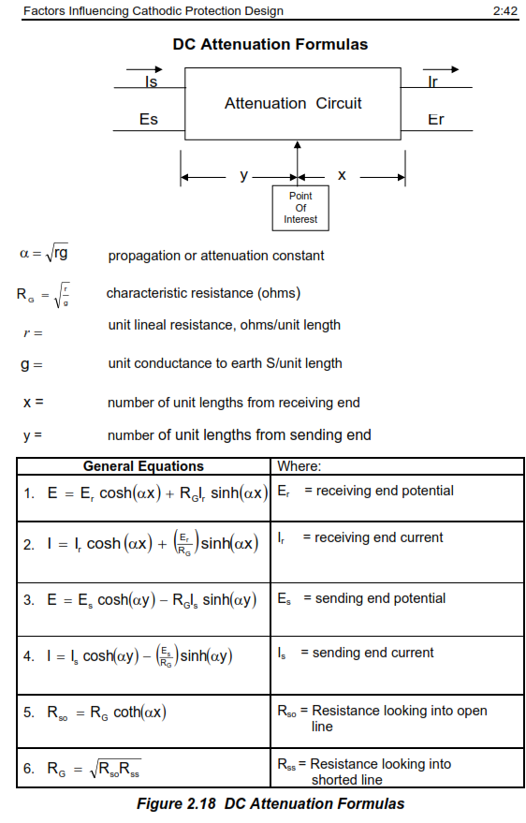

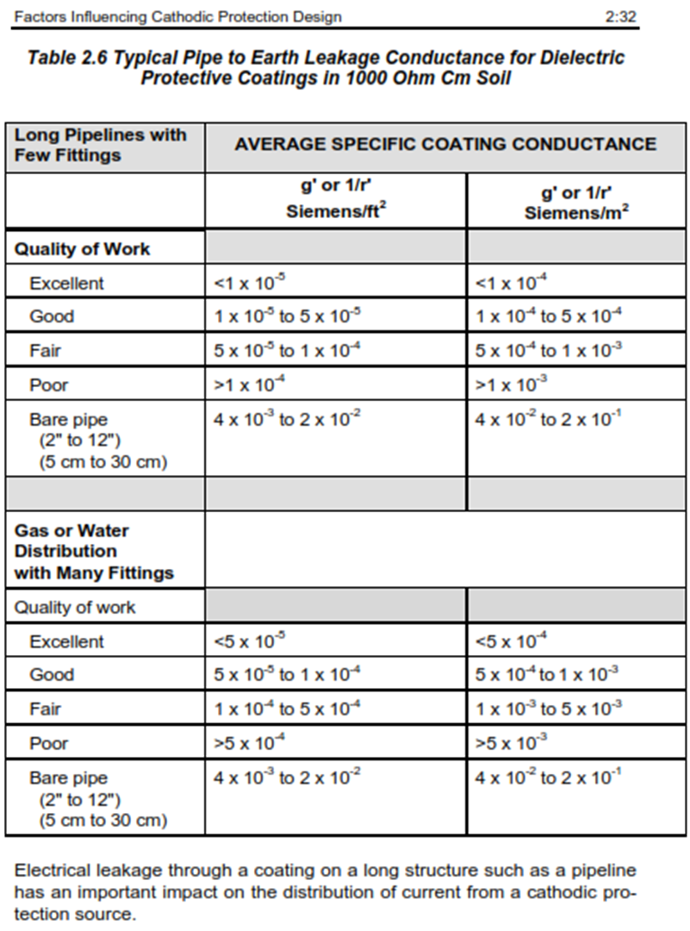

According to the above calculations, the total length of the pipeline can be protected in worst case by only one side. So, considering 2 stations can be increased this polarization will be certified.

With considering natural potential is 0.45 V, the potential in the end location of the will be;

E48 Km = -0.45 – 0.55 = 1.0 V

According to the above-mentioned formulas and 100 meter distance between anode bed to structure and 5414 ohm.cm (Average of soil resistivity in 3 meter depth of close to laying pipeline) the total length of the pipeline will be gained the convenient polarization with 2No.s CP stations.

The protection length of pipeline by one station will be 22 Km from each station due to obtain acceptance potentials as on potential in midpoint of line (E22 Km = - 0.45 – 0.75 = - 1.2 V).

## Temporary Cathodic Protection Calculation

The number of anodes for temporary based on current density is calculated as below:



Where:

8760 refers to hours per year

U: Anode utilization factor (0.85 For Mg anode)

: Electrochemical capacity (Ah/kg) (1200 for Mg anode)

Tf=life time (1)

Ic=appropriate current for one year that will be calculated as following:



Where:

ff: coating breakdown

fi: is the initial coating breakdown factor at the start of pipeline operation(0.5 according to ISO 155891 for FBE pipeline coating)

Δf: is the average yearly increase in the coating breakdown factor. (0.3 according to ISO 155891 for FBE pipeline coating)

tdl: is the design life time in year.(1 year)

ff=0.5+0.3=0.8

**Anode** **Specification**

* Type: High potential Magnesium Anode*
* Anode weight: 17 lbs. (7.7 kg)
* Chemical composition: In Accordance with IPS M-TP-750
* Utilization Factor: 0.85

D04

* Efficiency: 50%
* Design Life: 2 yrs.
* Consumption rate: 7.3 kg/A.y

Note: this type of sacrificial anode includes min 6% Al as respect to ISO15589-1.

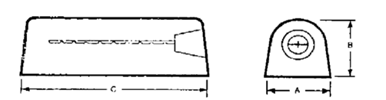

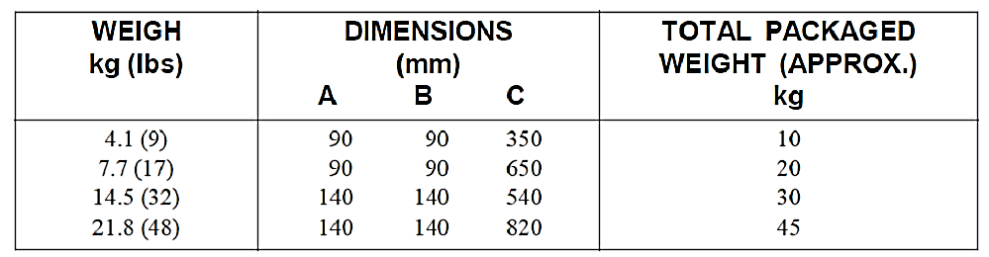

Current requirement for protection of Pipeline surface as below formula:



Where:

IC= Current Requirement (A)

S= Total Surface (m2)

CB= Coating Breakdown (%) = 0.8% based on above calculation

CE= Coating Efficiency (1-CB) (%) = 99.2 %

J1CD= Uncoated Current Density (mA/m2) = 20 mA/m2

J2CD= Coated Current Density (mA/m2) = 1.25 mA/m2

Required current are calculated:

The total current required is about 41.33 A.

Duo to anode current and weight methods, the number of these facilities should be accounted for optimum CP design through following formula:

Weight Method:

D04



With consideration of 14.5 kg type anode:

|  |  |  |  |
| --- | --- | --- | --- |
| Item | Total Anode Weight  Requirement (Kg) | Quantity of Magnesium (32lb) Anode Based on Weight plus surplus | No. of ground beds |
| 1 | 355 | 24.48 | 25 |

So, for 1 year’s cathodic protection service life:

Ma=355 kg

The most suitable size of anode will be 32 lbs (14.51kg). So, 25 Anodes, are required as minimum with weight method.

Current Output Method:

According to NACE CP4, for one anode bed resistance against ground bed shall be calculated according to following formula.

$$R_{a}=\frac{ρ}{2πL}Ln\left(\frac{2L}{d}\right)$$

Where;

ρ : Soil Resistivity (Ohm.m) ; 54.14

L : Length of Anode (m) ; 0.54

d : Diameter of Sacrificial Anode (m) ; 0.178

A, B = 140 mm, C = 540 mm $→$ C $\sim$ (A+B) $×$ 2 = (14+14) $×$ 2 = 56 cm

$$d=\frac{c}{π}$$

d = 56 /π = 17.82 cm

$$R_{a}=\frac{54.14 }{2×3.14×0.54} ×\ln{\frac{2×0.54}{0.718}}=15.96 ×0.4=6.51 Ω$$

Maximum Current output: Ia = ∆V/ Ra → Ia = (- 0.85 – (-1.7)) / $6.51$ = 0.13 Amp

Quantity of Magnesium Anode Requirement Based on Current:

D04

Na = ICR / Ia = 41.3 / 0.13 = 318 No. s for 1 years’ design life.

Therefore,

Due to not exceed standard duration time (3 month) between energize permanent cathodic protection system and laying underground pipeline we are considered 25 no.s of sacrificial anodes as respect to weight method. (ISO 15589-1 edited 2015 , Page 36 , Clauses 8.6). So, according to 25 test boxes are designed we can be distributed anodes in 25 points.

## Other Considerations and Summery

1. The stations will be positioned at: 1. beginning of line (Km 0.2) and 2. at the end of line (Km 43.5).
2. Temporary Cathodic Protection will use 25 No. Mg Anodes, each with 32lb weight Magnesium anodes, installed at 25 test points.
3. **Appendix**

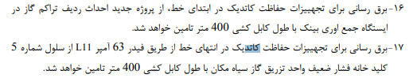

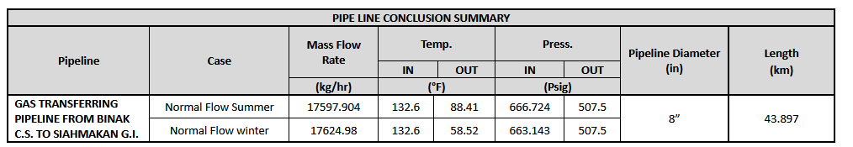

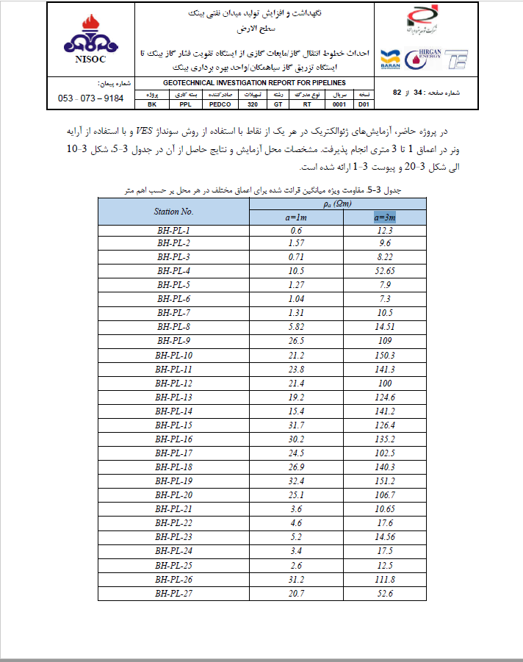

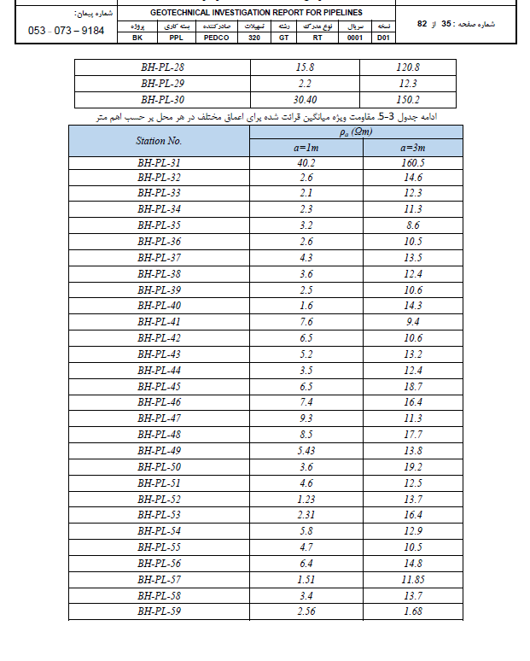

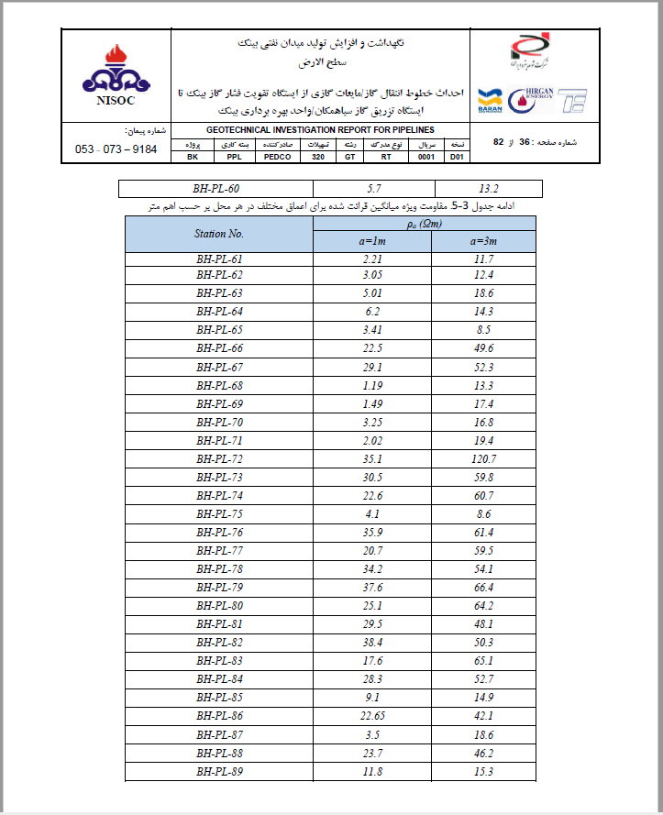

1. **Soil Resistivity Average in 3m depth.**

| Item | a= 3 m |
| --- | --- |
| R (Ω.m) |
| 1 | 12.3 |
| 2 | 9.6 |
| 3 | 8.22 |
| 4 | 52.65 |
| 5 | 7.9 |
| 6 | 7.3 |
| 7 | 10.5 |
| 8 | 14.51 |
| 9 | 109 |
| 10 | 150.3 |
| 11 | 141.3 |
| 12 | 100 |
| 13 | 124.6 |
| 14 | 141.2 |
| 15 | 126.4 |
| 16 | 135.2 |
| 17 | 102.5 |
| 18 | 140.3 |
| 19 | 151.2 |
| 20 | 106.7 |
| 21 | 10.65 |
| 22 | 17.6 |
| 23 | 14.56 |
| 24 | 17.5 |
| 25 | 12.5 |
| 26 | 111.8 |
| 27 | 52.6 |
| 28 | 11.7 |
| 29 | 12.4 |
| 30 | 18.6 |
| 31 | 14.3 |
| 32 | 8.5 |
| 33 | 49.6 |
| 34 | 52.3 |
| 35 | 13.3 |
| 36 | 17.4 |
| 37 | 16.8 |
| 38 | 19.4 |
| 39 | 120.7 |
| 40 | 59.8 |
| 41 | 60.7 |
| 42 | 8.6 |
| 43 | 61.4 |
| 44 | 59.5 |
| 45 | 54.1 |
| 46 | 66.4 |
| 47 | 64.2 |
| 48 | 48.1 |
| 49 | 50.3 |
| 50 | 65.1 |
| 51 | 52.7 |
| 52 | 14.9 |
| 53 | 42.1 |
| 54 | 18.6 |
| 55 | 46.2 |
| 56 | 15.3 |
| 57 | Average = 54.14 ohm.m |