|  |  |  |  |  |  |  |  |
| --- | --- | --- | --- | --- | --- | --- | --- |
| **طرح نگهداشت وافزایش تولید 27 مخزن** | | | | | | | |
| **CALAULATION NOTE FOR GAS COMPRESSORS FOUNDATION**  **نگهداشت و افزایش تولید میدان نفتی بینک** | | | | | | | |
|  | |  |  |  |  |  |  |
|  | |  |  |  |  |  |  |
|  | |  |  |  |  |  |  |
|  | |  |  |  |  |  |  |
| D00 | | DEC. 2024 | IFC | R.Berlouie | M.Fakharian | S.Faramarzpour |  |
| **Rev.** | | **Date** | **Purpose of Issue/Status** | **Prepared by:** | **Checked by:** | **Approved by:** | **CLIENT Approval** |
| **Class:2** | | | **COMPANY Doc. Number:** **F0Z-709121** | | | | |
| **Status:** | | **IDC: Inter-Discipline Check**  **IFC: Issued For Comment**  **IFA: Issued For Approval**  **AFD: Approved For Design**  **AFC: Approved For Construction**  **AFP: Approved For Purchase**  **AFQ:** Approved For Quotation  **IFI: Issued For Information**  **AB-R: As-Built for CLIENT Review**  **AB-A: As-Built –Approved** | | | | | |

**REVISION RECORD SHEET**

|  |  |  |  |  |  |  |  |  |  |  |  |  |
| --- | --- | --- | --- | --- | --- | --- | --- | --- | --- | --- | --- | --- |
| **PAGE** | **D00** | **D01** | **D02** | **D03** | **D04** |  | **PAGE** | **D00** | **D01** | **D02** | **D03** | **D04** |
| **1** | X |  |  |  |  | **66** |  |  |  |  |  |
| **2** | X |  |  |  |  | **67** |  |  |  |  |  |
| **3** | X |  |  |  |  | **68** |  |  |  |  |  |
| **4** | X |  |  |  |  | **69** |  |  |  |  |  |
| **5** | X |  |  |  |  | **70** |  |  |  |  |  |
| **6** | X |  |  |  |  | **71** |  |  |  |  |  |
| **7** | X |  |  |  |  | **72** |  |  |  |  |  |
| **8** | X |  |  |  |  | **73** |  |  |  |  |  |
| **9** | X |  |  |  |  | **74** |  |  |  |  |  |
| **10** | X |  |  |  |  | **75** |  |  |  |  |  |
| **11** | X |  |  |  |  | **76** |  |  |  |  |  |
| **12** | X |  |  |  |  | **77** |  |  |  |  |  |
| **13** | X |  |  |  |  | **78** |  |  |  |  |  |
| **14** | X |  |  |  |  | **79** |  |  |  |  |  |
| **15** | X |  |  |  |  | **80** |  |  |  |  |  |
| **16** | X |  |  |  |  | **81** |  |  |  |  |  |
| **17** | X |  |  |  |  | **82** |  |  |  |  |  |
| **18** | X |  |  |  |  | **83** |  |  |  |  |  |
| **19** | X |  |  |  |  | **84** |  |  |  |  |  |
| **20** | X |  |  |  |  | **85** |  |  |  |  |  |
| **21** | X |  |  |  |  | **86** |  |  |  |  |  |
| **22** |  |  |  |  |  | **87** |  |  |  |  |  |
| **23** |  |  |  |  |  | **88** |  |  |  |  |  |
| **24** |  |  |  |  |  | **89** |  |  |  |  |  |
| **25** |  |  |  |  |  | **90** |  |  |  |  |  |
| **26** |  |  |  |  |  | **91** |  |  |  |  |  |
| **27** |  |  |  |  |  | **92** |  |  |  |  |  |
| **28** |  |  |  |  |  | **93** |  |  |  |  |  |
| **29** |  |  |  |  |  | **94** |  |  |  |  |  |
| **30** |  |  |  |  |  | **95** |  |  |  |  |  |
| **31** |  |  |  |  |  | **96** |  |  |  |  |  |
| **32** |  |  |  |  |  | **97** |  |  |  |  |  |
| **33** |  |  |  |  |  | **98** |  |  |  |  |  |
| **34** |  |  |  |  |  | **99** |  |  |  |  |  |
| **35** |  |  |  |  |  | **100** |  |  |  |  |  |
| **36** |  |  |  |  |  | **101** |  |  |  |  |  |
| **37** |  |  |  |  |  | **102** |  |  |  |  |  |
| **38** |  |  |  |  |  | **103** |  |  |  |  |  |
| **39** |  |  |  |  |  | **104** |  |  |  |  |  |
| **40** |  |  |  |  |  | **105** |  |  |  |  |  |
| **41** |  |  |  |  |  | **106** |  |  |  |  |  |
| **42** |  |  |  |  |  | **107** |  |  |  |  |  |
| **43** |  |  |  |  |  | **108** |  |  |  |  |  |
| **44** |  |  |  |  |  | **109** |  |  |  |  |  |
| **45** |  |  |  |  |  | **110** |  |  |  |  |  |
| **46** |  |  |  |  |  | **111** |  |  |  |  |  |
| **47** |  |  |  |  |  | **112** |  |  |  |  |  |
| **48** |  |  |  |  |  | **113** |  |  |  |  |  |
| **49** |  |  |  |  |  | **114** |  |  |  |  |  |
| **50** |  |  |  |  |  | **115** |  |  |  |  |  |
| **51** |  |  |  |  |  | **116** |  |  |  |  |  |
| **52** |  |  |  |  |  | **117** |  |  |  |  |  |
| **53** |  |  |  |  |  | **118** |  |  |  |  |  |
| **54** |  |  |  |  |  | **119** |  |  |  |  |  |
| **55** |  |  |  |  |  | **120** |  |  |  |  |  |
| **56** |  |  |  |  |  | **121** |  |  |  |  |  |
| **57** |  |  |  |  |  | **122** |  |  |  |  |  |
| **58** |  |  |  |  |  | **123** |  |  |  |  |  |
| **59** |  |  |  |  |  | **124** |  |  |  |  |  |
| **60** |  |  |  |  |  | **125** |  |  |  |  |  |
| **61** |  |  |  |  |  | **126** |  |  |  |  |  |
| **62** |  |  |  |  |  | **127** |  |  |  |  |  |
| **63** |  |  |  |  |  | **128** |  |  |  |  |  |
| **64** |  |  |  |  |  | **129** |  |  |  |  |  |
| **65** |  |  |  |  |  | **130** |  |  |  |  |  |

**CONTENTS**

1.0 INTRODUCTION 4

2.0 Scope 4

**2.1** **Local Codes and Standards** 4

**2.2** **International Codes and Standards** 4

**2.3** **The Project Documents** 4

3.0 Material properties 5

4.0 LOADS 7

**4.1** **Deal Load** 7

**4.2** **Deal Load** 7

**4.3** **Operatio Load** 8

**4.4** **Dynamic Load** 8

**4.5** **Earthquake Load** 9

**4.6** **25% Operating Load** 9

5.0 Analysis 10

**5.1** **3d Model** 10

**5.2** **Analysis Cases** 10

**5.3** **Load Combinations** 12

6.0 Checking and Results 19

**6.1** **Soil Pressure** 19

**6.2** **Minimum Weight of Foundation** 19

**6.3** **Displacement Control** 20

7.0 Design 22

1. **INTRODUCTION**

Binak oilfield in Bushehr province is a part of the southern oilfields of Iran, is located 20 km northwest of Genaveh city.

With the aim of increasing production of oil from Binak oilfield, an EPC/EPD Project has been defined by NIOC/NISOC and awarded to Petro Iran Development Company (PEDCO). Also PEDCO (as General Contractor) has assigned the EPC-packages of the Project to "Hirgan Energy - Design and Inspection" JV.

1. **Scope**

This report covers the foundation calculation report of the “Gas Compressors Foundation”. The foundation modelled by “SAP2000” software.

**NORMATIVE REFERENCE**

* 1. **Local Codes and Standards**
* INBC Part 6 “Iranian National Building Code
* INBC Part 7 “Iranian National Building Code
* INBC Part 9 “Iranian National Building Code
* Iranian Seismic Design Code for Petroleum Facilities(3rd edition)
  1. **International Codes and Standards**
* C.Arya, W.O’Neil, “Design of Structures and Foundations for Vibrating Machines
* ACI 318. “Building Code Requirements for Reinforced Concrete”, American Concrete Institute.
* ACI 351.3R American Concrete Institute– Foundation Dynamic Equipment
* Structural Design Criteria
  1. **The Project Documents**
* BK-GNRAL-PEDCO-000-ST-SP-0001 Specification for Concrete Work
* BK-GNRAL-PEDCO-000-ST-SP-0004 Specification for Grouting
* BK-GCS-PEDCO-120-ST-DW-0059 Foundation Drawing For Gas Compressor Shelter
* BK-GCS-PEDCO-120-ST-DW-0060 Structural Drawing For Gas Compressor Shelter
* BK-GNRAL-PEDCO-000-ST-DC-0001 Structural Design Criteria

1. **Material properties**

Material properties are delivered in the following table.

table 1 -Material Properties

|  |  |
| --- | --- |
| Foundation Concrete | F'c = 30 Mpa(28- day cylindrical sample) |
| Long. reinforcement bar | Fy = 400 Mpa(AIII) |
| Trans. reinforcement bar | Fy = 400 Mpa(AIII) |
| Soil Shear modulus | G=2.9e7 (kg/m^2) According to geotechnical investigation report |

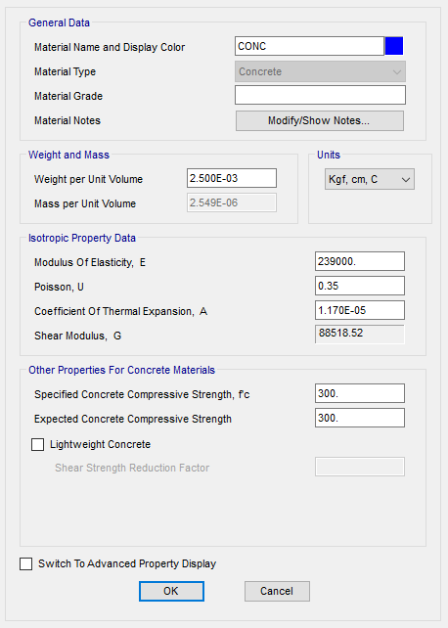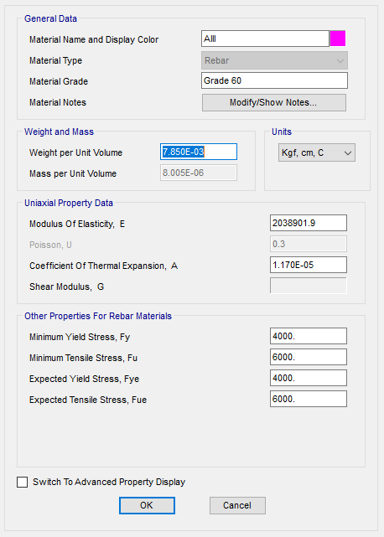

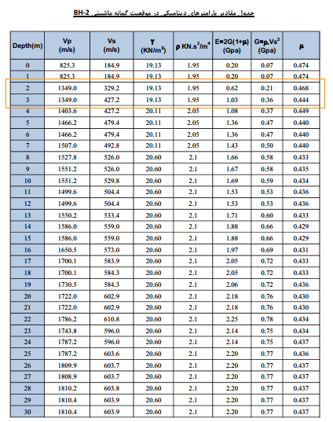

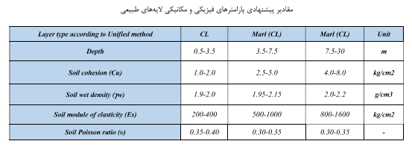

1. **LOADS**

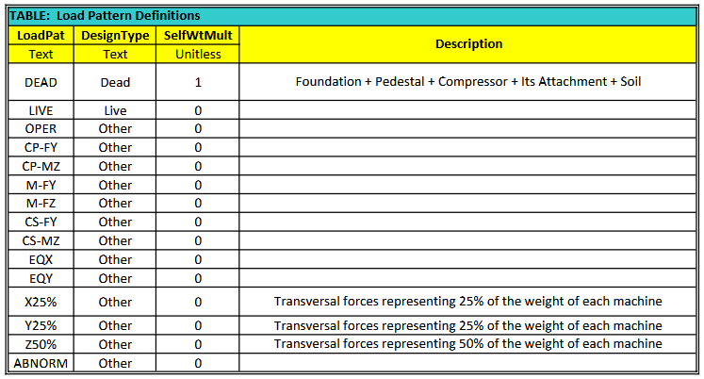

* 1. **Deal Load**

Dead loads are included the following loads:

Foundation weight + pedestals weight + soil weight and finally compressors and their attachments.

* 1. **Operation Load**

According to vendor data sheet the following loads are applied to the models

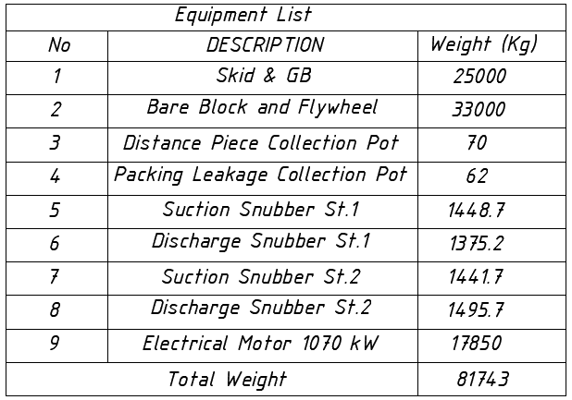

* 1. **Dynamic Load**

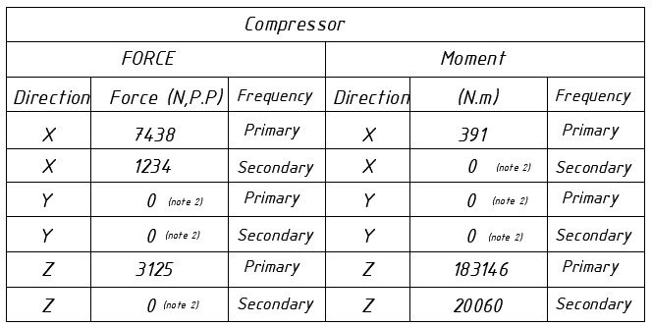 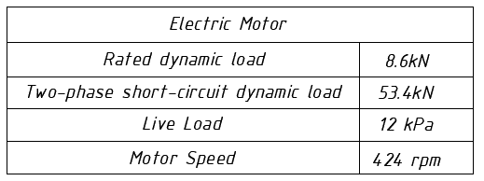

* 1. **Earthquake Load**

Seismic loads applied to the model manually and its calculations are mentioned below:

V=0.7*Ca*I*W

V=0.7*0.3*1.25*W=0.263W

* 1. **25% Operating Load**

According to regulations, 25% of the compressor's operating loads must be applied as dynamic loads in both directions.

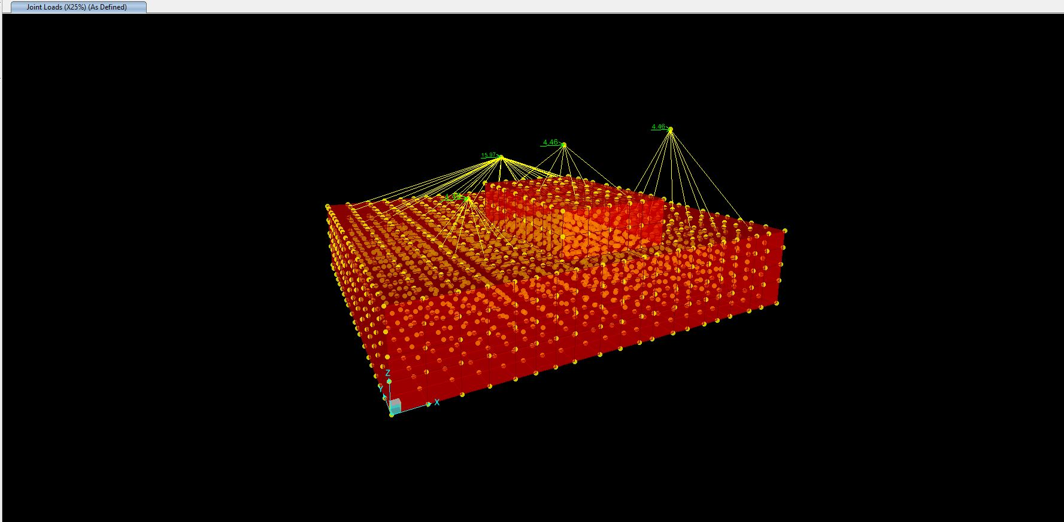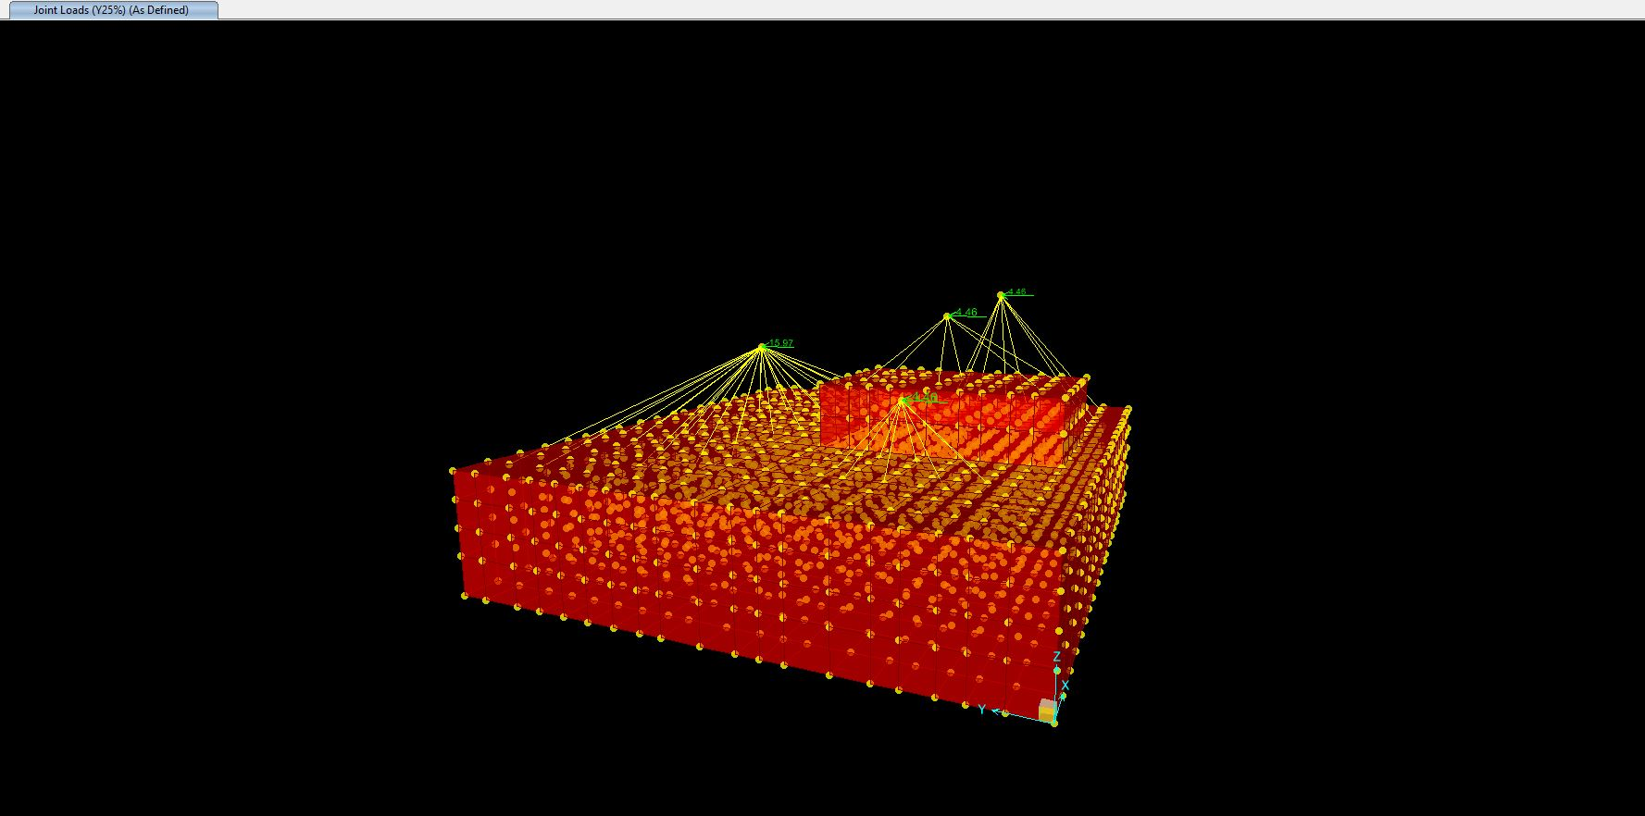

1. **Analysis**
   1. **3d Model**

SAP 2000 was applied for model this foundation and for more accuracy, solids elements have been used for checking of pressure and displacement of foundation.

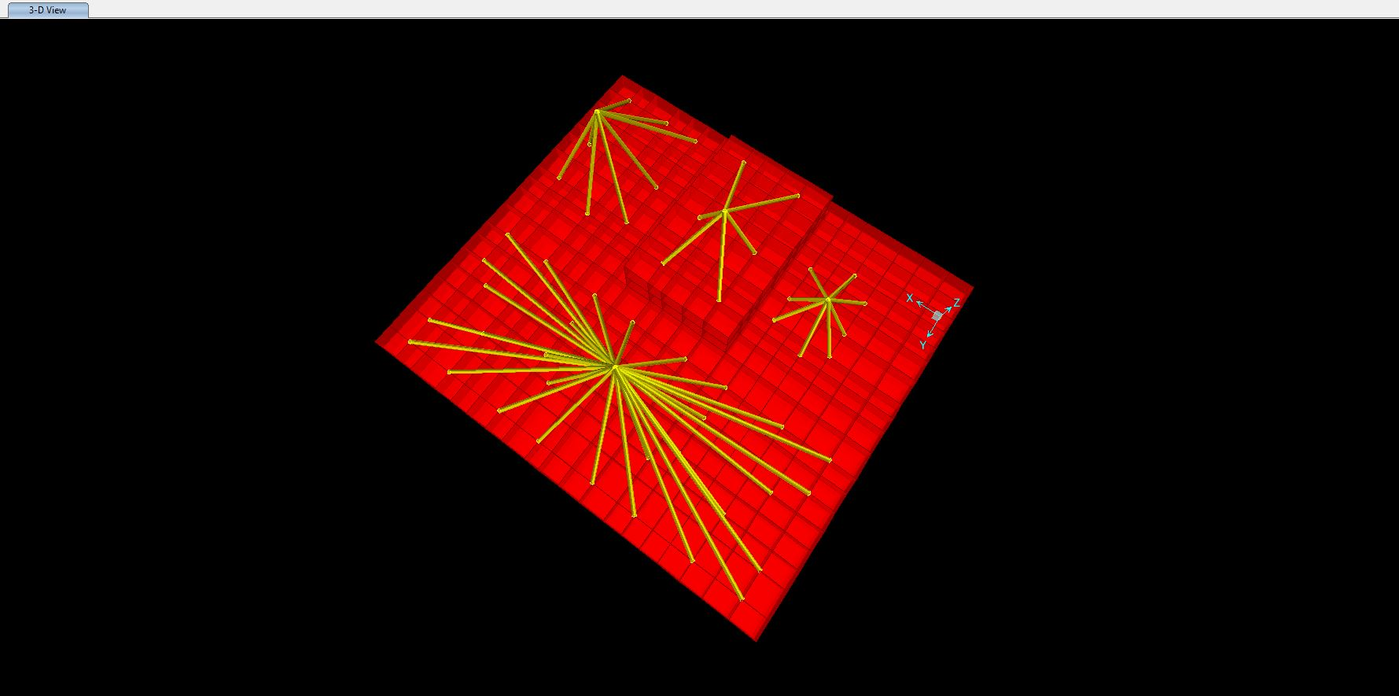

* 1. **Analysis Cases**

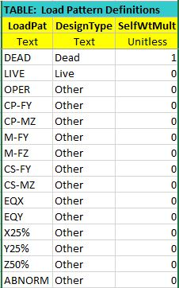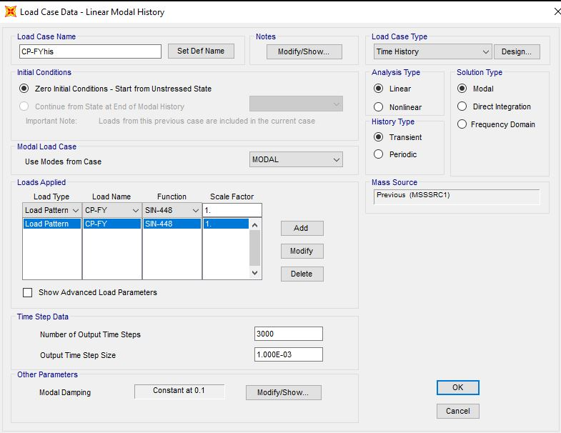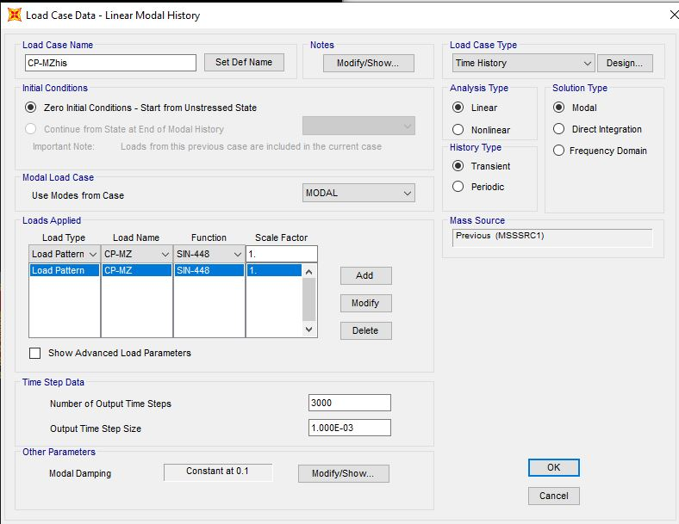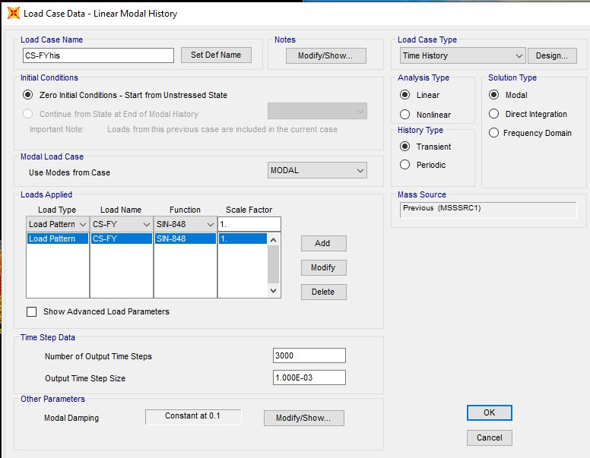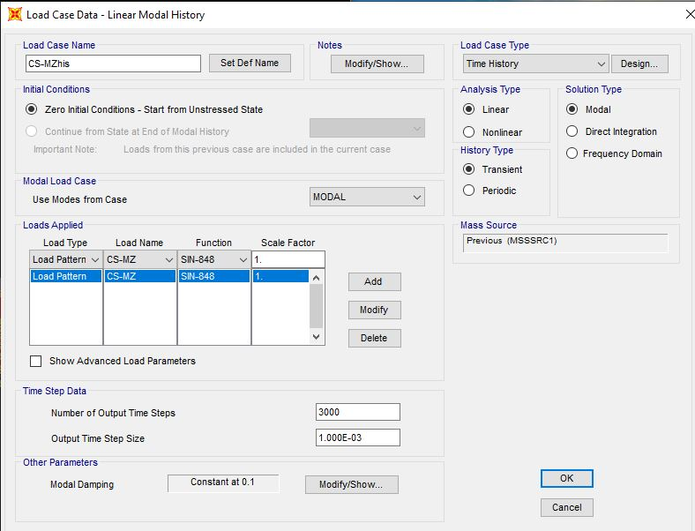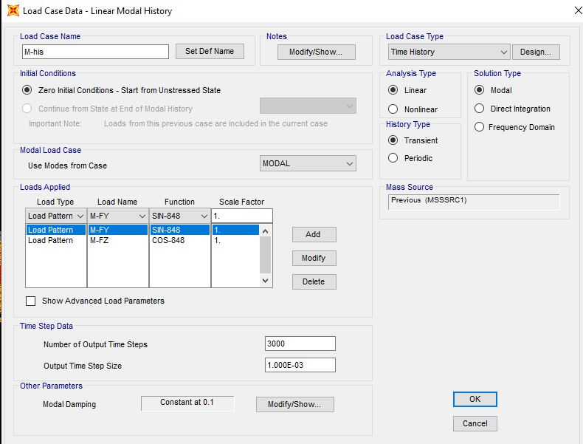

* 1. **Load Combinations**

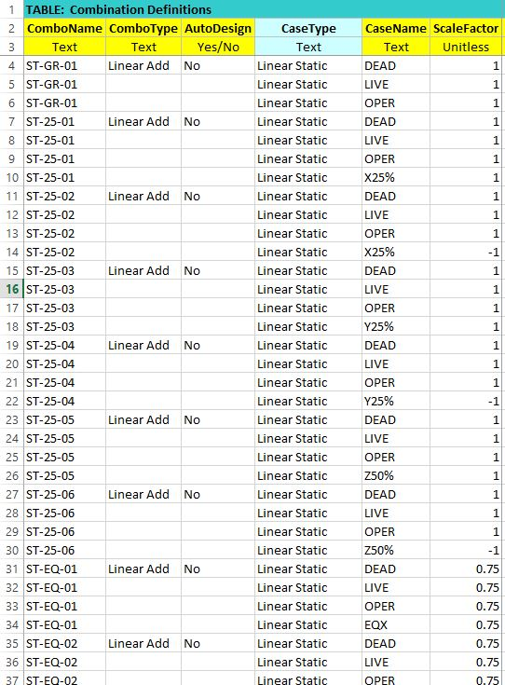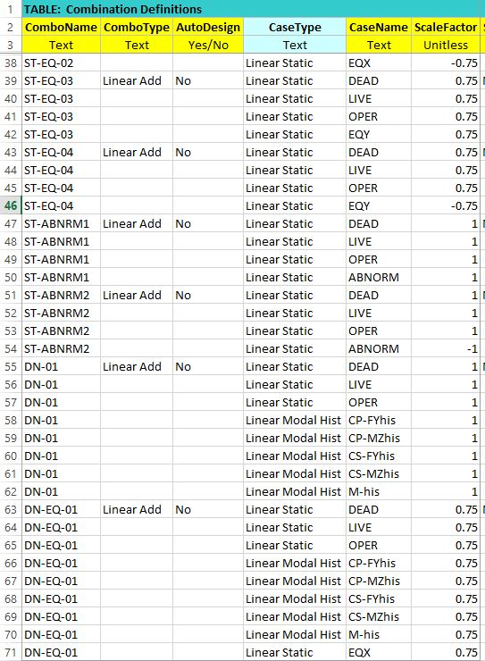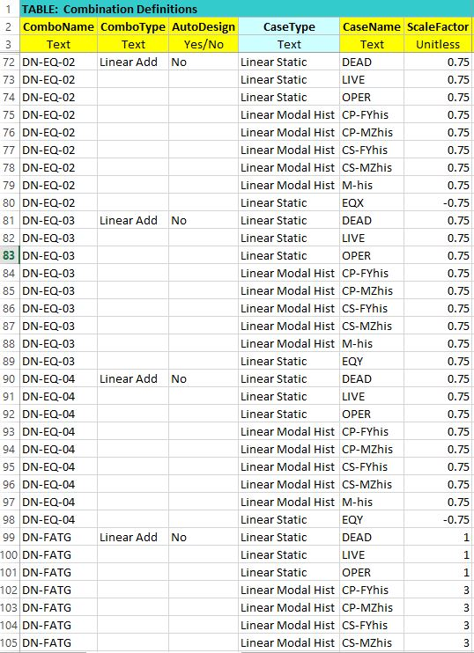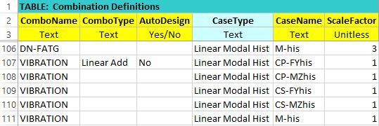

1. **Calculation of Stiffness:**

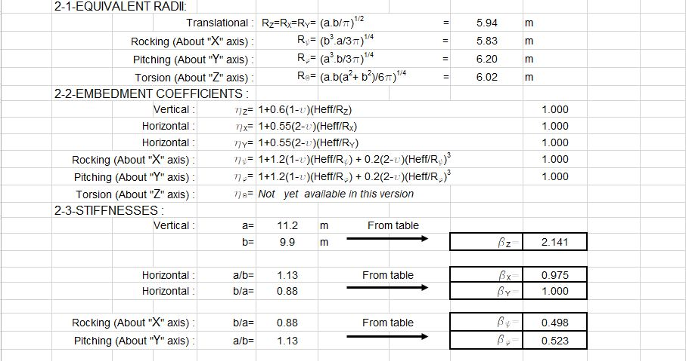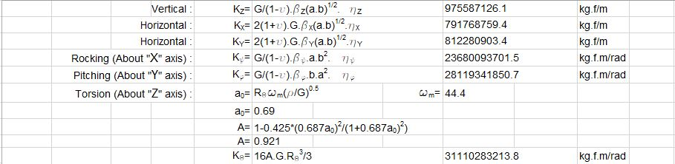

Compressor:

= 2572.17

= 13977.67

= 14558.91

Motor :

= 4595.43

= 4838.85

= 2014.61

Modified Stiffness:

Number of Joints : n=400

* Translational

kg/m

kg/m

kg/m

* Rotational

A=11.2*9.9=111 m2

m3

m3

kg/m

kg/m

kg/m

kg/m

kg/m

kg/m

1. **Checking and Results**
   1. **Minimum Weight of Foundation**

According to design criteria total foundation weight shall be at least 5 times the total machinery weight for Reciprocating machines.

Foundation Weight(Include foundation, pedestal & compressor)= 675.15 ton

Compressor Weight= 81.745 ton

675.15/81.745=8.05 > 5 ok√

* 1. **Displacement Control**

All dimensions are meters. This report has been given for compressor.

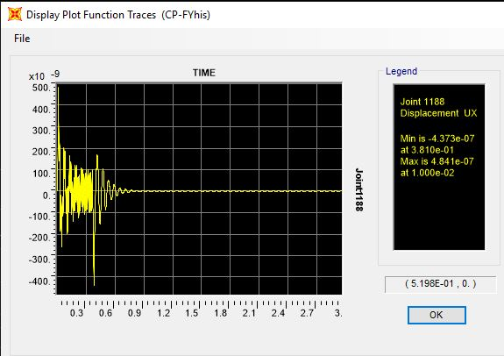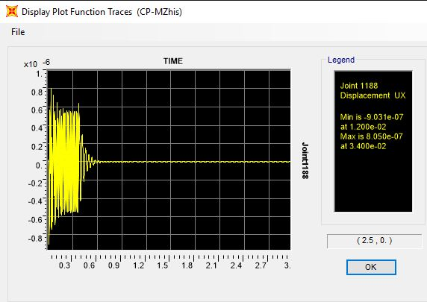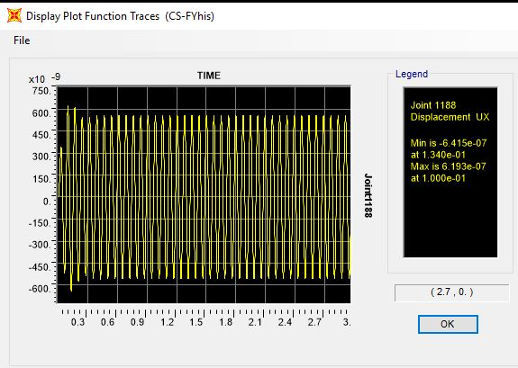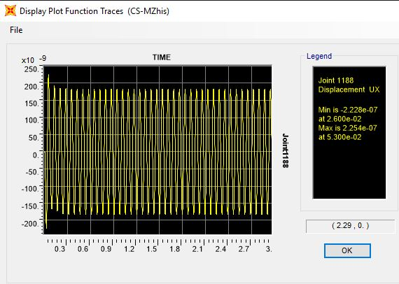

* 1. **Foundation Design**

Since foundation type is block, therefore the moments are negligible. In any directions minimum reinforcement is govern So T16 @ 200 is used.

Longitudinal & Transversal Footing: T16 @200 (Top & Bottom)

A=2x2×6 × 2.01 = 24.12 cm2 => == 0.0027

Based on I.N.B.C. Part: 9 section 2-1-7-10-9: 

 ˃ ok √