|  |  |  |  |  |  |  |  |
| --- | --- | --- | --- | --- | --- | --- | --- |
| **طرح نگهداشت و افزایش تولید 27 مخزن** | | | | | | | |
| **CALCULATION NOTE FOR LEAN GLYCOL STORAGE TANK(TK-2102)**  **نگهداشت و افزایش تولید میدان نفتی بینک** | | | | | | | |
|  | |  |  |  |  |  |  |
|  | |  |  |  |  |  |  |
|  | |  |  |  |  |  |  |
|  | |  |  |  |  |  |  |
| D00 | | JAN. 2024 | IFC | R.Berlouie | M.Fakharian | S.Faramarzpour |  |
| **Rev.** | | **Date** | **Purpose of Issue/Status** | **Prepared by:** | **Checked by:** | **Approved by:** | **CLIENT Approval** |
| **Class:2** | | | **COMPANY Doc. Number:** **F0Z-709135** | | | | |
| **Status:** | | **IDC: Inter-Discipline Check**  **IFC: Issued For Comment**  **IFA: Issued For Approval**  **AFD: Approved For Design**  **AFC: Approved For Construction**  **AFP: Approved For Purchase**  **AFQ:** Approved For Quotation  **IFI: Issued For Information**  **AB-R: As-Built for CLIENT Review**  **AB-A: As-Built –Approved** | | | | | |

**REVISION RECORD SHEET**

|  |  |  |  |  |  |  |  |  |  |  |  |  |
| --- | --- | --- | --- | --- | --- | --- | --- | --- | --- | --- | --- | --- |
| **PAGE** | **D00** | **D01** | **D02** | **D03** | **D04** |  | **PAGE** | **D00** | **D01** | **D02** | **D03** | **D04** |
| **1** | X |  |  |  |  | **66** |  |  |  |  |  |
| **2** | X |  |  |  |  | **67** |  |  |  |  |  |
| **3** | X |  |  |  |  | **68** |  |  |  |  |  |
| **4** | X |  |  |  |  | **69** |  |  |  |  |  |
| **5** | X |  |  |  |  | **70** |  |  |  |  |  |
| **6** | X |  |  |  |  | **71** |  |  |  |  |  |
| **7** | X |  |  |  |  | **72** |  |  |  |  |  |
| **8** | X |  |  |  |  | **73** |  |  |  |  |  |
| **9** | X |  |  |  |  | **74** |  |  |  |  |  |
| **10** | X |  |  |  |  | **75** |  |  |  |  |  |
| **11** | X |  |  |  |  | **76** |  |  |  |  |  |
| **12** | X |  |  |  |  | **77** |  |  |  |  |  |
| **13** | X |  |  |  |  | **78** |  |  |  |  |  |
| **14** | X |  |  |  |  | **79** |  |  |  |  |  |
| **15** | X |  |  |  |  | **80** |  |  |  |  |  |
| **16** | X |  |  |  |  | **81** |  |  |  |  |  |
| **17** | X |  |  |  |  | **82** |  |  |  |  |  |
| **18** | X |  |  |  |  | **83** |  |  |  |  |  |
| **19** | X |  |  |  |  | **84** |  |  |  |  |  |
| **20** | X |  |  |  |  | **85** |  |  |  |  |  |
| **21** | X |  |  |  |  | **86** |  |  |  |  |  |
| **22** |  |  |  |  |  | **87** |  |  |  |  |  |
| **23** |  |  |  |  |  | **88** |  |  |  |  |  |
| **24** |  |  |  |  |  | **89** |  |  |  |  |  |
| **25** |  |  |  |  |  | **90** |  |  |  |  |  |
| **26** |  |  |  |  |  | **91** |  |  |  |  |  |
| **27** |  |  |  |  |  | **92** |  |  |  |  |  |
| **28** |  |  |  |  |  | **93** |  |  |  |  |  |
| **29** |  |  |  |  |  | **94** |  |  |  |  |  |
| **30** |  |  |  |  |  | **95** |  |  |  |  |  |
| **31** |  |  |  |  |  | **96** |  |  |  |  |  |
| **32** |  |  |  |  |  | **97** |  |  |  |  |  |
| **33** |  |  |  |  |  | **98** |  |  |  |  |  |
| **34** |  |  |  |  |  | **99** |  |  |  |  |  |
| **35** |  |  |  |  |  | **100** |  |  |  |  |  |
| **36** |  |  |  |  |  | **101** |  |  |  |  |  |
| **37** |  |  |  |  |  | **102** |  |  |  |  |  |
| **38** |  |  |  |  |  | **103** |  |  |  |  |  |
| **39** |  |  |  |  |  | **104** |  |  |  |  |  |
| **40** |  |  |  |  |  | **105** |  |  |  |  |  |
| **41** |  |  |  |  |  | **106** |  |  |  |  |  |
| **42** |  |  |  |  |  | **107** |  |  |  |  |  |
| **43** |  |  |  |  |  | **108** |  |  |  |  |  |
| **44** |  |  |  |  |  | **109** |  |  |  |  |  |
| **45** |  |  |  |  |  | **110** |  |  |  |  |  |
| **46** |  |  |  |  |  | **111** |  |  |  |  |  |
| **47** |  |  |  |  |  | **112** |  |  |  |  |  |
| **48** |  |  |  |  |  | **113** |  |  |  |  |  |
| **49** |  |  |  |  |  | **114** |  |  |  |  |  |
| **50** |  |  |  |  |  | **115** |  |  |  |  |  |
| **51** |  |  |  |  |  | **116** |  |  |  |  |  |
| **52** |  |  |  |  |  | **117** |  |  |  |  |  |
| **53** |  |  |  |  |  | **118** |  |  |  |  |  |
| **54** |  |  |  |  |  | **119** |  |  |  |  |  |
| **55** |  |  |  |  |  | **120** |  |  |  |  |  |
| **56** |  |  |  |  |  | **121** |  |  |  |  |  |
| **57** |  |  |  |  |  | **122** |  |  |  |  |  |
| **58** |  |  |  |  |  | **123** |  |  |  |  |  |
| **59** |  |  |  |  |  | **124** |  |  |  |  |  |
| **60** |  |  |  |  |  | **125** |  |  |  |  |  |
| **61** |  |  |  |  |  | **126** |  |  |  |  |  |
| **62** |  |  |  |  |  | **127** |  |  |  |  |  |
| **63** |  |  |  |  |  | **128** |  |  |  |  |  |
| **64** |  |  |  |  |  | **129** |  |  |  |  |  |
| **65** |  |  |  |  |  | **130** |  |  |  |  |  |

**CONTENTS**

1.0 INTRODUCTION 7

2.0 Scope 7

3.0 NORMATIVE REFERENCE 7

4.0 Material properties 8

5.0 Computer software 8

6.0 Geometry 9

7.0 DESIGN LOAD 10

8.0 Design Load Combinations 17

9.0 Tank ANALYSIS AND DESIGN 18

10.0 ATTACHMENTS 23

1. **INTRODUCTION**

Binak oilfield in Bushehr province is a part of the southern oilfields of Iran, is located 20 km northwest of Genaveh city.

With the aim of increasing production of oil from Binak oilfield, an EPC/EPD Project has been defined by NIOC/NISOC and awarded to Petro Iran Development Company (PEDCO). Also PEDCO (as General Contractor) has assigned the EPC-packages of the Project to "Hirgan Energy - Design and Inspection" JV.

1. **Scope**

This report covers design of Lean Glycol Storage Tank (TK-2102). The calculation of foundation is performed using “SAP” software.

1. **NORMATIVE REFERENCE**
   1. **Local Codes and Standards**

* INBC Part 6 “Iranian National Building Code
* INBC Part 7 “Iranian National Building Code
* INBC Part 9 “Iranian National Building Code
* INBC Part 10 “Iranian National Building Code
* Iranian Seismic Design Code for Petroleum Facilities(3rd edition)
  1. **International Codes and Standards**
* ASCE 7-10 “Minimum Design Loads and Associated Criteria for Buildings and Other Structures-American Society of Civil Engineers”.
* ACI 318. “Building Code Requirements for Reinforced Concrete”, American Concrete Institute.
* AISC 358 “Prequalified Connections for Special and Intermediate Steel Moment Frames for Seismic Applications.” American Institute of Steel Construction, Inc.
* AISC 360 - “Specification for Structural Steel Buildings”. American Institute of Steel Construction, Inc.
  1. **The Project Documents**
* BK-GNRAL-PEDCO-000-ST-SP-0001 SPECIFICATION FOR CONCRETE WORK
* BK-GNRAL-PEDCO-000-ST-DC-0001 Structural Design Criteria
* BK-GNRAL-PEDCO-000-CV-SP-0004 Specification For Earth Work
* BK-GCS-PEDCO-120-GT-RT-0001 Geotechnical Investigation Report for Compressor Station

1. **Material properties**

Material properties are delivered in the following table.

|  |  |
| --- | --- |
| Material properties | |
| Structure and Foundation concrete | F’c=300kg/cm²(28 days cylindrical sample) |
| Long. Reinforcement | Fy=4000 kg/cm² (AIII) |
| Trans. Reinforcement | Fy=4000 kg/cm² (AIII) |

1. **Computer software**

Computer’s Software, which is used in structure and foundation analysis and design, are defined in the following table.

|  |  |
| --- | --- |
| Computer software | |
| analysis and design of structure and foundation | SAP 21.1.0 |

1. **Geometry**

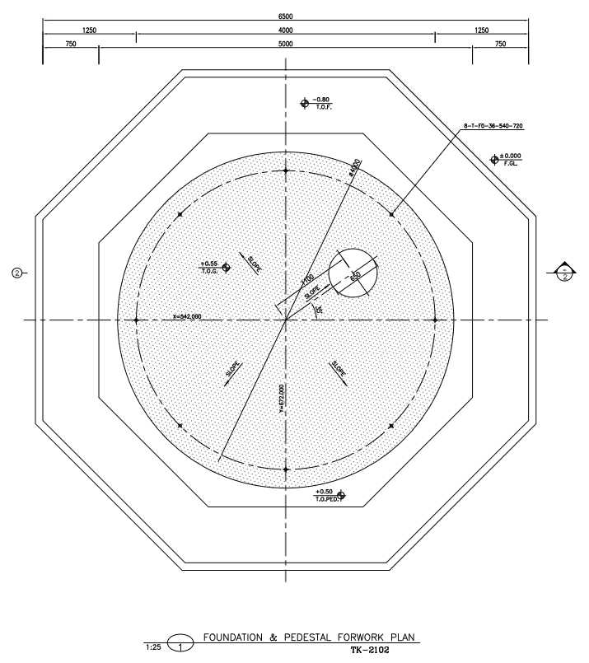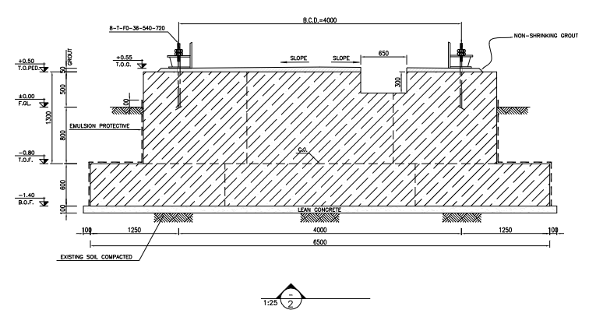

1. **foundation and pedestal plan for TK-2102**
2. **DESIGN LOAD**
   1. Load case for tank foundation design

The loads that apply on the foundation, according to tank design report (annex I), are as following:

|  |  |  |  |  |
| --- | --- | --- | --- | --- |
| Anchor Bolt data | | | | |
| anchor bolt dia. | M36 |  | | |
| No. of anchor bolt | 8 |  | | |
| BCD | 4200 | mm | | |
| foundation load data | | | | |
| Seismic | Shear (N) |  | 135,800 | N |
| Moment (N.m) | Ring wall | 311,500 | N.m |
| Slab | 348,600 | N.m |
| wind | Shear (N) | | 53,900 | N |
| Moment (N.m) | | 120,600 | N.m |
| Weight | Empty | | 6,700 | Kg |
| Operating | | 55,100 | Kg |
| Hydrotest | | 68,700 | Kg |

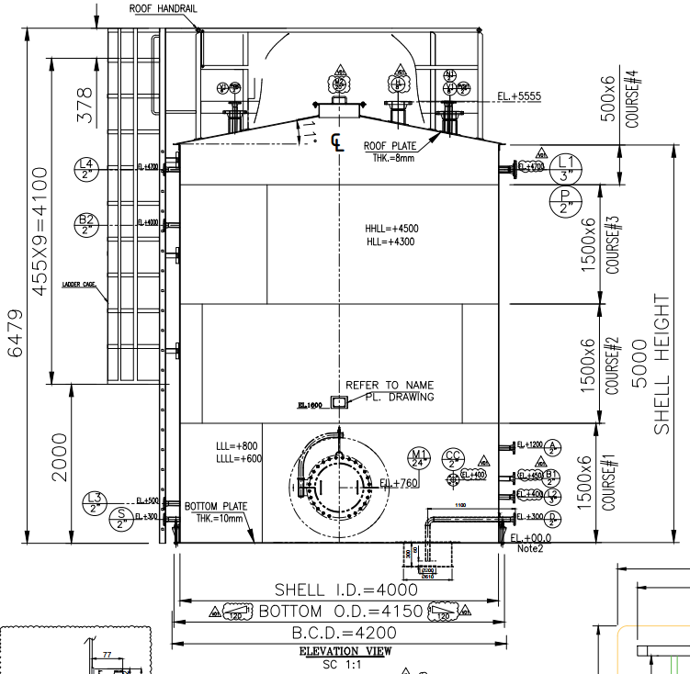

1. **foundation and pedestal plan for TK-2102**
   1. **Dead Load**

Based on mechanical data sheet fabrication load applied as Dead load on foundation as follows:

Dead Weight/Area: [6700/(3.1415x4*4)]*4=534 Kg /m2

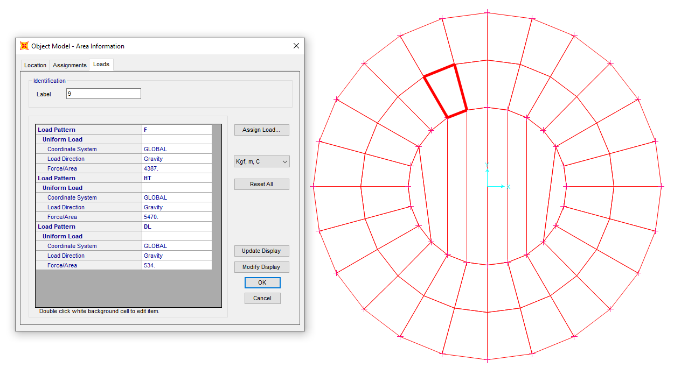

1. **Dead Load On Pedestal**
   1. **Operation Load**

Normal Fluid Load on ring foundation:

F = (Ope load / area of ring foundation) → area of ring foundation: (𝜋 × 4²)/4=12.56

55100/12.56=4.387 ton/m²

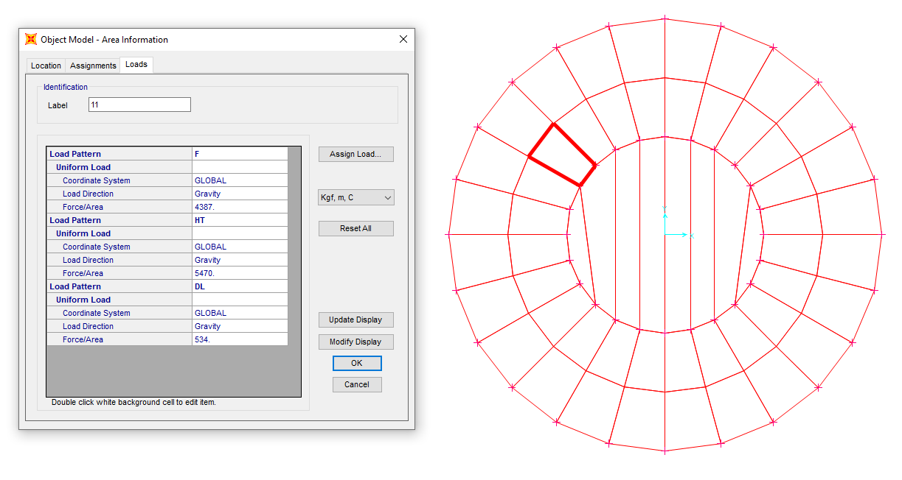

1. **Area uniform F load on the inside ring foundation** 
   1. **HT (Test Fluid Load)**

Test Load on ring foundation: HT = Hydro test load / area of ring foundation → area of ring foundation: (𝜋 × 4²)/4=12.56 m2 → 68700/12.56= 5.470 ton/m²

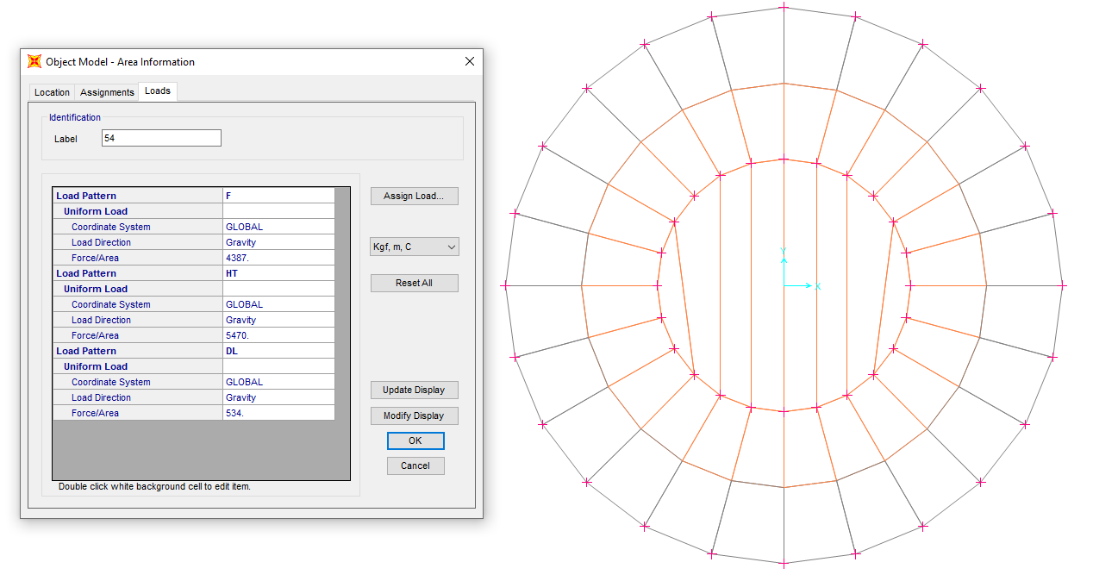

1. **area uniform HT load on the inside ring foundation**
   1. **E (Earthquake Load)**

Shear load = 135800 N (According to General Arrangement Lean Glycol Storage Tank (TK-2102).

This shear is based on the datasheet, but we used API650 with ASD behavior coefficient so its value is multiplied by 1.4 → 135800  1.4 = 190120 N

Moment = 311500 N.m (According to General Arrangement Lean Glycol Storage Tank (TK-2102).

This moment is based on the datasheet, but we used API650 with ASD behavior coefficient so its value is multiplied by 1.4 → 311500  1.4 = 436100 N.m

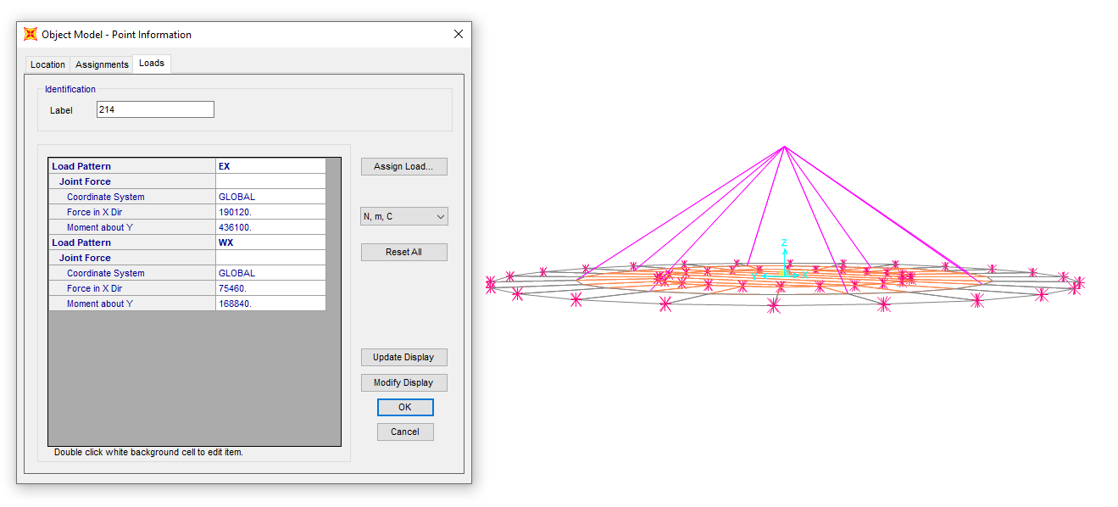

1. **Earthquake Load (EX)**
   1. **W (Wind Load)**

Shear load = 53900 N (According to General Arrangement Lean Glycol Storage Tank (TK-2102).

This shear is based on the datasheet, but we used API650 with ASD behavior coefficient so its value is multiplied by 1.4 → 53900  1.4 = 75460 N

Moment = 120600 N.m (According to General Arrangement Lean Glycol Storage Tank (TK-2102).

This moment is based on the datasheet, but we used API650 with ASD behavior coefficient so its value is multiplied by 1.4 → 120600  1.4 = 168840 N.m

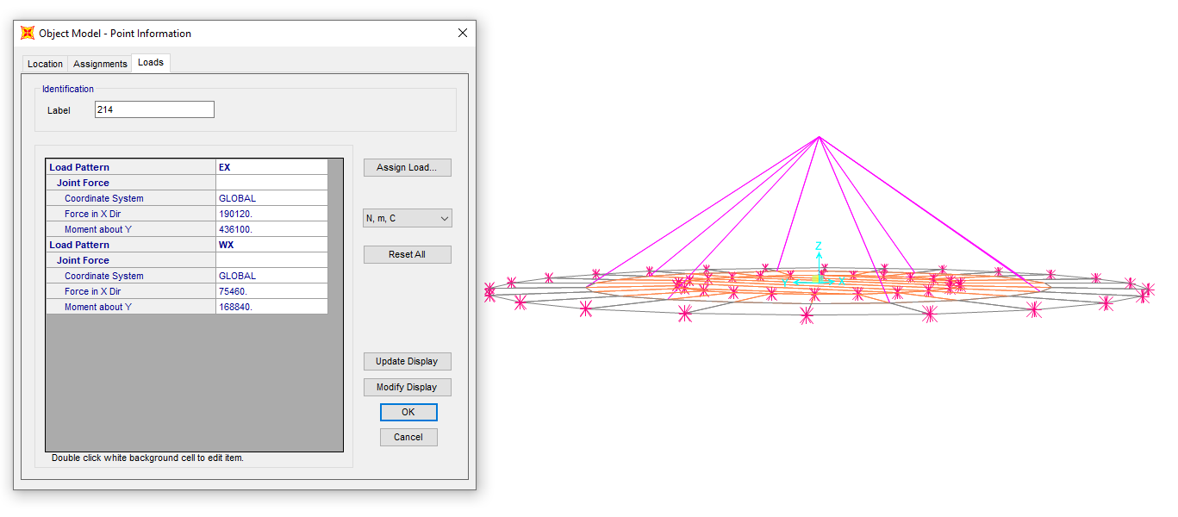

1. **wind load (WX)** 
   1. **Soil Pressure (DS)**

Due to soil weight on foundation apply Soil Load on foundation as follows :

ƔH=1800 x 0.80 = 1440 kg/m2

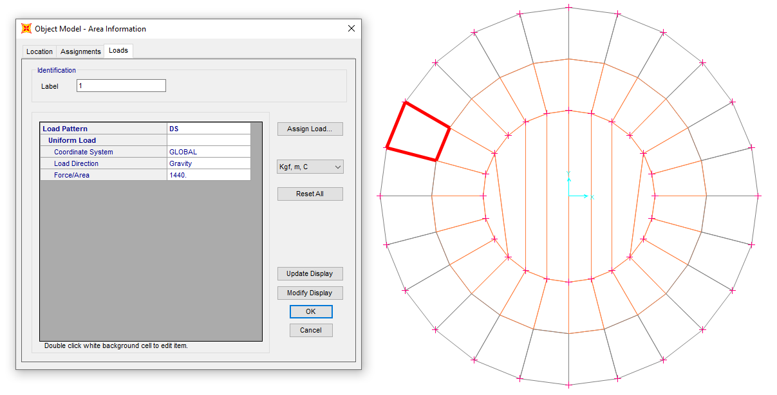

1. **SOIL PRESSURE**
2. **Design Load Combinations**

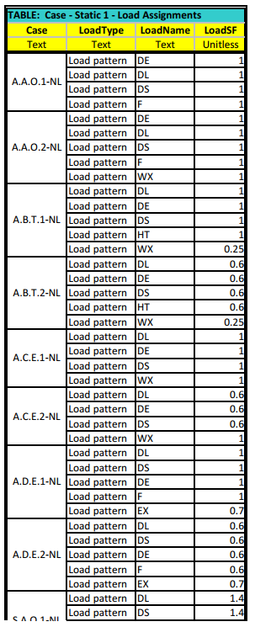 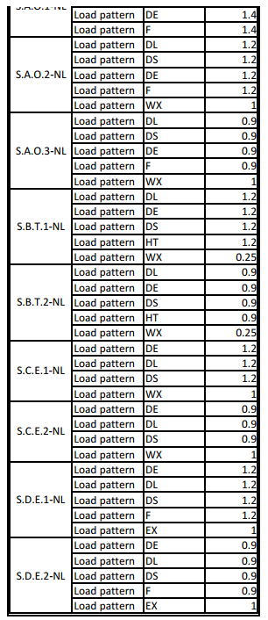

1. **Tank ANALYSIS AND DESIGN** 
   1. **Tank geometry**

As noted before, the structure has modelled and analysed by SAP2000. This figure shows a 3D view of the model in software.

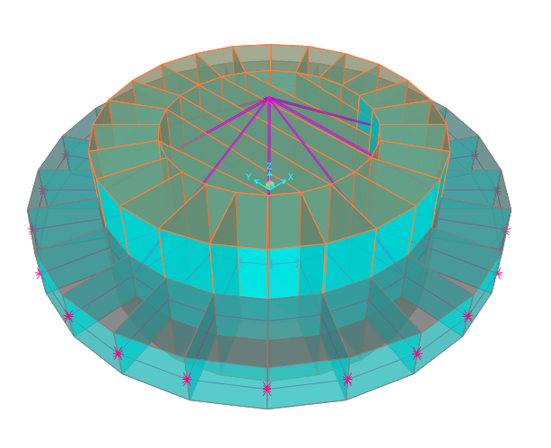

1. **3D model** 
   1. **Stability Check**

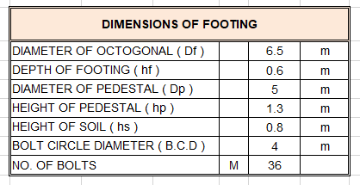

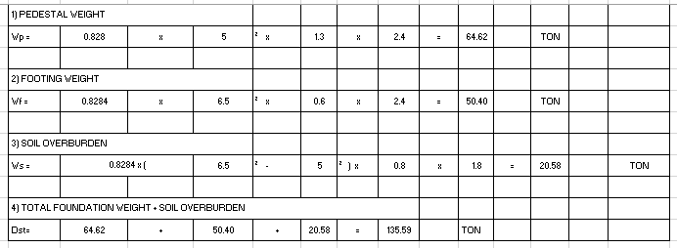

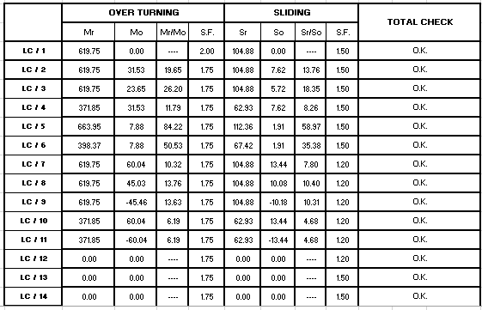

* 1. **Soil Pressure Check**

|  |  |  |  |  |  |  |  |  |  |  |
| --- | --- | --- | --- | --- | --- | --- | --- | --- | --- | --- |
| L / C | **Pu** | **Mu** | e | e/Df | L z-z | SOIL BEARING ( TON / M2 ) | | |  |  |
| Qmax | Qmin | ALLOW. |  | Uplift Length |
| **LC / 1** | 191 | 0 | 0.00 | 0.00 | 0.0 | 5.448 | 5.448 | 10.000 |  | 0.00 |
| **LC / 2** | 191 | 31.53444 | 0.17 | 0.03 | 0.0 | 6.584 | 4.313 | 10.000 |  | 0.00 |
| **LC / 3** | 191 | 23.65083 | 0.12 | 0.02 | 0.0 | 6.300 | 4.597 | 10.000 |  | 0.00 |
| **LC / 4** | 114 | 31.53444 | 0.28 | 0.04 | 0.0 | 4.405 | 2.133 | 10.000 |  | 0.00 |
| **LC / 5** | 204 | 7.88361 | 0.04 | 0.01 | 0.0 | 6.121 | 5.553 | 10.000 |  | 0.00 |
| **LC / 6** | 123 | 7.88361 | 0.06 | 0.01 | 0.0 | 3.786 | 3.218 | 10.000 |  | 0.00 |
| **LC / 7** | 191 | 60.044012 | 0.31 | 0.05 | 0.0 | 7.611 | 3.286 | 10.000 |  | 0.00 |
| **LC / 8** | 191 | 45.033009 | 0.24 | 0.04 | 0.0 | 7.070 | 3.826 | 10.000 |  | 0.00 |
| **LC / 9** | 191 | -45.4618948 | -0.24 | 0.04 | 0.0 | 3.811 | 7.086 | 10.000 |  | 0.00 |
| **LC / 10** | 114 | 60.044012 | 0.52 | 0.08 | 0.0 | 5.432 | 1.106 | 10.000 |  | 0.00 |
| **LC / 11** | 114 | -60.044012 | -0.52 | 0.08 | 0.0 | 1.106 | 5.432 | 10.000 |  | 0.00 |
| **LC / 12** | 0 | 0 | 0.00 | 0.00 | 0.0 | 0.000 | 0.000 | 10.000 |  | 0.00 |
| **LC / 13** | 0 | 0 | 0.00 | 0.00 | 0.0 | 0.000 | 0.000 | 10.000 |  | 0.00 |
| **LC / 14** | 0 | 0 | 0.00 | 0.00 | 0.0 | 0.000 | 0.000 | 10.000 |  | 0.00 |

|  |  |  |  |  |  |
| --- | --- | --- | --- | --- | --- |
| **MAXIMUM SOIL STRESS =** |  |  | **7.611** | **TON / M2** |  |

* 1. **Reinforcing**
  + Pedestal reinforcement

As Req=T / F. fy=2328 / 0.9x4000=0.64cm2

Min As=0.0015x Aped=0.0015x0.8284xDp2x10000=310.65 cm2

Max (0.64 , 310.65)=310.65

USE 72 T25 AS used=353.42 cm2

* + Foundation reinforcement

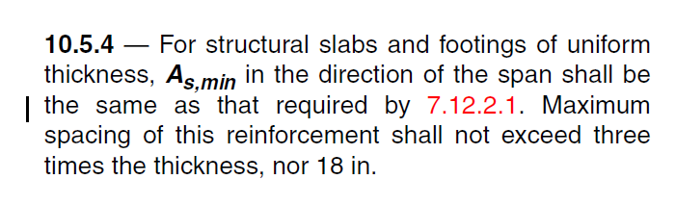 According to ACI-318-08:

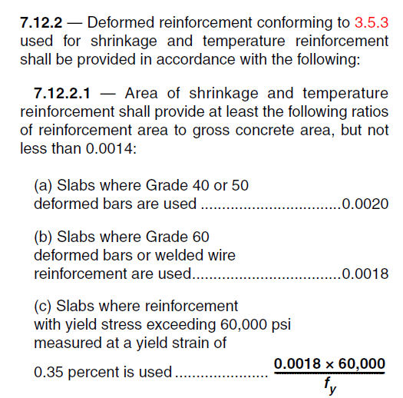

$$A_{S,min}=0.0018×60×100=10.8{cm}^{2} for top and bottom$$

→ If use Φ 16@200 → A = 10.05cm² > 5.4 cm² → ok

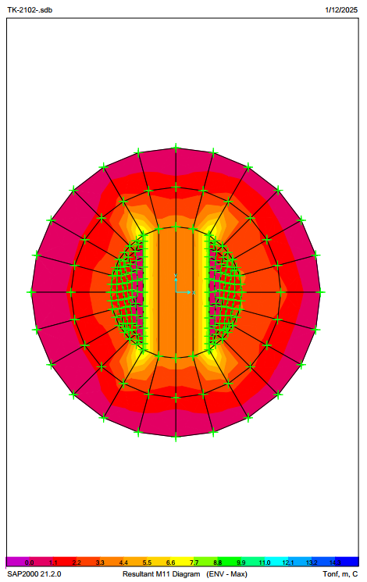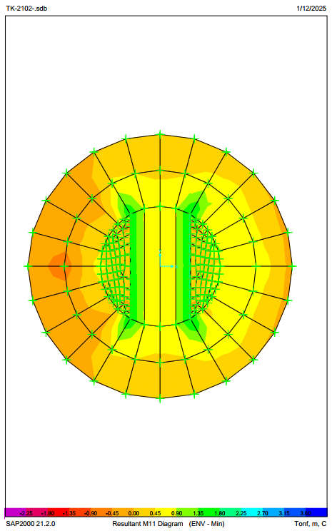

1. **M11 Max - M11 Min**

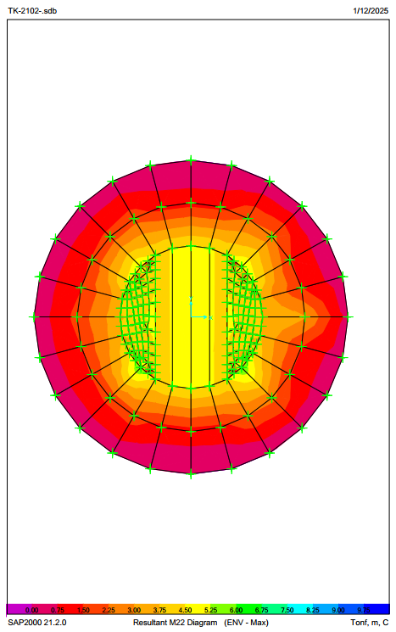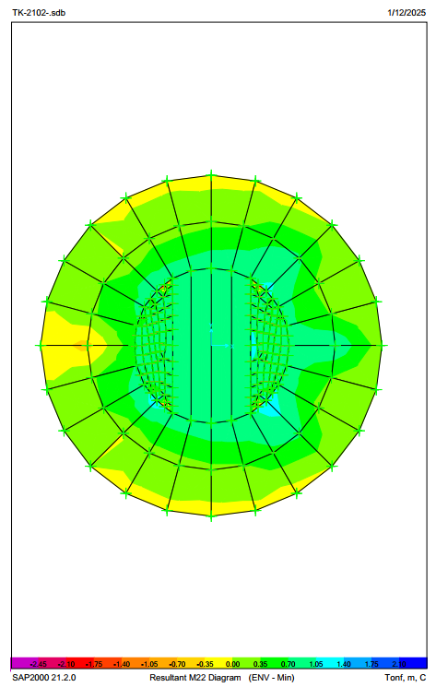

1. **M22 Max - M22 Min**
2. ATTACHMENTS
   1. **SOWFTWARE FILE**

“SAP” software file is attached.

* 1. **MECHANICAL DATA SHEET**

Mechanical data sheet is attached.