|  |  |  |  |  |  |  |  |
| --- | --- | --- | --- | --- | --- | --- | --- |
| **طرح نگهداشت و افزایش تولید 27 مخزن** | | | | | | | |
| **CALCULATION NOTE FOR LEAN GLYCOL STORAGE TANK(TK-2102)**  **نگهداشت و افزایش تولید میدان نفتی بینک** | | | | | | | |
|  | |  |  |  |  |  |  |
|  | |  |  |  |  |  |  |
|  | |  |  |  |  |  |  |
| D01 | | FEB. 2024 | IFA | R.Berlouie | M.Fakharian | S.Faramarzpour |  |
| D00 | | JAN. 2024 | IFC | R.Berlouie | M.Fakharian | S.Faramarzpour |  |
| **Rev.** | | **Date** | **Purpose of Issue/Status** | **Prepared by:** | **Checked by:** | **Approved by:** | **CLIENT Approval** |
| **Class:2** | | | **COMPANY Doc. Number:** **F0Z-709135** | | | | |
| **Status:** | | **IDC: Inter-Discipline Check**  **IFC: Issued For Comment**  **IFA: Issued For Approval**  **AFD: Approved For Design**  **AFC: Approved For Construction**  **AFP: Approved For Purchase**  **AFQ:** Approved For Quotation  **IFI: Issued For Information**  **AB-R: As-Built for CLIENT Review**  **AB-A: As-Built –Approved** | | | | | |

**REVISION RECORD SHEET**

|  |  |  |  |  |  |  |  |  |  |  |  |  |
| --- | --- | --- | --- | --- | --- | --- | --- | --- | --- | --- | --- | --- |
| **PAGE** | **D00** | **D01** | **D02** | **D03** | **D04** |  | **PAGE** | **D00** | **D01** | **D02** | **D03** | **D04** |
| **1** | X | X |  |  |  | **66** |  |  |  |  |  |
| **2** | X | X |  |  |  | **67** |  |  |  |  |  |
| **3** | X |  |  |  |  | **68** |  |  |  |  |  |
| **4** | X |  |  |  |  | **69** |  |  |  |  |  |
| **5** | X |  |  |  |  | **70** |  |  |  |  |  |
| **6** | X | X |  |  |  | **71** |  |  |  |  |  |
| **7** | X |  |  |  |  | **72** |  |  |  |  |  |
| **8** | X | X |  |  |  | **73** |  |  |  |  |  |
| **9** | X | X |  |  |  | **74** |  |  |  |  |  |
| **10** | X | X |  |  |  | **75** |  |  |  |  |  |
| **11** | X | X |  |  |  | **76** |  |  |  |  |  |
| **12** | X | X |  |  |  | **77** |  |  |  |  |  |
| **13** | X | X |  |  |  | **78** |  |  |  |  |  |
| **14** | X |  |  |  |  | **79** |  |  |  |  |  |
| **15** | X | X  X  X  X |  |  |  | **80** |  |  |  |  |  |
| **16** | X |  |  |  |  | **81** |  |  |  |  |  |
| **17** | X |  |  |  |  | **82** |  |  |  |  |  |
| **18** | X |  |  |  |  | **83** |  |  |  |  |  |
| **19** | X | X |  |  |  | **84** |  |  |  |  |  |
| **20** | X | X |  |  |  | **85** |  |  |  |  |  |
| **21** | X | X |  |  |  | **86** |  |  |  |  |  |
| **22** |  | X |  |  |  | **87** |  |  |  |  |  |
| **23** |  | X |  |  |  | **88** |  |  |  |  |  |
| **24** |  |  |  |  |  | **89** |  |  |  |  |  |
| **25** |  |  |  |  |  | **90** |  |  |  |  |  |
| **26** |  |  |  |  |  | **91** |  |  |  |  |  |
| **27** |  |  |  |  |  | **92** |  |  |  |  |  |
| **28** |  |  |  |  |  | **93** |  |  |  |  |  |
| **29** |  |  |  |  |  | **94** |  |  |  |  |  |
| **30** |  |  |  |  |  | **95** |  |  |  |  |  |
| **31** |  |  |  |  |  | **96** |  |  |  |  |  |
| **32** |  |  |  |  |  | **97** |  |  |  |  |  |
| **33** |  |  |  |  |  | **98** |  |  |  |  |  |
| **34** |  |  |  |  |  | **99** |  |  |  |  |  |
| **35** |  |  |  |  |  | **100** |  |  |  |  |  |
| **36** |  |  |  |  |  | **101** |  |  |  |  |  |
| **37** |  |  |  |  |  | **102** |  |  |  |  |  |
| **38** |  |  |  |  |  | **103** |  |  |  |  |  |
| **39** |  |  |  |  |  | **104** |  |  |  |  |  |
| **40** |  |  |  |  |  | **105** |  |  |  |  |  |
| **41** |  |  |  |  |  | **106** |  |  |  |  |  |
| **42** |  |  |  |  |  | **107** |  |  |  |  |  |
| **43** |  |  |  |  |  | **108** |  |  |  |  |  |
| **44** |  |  |  |  |  | **109** |  |  |  |  |  |
| **45** |  |  |  |  |  | **110** |  |  |  |  |  |
| **46** |  |  |  |  |  | **111** |  |  |  |  |  |
| **47** |  |  |  |  |  | **112** |  |  |  |  |  |
| **48** |  |  |  |  |  | **113** |  |  |  |  |  |
| **49** |  |  |  |  |  | **114** |  |  |  |  |  |
| **50** |  |  |  |  |  | **115** |  |  |  |  |  |
| **51** |  |  |  |  |  | **116** |  |  |  |  |  |
| **52** |  |  |  |  |  | **117** |  |  |  |  |  |
| **53** |  |  |  |  |  | **118** |  |  |  |  |  |
| **54** |  |  |  |  |  | **119** |  |  |  |  |  |
| **55** |  |  |  |  |  | **120** |  |  |  |  |  |
| **56** |  |  |  |  |  | **121** |  |  |  |  |  |
| **57** |  |  |  |  |  | **122** |  |  |  |  |  |
| **58** |  |  |  |  |  | **123** |  |  |  |  |  |
| **59** |  |  |  |  |  | **124** |  |  |  |  |  |
| **60** |  |  |  |  |  | **125** |  |  |  |  |  |
| **61** |  |  |  |  |  | **126** |  |  |  |  |  |
| **62** |  |  |  |  |  | **127** |  |  |  |  |  |
| **63** |  |  |  |  |  | **128** |  |  |  |  |  |
| **64** |  |  |  |  |  | **129** |  |  |  |  |  |
| **65** |  |  |  |  |  | **130** |  |  |  |  |  |

**CONTENTS**

1.0 INTRODUCTION 7

2.0 Scope 7

3.0 NORMATIVE REFERENCE 7

4.0 Material properties 8

5.0 Computer software 8

6.0 Geometry 9

7.0 DESIGN LOAD 10

8.0 Design Load Combinations 17

9.0 Tank ANALYSIS AND DESIGN 18

10.0 ATTACHMENTS 23

1. **INTRODUCTION**

Binak oilfield in Bushehr province is a part of the southern oilfields of Iran, is located 20 km northwest of Genaveh city.

With the aim of increasing production of oil from Binak oilfield, an EPC/EPD Project has been defined by NIOC/NISOC and awarded to Petro Iran Development Company (PEDCO). Also PEDCO (as General Contractor) has assigned the EPC-packages of the Project to "Hirgan Energy - Design and Inspection" JV.

1. **Scope**

This report covers design of Lean Glycol Storage Tank (TK-2102). The calculation of foundation is performed using “SAP” software.

1. **NORMATIVE REFERENCE**
   1. **Local Codes and Standards**

* INBC Part 6 “Iranian National Building Code
* INBC Part 7 “Iranian National Building Code
* INBC Part 9 “Iranian National Building Code
* INBC Part 10 “Iranian National Building Code
* Iranian Seismic Design Code for Petroleum Facilities(3rd edition)
  1. **International Codes and Standards**
* ASCE 7-10 “Minimum Design Loads and Associated Criteria for Buildings and Other Structures-American Society of Civil Engineers”.
* ACI 318. “Building Code Requirements for Reinforced Concrete”, American Concrete Institute.
* AISC 358 “Prequalified Connections for Special and Intermediate Steel Moment Frames for Seismic Applications.” American Institute of Steel Construction, Inc.
* AISC 360 - “Specification for Structural Steel Buildings”. American Institute of Steel Construction, Inc.
  1. **The Project Documents**
* BK-GNRAL-PEDCO-000-ST-SP-0001 SPECIFICATION FOR CONCRETE WORK
* BK-GNRAL-PEDCO-000-ST-DC-0001 Structural Design Criteria
* BK-GNRAL-PEDCO-000-CV-SP-0004 Specification For Earth Work
* BK-GCS-PEDCO-120-GT-RT-0001 Geotechnical Investigation Report for Compressor Station

1. **Material properties**

Material properties are delivered in the following table.

|  |  |
| --- | --- |
| Material properties | |
| Structure and Foundation concrete | F’c=300kg/cm²(28 days cylindrical sample) |
| Long. Reinforcement | Fy=4000 kg/cm² (AIII) |
| Trans. Reinforcement | Fy=4000 kg/cm² (AIII) |

1. **Computer software**

Computer’s Software, which is used in structure and foundation analysis and design, are defined in the following table.

|  |  |
| --- | --- |
| Computer software | |
| analysis and design of structure and foundation | SAP 21.1.0 |

1. **Geometry**

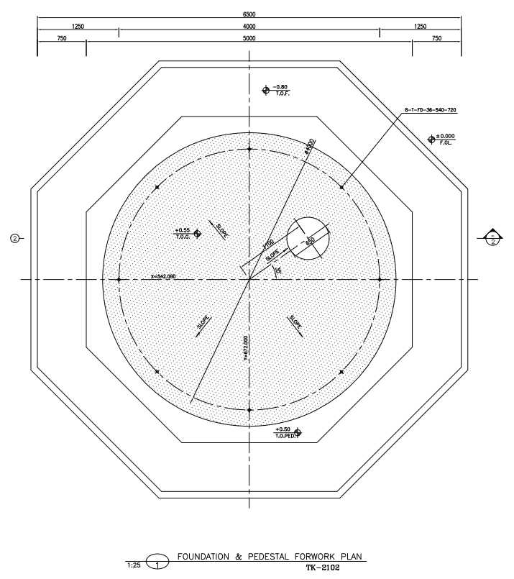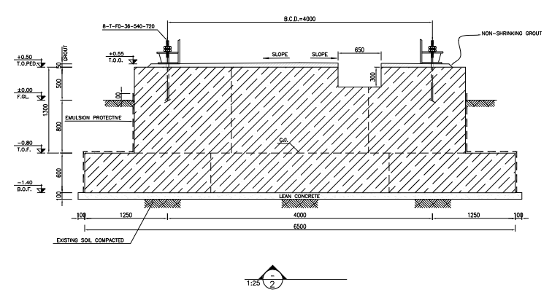

**D01**

1. **foundation and pedestal plan for TK-2102**
2. **DESIGN LOAD**
   1. Load case for tank foundation design

The loads that apply on the foundation, according to tank design report (annex I), are as following:

|  |  |  |  |  |
| --- | --- | --- | --- | --- |
| Anchor Bolt data | | | | |
| anchor bolt dia. | M36 |  | | |
| No. of anchor bolt | 8 |  | | |
| BCD | 4200 | mm | | |
| foundation load data | | | | |
| Seismic | Shear (N) |  | 135,800 | N |
| Moment (N.m) | Ring wall | 311,500 | N.m |
| Slab | 348,600 | N.m |
| wind | Shear (N) | | 53,900 | N |
| Moment (N.m) | | 120,600 | N.m |
| Weight | Empty | | 6,700 | Kg |
| Operating | | 55,100 | Kg |
| Hydrotest | | 68,700 | Kg |

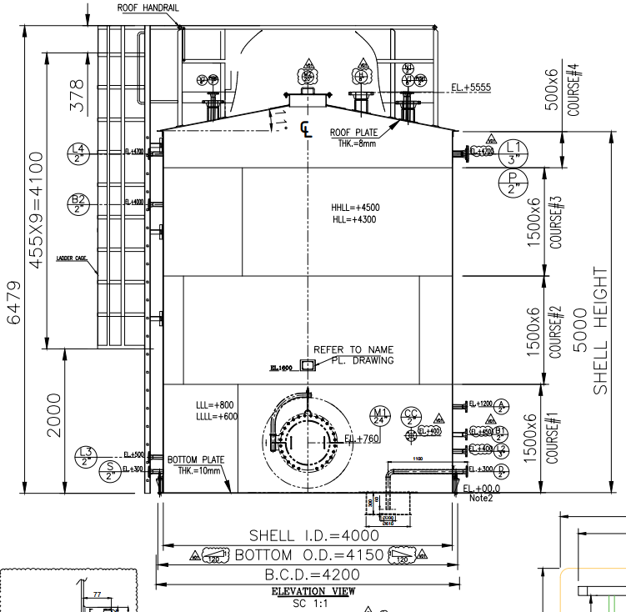

1. **foundation and pedestal plan for TK-2102**
   1. **Dead Load**

Based on mechanical data sheet fabrication load applied as Dead load on foundation as follows:

Dead Weight/Area: [6700/(3.1415x4*4)]*4=534 Kg /m2

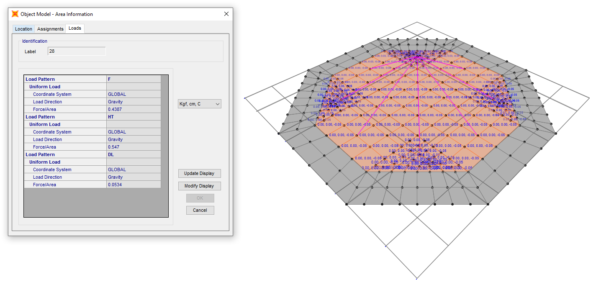

**D01**

1. **Dead Load On Pedestal**
   1. **Operation Load**

Normal Fluid Load on ring foundation:

F = (Ope load / area of ring foundation) → area of ring foundation: (𝜋 × 4²)/4=12.56

55100/12.56=4.387 ton/m²

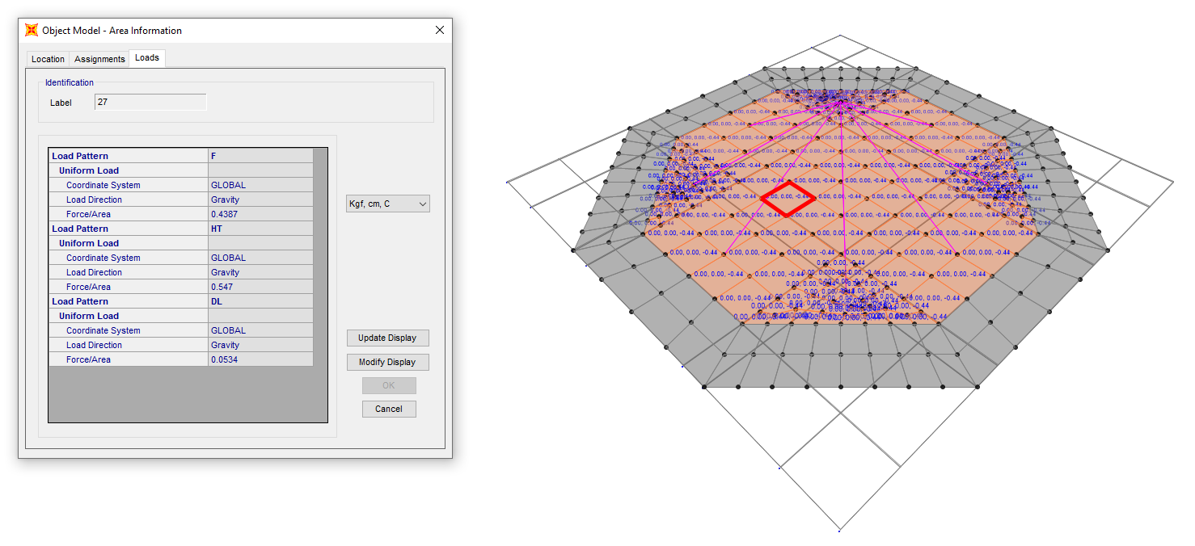

**D01**

1. **Area uniform F load on the inside ring foundation** 
   1. **HT (Test Fluid Load)**

Test Load on ring foundation: HT = Hydro test load / area of ring foundation → area of ring foundation: (𝜋 × 4²)/4=12.56 m2 → 68700/12.56= 5.470 ton/m²

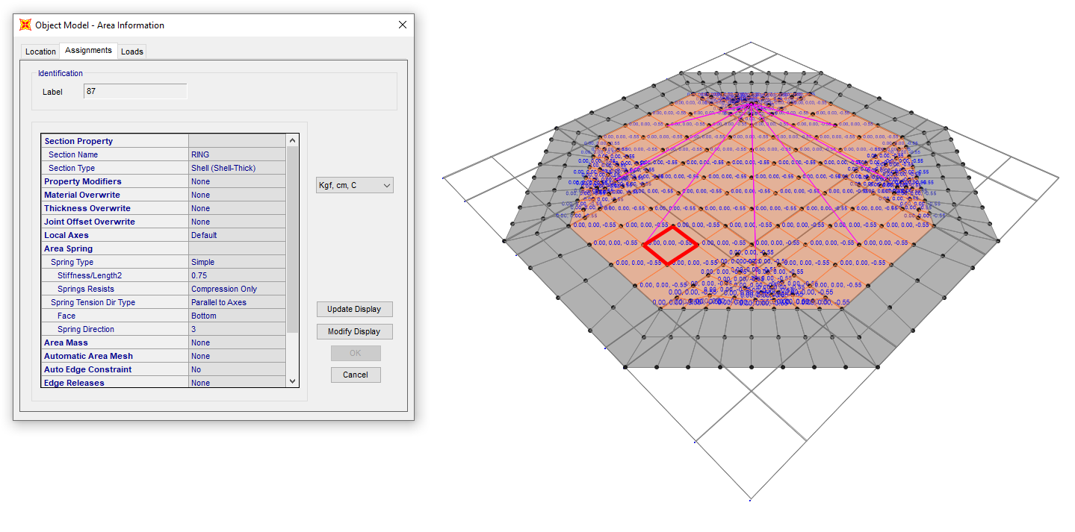

**D01**

1. **area uniform HT load on the inside ring foundation**
   1. **E (Earthquake Load)**

Shear load = 135800 N (According to General Arrangement Lean Glycol Storage Tank (TK-2102).

This shear is based on the datasheet, but we used API650 with ASD behavior coefficient so its value is multiplied by 1.4 → 135800  1.4 = 190120 N

Moment = 311500 N.m (According to General Arrangement Lean Glycol Storage Tank (TK-2102).

This moment is based on the datasheet, but we used API650 with ASD behavior coefficient so its value is multiplied by 1.4 → 311500  1.4 = 436100 N.m

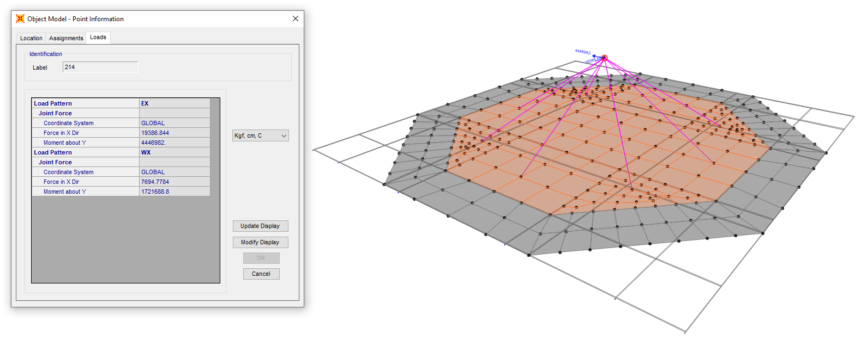

**D01**

1. **Earthquake Load (EX)**
   1. **W (Wind Load)**

Shear load = 53900 N (According to General Arrangement Lean Glycol Storage Tank (TK-2102).

This shear is based on the datasheet, but we used API650 with ASD behavior coefficient so its value is multiplied by 1.4 → 53900  1.4 = 75460 N

Moment = 120600 N.m (According to General Arrangement Lean Glycol Storage Tank (TK-2102).

This moment is based on the datasheet, but we used API650 with ASD behavior coefficient so its value is multiplied by 1.4 → 120600  1.4 = 168840 N.m

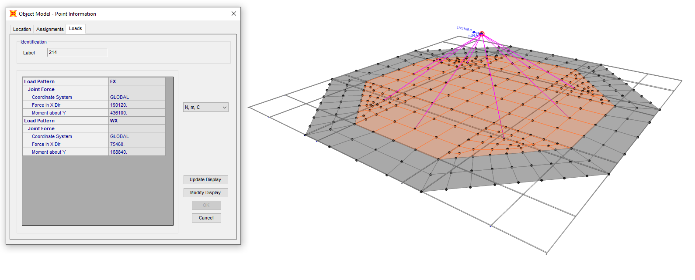

**D01**

1. **wind load (WX)** 
   1. **Soil Pressure (DS)**

Due to soil weight on foundation apply Soil Load on foundation as follows :

ƔH=1800 x 0.80 = 1440 kg/m2

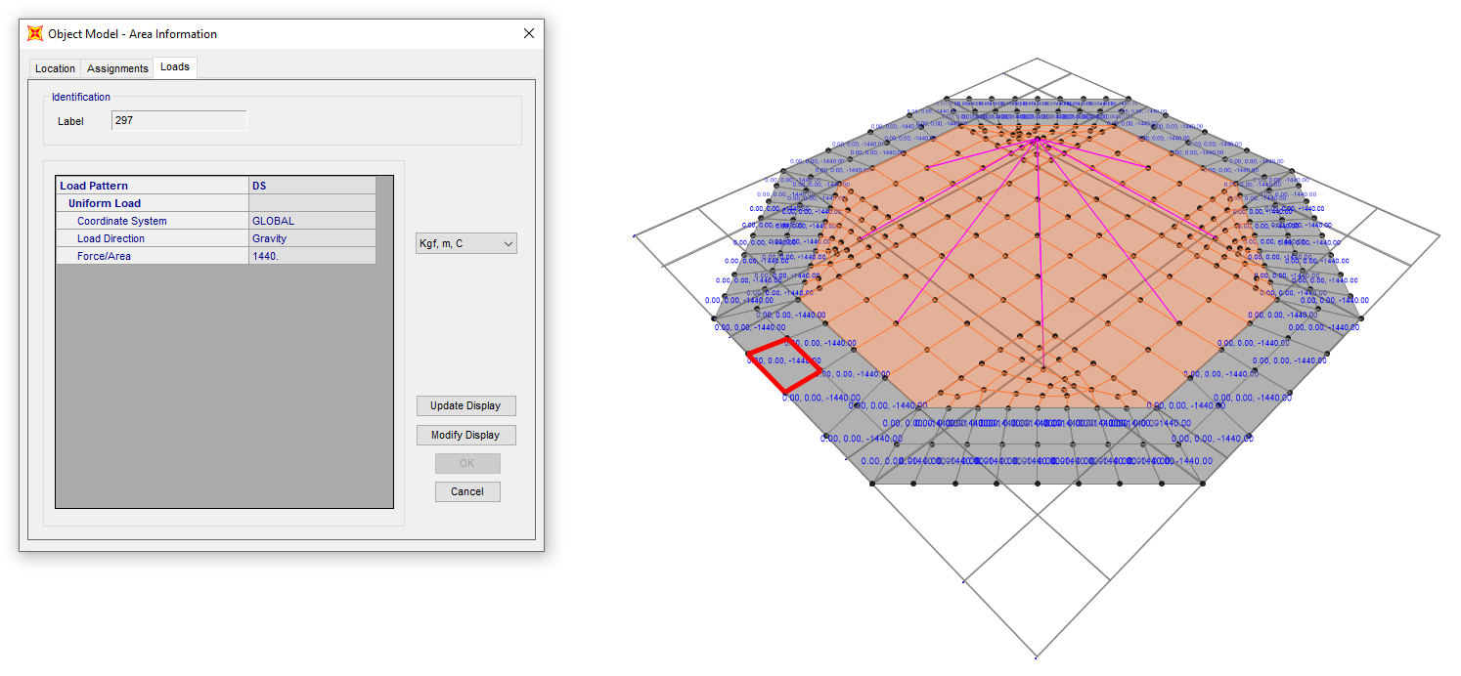

**D01**

1. **SOIL PRESSURE**
2. **Design Load Combinations**

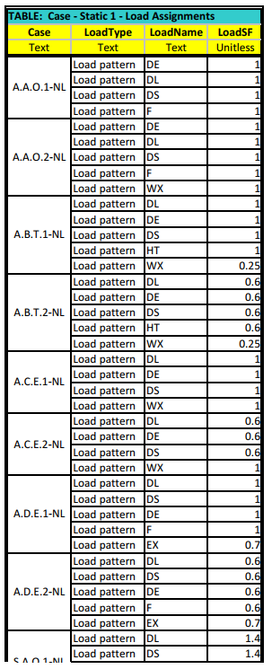 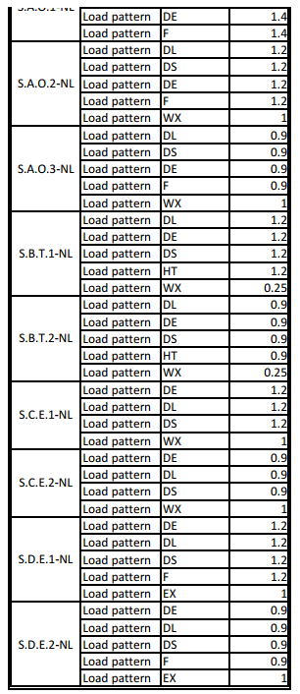

1. **Tank ANALYSIS AND DESIGN** 
   1. **Tank geometry**

As noted before, the structure has modelled and analysed by SAP2000. This figure shows a 3D view of the model in software.

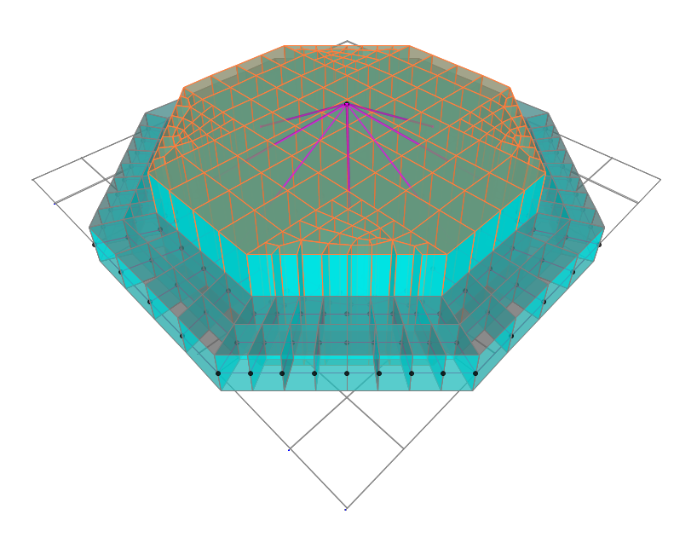

**D01**

1. **3D model** 
   1. **Stability Check**

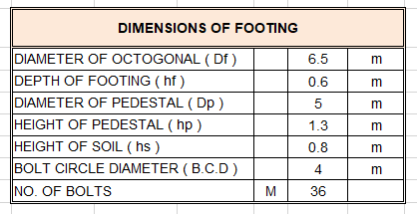

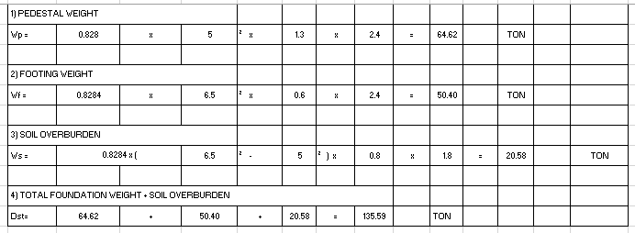

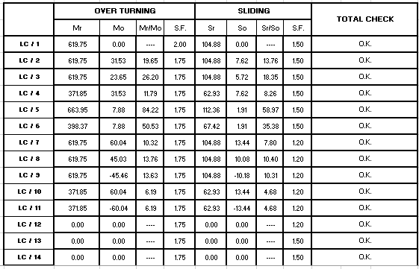

* 1. **Soil Pressure Check**

|  |  |  |  |  |  |  |  |  |  |  |  |  |  |  |  |  |
| --- | --- | --- | --- | --- | --- | --- | --- | --- | --- | --- | --- | --- | --- | --- | --- | --- |
| L / C | **Pu** | **Mu** | | e | | e/Df | | L z-z | SOIL BEARING ( TON / M2 ) | | | | | |  |  |
| Qmax | | Qmin | | ALLOW. | |  | Uplift Length |
| **LC / 1** | 191 | 0 | | 0.00 | | 0.00 | | 0.0 | 5.448 | | 5.448 | | 10.000 | |  | 0.00 |
| **LC / 2** | 191 | 31.53444 | | 0.17 | | 0.03 | | 0.0 | 6.584 | | 4.313 | | 10.000 | |  | 0.00 |
| **LC / 3** | 191 | 23.65083 | | 0.12 | | 0.02 | | 0.0 | 6.300 | | 4.597 | | 10.000 | |  | 0.00 |
| **LC / 4** | 114 | 31.53444 | | 0.28 | | 0.04 | | 0.0 | 4.405 | | 2.133 | | 10.000 | |  | 0.00 |
| **LC / 5** | 204 | 7.88361 | | 0.04 | | 0.01 | | 0.0 | 6.121 | | 5.553 | | 10.000 | |  | 0.00 |
| **LC / 6** | 123 | 7.88361 | | 0.06 | | 0.01 | | 0.0 | 3.786 | | 3.218 | | 10.000 | |  | 0.00 |
| **LC / 7** | 191 | 60.044012 | | 0.31 | | 0.05 | | 0.0 | 7.611 | | 3.286 | | 10.000 | |  | 0.00 |
| **LC / 8** | 191 | 45.033009 | | 0.24 | | 0.04 | | 0.0 | 7.070 | | 3.826 | | 10.000 | |  | 0.00 |
| **LC / 9** | 191 | -45.4618948 | | -0.24 | | 0.04 | | 0.0 | 3.811 | | 7.086 | | 10.000 | |  | 0.00 |
| **LC / 10** | 114 | 60.044012 | | 0.52 | | 0.08 | | 0.0 | 5.432 | | 1.106 | | 10.000 | |  | 0.00 |
| **LC / 11** | 114 | -60.044012 | | -0.52 | | 0.08 | | 0.0 | 1.106 | | 5.432 | | 10.000 | |  | 0.00 |
| **LC / 12** | 0 | 0 | | 0.00 | | 0.00 | | 0.0 | 0.000 | | 0.000 | | 10.000 | |  | 0.00 |
| **LC / 13** | 0 | 0 | | 0.00 | | 0.00 | | 0.0 | 0.000 | | 0.000 | | 10.000 | |  | 0.00 |
| **LC / 14** | 0 | 0 | | 0.00 | | 0.00 | | 0.0 | 0.000 | | 0.000 | | 10.000 | |  | 0.00 |
| **MAXIMUM SOIL STRESS =** | | |  | |  | | **7.611** | | | **TON / M2** | |  | |

* 1. **Reinforcing**
  + Pedestal reinforcement

As Req=T / F. fy=2328 / 0.9x4000=0.64cm2

Min As=0.0015x Aped=0.0015x0.8284xDp2x10000=310.65 cm2

Max (0.64 , 310.65)=310.65

USE 72 T25 AS used=353.42 cm2

* + Foundation reinforcement

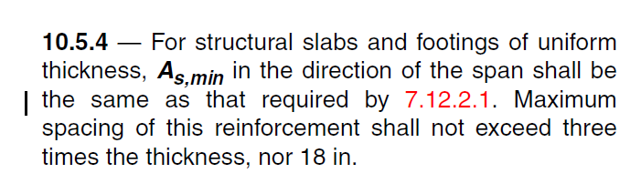 According to ACI-318-08:

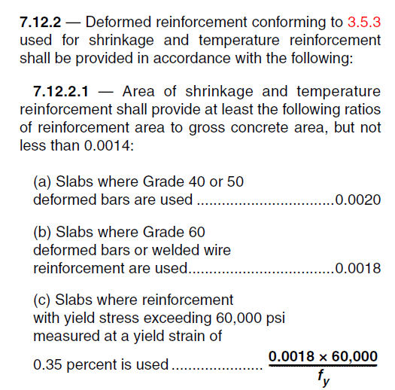

→ If use Φ 16@200 → A = 10.05cm² > 5.4 cm² → ok

|  |  |  |  |  |
| --- | --- | --- | --- | --- |
| Thickness | Cover | Width of strip |  |  |
| 700 mm. | 75 mm. | 1000 mm. | 4000 Kg/cm2. | 300 Kg/cm2. |

**D01**

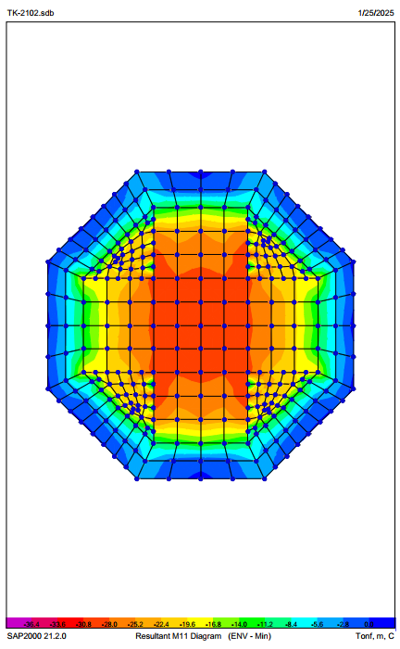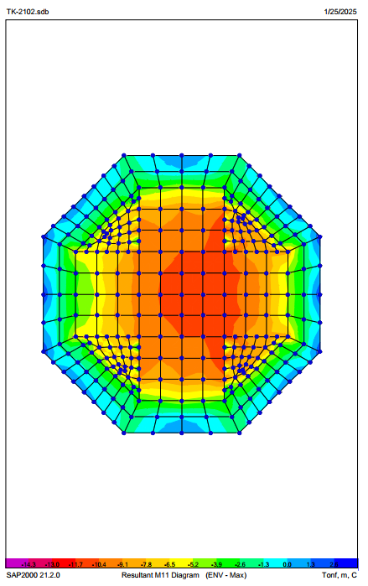

**D01**

1. **M11 Max - M11 Min**

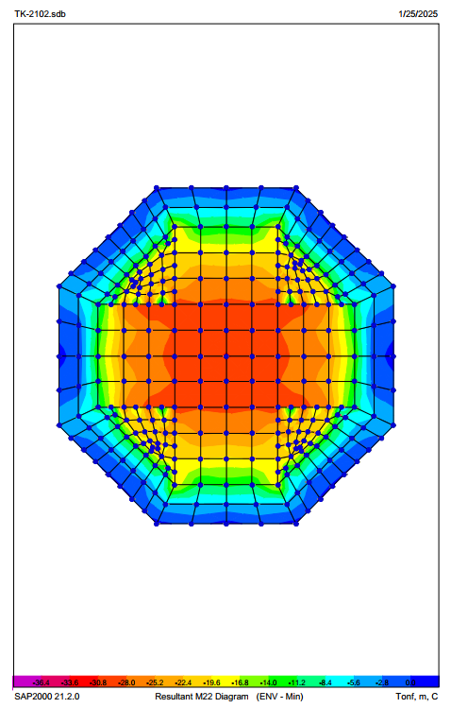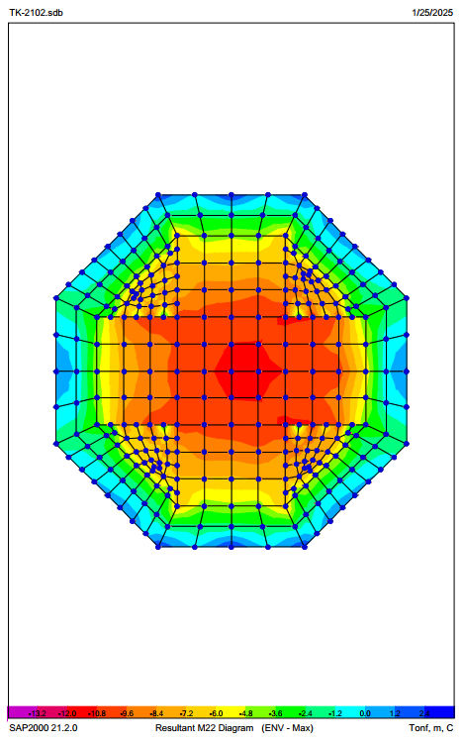

1. **M22 Max - M22 Min**
   1. **Foundation Settlement Control**

According to the analysis, the settlement resulting from the relevant loading combinations is less than the allowable settlement.

**D01**

To control the allowable soil stress, a combination of uncoefficient loads was used, and according to the analysis, the maximum pressure under the foundation due to settlement is less than the allowable soil stress under the foundation.

1. ATTACHMENTS
   1. **SOWFTWARE FILE**

“SAP” software file is attached.

* 1. **MECHANICAL DATA SHEET**

Mechanical data sheet is attached.