|  |  |  |  |  |  |  |  |
| --- | --- | --- | --- | --- | --- | --- | --- |
| **طرح نگهداشت و افزایش تولید 27 مخزن** | | | | | | | |
| Hydrostatic Test Procedure  **نگهداشت و افزایش تولید میدان نفتی بینک** | | | | | | | |
|  |  |  |  |  |  |  |
|  |  |  |  |  |  |  |
|  |  |  |  |  |  |  |
|  |  |  |  |  |  |  |
| V00 | 07.Jan.2024 | IFA | AAC | M.Fakharian | S.Faramarzpour |  |
| **Rev.** | **Date** | **Purpose of Issue/Status** | **Prepared by:** | **Checked by:** | **Approved by:** | **CLIENT Approval** |
|  | | | | | | |
| **Status:** | **IFA: Issued For Approval**  **IFI: Issued For Information**  **AFC: Approved For Construction** | | | | | |

**REVISION RECORD SHEET**

|  |  |  |  |  |  |  |  |  |  |  |  |  |
| --- | --- | --- | --- | --- | --- | --- | --- | --- | --- | --- | --- | --- |
| **PAGE** | **V00** | **V01** | **V02** | **V03** | **V04** |  | **PAGE** | **V00** | **V01** | **V02** | **V03** | **V04** |
| **1** | X |  |  |  |  | **66** |  |  |  |  |  |
| **2** | X |  |  |  |  | **67** |  |  |  |  |  |
| **3** | X |  |  |  |  | **68** |  |  |  |  |  |
| **4** | X |  |  |  |  | **69** |  |  |  |  |  |
| **5** | X |  |  |  |  | **70** |  |  |  |  |  |
| **6** | X |  |  |  |  | **71** |  |  |  |  |  |
| **7** | X |  |  |  |  | **72** |  |  |  |  |  |
| **8** | X |  |  |  |  | **73** |  |  |  |  |  |
| **9** | X |  |  |  |  | **74** |  |  |  |  |  |
| **10** | X |  |  |  |  | **75** |  |  |  |  |  |
| **11** |  |  |  |  |  | **76** |  |  |  |  |  |
| **12** |  |  |  |  |  | **77** |  |  |  |  |  |
| **13** |  |  |  |  |  | **78** |  |  |  |  |  |
| **14** |  |  |  |  |  | **79** |  |  |  |  |  |
| **15** |  |  |  |  |  | **80** |  |  |  |  |  |
| **16** |  |  |  |  |  | **81** |  |  |  |  |  |
| **17** |  |  |  |  |  | **82** |  |  |  |  |  |
| **18** |  |  |  |  |  | **83** |  |  |  |  |  |
| **19** |  |  |  |  |  | **84** |  |  |  |  |  |
| **20** |  |  |  |  |  | **85** |  |  |  |  |  |
| **21** |  |  |  |  |  | **86** |  |  |  |  |  |
| **22** |  |  |  |  |  | **87** |  |  |  |  |  |
| **23** |  |  |  |  |  | **88** |  |  |  |  |  |
| **24** |  |  |  |  |  | **89** |  |  |  |  |  |
| **25** |  |  |  |  |  | **90** |  |  |  |  |  |
| **26** |  |  |  |  |  | **91** |  |  |  |  |  |
| **27** |  |  |  |  |  | **92** |  |  |  |  |  |
| **28** |  |  |  |  |  | **93** |  |  |  |  |  |
| **29** |  |  |  |  |  | **94** |  |  |  |  |  |
| **30** |  |  |  |  |  | **95** |  |  |  |  |  |
| **31** |  |  |  |  |  | **96** |  |  |  |  |  |
| **32** |  |  |  |  |  | **97** |  |  |  |  |  |
| **33** |  |  |  |  |  | **98** |  |  |  |  |  |
| **34** |  |  |  |  |  | **99** |  |  |  |  |  |
| **35** |  |  |  |  |  | **100** |  |  |  |  |  |
| **36** |  |  |  |  |  | **101** |  |  |  |  |  |
| **37** |  |  |  |  |  | **102** |  |  |  |  |  |
| **38** |  |  |  |  |  | **103** |  |  |  |  |  |
| **39** |  |  |  |  |  | **104** |  |  |  |  |  |
| **40** |  |  |  |  |  | **105** |  |  |  |  |  |
| **41** |  |  |  |  |  | **106** |  |  |  |  |  |
| **42** |  |  |  |  |  | **107** |  |  |  |  |  |
| **43** |  |  |  |  |  | **108** |  |  |  |  |  |
| **44** |  |  |  |  |  | **109** |  |  |  |  |  |
| **45** |  |  |  |  |  | **110** |  |  |  |  |  |
| **46** |  |  |  |  |  | **111** |  |  |  |  |  |
| **47** |  |  |  |  |  | **112** |  |  |  |  |  |
| **48** |  |  |  |  |  | **113** |  |  |  |  |  |
| **49** |  |  |  |  |  | **114** |  |  |  |  |  |
| **50** |  |  |  |  |  | **115** |  |  |  |  |  |
| **51** |  |  |  |  |  | **116** |  |  |  |  |  |
| **52** |  |  |  |  |  | **117** |  |  |  |  |  |
| **53** |  |  |  |  |  | **118** |  |  |  |  |  |
| **54** |  |  |  |  |  | **119** |  |  |  |  |  |
| **55** |  |  |  |  |  | **120** |  |  |  |  |  |
| **56** |  |  |  |  |  | **121** |  |  |  |  |  |
| **57** |  |  |  |  |  | **122** |  |  |  |  |  |
| **58** |  |  |  |  |  | **123** |  |  |  |  |  |
| **59** |  |  |  |  |  | **124** |  |  |  |  |  |
| **60** |  |  |  |  |  | **125** |  |  |  |  |  |
| **61** |  |  |  |  |  | **126** |  |  |  |  |  |
| **62** |  |  |  |  |  | **127** |  |  |  |  |  |
| **63** |  |  |  |  |  | **128** |  |  |  |  |  |
| **64** |  |  |  |  |  | **129** |  |  |  |  |  |
| **65** |  |  |  |  |  | **130** |  |  |  |  |  |

**CONTENTS**

1.INTRODUCTION 4 2.Purpose..................................................................................................................................................5

**3.SCOPE.......................................................................................................................................................5**

**4.REFERENCE...........................................................................................................................................5**

**5.DESCRIPTION........................................................................................................................................5**

**6.DOCUMENTATION.............................................................................................................................10**

**7.ATTACHMENTS..................................................................................................................................10**

**1. INTRODUCTION**

Binak oilfield in Bushehr province is a part of the southern oilfields of Iran, is located 20 km northwest of Genaveh city. With the aim of increasing production of oil from Binak oilfield, an EPC/EPD Project has been defined by NIOC/NISOC and awarded to Petro Iran Development Company (PEDCO). Also PEDCO (as General Contractor) has assigned the EPC-packages of the Project to "Hirgan Energy - Design and Inspection" JV.

**GENERAL DEFINITION**

The following terms shall be used in this document.

|  |  |
| --- | --- |
| CLIENT: | National Iranian South Oilfields Company (NISOC) |
| PROJECT: | Binak Oilfield Development – Manufacturing (w/Engineering & Material Supply) of Air Coolers |
| EPD/EPC CONTRACTOR (GC): | Petro Iran Development Company (PEDCO) |
| OWNER: | OWNER is collectively refer to National Iranian South Oil Company (NISOC) and Petro Iran Development Company (PEDCO) |
| EPC CONTRACTOR: | Joint Venture of : Hirgan Energy – Design & Inspection(D&I) Companies |
| VENDOR: | Aban Air Cooler (AAC) |
| EXECUTOR: | Executor is the party which carries out all or part of construction and/or commissioning for the project. |
| THIRD PARTY INSPECTOR (TPI): | Third Party Inspector |
| SHALL: | Is used where a provision is mandatory. |
| SHOULD: | Is used where a provision is advisory only. |
| WILL: | Is normally used in connection with the action by CLIENT rather than by an EPC/EPD CONTRACTOR, supplier or VENDOR. |
| MAY: | Is used where a provision is completely discretionary. |

**2. Purpose**

The hydrostatic test is carried out to verify tightness and from stability of Air cooler. A hydrostatic test shall be conducted on air cooler after all fabrication has been completed, and all examinations have been performed. Approved and signed release note for hydro test shall be prepared before.

**3. Scope**

This procedure is applicable for testing of air-cooled heat exchanger.

**4. Reference**

ASME CODE SEC VIII, UG (99), (102)

API 661

**5. Description**

5.1. Test Equipment

The test equipment comprises a manually or motor operated test pump, a water tank & two calibrated pressure gauge. For the respective measuring range and suitable connection material (flanges, blind flanges, vent and drain connections, covers, bolts, gaskets) to comply with the test requirements shall be supplied.

All gauges shall be calibrated not more than 6 months before hydro test. The calibration / test certificate form for relevant pressure gauges shall be attached to test report.

5.2. Test fluid

Chloride content of water used in hydrotest procedure shall be as follow:

- For carbon steels, Up to 40°C, 200 ppm

- For carbon steels, 40°C < T ≤65°C, 100 ppm

- For stainless steels, Up to 65°C, 50 ppm

Vessels shall be thoroughly dried after draining to prevent evaporation and concentration of chlorides during storage and shipping.

It is recommended that the metal temperature during hydrostatic test be maintained at least 17 °C above the minimum design metal temperature, but need not exceed 48 °C, to minimize the risk of brittle fracture.

5.3. Safety instruction

All flange connections shall be closed and relevant bolts to be tight before pressurizing. Repairs and rework are not allowed on pressurized heat exchangers. If repairs are required the test must be stopped and start again after repair work is completed.

5.4. Preparation for pressure test

Prior to starting the pressure test, the inner and outer surface has to be cleaned from dust, rolling residues, dirt, oils and other foreign material. The pressure gauge must be installed the way that the operator can inspect it during pressurizing.

Each exchanger shall accompany with min. 2 Nos. pressure gauges (i.e. one on the top nozzle and another on the bottom nozzle.)

All gauges shall be calibrated & certificate shall be kept as a part of quality record. Dial indicating pressure gages used in testing shall be graduated over a range of about double the intended maximum test pressure, but in no case shall the range be less than 1 1⁄2 nor more than 4 times of that pressure. Digital reading pressure gages having a wider range of pressure may be used provided the readings give the same or greater degree of accuracy as obtained with dial pressure gages.

All gages shall be calibrated against a standard deadweight tester or a calibrated master gage. Gages shall be recalibrated at any time that there is reason to believe that they are in error.

5.5. Venting

During filling and depressurizing, the air cooler has to be properly vented at the highest point.

5.6. Testing process

5.6.1. The air cooler is pressurized slowly and gradually to the half of the design pressure. The holding time for a visual check at this stage is 15 minutes.

5.6.2. The pressure shall be increased to design pressure and a visual check in 15 minutes holding time shall be done. The pressure shall be increased to test pressure and a complete visual check for all connections and weld joints shall be done for determining leakages or deformation. The holding time for this stage is min.1 hour.

After that the pressure shall be decrease to design pressure & hold 15 minutes for this stage for final inspection.

5.6.3. The vent valve shall be gradually opened. After ensuring this valve is fully opened, the drain valve shall be slowly opened. At this stage care must be taken to avoid any vacuum in air cooler due to waters draining. After the hydro test all pressure gauges shall be checked to show zero value.

5.6.4. Gaskets shall be the same as for the service type, dry or coated with graphite. Use of compounds, glue, lead, is not permitted.

Metallic O-rings gaskets shall be replaced after testing if damaged. All other gaskets shall be replaced with new ones after testing.

Service bolting shall be used for pressure testing. Bolt and nuts shall be thoroughly inspected after testing and replaced whenever damaged. This inspection shall be witnessed by the inspection agency.

5.6.5. For protection and preservation of system after hydro test, air cooled heat exchanger must be fully and immediately drained & dry by blowing hot air.

- After hydro test, all exchangers should be thoroughly dried and tilled with Nitrogen.

5.6.6. Nitrogen filling

Internal surface shall be dry with blowing hot air. The absolute absence of water pockets must be ensured by using hygrometer.

All flanges shall be completely blind with BLANK & GASKET.

The purge gas flow rate shall be controlled by the use of a pressure regulator and flow meter or combination thereof.

In order to ensure that all ambient air has been removed from the air-cooled heat exchanger, an oxygen analyzer or other practices shall be used to verify the effectiveness of the purge. The oxygen analyzer shall read below 1 percent oxygen concentration.

Open nitrogen cylinder valve and allow dry nitrogen to flow through the system until air is removed from the system. As follows components shall be used & assembled as shown in following Figure 1.

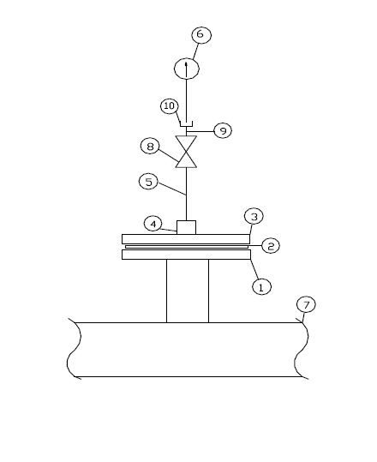1. FLANGE

2. GASKET

3. BLANK

4. COUPLING 1/2"

5. NIPPLE 1/2 "

6. GAGE,0-2 bar

7. AIR COOLED HEAT EXCHANGER

8. VALVE 1/2"

9. NIPPLE 1/2 "

10. CAP 1/2"

Valve, compound gauge, protective cover & warning tag shall be installed on the nozzle on the air-cooled heat exchanger.

Pressurizing method shall be applied to sweep air out of air-cooled heat exchanger.

Pressurize to 0.7 kg/cm2.g (10 psig) with nitrogen

Release to 0.0 kg/cm2.g (0.0 psig)

Pressurize to 0.7 kg/cm2.g (10 psig) with nitrogen

Reduce the pressure to 0.5 kg/cm2.g (7 psig) minimum, 0.7 kg/cm2.g (10 psig) maximum.

The tube bundle shall be completely purged & blocked in, test all flanged, gasket & plugged opening for leakage with soap solution confirm zero leakage.

The pressure of nitrogen gas shall be kept at 0.5 kg/cm2.g (.483 bar) minimum,0.7 kg/cm2.g (.689 bar) maximum pressure. Minimum pressure shall be verified, after the unit is loaded onto the ship.

For N2 detection in outlet a flame shall be used to ensure that N2 filled completely inside the air-cooled heat exchanger.

Warning tag attached to pressure valve: the following minimum information shall appear on the warning tags attached to the pressure nozzle.

WARNING

The equipment is under low pressure nitrogen blanket. Do not open equipment until pressure has been reduced to atmospheric & verified.

Note: The valve & pressure gauge for nitrogen purging shall be as below.

Valve: 1/2" (oil free type) NPT with cap

pressure gauge: 1/2" x75 with the range of 0~2 kg/cm2.G (Oil free type)

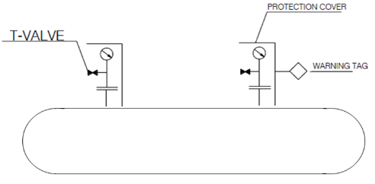

5.6.7. Pressure test diagram

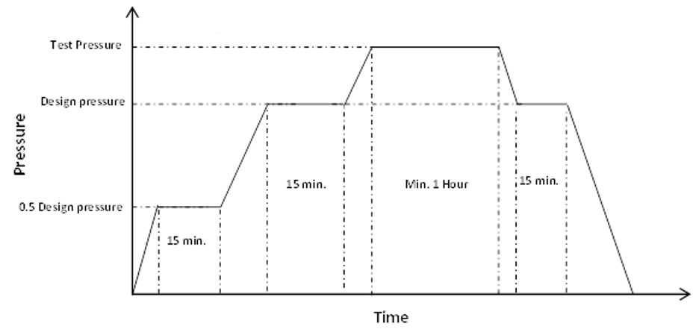

Figure 1: Pressure Test Diagram

Table 1: Design and test pressure for air cooler

|  |  |  |
| --- | --- | --- |
| *Item No.* | *Design Press. (BAR G)* | *Test Press. (BAR G)* |
| AE-2101 (A/B/C) | 22 | 28.60 |
| AE-2102 (A/B/C) | 62 | 78.00 |

5.7. Acceptance Criteria

During the holding time, the test pressure shall not fall below the required value. A deformation of the pressure retaining parts (permanent & transient deformation) is not allowed. If leakages are found at the weld joints, repairs shall be performed only according to an approved repair procedure. If any pressure drops detected, it must be depressurized & leakage shall be found & rectified under client witness.

**6. Documentation**

After satisfactory performance of pressure test the hydrostatic test report shall be issued and signed by AAC, TPI.

**7.** **Attachments**

Refer to next page for Hydrostatic Test Report.