|  |  |  |  |  |  |  |  |
| --- | --- | --- | --- | --- | --- | --- | --- |
| **طرح نگهداشت و افزایش تولید 27 مخزن** | | | | | | | |
| **Steel Structure Calculation Books**  **نگهداشت و افزایش تولید میدان نفتی بینک** | | | | | | | |
|  |  |  |  |  |  |  |
|  |  |  |  |  |  |  |
|  |  |  |  |  |  |  |
|  |  |  |  |  |  |  |
| V00 | MAR. 2024 | IFA | AAC | M.FAKHARIAN | S.FRAMARZPOUR |  |
| **Rev.** | **Date** | **Purpose of Issue/Status** | **Prepared by:** | **Checked by:** | **Approved by:** | **CLIENT Approval** |
|  | | | | | | |
| **Status:** | **IFA: Issued For Approval**  **IFI: Issued For Information**  **AFC: Approved For Construction** | | | | | |

**REVISION RECORD SHEET**

|  |  |  |  |  |  |  |  |  |  |  |  |  |
| --- | --- | --- | --- | --- | --- | --- | --- | --- | --- | --- | --- | --- |
| **PAGE** | **V00** | **V01** | **V02** | **V03** | **V04** |  | **PAGE** | **V00** | **V01** | **V02** | **V03** | **V04** |
| **1** | X |  |  |  |  | **66** |  |  |  |  |  |
| **2** | X |  |  |  |  | **67** |  |  |  |  |  |
| **3** | X |  |  |  |  | **68** |  |  |  |  |  |
| **4** | X |  |  |  |  | **69** |  |  |  |  |  |
| **5** | X |  |  |  |  | **70** |  |  |  |  |  |
| **6** | X |  |  |  |  | **71** |  |  |  |  |  |
| **7** | X |  |  |  |  | **72** |  |  |  |  |  |
| **8** | X |  |  |  |  | **73** |  |  |  |  |  |
| **9** | X |  |  |  |  | **74** |  |  |  |  |  |
| **10** | X |  |  |  |  | **75** |  |  |  |  |  |
| **11** | X |  |  |  |  | **76** |  |  |  |  |  |
| **12** | X |  |  |  |  | **77** |  |  |  |  |  |
| **13** | X |  |  |  |  | **78** |  |  |  |  |  |
| **14** | X |  |  |  |  | **79** |  |  |  |  |  |
| **15** | X |  |  |  |  | **80** |  |  |  |  |  |
| **16** | X |  |  |  |  | **81** |  |  |  |  |  |
| **17** | X |  |  |  |  | **82** |  |  |  |  |  |
| **18** | X |  |  |  |  | **83** |  |  |  |  |  |
| **19** | X |  |  |  |  | **84** |  |  |  |  |  |
| **20** | X |  |  |  |  | **85** |  |  |  |  |  |
| **21** | X |  |  |  |  | **86** |  |  |  |  |  |
| **22** | X |  |  |  |  | **87** |  |  |  |  |  |
| **23** | X |  |  |  |  | **88** |  |  |  |  |  |
| **24** | X |  |  |  |  | **89** |  |  |  |  |  |
| **25** | X |  |  |  |  | **90** |  |  |  |  |  |
| **26** | X |  |  |  |  | **91** |  |  |  |  |  |
| **27** | X |  |  |  |  | **92** |  |  |  |  |  |
| **28** | X |  |  |  |  | **93** |  |  |  |  |  |
| **29** | X |  |  |  |  | **94** |  |  |  |  |  |
| **30** | X |  |  |  |  | **95** |  |  |  |  |  |
| **31** | X |  |  |  |  | **96** |  |  |  |  |  |
| **32** | X |  |  |  |  | **97** |  |  |  |  |  |
| **33** |  |  |  |  |  | **98** |  |  |  |  |  |
| **34** |  |  |  |  |  | **99** |  |  |  |  |  |
| **35** |  |  |  |  |  | **100** |  |  |  |  |  |
| **36** |  |  |  |  |  | **101** |  |  |  |  |  |
| **37** |  |  |  |  |  | **102** |  |  |  |  |  |
| **38** |  |  |  |  |  | **103** |  |  |  |  |  |
| **39** |  |  |  |  |  | **104** |  |  |  |  |  |
| **40** |  |  |  |  |  | **105** |  |  |  |  |  |
| **41** |  |  |  |  |  | **106** |  |  |  |  |  |
| **42** |  |  |  |  |  | **107** |  |  |  |  |  |
| **43** |  |  |  |  |  | **108** |  |  |  |  |  |
| **44** |  |  |  |  |  | **109** |  |  |  |  |  |
| **45** |  |  |  |  |  | **110** |  |  |  |  |  |
| **46** |  |  |  |  |  | **111** |  |  |  |  |  |
| **47** |  |  |  |  |  | **112** |  |  |  |  |  |
| **48** |  |  |  |  |  | **113** |  |  |  |  |  |
| **49** |  |  |  |  |  | **114** |  |  |  |  |  |
| **50** |  |  |  |  |  | **115** |  |  |  |  |  |
| **51** |  |  |  |  |  | **116** |  |  |  |  |  |
| **52** |  |  |  |  |  | **117** |  |  |  |  |  |
| **53** |  |  |  |  |  | **118** |  |  |  |  |  |
| **54** |  |  |  |  |  | **119** |  |  |  |  |  |
| **55** |  |  |  |  |  | **120** |  |  |  |  |  |
| **56** |  |  |  |  |  | **121** |  |  |  |  |  |
| **57** |  |  |  |  |  | **122** |  |  |  |  |  |
| **58** |  |  |  |  |  | **123** |  |  |  |  |  |
| **59** |  |  |  |  |  | **124** |  |  |  |  |  |
| **60** |  |  |  |  |  | **125** |  |  |  |  |  |
| **61** |  |  |  |  |  | **126** |  |  |  |  |  |
| **62** |  |  |  |  |  | **127** |  |  |  |  |  |
| **63** |  |  |  |  |  | **128** |  |  |  |  |  |
| **64** |  |  |  |  |  | **129** |  |  |  |  |  |
| **65** |  |  |  |  |  | **130** |  |  |  |  |  |

**CONTENTS**

1.0 INTRODUCTION 4

*2.0* Scope 4

3.0 Codes & Standards 4

4.0 Reference Drawing & General Document: 4

5.0 Materials 4

6.0 Descriptions of Supported Equipment: 5

7.0 EXTERNAL LOADS 5

8.0 Analyis 12

9.0 Design 13

10.0 DESIGN OUTPUT 17

11.0 BEAM CONTROL 21

12.0 Connections 22

13.0 DISPLACEMENT CONTROL 29

14.0 JOINT REACTION 31

1. **INTRODUCTION**

Binak oilfield in Bushehr province is a part of the southern oilfields of Iran, is located 20 km northwest of Genaveh city.

With the aim of increasing production of oil from Binak oilfield, an EPC/EPD Project has been defined by NIOC/NISOC and awarded to Petro Iran Development Company (PEDCO). Also PEDCO (as General Contractor) has assigned the EPC-packages of the Project to "Hirgan Energy - Design and Inspection" JV.

1. **Scope**

This calculation book covers a structural design for air cooler AE2101/AE2102. A 3-dimensional model analysed by means of SAP-2000 software VER. 21.0.2. This report contains computerized model, load evaluation and design verification.

1. **Codes & Standards**

American Institute of Steel Construction. (AISC 360-16)

Minimum Design Loads and Associated Criteria for Buildings and Other Structures (ASCE-7-10)

1. **Reference Drawing & General Document:**

General Arrangement Drawings: (BK-GCS-AA-120-ME-DW-0001)

1. **Materials**

- Structural Steel: S235JR (ST37)

With Fy = 2400 kg/cm² & Fu = 3700 kg/cm²

- Bolts: A325 (ASTM.) or equivalent HR 8.8 (DIN.) With Fu = 8000 kg/cm²

- Anchor Bolts: ISIR/ISO 4.6 or equivalent A307 With Fu = 4000 kg/cm²

# Descriptions of Supported Equipment:



1. **EXTERNAL LOADS**

Load Case Definition

-**Dead Load (DLs):** Contain weight of steel structure & 20 percent weight of steel structure as structural connection and dead loadof walk way.

-**Empty Dead Load (DL)**: The dead load of equipment (bundle dry, plenum, fan ring, fan, fan guard, motor, motor support, reduction system).

**-Live Load (L):** Live load of walkway and load due to static pressure drop of fan.

**-Operation Load (EO):** The dead load of equipment (bundle dry, plenum, fan ring, fan, fan guard, motor, motor support, reduction system) and fluid weight that flows in bundles in operation.

**-Test Load (ET):** The dead load of equipment (bundle dry, plenum, fan ring, fan, fan guard, motor, motor support, reduction system) and Water weight that flows in bundles in hydro test.

**-ELX:** Effect of earth quake at x- direction.

**-ELY:** Effect of earth quake at y- direction.

**-WLX:** Effect of wind load at x- direction.

**-WLY:** Effect of wind load at y- direction.

**- Snow Load (SL):** Snow load shall be taken as 150 kg/m2 as per site information and shall be uniformly distributed over the horizontal projection of the loaded areas.

**- TL**: Thermal load.







**EARTHQUAKE LOADS:**

COEFFICIANT FOR SEISMIC ANALYSIS (ASCE 7-10)





|  |  |
| --- | --- |
| WXP | WXN |
| WYP | WYN |

**Ambient Temperature ± 35°C**

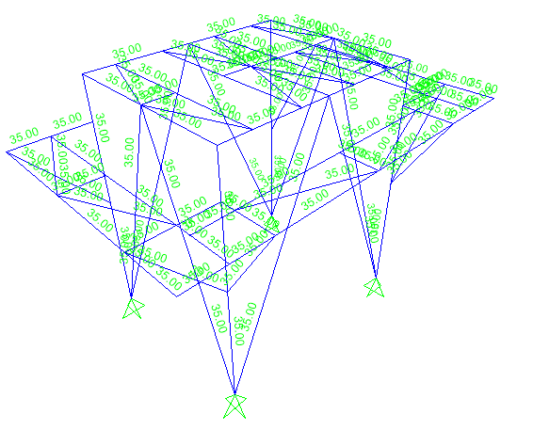

# Analyis

3D Computerized Model

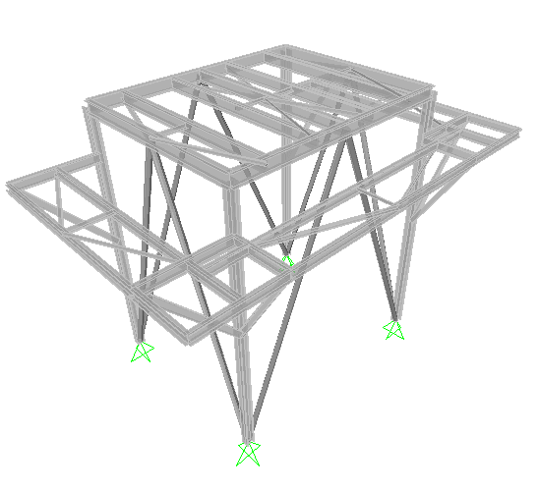

ANALYSIS INPUT DATA

|  |  |  |  |  |  |  |  |  |  |  |  |  |  |  |  |  |  |  |  |  |  |  |  |  |  |
| --- | --- | --- | --- | --- | --- | --- | --- | --- | --- | --- | --- | --- | --- | --- | --- | --- | --- | --- | --- | --- | --- | --- | --- | --- | --- |
| Mass Source According ASCE7:   |  |  |  | | --- | --- | --- | | **TABLE: Masses 1 - Mass Source** | | | | **Mass From** | **Load Pat** | **Multiplier** | | Text | Text | Unitless | | Loads | DLS | 1.2 | | Loads | DL | 1 | | Loads | EO | 1 | | Loads | LL | 0.25 | | Loads | SL | 0.2 | |  |
|  |  |

Load Pattern Definitions:

|  |  |  |
| --- | --- | --- |
| **TABLE: Load Pattern Definitions** | | |
| **LoadPat** | **DesignType** | **SelfWtMult** |
| Text | Text | Unitless |
| DLS | DEAD | 1.2 |
| DL | DEAD | 0 |
| EO | DEAD | 0 |
| TL | TEMPERATURE | 0 |
| LL | LIVE | 0 |
| SL | SNOW | 0 |
| WLXP | WIND | 0 |
| WLYP | WIND | 0 |
| ELX | QUAKE | 0 |
| ELY | QUAKE | 0 |
| ET | DEAD | 0 |
| WLXN | WIND | 0 |
| WLYN | WIND | 0 |

Auto Seismic - User Coefficient:

|  |  |  |  |  |  |  |  |  |
| --- | --- | --- | --- | --- | --- | --- | --- | --- |
| **TABLE: Auto Seismic - User Coefficient** | | | | | | | | |
| **LoadPat** | **Dir** | **PercentEcc** | **EccOverride** | **UserZ** | **C** | **K** | **WeightUsed** | **BaseShear** |
| Text | Text | Unitless | Yes/No | Yes/No | Unitless | Unitless | Kgf | Kgf |
| ELX | X | 0.05 | No | No | 0.319 | 1 | 35158.31 | 11215.5 |
| ELY | Y | 0.05 | No | No | 0.319 | 1 | 35158.31 | 11215.5 |

1. **Design**

|  |  |  |  |  |  |  |  |  |  |  |
| --- | --- | --- | --- | --- | --- | --- | --- | --- | --- | --- |
| **TABLE: Combination Definitions** | | |  | **TABLE: Combination Definitions** | | |  | **TABLE: Combination Definitions** | | |
| **ComboName** | **CaseName** | **ScaleFactor** |  | **ComboName** | **CaseName** | **ScaleFactor** |  | **ComboName** | **CaseName** | **ScaleFactor** |
| Text | Text | Unitless |  | Text | Text | Unitless |  | Text | Text | Unitless |
| EM1 | DL | 1.4 |  | OP1 | DL | 1.4 |  | TE1 | DL | 1.4 |
| DLs | 1.4 |  | DLs | 1.4 |  | DLs | 1.4 |
| TL | 1.4 |  | TL | 1.4 |  | TL | 1.4 |
| EM2 | DL | 1.2 |  | EO | 1.4 |  | ET | 1.4 |
| DLs | 1.2 |  | OP2 | DL | 1.2 |  | TE2 | DL | 1.2 |
| LL | 1.6 |  | DLs | 1.2 |  | DLs | 1.2 |
| SL | 0.5 |  | LL | 1.6 |  | LL | 1.6 |
| TL | 1.2 |  | TL | 1.2 |  | TL | 1.2 |
| EM3 | DL | 1.2 |  | EO | 1.2 |  | ET | 1.2 |
| DLs | 1.2 |  | SL | 0.5 |  | SL | 0.5 |
| WLXP | 1 |  | OP3 | DL | 1.2 |  | TE3 | DL | 1.2 |
| LL | 1 |  | DLs | 1.2 |  | DLs | 1.2 |
| SL | 0.5 |  | WLXP | 1 |  | WLXP | 1 |
| TL | 1.2 |  | EO | 1.2 |  | ET | 1.2 |
| EM4 | DL | 1.2 |  | LL | 1 |  | LL | 1 |
| DLs | 1.2 |  | SL | 0.5 |  | SL | 0.5 |
| WLXN | 1 |  | TL | 1.2 |  | TL | 1.2 |
| LL | 1 |  | OP4 | DL | 1.2 |  | TE4 | DL | 1.2 |
| SL | 0.5 |  | DLs | 1.2 |  | DLs | 1.2 |
| TL | 1.2 |  | WLXN | 1 |  | WLXN | 1 |
| EM5 | DL | 1.2 |  | EO | 1.2 |  | ET | 1.2 |
| DLs | 1.2 |  | LL | 1 |  | LL | 1 |
| WLYP | 1 |  | SL | 0.5 |  | SL | 0.5 |
| LL | 1 |  | TL | 1.2 |  | TL | 1.2 |
| SL | 0.5 |  | OP5 | DL | 1.2 |  | TE5 | DL | 1.2 |
| TL | 1.2 |  | DLs | 1.2 |  | DLs | 1.2 |
| EM6 | DL | 1.2 |  | WLYP | 1 |  | WLYP | 1 |
| DLs | 1.2 |  | EO | 1.2 |  | ET | 1.2 |
| WLYN | 1 |  | LL | 1 |  | LL | 1 |
| LL | 1 |  | SL | 0.5 |  | SL | 0.5 |
| SL | 0.5 |  | TL | 1.2 |  | TL | 1.2 |
| TL | 1.2 |  | OP6 | DL | 1.2 |  | TE6 | DL | 1.2 |
| EM7 | DL | 1.37 |  | DLs | 1.2 |  | DLs | 1.2 |
| DLs | 1.37 |  | WLYN | 1 |  | WLYN | 1 |
| ELX | 1 |  | EO | 1.2 |  | ET | 1.2 |
| ELY | 0.3 |  | LL | 1 |  | LL | 1 |
| LL | 1 |  | SL | 0.5 |  | SL | 0.5 |
| SL | 0.2 |  | TL | 1.2 |  | TL | 1.2 |
| EM8 | DL | 1.37 |  | OP7 | DL | 1.37 |  | TE7 | DL | 1.37 |
| DLs | 1.37 |  | DLs | 1.37 |  | DLs | 1.37 |
| ELX | 1 |  | ELX | 1 |  | ELX | 1 |
| ELY | -0.3 |  | ELY | 0.3 |  | ELY | 0.3 |
| LL | 1 |  | EO | 1.37 |  | ET | 1.37 |
| SL | 0.2 |  | LL | 1 |  | LL | 1 |
| EM9 | DL | 1.37 |  | SL | 0.2 |  | SL | 0.2 |
| DLs | 1.37 |  | OP8 | DL | 1.37 |  | TE8 | DL | 1.37 |
| ELX | -1 |  | DLs | 1.37 |  | DLs | 1.37 |
| ELY | 0.3 |  | ELX | 1 |  | ELX | 1 |
| LL | 1 |  | ELY | -0.3 |  | ELY | -0.3 |
| SL | 0.2 |  | EO | 1.37 |  | ET | 1.37 |
| EM10 | DL | 1.37 |  | LL | 1 |  | LL | 1 |
| DLs | 1.37 |  | SL | 0.2 |  | SL | 0.2 |
| ELX | -1 |  | OP9 | DL | 1.37 |  | TE9 | DL | 1.37 |
| ELY | -0.3 |  | DLs | 1.37 |  | DLs | 1.37 |
| LL | 1 |  | ELX | -1 |  | ELX | -1 |
| SL | 0.2 |  | ELY | 0.3 |  | ELY | 0.3 |
| EM11 | DL | 1.37 |  | EO | 1.37 |  | ET | 1.37 |
| DLs | 1.37 |  | LL | 1 |  | LL | 1 |
| ELY | 1 |  | SL | 0.2 |  | SL | 0.2 |
| ELX | 0.3 |  | OP10 | DL | 1.37 |  | TE10 | DL | 1.37 |
| LL | 1 |  | DLs | 1.37 |  | DLs | 1.37 |
| SL | 0.2 |  | ELX | -1 |  | ELX | -1 |
| EM12 | DL | 1.37 |  | ELY | -0.3 |  | ELY | -0.3 |
| DLs | 1.37 |  | EO | 1.37 |  | ET | 1.37 |
| ELY | 1 |  | LL | 1 |  | LL | 1 |
| ELX | -0.3 |  | SL | 0.2 |  | SL | 0.2 |
| LL | 1 |  | OP11 | DL | 1.37 |  | TE11 | DL | 1.37 |
| SL | 0.2 |  | DLs | 1.37 |  | DLs | 1.37 |
| EM13 | DL | 1.37 |  | ELY | 1 |  | ELY | 1 |
| DLs | 1.37 |  | ELX | 0.3 |  | ELX | 0.3 |
| ELY | -1 |  | EO | 1.37 |  | ET | 1.37 |
| ELX | 0.3 |  | LL | 1 |  | LL | 1 |
| LL | 1 |  | SL | 0.2 |  | SL | 0.2 |
| SL | 0.2 |  | OP12 | DL | 1.37 |  | TE12 | DL | 1.37 |
| EM14 | DL | 1.37 |  | DLs | 1.37 |  | DLs | 1.37 |
| DLs | 1.37 |  | ELY | 1 |  | ELY | 1 |
| ELY | -1 |  | ELX | -0.3 |  | ELX | -0.3 |
| ELX | -0.3 |  | EO | 1.37 |  | ET | 1.37 |
| LL | 1 |  | LL | 1 |  | LL | 1 |
| SL | 0.2 |  | SL | 0.2 |  | SL | 0.2 |
| EM15 | DL | 0.9 |  | OP13 | DL | 1.37 |  | TE13 | DL | 1.37 |
| DLs | 0.9 |  | DLs | 1.37 |  | DLs | 1.37 |
| WLXP | 1 |  | ELY | -1 |  | ELY | -1 |
| TL | 1 |  | ELX | 0.3 |  | ELX | 0.3 |
| EM16 | DL | 0.9 |  | EO | 1.37 |  | ET | 1.37 |
| DLs | 0.9 |  | LL | 1 |  | LL | 1 |
| WLXN | 1 |  | SL | 0.2 |  | SL | 0.2 |
| TL | 1 |  | OP14 | DL | 1.37 |  | TE14 | DL | 1.37 |
| EM17 | DL | 0.9 |  | DLs | 1.37 |  | DLs | 1.37 |
| DLs | 0.9 |  | ELY | -1 |  | ELY | -1 |
| WLYP | 1 |  | ELX | 0.3 |  | ELX | -0.3 |
| TL | 1 |  | EO | 1.37 |  | ET | 1.37 |
| EM18 | DL | 0.9 |  | LL | 1 |  | LL | 1 |
| DLs | 0.9 |  | SL | 0.2 |  | SL | 0.2 |
| WLYN | 1 |  | OP15 | DL | 0.9 |  | TE15 | DL | 0.9 |
| TL | 1 |  | DLs | 0.9 |  | DLs | 0.9 |
| EM19 | DL | 0.73 |  | WLXP | 1 |  | WLXP | 1 |
| DLs | 0.73 |  | EO | 0.9 |  | ET | 0.9 |
| ELX | 1 |  | TL | 1 |  | TL | 1 |
| ELY | 0.3 |  | OP16 | DL | 0.9 |  | TE16 | DL | 0.9 |
| EM20 | DL | 0.73 |  | DLs | 0.9 |  | DLs | 0.9 |
| DLs | 0.73 |  | WLXN | 1 |  | WLXN | 1 |
| ELX | 1 |  | EO | 0.9 |  | ET | 0.9 |
| ELY | -0.3 |  | TL | 1 |  | TL | 1 |
| EM21 | DL | 0.73 |  | OP17 | DL | 0.9 |  | TE17 | DL | 0.9 |
| DLs | 0.73 |  | DLs | 0.9 |  | DLs | 0.9 |
| ELX | -1 |  | WLYP | 1 |  | WLYP | 1 |
| ELY | 0.3 |  | EO | 0.9 |  | ET | 0.9 |
| EM22 | DL | 0.73 |  | TL | 1 |  | TL | 1 |
| DLs | 0.73 |  | OP18 | DL | 0.9 |  | TE18 | DL | 0.9 |
| ELX | -1 |  | DLs | 0.9 |  | DLs | 0.9 |
| ELY | -0.3 |  | WLYN | 1 |  | WLYN | 1 |
| EM23 | DL | 0.73 |  | EO | 0.9 |  | ET | 0.9 |
| DLs | 0.73 |  | TL | 1 |  | TL | 1 |
| ELX | 0.3 |  | OP19 | DL | 0.73 |  | TE19 | DL | 0.73 |
| ELY | 1 |  | DLs | 0.73 |  | DLs | 0.73 |
| EM24 | DL | 0.73 |  | ELX | 1 |  | ELX | 1 |
| DLs | 0.73 |  | ELY | 0.3 |  | ELY | 0.3 |
| ELX | 0.3 |  | EO | 0.73 |  | ET | 0.73 |
| ELY | -1 |  | OP20 | DL | 0.73 |  | TE20 | DL | 0.73 |
| EM25 | DL | 0.73 |  | DLs | 0.73 |  | DLs | 0.73 |
| DLs | 0.73 |  | ELX | 1 |  | ELX | 1 |
| ELX | -0.3 |  | ELY | -0.3 |  | ELY | -0.3 |
| ELY | 1 |  | EO | 0.73 |  | ET | 0.73 |
| EM26 | DL | 0.73 |  | OP21 | DL | 0.73 |  | TE21 | DL | 0.73 |
| DLs | 0.73 |  | DLs | 0.73 |  | DLs | 0.73 |
| ELX | -0.3 |  | ELX | -1 |  | ELX | -1 |
| ELY | -1 |  | ELY | 0.3 |  | ELY | 0.3 |
| EM27 | DL | 1.2 |  | EO | 0.73 |  | ET | 0.73 |
| DLs | 1.2 |  | OP22 | DL | 0.73 |  | TE22 | DL | 0.73 |
| SL | 1.6 |  | DLs | 0.73 |  | DLs | 0.73 |
| TL | 1.2 |  | ELX | -1 |  | ELX | -1 |
| LL | 1 |  | ELY | -0.3 |  | ELY | -0.3 |
| EM28 | DL | 1.2 |  | EO | 0.73 |  | ET | 0.73 |
| DLs | 1.2 |  | OP23 | DL | 0.73 |  | TE23 | DL | 0.73 |
| WLXN | 0.5 |  | DLs | 0.73 |  | DLs | 0.73 |
| SL | 1.6 |  | ELX | 0.3 |  | ELX | 0.3 |
| TL | 1.2 |  | ELY | 1 |  | ELY | 1 |
| EM29 | DL | 1.2 |  | EO | 0.73 |  | ET | 0.73 |
| DLs | 1.2 |  | OP24 | DL | 0.73 |  | TE24 | DL | 0.73 |
| WLXP | 0.5 |  | DLs | 0.73 |  | DLs | 0.73 |
| SL | 1.6 |  | ELX | 0.3 |  | ELX | 0.3 |
| TL | 1.2 |  | ELY | -1 |  | ELY | -1 |
| EM30 | DL | 1.2 |  | EO | 0.73 |  | ET | 0.73 |
| DLs | 1.2 |  | OP25 | DL | 0.73 |  | TE25 | DL | 0.73 |
| WLYP | 0.5 |  | DLs | 0.73 |  | DLs | 0.73 |
| SL | 1.6 |  | ELX | -0.3 |  | ELX | -0.3 |
| TL | 1.2 |  | ELY | 1 |  | ELY | 1 |
| EM31 | DL | 1.2 |  | EO | 0.73 |  | ET | 0.73 |
| DLs | 1.2 |  | OP26 | DL | 0.73 |  | TE26 | DL | 0.73 |
| WLYN | 0.5 |  | DLs | 0.73 |  | DLs | 0.73 |
| SL | 1.6 |  | ELX | -0.3 |  | ELX | -0.3 |
| TL | 1.2 |  | ELY | -1 |  | ELY | -1 |
|  |  |  |  | EO | 0.73 |  | ET | 0.73 |
|  |  |  |  | OP27 | DL | 1.2 |  | TE27 | DL | 1.2 |
|  |  |  |  | DLs | 1.2 |  | DLs | 1.2 |
|  |  |  |  | LL | 1 |  | ET | 1.2 |
|  |  |  |  | SL | 1.6 |  | LL | 1 |
|  |  |  |  | TL | 1.2 |  | SL | 1.6 |
|  |  |  |  | EO | 1.2 |  | TL | 1.2 |
|  |  |  |  | OP28 | DL | 1.2 |  | TE28 | DL | 1.2 |
|  |  |  |  | DLs | 1.2 |  | DLs | 1.2 |
|  |  |  |  | WLXP | 0.5 |  | ET | 1.2 |
|  |  |  |  | EO | 1.2 |  | WLXN | 0.5 |
|  |  |  |  | SL | 1.6 |  | SL | 1.6 |
|  |  |  |  | TL | 1.2 |  | TL | 1.2 |
|  |  |  |  | OP29 | DL | 1.2 |  | TE29 | DL | 1.2 |
|  |  |  |  | DLs | 1.2 |  | DLs | 1.2 |
|  |  |  |  | WLXN | 0.5 |  | ET | 1.2 |
|  |  |  |  | EO | 1.2 |  | WLXP | 0.5 |
|  |  |  |  | SL | 1.6 |  | SL | 1.6 |
|  |  |  |  | TL | 1.2 |  | TL | 1.2 |
|  |  |  |  | OP30 | DL | 1.2 |  | TE30 | DL | 1.2 |
|  |  |  |  | DLs | 1.2 |  | DLs | 1.2 |
|  |  |  |  | WLYP | 0.5 |  | ET | 1.2 |
|  |  |  |  | EO | 1.2 |  | WLYN | 0.5 |
|  |  |  |  | SL | 1.6 |  | SL | 1.6 |
|  |  |  |  | TL | 1.2 |  | TL | 1.2 |
|  |  |  |  | OP31 | DL | 1.2 |  | TE31 | DL | 1.2 |
|  |  |  |  | DLs | 1.2 |  | DLs | 1.2 |
|  |  |  |  | WLYN | 0.5 |  | ET | 1.2 |
|  |  |  |  | EO | 1.2 |  | WLYP | 0.5 |
|  |  |  |  | SL | 1.6 |  | SL | 1.6 |
|  |  |  |  | TL | 1.2 |  | TL | 1.2 |

1. **DESIGN OUTPUT**

These results are related to model: 17208-AE-2101&2102-REV0

|  |
| --- |
| ELV. ON AXIS” A” |
| ELV. ON AXIS” B” |
| ELV. ON AXIS” 1” |
| ELV. ON AXIS” 2” |
| PLAN AT EL.: 4570 |
| PLAN AT EL.: 5500 |

1. **BEAM CONTROL**

Where chevron braces intersect a beam from below, i.e., inverted V brace, the beam shall be capable of supporting all tributary gravity loads presuming the bracing not to exist.

These results are related to model: 17208-AE-2101&2102-Unbraced-REV0

PLAN AT EL.: 5500

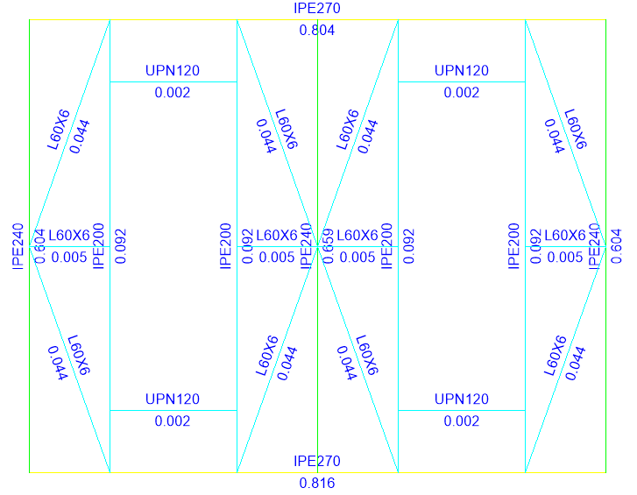

1. **Connections**

COLUMN BASE PLATE AND SETTING BOLT DESIGN -These loads are related to model: 17208-AE-2101&2102-Connection-REV0 (SEISMIC COEFFICIANT Cx =0.638, Cy = 0.638)















# DISPLACEMENT CONTROL

Allowable Deflections:

Design deflection of structural steel members shall not exceed the following values:

Floor beams supporting equipment: L/450

Floor beams without equipment: L/240

Frames (horizontal):

Drift = DPL = I*DP = I*(δx- δy)= I*( δxe *Cd / I) = δxe *Cd ≤ 0.02 H ⇒ δxe  ≤ 0.0057H

In which:

L= span of the beam; H= Height of the frame.

MODEL NAME: 17208-AE-2101&2102-REV0

SWAY OF STRUCTURE:

Max sway of structure due to Ex (in joint 6): 0.2 cm

H=550cm: 0.0057H=3.135 cm > 0.2 cm ok.

Max sway of structure due to Ey: (in joint 13): 0.7 cm

H=550cm: 0.0057H=3.135 cm > 0.7cm ok.

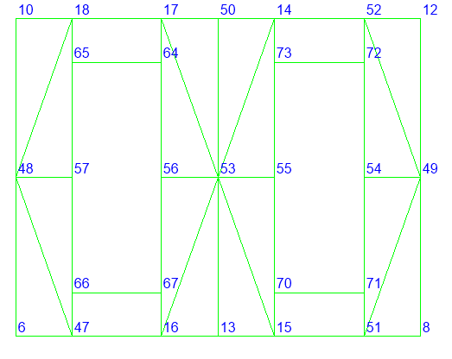

|  |  |  |  |
| --- | --- | --- | --- |
| **TABLE: Joint Displacements** | | | |
| **Joint** | **OutputCase** | **U1** | **U2** |
| Text | Text | m | m |
| 6 | ELX | 0.2 | 0.0 |
| 6 | ELY | 0.0 | 0.3 |
| 8 | ELX | 0.2 | 0.0 |
| 8 | ELY | 0.0 | 0.3 |
| 10 | ELX | 0.2 | 0.0 |
| 10 | ELY | 0.0 | 0.3 |
| 12 | ELX | 0.2 | 0.0 |
| 12 | ELY | 0.0 | 0.3 |
| 13 | ELX | 0.2 | 0.0 |
| 13 | ELY | 0.0 | 0.7 |
| 50 | ELX | 0.2 | 0.0 |
| 50 | ELY | 0.0 | 0.7 |

**CHECKING P-DELTA**

Control $θ_{i}$:

$$θ_{i}=\frac{P_{u}Δ_{eu}}{V_{u}h}$$

$$Δ_{eu}= 0.7$$

$$θ_{i}= \frac{21239.49*0.7}{6775.4*550}=0.004<0.1$$

**P-Δ need not be considered**

# JOINT REACTION

|  |  |  |  |  |
| --- | --- | --- | --- | --- |
| **TABLE: Joint Reactions** | | | | |
| **Joint** | **OutputCase** | **F1** | **F2** | **F3** |
| Text | Text | Kgf | Kgf | Kgf |
| A1 | DL | 817 | 322 | 5426 |
| EO | 33 | 14 | 160 |
| TL | 42 | 24 | 0 |
| LL | -119 | -101 | 3019 |
| SL | 5 | -9 | 494 |
| WLXP | -302 | 0 | -715 |
| WLYP | 0 | -769 | -2318 |
| ELX | -2967 | 48 | -6277 |
| ELY | 9 | -2828 | -7896 |
| DLs | 289 | 104 | 3294 |
| ET | 53 | 25 | 255 |
| WLXN | 302 | 0 | 715 |
| WLYN | 0 | 577 | 1738 |
| A2 | DL | -817 | 322 | 5404 |
| EO | -33 | 14 | 160 |
| TL | -42 | 24 | 0 |
| LL | 118 | -98 | 2909 |
| SL | -5 | -9 | 479 |
| WLXP | -302 | 0 | 715 |
| WLYP | 0 | -769 | -2318 |
| ELX | -2968 | -48 | 6277 |
| ELY | 4 | -2822 | -7907 |
| DLs | -289 | 105 | 3277 |
| ET | -53 | 25 | 255 |
| WLXN | 302 | 0 | -715 |
| WLYN | 0 | 577 | 1738 |
| B1 | DL | 798 | -322 | 4835 |
| EO | 25 | -14 | 120 |
| TL | 35 | -24 | 0 |
| LL | -133 | 101 | 449 |
| SL | 3 | 9 | 159 |
| WLXP | -302 | 0 | -714 |
| WLYP | 0 | -769 | 2318 |
| ELX | -2640 | 81 | -6127 |
| ELY | -29 | -2784 | 7896 |
| DLs | 283 | -104 | 2962 |
| ET | 52 | -25 | 253 |
| WLXN | 302 | 0 | 714 |
| WLYN | 0 | 577 | -1738 |
| B2 | DL | -798 | -322 | 4829 |
| EO | -25 | -14 | 120 |
| TL | -35 | -24 | 0 |
| LL | 134 | 98 | 418 |
| SL | -3 | 9 | 155 |
| WLXP | -302 | 0 | 714 |
| WLYP | 0 | -769 | 2318 |
| ELX | -2640 | -81 | 6127 |
| ELY | 16 | -2782 | 7907 |
| DLs | -283 | -105 | 2953 |
| ET | -52 | -25 | 253 |
| WLXN | 302 | 0 | -714 |
| WLYN | 0 | 577 | -1738 |