|  |  |  |  |  |  |  |  |
| --- | --- | --- | --- | --- | --- | --- | --- |
| **طرح نگهداشت و افزایش تولید 27 مخزن** | | | | | | | |
| Pickling & Passivation Procedure  **نگهداشت و افزایش تولید میدان نفتی بینک** | | | | | | | |
|  |  |  |  |  |  |  |
|  |  |  |  |  |  |  |
|  |  |  |  |  |  |  |
|  |  |  |  |  |  |  |
| V00 | July.2024 | IFA | AAC | M.FAKHARIAN | M.SADEGHIAN |  |
| **Rev.** | **Date** | **Purpose of Issue/Status** | **Prepared by:** | **Checked by:** | **Approved by:** | **CLIENT Approval** |
|  | | | | | | |
| **Status:** | **IFA: Issued For Approval**  **IFI: Issued For Information**  **AFC: Approved For Construction** | | | | | |

**REVISION RECORD SHEET**

|  |  |  |  |  |  |  |  |  |  |  |  |  |
| --- | --- | --- | --- | --- | --- | --- | --- | --- | --- | --- | --- | --- |
| **PAGE** | **V00** | **V01** | **V02** | **V03** | **V04** |  | **PAGE** | **V00** | **V01** | **V02** | **V03** | **V04** |
| **1** | X |  |  |  |  | **66** |  |  |  |  |  |
| **2** | X |  |  |  |  | **67** |  |  |  |  |  |
| **3** | X |  |  |  |  | **68** |  |  |  |  |  |
| **4** | X |  |  |  |  | **69** |  |  |  |  |  |
| **5** | X |  |  |  |  | **70** |  |  |  |  |  |
| **6** | X |  |  |  |  | **71** |  |  |  |  |  |
| **7** | X |  |  |  |  | **72** |  |  |  |  |  |
| **8** | X |  |  |  |  | **73** |  |  |  |  |  |
| **9** | X |  |  |  |  | **74** |  |  |  |  |  |
| **10** | X |  |  |  |  | **75** |  |  |  |  |  |
| **11** | X |  |  |  |  | **76** |  |  |  |  |  |
| **12** | X |  |  |  |  | **77** |  |  |  |  |  |
| **13** |  |  |  |  |  | **78** |  |  |  |  |  |
| **14** |  |  |  |  |  | **79** |  |  |  |  |  |
| **15** |  |  |  |  |  | **80** |  |  |  |  |  |
| **16** |  |  |  |  |  | **81** |  |  |  |  |  |
| **17** |  |  |  |  |  | **82** |  |  |  |  |  |
| **18** |  |  |  |  |  | **83** |  |  |  |  |  |
| **19** |  |  |  |  |  | **84** |  |  |  |  |  |
| **20** |  |  |  |  |  | **85** |  |  |  |  |  |
| **21** |  |  |  |  |  | **86** |  |  |  |  |  |
| **22** |  |  |  |  |  | **87** |  |  |  |  |  |
| **23** |  |  |  |  |  | **88** |  |  |  |  |  |
| **24** |  |  |  |  |  | **89** |  |  |  |  |  |
| **25** |  |  |  |  |  | **90** |  |  |  |  |  |
| **26** |  |  |  |  |  | **91** |  |  |  |  |  |
| **27** |  |  |  |  |  | **92** |  |  |  |  |  |
| **28** |  |  |  |  |  | **93** |  |  |  |  |  |
| **29** |  |  |  |  |  | **94** |  |  |  |  |  |
| **30** |  |  |  |  |  | **95** |  |  |  |  |  |
| **31** |  |  |  |  |  | **96** |  |  |  |  |  |
| **32** |  |  |  |  |  | **97** |  |  |  |  |  |
| **33** |  |  |  |  |  | **98** |  |  |  |  |  |
| **34** |  |  |  |  |  | **99** |  |  |  |  |  |
| **35** |  |  |  |  |  | **100** |  |  |  |  |  |
| **36** |  |  |  |  |  | **101** |  |  |  |  |  |
| **37** |  |  |  |  |  | **102** |  |  |  |  |  |
| **38** |  |  |  |  |  | **103** |  |  |  |  |  |
| **39** |  |  |  |  |  | **104** |  |  |  |  |  |
| **40** |  |  |  |  |  | **105** |  |  |  |  |  |
| **41** |  |  |  |  |  | **106** |  |  |  |  |  |
| **42** |  |  |  |  |  | **107** |  |  |  |  |  |
| **43** |  |  |  |  |  | **108** |  |  |  |  |  |
| **44** |  |  |  |  |  | **109** |  |  |  |  |  |
| **45** |  |  |  |  |  | **110** |  |  |  |  |  |
| **46** |  |  |  |  |  | **111** |  |  |  |  |  |
| **47** |  |  |  |  |  | **112** |  |  |  |  |  |
| **48** |  |  |  |  |  | **113** |  |  |  |  |  |
| **49** |  |  |  |  |  | **114** |  |  |  |  |  |
| **50** |  |  |  |  |  | **115** |  |  |  |  |  |
| **51** |  |  |  |  |  | **116** |  |  |  |  |  |
| **52** |  |  |  |  |  | **117** |  |  |  |  |  |
| **53** |  |  |  |  |  | **118** |  |  |  |  |  |
| **54** |  |  |  |  |  | **119** |  |  |  |  |  |
| **55** |  |  |  |  |  | **120** |  |  |  |  |  |
| **56** |  |  |  |  |  | **121** |  |  |  |  |  |
| **57** |  |  |  |  |  | **122** |  |  |  |  |  |
| **58** |  |  |  |  |  | **123** |  |  |  |  |  |
| **59** |  |  |  |  |  | **124** |  |  |  |  |  |
| **60** |  |  |  |  |  | **125** |  |  |  |  |  |
| **61** |  |  |  |  |  | **126** |  |  |  |  |  |
| **62** |  |  |  |  |  | **127** |  |  |  |  |  |
| **63** |  |  |  |  |  | **128** |  |  |  |  |  |
| **64** |  |  |  |  |  | **129** |  |  |  |  |  |
| **65** |  |  |  |  |  | **130** |  |  |  |  |  |

**CONTENTS**

1.0 INTRODUCTION 4

2.0 PURPOSE........................................................................................................................................................................5

**3.0 DEFINITION....................................................................................................................................................................5**

**4.0 REFERENCE STANDARD.............................................................................................................................................5**

**5.0 PRE-CLEANING..............................................................................................................................................................6**

**6.0 DESCALING.....................................................................................................................................................................6**

**7.0 DRYING............................................................................................................................................................................8**

**8.0 PROTECTION OF CLEANED SURFACES................................................................................................................9**

**9.0 INSPECTION AFTER CLEANING...............................................................................................................................9**

**10.0 PICKLING AND PASSIVATION REPORT...............................................................................................................10**

1. **INTRODUCTION**

Binak oilfield in Bushehr province is a part of the southern oilfields of Iran, is located 20 km northwest of Genaveh city.

With the aim of increasing production of oil from Binak oilfield, an EPC/EPD Project has been defined by NIOC/NISOC and awarded to Petro Iran Development Company (PEDCO). Also PEDCO (as General Contractor) has assigned the EPC-packages of the Project to "Hirgan Energy - Design and Inspection" JV.

**GENERAL DEFINITION**

The following terms shall be used in this document.

|  |  |
| --- | --- |
| CLIENT: | National Iranian South Oilfields Company (NISOC) |
| PROJECT: | Binak Oilfield Development – Manufacturing (w/Engineering & Material Supply) of Air Coolers |
| EPD/EPC CONTRACTOR (GC): | Petro Iran Development Company (PEDCO) |
| OWNER: | OWNER is collectively refer to National Iranian South Oil Company (NISOC) and Petro Iran Development Company (PEDCO) |
| EPC CONTRACTOR: | Joint Venture of : Hirgan Energy – Design & Inspection(D&I) Companies |
| VENDOR: | Aban Air Cooler (AAC) |
| EXECUTOR: | Executor is the party which carries out all or part of construction and/or commissioning for the project. |
| THIRD PARTY INSPECTOR (TPI): | Third Party Inspector |
| SHALL: | Is used where a provision is mandatory. |
| SHOULD: | Is used where a provision is advisory only. |
| WILL: | Is normally used in connection with the action by CLIENT rather than by an EPC/EPD CONTRACTOR, supplier or VENDOR. |
| MAY: | Is used where a provision is completely discretionary. |

**2.0 Scope**

The following procedure covers the general requirement for pickling and passivation of all welds and base metal on air cooler headers for “**Binak Oilfield Development** – **Manufacturing (W/Engineering & Material Supply) of Air Coolers**”.

Pickling and passivation of header shall be performed after all fabrication process activities like welding of tubes and nozzles to header, grinding, etc. Pickling and passivation of connecting tube to header shall also be done as far as available.

**3.0 Definition**

|  |  |
| --- | --- |
| CLIENT: | National Iranian South Oilfields Company (NISOC) |
| PROJECT: | Binak Oilfield Development – Manufacturing (w/Engineering & Material Supply) of Air Coolers |
| EPD/EPC CONTRACTOR (GC): | Petro Iran Development Company (PEDCO) |
| OWNER: | OWNER is collectively refer to National Iranian South Oil Company (NISOC) and Petro Iran Development Company (PEDCO) |
| EPC CONTRACTOR: | Joint Venture of : Hirgan Energy – Design & Inspection(D&I) Companies |
| VENDOR: | Aban Air Cooler (AAC) |

**4.0 Reference Standard**

Below mentioned references shall be considered as part of this procedure and shall be followed. In case of any deviation between below mentioned references and current document, vendor shall follow referred documents. Any mismatch is in vendor responsibility.

ASTM A 380 (Ed. 2017)

ASTM A967 (Ed. 2017)

Note: Solutions shall be tested on a sample prior to the main pickling and passivation process and if there is any problem, proper remedy action shall be considered.

**5.0 Pre-Cleaning**

Pre-cleaning is the removal of grease, oil, paint, soil, grit, and other gross contamination such as carbon steel contamination preparatory to a fabrication process or final cleaning.

Pre-cleaning include alkaline cleaners and degreases pre-cleaning may be accomplished by vapor degreasing; immersion in, spraying or swabbing with alkaline or emulsion cleaners, steam, or high - pressure water - jet. Prior to cleaning, chemical intrusion into clearance such as reinforcing pad, nozzle sleeve lining etc., must be protected by plugging.

Rinsing shall be performed after degreasing step. In this stage, the surface shall be kept in contact with agitated solution for about 15 to 30 min or until inspection shows that complete cleaner removal has been accomplished.

* PH of rinse water shall be between 6 and 8.
* Direct water shall be applied under high pressure into the inner surface of the inner vessel by a high-pressure jet pump for cleaning.
* Rinsing shall be carried out by water containing less Chloride content than 50 ppm.
* The rinsed surface shall be dried peaceable naturally or dried as quickly as compulsory by air blowing, heating, etc.
* Visual inspection for defect of the surface shall be carried out. If defect found, it shall be noted in inspection report and remedied prior to chemical cleaning.

For this project before applying pickling solution, it is better to clean and dry the header surface by using a cloth.

Depending on dimensions of the header box, the pre-cleaning method will be selected. In this project, mechanical cleaning and water jetting will be done.

**Mechanical cleaning**

The joint area and surrounding metal for several inches back from the joint preparation, on both faces of the weld, should be cleaned immediately before starting to weld. Any mechanical cleaning may be accomplished by brushing with a clean stainless-steel brush or scrubbing with a clean, lint-free cloth moistened with solvent, or both.

**6. Descaling**

**6.1. General**

Descaling is the removal of heavy, tightly adherent, oxide films resulting from hot-forming, heat-treatment, welding, and other high temperature operation. Scale may be removed by one of the chemical methods, grinding, power brushing or by a combination of these.

Wire brushes should be of a stainless steel which is equal in corrosion resistance to the material being worked on.

**6.2. Chemical Descaling (Pickling)**

Pickling and passivation condition/solution shall be selected based on ASTM A380 Table A1.1 for SA240 TP304L & SA240 TP316L.

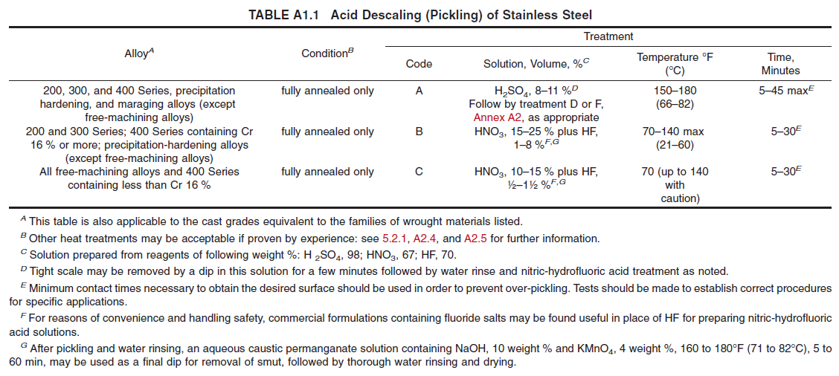

6.2.1. Over pickling

Over pickling must be avoided. Uniform removal of scale with acid pickling depends on the acid used, acid concentration, solution temperature, and contact time. Here, contact time range is 10-30 minutes Continues exposure to pickling solution for more than 30 min. is not recommended.

6.2.2. Passivation

The following chemical shall be applied in this stage:

20 - 50 HNO3 WT.%

Operating temperature: 50-70 °C

Application technique: Immersion in bath

Time: 10-30 minutes.

Picking shall be cleaned by coating the cleaning surface evenly with the chemicals to remove the oxidized scales.

**7. Cleaning**

After "Acid Pickling" and before "Passivation", a "Cleaning" step is required as per ASTM A380. For this project water jetting is used for the removal of oily, semisolid, and solid contaminants from metals. Also, passivation shall be done after cleaning and before Final Rinsing.

7.1. Passivation

After cleaning, the small stainless-steel parts are ready for immersion in a passivating acid bath, and for large parts the solution or gels brushed on the parts. Passivation solution shall be selected as per below Table.

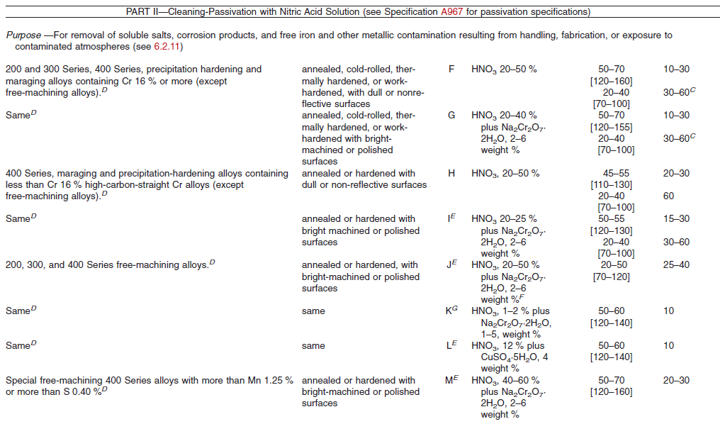

7.2. Final Rinsing

After chemical descaling, surface must be thoroughly rinsed to remove residual chemicals.

Direct water shall be applied under high pressure into the inner surface of the inner vessel by a high-pressure jet pump for cleaning.

The rinsed surface shall be dried peaceable naturally or dried as quickly as compulsory by air blowing, heating, etc.

For stainless steel, the final rinse shall be carried out using fresh water with following quality:

Quality of Water

Whenever possible, the flushing shall be made from the beginning to the end by fresh water with following quality:

PH of rinse water shall be between 6 and 8.

Rinsing shall be carried out by water containing less Chloride content than 50 ppm.

Note: In order to agitate the solvents and create turbulence, air blowing or mixers or the method of moving of parts in the chemical baths are used in each step.

Rinsing and drying shall be done after completion of passivation stage.

Rinsing shall be repeated until the used water is neutral (pH shall be in the range 6.5-8).

pH of final rinse water shall be between 6.5 to 8. Also, chloride of final stage of rinsing shall not be above 50 ppm.

Passivation followed by thorough rinsing several times with hot water and drying thoroughly after the final water rinse is recommended, whenever practical.

**8. Drying**

Drying may be carried out by: blowing hot (60 to 80°C), dry and oil-free air

**9. Protection of Cleaned Surfaces**

Measures to protect cleaned surfaces should be taken as soon as final cleaning is completed, and should be maintained during all subsequent fabrication, shipping, inspection, storage, and installation.

Do not remove wrapping and seals from incoming material and components until they are at the use site, ready to be used or installed. (See ASTM A380 -8.5)

**10. Inspection after Cleaning**

Testing should be sufficiently extensive to ensure the cleanness of all surface exposed to process fluids when in service.

Inspection techniques should represent careful, considered review of end use requirements of parts, equipment, and systems. There is no substitute for good, uniform, cleaning practices which yield a metallurgically sound and smooth surface, followed by adequate protection to preserve that condition. Establishment of the most reliable tests and test standards for cleanness are helpful in attaining the desired performance of parts, equipment, and systems. Testing should be sufficiently extensive to ensure the cleanness of all surfaces exposed to process fluids when in service. The following represent some tests that have been successfully applied to stainless steels. The purchaser shall have the option of specifying in his purchase documents that any of these quality assurance tests be used as the basis for acceptability of the cleanness or state of passivity of the stainless-steel item.

9.1. Visual Inspection

Items cleaned in accordance with this practice should be free of oil, grease, welding flux, slag and hot forming scale resulting from welding may be permissible on some surfaces. Visual inspection should be carried out under a lighting level, including both general and supplementary lighting, of at least 100 foot-candles (1080 lx), and preferably 250 foot-candles (2700 lx) on the surfaces being inspected.

* 1. Copper Sulfate Test (as per ASTM A967, ASTM A380)

This method is recommended for the detection of metallic iron or iron oxide on the surface of austenitic 200 and 300 Series, duplex, the precipitation hardening alloys, and the ferritic 400 Series stainless steels containing 16% chromium or more. The test solution is prepared by first adding sulfuric acid to distilled water and then dissolving copper sulfate in the following proportions (Warning—Always add acid to cold water.):

Distilled water 250-cm3

95-100% Sulfuric acid (H2SO4) 1 cm3

Copper sulfate (CuSO4·5H2O) 4 g

Swab the surface to be inspected with test solution, applying additional solution if needed to keep the surface wet for a period of 6 min. The specimen shall be rinsed and dried in a manner not to remove any deposited copper. Copper deposit will indicate the presence of free iron.

The tested samples shall not exhibit copper deposits.

The inside parts of header boxes inaccessible due to the existence of partitions would be smeared with solution by means of cotton and forceps and would be inspected with the help of flash lights. Other parts would be accessible through flanges.

* 1. Salt Spray Test (as per ASTM A967)

This method is recommended for detection of free iron or any other anodic surface contamination. The sample representing the lot of passivated parts shall be tested by salt spray test conducted in accordance with practice B117 for a minimum of 2 h using a 5% salt solution. The tested samples shall not exhibit rust or staining attributable to the presence of free iron particles embedded in the surface.

9.4. Safety Precautions:

Precautions must be taken to protect personnel, equipment, and facilities. This includes provisions for venting of explosive or toxic reaction product gases, safe disposal of used solutions, provision of barriers and warning signs, provisions for safe transfer of dangerous chemicals, and maintenance of constant vigilance for hazards and leaks during the cleaning operation.

**10. Pickling and Passivation Report**

Please refer to next page.

Attachment 1

|  |  |  |  |  |  |  |  |  |  |  |
| --- | --- | --- | --- | --- | --- | --- | --- | --- | --- | --- |
|  | | oilco  **NISOC**  Quality Control System  Pickling and Passivation Inspection Report | | | | | Code No.: QF-QC-30  Report No.:  Date: | | | |
| Equipment No.: | | DWG No.: | | | | | Part No.: | | | |
| Header Box No. | Cycle | | Method | Solution composition | | Temperature | Immersion Time | | Result | Remark  /  Inspection Type |
|  | Pre-cleaning (degreasing) | |  |  | |  |  | |  |  |
|  | Rinsing | |  |  | |  |  | |  |  |
|  | Drying | |  |  | |  |  | |  |  |
|  | Acid Pickling | |  |  | |  |  | |  |  |
|  | Cleaning | |  |  | |  |  | |  |  |
|  | Passivation | |  |  | |  |  | |  |  |
|  | Rinsing | |  |  | |  |  | |  |  |
|  | Final Rinsing | |  |  | |  |  | |  |  |
|  | PH metering | |  |  | |  |  | |  |  |
|  | Drying | |  |  | |  |  | |  |  |
| Note: | | | | | | | | | | |
| Inspector | | AAC | | | Hirgan Energy /PEDCO / NISOC | | | TPA | | |
| Name | |  | | |  | | |  | | |
| Signature | |  | | |  | | |  | | |
| Date | |  | | |  | | |  | | |