|  |  |  |  |  |  |  |  |
| --- | --- | --- | --- | --- | --- | --- | --- |
| **طرح نگهداشت و افزایش تولید 27 مخزن** | | | | | | | |
| **SAT (Performance Test) Procedure**  **نگهداشت و افزایش تولید میدان نفتی بینک** | | | | | | | |
|  |  |  |  |  |  |  |
|  |  |  |  |  |  |  |
|  |  |  |  |  |  |  |
|  |  |  |  |  |  |  |
| V00 | Nov. 2024 | IFA | AAC | M.FAKHARIAN | M.SADEGHIAN |  |
| **Rev.** | **Date** | **Purpose of Issue/Status** | **Prepared by:** | **Checked by:** | **Approved by:** | **CLIENT Approval** |
|  | | | | | | |
| **Status:** | **IFA: Issued For Approval**  **IFI: Issued For Information**  **AFC: Approved For Construction** | | | | | |

**REVISION RECORD SHEET**

|  |  |  |  |  |  |  |  |  |  |  |  |  |
| --- | --- | --- | --- | --- | --- | --- | --- | --- | --- | --- | --- | --- |
| **PAGE** | **V00** | **V01** | **V02** | **V03** | **V04** |  | **PAGE** | **V00** | **V01** | **V02** | **V03** | **V04** |
| **1** | X |  |  |  |  | **66** |  |  |  |  |  |
| **2** | X |  |  |  |  | **67** |  |  |  |  |  |
| **3** | X |  |  |  |  | **68** |  |  |  |  |  |
| **4** | X |  |  |  |  | **69** |  |  |  |  |  |
| **5** | X |  |  |  |  | **70** |  |  |  |  |  |
| **6** | X |  |  |  |  | **71** |  |  |  |  |  |
| **7** | X |  |  |  |  | **72** |  |  |  |  |  |
| **8** | X |  |  |  |  | **73** |  |  |  |  |  |
| **9** | X |  |  |  |  | **74** |  |  |  |  |  |
| **10** | X |  |  |  |  | **75** |  |  |  |  |  |
| **11** | X |  |  |  |  | **76** |  |  |  |  |  |
| **12** | X |  |  |  |  | **77** |  |  |  |  |  |
| **13** |  |  |  |  |  | **78** |  |  |  |  |  |
| **14** |  |  |  |  |  | **79** |  |  |  |  |  |
| **15** |  |  |  |  |  | **80** |  |  |  |  |  |
| **16** |  |  |  |  |  | **81** |  |  |  |  |  |
| **17** |  |  |  |  |  | **82** |  |  |  |  |  |
| **18** |  |  |  |  |  | **83** |  |  |  |  |  |
| **19** |  |  |  |  |  | **84** |  |  |  |  |  |
| **20** |  |  |  |  |  | **85** |  |  |  |  |  |
| **21** |  |  |  |  |  | **86** |  |  |  |  |  |
| **22** |  |  |  |  |  | **87** |  |  |  |  |  |
| **23** |  |  |  |  |  | **88** |  |  |  |  |  |
| **24** |  |  |  |  |  | **89** |  |  |  |  |  |
| **25** |  |  |  |  |  | **90** |  |  |  |  |  |
| **26** |  |  |  |  |  | **91** |  |  |  |  |  |
| **27** |  |  |  |  |  | **92** |  |  |  |  |  |
| **28** |  |  |  |  |  | **93** |  |  |  |  |  |
| **29** |  |  |  |  |  | **94** |  |  |  |  |  |
| **30** |  |  |  |  |  | **95** |  |  |  |  |  |
| **31** |  |  |  |  |  | **96** |  |  |  |  |  |
| **32** |  |  |  |  |  | **97** |  |  |  |  |  |
| **33** |  |  |  |  |  | **98** |  |  |  |  |  |
| **34** |  |  |  |  |  | **99** |  |  |  |  |  |
| **35** |  |  |  |  |  | **100** |  |  |  |  |  |
| **36** |  |  |  |  |  | **101** |  |  |  |  |  |
| **37** |  |  |  |  |  | **102** |  |  |  |  |  |
| **38** |  |  |  |  |  | **103** |  |  |  |  |  |
| **39** |  |  |  |  |  | **104** |  |  |  |  |  |
| **40** |  |  |  |  |  | **105** |  |  |  |  |  |
| **41** |  |  |  |  |  | **106** |  |  |  |  |  |
| **42** |  |  |  |  |  | **107** |  |  |  |  |  |
| **43** |  |  |  |  |  | **108** |  |  |  |  |  |
| **44** |  |  |  |  |  | **109** |  |  |  |  |  |
| **45** |  |  |  |  |  | **110** |  |  |  |  |  |
| **46** |  |  |  |  |  | **111** |  |  |  |  |  |
| **47** |  |  |  |  |  | **112** |  |  |  |  |  |
| **48** |  |  |  |  |  | **113** |  |  |  |  |  |
| **49** |  |  |  |  |  | **114** |  |  |  |  |  |
| **50** |  |  |  |  |  | **115** |  |  |  |  |  |
| **51** |  |  |  |  |  | **116** |  |  |  |  |  |
| **52** |  |  |  |  |  | **117** |  |  |  |  |  |
| **53** |  |  |  |  |  | **118** |  |  |  |  |  |
| **54** |  |  |  |  |  | **119** |  |  |  |  |  |
| **55** |  |  |  |  |  | **120** |  |  |  |  |  |
| **56** |  |  |  |  |  | **121** |  |  |  |  |  |
| **57** |  |  |  |  |  | **122** |  |  |  |  |  |
| **58** |  |  |  |  |  | **123** |  |  |  |  |  |
| **59** |  |  |  |  |  | **124** |  |  |  |  |  |
| **60** |  |  |  |  |  | **125** |  |  |  |  |  |
| **61** |  |  |  |  |  | **126** |  |  |  |  |  |
| **62** |  |  |  |  |  | **127** |  |  |  |  |  |
| **63** |  |  |  |  |  | **128** |  |  |  |  |  |
| **64** |  |  |  |  |  | **129** |  |  |  |  |  |
| **65** |  |  |  |  |  | **130** |  |  |  |  |  |

TABLE OF CONTENT

1. GENERAL……………………………………………………………………………………..4

2. STEEL WORK ASSEMBLY……………………………………………………….……..4

3. MECHANICAL EQUIPMENT ASSEMBLY..............................................4

4. PRE-START UP CHECK………………………………………………………….……....4

5. EQIUPMENT START UP CHECK……………………………………………….…….5

6. STRUCTURAL CHECK..........................................................................6

7. SHOP ASSEMBLY AND RUN TEST ……………………………….….……………...6

8. FAN CURVES …………………………………………………..…………………………...9

9. NOISE LEVEL…………………………………………………………………….………...10

10. VIBRATION MEASUREMENT PROCEDURE …………………………….……11

11. RUNNING TEST CHECK LIST ….……………………………………….……..…..12

1. GENERAL

This procedure describes the method for RUN-IN test of air coolers of the17208 project. The RUN-IN test shall be done at shop as per bellow sequence.

2. STEEL WORK ASSEMBLY

-         Columns

-         Beams

-         Bracings

-         Walkway supports

-         Plenums and fan rings

- Bundle

-         Motor supports

3. MECHANICAL EQUIPMENT ASSEMBLY

-         Installation of project fans.

-         Installation auxiliary parts (which are supplied by ABAN) for installing motors.

-         Installing auxiliary parts for speed reducers.

-      Installing of motors.

Make sure that feet of flanges are safely fixed and rest positively on their entire surface.

4. PRE-STAR UP CHECK

4.1) PULLY, FAN & motor alignment shaft

-check the alignment of the motor, pulley & fan shaft in accordance with data sheets.

-check the reading & compare with data sheet, if adjustment to be made within acceptable tolerances.

4.2) Blade Check

-Turn the rotor by hand

-check the gap between blade tips & "fan ring", is same at all point.

-Make sure the clearance between blade tips and ring meet data sheet records.

4.3) Motor Check

-The motor shall be run uncoupled for 5 min.

-Ensure correct voltage supply for motor to be tested.

-Check the starting current and record the reading.

-Ensure motor rotate in the right direction as indicated on the motor before running.

-Check RPM & record.

4.4) Check Instrumentation

4.5) Check lubrication by breaking unions at

breaking and filling grease line.

4.6) Rotate by hand to check fans and motors are running from any OBSTRUCTION, TOOLS, ASSEMBLYAID and debris are removed from the structure.

4.7) Ensure all fan guards are in position & security fixed.

4.8) Check the belt tension.

5.  EQUIPMENT START UP

Avoid resonance of the base with the turning frequency and double mains frequency .Turn the rotor by hand.

Check the direction of rotation .Use suitable tool to mount or pull off and cove with a protection against accidental contact.

-  Start-up of motors before connecting and check the motors.

-   Check the belt tensions.

-   Start-up of fan with design blade angle. (Refer to fan curves).

-   Noise level measuring (Fill the datasheets). - run motor uncoupled for 1 hr . check and record Amps ,bearing temp ,rpm , housing temp

-run motor for 4 hr . check and record above

Attachments:

1) Fan specification and curves in design case.

2) Noise datasheets.

3) Vibration switches datasheets.

4) Motor datasheets.

5) Run test check list

-The drive unit with all fans should be running simultaneously and kept continuously running for about 2 hours or more.

-Ensure all personnel other than group are evacuated to a suitable area outside boundary.

-Start motor No.1 and run approximately 1 minute, if unit does not exhibit excessive noise or Vibration level (indicating that machinery have problem) then motor No.2 can be also be started.

-Run for approximately 1 minute and if unit does not exhibit high noise or vibration level, commence test (Min. for 2 hours).

-During the running test, calibration or setting of the following equipment shall be carried out:

(1) Record amperage of each motor during running test.

(2) Vibration check of fan running on individual units as per API 661, record.

(3) Bearing temperature check & recording.

(4) RPM of fan record.

-The maximum permission amplitude of vibration at design fan speed & horse power shall be 0.15 millimetre peak to peak as measured on primary structural members & machinery mounts for either shop or filed test

- Fan assemblies shall be balanced by one of the following mean:

(1) Static or dynamic balancing as an assembly.

(2) Static or dynamic balancing of the hub & moment balancing of the blades.

(3) Hubs & automatically controlled pitch fans shall be dynamically balanced.

6. STRUCTURAL CHECK

After running test was completed, bolting on random joint should be checked to ensure that the bolts are still tight.

7. SHOP ASSEMBLY AND RUN TEST

7.1 When a run test is to be made, this test shall be hold by the inspector.

a) Check operational performance of each component which can be connected.

Sometimes instrument air is not available to permit complete checking of all components.

b) Check fan blade pitch. Witness demonstration of changing pitch to the extremes in setting specified in purchase order or data sheets.

c) Check direction of fan pitch change and position of louvers with loss of control air Pressure for conformance to specifications.

d) Check vibration cut out switch operation.

e) Check for objectionable vibration of structural components, especially excessive Amplitudes of vibration resulting from resonance.

f) Hold noise level test, if specifications require a noise level test to be performed in the shop. (Normally hold by Purchaser).

Following steps shall include in run in test:

a. Check and record the fan tip clearance.

b. Set the fan pitch for the required operating angle.

c. Check and record the fan shaft run-out tolerance.

d. Run the motor and fan at design capacity for at least 5 min, checking and recording the voltage, amperage, and vibration levels.

e. Perform air flow test .

f. Perform noise test .

7.2 Noise control measures applied to equipment (such as acoustic enclosures and acoustic insulation) shall not interfere with the operation and running maintenance of the Equipment. They shall, where appropriate be constructed so that they can be dismantled and re-assembled at site without affecting their acoustic properties. They shall not also interfere with emergency fire fighting in the unit.

7.3 The following equipment has been individuated as the critical individual items giving fundamental contribution to the noise level of the plant. The here below specified noise limits for these critical individual items are considered to be satisfactory in respect to the noise limits for the complete plant. The noise limits are shown both in dB (A) (global value) and by equivalent ISO NR (Noise Rating) curves.

The above specified noise limit values are to be considered consistent with the following prescriptions.

7.4 The above specified noise limits of each critical individual items of equipment will be part of the specification of that equipment and the manufactures will be required to supply satisfactory evidence that this equipment meets the noise limits as required in the specification. For this purpose the equipment manufacturers shall submit filled-in equipment noise data sheets, as per attached sample.

7.5 Fan rotational speed measurement

It can be measured using a tachometer or strobe light. Tachometers can be either mechanical or electronic. With mechanical tachometers, the tachometer shaft is rotated by pressing it against the center of the fan shaft so that both the tachometer shaft and fan shaft have the same speed. Mechanical tachometers should be used carefully so that no personnel or equipment damage occurs if the tachometer shaft slips off the fan shaft. Electronic tachometers (like the one in the figure) send light to a shiny, rotating object, such as a silver sticker attached to a fan blade or shaft, and the reflected light is measured by the tachometer and converted to an rpm measurement.

Tools: tachometer

7.6 air flow measurement

An airflow traverse requires at least 5 lengths of straight exhaust duct. An anemometer, a test instrument that measures air velocity is used to determine the average air speed in the duct. Then the average feet per minute is multiplied by the area of the duct in square feet to determine the airflow moving through the duct.

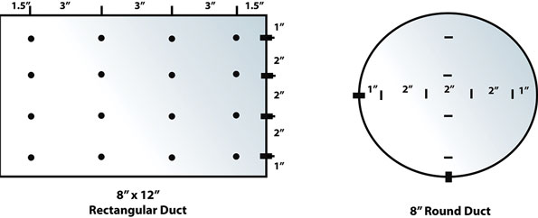

Example: You have a exhaust fan designed for 200 CFM. The system has an 8-in. exhaust duct. The area of an 8-in. duct is .35 sq. ft. You measure the velocity at a point in the duct and find the average velocity in the exhaust duct is 400 FPM. Multiply 400 Feet per Minute times the area of the duct, which is .35 square feet, to find 140 CFM exhaust fan airflow.

9 .NOISE LEVEL

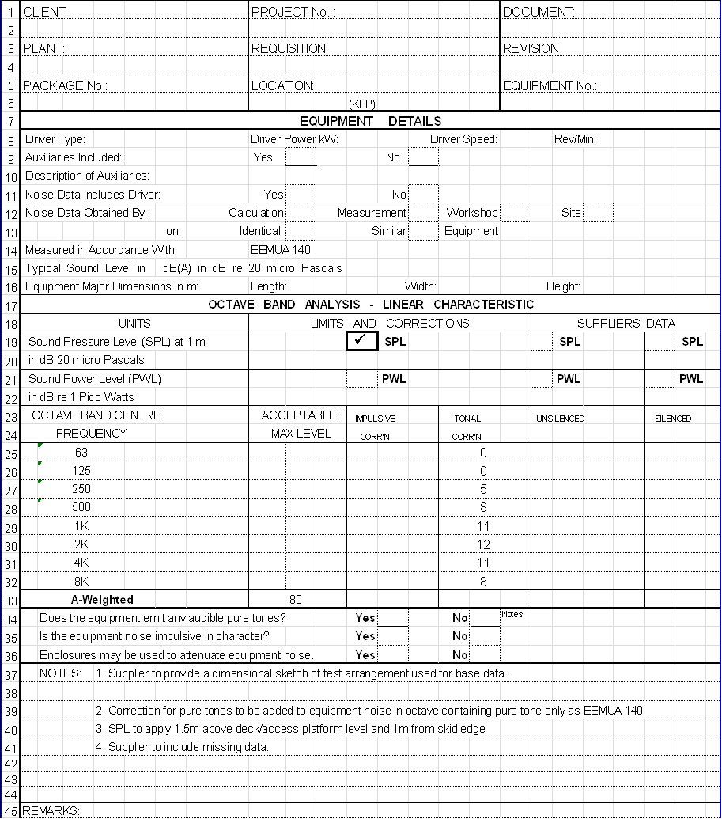

**10 .VIBRATION MEASUREMENT PROCEDURE**

Due to minimize the vibration, all structural members such as columns of air cooler are designed according to UBC-1997.

All consideration are done for minimize the vibration.

In Run-in test the vibration measurement shall be done at three points of each columns and machinery mountings such as motor supports.

The maximum amplitude of vibration over the design fan speed range & blade angle shall be 0.15mm from pick to pick. All fans of each type should be checked for balancing/vibration problem during the run in test.

Wind velocity at test conditions shall not exceed 5 m/s.

Structural member shall be designed to minimize vibration. The maximum amplitude of vibration over the design fan-speed range shall be 0.15 mm (0.006 in) from peak to peak, as measured on primary structural members’ machinery mountings.

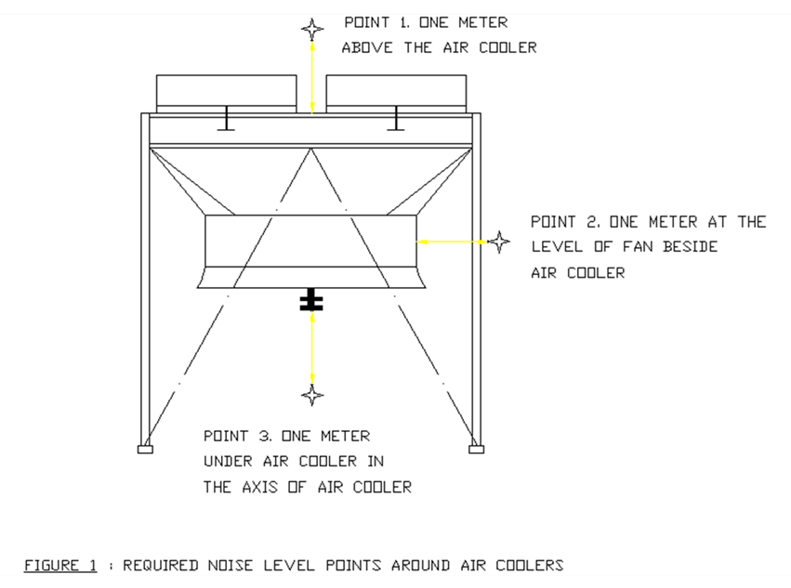

11. RUNNING TEST CHECK LIST

