|  |  |  |  |  |  |  |
| --- | --- | --- | --- | --- | --- | --- |
| **طرح نگهداشت و افزایش تولید 27 مخزن** | | | | | | |
| **NDE Procedure**  **نگهداشت و افزایش تولید میدان نفتی بینک** | | | | | | |
|  |  |  |  |  |  |  |
|  |  |  |  |  |  |  |
|  |  |  |  |  |  |  |
| V00 | Aug.2023 | IFR | Beh Koosh Vista | M.Fakharian | A.M.Mohseni |  |
| **Rev.** | **Date** | **Purpose of Issue/Status** | **Prepared by:** | **Checked by:** | **Approved by:** | **CLIENT Approval** |
| **Class:** | |  | | | | |
| **Status:** | |  | | --- | | **IFA: Issued for Approval**  **IFR: Issued for Review**  **IFI: Issued for Information**  **AFC: Approved for Construction** | | | | | | |

# Revision Record Sheet

|  |  |  |  |  |  |  |  |  |
| --- | --- | --- | --- | --- | --- | --- | --- | --- |
| **PAGE** | **V00** | **V01** | **V02** | **V03** | **V04** | **V05** | **V06** | **V07** |
| 1 | X |  |  |  |  |  |  |  |
| 2 | X |  |  |  |  |  |  |  |
| 3 | X |  |  |  |  |  |  |  |
| 4 | X |  |  |  |  |  |  |  |
| 5 | X |  |  |  |  |  |  |  |
| 6 | X |  |  |  |  |  |  |  |
| 7 | X |  |  |  |  |  |  |  |
| 8 | X |  |  |  |  |  |  |  |
| 9 | X |  |  |  |  |  |  |  |
| 10 | X |  |  |  |  |  |  |  |
| 11 | X |  |  |  |  |  |  |  |
| 12 | X |  |  |  |  |  |  |  |
| 13 | X |  |  |  |  |  |  |  |
| 14 | X |  |  |  |  |  |  |  |
| 15 | X |  |  |  |  |  |  |  |
| 16 | X |  |  |  |  |  |  |  |
| 17 | X |  |  |  |  |  |  |  |
| 18 | X |  |  |  |  |  |  |  |
| 19 | X |  |  |  |  |  |  |  |
| 20 | X |  |  |  |  |  |  |  |
| 21 | X |  |  |  |  |  |  |  |
| 22 | X |  |  |  |  |  |  |  |
| 23 | X |  |  |  |  |  |  |  |
| 24 | X |  |  |  |  |  |  |  |
| 25 | X |  |  |  |  |  |  |  |
| 26 | X |  |  |  |  |  |  |  |
| 27 | X |  |  |  |  |  |  |  |
| 28 | X |  |  |  |  |  |  |  |
| 29 | X |  |  |  |  |  |  |  |
| 30 | X |  |  |  |  |  |  |  |
| 31 | X |  |  |  |  |  |  |  |
| 32 | X |  |  |  |  |  |  |  |
| 33 | X |  |  |  |  |  |  |  |
| 34 | X |  |  |  |  |  |  |  |
| 35 | X |  |  |  |  |  |  |  |
| 36 | X |  |  |  |  |  |  |  |
| 37 | X |  |  |  |  |  |  |  |
| 38 | X |  |  |  |  |  |  |  |
| 39 | X |  |  |  |  |  |  |  |
| 40 | X |  |  |  |  |  |  |  |
| 41 | X |  |  |  |  |  |  |  |
| 42 | X |  |  |  |  |  |  |  |
| 43 | X |  |  |  |  |  |  |  |
| 44 |  |  |  |  |  |  |  |  |
| 45 |  |  |  |  |  |  |  |  |
| 46 |  |  |  |  |  |  |  |  |
| 47 |  |  |  |  |  |  |  |  |
| 48 |  |  |  |  |  |  |  |  |
| 49 |  |  |  |  |  |  |  |  |
| 50 |  |  |  |  |  |  |  |  |

|  |  |  |  |  |  |  |  |  |
| --- | --- | --- | --- | --- | --- | --- | --- | --- |
| **PAGE** | **V00** | **V01** | **V02** | **V03** | **V04** | **V05** | **V06** | **V07** |
| 51 |  |  |  |  |  |  |  |  |
| 52 |  |  |  |  |  |  |  |  |
| 53 |  |  |  |  |  |  |  |  |
| 54 |  |  |  |  |  |  |  |  |
| 55 |  |  |  |  |  |  |  |  |
| 56 |  |  |  |  |  |  |  |  |
| 57 |  |  |  |  |  |  |  |  |
| 58 |  |  |  |  |  |  |  |  |
| 59 |  |  |  |  |  |  |  |  |
| 60 |  |  |  |  |  |  |  |  |
| 61 |  |  |  |  |  |  |  |  |
| 62 |  |  |  |  |  |  |  |  |
| 63 |  |  |  |  |  |  |  |  |
| 64 |  |  |  |  |  |  |  |  |
| 65 |  |  |  |  |  |  |  |  |
| 66 |  |  |  |  |  |  |  |  |
| 67 |  |  |  |  |  |  |  |  |
| 68 |  |  |  |  |  |  |  |  |
| 69 |  |  |  |  |  |  |  |  |
| 70 |  |  |  |  |  |  |  |  |
| 71 |  |  |  |  |  |  |  |  |
| 72 |  |  |  |  |  |  |  |  |
| 73 |  |  |  |  |  |  |  |  |
| 74 |  |  |  |  |  |  |  |  |
| 75 |  |  |  |  |  |  |  |  |
| 76 |  |  |  |  |  |  |  |  |
| 77 |  |  |  |  |  |  |  |  |
| 78 |  |  |  |  |  |  |  |  |
| 79 |  |  |  |  |  |  |  |  |
| 80 |  |  |  |  |  |  |  |  |
| 81 |  |  |  |  |  |  |  |  |
| 82 |  |  |  |  |  |  |  |  |
| 83 |  |  |  |  |  |  |  |  |
| 84 |  |  |  |  |  |  |  |  |
| 85 |  |  |  |  |  |  |  |  |
| 86 |  |  |  |  |  |  |  |  |
| 87 |  |  |  |  |  |  |  |  |
| 88 |  |  |  |  |  |  |  |  |
| 89 |  |  |  |  |  |  |  |  |
| 90 |  |  |  |  |  |  |  |  |
| 91 |  |  |  |  |  |  |  |  |
| 92 |  |  |  |  |  |  |  |  |
| 93 |  |  |  |  |  |  |  |  |
| 94 |  |  |  |  |  |  |  |  |
| 95 |  |  |  |  |  |  |  |  |
| 96 |  |  |  |  |  |  |  |  |
| 97 |  |  |  |  |  |  |  |  |
| 98 |  |  |  |  |  |  |  |  |
| 99 |  |  |  |  |  |  |  |  |
| 100 |  |  |  |  |  |  |  |  |

Table of Contents

Revision Record Sheet 2

1 Introduction 6

1.1. Preamble 6

1.2. Definitions and symbols 6

1.2.1. Abbreviations 7

1.3. Safety 7

1.4. Personnel qualifications 7

1.5. Information required prior to testing 7

1.6. Extent of testing 8

1.7. Materials 8

1.8. Selection of testing method 8

1.9. Time of testing 8

1.10. Final report 8

2 Penetrant testing (PT) 10

2.1. Scope 10

2.2. Personnel qualifications 10

2.3. Equipment/testing material 10

2.4. Compatibility of testing materials with the parts to be tested 10

2.5. Preparation, pre-cleaning and testing 11

Preparation and pre-cleaning of the surface 11

Application of penetrant 11

Excess penetrant removal 12

Drying 12

Application of developer 12

2.6. Inspection 12

General 12

Viewing conditions 13

2.7. Reporting 13

2.8. Acceptance criteria 13

Welds 13

2.9. Post cleaning and protection 13

Post cleaning 13

Protection 13

2.10. Retesting 14

2.11. Reporting 14

Appendix-1 Liquid Penetration Examination Report Sample 15

3 Radiographic testing 16

3.1 Reference 16

3.2 Personnel Qualification 16

3.3 General 16

3.3.1 Radiation 16

X-radiation or gamma ray source such as lr-192 or Co-60 may be used as following 16

3.4 Radiographic Film 16

3.5 Intensifying Screens 17

3.6 Scattered Radiation 17

3.7 System of Identification 17

3.8 Radiographic Density 17

3.9 Density Limitation 17

3.10 Quality of Film 17

3.11 Density variation 17

3.12 Monitoring Density Limitation of Radiograph 18

3.13 Geometric Un sharpness Limitations 18

3.14 Verification of Source Size 18

3.15 Surface Preparation 19

3.16 Image Quality Indicator 19

3.17 Shims Under Hole IQIs 22

3.18 IQI Sensitivity 22

3.19 Radiographic Technique 23

3.20 Acceptance Standards 23

3.21 Radiation Safety 24

3.22 Records 24

3.23 Reporting 29

Appendix-2 Radiographic Examination Report Sample 31

4 Ultrasonic testing 32

4.1. Scope 32

4.2. Reference 32

4.3. Personnel Qualification 32

4.4. General 32

4.4.1. Examination Coverage 32

4.4.2. Rate of Search Unit Movement 32

4.4.3. Scanning Sensitivity 32

4.4.4. Equipment 32

4.5. Instrument Calibration 34

4.6. System Calibration 34

4.6.1. Basic Calibration Block 34

4.7. Calibration for Examination 35

4.8. Calibration Confirmation 36

4.9. Scanning 36

4.10. Angle Beam Scanning 36

4.11. Evaluation 37

4.12. Post-examination Cleaning 37

4.13. Acceptance standards 37

4.14. Records 37

4.15. Report 38

Appendix-3 Ultrasonic Examination Report Sample 39

5 Visual Inspection 40

5.1 Scope 40

5.2 REFERENCE 40

5.3 Equipment 40

5.4 TECHNIQUE 40

5.4.1. Preparation of surfaces 40

5.5 SURFACE CONDITION 40

5.6 METHOD OF EXAMINATION 40

5.7 ACCEPTANCE STANDARD OF BUTT WELDS 41

5.8 ACCEPTANCE STANDARD FOR FILLET WELDS 41

5.9 PERSONNEL QUALIFICATION 41

Appendix-4 Visual Inspection Report Sample 42

Appendix-5-Dimensional Check Report Sample 43

# Introduction

## 1.1. Preamble

This Classification Note applies for non-destructive testing for the following methods:

— Magnetic particle testing

— Penetrant testing

— Radiographic testing

— Ultrasonic testing

— Visual testing.

In general, this Classification Note has to be adhered to, as far as applicable, when non-destructive testing is required by the Client. The use of other standards or specifications may, however, be granted if an equivalent testing procedure is ensured or is more fit for the purpose.

The definitions and requirements stated below may satisfy the need of a written procedure. Where this is not the case, or where the techniques described in this Classification Note are not applicable to the object to be examined, additional written procedures shall be used and accepted by the Client before the testing is carried out.

## 1.2. Definitions and symbols

The following definitions apply:

— **Testing*:***Testing or examination of a material or component in accordance with this Classification Note, or a standard, or a specification or a procedure in order to detect, locate, measure and evaluate flaws.

— **Defect*:***One or more flaws whose aggregate size, shape, orientation; location or properties do not meet specified requirements and are rejectable.

— **Discontinuity*:***A lack of continuity or cohesion; an intentional or unintentional interruption in the physical structure or configuration of a material or component

— **Flaw*:***An imperfection or discontinuity that may be detectable by non-destructive testing and is not necessarily rejectable.

— **Indication*:***Evidence of a discontinuity that requires interpretation to determine its significance

— **False indication*:***An indication that is interpreted to be caused by a discontinuity at a location where no discontinuity exists.

— **Non relevant indication*:***An indication that is caused by a condition or type of discontinuity that is not rejectable. False indications are non-relevant

— **Imperfections*:***A departure of a quality characteristic from its intended condition.

— **Internal imperfections*:***Imperfections those are not open to a surface or not directly accessible.

— **Quality level*:***Fixed limits of imperfections corresponding to the expected quality in a specific object. The limits are determined with regard to type of imperfection, their amount and their actual dimensions.

— **Acceptance level*:***Prescribed limits below which a component is accepted.

— **Planar discontinuity*:***Discontinuity having two measurable dimensions

— **Non-planar discontinuity*:***Discontinuity having three measurable dimensions.

The following definitions relevant to MT or PT indications apply:

— **Linear indication:**An indication in which the length is at least three times the width.

— **Nonlinear indication*:***An indication of circular or elliptical shape with a length less than three times the width.

— **Aligned indication*:***Three or more indications in a line, separated by 2 mm or less edge-to-edge.

— **Open indication:**An indication visible after removal of the magnetic particles or that can be detected by the use of contrast dye penetrant.

— **Non-open indication*:***An indication that is not visually detectable after removal of the magnetic particles or that cannot be detected by the use of contrast dye penetrant.

— **Relevant indication*:***An indication that is caused by a condition or type of discontinuity that requires evaluation. Only indications which have any dimension greater than 1.5 mm shall be considered relevant.

### 1.2.1. Abbreviations

PT ………...Penetrant testing

RT ………. Radiographic testing

VT ………. Visual testing

HAZ ……...Heat affected zone

WPS ……...Welding Procedure Specification

TMCP ……Thermo mechanically controlled processed

NDT ……...Non-destructive testing

## 1.3. Safety

International, national and local safety and environmental protection regulation shall be observed at all times.

## 1.4. Personnel qualifications

Personnel performing testing shall be qualified and certified to an appropriate level in accordance with SNT-TC-1A. Personnel performing non-destructive testing in accordance with this Classification Note shall be qualified and certified to an appropriate level as specified for each method.

As a minimum the following applies:

***Level*** ***I***

An individual certificated to Level I has demonstrated competence to carry out NDT according to written instructions and under the supervision of level II or III personnel. Within the scope of the competence defined on the certificate, level I personnel may be authorized to:

— set up NDT equipment

— perform the test

— record and classify the results of the tests in terms of written criteria

— report the results

— Level I certificated personnel shall not be responsible for the choice of test method or technique to be used, nor for the assessment of the test results.

***Level II***

An individual certificated to Level I has demonstrated competence to perform non-destructive testing according to established or recognized procedures. Within the scope of the competence defined on the certificate, level II personnel may be authorized to:

— select the NDT technique for the test method to be used.

— define the limitations of application of the testing method

— translate NDT standards and specifications into NDT instructions

— set up and verify equipment settings

— perform and supervise tests

— interpret and evaluate results according to applicable standards, codes or specifications

— prepare written NDT instructions

— carry out and to supervise all level I duties.

## 1.5. Information required prior to testing

Before carrying out non-destructive testing, the following items, if applicable, shall be agreed between the manufacturer and the Society.

— specific testing procedure, if required

— extent of testing

— testing plan

— testing equipment

— calibration of the equipment

— calibration and reference blocks

— acceptance level

— actions necessary for unacceptable indications.

Prior to testing, the following information is usually required:

— grade of parent material

— welding parameters and conditions used to make the weld

— location and extent of welds to be tested

— weld surface geometry

— coating type and thickness.

Operators may ask for further information that will be helpful in determining the nature of discontinuities.

## 1.6. Extent of testing

The extent of testing shall be given in the relevant parts of the Rules or drawings or as agreed between the manufacturer and the Society.

The extent of NDT shall be increased if repeated occurrence of cracks or other significant weld defects are revealed. Corrective actions shall be taken to ensure that all similar defects will be detected.

All welds shall be 100% visually tested prior to carrying out other NDT.

## 1.7. Materials

This procedure Note is applicable for fusion welds in the following material:

* Carbon Steel

The use of this Procedure Note for other metallic materials shall be approved case by case.

## 1.8. Selection of testing method

Selection of NDT-method is shown in Table 1-1.

|  |  |  |  |  |  |
| --- | --- | --- | --- | --- | --- |
| Table 1-1 Selection of Testing Method | | | | | |
| NDT Method | Materials | Plate | Weld | | |
| T-  Joint | butt | Fillet |
| VT | CS | x | x | x | x |
| PT | CS | - | x | x | x |
| UT | CS | x | x | x | - |
| RT | CS | - | x | x | - |

Note: There is not any clad parts in this project.

## 1.9. Time of testing

Apply these tests after welding: VT, PT, UT, RT

And apply these tests after Post Weld Heat Treatment (PW HT): VT

## 1.10. Final report

All NDT shall be properly documented in such a way that the performed testing can be easily retraced at a later stage. The reports shall identify the unacceptable defects present in the tested area, and a conclusive statement as to whether the weld satisfies the acceptance criteria or not.

The report shall include a reference to the applicable standard, NDT procedure and acceptance criteria.In addition, as a minimum, the following information must be given:

— object and drawing references

— place and date of examination

— material type and dimensions

— post weld heat treatment, if required

— location of examined areas, type of joint

— welding process used

— name of the company and operator carrying out the testing including certification level of the operator

— surface conditions

— temperature of the object

— number of repairs if specific area repaired twice or more

— contract requirements e.g., order no., specifications, special agreements etc.

— sketch showing location and information regarding detected defects,

— extent of testing

— test equipment used

— description of the parameters used for each method

— description and location of all recordable indications

— examination results with reference to acceptance level.

Other information related to the specific method may be listed under each method.

The report shall be such that there is no doubt about what is tested, where it has been carried out and give a clear and exact description of reportable defect location.

# Penetrant testing (PT)

## Scope

This part describes penetrant testing used to detect imperfections which are open to the surface of the tested material. It is mainly applied to metallic materials, but can also be performed on non-metallic materials, e.g., ceramics.

WITNESS OF INSPECTION ITEMS: All Liquid Penetrant examination work shall be subject to witness by the Contractor's.

representatives at any reasonable time and place before, during and after fabrication.

## Personnel qualifications

Personnel performing testing shall be qualified and certified to PT level II or III in accordance with ASNT SNT-TC-1A.

## Equipment/testing material

The equipment for carrying out penetrant testing, depends on the number, size and shape of the part to be tested.

Irrespective of the method or system selected for use by the Subcontractor, all component materials (penetrant, cleaner, developer) shall be materials from the same brand or manufacturer's system. Interchanging or use of penetrants, cleaner, or developer from different manufacturers or brands shall not be permitted. All penetrant inspection materials shall be kept for site use in their original containers.

A product family is understood as a combination of the penetrant testing materials. Penetrant, excess penetrant remover and developer shall be from one manufacturer and shall be compatible with each other.

Typical testing product/testing material:

— Color contrast penetrant, fluorescent penetrant, dual purpose penetrant.

Typical penetrant remover:

— Water, Lipophilic emulsifier, solvent and hydrophilic emulsifier.

Developers:

— Dry, water soluble, water suspend able and solvent based.

|  |  |  |  |
| --- | --- | --- | --- |
| Technique | Type | | |
| Penetrant Brand  (see note 1) | Developer Brand | Remover Brand |
| Solvent  Removable | MAGNO FLUX | MAGNO FLUX | MAGNO FLUX |

Note 1: This brand is suggested; other brands could be used after approval of TPA.

*In This procedure recommended Solvent Removable Technique

## Compatibility of testing materials with the parts to be tested

The penetrant testing products shall be compatible with the material to be tested and the use for which the part is designed.

When using penetrant materials on austenitic stainless steel, titanium, nickel-based or other high-temperature alloys, the need to restrict impurities such as Sulphur, halogens and alkali metals should be considered. These impurities may cause embrittlement or corrosion, particularly at elevated temperatures.

## Preparation, pre-cleaning and testing

### Preparation and pre-cleaning of the surface

Contaminants, e.g., scale, rust, oil, grease or paint shall be removed, if necessary using mechanical or chemical methods or a combination of these methods. Pre-cleaning shall ensure that the test surface is free from residues and that it allows the penetrant to enter any defects/discontinuities. The cleaned area shall be large enough to prevent interference from areas adjacent to the actual test surface.

The surfaces to be examined, and all adjacent areas within at least 1 in. (25 mm), shall be dry and free from all dirt, grease, lint, scale, welding flux and spatter, oil or other extraneous matter, that could obscure surface indications and interfere with the examination. Excessive weld ripples, unevenness, etc., which may interfere with the evaluation of discontinuities, shall be ground smooth.

#### **Drying**

As the final stage of pre-cleaning, the object to be tested shall be thoroughly dried, so that neither water or solvent remains in the defects/discontinuities.

### Application of penetrant

#### **Methods of application**

The penetrant can be applied to the object to be tested by spraying, brushing, flooding or immersion.

Care shall be taken to ensure that the test surface remains completely wetted throughout the entire penetration time.

#### **Temperature**

In order to minimize moisture entering defects/discontinuities, the temperature of the test surface shall generally be within the range from 10°C to 50°C. For temperatures below 10°C or above 50°C only penetrant product families and procedures approved in accordance with recognized standard for this purpose shall be used.

#### **Penetration time**

The appropriate penetration time depends on the properties of the penetrant, the application temperature, the material of the object to be tested and the defects/discontinuities to be detected.

The minimum penetration time shall be as require in below Table.

Minimum Penetration (Dwell) Times

|  |  |  |  |
| --- | --- | --- | --- |
| Material | Form | Type of Discontinuity | Dwell Times (Min.) [Note (1)] |
| 10˚C to 52˚C |
| Carbon Steel | welds | Cold shuts, porosity, lack of fusion, cracks (all forms) | 5 |
| forgings, plate | Laps, cracks  (all forms) | 10 |

NOTE: (1) For temperatures from 5°C up to 10°C, minimum penetrant dwell time shall be 2 times the value listed.

### Excess penetrant removal

#### **General**

The application of the remover medium shall be done such that no penetrant is removed from the defects/discontinuities.

#### **Solvent**

Generally, the excess penetrant shall be removed first by using a clean lint-free cloth. Subsequent cleaning with a clean lint-free cloth lightly moistened with solvent shall then be carried out. To minimize removal of penetrant from discontinuities, care shall be taken to avoid the use of excess solvent. Flushing the surface with solvent, following the application of the penetrant and prior to developing, is prohibited.

#### **Excess penetrant removal check**

During excess penetrant removal the test surface shall be visually checked for penetrant residues. For fluorescent penetrants, this shall be carried out under a UV-A source.

### Drying

For the solvent removable technique, the surfaces may be dried by normal evaporation, blotting, wiping, or forced air.

### Application of developer

The developer shall be maintained in a uniform condition during use and shall be evenly applied to the test surface. The application of the developer shall be carried out as soon as possible after the removal of excess penetrant. When using color contrast penetrants, only a wet developer shall be used. When using fluorescent penetrants, a wet or dry developer may be used.

#### **Solvent-based developer**

The developer shall be applied by spraying uniformly. The spray shall be such that the developer arrives slightly wet on the surface, giving a thin, uniform layer.

#### **Development time**

The development time shall as a minimum be the same as the penetration time, however, longer times may be agreed. The development time shall be stated in the test procedure to ensure repeatable test results with respect to defect sizing. The development time begins immediately after drying when wet developer is applied.

|  |  |  |  |
| --- | --- | --- | --- |
| Material | Form | Type of Discontinuity | Developing Time (Min.) |
| Carbon  Steel | welds | Cold shuts, porosity, lack of fusion, cracks (all forms) | Min. 10 min. (5-16°C)  Min. 7 min. (16-52°C) |
| forgings, plate | Laps, cracks (all forms) |

## Inspection

### General

Generally, it is advisable to carry out the first examination just after the application of the developer or soon as the developer is dry. This facilitates a better interpretation of indications.

The final inspection shall be made not 10 min nor than 60min after the requirement of 3.5.5.2 are satisfied.

Equipment for visual examination, such as magnification instruments or contrast spectacles, can be used.

### Viewing conditions

#### **Fluorescent penetrant**

Photo chromatic spectacles shall not be used.

Sufficient time shall be allowed for the operator's eyes to become dark adapted in the inspection booth, usually at least 5 min.

UV radiation shall not be directed in the operator’s eyes.

The test surface shall be viewed under a UV-A radiation source. The UV-A irradiance at the surface inspected shall not be less than 10 W/m2 (1000 µW/cm2).

The statement above shall apply to inspections in darkened rooms where the visible light is limited to a maximum of 20 lx.

#### **Color contrast penetrant**

The test surface shall be inspected under daylight or under artificial white and luminance of not less than 1000 Lx on the surface of the tested object. The viewing conditions shall be such that glare and reflections are avoided.

## Reporting

Recording done by written description.

## Acceptance criteria

### Welds

According to the ASME Sec. VIII, Div.1, MANDATORY APPENDIX 8.

All surfaces to be examined shall be free of:

(a) Relevant linear indications;

(b) Relevant rounded indications greater than 3/16in. (5mm);

(c) Four or more relevant rounded indications in a line separated by 1/16in. (1.5mm) or less, edge to edge. Correction of unacceptable defects

Unacceptable defects shall be processed as follows:

– Remove by light grinding.

– Re-examination, repeat previous steps above as necessary until an acceptable test result is confirm. (This means grinding and examining until confirmed that the defect has been completely removed).

– Thickness verification after the removal of the defects (without repair welding). Either by a visual assessment or by direct measurement by Ultra-sonic gauging or pit gauge.

– Repair weld, if below minimum thickness

– Re-examination (if a repair weld has been performed)

## Post cleaning and protection

### Post cleaning

After final inspection, post cleaning of the object is necessary only in those cases where the penetrant testing products could interfere with subsequent processing or service requirements.

### Protection

If required a suitable corrosion protection shall be applied.

## Retesting

If retesting is necessary, e.g., because no unambiguous evaluation of indication is possible, the entire test procedure, starting with the pre cleaning, shall be repeated.

The use of a different type of penetrant or a penetrant of the same type from a different supplier is not allowed unless a thorough cleaning has been carried out to remove penetrant residues remaining in the defects/discontinuities.

## Reporting

In addition to the items listed under 1.10 Final Report the following have to be included in the penetrant testing report:

— Penetrant system used, e.g., colored or fluorescent

— Penetrant product

— Application methods

— Penetration and development time

— Viewing conditions

— Surface temperature.

## Appendix-1 Liquid Penetration Examination Report Sample

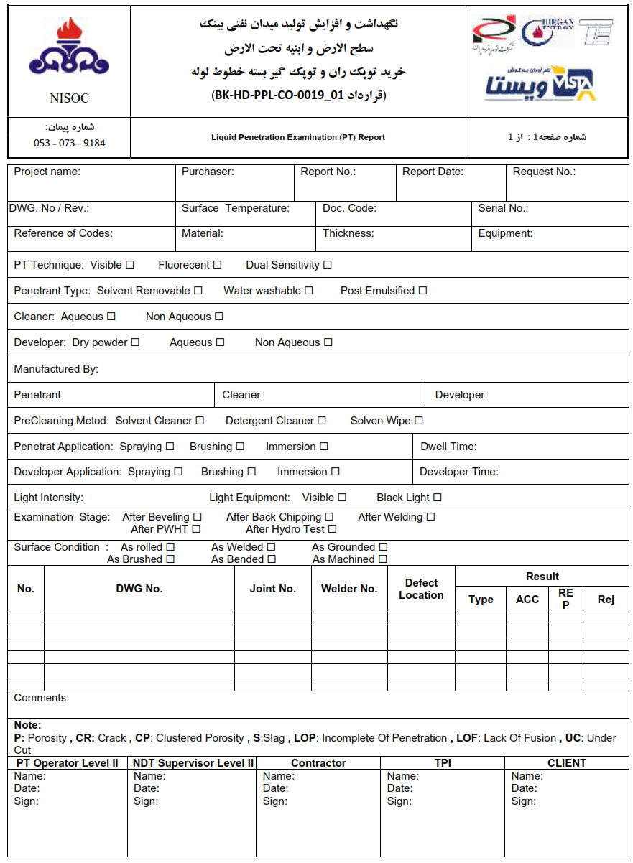

# Radiographic testing

This procedure covers the radiographic examination of carbon steel for stone trap and of the test coupon for welding operator and welder qualification.

The requirements not specifically described on this procedure shall comply with ASME Section V and the referencing Code Sections, (100% RT examination shall be considered for all butt welds).

## Reference

1. ASME Code Section VIII Div.1 and 2 (2010 Ed. Thru. 2011 Add.)
2. ASME Code Section V Art. 2 (2010 Ed. Thru. 2011 Add.)
3. ASME Code Section IX QW (2010 Ed. Thru. 2011 Add.)
4. Project specification: 9358-TYP-GEN-SPC-ME-007
5. IPS- M- PI-130

## Personnel Qualification

Personnel performing the nondestructive examination shall be qualified in accordance

With ISEC NDE Personnel Qualification and Certification Procedure, QMP-N01(IS),

Which meets the requirements of ASNT recommended practice No. SNT-TC-1A.

All engaged radiographers shall be qualified level II or III as per ASNT/SNT-TC-1A. All film interpretations shall be performed by level II or III examiners only. Level I may work under the direct supervision of Level II for radiography only.

## General

### Radiation

### X-radiation or gamma ray source such as lr-192 or Co-60 may be used as following

|  |  |  |  |
| --- | --- | --- | --- |
| **Radiation** | **Thickness Range (mm)** | **Film Type** | **Max. Source Size(mm)** |
| X-Ray  (300 Kvp Max.) | Up to 38 | Type-II or Better (Fine-grain) | 2.5 × 2.5 |
| Ir-192 | Up to 19 | Type-I or Better (Ultra-fine-grain) | 3.0 × 4.0 |
| Over 19~50 | Type-I or Better (Ultra-fine-grain) | 3.0 × 4.0 |
| Co-60 | Over 50~120 | Type-I or Better (Ultra-fine-grain) | 1. × 5.0 |

#### The maximum source size (effective focal spot size) and source to film distance shall be recorded in the report, and geometric un sharpness shall meet the requirements of para. 4.9.

#### Radiographic sources weaker than 6 Curie shall not be used.

#### For gamma ray's inspection, only ‘’ KODAK D7’’ film shall be used.

#### Fluorescent and flour-metallic films are not approved.

#### Before radiography, type of film & trade name, spire date shall be approved by client.

## Radiographic Film

Radiography shall be made using industrial radiographic film as described in para. 4.3.1.3.

Standard Guide for Controlling the Quality of industrial Radiographic Film Processing, SE-999, or paragraphs 23 through 26 of Standard Guide for Radiographic Examination SE-94 shall be used as a guide for processing film. The minimum length of film for spot radiography of piping shall be the lesser of one-half the pipe circumference or 250mm. The overlap of the beginning and end of each film should be 25 mm on each side.

## Intensifying Screens

Lead intensifying screen shall be used for both front and back side of the film.

## Scattered Radiation

To reduce back scattered radiation, back lead screen or back lead plate shall be placed in the film holder or behind the film holder.

For checking back scattered radiation, a lead symbol “B”, with minimum dimensions of 1/2 in. (13mm) in height and 1/16 in. (1.6mm) in thickness, shall be attached to the back of each film holder during exposure.

If a light image of the “B”, as described in para. 4.6.2, appears on a darker background of the radiograph, protection from backscatter is insufficient and the radiograph shall be considered unacceptable. A dark image of the “B” on a lighter background is not cause for rejection.

## System of Identification

A system shall be used to produce permanent identification on the radiograph traceable to the contract, component, and weld or weld seam, or part numbers, as appropriate. In addition, the Manufacturer’s symbol or name and the date of the radiograph shall be plainly and permanently included on the radiograph. This identification system does not necessarily require that the information appear as radiographic images. In any case, this information shall not obscure the area of interest.

## Radiographic Density

## Density Limitation

The density through the radiograph image of the body of the appropriate penetrameter and the area of interest shall be 1.8 minimum for radiographs made with an x-ray source and Gamma ray source for single film viewing. The maximum density shall be 3.0 for either single or composite viewing

## Quality of Film

All films shall be free from mechanical, chemical, or other blemishes to the extent that they shall not mask or be confused with the image of any discontinuity in the area of interest of the object being radio graphed.

Such blemishes shall include the following:

(1) Fogging.

(2) Processing defects such as streaks, water marks or chemical stains.

(3) Scratches, finger marks, crimps, dirtiness, static marks, smudges, or tears.

(4) Loss of detail due to poor screen to film contact.

(5) False indications due to defective screens or internal faults. These films shall be rejected and retaken where the occurrence interferes with interpretation in the area of interest.

## Density variation

If the density of the radiograph anywhere through the area of interest varies by more than minus 15% or plus 30% from the density through the body of the hole IQI or adjacent to the designated wire of a wire IQI, within the minimum/maximum allowable density range specified in para. 3.8.1, then an additional IQI shall be used for each exceptional area or areas and the radiograph retaken. When calculating the allowable variation in density, the calculation may be rounded to the nearest 0.1 within the range specified in para 3.8.1

When shims are used with hole-type IQIs, the plus 30% density restriction of para. 3.8.2 above may be exceeded. And the minimum density requirements of para. 3.8.1 do not apply for the IQI, provided the required IQI sensitivity of para. 4.13.1 is met.

## Monitoring Density Limitation of Radiograph

Densitometers shall be used for judging film density. Densitometers shall be calibrated using a step wedge comparison film at least every 90 days during use. The densitometer is acceptable if the density readings do not vary by more than ±0.05 density units from the actual density stated on the step wedge comparison film.

## Geometric Un sharpness Limitations

* + 1. **Geometric un sharpness of the radiograph shall not exceed the following;**

|  |  |
| --- | --- |
| Material Thickness in. (mm) | Ug. maximum in. (mm) |
| Under 2 (50.8) | 0.020 (0.51) |
| 2 through 3 (50.8 to 76.2) | 0.030 (0.76) |

Note: Material thickness is the thickness on which the IQI is based.

* + 1. **Geometric un sharpness of the radiograph shall be determined in accordance with;**

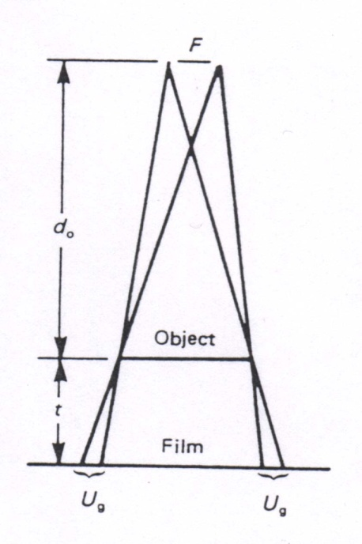 **Ug = F t / d0**

Where

**Ug** = geometric un sharpness,

**F** = source size: the maximum projected dimension

of the radiating source (or effective focal spot)

in the plane perpendicular to the distance D from

the weld or object being radiographed, in.

**d0** = distance from source of radiation to weld or

object being radiographed, in.

**t** = distance from source side of weld or object being radiographed to the film.

* + 1. **Minimum Source to Object Distance (D)**

The minimum source to object distance shall be met the requirement of the geometric un sharpness described in Para. 3.9.1.

* + 1. **Distance from Source Side of Object to the Film (d)**

The distance between the source side of the object and the film surface shall be as small as possible. if the film is not close to the object, the thickness of metal penetrated plus the gap thickness should be taken instead of specimen thickness described in para.4.9.2. Maximum distance from source side of object to the film shall be recorded in the examination report.

## Verification of Source Size

The equipment manufacturer's or supplier's publications, such as technical manuals. decay curves, or written statements documenting the actual or maximum source size or focal spot, shall be acceptable as source size verification.

When manufacturer's or supplier's publications are not available, source size may be determined in accordance with SE-1165 for X-ray machine, SE-1114 for lridium-192.

## Surface Preparation

* + 1. **Materials Including Castings**

Surfaces shall satisfy the requirements of the applicable materials specification or referencing Code Section, with additional conditioning, if necessary, by any suitable process to such a degree that the resulting radiographic image due to any surface irregularities cannot mask or be confused with the image of any discontinuity.

* + 1. **Welds**

The weld ripples or weld surface irregularities on both the inside (where accessible) and outside shall be removed by any suitable process to such a degree that the resulting radiographic image due to any surface irregularities cannot mask or be confused with the image of any discontinuity. The finished surface of all butt welded joints may be flush with the base material or may have reasonable uniform crowns, with reinforcement not to exceed that specified in the referencing Code Section.

## Image Quality Indicator

* + 1. **IQI Selection**

#### **Material**

IQIs shall be selected from either the same alloy material group or grade as identified in SE-1025, or SE-747, as applicable, or from an alloy material group or grade with less radiation absorption than the material being radiographed.

#### **Size**

The designated hole IQI or essential wire shall be as specified in Table 1. and Table 3 A thinner or thicker hole type IQI may be substituted for any section thickness listed in Table 1, provided an equivalent IQI sensitivity specified in para. 4.13.2 is maintained.

1. Welds with Reinforcements

The thickness on which the IQI is based is the nominal single wall thickness plus the estimated weld reinforcement not to exceed the maximum permitted by the referencing code section, backing rings or strips shall not be considered as part of the thickness in IQI selection. The actual measurement of the weld reinforcement is not required.

1. Welds Without Reinforcements

The thickness on which the IQI is based is the nominal single wall thickness. Backing rings or strips shall not be considered as part of the weld thickness in IQI selection.

* + 1. **Placement of IQIs**

#### **Source Side IQIs**

The IQI(s) shall be placed on the source side of the part being examined, except for the condition described in 4.11.2.2 When, due to part or weld configuration or size, it is not practical to place the IQI(s) on the part or weld, the IQI(s) may be placed on a separate block. Separate blocks shall be made of the same or radiographically similar materials (as defined in SE-1025) and may be used to facilitate IQI positioning. There is no restriction on the separate block thickness, provided the IQI / area of interest density tolerance requirements of 4.8.2 are met.

1. The IQI on the source side of the separate block shall be placed no closer to the film than the source side of the part being radiographed.
2. The separate block shall be placed as close as possible to the part being radiographed.
3. When hole type IQIs are used, the block dimensions shall exceed the IQI dimensions such that the outline of at least three sides of the IQI image shall be visible on the radiograph.

#### **Film Side IQI(s)**

Where inaccessibility prevents hand placing the IQI(s) on the source side, the IQI(s) shall be placed on the film side in contact with the part being examined. A lead letter “F” shall be placed adjacent to or on the IQI(s), but shall not mask the essential hole where hole IQIs are used.

#### **IQI Placement for Welds – Hole IQIs**

The IQI(s) may be placed adjacent to or on the weld. The identification number(s) and, when used, the lead letter “F”, shall not be in the area of interest, except when geometric configuration makes it impractical.

#### **IQI Placement for Welds – Wire IQIs**

The IQI(s) shall be placed on the weld so that the length of the wires is perpendicular to the length of the weld. The identification numbers and, lead letter “F”, when used, shall not be in the area of interest, except when geometric configuration makes it impractical.

#### **IQI Placement for Materials Other Than Welds**

The IQI(s) with the IQI identification number(s), and, when used, the lead letter “F”, may be placed in the area of interest.

* + 1. **Number of IQIs**

When one or more film holders are used for an exposure, at least one IQI image shall appear on each radiograph except as outlined in para. 4.11.3.2 below.

#### **Multiple IQIs**

If the requirements of para. 4.8.1 are met by using more than one IQI, one shall be representative of the lightest area of interest and the other the darkest area of interest; the intervening densities on the radiograph shall be considered as having acceptable density.

#### **Special Cases**

##### For cylindrical components where the source is placed on the axis of the component for a single exposure, at least three IQIs, spaced approximately 120 deg. apart, are required under the following conditions:

1. When the complete circumference is radiographed using one or more film holders, or;
2. When a section or sections of the circumference, where the length between the ends of the outermost sections span 240 or more deg., is radiographed using one or more film holders. Additional film locations may be required to obtain necessary IQI spacing.

##### For cylindrical components where the source is placed on the axis of the component for a single exposure, at least three IQIs, with one placed at each end of the span of the circumference radiographed and one in the approximate center of the span, are required under the following conditions:

1. When a section of the circumference, the length of which is greater than 120 deg. And less than 240 deg., if radiographed using just one film, holder, or;
2. When a section or sections of the circumference, there the length between the ends of the outermost sections span less than 240 deg., is radiographed using more than one film holder.

##### In 4.11.3.2.1 and 4.11.3.2.2 above, where sections of longitudinal welds adjoining the circumferential weld are radiographed simultaneously with the circumferential weld, an additional IQI shall be placed on each longitudinal weld at the end of the section most remote from the junction with the circumferential weld being radiographed.

##### For spherical components where the source is placed at the center of the component for a single exposure, at least three IQI, spaced approximately 120 deg. apart, are required under the following conditions:

1. When a complete circumference is radiographed using one or more film holders, or;
2. When section or sections of a circumference, where the length between the ends of the outermost sections span 240 or more deg., is radiographed using one or more film holders. Additional film locations may be required to obtain necessary IQI spacing.

##### For spherical components where the source is placed at the center of the component for a single exposure, at least three IQIs, with one placed at each end of the radiographed span of the circumference radiographed and one in the approximate center of the span, are required under the following conditions:

1. When a section of a circumference, the length of which is greater than 120 deg. and less than 240 deg., is radiographed using just one film holder, or;
2. When a section or sections of a circumference, where the length between the ends of the outermost sections span less than 240 deg. is radiographed using more than one film holder.

##### In 3.11.3.2.4 and 3.11.3.2.5 above, where other welds are radiographed simultaneously with the circumferential weld, one additional IQI shall be placed on each other weld.

##### When an array of components in a circle is radiographed, at least one IQI shall show on each component image.

##### In order to maintain the continuity of records involving subsequent exposures, all radiographs exhibiting IQIs that quality the techniques permitted in accordance with 4.11.3.2.1 through 4.11.3.2.3 shall be retained.

## Shims Under Hole IQIs

For welds, a shim of material radiographically similar to the weld metal shall be placed between the part and the IQI, if needed, so that the radiographic density throughout the area of interest is no more than minus 15% from (lighter than) the radiographic density through the IQI. The shim dimensions shall exceed the IQI dimensions such that the outline of at least three sides of the IQI image shall be visible in the radiograph.

## IQI Sensitivity

* + 1. **Required Sensitivity**

Radiography shall be performed with a technique of sufficient sensitivity to display the designated hole IQI image and the 2T hole, or the essential wire of a wire IQI. The radiographs shall also display the IQI identifying numbers and letters. If the designated hole IQI image and 2T hole, or essential wire, do not show on any film in a multiple film technique, but do show in composite film viewing, interpretation shall be permitted only by composite film viewing.

* + 1. **Equivalent Hole Type Sensitivity**

If a thinner or thicker hole type IQI than listed in Table 1 was substitute, an equivalent IQI sensitivity, as specified in Table 2, shall have been maintained as well as all other requirements for radiography having been met.

* + 1. **Location Markers**

Location marker (see Fig.1), which are to appear as radiographic images on the film, shall be placed on the part, not on the exposure holder/cassette. Their locations shall be permanently marked on the surface of the part being radiographed when permitted, or on a map, in a manner permitting the area of interest on a radiograph to be accurately traceable to its location on the part, for the required retention period of the radiograph. Evidence shall also be provided on the radiograph that the required coverage of the region being examined has been obtained. Location markers shall be placed as follows.

* + 1. **Single Wall Viewing**

#### **Source Side Markers**

Location markers shall be placed on the source side when radiographing the following:

1. Flat components or longitudinal joints in cylindrical or conical components;
2. Curved or spherical components whose concave side is toward the source and when the source to material distance is less than the inside radius of the component;
3. Curved or spherical components whose convex side is toward the source.

#### **Film Side Markers**

1. Location markers shall be placed on the film side when radiographing either curved or spherical components whose concave side is toward the source and when the source to material distance is greater than the inside radius.
2. As an alternate for source side placement in paragraph 3.14.1.1(1), location markers may be placed on the film side when the radiograph shows coverage beyond the location markers to the extent demonstrated by Figure 1(e) and when this alternate is documented in the record.

#### **Either Side Markers**

Location markers may be placed on either the source side or film side when radiographing either curved or spherical components whose concave side is toward the source and the source to material distance equals the inside of the component.

* + 1. **Double Wall Viewing**

For double wall viewing, at least one location marker shall be placed adjacent to the weld (or on the material in the area of interest) for each radiograph.

## Radiographic Technique

A Single wall exposure technique shall be used for radiography whenever practical.

When it is not practical to use a single wall technique, a double wall technique shall be used. An adequate number of exposures shall be made to demonstrate that the required coverage has been obtained.

* + 1. **Single Wall Technique**

In the single wall technique, the radiation passes through only one wall of the weld (material), which is viewed for acceptance on the radiograph.

* + 1. **Double Wall Technique**

When it is not practical to use a single wall technique, one of the following double wall techniques shall be used.

* + 1. **Single Wall viewing**

For materials and for welds in components, a technique may be used in which the radiation passes through two walls and only the weld (material) on the film side wall is viewed for acceptance on the radiograph. When complete coverage is required for circumferential welds (materials), a minimum of three exposures taken 120 deg. To each other shall be made.

* + 1. **Double Wall Viewing**

For materials and for welds in components 3-1/2 in. (89mm) or less in nominal outside diameter, a technique may be used in which the radiation passes through two walls and the weld (material) in both walls is viewed for acceptance on the same radiograph. For double wall viewing, only a source side IQI shall be used. Care should be exercised to ensure that the required geometric un sharpness is not exceeded. If the geometric un sharpness requirement cannot be met, then single wall viewing shall be used.

1. For welds, the radiation beam may be offset the plane of the weld at an angle sufficient to separate the images of the source side and film side portions of the weld so that there is no overlap of the areas to be interpreted. When complete coverage is required, a minimum of two exposures taken 90 deg. to each other shall be made for each joint.
2. As an alternative, the weld may be radiographed with the radiation beam positioned so that the image of both walls are superimposed. When complete coverage is required, a minimum of three exposures taken at either 60 deg. or 120 deg. to each other shall be made for each joint.
3. Additional exposures shall be made if the required radiographic coverage cannot be obtained using the minimum number of exposures indicated in (1) or (2) above.
4. Equipment requirement (same density meter with calibration certificate and etc.) shall be as per standard.

## Acceptance Standards

* + 1. **Spot Radiography**

Welds in which the radiograph shows any of the following types of indications are unacceptable:

1. Any type of crack, or zone of incomplete fusion or penetration.
2. Slag inclusions or cavities, if the length of any such imperfection is greater than 2/3T where T is the thickness of the weld excluding any allowable reinforcement. For a butt weld joining two members having different thicknesses at the weld, T is the thinner of those two thicknesses. If a full penetration weld includes a fillet weld, the thickness of the throat of the fillet shall be included in T. If several indications within the above limitations exist in line, the welds shall be judged acceptable if the sum of the longest dimensions of all such indications is not mare than T in a length of 6T (or proportionately for radiographs shorter than 6T) and if the longest indications considered are separated by at least 3L of acceptable weld metal, where L is the length of the longest indication. The maximum length of acceptable indications shall be 3/4 in. (19 mm).

Any such indications shorter than 1/4 in. (6mm) shall be acceptable for any plate thickness.

1. Round indications are not a factor in the acceptability of welds not required to be fully radiographed.
   * 1. **Full Radiography**

Indications shown on the radiographs of welds and characterized as imperfections are unacceptable under the following conditions.

1. Any indication characterized as a crack or zone of incomplete fusion or penetration;
2. Any other elongated indication which has a length greater than;
3. 1/4 in. (6mm) for t up 3/4 in. (19mm), inclusive.
4. 1/3t for t from 3/4 in. (19mm) to 2-1/4in. (57mm) inclusive
5. 3/4 in. (19mm) for t over 2-1/4 in. (57mm)

*Where t is the thickness of the thinner portion of the weld.

1. Rounded indications in excess of that shown by the acceptance standards given in Appendix 4 of Section VIII Div. 1, Appendix 8 of Section VIII Div.2, and Appendix A-250 of ASME Section 1.
   * 1. Acceptance Standards for Weld Metal Soundness Test
2. When evaluating the radiograph, a 1 in. (25mm) length on each end of the test welds shall be disregarded.
3. The radiographs shall not indicate any discontinuity in excess of that allowed by ASME Code Section II Part C.
   * 1. Acceptance Standard for Welding Operator and Welder Qualification

Welder and welding operator performance tests by radiography of welds in test assemblies shall be judged unacceptable when the radiograph exhibits imperfections in excess of the those allowed by ASME Code Section IX QW-191.2.

## Radiation Safety

* + 1. Personnel performing radiographic examination shall be trained by the radiological officer’s license holder.
    2. Safe practice shall apply as outlined in the Company’s regulations.

## Records

The results shall be recorded by the certified personnel who perform the radiographic examination.

Requirements of IPS standards must be met for archiving of records.

If there are repair points, after first repair, RT should be done 25% and after second time, RT100% should be performed for repaired weld line.

Table 1. I.Q.I Selection

|  |  |  |  |  |  |  |
| --- | --- | --- | --- | --- | --- | --- |
|  |  | | IQI | | | |
|  | | | Source Side | | Film Side | |
| Nominal Single-Wall | | |
| Material Thickness Range | | | Hole-Type | Wire-Type | Hole-Type | Wire-Type |
| In. | | mm | Designation | Essential Wire | Designation | Essential Wire |
| Up to 0.25, Incl. | | Up to 6.4, Incl. | 12 | 5 | 10 | 4 |
| Over 0.25 through 0.375 | | Over 6.4 through 9.5 | 15 | 6 | 12 | 5 |
| Over 0.375 through 0.50 | | Over 9.5 through 12.7 | 17 | 7 | 15 | 6 |
| Over 0.50 through 0.75 | | Over 12.7 through 19.0 | 20 | 8 | 17 | 7 |
| Over 0.75 through 1.00 | | Over 19.0 through 25.4 | 25 | 9 | 20 | 8 |
| Over 1.00 through 1.50 | | Over 25.4 through 38.1 | 30 | 10 | 25 | 9 |
| Over 1.50 through 2.00 | | Over 38.1 through 50.8 | 35 | 11 | 30 | 10 |
| Over 2.00 through 2.50 | | Over 50.8 through 63.5 | 40 | 12 | 35 | 11 |
| Over 2.50 through 4.00 | | Over 63.5 through 101.6 | 50 | 13 | 40 | 12 |
| Over 4.00 through 6.00 | | Over 101.6 through 152.4 | 60 | 14 | 50 | 13 |
| Over 6.00 through 8.00 | | Over 152.4 through 203.2 | 80 | 16 | 60 | 14 |
| Over 8.00 through 10.00 | | Over 203.2 through 254.0 | 100 | 17 | 80 | 16 |
| Over 10.00 through 12.00 | | Over 254.0 through 304.8 | 120 | 18 | 100 | 17 |
| Over 12.00 through 16.00 | | Over 304.8 through 406.4 | 160 | 20 | 120 | 18 |
| Over 16.00 through 20.00 | | Over 406.4 through 508.0 | 200 | 21 | 160 | 20 |

Table 2. Equivalent Hole-Type IQI Sensitivity

|  |  |  |
| --- | --- | --- |
| Hole-type  Designation  2 T Hole | Equivalent Hole-Type Designations | |
| 1T Hole | 4T Hole |
|
| 10 | 15 | 5 |
| 12 | 17 | 7 |
| 15 | 20 | 10 |
| 17 | 25 | 12 |
| 20 | 30 | 15 |
| 25 | 35 | 17 |
| 30 | 40 | 20 |
| 35 | 50 | 25 |
| 40 | 60 | 30 |
| 50 | 70 | 35 |
| 60 | 80 | 40 |
| 80 | 120 | 60 |
| 100 | 140 | 70 |
| 120 | 160 | 80 |
| 160 | 240 | 120 |
| 200 | 280 | 140 |

Table 3. Wire IQI Designation. Wire Diameter and Wire Identity

|  |  |  |  |  |  |
| --- | --- | --- | --- | --- | --- |
| Set A | | | Set B | | |
| Wire  Diameter, in. | (mm) | Wire  Identity | Wire  Diameter, in. | (mm) | Wire  Identity |
| 0.0032 | (0.08) | 1 | 0.010 | (0.25) | 6 |
| 0.004 | (0.01) | 2 | 0.013 | (0.33) | 7 |
| 0.005 | (0.13) | 3 | 0.016 | (0.41) | 8 |
| 0.0063 | (0.16) | 4 | 0.020 | (0.51) | 9 |
| 0.008 | (0.20) | 5 | 0.025 | (0.64) | 10 |
| 0.010 | (0.25) | 6 | 0.032 | (0.81) | 11 |
| Set C | | | Set D | | |
| Wire  Diameter, in. | (mm) | Wire  Identity | Wire  Diameter, in. | (mm) | Wire  Identity |
| 0.032 | (0.81) | 11 | 0.100 | (2.54) | 16 |
| 0.040 | (1.02) | 12 | 0.126 | (3.20) | 17 |
| 0.050 | (1.27) | 13 | 0.160 | (4.06) | 18 |
| 0.063 | (1.60) | 14 | 0.200 | (5.08) | 19 |
| 0.080 | (2.03) | 15 | 0.250 | (6.35) | 20 |
| 0.100 | (2.54) | 16 | 0.320 | (8.13) | 21 |







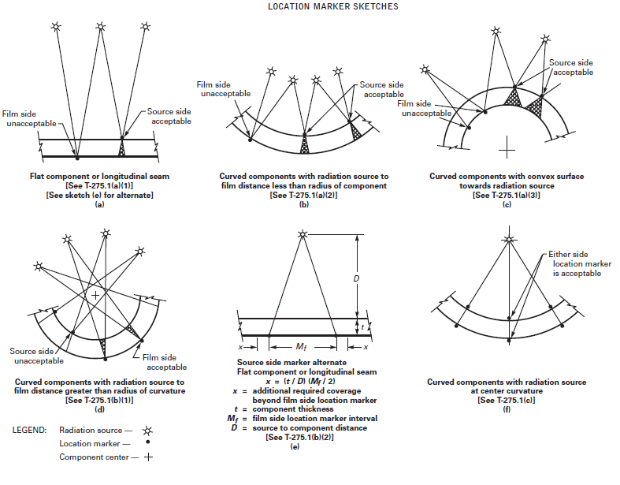

## Reporting

In addition to the items listed under 1.10 Final Report, the following have to be included in the radiographic testing report:

— radiographic technique and class

— type and position of image quality indicator

— source to film distance and exposure time

— geometric un-sharpness

— sensitivity

— density

— film, screens and filter

— source type, focus dimension, source activity, used tube voltage and current

— film processing technique: manual or automatic.

## Appendix-2 Radiographic Examination Report Sample

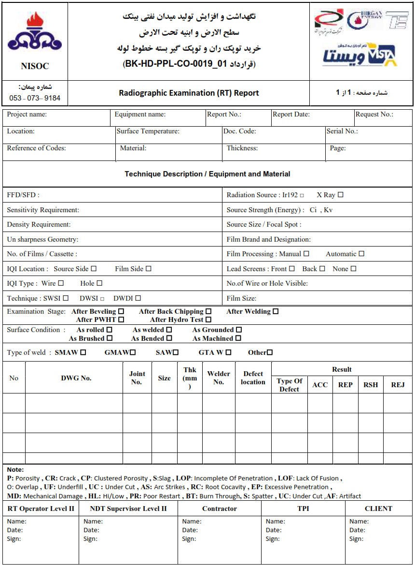

# Ultrasonic testing

## Scope

* + 1. This procedure covers both angle and straight beam technique with contact method of the ultrasonic examination of ferritic steel materials and weld metals for pressure vessel equipment.
    2. This procedure is provided for evaluating ultrasonic reflectors within the welds, heat affected zone, and adjacent material of full penetration welds in wrought and cast materials.
    3. The requirements not specifically described on this procedure shall comply with ASME SEC.V and the referencing Code Sections.
    4. For proper examination before starting any ultrasonic examination of a welded joint, the ultrasonic operator shall have the following essential information:

1. Material spec. & grade.
2. Type of groove / joint configuration for welds.
3. Thickness dimension and product form (plate, forging, etc.)
4. Type of welding process and, if possible, process data.

## Reference

1. ASME Code Section VIII Div. 1 (2010 Ed. Thru. 2011 Add.)
2. ASME Code Section V Art. 4 (2010 Ed. Thru. 2011 Add.)

## Personnel Qualification

Personnel performing the nondestructive examination shall be qualified in accordance with SNT-TC-1A.

## General

### Examination Coverage

The volume to be scanned shall be examined by moving the search unit over the examination surface so as to scan the entire examination volume for each required search unit. Each pass of the search unit shall overlap a minimum of 10% of the active transducer dimension perpendicular to the direction of the scan.

### Rate of Search Unit Movement

The rate of search unit movement shall not exceed 6 in. (150mm) per second.

### Scanning Sensitivity

Scanning shall be performed at a gain setting at least two times (+6 dB) the reference level, which is the primary reference response corrected for distance by the DAC curve.

### Equipment

* + - 1. A pulse-echo type of ultrasonic instrument shall be used as following Table. The instrument shall be capable of operation at frequencies over the range of at least 1 MHz to 5 MHz and shall be equipped with a stepped gain control in units of 2 dB or less.

|  |  |  |
| --- | --- | --- |
| Instrument Type | Model | Marker |
| Manual | CTS-9009 | SIUI |

* + - 1. Search Units

The search unit shall be selected according to the following tables;

1. Straight beam

|  |  |  |  |  |  |
| --- | --- | --- | --- | --- | --- |
| Material  Thickness (mm) | Type | Element  Size (φ) | Freq.  (MHz) | Angle in  Material | Wave Mode |
| 25.4 or less | MB4S | 10 | 4 | 0˚ | Longitudinal |
| Over 25.4 | B2S | 24 | 2 | 0˚ | Longitudinal |

1. Angle beam

|  |  |  |  |  |  |
| --- | --- | --- | --- | --- | --- |
| Material  Thickness (mm) | Type | Element  Size (φ) | Freq.  (MHz) | Angle in  Material | Wave Mode |
| 40 or less | MWB60-4  MWB70-4 | 8 x 9 | 4 | 60˚,70˚ | Transverse |
| Over 40 | MWB45-2  MWB60-2  MWB70-2 | 8 x 9 | 2 | 45˚,60˚or  45˚,70˚ | Transverse |

■ Note: Other frequencies of angles of search units may be used to assure adequate penetration or better resolution.

* + - 1. The equipment must be certified by qualify unit.
      2. Couplant
      3. A suitable liquid couplant such as reagent grade glycerin (Purity: 94% min.) or C.M.C (Carboxyl Methyl Cellulose Sodium) solution shall be used to couple search units to the surface being scanned.
      4. Couplants used on nickel base alloys shall not contain more than 250 ppm of sulfur.
      5. Couplants used on austenitic stainless steel or titanium shall not contain more than 250 ppm of halides (chlorides plus fluorides)
      6. Couplants materials used for examination shall be the same as used for the Calibration.
      7. Surface Preparation
      8. Base Metal
      9. The base metal on each side of the weld shall be free of weld spatter, surface irregularities, or foreign matter that might interfere with the examination.
      10. Weld Metal
      11. Where the weld surface interferes with the examination, it shall be prepared for the permission of the examination by grinding or suitable method.

## Instrument Calibration

4.5.1. The ultrasonic instrument shall be checked periodically for screen height linearity and the amplitude control linearity in accordance with applicable calibration procedure.

4.5.2. ultrasonic instruments shall be certified by qualify unit.

## System Calibration

### Basic Calibration Block

The basic calibration reflectors shall be used to establish a primary reference response of the equipment and to construct a distance correction curve.

* + 1. Block Materials

The material from which the block is fabricated shall be of the same product form, and material specification of equivalent P-number grouping as one of the material being examined. For the purpose of this paragraph, P-Nos. 1, 3, 4, and 5 materials are considered equivalent.

* + 1. Non-Piping Calibration Blocks
  1. Basic Calibration Block

The basic calibration block configuration and reflectors shall be as shown in Fig. 1. The block size and reflector locations shall be adequate to perform calibrations for the beam angles used.

* 1. Block Thickness

When two or more base material thicknesses are involved, the calibration block thickness shall be determined by the average thickness of the weld.

* 1. Block Range of Use

When the block thickness ±1 in. (25mm) spans two weld thickness ranges as shown in Fig. 1, the block’s use shall be acceptable in those portions of each thickness range covered by 1 in. (25mm).

* + 1. Piping Calibration Blocks

The basic calibration block configuration and reflectors shall be as shown in Fig. 2. The basic calibration block shall be a section of pipe of the same nominal size and schedule. The block size and reflector locations shall be adequate to perform calibration for the beam angles used.

* + 1. Block Curvature (Except for Piping)
  1. Materials with Diameters Greater Than 20 in. (508mm)

For examinations in materials where the examination surface diameter is equal to or less than 20 in. (508mm), a curved block shall be used. A single curved basic calibration block may be used for examinations in the range of curvature from 0.9 to 1.5 times the basic calibration block diameter

## Calibration for Examination

* + 1. **Straight Beam Method**

1. **Calibration for Base Metal Examination**
2. **Sweep Range Calibration**

The horizontal sweep range shall be adjusted for distance calibration to present the equivalent of at least two plate thicknesses on the CRT/LCD screen.

1. **Reference Sensitivity Calibration**

The reference level shall be adjusted from the first back wall echo to 80% ±5% of full screen height. (76~84% of FSH).

1. **Calibration for Weld Examination**

For weld examination with straight beam probes, distance range calibration and reference sensitivity calibration shall be as for angle beam method. (Construction of DAC based on proper selection of side-drilled hole from the reference block.

* + 1. **Angle Beam Method**

1. **Sweep Range Calibration**

Horizontal sweep range calibration shall include as a minimum the entire sound path distance to be used during the specific testing by using the llw block. The minimum sound path distance shall be calculated based upon one full skip distance with a maximum probe angle to be used. In all cases the distance range shall be sufficient to ensure coverage of the through member for all weld joints.

1. **Standard Sensitivity Level**

Standard sensitivity for testing of production welds shall be the basic sensitivity level corrected for distance by a Distance-Amplitude-Correction Curve established with the reference block and modified by transfer correction.

1. **Basic sensitivity Level**

Reference level screen height shall be obtained using maximum reflection from the side drilled holes in the reference block as described in paragraph 5.6.1 of this procedure. The amplitude shall be adjusted to 80% ±5% of full screen height. (76~84% of FSH)

1. **Distance Amplitude Correction (DAC)**

The reference level shall be adjusted to provide for attenuation loss throughout the range of sound path to be used, by three-point distance amplitude correction (DAC) curve. The block configuration shall be used and curves which are 100%, 50% and 20% of reference curve are to be constructed. (Described para.5.7 of this procedure)

1. **Notch Indication**

Position the search unit for maximum amplitude from the notch on the opposite surface. Mark the peak of the indication with an “X” on the screen.

* + 1. **Transfer Correction**

1. The reference level shall be adjusted to compensate for the differences in surface character and attenuation between the reference block and the material being tested, by means of the double probe technique.
2. A transfer correction shall be performed and recorded once for each separate angle that will be used for the examination (45˚, 60˚, 70˚).
3. Calibration surfaces shall closely match that of the test surface to minimize corrections required.

## Calibration Confirmation

* + 1. **System Changes**

When any part of the examination system is changed, a calibration check shall be made on the basic calibration block to verify that distance range points and sensitivity setting(s).

* + 1. **Periodic Examination Checks**

A calibration checks on at least one of the basic reflectors in the basic calibration block or a check using a simulator shall be made at the finish of each examination or series of similar examinations, every 4 hr. during the examination, and when examination personnel are changed.

* + 1. **Confirmation Acceptance Values**
       1. **Distance Range Points**

If any distance range point has moved on the sweep line by more than 10% of the distance reading or 5% of full sweep, whichever is greater, correct the distance range calibration and note the correction in the examination record. All recorded indications since the last valid calibration or calibration check shall be reexamined and their values shall be changed on the data sheets or recorded.

* 1. **Sensitivity Settings**

If any sensitivity setting has changed by more than 20% or 2 dB of its amplitude, correct the sensitivity calibration and note the correction in the examination record. If the sensitivity setting has decreased, all data sheets since the last valid calibration check shall be marked void and the area covered by the voided data shall be reexamined. If the sensitivity setting has increased, all recorded indications since the last valid calibration or calibration check shall be reexamined and their values shall be changed on the data sheets or re-recorded.

## Scanning

* + 1. Scanning Extent

Any imperfection which considered as the indication during scanning shall be investigated to the all the direction of the weld in other that it can be evaluated by operator.

* + 1. Straight Beam Scanning
    2. When the straight beam scanning of weld is required, the weld and base metal shall be scanned to the extent possible with the straight beam search unit.
    3. Before performing the angle beam examinations, a straight beam examination shall be performed on the volume of base material through which the angle beams will travel to locate any reflectors that can limit the ability of the angle beam to examine the weld volume.

## Angle Beam Scanning

* + 1. **Beam Angle**

The search unit and beam angle selected shall be appropriate for the configuration being examined and shall be capable of detecting the calibration reflectors, over the required angle beam path.

* + 1. **Reflectors Parallel to the Weld Seam.**

The angle beam shall be directed at approximate right angles to the weld axis from both sides of the weld (i.e., from two directions) on the same surface when possible. The search unit shall be manipulated so that the ultrasonic energy passes through the required volume of weld and adjacent base material.

* + 1. **Reflectors Transverse to the Weld Seam.**

The angle beam shall be directed essentially parallel to the weld axis. The search unit shall be manipulated so that the ultrasonic energy passes through the required volume of weld and adjacent base material. The search unit shall be rotated 180 deg and the examination repeated.

* + 1. **Restricted Access Welds**

Welds that cannot be fully examined from two directions using the angle beam technique (e.g., corner and tee joint) shall also be examined, if possible, with a straight beam technique. These areas of restricted access shall be noted in the examination report.

## Evaluation

* + 1. All indications which produce a response greater than 20% of the reference level shall be investigated to the extent that the operator can determine the shape, identity, and location of all such reflectors and them in terms of the acceptance standards given in para.5.13.
    2. In addition, all indications which produce a response greater than 50% of the reference level shall be recorded.
    3. The indicated defect length (sizing) shall be determined by locating the points at each end at which the echo height drops minus (-) 6dB, and measuring between the points from the center of the probe at one end to the center of the probe at the other end.

## Post-examination Cleaning

Post-examination cleaning is necessary in those cases where residual couplant or foreign material could interfere with subsequent processing or with service requirements. Those residual materials shall be completely removed by water rinse or other suitable technique.

## Acceptance standards

ASME Sec. VIII Div.1 APPENDIX 12, SEC.I PW-52.

All imperfections which produce a response greater than 20% of the reference level shall be investigated to the extent that the operator can determine the sharp, identity, and location of all such imperfections and evaluate them in terms of the acceptance standards given in para.5.13.1 and 5.13.2 below.

* + 1. Indications characterized as cracks, lack of fusion, or incomplete penetration are unacceptable regardless of length.
    2. Other imperfections are unacceptable if the indications exceed the reference level amplitude and have lengths exceed;

1. 1/4 in. (6mm) for t up to 3/4 in. (19mm) inclusive
2. 1/3 t for t from 3/4 in. (19mm) to 2-1/4 in. (57mm) inclusive
3. 3/4 in. (19㎜) for t over 2-1/4 in. (57㎜).

Where t is the thickness of the weld excluding any allowable reinforcement. For a butt weld joining two members having different thicknesses at the weld, t is the thinner of these two thicknesses. If a full penetration weld includes a fillet weld, the thickness of the throat of the fillet shall be included in t.

## Records

Ultrasonic examination results shall be recorded by certified personnel who performs the ultrasonic examination.

|  |  |  |  |  |
| --- | --- | --- | --- | --- |
|  | Calibration Block | Hole |  | Notch Dimensions  In. (mm) |
| Weld Thickness (t) | Thickness (T) in. | Diameter |  |
| In. (mm) | (mm) | In. (mm) |  | Notch Depth = 2 % T  Notch Width = 1/4 (6.4) max. |
| Up to 1 (25) | 3/4 (19) or t | 3/32 (2.4) |  |
| Over 1 (25) through 2 (51) | 1 1/2 (38) or t | 1/8 (3.2) |  | Notch Length = 1 (25) min. |
| Over 1 (51) through 2 (102) | 3 (76) or t | 3/16 (4.8) |  |
| Over 4 (102) | T ± 1 (25) | ** |  |  |

** For each increase in weld thickness of 2 in. (51 mm), or fraction thereof over 4 in. (102 mm), the hole diameter shall increase 1/16 in. (1.6 mm).

GENERAL NOTES:

(a) Holes shall be drilled and reamed 1.5 in. (38 mm) deep minimum, essentially parallel to the examination surface.

(b) For curved surfaces, two sets of calibration reflectors (holes, notches) oriented 90 deg from each other shall be used. Alternatively, two curved calibration blocks may be used.

(c) The tolerance for hole diameter shall be ± 1/32 in. (0.8 mm). The tolerance for hole location through the calibration block thickness (i.e., distance from the examination surface) shall be ±1/8 in. (3.2 mm).

(d) All three holes may be located on the same face (side) of the calibration block provided care is exercised to locate the holes far enough apart to prevent one hole from masking the indication of another hole during calibration.

(e) Minimum notch depth shall be 1.6% T and maximum notch depth shall be 2.2% T plus the thickness of cladding, if present.

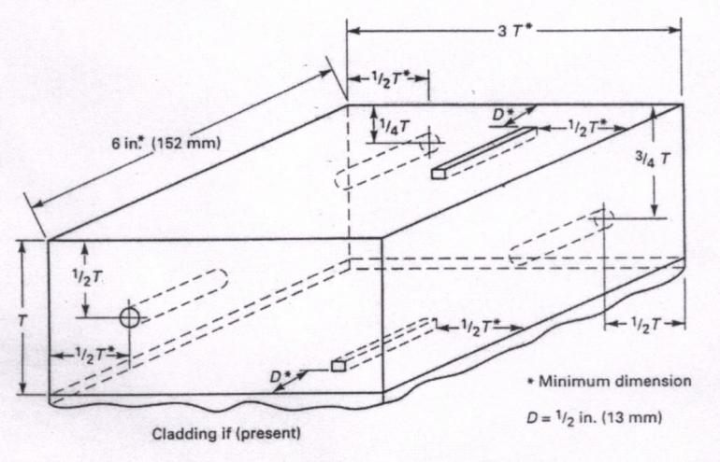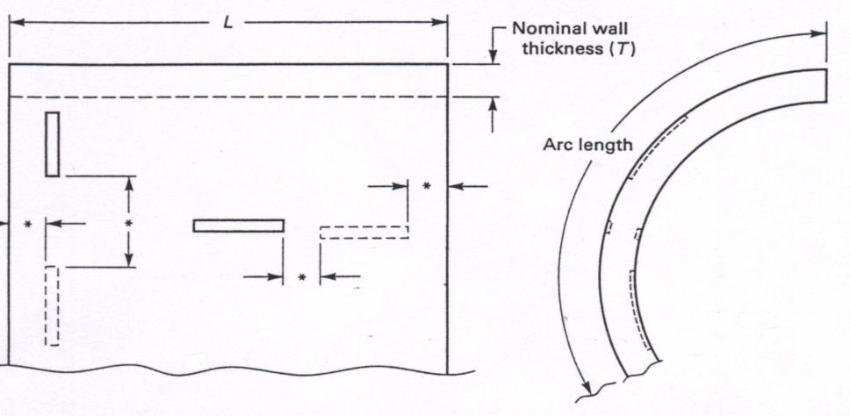

Fig.1 Non-Piping Calibration Blocks (T-434.2.1 of ASME Sec. Ⅴ)

* Notches shall be located not closer than T or 1 in. (25 mm), whichever is greater, to any block edge or to other notches.

GENERAL NOTES:

(a) The minimum calibration block length (L) shall be 8 in. (203 mm) or 8T, whichever is greater.

(b) For OD 4 in. (102 mm) or less, the minimum arc length shall be 270 deg. For OD greater than 4 in. (102 mm), the minimum arc length shall be 8 in. (203 mm) or 3T, whichever is greater.

(c) Notch depths shall be from 8% T minimum to 11% T maximum. Notch widths shall be 1/4 in. (6.4 mm) maximum. Notch lengths shall be 1 in. (25 mm) minimum.

Fig. 2. Calibration for Pipe (T-434.3 of ASME Sec. V)

## Report

In addition to the items listed under 1.10 Final Report, the following have to be included in the radiographic testing report:

— Ultrasonic technique— type and position of image quality indicator

— Equipment

— Type of couplant

— Sensitivity

— Frequency

## Appendix-3 Ultrasonic Examination Report Sample

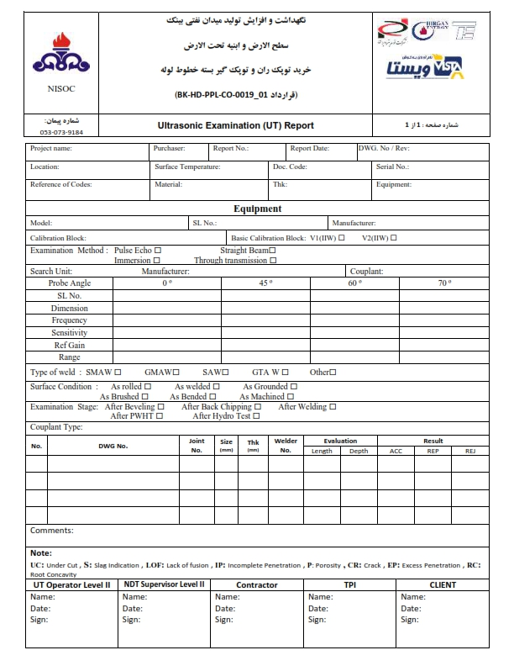

# Visual Inspection

## Scope

This part specifies visual testing of fusion welds in metallic materials.

The testing is to be performed in the as-welded condition including testing of repaired welds.

## REFERENCE

ASME Sec. V, and Sec. VIII Division (last revision).

Personnel qualifications

Personnel performing visual inspection shall be qualified and certified to an appropriate level in accordance with SNT-TC-1A.

Responsibility is with Vista Company.

## Equipment

The following equipment may be needed:

— for visual testing of welds with limited accessibility; mirrors, endoscopes, borescopes, fiber optics or TV cameras.

— magnifying lens

— radius gauge

— various set of weld gauges for measuring fillet welds, reinforcement, undercuts, misalignment etc.

— light source.

## TECHNIQUE

Direct visual examination shall be used.

If required, mirrors and magnifying lenses will be used to improve the angle of vision and to assist

examination.

The minimum light intensity at the examination surface will be 1000 Lux.

### 5.4.1. Preparation of surfaces

The weld surface shall be free of weld spatter, slag, scale, oil, grease, heavy and loose paint or other surface irregularities which might avoid imperfections from being obscured.

It can be necessary to improve the surface conditions e.g., by abrasive paper or local grinding to permit accurate interpretation of indications.

## SURFACE CONDITION

5.5.1 Surface prepared by gas cutting or arc cutting for welding shall be uniform and smooth and shall be free of all loose scale and slag accumulations.

5.5.2. The surface to be welded shall be clean and free of scale, rust, oil, grease, slag, detrimental oxides and other deleterious foreign materials.

5.5.3. As welded surfaces are permitted. However, the surface of the welds shall be sufficiently free from coarse ripples, grooves, overlaps, abrupt ridges and valleys.

5.5.4. The surfaces of the finished welds shall be suitable to permit proper interpretation of radiographic and

other required nondestructive examination.

5.5.5. The surface of the fillet weld shall merge smoothly with the surfaces joined.

## METHOD OF EXAMINATION

1. The material specification and dimensions shall be verified based on applicable drawing.
2. Edge preparation and weld fit up ·shall be verified with respect to the applicable drawing & WPS.
3. Fit up alignment shall be verified using steel rules and spirit level.
4. Groove angle and root gap shall be verified using templates.
5. Employment of qualified welder and usage of correct welding consumables shall be verified with 'List of Qualified Welders' and WPS.
6. Weld surface(s) shall be verified for the finish and cleanliness.
7. Fillet welds shall be verified using fillet gauges.
8. Cleanliness of Inside bore shall be inspected using hand lamp or Torch light.

## ACCEPTANCE STANDARD OF BUTT WELDS

* Cracks, Pin holes and lack of fusion are not acceptable
* Alignment tolerance shall not exceed the value given in Table-I. below.

TABLE -I Alignment Tolerance

|  |  |  |
| --- | --- | --- |
| Section Thickness (mm) | Joint Categories | |
| A | B, C and D |
| Up to 13.0 inch. | 1/4t | 1/4t |
| Over 13.0 to 19.0 inch. | 3.2mm | 1/4t |
| Over 19.0 to 38.0 inch. | 3.2mm | 4.8mm |
| Over 38.0 to 51.0 inch. | 3.2mm | 1/8t |
| Over 51.0 | Lesser of 1/16t lesser of or 10mm | 1/8t or 19mm |
| 't' is the nominal thickness of the thinner section at the joint | | |

* The reduction in thickness shall not reduce the material of the adjoining surfaces below the minimum required thickness at any point.
* The reduction in thickness shall not exceed 0.8 mm or 10% of the nominal thickness of the adjoining surface, whichever is less.
* Concavity due to the welding process on the root side of a single welded circumferential butt weld is permitted, when the resulting thickness of the weld is at least equal to the thickness of the thinner member of the two sections being joined and the contour of the concavity is smooth.
* The Thickness of the weld reinforcement on each face shall not exceed the value given in Table II.

TABLE –II Thickness of weld reinforcement

|  |  |  |
| --- | --- | --- |
| Maximum Reinforcement (mm)Material Nominal Thickness Butt welds |  |  |
| Categories B & C | Other Welds |
| Less than 2.4 | 2.4 | 0.8 |
| 2.4 to 4.8, incl. | 3.2 | 1.6 |
| Over 4.8 to 13.0, incl. | 4.0 | 2.4 |
| Over 13.0 to 25.0, incl. | 4.8 | 2.4 |

## ACCEPTANCE STANDARD FOR FILLET WELDS

1. Fillet welds shall meet the requirements of applicable drawing.
2. The reduction of the thickness of the base metal due to the welding process at the edges of the fillet weld shall be as per CI. 6.9.3 and 6.9.4

## PERSONNEL QUALIFICATION

Examination shall be conducted by personnel trained and qualified to carry out visual examination.

## Appendix-4 Visual Inspection Report Sample

## Appendix-5-Dimensional Check Report Sample

