|  |  |  |  |  |  |  |
| --- | --- | --- | --- | --- | --- | --- |
| **طرح نگهداشت و افزایش تولید 27 مخزن** | | | | | | |
|  |  |  |  |  |  |  |
|  |  |  |  |  |  |  |
|  |  |  |  |  |  |  |
|  |  |  |  |  |  |  |
| V00 | Aug.2023 | IFR | Beh Koosh Vista | M.Fakharian | A.M.Mohseni |  |
| **Rev.** | **Date** | **Purpose of Issue/Status** | **Prepared by:** | **Checked by:** | **Approved by:** | **CLIENT Approval** |
| **Class:** | |  | | | | |
| **Status:** | |  | | --- | | **IFA: Issued for Approval**  **IFR: Issued for Review**  **IFI: Issued for Information**  **AFC: Approved for Construction** | | | | | | |

# Revision Record Sheet

|  |  |  |  |  |  |  |  |  |
| --- | --- | --- | --- | --- | --- | --- | --- | --- |
| **PAGE** | **V00** | **V01** | **V02** | **V03** | **V04** | **V05** | **V06** | **V07** |
| 1 | X |  |  |  |  |  |  |  |
| 2 | X |  |  |  |  |  |  |  |
| 3 | X |  |  |  |  |  |  |  |
| 4 | X |  |  |  |  |  |  |  |
| 5 | X |  |  |  |  |  |  |  |
| 6 | X |  |  |  |  |  |  |  |
| 7 | X |  |  |  |  |  |  |  |
| 8 | X |  |  |  |  |  |  |  |
| 9 | X |  |  |  |  |  |  |  |
| 10 | X |  |  |  |  |  |  |  |
| 11 |  |  |  |  |  |  |  |  |
| 12 |  |  |  |  |  |  |  |  |
| 13 |  |  |  |  |  |  |  |  |
| 14 |  |  |  |  |  |  |  |  |
| 15 |  |  |  |  |  |  |  |  |
| 16 |  |  |  |  |  |  |  |  |
| 17 |  |  |  |  |  |  |  |  |
| 18 |  |  |  |  |  |  |  |  |
| 19 |  |  |  |  |  |  |  |  |
| 20 |  |  |  |  |  |  |  |  |
| 21 |  |  |  |  |  |  |  |  |
| 22 |  |  |  |  |  |  |  |  |
| 23 |  |  |  |  |  |  |  |  |
| 24 |  |  |  |  |  |  |  |  |
| 25 |  |  |  |  |  |  |  |  |
| 26 |  |  |  |  |  |  |  |  |
| 27 |  |  |  |  |  |  |  |  |
| 28 |  |  |  |  |  |  |  |  |
| 29 |  |  |  |  |  |  |  |  |
| 30 |  |  |  |  |  |  |  |  |
| 31 |  |  |  |  |  |  |  |  |
| 32 |  |  |  |  |  |  |  |  |
| 33 |  |  |  |  |  |  |  |  |
| 34 |  |  |  |  |  |  |  |  |
| 35 |  |  |  |  |  |  |  |  |
| 36 |  |  |  |  |  |  |  |  |
| 37 |  |  |  |  |  |  |  |  |
| 38 |  |  |  |  |  |  |  |  |
| 39 |  |  |  |  |  |  |  |  |
| 40 |  |  |  |  |  |  |  |  |
| 41 |  |  |  |  |  |  |  |  |
| 42 |  |  |  |  |  |  |  |  |
| 43 |  |  |  |  |  |  |  |  |
| 44 |  |  |  |  |  |  |  |  |
| 45 |  |  |  |  |  |  |  |  |
| 46 |  |  |  |  |  |  |  |  |
| 47 |  |  |  |  |  |  |  |  |
| 48 |  |  |  |  |  |  |  |  |
| 49 |  |  |  |  |  |  |  |  |
| 50 |  |  |  |  |  |  |  |  |

|  |  |  |  |  |  |  |  |  |
| --- | --- | --- | --- | --- | --- | --- | --- | --- |
| **PAGE** | **V00** | **V01** | **V02** | **V03** | **V04** | **V05** | **V06** | **V07** |
| 51 |  |  |  |  |  |  |  |  |
| 52 |  |  |  |  |  |  |  |  |
| 53 |  |  |  |  |  |  |  |  |
| 54 |  |  |  |  |  |  |  |  |
| 55 |  |  |  |  |  |  |  |  |
| 56 |  |  |  |  |  |  |  |  |
| 57 |  |  |  |  |  |  |  |  |
| 58 |  |  |  |  |  |  |  |  |
| 59 |  |  |  |  |  |  |  |  |
| 60 |  |  |  |  |  |  |  |  |
| 61 |  |  |  |  |  |  |  |  |
| 62 |  |  |  |  |  |  |  |  |
| 63 |  |  |  |  |  |  |  |  |
| 64 |  |  |  |  |  |  |  |  |
| 65 |  |  |  |  |  |  |  |  |
| 66 |  |  |  |  |  |  |  |  |
| 67 |  |  |  |  |  |  |  |  |
| 68 |  |  |  |  |  |  |  |  |
| 69 |  |  |  |  |  |  |  |  |
| 70 |  |  |  |  |  |  |  |  |
| 71 |  |  |  |  |  |  |  |  |
| 72 |  |  |  |  |  |  |  |  |
| 73 |  |  |  |  |  |  |  |  |
| 74 |  |  |  |  |  |  |  |  |
| 75 |  |  |  |  |  |  |  |  |
| 76 |  |  |  |  |  |  |  |  |
| 77 |  |  |  |  |  |  |  |  |
| 78 |  |  |  |  |  |  |  |  |
| 79 |  |  |  |  |  |  |  |  |
| 80 |  |  |  |  |  |  |  |  |
| 81 |  |  |  |  |  |  |  |  |
| 82 |  |  |  |  |  |  |  |  |
| 83 |  |  |  |  |  |  |  |  |
| 84 |  |  |  |  |  |  |  |  |
| 85 |  |  |  |  |  |  |  |  |
| 86 |  |  |  |  |  |  |  |  |
| 87 |  |  |  |  |  |  |  |  |
| 88 |  |  |  |  |  |  |  |  |
| 89 |  |  |  |  |  |  |  |  |
| 90 |  |  |  |  |  |  |  |  |
| 91 |  |  |  |  |  |  |  |  |
| 92 |  |  |  |  |  |  |  |  |
| 93 |  |  |  |  |  |  |  |  |
| 94 |  |  |  |  |  |  |  |  |
| 95 |  |  |  |  |  |  |  |  |
| 96 |  |  |  |  |  |  |  |  |
| 97 |  |  |  |  |  |  |  |  |
| 98 |  |  |  |  |  |  |  |  |
| 99 |  |  |  |  |  |  |  |  |
| 100 |  |  |  |  |  |  |  |  |

Table of Contents

1 Introduction 4

2 Reference Documents 4

3 Acceptance Criteria: 4

4 Required equipment for testing 4

5 Procedure 5

5.1 Checking of the coded marking 5

5.2 Pig Trap Wall Temperature 5

5.3 Filling the Pig Trap with the liquid 5

5.4 Test 5

5.5 Inspection 6

6 Document Control 6

7 Test Preparation 6

8 Leak check 6

9 Drain & Dry Shall Be Described 7

10 Safety Lock Action 7

11 Appendix-1 Hydro Static Test Report Sample 10

# Introduction

This procedure describes the control methods of hydrostatic test of the Pig Trap fabricated in accordance with applicable edition and addenda of ASME code Sec. VIII, Div. 1 and project specification.

# Reference Documents

* ASME Sec VIII Div. 1
* ASME B 31.8
* IPS-M-PI-130
* S4L-6516 (Rev. B)

# Acceptance Criteria:

- Any leakage of water from all welding joints and connections during the hydrostatic test is not acceptable.

- Any plastic deformation (permanent deformation) of the pressure retaining parts is not allowed

- Any pressure dropping in test pressure during holding time is not acceptable.

- If any repair is required, shall be performed with purchaser's approval and under supervision as per approved repair procedure. After repair, PWHT and hydrostatic test should be done again.

# Required equipment for testing

1- Vent pipe

2- Joint for feed water

3- Pressure gauges

Its capacity should be 1.5~3 times of the test pressure. All pressure gauges should be calibrated against a standard Dead Weight Tester or a calibrated Master Gauge at least every 1 years and also be assured of its calibration during the test. According to ASME Sec. VIII, Div. 1 shall be used Two analog pressure gauges, One at the highest altitude and one at the lowest altitude elevation of pig traps.

4- All pressure gauges used in this procedure shall be having high sensitivity with pressure variation.

5- Thermometer for measuring the Pig Trap wall temperature.

6- Blind flanges, bolt, nut and gasket according to hydrostatic test form.

7- Pressurizing pump for hydrostatic test.

8- Pressurizing pump for water filling.

9- Needle valve that connected before the pressure gauge.

10- Lamp

11- Water hose

# Procedure

## Checking of the coded marking

1. Hydrostatic test shall be a Q.A/QC hold point.

The Q.A inspector shall check and verify the identification marked on the Pig Trap.

1. Supports such as scaffold shall be of proper type to ensure safe inspection.

In order to be able to inspection all the welded joints, no supports shall be placed on or over any welded joints of the Pig Trap.

## Pig Trap Wall Temperature

The Pig Trap wall temperature should be more than 16°C during the whole time of test, If the test temperature exceeds 49°, it is recommended that examination of the Pig Trap be delayed until the temperature is reduced to 49°.

## Filling the Pig Trap with the liquid

Hydrostatic testing shall be carried out after completion of PWHT (Post Weld Heat Treatment)

- Prior to testing, the equipment shall be thoroughly cleaned and free from dirt, debris, loose scale and slag, pieces of metal, weld spatter, oil and grease, etc.

- Before testing, outside surface of equipment shall be completely dry.

- Hydrostatic test shall be performed with clean fresh water with a chloride content not exceeding 50 ppm and shall contain a corrosion inhibitor.

1. Vents shall be provided at all high points of the Pig Trap in the position in which it is to be tested to purge possible air pockets while the Pig Trap is being filled.
2. During the time of water feeding, all pressurized parts shall be checked for leakage. If found, the handling shall be made intermediately, after fixed and the feeding shall be continued.
3. Before applying pressure, the operator shall check the test equipment to assure that it is tight and that all low-pressure filling lines and other appurtenances that should not be subjected to the test pressure have been disconnected or isolated by valves or other suitable means.
4. After the Pig Trap is completely filled, the vent shall be shut-off.

## Test

|  |  |  |  |  |
| --- | --- | --- | --- | --- |
| **Item** | **Equipment Name** | **Design Pressure** | **Test Pressure** | **Test Duration** |
| 1 | Pig Launcher Trap (PL-3201) | 62 barg | 93 barg | 60 min. (1 hr.) |
| 2 | Pig Receiver Trap (PR-3201) | 62 barg | 93 barg | 60 min. (1 hr.) |

1. The pressure in the Pig Trap shall be increased gradually until the required test pressure has been reached.
2. The gaskets used for tests shall be of the same type as those used for operation.
3. Feed Water and Applying of Pressure.

After tightening all of nozzle joints, water is led to Pig Trap trough the feed water nozzle the temperature of the testing water and metal surface of shell body should be than 16°C during the test and test pressure should not be applied until the Pig Trap and water are about the same temperature. When the Pig Trap was prepared for applying pressure, we increase the pressure slowly and continuously till reaching 25% test pressure.

Then the pressure shall be increase step by step approximately 50% anticipated test pressure. The pressure shall be held station at the end of increment for sufficient time (15 minutes) to allow the observations (visual inspection) required by the test procedure to be made (according to the test diagram). The test pressure should be held 60 minutes (1 hour). Then we reduce pressure about 0.7 test pressure for time about 15 min. This time specify in the test diagram.

Then test pressure during vertical hydrostatic testing shall be checked with top pressure gage release the pressure down till reaching inspection pressure is equal to two-them of test pressure joints and welding should be inspected accurately and results should be signed by inspectors. If the client wants, it is needed all of the inspection processes are performed under supervision. After inspection, the Pig Trap should be drained and air dried after draining, vents should be opened to avoid danger of bulging due to draining.

Prior to draining, vents should be opened to avoid danger of bulging due to forming vacuum. It is not permitted to perform repair work under pressure.

## Inspection

1. At the pressure described in paragraph 2.5.3 above inspection for leakage shall be made on the whole body of the Pig Trap, especially on weld seams and all areas of high stress concentration, as well as sealing of Quick opening closure.
2. The test shall be conducted by the Manufacturing Dept. and monitored by the Q.C Inspector, witnessed by the customer.
3. After completion of the pressure test, the Q.C Inspector shall record the result on the pressure test Report (Exhibit-a) and the Q.C Dept. Manager shall approve and verity it.

# Document Control

All documents prepared for or generated from activities prescribed by this procedure are available to the customer for his review.

# Test Preparation

1. All activities shall be performed according to specification and under Q.C. personnel and purchaser representative control (according to QCP).
2. Personnel must stay far from the work zone, until the pressure test values are reached and the structural resistance of the Pig Trap is assured. The area where the hydrostatic test is carrying on shall be abstractly area for safety reason and the access must be limited to authorized people for the short time necessary for made a visual check.
3. Prior to commencement of the test a thorough check shall be made to ensure all fittings, flanges, are in place. All flanges and flanged fittings shall be bolted and bolts property torque.

# Leak check

Keeping the test pressure for 60 minutes (1 hour), the pressure of test shall be reduced down to the design rated pressure for overall inspection. During the period of inspection, the pressure shall be held and there should not be any sign of any leakage, deformation and crack on all the welding joints and flanges.

No abnormal deformation or leak of test medium shall be acceptable. If the test is acceptable, the hydrostatic test certificate shall be signed by all parties involved in the test.

# Drain & Dry Shall Be Described

After draining the pig trap, adequate steps are taken to ensure complete removal of water from the system after testing.

# Safety Lock Action

The safety lock it must be reached to full operation after applying 2bar pressure. It means that the safety lock it closed. It is considerable when the trap is pressurized the safety lock is open again.

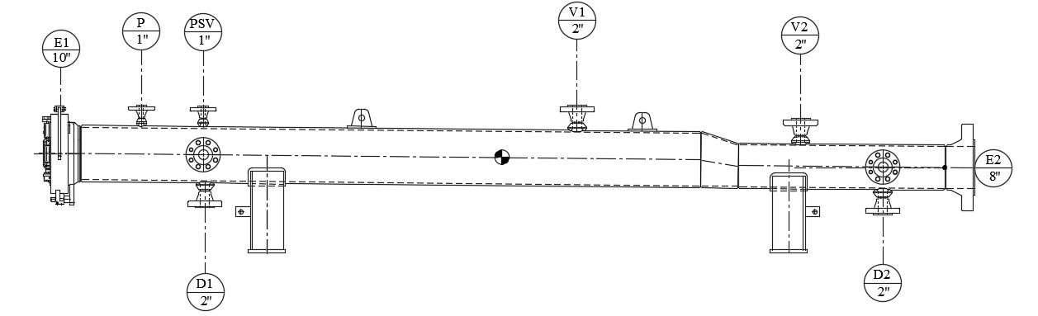

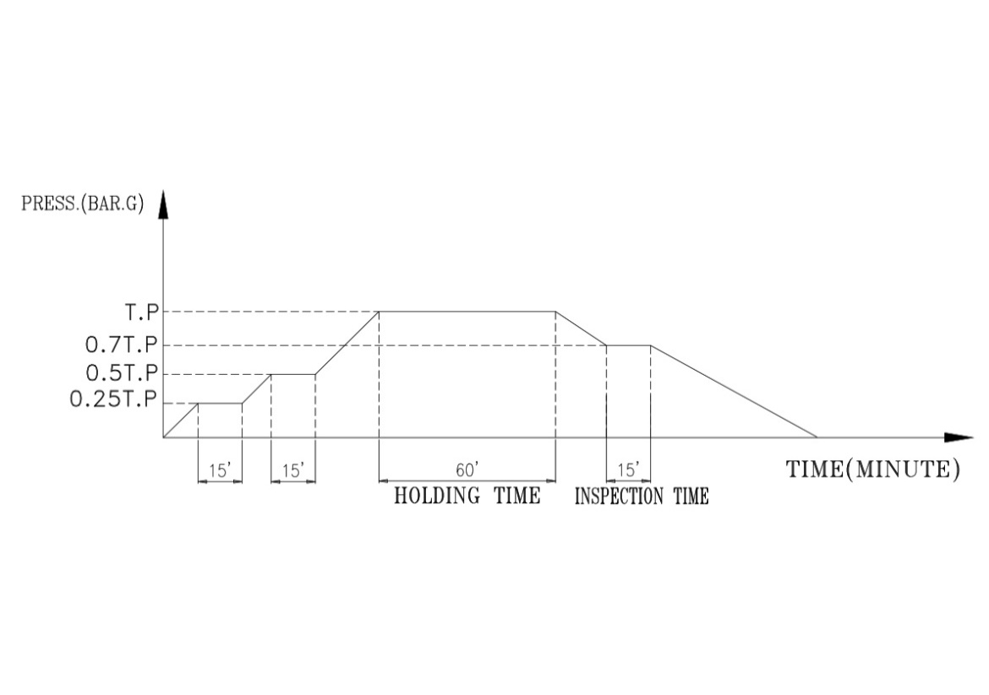

|  |  |
| --- | --- |
| NOZZLE MARK FOR FEED WATER | **PSV** |
| NOZZLE MARK FOR PRESS. GAUGE | **P** |
| NOZZLE MARK FOR PRESS. PUMP | **PSV** |
| NOZZLE MARK FOR VENT | **P** |
| NOZZLE MARK FOR DRAIN | **D2** |
| FEED WATER TEMP. (°C) | **min 16° max 49°** |
| HYDRO. PRESS. (BAR.G) | **93barg** |

|  |  |
| --- | --- |
| NOZZLE MARK FOR FEED WATER | **V1** |
| NOZZLE MARK FOR PRESS. GAUGE | **K** |
| NOZZLE MARK FOR PRESS. PUMP | **V1** |
| NOZZLE MARK FOR VENT | **K** |
| NOZZLE MARK FOR DRAIN | **D1** |
| FEED WATER TEMP. (°C) | **min 16° max 49°** |
| HYDRO. PRESS. (BAR.G) | **93barg** |

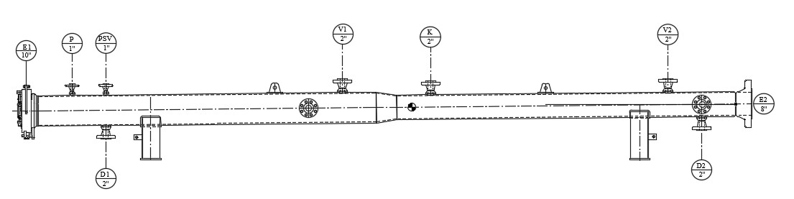



# Appendix-1 Hydro Static Test Report Sample

